
Professional Practice: Fieldwork 1

MA Youth and Community Work

Re-engaging young people who are NEET in Ceredigion
Ceredigion Youth Service Outreach provision

SJYW7014
Gwenllian Evans

Content List

Chapter 1 – Risk Assessment
- Definition of Risk Assessment……………………………………………………………… Page 4
- Good Practice Development Stages………………………………………………………Page 5
- Ceredigion Youth Service Outreach Provision Risk Assessment…………...page 6 – 9

Chapter 2 - Observation
- Observation…………………………………………………………………………………………..page 10
- Youth Service Team Structure………………………………………………………….…...page 13
- Ceredigion Youth Service Framework…………………………………………………...page 13
- Contact with young people in Ceredigion………………………………………….....page 16
- Registered members of youth work provision in Ceredigion……………..….page17
- Core Youth Work Budget…………………………………………………………………….…page 18
- All Wales Youth Service members………………………………………………………...page 19
- Destination of year 11 pupils in schools………………………………………….……..page 20
- Bibliography………………………………………………………………………………….….…….page 21

Chapter 3 – Reflective Practice
- Reflective Practice…………………………………………………………………………………page 22
- Gibbs Cyclical Model……………………………………………………………………………..page 22
- Reflective Blogs……………………………………………………………………………………..page23 – 62
- Bibliography…………………………………………………………………………………………..page 63 - 65

Chapter 4 – Community Profile
- Community Profile…………………………………………………………………………….....page 66
- Ingram and Harries community profile diagram………………………….……..…page 67
- Ceredigion background……………………………………………………………….……..…page 68
- Aberystwyth background……………………………………………………………………..page 69
- Population Structure……………………………………………………………………….…….page 70
- Employment/unemployment……………………………………………………………….page 71
- Employment Opportunities……………………………………………………………….….page 72
- Employment rate……………………………………………………………………………….….page 73
- Crime Statistics………………………………………………………………………………….…..page74 – 75
- Poverty in households……………………………………………………………………….….page
- Housing……………………………………………………………………………………………….…page 75 – 76
- Transport………………………………………………………………………………………………page 77
- Welsh Language……………………………………………………………………………………page 78
- Bibliography………………………………………………………………………………………….page 79 - 80
Chapter 5 – Case Study
- Case Study…………………………………………………………………………………………….page 81

Chapter 6 – Critical Reflection
- Critical Reflection………………………………………………………………………………….page 84
- Bibliography……………………………………………………………………………………….….page 87

Chapter 7 - Summary
- Summary……………………………………………………………………………………………….page 88
- Bibliography…………………………………………………………………………………………..Page 92
Appendix
Supporting Evidence…………………………………………………………………………………………..page 93 - 250

Chapter 1
Risk Assessment
The indicated risk assessment is used within the outreach provision under Ceredigion Youth Service where the placement is carried out. Outreach work takes place in a variety of settings in which the reason of the risk assessment being a broad and detailed piece to support the work. Similarly, creating and following risk assessments within the setting is good practice to support and implement the stages of youth outreach planning.
Risk Assessment is a form of evaluating the potential risks. According to Ceredigion Youth Service Handbook (2014:19) ‘As well as considering the risks present in your day-to-day work and locations, individual risk assessments should be made for particular activities or locations when appropriate’. Thus, is taken in to consideration when delivering activities, supporting young people within formal/informal settings in public and in their home environment to ensure the safety of young people and staff are met within outreach.
In relation to risk assessing the outreach provision, the Detached and Outreach Youth Work Handbook (CWVYS, 2012) states:
‘Outreach takes place in a non-centre based setting which may include parks, beach, bus-stops, streets or any other places where young people choose to informally gather or access to informal learning opportunities and resources on their own turf’.
(CWVYS, 2012)

This shows that a risk assessment must be specific to the activity but also flexible to suit various context of outreach provision. Outreach provisions take place in various locations where youth workers support young people who are in need of support. This could be in difficult situations, for example under the influence of alcohol, substance misuse, behaviour issues including anger, suicidal thought and other scenarios.

Found at: Ceredigion Youth Service Youth Workers Handbook (Jones,G 2017:8)

General

Risk Assessment Form
Department |  |  |  | Learning Services |  |  |  |  |  |  |  | Assessment No
Section |  |  |  | Youth Service |  |  |  |  |  |  |  | Date |  |  |  |  |  |  |  |  |  |  | 09/03/2018
 |  |  |  |  |  |  |  |  |  |  |  | Assessor |  |  |  |  |  |  |  |  |  |  | Gwenllian Evans
Activity / Process |  |  |  |  |  |  |  |  |  |  |  | Numbers & Persons At Risk
Outreach provision for Ceredigion Youth Service, which includes elements of house visits and detached youth work in both towns and rural areas across Ceredigion for young people aged 14-25. |  |  |  |  |  |  |  |  |  |  |  |  |  |  |  |  |  |  |  |  | Employees |  |  |  |  |  | Others |  |  |  |  |  |  | Pupils
 |  |  |  |  |  |  |  |  |  |  |  |  | 1 |  |  |  |  |  |  |  | X
 |  |  |  |  |  |  |  |  |  |  |  |  | 2 – 5 |  |  |  |  |  |  |  |  |  |  |  |  |  | X |  |  |  |  |  |  | X
 |  |  |  |  |  |  |  |  |  |  |  |  | 6 – 9
 |  |  |  |  |  |  |  |  |  |  |  |  | 10 +
 |  |  |  |  |  |  |  |  |  |  |  |  | X |  |  |  |  |  |  | Employee |  |  |  |  |  |  |  | X |  |  | Lone Worker
 |  |  |  |  |  |  |  |  |  |  |  |  |  |  |  |  |  |  |  | Handles Money |  |  |  |  |  |  |  |  |  |  | Contractor
 |  |  |  |  |  |  |  |  |  |  |  |  | X |  |  |  |  |  |  | Unsociable Hours |  |  |  |  |  |  |  | x |  |  | Visit Premises
 |  |  |  |  |  |  |  |  |  |  |  |  | X |  |  |  |  |  |  | Deal With Public |  |  |  |  |  |  |  |  |  |  | Young Vulnerable Staff
 |  |  |  |  |  |  |  |  |  |  |  |  | X |  |  |  |  |  |  | Young Person |  |  |  |  |  |  |  | x |  |  | Public / Client
 |  |  |  |  |  |  |  |  |  |  |  |  |  |  |  |  |  |  |  | Infant School Pupil |  |  |  |  |  |  |  |  |  |  | Primary School Pupil
 |  |  |  |  |  |  |  |  |  |  |  |  | X |  |  |  |  |  |  | Secondary School Pupil
Hazard Involved In The Activity / Process
- Assault
- Verbal Abuse
- Mistaken Identity
- Discarded needles / other drug equipment
- Trips and falls
- No escape route
- Lone Working
- Transporting young people
- Home Visits
- Working Outdoors/ inclement weather
- Working with Young People who are under the influence of substances
- Exposure to unsuitable personnel
Existing Safety Measures / Controls
1)Assault - Avoid lone working. Always work with a partner. Ceredigion Outreach Guidelines. First Aid trained.

2) Verbal Abuse - Avoid confrontation. Keep distance. De-escalation techniques. Avoid areas of confrontation.

3) Mistaken Identity - Always wear ID badges. Wear Youth Service uniform

4) Discarded needles / other drug equipment - Refer to Council Drugs policy and health and safety manual/ training.

5)Trips and falls - Wear Appropriate footwear, walk on designated paths and be aware of underfoot conditions

6)No escape route - Always ensure there is a clear exit for you or a young person to alleviate themselves from the room/ area if needed

7)Lone Working - Ensure worker is fully aware of Lone Working Policy and uses methods of communication agreed (call in regularly, use code word system for any problems, etc) inform Line Manager

8) Transporting young people - All Staff to have appropriate vehicle/insurance. Where appropriate employees to eliminate the need to drive/ if journey is avoidable: e.g. use video conferencing, public transport. Staffs are advised to allow sufficient journey time and planned breaks – in order to allow adequate time to arrive at destination. Staff will aim to drive in normal working hours and plan reasonable breaks (recommended: 15 minutes every 2 hours). Staff will aim to avoid driving at peak times, late at night or early morning.i.e. distraction, hostility, volume and risk of allegations whilst in the vehicle and outside the vehicle
- Young people briefed beforehand about required behaviour with reasons and consequences by staff. Behaviour protocol to be followed.
- Staff to monitor young people by regularly checking mirror in order to maintain good order, ensure young people keep seat belts on, and attend to any needs if necessary – by stopping in a safe and practical location.
- It is the driver’s legal responsibility to ensure that seat belts are fitted correctly on all young people aged under 14 years
- The driver has a duty of care to ensure that seat belts are fitted correctly on all passengers aged 14 years and over.
- Where practical – staff are advised to seat single passengers in the back of the vehicle in order to alleviate false allegations between the passenger in the front passenger seat and the driver.
- Staff to record any incidents immediately after the journey and their inform line manager
- Staff to carry mobile phones and first aid kit in the event of an incident

9) Home Visits - Ensure staffs go into unfamiliar areas/homes in pairs, preferably mixed gender pairings to ensure safeguarding of staff.

10) Working Outdoors/ inclement weather - Ensure Correct equipment is carried/worn (Wet weather/warm clothing, first Aid kit, high visibility/ torch etc...)
- Staff to monitor and review weather forecast prior and during the activity. In the event of adverse weather conditions, the event/ activity to be cancelled and passengers to be informed in good time.

11)Working with Young People who are under the influence of substances - This must be avoided, if a young person is suspected of being under the influence of substances then worker must make excuses/apologies and agree to contact young person at another time. If the worker has concerns for the Young person they must contact the emergency services or PCSO

12)Exposure to unsuitable personnel - All staff/ support staff that comes into contact with children and young people has up to date relevant enhanced CRB checks. No staffs are able to come into contact with children and young people unsupervised until enhanced CRB checks and references have been received and reviewed.
- No external staff to be unsupervised when working with young people at any time.

The Residual Risk(s) (After Existing Control Measures).  If There Are None, Write ‘Controls Adequate’ Below. If Risks Still Exist, Detail Below & Rate The Residual Risk(s). |  |  |  |  |  |  |  |  |  |  |  |  |  |  |  |  |  |  |  |  |  | Risk Rating
 |  |  |  |  |  |  |  |  |  |  |  |  |  |  |  |  |  |  |  |  |  | Likelihood |  | x |  | Severity |  |  |  |  |  | = |  |  | Rating
Trips and falls |  |  |  |  |  |  |  |  |  |  |  |  |  |  |  |  |  |  |  |  |  | 1 |  | x |  | 1 |  |  |  |  |  | = |  |  | 1-5
Verbal abuse |  |  |  |  |  |  |  |  |  |  |  |  |  |  |  |  |  |  |  |  |  | 3 |  | x |  | 2 |  |  |  |  |  | = |  |  | 6-10
Assault |  |  |  |  |  |  |  |  |  |  |  |  |  |  |  |  |  |  |  |  |  | 3 |  | x |  | 3 |  |  |  |  |  | = |  |  | 6-10
 |  |  |  |  |  |  |  |  |  |  |  |  |  |  |  |  |  |  |  |  |  |  |  | x
Likelihood |  |  |  |  | Severity |  |  |  | Risk Rating
1 | Rare |  |  |  | 1 |  | Insignificant |  | 1 - 5 |  |  |  |  |  | Minimal Risk - Maintain Measures
2 | Unlikely |  |  |  | 2 |  | Minor |  | 6 – 10 |  |  |  |  |  | Low Risk - Review Risks
3 | Possible |  |  |  | 3 |  | Moderate |  | 11 – 15 |  |  |  |  |  | Moderate Risk - Additional Controls In 12 Months
4 | Likely |  |  |  | 4 |  | Major |  | 16 - 25 |  |  |  |  |  | High Risk - Additional Controls Implemented Immediately
5 | Almost Certain |  |  |  | 5 |  | Catastrophic
Implementation of controls and monitoring
Additional controls required to reduce risk(s) below risk rating of 5
Additional controls agreed Yes / No (If Yes, Detail The Action To Be Taken)
Target Date For Implementation |  |  |  |  |  |  |  |  |  |  |  |  |  |  |  |  |  |  |  |  | 09/03/2018
Signature - Responsible Line Manager / Head Teacher
Assessment Review
Date Implemented |  |  |  |  |  |  |  |  |  |  |  |  |  |  |  | Controls Effective? Yes / No
Comments
Assessment Review Date
Signature – Responsible Line Manager / Head Teacher

Risk Assessment Created by Evans (2018)
Template created by Ceredigion County Council

Bibliography
CWVYS (2012) Detached and Outreach Youth Work
http://www.cwvys.org.uk/wp-content/uploads/2014/06/HB-Detached-and-Outreach-Youth-Work.pdf (Accessed on the 29/02/2018).
Jones,G (2007). Ceredigion Youth Service Youth Workers Handbook. Dyffryn Aeron: Ceredigion County Council. 19.

Chapter 2
Observation
The chosen organisation which will be used as a placement to complete this Fieldwork module is located with Ceredigion Youth Service, where I currently undertake the role of an Outreach Youth Worker. The main focus of the placement will be to engage with the outreach sector of the youth service to support young people aged 16 – 25 who are being categorised as being at risk or currently not in Employment, Education or Training (NEET). Crucial elements of the role include partnership working with other agencies to enhance young people’s fulfilment and their holistic needs. The main partnerships the outreach works with vary from Job Centre Plus, Careers Wales, Youth Justice, schools/colleges, Social Services, statutory/voluntary services and so on.
My main focus within this placement is to explore the issues and outcomes of the reasoning of young people who are at risk or currently not in education, employment or training and to provide young people the support that has been misplaced in order for them to enhance their opportunities. The course of action that will be considered to accomplish this programme will include various methods from employability workshops, educative taster days, individual outreach support visits, confidence building workshops and many more. This plays an educative power as the role of the Youth Worker according to the Albemarle Report ‘encourages young people to come together into groups of their own choosing is the fundamental task of the Service’ (Ministry of Education cited in Jeffs 2010:3).The outreach provision covers the whole of Ceredigion county where it is a rural and around 50 miles from North to South of the county.
Ceredigion Youth Service is a statutory service and is managed by the local authority in which is located under the education and learning services department. With the Youth Service located under the education Provision, it is important to work with other sectors within the department such as Alternative Curriculum, Work Related and Learning Preventions Team and Youth Justice to focus on the targeted provision and monitor school leavers.
As a whole, the service works with young people aged 11 – 25 where it aims to enhance and provide opportunities for young people who need support in improving their own lives, engage young people in activities in non-formal education, identify their personal and social needs and help young people develop holistically. This is achieved through planning and creating activities around the needs of the young people in a non-formal, fun way. Ceredigion Youth Service believes in the young people having their voice to be heard in which young people are able to take part in planning activities of their own choice.
As well as the outreach provision, the Youth Service have located school based youth workers where the aim is to provide support to young people within the school setting. Youth based school workers aims to support young people aged 11 - 16 to progress to their achievement, support young people who are identified as disaffected and lack of coping mechanisms. School based youth workers plan and support around the individual through informal learning to meet young people’s needs. According to Williams and Edelston (cited in Sapin,2013:16) ‘Informal education seeks young people’s active participation in bringing about change towards greater equity and justice’. Within Ceredigion Youth Service, there are four school based youth workers where each staff work out of two secondary schools each. Through effective communication, school based youth workers work closely with the outreach provision in order to refer individuals who are about to leave the school/education setting and are at risk of becoming dis-engaged, not in employment, education or training and loss of contact from the support they need. Having the youth service work together, this overcomes the barrier of prevention where young people receive the full support they need.
The outreach provision also supports youth clubs in which Ceredigion Youth Service currently run four statutory clubs around the county located at Lampeter, Aberaeron, Cardigan and Penparcau. The outreach holds regular drop-ins within the youth clubs around the county to target the young people who are in need of the support. Similarly, there are also voluntary organisations around the county where the outreach provide regular drop-ins and work closely with the young people who attend the organisations such as Area 43, Careers Wales, Ty Curig and Tysul Youth.
Ceredigion Youth Service is also a centre that delivers Agored Cymru and ASDAN which is an opportunity for young people to undertake qualifications/accreditations. These accreditations are undertaken within school settings where youth workers support individual learners, throughout the holiday programmes and outreach where it is delivered within activities, individually or in Job Centre Plus.
My aim is to work closely with the team at Ceredigion Youth Service to ensure that young people are benefitting from the Service, but also are receiving the support they need from education to employment or training. According to Taggart (cited in De St Croix, 2016:62):
‘The positive emotions are demonstrative of a principled and value-based commitment to young people that goes beyond straightforward job satisfaction, and can perhaps be seen as a political ethic of care’.
Taggart (cited in De St Croix, 2016:62)

I believe that Ceredigion Youth Service demonstrates this good practice and energies young people to further their opportunities in future. This is carried out through the different aspects of Outreach they have to offer to support young people.
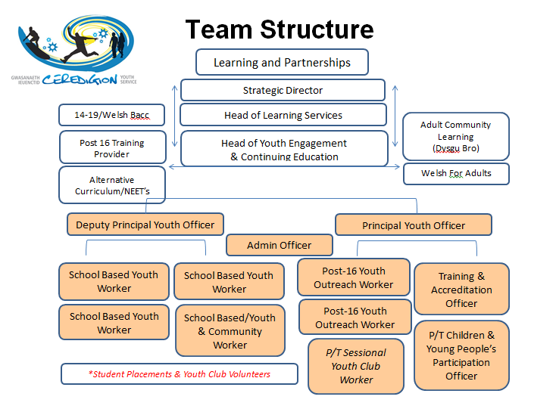
Found at: Ceredigion Youth Service Youth Workers Handbook (2017:8)
Thus, is currently Ceredigion Youth Service Team Structure which shows individuals job role within the Service. The structure and the service itself targets young people who are in need of the support in which could be identified when attending school and be referred onwards to the Outreach provision for further support when leaving education.
Ceredigion Youth Service Framework
Furthermore, Ceredigion County Council started its outreach provision in 2010 where it first started as a three year trial, funded by ESF Engage (ESF, 2014). Due to Ceredigion outreach provision being able to evaluate and provide enough supported evidence of the need of outreach within Ceredigion, the Youth Service then received funding by the Welsh Government new scheme (Welsh Government, 2013:3) ‘Youth Engagement and Progression’ which allocates staff to be able to deliver the service. The aim of the framework is to work closely with work based learning providers to reduce the number of young people becoming a risk of or who are not in employment, education or training.
‘The framework is based around 6 component elements, proven to be effective at increasing youth engagement and progression. They aim to:
- Identify young people most at risk of disengagement
- Provide better brokerage and co-ordination of support
- Provide stronger tracking and transition of young people through the system
- Ensure provision meets the needs of young people
- Strengthen employability skills and opportunities for employment
- Provide greater accountability for better outcomes for young people.’
(YEP,2015)

Thus Framework shows a great understanding of what the outreach provision within Ceredigion should aim to work alongside in order to meet the criteria of youth work profession. The first key implementation to this is working with other providers to ensure that young people are able to experience better outcomes. The second is identifying and building strong relationships with young people in order to plan around their needs and ensure that they are able to enhance their opportunities individually.
Within the Youth Progression and Engagement Framework (2013:3) Huw Lewis, the minister of Education and Skills expresses his view on outreach as:
“An aim to drive change through the whole system in Wales and sets out how local authorities, working with Welsh Government and partner organisations such as Careers Wales and providers of education and training can put in place more effective systems in order to achieve this change. It is a challenge for us all, but one we must all embrace, if we are to deliver the outcomes that our young people deserve”.
Youth Progression and Engagement Framework (2013:3)

This underlines that giving the possible opportunities for young people and follow the development of good practice from the six elements of the Youth Engagement and Progression Framework. The Framework is an important implementation for Ceredigion Youth Service to work towards the achievement and progression of young people transferring from being currently NEET, to engage with outreach or within education, employment or training. When looking at different approaches of engaging young people within outreach it may be helpful to understand the five-tier-model from the Welsh Government (WLGA,2013:22) which focuses on the different stages young people are within their engagement varying from level 1 - unidentified engagement to level 5, sustaining education, employment or training.

One of my intentions whilst working with outreach will be to create workshops that will support young people back in to employment, education or training for example Food and Hygiene/First Aid Courses, confidence building programmes, volunteering workshops and so on. My aim is to also work alongside Careers Wales and Work Related and Learning Preventions Team to prevent young people who are in their final year of education become NEET. This work will include various approaches of engaging young people through one to one outreach, projects/workshops, and training opportunities and so on. Thus, activities (cited in Roberts, 2009:97) are to:
‘Promote social justice as a core activity to focus on the heart of progressive society and changing attitudes for example, the poor (UN Article 27), the poorly educated (UN Article 28) and disabled (UN Article 23)’.

(cited in Roberts, 2009:97)

Consequently, all activities delivered by the outreach provision are to cater all young people’s needs in order for them to develop holistically and ensure their needs are met. The programmes are advertised to various organisations such as Job Centre Plus, Tai Ceredigion, Careers Wales, Team around Family and many more in order to target young people who are in need of the support. According to National Statistics for Wales 2017 (Welsh Government,2014), compared with the previous year there have been slight decreases to youth work membership, and finance whilst staffing levels have increased.
- ‘16 per cent of the population of 11 to 25 year olds are registered members of the statutory sector youth work provision in Wales (87,600 amongst the 21 authorities who responded), compared with 17 per cent (93,400) last year.
- At March 2017, there was 652 full-time equivalent (FTE) Youth Work management and delivery staff working across local authorities in Wales, an increase of 3 per cent compared with March 2016.
- The total income for Youth Work provision across Wales in 2016-17 was £31.3 million. Total income decreased by 2 per cent compared with 2015-16, whilst core budget decreased by 1 per cent.
- The total spends for Youth Work provision across Wales in 2016-17 was £31.1 million’.
(Welsh Government,2014)

Ceredigion Youth Service has progressed within the last five years where reaching out to young people have increased through formal and in-formal learning. The number of contacts of young people have amplified, which shows that Youth workers in School, Outreach Provision, Community and participation are thriving to encourage young people to engage with the Youth Service within their settings.
Contact with young people
Looking at figure one below, the outreach provision has reached 4,922 contacts between 2016 – 2017. This contact figure includes workshops focusing on courses such as Food and Hygiene and First Aid, employability residential, individual outreach support, confidence workshops and many more.

Figure 1

Found at: Ceredigion Youth Service

The total reach figure within this year is a big achievement, for the two Youth Outreach Workers who covers the whole County. Similarly, looking at the Welsh Government stats for 2016 – 2017, Ceredigion is the second highest in Wales for the most registered members in youth work provision (see figure 2 below).
Registered Members
Figure 2

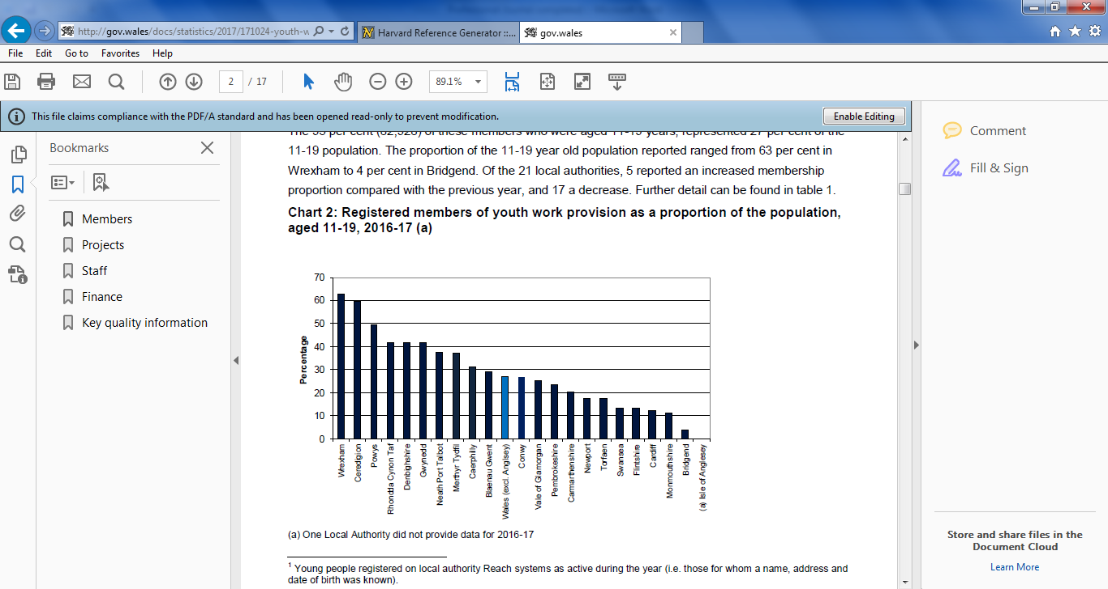

Found at: Welsh Government (2017:2). Youth work in Wales, 2016-17: Statistics for Wales
However, this includes the members reached by the Service as a whole not only the Outreach Provision. This can be argued within the next statistic, where we have the smallest budget throughout Wales.
Looking at the statistics in figure 3 below, Ceredigion Youth Service has worked hard to reach young people in such rural areas that they have the second highest contacts with young people with the smallest number of staff within the Service throughout Wales. In comparison, Ceredigion Youth Service in the year of 2016 – 2017 received the lowest core budget as seen in the chart below.

Core Youth Work Budget
Figure 3
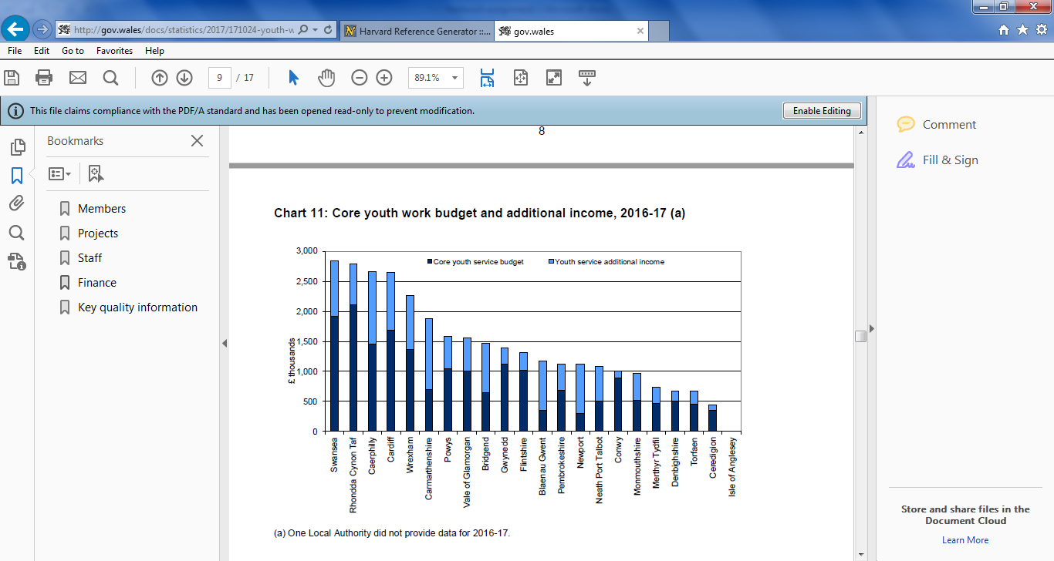

Found at: Welsh Government (2017:9). Youth work in Wales, 2016-17: Statistics for Wales
This shows that although Ceredigion have the lowest funding throughout Wales, they are able to prioritise the funding equally and demonstrate that they are able to reach a number of young people with the support of the Outreach Provision. However, it is necessary to argue that young people are receiving lack of activities and opportunities during school holidays compared to other Counties.
There has been questioning on what is Youth Work and how Services are funded however, there is no doubt that cuts have been made over the last few years.
According to the House of Commons (cited in Ord, 2016:137):
‘It seems that the removal of ring-fencing for youth provision, coupled with the 10.9% cut in the value of funds going to the Early Intervention Grant, is leading some local authorities to prioritise statutory and higher-risk services, such as Children’s Service above Youth Services’.
House of Commons (cited in Ord, 2016:137)

All Wales Youth Services Members
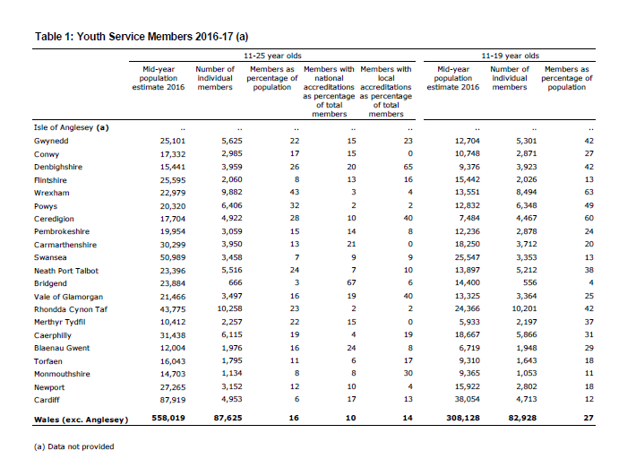
Figure 4

Found at: Welsh Government (2017:10). Youth work in Wales, 2016-17: Statistics for Wales
This diagram (figure 4) shows the comparison of members between all the Counties in Wales. Within the second column, under the 11 – 25 categories, the number of individual members Ceredigion Youth Service reached is 4,922young people in comparison to Swansea with 3,458.
‘The total spend by youth work provision in Wales in 2016-17 was £31.1 million. Compared with the previous year, there was a decrease of 2 per cent in total spend. Expenditure ranged from £0.41 million in Ceredigion, to £2.8 million in Swansea’.
(Welsh Government, 2014)

Destination of year 11 pupils in schools
Figure 5


Found at: Welsh Government, 2013:8 (Youth Engagement Progression Framework)

Looking at this survey from Careers Wales, Ceredigion is currently sustaining the amount of young people who are not in employment, education or training. However, looking at other Counties, the amount of young people currently NEET are slowly decreasing. This can be argued that the population of Ceredigion is one of the least out of the whole counties listed.
Bibliography
YEP (2015) Youth Engagement and Progression
http://gov.wales/topics/educationandskills/skillsandtraining/youthengagement/?lang=en [Accessed on the 10/03/2018]
Welsh Government, 2013:8 (Youth Engagement Progression Framework)
http://gov.wales/docs/dcells/publications/131007-ye-framework-implementation-plan-en.pdf [Accessed on the 10/03/2018]
De St Croix,T (2016). Grassroots Youth Work: Policy, Passion and Resistance in Practice. Great Britain: Policy press. 62.
Jeffs,T (2010). Youth Work Practice. London: Palgrave Macmillan. 3.
Jones,G (2007). Ceredigion Youth Service Youth Workers Handbook. Dyffryn Aeron: Ceredigion County Council. 8.
Ord,J (2016). Youth Work Process, Product and Practice: Creating an authentic curriculum in Work with Young People. Oxon: Routledge. 137
Sapin,K (2013). Essential Skills for Youth Work Practice. 2nd ed. London: SAGE. 16.
Roberts,R (2009). Youth Work Ethics. Exeter: Learning Matters. 97
Thorburn,J. Reveley,A (2006). Ceredigion Community Profiles. Aberaeron: Ceredigion County Council. 7,13
Welsh Government (2014) Local Area Summary Statistics
http://gov.wales/docs/statistics/2017/171024-youth-work-2016-17-en.pdf pg2 [Accessed on the 13/03/2018]
Welsh Government (2017). Youth work in Wales, 2016-17: Statistics for Wales. Wales: Welsh Governement . 9,10.
WLGA (2013) The National Youth Work Strategy for Wales 2014 - 2018 http://dera.ioe.ac.uk/19353/1/140221-national-youth-work-strategy-en.pdf [Accessed: 12/03/2018]
ESF (2014) European Social Fund
http://gov.wales/topics/educationandskills/allsectorpolicies/europeansocialfund/?lang=en [Accessed on the 17/03/2018]

Chapter 3
Reflective Practice
To reflect on the different aspects of outreach provisions within Ceredigion Youth Service, I will be using Gibbs model of reflection (1988) to create key questions and observations to seek information on how the provision meets the needs of the young people. As part of reflection, I will be reflecting and analysing of issues arising from practice to identify and plan transformative action (Freire1970, cited in Sapin, 2013:220). Reflection will be taken into account by following Gibbs’ cycle.
Gibbs (1988) cycle (cited in Sapin, 2013:215):
This reflective process will follow questions in association with Gibbs’ (1988) cyclical model of reflective practice in order to structure and guide reflections-on-practice (Schön, 1986). In terms of researching and structuring reflective questioning, I will look at specific accounts of practice, evidence how it is improving my own learning and in turn influencing the learning of others. These accounts come to stand as their own practical theories of practice, from which others can learn if they wish (McNiff, 2006:7). This chapter will be a specific reflection of Ceredigion Youth Service’s Outreach projects, which includes skill-building workshops, taster courses and employability drop-in surgeries.
Reflective Blog 1 - Standing Strong Programme - Employability Residential 15/02/2018
- Description
This was the first workshop of the Standing Strong Programme which aimed at young people aged 16 - 25 who are at risk of or who are currently not in employment, education or training (NEET). However, this particular workshop was not only aimed at young people who were NEET, but aimed at young people who had lack of confidence, struggled with anxiety and de-motivation. The residential was promoted within Job Centre Plus, Careers, one to one support and had been shared with children support services such as Looked after children, Youth Justice, engagement groups and so on. The residential had been organised to give young people a chance to socialise with others, as well as giving them an opportunity to enhance their knowledge and skills within employment. As Spence (cited in Jeffs, 2010:5) states; ‘It is the open informality of youth work which encourages the engagement of young people who refuse other institutional participation’. Therefore, preparing workshops which are varied and offer a range of support to young people are effective in terms of participation and engagement.
The first day was focused on guest speakers from Coleg Ceredigion and Big Ideas Wales to enthuse young people with business opportunities and courses within the area and local colleges. It started off with a gentle warm up exercise where young people didn’t have to communicate too much, but enough to get to know each other. The session was delivered through power point alongside practical group work and creating fun items such as a bird box to take home where young people were able to achieve through making an item.
The second day consisted of CV writing workshops, searching for employment and education opportunities with a skiing activity in the middle to break up the day. Young people also had accredited opportunities where they undertook Agored Cyrmru within ‘Exploring Job Opportunities’ and ‘Becoming an Entrepreneur’.
Within this residential, we had 14 young people attending the two days, in which our role was to consider all individual needs such as young people with confidence issues, de-motivated and embarrassed to be unemployed etc. Young people completed an evaluation form at the end of the residential to reflect on the overall workshop. According to the Ministry of Education (cited in Jeffs, 2010:3),’ the Albemarle Report argues that encouraging young people to come together into groups of their own choosing is fundamental task of the Service’. This shows that young people tend to follow the trend of attending certain groups knowing that others similar to them take part in the group. A good example is this Standing Strong Programme, where young people who have lack of confidence know that young people similar to them take part in the workshops.
- Feelings
My feelings whilst organising the residential was excited, putting a lot of work in to develop the workshop through working in partnership with Big Ideas Wales and Coleg Ceredigion to ensure that the residential would be a great benefit for the young people who attended. On the other hand I did feel a little pressurised, as I had organised the residential with no support from my colleagues and felt the pressure of making sure the residential had to run smoothly. This consisted of me ensuring the residential was booked, ensuring the guest speakers had been given a time to deliver their session, advertise and collect names of young people to attend, organising transport and activities during the day.
I found it difficult to recruit young people to attend, where they either had a negative attitude in seeking work or would rather stay home and not engage with other young people. Maslow’s 1943 hierarchy of human motivation (cited in Sapin, 2009:76) ‘recognises that most people are only partially satisfied in relation to their needs’. However, this was addressed when meeting with the young people before the residential to address any concerns to prepare to meet the individual’s needs during the residential. I felt that I had created the posters ‘young people friendly’ and had advertised fun activities for the young people to take part in, in which I took on board young people’s ideas such as skiing which was delivered on the residential campus. I was a little anxious that young people aged 16 – 25 wouldn’t want to stay overnight, however twelve out of fourteen young people had stayed in which the other two had stayed home and returned the next day.
My only concern in organising this residential was that young people would be nervous in taking part in the activities provided, having that each individual were at different levels of confidence and motivation. As a youth worker, my role was to ensure that young people felt secure and was able guide them to the level of engagement they were comfortable with.
- Evaluation
The residential was really positive, where young people engaged and participated really well considering the cohort was targeted at young people with low confidence, anxiety and de-motivated. The young people identified that others who attended the residential had the same issues as themselves and were able to reach out of their comfort zones which was really encouraging for them. I found that this was worthwhile for the young people to express their feelings and be able to engage with young people, in which they hadn’t done in a while.
The aim of the Programme was to encourage young people raise their voice and be able to socialise with others and take part in activities. One young person was terrified of staying in which she had given herself a task to join our residential and aim to tackle her fear in which she did. It was not only about engaging with others for her, but was about stepping out of her own house and being able to cope with people around her for two days. Similarly, other young people were able to take part in tasks and be able to take an end product home in which they took home bird boxes and their painted pottery as well as going home with the support to raise their own confidence. This was an example of a rewarding moment for these young people to be able to have a taster of what it is like to participate in activities that will support them in the future. Kantian Principles (cited in Banks 1999:153) believed that ‘the dilemmas raised in these situations usually relate to balancing the young person’s rights to freedom to determine their own actions and to have their confidence respected’. Through offering a programme like this, young people attend voluntary and are respected by other young people and youth workers of who they are.
Another important part of the residential was that young people were able to achieve an accreditation which some young people hadn’t had a certificate since education or received a certificate at all. This motivated a lot of young people to believe in themselves that they could achieve and reach their aims and goals in future. Overall, I felt overwhelmed by the amount of engagement the young people did and although a few activities weren’t at their interest such as skiing, all individuals tried, even for a short period of time.

- Analysis
The residential worked out well with the amount of young people that engaged and the focus on a particular cohort which needed the support to open up a variety of options in to employment. I felt that the workshops were really engaging, however, next time I might prepare workshops that are more focused on becoming an employee rather than inviting guest speakers in to inspire them to create/set up their own business. However, the second day of the residential supported the young people in searching for jobs and creating cv’s which led them to be prepared to seek for work. Through previous experience, the residential flowed really well, where the timetable had set times of each workshop and each activity were varied where young people were able to take part in fun, and interactive activities as well as gaining knowledge and enhancing their skills.
Evaluation forms were completed by the young people and had been looked at to see whether the workshops could have been improved or what the young people liked about the whole two days. Feedback given was that they wanted more practical activities within the residential, where the young people could enjoy rather than be inside for too long. The next time this would be organised, I will take this on board however the residential was given a budget where the maximum of £500 was to be spent. This covered the cost of staying overnight and activities at the Gwersyll Urdd Llangrannog, Supper, Breakfast and lunch for the young people. This was very limited, in which why myself and another youth worker delivered sessions and had invited guest speakers in which was no added cost.
However, I agree with Sercombe (2010:79) where he states ‘the Governments have increasingly recognised the potential of youth work-type methods to reach the ‘hard to serve’ people and address a range of social problems’. This clearly shows the recognition of youth work where even though the funding is low, the support delivered to individual young people is committed and of quality in order for young people to enhance their skills and achieve their aims and goals.
- Conclusion
To conclude this reflection, I feel the two day programme had been a success where each individual had achieved a goal such as being able to socialise with others, take part/giving a go in outdoor activities, creating cv’s / exploring job opportunities, staying overnight at the Gwersyll Urdd Llangrannog or even making an end product which they were able to take home such as bird boxes and pottery. The residential and activities were planned before the day and was guided by a timetable that I had made beforehand. Perhaps, next time I plan a residential, I will look more in detail to young people having more regular breaks to being that some felt that the sessions were too long.
Unquestionably, I will be looking in to delivering such a residential again, as I felt that the young people had a lot out of the two day workshop. This was an experience where I identified the importance of youth work and how it meets the needs of young people through encouraging them to participate in activities they have never tried before. The residential met the 6 key elements of the Youth Engagement and Progression Framework which focuses on supporting vulnerable young people who are in NEET.
- Action Plan
My aim for the next workshop is to reduce the number of young people on the activity from fourteen to eight young people to ensure that they are able to receive the most support from myself and another youth worker. I feel that putting a capacity number on a workshop will provide individuals sufficient guidance through to employability, education or training.
Reflective Blog 2 - Standing Strong Programme - Volunteering with Cardigan Castle (Garden Patch) 07/03/2018
- Description
Following on from the employability residential, it was the second workshop of the Standing Strong Programme where young people had an opportunity to volunteer with Cardigan Castle for the day. The aim of the workshop was to enable young people to enhance their skills in order for them to develop their cv’s and employment applications. Similarly, volunteering at Cardigan Castle had broadened young people’s horizons by exploring different opportunities and having a taster of following a work patterned routine. Young people had been given a task by Cardigan Castle to clear old weeds and roots of their garden patch in order to prepare to pant new seeds and bulbs to grow vegetables for their café/restaurant.
For this workshop, eight young people’s names were down to attend however three young people turned up to volunteer. This was disappointing, being that the organisation had given us a big patch to clear thinking that we would be a bigger group. Despite this, young people had the drive to complete the task which was rewarding seeing the before and after pictures of their work.
Resources for the work were provided by Cardigan Castle in which young people also cleaned up after their task and washed down the tools used. Young people had also completed an accreditation, ‘volunteering’ at the end of the day which they were handed their certificate short while afterwards.

- Feelings
My feelings when I first organised this volunteering opportunity was motivated knowing not only that the young people could volunteer in a famous historic Castle of Cardigan, but to experience outdoor work where young people were able to volunteer and achieve or adapt new skills and an opportunity to fulfil their cv. From observing the young people taking part in the workshop, young people showed their strengths of being able to work as part of a team, great communication and being able to see their work through. Although the three young people who volunteered can be quite challenging in terms of getting involved in activities, communicate with others being that they have low confidence, the outcome was really rewarding seeing them get along as a small group.
My feelings when providing transport around the County in the morning was rather disappointing when picking up young people, they either hadn’t answered the door or parents had approached me saying that they had changed their mind. Out of eight young people, three turned up to the workshops which I thought it was a shame as it was a great opportunity for young people to help them further develop themselves and to better their chance of seeking employment. Reflecting back to the scenario where I approached a few parents when picking up the young person, I felt that the parent had given an attitude of engaging with myself and had the view of ‘couldn’t be bothered’. I feel that this had a knock on effect of why the young person is currently NEET, where they follow their guardian’s footsteps of having a negative attitude towards getting back in to employment or education. Robinson and Lamb 2012 (cited in Riele & Gorur,2015:134) stated that ‘those from the poorest families, and those with lower education attainment, are most likely to remain NEET long-term’. I feel this somewhat is true, however, although there are support organisations available, for example ourselves as a youth service we are a voluntary organisation where young people choose to engage. Without their authority we cannot force young people to engage with us to seek support. UK research suggests NEET young people may have more negative attitudes and lower expectations regarding to education and employment (Finley cited in Riele & Gour, 2015:134).
- Evaluation
Overall, it was really positive to see the three young people who engaged in the volunteering day with Cardigan Castle and participated well in the task that was given to them. Following the feedback we had from the young people’s evaluation forms, I felt reassured reading the affirmative comments of the enjoyment young people achieved from the day as well as enhancing their skills and experience. It was also conclusive to see the group of three young people participating well in the task and work well together as a group through their own encouragement.
From this workshop, I felt that the group of young people had benefited from the day through achieving positive outcomes such as communication, teamwork, adapting their knowledge to outdoors to support them in to employment, education or training. I found that a practical and full day workshop made the young people realise and get the feeling of a routine and completing work hours.
The workshop focused on transforming young people’s lives within employment where the purpose was to enable young people to discover their needs and interests and learn from others. This follows the framework for professional youth work practice where it considers young peoples practice, principles and values (Sapin, 2009:4).
- Analysis
My initial thoughts of planning an activity like this has made me realise it’s not all about the group size but the quality of the service and support we deliver as youth workers. As a youth worker, I have realised that planning is essential and an important part of youth work where we plan around all individuals, for example, consider their learning environment whether formal or informal learning is best to take place. Jackson and Kassam 1998 (cited in Ord, 2012:88) stated the principles in youth work, ‘is the participatory evaluation process that empowers individuals, communities and organisations to analyse and solve their own problems and value the knowledge and experience of participants’.
Although funding is an issue at times within the service, activities such as volunteering gives a wide spread of opportunities for young people to have a taster of work opportunities and experience. According to Wynn and White 1997 (cited in Ord 2016:228) ‘the transition of young people from childhood to adulthood, although in itself is a problematic concept of providing a “framework” for a number of key tasks which need to be completed, such as identity information, the negotiating and maintaining of adult relationships, and practical issues such as finding a job’.
- Conclusion
From my experience of planning and delivering this session, I would be encouraged to plan this again for young people who are NEET given that the day enabled young people to explore and participate in a local project. I am also a believer in UNCRC Article 12 (UC, No date) where the concerns of young people to have their voice heard on matters that affect their lives. Through delivering workshops like this, I feel that it gives young people an opportunity for their voice to be heard through participation and inspired programmes that make young people feel included. Although I had negative thoughts to start with when reflecting on the numbers of young people who turned up, I feel the important part of the workshop was the quality and the experience other young people had from participating on the day.
- Action Plan
This workshop will be a great opportunity for young people to volunteer regularly and have a taster of a variety of volunteering opportunities with different organisations and different roles. Williams and Edelston (cited in Sapin, 2009:16) states ‘Informal education with young people encourages a critical understanding of the links between personal, local and global issues. It seeks their active participation in bringing about change towards greater equity and justice’. The importance is to address young people’s interests, where the focus in the next volunteering day will be to undertake different tasks to empower young people to different future opportunities.
My aim is to continue with this volunteering project and work with other organisations such as National Trust, New Quay Wildlife Trust and many more to explore employment opportunities. I will also look at involving young people to choose their volunteering opportunities and plan around their interests in order for the young people’s voice to be heard. The project enables young people to deal with challenges of work and to strengthen their values of employment.

Reflective Blog 3 - Food and Hygiene Course 21/03/2018
- Description
This workshop was a one day food and hygiene course which was open to young people aged 16 – 25 years to take part in order to achieve a Level 2 Certificate. This was advertised throughout the whole county in Job Centre plus, Careers Wales, voluntary organisations such as Area 43, Youth Clubs, Cavo and many more to young people that were NEET.
The aim of the food and hygiene course is to benefit young people with an extra qualification, for those who would like to work in the food industry such as restaurants and cafés. The certificate is often required by employers; however it can be an expensive qualification to complete if not currently in employment. Therefore, I developed a one day course which young people could undertake through an online programme, certified through High Speed Training. As a service we provided the course for free to the young people who were NEET where they were able to achieve a Level 2 Food and Hygiene certificate in order to support them seek for employment.
Planning was efficient in this workshop where resources such as iPad’s in this session were needed for each individual to complete the course. Similarly, each individual had a username and password to access the training which needed to be correctly distributed under their names and date of births.
Before the workshop, young people who were to attend had to fill in a consent form which was needed for me as a youth work to ensure that the learners were able to complete the course to suit their needs. After each individual had completed their forms, it was important for me to read over their personal information such as any medical, learning needs or disability on the consent form to ensure that I was able to adapt the session to their needs for the individual to complete the qualification. Through reading the young people’s consent forms, there were no concerns or issues that young people stated within their medical/learning needs that I needed to adapt to. However, once the session started, I noticed one individual struggled with their reading in which they needed support after them clarifying they had dyslexia.
My role was to organise transport, create posters, recruit young people and organise the appropriate resources needed for this day with support of another outreach youth worker. 8 young people attended the course in which 8 had received a Level2 in Food and Hygiene.
- Feelings
If something, I felt overwhelmed that the eight young people were keen to take part in the course and that they had achieved at the end of the day a Level 2 Food and Hygiene certificate. On the other hand, I did feel disappointed in myself not screening the consent forms with the young people individually. I believe if I did this before the workshop, I could have supported the individual who suffered with dyslexia better to make the task less challenging. Lambing 2003 (cited in Lefevre, 2010:19) states that ‘Seeing, listening to and observing the child must be an essential element of an initial assessment’. After reflecting my work, I agree with this statement where the importance of communicating with the young person is important.
I think other people who participated felt comfortable with the refreshments and the environment in the Youth Club was relaxed. Young people undertook the course at their own pace and took a break when they wanted to. During the course, young people bonded well and had supported each other when they had any queries or wanted support.
- Evaluation
It was positive to see the young people wanting to achieve a Level 2 Food and Hygiene, in which they had requested as one of the courses they would like to see delivered by the youth service. This had motivated me to ensure that I was able to develop this course to cater the needs of the young people. Whilst the young people were logging in to their accounts to start the course I could see one individual struggle with the iPad. From approaching the young person, they expressed their difficulty in reading the information on the iPad, and suffer with dyslexia, however this had not been stated on his consent form. To support the individual, we had zoomed the screen in for him to be able to read more clearly and supported him with the reading within some slides through reading it out. I felt that this had put pressure on me to ensure the needs of the individual are met, but also put pressure on the young person to read the slides in a certain time being that the course was between 10:30am – 3pm. However, the online course had also a sound where the young person could listen to the programme rather than reading, which suited the individual better and was more comfortable with this method of completing the course. My role was to respect the young person’s needs in which as a youth worker is ‘to retain core values in ways that are relevant to changing social circumstances’ Cooper 2012 (cited in Pantea, Diroescu & Zielger, 2014:43). This states inclusive youth work practice is important and by observing and evaluating my priorities, this was for the young person to achieve a qualification in food and hygiene. Stake and Trumbull 1982 (cited in Ord, 2012:89) an ‘evaluator facilities the various stakeholders to discover ideas, answers and solutions within their own mind’. My role was to identify the key issues and to empower the learner to develop self-sufficiency and personal development (Patton, 2008 cited in Ord, 2012:89).
Although I faced some difficulty with an individual, I approached the concern in a professional manner, making sure that the individual felt included and wanting to achieve. As well as the young people taking part in the food and hygiene course, we allowed comfort brakes and supplied tea and biscuits as well as a warm lunch as an incentive.
An alternative way to deliver this workshop could have been half tutor based and half exam. However, I felt that through delivering the course online was a better option for myself and the young people, where I could support them through their reading and question process. In this way, I was able to support the individual who had difficulties in reading by assisting his difficulties.
- Analysis
Merton et al’s evaluation of youth work (cited in Jeffs, 2010:6) ‘claimed that youth work had made considerable difference to their lives’. From this perspective, the food and hygiene workshop as an example, was able to empower young people in several ways for example, attending a course, achieving a certificate, had been provided transport and warm lunch and had support of youth workers throughout the day with any difficulties. For some young people, they couldn’t afford lunch, transport or attending the course. Mason and Prior 2003 (cited in Stephenson, Giller & Brown, 2011:38) ‘effective youth work is based on the quality of the relationship developed between youth workers and young people’. It was important for me to continue developing the relationship between myself and the young people to understand their abilities, background and values to support them to up skill to future employment opportunities. In a process like this, it could be highlighted that my focus was more on the outcome rather than enforcing the resources to suit individual needs.

- Conclusion
Reflecting back at the workshop, I feel I could have approved the consent forms individually with the learners to re-assure that I could adapt to their needs, rather than assuming that the young person had filled the form out correctly. This could be that the young person was nervous or paranoid to state on the form that they had dyslexia. My role as a youth worker was ‘to establish serve distinct functions, from offering guidance and emotional support to providing authority and expertise’ (Ross, Capra, Carpenter, Hubbell & Walker, 2016:128).

- Action Plan
Reflecting on practice, next time I will organise a workshop, I need to focus more on the young people’s abilities and ensure that the resources and delivery of the workshop Is suitable for all individuals. I will also ensure that I will make a pre-visit to the young people to speak to them individually within their preferred environment where they can open up to express their concerns.
Reflective Blog 4 - Easter Skills at Hyfforddiant Ceredigion Training 03/04/2018
- Description
The Easter skills was part of a vocational studies aimed at young people aged 16 – 25 taking place over the half term holidays over a period of three days in partnership with Ceredigion Training Centre. The aim of the project was to provide young people who are at risk of becoming NEET a ‘taster’ of different opportunities they may want to undertake in the future to enhance their skills for future career opportunities. The workshops are carried out over a period of three days where young people are provided with six different career opportunities such as hairdressing; carpentry; plumbing; childcare; welding; and fabrication and mechanics to explore their possible experiences to develop further in to education and employment.
The project is an ongoing programme that occurs every Easter Term where we target young people before they come to an end of their education and need support to pursue their education or enhance their options into employment. This first day was focused on young people having the opportunity to meet the tutors and choose their specific workshop they would like to take part in for the three days of the programme. The aim at the end of the three days is that young people create an item out of the skills of their trade such as in welding and fabrication where they made hooks to take home. From this experience, young people were able to explore their strengths and passions, but also consider their likes and dislikes. Upon completing the first day, a handful of young people decided that their initial choice of workshops were not to their liking and wanted to change their workshop to try another vocational session.
Twelve young people took part on the first day where they also achieved an Agored Cymru accreditation such as ‘Taster courses – woodwork’ at the end of their chosen workshop. Young people also reflected at the end of their three days, looking at their positives, negatives and aims.
- Feelings
I felt rather frustrated on the first day, where a lot of work had been prepared for the young people to take part in such programme that would support individuals to explore a variety of opportunities to enhance their career choices. Although we had an overall twelve attend the programme, twenty young people had signed up to take part in which staff had made a journey around Ceredigion to collect these young people, however they decided at the time youth workers collected them, they decided to withdraw from the project. I felt that this was a poor take up, in which these young people could have benefited from the programme, being that the transport and the workshops was provided. The workshops had also given young people a ‘feel’ and experience of attending Ceredigion Training Centre and would have given them confidence to attend the centre before their start date if they had chosen to take on a course. From this experience, I feel that target cultures such as this where there are pressure of meeting targets in the workplace, ‘practitioners are judged and since performativity increases the ability to be right’ (Lyotard 1984 cited in De St Croix,2016:85). However, performances like this cannot be judged, where we are not to force young people to engage, being that we are a voluntary organisation. On the other hand, quality is better than quantity where the young people attended had benefited from attending the workshops and as a bonus they achieved an end product of creating an item and received an Agored Cymru certificate of their participation.
One disappointment I had with a young person, which I felt I handled well, was ensuring that all individuals had safety wear to carry out their projects. All individuals had been asked to wear appropriate footwear that was provided by the training centre; however one individual was adamant that they would not wear these boots. Without wearing the appropriate footwear, the tutor would not enable the individual to take part. Banks 2001 (cited in Ord, 2016:34) believes the importance of ‘youth work principle of self-determination which underpins the right of young people to make their own choices’. After sometime, the young person began to see other young people taking part in workshops and then decided they would wear the footwear to take part.

- Evaluation
The day consisted of the young people engaging in different workshops which worked out really well overall and was positive seeing the young people engaged and eager to finish their end product within the workshops. Through observing, young people had the opportunity to learn new skills and were able to have a taster of the practical side of the workshop. Although there were concerns of one individual not taking part because of not wanting to wear appropriate foot wear, she took part throughout the whole programme and was proud to have an end object to take home. ‘Given that an important principle of youth work is that young people make their own decision’ (NYA 2001 cited in Ord, 2016:34). Young people were able to experience making their own decisions and experiences and were ready to challenge themselves to complete the vocational workshops.
A workshop like this is a great opportunity for young people to undertake before it comes to time where they need to decide their future careers. From undertaking this project, young people were able to find out whether the course was suitable or not for them. Workshops gave a great understanding for the young people to explore their future opportunities and receive the support of youth workers to access employment or education.
- Analysis
Having observed young people taking part within the programme, I feel that informal learning for young people who are at risk of becoming dis-engaged is the way forward. However, getting young people to complete their Agored Cymru booklets at the end of the taster days was an issue where a few of the learners would not open the booklet at all. Miles 2002 and Ord 2007 (cited in Batsleer, 2008:6) believe ‘there has been a vigorous debate about the accreditation of informal learning and the use of certification in the setting’. In this instance, delivering an accreditation in an informal learning is an outcome required by education funding and within youth work it is important to achieve accredited outcomes. Brent 2004 (cited in Batsleer,2008:6) feels that ‘young people’s work is recognised by the award of a certificate, which lower expectations of what can be achieved in the process’. This threatens the limitations of young people learning within an informal environment where they can explore their limitations, reflect on their practice and learn in an informal setting. On the other hand, Agored Cymru can show an understanding of what the young people have learnt and is a good way of reflecting the skills and understanding they have developed in the workshop.
I feel overall the workshops worked out well where each group were low in numbers where the young people had more support from the tutors to develop their piece of work within the three days. Freire and Rogers (cited in Richardson & Wolfe,2001:9) both put forward their own ideas of what education should be like, which Freire calls ‘problem - solving’ and Rogers ‘person-centred’. The workshops aimed to be practical where young people created an item where they didn’t feel that they had to learn, but to enjoy the learning.
- Conclusion
When reflecting back at the Easter skills, I felt that the young people had a great experience of an informal learning and exploring different skills that will support them in future decisions. The order and timing of the workshops were effective, which had regular breaks and had four hours to complete their work within a day. After approaching the young person who didn’t want to take part because of appropriate wear, the young person was glad to take part and apologised for the behaviour they had before the session. My role was to set boundaries, but also to build an effective relationship and trust with the young person and not use power and authority. Doel and Sawdon 1999 (cited in Brownhill, 2014:111) ‘argue that it is the professional’s denial of their own power and their inability to use it appropriately which poses the greatest threat to a young person’. In some occasions there is no correct theory on dealing with behaviours in one way, youth workers have to observe and use their initiative with each individual.
- Action Plan
From experience, the next time I will be organising this programme I will send letters out to confirm that young people will have to wear safety clothing such as steal toe caps to ensure that the clear message is delivered before individuals engage in the workshops. This I feel will give clear instructions of what is expected within the training centre, and will provide good practice within the education and employment environment. My aim next time is to encourage young people to try other opportunities other than one vocational focus.
Reflective Blog 5 - Aberystwyth Job Centre’s Jobs Fair 19/04/2018
- Description
The Job Centre’s runs an employability fair every 6 months where the aim is to work in partnership with businesses, organisations, voluntary organisations, colleges and universities attend the day in order for young people to explore future opportunities there are available within the County. There are two Job Centres within the County, Aberystwyth and Cardigan which hold their own Jobs Fair in order to target both ends of the County.
Aberystwyth Job Centre’s Employability Fair was organised by the Job Centre Plus themselves, however my role within this employability fair was to support and direct the young people aged 18 – 25 years around the Centre to support their involvement within the day. I had worked with the Job Centre at the beginning of role as an Outreach Youth Worker two years ago, where my role was to attend Thursday Job Hubs which young people 18 – 25 years attended every fortnight for continued support and took part in workshops such as Exploring Job opportunities, Overcoming Barriers to Work, CV workshops, Mock Interviews and so on. From this, I have built trusting relationships with the young people attending, in which I felt it was essential for me to support the young people within the employability fair when needed. The fair was open to the public who weren’t employed and focused on 18 +. I have noticed by attending the Job Centre weekly, many young people who claim Job Centre benefits come from out of County. This to me shows that local people within the County have benefited from finding employability or further education from leaving mainstream education or have moved out of County.
Variety of businesses, organisations and education authorities, voluntary sectors, university and colleges attended the day which I thought was really effective seeing different opportunities that could inspire young people back in to employment, education or training. Resources such as flyers and programmes were handed out by different organisations where the aim was to give an insight of each business, voluntary groups and so on. There were twenty three stands altogether which filled the Job Centre and provided information for people seeking for support.
- Feelings
My feelings for this opportunity for young people were intrigue and curious of what the day had to offer to young people and how well the young people would engage in an event like this. From previous events I understand that an event like this is voluntary for young people who claim Job Seekers Allowance to attend. I felt that this was interesting to observe, as I felt the young people who attend are the ones who make the effort to seek employment.
For the first hour of the Jobs Fair, it was quiet with one or two people floating in who were over twenty five which was over the age of young people I work with as a service. As time went by the Jobs Fair started to get busier, however I was slightly disappointed to see many of the guests weren’t from the job hub which showed they weren’t making any effort to attend or seek for employment, education or training. It frustrated me that from the whole day 83 people attended the jobs fair, 4 young people from my job hub aged 18 – 25 attended. This went to show that young people who attend the job hub are not actively seeking for work in which they should be seeking 30 hours a week.
- Evaluation
Overall, the aim of me working in partnership with the Job Centre Plus within the jobs fair was to support the young people who attends the Job Hub fortnightly in order for them to have an insight of opportunities within Ceredigion, and also have the support of a youth worker if needed with any applications, CV’s and transport. I feel this day was beneficial and a great opportunity for young people to expand their interests to become employed or return back in to education or training.
However, it appeared to be an opportunity where young people aged 18 – 25 took for granted and missed an event which could have supported them in future horizons. Gallie 1999, (cited in Hammer, 2003:2) believed this could be:
‘The decline of class solidarity, which previously gave the less privileged a sense of belonging to an identifiable social group may have encouraged a tendency for people to withdraw into themselves’.
Gallie 1999, (cited in Hammer, 2003:2)
This may support the evidence of the cohort which did not involve themselves in the local jobs fair. Although it was encouraged for the young people to attend, it might not have been comfortable setting for them to participate in such event.
For those who attended the Jobs Fair, the day was really effective where individuals benefited from seeking advice across all organisations, agencies and employers which looked promising for some whom benefited from having work and volunteering opportunities from event. The event did have good outcomes from those whom attended but was also were a shame for those who didn’t attend to value such event.
- Analysis
From taking part in such event, I feel overall participants benefited from the day, however it was a shame to see the cohort I work with not turn up to explore the different organisations, education sectors, business and voluntary organisations that were giving their time to support individuals seeking employment or return to education or training. The jobs fair gave insight to those who attended, to work related learning for example, where they could benefit from opportunities within employment. According to QCA 2003 (cited in Mann, Stanley & Archer, 2014:2) ‘Work – related learning is defined as a range of learning experiences that should be offered to young people and which served particular learning objectives’. In this perspective, young people were able to learn what is required for the jobs roles advertised in the job fair and were able to discuss the role and purpose of the company/business.
My role was to encourage young people to speak to the range of opportunities that interests them and speak to the organisations and businesses on the requirements for the jobs they have available, how do they apply, or even what do they need to do to succeed in a job opportunity they want to achieve. To those who attended the jobs fair, I felt that they engaged really well where from a distance the stands looked busy where you could see young people were eager to find out information, and took an interest of the whole event.
I thought it was important me to seek feedback from those who attended the event to see whether the jobs fair was valuable to them. Two young people were certain they wanted to apply for certain jobs that they felt they had really good advice from the employers which motivated them to seek for employment. Others weren’t sure if they had benefited from the jobs fair, which I felt that it was my role to challenge these young people and guide them to the right pathway of career opportunities. From speaking to the young people, one young person decided they may want to volunteer within a certain area of employment to gain experience and to have a taster of the opportunity.
- Conclusion
Through reflecting on the whole planning and delivery of the event, I feel that the next time that this would take part that the Jobs Fair should be compulsory for all young people to attend. From this, young people would benefit from exploring opportunities throughout the County and would be part of their thirty hours of seeking for employment.
I think it was a benefit for young people whom attended the jobs fair, where a lot of people who attended had stopped claiming Job Seekers allowance which meant that they found work or entered/return back in to education or training.
- Action Plan
My aim for next time is to work alongside the Job Centre closely to ensure that the Jobs Fair event is compulsory for young people to attend. In this way, the event may be more successful for both people seeking for work and the organisations that attend to promote their opportunities within employment, education or training.
Reflective Blog 6 - Aberystwyth University Taster Day 02/04/2018
- Description
My role as an outreach worker is to ensure that varied workshops are offered to young people to support them back in to employment, education or training. This workshop aimed at supporting young people back in to education or even further their education to a certain level. This workshop aimed at young people aged 16 – 25 and was open to those who were currently attending Job Centre, supported by outreach, supported by other services such as Team around Family, Social Services and many more. The purpose of creating this workshop was to give young people an insight of what Aberystwyth University had to offer such as courses, support and socialising. This workshop targeted fifteen young people who had been disadvantaged within education, or hadn’t received the support they needed to further their ability within future courses. Forsyth & Furlong (2000) have written papers on access to Higher Education for disadvantaged young people. Within their study of ‘Scottish young people’s transitional patterns, they distinguished a number of clusters, with highly educated young people attaining greater labour market success’ (cited in Bradley, Harriet, van Hoof, Jacques, 2005:101). This shows that provision such as the Aberystwyth University taster days will fulfil young people’s career opportunities within future.
The day focused on three different topics that were available at Aberystwyth University, these were Equine, Film and TV, Sport as well as Team building workshops and a tour around the campus. Within these workshops, young people took part in hands on experiences for example within the Film and TV workshop young people had a chance to film, use the background set, lighting and were able to film a short clip of their own choice. From taking part in these sessions young people had an opportunity to explore different opportunities within the University and open up their choices for future career development. The second workshop of the morning consisted of young people exploring the Equine workshop where they took part in maintaining the horses, received a tour around the campus and the resources they had for their students. Finally the sports workshop focused on young people having a go on their resources also such as using a machine to test oxygen intake when exercising, looking at how the body works when exercising and so on.
Young people also had a ticket each for free lunch where they choose a meal where all of the students went for their lunch so that the cohort had a ‘feel’ of being a student. This decision was made with the aim of breaking down a frequent barrier to participation, where young people do not feel comfortable in attending, knowing they will not have funds to subsidise lunch, essentially highlighting poverty or inequality. Within the afternoon, the cohort had a tour around the campus where the tour guide showed the young people the student halls, library, leisure centre and sports groups, food hall and many more.
When planning the whole event, the cohort had an opportunity to choose the topics they would like to visit within the University, where it is important to listen to young people’s voices and opinions.
- Feelings
Having planned this workshop accordingly to the young people’s interest, I felt excited to see the youngster’s engagement throughout the day. I also felt encouraged to deliver this workshop to ensure that young people from disadvantaged backgrounds had an opportunity to see the benefits and possible future career pathways. The workshop also highlighted the importance of the young people ‘developing trusting relationships through activities and engaging in conversation is the heart of youth work’ (Smith 2010 cited in Fitzsimons,Hope,Russell & Cooper, 2011:65)
Young people had an insight of the opportunities they weren’t aware of, in which the feedback we had from the day from the cohort showed it opened their eyes of the variety of subjects that were available to study so close to home. During the day, young people were positive and took part in each workshop, although not all workshops interested everyone. I could see one or two young people were positive to see the University, but weren’t sure if they were ready to attend the university and only wanted a tour to see the campus itself. Although these two young people had the feeling of not wanting to attend, the importance of the workshop to these individuals was that they engaged and tried to open up their options for future career development.
- Evaluation
Although Ceredigion Youth Service is a non-formal and voluntary engagement setting, youth work has an educational role where it facilitates young people’s participation within the educational process where the practice ‘resonates with a conceptualization of education as a practice of freedom’ (Freire 1996 cited in Bright, 2015:207). From participation, one of the attendees of the day who had only moved to Ceredigion for one month at the time was overwhelmed from the experience he had from the day. Having started studying Law in Syria, he was thriving to get his feet in to Aberystwyth University to finish his degree. He felt that from the day, he had received a taster of the university and felt he had got to know the University before applying. The group who attended were varied where some individuals had not thought about attending University as coming from different backgrounds, some who were on the verge of poverty didn’t think they were able to apply. My role within this scenario was to ‘being there’ for young people that are involved in the group, essentially in hope and faith (Doyle and Smith 2003 cited in Jeffs, 2010:5).
- Analysis
Overall, I felt that the workshop was a success where young people participated and engaged well, where for some it was an eye opener of the opportunities available within further and higher education. The sessions were timed well where the young people had enough time to explore and complete their tasks within each workshop in order to have a taster of the sessions. Young people worked well as a group together, and were able to problem solve and make decisions to complete their tasks. Young people experience a number of stages through informal and formal learning. Tuckman 1965 (cited in Dwivedi, 1993:316) ‘describes these stages as forming, storming, norming, performing and mourning’. This defines the initial coming together, sort out behaviour roles, has formed an idea, begin to achieve and when the group has ended.
From reflecting on the individual participation, some of the young people had more interest than others which stated the obvious of how much they engaged with the session. One individual, a Syrian refugee was one of those who showed passion for attending the University to complete a course in his interest. Brandeis University researchers (cited in Checkoway, 2006:21) ‘found that ‘service-learning’s academic and civic impact was greater for lower income, minority, and more at risk youth’. This indicates that through creating a workshop like this for young people who are not in education, employment or training and come from different ethnic backgrounds, are able to have a taster of the opportunities available with the support of the University and Youth Workers.
- Conclusion
From reflecting back to the taster of Aberystwyth University, I feel I wouldn’t have changed the format of the day and the workshops that were delivered. I felt that the day ran smoothly, and looking back at the feedback we received the day had been a highlight which young people had found the day helpful and were able to think about their life-experiences that may be an option for them to enhance their qualifications. If it was to happen again, maybe I would use a rotating system where I would halve the group to ensure that the young people receive more one to one and guidance.
- Action Plan
If I was to plan the Aberystwyth University taster day again, I would plan an overnight stay at the halls where young people receive a deeper insight of becoming a student. Within this action plan, I would also choose other subject where young people can explore other opportunities within the University.
Reflective Blog 7 - SPARK Workshop 08/05/2018
- Description
This workshop was focused on supporting young people to re-engage back in to employment through providing a workshop that focused on CV writing, interview skills, young people’s skills and qualities and team building. The workshop was created to work alongside the Youth Engagement and Progression Framework (WG, 2016) where one of the components and aims was to ‘ensure provision meets the needs of young people and to strengthen employability skills and opportunities for employment’. From listening to young people’s barriers and challenges, their weaknesses were being prepared to re-engage into employment. The workshop was delivered in one of Ceredigion Youth Services’ Youth Clubs where the atmosphere was relaxed and comfortable for young people to take part in meeting the needs of young people within their own communities. Within the workshops, activities were varied where the tasks provided were practical where young people were able to engage with others as well as giving individual input with myself as a youth worker.
This workshop targeted young people who were NEET, and were referred to the workshop from a variety of organisations such as Careers Wales, Job Centre Plus, Youth Outreach Workers, Team around Family and the Youth Justice Team. This had shown that the workshop was advertised thoroughly to other services and young people where young people had an opportunity to access the support from the Youth Service. Many of the young people who were accessing the workshop were receiving support from other support services for a variety of reasons such as low confidence, health issues, substance misuse and the lack of support at home. Griffin 1993 (cited in Young 2006: 27) identified this cohort as ‘youth in trouble and therefore in need of protection’. From this workshop, young people had an opportunity to create their own CV, had a taster of interview questions and had the opportunity to engage with other in team building activity where they were able to reflect on the skills and qualities they had as an individual which were useful for them within the process of applying and completing an interview. During the day, young people had also completed an accreditation on Overcoming Barriers to work which was certified by Agored Cymru. Attendance of the workshop was overall poor, where ten young people had confirmed they were attending, however from the morning of the transport, it was discovered that five had pulled out which left us with five young people attending the workshop.

- Feelings
From observing, I was overwhelmed to see the participants engage within the workshop and how well they connected together as a group. I believe that the cohort we were supporting were approached from different backgrounds whereas Youth Workers were able to work with individuals as a whole to support their social, emotional and physical development. The key aspect of this workshop was to encourage young people to take part in such workshop to inspire them to reflect on their own feelings, thoughts and actions.
Instantly, from observing the group, I felt that one young person experienced Tuckman’s (1965) stages of group development Forming, Storming, Norming and Performing and Adjourning. The young person related to the storming stage where his tendencies seemed to be sharp and not much of a team player where ‘competition and power struggles occurred’ (Claire, Halverson, Aqeel Tirmizi, 2008:85). He did show strong leadership skills within the team building activities where he took the lead with the communication and led the group to complete the activity. However, I felt somewhat daunted to see that the individual was overpowering at times and took the group management too far where his tone of voice became frustrated and sharp to others participating. In such instance, Rogers (1961) ‘describes an attitude of mind that ensures that we are positive towards the people we work with regardless of our personal feelings towards them’. This was an opportunity for me to interact with the group and praise the self-empowerment of the individual who had taken the leadership of the group activity. Mullender and Ward 1991 (cited in Harrison and Wise, 2005:126) believes it’s the ‘people’s ability to make choices for themselves’. However, I thought it was my responsibility to support the group and to change the atmosphere where all of learners are able to voice their opinions and gain respect for each other. Consequently, this emphasises my role as ‘enabling’ style of Youth Worker where Gibson and Clarke (1995:64) identified the role as ‘setting boundaries, shares information, initiates discussion and supports decision making by the group’. As a result, the activity flowed well, where all young people had an opportunity to develop their leadership and communication skills within the teamwork activities which was positive.
- Evaluation
Overall, I thought the workshop was a success where according to Brookfield (1986:233) ‘the idea was that we were engaged with learners in collaborative activity’. Having observed the group, it was evident that young people attended required support and information out of the day in order to re-engage in to employment. This was an enormous achievement for some of the young people to attend such a workshop having read their pre-personal assessment forms, at least half of the young people attended had low-confidence and self-esteem. The purpose of the workshop was for young people to elaborate on their work related skills and to enhance their ability of applying for job opportunities. This workshop included the outcomes of the National Strategy Youth Work for Wales 2014 – 2018 (WG, 2014) where young people had the opportunity to explore ‘wider skills development through team building, communication, problem solving, decision-making and influencing others’. Young people likewise had the opportunity to enhance their levels of confidence and self-worth and being supported to explore their life skills.
- Analysis
On a whole, I felt that the session was a success where young people valued their support and made every effort to participate in the workshop. Taking into account the feedback of the workshop, it can be concluded that the workshop had benefited young people prepare to re-engage back in to employment as well as a chance to take part in a fun and informal setting where they were able to explore their life skills. The workshop had covered the five pillars of Youth Work in Wales (WG, 2013) and incorporated the principles of educative, expressive, participative, Inclusive, and empowering which values young people’s inclusive practice.
The session took place at a Youth Club where it was central within the County for all young people to travel at a fair distance. I felt that this venue was appropriate where young people were learning in an informal and relaxed setting which included sofas, pool table, music and had the opportunity to rewind during rest periods. Preparation was key for this workshop where I felt we had the appropriate and current resources such as Agored Cymru units, Team Building materials and appropriate setting to deliver the activities effectively.
I believe that during the session, I managed the delivery of the workshop professionally, where the tasks provided to the cohort were goal-oriented as well as achievable targets for the young people. Within practice I felt that I managed the group appropriately and intervened when required, such as the instance of the young person who took the role of the leader in a team building activity but started to become flustered with others. Within practice, I developed reflection in action where according to Schön 1983 (Cited in Bolton, 2005:25) is ‘Self – respectful effective reflection upon action’. I feel that the workshop had flowed smoothly, where concerns had been professionally managed without disturbing young people’s learning.
- Conclusion
In summary of the workshop, I feel that it was a success where young people had fed back how useful the workshop was to support them to re-engage in to employment. I feel that I provided a well-structured workshop for the young people. However, looking back at the session using Schön 1983 upon – action, I feel that I should have approached the individual that was raising his voice to the group to the side after the activity. In this way, I could have supported the young person further through managing their weaknesses and assisting to overcome his area of development for future group work activities.
Another alternative approach I possibly should have put in practice, was to get all young people to reflect upon their thoughts and feelings of the activities they participated within. From doing this task, young people had an opportunity to voice their opinions and reflect back on how well they believed they participated.
- Action Plan
When planning such workshop in future, my aim is to encourage young people to reflect upon their engagement of the workshop in terms of how they feel they contributed to the group tasks, working alone and whether they can underpin any strengths and weaknesses. Although, young people received evaluation forms at the end of the session, these benefited us as Youth Workers in order to improve our practice in delivering sessions for young people. An approach that could be used in future is Dialogical evaluation where ‘the educator and participants focus on issues concerning the value of people’s experiences and learning’ (Jeffs and Smith, 2005:86). This would enable young people to reflect upon their own learning and experiences.

Reflective Blog 8 – Outreach – supporting an individual one to one 08/03/2018
- Description
Prior to creating workshops for young people aged 16 – 25 who are not in education, employment or training, my role also involves reaching out to the hard of reach young people within their home environment to support them further and encourage their involvement with youth work.
Firstly, we had a referral of a young person aged 16 from Social Services where they as an authority were supporting her family as a whole. However, this young person would not engage with the Social Services, therefore had been referred to us to support her further. The young person believed to have finished education and felt that she wasn’t confident enough to find work or attend College. Parents were also concerned at this time of the welfare of the young person, knowing that she had been walking out of the house late at night and coming back dazed and loud, which was unusual for her. Having made many visits and developed a trusting relationship with the young person, she began to engage and communicate through visiting her local town for a coffee, and engaging in fun activities of her interest such as a playing a game of pool, walking the harbour and so on. According to Sapin (2013:48) ‘Conversations take place in and around other enjoyable activities are the mainstay of youth work’. From this engagement, she had poured out her emotions and declared her habits of substance misuse in which she felt that it helped with her confidence.
Further on, having the support from myself as an outreach worker to overcome her substance misuse habits, she had made an essential point of wanting to apply for a course in college. Having made an appointment with the tutor of the course, we had discovered that the young person needed to find a placement as well as attending the college on a weekly basis. After the visit from college, we discussed possible placement opportunities for the young person, and inquired one option within a local retail store. Whilst waiting for the store manager to attend our query, I caught the young person planting an item of the shop up her sleeve in the corner of my eye. At this point, the manager had approached us, responding to our enquiry and returned back to his work. This had left me stumbled and irritated knowing I had to confront the young person to pull the item out of her sleeve before leaving the store.
- Feelings
Having built up a positive relationship with this young person over the period of a year and seen her progress since day one of supporting her, I felt quite intimidated but also devastated to see her take such action of attempting to steal within the store. Sapin (2013:52) believes that:
‘Recognising the difference between young people who are expressing strong opinions, anger or other negative emotions and individual or circumstances that could be personally dangerous may only come through experience’.
Sapin (2013:52)
From this involvement, it could be argued that this may be the only way the young person could express themselves through behaviour rather than communication. Although I was distraught in what I was seeing, I had to think on my feet, using my skill of praxis to approach the young person professionally. I felt that I had to confront the young person confidently to reveal the consequences of such action as well as avoiding the negative approach of ripping the relationship apart between myself and the young person.
It was apparent that the young person understood my concerns of such action, and had expressed her worries that she had no money to buy the item.
- Evaluation
Within this scenario, I feel that I controlled the situation confidently having to think on my feet of approaching the young person professionally. I felt that I approached the young person where we were able to discuss the reasons behind the behaviour she was demonstrating and how I as a Youth Worker can support her further from this situation. My role was to ensure her voice was being heard where she could express her concerns and I was able to identify her needs to fill the areas she wasn’t supported in. The needs of the young person needed to be addressed in order to fulfil her personal growth and development as well as those that need to be developed further. According to Maslow 1943 (cited in Sapin, 2013:78) ‘for humans to reach their personal growth and fulfilment, they need physiological, security, love, esteem and self-actualisation’. This had made me question if some of these development needs are absent within the young person’s adolescent life.
To resolve part of this issue we had discussed reachable goals for the young person to focus upon, where the first goal was to go through personal income and expenditure plan and calculate the surplus position (if there is one) for the young person to treat herself to luxury items in order to make her feel good about herself. Moving on, we also focused upon her existing strengths, weaknesses, feelings and emotions that she experiences in order to explore her personality and needs.
- Analysis
The main factor which led me to feeling flustered was the fact that the young person was attempting to steal from a store whilst being supported by myself as a Youth Worker. My initial thoughts before this incident felt like my engagement with this young person had progressed from where it began in the position of the young person not wanting to be involved with any Services to engaging with myself as a Youth Worker. However, Jeffs (cited in Furlong, 2013:245) described youth work ‘as a rescue mission for the disadvantaged’. It can be seen that the behaviour that the young person demonstrated was a sign of emotion and crying out for help.
Likewise, reflecting on the incident had enabled me to use ‘the process of in –depth reflection in order to continue to learn and develop from experiences’(Davys and Beddoe 2010 cited in Wood,Westwood & Thompson, 2015:137). Subsequently, this ensured me to encourage the young person to recognise her values, strengths and develop achievable goals in order for her to fulfil her holistic development. Furthermore, continuing the relationship with the young person is vital, knowing that it was her choice to voluntary engage with the Youth Service to seek support.
- Conclusion
In my opinion, I feel I wouldn’t have changed the way I approached the young person when she attempted to steal within the store. I felt that the young person herself had a shock when I caught her stealing in the corner of my eye. However she had given her sincere apologies and was embarrassed of such actions. From this scenario, the young person had recognised the limitations as I recapped the boundaries of being supported by myself as a Youth Worker.
Perhaps, I should have observed the young person more in-depth where I should have noted the young person’s emotions and main points of each discussion within a reflective log. I should have reflected myself when working with this young person ‘listen, observe, analyse, attend to the young person and question who this young person is? Why is she here?’ (Davies,2005 Cited in Batsleer, 2008:51).
- Action Plan
In the future, I feel that within practice I should prepare myself to be more observant with the young people I support and to recognise their emotions as early as I can. Clearly I could have developed a strategy for support for the young person’s emotional disorders. An example of this is the Functional Community referenced assessment ‘a community based assessment process which assists youths with emotional disorders in choosing and getting a job’(Conseil de l'Europe, Council of Europe, Council of Europe, 2001:137). This is a process which identifies the young person’s strengths, home environment, barriers, home environment, and social-emotional domains. This could also encourage reflection within practice, where I should reflect more thoroughly on each outreach visit to track the engagement and discussions of each visit.

Bibliography
Banks.S (1999). Ethical Issues in Youth Work. London & New York: Routledge . 153.
Batsleer.J (2008). Infomral Learning in Youth Work. London: SAGE. 6.51.
Bolton.G (2005). Reflective Practice: writing & professional development. London: SAGE. 25.
Bradley, Harriet, van Hoof, Jacques (2005). Young People in Europe: Labour Markets and Citizenship. United Kingdom: Policy Press. 101.
Bright.G (2015). Youth Work: Histories, Policy and Contexts. London: Palgrave. 207.
Brookfield.S (1986). Understanding and Facilitating Adult Learning. Buckingham : Open University Press. 233
Brownhill.S (2014). Empowering the Children's and Young People's Workforce: Practice Based Knowledge and Skills and Understaning. London: Routledge. 111.
Checkoway.B (2006). Youth Participation and Community Change. New York: Routledge. 21.
Claire, Halverson, Aqeel Tirmizi (2008). Effective Multicultural Teams: Theory and Practice. USA: Springer. 85.
Conseil de l'Europe, Council of Europe, Council of Europe (2001). Youth Research in Europe: The Next Generation : Perspectives on Transitions, Identities and Citizenship. France: Council of Europe Publishing . 137.
De St Croix.T (2016). Grassroots Youth Work: Policy, Passion and Resistance in Practice. Bristol: Policy Press. 85.
Dwivedi.K (1993). Group Work with Children and Adolescents: A Handbook. London: Jessica Kingsley Publishers. 316.
Fitzsimons.A,Hope.M,Russell.K,Cooper.C (2011). Empowerment and Participation in Youth Work. Exeter: Learning Matters. 65.
Furlong.A (2013). Youth Work Studies: An introduction . Oxon: Routledge. 245.
Gibson.A and Clarke.G (1995). Project-Based Group Work Facilitator's Manual:Young People, Youth Workers and Projects. London and Bristol: Jessica Kingsley Publishers. 64.
Hammer,T (2003). Youth Unemployment and Social Exclusion in Europe: A Comparative Study. Bristol: The Policy Press. 2.
Harrison.R, Wise.C (2005). Working with Young People. London: The Open University. 126.
Jeffs,T (2010). Youth Work Practice. United Kingdom: Palgrave Macmillan. 3,5,6
Jeffs.T and Smith.M (2005). Informal Education: Conversation, democracy and learning. Nottingham : Educational Heretics Press. 86.
Lefevre.M (2010). Communicating with Children and Young People: Making a Difference. Bristol: The Policy Press. 19.
Mann.A,Stanley.S, Archer.L (2014). Understanding Employer Engagement in Education: Theories and Evidence. Oxon: Routledge. 2.
Ord.J (2016). Youth Work Process, Product and Practice: Creating an Authentic Curriculum in work with young people.Oxon: Russell House Publishing . 34.
Ord,J (2012). Critical Issues in Youth Work Management. London: Routledge. 97.89
Ord.J (2016). Youth Work Process, Product and Practice: Creating an Authentic Curriculum in Work with Young People. 2nd ed. Oxon: Routledge. 228.
Pantea.M, Diroescu.R, Zielger.M (2014). Young people, entrepreneurship and non-formal learning: A work in progress. ru du commeree: Salto Youth. 43.
Richardson.L,Wolfe.M (2001). Principles and Practice of Informal Education: Learning Through Life. London: Routledge. 9.
Riele.K, Gorur.R (2015). Interrogating Conceptions of “Vulnerable Youth” in Theory, Policy and Practice. Netherlands: Sense Publishers. 134.
Rogers,C (1961). On Becoming a Person. London: Constable. 120.
Ross.L,Capra.S, Carpenter.L, Hubbell.J, Walker.K (2016). Dilemmas in Youth Work and Youth Development Practice. Oxon: Routledge. 128.
Sapin,K (2009). Essential Skills for Youth Work Practice. London: SAGE. 76,4,16
Sapin.K (2013). Essential Skills for Youth Work Practice. 2nd ed. London: SAGE. 48.215.
Stephenson.M, Giller.H, Brown.S (2011). Effective Practice in Youth Justice. 2nd ed. Oxon: Routledge. 82.
Sercombe.H (2010). Youth Work Ethics. London: SAGE. 79.
Wood.J,Westwood.S, Thompson.G (2015). Youth Work: Preparation for Practice. Oxon: Routledge. 137
UC, No date
www.unicef.org/crc/files/Rights_overview.pdf
[Accessed on the 17/05/2018]

WG, 2016
https://gov.wales/topics/educationandskills/skillsandtraining/youthengagement/?skip=1&lang=en [Accessed on the 10/05/2018]

WG,2014 The National Youth Work Strategy for Wales 2014 - 2018
https://gov.wales/docs/dcells/publications/140417-national-youth-work-strategy-en.pdf
[Accessed on the 15/05/2018]

WG, 2013 Youth Work in Wales: Principles and Purposes
http://www.wlga.wales/SharedFiles/Download.aspx?pageid=62&mid=665&fileid=568
[Accessed on the 15/05/2018]
Young,K (2006). The Art of Youth Work. 2nd ed. Dorset: Russell House Publishing . 27.
ries.

Chapter 4
Community Profile
The key purpose to having a community profile is to look at the environment, community and people involved. This profile will focus on the hard to reach groups within Ceredigion, particularly in Aberystwyth area to thoroughly seek information at a specific area in the County. Combe 2002 (cited in Mc Auley, Pecora and Rose, 2006:305) stated that the ‘Success of community profiling depend on developing innovative approaches that challenges the capacity and established practice of staff and organisations’. Within this context, it is important to have knowledge of the community to be able to develop the community further in terms of relating to the young people and providing the correct resources.
Percy-Smith & Hawtin (2007:5) describes community profile as:
‘A comprehensive description of the needs of population that is defined, or defines itself as a community, and the resources that exits within that community, carried out with the active involvement of the community itself, for the purpose of developing an action plan or other means of improving the quality of life in the community’.
Percy-Smith & Hawtin (2007:5)

The importance of community profiling is to assess the environment and to familiarise with the young people in ways they interact with the public. The focus of this community profiling will be seeking information on employment, housing, transport, crime and health. To do this, theory such as Ingram and Harries (2001) will be able to support through the process of community profiling (see figure 6 below).

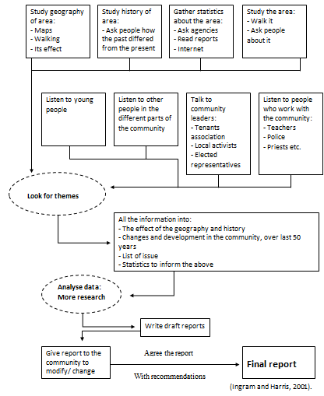
Figure 6

Found at: Ingram & Harris (2001)

According to the National Assembly Wales (2010:5) the key findings of Ceredigion statistics were:
- ‘Mid 2007 population estimates show that around 77,800 people live in Ceredigion. With 43 people per square kilometre the area is less densely populated than Wales as a whole;
- A higher share of the population in the area (23 per cent) than in Wales (21 per cent) is of retirement age;
- The 2008 Annual Population Survey estimated 52 per cent of people aged 3 or more can speak Welsh, compared with 27 per cent across Wales;
- Turn-out for the constituency ballot in the 2007 National Assembly for Wales elections was 55.6 per cent. This was above that for Wales (43.5 per cent). The winning party was Plaid Cymru;
- In February 2010, around 2.2 per cent of the working age population in Ceredigion were claiming Jobseeker's Allowance. The equivalent figure for Wales was 4.6 per cent. In 2008, around 66 per cent of working age adults were in employment compared with 71 per cent in Wales;
- 2006-08 data show the average gross weekly earnings for those working in Ceredigion was around £424. The equivalent figure for Wales was £470;
- In 2007, an estimated 11 per cent of working age adults in Ceredigion had no qualifications, this compares with 15 per cent in Wales;
- Welsh Health Survey results for 2003-07 showed that, around 24 per cent of adults in Ceredigion reported that they currently smoke and 29 per cent reported drinking more than the daily guidelines on at least one day in the past week. The equivalent figures for Wales were 26 per cent and 36 per cent respectively; and
- The Welsh Index of Multiple Deprivation 2008 ranks specific small areas in Wales in terms of deprivation. In Ceredigion, none of areas fall in the 10% most deprived areas in Wales and overall the majority of its areas are less deprived than the Wales average’.

National Assembly Wales (2010:5)
Ceredigion background
Ceredigion is a county which is situated on the coast of Cardigan Bay to the West, Carmarthenshire to its South, Powys to the east and Gwynedd to the north. The County has six located towns which are: Aberystwyth, Cardigan, Lampeter, Aberaeron, Llandysul and Tregaron. Towns such as Tregaron and Llandysul are small located towns which have a local function, whilst others in the county have a wider regional/national function.
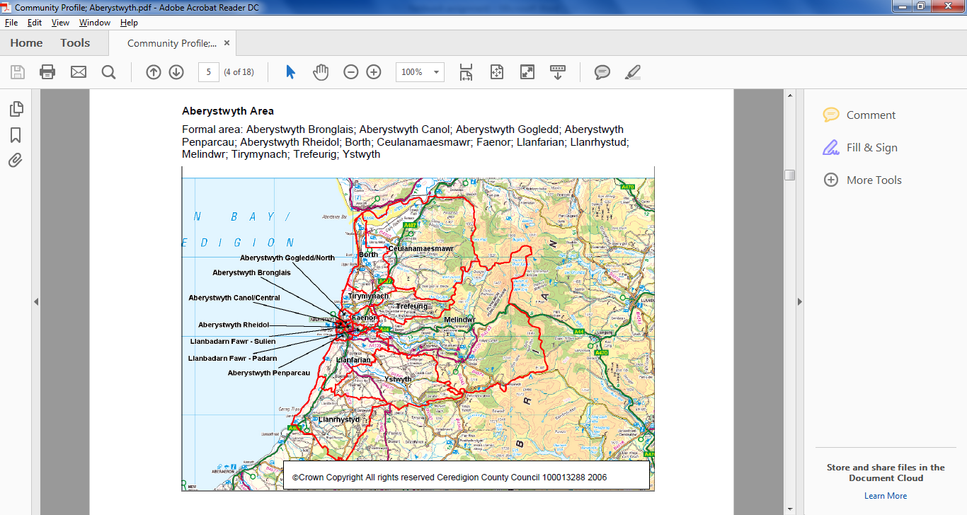
Aberystwyth

Found at: Thorburn & Reveley Community Profiles 2006:5 Research and Information, Ceredigion County Council
Aberystwyth is the largest towns in Ceredigion which its population measures student presence ages 18 – 25 years. This has a result, ‘in low rates of benefits claimants as % age of 16 – 74’ (Thorburn & Reveley, 2006). Aberystwyth is a well-known town, and has a population of 18,965 as a town. The town draws thousands of people including tourists and students with its land marks, education, history and events such as Big Tribute Music Festival, Art Centre, Rheidol Railway, constitution Hill and many more. Aberystwyth is famous for the University of Wales and the National Library where it holds education and history of Ceredigion. There are many high streets and shops in Aberystwyth, some of which are voluntary organisations such as charity shops, other shops are varied involving food and retail businesses. Aberystwyth also has a general hospital, Bronglais, which is the only hospital in Ceredigion. The town has two secondary schools and three primary schools, both in which promote Welsh and English language. Aberystwyth holds a college, Coleg Ceredigion whom deliver post 16 educations, Hyfforddiant Ceredigion a training provider where young people are able to study various subjects and also a University which has been marked as one the best Universities in Wales. Ceredigion Youth Service also runs a youth club in the town of Aberystwyth which currently has up to 60 members. Within the area, there are organisations which are available to support young people aged 16 – 25 such as Careers Wales, Job Centre Plus, Youth Justice, Mind, West Wales Domestic Abuse, CHAMS, Choices (Drug Aid) and many more.
Thorburn & Reveley carried out a survey that focused on the population structure. Their outcomes were that Aberystwyth has a total population of 18,965, which is the largest population within the County (see figure 7 below). This shows that Aberystwyth acts as the main town within the County which attracts many people. However, it can be argued that out of this population, 8,500 are students whom attend Aberystwyth University which means one third of Aberystwyth’s population according to the University’s statistics (Aberystwyth, 2018). According to the University’s statistics ‘95% of full time first degree students in Employment or further study within six months of graduating’ (Aberystwyth University, 2018).

Figure 7
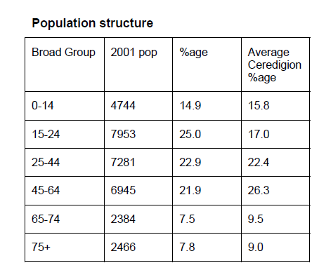

Found at: Thorburn & Reveley Community Profiles 2006:6 Research and Information, Ceredigion County Council
According to the population structure table, there are a high proportion of young people 15 – 24 in Aberystwyth. However, Aberystwyth has one of the biggest Universities in Wales which answers the reason of the large population of this age category is due to the students. Similarly, this also shows part of the population of young people leaving school who are currently seeking for employment, education or training.
Employment / unemployment
In 2016/17, 342 young people aged 16-25 engaged with Ceredigion Youth Service’s Outreach team to receive support in engaging in education, employment and/or training opportunities. 35% of those young people achieved nationally recognised accreditations and subsequently re-engaging in education, employment and/or training activity. The Number of Job Seekers Allowance (JSA) claimants aged 17-24 years have decreased from 75 in 2016 to 50 in 2017 which is the best performing in Wales (Ceredigion for All, 2016).

According to NHS Wales statistics (2010:6):
- ‘Ceredigion has the fourth lowest rate of children in Wales living in workless households and the third lowest proportion of children eligible for free school meals.
- Young people brought up in Ceredigion continue to migrate away from their home county especially after leaving education.
- There remain areas where affordable childcare is insufficient
- There is a need for a cohesive early intervention service and a more integrated family support mechanism
- The number of NEET young People is increasing and those who live in the countryside are particularly disadvantaged’.
NHS Wales (2010:6)

Liz Western, Senior Public Health Officer at Public Health Wales (Wales,NHS) had researched Adverse Childhood Experiences where 2,000 adults had been surveyed on their experiences before the age of 18 and their health behaviours in adult life. The study showed that the results were negative experiences during their childhood. Negative experiences were varied such as; verbal, physical, sexual abuse, alcohol abuse, domestic violence, mental illness and more. One in seven adults had experienced four or more under the welsh population. This may be one of the reasons of unemployed young people, where it has a negative effect to their children of becoming un-supported, housing issues, supported by LAC / Social Services and so on (NHS,2017).

Donnison (1980), and Andrews and Jacobs, (1990) (cited in Rose, 1997:7) who suggested that the link between youth unemployment and social security changes was a major influence on young homeless people.
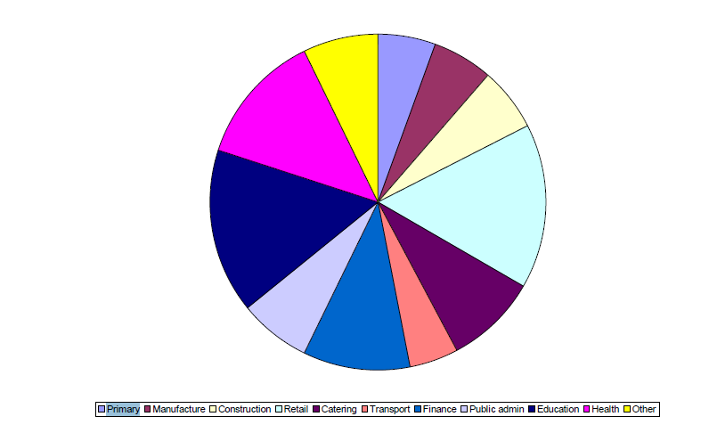
Found at: Thorburn & Reveley. Community Profiles 2006:9 Research and Information, Ceredigion County Council (Employment opportunities)
Looking at the age and gender profile within the National Assembly Wales statistics (2010:11) there are a fewer men than women which can reflect on the employment opportunities in Ceredigion.
Ceredigion have a low proportion of employment opportunities in some sectors such as agriculture or manufacturing compared with other areas. Research has been found by the Welsh Government (Welsh Government, 2014:3) that in 2013, the employment rate in Ceredigion was 62.8 per cent. This was the second lowest amongst the 22 Welsh local authorities. Similarly, in 2001 the number of working adults have raised with qualifications level 4 and above. In 2013, Ceredigion was the eleventh lowest local authority, which was lower than the Welsh average of unemployed adults. Murray 1996; Banks and Davies 1990 (1996:71) state that ‘few young people believe with any conviction that work -welfare in general is sympathetic or useful to their needs, or that it can provide much in way of genuine assistance’.
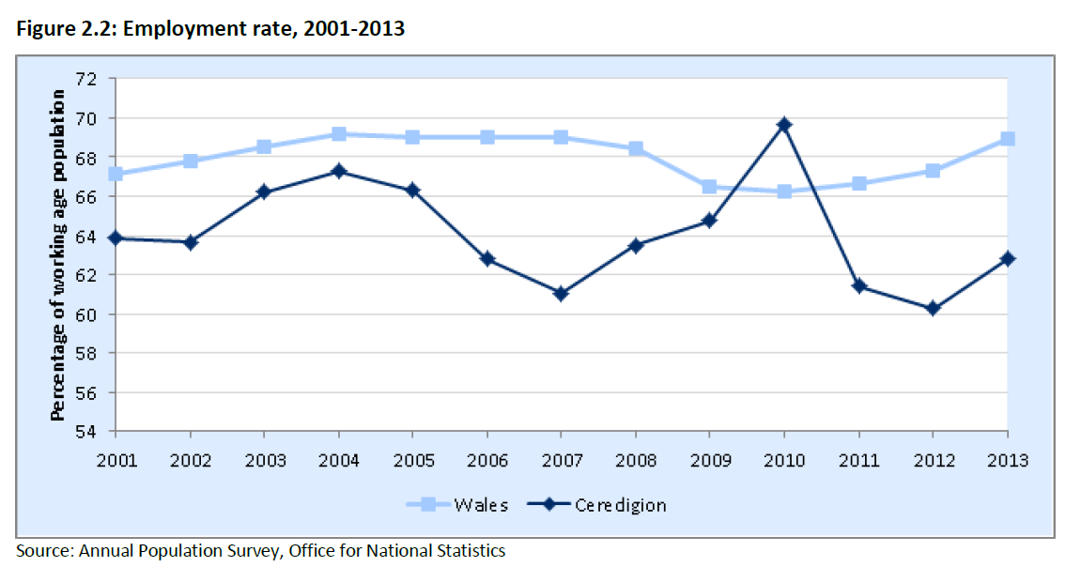

Found at: Welsh Government, 2014
Looking at the diagram above, Ceredigion’s employment rate is the lowest County than average throughout Wales. However, it can be criticised that Ceredigion it the lowest populated County throughout Wales which can effect on the percentage of population within this survey. On the other hand, Ceredigion has the least organisations and charities that support young people compared to other Counties. One example of organisations that are out of County is Princess Trust, where they offer workshops to young people occasionally within Ceredigion however Swansea is the nearest Centre for young people to seek support.

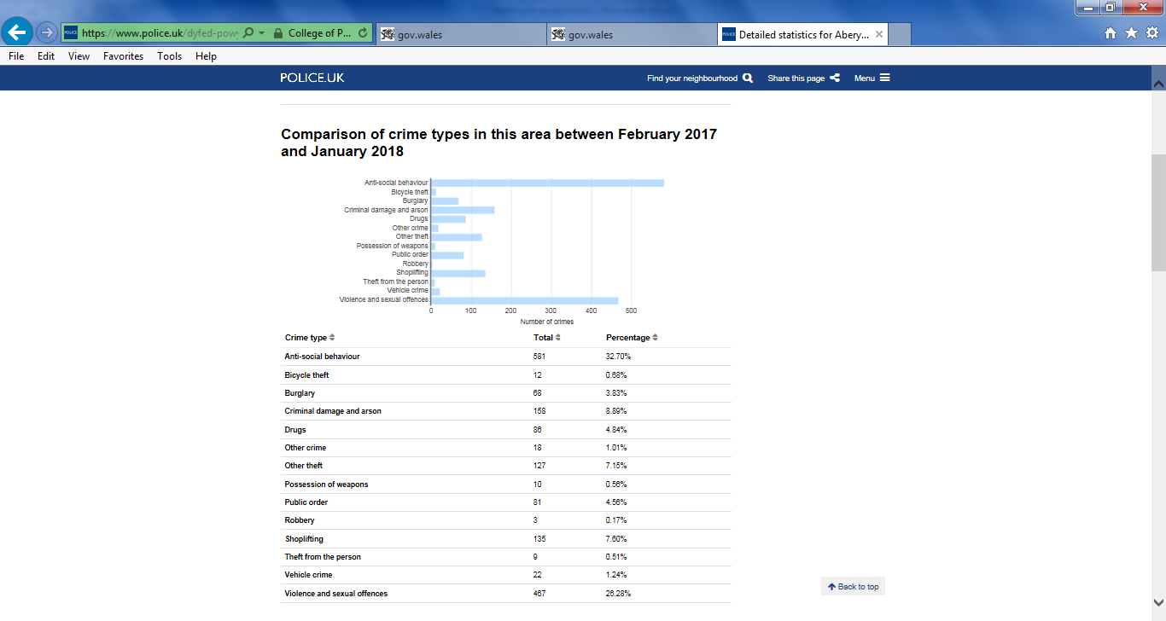

Found at: Police, 2017
Crime statistics
Moving forward, having the number of unemployed of young people decreasing the number of crime within the County is also effected. According to Dyfed-Powys Police, Ceredigion crime rate is 27 percent lower than the average throughout Wales. This has fallen 39 per cent since 2002-03. Smith and Ecob (2007:633-59) believes that although young people ‘poses a threat to others, they are themselves fragile and vulnerable victims and in need of protection and support’. This expresses the importance of having organisations and Services being available to support young people within the County. According to the Welsh Assembly statistics, the estimated number of individuals referred for alcohol treatment in Ceredigion was higher than the Wales average in 2013-14. Results found that 63% were no further action and 21% under investigation (Welsh Government, 2014:5).
Poverty in households
Another topic that needs to be addressed when focusing on young people’s reason for being unemployed is poverty and children living in workless households which could possibly be self-inflicted from parents. In 2013, looking at the figure below Ceredigion had the lowest rate within Wales of children living in workless households (Welsh Government, 2014:4).
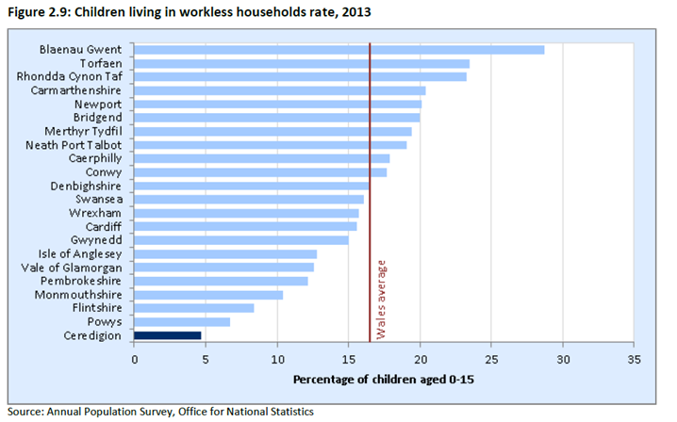

Found at: Welsh Government, 2014

Again, Ceredigion is a small populated County compared to others in Wales, however, this is positive showing that support Services are able to support families as a whole. According to Parton 2006 and Churchill 2007 (2006), inside Every Child Matters (Green Paper) 2003, the aim was to ‘support parents with a range of services provided by agencies working in partnership under an integrated Children and Young People’s Plan’. However, it can be argued that supports Services are limited within Ceredigion, however are expanding with the support of Families First, Family Centres, TÎm Teulu, Families First and so on.
Housing
Housing is one of the key aspects which young people have struggle within Aberystwyth, where young people can’t afford rented accommodation with the high rates. However, the Welsh Government aims to improve housing related Services to support vulnerable young people within the Aberystwyth area. This includes supporting young people who are first time buyers and introducing help to buy ISA’s. On the other hand, support Services are in place where Aberystwyth currently offers support teams such as Ty Currig whom caters accommodation for homeless young and vulnerable people 16 – 24 years over 24 hours. According to the Ceredigion County Council’s Cabinet meeting of “Supporting People Operational Plan” (Supporting People Operational Plan, 2006) Ty Currig creates a ‘personal development plans to focus on the support of young people to help develop the skills required to maintain a tenancy independently’. Ty Currig is a supporting organisation that supports young people caused by unsuccessful tenancies.

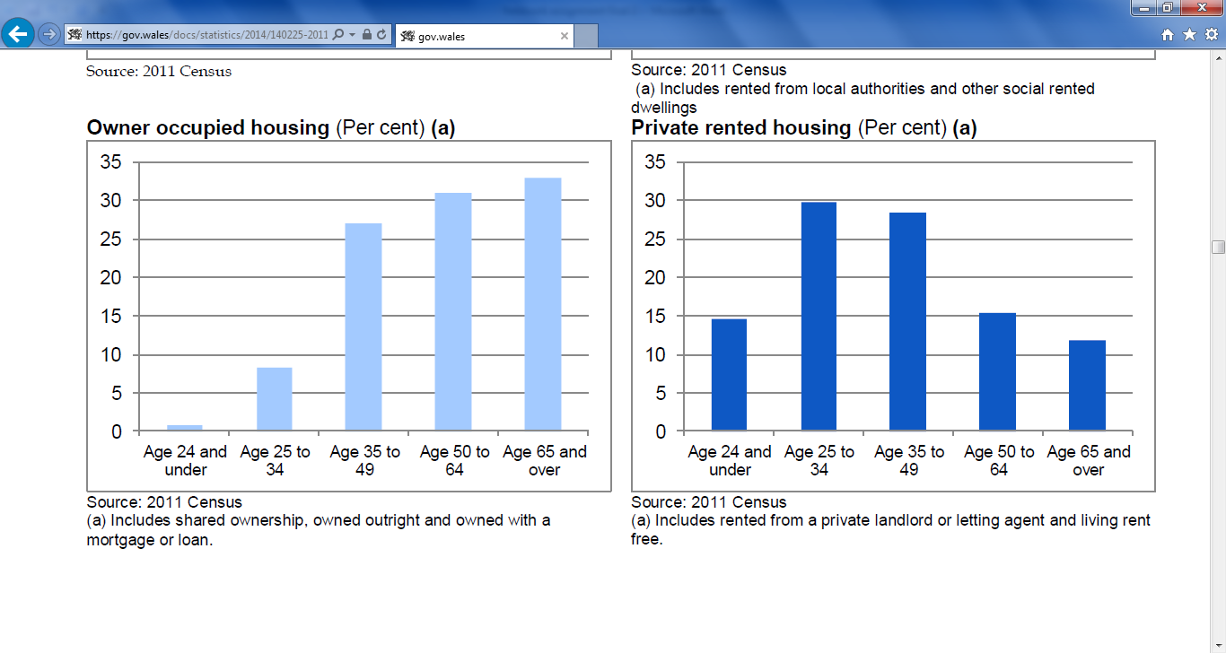
According to Cenus Report (Cenus, 2011), the percentage of young people aged 24 and under of owning a property with a mortgage or a loan is very low, which shows that it is difficult for young people to climb on to the property ladder.
(Cenus, 2011)
In comparison, in 2016 Ceredigion was one of two Counties which showed the largest decrease of households throughout Wales. Ceredigion was down ‘40 (0.1 per cent) followed by the Isle of Anglesey with a decrease of 30 (0.1 per cent); these were the only local authorities to show a decrease’ (Welsh Government, 2017). There could be many reasons for this outcome where young people have lack of life skills, employment opportunities in Ceredigion are low and housing rates are high particularly in Aberystwyth.
Transport
Ceredigion is a rural County where network of bus services links to main towns such as Aberystwyth, Aberaeron, Lampeter and Cardigan and smaller villages. However, further rural areas within the County such as Tregaron, have minimal transport where is becomes an issue for some. In Villages such as Tregaron, public transport is provided twice a day where timings are inconvenient to people who want to use transport to reach to their daily jobs.
According to the Welsh Government’s (2014) chart below, Ceredigion on average has the lowest proportion of car, van or mini bus users in comparison to all Wales. However through looking at the chart below, Ceredigion is on an increase since 2008 where more people are using vehicles regularly and relying on their individual transport than public transport.
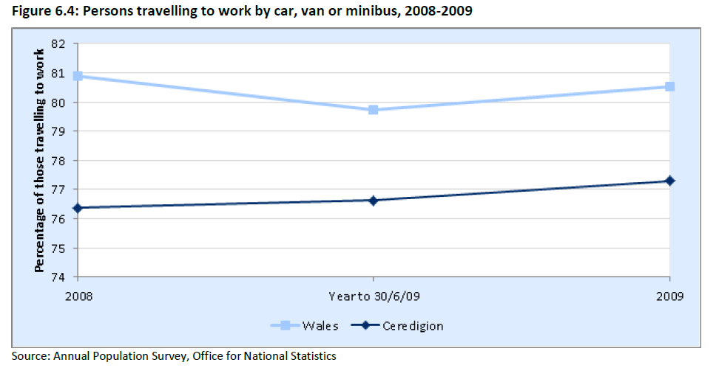
Welsh Government, 2014

Welsh Language
In 2011, Cenus (Cenus, 2011) reported that ‘19 per cent of people living in Wales aged three and over stated that they could speak Welsh’. In 2001 this had decreased down from 20.8 per cent in, despite an increase in the size of the population, by 20,000 the number of Welsh speakers decreased to 562,000 in 2011. However, according to the National Assembly for Wales (2008):
‘59% of Ceredigion residents were born in Wales and 52% of people aged three or more can speak Welsh. Across Wales, 75% of all Welsh residents were born in Wales and 21% of people aged three or more can speak Welsh’.
National Assembly for Wales (2008)
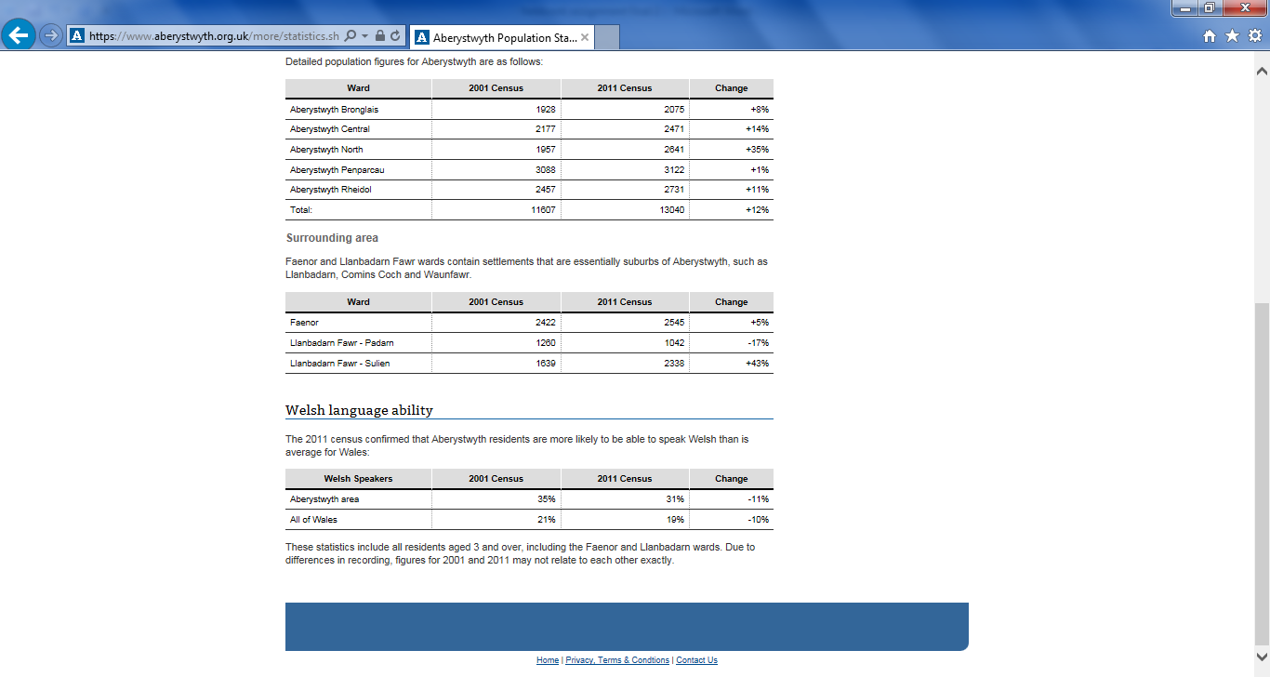
Ceredigion is one of the most populated County’s in Wales which has the most spoken Welsh Language (see the Welsh language statistics below). This being, that Local Authorities such as Ceredigion County Council promote the Welsh language through requiring employees to attend Welsh Language classes to promote the Welsh Language throughout the County.
Population Statistics, 2011

Bibliography
Aberystwyth University, 2018
https://www.aber.ac.uk/en/parents/why-aber/facts-figures/
[Accessed on the 18/05/2018]
Cenus, 2011
https://gov.wales/docs/statistics/2014/140225-2011-census-characteristics-households-en.pdf [Accessed on the 13/06/2018]
Ingram, G. & Harris, J. (2001). Delivering Good Youth Work: A Working Guide to Surviving and Thriving, Russell House Publishing
National Assembly Wales (2010). Key statistics for Ceredigion 2010. Cardiff: Members Research Service. 5.
NHS Wales (2010). Ceredigion Children and Young People Partnership. Ceredigion: NHS. 6
Mc Auley.C, Pecora.P, Rose.W (2006). Enhancing the Well-being of Children and Families Through Effective Interventions. London: Jessica Kingsley Publishers. 305.
Murray, I. (1996) ‘Compulsion is not working’, Working Brief, London: Unemployment Unit , No.71.
Parton,N. (2006) Safeguarding Childhood: Early Intervention and Surveillance in a late modern society, Basingstoke: Palgrave Macmillan.
Percy-Smith.J, Hawtin.M (2007). Community Profiling: A Practical Guide: Auditing social needs. 2nd ed. England: Open University Press. 5.
Rose,J (1997). The Historical Development of the Youth Service - Early Developments of Youth Work . Great Britain: Wales Youth Agency. 7.
Smith,D.J and Ecob,R. (2007) ‘An Investigation into Casual Links between Victimization and Offending Adolescents’ , British Journal of Sociology.Pp.633-59.
Ceredigion for All (2016) Ceredigion Local Service Board’s Single Integrated Plan

https://www.ceredigion.gov.uk/media/3361/ceredigion-for-all-single-integrated-plan-annual-report-2016-17.pdf [Accessed on the 18/03/2018]

http://gov.wales/docs/statistics/2014/141218-local-area-summary-ceredigion-en.pdf [Accessed on the 19/03/2018]

National Assembly for Wales, 2008
http://www.assembly.wales/NAfW%20Documents/ceredigion.pdf%20-%2018042008/ceredigion-English.pdf [Accessed on the 13/06/2018]

NHS (2017) Ceredigion Public Service Board
http://www.wales.nhs.uk/sitesplus/documents/862/PublicServicesBoardMinutesforMayBoard.pdf [Accessed on the 18/03/2018]

Police (2017) Comparison of crimes 2017 - 2018
https://www.police.uk/dyfed-powys/102/crime/stats/ [Accessed on the 19/03/2018]
Supporting People Operational Plan, 2006
http://www.ceredigion.gov.uk/cpdl/Democratic_Services_Meetings_Public/Cynnal%2520Pobl%2520%2520Supporting%2520People_47802.doc+&cd=5&hl=en&ct=clnk&gl=uk [Accessed on the 13/06/2018]
Welsh Government, 2017
https://gov.wales/docs/statistics/2017/170926-household-estimates-mid-2016-en.pdf [Accessed on the 13/06/2018]
Welsh Government, 2014
https://gov.wales/docs/statistics/2014/141218-local-area-summary-ceredigion-en.pdf [Accessed on the 13/06/2018]
Population Statistics, 2011
https://www.aberystwyth.org.uk/more/statistics.shtml [Accessed on the 13/06/2018]

Chapter 5
Case Study
The aim of this fieldwork project was to research background information of the outreach provision and engage with young people aged 16 – 25 who are currently at risk or not in education, employment or training (NEET). The purpose of the project was to plan and deliver workshops and activities where young people have a ‘taster’ of different opportunities within employment and activities there are around Ceredigion. The project had been given a name, ‘Standing Strong’ and was advertised as a range of workshops that suited all individual’s needs, ranging from confidence workshops, employability workshops/residential and accredited / certified courses where young people were provided with the support they needed to enhance their options in future.
The Standing Strong Programme was aimed to target young people who were currently claiming Job Seekers Allowance, self-referrals, referrals from agencies, Careers Wales, voluntary organisations and Collages. The outreach team promoted the workshops by posters and application forms for young people/guardians/ support workers to complete and specify their interest in their selected workshops to benefit their future career. Youth Workers were to make contact with the young person before the session to familiarise any concerns of the young person to take on board to support the individual as best as they can and to ensure they were comfortable attending the sessions.
The Standing Strong Programme consisted over one term which had varied projects activities/workshops delivered once a week. The Employment residential was a two day workshop that aimed to support young people back in to employment. On the first day of the residential young people took part in sessions delivered by guest speakers from Big Ideas Wales and Coleg Ceredigion whom delivered motivational activities for young people to think about creating or setting their own business up. The workshops delivered were fun and creative where young people were able to socialise with others and create items such as a bird boxes and pottery making to take home as part of an opportunity to business ideas. The second day of the residential aimed at supporting young people creating CV’s and search for jobs and courses within the interest of the individuals. Over the two day residential, young people were able to achieve accredited Agored Cymru Booklets on Exploring Job Opportunities which focused on young people to reflect on their future decisions.
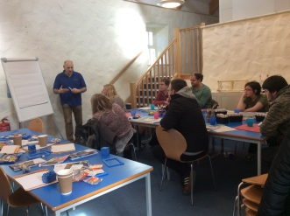
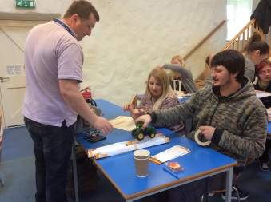

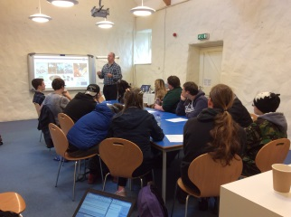
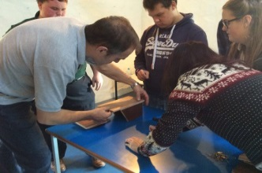

The second part of the Standing Strong Programme aimed at supporting young people with lack of confidence. The aim of the sessions is for young people to express their anxiety and confidence through attending weekly accredited workshops designed to help them, find their own voice, express their emotions, build confidence and unlock their creativity. The workshops were specifically focused on young people whom have low confidence in which enables young people to identify themselves and others who are in the same position as them. The themes of the activities varied, in which cater for all interests from Art and Craft, Yoga, Bushcraft and skiing. Young people achieved accreditations from Art and Bushcraft.
The third part of the programme entails volunteering opportunities for the young people to enhance their experience and skills. Varied volunteering opportunities were provided for young people to explore different opportunities with organisations such as Cardigan Castle, National Trust and the Youth Service. This supported young people in being able to fulfil their CV and add their experiences which supported them into employment.
Throughout the Programme, 39 young people in total engaged who were at risk of or currently are NEET. The total of young people who attended each workshop varied from 8/15 young people which depended on their interests and 26 young people achieved an accreditation.
Whilst delivering this programme, reflecting and observing was one of my priorities to ensure that all individuals receive the best support they could. An example of one individual that had been observed within the programme whom had no confidence to engage with others, catch the public transport or even socialise other than within her own home. Confidence became an issue after leaving previous education and staying at home became a regular habit for her. After attending couple of the workshops aimed at building her confidence, this young person had a taster of what it is like to get out of the house and to manage their coping strategies of confidence and anxiety in their own particular way. Yoga was one of the activities that this young person enjoyed where she was able to take part in an activity without having to socialise too much to begin with, but taking part was the main focus. Knowing the individual before the programme helped the youth workers to support the young person further and understand her coping mechanism of anxiety. The outcomes of the Programme were outstanding where it resulted in the young person staying over for the one night of the residential becoming more confident and felt as if she had overcome one of her barriers.
After the success from the Standing Programme of individuals being able to build their confidence, gain some experience and skills in volunteering and receiving the support for employment, the Programme is an on-going process within the outreach provision.

Chapter 6
Critical Reflection
This critical reflection will analyse the impact of the workshops part of the Standing Strong Programme had to the young people who engaged throughout. This section will focus on the effectiveness of the workshops that have been delivered and how these support young people to re-engage in to education, employment or training.
Ceredigion Youth Service outreach provision is funded majority by the Welsh Government (Welsh Government 2013:3) through the ‘Youth Engagement and Progression’ funding which is aimed to work specifically with young people aged 16 – 25 who are NEET. However, according to Ceredigion Community Strategy Statistics (CCS: no date), Ceredigion has a low population of 1.7% as percentage of working age population as unemployed. Other than this, those who are unemployed are hard to reach and have lack of engagement with services within Ceredigion. The outreach provision continuously receives new referrals from Job Centre Plus, Careers Wales, and Secondary Schools through the NEET’S coordinator within the Council. The Service have created an inclusive, diverse and open access workshops for the hard to reach young people in order to engage them within their interests, having identified many of the young people had lack of work ethic, confidence and life skills which is needed to be able to re-engage in to EET. This led to creating a Standing Strong Programme which involved a variety of workshops that is able to support young people to overcome their barriers and to enhance their skills to be work ready. The outreach Provision plans their workshops for young people aged 16 – 25 where they entail the Five Pillars of Youth Work Principles for young people which are Educative, Participative, Inclusive, Expressive and Empowering (WLGA, 2013). There are many opportunities in Ceredigion which are open to young people aged 16 – 25, such as Careers Wales, Work Ways, Shaw’s Trust and so on however these opportunities were focused on employment or training opportunities, rather than supporting young people to build up being ready to re-engage within these life experiences. The Outreach provision ‘increasingly engage with young people in targeted, pre-defined and often welfare orientated ways that challenge some of the key tenets of youth work principles’ (Wood,Westwood & Thompson, 2015:54).
Within Ceredigion, young people receive ‘higher proportions of good GCSE passes than the Welsh average’ according to Ceredigion Community Strategy (CCS : no date). Alternatively, Ceredigion has the lowest percentage of 28% of young people with no qualifications. In this essence, young people who are likely to become NEET from leaving education are referred from Youth Workers in schools to the Outreach provision to prevent these young people from becoming disengaged and NEET.
Ceredigion Council currently hold strategies in place in order to develop the impact on the social inclusion and wellbeing of young people. These strategies involve Alternative Curriculum, NEET Strategy, and Youth Workers in schools and keeping in Touch Protocol. Strategies such as this have:
‘Supported improved school attendance and attainment, and has reduced the percentage of NEET young people aged 16-18 years by 68.2%, or by 176 individuals over the past three years (2010 – 2013)’.
(CCC,2013)
Youth workers in schools approach these young people in schools to support their life skills and to complete their work through informal learning and accreditations such as Agored Cymru.
Moving on, within practice through delivering various workshops, the Youth Workers had shown respect for the young people which is ‘at the heart of Youth Work values in a profession that works where young people are with a positive, participative and anti – oppressive approach’ (Sapin:3). On the other hand, the young people had engaged and participated well within the activities and had made a relationship with the Youth Workers in order to support them further within the workshops. It had helped that the numbers of each workshop were low ranging from 8 – 10, where young people felt comfortable engaging with others and had an opportunity to create relationships with other young people. Young people who had attended the workshops had achieved certificates from Agored Cymru that focused on employability in order to fulfil their CV’s. Most of all, young people were able to participate in workshops and activities that they hadn’t experienced and wouldn’t have had the opportunity without the Youth Service.
Evaluations were provided for each workshop where it was a chance for us as Youth Workers to reflect in practice and the feedback provided from the young people. Roberts (2009:9) believes that ‘Youth Work is a reflective, informal, educational discipline and can draw educational themes’. In order to better the delivery of the workshops and support for the young people, reflection needs to be taken in to account. Young people’s visions were varied, where the main feedback received from the workshops were:
- Would be even better next time if we participated in different activities rather than doing the same thing all day: This was focused on the volunteering day and could be avoided next time through providing more than one task.
- Youth Workers were friendly and felt that I was supported through applying for job opportunities.
- Less Agored Cymru Booklets: Agored Cymru booklets were delivered as part of the workshops in order to fulfil young people’s CV. Next time workshops are delivered, this could be optional when delivering workshops.
- More Residential opportunities: Young people had attended the two day residential for free where they had engaged really well in a variety of activities and had been provided with food and warmth from the Urdd Campus. A few of these young people had appreciated the catered residential, as if they hadn’t experienced anything like it and was an eye opener for them to participate in such a workshop.
The feedback was positive and had given a few facts of how the workshops could be better next time. From the whole project, 39 young people had participated with the Youth Service and by now 23 have re-engaged in to education, employment or training. This is more than half of the young people the Youth Workers have worked with have re-engaged in to EET. The other cohort who is NEET will continue with the support of the Youth Service until they have reached their aims and goals.

Bibliography
CCS : no date Ceredigion Community Strategy 2020:
http://www.ceredigion.gov.uk/cpdl/Democratic_Services_Meetings_Public/Annexe%202_13074.pdf [Accessed on the 01/05/2018]
CCC,2013 – Ceredigion County Council (Promoting Social Inclusion and Well-Being)
http://www.ceredigion.gov.uk/cpdl/Democratic_Services_Meetings_Public/Adborth%20gan%20ffrydiau%20gwaith%20Feedback%20from%20the%20workstreams.pdf
[Accessed on the 02/05/2018]
Roberts,J (2009). Youth Work Ethics. Exeter: Learning Matters. 9.
Sapin.K (2013).Essential Skills For Youth Work Practice. 2nd ed. London: SAGE. 3.
WLGA (2013:3) The National Youth Work Strategy for Wales 2014 – 2018:
http://dera.ioe.ac.uk/19353/1/140221-national-youth-work-strategy-en.pdf
[Accessed: 02/05/2018]

WLGA, 2013 Youth Work in Wales: Principles and Purposes
http://www.wlga.wales/SharedFiles/Download.aspx?pageid=62&mid=665&fileid=568
[Accessed on the 22/05/2018]
Wood,Westwood & Thompson (2015). Youth Work: Preparation for Practice. London: Routledge. 53.54

Chapter 7
Summary
From reflecting upon this fieldwork peace of work within the Outreach perspective, there are excellent opportunities that are open to young people within Ceredigion as a rural County. However, it could be emphasised that a lot of organisations such as Careers Wales, Cavo, Youth Justice and Services within the Council such as Work Related Learning & Preventions duplicate their work through providing repetitive workshops which could easily be managed through partnership working. On the other hand, this is a working process where organisations are slowly coming together to develop relationships and process duplications to share responsibilities. Regular meetings are being held within the County to ensure that organisations working with the similar cohort of young people, who are NEET, share information and discuss the support needed for each individual. In my eyes, this is a great way of multi – agency partnership working to ensure the best for the individuals who are NEET and is an opportunity for organisations to work together within future. I found from the Outreach perspective, an example of multi-agency working is within the NEET’s meetings where different agencies collide together once a month to discuss new referrals that needs to be supported. On one hand I do feel this is good practice where organisations are able to discuss the young person’s background and direct them to the best service to be supported within.
The outreach provision within the Service offers a range of activities and individual sessions that are informal and supportive to ensure that young people are able to adapt to everyday life skills with the support of a youth worker. According to Jeffs and Smith 1999 (cited in Wood,Westwood & Thompson, 2015:54) ‘Informal educators are intentional and purposeful, and create opportunities for young people with the aim of fostering learning’. However, as the service is non-formal and voluntary for young people to participate within, the outreach faces such difficulty and pressure when reaching out to new referrals from their homes. Referring back to the multi-agency NEET meetings, organisations seem to think that as we are the only organisation that reach young people within their home setting’s that young people have to receive support and engage with us. This matter has become more difficult, knowing that the young people are not currently engaging with any other services; however we cannot force young people to engage. Similarly, this has been stressed within NEET meetings, when pressure has been put on to the Outreach Workers of making another visit to offer support or to try and offer them transport to attend a Careers appointment. However, ‘Youth participation is central to professional youth work practice and essential if young people are to determine their own development’ (Roberts, 2009 cited in Fitzsimons, Hope, Russell,Cooper, 2011:46).
Having experienced working within the Outreach Provision, I felt that the role is challenging, however, at times rewarding to see the young people achieve their goals and overcome their barriers in everyday life. I feel from experiencing the role of an outreach worker, part of the duty is to tackle today’s issues and barriers the young people are facing such as stereotyping, effects of social media, mental health and substance misuses. I feel that from experience, outreach tackles these barriers through enabling young people ‘to come to voice, meet people and start where those people are with their own preoccupations and in their own places’(Bastleer 2008 cited in Wood,Westwood & Thompson, 2015:54). Activities such as the Standing Strong Programme ensured that the workshops were young people focused and aimed at supporting the young people to tackle their barriers rather than putting pressure for them to re-engage in to EET. However, there the outreach provision face some difficulty where there are high demands from the Welsh Government (WAG, 2004) where meeting targets to re-engaging young people in to EET are in place in order to attain funding. To support the Youth Service, this is where it is important to work with multi agencies such as educational providers such as Coleg Ceredigion in Aberystwyth in order to re-engage young people when leaving education or even developing taster days for young people to experience a variety of opportunities. This puts a significant amount of strain for youth workers and is difficult to balance the work with young people and to ensure the statistics are up to date. Other than this, I feel from practice, to attain such funding, youth work can be ‘summarised as ticking the boxes and missing the point’ (Batsleer, 2008:141).
It is evident, when working with young people who are NEET, each individual are at different levels of engagement and needed to be supported to their needs. Working with young people who are NEET can be challenging where many young people come across barriers to re-engage into EET. From experiencing with working young people in Outreach, these barriers are short and long –term where we would support the individual to overcome their identified issues. The Outreach have a planned approach reflecting on Lewin’s 1946 Spiral process which provides steps of a plan to approach the issue or barrier the young person is experiencing. The spiral process begins to address the concern, following on to planning appropriate actions, taking action and to reflect upon the evaluation of the process. Examples of such barriers that are addressed are confidence and anxiety, substance misuse, mental health and many more have been discovered from being disengaged for so long, young people intend to forget how to socialise and have not been supported with their health and life skills. The outreach provision provides a second home ‘where workers care and young people are valued, respected, and have choice (Spence, 2007 cited in Jeffs, 2010:5). Although there is no specific time an outreach worker should support a young person until they re-engage in to EET, again, Welsh Government (WAG, 2004). Targets tend to put pressure on the Service to be able to re-engage certain amount of young people into EET. To avoid this, Outreach work closely with Youth Workers in Schools all around the County to prevent a gap between young people leaving school and being referred to as NEET.
Engaging with the community has been beneficial for the County where young people are engaged in clubs, activities with ‘the willingness to have fun as well as educate, and the involvement with the youth’s family’ all contribute’ (Hirsch 2005, cited in Jeffs, 2010:7). The Youth Service is an open access to all young people and is hopeful for those who are socially excluded to accept the support and are disadvantaged through unemployment, suffering from poor/mental health, living alone, financial distress or poor housing. Irving 1996 defined work such as youth clubs, outreach and community projects ‘outlines valuable work with these young people who may have the incidental effect of reducing crime’ (Irvine 1996 cited in Hill, 1988:192).
To conclude, having an insight of the outreach provision has been an eye opener and certainly a positive experience of knowing the support of other organisations available or young people aged 16 – 25 within the County. I feel there are growing concerns of young people’s issues and barriers to EET such as mental health, substance misuse, confidence and anxiety. However, it is a concern that Ceredigion Youth Service has the least funding out of all of Counties within Wales which could be enhanced knowing that young people will benefit more from youth work. On the other hand Ceredigion Youth Service is currently the second highest County of engagement with young people whom provides workshops, support where young people are the heart of youth work. I believe the Outreach provision with in Ceredigion:
‘Ensure young people are based on certain core values and principles requiring the establishment of voluntary relationships with young people, links with communities and other relevant organisations’.
(Sapin, 2013:3)
Having had experience with the outreach provision has enable me to enhance my future ideas to support young people who are NEET, but to also to prevent young people from becoming dis-engaged through activities, individual outreach settings, informal discussions clubs and so on.

Bibliography
Batsleer,J (2008). Informal Learning in Youth Work. London: SAGE. 141.
Fitzsimons,A, Hope,M, Russell,C, Cooper,K (2011). Empowerment and Participation in Youth Work. Exeter: Learning Matters. 46.
Hill,M (1988). Effective Ways of Working with Children and Their Families. London: Jessica Kingsley Publishers. 192.
Jeffs,T (2010). Youth Work Practice. New York: Palgrave Macmillan. 5.7.
Sapin.K (2013).Essential Skills For Youth Work Practice. 2nd ed. London: SAGE. 220.
Welsh Assembly Government, (2004) Learning Pathways 14-19 Guidance. [online] [Accessed:01/05/2018].

Wood,Westwood & Thompson (2015). Youth Work: Preparation for Practice. London: Routledge. 54.

