Kimberley Robinson 1707907
Skuldelev Ship 2
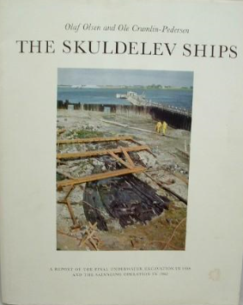
The men responsible for the excavation of the Skuldelev ship 2 were Ole Crumlin-Pedersen & Olaf Olsen, they have published several publications on all these ships, a primary example is used in this essay Skuldelev Ships I (Crumlin-Pedersen and Olsen 2002 p7). This ship and the other Skuldelev ships found have taken up more than 39 years of these men’s lives (Crumlin-Pedersen and Olsen 2002 p7) which gives an understanding of the men’s passion. In this ship project essay, there will be several stages discussed as regards to one of the ships excavated on the barrier of the Roskilde Fjord. The stages from the detection of the ship, to the several disturbances of the wrecks at the early phases, and to the final excavation, assessment, documentation analysis and conservation. The essay will include discussions of the rebuilding of the replica and to sailing Sea Stallion to Dublin and back. Below are some of the publications Ole Crumlin-Pedersen and Olaf Olsen have dedicated their life too.
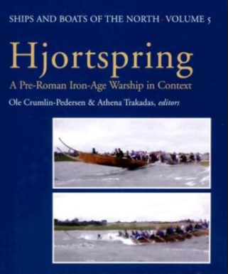
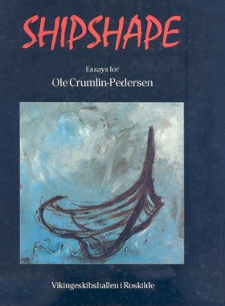
.

Detection of the ship.
There is a story which had been passed down through generations in Denmark. This story stated the Danish Queen, who ruled from 1387-1412, instructed for her ship, the Queen Margerete to be sunk (Crumlin-Pedersen and Olsen 2002 p 23). This was done by filling the vessel with stones, which blocked the very shallow and narrow water way entrance at Peberrenden, into the Roskilde Fjord. This was done to deter the Swedish who the Danes were at war with (Crumlin-Pedersen and Olsen 2002 p 23). An investigation had been carried out in 1947 by Aage Roussell from the National Museum in Denmark. He visited the area, and after lifting a few stones came across some planking and lifted out a single frame (Crumlin-Pedersen and Olsen 2002 p24). No further investigation was carried out, until there was some publicity generated when a magazine commissioned a professional diver to examine the wreck, with much the same conclusion (Crumlin-Pedersen and Olsen 2002 p24). In 1956 two amateur divers Aage Skjelborg and Harting Conradson, went to examine the “vessel”. With photographic evidence of the keelson and the frames which they found, it was evident the wooden structure wasn’t a medieval ship, but a Viking age ship. This prompted the National Museum to organise an excavation of the site (Crumlin-Pedersen and Olsen 2002 p24).

Underwater excavation.
In July 1957 the first excavation of the barrier to the fjord was started, this was when the small team discovered more than one wreck using a floating platform to carry all the equipment. The team
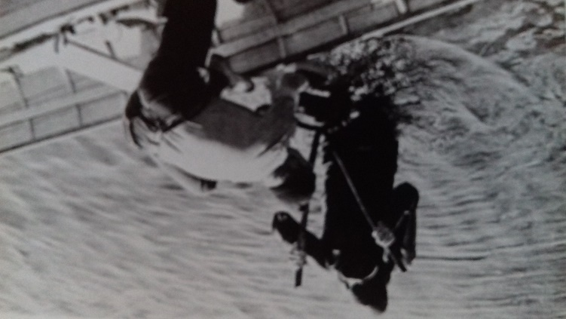
raked the moss and lifted the stones off the delicate timbers (see picture below), and by using the hose and water pump which was adapted to blow the sediment off the timbers (Crumlin-Pedersen and Olsen 2002 p26). There was only enough funding for two weeks work, but there was plenty of public attention which made it easier for funding for further excavations in the summer of 1958. With more money there was an opportunity to purchase better equipment, (Crumlin-Pedersen and Olsen 2002 p26). This time it was possible to build a raft that had a tipping device for the removal of stones off the wrecks. By making a suction through the hose it was possible to suck away the sediment for better visibility (Crumlin-Pedersen and Olsen 2002 p28). At this stage, before the excavation in 1962, the movement of the frame and timbers, must have caused damage and in hind sight if the wrecks had been left undisturbed and only observed they may have been in a better condition. Effort was made to secure the wrecks down at this point by putting the stones back in over the timbers, to anchor them down to stop them from breaking up in the tide and being wash away (Crumlin-Pedersen and Olsen 2002 p29).
Assessment
At the end of this stage it was evident there was more than one wreck, there were 5 in total, however four years later it became apparent that ship number 2 + 4 were both part of the same Viking war ship (Crumlin-Pedersen and Olsen 2002 p27). Keith Mackelroy, in his book Maritime Archaeology, explains that the ships did not have any of their fixtures, (1978 page 89), it is hard to tell whether the fixings were taken off prior to sinking or whether they just washed away. Nevertheless, this could cause difficulties later in obtaining a true structure of the ship whilst identifying it and building any replica. What was left of ship 2 was, 21 planks, a floor timber, keel and keelson (Crumlin-Pedersen and Olsen, 2002, p66). There is no real evidence from the site of what the rest of this ship looked like. It can be dated and measured, and the material confirmed, and where that material came from. For this to be done the most important thing was to get the ship out of the water, and to do that whilst saving the delicate timbers and to that a special operation was needed to be applied to succeed in this mission.

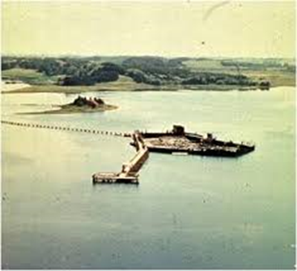
Final Excavation
The final excavation of all the ships in 1962, was a special excavation (see left) (Muckelroy, 1978, p88). It was clear from the previous involvement with the wrecks, there needed to be a barrier created and water pumped out of this barrier to create a protection area, whilst excavation could take place (Muckelroy, 1978, p88), enabling the lifting and relocating of the evidence to be analysed. The scale of this site was 2,500 sqm (Crumlin-Pedersen and Olsen, 2002, p30). The cofferdam was set up around the ships’ remains whilst the water was pumped out bit by bit, firstly to clean off the stones. Then gradually more water was let out to be able to clean the soft wood. This process was undertaken slowly reducing the water then cleaning more of the evidence. (Crumlin-Pedersen Olsen, 2002, p33). The photographs were taken with dual cameras to record the excavation, with drawings being completed at the lab, measurements and numbering all the remains of the ships were undertaken (Crumlin-Pedersen and Olsen, 2002, p39). After this it was then important to devise a way to move all the delicate parts of the ships in a way in which they stayed moist and in the best condition possible. These wooden remains were so delicate that the slightest touch would sustain a mark, this would spoil further investigation of how the wood was worked (Crumlin-Pedersen, 2002, p39). All the timbers were wrapped in 1,500 air tight plastic bags, and braced on flat stretchers, after 12 weeks all 5 ships had been successfully salvaged (Crumlin-Pedersen, 2002, p41). There was one last task left, and that was given to a small team of archaeologists to remove the 14-metre-long keelson from wreck 2. On October 17th, 1962 the excavation was complete (Crumlin-Pedersen and Olsen, 2002, p41) (picture below shows, final excavation).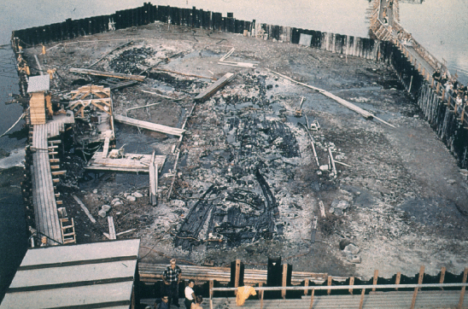

Documentation and analysis.
Gillian Hutchinson describes in Medieval Ships and Shipping, that the dendrochronological report of Skluldelev 2, suggests the oak planking originated from Dublin, and that the build of the ship was of clinker style (1994, p5). Ole Thirup Kastholm debates in his journal, The Rigging of the Viking Age Warship, that there was only a small part of the hull that had survived, only 20% (2011) was left to be analysed and documented. Dating Analysis of Skuldelev 2, twigs, caulking, tree nails and planking suggest a time of construction around 950 to 1050 (Crumlin-Pedersen and Olsen, 2002, p68). The wood for the ship, was cut down AD42, the ship was possibly built in Ireland and later the ship was repaired, maybe around 1060’s. (Crumlin-Pedersen and Olsen, 2002, p185). The repaired part of the ship was analysed and thought to be either from Ireland, Wales or England (Crumlin-Pedersen, 2002, p185), So that is an ambiguous result. However, it does confirm the ship had sailed from Ireland to where it was eventually purposely sunk. Richard Gould confirms in his book Archaeology and the Social History of Ships that there are no shipworms in the low salinity of the Baltic Sea (2000 p176), which is fortunate for future scientific experience involving Skuldelev 2. The small proportion of wood, which was found, were coded and drawn by hand, the drawing was at first done to scale (Crumlin-Pedersen and Olsen, 2002, p54). This enabled the artist to see every small detail and nothing of importance in the detail gets over looked, (Crumlin-Pedersen, 2002, p54). (Pictures below show a plan of the ship remains as it was found with code numbers).
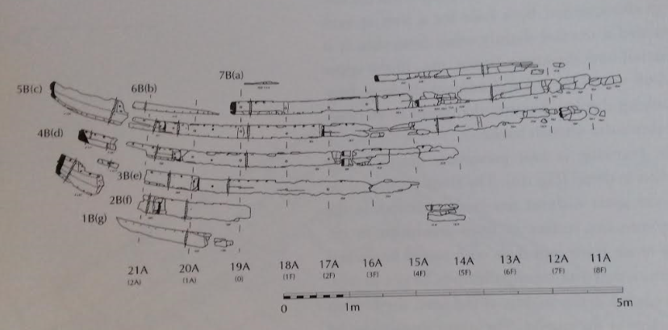

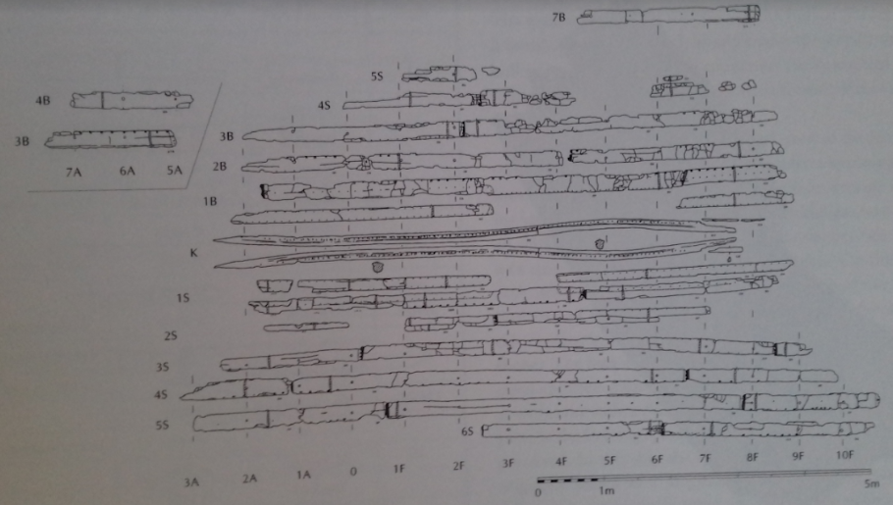

Conservation.
Polyethylene glycol (PEG) has a structure allowing it to be absorbed into water-logged wood (Journal of Archaeological Science, 34(8), p.121), If this process is not carried out the material structure will break down (Journal of Archaeological Science, 34(8), p.1211). The usual procedure on applying the solution is either by using large containers to immerse the items in or there is the option of spraying the solution. PEG was used to treat the timbers of Skuldelev 2, at a temperature of 60°, the solution is gradually increased from 10% to 95%. Over several months the water in the wood was replaced by the PEG (Crumlin-Pedersen and Olsen, 2002, p72). Unfortunately, this treatment shrank the oak up to 14%. Another treatment was applied at a colder temperature over a longer period, 1% of biocide was added to reduce the micro-organisms (Crumlin-Pedersen and Olsen, 2002, p73). It was not until after 14 years that it was noticeable that this process caused a thick layer of PEG on the surface of the wood, in turn cracking started to appear (Crumlin-Pedersen, 2002 and Olsen, p74). To rectify this a new method was tried, by using tertiary butanol alcohol, TBA, to penetrate the wood and the temperature kept at 54°C. this treatment showed the best outcome (Crumlin-Pedersen and Olsen, 2002, p75).
Replica and construction.
Blue, Hocker and Englert, 2006 Summarise in the publication, Connected by the sea, that Skuldelev 2 was the last of the ships found at the barrier of Rosklide to be constructed, although the reconstructed remains are held on display at the Rosklide museum (2006 p16). The reconstruction of the replica of Skuldelev 2 was stared in 2000, all 9 boat builders who took part had extensive knowledge in boat building (Blue, L, Hocker, F, and Englert, A, 2006 p17). A model was made, with the missing planks attached in place (Blue, L, Hocker, F, and Englert, A, 2006 p18), and photographs taken of the conserved original planking (Blue, L, Hocker, F, and Englert, A, 2006 p18). Comparisons were made for the rigging and the sail from Iconography, such as Haithabu coins and stone carvings like the one in the open-air museum in Bunge Northern Gotland (Kastholm 2011 p175/176). Other considerations included the Roskilde 6, a 36-meter-long ship (Blue, L, Hocker, F, and Englert, A, 2006 p18). Crumlin-Pederson gives a precise account in Archaeology and the Sea in Scandinavia and Britain, that, 27 Oak and Ash trees were harvested using the same technique and tools used in the Viking age, which were used to shape planks, keel, keelson and beams (2010 p22,32). Another timely process was growing 285 branches for the ships frame (Crumlin-Pederson 2010 p32), consideration had to be made about the iron nails, tar and wool which was used for caulking (Crumlin-Pederson 210 p32). (Below plan of Skuldelev 2 remains)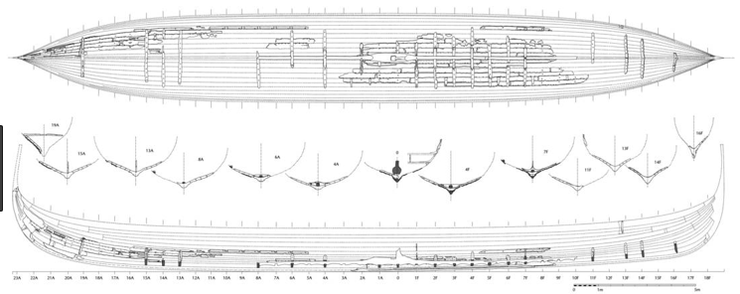

Sea Trials.
The full-size built replica of the long ship Skuldelev 2, was named by the Danish Queen and launched in 2004. Sea Stallion and the crew were given sea trials and training in preparation for future sea voyages (Crumlin-Pederson 2010 p36). The main objective was to sea if the ship and the crew of 61 could sail Sea Stallion to Dublin. (Crumlin-Pederson 2010 p36). Each crew member had 1msq of space each, Safety apparatus was carried along on the expedition just in case of emergency (Crumlin-Pederson 2010 p38). They did complete the voyage after 500 hrs at sea and out of the 2,251 miles the ship was only towed 231m and after extensive TV coverage and several publications and time spent in the Dublin Museum. Sea stallion sailed back home to Roskilde Museums Harbour. (Crumlin-Pederson 2010 p40). The outcome being very successful, but it is worth mentioning the extensive training which the crew had endured was nothing in comparison to the livelihood and up-bringing of a Viking crew, this considered the journey could have possibly been quicker, even without a tow.
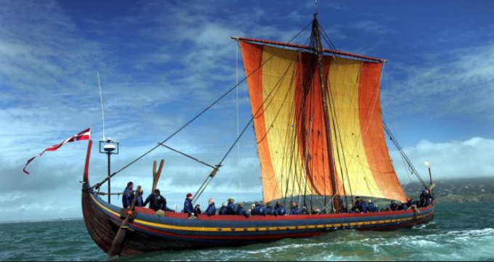
Sea stallion.
Conclusion
Excavation of the Skuldelev 2, was, expensive and time consuming. Conservation was experimental, with plenty of space needed to treat and store the ship remains, which was also a long process and again very costly. However valuable evidence and knowledge has been gained for future projects. A reconstruction of vessel, after its been excavated can bring valuable data and understanding to the building and sailing of the craft. By completing the replica in a way in which the original builders would have given a broader understanding of the past, giving a clear description of their traditions in a historical frame work.

Reference List.
Blue, L, Hocker, F, and Englert, A, 2006. Connected by the sea. 1st ed. Oxford: Oxbow Books.
Crumlin-Pedersen, O, and Olsen, O, 2002. The Skuldelev ship I. 1st ed. Roskilde: Roskilde Museum.
Crumlin-Pederson, O, 2010. Archaeology and the Sea in Scandinavia and Britain. 1st ed. Rosklide: Viking Ship Museum.
Gould, R, 2019. Archaeology and the Social History of Ships. 1st ed. Cambridge: Cambridge University Press.
Hutchinson, G, 1997. Medieval Ships and Shipping. 2nd ed. London: Leicester University Press.
Kastholm, O.T., 2011. The rigging of the Viking age warship. The Skuldelev find and the ship motifs. The iron age on Zealand. Status and perspectives. Nordiske Fortidsminder, Serie C, Copenhagen, 8, pp.175-183.
Mortensen, M.N., Egsgaard, H., Hvilsted, S., Shashoua, Y. and Glastrup, J., 2007. Characterisation of the polyethylene glycol impregnation of the Swedish warship Vasa and one of the Danish Skuldelev Viking ships. Journal of Archaeological Science, 34(8), pp.1211-1218.
Muckelroy, K, 1978. Maritime Archaeology. 1st ed. Cambridge: Cambridge University Press.

Photographs.
Crumlin-Pedersen, O, and Olsen, O, 2002. The Skuldelev ship I. 1st ed. Roskilde: Roskilde Museum.
Photograph of replica: Kevin O'Sullivan. 2018. The Irish times. [ONLINE] Available at: https://www.irishtimes.com/news/science/dna-study-reveals-fate-of-irish-women-taken-by-vikings-as-slaves-to-iceland-1.3521206. [Accessed 19 February 2019].

