Design and Implementation of a Relational Database System

Student Name: Shahana Nimmi Parvin
STUDENT ID: 2509124

Programme: CertHE Computing Skills for Workplace
Module: Introduction to Web and Database Concepts

2026

Contents
Introduction 1
System Analysis and Database Design 2
Data Structure and Design Justification 3
Query Design and Functional Requirements. 7
Reflection and Professional Development 9
References 11

Introduction
In today’s world, the digital transformation of healthcare services is essential to reduce manual errors and enhance operational efficiency in community pharmacy settings. This project addresses a request from the CEO of MediLink Pharmacy to replace an existing manual system with a centralised database solution developed in Microsoft Access. As noted in the assignment specification, the system must automate the management of medicine stock, supplier details, and patient prescriptions [1]. The primary purpose of this project is to design a system capable of managing these intricate data points while ensuring regulatory compliance and data security.
The first component of this work will focus on the technical implementation of the database. This will involve conducting a detailed scenario analysis to identify core entities and establish a robust architecture through an Entity-Relationship Diagram (ERD). According to Coronel and Morris, a well-designed ERD is the critical bridge between real-world requirements and the actual database implementation [2]. To ensure data integrity and minimise redundancy, the model is developed in accordance with Third Normal Form (3NF) principles. Furthermore, the practical application includes the development of complex queries to provide management with actionable insights regarding stock levels and customer activity.
The second part consists of a written report and documentation. This section provides a reflective analysis of the design decisions. This includes justifying the chosen query structures and presenting visual evidence of the implementation through screenshots. Microsoft documentation highlights that using a relational database such as Access allows for superior data validation compared to traditional flat-file systems like Excel [3]. By documenting the validation and testing phases, this report confirms that the final system meets the functional requirements of the pharmacy while demonstrating a systematic understanding of database design methodologies.

System Analysis and Database Design
In brief, MediLink Pharmacy is a growing community-based healthcare provider that relies heavily on manual, paper-based systems to record its daily operations. This approach has led to significant operational risks, including data redundancy, human error in prescription tracking, and a lack of real-time visibility into inventory levels. As the pharmacy handles sensitive patient data and regulated substances, the integrity and security of information are paramount.
The primary objective of the proposed relational database system is to transition MediLink from a fragmented manual process to a centralised digital environment. By utilising Microsoft Access, the pharmacy can ensure that data is stored in a structured format where each piece of information is stored in only one place [4]. This transition will solve three core business problems:
- Currently, the pharmacy struggles to track medicine stock levels. The new system will link medicines to specific suppliers, allowing for automated "Low Stock" alerts to prevent shortages.
- By linking customers directly to their prescribed medications through relational tables, the risk of dispensing errors is minimised. The database ensures that a prescription cannot be issued without being tied to a valid customer [5].
- The system will maintain a dedicated directory of suppliers. This eliminates the need to record supplier contact details multiple times, reducing the risk of outdated information and streamlining the procurement process.
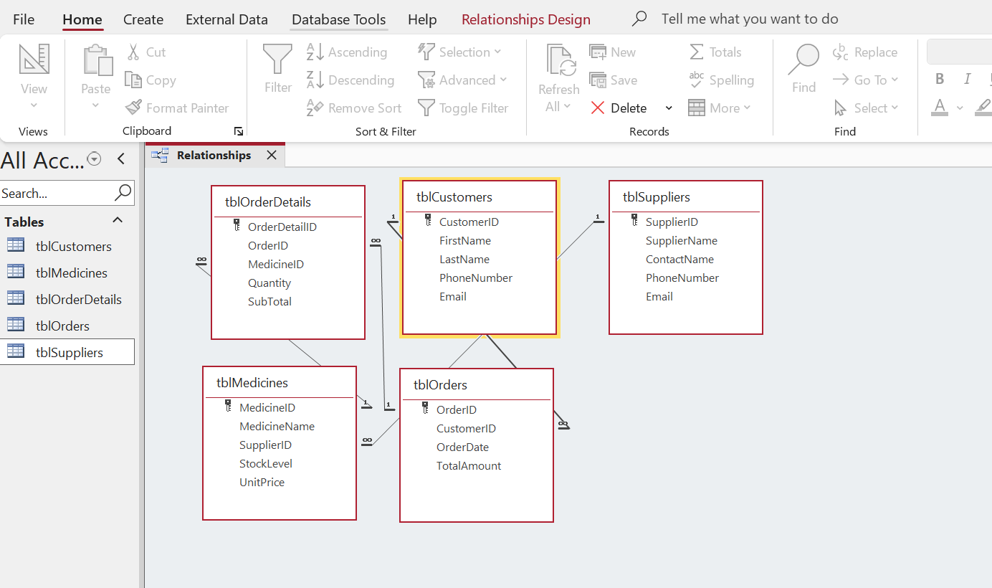
Figure 1: MediLink Pharmacy Relational schema illustrating relationships and Referential Integrity.
From a technical standpoint, the design utilises a relational model to represent the real-world entities of the pharmacy. According to database design theory, a relational database is superior to flat files because it allows for complex data retrieval through queries and ensures that relationships between different data categories such as patients and their specific doctors are maintained accurately [6]. This systematic approach ensures that MediLink Pharmacy can scale its operations while maintaining high standards of patient care and data management.

Data Structure and Design Justification
In order to transition MediLink Pharmacy from a manual system to a robust digital environment, a structured data dictionary was developed. The following tables represent the core entities identified during the scenario analysis phase. Each table has been designed in alignment to the Third Normal Form. This ensures data is non-redundant and that every non-key attribute is functionally dependent only on the Primary Key [7].
The selection of data types is a critical component of this design. AutoNumber is utilised for all Primary Keys to provide a system-generated unique identifier for every record and eliminating the risk of human error during data entry. Fields requiring mathematical precision such as Unit Price and Stock Level, the Currency and Number types were chosen respectively. This ensures that the database can accurately perform the calculations required for the "Low Stock" and "Sales" queries requested by the CEO [8].
1. Table: Medicines

Field Name | Data Type | Description / Purpose
Medicine ID | AutoNumber | Primary Key: Unique ID for each drug.
Medicine Name | Short Text | Name of the medication (e.g., Paracetamol).
Category | Short Text | Type of drug (e.g., Antibiotic, Painkiller).
Unit Price | Currency | Cost per unit.
Stock Level | Number | Current quantity in stock (used for Low Stock Query).
Supplier ID | Number | Foreign Key: Links to the Supplier table.

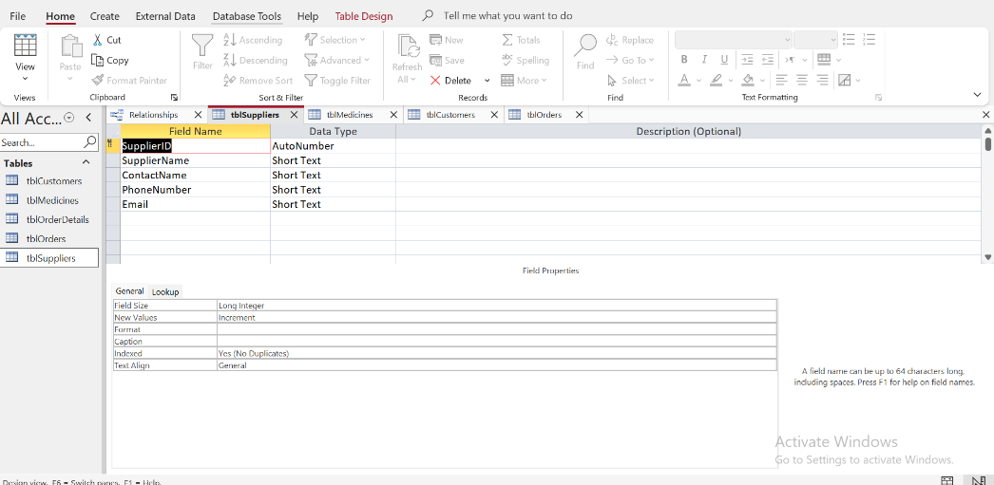
Figure 2: Design View of tblSuppliers showing Primary Key assignment and Data Type selection.

2. Table: Suppliers

Field Name | Data Type | Description / Purpose
Supplier ID | AutoNumber | Primary Key: Unique ID for the company.
CompanyName | Short Text | Name of the pharmaceutical supplier.
Contact Phone | Short Text | Phone number for ordering.
Email Address | Short Text | Email for digital invoicing.

3.Table: Customers
Field Name | Data Type | Description / Purpose
Customer ID | AutoNumber | Primary Key: Unique ID for the patient.
FirstName | Short Text | Patient's given name.
Last Name | Short Text | Patient's family name.
Date of Birth | Date/Time | Used to verify patient identity.
Contact Number | Short Text | Phone number for prescription alerts.

4.Table: Prescriptions

Field Name | Data Type | Description / Purpose
Prescription ID | AutoNumber | Primary Key: Unique ID for the script.
Customer ID | Number | Foreign Key: Links the script to a customer.
Date Issued | Date/Time | When the prescription was written.
Doctor Name | Short Text | The prescribing physician.

5.Junction Table: Prescription Details

Field Name | Data Type | Description / Purpose
Detail ID | AutoNumber | Primary Key.
Prescription ID | Number | Foreign Key: Links to tblPrescriptions.
Medicine ID | Number | Foreign Key: Links to tblMedicines.
Quantity | Number | Number of units prescribed for this specific item

Justification of Data Types
The selection of data types is a critical component of this design to ensure data integrity and system performance:
- AutoNumber: This was assigned to all Primary Keys (MedicineID, CustomerID). It provides a system-generated unique identifier for every record, eliminating the risk of human error or duplicate entries during high-volume pharmacy operations.

- Short Text: Used for names, addresses and contact details. This format is storage-efficient while allowing for the inclusion of symbols such as parentheses in phone numbers that a standard number field would reject.

- Currency: Applied to the Unit Price field in Medicines table. Unlike a standard decimal number, the currency type prevents rounding errors during complex financial calculations which is vital for accurate billing and stock valuation [3].

- Number: Utilised for Stock Level and all Foreign Keys. Using a numeric type for stock allows the "Low Stock" query to perform mathematical comparisons (as an example < 10) which would be impossible if the data was stored as text.

- Date/Time: Essential for Date of Birth and Date Issued fields. This ensures the data follows a standardised format allowing the pharmacy to sort prescriptions chronologically or verify a patient's age for specific medications.

Query Design and Functional Requirements.
To support the operational requirements of MediLink Pharmacy, a series of relational queries were developed. These queries transform raw data into actionable management information, allowing the CEO and pharmacy staff to make informed decisions regarding inventory and patient care [1].
Low Stock Alert (Inventory Management)
- Purpose: To identify medications that have fallen below a critical threshold.
- Logic: This query filters the tblMedicines where the StockLevel field is less than 10.
- Business Value: This prevents "stock-outs," ensuring that life-saving medications are always available for patients. It automates the reordering process which was previously a manual and error-prone task in the old paper-based system.
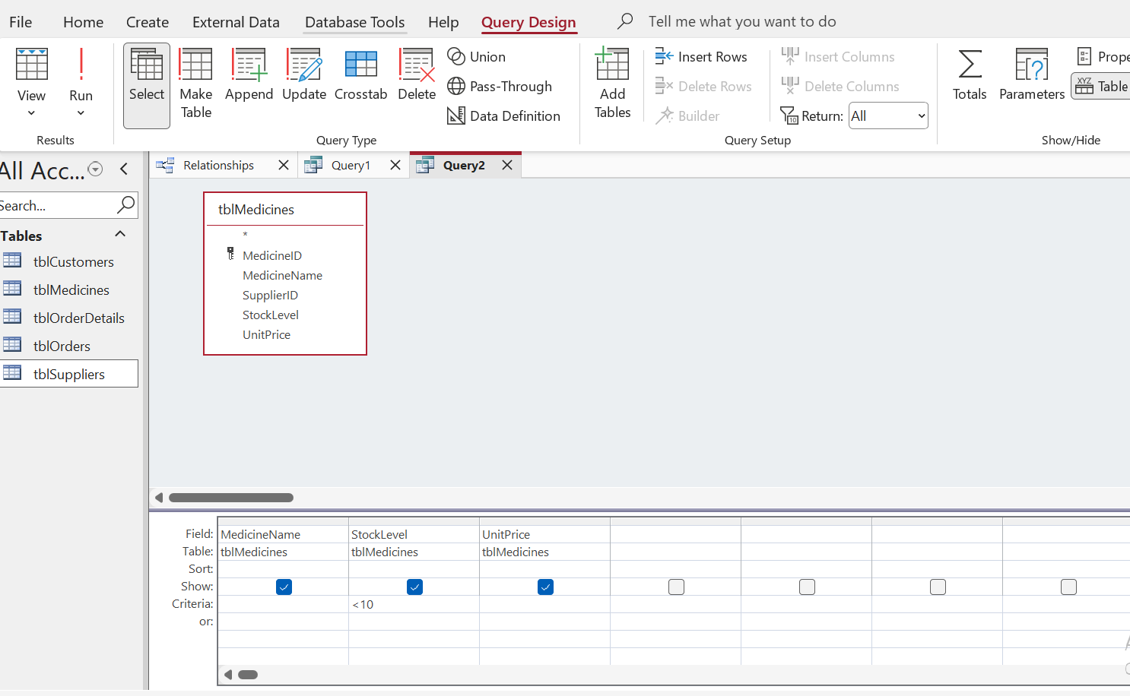

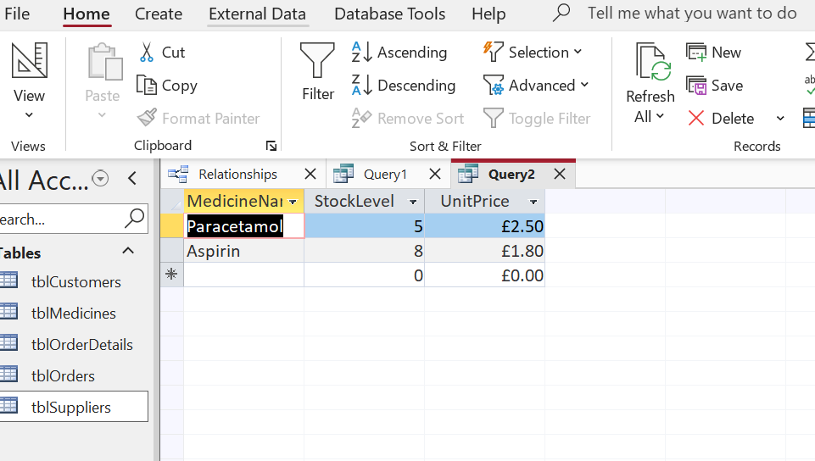
Figure 3: Query logic (Criteria <10) and the resulting inventory alert list.

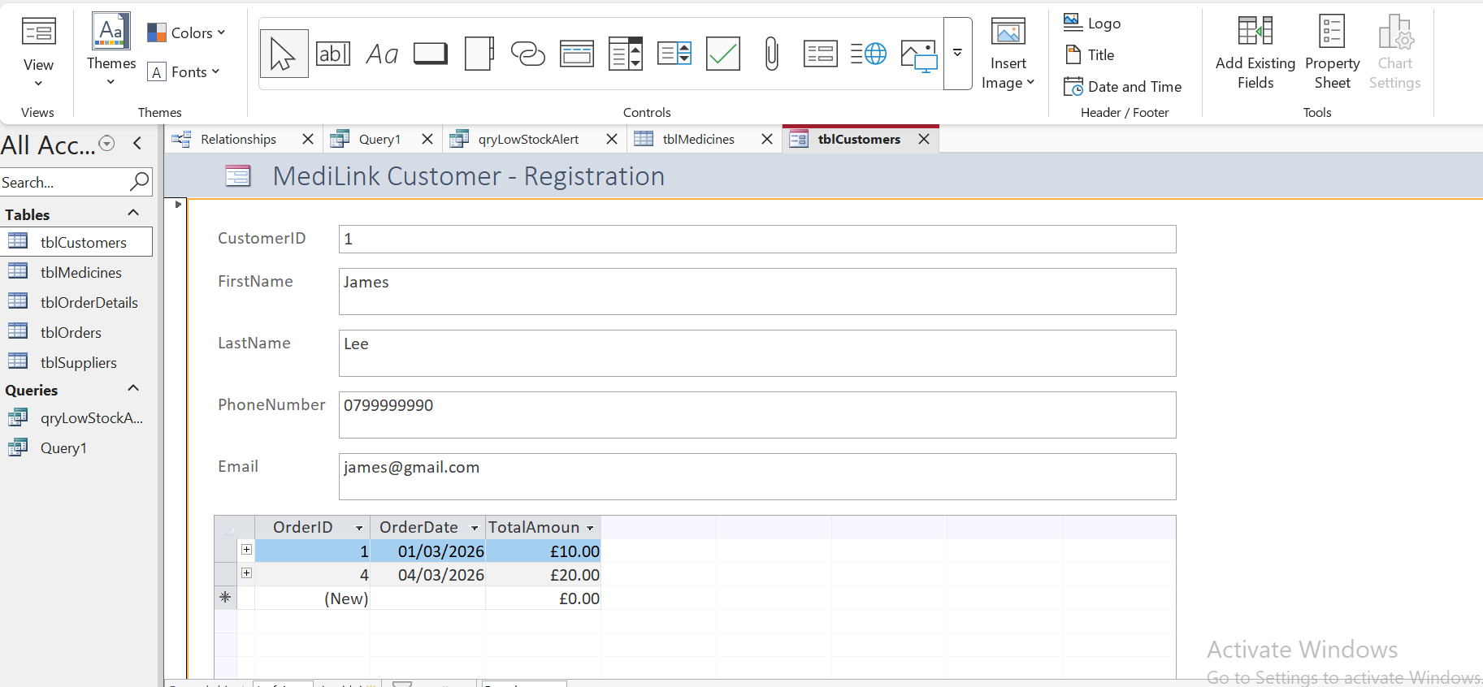
Figure 4: Customer Registration Form designed for end-user data entry efficiency.
Patient Prescription History (Clinical Audit)
- Purpose: To retrieve a comprehensive list of all medications issued to a specific individual.
- Logic: A multi-table join was created between tblCustomers, tblPrescriptions, and tblMedicines.
- Business Value: This provides a vital safety audit trail. If a patient has an adverse reaction or if a doctor needs to review previous treatments, the pharmacist can generate a report in seconds rather than searching through physical files.
Supplier Performance Report
- Purpose: To list all products associated with a specific vendor.
- Logic: This query links tblSuppliers to tblMedicines using the SupplierID foreign key.
- Business Value: This streamlines communication with wholesalers. When placing a weekly order, the pharmacy can see exactly which items are sourced from a particular supplier, allowing for bulk ordering and potential cost savings [2].

Reflection and Professional Development
The development of the MediLink Pharmacy database system has provided a significant opportunity to bridge the gap between theoretical database design and practical software implementation. Throughout this process, the primary challenge shifted from conceptualising a Third Normal Form (3NF) architecture to managing the technical constraints of Microsoft Access. This transition highlighted the importance of Data Integrity as a practical necessity rather than just a classroom concept.
One of the most significant technical hurdles encountered during the implementation phase involved the Relationships Window. While the initial Entity-Relationship Diagram (ERD) appeared logically sound on paper, enforcing Referential Integrity within Access revealed several data-entry inconsistencies. Specifically, the system initially rejected the links between tblSuppliers and tblMedicines. Through a systematic troubleshooting process, it was discovered that the foreign key values in the medicine table did not have matching "Primary Key" entries in the supplier table. Resolving this required a manual audit of the data to ensure that every medicine was tied to a valid, existing vendor. This experience reinforced the professional importance of clean data and demonstrated how relational databases serve as a fail-safe against the human errors common in manual, paper-based systems.
Furthermore, the creation of the Low Stock Alert Query demonstrated the power of relational algebra in a business context. Transitioning from a flat-file mindset where one might simply look at a list to a query-based mindset allowed for the automation of a critical business process. By using the <10 criteria, the system proved it could handle management by exception, alerting the CEO only to the items requiring immediate action. This significantly reduces the cognitive load on pharmacy staff and minimizes the risk of stock-outs for life-saving medications.
From a professional development perspective, this project has enhanced my proficiency in UI/UX design through the creation of Data Entry Forms. I learned that a database is only as good as the user’s ability to interact with it; therefore, creating a streamlined Customer Registration Form was essential to ensure that non-technical staff could maintain the system without compromising the underlying table structures. If I were to extend this project in a professional environment, I would implement macros to automate the generation of weekly PDF reports for the CEO. This experience has solidified my understanding of how centralized digital systems are the backbone of modern healthcare efficiency, ensuring both regulatory compliance and operational excellence.

References
[1] [8] Prifysgol Cymru Y Drindod Dewi Sant, "Level 4 Assessment Specification: Introduction to Web and Database Concepts (ACCA4023)," Internal Course Document, Feb. 2026.
[2] [7] C. Coronel and S. Morris, Database Systems: Design, Implementation, & Management, 13th ed. Boston, MA, USA: Cengage Learning, 2019.
[3] Microsoft Support, "Database design basics," Microsoft Support. [Online]. Available: https://support.microsoft.com/en-us/office/database-design-basics. [Accessed: Mar. 12, 2026].
[4] Prifysgol Cymru Y Drindod Dewi Sant, "Level 4 Assessment Specification: Introduction to Web and Database Concepts (ACCA4023)," Feb. 2026.
[5] C. Coronel and S. Morris, Database Systems: Design, Implementation, & Management, 13th ed. Boston, MA, USA: Cengage Learning, 2019.
[6] R. Elmasri and S. B. Navathe, Fundamentals of Database Systems, 7th ed. Hoboken, NJ, USA: Pearson, 2017.

