  University Of Wales Trinity Saint David | Software Solutions for Business (ACCA4026_LON)  Name: Damian Szast  Student ID: 2513630  Due Date: 15 Dec 2025 - 14:00  Lecturer: Kwame Assa-Agyei

Table of Contents
Introduction 1
Task 1. e-Commerce Website builders or software solutions 1
1.1 WooCommerce 1
1.2 Wix 2
Task 2. Mind-map of contemporary software applications 3
a. Mind mapping and explain the benefits of using mind mapping in business operations 3
b. Create a mind map of contemporary software applications 4
Task 3. Office Applications 4
a. Four office software solutions for business operations 4
MS Word 4
MS PowerPoint 5
MS Excel 7
MS Access 8
Practical demonstration of Two Office Features 9
Mail Merge 9
If Statement 10
Task 4. Communication and Collaboration applications 11
a. One contemporary Communication and one Online Collaboration applications/tools 11
MS Outlook 11
MS Teams 12
b. One feature of a freely available Communication (1) and one feature of a Collaboration (1) application 12
MS Outlook 12
Ms Teams 12
Conclusion 13
References 13

Introduction
This assignment will show my ability to use a range of software’s and tools. This will help me improve my technology-oriented solutions in the workplace. These tools are vital for improving communication, productivity and decision-making. With the research and practical’s, I’ll be able to understand how to improve performance and efficiency.


Task 1. e-Commerce Website builders or software solutions

1.1 WooCommerce
WooCommerce is an open-source commerce plugin [1]. It’s used to build a WordPress website into a functional online store. In 2011 it was acquired by automatic, the company behind wordpress.com. Its popularity has grown because of its flexibility, and most importantly that it is free under a GPL License [4].
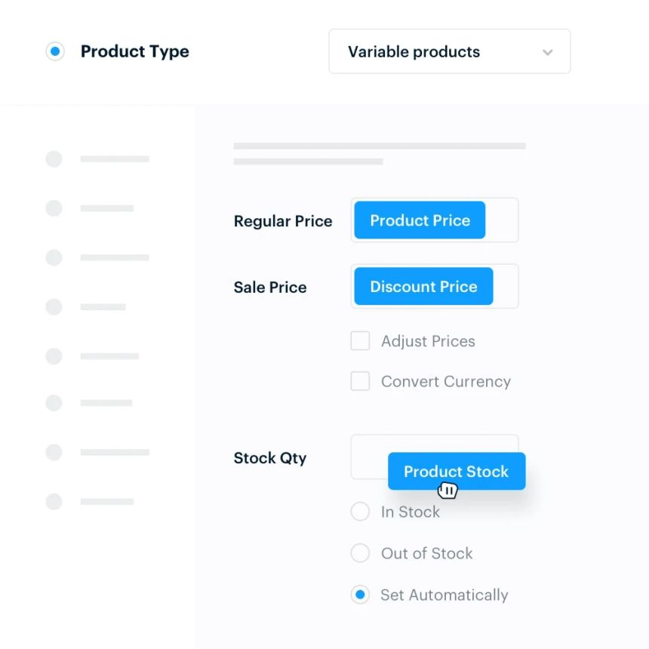
This plugin at its core allows for important store management features. Some of its features consist of: Physical, Digital, Variable and affiliate products. It has good payment integration with PayPal and Stripe [3]. As it is built on WordPress it naturally has some of its features ported over like content management and blogging which allow for marketing and ecommerce seamlessly [1]. Its most outstanding feature is the customisability. Devs and store owners have a wide range of themes and extensions, not only that but they can modify code since it is open source [4]. These features allow for the creation of any online store from simple boutiques to subscription services, memberships or wholesale B2B stores [3].
The possible downside is that you are the one that is responsible. WooCommerce is self-hosted meaning that you must have your own web hosting, backups etc. This requires extra work which some businesses may not want to deal with due to lack of time, skill or funds. There is a higher maintenance overhead compared to fully managed SaaS e-commerce platforms [3]. Furthermore, as your business grows so will you traffic to you online services, meaning that good optimisation and performance is needed for a smooth customer experience. A stress-test study found that WooCommerce’s performance under load depends heavily on the hosting environment [2].
WooCommerce is a great choice for some users for the following reasons:
- Already use or are comfortable with WordPress.
- Want full control over their store, data, and customisations.
- Are willing to manage hosting, performance optimisation, and security [3].
- Have plans to scale and customise their store beyond basic out-of-the-box capabilities [4].

1.2 Wix

Wix is an online website builder. It offers a robust e-commerce platform [2]. It is a very convenient website that allows users to make an online store without needing to worry about hosting [1].
Wix has a vast array of features that allow the user to precisely customise their website. It has customisable templates, optimised mobile design and allows for sales to be made from many different platforms [1]. Wix payments is a native built-in checkout system [1]. Inventory and order management tools are also included; they allow users to check their analytics from their dashboard. Shipping and fulfilment workflows, and the ability for customers to create accounts, leave reviews and use wish-lists [1]. The platform ensures that it is easy to use even to beginners [2].
Wix is a modular and extensible architecture, which means that developers can customise components such as checkout UI, service plugins or data extensions with Wix’s APIs and Velo by Wix [1].
Strengths:
- Very user friendly – Good for users with limited knowledge [2]
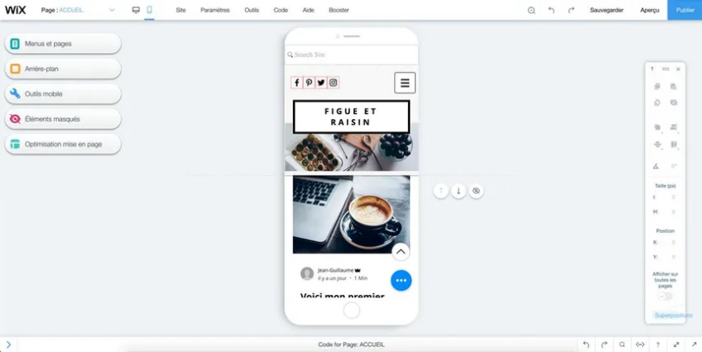
- No need for users to host or worry about security
- Good multichannel and marketing integration – built in tools for social media selling, ads and analytics.
Weaknesses:
- Wix isn’t open source meaning that customisation might be more constrained than platforms that are open frameworks
- Inventory - Large stores (with high volume) could cause issues as there is a 50,000-product limit.
- Due to wix ecommerce’s simplicity more advanced features like Advanced Inventory and wholesale B2B workflows [2].
Wix is a very good choice for businesses at a small to medium scale, which may not have the knowledge to create a website for their business themselves. The plethora of features to create the website from the ground up allow users to create a website exactly as they want. It is ideal for users that want simplicity and don’t want to deal with servers or any code customisation. Alternatively, if users anticipate they will need full control of their website or will need high scalability wix may not be suitable [2].

Task 2. Mind-map of contemporary software applications

Mind mapping and explain the benefits of using mind mapping in business operations
Mind mapping is a great visual way of organising information. The structure consists of a key concept in the middle and connected ideas around it. Unlike standard note taking mind map allows thoughts naturally appear and create subtopics. Mind maps allow individuals and teams to visualise information, which can make identifying patterns allow easier. As Buzan highlights, this technique benefits the brains preferences for visual information and nonlinear organisation, which increases understanding and stimulates creativity [1].
Mind mapping provides many benefits for business operations. The main benefit is the improved planning and organisation. Big projects and operational processes often require multiple tasks to be done. Mind maps provide a clear structure that breaks down more complex tasks into more manageable parts. This enables teams to visualise workflows, prioritise tasks, capture critical details and reduce data overflow. Eppler’s study on visual knowledge tools found that mind maps improve clarity and reduce doubts. This makes them effective for project planning and strategic analysis [2].
Collaboration and communication also improve through mind mapping. The strength of mind mapping is that during meetings, brainstorming sessions or workshops, it is easy for participants to contribute and add onto any ideas due to the nature of mind maps and a central topic. The shared visuals information allows everyone to stay involved. It makes sure that everyone is on the same page, and everyone understands how every idea is connected to the main goal. At the workplace where different departments may need to work together, mind maps can help teams agree faster and it can help avoid communication problems.
Creativity and problem solving are also improved with mind maps. Many businesses problems and challenges are complex and nonlinear, which mind maps can solve. Mind maps allow teams to explore alternative paths and possible previously hidden connections. This approach supports product development, marketing and operational processes.
The visual approach allows leaders to make stronger and more confident decisions as they can visually compare options and evaluate risks. This helps leaders make stronger and more confident decisions and figure out possible conflicts which may have not been previously noticed.
Finally mind mapping improves productivity and knowledge retention. Visual information is processed more efficiently than information that has lots of text, which allows for information to be recalled efficiently and allows for learning to be more effective.
In conclusion mind mapping is a very effective tool for businesses to use due to the visual simplicity of the information presented. It supports strong collaboration, enhances creativity, making decisions and improves knowledge retention. Its strong visual approach aligns with the dynamic environments of modern organisations which make it very effective for planning, communication and problem solving.

Create a mind map of contemporary software applications
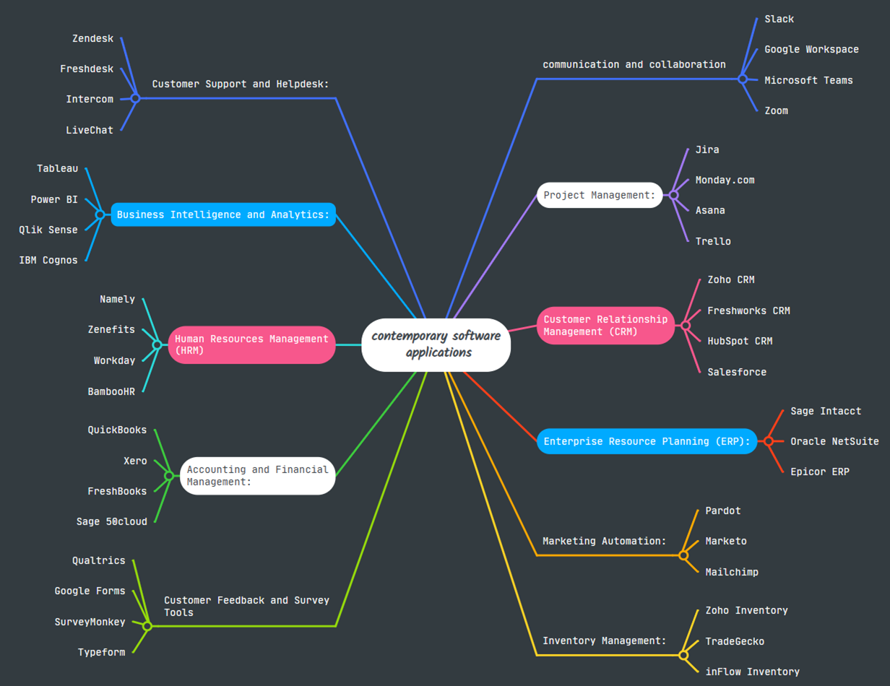

Task 3. Office Applications


Four office software solutions for business operations

MS Word
Microsoft word is one of the most used word processing applications. People use it to create, edit, format, and manage text documents [2]. It supports a wide variety of business document types such as reports, letters, contracts, proposals, and newsletters [3]. Word is easily accessible, desktop, web and mobile. This allows individuals to work from anywhere with an internet connection [1].
Word includes text formatting, templates and page layout controls, which can produce professional business documents. Word allows inserting tables, images, charts and graphs into documents. The use of these allows for better visualisation of information and is very useful for business communication [2]. It has very strong collaboration, it allows for changes to be tracked, comments to be added and multiple users to work on the same document through Microsoft 365 cloud services [4]. Users are also able to convert their documents into the PDF format and go into version history to restore older files [1].
Word makes it easy for organisations to keep their consistent branding as there are predesigned templates [3]. The ability to collaborate in real time improves teamwork and reduces delays when writing reports/documents or editing shared documents [4]. The software is very familiar with most employees which leads to minimal training required [2]. It is often used in schools so many future employees wont need much training if any. The strength of word is the integration with other Microsoft 365 apps like OneDrive and Outlook. This increases efficiency as documents are easily stored so they can be accessed easily and shared [1].
Word has many features which only a small number of users use meaning that businesses pay for functions which they do not need [4]. Some advanced collaboration tools need to have an internet connection which may cause disruptions if the connection is unstable [1]. Also, word docs may have issues with formatting inconsistencies when opened on different devices or even older versions [1]. For more specialised tasks like advanced design layouts or large data analysis word may not be as suitable. Dedicated software like publishing tools or spreadsheets may be more suitable [2]. 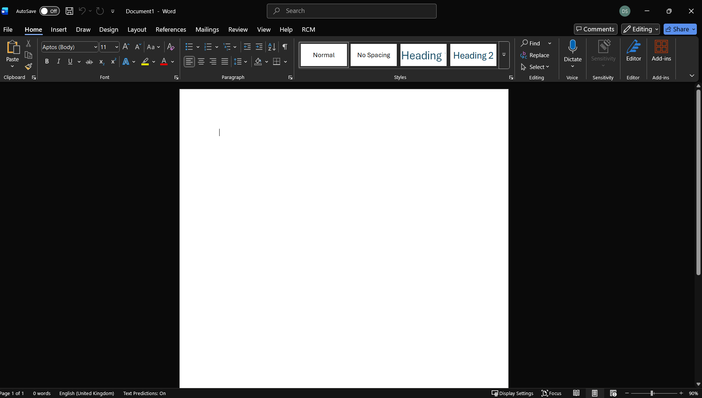
Furthermore, Ms Word has a very strong role of keeping documents secure and making sure to be in line with data protection. Features like password protection, restricted editing and permissions for documents provide strong security. Companies and businesses often use word to use legal documents which need visible history of edits. Word can automate things like sending mail. Mail merge allows for a large sum of letter to easily be personalised and changed in a very efficient way. The ability to store files in Microsoft’s cloud provides an efficient way to keep documents easily accessible and backed up in case your locally stored file fails. The continuous updates of words interface and features keep up with modern business needs. This ensures that MS word is future proof and a long-term application for organisations.


MS PowerPoint
PowerPoint is a presentation software that allows teams and individuals to create slide presentations. Text, images, charts, videos, audio’s, themes, animations and transitions are all available in Ms PowerPoint. All the listed above features allow to produce visually engaging slideshows [1].
One of Ms PowerPoints strengths is the easy to use and flexible nature of the application. Even users that don’t have any graphic design skills can create professional looking presentations with the use of the templates the application provides. This benefits businesses and teams, as little to no training is needed to use the software. Teams can make slideshows for meetings, pitches, reports, training sessions and much more [3]. Similarly to word charts, graphs, videos and audio can be added to improve the presentations which can help more complex information to be shown visually and clearly [3].
Ms PowerPoint also support collaboration. This is done by the cloud-based Microsoft 365. Multiple team members can seamlessly edit and leave comments in real time which allows for remote working [1]. The ability for PowerPoint presentations to be exported into many formats such as PDF, video and images allow for great distribution, archiving and sharing outside PowerPoint [3].
For businesses this tool is valuable not only for live presentations but also for semi-formal reporting tool. Many organisations use slide decks as project updates, strategic overviews or investor pitch documents. This is because slides can mix graphics, data, and text seamlessly and more it easier for individuals to understand compared to long paragraphs in reports [3].
PowerPoint is not without limitations, the over-reliance on templates and default designs can lead to basic looking presentations. Many slides may end up cluttered or monotone if the users doesn’t have the time to refine it [2]. For large and highly complex data PowerPoint may not have the depth and flexibility to show this data effectively, charts may be simplistic and complex tables cumbersome [2]. The performance might take a hit if there are lots of animations, slides or heavy multimedia, which may lead to bad performance on some devices [4].
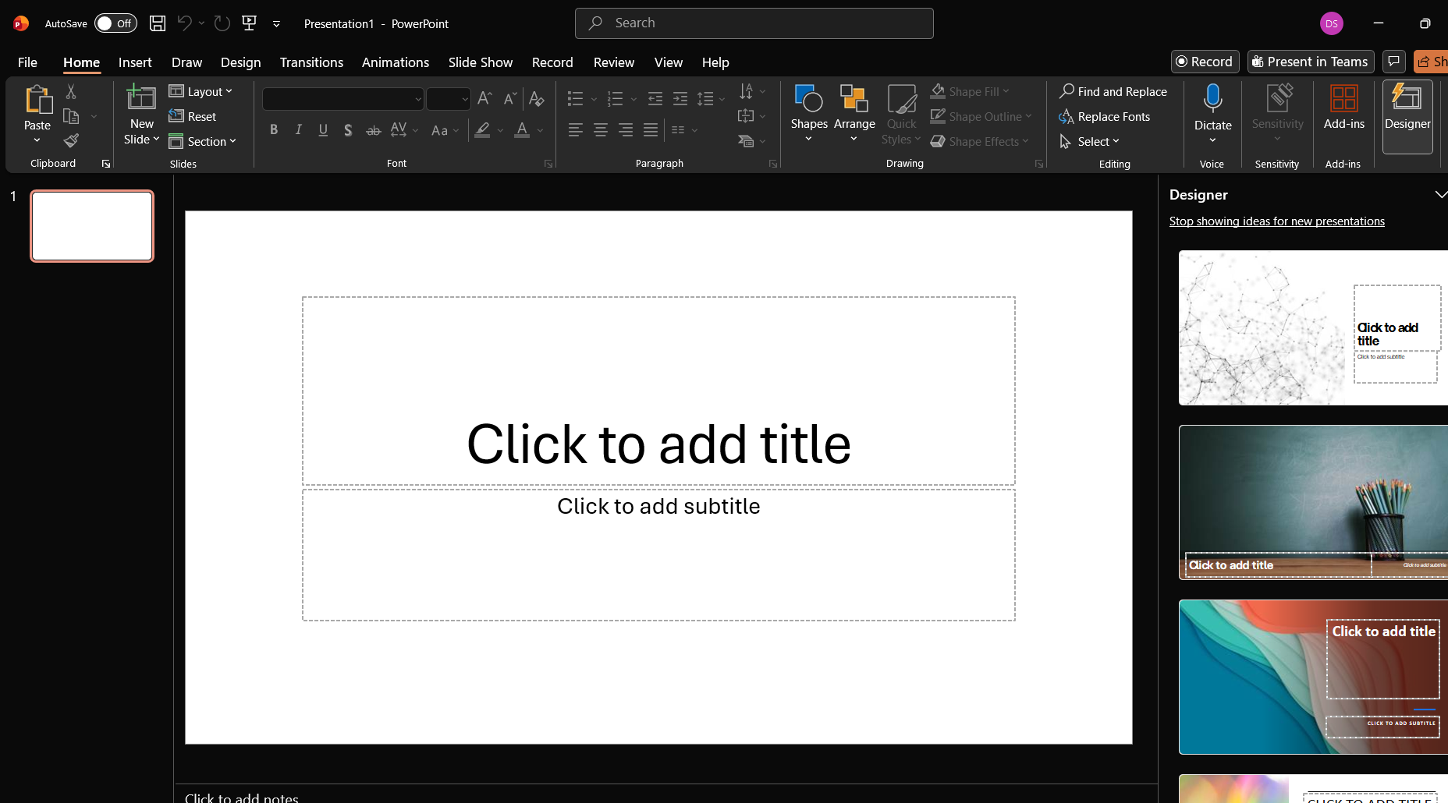
Slide presentations may also encourage oversimplification. Complex ideas may be reduced to bullet points or oversimplified these risks losing meaning and discourages deep analytical thinking [2]. PowerPoint doesn’t require a high skill level but with basic skills of PowerPoint, presentations may lack a good layout or visual hierarchy [4]. I think that Ms PowerPoint is lacking a basic tutorial that would familiarise individuals with the basic and more advanced tools the app has to offer.
I believe that Microsoft PowerPoint remains a very valuable tool for business and teams, especially for communication, reporting, training and pitches. Its easy-to-use features and effective collaboration make it a very useful tool for small and large organisations. It’s important to remember that to get the most from PowerPoint design quality shouldn’t be ignored and to avoid treating every communication as a slideshow sometimes traditional documents or interactive dashboards are better.


MS Excel
MS Excel is a spreadsheet application used by many businesses and organisations. Users can organise information in a grid of rows and columns. They can also perform calculations with built in formulas and functions and can analyse data using tools like PivotTables [1].
A strength of excel is its versatility and flexibility. It can do simple data entry, complex financial analysis, forecasting and statistical calculations [2]. Excel supports dynamic tables, filtering, sorting, conditional formatting and data validation which enables businesses to manage structured data efficiently [1].
Data analysis and visualisation is very valuable [3]. The use of charting tools, graphs and the summary of large datasets Excell turns data into simple insights [3]. For small and medium sized businesses Excel is widely used for financial statements, sales tracking, budgeting, performance metrics and project tracking.
Excel is a very well-known software which is widely available. Most employees already have a good understanding and familiar with it which reduces training costs [3]. Its most likely already included with office-software suites companies already use, which makes it cost effective [3].
However, Excell isn’t without limitations. For very large datasets or highly complex models’ performance can suffer and files may become unstable or slow [4]. Scalability can also suffer which storing many files separately which may create data inconsistencies or fragmentation.

Human error could be an issue as incorrect formulas or data entry mistakes could be made which leads to bad results [4]. Issues may happen when trying to collaborate when using offline versions. Furthermore, version conflicts could become an issue, and teams may unintentionally modify the same files would lead to lost changes. Cloud versions do improve on this but still lack some advanced live-collaboration features found in specialist tools.
Excell lacks the ability to automate. It struggles on large relational databases, advanced BI workflows or complex reporting, because of this must shift to dedicated data systems as they scale [1].
Excel is also very customisable. Users can create macros for automation which can reduce repetitive workload. Organisations and businesses often design custom dashboards to monitor KPI’s. A big advantage is Excel has large online resources and templates because of this user can improve skills without much training. But the misuse of macros or external risks can introduce security risks. Some organisations enforce restrictions on Excel functionality to avoid malware or corrupted spreadsheets.
Due to Excel’s flexibility, familiar interface and strong analytical capabilities it remains essential in businesses [3]. But companies must understand that it has limitations in scalability, collaboration and data governance as tasks become more complex [4].


MS Access
Microsoft Access is a relational database management system from Microsoft, part of the Microsoft 365/Office ecosystem. The applications are made to help users store manage, query and report data in a structural way. It has a great graphic user interface that even people without programming knowledge can easily create databases, queries, forms and much more [1].
Like all Microsoft 365 software’s its main strength it’s the ease of use and accessibility. Databases can be made quickly with templates or the drag and drop interface. There is no need to write SQL code – but there is an option to extend functionality with SQL, macros or VBA (Visual Basic for Applications) when needed [2]. Access is perfect for organisations that are low-medium sized. It’s ideal as organisations don’t need to invest in enterprise grade database infrastructure for a custom database [2].
As MS Access is part of Microsoft office it seamlessly integrates with word and outlook. This allows data to be imported and exported. From this data forms and reports can be made. Macros or VBA can automate routine business tasks like invoice generation, report creation etc. It’s a useful tool for workflow automation and reducing manual effort [3]. The easy creation of user-friendly forms improves data entry accuracy and standardises how data is collected in the company [3].
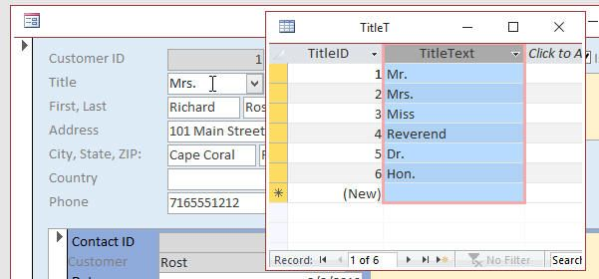
Access is the perfect option for businesses that need a local database rather than a full enterprise level system. It is a low-cost solution as its part of Microsoft office and most companies have Microsoft 365 licenses. Any additional costs wouldn’t be very high which would for small business would be beneficial for managing customer lists, inventory, simple CRM tasks or project-level data [2].
Access isn’t bulletproof as it has its limitations which can affect scalability, performance and long-term viability. A single Access database file is limited to 2 GB including all data and objects. The moment that the 2gb is reached (or when there are a lot of: tables, forms, queries or reports becomes very large) performance can worsen, database corruption becomes more likely and management becomes difficult [1].
A large amount of people can also cause issues even though access supports up to 255 concurrent users. In practising there are performance issues, file-locking conflicts and data integrity risks. This happens when more than a handful of users attempt simultaneous access making Access quite a bad fit for large teams or heavy concurrent workloads [4].
Security and robustness are also an issue. Access lacks advanced access control, encryption, auditing and concurrency control provided by server-based DBMS. Businesses that require strong security, complex permissions, reliable backups Access may be insufficient [4].
Access has issues with complex data models, high volume analytics, availability and scalability. Companies/Organisations often “Upsize” to more sturdy data base engines.
I think Ms Access is a great entry level database solution. It’s great for small teams, projects or small to medium businesses that need custom data management without heavy infrastructure. Organisations should weigh up the pros and cons before relying on Access for critical, large-scale, high-concurrency or important information applications [4].

Practical demonstration of Two Office Features

Mail Merge

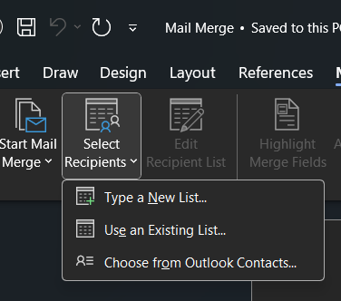
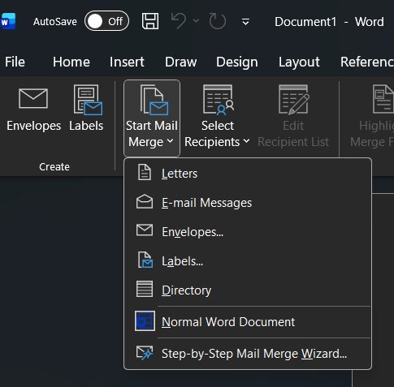+
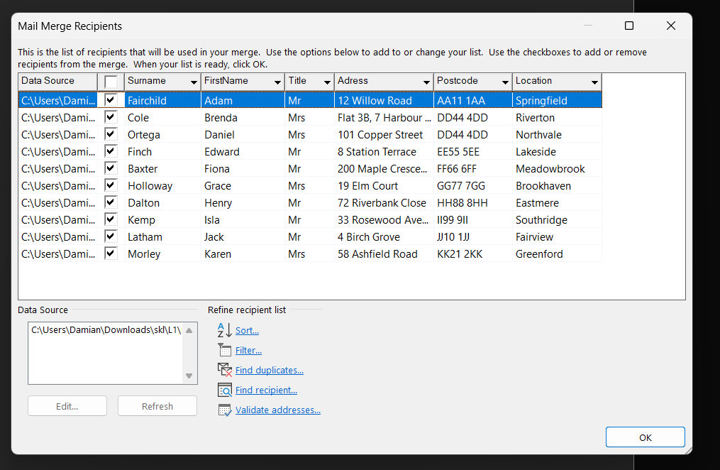
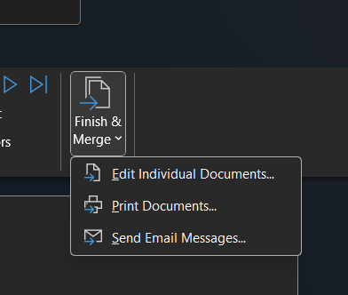


If Statement




Task 4. Communication and Collaboration applications


One contemporary Communication and one Online Collaboration applications/tools

MS Outlook
For most organisations Outlook is the main platform for communication between different teams, and from different organisations. Its one of the first and last thing employees check in their shift. Outlooks aren’t just an email sender. It has functions such as scheduling, information sharing, reminders, task coordination and direct collaboration in teams [1].
Outlook blends email and time-management into one place. Work communication is naturally tied to deadlines and meetings, so having the calendar next to the inbox makes decision making faster and clearer. An example of this would be if a client requested a meeting, users would be able to propose suitable times whenever they are available. This avoids long series of miscommunication and reduces the need for conversations and prevents double booking. This makes Outlook improve productivity in a company.
Outlook also improves communication through features like Focused Inbox, flags, categories, rules and snoozing messages. These features help individuals avoid missing important information that could significantly negatively impact their work. A salesperson can highlight urgent client emails and filter out low-priority automated updates. Managers can turn emails into tasks which allows them to prioritise work more strategically.
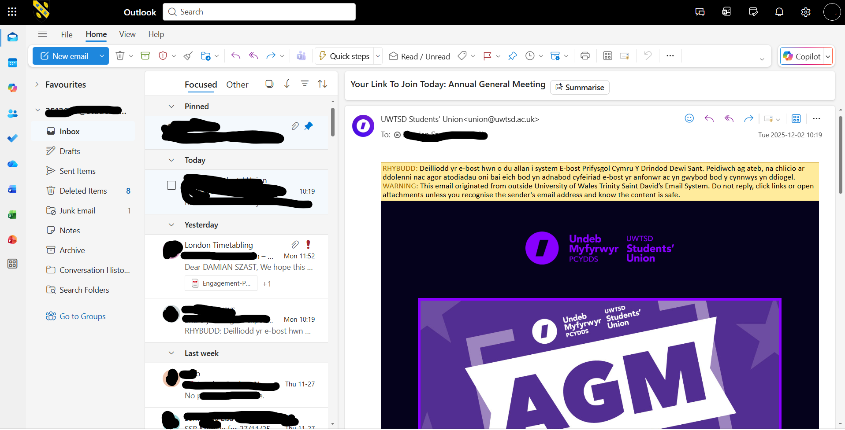
Collaboration is easy with Outlook as it links directly with cloud storage and tools such as Teams, OneDrive and SharePoint [2]. Instead of attaching outdated document copies, users can share live files that update automatically. This is ideal for teams that work on documents that may change very often. Comments, version history and co-editing happen in the background. This keeps everyone sure that they are up to date without constant manual updates. Mobile access is another great advantage. Individuals can work remotely, with the ability to access emails, join meetings, check schedules and approve tasks from the Outlook app. This is ideal for companies as hybrid work can be done and ensures that communication is still strong when away from the office.
New users often say that Outlooks interface feels busy/cluttered, because of the features hidden inside menus. Teams with very large mailboxes may experience slower performance. Searching for old messages is sometimes unreliable. Outlook requires a stable internet connection to sync calendars and shared content effectively so a bad connection can cause teamwork to stall [2]. Some organisations also believe that Outlook encourages too much email. This leads to “notification fatigue” especially when alternatives could resolve certain tasks. Even with these limitations, it is clear why Outlook remains a standard in business. It handles the everyday work that keeps organisations running. Coordinating with clients, to managing everyday work, planning the week ahead it gives employees structure, consistent and reliable communication. It’s vital for any company or team that wants to improve their productivity.

MS Teams
Ms Teams is a very popular collaborations for modern organisations [1]. The software is good for messages, video calls, file sharing and bring spaces for teamwork. Many individuals work hybrid or remotely, so teams have a central digital workspace [2]. Teams and individuals can communicate without needing to switch between multiple applications, improving efficiency.
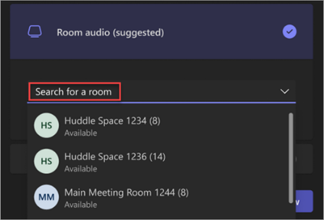
Teams is a channel communication structure [1]. Instead of long email chains teams can create separate channels for projects. In the channels users can chat, send images, files and pin important documents. This allows for information to flow easier and reduces clutter usually seen in standard communication tools [2].
Teams is mostly used for online meetings and presentations [1]. It supports audio and video calls, screen sharing, breakout rooms, recording and background noise suppression. Those features make remote meetings more structured and professional. Teams is used by lots of organisations daily for stand-up meetings, interviews, training sessions and large company briefs [2]. The platform is made in such a way to keep participants engage with the ability to record sessions to help individuals that couldn’t attend at that time.
A clear advantage of Ms Teams is its great integration with Microsoft 365 [1]. Users can open and collaborate on work without leaving the app. Files that are shared on teams are automatically saved in SharePoint or OneDrive which makes for consistent access for everyone. This stops confusion about document ownership and file duplication, which can save confusion and time [2].
Teams has great third-party integrations, organisations can connect tools such as Trello, Asana, Adobe Creative Cloud, GitHub etc. This makes teams not only a communication tool but a multifunctional workspace.
New users the interface may be overwhelming as it has lots of features and menu options. Large companies sometimes report performance issues when in large teams calls or sharing big files. Teams also relies heavily on a stable internet connection unstable network quality can lead to frozen video or delayed messages [2].

Teams integrates with external tools it’s important for organisations to manage permissions and security to avoid any accidental data access or misconfigured settings.
Teams is generally a flexible space where employees can collaborate in real time. They can also share resources and communicate more effectively [1]. Teams is ideal for daily chats and large-scale remote meetings for modern businesses; it centralises work into one platform which reduces the need to multiple applications.

One feature of a freely available Communication (1) and one feature of a Collaboration (1) application

MS Outlook
1: Click new email
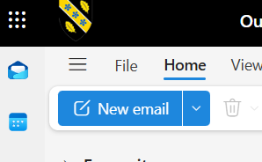
2: Fill in Information needed
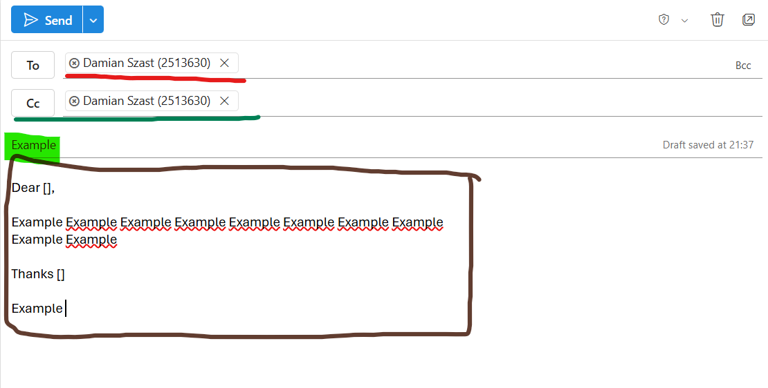
3. Click send
Scheduled:
1.Click the drop down, and select schedule send
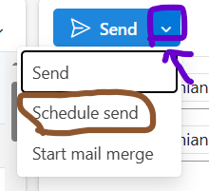
2. Pick a date and time, and click sent to send it at the selected time
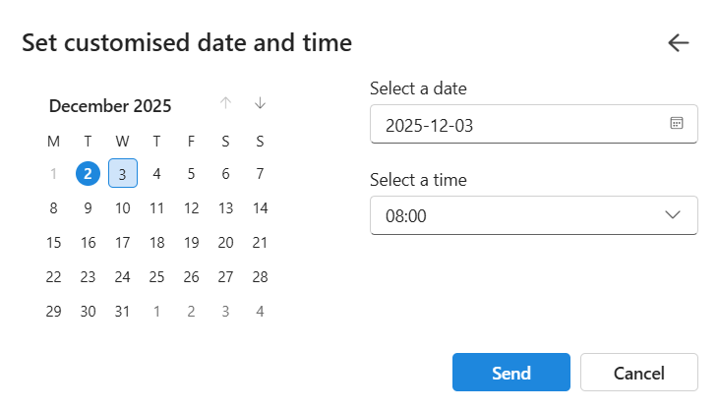

Ms Teams
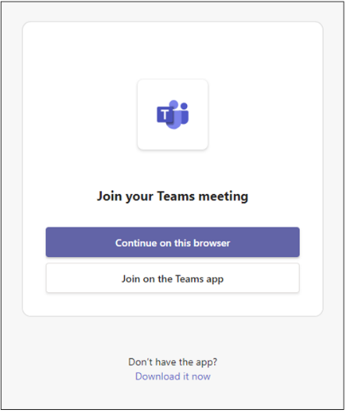
Join Teams meeting- either join on browser or on that app.
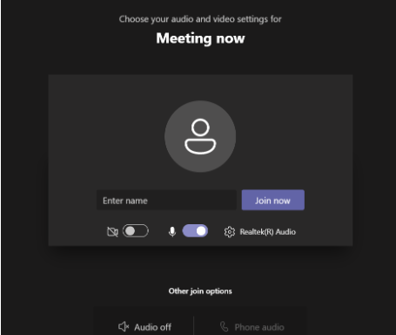
Enter your information and preferred microphone and video settings.

Wait for others to join you.

Conclusion
My report has checked different digital tools that modern businesses use for things like communication and to help in their business directly. I compared platforms like WooCommerce and Wix, which help individuals and teams sell online and their critical features.
I also discussed the benefits of mind mapping for planning, teamwork and problem solving inside organisations. I analysed important Microsoft Office applications such as Word and PowerPoint. I found out how they support professional document creation and visual communication and their drawbacks. I reviewed how Ms Outlook can improve communication within an organisation and teams aided by many of its features. Microsoft Teams was also discussed. It can enhance real-time communication, file sharing and virtual meeting capabilities across businesses.

References
WooCommerce:
[1] C. Landefeld, “An Introduction to eCommerce for WordPress – WooCommerce”, WooCommerce.com, Jul. 2018. [Online]. Available: https://woocommerce.com/posts/introduction-to-wordpress-and-woocommerce/.
[2] P. Organiściak, “WooCommerce in eCommerce – Overall System Review and Stress Tests”, Zeszyty Naukowe Wyższej Szkoły Technicznej w Katowicach, no. 17, pp. 143-156, 2023.
[3] “WooCommerce Review 2025: Features, Pricing, Pros and Cons”, HeroThemes.com, 4 Sept. 2025. [Online]. Available: https://herothemes.com/blog/woocommerce-review/.
Building Your Online Store With WordPress and WooCommerce: Learn to Leverage the Critical Role E-commerce Plays in Today's Competitive Marketplace
[4] L Sims – 2018 - https://books.google.co.uk/books?hl=en&lr=&id=boNyDwAAQBAJ&oi=fnd&pg=PR5&dq=WooCommerce+in+eCommerce&ots=-EWSzIVLvD&sig=Tv-kB7R2CfjkTE-6kCs0IQdrxUg&redir_esc=y#v=onepage&q=WooCommerce%20in%20eCommerce&f=false
Wix:
[1] Wix.com, “eCommerce Features That Help You Sell More Online,” Wix, 2025. [Online]. Available: https://www.wix.com/ecommerce/features. Accessed: Nov. 13, 2025.
[2] LitExtension, “Wix eCommerce Review: Is It Good for Online Store in 2025,” LitExtension, Sep. 2025. [Online]. Available: https://litextension.com/blog/ecommerce-platforms/wix/. Accessed: Nov. 13, 2025.
Mindmap:
[1] A. Buzan and B. Buzan, The Mind Map Book: How to Use Radiant Thinking to Maximize Your Brain’s Untapped Potential, BBC Active, 2010.
[2] M. Eppler, “A comparison between concept maps, mind maps, conceptual diagrams, and visual metaphors as complementary tools for knowledge construction and sharing,” Proc. IEEE Int. Conf. on Information Visualization, pp. 1–6, 2006
Task 2:
[1] A. Buzan and B. Buzan, The Mind Map Book: How to Use Radiant Thinking to Maximize Your Brain’s Untapped Potential,
[2] M. Eppler, “A comparison between concept maps, mind maps, conceptual diagrams, and visual metaphors as complementary tools for knowledge construction and sharing,” Proc. IEEE Int. Conf. on Information Visualization, pp. 1–6, 2006.
MsWord:
[1] Microsoft, “Word features comparison: Web vs Desktop,” Microsoft Support, 2024. [Online]. Available: https://support.microsoft.com/en-gb/office/word-features-comparison-web-vs-desktop-3e863ce3-e82c-4211-8f97-5b33c36c55f8. Accessed: Nov. 26, 2025.
[2] EBSCO, “Microsoft Word: Overview and Key Capabilities,” EBSCO Research Starters, 2023. [Online]. Available: https://www.ebsco.com/research-starters/computer-science/microsoft-word. Accessed: Nov. 26, 2025.
[3] The Knowledge Academy, “What is Microsoft Office?,” The Knowledge Academy, 2023. [Online]. Available: https://www.theknowledgeacademy.com/blog/what-is-microsoft-office/. Accessed: Nov. 26, 2025.
[4] G2, “Microsoft Word Reviews,” G2 Software Marketplace, 2025. [Online]. Available: https://www.g2.com/products/microsoft-word/reviews. Accessed: Nov. 26, 202
Ms PowerPoint:
[1] Microsoft, “What is PowerPoint?,” Microsoft Support, 2025. [Online]. Available: https://support.microsoft.com/en-us/office/what-is-powerpoint-5f9cc860-d199-4d85-ad1b-4b74018acf5b. Accessed: Nov. 27, 2025.
[2] SlideUpLift, “Advantages and Disadvantages of Using PowerPoint for Presentations,” SlideUpLift.com, 2025. [Online]. Available: https://slideuplift.com/blog/advantages-and-disadvantages-of-using-powerpoint-for-presentations/. Accessed: Nov. 27, 2025.
[3] SlideModel, “What Is Microsoft PowerPoint? History, Features & Uses,” SlideModel.com, 2025. [Online]. Available: https://slidemodel.com/microsoft-powerpoint/. Accessed: Nov. 27, 2025.
[4] G2.com, “Microsoft PowerPoint Reviews – Pros & Cons,” G2, 2025. [Online]. Available: https://www.g2.com/products/microsoft-powerpoint/reviews. Accessed: Nov. 27, 2025.
Ms Excel:
[1] “What are features of MS Excel,” Testbook.com, 2025. [Online]. Available: https://testbook.com/computer-awareness/ms-excel. Accessed: Nov. 27, 2025.
[2] A. Raj, “Top 12 Advanced Features of MS Excel in 2025,” AlmaBetter, 2025. [Online]. Available: https://www.almabetter.com/bytes/articles/features-of-ms-excel. Accessed: Nov. 27, 2025.
[3] “Why Microsoft Excel is Important for Business Organizations?” EduDelphi.com, Feb. 23, 2024. [Online]. Available: https://edudelphi.com/blog/why-microsoft-excel-is-important-for-business-organizations. Accessed: Nov. 27, 2025.
[4] “What are the Advantages and Disadvantages of MS Excel,” AlmaBetter, Dec. 14, 2023. [Online]. Available: https://www.almabetter.com/bytes/articles/advantages-and-disadvantages-of-ms-excel. Accessed: Nov. 27, 2025.
Ms Access:
[1] Microsoft, “Access specifications – database file and object limits,” Microsoft Support, 2025.
[Online]. Available: https://support.microsoft.com/en-us/office/access-specifications-0cf3c66f-9cf2-4e32-9568-98c1025bb47c. Accessed: Dec. 1, 2025.
[2] Indeed Editorial Team, “Key Microsoft Access Benefits That Make It a Good Database,” Indeed Career Guide, Nov. 21, 2025.
[Online]. Available: https://ca.indeed.com/career-advice/career-development/microsoft-access-benefits. Accessed: Dec. 1, 2025.
[3] Kessoft, “Microsoft Access Databases as a Database Management System,” Kessoft.com, Nov. 14, 2025.
[Online]. Available: https://www.kessoft.com/en/blog/microsoft-access-databases-as-a-database-management-system. Accessed: Dec. 1, 2025.
[4] The Knowledge Academy, “Microsoft Access Database Limitations,” TheKnowledgeAcademy.com, Sep. 9, 2025.
[Online]. Available: https://www.theknowledgeacademy.com/blog/microsoft-access-database-limitations/. Accessed: Dec. 1, 2025.
Outlook:
[1] Microsoft, “Outlook Overview: Email and Calendar for Business,” Microsoft.com, 2025. [Online]. Available: https://www.microsoft.com/en-us/microsoft-365/outlook/outlook-for-business
[2] Microsoft, “Share and collaborate with Outlook and OneDrive,” Microsoft Support, 2025. [Online]. Available: https://support.microsoft.com
Ms Teams:
[1] Microsoft, “Microsoft Teams: Communication and Collaboration Features,” Microsoft.com, 2025. [Online]. Available: https://www.microsoft.com/microsoft-teams
[2] N. Alhindi and M. Alghamdi, “Evaluating Microsoft Teams for Remote Collaboration in Educational and Business Environments,” IEEE Access, vol. 10, pp. 45210–45220, 2022.

