Leading in Action

Reflective Diary

2017/18

Name: Lowri Elisabeth White
Student number: P151419

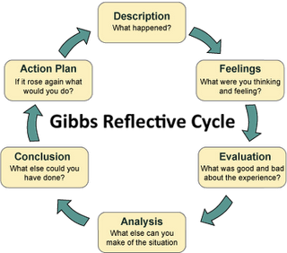

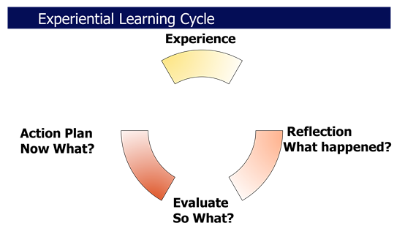

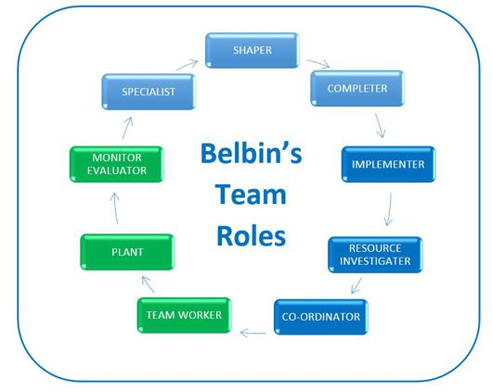

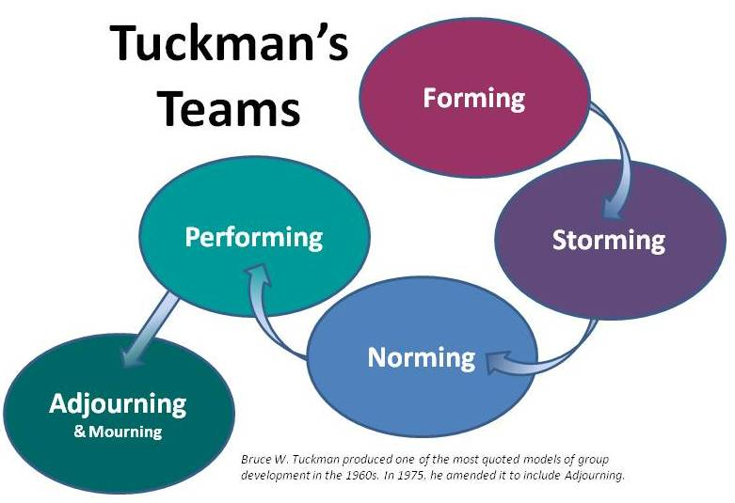
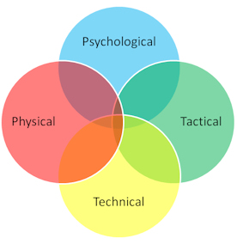

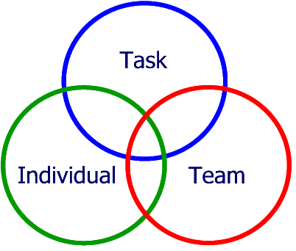John Adair

Tasks:
Task One:
Using the reflective models and models of teamwork you need to reflect on how the activities undertaken, critically evaluate your role in that activity, how well you worked as a team and your leadership skills.

You need to apply the theories discussed and any other theories you wish to use. Make sure you Harvard reference.

Use this electronic version of the diary to submit your reflective writing.

Task Two:
You need to keep a reflective diary of your fitness. There are 20 fitness sessions per semester, 50% of the mark is attendance for all of those sessions. The diary is a record and evidence that you attended these sessions.
In the diary you will need to reflect on your performance, what level you started at, how has your fitness changed and developed during the year.
You will need to show the use of reflective theory in your answers.

Record all your entries in this electronic diary and submit through turnitin by 4th May 2018.

Outdoor Session One:
Activity: Surfing
Performance Evaluation: Surfing was really fun and a great experience despite the cold water. Although the water was cold it was a lovely day and a great bonding environment. Surfing was more challenging that I initially thought and put not only my team work but fitness to the test, this is Kolb`s concrete experience stage (McLeod 2017). It was important to work as a team as I would consider it quite a dangerous sport due to the water and the foot cable on the board. Before entering the water, the instructors made sure that we all knew each other’s names, also, he made sure that we understood hand gestures which were the instructions that he wished for us to follow while in the water. These were critical as they were a matter of life and death. We learned how to paddle and stand up on the board on the beach before entering the water as it was important that we knew how to carry out the task correctly. In order to get the boards down onto the beach we had to work in a team to carry the boards. We did this by arranging ourselves into pairs and carrying two boards at once. One person was at the front and one person at the back, this was an effective and practical way to carry the boards without causing injury to anyone’s backs. Whilst in the water one of my team mates was wiped of their board and due to the momentum of the board they hurt themselves. I walked them into to the shallow waters in order to check that they were ok and controlled their board through the waves to ensure that they did not sustain further injury.
Actions for next time: Kolb`s theory states that you learn from the experience there fore, Next time I would wish to improve my own skills at surfing but also help my team members improve theirs (McLeod 2017). In order to be able to stay in the water for a longer period of time I am going to purchase wet suit gloves as this was the only part of my body which felt the cold. Once I became cold my whole attitude changed and the enjoyment was taken away from me. It was quite difficult to communicate whilst in the water, therefore this lead to multiple crashes with my team mates. In order to ensure this wouldn’t happen again as my confidence will only grow I would distance myself from my team members slightly. Kolb 1974 views learning as an integrated process which each stage requires mutual support in order to feed into the next stage, in addition, he adds that it is possible to enter his cycle at any stage and then follow the cycle in a logical sequence (McLeod 2017).
Outdoor Session Two:
Activity: Coastal Walk
Performance Evaluation: Gibbs` 1988 reflective theory allows you to critically evaluate your individual performance (Mind Tools 2018). Gibbs` theory was applied throughout this activity. During this activity I was placed in a team of which I only knew one member. I wasn’t worried about this as I am a confident person and more than happy to take initiative and introduce myself to people, after all we were going to be working as a team so it was important for us all to communicate. We were provided with maps and asked to identify our location on the map at various points, this required both team work and communication as some team members had no knowledge of map reading. This activity was a challenge as it was raining and cold, due to this some members of the team lacked enthusiasm so as a team we all had to work together in order to encourage and support eachother. At certain points members of the team were becoming confused with reading the maps, I have completed both my bronze and silver Duke of Edinburgh awards and this allowed me to help and lead my team members in order to build on their map skills. Some members of the team were not wearing the appropriate footwear and were slipping in the mud due to the weather conditions on this day. In order to help these team members, I allowed them to lean on me as a support whilst ascending and descending down the mountains. Linking to Belbin`s theory I would describe myself as a resource investigator during this activity (Belbin 2018).
Actions for next time: I would remind my team that we could face many weather conditions throughout the walk and ensure that they all had appropriate foot wear and clothing, as some of the team didn’t have any form of waterproof clothing on and we were walking in the rain. When I took responsibility and lead the team whilst map reading, it left the team appreciative as they were confused as to where we were, therefore I would take on this role again as my team felt confident in my ability to read the map. Relating to the maps, next time I would take my own map case as it can be placed over my neck making it easier to carry and leaving my hands free.
Outdoor Session Three:
Activity: Rock Climbing
Performance Evaluation: Tuckman’s forming, storming, norming and performing theory was very present during this activity (Mind Tools 2018). Whilst rock climbing we were in a team of three, I found rock climbing to be rather dangerous and required complete concentration whilst supporting your team mate who was currently climbing. The two other roles within the team were belaying and a position of extra support for the person conducting the belaying. I felt under immense pressure whilst belaying as I didn’t want the person rock climbing to injure themselves. I was very nervous about completing the task at hand. Communicating was really important in order to help the climber progress up the wall as you both have a different view of the wall, therefore by communicating and team work the climber was able to achieve the top of the wall. As a team we worked really well as two members managed to reach the top of the wall. I didn’t manage to reach the top of the wall which was purely down to fear. This activity was really challenging for me, although I am not afraid of heights I felt I struggled with this activity as I lacked confidence in the thought that I was relying on a rope for my safety. Linking to this, when trying to climb down the wall I slipped which lead me to crash into the wall giving me quite a fright.
Actions for next time: Next time I would make sure I had a different shoe on as I had walking boots on and I feel a trainer may have been more suitable. In addition, I would try harder in order to reach the top as I feel as though I did not push myself enough. I would take a positive approach in order to achieve my desired outcome.
Outdoor Session Four:
Activity: Coasteering
Performance Evaluation: The coasteering activity was great fun, however required a lot of team work. In order to complete the task, it required elements of John Adair`s theory of action centred leadership, he defines his theory in three sections. The first being, the achievement of the goal/task, secondly, the group preforming the task and finally, each individual member must have taken part in the task, he believes that all three of these components are critical for success (Learn to be a leader 2018). We all had to encourage eachother to participate as it was rather scary at the beginning. We were also informed beforehand by previous groups that we may encounter seals which made us all apprehensive and nervous about what might be in the water with us. Before entering the water, our instructor explained how to stay safe in the water and what to do when approaching the rocks. We also all wore safety equipment including a life jacket and a helmet. In order to get out of the water required team work as it was often challenging due to the un even surfaces and uncomfortable textures. We communicated with eachother the best possible way to get out of the water which was safe as easy. In order to reach the water, we had to climb over uneasy grounds which was challenging for some members of the team. We all supported eachother and helped eachother when needed. Team work was also involved when we had to check that each other’s buoyance aid was fitted correctly and suitable to enter the water.
Actions for next time: If I were to do this activity again I would carry out all of my actions the same as I felt they were effective and as a team we worked well together. However, I would try to encourage the more frightened team members and I would try and calm my team mates down when panicking about what potentially may be swimming around them. I am a strong swimmer so helped people who were not as confident in the water and I would do this again. I would stick to the same team as I felt that we worked well together and Belbin`s theory of team roles reflected through each member of the team making us successful (Belbin 2018).

Fitness Diary:
Date: 2/10/17
Activity: HIIT
Performance Evaluation: As it was the first session back after the holidays I found it challenging and ached for the following five days. However, I enjoyed.
Actions for next time: Maintain and improve my fitness level.
Fitness Diary:
Date: 5/10/17
Activity: No fitness
Performance Evaluation:
Actions for next time:
Fitness Diary:
Date: 9/10/17
Activity: HIIT
Performance Evaluation: Due to my own efforts of attending the gym in my spare time I ached for two days. I went swimming afterwards which I felt helped relax my muscles.
Actions for next time: Continue to improve my fitness for personal and professional reasons.
Fitness Diary:
Date: 12/10/17
Activity: Absent (Specials)
Performance Evaluation:
Actions for next time:
Fitness Diary:
Date: 16/10/17
Activity: Bleep Test
Performance Evaluation: Achieved level 7.8
Actions for next time: Continue to improve and hopefully achieve a higher score.
Fitness Diary:
Date: 20/10/17
Activity: HIIT
Performance Evaluation: This workout included multiple movements which were concentrated mostly on training the abdominal area. I really enjoyed this class as abs are my favourite area to work and I feel that my core strength is a strong point of mine.
Actions for next time: Continue to improve and hopefully achieve a visual outline of a six pack.
Fitness Diary:
Date: 23/10/17
Activity: HIIT
Performance Evaluation: This session included weights, I used a 2kg dumbbell and a 5kg plate for various exercises. As I have said I love working my abs so I used the 5kg plate to my Russian twists in order to make it that little bit more challenging and thoroughly enjoyed. I also used the 5kg plate for the shoulder exercises, as I don’t often do weighted exercises on my shoulders when I attend my own gym my shoulders were aching the following day.
Actions for next time: Continue to improve my shoulder strength on my own time and in university so I have more strength in them and continue lifting weights in order to sustain muscle shape and strength.
Fitness Diary:
Date: 26/10/17
Activity: Cancelled
Performance Evaluation:
Actions for next time:
Fitness Diary:
Date: 30/10/17
Activity: HIIT (45 seconds on 15 seconds off)
Performance Evaluation: This class concentrated mainly on arms, which is admittedly is my weakest area to exercise. My arm strength is so poor that they started to ache during the class as well as the following day. The weights I used were the 5kg disk and the 2kg dumbbell.
Actions for next time: Continue to improve my arm strength in order to be able to complete the workout without my arms aching during the workout.
Fitness Diary:
Date: 2/11/17
Activity: Weighted Bleep Test
Performance Evaluation: I achieved level 6.2 whilst carrying weights, maximum wright achieved was 8kg. I felt that I had an effective method in order to complete the task as I carried the weights with my arms extended down in order to relieve the pressure on my arms, allowing me to contain more energy.
Actions for next time: I achieved this result on five hours sleep the previous night before, due to metpol. If I were to complete this again I would ensure I had the appropriate rest.
Fitness Diary:
Date: 6/11/17
Activity: Dodgeball
Performance Evaluation: This session focused on team work. As a team we discussed our plan of action before the actions were carried out. I was sweating after the games more than I expected, and my heart rate increased from the adrenaline and excitement.
Actions for next time: Change the teams so that I get the chance to work with everyone on my course, also adopt new strategies in order to win.
Fitness Diary:
Date: 9/11/17
Activity: Cancelled
Performance Evaluation:
Actions for next time:
Fitness Diary:
Date: 13/11/17
Activity: Rhosilli
Performance Evaluation:
Actions for next time:
Fitness Diary:
Date: 16/11/17
Activity: Reading Week
Performance Evaluation:
Actions for next time:
Fitness Diary:
Date: 20/11/17
Activity: Zumba
Performance Evaluation: this is a way to have great fun while exercising, and you don’t realise how much you are actually sweating. After the higher intensity dances I found myself very out of breath.
Actions for next time: Continue with the same amount of effort as my clothes were saturated in sweat which suggests I had a good workout and continue to enjoy.
Fitness Diary:
Date: 23/11/17
Activity: Dodgeball
Performance Evaluation: Again, this session was focused on team work whilst improving fitness.
Actions for next time: Continue to focus on exercising during the games as well as having fun.

Fitness Diary:
Date: 27/11/17
Activity: High Intensity Fitness Team Games
Performance Evaluation: Continuous exercise with minimal rest periods. The games were focused on team work as well as fitness. I felt as though my fitness was strong and completed the session easily yet managed to work up a sweat.
Actions for next time: Carry out the activity the exact same way as I feel that I excelled and my fitness level was very good.
Fitness Diary:
Date: 30/11/17
Activity: Absent (Specials)
Performance Evaluation:
Actions for next time:
Fitness Diary:
Date: 4/12/17
Activity: Weights session
Performance Evaluation: Due to my own efforts of attending the gym my strength has improved massively. In this session I made my weights heavier by using the 4kg dumbbell and the 10kg plates on the bar. I was aching the following day especially in my legs. But to me aching is a reward as it means you had a good work out. I wasn’t able to do many weighted lounges and they hurt my knees.
Actions for next time: build up the mobility in my knees so that I can double my reps with lunges. This is something I have been working on in my own time at the gym.
Fitness Diary:
Date: 11/12/17
Activity: Cancelled
Performance Evaluation:
Actions for next time:
Fitness Diary:
Date: 29/1/18
Activity: Legs, Bums and Tums
Performance Evaluation: Due to my own fitness sessions being my main fitness sessions the university sessions I applied a medium amount of energy into as I didn’t want to tier myself too much and keep energy for my later sessions. Therefore, I used the 4kg dumbbell and the 6kg bar for this session. This was a very good session and still allowed me to ache, which I enjoy. The stretching movements which we did at the end were also really lovely to include and very beneficial to me and made me feel very relaxed.
Actions for next time: I would like to do the stretching movements again. I would also keep to a similar weight as I felt it was the perfect balance, allowing me to ache but not tire me too much so I was able to do my own workout later that day.
Fitness Diary:
Date: 5/2/18
Activity: Cancelled
Performance Evaluation:
Actions for next time:
Fitness Diary:
Date: 12/2/18
Activity: Multi-Purpose Fitness
Performance Evaluation: 45 minutes continuous exercise with low intensity rest periods. I felt as though during this class my level of fitness was really good and I felt fit and confident through the whole duration. I didn’t feel as though I was struggling and able to do all the tasks asked as soon as they were asked to which thoroughly enjoyed. We worked all areas of our body combining cardio and natural body weight.
Actions for next time: Continue with the same application as I felt I excelled in this session and my fitness was strong yet being challenged which I liked. In addition, it was great fun.
Fitness Diary:
Date: 19/2/18
Activity: HIIT
Performance Evaluation: This was a circuit HIIT session where I struggled with the chest exercises as I don’t regularly exercise that area. My chest and arms were aching the following day.
Actions for next time: I have been building up my chest muscle at the gym, so next time I am better prepared and will be more confident in these exercises.
Fitness Diary:
Date: 26/2/18
Activity: Circuits
Performance Evaluation: I increased my weights in order to challenge myself, and I enjoyed. Slightly aching the following day due to increasing my weights but I was able to keep up with my normal amount of reps.
Actions for next time: Continue with the new heightened weight.
Fitness Diary:
Date: 12/3/18
Activity: Dodgeball and Bench ball Performance Evaluation: Both these activities were focused on team work as well as fitness. Performing well as a team can sometimes become more challenging when everyone feels pressure especially when exercise is added to the mixture. I felt that I was fit throughout the both activities and didn’t sweat that much although my heart rate was increased and my adrenaline was going.
Actions for next time: Continue to adopt new method s and strategies in order to win.
Fitness Diary:
Date: 19/03/18
Activity: Bleep Test
Performance Evaluation: Achieved level 7. I was happy yet disappointed with my result. My mind gave u before my body as I know I could have continued, I didn’t have the right attitude towards the bleep test on this particular day. However, I achieved over the requirement for entrance to the police force.
Actions for next time: Don’t give up so soon and continue until my body wont physically let me carry on in order to challenge myself. In addition, I would like to know in advance so that I can wear the appropriate clothing. I was wearing a long sleeve top which I don’t enjoy running in as I get too warm, I require a vest top so that the heat my body is producing can escape in order to cool me down allowing me to continue.
Fitness Diary:
Date: 26/03/18
Activity: Cancelled
Performance Evaluation:
Actions for next time:

Final Evaluation on fitness.
In 500 words give an evaluation of how you feel that your fitness has changed and developed over the last year.
My fitness has definitely improved over the past year. In the past year my attitude towards fitness has changed for three reasons. I appreciate that it is required for some public service organisations and don’t want to allow something as simple as fitness to limit my chances, secondly, I appreciate that being fit and healthy is a positive way to live life and finally, I love the visual aspects of keeping fit and seeing my body shape change for the better, including gaining muscle definition. My fitness has improved not only due to fitness sessions with university but I attend the gym myself a minimum of three times a week. Exercising gives me a thrill and allows me to destress and I feel it provides me with more energy. I have also noticed, that my strength has improved I am able to do a lot more weighted movements now than at the beginning of the year, in addition, I have noticed that the amount of weighted reps I am able to complete has improved drastically. Linking to this, my flexibility has improved which allows me to incorporate multiple movements into my exercise. In order to pass the current police fitness test, you have to obtain level 5.4 on the bleep test I am already exceeding this as my highest achievement this year was 7.8 however, this is lower than my highest last year, I believe this to be purely down to mind set. I want to improve my bleep test score as it is something which I want to improve on for myself. In order to secure a place in my chosen organisation upon graduation it is important to maintain this standard of fitness. I have also noticed that due to my new exercise regime that my weight has increased. This is not concerning to me as I know it is due to my muscle development. As I previously mentioned I am visually leaner now than at the beginning of the year, this is something that gives me great pleasure as it is something I have wanted to achieve for a while but never had the appropriate mind set. I have surprised myself this year with my new love for fitness which I am thoroughly enjoying and I think it is something I will stick to forever. I have always been fit but there is always room for improvement, within the next year I would like to become even fitter and stronger as I am aware that the role of a police officer can be very demanding on your body so it is very important to be fit and I want to allow myself to be in the best possible position. Also, being fit and healthy allows you to recover better from any injuries I may suffer. The above reflection is based on Gibbs` theory (Mind Tools 2018).

References
Belbin (2018), The Nine Belbin Team Roles, (Online), Available at, http://www.belbin.com/about/belbin-team-roles/ , Accessed on the 17th May 2018.
McLeod (2017), Simply Psychology, Kolb – Learning Styles, (Online), Available at, https://www.simplypsychology.org/learning-kolb.html , Accessed on the 17th May 2018.
Mind Tools (2018), Gibbs` Reflective Cycle, (Online), Available at, https://www.mindtools.com/pages/article/reflective-cycle.htm , Accessed on the 17th May 2018.
Mind Tools (2018), Forming, Storming, Norming and Performing, (Online), Available at, https://www.mindtools.com/pages/article/newLDR_86.htm , Accessed on the 17th May 2018.
Learn to be a Leader (2018), John Adair`s Action Centred Leadership, (Online), Available at, https://www.learn-to-be-a-leader.com/john-adair.html , Accessed on the 17th May 2018.

