Title Page
Student Name: Darlington Chidiebere Agu
Student ID:2529429
Programme of Study:
Module Name: CertHE Computing Skills For Workplace
Module Code: ACCA4026
Lecturer’s Name: Martin Svejda, Osman Elgawi
University: University Of Wales, Birmingham, Trinity St Davids
Date of Submission:24/03/2026

Table of Contents
1. Task 1: e-commerce website Builders/Software Solutions
2. Task 2: Mind Mapping of Contemporary Software Applications
3. Task 3: Office Applications for Creating, Storing, Presenting and Analysing data
4. Task 4: Communication and Collaboration Applications
5. References

1:1 Wix:

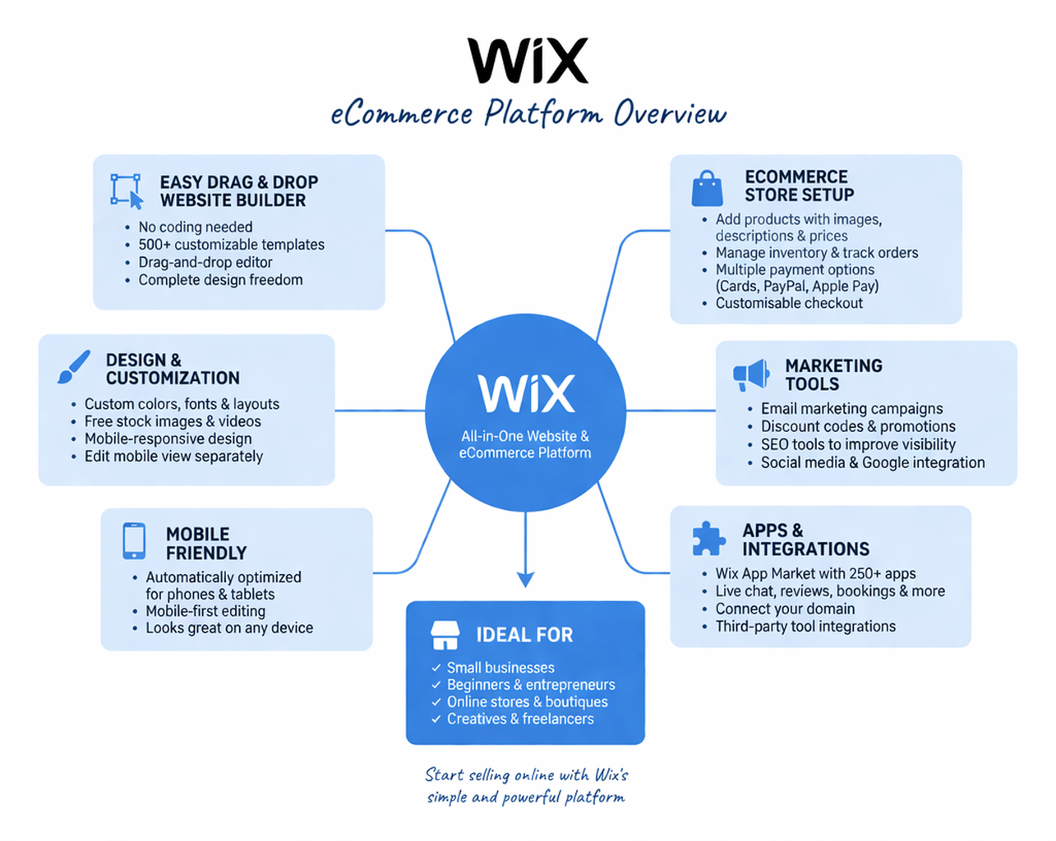

When I first found Wix, I was struck by how easy and welcoming it seemed, especially for people without much experience in coding or web design. It’s an all-in-one platform where you can build an eCommerce website from the ground up without any technical know-how. That makes it a great choice for beginners or small business owners who want to get started online.
My favourite thing about Wix is its drag-and-drop feature. It really feels like you’re just moving things around on a page, however you like. You can choose a template that fits your brand or style, then change anything you want, like images, text, colours, and layout. It gives you plenty of creative freedom without making things complicated. I enjoyed using it because it feels more like designing than coding [1]
For e-commerce, Wix makes setting up an online store simple. You can add products, write descriptions, upload images, and set prices with ease. It also lets you manage inventory, track orders, and offer different payment options like cards or PayPal. This is helpful because it covers everything you need to run a business, not just create a website.[2]
I also noticed that Wix comes with built-in marketing tools. You can create email campaigns, offer discount codes, and optimise your site for search engines. This matters because having a website is one thing, but getting visitors is another. Wix gets this and gives you tools to help your business grow.
I like that Wix is mobile-friendly. Sites you build with it automatically look good on phones and tablets, which is important since most people shop on their phones now. You can even edit the mobile version separately if you want more control, which is a handy feature.
However, while Wix is great for beginners, it can feel limiting if you want advanced customisation or need to scale up. It’s perfect for getting started, but bigger businesses with more complex needs might find other platforms more flexible.
Overall, my impress Overall, I think Wix is a simple, practical, and user-friendly eCommerce website builder. It takes away the stress of making a professional online store and makes the process more creative and straightforward. I’d recommend it to anyone who wants to start selling online without worrying about technical details. Who wants to grow and scale their e-commerce brand? Wix should be the Best [3]

1:2 Shopify
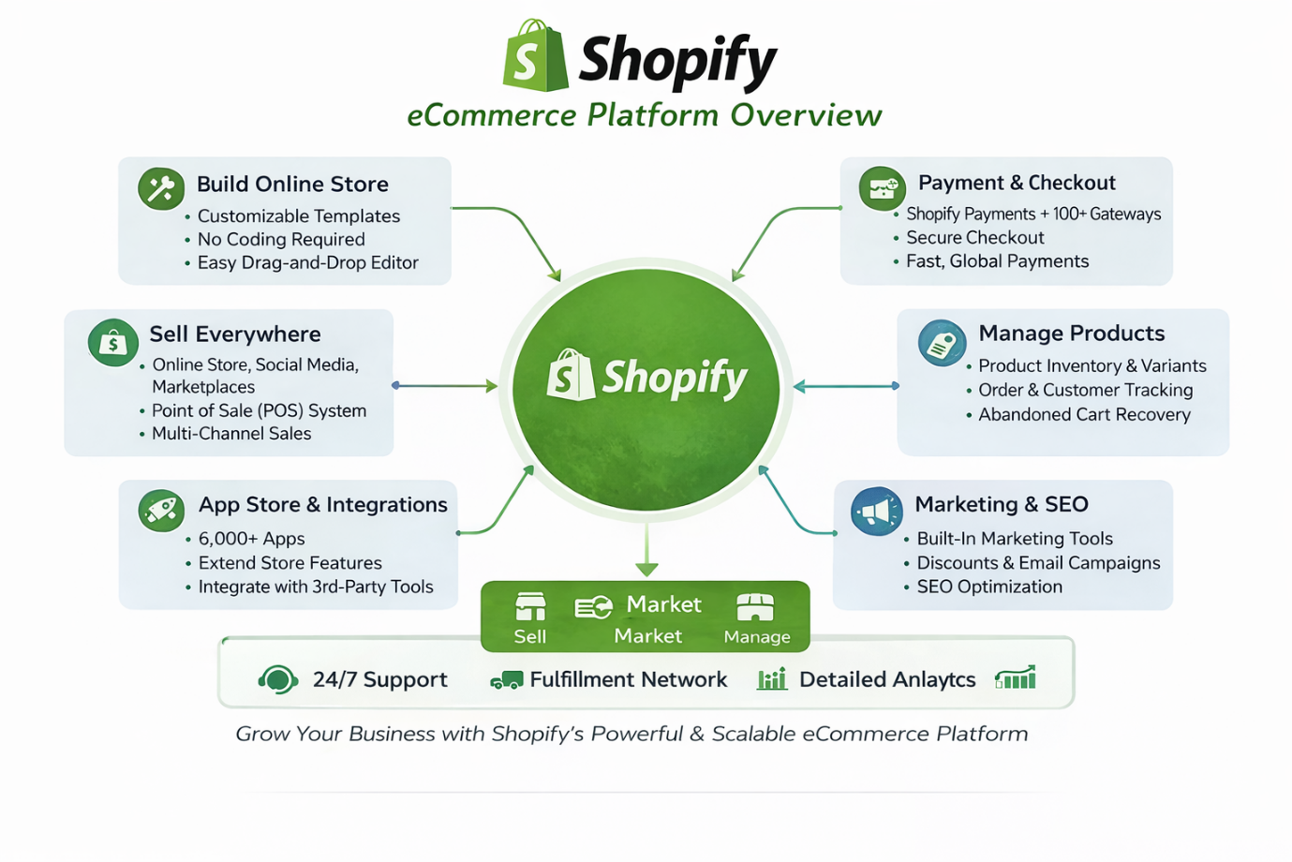
When I first looked into Shopify, what really stood out to me was how professional and business-focused it feels compared to other website builders. It’s clearly designed for people who are serious about selling online, whether you’re just starting a small store or planning to build a big brand.
One thing I immediately noticed is how smooth the setup process is. Shopify guides you step by step, so you’re not left guessing what to do next. From adding your first product to setting up payments and shipping, everything is laid out in a way that makes sense. Even though it’s more advanced than some platforms, it still feels manageable.[4]
What I like about Shopify is how strong its eCommerce features are. Adding products is straightforward, you can include descriptions, prices, images, and variants like sizes or colours. It also helps you keep track of stock automatically, which is useful if you’re selling multiple items. The order management system is another highlight because you can easily see what’s been purchased, what needs shipping, and what’s been delivered.
Another thing that impressed me is the range of payment options. Shopify supports different methods like card payments, PayPal, and even its own system called Shopify Payments. That flexibility makes it easier for customers to check out without any issues, which is important if you want to avoid losing sales.[5]
I also think Shopify does a great job when it comes to design. There are plenty of themes to choose from, and they look clean and modern. While it’s not as “drag-and-drop” as some platforms, you can still customise your store quite a bit to match your brand. It feels more structured, which in a way makes your website look more professional.
One thing I found powerful is the app store. Shopify has loads of apps that you can add to your store to extend its features things like marketing tools, customer reviews, drop shipping, and analytics. It’s like you can build your store exactly how you want it, depending on your needs.
Another big plus is how Shopify handles the technical side of things. You don’t have to worry about hosting, security, or updates—it’s all taken care of. That means you can focus more on running your business instead of dealing with the backend.[4]
However, I did notice that Shopify can get a bit expensive, especially when you start adding apps or upgrading your plan. Also, if you want full control over every detail, you might find some limitations unless you know how to code.
Overall, my impression of Shopify is that it’s a powerful and reliable platform for building an online store. It feels more serious and business-oriented, which I think is perfect for anyone who wants to grow and scale their eCommerce brand. If you’re looking for something that can handle both small and large operations, Shopify is a strong option.[5]

Task 2: Mind Mapping of Contemporary Software Applications
Mind mapping is a visual representation of ideas in diagram form. It presents information, ideas, and illustrations in a clear and structured way. As the name suggests, a mind map starts with a main idea or illustration at the centre and then branches out into sub-ideas and related information.
This method helps individuals and organisations understand information more easily by highlighting important keywords and relationships between ideas. Mind mapping makes brainstorming, problem-solving, and decision-making clearer and more manageable.
By arranging information and ideas into sub-diagrams, users and viewers can easily understand the message being communicated. This improves the way information is passed from one person to another, making communication more effective and efficient.[6]
- Benefits of Mind Mapping: Mind Mapping Provides Clarity and understanding. In Most Business Organisations, they use Mind Maps because it helps reduce the burden on employees and workloads.
Mind Map helps to improve work productivity and efficiency, through visually organising ideas, making it possible for most organisations and teams to connect ideas and priorities visually. Through Mind Mapping, most people will visually have a direction to where they are going. It also brings out the beauty in creativity and problem-solving by allowing individuals to explore ideas freely without restrictions, which can lead to something so innovative.
Mind Mapping is a valuable tool that every organisation should have in their daily use for easy workflow, clarity, communication and decision making.[7]

Task 2:2 Mind Mapping Showing Contemporary Software Applications Used in Business Operations
Contemporary Software Application in Business

Microsoft Word

Google Workspace

Alibaba

Gmail

Xero
Task 3 a: Office Applications for Creating, Storing, Presenting and Analysing Data

3.1 Microsoft Word
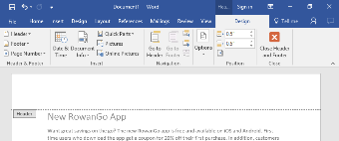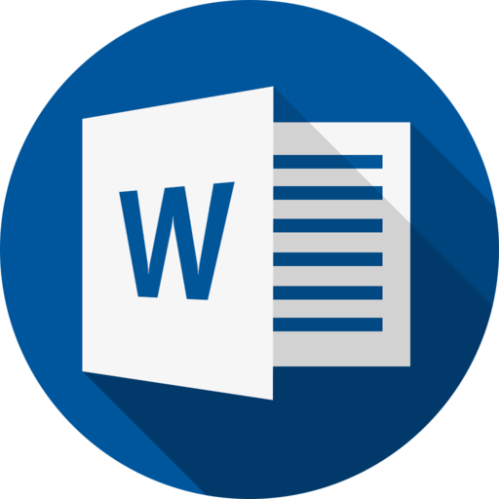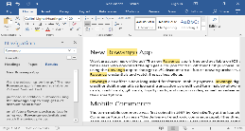
This Photo by Unknown Author is licensed under CC BY
This Photo by Unknown Author is licensed under CC BY

This is a word-processing application used to create, edit, and format documents such as letters, reports, and contracts. Microsoft Word allows people to work on tasks together while tracking changes. It has loads of features that make it more efficient for users, including spelling and grammar checks, page layout and design, reviewing and commenting, collaborating and sharing, using Templates, and a user-friendly Interface.[8]
Microsoft has built in features that make teamwork easier. For example:

- Multiple people can edit a Word document at the same time
- Teams can share files instantly through OneDrive
- Microsoft Teams allows video meetings, chat and file sharing. These tools help improve communication and reduce delays in the workplace.[9]

- Benefits: Microsoft Word is so easy to use. In workplaces, organisations, and businesses. It suits almost all devices and can be accessed anywhere, making it remote and flexible. It also offers strong collaboration tools and features, such as editing in Word and Excel, along with communication tools in Microsoft Teams, thereby making teamwork faster and more organised.[10]

3.2 Microsoft PowerPoint

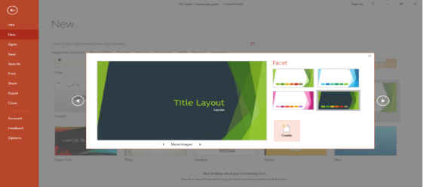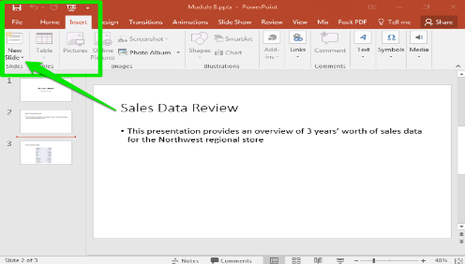
This Photo by Unknown Author is licensed under CC BY

This is basically a tool for sharing ideas in a way people can easily follow. It helps you put your thoughts into clear, visual slides that are easy for your audience or business to understand. Each slide is like a page in your story. You can keep them simple or make them as creative as you want; they're user-friendly. Think of it as a digital canvas where you can drop in:
- Words that will explain your point and give you clarity
- Pictures that make things clearer
- Videos that will bring your ideas to reality
- Charts that make numbers less boring
- Animations that add personality

However, The Design qualities can matter at times, which can cause a limitation.

- Benefits
- Microsoft makes communication clearer and more concise
- It keeps your audience glued and interested in your work
- It's easy for everyone to use.
- Its supports teamwork
- It makes your work look professional
- It’s compatible with Most Devices such as iOS, Mac, and PC’s[11]

3.4 Microsoft Excel

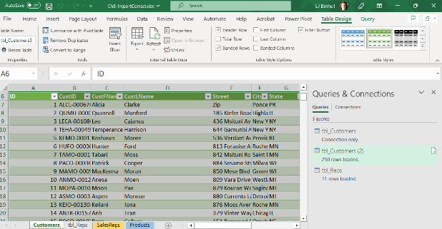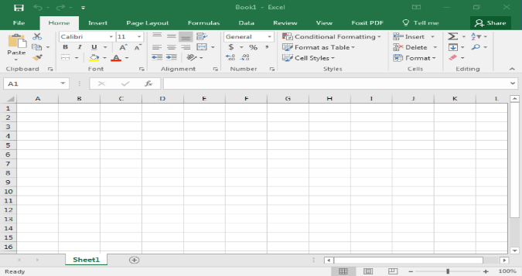
This Photo by Unknown Author is licensed under CC BY-NC
This Photo by Unknown Author is licensed under CC BY

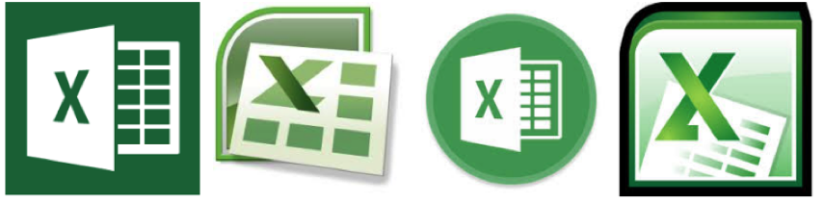
This Photo by Unknown Author is licensed under CC BY

When you think of numbers, calculations, tables, lists, or any kind of information that needs organising. This is the best Life Organiser that organises your work and ideas. It's the hero for most schools, budgets, business decisions and even personal planning. This is one of the most Used Microsoft tools in almost all organisations.
Like a spreadsheet tool, it’s the most powerful way to organise information, understand data, and make smarter decisions. Its ability to handle everything from simple lists to massive datasets makes it truly essential in today's digital world.
At the end, Microsoft Excel stands out not just for organising data but also for its ability to handle advanced calculations and data analysis, making your work concise, clearer, and cleaner.[12]
Benefits
- It Helps Reduce Mistakes
- It Makes Data easy to research
- It Helps You stay Organised Long term
- It Supports decision Making
- Its Great for Planning
- It’s Very Customizable
- Its Widely Used Everywhere

3.4 Microsoft Access

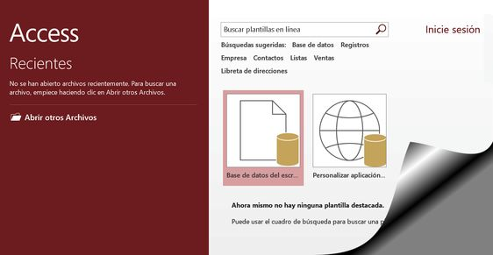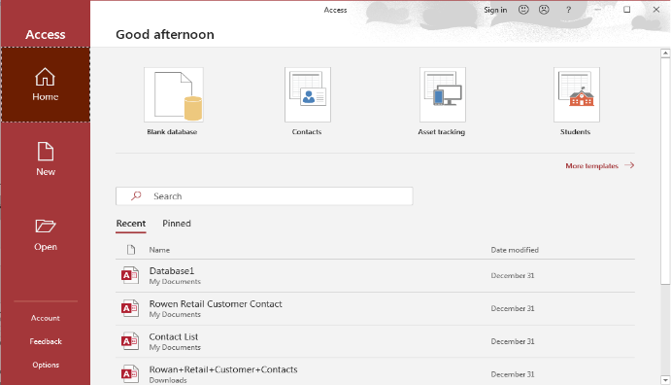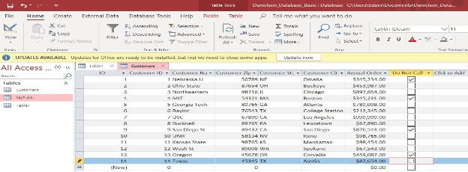
This Photo by Unknown Author is licensed under CC BY-SA-NC
This Photo by Unknown Author is licensed under CC BY
This Photo by Unknown Author is licensed under CC BY
This is an advanced form of Microsoft Excel. When Microsoft Excel turns into a baby, Microsoft Access comes in because it's way more advanced than Excel. At its advanced form, Microsoft Access helps you organise large amounts of information in a way that stays clean and structured. Access helps you break down information into separate tables, link them, and connect them in order, which is what makes it a top-notch tool in Microsoft.
Microsoft is special; it can help you build your own apps without being a developer and gradually grow into your needs.[13]

Microsoft Access creates a level of balance that helps you organise your information more effectively, allowing you to build a safe, well-structured system that keeps you connected, balanced, and consistent, so you can retrieve it whenever you need it. Microsoft Access may be limited cause its not designed for very large datasets and also an Access license.
Benefits
- Microsoft Access helps keep your data Consistent and Accurate
- It makes searching and filtering easier
- Microsoft Access Helps You Create Professional Reports
- Its Helps Support Team work
- It Saves Time Through Automation
- It's More Advanced Than Excel
- You Can Customise it to your Needs
- Its Less Affordable and cost-effective [14]

3.b Test any two features from the following: Mail Merge, IF Function, VLOOKUP, Pivot Table, Goal Seek in MS Excel and document several Screenshots With accompanying descriptions to provide evidence of practical use

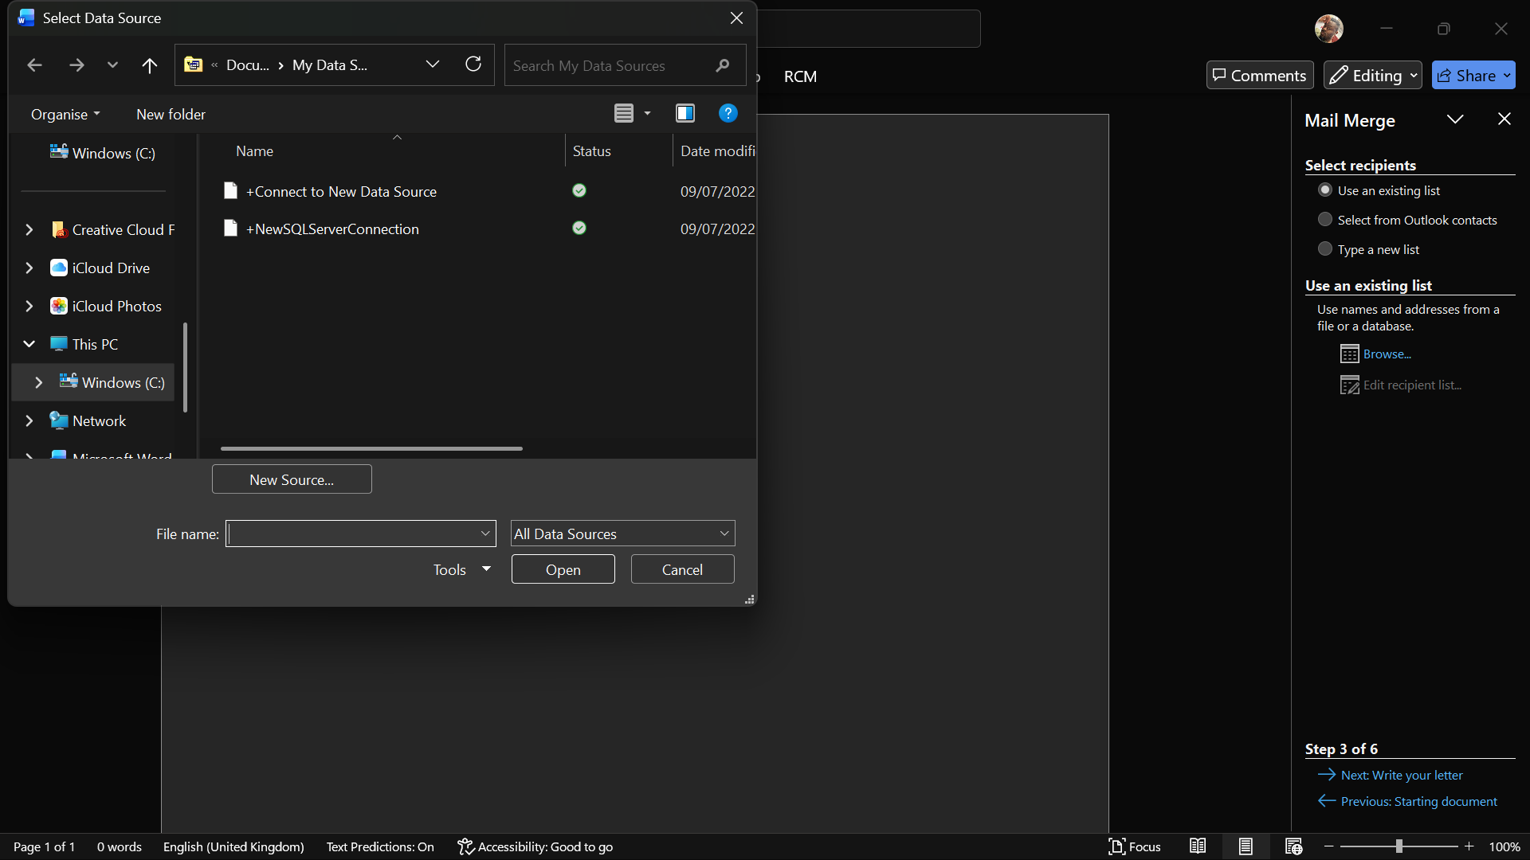
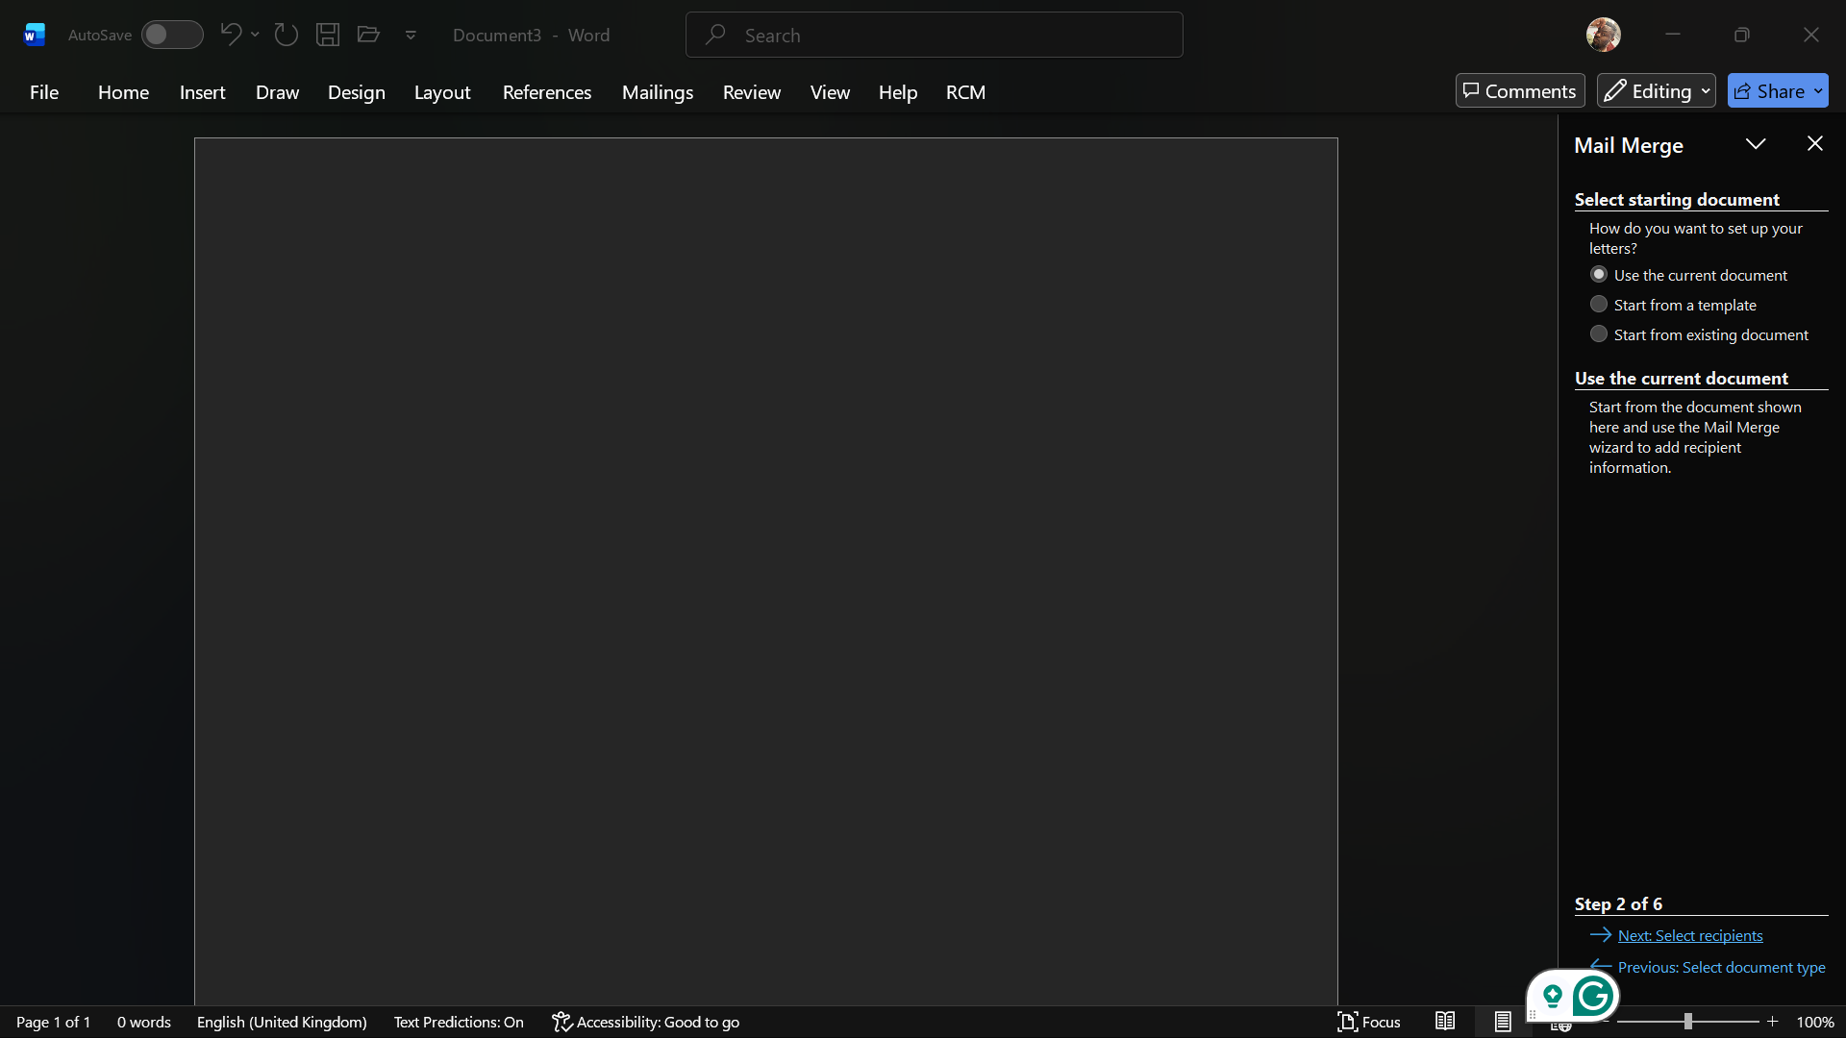

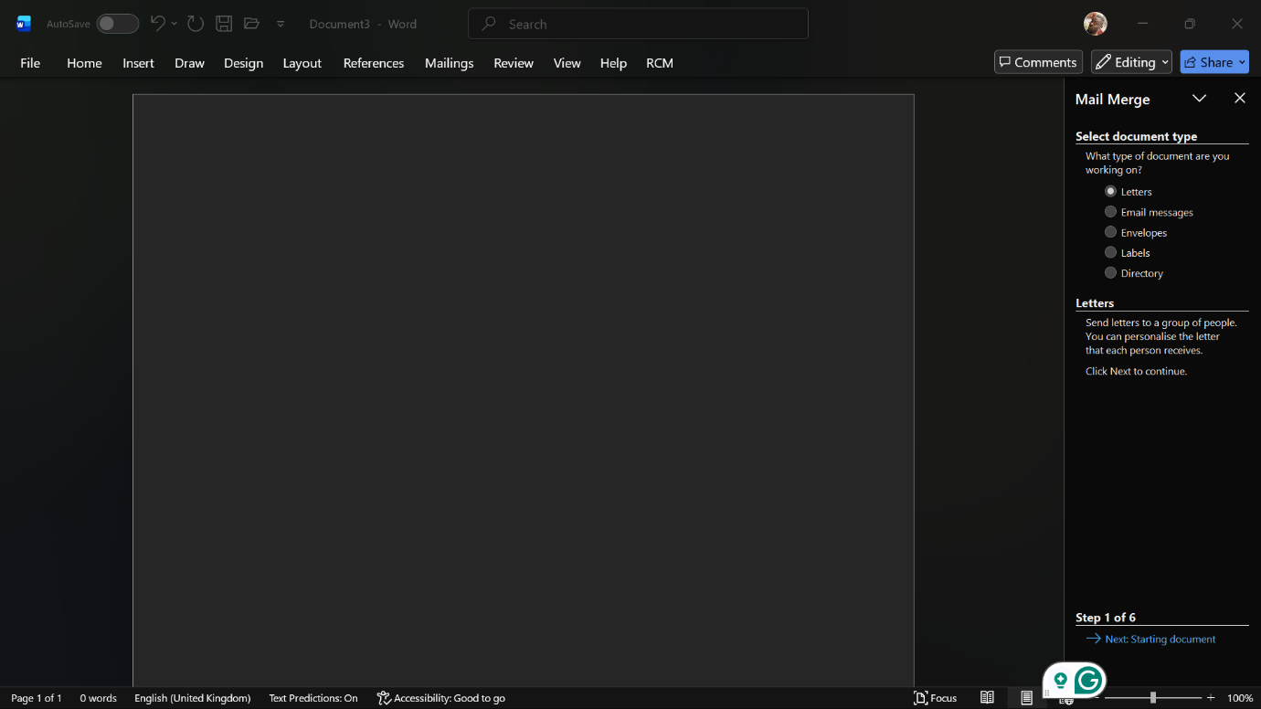

3.b.1 VLOOKUP: In this activity-based exercise, I decided to choose VLOOKUP as one of the functions in Microsoft Excel. In the images below, you can see that the table is used to represent students' best subjects instead of typing it manually [15].

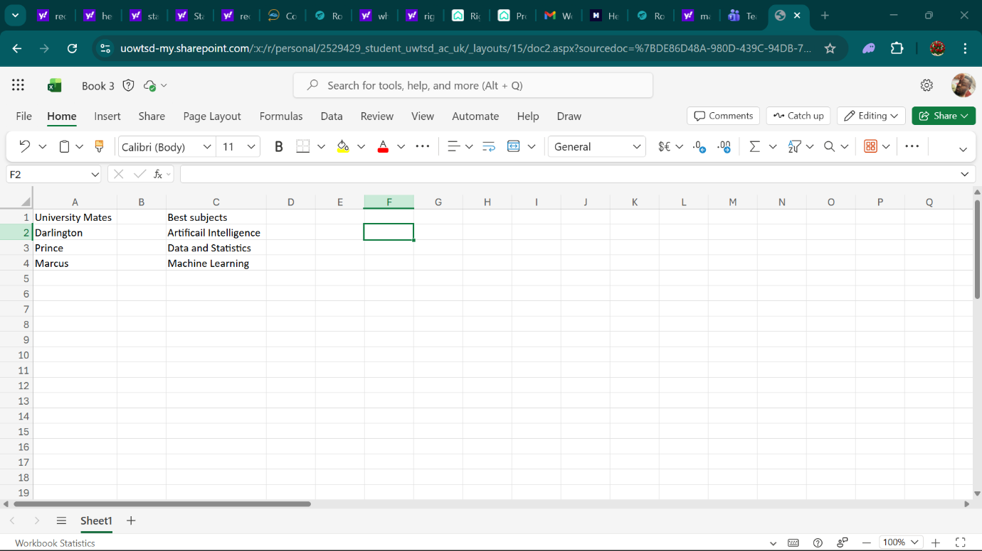
First, I created a table with my name and my fellow students' names, and in the next column, I listed their best students in subjects such as Artificial Intelligence, Data and Statistics, and Machine Learning. Then I went further by using the VLOOKUP formula to find each student's best subjects and return their best subject
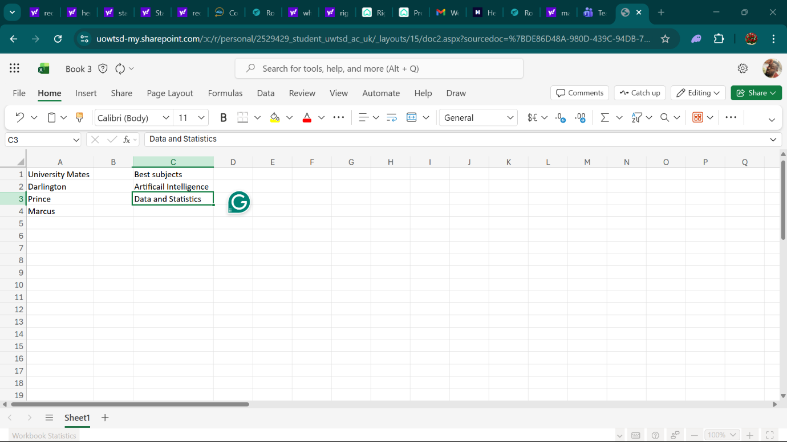
Furthermore, what the formula does is simple. VLOOKUP helped me look up the name in the first column, then go across that same row and return the matching subject. This is done once I type it in, and Excel automatically fills in the correct subject. This made my work much easier and clearer, and kept me from making mistakes.
Using VLOOKUP in Microsoft Excel has taught me how powerful it is. It Makes Work faster, more Organised and more accurate [16]
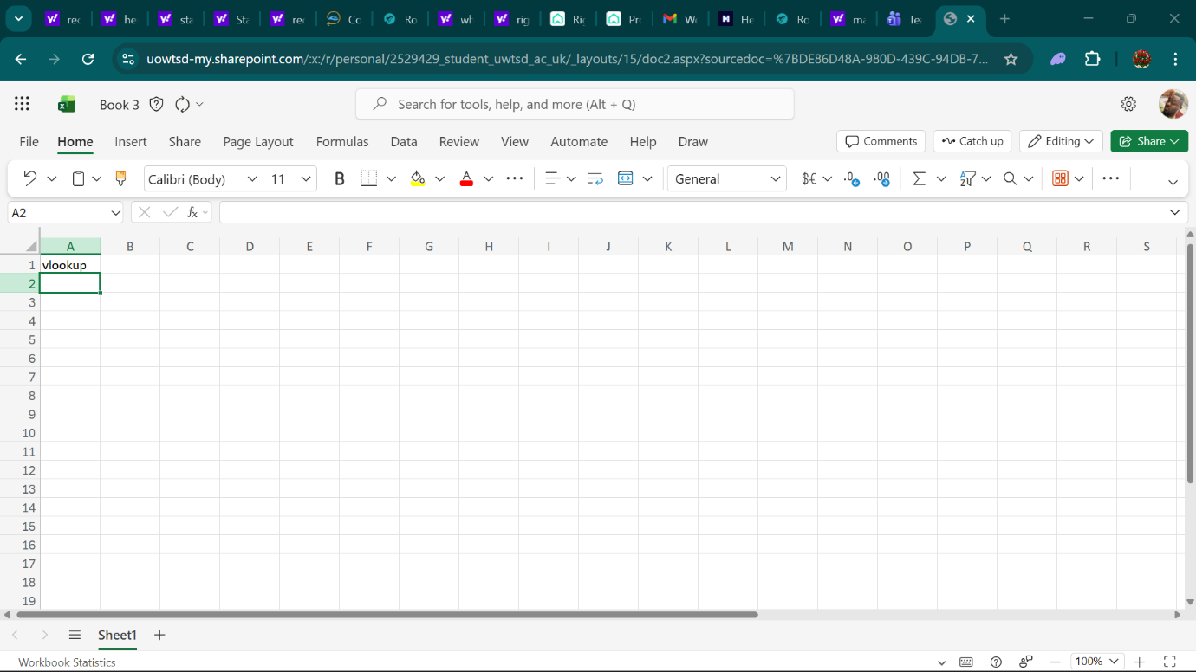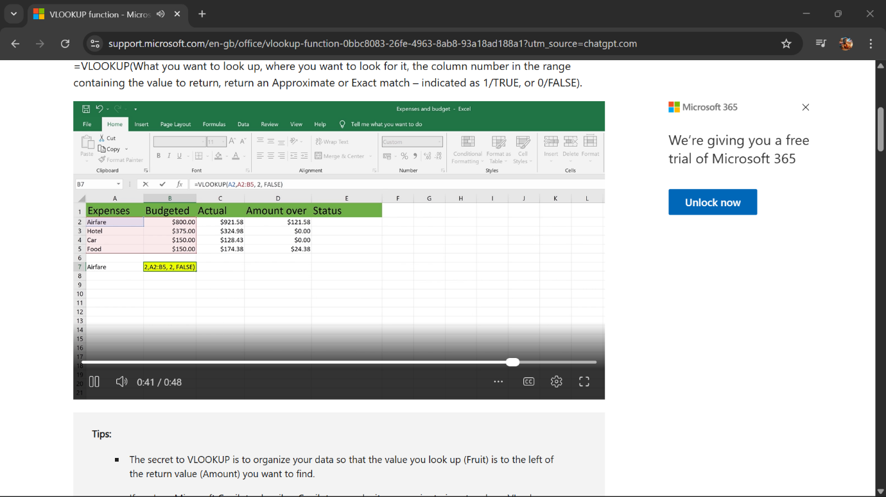

Task 4: Communication and Collaboration Applications
Communication and Collaboration Applications
In the contemporary business environment, communication and collaboration tools are essential for enabling teams to operate efficiently, particularly with the increasing prevalence of remote and hybrid work arrangements. Two widely adopted tools in this domain are Slack, a communication application, and Microsoft Teams, an online collaboration application. Both platforms aim to improve teamwork, streamline communication, and enhance productivity within organisations.[17]
1. Communication Application: Slack

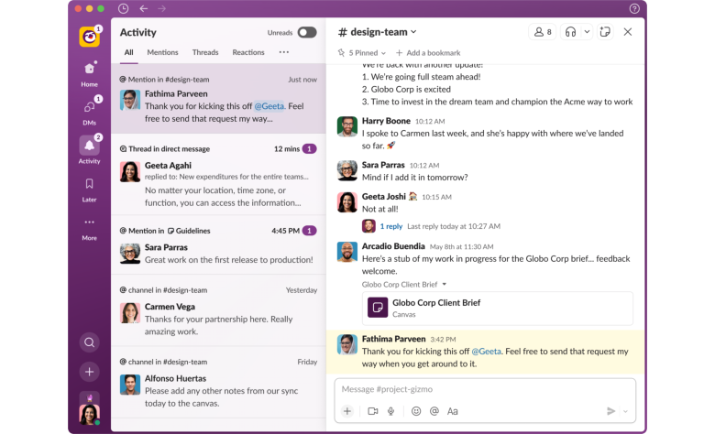

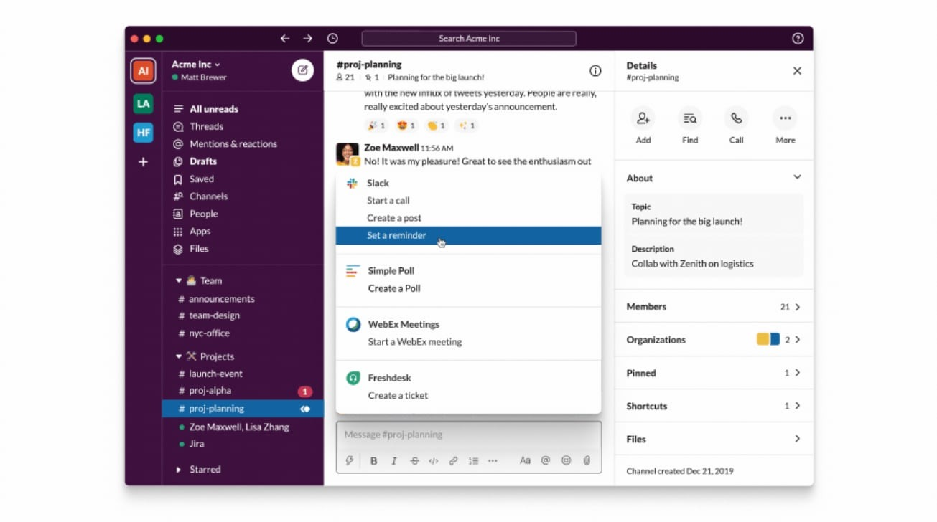
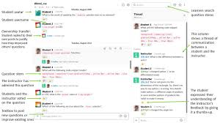

Slack is a cloud-based communication tool that primarily facilitates real-time messaging and team interaction. It serves as a modern replacement for email, offering faster and more organised communication.
Key Features
A key feature of Slack is its channel-based communication system. Rather than relying on lengthy email threads, Slack enables users to create channels dedicated to specific teams, projects, or topics. This structure organises conversations and makes them easier to follow. For instance, a company may establish separate channels for marketing, finance, another significant feature is real-time messaging. Users can send instant messages to individuals or groups, which accelerates communication and increases efficiency compared to email. Additionally, messages are searchable, allowing users to easily locate previous conversations or shared files as needed. Red files when needed.
Slack supports file sharing and integration with external applications. Users can upload documents, images, and videos directly into chats. The platform also integrates with numerous third-party tools, including Google Drive, Trello, and Dropbox, enabling teams to collaborate without frequently switching between platforms.
Customisation of notifications is another notable feature. Slack allows users to tailor notification settings to receive alerts only for important messages, which helps reduce distractions and enhances focus. Recently, Slack has introduced AI-powered features, including conversation summarisation and tools that assist users in quickly locating information. These developments demonstrate the platform's ongoing adaptation to contemporary business requirements. Ness needs.[18],[19]
Analysis
Slack is widely regarded as user-friendly and flexible. It is particularly popular among startups and smaller teams due to its straightforward design and extensive integration options. However, its video conferencing capabilities are less robust compared to some competing tools.
Overall, Slack is well-suited for rapid communication, effective teamwork, and operational flexibility, establishing it as a valuable communication tool in contemporary business settings.

2. Online Collaboration Application: Microsoft Teams
Microsoft Teams is a comprehensive platform that integrates communication and collaboration tools within a single interface. It is widely adopted by organizations, particularly those utilizing Microsoft 365.
Key Features
A primary strength of Microsoft Teams is its integration of multiple tools, including chat, video conferencing, file sharing, and project collaboration, within a unified platform. This integration streamlines teamwork by reducing the need for multiple separate applications.
Video conferencing and meeting capabilities are also significant features. Microsoft Teams enables users to host virtual meetings with functionalities such as screen sharing, breakout rooms, and recording, making it well-suited for remote work and large organisations.
Microsoft Teams supports real-time document collaboration. Through integration with Microsoft 365, users can simultaneously edit Word, Excel, or PowerPoint files, which enhances teamwork and minimises workflow delays.
Additionally, Microsoft Teams offers structured channels and workspaces, comparable to those in Slack, allowing teams to communicate and share files according to specific projects or departments.
Security and compliance represent another important aspect. Microsoft Teams provides advanced security features, making it appropriate for large organisations that manage sensitive data.[20]
Image Example
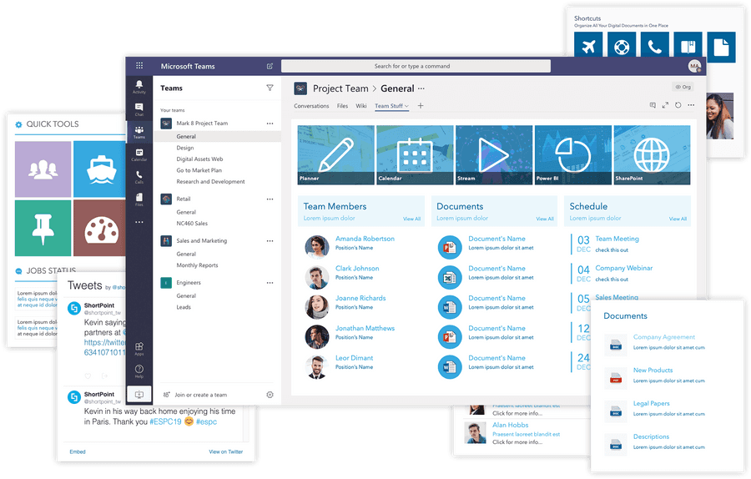

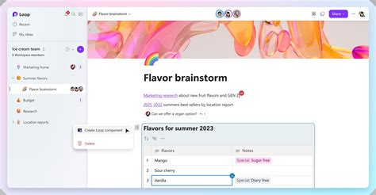

Analysis
Microsoft Teams offers more robust collaboration capabilities than Slack. It is designed for comprehensive teamwork and project management, performing particularly well in large organisations where structured communication and security are priorities. However, Microsoft Teams can be complex or overwhelming for new users. Compared to Slack, it is less flexible but offers greater structural organisation.[21]

A comparison of Slack and Microsoft Teams indicates that both tools are highly effective, although they serve distinct purposes.
Slack prioritises communication and user-friendliness, which makes it suitable for smaller teams or organisations requiring rapid and flexible messaging. In contrast, Microsoft Teams offers a comprehensive collaboration platform that integrates communication, meetings, and document sharing within a single system.
Both platforms enhance productivity, decrease dependence on email communication, and facilitate remote work. Research indicates that these tools are essential in contemporary business environments, as they promote teamwork, transparency, and operational efficiency.
In summary, selecting between these tools depends on organisational requirements. Slack is recommended for organisations prioritising straightforward and efficient communication, whereas Microsoft Teams is preferable for those seeking a more integrated and secure collaboration platform.[22],[23]

References
[1] G. Rossi, O. Pastor, D. Schwabe, and L. Olsina, Web Engineering: Modelling and Implementing Web Applications. Springer Science & Business Media, 2007.
[2] G. J. Netto and K. Kaul, Genomic applications in pathology. Cham, Switzerland: Springer, 2019.
[3] K.-P. L. Vu and R. W. Proctor, Handbook of Human Factors in Web Design, Second Edition. CRC Press, 2011.
[4] M. Khosrow-Pour D.B.A., Encyclopaedia of Organisational Knowledge, Administration, and Technology. Hershey: IGI Global, 2020.
[5] D. Chaffey, Digital Business and E-Commerce Management, 7th ed. Pearson, 2019.
[6] L. B. Nilson, Teaching at Its Best: A Research-Based Resource for College Instructors, 4th ed. San Francisco: Jossey-Bass, 2016.
[7] H. Mento, P. Martinelli, and R. Jones, “Mind mapping in executive education: Applications and outcomes,” Journal of Management Development, vol. 18, no. 4, pp. 390–416, 1999.
[8] J. A. Jacko and Constantine Stephanidis, Human-Computer Interaction. CRC Press, 2003.
[9] G. Laudon and K. Laudon, Management Information Systems: Managing the Digital Firm, 16th ed. Pearson, 2020.
[10] D. Chaffey, Digital Business and E-Commerce Management, 7th ed. Pearson, 2019.
[11] Wolfgang Schoppek, J. Funke, M. Osman, and A. Kluge, Complex Problem Solving Beyond the Psychometric Approach. Frontiers Media SA, 2018.
[12] Kieran Walsh, Oxford textbook of medical education. Oxford University Press, 2016.
[13] R. E. Mayer, Multimedia Learning, 2nd ed. Cambridge University Press, 2009.
‌[14] G. Laudon and K. Laudon, Management Information Systems: Managing the Digital Firm, 16th ed. Pearson, 2020.
[15] J. Walkenbach, Microsoft Excel 2019 Bible. Wiley, 2018.
[16] K. C. Laudon and J. P. Laudon, Management information systems: managing the digital firm, 17th ed. Harlow, Essex: Pearson Education Limited, 2021.

[17] Khosrow-Pour, D.B.A., Mehdi, Web Technologies for Commerce and Services Online. IGI Global, 2007.
[18] K. J. Kim, Nakhon Baek, and SpringerLink (Online Service, Information Science and Applications 2018: ICISA 2018. Singapore: Springer Singapore, 2019.
[19] E. K. Kelleher and D. M. Miller, “Enterprise collaboration systems and productivity improvements,” Journal of Organisational Computing and Electronic Commerce, vol. 28, no. 2, pp. 150–165, 2018.
[20] T. H. Davenport, Process Innovation: Reengineering Work through Information Technology, Harvard Business School Press, 1993.
[21] J. Roberts, “Digital collaboration and productivity in modern organisations,” International Journal of Information Management, vol. 54, 2020.
[22] Hans-Ruediger Kaufmann and Hans Ruediger Kaufmann, Handbook of research on managing and influencing consumer behaviour. Hershey, Pennsylvania: Business Science Reference, 2015.
[23] B. Stanford-Smith and P. T. Kidd, E-business: key issues, applications and technologies. Amsterdam: IOS Press; Tokyo, 2000.
‌

‌

‌

‌

‌

