

University of Wales Trinity Saint David
School of Engineering

Suspension Optimisation of the Morgan Plus 6: Enhancing Dynamics and Comfort

Taylor Winter
Automotive Engineering
1901843

01/07/2023
This thesis is the sole work of the author and is the result of original research. All works completed have been done so by the author, using resources from University of Wales Trinity Saint David and Morgan Motors. It has not been previously submitted for examination which has led to the award of a degree.
Signed: TWinter Date: 10/09/2023

My sincere thanks go to Owen Williams, Tim Tudor, and Tony Kiss for their guidance and supervision throughout this thesis. Additionally, I would like to express my special appreciation to Andrew Noble and Paul Davies for their contributions and assistance.

Abstract
The proposed suspension configuration for the Morgan Plus 6 demonstrates significant potential for enhancing both ride comfort and driving performance. Key improvements, including reduced damper forces for a smoother ride, minimized body roll for improved stability and cornering, and a lower ride height enhancing handling capabilities, mark noteworthy advancements. Additionally, the suspension's increased pitch and yaw angles offer improved weight transfer and responsiveness during manoeuvres while maintaining stability.

Further fine-tuning opportunities lie in considering dampers with slightly higher damping forces, potentially achieving a sportier feel without compromising ride comfort. Variations in the contact patch observed during different manoeuvres suggest valuable room for improvement in vehicle stability and overall driving experience.

In conclusion, Morgan Motors can leverage the proposed suspension setup to optimise the Morgan Plus 6, catering to both driving enthusiasts seeking enhanced performance and everyday drivers desiring a comfortable ride. Refinements in suspension parameters and potential damper adjustments promise to deliver a more well-rounded and appealing sports car, aligning with diverse customer expectations.

Table of Contents
Abstract 3
Table of Figures 6
1 Introduction 8
2 Literature Review 9
2.1 Ride and Handling Optimisation 9
2.1.1 Practical Testing 9
2.2 Camber Optimisation 10
2.2.1 Practical Testing 10
2.3 Suspension Hardpoints Optimisation 11
2.3.1 Practical Testing 11
2.4 Centre of Gravity Optimisation 12
2.4.1 Practical Testing 12
2.5 Damper Optimisation 12
2.5.1 Practical Testing 13
2.6 Tyre Optimisation 14
2.6.1 Practical Testing 14
3 Research 15
3.1 Dampers 15
3.2 Ackermann 16
3.3 Ride Height 17
3.4 Roll Centre 17
4 Methodology 19
4.1 WinGeo 19
4.2 VI-Grade 21
5 Assumptions and Changes Made 23
5.1 WinGeo Assumptions 23
5.2 VI-Grade Assumptions 23
5.3 Changes Made 24
6 Results 25
6.1 WinGeo 25
6.1.1 Current Setup 25
6.1.2 Proposed Setup 27
6.1.3 Roll Centre Results 29
6.1.4 Ackermann Analysis Results 32
6.1.5 Tyre Load Analysis Results 36
6.2 VI-Grade 39
6.2.1 Current Setup 39
6.2.2 Proposed Setup 40
6.3 VI-Grade Comparison 41
6.3.1 Pembrey Results 41
6.3.2 J Turn Results 47
6.3.3 Swept Steer Results 53
6.3.4 Fishhook Results 57
7 Conclusion 63
Bibliography 64

Table of Figures
Figure 1: Morgan Plus 6 Prototype. 8
Figure 2: Assy-Spring Damper Front - Wide Body. 15
Figure 3: Assy-Spring Damper Rear - Wide Body. 16
Figure 4: Current WinGeo Suspension Hard Points. 20
Figure 5: Proposed WinGeo Suspension Hard Points. 20
Figure 6: Current VI-Grade Suspension Hard Points. 21
Figure 7: Proposed VI-Grade Suspension Hard Points. 22
Figure 8: Updated Proposed WinGeo Suspension Hard Points. 24
Figure 9: Updated Proposed VI-Grade Suspension Hard Points. 24
Figure 10: Plus 6 Current Suspension WinGeo. 25
Figure 11: Plus 6 Front Current. 25
Figure 12: Plus 6 Front Current (Top View). 26
Figure 13: Plus 6 Rear Current. 26
Figure 14: Plus 6 Rear Current (Top View). 27
Figure 15: Plus 6 Proposed Suspension WinGeo. 27
Figure 16: Plus 6 Front Proposed. 28
Figure 17: Plus 6 Front Proposed (Top View). 28
Figure 18: Plus 6 Rear Proposed. 29
Figure 19: Plus 6 Rear Proposed (Top View). 29
Figure 20: Roll Centre Height. 30
Figure 21: K Instant Centre. 31
Figure 22: Camber (Ride). 32
Figure 23: Toe (Ride). 32
Figure 24: Ackermann Analysis. 33
Figure 25: Turn Centre. 34
Figure 26: Camber (Pitch). 35
Figure 27: Toe (Pitch). 36
Figure 28: Tyre Load. 37
Figure 29: Camber (Roll). 38
Figure 30: Toe (Roll). 39
Figure 31: Plus 6 Current Front. 39
Figure 32: Plus 6 Current Rear. 40
Figure 33: Plus 6 Proposed Front. 40
Figure 34: Plus 6 Proposed Rear. 41
Figure 35: Pembrey Damper Forces. 42
Figure 36: Pembrey Contact Patch. 42
Figure 37: Pembrey Suspension Roll. 43
Figure 38: Pembrey Vehicle Front Ride Height. 44
Figure 39: Pembrey Vehicle Inclination Roll. 45
Figure 40: Pembrey Vehicle Pitch. 46
Figure 41: Pembrey Vehicle Yaw. 47
Figure 42: J Turn Damper Forces. 48
Figure 43: J Turn Contact Patch. 49
Figure 44: J Turn Suspension Roll. 50
Figure 45: J Turn Vehicle Front Ride Height. 50
Figure 46: J Turn Vehicle Inclination Roll. 51
Figure 47: J Turn Vehicle Pitch. 52
Figure 48: J Turn Vehicle Yaw. 53
Figure 49: Swept Steer Damper Forces. 54
Figure 50: Swept Steer Contact Patch. 55
Figure 51: Swept Steer Suspension Roll. 55
Figure 52: Swept Steer Vehicle Front Ride Height. 56
Figure 53: Swept Steer Vehicle Inclination Roll. 56
Figure 54: Swept Steer Vehicle Pitch. 57
Figure 55: Swept Steer Vehicle Yaw. 57
Figure 56: Fishhook Damper Forces. 58
Figure 57: Fishhook Contact Patch. 59
Figure 58: Fishhook Suspension Roll. 59
Figure 59: Fishhook Vehicle Front Ride Height. 60
Figure 60: Fishhook Vehicle Inclination Roll. 61
Figure 61: Fishhook Vehicle Pitch. 61
Figure 62: Fishhook Vehicle Yaw. 62

1 Introduction
The Morgan Plus 6 project represents a pivotal endeavour for Morgan Motors, aimed at elevating the iconic Morgan Plus 6 sportscar to new heights of performance and ride comfort. This project is rooted in an extensive analysis and evaluation of the existing suspension system, with the goal of transitioning to a proposed suspension setup that promises a harmonious blend of exhilarating driving dynamics and exceptional ride quality. All suspension hardpoints employed in this project are derived directly from Morgan Motors, underscoring the commitment to authenticity and the preservation of the classic Morgan sportscars.

The main research question is: What are the most effective techniques for optimising ride and handling performance in the Morgan Plus 6, with the goal of improving the overall ride comfort of the car and enhancing the driving experience? In order to provide context for the research question, ride and handling optimisation will be discussed. Following this, the broader context of further optimisation will be examined, with a focus on highlighting the key features that will be explored with the Morgan Plus 6.

The proposed study is worth doing for several reasons. First, the Morgan Plus 6 represents a significant milestone in the history of sports car design, and understanding its evolution can provide insights into the broader trends and influences that have shaped this field. Second, the Morgan Plus 6 has a devoted following among car enthusiasts, and this research can help to shed light on the benefits of optimisation.

In terms of major issues and sub-problems, the focus will be on several key areas, including the design and materials used in the Morgan Plus 6, its performance characteristics, and its historical and cultural significance. The primary focus of this study will be to optimise ride and handling. To ensure clarity of research objectives, other key areas that will be covered include camber, suspension hardpoints, centre of gravity, damper, and tyre optimisation.
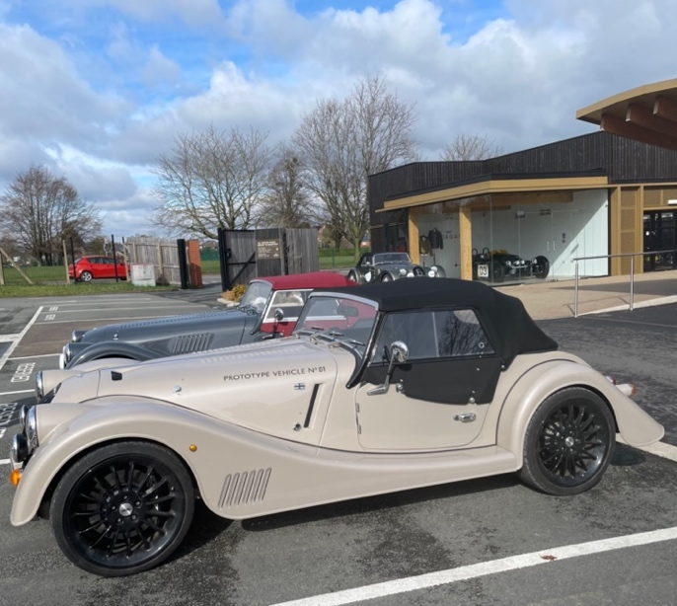
Figure 1: Morgan Plus 6 Prototype.

2 Literature Review
The suspension system of a vehicle represents a critical interface between the vehicle and the road surface, profoundly influencing its ride quality, handling characteristics, and overall safety. Over the decades, the optimisation of suspension systems has been a focal point in the field of vehicle dynamics and automotive engineering, driven by the pursuit of enhancing driver and passenger comfort while improving vehicle stability and control. As the demands on modern vehicles continue to evolve with changing road conditions, vehicle designs, and driver expectations, achieving the optimal balance between ride comfort and dynamic performance becomes increasingly complex. The aim of this literature review is to delve into the extensive body of research and knowledge surrounding the optimisation of suspension systems, shedding light on the key advancements, methodologies, and challenges that have shaped this critical aspect of automotive engineering. By examining the historical context, theoretical foundations, and contemporary approaches, this review will provide a comprehensive understanding of the state of the art in suspension optimisation, paving the way for the subsequent research in this master's dissertation.

2.1 Ride and Handling Optimisation
Ride and handling are two important aspects of a vehicle’s performance that describes its behaviour and characteristic. Ride refers to the comfort and smoothness experienced by the driver and passengers while driving. It encompasses how well the vehicle absorbs and dampens shocks and vibrations from the road surface, resulting in a comfortable and pleasant experience for passengers. A good ride quality means that passengers feel minimal disturbances, even when driving over rough or uneven ground. Achieving a comfortable ride involves factors like suspension design, shock absorbers, tyre selection, and chassis stiffness. Handling refers to a vehicle's responsiveness to driver inputs, particularly during critical manoeuvres like steering, cornering, and braking. When a vehicle possesses good handling characteristics, it signifies that the vehicle behaves in a predictable, stable, and responsive manner, instilling confidence in the driver's ability to control it effectively. These handling attributes are shaped by several key factors, including the design of the suspension system, the quality of tyre grip, the distribution of weight within the vehicle, and the overall chassis design. The fine-tuning of a vehicle's handling can significantly enhance its overall performance and safety, with a particular focus on bolstering cornering stability and the vehicle's capability to execute emergency manoeuvres.

To achieve the optimal ride and handling, there are numerous techniques and methods available, such as time-domain and frequency-domain analysis, damper optimisation, and multi-body dynamic modelling (Dixon, 2007) (SAE International, 2015) (Silva, et al., 2021). The aim of optimising ride and handling is to strike a balance between ride comfort and handling stability, which can be accomplished by analysing and fine-tuning diverse vehicle components (Technical Bulletin, 2013) (Technical Bulletin, 2018).

2.1.1 Practical Testing
Totu and Alexandru, researchers from the University of Transylvania, conducted a study to optimise a novel race car suspension system. Their comprehensive methodology encompassed conceptual design, modelling, simulation, optimisation, and the creation of an experimental suspension model. For optimisation, they employed multi-objective optimal design techniques, leveraging design of experiments (DOE) strategies and regression models. They developed a synthesis method using the least squares approach, which was integrated into the optimal design algorithm.

The suspension system's virtual design and simulation were executed using ADAMS, a multi-body systems (MBS) software package, including ADAMS/View for modelling and simulation and ADAMS/Insight for multi-objective optimisation. Following virtual design, they implemented a physical prototype on the Transylvania University of Brașov's Formula Student race car, Blue Streamline. The team conducted specific experimental tests to assess the prototype's dynamic performance, mirroring real competition conditions. The study's virtual and experimental results effectively demonstrated the proposed suspension system's performance and validated the utility of their design algorithm. This research underscores the efficacy of a comprehensive approach that combines virtual and experimental methods for designing and optimising race car suspension systems (Totu & Alexandru, 2021).

2.2 Camber Optimisation
Camber is a key aspect of a vehicle’s wheel alignment, and it refers to the angle at which the wheels are tilted relative to the vertical axis when viewed from the front or rear of the vehicle. If the top of the wheel tilts outward from the vehicle (away from the centreline), it is considered positive camber which can enhance stability in certain situations, such as when carrying heavy loads. If the top of the wheel tilts inward toward the vehicle (towards the centreline), it is negative camber which is often used to improve cornering performance and traction, as it helps keep more of the tyre's tread in contact with the road during turns. Camber angle is an important parameter in wheel alignment, as it can affect tyre wear, handling characteristics, and the overall performance and safety of a vehicle. Proper camber adjustment is essential to ensure even tyre wear and optimal handling performance for various driving conditions.

What is the reason for implementing negative camber in a car's suspension system? A key objective of the suspension system is to maximize lateral grip, which is determined by the coefficient of friction. This is calculated by dividing the lateral load capacity of the tyre (Fy) by the vertical load on the tyre (Fz), without causing it to slide sideways. Studies have demonstrated that tilting the top of the outside tyre (right tyre for left-hand turn) towards the centre of the car can increase the lateral load the tyre can bear without slipping, for a given vertical load. This can be achieved by incorporating negative camber into the suspension system (Sanat Fe Garage, 2013).

2.2.1 Practical Testing
A study by SAE International suggests that at around 5 degrees with radial tyres, the effect reaches its peak. However, it should be noted that this is a general statement and there are several other variables to consider, such as tyre width and type of tyre construction. Furthermore, the test only measured the impact of dynamic camber, meaning the tyre was loaded and executing a turn of approximately 6 to 7 degrees. Therefore, for a performance road car, it is recommended to incorporate some dynamic negative camber (Milliken & Milliken, 1994).

Another paper written by Mitra, Soni and Kiranchand, aims to address health issues caused by whole body vibrations induced by automobiles and presents a method for optimising suspension performance to enhance ride comfort. The study utilises factorial methods of Design of Experiments and adheres to ISO 2631-1:1997 standards. A quarter car test rig integrated with a LabVIEW based data acquisition system was developed to understand the real-time behaviour of a vehicle. The pilot experiment focused on three primary suspension parameters, spring-stiffness, damping, and sprung mass, and the full factorial method was implemented for optimisation.

However, the regression analysis indicated that other parameters were likely to influence the response. The study subsequently included steering geometry angles, camber and toe, and tyre pressure in the design, and a fractional factorial method with six factors was implemented to optimise ride comfort. The optimal combination was then verified on the test rig, showing high correlation. The results highlight the effectiveness of the proposed method in enhancing suspension performance and reducing health issues caused by whole-body vibrations (Mitra , et al., 2016).

2.3 Suspension Hardpoints Optimisation
A vehicle's suspension system is a crucial component responsible for managing the interaction between the wheels and the road surface. The primary function of suspension is to provide ride comfort, maintain tyre contact, enhance handling and stability, support vehicle weight and adjust to variable road conditions. Suspension systems comprise various components, including springs (coil springs or leaf springs), shock absorbers (dampers), struts, control arms, anti-roll bars, and more. These components work together to provide a balance between ride comfort and handling performance, and they can be tuned for different vehicle types and driving preferences. Hence why the suspension system is a critical element of a vehicle's design, impacting both comfort and safety while driving.

Suspension hardpoint optimisation is a process used in suspension design to improve ride comfort and handling. Design of Experiments (DOE) can be used to find the ideal combination of suspension and steering geometry parameters, including tyre pressure, damping coefficient, spring stiffness, sprung mass, camber, toe, and wheel speed (Mitra, et al., 2015). Design of Experiments is a statistical tool used to determine the individual and interactive effects of various factors that can influence the output results of a system, process, or product.

2.3.1 Practical Testing
Mitra conducted a study focused on optimising ride comfort in race cars through the application of design of experiments (DOE). The primary objective was to identify the optimal combination of spring stiffness, damper settings, tyre pressure, and steering geometry angles across varying speeds, all in accordance with ISO 2631-1:1997 standards. To execute the experiments, Mitra developed a quarter car test rig, which was integrated with a data acquisition system based on NI LabVIEW. Within this setup, six key parameters were systematically adjusted within predetermined ranges. The DOE methodology was then employed to determine the optimal settings for each parameter. The fractional factorial method was used to carry out the experimental runs, and the data was subsequently analysed using Minitab. The resulting statistical model exhibited a high R2 value of 96.21%, an adjusted R2 of 94.6%, and a predicted R2 of 91.98%. The study's findings underscored that among the varied parameters, sprung mass and damping coefficient had the most substantial influence on achieving optimal ride comfort. This research serves as a compelling illustration of the effectiveness of DOE in suspension design, emphasizing the critical importance of considering multiple influential parameters (Mitra, et al., 2015).

2.4 Centre of Gravity Optimisation
The centre of gravity (CG) of a vehicle is a specific point within the vehicle where the total weight of the vehicle and its occupants can be considered to act. It is the point at which the vehicle's mass is effectively concentrated in terms of gravitational forces. The CG is typically located near the geometric centre of the vehicle horizontally but may be at varying heights depending on the vehicle's design, weight distribution, and load. In most vehicles, it's closer to the front due to the engine's weight. A lower CG generally contributes to greater stability and reduced susceptibility to tipping during sharp turns or abrupt manoeuvres. Sports cars and performance vehicles often have lower CGs to enhance handling. The CG also affects weight transfer in braking and acceleration. The centre of gravity is a fundamental concept in vehicle dynamics. Its position influences a vehicle's behaviour in terms of stability, handling, and response to various driving conditions, making it an essential consideration in vehicle design and performance tuning.

The optimisation of the centre of gravity is a procedure that enhances a vehicle's stability and manoeuvrability by evenly distributing its weight. This process involves adjusting the weight distribution of the vehicle to improve its balance and handling (Britannica, 2022). The implementation of DOE can assist in determining the optimal suspension and steering geometry parameters such as tyre pressure, damping coefficient, spring stiffness, sprung mass, camber, toe, and wheel speed. This methodology aims to enhance ride comfort and handling while preserving an optimal centre of gravity, as indicated in a study conducted by Mitra and colleagues in 2016 (Mitra, et al., 2016).

2.4.1 Practical Testing
A study by Winkler, Campbell, and Mink evaluated current practices of measuring the vertical position of the centre of gravity (CG) of light truck-type vehicles. The round-robin experiment involved multiple laboratories and aimed to determine differences in measured CG height and their causes. Results showed significant differences between laboratories, but good repeatability within laboratories. The study suggests the need for standardisation in measurement procedures to minimise variability in CG height measurements (Winkler, et al., 1991). This is a key area of interest as the Morgan Plus 6 currently has issues with the movement of CG height.

2.5 Damper Optimisation
Dampers are pivotal components within a vehicle's suspension system, tasked with a fundamental mission: to manage and control the oscillations and vibrations generated by the dynamic interaction between the wheels and the road surface. These key components serve multiple essential functions:

First and foremost, dampers are energy transformers. When a wheel encounters a bump or uneven terrain, the suspension compresses, prompting the damper's piston to move within a hydraulic or gas-filled chamber. Through this motion, kinetic energy generated by the suspension's movements is efficiently absorbed and converted into heat. This process significantly contributes to the effective dampening of the suspension's oscillations, diminishing their amplitude and preventing excessive bouncing.

Beyond this energy transformation role, dampers significantly influence ride comfort. By reducing the impact of jolts and vibrations, they enhance the overall smoothness of the ride, ensuring that passengers experience minimal discomfort, even when traversing uneven road surfaces. A well-tuned damper system is the linchpin for preserving tyre contact with the road while mitigating the disruptive effects of road imperfections, ultimately culminating in a more enjoyable and comfortable ride.

In addition to their contributions to ride quality, dampers are integral to a vehicle's handling and stability. They play a pivotal role in maintaining consistent tyre contact with the road surface, a key factor in preventing undesirable outcomes such as excessive bouncing or the loss of traction during dynamic manoeuvres such as cornering, braking, and acceleration. When dampers are appropriately calibrated, they enhance a vehicle's capacity to respond predictably and controllably to the inputs provided by the driver, significantly enhancing the overall driving experience.

It's essential to recognize that dampers do not operate in isolation; they are integral elements within a broader suspension system. Collaboratively with other components such as springs and anti-roll bars, dampers function in unison to establish a harmonious and balanced suspension system. These collective efforts collectively dictate a vehicle's unique ride and handling characteristics, ultimately shaping the driving experience.

Damper optimisation plays a crucial role in suspension design, contributing to improved ride comfort and handling performance. One effective approach to determine the optimal combination of suspension and steering geometry parameters, including damping coefficient, tyre pressure, spring stiffness, sprung mass, camber, toe, and wheel speed, is the application of design of experiments (DOE). This method allows for enhancements in both ride comfort and handling characteristics while maintaining an optimal centre of gravity (Mitra, et al., 2016).

Hyper Mesh OptiStruct, a state-of-the-art optimization tool, offers the capability to optimise the front axle beam of a vehicle, enhancing its strength-to-weight ratio without necessitating modifications to assembly parameters (Ruban & Sivaganesan, 2016). Additionally, multi-objective optimisation frameworks can be used to optimise mass dampers in controlling vortex-induced vibration in long-span bridges (Xu, et al., 2023). Basic damper tuning can be used to optimise suspension and car setup.

2.5.1 Practical Testing
Magneto-rheological (MR) dampers, a type of semi-active device, have garnered significant attention in the field of suspension systems. These dampers offer the reliability of passive systems while retaining the adaptability and versatility of fully active control devices. In recent years, there has been a growing interest in optimising the geometric parameters of MR dampers to enhance their performance.

This study focuses on a unique approach that proposes an optimisation process for the geometric parameters of MR dampers, employing the finite element method (FEM) in conjunction with the Taguchi approach—a methodology that is rarely reported in the literature. The primary objective of this study is to maximize the damping force of MR dampers. The research involves the development of 18 FEM models, based on the Taguchi orthogonal array, utilizing the ANSYS platform.

The results obtained from these FEM models are subjected to analysis using the Design of Experiments (DOE) methodology, ultimately leading to an optimised solution. This optimal solution is subsequently validated both experimentally and through FEM, achieving a high level of confidence at 95%. The results from both experimental and FEM validation are found to be in excellent agreement.

In conclusion, this study demonstrates that numerical techniques such as FEM can effectively substitute real experimental results in the optimisation of geometric parameters for MR dampers. The proposed methodology offers significant advantages in terms of time and resource savings when designing optimised MR dampers for various applications, including automotive suspension systems. Additionally, the study underscores the efficacy of the Taguchi approach in optimising the geometric parameters of MR dampers (Mangal & Kumar, 2015).

2.6 Tyre Optimisation
Tyre optimisation is critical for vehicle dynamics, enhancing ride comfort and handling. It entails fine-tuning suspension and steering geometry parameters to achieve optimal performance in conjunction with the tyres. This includes adjustments to parameters like tyre pressure, damping coefficient, spring stiffness, sprung mass, camber, toe, and wheel speed.
The primary objective of tyre optimisation is to maintain an optimal centre of gravity throughout the vehicle's motion. This is vital for ensuring stability and control during cornering and other manoeuvres.

Key factors affecting tire performance include tyre pressure, which ensures optimal road contact for handling and braking. Tyre pressure adjustments can also impact ride comfort by affecting road impact and vibration transmission. Parameters like damping coefficient, spring stiffness, and sprung mass also influence tyre optimisation by affecting the suspension system's ability to absorb impacts and vibrations. Fine-tuning these parameters helps strike a balance between ride comfort and handling based on desired performance characteristics (Mitra, et al., 2016).

2.6.1 Practical Testing
FEA optimises tyre design by varying construction details and using an iterative process. It divides the tyre into small elements, calculating deformation and stress under various loads.
By adjusting parameters like tyre pressure, damping coefficient, spring stiffness, sprung mass, camber, toe, and wheel speed, FEA identifies the best combination for ride comfort, handling, and optimal centre of gravity. Case studies, like SAE International's 2007 study, have used FEA to optimise tyre design, significantly improving performance for better handling and ride comfort (SAE International , 2007).

3 Research
This section delves into critical automotive concepts essential for understanding vehicle engineering and performance. These concepts play pivotal roles in shaping a vehicle's behaviour on the road, encompassing aspects such as suspension dynamics, steering precision, and aerodynamics.

3.1 Dampers
In Figure 2, there is a detailed view of the front dampers utilised in the suspension system of the Morgan Plus 6. These components have a critical role in ensuring the vehicle's stability and handling performance. The front dampers are positioned near the front wheels and have the responsibility of dampening the impact of road irregularities and vibrations. This damping action is essential for providing a smooth and comfortable ride, as well as maintaining tyre contact with the road surface during various driving conditions.

The front dampers installed on the Morgan Plus 6 is well-engineered and designed to handle the demands of both everyday driving and spirited performance. They offer adjustability to some extent, allowing drivers to fine-tune the suspension setup according to their preferences or specific driving situations. The choice of front dampers can have a significant impact on the car's responsiveness, cornering stability, and overall ride comfort.
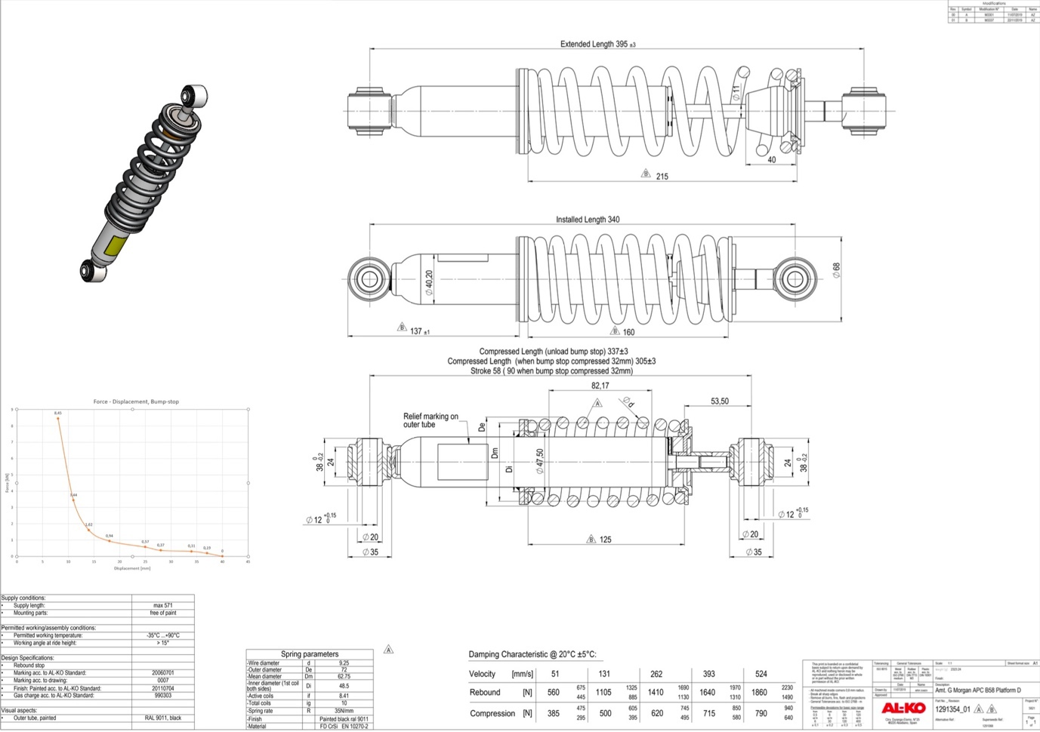
Figure 2: Assy-Spring Damper Front - Wide Body.
In Figure 3, there is a close-up view of the rear dampers used in the Morgan Plus 6's suspension system. Rear dampers, much like their front counterparts, play a crucial role in maintaining the vehicle's balance and handling characteristics. Positioned near the rear wheels, these dampers have the responsibility of minimising the bounce and sway of the vehicle, particularly during acceleration, braking, and cornering.
The rear dampers installed on the Morgan Plus 6 are designed to complement the front dampers, resulting in a harmonious and balanced suspension setup. They cooperate with other suspension components to ensure that the rear wheels maintain optimal contact with the road surface, which in turn enhances traction and stability. Similar to the front dampers, the rear dampers also offer adjustability options to cater to various driving preferences and road conditions.

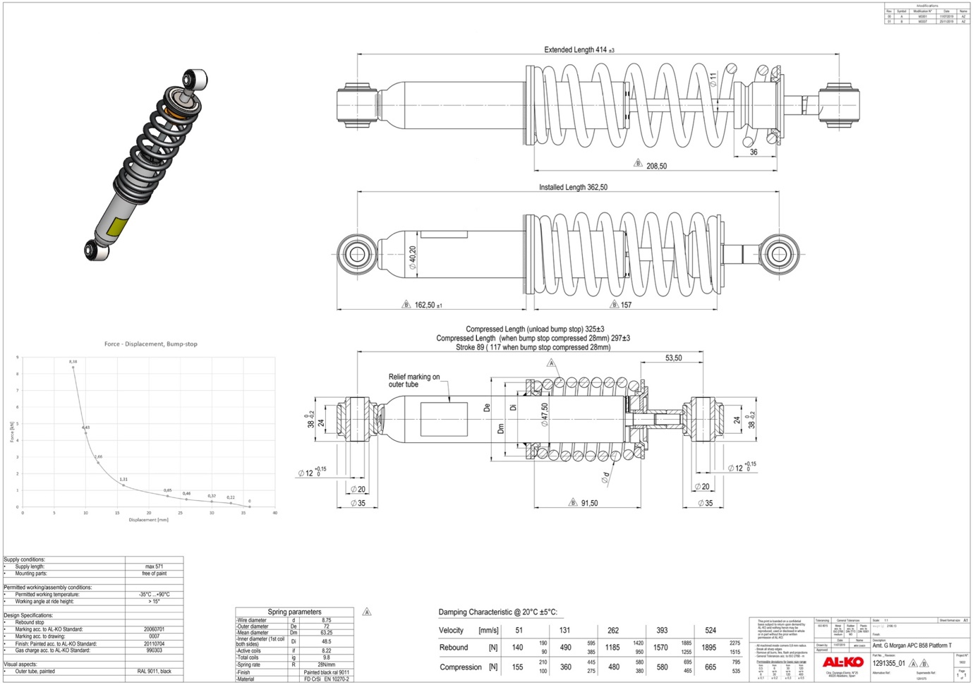
Figure 3: Assy-Spring Damper Rear - Wide Body.

3.2 Ackermann
Ackermann analysis is a specialised field of study and design that delves into the intricate aspects of Ackermann steering geometry. This geometric arrangement of linkages in a vehicle's steering system serves a fundamental purpose: addressing the challenge of wheels on the inside and outside of a turn having to follow circles with different radii.

At its core, the Ackermann steering mechanism is a clever modification of the four-bar linkage system, where the kinematics of Ackermann steering are defined by the intricate interplay of these mechanical links and the precise angles at which the wheels are turned. This engineering marvel ensures that when a vehicle makes a turn, the two front wheels are perpetually oriented toward a common centre corresponding to the turning radius (Skill Lync, 2022).

What distinguishes Ackermann steering is its remarkable ability to facilitate turns without inducing any tyre slip. Unlike some other steering mechanisms, Ackermann steering is primarily concerned with analysing the relative motion between the force links, rather than delving into the intricate effects of forces involved. This approach simplifies the understanding and design of steering systems.

The practical application of Ackermann steering geometry is most evident in front-wheel steering control. By adhering to this principle, engineers aim to minimise unnecessary tyre sliding during vehicle cornering. In essence, Ackermann analysis and its associated steering geometry form the bedrock upon which modern front-wheel steering systems are built, contributing significantly to the safe and efficient manoeuvring of vehicles through curves and turns (Walter, 2021).

3.3 Ride Height
Ride height, also known as ground clearance, is a fundamental measurement in the automotive world. It precisely quantifies the vertical distance between the base of a vehicle's tyre and its lowest point, which is typically the axle. This measurement is typically taken under standard conditions, meaning no cargo or passengers in the vehicle. Understanding ride height is crucial because it has profound implications for a vehicle's handling and aerodynamic performance.

One of the most noticeable effects of ride height is its influence on a vehicle's handling characteristics. When a vehicle has a higher ride height, it essentially raises the centre of mass of the car. This, in turn, can result in less precise and potentially more hazardous handling. Vehicles with higher centres of mass are at a higher risk of rollovers during sharp turns or sudden manoeuvres. In contrast, lower ride heights contribute to better stability and cornering capabilities, which is why sports cars, built for precision and speed, typically have very low ground clearances (Low Offset, 2022).

Aerodynamics also come into play when discussing ride height. The height of a vehicle above the ground can significantly affect its aerodynamic properties. Lower ride heights, again common in sports cars, reduce aerodynamic drag, allowing for better fuel efficiency and high-speed performance. Conversely, vehicles designed for off-road adventures and SUVs often feature higher ground clearances to navigate rough terrain effectively.

3.4 Roll Centre
Roll centre is a term used in vehicle suspension design that refers to the point at which the cornering forces in the suspension are reacted to the vehicle body. There are two definitions of roll centre: the geometric roll centre and the force-based roll centre. The geometric roll centre is solely dictated by the suspension geometry, while the force-based roll centre is defined as the point in the transverse vertical plane through any pair of wheel centres at which lateral forces may be applied to the sprung mass without producing suspension roll. The lateral location of the roll centre is typically at the centreline of the vehicle when the suspension on the left and right sides of the car are mirror images of each other. The significance of the roll centre can only be appreciated when the vehicle's centre of gravity is taken into account.

Roll centres can be adjusted to increase or decrease the roll stiffness at one end of the car in a similar way that anti-roll bars work (Suspension Secrets, 2018). The most accurate way to calculate the roll centre is to draw a diagram representing the following points of the suspension system: wheel and tyre location, upper wishbone, upper arm or MacPherson strut chassis mounting point, upper wishbone, upper arm or MacPherson strut hub mounting point, lower wishbone, lower arm chassis or subframe mounting point, and lower wishbone, lower arm hub mounting point. If the car has a solid rear beam axle setup, then locating the roll centre is a much simpler operation. Due to the wheel being joined by the one single beam, a line can be traced down the centre of it to the centre point, which is where the roll centre for the rear beam axle is located (Suspension Secrets, 2018).

Roll centre represents the pivot point of the suspension system in its entirety, and any force that is parallel to the ground and applied to the vehicle will act through the roll centre (Vogel, 2021). The roll centre interacts with the centre of gravity to create weight transfer and roll (whitelineperformance, 2018). The ideal range for roll centres to sit within for non-aero vehicles is suggested to be within a lot of motorsport data.

4 Methodology
In the quest for optimising vehicle suspension systems, the selection and evaluation of appropriate analysis tools stand as crucial considerations. This methodology section outlines the approach employed in utilising two renowned software platforms, WinGeo and VI-Grade, to conduct comprehensive analyses and comparisons of two distinct suspension setups. The primary objective of this methodology is to establish a systematic framework for the assessment of performance, handling characteristics, and dynamics within these configurations. The overarching goal is to foster a deeper comprehension of their respective strengths and weaknesses.

Delving into the intricacies of this methodology involves an exploration into the multifaceted realm of suspension engineering. This exploration utilises advanced software tools to illuminate the interplay among components, parameters, and configurations. The process involves the methodical creation of models, conducting simulations, and performing detailed analyses. The ultimate aim is to uncover valuable insights that will provide guidance for the optimisation of the Morgan Plus 6 suspension system, with the overarching objectives of enhancing ride comfort, stability, and overall vehicle performance in mind.

4.1 WinGeo
In this project, WinGeo will primarily be used as a visual aid to supplement the main analysis which will be conducted using VI-Grade results. Secondarily, WinGeo will be used to evaluate the kinematics of the suspension setups. Kinematics, in the context of automotive engineering, refers to the study of motion without considering the forces or factors causing that motion. When applied to suspension systems, kinematics focuses on understanding how various components move and interact with each other as a vehicle traverses different road conditions and manoeuvres.

WinGeo is a software tool that allows for the visualisation of suspension geometry and other related factors. By displaying the suspension geometry in WinGeo, a better understanding of the current state of the suspension system and how it might be modified or optimised to achieve the desired ride and handling performance can be shown.

While WinGeo will not be the primary tool used for analysis in this project, it will play an important role in visualising the suspension geometry and tracking progress as the optimisation process unfolds. By using WinGeo alongside VI-Grade, the project will show a more comprehensive understanding of the suspension system and how it can be improved to achieve the desired ride and handling performance.

Figures 4 and 5 below depict the suspension hardpoints provided by Morgan Motors, serving as the foundational data for generating reasonably accurate models of both the current and proposed suspension setups within WinGeo. It's important to highlight that the standard double A-arm model will be applied to both front setups, while the rear will feature the coil-over double A-arm model.
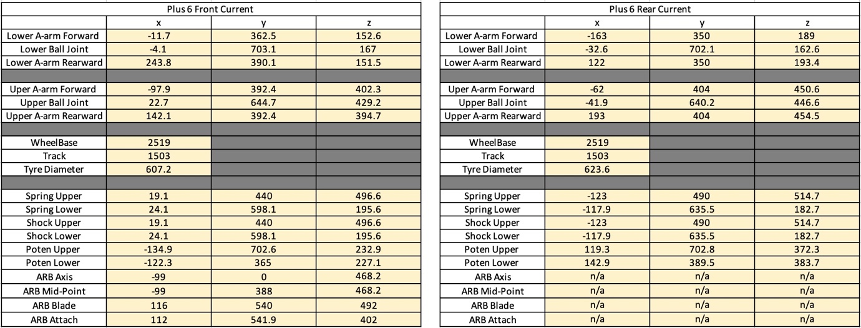
Figure 4: Current WinGeo Suspension Hard Points.
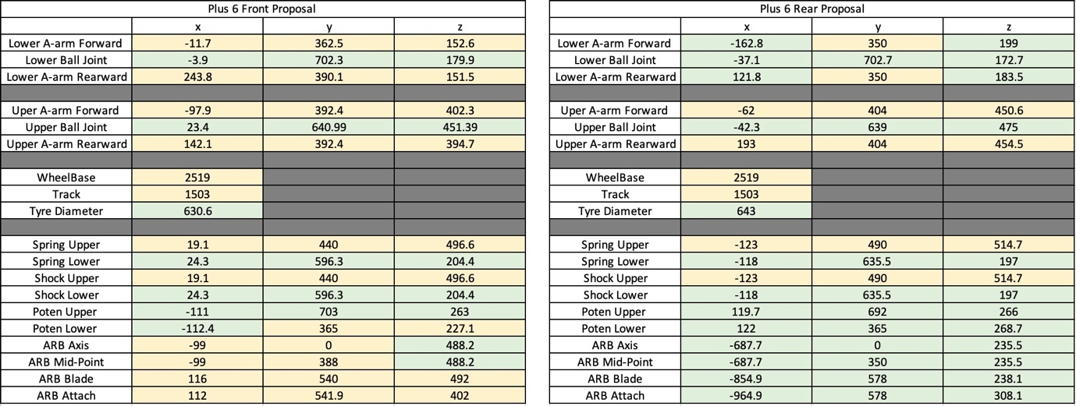
Figure 5: Proposed WinGeo Suspension Hard Points.
Three tests will be carried out for both the current and the proposed suspension. The first test focuses on the roll centre and involves adjusting the ride height. Given that the Morgan Plus 6 is a sports car, the ride height will be varied, starting at -20mm and incrementally increasing to +20mm, with each adjustment made in 1mm increments. This comprehensive evaluation will yield valuable insights into the roll centre height, instant centre, as well as camber and toe settings corresponding to specific vehicle movements. The second test involves an Ackermann analysis, which entails pitch adjustments. The pitch will commence at -1 and progressively rise to +2.5 in 0.1 increments. This test is instrumental in revealing key parameters, including Ackermann properties, turn centre characteristics, as well as camber and toe settings. The last test focuses on tyre load analysis, involving roll adjustments ranging from -2.5 to +2.5 in 0.1 increments. This examination will unveil information about total tyre load distribution for both the left and right sides, along with corresponding camber and toe measurements.

4.2 VI-Grade
VI-Grade is a highly sophisticated and effective software tool that will be utilised in this project to analyse the performance and handling of the Morgan Plus 6. One of the primary advantages of using VI-Grade is its ability to simulate drive cycles, which will allow for a detailed analysis of the vehicle's handling characteristics and performance under different driving conditions.

The Morgan Motor Company has provided the necessary parameters for the Plus 6 model to be inputted into VI-Grade. This will enable the simulation of a wide range of drive cycles, which can help to identify any areas where the vehicle's ride and handling performance could be improved. By analysing the results generated by VI-Grade, it will be possible to develop optimisation strategies that will enhance the car's overall ride comfort and driving experience.

In addition to its drive cycle simulation capabilities, VI-Grade is also equipped with a range of other features and tools that make it an ideal software solution for this project. These include advanced modelling and simulation capabilities, which will enable the creation of highly accurate virtual representations of the car's suspension and other components.

Figures 6 and 7 below illustrates the suspension hardpoints that have been slightly adapted for the use of VI-Grade (y axis hardpoints must be negative). These hardpoints encapsulate details concerning the geometry and attachment points of suspension components, facilitating the development of models that closely approximate the real-world behaviour of the vehicle's suspension system.

Nevertheless, it is imperative to recognise the limitations encountered in the quest for absolute precision. Certain critical information, including comprehensive brake parameters and a chassis model, remains elusive or undisclosed. Consequently, the precision of the broader vehicle model, extending beyond the realm of the suspension system, may exhibit a degree of compromise.

However, it is crucial to underscore the primary focus of this project, which centres on the domain of suspension optimisation. At its core, the principal objective of this study resides in the enhancement of vehicle performance, ride comfort, and handling characteristics, primarily through the implementation of targeted suspension modifications. While the attainment of a precise representation of the entire vehicle would be an ideal scenario, the interest remains vested in the suspension subsystem.
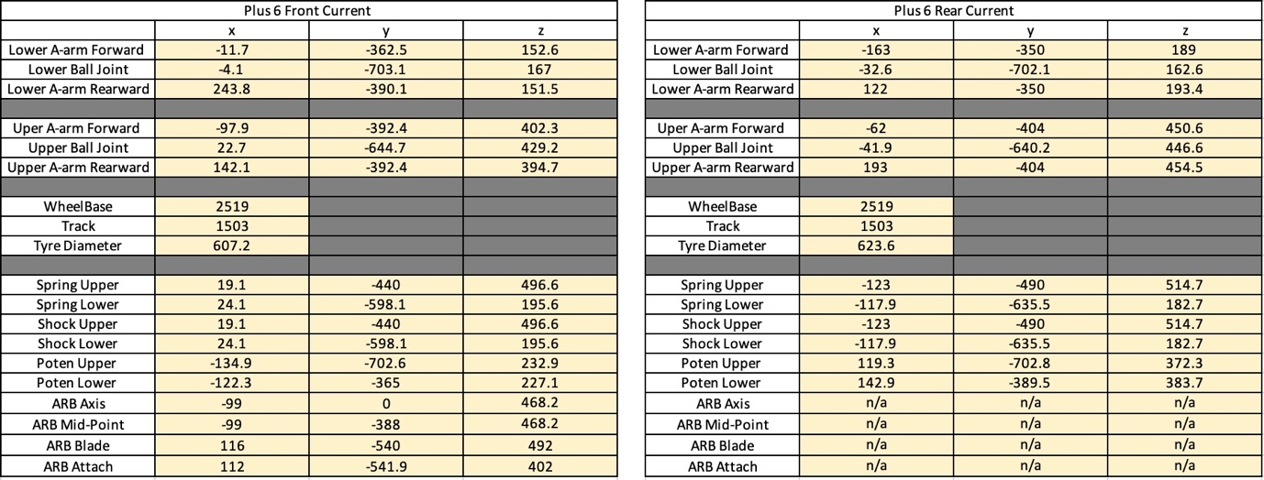
Figure 6: Current VI-Grade Suspension Hard Points.
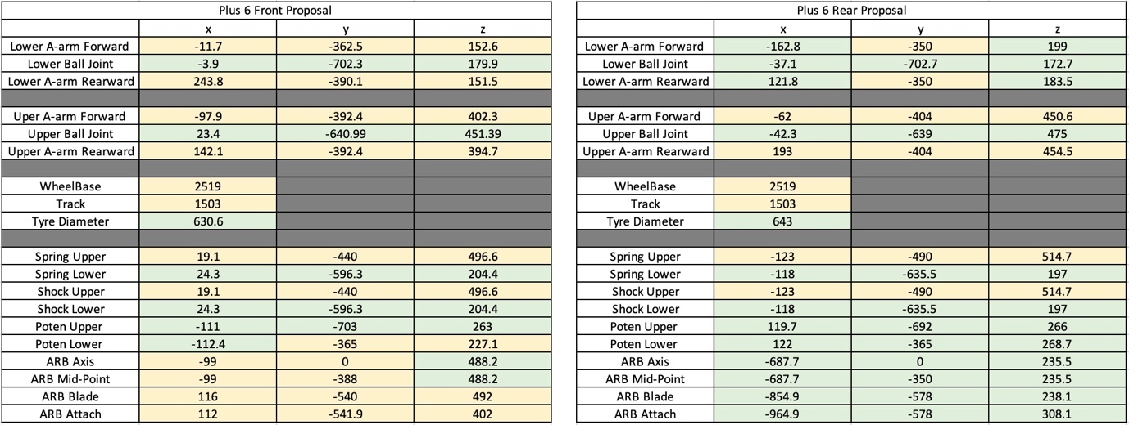
Figure 7: Proposed VI-Grade Suspension Hard Points.
The evaluation of the suspension setups encompasses an extensive range of dynamic scenarios, featuring four distinct circuits: Pembrey, J Turn, Swept Steer, and Fishhook. Each circuit is chosen to subject the suspension systems to a diverse array of challenges, effectively simulating real-world driving conditions.

Pembrey serves as a versatile testing ground, offering a balanced mix of corners, straights, and varying surface conditions. This circuit provides insights into the adaptability of the setups across different sections of the track, showcasing their responsiveness to fluctuations in road surface and vehicle speed. The J Turn circuit presents a demanding test of agility and responsiveness. It assesses how effectively the setups manage weight transfer during rapid directional changes, offering insights into their suitability for evasive manoeuvres and sharp turns.

Swept Steer replicates the intricacies of navigating through a series of sweeping curves, requiring continuous steering inputs. This circuit evaluates the stability and predictability of the suspensions as they respond to prolonged lateral forces, revealing their ability to maintain tyre contact with the road surface. The Fishhook circuit poses a formidable challenge with tight corners and abrupt directional shifts. By subjecting the suspensions to this circuit, insights are gained into their behaviour during demanding, stop-and-start driving scenarios, including their performance in situations such as emergency lane changes and urban driving conditions.

Across these four circuits, the analysis encompasses a comprehensive array of suspension parameters and dynamics. Damper forces are closely examined to unravel their role in managing vehicle oscillations and controlling wheel movements. Contact patch characteristics provide insights into how effectively the suspensions maintain tyre grip, a crucial factor for optimising traction and handling.

Furthermore, the analysis delves into suspension roll, ride height variations, and the dynamics of roll, pitch, and yaw. These aspects collectively offer an understanding of how the suspension setups respond to an extensive spectrum of driving conditions. The data gained from these circuits forms a solid foundation for assessing the overall performance and effectiveness of the suspension systems, facilitating their refinement and optimisation to enhance ride comfort, stability, and vehicle performance.

5 Assumptions and Changes Made
In vehicle suspension analysis, achieving an accurate representation of real-world dynamics often requires a balance between the complexities of reality and the practicalities of simulation. This section explores the assumptions and simplifications inherent in the utilisation of two leading software tools, WinGeo and VI-Grade, for appraising a vehicle's suspension system.

5.1 WinGeo Assumptions
When using WinGeo several assumptions and simplifications are typically made to facilitate the setup and analysis of a vehicle's suspension system. These assumptions and simplifications can vary depending on the specific analysis and configuration but often include rigid bodies, linear suspension behaviour, ideal tyres, constant parameters and more.

WinGeo assumes that the vehicle components, including the chassis, suspension arms, and subframes, are rigid bodies. This simplification disregards the flexibility and deformation of these components under load. The software assumes linear suspension behaviour, meaning that suspension components like springs and dampers follow linear force-displacement curves. In reality, these components may exhibit nonlinear behaviour, especially under extreme conditions. Assumptions about tyre behaviour are made, often using idealised tyre models that do not account for complex tyre characteristics like sidewall flexibility, tyre deformation, and variations in tyre properties under different loads and conditions. WinGeo often relies on constant suspension parameters throughout the analysis, ignoring factors like temperature-dependent behaviour or changes in components over time due to wear and tear.

Many analyses in WinGeo assume steady-state conditions, neglecting transient effects or dynamic behaviour during rapid changes in vehicle motion. Some analyses simplify the problem by assuming two-dimensional motion, rather than three-dimensional motion, ignoring certain degrees of freedom and complexities in three-dimensional movement. The software uses idealised joint connections, such as ball joints or pivot points, which do not account for real-world joint friction, play, or wear. In some cases, external factors like wind, road irregularities, or crosswinds are not considered in the analysis, simplifying the modelling assumptions. For dynamic analyses, linearisation of equations of motion are used around specific operating points, assuming small deviations from these points. Vehicle mass is considered constant, ignoring changes due to factors like fuel consumption or load variations. Assumptions about ideal steering behaviour and control inputs may be made, neglecting aspects like steering system compliance, backlash, or nonlinear steering behaviour. Some analyses assume no tyre slip or disregard complex tyre slip angles and longitudinal slip.

5.2 VI-Grade Assumptions
VI-Grade, as a simulation software of similar stature, shares several of these assumptions while introducing additional considerations. These assumptions include no suspension wear. VI-Grade does not account for wear and tear of suspension components, which can impact performance over time.

5.3 Changes Made
A rear anti roll bar is a component of a vehicle’s suspension system designed to minimise body roll during cornering and other dynamic manoeuvres. The primary purpose of a rear anti-roll bar is to improve a vehicle's stability and handling by reducing body roll. Body roll occurs when a vehicle leans to one side during cornering, which can negatively affect traction, handling, and driver comfort. They are typically located at the rear axle of a vehicle and connects the suspension components on both sides of the rear wheels. It's mounted horizontally and often consists of a solid or tubular metal bar. However, using the suspension hardpoints given by Morgan Motor (seen in section 4, figures 4, 5, 6 and 7), the rear anti roll bar on the proposed setup are not connected to the suspension components. They are instead attached to the chassis between the front and rear axle. This can’t be simulated on VI-Grade or WinGeo as a standard anti roll bar, therefore the rear anti roll bar has not been included in the study.

Figures 8 and 9 below shows the updated suspension hardpoints used for WinGeo (8) and VI-Grade (9).
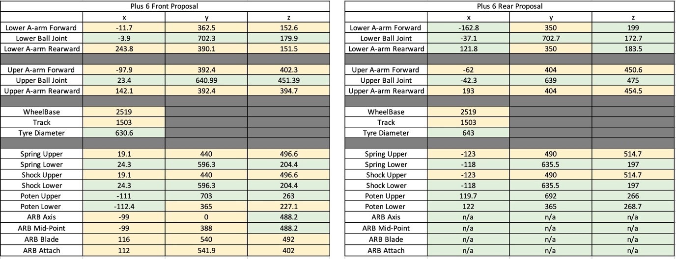
Figure 8: Updated Proposed WinGeo Suspension Hard Points.
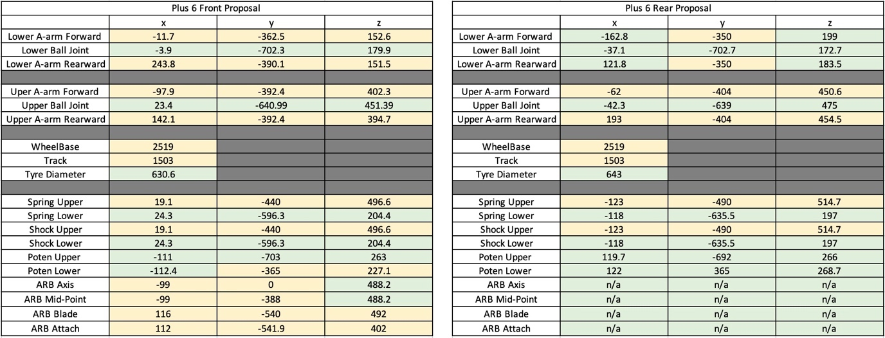
Figure 9: Updated Proposed VI-Grade Suspension Hard Points.

6 Results

6.1 WinGeo

6.1.1 Current Setup
Figure 10 serves as a visual representation of the current suspension setup in WinGeo for the Morgan Plus 6. This detailed illustration provides an overview of how the suspension components are arranged and interact both at the front and rear of the vehicle.
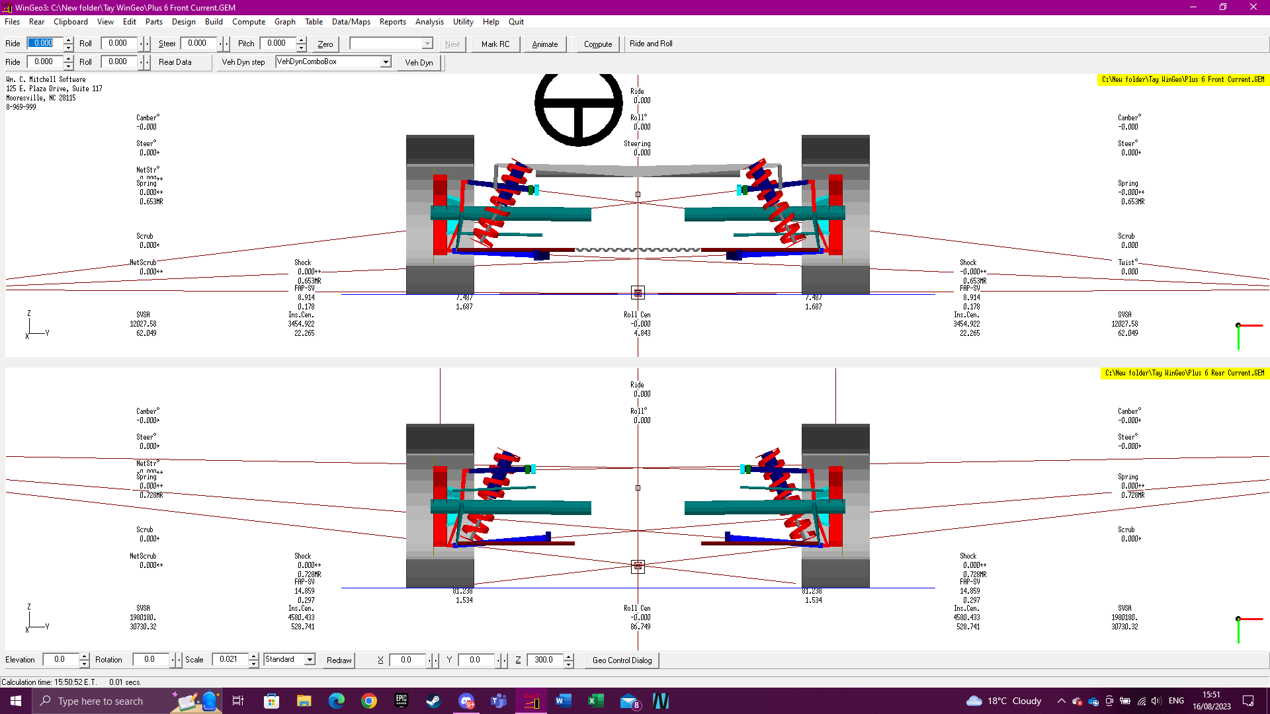
Figure 10: Plus 6 Current Suspension WinGeo.
Figures 11 and 12 delve deeper into the specifics of the front suspension setup. These figures offer a closer look at the details of the front suspension components, allowing for a more focused analysis of this part of the vehicle's suspension system.
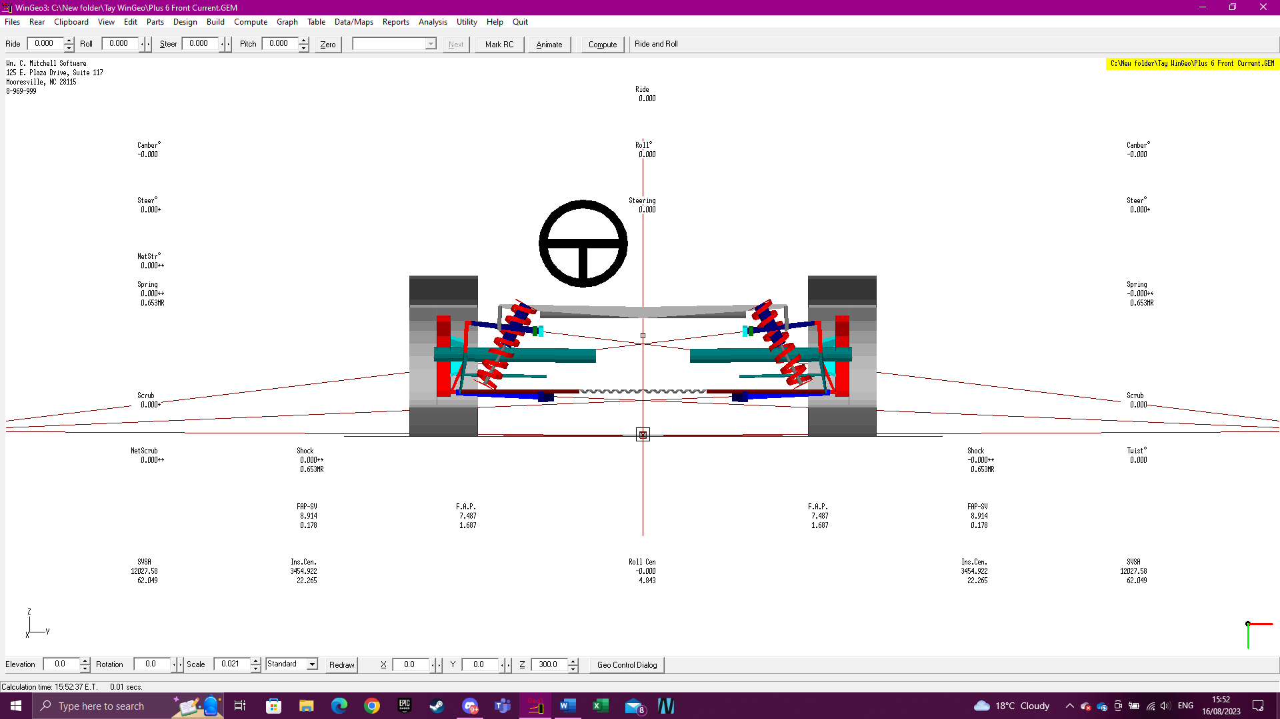
Figure 11: Plus 6 Front Current.
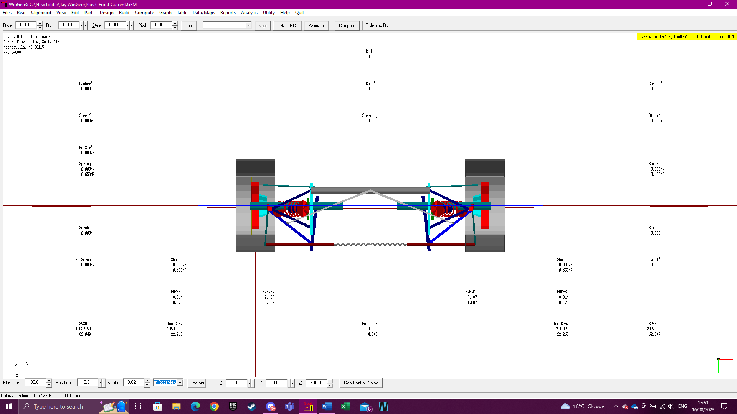
Figure 12: Plus 6 Front Current (Top View).
Figures 13 and 14 shift the focus to the rear suspension. These illustrations provide a detailed examination of the rear suspension components and their arrangement. Like Figures 11 and 12, these figures allow for a more in-depth analysis of the rear suspension system, shedding light on how components work together to support the vehicle's rear end.
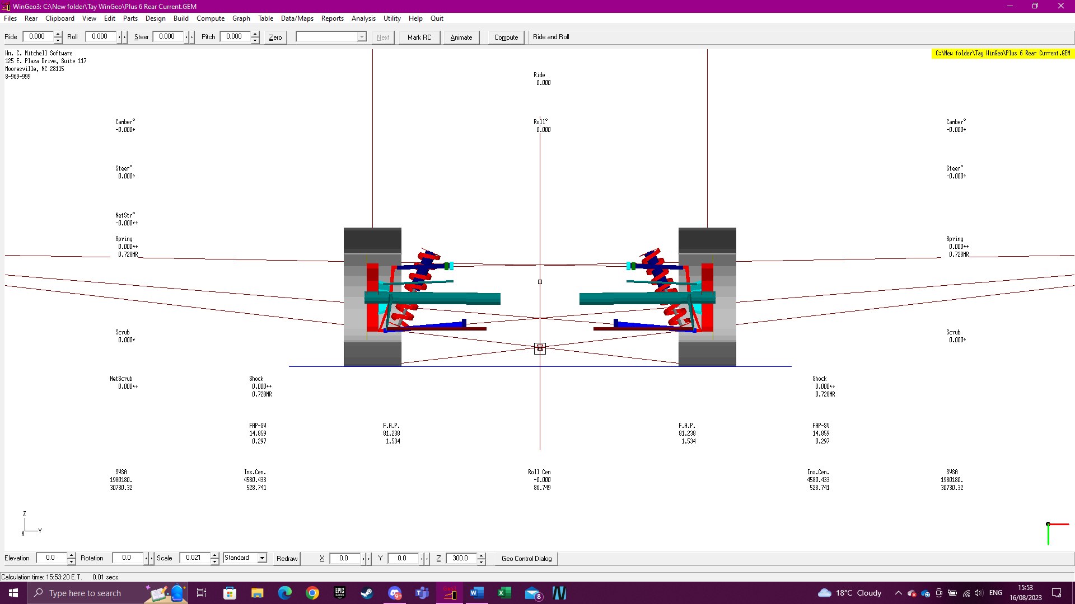
Figure 13: Plus 6 Rear Current.
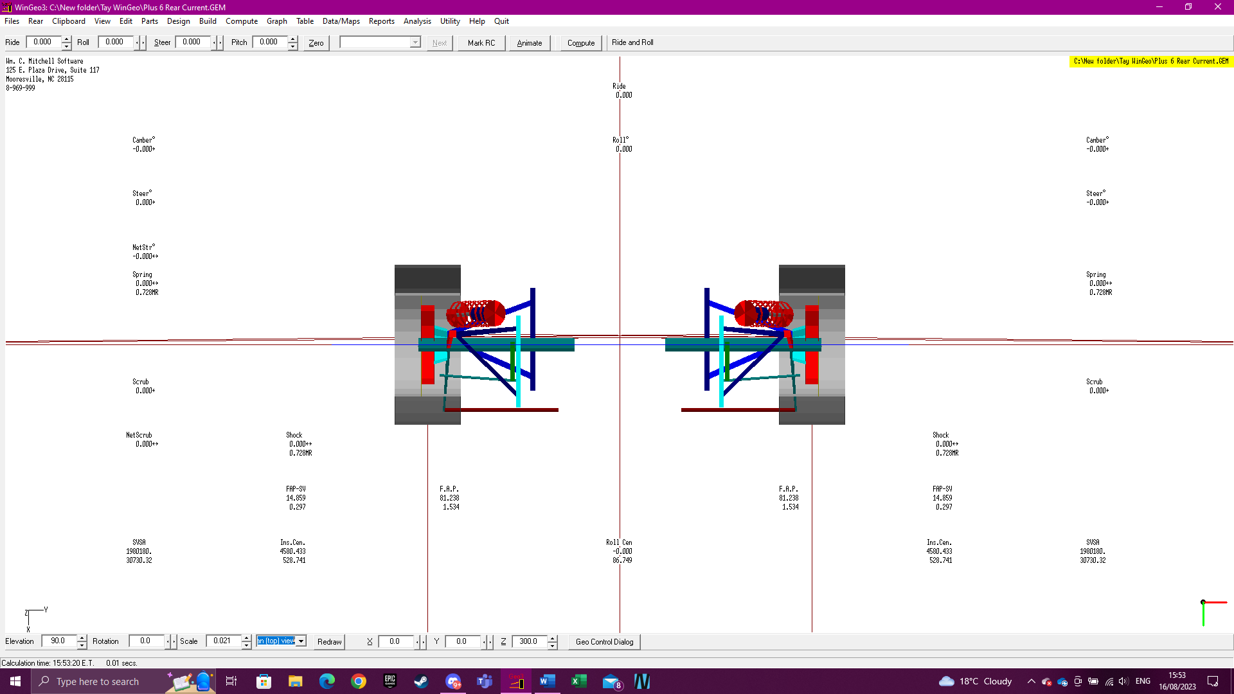
Figure 14: Plus 6 Rear Current (Top View).

6.1.2 Proposed Setup
Figure 15 provides a detailed visualisation of the proposed suspension setup in WinGeo. This figure offers an overview of the planned configuration for both the front and rear suspensions.
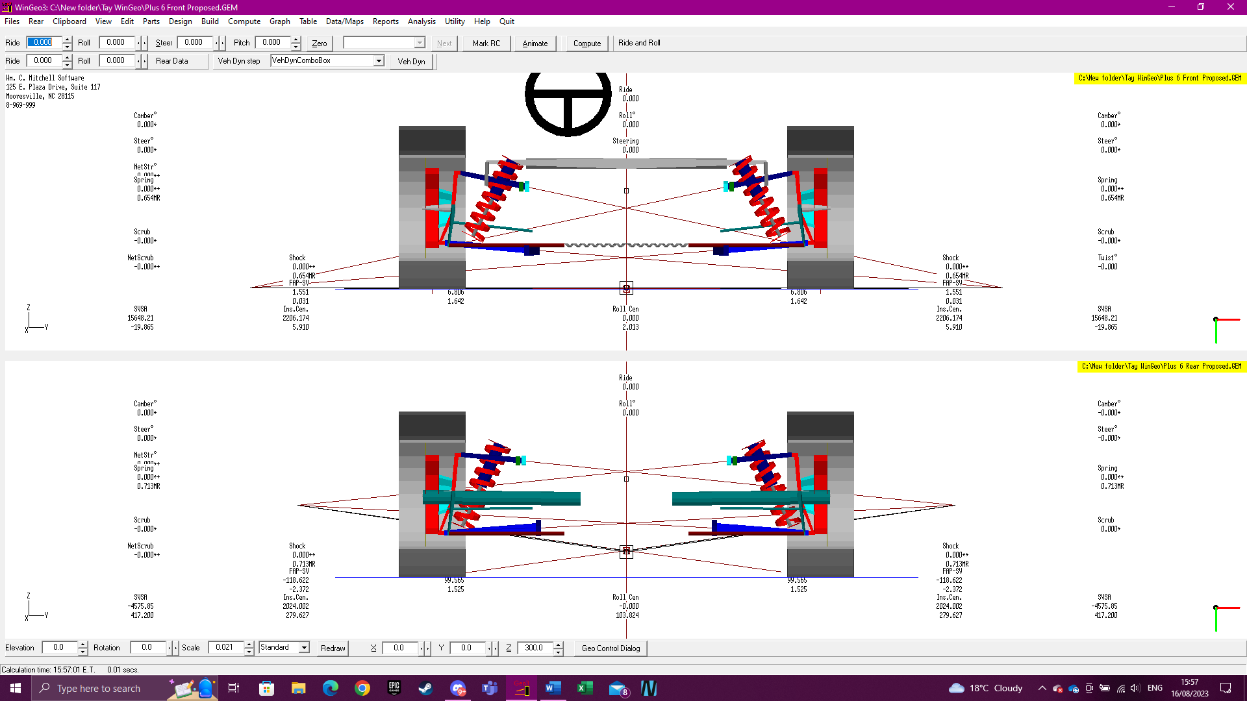
Figure 15: Plus 6 Proposed Suspension WinGeo.
Figures 16 and 17 delve deeper into the specifics of the front suspension of the proposed setup. These figures offer a closer look at the details of the front suspension components in the redesigned system, allowing for a more focused analysis of this part of the vehicle's suspension.

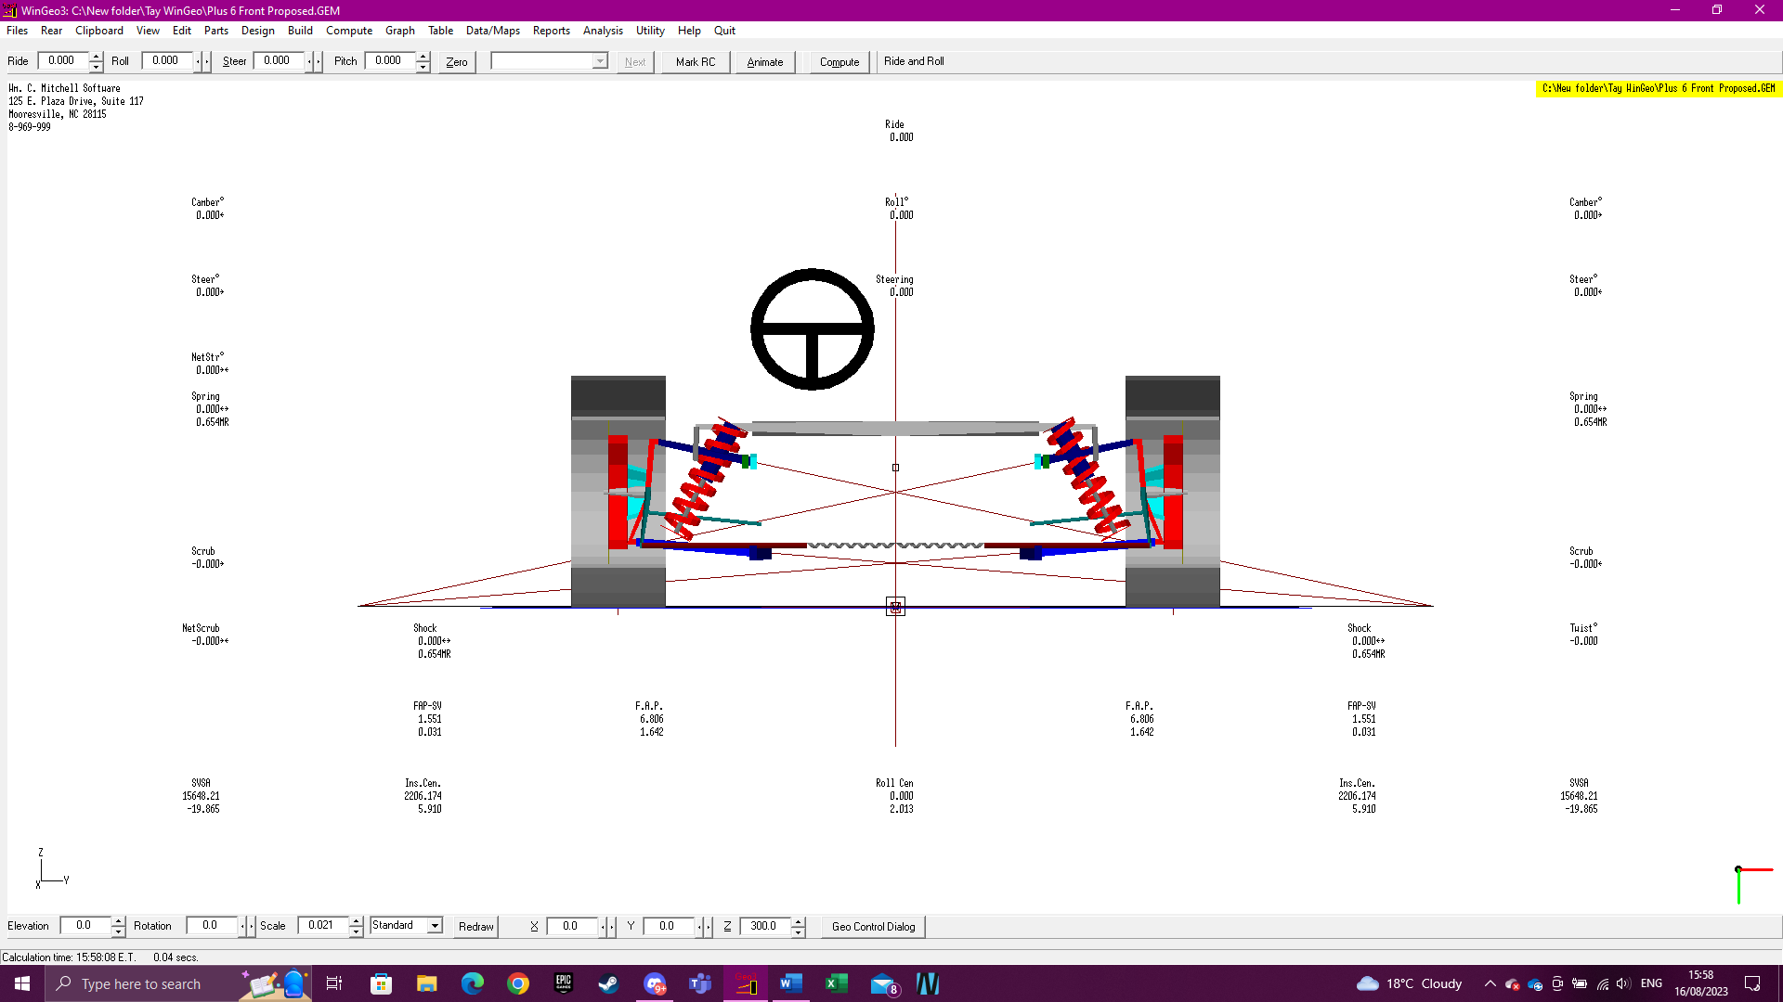
Figure 16: Plus 6 Front Proposed.
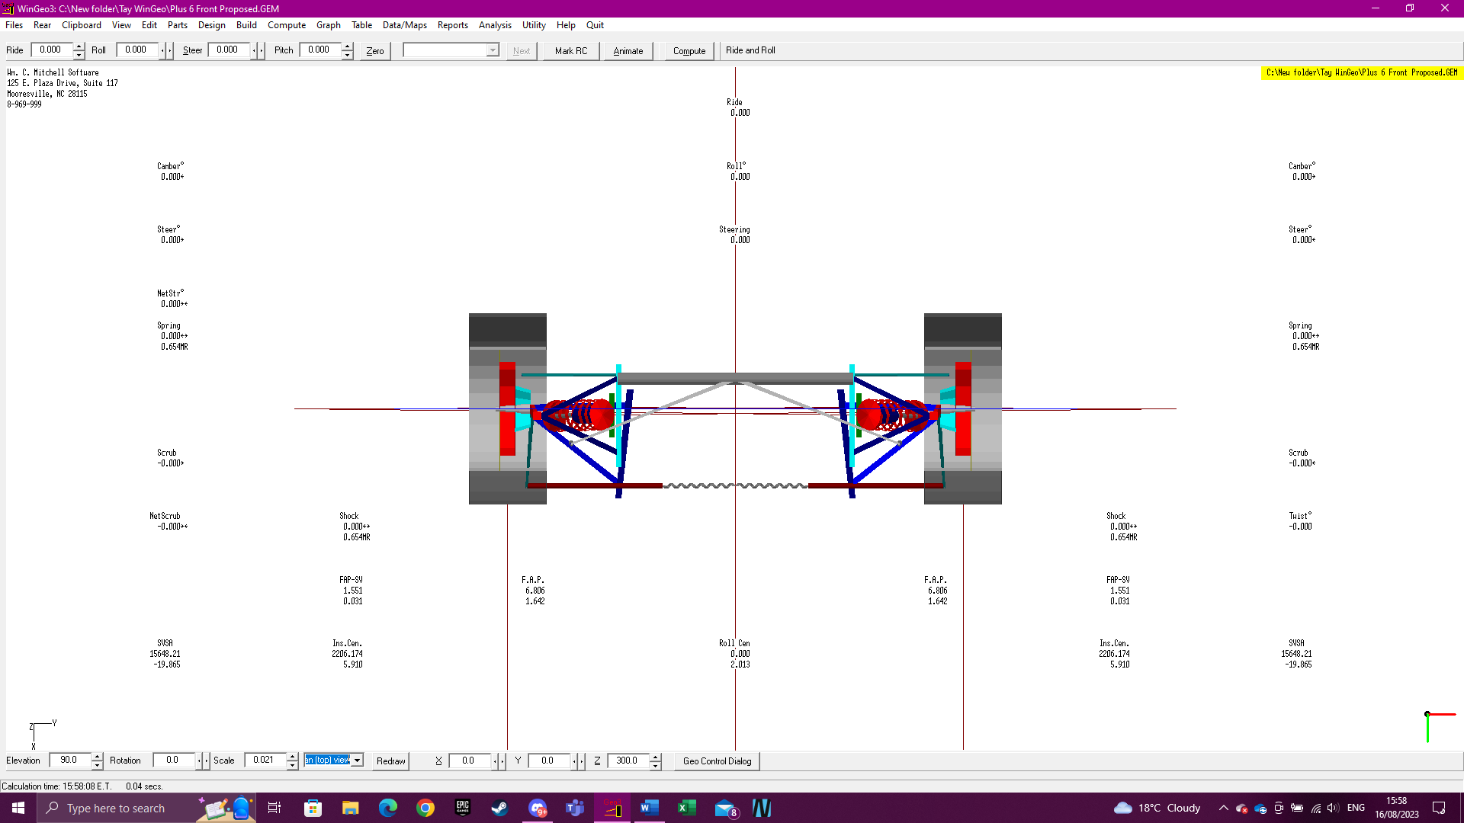
Figure 17: Plus 6 Front Proposed (Top View).
Figures 18 and 19 shift the focus to the rear proposed suspension setup. These illustrations provide a detailed examination of the rear suspension components and their arrangement in the redesigned system. Like Figures 16 and 17, these figures allow for a more in-depth analysis of the rear suspension system in the proposed configuration.

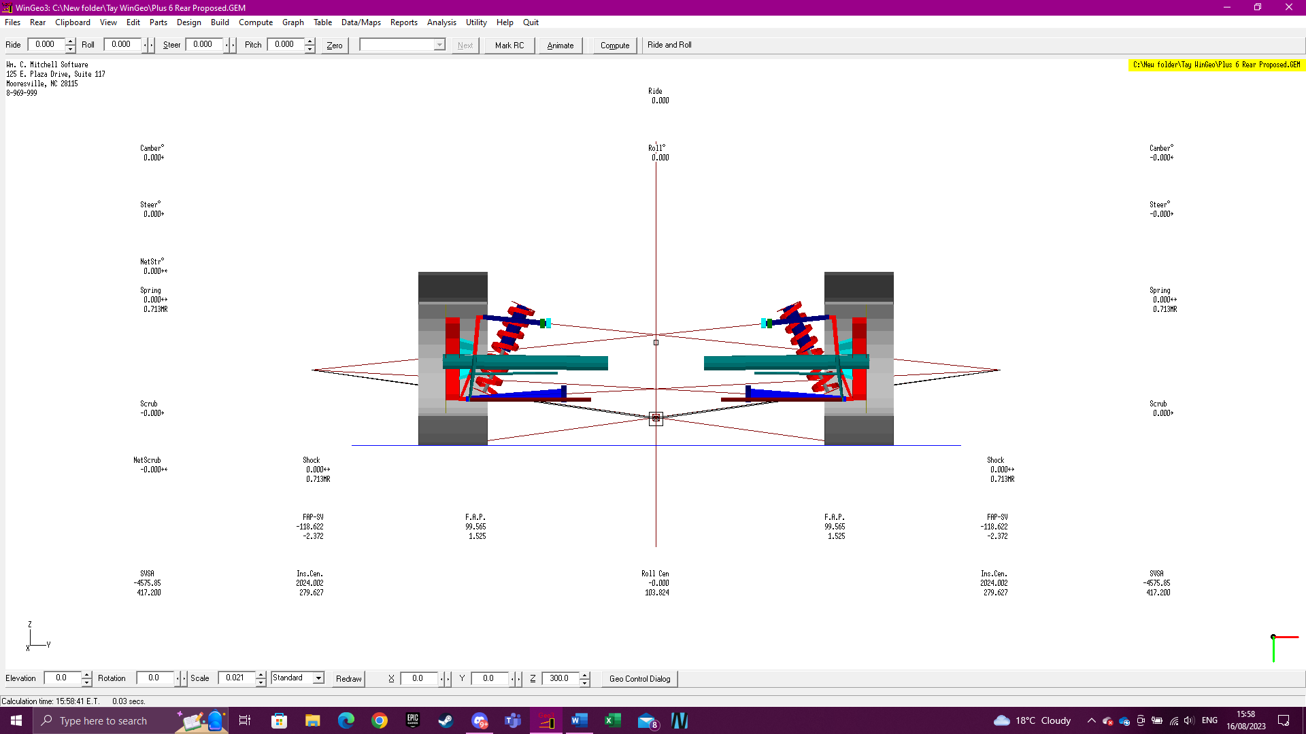
Figure 18: Plus 6 Rear Proposed.
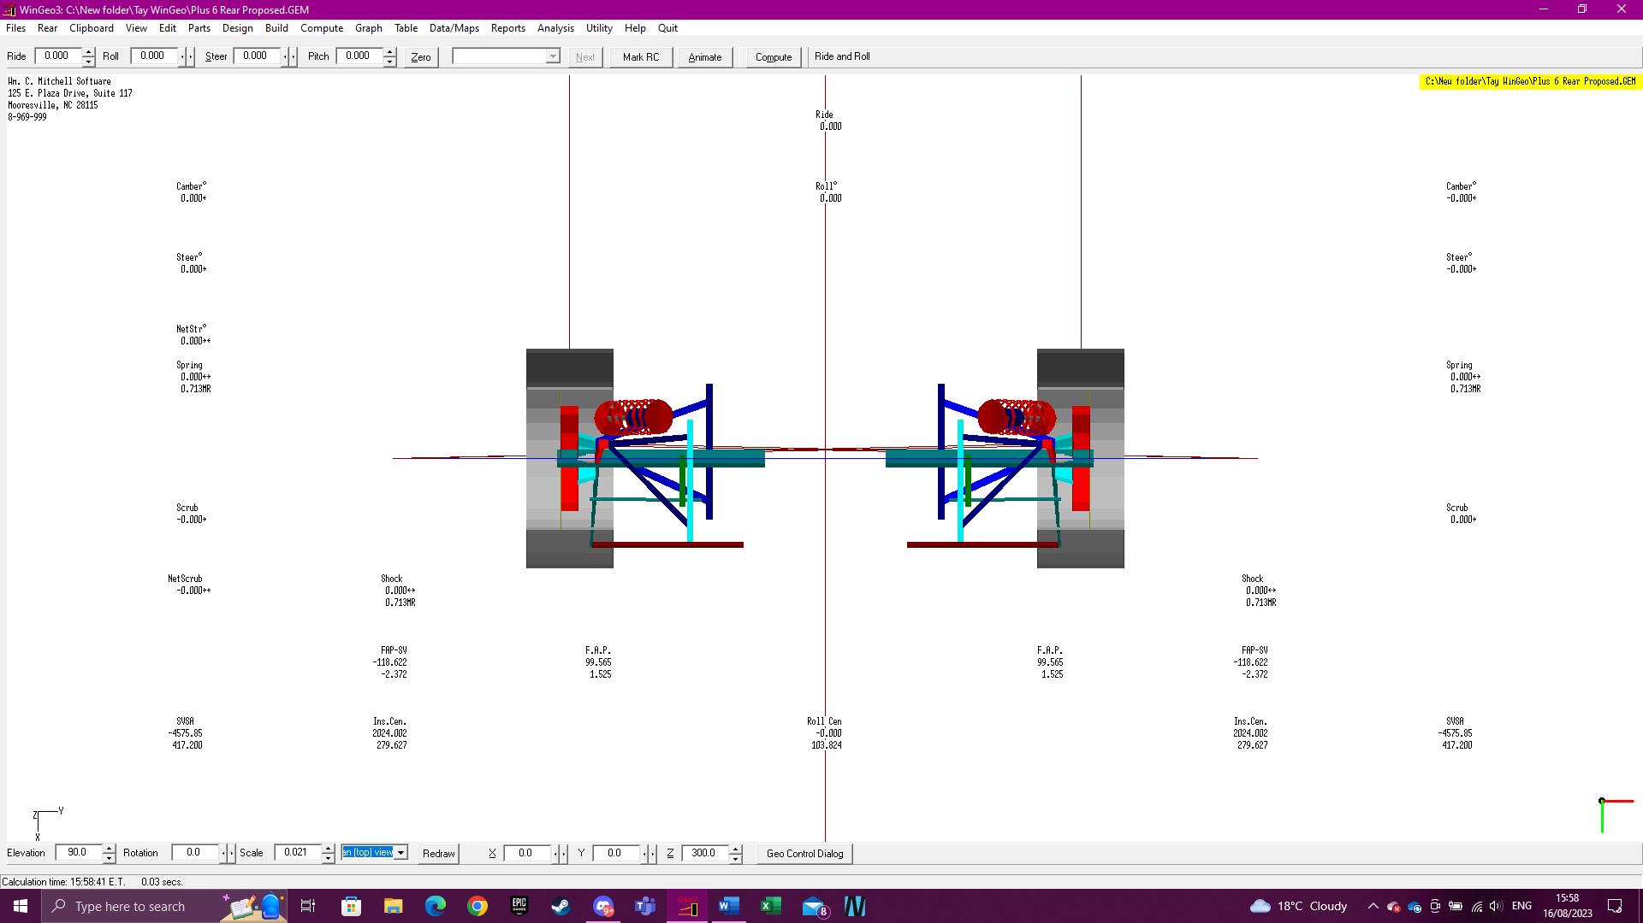
Figure 19: Plus 6 Rear Proposed (Top View).

6.1.3 Roll Centre Results
In figure 20, the roll centre heights of both the current and proposed suspensions are graphically depicted, allowing for a direct comparison between the two. The roll centre height represents the point around which the vehicle's body and suspension system rotate during cornering, impacting its stability, handling, and overall dynamic behaviour. The significant observation here is that the proposed suspension exhibits a lower roll centre height when compared to the existing setup. This is a noteworthy finding because a lower roll centre can have several implications for the vehicle's performance.

A lower roll centre typically results in improved stability during cornering. It reduces the amount of body roll, which is the tilting or leaning of the vehicle's body when taking a turn. This reduction in body roll enhances the vehicle's cornering ability and can contribute to a more confident and responsive handling experience. Furthermore, a lower roll centre can also lead to a more balanced weight distribution between the inside and outside wheels during cornering. This balance is essential for optimising traction and preventing excessive tyre wear, especially during aggressive manoeuvres.

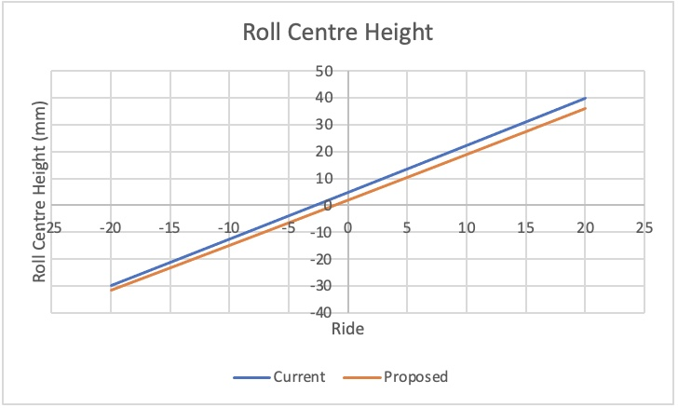
Figure 20: Roll Centre Height.
In figure 21, the instant centre locations for both suspension configurations are graphically represented. Notably, the proposed suspension demonstrates a substantially lower instant centre when compared to the current setup. The instant centre, often referred to as the "IC" in vehicle dynamics, is the point where the lines extending from the upper and lower control arms or suspension links intersect. It's a critical parameter because it influences several key aspects of a vehicle's handling and dynamics.

The IC affects how quickly and precisely a vehicle responds to steering inputs. A lower IC typically results in more responsive steering, providing the driver with a more immediate connection to the road. The location of the IC impacts how weight transfers between the front and rear wheels during acceleration, braking, and cornering. A lower IC can help distribute weight more evenly between the tyres, optimising traction, and handling. The instant centre’s position also influences a vehicle's resistance to diving under braking (anti-dive) and squatting during acceleration (anti-squat). A lower IC can enhance these characteristics, contributing to stability during dynamic manoeuvres.

The substantial difference in IC locations between the proposed and current suspensions is noteworthy. The proposed setup exhibits a much lower instant centre at its peak, indicating that it offers superior steering responsiveness, reduced weight transfer during dynamic manoeuvres, and potentially improved anti-dive and anti-squat characteristics.

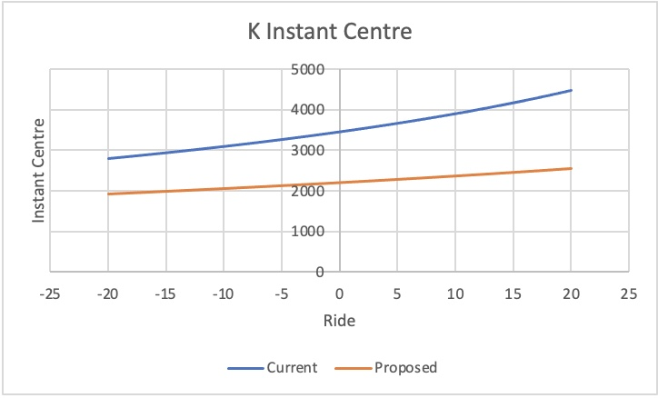
Figure 21: K Instant Centre.
In figure 22, the camber angles for both front and rear wheels are depicted for both suspension configurations. The proposed suspension exhibits more camber in both positive and negative directions when compared to the current setup.

The observed increase in camber for the proposed suspension suggests a deliberate design choice aimed at enhancing certain aspects of the vehicle's performance. More negative camber can improve the contact patch of the tyre with the road surface during cornering. This results in increased grip and traction, particularly when the vehicle is navigating curves or making aggressive turns. While negative camber enhances cornering performance, it can also affect straight-line stability. Therefore, the design must strike a balance to maintain stable and predictable behaviour during normal driving.

It's important to consider that excessive negative camber can lead to uneven tyre wear, as the inner edges of the tyres carry a heavier load during straight-line driving. Proper alignment and regular maintenance are essential to address potential tyre wear issues. The decision to incorporate more camber in both the positive and negative directions in the proposed suspension reflects a deliberate effort to enhance the Morgan Plus 6's handling characteristics, particularly its cornering performance and grip.

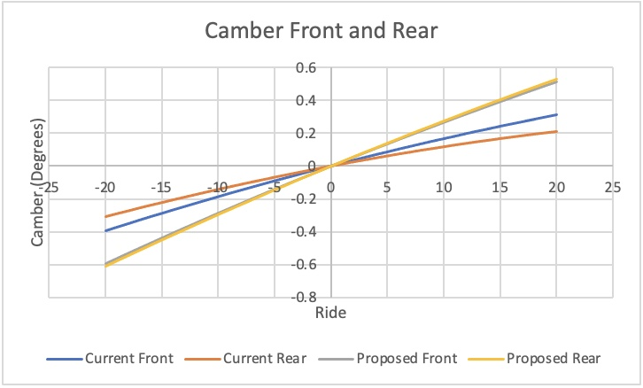
Figure 22: Camber (Ride).
In figure 23, the proposed suspension setup demonstrates notably higher toe angles for both positive and negative directions when compared to the current configuration. Increased toe-out (negative toe) at the front wheels can improve the vehicle's responsiveness to steering inputs, enhancing cornering agility and turn-in behaviour. This design choice can make the vehicle feel nimbler and more responsive during dynamic manoeuvres. While toe-out at the front wheels improves agility, it should be balanced with rear-wheel toe settings to maintain overall stability. The combination of toe settings at both front and rear axles is critical to achieve the desired balance of handling and stability. The higher toe angles in both directions should be carefully monitored to ensure they do not lead to uneven tyre wear.
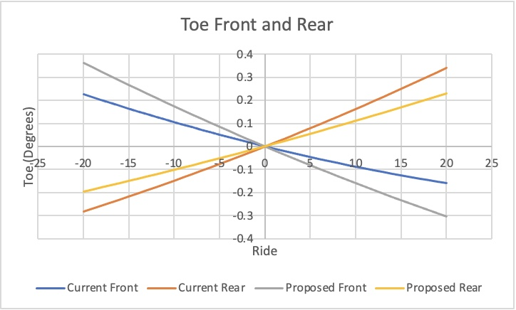
Figure 23: Toe (Ride).

6.1.4 Ackermann Analysis Results
Figure 24 presents the Ackermann values for both the proposed and current suspension setups. The Ackermann angle is a critical parameter in steering geometry and plays a vital role in a vehicle's cornering performance and handling characteristics. It is evident that the proposed suspension setup exhibits a 2% higher Ackermann value compared to the current configuration.
A higher Ackermann angle often leads to more precise and predictable cornering performance. It ensures that the inside wheel turns at a sharper angle than the outside wheel during a turn, reducing the likelihood of understeer (where the vehicle tends to push wide in a turn) and promoting better cornering stability. Proper Ackermann geometry reduces tyre scrubbing during turns. When the inside wheel turns at a sharper angle, it follows a tighter path, resulting in less lateral tyre scrub and reduced tyre wear. This is particularly important for maintaining tyre longevity and minimising rolling resistance. A higher Ackermann angle can enhance steering response, making the vehicle feel more agile and responsive to driver inputs. This is especially beneficial in dynamic driving situations, such as navigating tight corners or making quick lane changes. Achieving an optimal Ackermann angle is essential for balancing the handling characteristics of the vehicle. It helps maintain a harmonious relationship between the front and rear axles, contributing to stable and predictable handling.

While a 2% difference in Ackermann values may seem relatively small, it can have a noticeable impact on the vehicle's cornering behaviour and overall handling. The intentional increase in the Ackermann angle for the proposed suspension setup suggests a design choice aimed at enhancing cornering performance and steering precision.
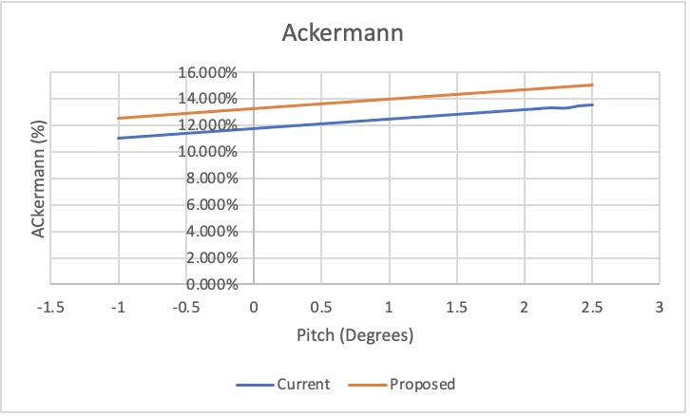
Figure 24: Ackermann Analysis.
Figure 25 compares the turn centre of the proposed and current suspension setups. The graph indicates that the proposed suspension setup exhibits a slightly higher turn centre compared to the current configuration. This means that when the vehicle is making a turn, it appears to pivot around a point that is situated slightly higher above the road surface. A higher turn centre leads to more responsive steering. When the turn centre is elevated, the vehicle responds more quickly to steering inputs, which can enhance agility and manoeuvrability.

An elevated turn centre tends to reduce body roll during cornering. This means the vehicle is less likely to lean excessively to one side during turns, contributing to a more stable and controlled ride. This can help mitigate understeer tendencies, which occurs when the front tyres lose grip, causing the vehicle to push wide in a turn.

While a higher turn centre can offer advantages in terms of steering response and handling, it's important to strike a balance. Extreme changes in turn centre height can affect the vehicle's stability and ride comfort. Therefore, designers and engineers carefully consider the trade-offs and aim for an optimal balance that aligns with the vehicle's intended use and performance goals.
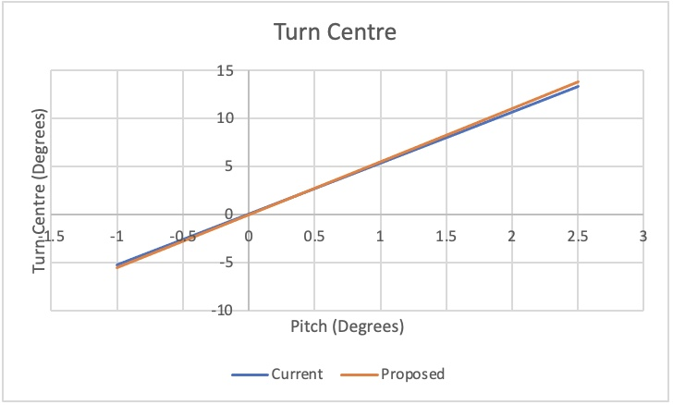
Figure 25: Turn Centre.
Figure 26 provides a detailed comparison of camber angles in pitch for both the proposed and current suspension setups. The graph clearly indicates that the proposed suspension setup features more negative camber compared to the current configuration. This means that the tops of the wheels are tilted inward toward the vehicle's centreline when viewed from the front or rear.

Negative camber enhances the tyre's contact patch during cornering. When the vehicle turns, the outside wheel gains more contact with the road surface, improving grip and cornering performance. It also helps mitigate understeer tendencies and it encourages the front tyres to maintain better contact with the road, improving steering response.

Another noteworthy observation in Figure 26 is that the camber angles for the front and rear of the proposed setup are much closer together compared to the front and rear of the current setup. This indicates a more balanced camber distribution between the front and rear wheels. This is desirable as it contributes to consistent handling characteristics between the front and rear of the vehicle. It helps maintain stability and predictability during cornering manoeuvres and ensures that both sets of tyres are actively engaged in providing grip and control.

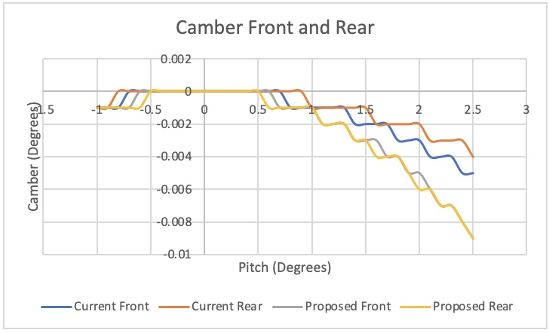
Figure 26: Camber (Pitch).
Figure 27 presents a comparison of toe angles in pitch for both the current and proposed suspension setups. Toe angle in pitch, often referred to as "pitch toe," represents the angle at which the front or rear wheels are tilted when viewed from the top or bottom of the vehicle. This angle indicates whether the wheels are pointed inward or outward relative to the vehicle's centreline in the vertical plane.

The proposed front suspension setup exhibits a higher positive toe angle, which occurs when the front of the wheels is pointed inward toward the centreline of the vehicle. This configuration can be advantageous in certain situations. Positive toe can enhance straight-line stability, when both front wheels are slightly pointed inward, they tend to resist turning, helping the vehicle maintain a straight path, especially at higher speeds. It can reduce the responsiveness of the steering system. This can be beneficial for drivers seeking a more stable and less twitchy steering feel, which can be desirable for long motorway drives.

On the other hand, the current front suspension setup exhibits a higher negative toe angle, which occurs when the front of the wheels is pointed outward, away from the centreline of the vehicle. Negative toe can enhance cornering response and agility, when the front wheels are slightly pointed outward, it allows for quicker turn-in and improved cornering grip. Negative toe increases steering sensitivity, making the steering system more responsive to driver input. This is often preferred in sports and performance-oriented vehicles for precise handling.

It's also important to note that the proposed setup features a balanced distribution of positive and negative toe angles, suggesting a careful tuning of the suspension for overall handling characteristics. This balance aims to combine the stability benefits of positive toe with the cornering agility of negative toe.

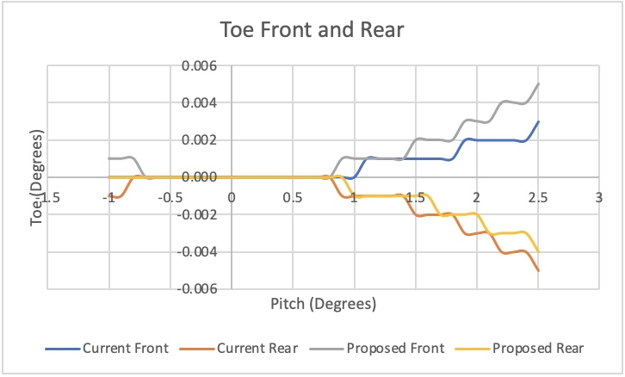
Figure 27: Toe (Pitch).

6.1.5 Tyre Load Analysis Results
Figure 28 presents a comparison of the front tyre load distribution between the left and right sides for both the current and proposed suspension setups. Tyre load distribution is a crucial aspect of suspension analysis, as it directly impacts the vehicle's handling, traction, and overall performance.

Tyre load distribution refers to how the weight of the vehicle is distributed across the individual tyres, specifically between the left and right sides of the vehicle. It's essential to maintain a balanced load distribution to ensure optimal traction, stability, and handling. Figure 28 shows that for both the current and proposed suspension setups, the tyre load distribution between the front left and front right tyres is identical. This means that the weight of the vehicle is evenly distributed between the two front tyres.

Balanced tyre load distribution helps ensure that both front tyres maintain good contact with the road surface. This is crucial for maximising traction, especially during acceleration and braking. An even load distribution contributes to stable handling characteristics. When the front tyres have similar loads, the vehicle is less prone to understeer (front-end pushing) or oversteer (rear-end sliding) during cornering. Balanced load distribution also supports consistent and predictable steering response. When both front tyres share the load equally, the vehicle is more likely to respond to steering inputs predictably and smoothly. The fact that both setups exhibit similar front tyre load distribution suggests that the proposed suspension adjustments do not significantly alter the balance of weight between the front tyres. This indicates that the changes made were aimed at improving other aspects of the suspension, such as camber, toe, or handling characteristics, rather than redistributing weight.

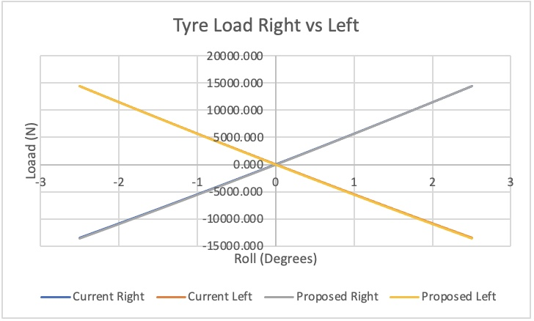
Figure 28: Tyre Load.
Figure 29 below shows the camber in roll front and rear for both setups. Camber in roll, also known as dynamic camber, refers to how the camber angle of a wheel changes as the vehicle experiences body roll during cornering or other dynamic manoeuvres. The graph shows that the proposed suspension setup exhibits a consistent trendline for both the front and rear wheels. This trendline indicates that, as the vehicle undergoes body roll, the camber angles for both the front and rear wheels decrease compared to the static (straight-line) camber settings. The most notable finding in this figure is that the proposed setup consistently maintains lower camber angles for both the front and rear wheels, whether in positive or negative camber conditions. This suggests that the proposed suspension adjustments result in less dynamic camber change during cornering compared to the current setup.

Conversely, the current setup exhibits slightly higher camber angles in both positive and negative camber for the rear wheels and slightly lower camber for the front wheels. These differences indicate that the current setup allows for greater dynamic camber changes during cornering, particularly for the rear wheels. The implications of this include, lower dynamic camber changes, as seen in the proposed setup, can contribute to greater stability during cornering. A more consistent camber angle means that the tyres maintain better contact with the road, enhancing traction and reducing the risk of sudden oversteer or understeer. Higher dynamic camber changes can cause uneven tyre wear, particularly on the inside or outside edges of the tread. Whereas, lower dynamic camber changes, as observed in the proposed setup, result in more even tyre wear. Camber adjustments can also affect the handling balance of the vehicle. The choice of camber settings, whether static or dynamic, can influence how the vehicle responds to steering inputs and body roll.

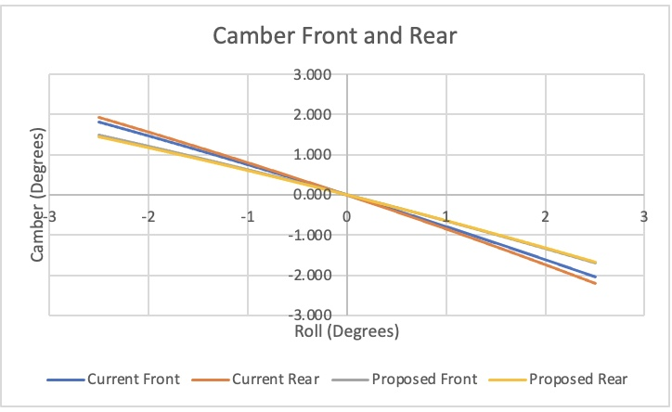
Figure 29: Camber (Roll).
Figure 30 highlights the differences in toe characteristics during roll between the current and proposed suspension setups. Toe during roll is a crucial parameter in suspension analysis because it directly affects how the vehicle responds to cornering forces. It influences how the wheels steer inward or outward as the vehicle undergoes body roll. The graph illustrates that the proposed front suspension setup exhibits the highest toe angle in both positive and negative directions during roll. This means that as the vehicle corners, the front wheels tend to steer significantly inward (toe-in) compared to their static position. This characteristic can have implications for the vehicle's handling behaviour.

In contrast, the current front suspension setup shows a slightly lower toe angle in both positive and negative directions during roll compared to the proposed front setup. This indicates that the current front setup results in less toe-in during roll, implying a somewhat different steering response during cornering.

For the rear suspension setups, the proposed setup displays a lower toe angle in both negative and positive directions during roll compared to the current rear setup. This means that the rear wheels tend to steer less inward (toe-in) as the vehicle undergoes body roll in the proposed setup.

Toe during roll significantly affects the handling characteristics of the vehicle. Higher toe-in values during roll can enhance stability and reduce the risk of sudden oversteer during cornering. Lower toe-in values can make the vehicle more responsive to steering inputs, potentially improving agility. The choice of toe settings during roll can influence how the vehicle responds to cornering forces. More toe-in during roll can contribute to a stable and predictable cornering behaviour, while less toe-in can result in a more responsive and agile feel.

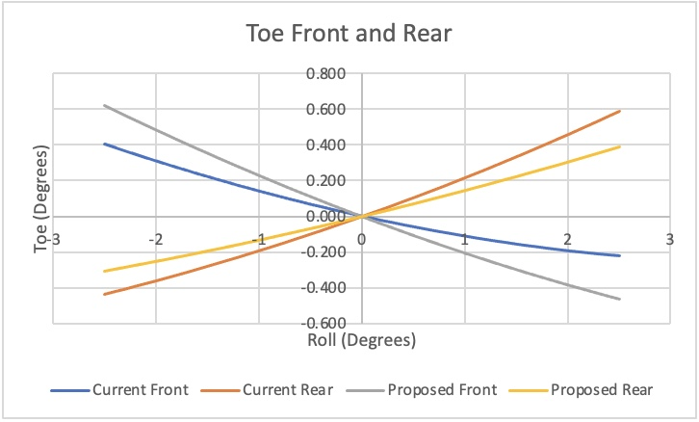
Figure 30: Toe (Roll).

6.2 VI-Grade

6.2.1 Current Setup
Figure 31 below provides a detailed depiction of the current front suspension setup within the VI-Grade software. This visual representation offers a comprehensive view of the intricate components and geometries that constitute the front suspension system of the vehicle under analysis.
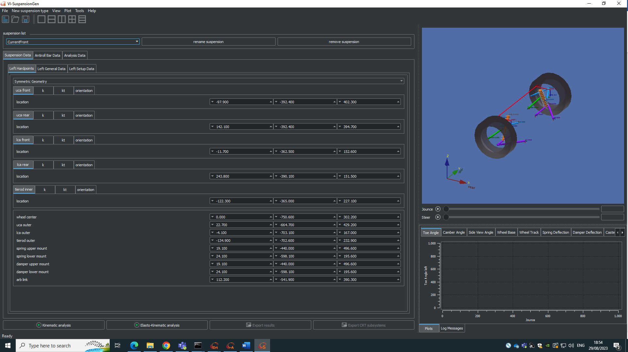
Figure 31: Plus 6 Current Front.
Figure 32 below provides a detailed depiction of the current rear suspension setup within the VI-Grade software.
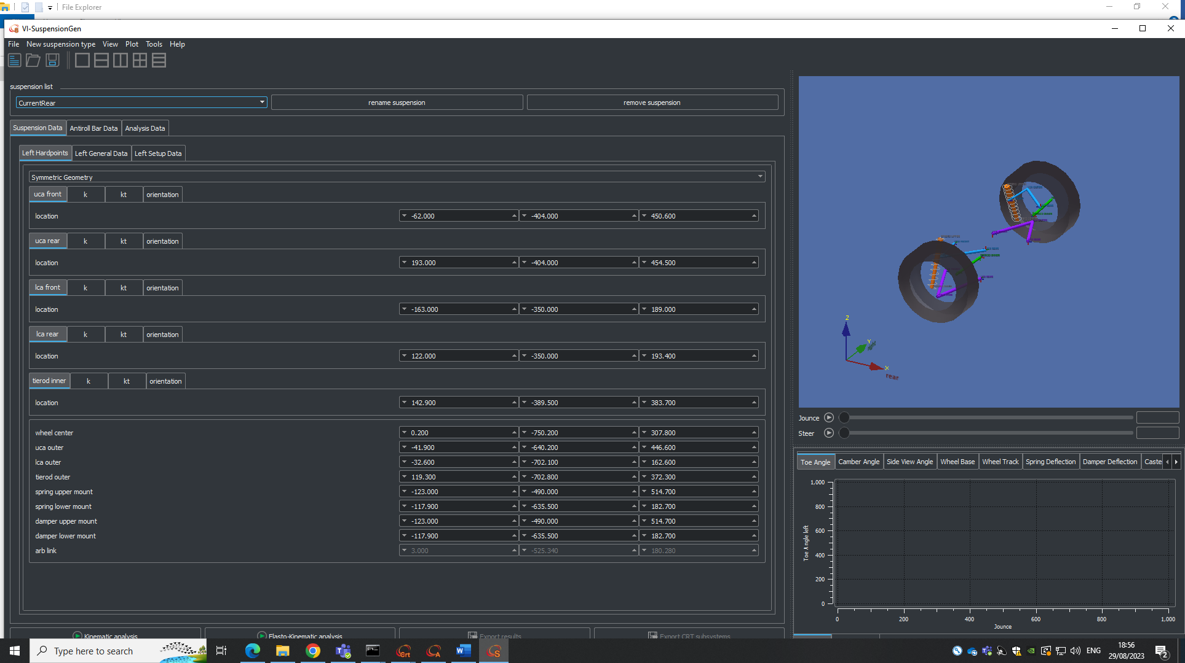
Figure 32: Plus 6 Current Rear.

6.2.2 Proposed Setup
Figure 33 below provides a detailed depiction of the proposed front suspension setup within the VI-Grade software. This visual representation offers a comprehensive view of the intricate components and geometries that constitute the front suspension system of the vehicle under analysis.
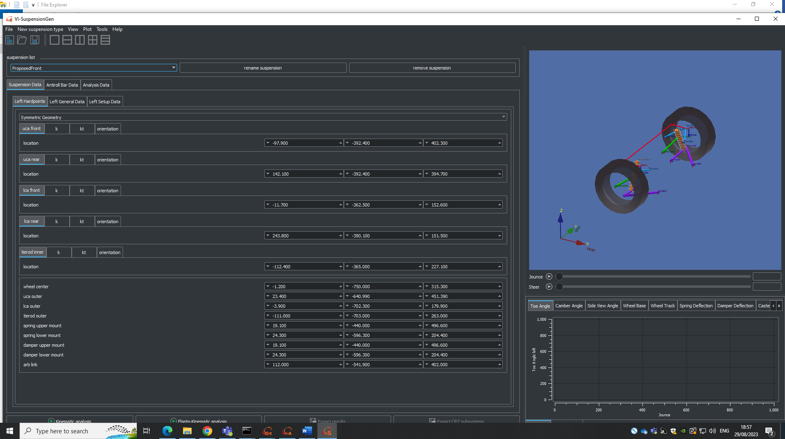
Figure 33: Plus 6 Proposed Front.
Figure 33 below provides a detailed depiction of the proposed rear suspension setup within the VI-Grade software.
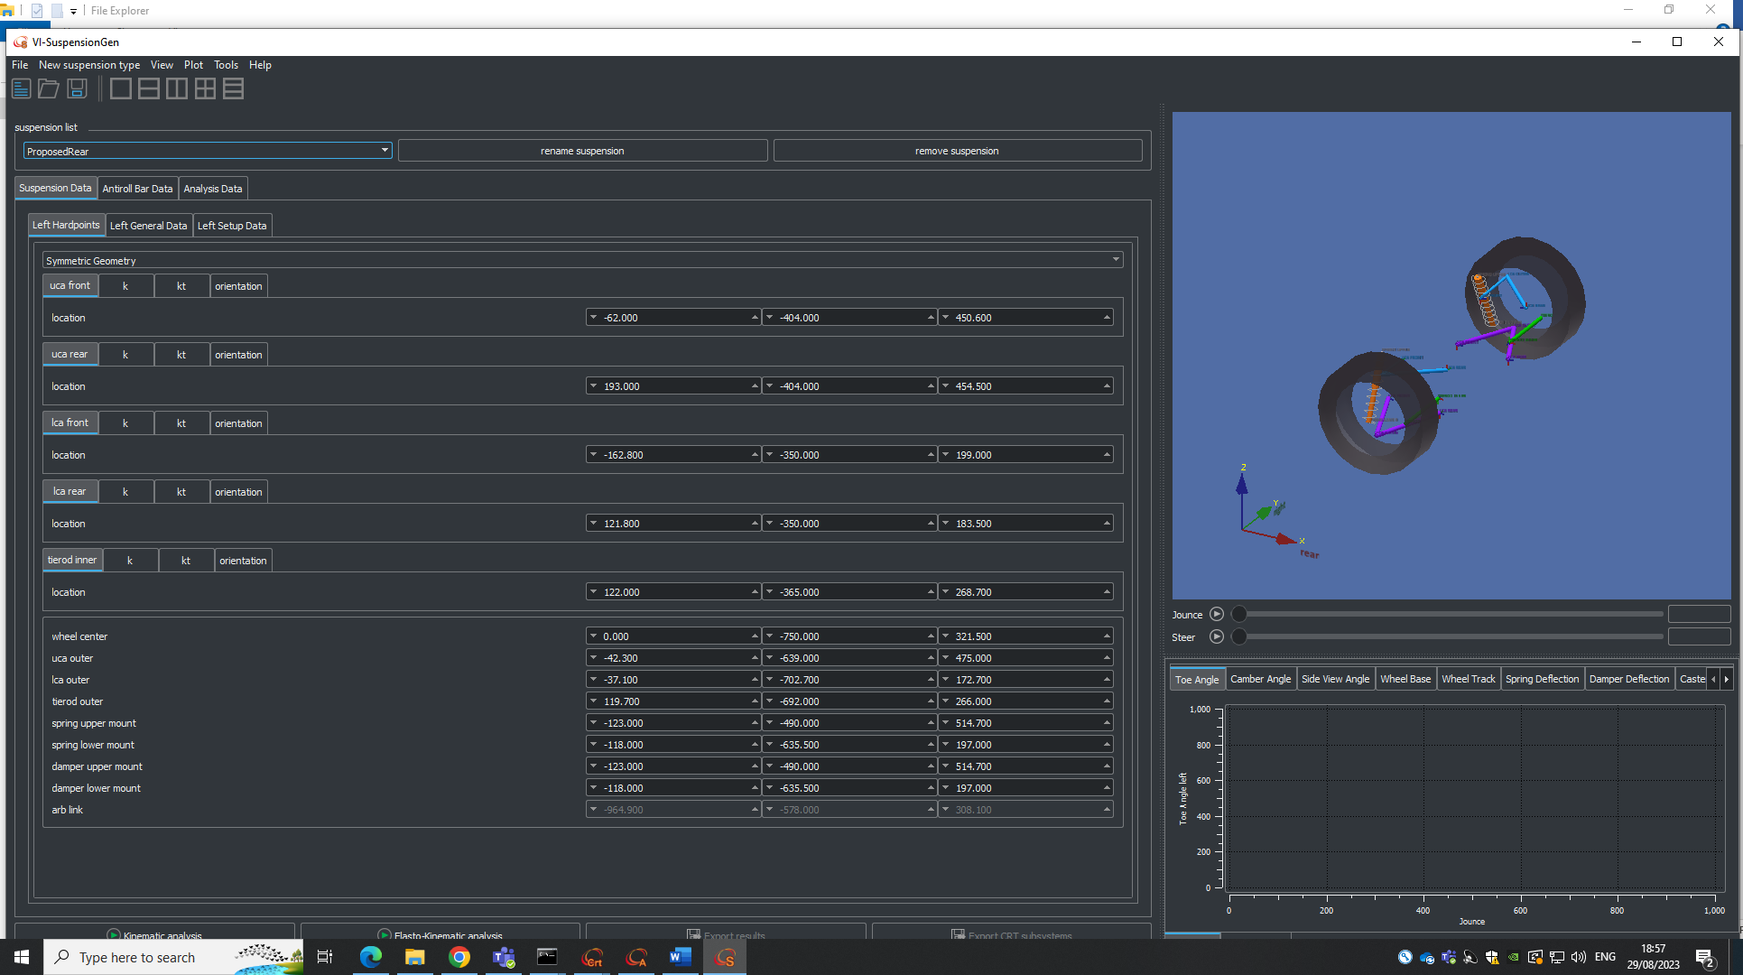
Figure 34: Plus 6 Proposed Rear.

6.3 VI-Grade Comparison
This section delves into a detailed analysis of crucial parameters and performance metrics related to the current and proposed suspension setups of the vehicle as it undergoes testing on the Pembrey circuit, J Turn, Swept Steer and Fishhook. These visualisations and data interpretations shed light on how the suspension systems handle the dynamic forces encountered during high-performance driving conditions, providing essential insights for optimising vehicle dynamics and ride quality.

6.3.1 Pembrey Results
Figure 35 provides a comparison of damper forces on each corner of the vehicle for both the current and proposed suspension setups as the vehicle traverses the Pembrey circuit. This detailed analysis offers crucial insights into how the suspension systems manage the forces encountered during dynamic driving conditions.

In this graph, the proposed suspension setup exhibits a notable difference in damper forces compared to the current setup. Specifically, the damper forces, both in bump (compression) and rebound (extension), are noticeably lower for the proposed suspension configuration. The reduction in damper forces is a significant finding with several implications. Lower damper forces suggest that the proposed suspension system provides a more compliant and forgiving ride experience. It indicates that the suspension is better equipped to absorb and dampen the impact of road irregularities, such as bumps and undulations, resulting in improved ride comfort for the vehicle's occupants.

Furthermore, the lower damper forces also signify a more balanced and controlled response of the suspension during dynamic manoeuvres. This contributes to enhanced stability and predictability when navigating corners, making the vehicle more agile and responsive. However, it's essential to interpret these findings in the broader context of the project objectives. While lower damper forces can offer advantages in terms of ride comfort and stability, they must be balanced with other suspension parameters to ensure optimal performance. Therefore, further analysis and consideration of various factors, including handling characteristics and overall vehicle dynamics, will be necessary to make informed decisions regarding the proposed suspension setup.
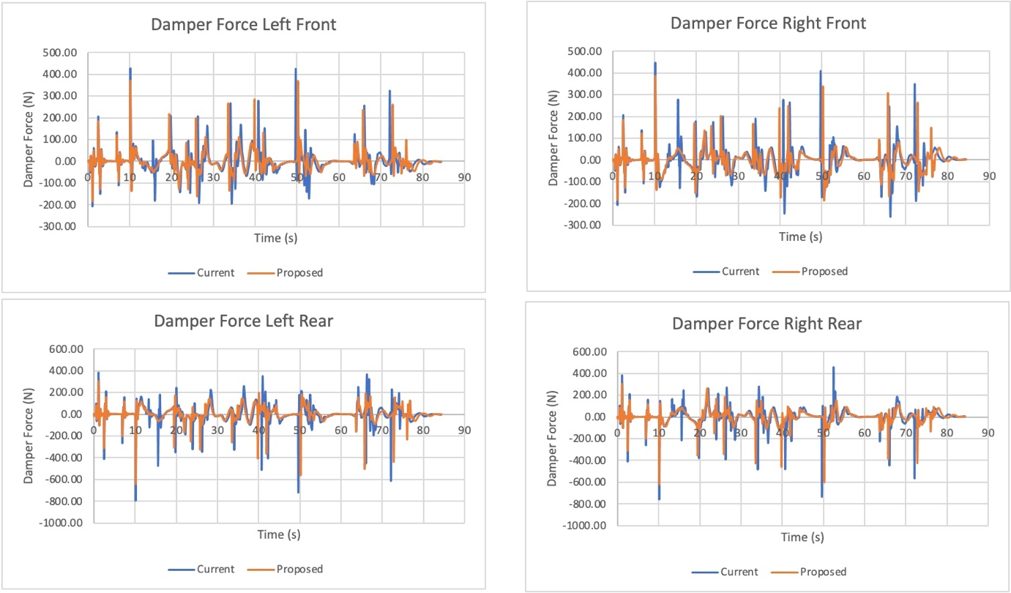
Figure 35: Pembrey Damper Forces.
Figure 36 presents an analysis of the contact patch for both the current and proposed suspension setups as the vehicle navigates the Pembrey circuit. The contact patch is a critical parameter that provides valuable insights into how the tyres interact with the road surface during dynamic driving conditions. Upon examination of this graph, it becomes evident that both suspension setups exhibit a similar overall trend in terms of the contact patch. Throughout the majority of the circuit, the contact patches for both setups follow a parallel trajectory, indicating that the tyres maintain consistent contact with the road surface.

However, a noteworthy distinction emerges during the final 15 seconds of the track. In this segment, the contact patch for the proposed suspension setup shows a slightly higher value compared to the current setup. This divergence in the contact patch suggests that the proposed suspension configuration offers a marginal advantage in terms of tyre grip and traction during the latter part of the circuit. The significance of this observation lies in its potential impact on the vehicle's handling and performance. A higher contact patch indicates that the tyres are better engaged with the road, which can translate to improved cornering capabilities, enhanced stability, and potentially faster lap times. This finding aligns with the project's objective of optimising the suspension to enhance overall vehicle performance. The difference in contact patch during the final segment of the circuit is relatively small, and its practical significance may vary depending on specific driving scenarios and conditions.
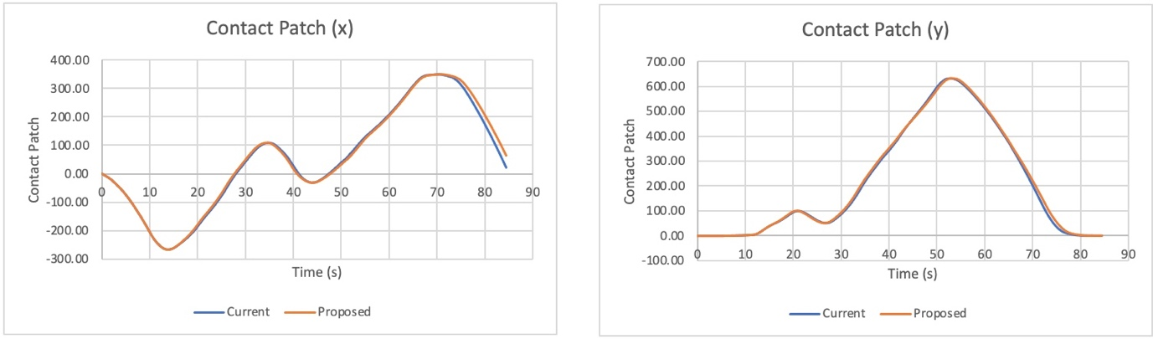
Figure 36: Pembrey Contact Patch.
Figure 37 provides an analysis of suspension roll behaviour for both the current and proposed suspension setups as the vehicle completes laps on the Pembrey circuit. Suspension roll, often referred to as body roll, is a critical parameter that influences a vehicle's handling characteristics and stability during cornering and dynamic manoeuvres.

It’s apparent that both suspension setups exhibit a comparable trend in terms of suspension roll throughout the course of the circuit. Both configurations demonstrate a well-controlled and balanced approach to managing body roll, which is indicative of effective suspension design. However, a subtle distinction emerges in the data. The proposed suspension setup consistently shows a slightly lower suspension roll value compared to the current setup by approximately 0.025mm. While this difference may appear minor, it has important implications for the vehicle's handling and overall performance.

A lower suspension roll signifies that the proposed suspension configuration effectively limits the amount of body lean or sway during cornering and dynamic manoeuvres. This characteristic contributes to improved stability, enhanced cornering capabilities, and a more responsive and predictable driving experience. Reduced body roll is often desirable in sports cars and high-performance vehicles, as it allows for better weight distribution and tyre contact with the road surface, ultimately translating to improved traction and handling.

It's important to note that even though the difference in suspension roll is relatively small, its impact on vehicle dynamics and driver confidence can be significant. Drivers will experience a greater sense of control and agility when driving a vehicle with reduced body roll, especially during aggressive cornering and track sessions.
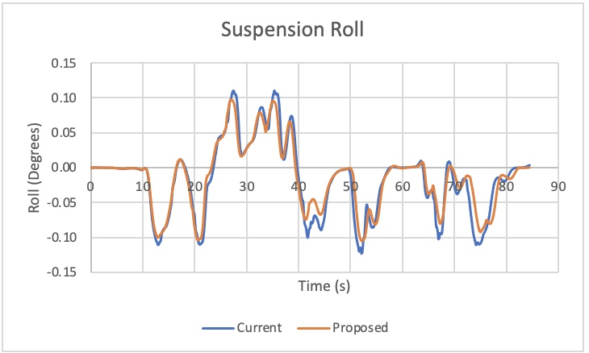
Figure 37: Pembrey Suspension Roll.
Figure 38 provides an insightful comparison of the front ride height between the current and proposed suspension setups. Ride height, a critical parameter in vehicle dynamics, refers to the vertical distance between the base of the tyre and the vehicle's lowest point, typically the axle or chassis.

In this analysis, it is evident that the proposed suspension setup consistently maintains a notably lower front ride height compared to the current setup, with a difference of approximately 0.07mm. While this difference may appear minuscule, it holds considerable significance in terms of vehicle dynamics and performance.
A lower front ride height indicates that the proposed suspension configuration positions the front of the vehicle closer to the road surface. This adjustment has several implications for the vehicle's handling and overall behaviour. A lower front ride height can enhance the vehicle's aerodynamic efficiency. Reduced air resistance can lead to improved fuel efficiency and higher top speeds, making it particularly advantageous for this vehicle. Lowering the front ride height effectively lowers the vehicle's centre of gravity. This is beneficial for stability and handling, as it reduces the tendency for body roll during cornering and minimises the risk of rollovers during rapid manoeuvres. A lower front ride height contributes to improved handling characteristics. It allows for better weight distribution between the front and rear axles, resulting in more balanced and predictable cornering behaviour. The vehicle is less prone to understeer (front-wheel traction loss) and more responsive to steering inputs.

Maintaining a lower front ride height helps ensure that the vehicle's tyres maintain optimal contact with the road surface. Lower ride height reduces the tendency for the vehicle to pitch forward or backward under braking and acceleration. This enhances driver confidence and control, particularly in dynamic driving scenarios. It's important to note that while the difference in front ride height between the two setups is relatively small, it has a cumulative effect on the vehicle's overall behaviour. This difference aligns with the project's objective of optimising the suspension to enhance ride comfort, stability, and vehicle performance.
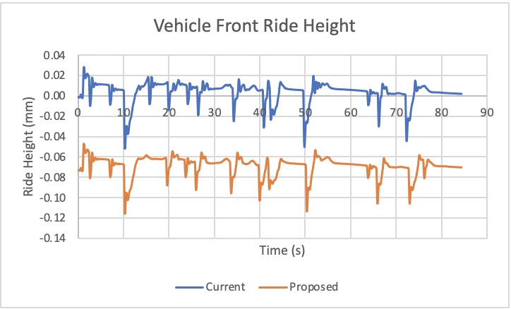
Figure 38: Pembrey Vehicle Front Ride Height.
Figure 39 shows the vehicle inclination roll for both the current and proposed suspension setups during the Pembrey circuit analysis. Vehicle inclination, specifically roll, refers to the tilting motion of the vehicle from side to side when navigating corners or uneven terrain. This motion is a crucial aspect of vehicle dynamics and can significantly impact handling and stability.

The comparison between the current and proposed suspension setups reveals an interesting finding: the proposed setup consistently exhibits lower vehicle inclination roll, with a noticeable difference of approximately 0.03mm. While this difference may seem small, it carries significant implications for the vehicle's behaviour and performance.

Reduced roll indicates greater stability during cornering and dynamic manoeuvres. The vehicle is less prone to leaning excessively in turns, which can contribute to a more confident and controlled driving experience. Lower roll enhances the responsiveness of the vehicle to steering inputs. It reduces the sensation of body roll, making the vehicle feel more planted and predictable in corners. This can result in improved handling characteristics and driver confidence. Lower roll also reduces weight transfer from side to side during cornering. This is important because excessive weight transfer can negatively impact tyre grip and traction. With less roll, the tyres are better able to maintain contact with the road surface, improving overall cornering performance.

In extreme cases, excessive vehicle roll can lead to rollovers, especially in high-profile vehicles like SUVs. Lower roll, as observed in the proposed setup, contributes to a safer and more stable vehicle which can lead to a more comfortable ride for occupants. Reduced lateral body movement can mitigate motion sickness and discomfort, particularly for passengers.

The graph provides valuable insights into how the proposed suspension setup effectively manages vehicle inclination roll throughout the Pembrey circuit. While the difference in roll may appear modest, it represents a meaningful optimisation that can translate into tangible benefits for the vehicle and its occupants.
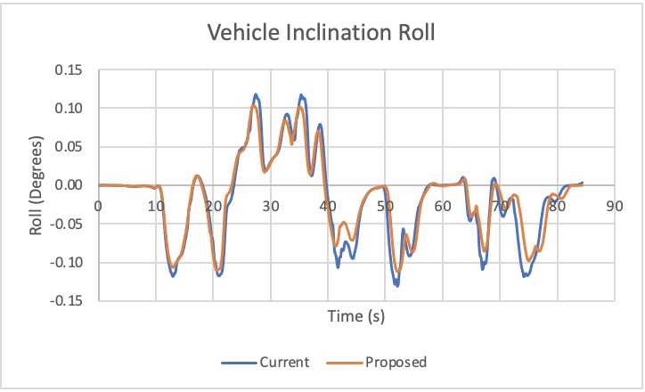
Figure 39: Pembrey Vehicle Inclination Roll.
Figure 40 examines the vehicle pitch, specifically focusing on how both the current and proposed suspension setups influence this aspect during the Pembrey circuit. The data indicates that the proposed suspension setup exhibits a 0.01 degree higher pitch than the current setup. While this difference may seem modest, it can have several implications for vehicle performance and dynamics.

Vehicle pitch affects weight distribution, particularly during braking and acceleration. With a slightly higher pitch in the proposed setup, there is a slightly more pronounced weight transfer during these manoeuvres. This could influence how the vehicle responds to abrupt braking or rapid acceleration, potentially impacting stability and traction. Pitch can also influence a vehicle's behaviour during cornering. A higher pitch can affect the balance of weight between the front and rear axles, altering the vehicle's cornering characteristics.

Vehicle pitch plays a role in passenger comfort. A more pronounced pitch results in a sensation of "nose-diving" during braking or "lifting" during acceleration, which can be uncomfortable for passengers. However, the 0.01 degree difference observed here is relatively minor and may not significantly impact ride comfort. However, the difference in pitch could affect driver confidence, especially during aggressive driving or high-performance manoeuvres. Drivers may notice variations in how the vehicle behaves under hard braking or acceleration, which will influence their trust in the vehicle's stability and handling.

It's essential to consider that the 0.01 degree difference in pitch is relatively small and may not result in significant changes in vehicle behaviour. However, it does highlight the importance of fine-tuning suspension setups to achieve the desired driving characteristics.
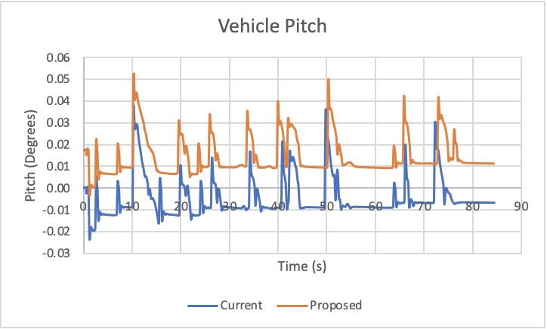
Figure 40: Pembrey Vehicle Pitch.
Figure 41 shows a comparison of the vehicle's yaw behaviour between the current and proposed suspension setups. Yaw refers to the rotation of the vehicle around its vertical axis, typically caused by steering input or lateral forces during cornering. A positive yaw indicates a clockwise rotation (as viewed from above), while negative yaw denotes an anticlockwise rotation.

The data reveals that both suspension setups exhibit a similar pattern of yaw behaviour throughout the Pembrey circuit, with the proposed setup showing a slightly higher degree of yaw. Yaw is closely associated with a vehicle's cornering behaviour. A higher degree of yaw suggests that the proposed setup allows for slightly more rotation during cornering. This can influence how the vehicle responds to steering inputs, resulting in more agile and responsive handling characteristics. Yaw control is essential for vehicle stability, especially during rapid changes in direction. While the proposed setup shows a slightly higher yaw, it's important to assess whether this additional yaw is within acceptable limits and doesn't compromise overall stability.

The degree of yaw can influence the driving experience and driver sensation. Some drivers may prefer a setup that allows for more yaw, as it can provide a sportier and more engaging driving feel. Others may favour a setup with less yaw for a more stable and predictable ride. The observed yaw difference influences how the vehicle's weight is distributed across the tyres during cornering. Yaw can impact steering response and how quickly the vehicle reacts to steering inputs. A setup with slightly higher yaw may exhibit more responsive steering, potentially benefiting drivers looking for precise control.

It's important to note that the observed difference in yaw between the two setups is relatively small. Whether this difference is considered advantageous or not depends on the specific goals and preferences of the vehicle's intended use. Some drivers may appreciate the enhanced agility and responsiveness, while others may prioritise stability. As the Morgan Plus 6 is a sportscar, the increase in yaw is beneficial to vehicle stability. However, as the difference between the two setups is very minimal this is not something that needs to be considered at this time. Further investigation into the changes in yaw may be helpful for Morgan Motors to consider with customer feedback.
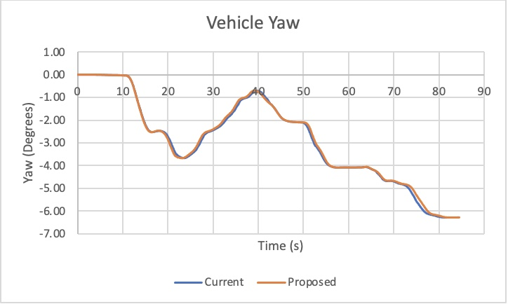
Figure 41: Pembrey Vehicle Yaw.

6.3.2 J Turn Results
Figure 41 provides a detailed analysis of damper forces at all four corners of the vehicle during a J Turn manoeuvre. This graph offers an insight into how the proposed and current suspension setups respond to the challenging forces encountered during this manoeuvre.

The data reveals a consistent trend throughout the J Turn, with the proposed suspension setup generally exhibiting lower damping forces at each corner compared to the current setup. This observation is significant as it suggests that the proposed suspension system offers a more compliant and forgiving response to the dynamic forces involved in the J Turn. Lower damping forces are indicative of a suspension system that can effectively absorb and dampen the sudden changes in load and direction, contributing to improved ride comfort and handling predictability.

However, a notable anomaly emerges between 3 and 4 seconds into the manoeuvre. During this brief time frame, there is a sudden and substantial spike in bump (compression) forces observed in all four corners of the vehicle. Additionally, there is a simultaneous spike in rebound (extension) forces, specifically in the right front and right rear corners. Several factors could contribute to these anomalous spikes in damper forces. The J Turn manoeuvre involves rapid weight transfer from one side of the vehicle to the other. The spikes in damper forces could be a response to this abrupt change in weight distribution, causing the suspension to react more aggressively to maintain stability.

While these spikes in damper forces may initially appear as outliers, it's crucial to assess their impact on overall vehicle behaviour and safety. Further analysis and testing would be required to determine whether these spikes are within acceptable limits and do not compromise the vehicle's stability or ride comfort during this specific manoeuvre. This again is something that should be considered by Morgan Motors and may be something that requires further investigation.
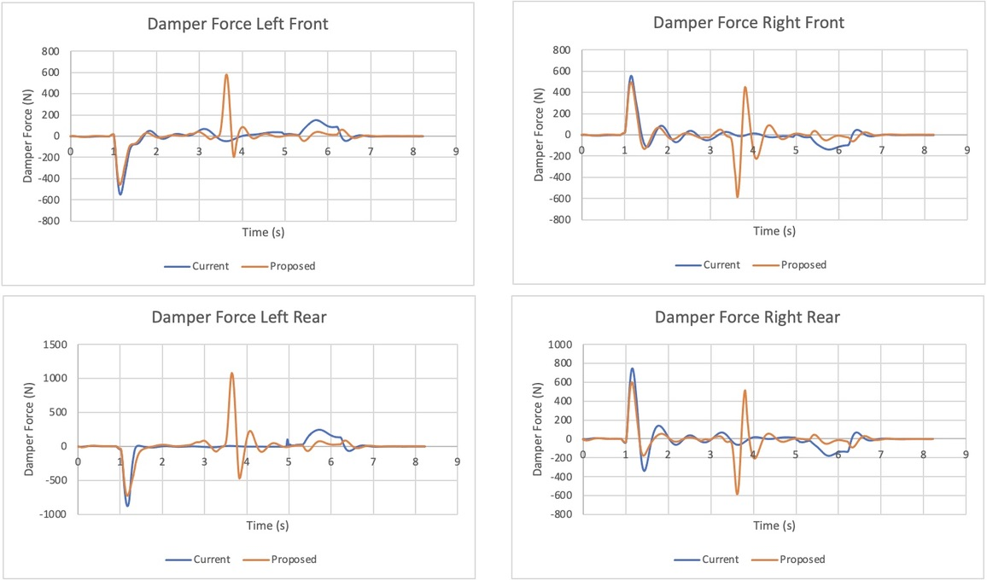
Figure 42: J Turn Damper Forces.
Figure 43 provides an analysis of the contact patch's behaviour in both the x-axis and y-axis for both the proposed and current suspension setups during a J Turn manoeuvre. In the x-axis, the proposed suspension setup exhibits a higher contact patch compared to the current setup. This signifies that the tyres have more lateral grip during the J Turn manoeuvre. This suggests that the vehicle has improved lateral stability during aggressive cornering. It means the tyres can better resist side-to-side forces, which is crucial for maintaining control and preventing skidding during sharp turns. With improved lateral grip, the vehicle can handle corners more effectively, allowing for sharper and more controlled manoeuvres. This is particularly important for sports cars.

In the y-axis, the current setup exhibits a much higher contact patch compared to the proposed setup. This indicates that the tyres have substantially more longitudinal grip during the J Turn manoeuvre. This suggests that the tyres can provide better braking performance. This is crucial for maintaining control and stopping the vehicle safely, especially in emergency braking situations. More longitudinal grip means the tyres can effectively transfer power from the engine to the road surface during acceleration. This results in quicker and more responsive acceleration. The higher contact patch in the y-axis helps distribute weight more effectively during braking and acceleration. This contributes to better weight balance and stability, reducing the risk of skidding or loss of control.

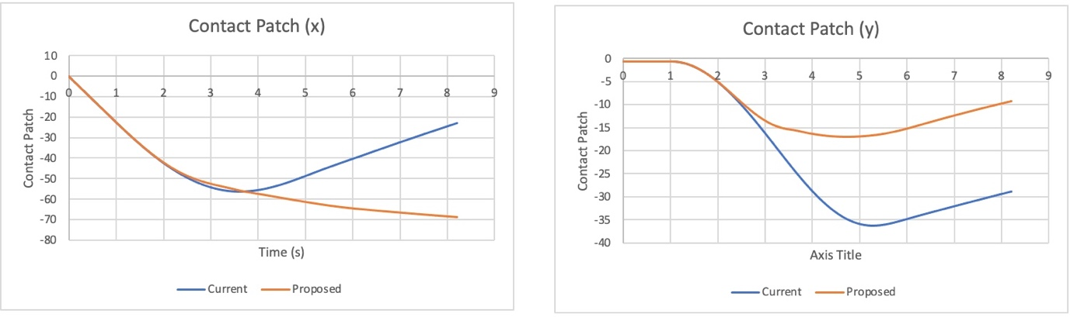
Figure 43: J Turn Contact Patch.
Figure 44 provides a comparison of suspension roll behaviour for both the proposed and current suspension setups. It is evident that the proposed suspension setup consistently exhibits a lower degree of suspension roll compared to the current setup, with a reduction of approximately 0.02 degrees. While this difference may appear modest at first glance, it holds considerable significance in terms of vehicle dynamics and handling performance.

Reduced suspension roll indicates that the proposed suspension configuration effectively limits the amount of body lean or sway experienced by the vehicle during cornering. It means that the vehicle remains flatter and more composed, reducing the risk of rollovers or excessive body movement. Lower suspension roll helps maintain a more stable and evenly distributed weight profile during cornering. This is particularly beneficial for the Morgan Plus 6 as a rear-wheel-drive (RWD) configuration, as it minimises the risk of oversteer or understeer, ensuring balanced handling characteristics.

However, between 4 and 6 seconds the current setup shows a steady decrease in suspension roll, whereas the proposed setup declines rapidly at 3.5 seconds. This difference in suspension roll behaviour highlights the unique characteristics of each suspension setup. The current setup maintains a steady and controlled reduction in roll, contributing to stable and predictable handling. On the other hand, the proposed setup exhibits a more rapid change in roll during a specific time frame, suggesting potential variability in handling behaviour.

It's important to consider that these observations are specific to the J Turn manoeuvre and does not represent the setups' behaviour in all driving scenarios. Further testing of suspension roll through a J Turn manoeuvre would be beneficial for Morgan Motors to complete as this could greatly affects the stability of the vehicle with the proposed suspension configuration.
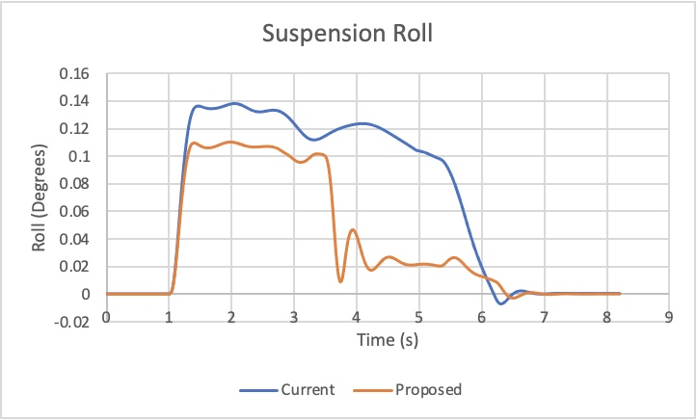
Figure 44: J Turn Suspension Roll.
Figure 45 below shows the vehicle front ride height for both setups during the J Turn manoeuvre. Again, the proposed setup shows a significantly lower ride height by 0.072mm.
While the observed difference in front ride height between the two setups is relatively small, it represents a meaningful optimisation that aligns with the project's objective of enhancing ride comfort, stability, and vehicle performance during challenging manoeuvres like the J Turn. This results in tangible benefits in terms of aerodynamics, handling, and overall driving satisfaction.
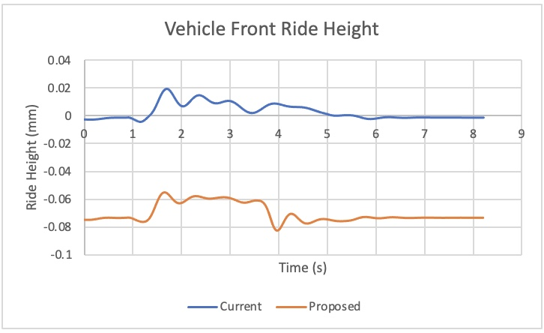
Figure 45: J Turn Vehicle Front Ride Height.
Figure 46 below provides a comparison of vehicle inclination roll behaviour for both suspension setups during the J Turn manoeuvre. Similar to the Pembrey results, the proposed setup presents a lower roll degree. However, the change in vehicle inclination roll behaviour between 3 and 6 seconds during the J Turn manoeuvre, where the proposed setup experiences a rapid drop while the current setup gradually tapers down over a 3-second period, suggests significant differences in how these two suspension setups manage vehicle dynamics during this specific phase of the manoeuvre. The rapid drop in roll degree for the proposed setup indicates a sudden reduction in lateral body movement or sway. This suggests that the proposed suspension configuration is highly responsive to changes in lateral forces. The quick drop in roll degree can be interpreted as enhanced responsiveness, improved control and optimised weight distribution.

In contrast, the gradual tapering down of roll degree for the current setup implies a slower response to lateral forces and steering inputs. This behaviour can be interpreted as moderate responsiveness and balanced handling. The gradual taper down also suggests a more gradual and predictable response to changes in lateral forces, which can be advantageous for drivers seeking a stable and consistent feel during manoeuvres.

In terms of vehicle dynamics, the observed change in behaviour highlights the trade-off between responsiveness and comfort in suspension tuning. The proposed setup prioritises quick responses and enhanced control, which can be ideal for drivers seeking a sportier and more dynamic driving experience. On the other hand, the current setup offers a smoother and more gradual response, potentially appealing to those who value a more comfortable and less abrupt ride.

The choice between these two suspension setups should consider the intended use of the vehicle and driver preferences. Sports car enthusiasts might prefer the rapid drop in roll for the enhanced driving dynamics it offers, while drivers seeking a more relaxed and comfortable ride may prefer the gradual tapering behaviour of the current setup. Morgan Motors should consider exploring this aspect further, taking into account customer feedback. Given that the Morgan Plus 6 is marketed as a sports car, the observed behaviour of the proposed setup, characterised by a rapid drop in roll degree, aligns well with the expectations of a sportier driving experience. This suggests that the proposed setup may provide the ideal amount of roll for those seeking a more pronounced sports car feel during manoeuvres.
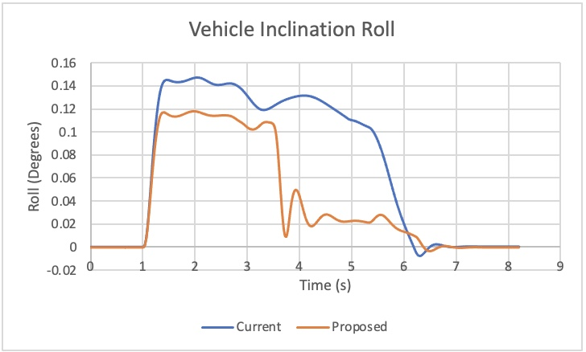
Figure 46: J Turn Vehicle Inclination Roll.
Figure 47 illustrates the vehicle's pitch behaviour during the J Turn manoeuvre for both suspension setups. Once again, it mirrors the findings from the Pembrey analysis, with the proposed setup consistently exhibiting a higher degree of pitch. This indicates that during the J Turn manoeuvre, the front of the vehicle tends to pitch upward to a greater extent. The proposed setup displays more variability in pitch behaviour. Between 3 and 5 seconds, pitch for the current setup increases, while the proposed pitch decreases.
The differences in pitch behaviour between the current and proposed suspension setups suggest that the proposed setup may exhibit characteristics that affect stability, weight transfer, and driver perception. The observed variability in pitch also indicates that the proposed suspension may react differently under specific conditions. These findings should be carefully considered in the context of the Morgan Plus 6's intended use as a sports car, where stability, responsiveness, and predictable handling are essential attributes. Further testing and evaluation, possibly with driver feedback, may be necessary to determine the optimal suspension setup for this specific vehicle model.
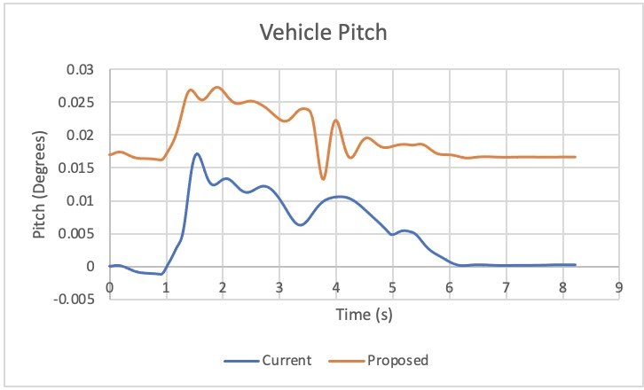
Figure 47: J Turn Vehicle Pitch.
Figure 48 below provides a comparison of the vehicle yaw for both suspension configurations during a J Turn manoeuvre. The proposed suspension setup exhibits a relatively steady increase in yaw between 1 and 3 seconds, peaking at 3.25 degrees at 3.75 seconds, followed by a decrease to 2.2 degrees. This pattern suggests that the vehicle initially experiences a relatively rapid rotation (yaw) during the first few seconds of the manoeuvre. The peak yaw of 3.25 degrees indicates a significant degree of rotation or spinning during this phase. However, the subsequent decrease in yaw to 2.2 degrees implies that the rotation is gradually corrected or stabilised.

In contrast, the current suspension configuration shows a steadier increase in yaw up to 6 seconds, where the yaw peaks at 3.5 degrees and maintains that level. This behaviour suggests a consistent and sustained rotation of the vehicle throughout the manoeuvre. The maintenance of yaw at 3.5 degrees implies that the current setup keeps the vehicle in a relatively constant state of rotation or spin during the later stages of the manoeuvre.

The choice between these behaviours depends on the desired driving characteristics and the intended use of the vehicle. A setup that maintains a consistent level of yaw provides a more predictable and controlled driving experience, suitable for scenarios where stability is important. Conversely, a setup with rapid initial yaw followed by correction may be favoured by drivers looking for a more agile and responsive feel, such as in sports car applications. Therefore, the proposed configurations yaw pattern for this manoeuvre aligns with the sportscar feeling of the Morgan Plus 6.

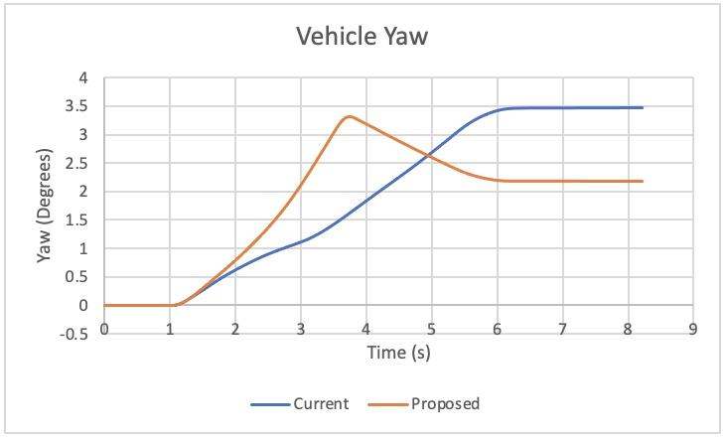
Figure 48: J Turn Vehicle Yaw.

6.3.3 Swept Steer Results
Figure 49 below provides a comparison of damper forces on each corner of the vehicle for both the current and proposed suspension setups during a swept steer manoeuvre. Both suspension configurations follow the same pattern on all four corners, however the proposed setup has a consistently lower damper force for each corner. This implies that the suspension system in the proposed setup is providing less resistance to vertical motion (both compression and extension) compared to the current setup. While lower damper forces enhance ride comfort, they can also impact handling characteristics. A suspension system with lower damper forces may result in increased body movement and weight transfer during dynamic manoeuvres. This could lead to a softer or less responsive feel when steering and cornering. Drivers may experience more body roll and less precise control in situations where firm suspension and minimal body movement are desired.

When considering overall vehicle dynamics, the choice of suspension setup, whether favouring lower damper forces for comfort or higher damper forces for sportier handling, should be made while considering the overall vehicle dynamics and the intended use of the vehicle. Morgan Motors might want to explore the possibility of incorporating dampers with slightly higher damping forces into the proposed configuration. This adjustment could introduce a sportier feel, striking a better balance between ride comfort and handling performance.

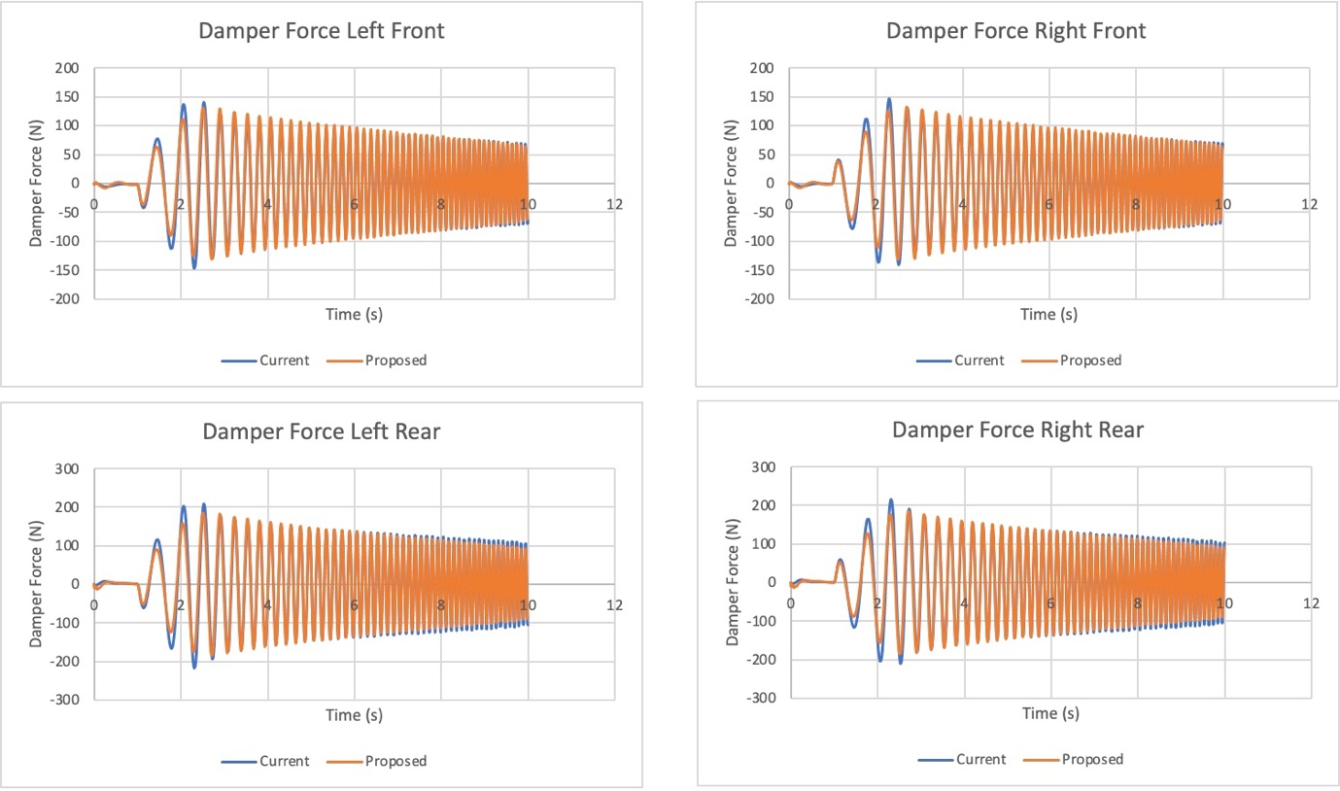
Figure 49: Swept Steer Damper Forces.
Figure 50 offers an insightful analysis of the contact patch behaviour during a swept steer manoeuvre for both the proposed and current suspension setups. This data reveals intriguing patterns in how the tyres interact with the road surface under dynamic conditions.

In the x-axis both suspension configurations exhibit a remarkably similar trendline for the contact patch. Initially starting at zero, the contact patch gradually decreases as the steering input induces a side-to-side motion. This decrease is consistent and linear, ultimately reaching a value of -50. This behaviour indicates that both setups maintain consistent tyre contact with the road surface during the swept steer manoeuvre. The linear decrease suggests that the tyres progressively shift their contact points in response to the steering input, which is a desirable trait for predictable and controlled handling. On the other hand, in the y-axis both setups again demonstrate a synchronised trend in contact patch behaviour. Starting at -0.7, the contact patch decreases steadily to -1.18. This pattern indicates that as the vehicle undergoes the swept steer manoeuvre, the tyres maintain stable and synchronised contact with the road surface in the front-to-back direction.

The fact that both suspension configurations follow the same trendlines in both the x and y axes suggests that they provide consistent and balanced handling characteristics during this specific manoeuvre. Such consistency is vital for driver confidence and predictability, as it ensures that the tyres respond predictably to steering inputs without exhibiting sudden or unpredictable behaviour.

Overall, this analysis of the contact patch behaviour during a swept steer manoeuvre highlights the stability and predictability of both the proposed and current suspension setups. It indicates that these configurations effectively manage tyre-road interactions, contributing to a controlled and confident driving experience, particularly during dynamic manoeuvres that involve steering input.

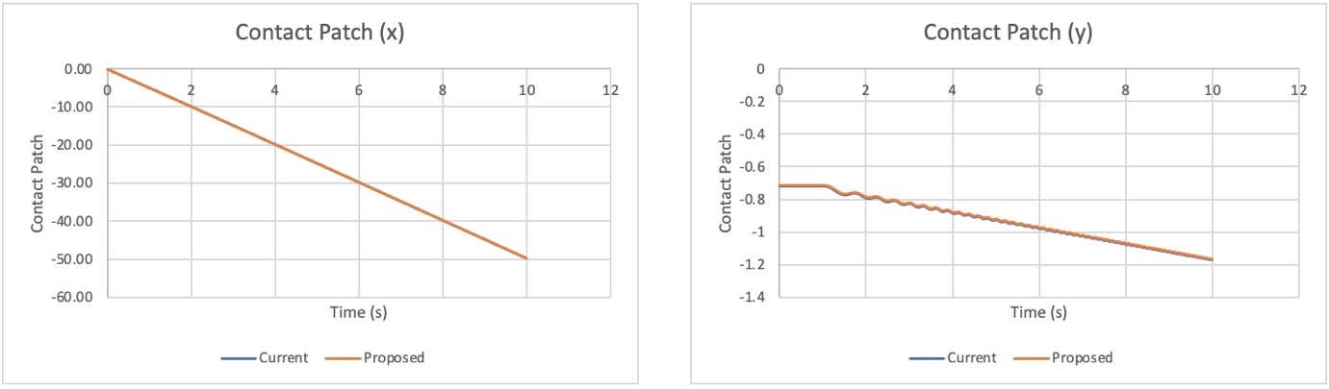
Figure 50: Swept Steer Contact Patch.
Figure 51 below provides a comparison of suspension roll behaviour for both the proposed and current suspension setups. The data indicates that both suspension configurations exhibit similar overall trends, which provide valuable insights into how these setups handle lateral weight transfer during dynamic driving. During the initial 2.5 seconds of the manoeuvre, the proposed suspension setup shows a slightly lower roll degree compared to the current setup. This observation suggests that the proposed suspension is slightly more effective at controlling body roll during the early phase of the swept steer manoeuvre.

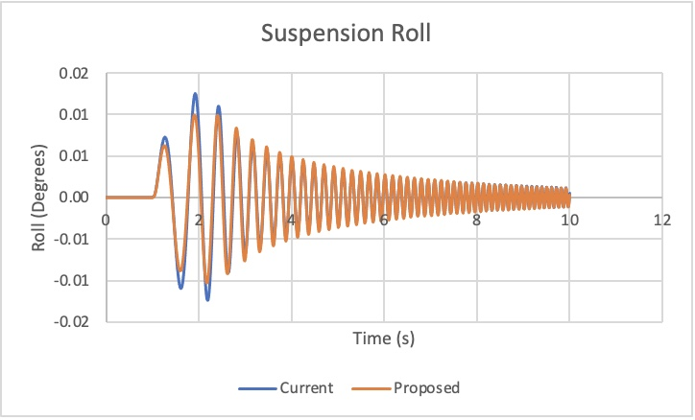
Figure 51: Swept Steer Suspension Roll.
Figure 52 provides an analysis of the vehicle's front ride height for both the proposed and current suspension setups during the Swept Steer manoeuvre. While both suspension setups maintain ride height consistency during the Swept Steer manoeuvre, the proposed setup distinguishes itself by consistently maintaining a lower front ride height. This characteristic results in enhanced aerodynamics, a more favourable centre of gravity, optimised weight distribution, an ideal tyre contact patch, and improved ride comfort. These benefits collectively underscore the project's goal of optimising the suspension for superior vehicle dynamics.

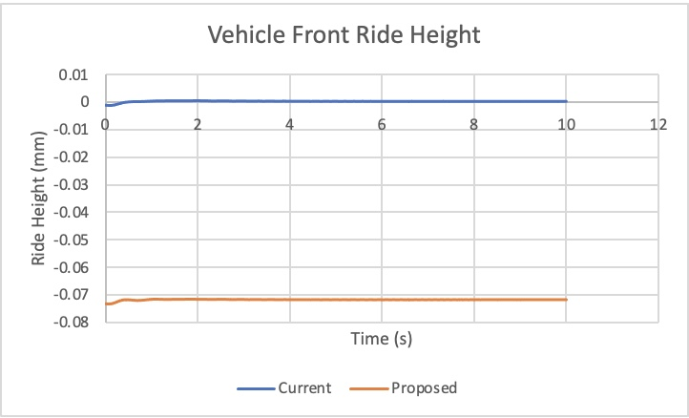
Figure 52: Swept Steer Vehicle Front Ride Height.
Figure 53 below provides a comparison of vehicle inclination roll behaviour for both suspension setups during the Swept Steer manoeuvre. Like the Pembrey and J Turn results, both setups follow the same trend, with the proposed showing a slightly higher roll degree. This finding implies that the vehicle's handling leans towards a sportier feel with more pronounced roll.
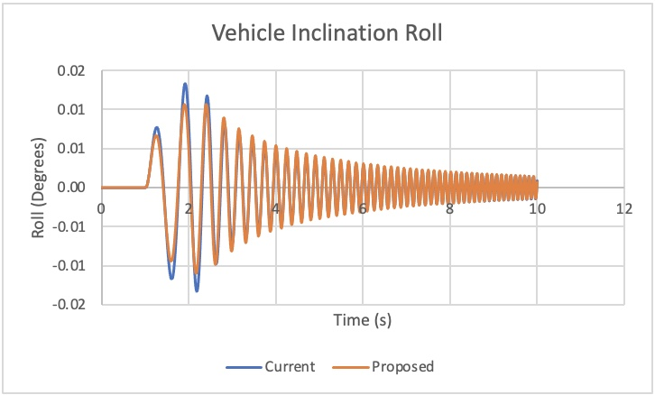
Figure 53: Swept Steer Vehicle Inclination Roll.
Figure 54 illustrates the vehicle's pitch behaviour during the Swept Steer manoeuvre for both suspension setups. Both setups show consistent vehicle pitch throughout the manoeuvre.
Once again, it mirrors the findings from the Pembrey and J Turn analysis, with the proposed setup consistently exhibiting a higher degree of pitch. Again, suggesting improved weight distribution, improved driver sensation and improved corner stability.
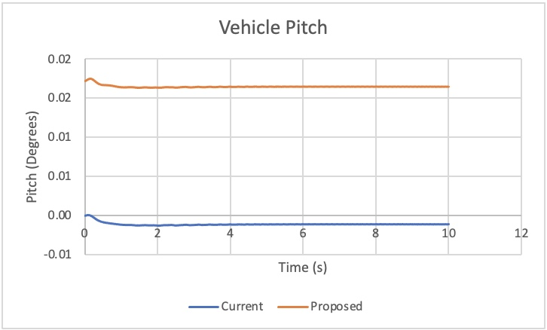
Figure 54: Swept Steer Vehicle Pitch.
Figure 55 provides a comparison of the vehicle yaw for both suspension configurations. Both setups show the same trend with the proposed setup displaying consistently lower yaw degree throughout which indicates that the vehicle's rotation around its vertical axis (typically influenced by steering input or lateral forces during cornering) is less pronounced compared to the current setup. This implies the proposed setup has superior stability and predictability, as well as a more controlled steering response and cornering control.
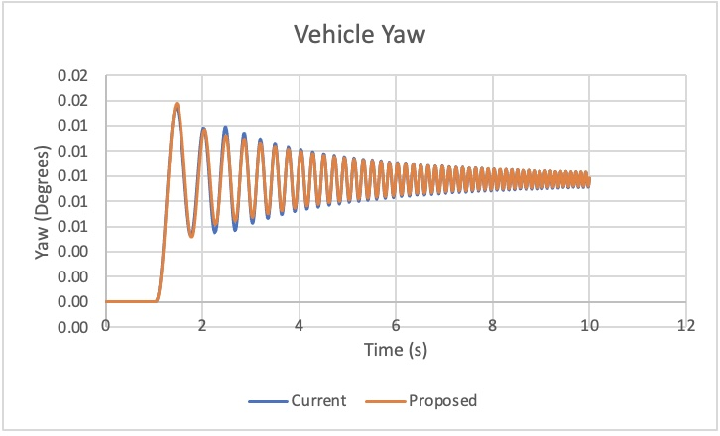
Figure 55: Swept Steer Vehicle Yaw.

6.3.4 Fishhook Results
Figure 56 provides a comparison of damper forces on each corner of the vehicle for both the current and proposed suspension setups as the vehicle traverses the Fishhook manoeuvre. This analysis aligns with the consistent trend observed in previous damper force results, where the damper forces of the proposed setup are consistently slightly lower than those of the current setup. This repetition of lower damper forces solidifies the earlier finding that the proposed suspension configuration offers a more compliant and forgiving ride experience. While this characteristic is generally desirable for a typical road car, it may not align perfectly with the expectations of a sports car, such as those produced by Morgan Motors.
As mentioned previously, to address this potential mismatch between suspension characteristics and the desired sporty feel, Morgan Motors may consider adjusting the damper forces. Specifically, increasing the damper force of both the front and rear dampers can result in a sportier feeling ride and handling. This adjustment can enhance the responsiveness, stability, and overall dynamic performance of the vehicle, making it more suitable for customers seeking a more spirited driving experience.
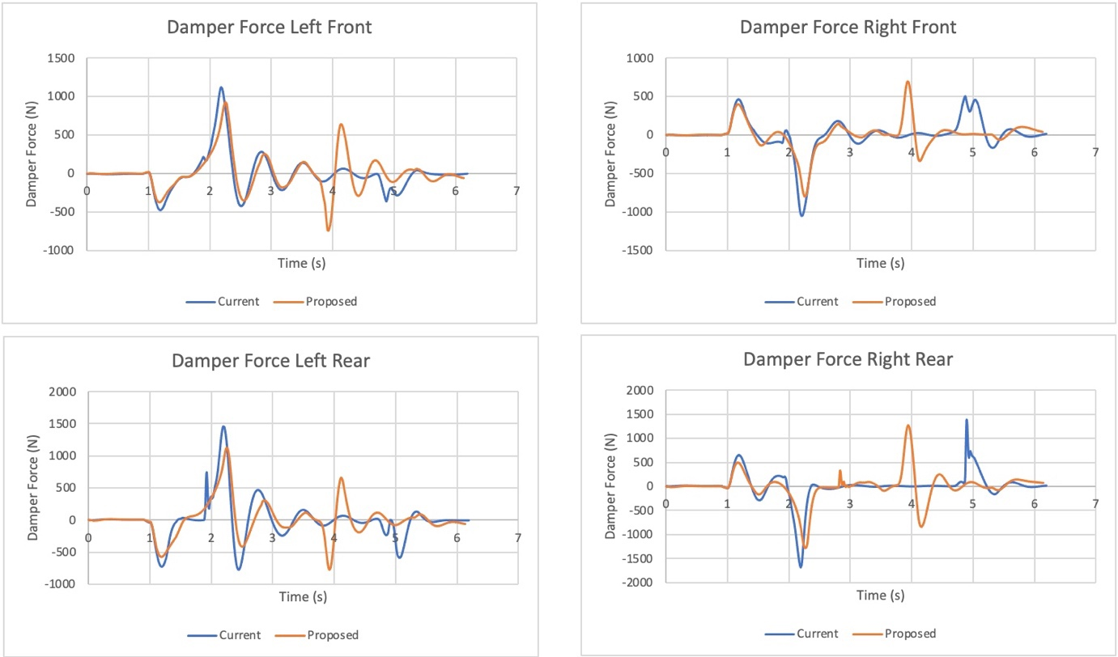
Figure 56: Fishhook Damper Forces.
Figure 57 offers an insightful analysis of the contact patch behaviour during a Fishhook manoeuvre for both the proposed and current suspension setups. Unlike the previous analyses, the current setup has a higher contact patch than the proposed. This suggests that the suspension geometry of the current setup may be better suited for maintaining tyre contact with the road surface during specific dynamic manoeuvres like the Fishhook. It's possible that the geometry of the current suspension system optimally aligns with the driving conditions encountered during this particular manoeuvre, leading to a higher contact patch. However, this is an unlikely manoeuvre in real-world driving therefore there is no cause for concern due to the fact that the proposed configuration generally provides a better contact patch during other manoeuvres.

The positive contact patch in the y-axis suggests that at that specific moment, the tyres on one or more corners of the vehicle may have lost complete contact with the road surface. This could occur when the lateral forces applied to the tyres exceed their grip limits. In other words, the tyres may have momentarily lost traction, leading to this unusual contact patch behaviour.

To address this concern, Morgan Motors should consider a comprehensive evaluation of the current suspension setup, alignment settings, and tyre specifications. Adjustments may be needed to improve the vehicle's stability and grip during such manoeuvres. Safety should always be a top priority, and resolving issues related to tyre contact and grip is crucial for maintaining control and stability during dynamic driving scenarios. However, as the proposed setup is the most likely to proceed this might not be something that needs to be addressed.
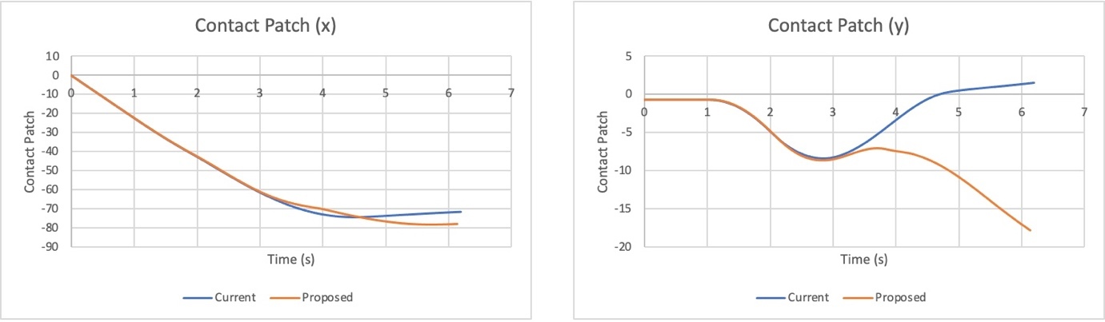
Figure 57: Fishhook Contact Patch.
Figure 58 below shows the suspension roll during the Fishhook manoeuvre for both suspension setups. Like the previous analyses the proposed setup shows less variation as well as a lower degree of roll throughout the manoeuvre. This solidifies the previous findings that suggest the proposed setup maintains a more consistent and predictable response to lateral forces. As well as experiencing less body lean or sway. This results in predictable handling, enhanced stability, and improved cornering performance, which perfectly aligns with the preferences of the Morgan Plus 6.
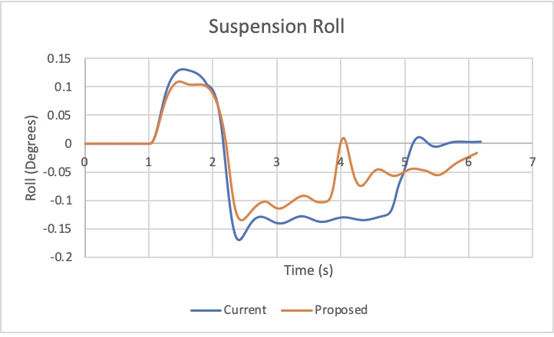
Figure 58: Fishhook Suspension Roll.
Figure 59 provides an analysis of the vehicle's front ride height for both the proposed and current suspension setups during the Fishhook manoeuvre. Like all previous analyses, the ride height for the proposed setup is substantially lower than the current setup. This corroborates the earlier discovery regarding the front ride height of the vehicle.

The lower ride height of the proposed setup suggests an ongoing commitment to enhancing various facets of the vehicle's behaviour. Firstly, it points towards improved aerodynamic efficiency, as a lower profile reduces air resistance. This, in turn, can lead to benefits such as heightened fuel efficiency and elevated top speeds, particularly advantageous in vehicles geared towards high performance.

Furthermore, a lower front ride height actively contributes to the vehicle's overall stability and handling capabilities. By lowering the vehicle's centre of gravity, the proposed setup minimizes the tendency for body roll during cornering and reduces the risk of rollovers during rapid manoeuvres. This aspect has a direct bearing on driver confidence and control, particularly in scenarios involving dynamic driving.

The consistent lower front ride height aids in the distribution of weight between the front and rear axles, fostering more balanced and predictable cornering behaviour. The vehicle is less prone to understeer, where front-wheel traction is lost, and it becomes more responsive to steering inputs. Additionally, maintaining a lower front ride height ensures that the vehicle's tyres maintain optimal contact with the road surface, enhancing overall cornering performance.
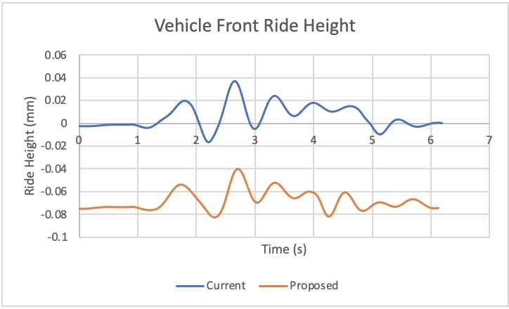
Figure 59: Fishhook Vehicle Front Ride Height.
Figure 60 offers a comparative analysis of vehicle inclination roll behaviour for both suspension setups, and once more, it echoes the earlier observations. The data underscores the consistent trend seen throughout the analyses, where the proposed suspension setup consistently exhibits lower degrees of roll and experiences less variation in roll behaviour.

This steadfast pattern reaffirms the superior control and predictability of the proposed suspension configuration, as it adeptly mitigates body lean or sway during lateral forces, such as those encountered during cornering and dynamic manoeuvres. The reduced roll contributes to enhanced stability, superior cornering capabilities, and an overall more responsive and controlled driving experience.

In essence, Figure 60 provides further validation of the key advantages associated with the proposed suspension setup, emphasising its ability to maintain a stable and balanced vehicle posture, particularly during scenarios demanding sharp turns or rapid changes in direction.

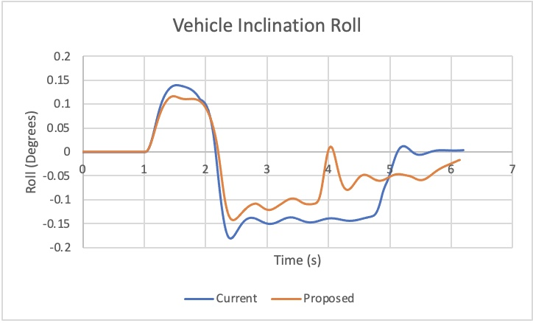
Figure 60: Fishhook Vehicle Inclination Roll.
Figure 61 highlights the vehicle's pitch behaviour for both suspension setups, consistently showcasing the tendency of the proposed suspension to exhibit a higher degree of pitch. This aligns with the recurring trend observed in the previous analyses. The elevated pitch in the proposed suspension setup signifies that during various manoeuvres, especially transitions, the front of the vehicle tends to rise to a greater extent. This characteristic, while more pronounced in the proposed setup, is reflective of sportier handling traits and responsiveness.
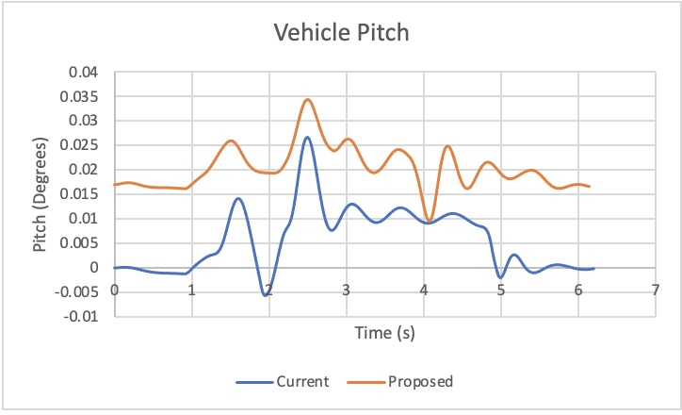
Figure 61: Fishhook Vehicle Pitch.
Figure 62 offers a comparison of the vehicle's yaw behaviour between both suspension configurations during the test. Both setups initially start from zero and undergo a gradual increase to 0.5 degrees of yaw. After reaching this point, both setups experience a rapid descent in yaw angle. However, a notable distinction arises during this descent phase. In the case of the proposed setup, the rate of decrease is more pronounced, and it appears to reach a lower minimum yaw angle before starting to increase again. On the other hand, the current setup continues its descent without any noticeable increase in yaw. This difference in yaw behaviour implies that the proposed setup exhibits a more dynamic response to the test conditions, with quicker changes in yaw angle. The current setup, in contrast, maintains a more consistent yaw angle without notable fluctuations.

This observation further substantiates the notion that the proposed suspension setup delivers a sportier driving experience, aligning perfectly with Morgan Motors' intended objective. The pronounced changes in yaw angle seen in the proposed setup indicate a high level of responsiveness to steering inputs and dynamic conditions. This heightened agility can make the vehicle feel livelier and engaging to the driver, enhancing the overall sporty character of the car.
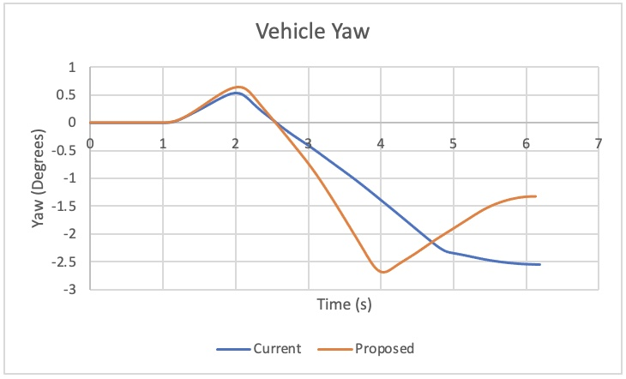
Figure 62: Fishhook Vehicle Yaw.

7 Conclusion
In conclusion, the transition from the current suspension configuration to the proposed setup for the Morgan Plus 6 brings about several noteworthy improvements that cater to both ride comfort and enhanced driving performance. These improvements include lower damper forces, reducing jolts and ensuring a smoother ride for passengers. Additionally, the reduction in body roll contributes to better weight distribution, enhancing the vehicle's stability and cornering abilities.

The lower ride height of the proposed setup is a key advantage, leading to improved handling characteristics and enhanced cornering capabilities. Lower vehicle inclination roll further boosts stability during dynamic manoeuvres, ensuring drivers experience greater confidence when navigating corners. The slight increase in pitch results in pronounced weight transfer, enhancing the vehicle's responsiveness during braking and acceleration. Furthermore, the slightly higher yaw angle observed in the proposed configuration promotes more rotation during cornering, making the vehicle more agile and responsive, while also maintaining stability. Additional suspension parameters such as the lower roll centre height, lower instant centre height, a 2% higher Ackermann angle, and a higher turn centre collectively contribute to a more refined and optimised suspension system.

To further enhance the ride and handling of the Morgan Plus 6, it's recommended that Morgan Motors explores the possibility of incorporating dampers with slightly higher damping forces into the proposed configuration. This adjustment could strike a balance between ride comfort and handling performance, introducing a sportier feel while maintaining the vehicle's overall composure. Furthermore, given the varying results observed in the contact patch during different manoeuvres, it would be beneficial for Morgan Motors to conduct further testing and analysis in this regard. This additional research could lead to refinements that further improve vehicle stability and overall driving experience.

In summary, the proposed suspension setup presents a compelling opportunity for Morgan Motors to optimise the Morgan Plus 6's ride comfort and handling performance. By fine-tuning certain parameters and considering potential damper adjustments, the company can potentially create a more well-rounded and appealing sports car that meets the expectations of driving enthusiasts while maintaining a comfortable ride for everyday use.

Bibliography
Britannica, 2022. Britannica. [Online]
Available at: https://www.britannica.com/science/centre-of-gravity
[Accessed 24 March 2023].

Dixon, J. C., 2007. Ride and Handling. Chapter 3 ed. s.l.:s.n.
Low Offset, 2022. Low Offset. [Online]
Available at: https://low-offset.com/workshop/ground-clearance-ride-height/
[Accessed 3 September 2023].

Mangal, S. K. & Kumar, A., 2015. Geometric parameter optimization of magneto-rheological damper using design of experiment technique. International Journal of Mechanical and Materials Engineering volume, 10(4).
Milliken, W. F. & Milliken, D. L., 1994. Race Car Vehicle Dynamics. s.l.:SAE International.
Mitra , A. C., Soni, T. & Kiranchand, G. R., 2016. Optimization of Automotive Suspension System by Design of Experiments: A Nonderivative Method. Advances in Acoustics and Vibrations , Volume 2016.

Mitra, A. C., Kiranchand, G. R., Soni, T. & Banerjee, N., 2016. Design of Experiments for Optimization of Automotive Suspension System Using Quarter Car Test Rig. Procedia Engineering, Volume 144, pp. 1102-1109.

Mitra, A. C. et al., 2015. Experimental Design and Optimization of Vehicle Suspension System. Materials Today: Proceedings , 2(1-4), pp. 2453-2462.

Ruban, M. & Sivaganesan, S., 2016. DESIGN ANALYSIS AND OPTIMIZATION OF FRONT AXLE FOR COMMERCIAL VEHICLE USING CAE. ARPN Journal of Engineering and Applied Sciences , 11(13).

SAE International , 2007. SAE International. [Online]
Available at: https://www.sae.org/publications/technical-papers/content/2007-26-043/
[Accessed 26 March 2023].

SAE International, 2015. SAE. [Online]
Available at: https://www.sae.org/publications/technical-papers/content/2015-01-1348/
[Accessed 22 March 2023].

SAE, 2021. SAE International. [Online]
Available at: https://www.sae.org/publications/technical-papers/content/2021-01-0316/
[Accessed 19 February 2023].

Sanat Fe Garage, 2013. Sanat Fe Garage. [Online]
Available at: https://www.santafegarage.com/precision-alignments/camber-explained/
[Accessed 22 March 2023].

Silva, R. R. M. R. d. et al., 2021. Sage Journals. [Online]
Available at: https://journals.sagepub.com/doi/10.1177/0954407020983057
[Accessed 22 March 2023].

Skill Lync, 2022. Skill Lync. [Online]
Available at: https://skill-lync.com/blogs/ackermans-principle-of-steering-working-and-applications
[Accessed 3 September 2023].

Suspension Secrets, 2018. Suspension Secrets. [Online]
Available at: https://suspensionsecrets.co.uk/roll-centre-and-roll-moment/
[Accessed 3 September 2023].

Technical Bulletin, 2013. Static NHTSA. [Online]
Available at: https://static.nhtsa.gov/odi/tsbs/2013/SB-10100923-9340.pdf
[Accessed 22 March 2023].

Technical Bulletin, 2018. Static NHTSA. [Online]
Available at: https://static.nhtsa.gov/odi/tsbs/2018/MC-10146408-9999.pdf
[Accessed 22 March 2023].

Totu, V. & Alexandru, C., 2021. MDPI. [Online]
Available at: https://www.mdpi.com/2076-3417/11/9/4167
[Accessed 15 February 2023].

Vogel, J., 2021. Racecar Engineering. [Online]
Available at: https://racecar-engineering.telegraph.co.uk/tech-explained/tech-explained-roll-centre/
[Accessed 3 September 2023].

Walter, J., 2021. Tire Technology International. [Online]
Available at: https://www.tiretechnologyinternational.com/opinion/the-story-of-ackermann-steering.html
[Accessed 3 September 2023].

whitelineperformance, 2018. whitelineperformance. [Online]
Available at: https://whitelineperformance.com/blogs/whiteline-blog/what-is-roll-centre-and-how-does-ride-height-affect-it
[Accessed 3 September 2023].

Winkler, C. B., Campbell, K. L. & Mink, C. E., 1991. Center of Gravity Height: A Round-Robin Measurement Program , Michigan: The University of Michigan Transportation Research Institute .

Xu, W.-P., Dai, J. & Xu, Z.-D., 2023. A novel multi-objective optimization of mass dampers for controlling the vortex-induced vibration in bridges. Engineering Structures , Volume 281.

