Organisational Consultancy

Name: Eiman Hussien

Student ID: 2108411

Assignment 2: Consultancy Report

Module Title: Organisational Consultancy BMIH6005

Lecturer: Jaliya De Silva

Executive Summary
This report presents a comprehensive analysis and strategic recommendations addressing the sustainability and environmental impact challenges faced by the Burj Al Arab, Dubai. As global consciousness towards environmental sustainability intensifies, luxury hotels, particularly landmark establishments like the Burj Al Arab, are under increasing scrutiny to demonstrate environmental stewardship. This report, therefore, focuses on evaluating the current sustainability practices of the hotel and proposing enhancements that align with global standards and guest expectations.
Our analysis revealed that while Burj Al Arab excels in luxury service and guest experience, there is a growing need to integrate robust sustainability practices into its operations. Key findings indicate that the hotel has opportunities to significantly reduce its carbon footprint, optimize energy and water usage, improve waste management, and implement sustainable sourcing practices. These areas are not only crucial for environmental conservation but also play a significant role in maintaining the hotel’s prestigious image in a rapidly evolving market.
The Burj Al Arab's present sustainability initiatives were evaluated in comparison to industry best practices and international benchmarks. We discovered that the hotel had made excellent progress in a few areas, including energy-efficient lighting and in-house water treatment. But there's still space for development in areas like the use of renewable energy, all-encompassing waste management plans, and integrated sustainable supply chains. The investigation also took into account the wider effects of these practices on the market positioning, guest happiness, and operational efficiency of the hotel.
This paper makes a number of strategic recommendations based on our results. These include implementing a zero-waste policy, adopting state-of-the-art renewable energy technologies, and switching to an environmentally friendly supplier chain. The focus is on workable, expandable solutions that can be put into practice without sacrificing the opulent experience that characterizes the Burj Al Arab. The paper provides a thorough change management approach, acknowledging the challenges involved in putting such big changes into practice. The goal of this plan is to guarantee that the suggested practices are adopted smoothly and with the least amount of disturbance to hotel operations and visitor experiences. Phased implementation plans, stakeholder participation, and staff training are all included. The proposed strategies promise not only to enhance the environmental performance of the Burj Al Arab but also to strengthen its brand as a leader in sustainable luxury. By embracing these recommendations, the hotel can set a new standard in eco-friendly luxury hospitality, ensuring its continued appeal to environmentally conscious luxury travelers while contributing positively to global sustainability efforts.
Our thorough research into the Burj Al Arab’s current sustainability practices yielded several key findings. Firstly, energy consumption per guest night is higher than the industry average for luxury hotels, primarily due to the extensive use of high-energy amenities. Water usage statistics also indicate inefficiency, with gallons per guest exceeding sustainable benchmarks. Waste management practices, while compliant with local regulations, lag behind global best practices, particularly in recycling and composting. A significant portion of the hotel's carbon footprint is linked to its reliance on non-renewable energy sources. The analysis also highlights the hotel's supply chain, where a considerable portion of materials and food products are imported, contributing to higher carbon emissions due to transportation.
The analysis underscores a crucial gap between current practices and potential sustainability milestones. The high energy and water usage are not only environmentally unsustainable but also financially burdensome in the long term. The reliance on non-renewable energy sources poses risks associated with fluctuating energy prices and regulatory changes. Additionally, the current waste management practices, while compliant, do not align with the growing global emphasis on reducing landfill contributions and promoting recycling and composting. The supply chain analysis reveals opportunities for reducing carbon emissions and supporting local communities by sourcing locally wherever feasible. This shift could enhance the hotel's reputation for responsible business practices and appeal to a growing segment of environmentally conscious consumers.
Based on our findings, we recommend the following:
Energy Efficiency: Implement energy-saving initiatives such as LED lighting, high-efficiency HVAC systems, and occupancy sensors. Investing in renewable energy sources, like solar panels, could significantly reduce the hotel's carbon footprint.
Water Conservation: Install low-flow fixtures and implement water recycling systems for landscaping and other non-potable uses. Adopting innovative technologies for water conservation will not only reduce consumption but also lower utility costs.
Waste Management Enhancement: Shift towards a zero-waste goal by enhancing recycling programs, introducing composting for organic waste, and implementing waste reduction strategies in operations.
Sustainable Sourcing: Develop a sustainable procurement policy focusing on local sourcing. This approach can reduce the carbon footprint associated with transportation and support the local economy.
Guest Involvement in Sustainability Practices: Create programs to engage guests in sustainability efforts, like opting for digital receipts, towel reuse programs, and awareness campaigns about the hotel’s sustainability initiatives.
Implementing these recommendations positions the Burj Al Arab as a leader in sustainable luxury hospitality. These changes not only address environmental concerns but also present an opportunity to innovate and enhance operational efficiencies. Adopting these practices will likely resonate with the increasing segment of environmentally conscious travelers, thereby bolstering the hotel’s reputation and market appeal.

Contents
Executive Summary 2
Introduction 6
Analysis 8
Analysis: Current Sustainability Practices 8
External Factors (PESTEL Analysis) 9
Internal Factors (SWOT Analysis) 12
Improvement Potential (TOWS Analysis) 16
Recommendations 18
Strategic Recommendations 18
Change Management Strategies 22
Action Plan 26
Conclusion 27
References 29

Introduction
In an era where environmental consciousness defines consumer choices and corporate strategies alike, the luxury hospitality sector is at a crucial juncture. It must reconcile its traditionally opulent practices with the growing demand for sustainability (Garrison &Thompson, 2021). This report, commissioned by the illustrious Burj Al Arab in Dubai, seeks to bridge this gap. It aims to provide a strategic roadmap for enhancing the hotel’s sustainability practices, aligning its operations with environmental imperatives while maintaining its hallmark luxury.
Since its inception in 1999, the Burj Al Arab has stood as a symbol of modern architectural ingenuity and unparalleled luxury (Dubai FDI, n.d.). Situated on an artificial island 280 meters from Jumeirah Beach, the hotel is renowned for its distinctive sail-shaped silhouette against the Dubai skyline (Burj Khalifa, 2019). With 202 luxurious duplex suites, the hotel offers a range of amenities including nine world-class restaurants and bars, four swimming pools, a private beach, and a lavish spa. Beyond its physical attributes, the Burj Al Arab has cemented its status as one of the most prestigious hotels globally, often colloquially referred to as the world’s only “seven-star” hotel (Al Kassim and Al, 2016). This distinction underscores not just the opulence of its offerings but also its commitment to exemplary service standards, which has consistently attracted an elite clientele.
Our firm specializes in providing strategic consultancy services to the hospitality sector, with a focus on sustainability and innovation. With over a decade of experience, we have assisted numerous high-profile clients in transforming their operations to be more environmentally responsible without compromising on quality or luxury (Awad et al., 2022). Our team comprises experts in environmental science, sustainable business practices, and luxury hospitality management. We bring a nuanced understanding of the unique challenges and opportunities in balancing luxury with sustainability, underpinned by a commitment to delivering practical, impactful solutions.
To comprehensively address the sustainability challenges and opportunities for the Burj Al Arab, we will employ several analytical frameworks:
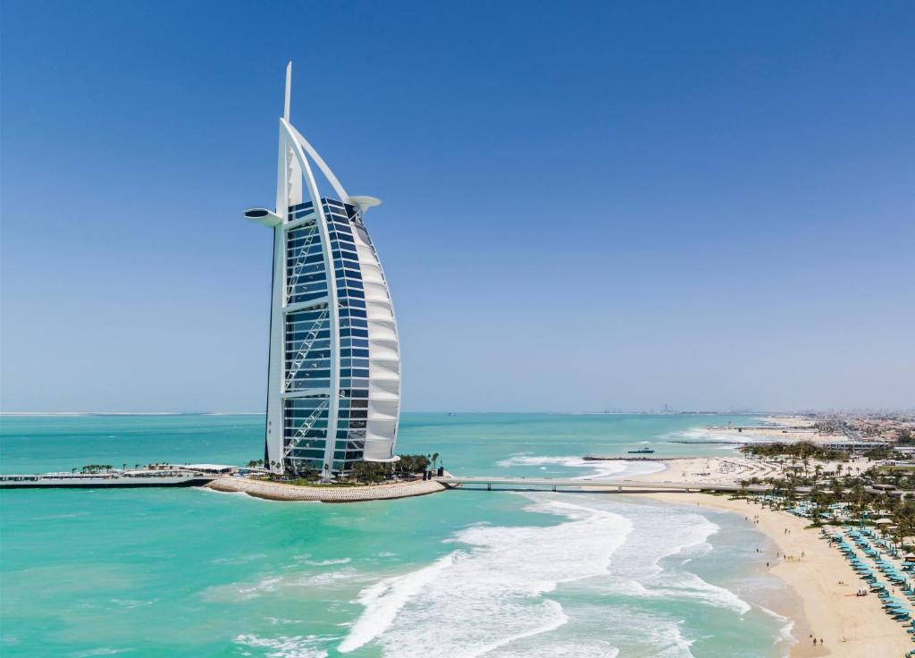
PESTEL will help in understanding the external macro-environmental factors that affect the hotel’s operations. Political, Economic, Social, Technological, Environmental, and Legal factors will be considered to ensure that our recommendations are relevant and feasible within the context of Dubai and the broader global hospitality industry (Stephenson and Ali-Knight, 2010).

Figure: Burj Al Arab (Google, 2023)
A thorough SWOT analysis will provide insights into the hotel’s internal strengths and weaknesses, as well as the opportunities and threats in its external environment. This analysis will be pivotal in identifying areas where sustainability can be integrated into existing strengths, and where it can help mitigate weaknesses or threats. Building on the SWOT analysis, the TOWS framework will be utilized to develop strategic options (Awad et al., 2022). This analysis will specifically focus on how the Burj Al Arab can turn its sustainability challenges into competitive advantages and operational improvements.
These frameworks will guide our exploration of how the Burj Al Arab can effectively integrate sustainability into its business model. The report will delve into specific areas such as energy efficiency, water conservation, waste management, sustainable sourcing, and stakeholder engagement. It will provide a balanced view, considering the feasibility and impact of each recommendation, and how these align with the hotel’s prestige and operational realities. This report aims not only to provide a blueprint for the Burj Al Arab to enhance its environmental sustainability but also to set a benchmark in the luxury hospitality industry. The goal is to demonstrate that luxury and environmental stewardship can coexist, creating a new paradigm in which indulgence does not come at the expense of the planet. (Klettner, Clarke and Boersma, 2013)

Analysis

Analysis: Current Sustainability Practices
Energy Use and Efficiency
The Burj Al Arab's energy consumption is a critical component of its sustainability profile. As a luxury hotel, its energy demands are substantial, driven by extravagant amenities such as underwater restaurants, temperature-controlled pools, and expansive guest suites (Alawadi, 2017). While the hotel employs some energy-saving measures like LED lighting and smart automation systems, there is a significant reliance on conventional energy sources. This reliance not only increases operational costs but also contributes to a larger carbon footprint. The hotel's current energy management system, although efficient in some respects, lacks comprehensive integration of renewable energy sources, such as solar or wind power, which are abundantly available in Dubai’s geographical context (Ibrahim & Ahmed, 2022).
Water Management
Water management at the Burj Al Arab is another area where sustainability practices can be enhanced (Al Kassim, 2016). Located in a desert region where water is a precious commodity, the hotel’s current water usage patterns reflect a high per-guest consumption rate. Despite having sophisticated in-house water treatment facilities, the potential for recycling and reusing water is not fully tapped (Faccia et al., 2023). For instance, gray water from sinks and showers can be further treated and utilized for non-potable purposes like landscaping and flushing toilets. The absence of such practices indicates a gap in achieving water sustainability. Additionally, the hotel's extravagant water features, though aesthetically pleasing, contribute significantly to overall water consumption, suggesting a need for balancing luxury with conservation (Khudhair et al., 2020).
Waste Management Practices
Waste management at the Burj Al Arab, while adhering to local regulations, has room for improvement in aligning with global best practices (El Gendy & El Gendy, 2018). The current waste disposal methods primarily focus on landfilling, with limited recycling and composting initiatives. As a hotel that prides itself on luxury dining experiences, food waste is a notable concern. There is a lack of a comprehensive organic waste management strategy, such as composting or donation programs for surplus food (Harith et al., 2021). Similarly, the hotel's reliance on single-use plastics and non-recyclable materials in its daily operations contradicts the emerging global trends toward minimizing plastic waste. Enhancing these practices is crucial not only for environmental reasons but also for reinforcing the hotel's image as a leader in sustainable luxury.
While the Burj Al Arab has made strides in certain areas of sustainability, there is a clear opportunity to improve its energy use, water management, and waste disposal practices (ResearchGate, n.d.). Embracing more robust and innovative sustainability measures in these areas can significantly enhance the hotel's environmental performance, aligning it with global standards and reinforcing its stature as a leader in the luxury hospitality sector.

External Factors (PESTEL Analysis)
The PESTEL analysis offers a thorough examination of the outside variables affecting the sustainability activities of the Burj Al Arab. This methodology facilitates comprehension of the hotel's operational milieu and pinpoints domains where exogenous factors might demand modifications to sustainable practices.

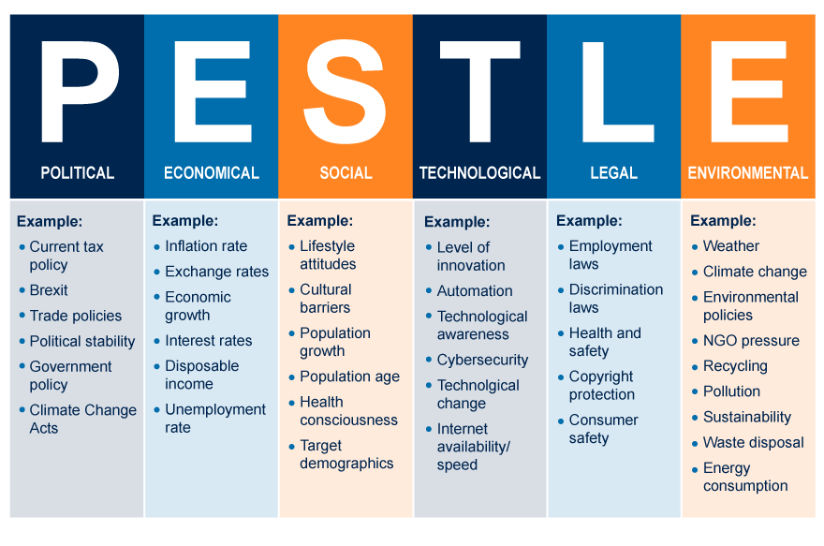
Figure: PESTLE analysis (The Open University, 2023)
Political
Although Dubai's political environment is generally stable and friendly to economic expansion, the Burj Al Arab is subject to government rules and norms for environmental sustainability (Yap, Saha and Alsowaidi, 2022). Environmental preservation and sustainable growth are given top priority in the UAE's Vision 2021. The hotel needs to make sure that its sustainability measures are in line with these regulations. Moreover, the hotel must be ready for any modifications to environmental laws that may require stricter sustainability standards.
Economic
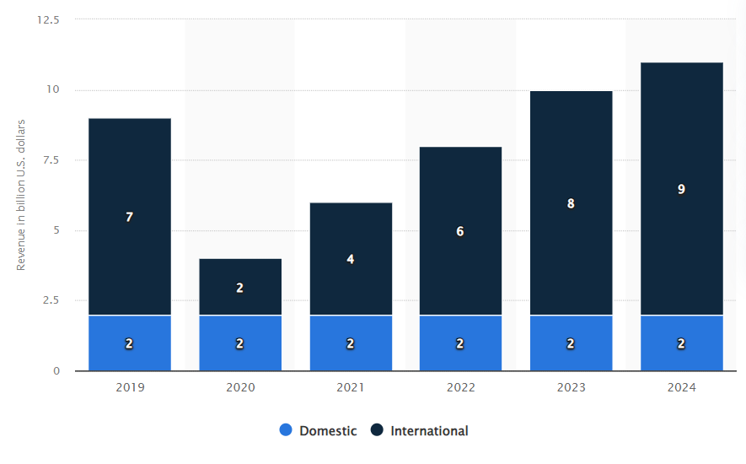
The Burj Al Arab is directly impacted by Dubai's economy, which is renowned for its opulent tourism and business-friendly environment. Although the current economic climate presents prospects for expansion, it also poses difficulties with regard to the running costs of putting sustainable practices into effect (Salimi et al., 2022). It is critical to weigh these expenses against the anticipated long-term financial gains. Furthermore, customer tastes may be influenced by the worldwide movement towards sustainable tourism, which could have an effect on the hotel's earnings if it is unable to satisfy these changing needs.
Figure: UEA: luxury tourism revenue 2019-2024, by market (Statista, 2022)
Sociocultural
Social and cultural factors play a significant role in shaping the sustainability agenda. There is a growing global awareness and preference for environmentally friendly and sustainable practices, especially among luxury consumers (ZAIDAN, E., 2015). This societal shift towards environmental responsibility puts pressure on the Burj Al Arab to adopt more sustainable practices or risk losing favor with environmentally conscious guests.
Technological
Technological advancements offer significant opportunities for improving sustainability. The Burj Al Arab can leverage cutting-edge technologies in energy efficiency, water conservation, and waste management (Maleki et al., 2023). The rapid development of renewable energy technologies, water-saving devices, and efficient waste processing methods provides the hotel with numerous options to enhance its sustainability quotient.
Environmental
The Burj Al Arab has distinct environmental difficulties because of its desert climate, especially with regard to heat waves and a lack of water. These reasons make energy-efficient cooling systems and water conservation crucial (Formaneck, 2013). In addition, the hotel's adoption of sustainable methods is made imperative by the larger global environmental concerns of resource depletion and climate change.
Legal
Legal Compliance with national and international environmental rules and regulations is one of the legal considerations. In particular, the Burj Al Arab has to make sure that its operations adhere to these legal requirements for resource utilization, emissions, and waste disposal (Salama, 2015). Non-compliance can harm the hotel's reputation in addition to posing a danger of legal consequences.
The PESTEL analysis reveals that the Burj Al Arab's approach to sustainability is influenced by a variety of factors and functions within a complicated external environment. It is imperative that the hotel comprehends and adjusts to these outside forces in order to effectively carry out its sustainability programs and preserve its standing as a premier luxury hotel.

Internal Factors (SWOT Analysis)
An in-depth understanding of the Burj Al Arab's internal strengths, weaknesses, opportunities, and threats is possible through a SWOT analysis, especially when considering sustainability. The hotel's strategy for environmental sustainability is greatly aided by this analysis.
Strengths
- Luxurious Brand Reputation: The Burj Al Arab's greatest asset is its standing as a symbol of exclusivity and elegance (Khudhair et al., 2020). Because of its notoriety, it has the brand and financial clout to engage in environmentally friendly practices and technology without sacrificing its opulent appeal.
- Resource Availability: The hotel has access to significant financial and technological resources because it is a member of the Jumeirah Group and is situated in a resource-rich nation like the United Arab Emirates (Abdrabo, 2018). This makes it easier for creative sustainability projects to be adopted.
- Operational Excellence: The hotel has some of the greatest operational standards in the world, encompassing both service and facility management. The hotel's current systems can be effectively integrated with sustainability practices by utilizing this operational excellence (Hassanien & Dale, 2019).
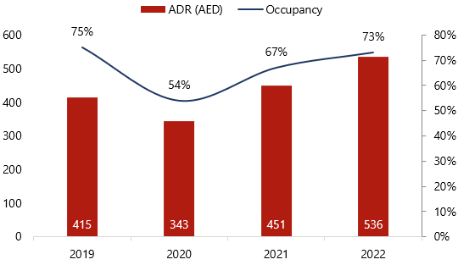

Figure: Dubai Hotel Market Yearly Performance Indicators (The Department of Economy and Tourism in Dubai, 2022)

Weaknesses
- High Energy and Water Consumption: As a luxury hotel, the Burj Al Arab’s current energy and water consumption rates are significantly high (Salimi et al., 2022). This not only impacts the environment but also increases operational costs in the long term.
- Dependence on Non-Renewable Energy Sources: The hotel’s reliance on non-renewable energy sources is a major weakness, considering the global shift towards renewable energy (Korotich, 2018).
- Limited Waste Management Measures: Current waste management practices at the hotel are not fully aligned with global sustainability standards, particularly in areas like recycling and organic waste management (Von Klemperer & Gamburg, 2018).
Opportunities
- Growing Demand for Sustainable Tourism: There is a rising trend in eco-conscious travel. The Burj Al Arab can capitalize on this by enhancing its sustainability credentials, thereby attracting a new segment of environmentally conscious guests (Abdrabo, 2018).
- Technological Advancements: The rapid development of green technologies offers the hotel an opportunity to upgrade its facilities to be more energy-efficient and environmentally friendly.
- Governmental Support for Sustainability: The UAE government's focus on sustainable development opens up opportunities for support, incentives, and partnerships in implementing green initiatives (Hassanien & Dale, 2019).
Threats
- Changing Regulatory Environment: The possibility of more stringent environmental regulations could pose a threat if the hotel is not prepared to adapt its practices accordingly (Salimi et al., 2022).
- Competitive Pressure: Other luxury hotels are increasingly adopting sustainable practices, which could put the Burj Al Arab at a competitive disadvantage if it fails to keep pace.
- Reputational Risks: In the age of social media and instant communication, any perceived neglect of environmental responsibilities can quickly damage the hotel’s reputation (Yap et al., 2022).
The SWOT analysis underscores the Burj Al Arab’s strong potential to enhance its sustainability practices. Leveraging its strengths and opportunities while addressing its weaknesses and threats will be key in successfully integrating environmental sustainability into its operational ethos.

Improvement Potential (TOWS Analysis)
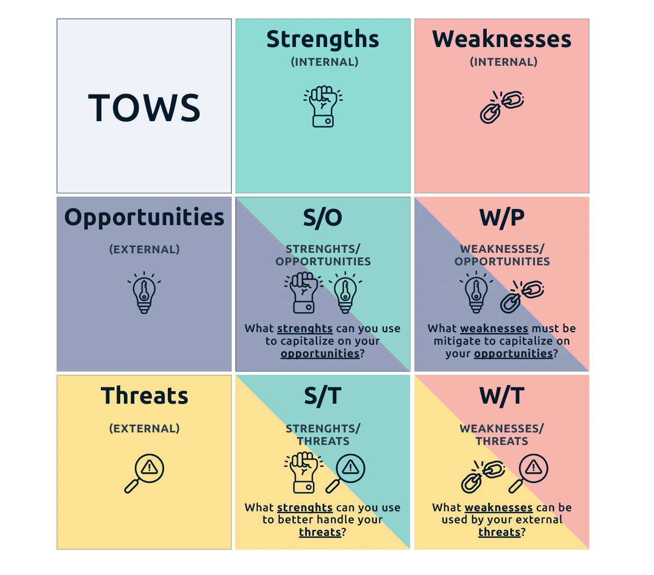
The TOWS analysis for the Burj Al Arab provides strategic options by integrating its internal strengths and weaknesses with external opportunities and threats, specifically focusing on sustainability. This approach facilitates the identification of actionable strategies that can enhance the hotel's environmental performance.
Figure: TOWS framework (Digital Leadership, 2023)
Utilizing Strengths to Capitalize on Opportunities
- Leveraging Luxury Brand for Sustainable Innovation: The Burj Al Arab can use its luxury brand reputation to pioneer innovative sustainability initiatives. By positioning itself as a leader in sustainable luxury, the hotel can attract eco-conscious travelers (JEVREMOVIC, 2015). For example, investing in cutting-edge renewable energy technologies or creating unique, eco-friendly guest experiences can set new industry standards.
- Resource Utilization for Technological Advancements: The hotel’s access to financial and technological resources can be directed towards adopting state-of-the-art sustainable technologies (Maleki et al., 2023). This could include implementing advanced water recycling systems or adopting smart building technologies to optimize energy use.
Addressing Weaknesses by Exploiting Opportunities
- Transforming High Consumption into Efficiency: The hotel’s current high levels of energy and water consumption represent a significant weakness. This can be transformed by capitalizing on the growing trend of sustainable tourism. By adopting more efficient resource utilization methods, the hotel can reduce its operational costs and appeal to a broader market (Busaidi et al., 2019).
- Upgrading Waste Management: The Burj Al Arab can turn its limited waste management measures into an opportunity by developing comprehensive recycling and composting programs (Almheiri et al., 2020). This will not only align with global sustainability standards but also resonate with environmentally conscious guests.
Using Strengths to Mitigate Threats
- Brand Influence to Navigate Regulatory Changes: The hotel’s strong brand presence can be leveraged to navigate the changing regulatory environment. By proactively enhancing its sustainability practices, the hotel can stay ahead of potential new regulations and avoid compliance issues (Almheiri et al., 2020).
- Operational Excellence to Stay Competitive: The hotel's operational excellence can help it stay competitive amidst increasing sustainability efforts by rivals. By integrating sustainable practices into its operations, the Burj Al Arab can maintain its competitive edge (Maleki et al., 2023).
Overcoming Weaknesses to Counter Threats
- Adapting to Renewable Energy to Avoid Reputational Risks: The shift towards renewable energy sources is crucial in countering the threat of reputational damage. Moving away from non-renewable energy sources will not only reduce environmental impact but also strengthen the hotel’s reputation as a responsible and forward-thinking establishment (Gorgenländer, 2010).
The TOWS analysis suggests that the Burj Al Arab has significant potential for improvement in sustainability. By strategically aligning its internal capabilities and addressing its weaknesses in the context of external environmental factors, the hotel can enhance its sustainability practices and reinforce its position as a leader in the luxury hospitality industry.

Recommendations

Strategic Recommendations
In the context of the Burj Al Arab's sustainability objectives, strategic recommendations focus on enhancing energy efficiency and water conservation. These initiatives are critical for the hotel to align with global environmental standards and respond to the growing demand for sustainable practices in luxury hospitality.
Energy Efficiency Initiatives
- Renewable Energy Adoption: The hotel should significantly invest in renewable energy sources, such as solar panels and wind turbines. Dubai's climate offers an abundance of solar energy, making it a feasible and sustainable option (Mawed et al., 2017). The integration of these technologies not only reduces reliance on non-renewable sources but also positions the hotel as an environmentally responsible leader.
- Advanced Energy Management Systems: Implementing a state-of-the-art energy management system can drastically improve energy efficiency (Shibeika et al., 2021). This system should include smart sensors and automation controls to manage lighting, heating, and air conditioning, ensuring that energy is used optimally and only when needed.
- Energy-Efficient Appliances and Lighting: Transitioning to energy-efficient appliances and LED lighting across the hotel can significantly reduce energy consumption (Siebert et al., 2015). This includes kitchens, laundry services, and guest rooms, where energy-efficient practices can be implemented without compromising guest comfort.
- Staff Training and Guest Awareness Programs: Educating staff on energy conservation practices and encouraging guests to participate in energy-saving initiatives can foster a culture of sustainability (Afzal et al., 2022). Simple measures like turning off lights and electronics when not in use can have a considerable impact when applied hotel-wide.
Water Conservation Measures
- Water Recycling and Reuse: Implementing an advanced water recycling system will enable the hotel to treat and reuse greywater for non-potable purposes, such as landscaping and flushing toilets (Juaidi et al., 2019). This measure is particularly crucial in Dubai's water-scarce environment.
- Low-Flow Fixtures and Appliances: Installing low-flow fixtures in bathrooms, kitchens, and spa areas can drastically reduce water usage. These fixtures, designed to use less water without compromising functionality, are essential in areas like showers, sinks, and toilets (Shibeika et al., 2021).
- Rainwater Harvesting: Although rain is scarce in Dubai, harvesting and storing rainwater for non-potable uses can contribute to water conservation efforts (Mawed et al., 2017). This system can supplement the hotel’s water supply, especially for landscaping needs.
- Water-Efficient Landscaping: Redesigning the hotel's landscaping with drought-resistant plants and efficient irrigation systems can significantly reduce water usage (Anuradha, 2017). This approach involves using native plants that require less water and are better adapted to the local climate.
Waste Reduction and Recycling
- Comprehensive Recycling Program: The Burj Al Arab should implement a robust recycling program that encompasses not only common recyclables like paper and plastics but also e-waste, glass, and metal (Juaidi et al., 2019). This program must be well-communicated to both guests and staff to ensure maximum participation.
- Food Waste Management: Given the significant amount of food waste generated by luxury hotels, the Burj Al Arab could adopt a food waste reduction strategy. This might include measures such as more accurate demand forecasting in restaurants to reduce over-preparation, composting organic waste, and possibly collaborating with local charities for food donations (Yahya, 2015).
- Single-Use Plastic Reduction: The hotel should work towards minimizing the use of single-use plastics. Alternatives such as biodegradable materials or reusable options for items like water bottles, straws, and packaging can significantly reduce plastic waste (Yahya, 2015).
- Guest Involvement in Recycling Efforts: Engaging guests in recycling efforts through in-room recycling bins and informational campaigns can enhance waste segregation and collection. This initiative can be an effective part of the hotel's broader sustainability communication strategy (Virtudes et al., 2017).
Sustainable Sourcing
- Local and Sustainable Supply Chains: Emphasizing the use of locally sourced products not only supports the local economy but also reduces the environmental impact associated with transportation (Nadkarni & Heyes, 2016). The hotel should prioritize suppliers who practice sustainable production methods.
- Eco-Friendly Amenities and goods: A hotel's environmental impact can be greatly decreased by converting to sustainable and eco-friendly goods for guest amenities, cleaning, and upkeep (Wood, 2017). This covers organic toiletries and linens as well as biodegradable cleaning supplies.
- Sustainable Food Sourcing: Organic and sustainable food products should be the focus of the hotel's restaurants. To accommodate a wider range of dietary preferences, this strategy can include utilizing organic produce, obtaining seafood from sustainable fisheries, and thinking about creating vegan and vegetarian menu items (Petratos, 2020).
- Energy and Water-Efficient Supplier Criteria: In addition to price and quality, selection criteria for suppliers should take into account how energy- and water-efficient their production methods are (Formaneck, 2019). By using a comprehensive strategy, the hotel guarantees that its dedication to sustainability permeates its whole supply chain.
Change Management for fixing the issues
Implementing these recommendations requires a comprehensive change management strategy to ensure a smooth transition and acceptance among all stakeholders.
- Stakeholder Engagement: It's important to involve all stakeholders, including employees, guests, and suppliers, in the sustainability journey. Regular communication about the importance and benefits of these initiatives helps in building support and commitment (Faccia et al., 2023).
- Phased Implementation: Adopting a phased approach to implementing these changes allows for gradual adjustment and troubleshooting. Starting with smaller, more manageable changes can build momentum and confidence for larger-scale initiatives (Faccia et al., 2023).
- Training and Capacity Building: Staff should receive thorough training on new systems and practices (Balasubramanian et al., 2021). This training should focus not only on how to use new technologies but also on understanding the broader environmental issues.
- Performance Metrics and Continuous Improvement: Establishing clear performance metrics for waste reduction and sustainable sourcing is crucial. Regularly monitoring these metrics will help in identifying areas for improvement and assessing the effectiveness of the initiatives (Al Kassim, 2016).
- Recognition and Rewards: Recognizing and rewarding departments or employees who excel in implementing sustainability practices can motivate staff and create a culture of environmental responsibility (Maxim, 2020).
Implementing these recommendations requires an integrated approach, combining strategic initiatives with effective change management. By adopting these measures, the Burj Al Arab can significantly enhance its sustainability profile, aligning itself with global environmental standards and reinforcing its position as a leader in the luxury hospitality industry.

Change Management Strategies
Staff Training and Engagement
Implementing sustainability initiatives at the Burj Al Arab requires a comprehensive approach to staff training and engagement, ensuring that all team members are not only aware of the changes but are also active participants in the shift towards a more sustainable operation.
- Detailed Training Programs: Education is the cornerstone of change management. All employees should receive thorough training from the hotel, with an emphasis on the most recent sustainability initiatives (Karambelkar & Bhattacharya, 2017). The fundamentals of environmental awareness, specialized training on new practices and technologies, and the significance of each person's part in accomplishing the hotel's sustainability goals should all be included in these programs. For example, the kitchen crew should know about sustainable sourcing and food waste reduction methods, and the housekeeping staff should be trained in waste segregation practices.
- Ongoing Education and Training: Since the subject of sustainability is always changing, the hotel's strategy should place a strong emphasis on ongoing education. Regular seminars, guest lectures by environmental specialists, and online courses covering the newest developments in sustainability practices and trends are a few examples of this (Klettner et al., 2014). Encouraging employees to keep knowledgeable and current guarantees that the hotel's environmental stewardship standards will never lag.
- Employee Engagement Programs: Involving staff members in environmental initiatives helps them feel like they're a part of the solution. This might be creating a "green team" made up of staff members who volunteer to lead and oversee sustainability projects, setting up suggestion boxes where staff members can submit fresh eco-friendly concepts, and including staff members in the project planning and execution phases (Aleixo et al., 2018)
- Incentivization and Recognition: Recognizing and rewarding employees who excel in implementing sustainable practices can be a significant motivator. This could be in the form of employee of the month awards for sustainability, bonuses, or public acknowledgment in company communications (Williams & Schaefer, 2013).
- Internal Communication: Effective and transparent internal communication is key to successful change management. Regular updates on the progress of sustainability initiatives, feedback sessions, and open forums for discussion help in creating an environment of trust and collaboration (Dyball & Keen, 2012).
Through these strategies, the Burj Al Arab can foster a culture of sustainability within its workforce. Well-trained and engaged employees will be instrumental in seamlessly integrating new practices into the hotel's daily operations, making sustainability an intrinsic part of the Burj Al Arab experience.
Implementation Planning
Successful implementation of sustainability initiatives at the Burj Al Arab hinges on meticulous planning. This involves setting clear objectives, establishing timelines, allocating resources, and ensuring that all stages of implementation are executed efficiently and effectively.
- Establishing Measurable and Unambiguous Goals: The first stage in any sustainable endeavor is to set quantifiable and unambiguous goals (Bakker & Leiter, 2017). These goals ought to be sufficiently detailed to direct action and should be in line with the hotel's overarching aims. For instance, hitting a target recycling rate or cutting water use by a certain percentage in a year. Setting milestones aids in tracking advancement and sustaining momentum in addition to these goals.
- Creating a Comprehensive Action Plan: A comprehensive action plan should include all the steps needed to accomplish each goal. According to Siebert et al. (2015), this plan should outline the tasks that need to be done, who is in charge of each one, and when they should be finished. The action plan might contain actions like evaluating existing energy use, identifying areas for improvement, installing energy-efficient equipment, and educating staff on new procedures, for example, if the goal is to reduce energy use.
- Resource Allocation: To guarantee a successful execution, sufficient funds, manpower, and technology must be allotted. This could include making investments in cutting-edge technology, employing specialists in sustainability, or reassigning staff members' tasks to concentrate on sustainability initiatives (Baumgartner & Rauter, 2017).
- Risk Assessment and Contingency Planning: It's critical to anticipate potential hazards and roadblocks. This could involve financial limitations, technological difficulties, or opposition to change (Karambelkar & Bhattacharya, 2017). To mitigate these risks and keep the implementation process moving forward even in the face of unforeseen obstacles, contingency plans ought to be put in place.
- Monitoring and Evaluation: To determine the success of the sustainability measures, regular monitoring and evaluation are essential. This entails gathering information, assessing performance in relation to predetermined goals and benchmarks, and making any required corrections (Gerbec, 2017). It's also important to set up feedback channels so that visitors and employees can share their perspectives and guide future developments.
The Burj Al Arab's sustainability initiatives may be effortlessly incorporated into its operating framework with careful planning and execution, which will have a substantial positive impact on the environment and strengthen the hotel's dedication to sustainable luxury.
Stakeholder Communication
Implementing sustainability activities at the Burj Al Arab requires effective communication with stakeholders (Kay & Alder, 2017). Actively involving all pertinent stakeholders, including staff, visitors, vendors, and the neighborhood community, guarantees widespread backing and the effective implementation of these novel procedures.
- Creating Communication strategy: According to Dyball and Keen (2012), a thorough communication strategy should be created, describing the main points, the channels of communication, and the schedule. The strategy ought to educate stakeholders on the hotel's sustainability objectives, the rationale behind these modifications, the anticipated advantages, and the ways in which they may influence or contribute.
- Internal Communication with Workers: The main participants in this process of change are the workers themselves. To keep them informed and involved, open lines of communication must be maintained on a regular basis. Staff meetings, corporate newsletters, and digital communication platforms can all be used to do this (Aleixo et al., 2018). It's critical that staff members comprehend not only the "what" and "how" of the changes, but also the "why"—the significance and justification for the sustainability measures.
- Interacting with Visitors: To improve visitors' comprehension and admiration of the hotel's sustainable initiatives, communications with them should be thoughtfully planned. Informational signage located throughout the hotel, in-room reading materials, and digital communications such as emails or the hotel app can all help achieve this (Klettner et al., 2014). Involving visitors in these projects—like recycling or water conservation campaigns—can improve their visit and encourage involvement.
- Partnering with Suppliers: The hotel's new sustainability policies and how they will affect procurement procedures should be communicated to suppliers and business partners (Aleixo et al., 2018). This could entail renegotiating contracts, establishing new sustainability guidelines for suppliers, or working together on cooperative sustainability initiatives.
- Outreach to the Local Community and Industry Bodies: Communicating with the local community and industry bodies can help in building external support and recognition (Dyball & Keen, 2012). This could involve press releases, community events, and participation in industry forums focused on sustainability.
Effective stakeholder communication not only facilitates smoother implementation of sustainability initiatives but also helps in building a strong brand image of the Burj Al Arab as a socially responsible and environmentally conscious establishment.

Action Plan
Problem | Solution | Desired Outcome | Time Scale | Completion Date | Planned Budget
High Energy Consumption | Install renewable energy systems and energy-efficient appliances | Reduced energy use, lower carbon footprint | Short to Long Term | 0-3 years | £3.2M - £5.6M
High Water Consumption | Implement water recycling systems and low-flow fixtures | Reduced water use, efficient resource management | Short to Medium Term | 0-12 months | £800K - £1.6M
Inadequate Waste Management | Initiate comprehensive recycling and food waste management programs | Effective waste reduction and management | Short Term | 0-6 months | £160K - £400K
Non-Sustainable Sourcing | Transition to local and sustainable sourcing for hotel operations | Sustainable supply chain, support for local economy | Short to Medium Term | 0-12 months | £40K - £80K (initial)

Conclusion
As the consultancy process for the Burj Al Arab draws to a close, it is pertinent to reflect on the key findings and recommendations, consider the potential impacts on the hotel and the wider industry, and look forward to future collaboration prospects. The analysis of the Burj Al Arab’s current sustainability practices revealed significant areas for improvement, particularly in energy use, water management, and waste disposal. Our recommendations were strategically tailored to address these areas with a focus on long-term sustainability and operational efficiency. Key recommendations included the adoption of renewable energy sources, implementation of advanced water recycling systems, comprehensive waste management strategies, and a shift towards sustainable sourcing.
We suggested integrating energy-efficient technology with renewable energy systems in energy management since they not only meet international environmental criteria but also hold the potential to save money over the long run. Installing low-flow fixtures and putting in place water recycling systems are two crucial water conservation techniques that are essential in Dubai's dry climate. We pushed for strong recycling initiatives and a large decrease in single-use plastics in waste management. Finally, in order to lessen the hotel's carbon footprint and boost the local economy, we stressed the significance of sustainable sourcing and promoted the use of eco-friendly and local items.
By putting these suggestions into practice, the Burj Al Arab establishes itself as a pioneer in sustainable luxury as well as a leader in opulent hospitality. This shift may have far-reaching effects and establish new standards for environmental stewardship in the upscale lodging sector. Beyond the impact on the environment, there are other possible advantages such as improved brand recognition, higher operational effectiveness, and compatibility with the values of an increasing number of environmentally sensitive customers. Moreover, these endeavors may serve as a model for other industry participants, which could result in the extensive integration of sustainable practices in high-end hospitality. Future opportunities for cooperation between our company and the Burj Al Arab have been made possible by the consulting process. The hotel will need constant help and direction as it sets out on this revolutionary adventure. This entails ongoing assessment and monitoring of the tactics put into practice, improvement of sustainability programs, and adjustment to changing environmental regulations and visitor demands.
Collaboration is also possible when examining novel sustainability frontiers such community participation initiatives, biodiversity protection campaigns, and carbon-neutral targets. Our company is in a perfect position to offer ongoing knowledge in these fields, assisting the Burj Al Arab in leading the way in sustainable luxury hospitality while also assisting it in meeting its sustainability goals. Let us conclude by saying that the Burj Al Arab is about to undergo a monumental change. The hotel can improve its brand image, increase operational efficiency, and significantly contribute to environmental conservation by adopting sustainability. The foundation for this change has been established by our consultation, and we are excited to continue supporting the Burj Al Arab in its pursuit of sustainable excellence.

References
Abdrabo, A.A., (2018) Egypt's Knowledge-Based Development: Opportunities, Challenges, and Future Possibilities. Knowledge-Based Urban Development in the Middle East, pp.80-101.

Afzal, M.S., Tahir, F. and Al-Ghamdi, S.G., (2022) Recommendations and strategies to mitigate environmental implications of artificial island developments in the Gulf. Sustainability, 14(9), p.5027.

Al Kassim, Z. and Al (2016). The impact of Dubai’ s architectural wonders on the daily indigenous performance in light of cultural modernity: A comparative case study between Burj Khalifa and Burj Al-Arab Recommended Citation. [online] Available at: https://scholarworks.uaeu.ac.ae/cgi/viewcontent.cgi?article=1342&context=all_theses.

Alawadi, K. (2017). Rethinking Dubai's urbanism: Generating sustainable form-based urban design strategies for an integrated neighborhood. Cities, 60, 353-366. https://doi.org/10.1016/j.cities.2016.10.012

Aleixo, A.M., Leal, S. and Azeiteiro, U.M., (2018) Conceptualization of sustainable higher education institutions, roles, barriers, and challenges for sustainability: An exploratory study in Portugal. Journal of cleaner production, 172, pp.1664-1673.

Almheiri, M.K., Ahmad, S.Z. and Abu Bakar, A.R., (2020) Battle of the glitters in the United Arab Emirates. Emerald Emerging Markets Case Studies, 10(2), pp.1-19.

Awad, J., Arar, M., Jung, C. and Boudiaf, B. (2022). The Comparative Analysis for the New Approach to Three Tourism-Oriented Heritage Districts in the United Arab Emirates. Heritage, [online] 5(3), pp.2464–2487. https://doi.org/10.3390/heritage5030128

Bakker, A.B. and Leiter, M., (2017) Strategic and proactive approaches to work engagement. Organizational dynamics, 46(2), pp.67-75.
Bal, M., Bryde, D., Fearon, D. and Ochieng, E., (2013) Stakeholder engagement: Achieving sustainability in the construction sector. Sustainability, 5(2), pp.695-710.

Balasubramanian, S., Shukla, V., Islam, N. and Manghat, S., (2021) Construction industry 4.0 and sustainability: An enabling framework. IEEE transactions on engineering management.

Baumgartner, R.J. and Rauter, R., (2017) Strategic perspectives of corporate sustainability management to develop a sustainable organization. Journal of Cleaner Production, 140, pp.81-92.

Busaidi, M.A., Bose, S., Claereboudt, M. and Tiwari, M., (2019) Sea turtles tourism in Oman: Current status and future prospects. Tourism and hospitality research, 19(3), pp.321-336.

Burj Khalifa (2019). Facts & Figures | Burj Khalifa. [online] Burjkhalifa.ae. Available at: https://www.burjkhalifa.ae/en/the-tower/facts-figures/.

Cameron, E. and Green, M., (2019) Making sense of change management: A complete guide to the models, tools and techniques of organizational change. Kogan Page Publishers.

Digital Leadership., (2023) TOWS framework. [online] available at: https://digitalleadership.com/unite/swot-analysis/ (Accessed on: 15 November, 2023)

Dubai FDI. (n.d.). About Us. [online] Available at: https://dubaifdi.gov.ae/page/en/about_dubai_fdi [Accessed 17 Nov. 2023].

‌Dyball, R. and Keen, M. eds., (2012) Social learning in environmental management: towards a sustainable future. Taylor & Francis.

El Gendy, O. and El Gendy, A., (2018) Analysis of Piled raft of Burj Khalifa in Dubai by the program ELPLA. GEOTEC Software Inc., Canada, pp.3-23.

Faccia, A., Le Roux, C. L., & Pandey, V. (2023). Innovation and E-Commerce Models, the Technology Catalysts for Sustainable Development: The Emirate of Dubai Case Study. Sustainability, 15(4), 3419. https://doi.org/10.3390/su15043419

Formaneck, S.D., (2013) Skyscrapers and Economic Strategy and Development: The Case of Bahrain‟ s Proposed Murjan Tower. Journal of Economics, Business and Management, 1(4), pp.350-354.

Garrison, J. and Thompson, Z. (2021). Burj Al Arab. 2021 Undergraduate Research Showcase. [online] Available at: https://scholarworks.boisestate.edu/under_showcase_2021/18/.

Gerbec, M., (2017) Safety change management–A new method for integrated management of organizational and technical changes. Safety Science, 100, pp.225-234.

Gorgenländer, V., (2010) A strategic analysis of the construction industry in the United Arab Emirates: Opportunities and threats in the construction business. diplom. de.

Hassanien, A. and Dale, C., (2019) Hospitality business development. Routledge.

Harith, Y., Khudhair, Mardani, A., Khudhair, A. and Mardania (2021). The Positive Role of the Tourism industry for Dubai City in the United Arab Emirates. [online] Available at: https://www.iaras.org/iaras/filedownloads/ijems/2021/007-0018(2021).pdf.

Herremans, I.M., Nazari, J.A. and Mahmoudian, F., (2016) Stakeholder relationships, engagement, and sustainability reporting. Journal of business ethics, 138, pp.417-435.

HVS., (2023) Indisputable Success - The UAE. [online] available at: https://www.hvs.com/article/9662-indisputable-success-the-uae (Accessed on: 14 November, 2023)

Ibrahim, I. and Ahmed, N., (2022) Investigating regenerative ideation within sustainable development goals. Sustainability, 14(16), p.10137.

JEVREMOVIC, D., (2015) Library for the School of Architecture-Dubai (UAE). Urban design, architectural design and sustainable technological design.

Juaidi, A., AlFaris, F., Saeed, F., Salmeron-Manzano, E. and Manzano-Agugliaro, F., (2019) Urban design to achieving the sustainable energy of residential neighbourhoods in arid climate. Journal of Cleaner Production, 228, pp.135-152.

Karambelkar, M. and Bhattacharya, S., (2017) Onboarding is a change: Applying change management model ADKAR to onboarding. Human resource management international digest, 25(7), pp.5-8.

Kay, R. and Alder, J., (2017) Coastal planning and management. CRC Press.

‌Khudhair, H.Y., Mardani, A., Albayati, Y., Lootah, S.E. and Streimikiene, D., (2020) The positive role of the tourism industry for Dubai city in the United Arab Emirates. Contemporary Economics, pp.604-619.

‌Khudhair, H.Y., Mardani, A., Albayati, Y., Lootah, S.E. and Streimikiene, D., (2020) The positive role of the tourism industry for Dubai city in the United Arab Emirates. Contemporary Economics, pp.604-619.

Karmakar, A. (2015). E-governance and its role in infrastructure services of UAE, case study—Dubai. In T. M. Vinod Kumar (Ed.), E-governancefor smart cities (pp. 81-97). Springer.

Klettner, A., Clarke, T. and Boersma, M. (2013). The Governance of Corporate Sustainability: Empirical Insights into the Development, Leadership and Implementation of Responsible Business Strategy. Journal of Business Ethics, [online] 122(1), pp.145–165. https://doi.org/10.1007/s10551-013-1750-y.
‌Korotich, A.V., (2018) Artistic Features of the Middle East Modern Tall Architecture. United Arab Emirates. Dubai. Academia. Архитектура и строительство, (2), pp.57-65.

Lewis, L., (2019) Organizational change: Creating change through strategic communication. John Wiley & Sons.

Mader, C., Scott, G. and Razak, D.A., (2013) Effective change management, governance and policy for sustainability transformation in higher education. Sustainability Accounting, Management and Policy Journal, 4(3), pp.264-284.

Maleki, B., del Mar Casanovas-Rubio, M., Daniel Tsavdaridis, K. and de la Fuente Antequera, A., (2023) An Assessment of Sustainability for Residential Skyscrapers in Accordance with a Multicriteria Decision-Making Method: Nine Dubai Case Studies. Journal of Architectural Engineering, 29(4), p.04023038.

Mawed, M., Al Bairam, I. and Al-Hajj, A., (2017) Linking Between Sustainable Development and Facilities Management Strategies: An Integrated Approach for Evaluating the Sustainability of Existing Building in the UAE. ICSF 2017 Kingdom of Bahrain, 33.

Maxim, C., (2020) Challenges of world tourism cities: London, Singapore and Dubai. In Routledge Handbook of Tourism Cities (pp. 19-30). Routledge.

Nadkarni, S. and Heyes, A., (2016) Luxury consumption in tourism: The case of Dubai. Research in Hospitality Management, 6(2), pp.213-218.

Petratos, P., (2020) Sustainability and financing project: The UAE paradigm. In Sustainable Development and Social Responsibility—Volume 1: Proceedings of the 2nd American University in the Emirates International Research Conference, AUEIRC'18–Dubai, UAE 2018 (pp. 163-170). Springer International Publishing.

Ramos, T.B., Caeiro, S., Van Hoof, B., Lozano, R., Huisingh, D. and Ceulemans, K., (2015) Experiences from the implementation of sustainable development in higher education institutions: Environmental Management for Sustainable Universities. Journal of Cleaner Production, 106, pp.3-10.

ResearchGate. (n.d.). (PDF) The Positive Role of the Tourism Industry for Dubai City in the United Arab Emirates. [online] Available at: https://www.researchgate.net/publication/348334227_The_Positive_Role_of_the_Tourism_Industry_for_Dubai_City_in_the_United_Arab_Emirates

Salama, H.H., (2015) Dubai: An urbanism shaped for global tourism.

Salimi, M., Hosseinpour, M. and N Borhani, T., (2022) Analysis of solar energy development strategies for a successful energy transition in the UAE. Processes, 10(7), p.1338.

Stephenson, M.L. and Ali-Knight, J. (2010). Dubai’s tourism industry and its societal impact: social implications and sustainable challenges. Journal of Tourism and Cultural Change, 8(4), pp.278–292. https://doi.org/10.1080/14766825.2010.521248.

‌Shibeika, A., Khoukhi, M., Al Khatib, O., Alzahmi, N., Tahnoon, S., Al Dhahri, M. and Alshamsi, N., (2021) Integrated design process for high-performance buildings; a case study from dubai. Sustainability, 13(15), p.8529.

Siebert, S., Paton, R.A. and McCalman, J., (2015) Change management: A guide to effective implementation. Change Management, pp.1-336.

Statista., (2022) Luxury tourism revenue in the United Arab Emirates from 2019 to 2024, by market. [online] available at: https://www.statista.com/statistics/1071620/united-arab-emirates-luxury-tourism-revenue-origin/ (Accessed On: 14 November, 2023)

The Open University., (2023) PESTLE framework. [online] available at: https://www.open.edu/openlearn/mod/oucontent/view.php?id=140156&extra=thumbnailfigure_idm968 (Accessed on: 13 November, 2023)

Virtudes, A., Abbara, A. and Sá, J., (2017) October. Dubai: A pioneer smart city in the Arabian territory. In IOP Conference Series: Materials Science and Engineering (Vol. 245, No. 5, p. 052071). IOP Publishing.

Von Klemperer, J. and Gamburg, E., (2018) Royal Atlantis, Dubai. CTBUH Journal, (4), pp.12-19.

Williams, S. and Schaefer, A., (2013) Small and medium‐sized enterprises and sustainability: Managers' values and engagement with environmental and climate change issues. Business Strategy and the Environment, 22(3), pp.173-186.
Wood, M.E., (2017) Sustainable tourism on a finite planet: Environmental, business and policy solutions. Taylor & Francis.

Yahya, M.M., (2015) Sustainable Solutions for Construction Waste Reduction in UAE (Doctoral dissertation, The British University in Dubai (BUiD)).

Yap, G., Saha, S. and Alsowaidi, S.S. (2022). The Competitiveness of Qatari Tourism: A Comparative and SWOT Analysis. Advances in Social Sciences Research Journal, [online] 9(7), pp.187–210 https://doi.org/10.14738/assrj.97.12536.

ZAIDAN, E., (2015) CHAPTER SIX DEVELOPING STRATEGIES AND OVERCOMING BARRIERS FOR THE ‘DUBAI TOURISM VISION 2020’ESMAT ZAIDAN. Tourism Development, p.76.

