  Component One: Student Journal (learning log) 750 words +/- 10%  Contribution to Overall Module Assessment: 25% | Student No: | 2246646
 | Module Title: | Hotel Placement - Operating Hotel Facilities
 | Module Code: | BMIH4006
 | Lecturer: | Lisa Bassler

1. Introduction
The reflective journal is based on my experience gathered during my placement within the housekeeping department at Hotel Novotel Milton Keynes. Through the utilisation of Gibbs Model of Reflection, I have managed to provide a detailed analysis of my placement experience.

2. Experience within the service housekeeping department
During my placement experience within the housekeeping department at the Hotel Novotel Milton I have managed to gain valuable foresight regarding the work pattern and improved various interpersonal and professional skills.
This placement experience made me understand that communication skills are vital within the workplace, as I had to interact with my colleagues and guests on a daily basis, making sure I fostered clear communication, ensured a conducive workforce and delivered efficient services. Gardner and Matviak (2022) denoted that collaborating effectively highlights the significance of teamwork as individuals can effectively tackle the task and maintain the highest standards of the requirements.
Additionally, Elsharnouby and Elbanna (2021) stated that it is of paramount importance to possess service skills in the hospitality sector. I have also demonstrated this during this placement as my priority was customer satisfaction and I ensured to provide meticulous attention to details and be responsive to the requirements of the guests.
During my placement, time management has been crucial as it helped me to carry out responsibilities, optimise productivity and boost efficiency whilst meeting the deadlines. Nevertheless, I also faced operational issues at times, which required quick problem-solving thinking to make sure that things are running smoothly, and no issues occur due to this.

3. Self-Reflection
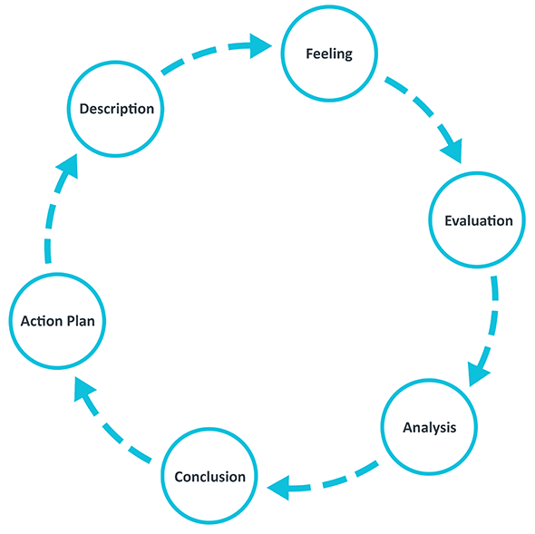
Figure 1: Gibbs Reflective Cycle
(Source: The University of Edinburgh, 2020)
As per the reports published by The University of Edinburgh (2020), Gibbs reflective cycle is a cyclic framework developed by Graham Gibbs in 1988 to give perspective on the base on which the learning experience could be analysed. It can be utilised for personal reflection through six phases, which include description, feelings, evaluation, analysis, conclusion, and action plan (University of Cumbria, 2020).
Description
During my housekeeping department placement, I engaged in various tasks ranging from guest assistance to room cleaning. I have also partnered closely with other team members to ensure high standards of guests’ satisfaction. As per the opinion of Akram, Abbas and Khan (2022), it is evident that teamwork, communication and service skills are crucial to make sure of smooth operations and guest satisfaction. Although I have been proficient in my communication, teamwork, and service provision, I lack the expertise in task management and navigation of operational issues, which posed as challenges during my placement.
Feelings
Although initially I was confident in my abilities, I soon realised that it is far more complex to manage multiple tasks efficiently. This generated a feeling of frustration as I was struggling to categorise all the tasks appropriately. As per the article published in Forbes (2017), it is evident that it is of great importance to be able to manage under pressure and provide effective outcomes. I have therefore discussed with my manager and have understood how to manage the tasks, which has helped me for the remaining of the placement.
Evaluation
My teamwork skills and communication were effective and helped me create a constructive workplace and improve the guests’ experience. Nevertheless, my lack of expertise in task management has hindered on some of my deadlines.
Analysis
Refining my task management skills is important to improve my productivity and efficiency as a whole. Reher and Ames (2021) have devised that time management techniques and effective consideration are vital for navigating a dynamic work atmosphere efficiently. Furthermore, developing a proactive approach to address the issues regarding operational issues can also help in mitigating issues and improving performance (Kutty et al., 2020).
Conclusion
In conclusion, I can state that my housekeeping placement experience was very valuable, as it helped me develop my professional and personal skills. I was able to demonstrate my strong teamwork, communication, and service skills, whilst discovering areas where I need to improve such as task management and operational skills.
Action plan
Skills | Resources/action | Time frame
Task management | In light of my aim to improve my task management skills, I would utilise time management techniques and productivity tools. Alongside this, I would also engage and attend training programs to improve my skills and apply them effectively. | 3 months
Operational skills | I would implement problem-solving strategies and seek mentorship in order to develop my technological knowledge to be able to handle operational issues. | 6 months
Table 1: Action Plan

Component Two: Health and Safety Guide
Contribution to Overall Module Assessment: 25%
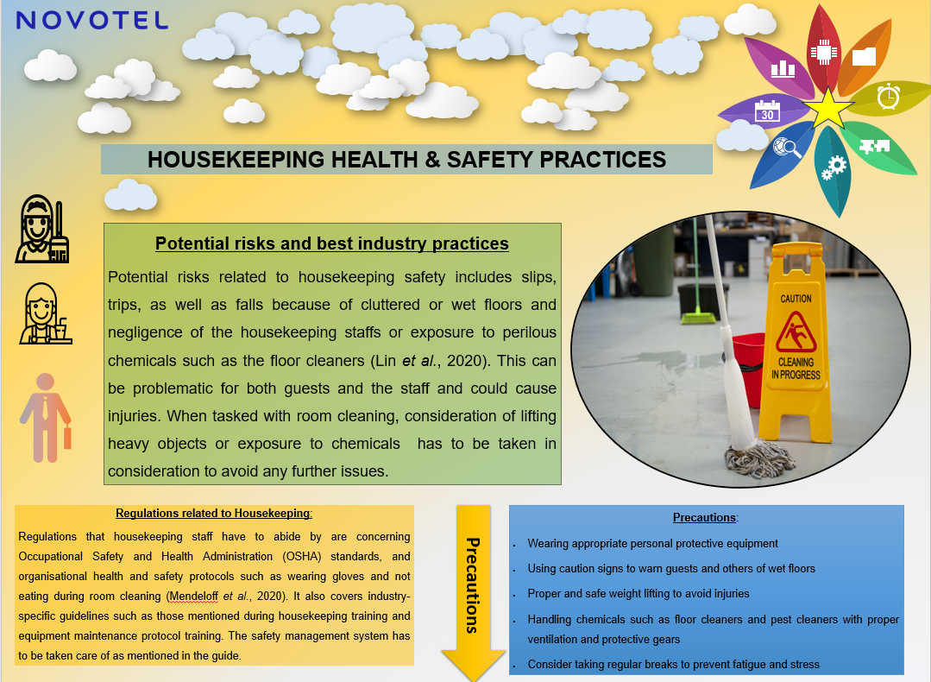
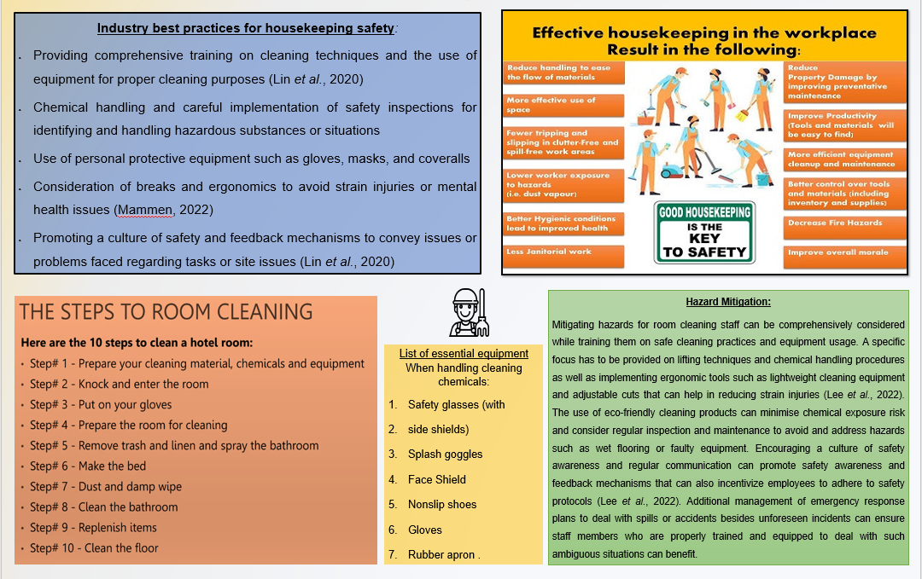

Reference List

References: Component One
Akram, M.W., Abbas, A. and Khan, I.A., (2022). Effects of Perceived Value, Service Quality and Customer Trust in Home Delivery Service Staff on Customer Satisfaction: Evidence from Pakistan. International Journal of Management Research and Emerging Sciences, 12(4).
Elsharnouby, T.H. and Elbanna, S., (2021). Change or perish: Examining the role of human capital and dynamic marketing capabilities in the hospitality sector. Tourism Management, 82, p.104184.
Forbes (2017) ‘18 Ways To Get Better At Working Under Pressure’, Forbes, 28 July. Available at: https://www.forbes.com/sites/forbescoachescouncil/2017/07/28/18-ways-to-get-better-at-working-under-pressure/ (Accessed: 20 February 2024).
Gardner, H.K. and Matviak, I.A., (2022). Smarter Collaboration: A New Approach to Breaking Down Barriers and Transforming Work. Harvard Business Press.
Kutty, A.A., Abdella, G.M., Kucukvar, M., Onat, N.C. and Bulu, M., (2020). A system thinking approach for harmonizing smart and sustainable city initiatives with United Nations sustainable development goals. Sustainable Development, 28(5), pp.1347-1365.
Reher, J. and Ames, A.D., (2021). Dynamic walking: Toward agile and efficient bipedal robots. Annual Review of Control, Robotics, and Autonomous Systems, 4, pp.535-572.
The University of Edinburgh (2020) Gibbs’ reflective cycle, The University of Edinburgh. Available at: https://www.ed.ac.uk/reflection/reflectors-toolkit/reflecting-on-experience/gibbs-reflective-cycle (Accessed: 20 February 2024).
University of Cumbria (2020) Gibbs’ reflective cycle. University of Cumbria, pp. 1–4. Available at: https://my.cumbria.ac.uk/media/MyCumbria/Documents/ReflectiveCycleGibbs.pdf (Accessed: 20 February 2024).

References: Component Two
Lee, T. et al. (2022) ‘Ergonomic exposures and control measures associated with mass fatality decedent handling in morgues and body collection points in a New York healthcare system during COVID-19: A case series’, International Journal of Industrial Ergonomics, 88, p. 103260. Available at: https://doi.org/10.1016/j.ergon.2022.103260.
Lin, N. et al. (2020) ‘Occupational exposure and health risks of volatile organic compounds of hotel housekeepers: Field measurements of exposure and health risks’, Indoor Air, pp. 26–39. Available at: https://doi.org/10.1111/ina.12709.
Mammen, R. (2022) ‘Assessment of ergonomic problems and prevalence of pain among low wage hotel housekeepers in Orlando’, Journal of Human Resources in Hospitality & Tourism, 21(2), pp. 246–271. Available at: https://doi.org/10.1080/15332845.2022.2031609.
Mendeloff, J. et al. (2020) ‘The re‐occurrence of violations in occupational safety and health administration inspections’, Regulation & Governance, 15(4), pp. 1454–1479. Available at: https://doi.org/10.1111/rego.12315.

