Abstract

Contents
Abstract 1
Introduction 3
Market failure of the tobacco industry 3
Methods to improve market failure 5
Indirect taxation 6
Market performance after indirect taxation 7
Negative Advertising campaign and standardised packaging 7
Market performance after standardised packaging 8
Post market failure (after solutions implemented) 9
Substitute for tobacco industry 11
Conclusion 12
References 13

Introduction
Originating in the Americas, tobacco, according to Hilton, links to societal culture, its very purpose originating in spiritual rituals, but it wasn’t until the 15th-16th century that habitual smoking of tobacco became popular, where most believed that it was a ‘cure all’ remedy, curbing hunger (Hilton, n.d.). The popularisations through social, cultural, and perceived health benefits helped establish tobacco’s continued success, despite British doctors finding links to cancer as far back as 1761. By 1924 over 70 billion cigarettes were sold in the US, however, the US surgeon general definitively linked smoking to lung cancer in 1964 (Bayne-Jones, et al., 1964), paving the way for the first meaningful legislation by government, that manufacturers must print warnings on packets (Tobacco Free Life, n.d.). 1970 also saw a tax yield in the UK of £1,142.5 million in taxation from tobacco products according to sales data (Uk Parliment, 1971), and 2022-2023 saw a tax revenue of £10,004 million (HM Revenue and Customs, 2024). Although the links between smoking tobacco and negative health effects have been established since the 1960’s, the UK government did not act to offset the cost to society until 1993 (ASH, n.d.), a slow reaction to the market failure. In 2021 Bath University launched the UK Tobacco Industry Interference Index (UKTI), a report which measures and scores such interference and the government’s response to it (University of Bath, 2024), and in doing so, it can be assumed that there existed a need to create transparency.
Contemporary views on smoking are in favour of a smoke free 2030 target, recently highlighted by the king, where the chair, Blackman, points out that it is the backbenchers who have historically “led the way in tobacco legislation” suggesting a better overview and representation by society, that the current proposals don’t act strongly enough (UK Parliment, 2024). It is the view of Bafunno et al. that early intervention is key, that implementation of WHO regulation has been low, and that governments have not been doing enough (Bafunno, et al., 2020).
This essay will discuss the tobacco industry, where there is a negative externality to society through the health impacts associated with the consumption of tobacco. There will be evidence-based examination of theoretical market failure, shown through hypothetical diagram visual representations, allowing for a clear understanding of the market failure parameters. There will be an examination of two solutions introduced in order to address the market failure, considering these through further hypothetical diagrams. This will be followed by a discussion with a view of the current Tobacco industry position and the efficacy of the solutions, allowing for an apt conclusion with recommendation for future action.

Market failure of the tobacco industry
A market, the means by which buyers and sellers, in contact with each other, exchange of goods and services takes place (Robinson, 2024). Free markets, where market participants choice is of free will, and economics, are subject to the law of supply and demand according to Fernando, as prices increase, demand declines, and supply rises (2023). Supply and demand are also subject to marginal cost and utility theories, where, marginal utility translates as a downward sloping demand curve as is associated with the diminishing benefit each additional purchased good provides (Berkman, Kahn, & Livingston, 2016), and where Marginal cost translates as an upward sloping supply curve as is associated with productions incrementally increased cost per unit (Indeed Editorial Team, 2023). Both supply and demand are also considered through their personal and societal costs and benefits, where an ideally balanced demand curve would have equal marginal personal and social benefits, and the supply would have equal marginal social and private cost (AP MICROECONOMICS, 2022). Once the curves are plotted, the intersection, known as the equilibrium or allocative efficiency, is where the price will tend to move toward in order to balance the supply and demand (Sloman, 2019), and clear the market.
When there is an inefficient distribution or allocation of resources on either the supply or demand line causing an imbalance in equilibrium price, this is referred to as a market failure (Parlour & Seppi, 2008). An imbalance can be caused by an eternality, an effect caused by consumption or production of a good or service which is not normally considered in either marginal decision process, either negative or positive, having societal or personal effect (Helbling, 2010). Contemporary corporate social responsibility theories surrounding business, such as that of the triple bottom line, or the three ‘P’s highlight the importance of people, the plant and profit (prosperity) within society when conducting business (Miller, 2020). Considering this, a negative externality of production could be considered its effects on the planet through pollution, therefore society, and a positive of consumption could be of education, where its consumption positively impacts societies prosperity.
Smoking, or the consumption of tobacco, has a well-documented health impact and cost to society, the first highlight of this of noteworthiness was a report published by Doll and Bradford Hill, in which it was determined that most cases of lung cancer were caused by smoking (1950), reinforced by the 1964 US Surgeon General which also linked numerous other diseases, including bronchitis, emphysema and heart disease (Bayne-Jones, et al., 1964). Time allowed for further linear studies, and further health detriment ties have been found, including heart disease (Freund, Belanger, D'Agostino, & Kannel, 1993), lung disease, strokes, diabetes, COPD, and increases risks of many other conditions, these plus the establishment of a link between passive smoking and preventable disease caused deaths (Centre for Desease Control and Prevention (CDC), 2021).
The detrimental health effects of the consumption of tobacco constitute as a negative externality, which imposes a cost to society as a whole. This external cost can be theoretically applied as a reduction in marginal societal benefit (MSB), which as is of consumption, effects the demand curve, separating the societal benefit from the personal benefit.
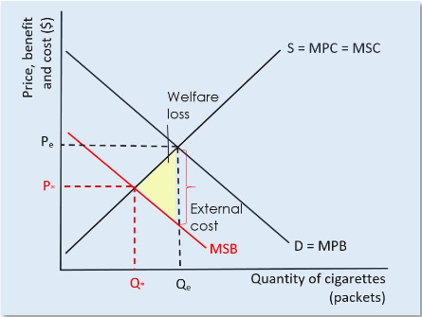
Figure 1: Negative externalities of cigarette consumption: MSB < MPB (microeconomicsap)
Figure 1 demonstrates this, where the supply curve, depicted with an ‘S’, is in perfect balance between personal and social cost for illustrative purposes, therefore Marginal social cost is equal to Marginal personal cost, or MPC=MSC. If all aspects were equal, as you can see, the allocative efficiency point would be where the black lines cross, allowing for an efficient price set and quantity supplied to clear the market, Pe and Qe, and is reflective of the good price before awareness of any consumption related issues, however, once the negative benefit to society was discovered, i.e. its health impacts, the demand curve line is split, separating its marginal social benefit, MSB, from that of personal benefit, MPB, and the negative marginal social benefit drawn lower, shown here in a solid red line. The graph shows that due to the negative effect to society, there is a market failure, and without intervention to reduce the price and quantities to the new equilibrium, P* and Q*, there will be a negative external cost to society. The cost caused by this externality is denoted by the vertical dotted line between the equilibrium point and the new MSB line, which coincides with the Qe line, and the welfare lost as a result denoted by the yellow area.

Methods to improve market failure
Despite the reported external cost to society, smoking remained an issue, mainly due their addictiveness and the tobacco industry’s implementation of PR campaigns to implant ambiguity and doubt over the health impacts of smoking, which continued into the 90’s (Brandt, 2007). Brandt also described the beginning of the end of the industry and their credibility due to further studies and restrictions of public smoking in the 80’s US, followed by the release of incriminating internal documents.
In 1971, according to ASH, the UK government confirmed their intent to control tobacco consumption (ASH, n.d.). The different methods, according to O’Driscoll and Hoskins, generally fall under either Market policies, through charges and taxation, or Government regulation, i.e. command and control (O'Driscoll & Hoskins, 2006), below are two examples of their approaches.

Indirect taxation
A market policy otherwise known as excise Tax, or duties, as are paid by wholesalers, businesses, or merchants, raising the prices paid by the consumer indirectly for a specific good or service at time of purchase (Kagan, 2023), in this case tobacco products. The intent by the government is to reduce consumption through increased personal pricing, and therefore raising the marginal social cost to marginal personal cost + tax. The goal is to obtain a new equilibrium point at its intersection with marginal personal benefit line, aligning with the original externality cost, so that in theory, the cost of the externality can be covered proportionately by the additional income the taxation provides, and the higher price paid for the good deters marginal purchases.
In 1993, the UK government committed to an annual increase of tobacco duties, specifically, for cigarettes, a minimum of £9 per 1000 sticks, which stands in November 2023 as £422.80 per 1000 sticks (HM Revenue & Customs, 2024). This approach has been found to be the most effective and popular approach adopted worldwide (Ellis, 2021), however, this largely benefits the cost of health care, and has greater effect in countries where that care is paid for by the consumer directly (Fuchs & Meneses, 2017), which would question its perspective efficacy as a singular approach in the UK.
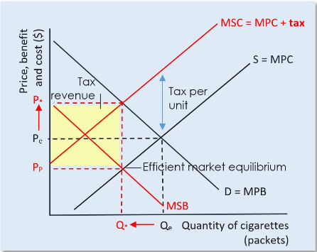
Figure 2: An indirect excise tax on demerit goods (microeconomicsap)
Figure 2 demonstrates how raising the marginal social cost of the good to include additional personal tax, MSC = MPC +Tax, which shows how the taxation will move the equilibrium to be in alignment with the desired reduction of quantity to Q* along the demand curve MPB, denoting the efficient market equilibrium, and shows the tax revenue gained between Pp and P*, therefore the negative externality cost has been internalised.

Market performance after indirect taxation
The increase of tobacco products through taxes, according to tobaccofreekids.org, is “the most effective method for reducing tobacco consumption” (tobaccofreekids, 2012), and provided Figure 3, which shows the relation between packet price, sales, and tax revenue. This demonstrates a successful implementation of market measure to decrease the demand for tobacco products, whilst maintaining the cost to society internally, and raising the price to the equilibrium point, as depicted in Figure 2. Of noteworthiness in figure 3 is the sharp decline in sales in 1999, this could be attributed to findings that 20% of cigarettes and 60% of hand rolled tobacco consumer in the UK in 2000-01 was illicit according to ASH, although they concede that it is evident that TAX is not the major cause, quoting the World Bank (ASH, n.d.), or due a ban on advertising, EU regulation, or perhaps a publication linking smoking to impotency (ASH, n.d.).

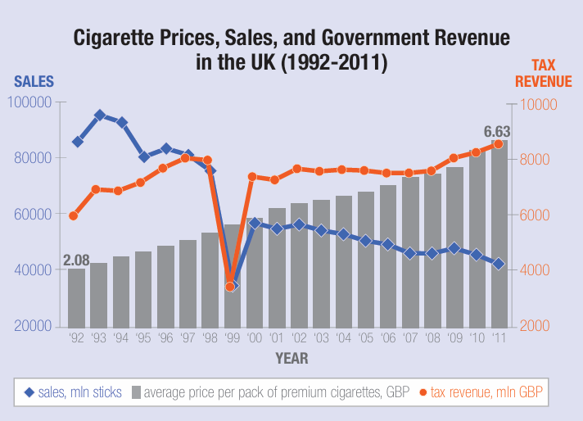
Figure 3: Cigarette Prices, Sales, and Government Revenue in the UK (1992-2011) (tobaccofreekids, 2012)

The resultant findings, above, from the market-based measure is affirmed by O’Brien and O’Leary, who found that the direct tax revenue from cigarettes was approximately £12billion in 2015, and suggest the revenue was substantially above that of the recorded smoking associated NHS costs, however it was found to be slightly below the estimated cost to society as a whole by a think tank, which was put at £14billion in 2010 (2015).

Negative Advertising campaign and standardised packaging
A Government regulation, according to Rose, is an obligatory condition for firms and individuals to realize governments ends (Rose, 2015), which can include such things as anti-alcohol, and anti-gambling, or in this case, anti-smoking through negative advertising campaigns (Sims, et al., 2016) and standardised packaging (Best, 2017), to highlight the negative personal impacts of a good’ consumption in order to reduce the marginal private benefit in line with the marginal social benefit theoretically eliminating the externality and welfare loss.
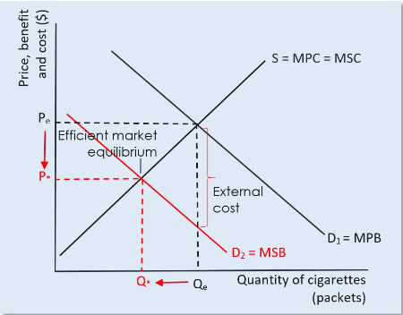
Figure 4: Government Regulations and Advertising (microeconomicsap)
Figure 4 illustrates implied reduction of personal benefit (MPB) to meat that of a societal level (MSB), which as a result reduces demand, moving Qe to Q*, and potentially has a less important side effect of initial price reduction, Pe to P*, in order to clear the product surplus, thus creating an efficient market equilibrium.

Market performance after standardised packaging
Studies in the US confirmed significant links between awareness of negative tobacco advertising and a reduction in cigarette consumption (Farrelly, Crankshaw, & Davis, 2008) (Durkin, Biener, & Wakefield, 2009)(Davis, Farrelly, Duke, Kelly, & Willet J, 2012), the later analysed results from the New York Adult Tobacco Survey, to provide an insight into the efficacy of the 2003 New York Tobacco Control Programme in the US.
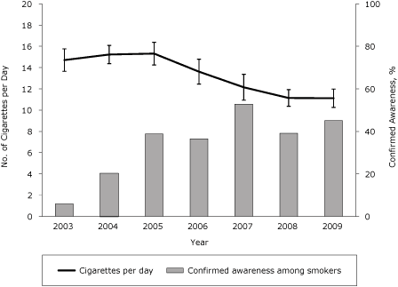
Figure 5: Cigarette consumption among smokers in New York, 2003-2009
(Davis K. C., Farrelly, Duke, Kelly, & Willet, 2012)
Figure 5 represents a timeline of New York cigarette consumption comparative to awareness of negative media campaigns, showing the percentage of smokers who made at least one attempt to quit smoking following the advertising, demonstrating that the marginal personal benefit is reducing, and as such so it the negative externality and welfare cost, as per the hypothetical representation above.

Post market failure (after solutions implemented)
Tobacco consumption, namely smoking, was already in decline in the UK before the introduction of indirect taxation (Foundation for a smoke free world, 2024), however, the external cost to society was still going unbalanced, and the market in failure. It can be assumed that the indirect taxation had a dual purpose, as not only does the approach reduce consumption, but also raises financial capital that can be used to offset the cost to the health service. Taxation does lead to a reduction in consumption of tobacco overall, however all illude to partial success, stating concerns over long term or heavy smokers, as well as sub groups of smokers, and suggest tax avoidance or lessening tactics are undertaken by the consumer (Bader, Boisclair, & Ferrence, 2011) (van Walbeek, 2015) (Chiou & Muehlegger, 2014). Similarly, a study by Beard et al. found that whilst there were quitting rates associated with tax rises, the findings were temporary, inconsistent, and not robust (2022). This suggests that market-based measures were predominantly to internalise the social cost, and not eradicate the behaviour, allowing for a recuperation of sorts to lost welfare. The government hypothetically recognised this by implementing measures of command and control, of negative advertising and packaging standardisation, as well as additional laws such as age restrictions and on passive smoking, in order to reduce personal benefit in line with social, and therefore eradicate the externality through behaviour change.

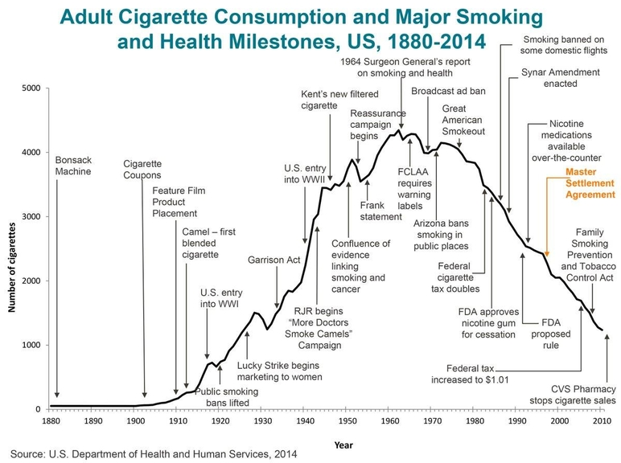
Figure 6: Adult Cigarette Consumption and Major Smoking and Health Milestones, US, 1880-2014 (truth initiative, 2017)

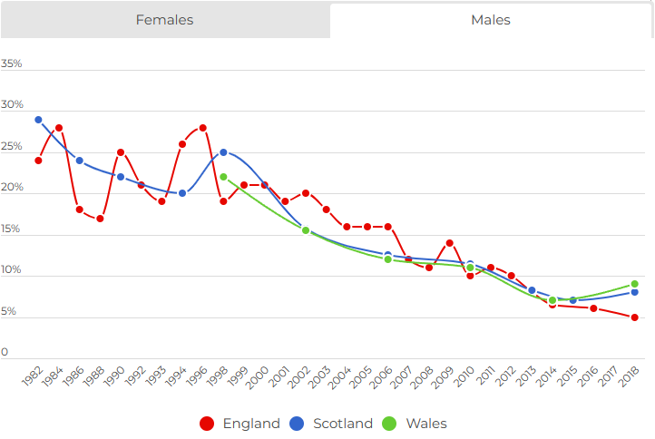Figure 7: Proportion of regular smokers at age 15 by gender, England, Scotland, and Wales, 1982-2018 (RCPCH, 2020)
Government approaches have success in curbing consumption overall, as illustrated by the US’s timeline of efforts and cigarette consumption in Figure 6, and the downward curve for England Wales and Scotland in Figure 7, however, there can be seen that there is a small upturn of regular young smokers toward the end of the study, the combined efforts it seems are not enough to continue the complete downward trajectory in consumption behaviour that is inherently harmful, and as such, it can be assumed, was influential in in the King and Governments intent to do just this through additional command and control measures (UK Parliment, 2024).

Substitute for tobacco industry
As a by product of the increased indirect taxation shown in figure 2, and the reduced demand for tobacco due to command and control action, there has been a hypothetical increase in demand for a substitute to sustain the market. This has been found to be e-cigarettes, more commonly known as vaping.
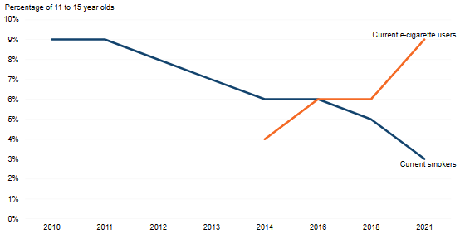
Figure 8: 11 to 15 year olds that are current smokers and vape users
(Secretary of State for Health and Social Care by Command of His Majesty, 2023)
Unfortunately, as Figure 8 shows, this has become a particular issue amongst young persons, where there remain some associated health risks (Secretary of State for Health and Social Care by Command of His Majesty, 2023), meaning further government measures may be required in the long term.

Conclusion
Before government solutions were implemented, the tobacco market was failing due to the negative externalities associated with its consumption. Command and control measures were implemented to change consumer behaviour, and market-based measures to internalise the externality costs. These approaches have resolved the failure to an extent, but it is evident that this market is of such high detriment, that further command and control is necessary to eradicate it.

References
AP MICROECONOMICS. (2022). AP® MICROECONOMICS:. Retrieved from AP MICROECONOMICS: https://www.microeconomicsap.com/externalities-ap-microeconomics.html
ASH. (n.d.). Action in Smoking and Health. Retrieved 03 20, 2024, from Illicit trade in tobacco: https://ash.org.uk/tobacco-industry/tobacco-taxation-and-illicit-trade
ASH. (n.d.). Key Dates. Retrieved 03 22, 2024, from Ash.org.uk: https://ash.org.uk/uploads/Key-Dates.pdf
Bader, P., Boisclair, D., & Ferrence, R. (2011). Effects of Tobacco Taxation and Pricing on Smoking Behavior in High Risk Populations: A Knowledge Synthesis. Int J Environ Res Public Health, 8(11), 4118-4139.
Bafunno, D., Catino, A., Lamorgese, V., Del Bene, G., Longo, V., Montrone, M., . . . Galetta, D. (2020). Impact of tobacco control interventions on smoking initiation, cessation, and prevalence: a systematic review. Journal of Thoracic Desease, 12(7), 3844-3856. doi:https://doi.org/10.21037%2Fjtd.2020.02.23
Bayne-Jones, S., Burdette, W. J., Cochran, W. G., Farber, E., Fieser, L. F., Furth, J., . . . Seevers, M. H. (1964). Smoking and Health: Report of the advisory committee to the surgeon general of the public health service. Washington D.C.: U.S. Department of Health, Education, and Welfare, Public Health Service.
Beard, E., Brown, J., & Shahab, L. (2022). Smoking prevalence following the announcement of tobacco tax increases in England between 2007 and 2019: an interrupted time–series analysis. Addiction, 117(9), 2481-2492.
Berkman, E. T., Kahn, L. E., & Livingston, J. L. (2016). Chapter 13 - Valuation as a Mechanism of Self-Control and Ego Depletion. In E. T. Berkman, L. E. Kahn, & J. L. Livingston, Self-Regulation and Ego Control (pp. 255-279). Oregon: Acedemic Press. doi:https://doi.org/10.1016/B978-0-12-801850-7.00013-5
Best, A. (2017, 05 19). This is the end of tobacco advertising. Retrieved from CancerresearchUK: https://news.cancerresearchuk.org/2017/05/19/this-is-the-end-of-tobacco-advertising/
Brandt, A. (2007). The Cigarette Century: The Rise, Fall, and Deadly Persistence of the Product that Defined America. New York: Basic Books.
Centre for Desease Control and Prevention (CDC). (2021, 10 29). Health Effects of Cigarette Smoking. Retrieved from Centre for Desease Control and Prevention (CDC): https://www.cdc.gov/tobacco/data_statistics/fact_sheets/health_effects/effects_cig_smoking/index.htm
Chiou, L., & Muehlegger, E. (2014). CONSUMER RESPONSE TO CIGARETTE EXCISE TAX CHANGES. National Tax Journal, 67(3), 621-650.
Davis, K. C., Farrelly, M. C., Duke, J., Kelly, L., & Willet, J. (2012). Cigarette consumption among smokers in New York, 2003-2009. Antismoking Media Campaign and Smoking Cessation Outcomes, New York State, 2003-2009. Retrieved from https://www.cdc.gov/pcd/issues/2012/images/11_0102_03.gif
Davis, K. C., Farrelly, M., Duke, J., Kelly, L., & Willet J. (2012). Antismoking media campaign and smoking cessation outcomes, New York State, 2003-2009. Preventing Chrinic Desease, 9. doi:http://dx.doi.org/10.5888/pcd9.110102
Doll, R., & Bradford Hill, A. (1950). SMOKING AND CARCINOMA OF THE LUNG: preliminary report. BRITISH MEDICAL JOURNAL, 2, 739-748.
Durkin, S. J., Biener, L., & Wakefield, M. A. (2009). Effects of Different Types of Antismoking Ads on Reducing Disparities in Smoking Cessation Among Socioeconomic Subgroups. American Journal of Public Health, 99(12), 2217-2223.
Ellis, L. D. (2021, 03 16). Evidence-Based Strategies to Reduce Global Tobacco Use. Retrieved from Harvard T.H. CHAN: https://www.hsph.harvard.edu/ecpe/evidence-based-strategies-to-reduce-global-tobacco-use/
Farrelly, M., Crankshaw, E., & Davis, K. (2008). Assessing the effectiveness of the mass media in discouraging smoking behavior. In: The role of the media in promoting and reducing tobacco use. Tobacco Control Monograph No. 19. Bethesda (MD): US Department of Health and Human Services, National Institutes of Health, 7.
Fernando, J. (2023, 12 31). Law of Supply and Demand in Economics: How It Works. Retrieved from Investopedia: https://www.investopedia.com/terms/l/law-of-supply-demand.asp
Foundation for a smoke free world. (2024, 02 09). State Of Smoking And Health In The United Kingdom. Retrieved from Foundation for a smoke free world: https://www.smokefreeworld.org/health-science-research-2/health-science-technology-agenda/data-analytics/global-state-of-smoking-landscape/state-smoking-united-kingdom/
Freund, K. M., Belanger, A. J., D'Agostino, R. B., & Kannel, W. B. (1993). The health risks of smoking the framingham study: 34 years of follow-up. Annals of Epidemiology, 3(4), 417-424. doi:https://doi.org/10.1016/1047-2797(93)90070-K
Fuchs, A., & Meneses, F. (2017). ARE TOBACCO TAXES REALLY REGRESSIVE?: EVIDENCE FROM CHILE. Washington DC: The World Bank, Poverty and Equity Global Practice.
GGTC. (n.d.). About Globel Tobacco Index. Retrieved 03 20, 2024, from Global Centre for Good Governance in Tobacco Control: https://globaltobaccoindex.org/about
Helbling, T. (2010). Back to Basics: What Are Externalities? FINANCE & DEVELOPMENT magazine, 47(4), 48-49. Retrieved from https://www.imf.org/external/pubs/ft/fandd/2010/12/basics.htm
Hilton, M. J. (n.d.). A social and cultural history of smoking. Retrieved 03 19, 2024, from Britannica: https://www.britannica.com/topic/smoking-tobacco/A-social-and-cultural-history-of-smoking
HM Revenue & Customs. (2024, 02 29). National statistics: Historical Tobacco Duty rates. Retrieved from Gov.uk: https://www.gov.uk/government/statistics/tobacco-bulletin/historical-tobacco-duty-rates
HM Revenue and Customs. (2024, 02 29). Tobacco statistics commentary January 2024. Retrieved from Gov.UK: https://www.gov.uk/government/statistics/tobacco-bulletin/tobacco-statistics-commentary-april-2023--2
Indeed Editorial Team. (2023, 07 31). How To Calculate Marginal Cost (With Formula and Examples). Retrieved from indeed: https://www.indeed.com/career-advice/career-development/how-to-calculate-marginal-cost
Kagan, J. (2023, 10 20). Excise Tax: What It Is and How It Works, With Examples. Retrieved from Investopedia: https://www.investopedia.com/terms/e/excisetax.asp
microeconomicsap. (n.d.). An indirect excise tax on demerit goods. AP® MICROECONOMICS: 4.1 EXTERNALITIES. Retrieved 03 24, 2024
microeconomicsap. (n.d.). Government regulations and advertising. AP® MICROECONOMICS: 4.1 EXTERNALITIES. Retrieved 03 24, 2024, from https://www.microeconomicsap.com/uploads/1/1/7/5/11758934/ib-economics-government-regulations-and-advertising_3_orig.jpg
microeconomicsap. (n.d.). Negative externalities of cigarette consumption: MSB < MPB. AP® MICROECONOMICS: 4.1 EXTERNALITIES. Retrieved 03 24, 2024, from https://www.microeconomicsap.com/externalities-ap-microeconomics.html
Miller, K. (2020, 12 08). THE TRIPLE BOTTOM LINE: WHAT IT IS & WHY IT’S IMPORTANT. Retrieved from Harvard Business School-HBS Online-Business Insights: https://online.hbs.edu/blog/post/what-is-the-triple-bottom-line
O'Brien, L., & O'Leary, J. (2015, 10 12). Does smoking cost as much as it makes for the Treasury? Retrieved from Full Fact: The Economy: https://fullfact.org/economy/does-smoking-cost-much-it-makes-treasury/
O'Driscoll, G. P., & Hoskins, L. (2006). THE CASE FOR MARKET-BASED REGULATION. Cato Journal, 26(3), 469-487.
Parlour, C. A., & Seppi, D. J. (2008). Limit Order Markets: A Survey. In A. V. Thakor, & A. W. Boot (Eds.), Handbook of Financial Intermediation and Banking (pp. 63-96). London: Elsevier Science.
RCPCH. (2020). Proportion of regular smokers at age 15 by gender, England, Scotland and Wales, 1982-2018. Smoking in young people. Retrieved from https://infogram.com/1pk6kr5d09eyqkc9exgjl19rm5c3n319vwq
Robinson, J. V. (2024, 03 13). market. Retrieved from Britannica Money: https://www.britannica.com/money/market
Rose, N. (2015). Regulation, Political Economy of. Cambridge, MA: Massachusetts Institute of Technology. Retrieved from Econlib.
Secretary of State for Health and Social Care by Command of His Majesty. (2023, 11 08). 11 to 15 year olds that are current smokers and vape users. Stopping the start: our new plan to create a smokefree generation. Retrieved from https://assets.publishing.service.gov.uk/media/651e8b9f7309a1000db0a889/Slide6.SVG
Secretary of State for Health and Social Care by Command of His Majesty. (2023, 11 08). Stopping the start: our new plan to create a smokefree generation. Retrieved from Gov.UK Department of health & Social care: https://www.gov.uk/government/publications/stopping-the-start-our-new-plan-to-create-a-smokefree-generation/stopping-the-start-our-new-plan-to-create-a-smokefree-generation
Sims, M., Langley, T., Lewis, S., Richardson, S., Szatkowski, L., McNeill, A., & Gilmore, A. B. (2016). Effectiveness of tobacco control television advertisements with different types of emotional content on tobacco use in England, 2004–2010. Tobacco Control, 25, 21-26.
Sloman, J. (2019). Economics for Business (8th ed.). Harlow: Pearson.
Tobacco Free Life. (n.d.). History of Tobacco. Retrieved 03 20, 2024, from tobaccofreelife.org: https://tobaccofreelife.org/tobacco/tobacco-history/
tobaccofreekids. (2012, 10). Cigarette Prices, Sales, and Government Revenue in the UK (1992-2011). Action on Smoking & Health: Campaign for Tobacco-Free Kids. Retrieved from https://assets.tobaccofreekids.org/global/pdfs/en/success_UK_en.pdf
tobaccofreekids. (2012, 10). TOBACCO TAX SUCCESS STORY: UNITED KINGDOM. Campaign for Tobacco-Free Kids. Retrieved from https://assets.tobaccofreekids.org/global/pdfs/en/success_UK_en.pdf
truth initiative. (2017, 01 05). Adult Cigarette Consumption and Majour Smoking and Health Milestones, US, 1880-2014. Milestones in tobacco history. Retrieved from https://truthinitiative.org/research-resources/tobacco-prevention-efforts/milestones-tobacco-history
Uk Parliment. (1971, 08 05). Hansard: Tax Revenue. Retrieved from UK parliment: https://hansard.parliament.uk/commons/1971-08-05/debates/2cb84990-4816-4923-84a6-bc8410637774/TaxRevenue
UK Parliment. (2024, 01 11). Hansard: Smokefree Future. Retrieved from UK Parliment: https://hansard.parliament.uk/commons/2024-01-11/debates/446BBC46-98BF-4DCB-8CC5-8605DA1BB563/SmokefreeFuture
University of Bath. (2024, 01 10). Launch of UK Tobacco Industry Interference Index 2023. Retrieved from To9bacco Tactics University of Bath: https://tobaccotactics.org/news/launch-of-uk-tobacco-industry-interference-index-2023/
van Walbeek, C. (2015). The Economics of Tobacco Control (Part 2): Evidence from the ITC Project. Tobacco Control, 24, iii1-iii3.

