Circuits for Simulation
Exercise 1
To find Equivalent resistance
Circuit Diagram
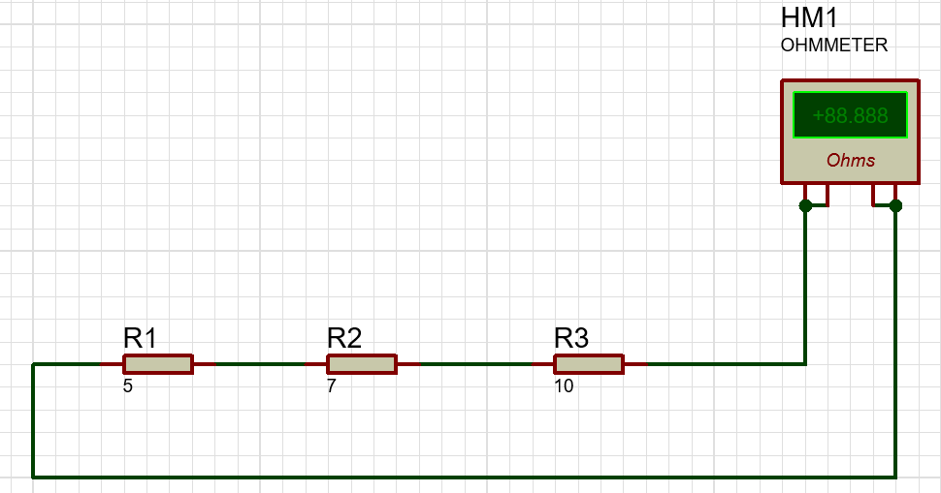
Tabulation
Practical | Theoretical
$R_{eq}$( Ω) | $R_{eq}$( Ω)

Exercise 2
To find Equivalent resistance
Circuit Diagram
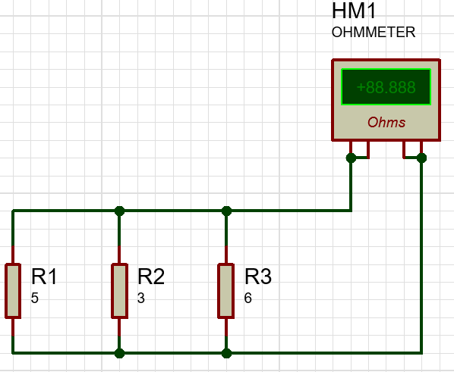
Tabulation
Practical | Theoretical
$R_{eq}$( Ω) | $R_{eq}$( Ω)

Exercise 3
To find Equivalent resistance
Circuit Diagram
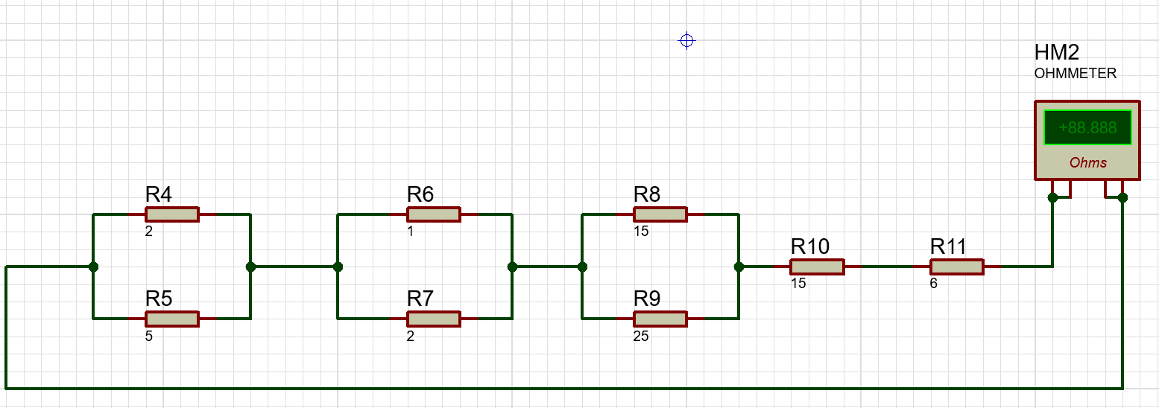

Tabulation
Practical | Theoretical
$R_{eq}$( Ω) | $R_{eq}$( Ω)

Exercise 4
To find Equivalent resistance
Circuit Diagram
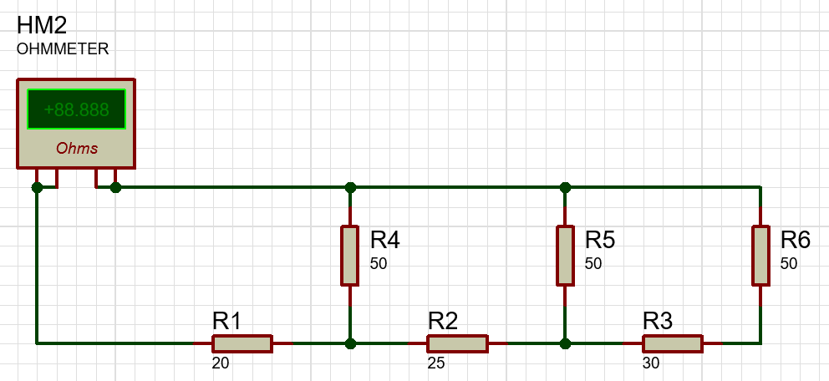
Tabulation
Practical | Theoretical
$R_{eq}$( Ω) | $R_{eq}$( Ω)

Exercise 5
To find Equivalent resistance
Circuit Diagram
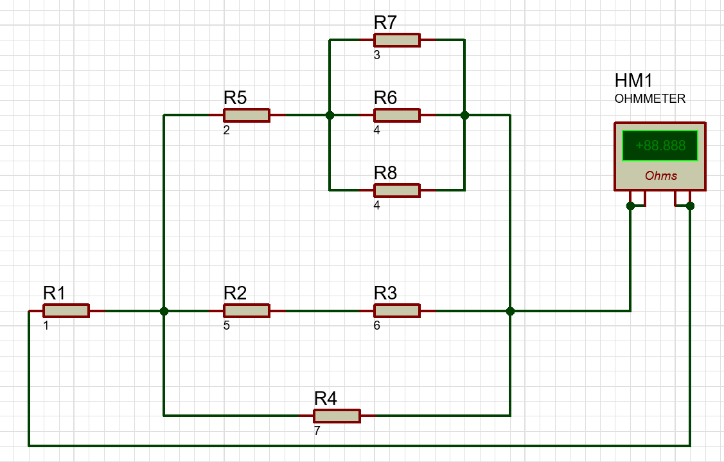

Tabulation
Practical | Theoretical
$R_{eq}$( Ω) | $R_{eq}$( Ω)

Exercise 6
To measure the current and voltage
Circuit Diagram
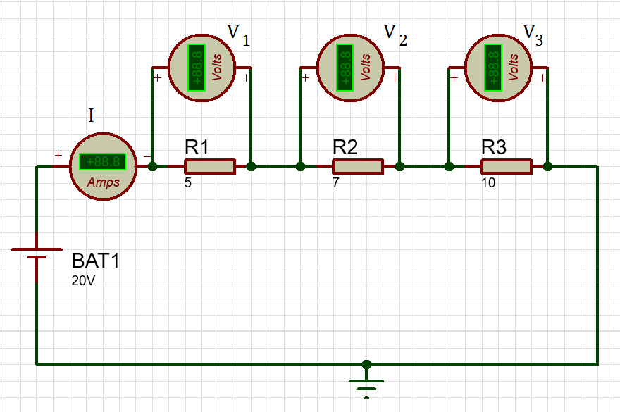

Tabulation
Practical |  |  |  | Theoretical
Current I ( A) | Voltage $V_{1}$ ( V) | Voltage $V_{2}$ ( V) | Voltage $V_{3}$ ( V) | Current I ( A) | Voltage $V_{1}$ ( V) | Voltage $V_{2}$ ( V) | Voltage $V_{3}$ ( V)

Exercise 7
To Verify KVL
Circuit Diagram
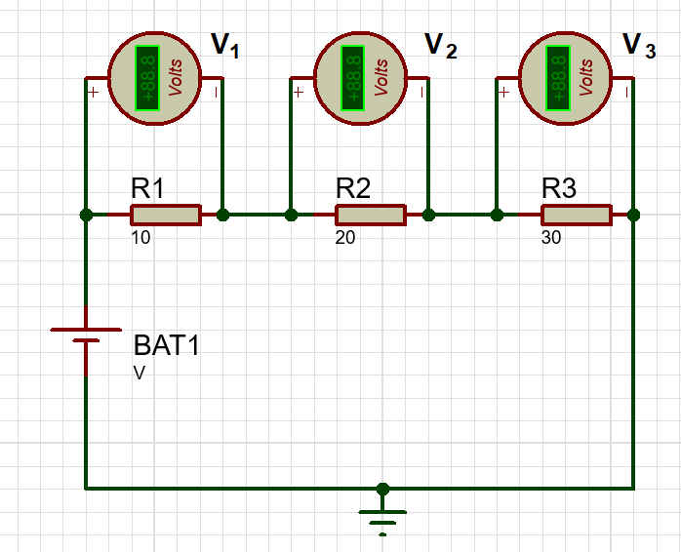

Tabulation
Supply voltage (V) | Practical |  |  | Theoretical
Supply voltage (V) | Voltage $V_{1}$ ( V) | Voltage $V_{2}$ ( V) | Voltage $V_{3}$ ( V) | Voltage $V_{1}$ ( V) | Voltage $V_{2}$ ( V) | Voltage $V_{3}$ ( V)
5
10
15

Exercise 8
To Verify KCL
Current Entering =I
Current leaving =I1+I2
Circuit Diagram
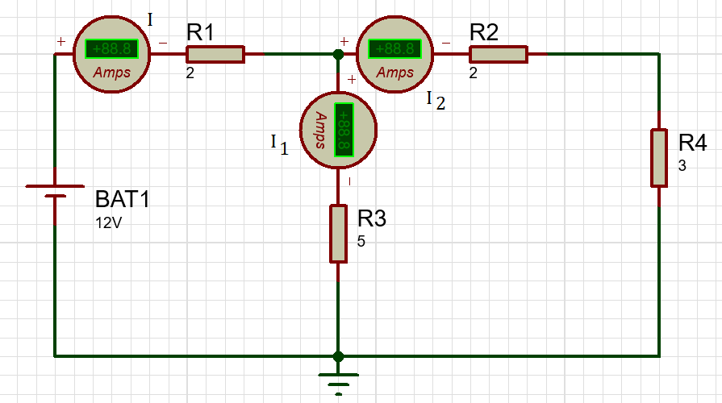

Tabulation
Supply voltage (V) | Practical |  |  | Theoretical
Supply voltage (V) | Current I ( A) | Current $I_{1}$ ( A) | Current $I_{2}$ ( A) | Current I ( A) | Current $I_{1}$ ( A) | Current $I_{2}$ ( A)
12 | 2.67 | 1.33 | 1.33

