10/5/2022
Assessment 1 REWORK(WEEENEN) | Group 1/ The Global Business Environment-LCBB4005, Lecturer: Dr Akinseye Aluko, Student name: Miroslava Georgieva Student ID:2112588

report | Environmental Analysis of Automobile Industry

Table of content

- Executive Summary……….2
- Global business environment……3
- Business models………4-6
PESTEL
- Porter’s five forces
- Value chain
- Assess market in action ……7
- Conclusion ……8
- Reference list…..9

Executive summary

This report will discuss the significant features of the international economy and assess the micro and macroeconomic factors and their impact on the environment. Thus, the statement aims to recognise and analyse the global business environment. COVID-19 have a considerable impact on the industry and the smooth transition into electric vehicle attempts. The automotive industry has a massive effect on the global economy, producing vehicles that efficiently transport people and goods. Applying relevant business models such as Value Chain, Forces 5 Forces, and PESTEL analysis will reveal different market structures and their influence on firm strategy. It includes many companies and organisations involved in designing, developing, producing, marketing, and selling motor vehicles. As one of the world’s largest revenue industries, the United States has been the worldwide leading automobile manufacturer for many decades-but not for longer. China is leading with just 12%, and it is famously known as the world’s car manufacturer. The sustainable use of the automobile industry will inevitably lay a solid foundation for the overall implementation of sustainable development. Therefore, it needs to be analysed from the environmental, economic, and social aspects.

First, to ensure continued economic and financial support to meet people’s needs for automobiles- evs.

Secondly, it must maximise people’s quality and in environmental sustainability.

Finally, the economic benefits generated by transportation must be shared equally by all parties, which is the sustainability of social development.

In addition to the current cost of making new vehicles is increasing, coupled with the impact of COVID-19, the price of new cars will be relevantly high in the next one to two years.

The Global business environment
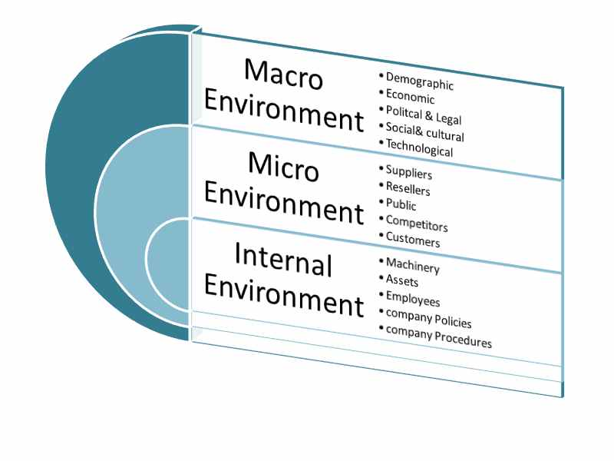

Micro and macro marketing activities have a significant impact on the success of the environment. Therefore, such environmental factors must be considered in-depth while creating a strategic marketing plan. Considering these factors will improve the success of any organisation's marketing campaign and the brand's reputation in the long term.

The automobile industry promotes people's consumption. It requires people to buy vehicles and other sponsorships to make the technology and quality of cars better. Therefore, companies in the automotive industry must also pay more attention to sustainable development. For example, new energy vehicles are an essential part of sustainable development, and their growth has considerable practical significance and value for the social dimension of sustainable development. For example, new energy vehicles, also known as alternative fuel vehicles, refer to vehicles that do not use gasoline or diesel as driving energy, including pure electric vehicles, fuel cell vehicles, hybrid electric vehicles, and ethanol-gasoline vehicles. Pure electric vehicles completely abandon internal combustion engines and do not rely on burning traditional fuels such as gasoline and diesel. Its advantages are zero pollution, low noise, and a simple structure. Currently, hybrid electric vehicles mostly use electric motors as auxiliary or main power, which inherits the advantages of low emissions from electric vehicles and improves vehicles' pollution and fuel consumption compared with traditional internal combustion engines. Fuel cell vehicles do not burn fuel but directly obtain electrical energy through conversion. The entire battery operation process hardly generates harmful gas or energy loss, and fuel cell vehicles have excellent power and operability.

According to Ginting (2021), China is the world's largest electric vehicle market, with total sales of 1.3 million vehicles last year, more than 40% of global sales. Chinese battery maker CATL controls about 30% of the global EV battery market. This makes China a major player and battery maker monopoly for the global chain. It also competes with Europe and the US for the most significant cobalt and nickel markets.

Canada and India are two nations competing in the manufacture of EV batteries. Canada expects to deploy solely electric battery vehicles by 2035.

As the EV market grows, Canada is challenged to become the most sustainable Cobalt producer globally. The aim is to develop technology that improves cathode materials' cost and environmental footprint from mining through to the battery. That will be the next generation of technologies and electronic vehicle batteries. Nonetheless, the traditional way of making batteries is costly, and the Canadian manufacturer will reduce the cost and the time of production by using the CAM process(M2CAM).

Another macro-environmental factor is the newly developed recycling technology of 95% lithium-ion batteries, and enormous changes will be seen in the next decade. Cars will remain a way of life, though rising costs and challenging norms are considerable obstacles for the global auto market. Complex regulations and environmental legislation have also significantly impacted the global automotive industry. As a result, new firms are sluggish to enter the automobile market. Significant opportunities lie in the emerging economies of Asia and South America, especially India and Brazil. According to a study, these two countries have shown a substantial rise in car sales in the past year. This growth rate will continue, with India expected to grow to the third-largest automobile market by 2021.

One of the political factors affecting the automobile industry is the carbon-emission regulations. Once the government introduces environmental regulations, the automotive companies must go through the ecological legalities.

The critical impact of the pandemic is the worldwide economic recession, increasing unemployment rate, and lower buying power. On the other hand, with income levels rising in developing nations (Europe, South America, India, Brazil), the population has considerable disposable income to invest in personal vehicles. While technology giants are raiding the automotive industry (think Tesla and Google), global carmakers are coming together to stay relevant in a market where consumer demands are fast becoming new.

The Social factors affecting the automobile industry are the driving trend.

The automobile companies know the shopping trends, lifestyle of people, and customer attraction features. They target the customers accordingly. Most importantly, such movements have increased the industry's growth, sale, and revenue.

Audi AG brand is one of the latest electronic vehicle producers. Why? Simple, the heart of Audi is driver-oriented. E-Tron is the electronic dream for the brand followers.

Technologically, the automobile industry is innovative, with more battery timing and safe, self-sustainable solar and wind technology. Because most companies are ecological forces for the better, Siemens and Porsche, collaborate with advanced climate-neutral e-fuel development. The world's first integrated commercial plant for producing climate-neutral fuel is in progress in Chile.

Pollution is a conscience of global warming and climate change. Also, it is one of the environmental factors impacting the automobile industry. Mission Zero for Audi began in 2014 when it was the first first-class manufacturer to determine its corporate carbon footprint according to an internationally accepted standard. The result is marked a critical step toward transparency in greenhouse gas emissions. Today, these emissions can be analysed and effectively reduced in more detail.
However, as this automobile sector PESTLE study shows, growing economies and technology improvements provide considerable opportunity for automakers to embrace new practises and business models to overcome the present demand slump and become profitable soon.

Audi is well-known for its style and technology. Also, one of the leading premium brands in its portfolio of Volkswagen. People look for a proven history of reliability and product innovations when buying a luxury car. Audi's competitive advantage emanates from several sources, including excellent product quality, marketing, and customer experience.

Audi has maintained its powerful presence globally through an extensive sales and distribution network that spans all the major markets, including China and the United States.
Moreover, Audi is among the best-selling premium car brands in the Chinese market.
Porter's five forces analysis will determine Audi's position against these forces and its competitive position in the automobile industry.

The bargaining power of the suppliers is low.

Following is the bargaining energy of suppliers in Porter’s Five Forces evaluation of Audi is a top class luxury company that continuously invests in innovation and product differentiation. Suppliers have little room to combine what Audi is doing, influence their business, and earn bargaining strength over Audi. Also, the size at which Audi operates cannot be matched by the suppliers, and the boundaries of entry referred to above had to be crossed to even enter the industry. A few large suppliers can have big bargaining strength against Audi. Still, the truth that the company does now not collect from just a single dealer counter this bargaining power. The truth that the raw materials are sourced from specific parts of the world takes away the cohesive bargaining electricity the suppliers should have possessed in opposition to Audi. To justify this, Audi and its mother or Father VW maintain a sustainable furnish chain and observe precise codes of behaviour for the suppliers. Taking all these factors into account, the bargaining strength of the suppliers can be stated to be below.

Audi's business is a part of Volkswagen AG. There are very few large suppliers, and the smaller size of supplier businesses limits their bargaining power. Brands like Audi do not depend on a single supplier for a particular raw material. These suppliers are in various corners of the world, and most of them are smaller businesses that depend on more prominent brands like Audi. These factors limit the bargaining power of suppliers.

The bargaining power of customers

That power is driven by some customer factors such as:

Higher competition, safety regulations, customers experience and loyalty

Also, there are many competing brands for the chance to win customers' loyalty. The bargaining power of Audi customers is moderate because of the high switching cost. The company is innovative oriented and always doing lots of research before announcing a new project.

Threat of substitute

The competitor's goods and products have impacted the threat of substitutes for Audi. Several factors such as brand image, product innovation and popularity have limited the threats of substitutes for Audi.

The brand's main competitors are BMW, Tesla, Mercedes-Benz, and Porsche. The threat to Audi from the substitute products is moderate. Audi is a premium car brand and enjoys participating in all leading vehicle markets, including China and the United States.

The threat of new entrants

One of the critical factors for the low threats of new entrants to the Audi Market is the high level of competition. Secondly, the entry and exit barriers are too high. If any new brand is training to drop on, the automobile industry will need significant capital and investments, know-how and the most essential- skilled human resources. Furthermore, this is just a tiny step at the beginning. The next jump must be establishing a factory, connecting with suppliers, and remaining in the local market. The incumbent players aggressively protect their market shares through innovation, marketing, and customer service. That is why the new entrant will make its presence felt in a short time.

The intensity of competitors

In the automobile industry, the intensity of competitive rivalry is significant. All brands invest aggressively in research, development, and marketing to grow their market share and customer base. Leading competitors such as Audi include Porsche, Mercedes-Benz, Tesla, Aston Martin, and BMW are the global brands in the automobile industry with premium and luxury car brands.

Some distinguishing new entrants have the potential to change misrepresentation style and countryside, complementary to Tesla inside the indulgence car manufacturing. All the brands noticed above enduringly purchase change to change themselves and devote effort to something the customer occurrence, security, and publicity to win ruling class over. Over occasion, this aggressive contest has only developed.

Conclusion
Summarising the above analyses highlight the more than a few elements affecting the competitive landscape. This understanding helps in evaluating the distinctive exterior commercial enterprise drivers for each company.

The automobile industry market is innovative designs in line with emerging socio-cultural trends and environmental regulations. The winning competitors will be those who use newly available technologies to capitalise on this trend, designing fuel-efficient, eco-friendly, and comfortable vehicles. In addition, although the North American market does not leave much room for growth, other parts of the world (regions with much larger populations) are developing, and individuals have increasing disposable incomes. More individuals purchase new vehicles in Asia, Central and South America, and Eastern Europe. Opportunistic companies will have to develop strategies that fit those cultures to seize foreign growth.

Reference list
1.Audi Media Centre (2021). Audi defies the corona crisis with a robust performance in the 2020 financial year
Available at: https://www.audi-mediacenter.com/en/press-releases/audi-defies-the-corona-crisis-with-a-robust-performance-in-the-2020-financial-year-13853
(Accessed: 18/10/21)

2.Audi Media Centre (2020). Audi launches initiative for digital factory transformation in Heilbronn.
Available at: https://www.audi-mediacenter.com/en/press-releases/audi-launches-initiative-for-digital-factory-transformation-in-heilbronn-13945
(Accessed by 30/04/21)

3. Audi Company (2021). Stakeholder management
Available at: https://www.audi.com/en/company/sustainability/stakeholder-management.html

4.The Guardian November 30, 2021 Battery-arms race. How China has monopolised the electric vehicle industry.
Available at: https://www.theguardian.com/global-development/2021/nov/25/battery-arms-race-how-china-has-monopolised-the-electric-vehicle-industry

5. Desjardins, Jeff (2018) The 8 major forces shaping the future of the global economy.
Available at: https://www.visualcapitalist.com/the-8-major-forces-shaping-the-future-of-the-global-economy/

6. Electric vehicles (2021) Canada: A spark for the batteries and electric vehicles industry
Available at: https://www.investcanada.ca/blog/canada-spark-batteries-and-electric-vehicles-industry

7. Exploring business (n.d.) The Global Business Environment
Available at: https://open.lib.umn.edu/exploringbusiness/chapter/3-3-the-global-business-environment/

8. Hamid, Zaid (2021) Going green with Porsche Exclusive Manufacturer
Available at: https://newsroom.porsche.com/en/2022/products/porsche-exclusive-manufaktur-911-speedster-brewster-green-26971.html

9. Market research report, April 21, 2021. China Luxury Car Market - Growth, Trends, COVID-19 Impact, and Forecasts (2021 - 2026)
Available at: https://www.giiresearch.com/report/moi866624-china-luxury-car-market-growth-trends-forecast.html

10. Forbes 2021, The Coronavirus’ Impact On The Global Automotive Supply Chain
Available at: https://www.forbes.com/sites/laurieharbour1/2020/03/13/the-coronavirus-impact-on-the-global-automotive-supply-chain/?sh=4f8a5e9b444e

