University of Wales Trinity Saint David

School of Engineering

Performing an Energy Audit

Energy Management and Efficiency
M6X01197

Timothy Jones
1701384

02/02/2020
Contents
1. Introduction 3
2. Company Background 4
3. Types of energy used and where it is used 4
4. Assessment of current situation 5
4.1 Energy usage and behaviour 5
4.2 Losses in energy 6
5. Calculations 7
6. Discussion of potential energy savings 10
7. Recommendations 11
8. References 12

Introduction

The aim of this project is to perform an energy audit on a chosen business and as a result of the energy audit outlining areas for improvement. The purpose of an energy audit is to identify these areas of energy consumption and analyse what solutions best to reduce this consumption to save on energy costs (DIVERSEGY, 2014).
There are several types of have how an energy audit can be undertaken. These depend on the size of a business. A large-scale business would require a more in-depth audit as there would be greater potential for improvement compared to a detailed audit of a small business. Benchmarking is the simplest for of audit which compares itself to another business or building similar in size and production to determine if there is a difference in energy (The Green Energy Advice Bureau, 2017).
A walkthrough audit is conducted by a visual assessment of a workplace to analyse areas of energy consumption as well as their associated durations (Anoop, n.d.). These areas of consumption can be prodced by anything such as machinery, lighting and heating. A comprehensive energy audit follows the same principles as a walkthrough audit but goes into further detail and takes longer to complete. A walkthrough accounts for the majority of energy used whereas the detailed audit accounts for all the energy consumed and can further recommend short term and long-term recommendations (Santalla, 2019).
After a walkthrough has taken place the auditor assesses the businesses energy consumption for a period of over 24 months. They will analyse their calculations against energy consumed and write a report with appropriate recommendations. The next stage implements the energy saving procedures entailed within the report, some of which are behavioural and others which need to be invested in. (TCCI, n.d.).

Company Background

Canaston Oaks is an award-winning luxury bed and breakfast located in Narberth within the Pembrokeshire countryside. The B&B first opened in 2005 as a family run business with the farm’s original barns dated back to the 19th century, converted into the luxury rooms. Beginning with only 4 rooms the B&B has expanded in 2012 years to accommodate 10 rooms and a communal lounge (Canaston Oaks, 2019). During 2019 Canaston Oaks had a total of 3022 guests with an average duration of stay to be 3 days. Each of these guests attending breakfast every morning during their stays. Out of all the guests at the B&B only 70 utilised the evening meal option due spending the day elsewhere exploring local towns (Millership, 2020). The B&B is aimed towards couples that want a luxury getaway with access to the outdoors and small towns. It also a popular destination for businessmen to stay on their travels.

Types of energy used and where it is used

In 7 out of the 10 rooms 2 kerosene fuelled oil burners are used. These oil burners produce heat to provide central heating in the rooms as well as providing hot water.
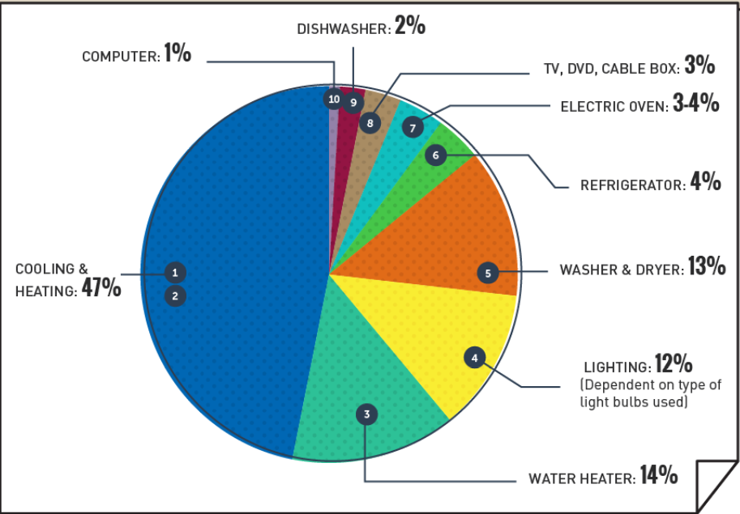
The B&B isn’t dissimilar to a regular house in terms of types of energy and usage except on a larger scale. Comparing the ratio of energy distribution, heating and cool and hot water equate to 61%. The B&B is expected to follow a similar ratio if not higher as during the majority of the day the facilities are not used and guests are more than likely out of their rooms. Electricity is not likely to be used when areas are unoccupied, whereas heating remains on with a larger volume to fill.
Figure 1 Energy distribution (Desjardins, 2016)
Upon refurbishment of the B&B a ground sourced heat pump was installed. The pump circulates water and antifreeze through a series a pipe buried underground which absorbs the heat and is transferred through the pipes into the building to be used (Energy Saving Trust, 2020). Their ground source heat pump is used in the reception, kitchen and dining area as well as the remaining 3 rooms. It provides central heating and heats the water in all these areas. Electricity is still needed to operate the pumping system but at a smaller percentage to that of using electricity to directly heat water for the same applications (Vekony, 2019).
The remaining energy demand is supplied by electricity. These include electrical equipment and appliances in each of the guest rooms, kitchen & dining room and utility room. The kitchen will mostly likely consume more energy compared to all other energies at the B&B due to the nature of the culinary equipment needed to provide breakfast and evening meals which require more power.

Assessment of current situation

Energy usage and behaviour

Breakfast is served every day of the year that the B&B is open as its part of the package price. The kitchen is prepped before serving times. The kitchen is used to cook the breakfast for approximately 2 hours. The lights will be on during preparation, serving and clear up which on average takes 5 hours (Millership, 2020).
On site at the B&B they provide evening meal options. To attend an evening meal the B&B must be notified by 10 am the same day. Customers are well informed and even have the option to place their order so the staff can have the food ready for them when they arrive. Doing so this enables the business when the kitchen is needed and what meals they will need to cook. If they know the meals in advanced only the applicable kitchen appliances need to be used and corresponding duration as they do not expect additional orders.
The utility room on site contains 2 washing machines and 2 tumble dryers used to clean guests bedding. The room also contains 3 fridge freezers acting as additional storage to the kitchen for products that
The reception is open for 2 hours between 4-6pm as it is the recommended time for guests to arrive. If a guest is going to arrive late they can notify the staff if they have not already done so.
Each room has radiators that can be timed when to come on as well as having an easily accessible thermo stat for guests to access and change the temperate as they wish. During a guest stay they typically leave the heating on to return a warm room. As the B&B is not linked with gas mains, kerosene a clean burning oil provides a respectable alternative to gas (National Energy Foundation, n.d.). Oil burners can be as efficient as 90% producing vast amounts of heat per unit of oil. However, the validity of using oil burners is dependent on current oil prices as the fluctuate frequently (Ingrams, 2018).
The ground sourced heat pump still requires some electricity to pump the water around the system. On average every 3-4 kw’s of heat extracted it requires 1 kw of electricity (Ground Source Heat Pump Association, n.d.). Therefore, using ground source heat is 300-400% more efficient than using electricity alone to produce the same equivalent amount of heat. This provides a cheaper alternative form of heating it terms of running costs but would have needed a substantial capital cost up front during the refurbishment of the B&B.

Losses in energy
Its is important to track where energy is used within a business but also as important to see where energy is lost. Areas of loss such as insulation where heat is lost through walls, windows and doors. If insulation is not invested in, a greater energy requirement is needed to continually heat a space. Especially since the B&B uses a ground source heat pump it would maximize the effectiveness of having it installed (Green Match, 2019). The current insulation measures of the B&B are unknown. The barns were built in the 19th century but during 2012 they would have been fitted with insulation during refurbishment.
Appliances such as the refrigerators and washing machines are given energy efficiency ratings. These appliances are used when needed and are not down to behaviour. Energy is lost due to inefficient rated appliances.

Calculations

After completing a walkthrough of the B&B and observing the patterns of energy usage and appliances used, these can be used to calculate an approximate value of the energy consumption of the B&B. The total business’s electricity consumption came to 32,000 kwh which cost approximately £4,400. The oil burners used £3800 worth of oil for the heating of water and central heating within each room (Millership, 2020).
Due to guests at the B&B are calculated daily regardless of duration of stay. The nature of the B&B attracts couples therefore it can be assumed that out of the 3022 guests there were 1511 nights stayed, in 2019. To assist with yearly consumption values canaston oaks was closed for 4 weeks of the year, therefore;

365-28 = 337 days open
337 days x 10 rooms = 3370 nights per calendar year (max capacity)
3022/2= 1511 nights stayed
(1511/3370) x100 = 44.8%
(Average occupancy rate at the B&B)
This 44.8% average doesn’t take into consideration how occupancy is weighted throughout the seasonal year such as winter and summer which would later affect behavioural calculations such as heating and lighting which are heavily related to time of year.
Estimated energy consumption within rooms are relative to their occupancy status. The occupancy rate allows a more accurate solution in determining total energy consumption within guests’ rooms through the use of recorded data.

Rooms
Each of the rooms contain a minifridge and LED lighting. Each of the 13 5w lights were assumed to be on an average of 6 hours per day with consideration to natural light produced seasonally. The manufacturers of the minifridge’s states a yearly value of 204 kwh.
Appliance | Quantity (10 rooms) | Power (Kw) | duration (hours) |  | occupancy rate | days | Kwh Per Year
lights | 130 | 0.005 |  | 6 | 0.448 | 337 | 588.8064
Table 1 (Room usage)
1 minifridge per year = 204kwh
10 rooms x 204 = 2040 kwh per year for all rooms

Utility room
Each machine is assumed to be used once per day to keep up with the demand and each machine has a duration of 2 hours. The fridge-freezers are kept permanently on. The fridge freezers have a yearly usage of 250 kwh.

Appliance | Quantity | Power (Kw) | Duration | Days | Kwh Per Year
Washing Machine | 2 | 0.8 | 2 | 337 | 1078.4
Tumble dryer | 2 | 1 | 2 | 337 | 1348
 |  |  |  |  | 2426.4
Table 2(Utility room usage)
1 fridge-freezer =250 kwh
3 x 250 = 750 kwh per year
Kitchen, Dining Room & Reception
As mentioned in 4.1 the lights will be on for the 5 hours during breakfast and 2 hours when reception is open in the evenings. Culinary appliances are operated for 2 hours and an additional 2 hours for the dishwasher. Fridges and permanently on all year round where as all other appliances are determined by working days.

Appliance | Quantity | Power (Kw) | Duration (Hours) | Days | Kwh Per Year
Griddle | 1 | 3 | 2 | 337 | 2022
Oven | 1 | 6 | 2 | 337 | 4044
Induction Hob | 1 | 9 | 2 | 337 | 6066
Fridges | 5 | 0.103 | 24 | 365 | 4511.4
Lights | 40 | 0.005 | 7 | 337 | 471.8
Dishwasher | 1 | 0.9 | 2 | 337 | 606.6
 |  |  |  |  | 17721.8
Table 3 (Kitchen, dining room & reception energy usage)
As a total of 70 guests attended meals it has been assumed that there were 35 days were evening meals took places as couples would each together. The table below contains energy consumption associated with these evening meals. Each meal’s cooking duration and cleaning using dishwasher are estimated to each take 1 hour to perform.

Appliance | Quantity | Power (Kw) | Duration (Hours) | Days | Kwh Per Year
Griddle | 1 | 3 | 1 | 35 | 105
Oven | 1 | 6 | 1 | 35 | 210
Induction Hob | 1 | 9 | 1 | 35 | 315
Dishwasher | 1 | 0.9 | 1 | 35 | 31.5
 |  |  |  |  | 661.5
Table 4 (Evening meal energy usage)

Total of 24188.51 Kwh calculated through a walkthrough of the B&B. Out of the 32,000 Kwh remains 7811.5 of unrecorded electricity. As previously mentioned in section 4.1, the use of heat pumps requires electricity to operate. The unaccounted electricity usage can be allocated to pumping the water. If the full amount unaccounted for was used by the pump it could produce 23434.5 to 31246 kwh of thermal energy if the system follows the average efficiency ratio.

These calculations are performed under several assumptions based on patterns to approximate an appropriate energy consumption to highlight excessive use. These assumptions do not include the use of external devices brought to the B&B such as laptops etc that are not permanent on site.
The power usage values used in these calculations were discovered by visually displayed labels on appliances during the walkthrough, or research conducted using the make, model and year of each appliance directly given by manufactures websites.

Discussion of potential energy savings

Firstly, to save on any energy bill would be to compare the current tariff to other tariffs on the market.
$$\frac{£4400}{32000 kwh}=£0.1375 per Kwh$$
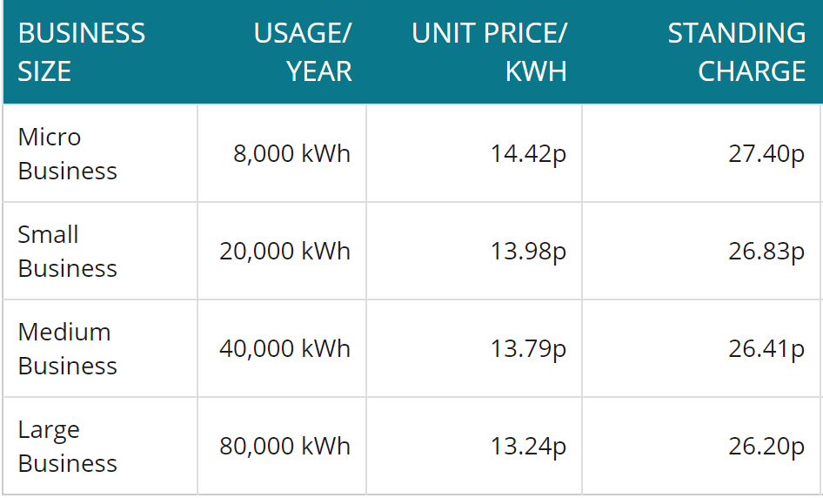
Figure 2 (Business Electricity Prices, 2020)
The B&B’s current tariff corresponds with tariffs of businesses in the same usage bracket to itself show in figure 2.
Kerosene used to fuel the oil burners prove to be an efficient alternative to gas but a form of tracking the heat energy directly generated per unit of fuel would investigate its performance. If only small amounts of hot water were needed it would render the burner to be less efficient.
Due to the environmental impact of high carbon fuel such as oil, an oil boiler scrappage scheme is in place in the attempt to phase out these burners by 2022 and replace with burners that can run off bio fuels (Logic 4 Training, 2018). The B&B has already incorporated renewable energy before with a ground sourced heat pump and could benefit further by introducing this to the remainder of the rooms, especially as they spend £3800 a year on oil and oil burners are wanting to be phased out as well as the potential increase in oil prices (Ingrams, 2018).
Over recent years there has been an advancement and drive towards renewable technologies. Each year there are stricter regulations to reduce carbon which result in social and economic pressures. Long term there is a need to transition towards renewable technologies (Hill, et al., 1995). The B&B currently plans to introduce solar energy. Introducing solar and/or another ground sourced heat pump would ensure they meet standards that will inevitably be placed upon them, and reap the benefits of a reduced energy bill but at the cost of a capital investment (Van Den Bergh & Bruinsma, 2008).
If advanced metering infrastructures (AMI) were used across the B&B it would help to location areas of excess usage. Not only would it just track the usage but surveys have shown that users of smart meters change their attitudes and behaviour around energy consumption through the use of data visually displayed (Crossley, 2007).
To prevent further losses in energy the efficiency ratings of appliances and insulation should be compared to that of newer and more sustainable products. Depending on the current efficiencies the percentage gained might not justify the capital of new appliances.
Behaviour of users impacts energy usage. Verbally or through some other communication present ways in which guest or employees can play a part such as leaving heating on continuously if they plan on leaving their room for long periods of time.

Recommendations

Short term
Solutions that could help energy consumption would involve advanced metering infrastructures. This may not reduce the energy consumed but will be target areas to further to improve. Metering is also inexpensive and can be installed at any time.
A zero-cost measure would be to ask guests and staff personally to alter their behaviour regarding energy usage. This a very simple procedure but could have a considerable impact if the message is expressed clearly and the benefits of doing so.
Long term
Although it was found that the B&B’s current tariff was reasonable, it would be beneficial to keep observing alternative tariffs as they fluctuate to select the most appropriate one at the time. Saving just a few pence per Kw in a company such as the B&B using 32,000 kwh a year has the potential to save hundreds of pounds.
Current price per kwh =0.1375
Cost £4400
If the cost per unit of electricity cost £0.005 less than what they currently pay:
0.1325 x 32,000 = £4240
Savings = £160

Electricity prices do fluctuate but this example shows how the smallest amount can affect the amount of money spent. It is not a significant amount of money but to a small business for such a simple task can save money for just a few moments of their time.

Additional ground sourced heat pumps would be a great long-term solution for the B&B. They have plenty of surrounding land in order to build the system and has been proven to work effectively for the duration they’ve currently been installed. It may be an issue to install in existing rooms but would suit in conjunction with the planning of luxury cabins.

References
Anoop, J., n.d. A Walkthrough Energy Audit of PRECOT MERIDIAN. [Online]
Available at: http://www.nitc.ac.in/electrical/ipg/PDF/INDUSTRIAL%20AUDIT/EAM2.pdf
Business Electricity Prices, 2020. Unit Kwh Prices. [Online]
Available at: https://www.businesselectricityprices.org.uk/cost-per-kwh/
Canaston Oaks, 2019. Canaston Oaks. [Online]
Available at: https://www.canastonoaks.co.uk/
Crossley, D., 2007. Smart Metering, Load Control and Energy Using Behaviour. Energy Futures Australia Pty Ltd.
Desjardins, J., 2016. What Uses the Most Energy in Your Home?. [Online]
Available at: https://www.visualcapitalist.com/what-uses-the-most-energy-home/
DIVERSEGY, 2014. Why it's important to have an Energy Audit. [Online]
Available at: https://www.diversegy.com/blog/13/why-its-important-to-have-an-energy-audit/
Energy Saving Trust, 2020. Ground Source Heat Pumps. [Online]
Available at: https://energysavingtrust.org.uk/renewable-energy/heat/ground-source-heat-pumps
Green Match, 2019. Compare price of green energy solutions. [Online]
Available at: https://www.greenmatch.co.uk/blog/2014/08/insulation-why-is-it-important
Ground Source Heat Pump Association, n.d. Ground Source Heat Pumps. [Online]
Available at: https://www.gshp.org.uk/Ground_Source_Heat_Pump.html
Hill, R., O'Keefe, P. & Snape, C., 1995. The Future Of Energy Use. London: Earthscan Publications Limited.
Ingrams, S., 2018. Oil Central Heating. [Online]
Available at: https://www.which.co.uk/reviews/home-heating-systems/article/home-heating-systems/oil-central-heating
Logic 4 Training, 2018. Is there a future for oil heating?. [Online]
Available at: https://www.logic4training.co.uk/blog/oil/is-there-a-future-for-oil-heating/
Millership, E., 2020. Manger of Canaston Oaks [Interview] (January 2020).
National Energy Foundation, n.d. Oil Central Heating. [Online]
Available at: http://www.nef.org.uk/knowledge-hub/view/oil-central-heating
Santalla, H., 2019. How many types of energy audit are there?. [Online]
Available at: https://www.businessmanagementideas.com/energy-management/energy-audit-and-its-types-energy-management/6346
TCCI, n.d. The Energy Audit Process. [Online]
Available at: http://www.tcci.com.au/Services/Sustainability/Earn-Your-Stars/The-Process
The Green Energy Advice Bureau, 2017. Types of Energy Audits. [Online]
Available at: https://www.greenpoweradvice.co.uk/types-of-energy-audits/
Van Den Bergh, J. & Bruinsma, F., 2008. The Transition to Renewable Technology. Cheltenham: Edward Elgar Publishing Limited.
Vekony, A. T., 2019. The Running Costs of Heat Pumps. [Online]
Available at: https://www.greenmatch.co.uk/blog/2014/08/the-running-costs-of-heat-pumps

