Lonyé Browne (2114209)
UWTSD
ACBA 6007 STRUCTURAL DESIGN
ASSESSMENT 2 p1

Introduction
Earthquakes are one of the deadliest natural hazards which occur that result in loss of life, disasters and damage to the built environment, and great economic impact. Earthquakes strike without warning; they cannot be avoided, and neither can their effects. However, the intensity of damage they cause can be reduced with proper planning and designing of buildings and structures. This paper will explore the different architectural and structural considerations in the seismic design of buildings. It will also discuss seismic design codes and the many structural systems that have been used to make buildings earthquake-resistant in different regions.

Earthquakes
British Geological Survey defines an earthquake as the sudden release of strain energy in the Earth’s crust, resulting in waves of shaking that radiate outwards from the earthquake source. The source of an earthquake is deep within the earth and is known as the hypocentre/ focus, the epicentre is located on the earth’s surface directly above the focus (BGS, 2021). The waves from earthquakes spread in primary waves (quickly) through solids, liquids, and gases; and secondary waves (slower) through solids. The main effect of earthquakes is ground shaking, and others are surface rupture, soil liquefaction and landslides (Bachmann, 2003). The adversity of the effects on an area depends on the size and length of the earthquake, distance from the epicentre and the makeup and characteristics of the soil.

Earthquakes have been labelled as the built environment’s worst enemy due to the damage/ plastic deformation to buildings and structures which range from minor fractures to total devastation/ collapse. Earthquakes are dynamic loads which act on buildings both vertically and horizontally. As the ground moves rapidly back and forth, the foundations of a building also adapt to these movements, but the upper part of the building does not move immediately or as much due to the mass of inertia. This difference in movement causes large internal forces within the building resulting in plastic deformation of the structure.

Due to these unexpected natural events and the adverse effects that result in disaster, it is necessary to design buildings to best resist or withstand these earthquake loadings. Seismically designed buildings should also be able to resist blast/ terrorism (FEMA, 2013).

Seismic Considerations
The considerations for the seismic design of a building have two sides, the architectural and the structural, however, collaboration of both disciplines (parallel designing) from the inception of the project proves to be most effective (Bachmann, 2003). This means that the engineer should not be employed after the architectural design to calculate the loadings but should be involved throughout the conceptual design process to ensure optimal structural safety along with aesthetics (from the architect). Using serial design (architect, then engineer), leaves the architect to select the materials for the non-structural elements which can imply that the building can only be ‘fixed’ for seismic loadings resulting in more expensive and patchy work (Bachmann, 2003).

Some of the structural and architectural considerations taken in the seismic design of buildings are:
- Torsion
- Ductility
- Damping
- Strength and Stiffness
- Building Configuration and Layout
- Openings, Facades, and Cladding
- Escape Routes and Safe Areas

Dynamic analysis is often used to study and evaluate the behaviours of structures under dynamic loadings (including earthquakes). In dynamic analysis, the response of a structure to time-varying loads is studied to understand the behaviour of the different elements. The results from the dynamic analysis aid in setting the parameters for the different considerations within the seismic design of a building to ensure that the building can withstand these loadings by minimizing vibrations, oscillations and failures (Prasad, 2023).

Structural
Torsion is the twisting or wrenching of a body by the exertion of forces tending to turn one end or part about a longitudinal axis while the other is held fast or turned in the opposite direction (a visual is shown in Figure 1 below) (Merriam-Webster, 2024). Within a building, there is a centre of mass otherwise described as the point at which the building is balanced without any rotation (Gabor, 2016). If the mass of the building is evenly distributed, then the geometric centre of a floor and the centre of mass will align. However, if the mass is not distributed evenly, the centre of mass and geometric centre will be misaligned, causing torsion in a building. Buildings should be designed to have symmetrical mass distribution but there is an allowable amount of torsion stresses within buildings as torsion is unavoidable. When an earthquake occurs, it induces rotational (torsional) motions in a building because the location of the centre of mass is moved to a point where it acts outside of the geometric centre of the building, resulting in the uneven/ irregular distribution of loading within the different parts of the building. Torsion causes stress in structural elements which results in structural damage or failure.

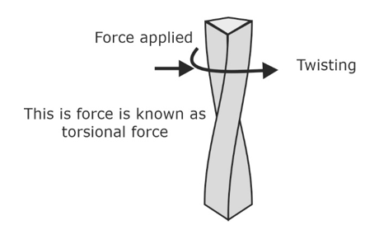
Figure 1 Image Showing Torsional Force (BYJU'S Exam Prep, 2023).

Ductility is the ability of a material to bend or deform before fracturing (plastic deformation) (O’Donnell and Krezel, 2016) . All building materials have a failure point at which the maximum loading is reached or exceeded after undergoing significant plastic deformation. In seismic design, some of the elements of a structure are designed to be more ductile or stronger than others so that they can absorb more of the seismic forces, this aids in protecting the critical parts of the structure to maintain overall stability and structural integrity (Natsoulis, 2019). Ductility dictates the behaviour of the structural elements of a building like beams, columns, connections, and reinforcements under seismic loading, therefore, they must be carefully crafted to achieve good ductility. The material choice influences the ductility of a structure, non-ductile/ low ductility materials like concrete or poorly reinforced concrete fail almost instantly. Buildings with low ductility tend to crumble under seismic loading. There are codes which dictate the minimum ductility requirements of a structure to ensure adequate performance under seismic loading.

Damping refers to the ability of a structure to dissipate energy during dynamic loadings (Natsoulis, 2019). Damping simply means, the rate at which natural vibration is absorbed by a building. Generally, buildings should be designed to effectively respond to vibrations by absorbing and dissipating the seismic vibrations. Designing seismically to account for damping will influence the structural systems and materials used within a building, buildings that use damping devices may require less strengthening compared to those without damping devices.

Strength and Stiffness: A material's ability to resist and bear applied forces within its safe limit is referred to as its strength (Lorant, 2016). A material's stiffness is determined by how resistant it is to deflection or drift, which is the relative displacement of stories in a horizontal direction; otherwise defined as rigidity. An unreinforced wall is not rigid enough to resist and effectively transfer to the foundations the shear strength applied during an earthquake, therefore, steel reinforcement is suggested which will also increase the strength of the wall.

Architectural
Building configuration refers to the size and shape of a building as well as its structural and non-structural elements. It can influence the response to seismic forces because it determines how the seismic forces are distributed within the structure. Generally, regular building shapes (square, rectangular) perform better under dynamic loading rather than irregular shapes (L, T) (Katwal and Maskey, 2019). This is because a square plan can distribute the forces equally, therefore lessening concentrated loads, because of this it is suggested that architects design symmetrical buildings. The layout of the building also alters the path the loads travel, it is better to have direct load oaths as large open areas are more difficult to design for. Placing heavier components lower in the structure reduces the risk of overturning (Katwal and Maskey, 2019).
Openings, Facades, and Cladding: it is crucial to provide the right details, strength, and anchoring for openings and facades. Flexible materials, like curtain walls, can allow for structural movement while preventing cladding separation during seismic events if they are paired with the right joints and connections (Shareef, 2023).

Escape Routes and Safe Areas: providing safe spaces with easily accessible escape pathways is crucial. Care should be taken in strategically placing these areas to provide residents with safe havens in the event of an earthquake. Stairwells, elevators, and emergency exits must be designed adequately to ensure their functionality during and after earthquake disasters. Safe areas should have a sturdy structural foundation and be clear of any hazards, such as flying objects or broken construction components (Shareef, 2023).

An overview of both the structural and architectural design shows that collaboration is indeed necessary to ensure effective seismic design. The floor plan/ shape of a building can determine how the loads are distributed which is important in the structural design to properly withstand dynamic loadings. The materials used in a building can be determined by the architect for aesthetics or the engineer for structural integrity, however, collaboration can aid in choosing materials to satisfy both disciplines.

Design Codes
The building codes are a set of documents which outline a guide for professionals to follow. When designing for seismic buildings that are structurally secure and resilient, the architects and engineers must adhere to the building codes based on their region (how seismically active the area is). The occupancy of the building also determines the seismic design, and the section of the relevant building code to follow. The building codes provide and in-depth analysis which stem from historical information and the lessons learnt from past disasters, this means that the codes will change overtime as more earthquakes occur. The codes are meant to protect the occupants of a building by preventing total collapse and allowing for safe evacuation. The International Building Codes (IBS) provide the basis for all other codes in different regions.

Some codes and standards are for seismic structures are:
- The American Concrete Institute (ACI) 318 (steel and concrete)
- The American Society of Civil Engineers (ASCE) 7 (steel and concrete)
- The American Institute of Steel Construction (AISC) 341 & 358 (steel)
- Eurocode 8 (steel and concrete)
- The New Zealand Standard for Structural Design (NZS) 1170 (concrete)
- Bureau of Indian Standards (BIS) IS 1893 (concrete)
- The Chinese Standard for Seismic Design of Buildings GB 50011 (concrete)
- ISO 3010:2017 (steel)

Structural Systems
Through interdisciplinary work, earthquake-proof buildings are designed using reinforcements, energy-dissipating devices, seismic cloaking, and flexible foundations. Certain materials can also be used to contribute to earthquake-proofing. These measures are essential for ensuring maximum stability and safety for the patrons of such buildings.

Reinforcements
Diaphragms: this method utilizes horizontal planes such as floors and roofs by making them rigid to remove the tension from those members and transfer them to the vertical elements such as walls and beams (Norwich University, 2024).

Shear wall: steel diagonal cross braces are placed in the walls to stiffen them which transfer lateral forces from the floors and roofs to the foundation. They help the building to keep its shape during ground movement by giving compression and tension support (BigRentz, 2023).

Braced frames: are vertical frames that are also used to transfer the lateral loads from the floors and roofs to the foundation. They are employed when shear walls are impractical (Norwich University, 2024).

Moment-Resistant Frames: these are designed to bear both shear and bending forces, and they are placed among a building’s joints. With this, the beams are flexible while the joints maintain rigidity, this combination allows the building to the larger forces of an earthquake, it uses the ductility of steel or reinforced concrete (BigRentz, 2023).

Energy-Dissipating Devices
Making a structure more resistant to seismic forces (like with the use of reinforcements) will increase shaking which can damage the building. These devices are used to reduce shaking by controlling the way ductile materials deform to allow energy dissipation. Dampers are devices that act as shock absorbers and help the building to ride out the shaking, they are placed between columns and beams. Another method is the pendulum used in tall buildings, a ball is attached at the top of the building, and it moves in the opposite direction the building is being swayed (Nikken Sekkei, 2020).

Seismic Cloaking
This is a new method that is being tested and is supported by theoretical knowledge. Unlike energy dissipators which counteract the forces, seismic cloaks will create protective barriers by deflecting and rerouting seismic energy from aboveground structures. It involves ground modification of the soil by burying a cloak of 100 concentric plastic and concrete rings at least three feet below the foundation of a building. this method has disadvantages as it would reflect that unto surrounding structures (Norwich University, 2024).

Flexible Foundations
Base isolation is a strategy used to separate the building from its foundation using isolators which absorb shock. The earthquake energy is absorbed by the isolation layer before it reaches the building. Because of this, the isolators vibrate while the building remains steady or moves at a slower rate through the building. Base isolators are applied to rigid buildings and the utility connections should be flexible to facilitate movement, it is also only used in buildings of appropriate heights to avoid overturning. This method is best utilised in new construction rather than retrofitting (BigRentz, 2023).

Other
Retrofitting
Lightweight construction
Materials: timber, steel reinforced concrete or hybrid structures.

Case Studies

6.1 Christchurch Town Hall, New Zealand
This building was retrofitted after surviving two earthquakes in 2010 and 2011. The existing concrete structure was reinforced, and base isolators were added to the foundation to improve its resilience. The retrofit of this building was important to maintain its architectural and historic significance in New Zealand (Shareef, 2023).
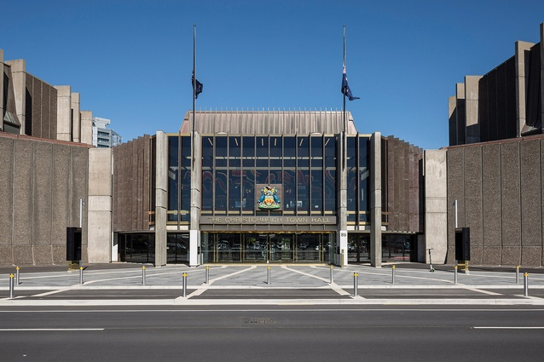
Figure 2 Image of the Christchurch Town Hall, New Zealand (Architecture Now, 2019).

6.2 The Guangzhou Opera House, China
Designed by the renowned, Zaha Hadid, the construction of this building was completed in 2010. This building uses a hybrid system of materials, its inner frame is concrete, and the outer is steel. The inner concrete framing provides structural integrity, and the steel is for additional lateral stability. This hybrid system will aid the building in resisting seismic forces (Shareef, 2023).

Figure 3 Image Showing The Guangzhou Opera House, China (Zaha Hadid, Architects, 2019).

The San Francisco Museum of Modern Art (SFMOMA), USA
The construction of this building was completed in 2016, in the seismic active area of California. The architectural concept was designed with a base isolation system of lead-rubber bearing sand sliding isolators. This flexible foundation lessens the transfer of seismic pressures to the structure, safeguarding the artwork the museum holds. It is also an example of the seismic design from inception of the project, showing interdisciplinary collaboration (Shareef, 2023).

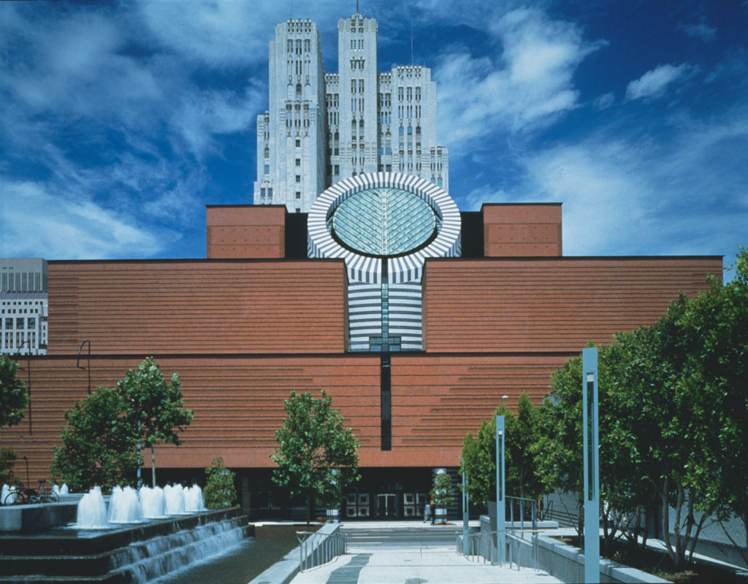
Figure 4 Image Showing The San Francisco Museum of Modern Art (SFMOMA), USA (SFMOMA, 2023)

7.0 Reference List
Architecture Now (2019) Christchurch Town Hall entered on New Zealand Heritage List/Rārangi Kōrero. Available at: https://architecturenow.co.nz/articles/christchurch-town-hall-entered-on-new-zealand-heritage-listrarangi-korero/ (Accessed: 7 May 2024).
Bachmann, H. (2003) Seismic Conceptual Design of Buildings -Basic principles for engineers, architects, building owners, and authorities. Available at: https://www.preventionweb.net/files/7552_SeismicConceptualDesign.pdf (Accessed: 5 May 2024).
BigRentz (2023) How Earthquake-Proof Buildings Are Designed in 2024. Available at: https://www.bigrentz.com/blog/earthquake-proof-buildings (Accessed: 5 May 2024).
British Geological Survey (2021) Earthquakes. Available at: https://www.bgs.ac.uk/discovering-geology/earth-hazards/earthquakes/ (Accessed: 5 May 2024).
BYJU'S Exam Prep (2023) Torsional Force - Definition, Formula, Effect and Examples. Available at: https://byjusexamprep.com/gate-ce/torsional-force (Accessed: 6 May 2024).
Chopra, A.K. (2007) Dynamics of Structures: theory and applications to earthquake engineering. New Jersey: Prentice Hall. Available at: https://gacbe.ac.in/images/E%20books/Dynamics%20of%20Structures%20Theory%20and%20Applications%20to%20Earthquake%20Engineering%20A.K.%20Chopra_NNN_bb.pdf#pagemode=thumbs (Accessed: 6 May 2024).
Federal Emergency Management Agency (2013) Earthquake-Resistant Design Concepts: an Introduction to the NEHRP Recommended Seismic Provisions for New Buildings and Other Structures (FEMA P-749 / December 2010). U.S. Department of Homeland Security: Createspace Independent Pub. Available at: https://www.researchgate.net/ (Accessed: 5 May 2024).
Fema (2023) Seismic Building Codes. Available at: https://www.fema.gov/emergency-managers/risk-management/earthquake/seismic-building-codes (Accessed: 5 May 2024).
Fox Blocks (2024) How to Design an Earthquake Resistant Home. Available at: https://www.foxblocks.com/blog/earthquake-resistant-home (Accessed: 5 May 2024).
Gabor, L. (2016) Seismic Design Principles. Available at: https://www.wbdg.org/resources/seismic-design-principles#:~:text=Base%20Isolation%3A%20This%20seismic%20design,large%20part%20of%20the%20shock (Accessed: 5 May 2024).
Katwal, S. and Maskey, N. (2019) ‘Effect of Plan Configurations on the Seismic Performance of the Masonry Structure’. Proceedings of IOE Graduate Conference 6(2350-8914), pp. 275–279.
Merriam-Webster Dictionary (2024) Torsion. Available at: https://www.merriam-webster.com/dictionary/torsion (Accessed: 6 May 2024).
Natsoulis, N. (2019) Basic Principles of Seismic Design for Buildings, Part II. Available at: https://www.ny-engineers.com/blog/basic-principles-of-seismic-design-for-buildings-part-2 (Accessed: 5 May 2024).
Nikken Sekkei (2020) Seismic resilience of buildings. Available at: https://www.nikken.co.jp/en/expertise/structural_engineering/seismic_resilience_of_buildings.html#:~:text=Three%20Types%20of%20Seismic%20Structures,damping%2C%20and%20seismic%2Disolation (Accessed: 5 May 2024).
Norwich University (2024) 5 Civil Engineering Innovations That Help Buildings Withstand Earthquakes. Available at: https://online.norwich.edu/5-civil-engineering-innovations-help-buildings-withstand-earthquakes (Accessed: 5 May 2024).
O’Donnell, A. and Krezel, J. (2016) Ductility and Stiffness—What They Are and Why They Matter in an Earthquake. Available at: https://www.air-worldwide.com/blog/posts/2016/12/ductility-and-stiffness-what-they-are-and-why-they-matter-in-an-earthquake/#:~:text=Ductility%20describes%20the%20extent%20to,displacements%20imposed%20by%20ground%20shaking. (Accessed: 6 May 2024).
Oleg Ishchuk (2023) Seismic Design Codes & Standards: A Practical Guide. Available at: https://sdcverifier.com/articles/overview-of-seismic-codes-for-structural-engineering/ (Accessed: 7 May 2024).
Prasad (2023) Dynamic Analysis of Structures: Basics and Applications - Structural Guide. Available at: https://www.structuralguide.com/dynamic-analysis/ (Accessed: 6 May 2024).
SFMOMA (2023) Our History. Available at: https://www.sfmoma.org/read/our-history/ (Accessed: 7 May 2024).
Shareef, S.S. (2023) ‘Earthquake Consideration in Architectural Design: Guidelines for Architects’. Sustainability 15(18), pp. 13760–13760. Available at: https://www.mdpi.com/2071-1050/15/18/13760 (Accessed: 4 May 2024).
Zaha Hadid Architects (2019) Guangzhou Opera House. Available at: https://www.zaha-hadid.com/architecture/guangzhou-opera-house/ (Accessed: 7 May 2024).

