

Can an Artificial Neural Network Compose Music?

by
Andrew John Edward Cooper

Supervisor: Gordon Dickers
Second Marker: Andrew Baker

Project submitted as part of the requirements for the award of BSc(Hons) Computing (Software Engineering)

April 2020

Declaration Form and Form of Consent

DECLARATION
I, Andrew John Edward Cooper declare that I am the sole author of this Project; that all references cited have been consulted; that I have conducted all work of which this is a record, and that the finished work lies within the prescribed word limits.

This work has not previously been accepted as part of any other degree submission.

Signed: 
Date: 22/07/2020

FORM OF CONSENT

I, Andrew John Edward Cooper hereby consent that my Project, submitted in candidature for the B.Sc. Computing (Software Engineering) degree, if successful, may be made available for inter-library loan or photocopying (subject to the law of copyright), and that the title and abstract may be made available to outside organisations.
Signed:
Date: 22/07/2020

Abstract
The idea of computational music dates back to the 1950s when Hiller and Isaacson programmed the ILLIAC computer to compose music by using the mathematical theory of probability. Throughout the last decade many more attempts have been made to develop computational music due to the much increased powers and capabilities of computing and AI. In this project a neural network was trained using a dataset of a given genre in the attempts to compose music based on trends and patterns discovered in the training phase. To understand the current capabilities of computational music data was collected from a group of participants who were asked to analyse two samples of music and attempt to identify which composition was that of a human. It was found that in most cases the AI received a large number of people who believed that the composition was human.

Table of Contents
Declaration Form and Form of Consent i
Abstract ii
Table of Figures vi
Table of Equations vi
Table of Tables vi
1 Introduction 1
1.1 Problem 2
1.2 Aim 2
1.3 Objectives 2
1.4 Structure of Report 3
2 Review of Literature 3
2.1 Artificial Intelligence (AI) & Machine Learning (ML) 4
2.2 Types of Machine Learning 7
2.2.1 Supervised Learning 7
2.2.2 Unsupervised Learning 7
2.2.3 Semi-Supervised Learning 8
2.2.4 Reinforcement Learning 8
2.3 Machine Learning Tasks 8
2.4 Common Issues in Machine Learning Models 10
2.4.1 Data Quality 10
2.4.2 Overfitting 10
2.4.3 Underfitting 10
2.5 Artificial Neural Networks 11
2.5.1 Backpropagation 14
2.5.2 Activation Functions 14
2.5.3 Types of Neural Networks 17
2.6 Projects of a Similar Nature 20
2.7 Musical Instrument Digital Interface (MIDI) 25
2.8 Conclusion 26
3 Research and development methodologies 27
3.1 Research Methodology 27
3.1.1 Philosophy 27
3.1.2 Strategy 28
3.1.3 Approaches 29
3.1.4 Risks & Limitations 29
3.1.5 Validity, Reliability & Generalisability 29
3.1.6 Data Evaluation Methods 31
3.2 Development Methodology 31
3.2.1 Software Development Methodology 31
3.3 Resources 32
3.3.1 Hardware Resources 32
3.4 Software & Library Resources 33
3.5 Information Resources 33
3.6 Human Resources 34
3.7 Conclusion 34
4 Implementation 34
4.1 Influences of the Project 34
4.2 Analyse the Problem 35
4.3 Collection of Data 36
4.4 Data Pre-Processing 36
4.5 Data Preparation 38
4.5.1 Extracting Notes and Chords 38
4.5.2 Preparing Sequences for Training 39
4.6 Model Selection 41
4.7 Self Evaluation of the Model 42
4.8 Future Improvements 43
5 Results 43
5.1 What was Tested? 43
5.2 Expected Results 44
5.3 Actual Results 44
5.3.1 Set 1 44
5.3.2 Set 2 46
5.3.3 Set 3 47
5.3.4 Outcome of Results 47
5.4 Future Potential Changes 48
5.5 Conclusion 48
6 Reflection 48
7 Conclusion 50
8 References 52
9 Appendix A: Getting Started 57
10 Appendix B: Code Listings 60
10.1 Train.py 60
10.2 Compose.py 67
11 Appendix C: Images of Data Collection Webiste 73

Table of Figures
Figure 1: The McCulloch Pitts Neuron after [3] 11
Figure 2: The Perceptron after [3] 13
Figure 3: Rectified Linear Units [32] 16
Figure 4: Leaky ReLU [32] 16
Figure 5: An Illustration of a Multi-Layer Feed-Forward NN after [3] 17
Figure 6: An Illustration of a Recurrent Neural Network after [3] 19
Figure 7: The Markov Chain Model after [3] 21
Figure 8: Transposing the Key of Music after [53] 38
Figure 9: Extracting Data from Stream Object 39
Figure 10: Sequences for Training 39
Figure 11: Creating Sequences for Training 40
Figure 12: Visual Representation of One-Hot-Encoding 40
Figure 13: Sequential Model 41
Figure 14: The Layers in the Sequential Model 41
Figure 15: Results for Set 1 45
Figure 16: Results for Set 2 46
Figure 17: Results for Set 3 47

Table of Equations
Equation 1: The MP Neuron Summation of Inputs to Determine an Output 12
Equation 2: Perceptron Formula before Activation 13
Equation 3: Computation of ReLU 15

Table of Tables
Table 1: Notes Associated with the Key of C Major 37
Table 2: Notes Associated with the Key of D Major 37
Table 3: Notes Associated with the Key of A Minor 37

Introduction
Artificial intelligence has seen a great peak in interest throughout the last decade as new advancements has emerged, resulting in better optimisation of algorithms capable of performing tasks to an accurate and high standard. This, coupled with the increase of affordable, more powerful computing hardware means learning models are able to learn a lot faster than previous attempts to train machines to perform tasks.
Artificial intelligence is an umbrella term that encompasses many different techniques to make it seem that a computer is working in a “smart” manner. Some of the techniques associated with AI include decision trees, expert systems, rule-based systems and machine learning. This project focuses on the use of machine learning systems and how they can be trained to compose music.
Since it’s initial development in the 1950s artificial intelligence has fallen prey to the “AI winter”, a term to describe a peak of interest that over time plateaus and drops taking with it the funding for research and development. However, new advancements in the research and development of AI such as deep learning and more practical uses of AI has broken this trend over the last decade.
Artificial intelligence has seen great use in commercial and industrial settings because of its ability to streamline workflow, enhance productivity, increase sales, reduce the cost of labour through automation, cut costs from human error, help build a much better rapport between business and customers with the use of 24 hour chat bots and maximise profits, the list is endless for business use of artificial intelligence techniques.
However, the commercial and industrial sectors are not the only place where artificial intelligence has had positive impacts as the benefits can also be found within domestic settings and has been used for home automation and security with the use of artificial intelligence integrated security cameras. The use of artificial intelligence is so prominent in daily life that most people are inadvertently interacting with AI algorithms such as smart assistants as well as applications which are being used to personalise the users experience by adapting to individual preferences, examples of which being Netflix and Amazon [1] [2].

Problem
Artificial intelligence is reshaping how the current world works by bringing ease and simplicity to daily tasks and operations within the majority of major sectors. However, jobs that call for creativity such as the arts and music industries are some of which being left behind in the machine learning boom, although these techniques could be used to assist the creator to invoke creativity, used for game and cinematography as well as further use in the commercial sector.

Aim
The aim of this project is to develop a machine learning algorithm to be able to learn and compose a piece of music based off trends and patterns discovered from a dataset of songs within a given genre.

Objectives
To help ensure the aim is fulfilled, objectives will support the completion of the main aim. These objectives include:
- Research different artificial neural network architectures and the best cases uses for each type.
- Establish core understanding of the training requirements of neural networks and how they can be optimized to perform their best.
- Study current research that has been conducted in machine and deep learning and perform a critical analysis and comparison on a selection of the literature.
- Review methodologies and choose which research and development style would best suit the project.
- Find appropriate frameworks and libraries to help reduce the scale of the project.
- Collect a large set of midi files that will be used to train the artificial neural network.
- Develop and train the artificial neural network with the collected dataset, experimenting with both the size of the training set and the amount of times the neural network is trained using the dataset.
- Evaluate the effectiveness of the artificial neural network and adjust training and or data size accordingly.
- Seek peer review of the development of the artificial neural network and adjust the algorithm to meet peer advice.

Structure of Report
This report is constructed of six main sections, described below.
Chapter one discusses an overview of the project, describing the aims and objectives set to ensure the project is successful.
Chapter two aims to develop the core understanding problem and best approach to help tackle the problems effectively by reviewing research that has already been presented relating to the given topic.
Chapter three gives an insight to the research and development methodologies taken for the implementation of the project and why these best fit and can be used to help breakdown the problem.
Chapter four discusses the implementation of the project by elaborating on the thought process of the development of the model. Furthermore, the implementation section adopts the approach suggest by Aurélien Géron [3] who developed a machine learning checklist to ensure the main aspects of the project have been considered and met.
Chapter five analyses the results collected from the data collection web app developed by the author. The results are imperative to project as with statistical analysis will be used to answer the question composed by the author, “Can an Artificial Neural Network Compose Music?”.
Chapter six concludes the project by discussing key concepts and ideas found throughout the course of the project. This section will also be used to determine whether or not the AI was able to succeed in composing music.

Review of Literature
This chapter aims to produce a core understanding of the project by reviewing work already conducted in the area of study of machine learning. To understand how machine learning can be incorporated with music, a more in-depth look will discover what researchers have done in terms of algorithmic computational music. This approach can not only help steer the project in the right direction but also build a fundamental understanding of artificial intelligence and machine learning.
Areas of interest within the review of literature will include:
- Artificial Intelligence and machine learning – This will help build a fundamental understanding of what artificial intelligence and machine learning is by delving into it’s history, it’s positives, negatives and it’s effect on businesses.
- Types of machine learning – Understanding the different techniques in which an algorithm can be trained is important as these will help build a picture of the problem.
- Artificial neural networks – As the project will use artificial neural networks as a means to train and run the algorithm, having a deep understanding of what artificial neural networks are, how they learn, their different architectures and what problems different architectures are best at solving means the correct network model can be chosen to implement the project.
- Projects of a similar nature – This section of the literature review will serve to look at projects that are similar to that of this project. Not only will this help build an understanding of the different methods other researchers have used to complete their project but will also give an insight into discrepancies between projects. Viewing a variety of sources will identify gaps in the current research of algorithmic music.

Artificial Intelligence (AI) & Machine Learning (ML)
It has long been in the interest of researchers to use artificial intelligence to not only gain a better understanding of human intelligence but to also create an intelligent entity [4] which can interact and understand the world as a human can. This concept is known as artificial general intelligence (AGI) as of writing this project true AGI remains science fiction due to the complexity of the human brain [5].
Norvig and Russell believe that AI can be categorised into one of four definitions that determine whether an AI can think, act as a human would or think and act in a rational manner [4]. Norvig and Russell emphasise the need to differentiate between acting humanly and within a rational manner as humans are prone to mistakes due to acting without logical reasoning.
To determine whether an AI agent can act humanly, Alan Turing created the idea of the imitation game [6], later rebranded as the “Turing test” [7]. Turing suggested that to measure the capability of AI, an interrogator should communicate with another human and an AI agent via an electronic chat application. Given the freedom to ask any questions over a period of five minutes, the interrogator must correctly identify the answers that were provided by the human and which responses came from the AI [6]. Similarly, it is the responsibility of the AI agent to try to fool the interrogator that the answers supplied were from the other participant. Turing believed that a reasonable measurement of success would be if the AI was able to fool the interrogator into believing that 30% of the answers provided were from the other participant.
Turing suggested that with the computing resources available in 1950 that this would not be accomplishable, however, estimated that this may be a achievable task by the year 2000 due to the beliefs that computers could possess much more memory (RAM) than what was available to Turing, he believed that 100MB should suffice. Although having much more availability in computing memory than suggested by Turing, the Turing test wasn’t ‘solved’ until 2014. Russian researchers claimed to have developed model that was able to achieve a 33% success rate of fooling interrogators within a five minute conversation [8]. However, without an official research paper; these claims should be discredited as there is no indication to the condition in which the tests were conducted nor how data was collected.
Norvig and Russell also state the importance of before stating a program thinks like a human, that analysis of a how a human thinks needs to be performed. One method of testing this includes analysing the input and output behaviour of both a programme and a human to determine whether or not they correlate with each other as this suggests that the models behaviour pattern could be that of a humans [4].
Although the development of artificial intelligence has not reached AGI status, its current capabilities has become a huge advantage in the daily life of most businesses across multiple industries. This is because AI was designed to have a low error rate, perform tasks with a high level of accuracy [9] and can adapt to environments constantly changing [4] [3] [10] thus allowing for a huge reduction of human labour saving time and money.
However, there are some that believe that AI may result in being more of a curse rather than a blessing such as the European Parliamentary Research Service (EPRS) [11]. Although acknowledging the effectiveness of artificial intelligence Szczepański argues that the rapid integration of AI may have serious consequences for the economy and could cause mass redundancies within businesses, something that is widely agreed upon globally [12]. Furthermore, Szczepański also argues that the huge leap within AI could further separate the economic statuses between developed and undeveloped countries due to the wealth of available data being present in developed countries. Moreover, with the promising emergence of methods to better AI, such as machine learning, deep learning and artificial neural networks, AI could further the economic gap between low and mid-skilled workers to high skilled workers due to the ability to integrate machine learning tasks into their work, making higher skilled workers more effective and able to work at a much quicker rate [11] as well as working more efficiently that low and medium skilled workers therefore making their job roles redundant.
Machine learning, as previously mentioned is an artificial intelligence technique which is the field of study in which a computer is able to learn to perform a task without the need to be explicitly programmed [13] [14]. The term was first coined in 1959 by Arthur Lee Samuel [15] who sought after a way to train an algorithm to learn from experience, given a specific task to thus better it’s performance [3] [13].
Machine learning is an extremely valued concept of artificial intelligence because unlike other techniques an algorithm can be used to view data and find trends and correlations within the found data thus creating rules to obtain optimum results when making predictions on new observations. Machine learning has been popularised by its ability to find patterns and correlations in data that could be difficult for a human analyst to obtain this information from, also known as “messy” data [16]. Furthermore, machine learning has been credited for being able to solve problems that would require constant adaption of code over time. One such problem that this would relate to is the spam filter associated with electronic mailing services. Without the use of machine learning, identifying spam emails would require a extensive list of complex rules that would need updating every time spam is formatted in a manner than doesn’t fit the rules programmed. Machine learning is a valuable asset in this situation as it can be trained once to identify spam emails and then update rules over time via community input (flagging emails as spam) [3].

Types of Machine Learning
Machine learning can be categorised into one of four learning techniques which determines how the model is trained.

Supervised Learning
Supervised learning is the process of training an algorithm by giving the model inputs along with their corresponding desired outputs, named labels [3]. The aim of training a model this way is to allow the model to infer structure in the data allowing it to map inputs to outputs [17]. The supervised learning approach is often compared to the classic human learning experience where a teacher will create examples of subjects and the student will formulate rules to better understand the problem to get to the correct solution.
Supervised learning models are most commonly found is tasks of classification and regression [18] Please refer to 2.3 for further details.
However, supervised learning can often suffer from a lack of readily available labelled data as when data is collected, the data is left unlabelled. This would mean that the researcher would be required to create labels themselves which could be a timely process.

Unsupervised Learning
Unsupervised learning is the training technique where training data is given to the model without any labels [17]. By using this learning approach, the model is left to explore the data to find trends, patterns and structure by itself [18]. Unsupervised learning is particularly useful for identifying relationships between features in messy data, as defined in section 2.1.
The task most commonly associated with unsupervised learning is clustering and association rules mining [3]. Please refer to section 2.3 for further details.
Müller & Guido [18] suggest that the main issue associated with using an unsupervised training model is understanding whether what the model was able to learn was useful or not. Furthermore, Müller & Guido believe that due to the model not having any reference to correct or incorrect answers, the output of the model may not be what was expected, resulting in the model requiring fine tuning and training to be restarted.

Semi-Supervised Learning
Semi-supervised learning is the combination of both supervised and unsupervised learning and is used to understand the effect of which having access to labelled and unlabelled data will have on the behaviour of a machine learning model [3]. Therefore, the unsupervised learning part of the model may be in charge of clustering whereas if given user input, the supervised section may be to label the data.
There are many benefits of using semi-supervised learning models, the main one of which being that the labelling of data can sometimes be expensive in terms of time consumption. By using this approach the amount of data needing to be labelled is vastly reduced.

Reinforcement Learning
Reinforcement learning is a reward/ punishment systems that takes a trial and error approach to learning to perform a task. The agent in this model will be used to observe and interact with it’s environment and is rewarded for desirable behaviour and penalised for wrong doings, which is determined by a policy and is used to define what action the agent should do in it’s current state [3]. The idea is that the agent will want to strategize so that it obtains the highest amount of reward.
Reinforcement learning has most commonly been used in the game industry [19] [20] as this environment is perfect for an agent to be able to interact with the environment as well as there being clear policies to how the agent should act at a given state. The most well known case of where reinforcement learning has prevailed is where an agent was able to beat a human expert in the game of GO [21].

Machine Learning Tasks
When developing a machine learning algorithm it is important to understand the what the problem is that the model should be able to solve as this can help categorise the problem.
Between supervised and unsupervised learning there are four main tasks which can later be broken down into algorithms. These tasks include:
- Classification – This is the process of training a model to map input features with respective outputs, also known as labels, and sorting each observation into classes based on features discovered in the observation [18] [22]. Classification models are very commonly used in image recognition and has had very successful case uses in detecting cancer and tumours within patients [23] [24] but can also be used for simple tasks such as appropriately classifying images of cats and dogs. As this requires the use of training data to be labelled for the model to learn, it becomes a supervised learning problem.
- Regression – Regression models are used to predict real figure such as real numbers in mathematical terms [18], values such as quantity and prices. In regression models the aim is to estimate the output value of an observation, given the features of the input values. An example of where this has been used is when predicting house prices and fluctuations within the stock market. Training of these models require data to be labelled so that the model is able to appropriately learn how to map features to an output.
- Clustering – A clustering algorithm is similar to classification but relies on the model to assign an observation to a group but unlike classification algorithms it isn’t provided any labels. The algorithm is given the dataset which will hold a group of features then is expected to group each observation from what has been discovered [18]. The model will then provide an ID for each cluster. Clustering can be very important for businesses as this can be used to segment customers based on interactions and uses of a given service or application. With these segments, more specific advertising can be targeted towards different clusters. Furthermore, clustering techniques has many different ideal uses some of which include anomaly detection and semi-supervised learning, an example of using clustering in semi-supervised learning is if a few of the observations are labelled, a clustering algorithm should be able to group all new observations containing shared features to the labelled instances.
- Association Rules – This is the method of finding relationships between two elements within a dataset. Therefore, the model will be able to predict the next output given it’s current state. Association rules mining is used a lot in the supermarket industry to increase sales as the model will be able to make suggestions based on what the customer has already bought. An example of this being, from association rules mining, a customer maybe 60% more likely to purchase butter, given bread is already in their basket.
Some tasks are best fitted in certain styles of machine learning as they are more appropriate to the techniques that these use in which to learn.

Common Issues in Machine Learning Models
Although being stated by Szczepański [11] as being the main medium of AI systems, there are some major downfalls that may cause major disruption to a business if not noticed in the early stages of development and deployment.

Data Quality
Machine learning is a concept that highly revolves around the quality of data [3], having poor data will result in poor output or more commonly known in the machine learning community as “garbage in, garbage out”. Due to the impact that data has on the training and predictions of a neural network it is important that data is explored to find any outliers within the data. An outlier is an abnormality within a dataset that doesn’t follow the same behaviours as the rest of the population of data [25].

Overfitting
Overfitting is the error in which a model, after being trained performs very well on the set of data it’s been trained on but does not generalise well meaning that it will struggle to predict for new observations [3] [18]. This could clearly become an issue when using machine learning models to detect cancer in patients or defects in items coming off a production line in a factory.
Overfitting can occur when the model is fitted to closely with the training set such that the model learns irrelevant information from the dataset, also known as ‘noise’, which is potentially caused by using a model that is too complex for the dataset [18].

Underfitting
As the name suggests it is the opposite of overfitting and means that the model unable to find underlying patterns within the training data let alone in new observations [18]. This can occur when the model is to simple for the task which means that a more powerful model is needed to be able to learn.

Artificial Neural Networks
An artificial neural network is a tool that can facilitate machine learning which is based on the structure of biological neurons within a humans/ animals brain. The concept was developed by Warren McCulloch and Walter Pitts who introduced the idea of neural events to exhibit behaviours such as decision making and problem solving [26]. McCulloch and Pitts’ suggestion of neural activity laid the groundwork in which machine learning has been able to build it’s successes from. To demonstrate their theory McCulloch and Pitts developed a circuitry model capable of sending signals between nodes. By using the brain as inspiration, McCulloch and Pitts were able to develop a mathematical model that was able to combine input information to then perform output.
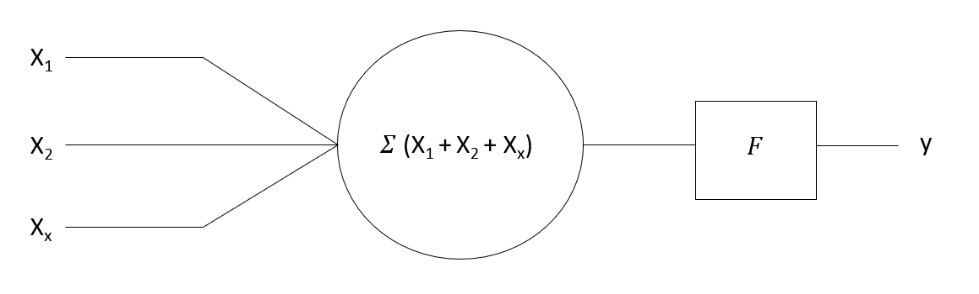
Figure 1: The McCulloch Pitts Neuron after [3]
The McCulloch and Pitts (MP) neuron relied on having two types of inputs, being inhibitory and excitatory, both being binary values. Excitatory inputs are that of something that may express a certain trait therefore are assigned the value of 1. Whereas inhibitory being the opposite therefore receiving a value of 0, it also important to note that inhibitory inputs will have the greatest impact on the outcome value as will always cause the output to be 0.
Figure 1 displays a very simplistic version of the MP neuron which shows the summation of the inputs going through a squashing function, labelled “F”. This function is used to determine whether the neuron will fire and is expressed if the summation of the values has exceeded a numerical value, also known as a threshold, an example of this can been seen in equation 1.

$$where y=\left\{\begin{aligned}1 if \sum_{i=0}^{n}{Xi ≥1} \\ 0 if \sum_{i=0}^{n}{Xi<1}\end{aligned}\right.$$
Equation 1: The MP Neuron Summation of Inputs to Determine an Output
Please note: Equation 1 takes the assumption that there are no inhibitory inputs present.
Equation 1 shows that a neuron will fire if the sum of it’s inputs is greater or equals to 1, else will not fire. The MP neuron relied on the threshold to be adjusted by the user of the model. It is also important to understand that the threshold, which is the comparison number in Equation 1 can be adjusted.
The McCulloch Pitts neuron was a huge leap in the realms of artificial intelligence and allowed many other great advancements to be accomplished through the ground work already laid by Warren McCulloch and Walter Pitts. Although a huge success for it’s time, there were ways in which the neural network could be enhanced, some of the issues include:
- Inability to learn – The model presented by McCulloch and Pitts was never able to learn from data, therefore rules must be hard coded by a developer.
- Binary inputs and outputs – MP neurons aren’t able to take in real numbers only binary ones and zeros.
- Unable to solve XOR problems – The neuron developed by McCulloch and Pitts was unable to solve problems of which were not linearly separable meaning there was no way which a plane could be used to separate the outputs.
Whilst studying the behaviours and adaptions of biological neurons during the learning process in 1959 [27] , Frank Rosenblatt, influenced by the efforts already demonstrated over a decade early by McCulloch and Pitts, developed a model that would best its predecessors by implementing core functionality, in which he named the perceptron. The perceptron was a huge improvement over the MP neuron as it was able to adopt a learning rule which would adjust the network which would allow the network to learn and be trained through new instances.
To build a trainable network Rosenblatt was able to extend the functionality of the already well define McCulloch Pitts neuron. Firstly, Rosenblatt introduced the concept of input neurons to be assigned with adjustable weighted values, as demonstrated in figure 2. The concept of weightings between neurons came from the original publication by Hebb [28] in 1949, which suggested that the firing of one cell to another strengthens the bond between two cells in a biological brain which he believed is the key to understanding how people learn.
“Neurons that fire together wire together” (Hebb) [28] .
Hebb’s suggestion of biological neurons wiring and strengthening within the brain allowed Rosenblatt to formulate the idea to work within his perceptron. By doing this he was able to assign random weights at the start of his training and slightly increase and decrease the weights in times where perceptron made inaccurate predictions, this would have to had been repeated for every training observation but nonetheless result in the model to produce accurate predictions.
Secondly, Rosenblatt further extended the MP neuron by introducing adjustable biases with the purpose of being able to shift the threshold to best suit the data. The introduction of biases as a learnable parameter was important because it means that when plotting data on a graph the point of origin may not produce the best solution, therefore having a adjustable bias means that the neuron can be more dynamic to more complex data structures.
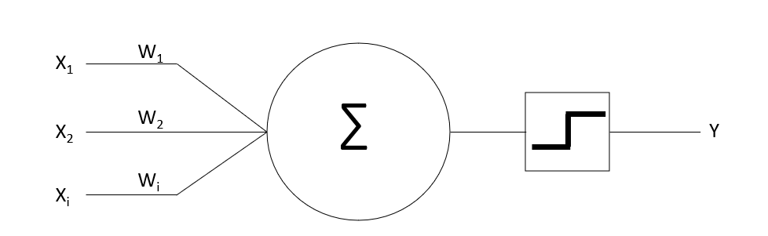
b
Figure 2: The Perceptron after [3]
The new formulae for the perceptron becomes:
$\sum{(X}$₁$W$₁ $+$ $X$ ₂$W$_{2 …} $+ X$_{i}$W$_{i} $)+$ b
Equation 2: Perceptron Formula before Activation
Figure 2 shows the basic principle of the perceptron developed by Rosenblatt and displays the neuron which collects a summation of its inputs and weights and biases, applies a stepping function which is a type of activation function, that produces a binary output. Activation functions will be further covered later this chapter. A single perceptron was able to perform a simple binary classification, where the positive output would be one class and negative, another [3]. An issue with the perceptron model defined by Rosenblatt is the need for weights and bias elements to be manually updated and still even with this new learning rule was unable to solve certain problems such as the XOR problem [29]. However, it was later discovered that the XOR problem could easily be fixed by stacking perceptrons, in what is now known widely as the multi-layer perceptron (MLP) neural network [3].

Backpropagation
An issue of using the perceptron model for training is that it required human intervention to be able to adjust weights and biases, something that could be timely and inefficient. However, research by Rumelhart et al [30] discovered that by changing the activation function from the step function, that was most commonly used, to an activation function with smoother edges, such as the sigmoid they could work out the differential of the desired output and the actual output, also known as the error, loss or cost, thus allowing for the result calculated between the desired output and the actual to be backpropagated through the network, automatically updating the weights. Rumelhart et al also found that by stacking perceptrons they were able to solve the long standing issue of using machine learning models to solve non-linear problems.

Activation Functions
The activation function is a vital part of neural networks as this will determine the state of a given neuron within the network. The activation function works by taking a summation of inputs, weights and biases, see figure 2 for clarification, and comparing the value to a set threshold. Should the result of the summation exceed the threshold value the neuron will fire, if not the neuron will not fire.

Step Function
The step function is the most basic of the activation functions and has already been described in Equation 1. However, to reiterate, the step function is used to transform the output to 1 if the summation of its inputs reaches or exceeds the neuron’s threshold value, causing it to fire, otherwise if the summation did not reach the required threshold, therefore the output will transformed to 0, meaning the neuron will not fire.
This activation function is fine when handling binary classification problems due to only having two possible outputs, either 1 or 0 (yes or no) but most problems deal with multiple classes.
Lastly, another main reason why the step function is vary rarely used in machine learning is because of the emergence of backpropagation. Remember, that backpropagation is the most efficient way to train neural networks but require an activation function where the differential can be calculated.

Sigmoid Function
The sigmoid function is a common activation function in machine learning models. The main characteristics for the sigmoid function is its S shape which researchers such as Rumelheart et al [30] discovered that they could use the distinctive S shape to calculate the differentiable [31], which couldn’t be obtainable when using a nondifferentiable activation function, such as the step function.
However, this activation itself comes with it’s own problems, such as the vanishing gradient problem which happens when the becomes more parallel to the x-axis the gradient becomes tiny thus failing to train the network.

Rectified Linear Units (ReLU)
A common activation function used in deep learning models are rectified linear units (ReLU) as these have been seen to be more computational friendly leaving to faster trained networks. The formula for can be seen in equation 3. Many researchers switched to ReLU activation function because they can reduce the possibility of running into unstable gradients [3].
$$y=Max\left(0, X\right)$$
Equation 3: Computation of ReLU
Equation 3 simply states that if the summation of inputs are greater than 0 then the value will be used otherwise the value will be transformed to 0.
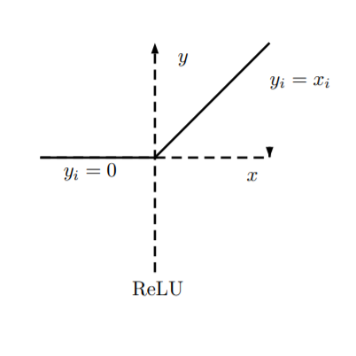
Figure 3: Rectified Linear Units [32]
However, ReLUs do suffer from their own problems somewhat similar to the sigmoid function, which is known as the “dying ReLu” problem. This problem occurs when the weights are updated via gradient decent and causes the inputs of the neuron to always evaluate to 0, see equation 2 for reference. This is where the main drawback of ReLUs are present, as the derivative of 0 in a rectified linear unit is 0 causing the model to stop learning.

Leaky ReLU
The leaky ReLU is an adaption of the rectified linear unit activation function but has implemented a slope on the flat side to solve the problem associated with the standard ReLU function.
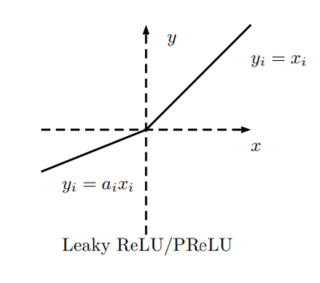
Figure 4: Leaky ReLU [32]

Types of Neural Networks
There are many different types of neural networks with some being more recommended to perform certain tasks over others due to their architecture. In this paper the author has already discussed the multilayer perceptron which is the simplest of the form of neural networks and is a type of feedforward neural network, pictured in figure 5.
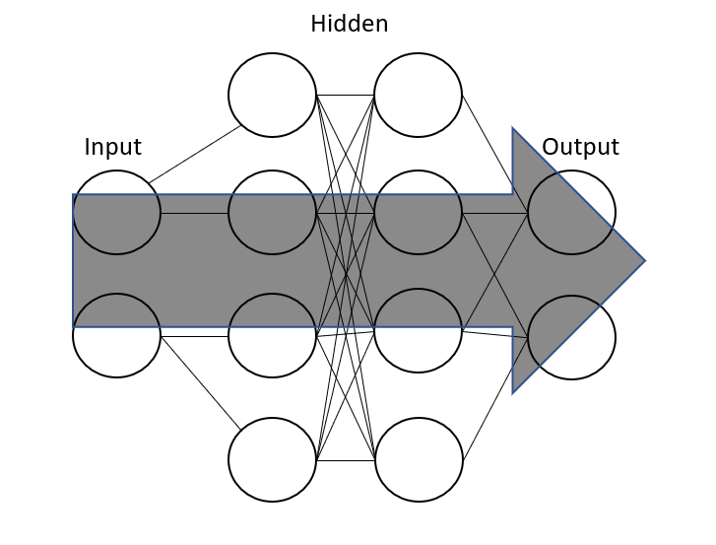
Figure 5: An Illustration of a Multi-Layer Feed-Forward NN after [3]
As pictured in figure 5 feedforward neural networks and models where data can only flow forwards through the network from the input through to the output.
Feedforward networks can be use in many cases such as regression tasks which described earlier, in section 2.3, as the task of using a machine learning model to output real numbers which is commonly used for predicting prices, e.g. stock market and housing prices. MLPs can also be used effectively for classification which again described earlier as the process of classifying an observation given a set of input features.
Another very popular type of feedforward network is the convolutional neural network (CNN). This network architecture is commonly used in image recognition due to how data is obtained and processed from an observation. Unlike other types of neural networks the CNNs implement convolutional layers which is a mathematical operation used to take the sum of two functions to produce a third function. This is achieved with the use of a filter layer which can convolve over a given input and calculate the dot product of the values from the input and the values self contained in the filter layer which then creates a new function which contains the convolved features. The most common example of case use for this neural network architecture is for image recognition. This is because a convolutional neural network’s can break down an image to very simple features such as lines then progressively get more detailed, such as shapes and finally full image figures.
The previous models are fine when dealing with models that need no temporal dependencies, such as standard classification problems. However, there are times in which, for the model to be able to make good predictions it will need to know the context of the problem [33]. Such a problem wouldn’t fair well on feedforward networks as they only have the ability of dealing with information in the time in which they are needed. Once the calculation has been performed and the activation function decides to either fire or not fire, all information will be lost.
Nonetheless, by using models that are able to deal with sequential data means that problems that require knowledge of past interactions can be solved, these models are known as recurrent neural networks (RNNs) as seen in figure 6.
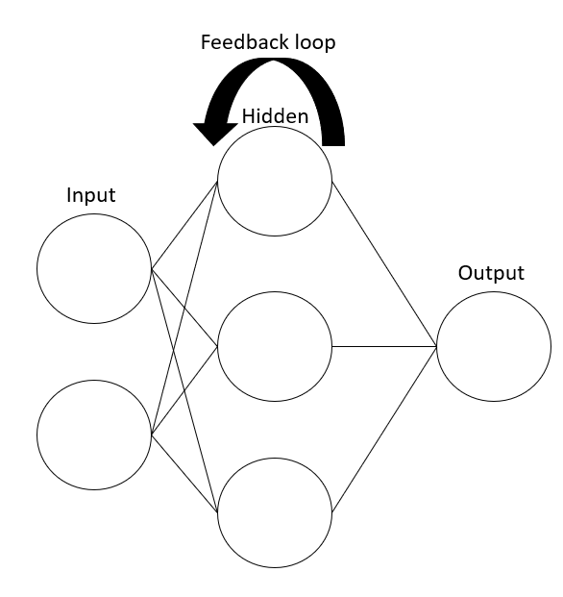
Figure 6: An Illustration of a Recurrent Neural Network after [3]
Recurrent neural networks hold a huge advantage over conventional feedforward neural networks when dealing with sequential data with the introduction of a feedback loop, as displayed in figure 4. The feedback loop is an essential extension on feedforward neural networks to achieve the training and output of time series data as this allows the output of a neuron to become a new part of it’s input. Mikolov et al [33] describe the need for RNNs within their research, where they aimed to create a model capable of predicting a word that could fit in, in the end of a sentence. If one considers the similarities to the research conducted by Mikolov et al and this research project, it would be apparent that the need for temporal dependencies extends to the research discussed in this paper as both projects rely on the knowledge of past outputs to form the basis of new outputs.
However, it was noticed that by Hochreiter and Schmidhuber [34] that recurrent neural networks have some defects that may cause the model to not produce optimum results. Firstly, Hochreiter and Schmidhuber addressed the issue that the current recurrent neural networks are only able to learn short-term temporal dependencies due to the vanishing/ exploding gradient problem. This is the problem in which when calculating in gradients in the output layer of a model, as the error is backpropagated through the network the gradients at earlier timesteps becomes so tiny that the earlier weights are not adjusted as proportionate to the layers closer to the output layer [3] [34]. similarly, exploding gradients is where as the gradients are backpropagated but with each term it reaches is greater than one, when calculated weights can end up becoming really large. Note that earlier within the research paper, the author discussed the importance of the discovery of weighted inputs by Rosenblatt [27], this is because weighted connections between neurons are adjusted such that the model will reduce loss which is measured by the amount of bad predictions made by the model [3]. Therefore, by having a unstable gradient problem means that the model may never reach its optimal weights.
Hochreiter and Schmidhuber suggested that by using a special type of recurrent neural network, they were able to train a model through 1000 time steps, which they named the “long short-term memory” (LSTM) recurrent neural network. To overcome the issues that recurrent neural networks have, Hochreiter and Schmidhuber discovered that implementing different gates they could allow the neurons to maintain information over longer time steps.

Projects of a Similar Nature
It is important to have a good understanding of what projects have already been developed to gain an insight into some issues that may occur and what previous researchers would have done differently.
Development of algorithmic music using machine learning models to compose music has seen a great amount of interest since through the last decade due to the substantial increase of computing power and advancements made within the machine learning community. However, the concept was first theorised in 1959 by Hiller and Isaacson [35] who wanted to discover if there was a relationship between music and mathematics. Using this idea of correlation between algorithms and music Hiller and Isaacson sought to understand if using a numerical based system, such as a digital computer, it could produce a piece of music. Thus Hiller and Isaacson was able to create the first computerised musical composer, named the Illiac.
Hiller and Isaacson pondered the idea of music composition and theorised that the process of composing a musical piece is the activity of creating order out of chaos, chaos being the overall possibilities of choices available to the composer. Therefore, Hiller and Isaacson suggested that the study of algorithmic music should be conducted by using the theory of probability such that the probability of a note being played is determined by it’s current state. Furthermore, to ensure the Illiac was able to assemble music that was pleasing to listen to, it had to follow basic rules of music composition. The model developed by Hiller and Isaacson used probability of an event and randomness given by its stochastic properties, in this case a note being played, given it’s current state in a Markov chain [36] [37]. Markov chains can be seen as the evolution of states, these models require a finite number of states and the probability of one state transitioning into another state, as displayed in figure 7 which shows a very simplistic Markov chain process where each state is connected via probability ruling. This particular model will eventually get into a state where it will remain for the duration of the run time of the programme, state 4 “S₄” which is also known as it’s terminal state.
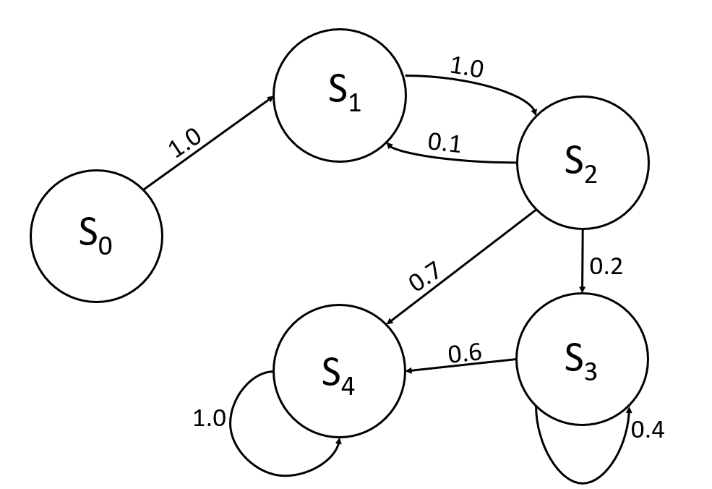
Figure 7: The Markov Chain Model after [3]
If considering the Markov chain displayed in figure 7, it is easy to imagine that each state is a note to be played and after which its state is determined by the rules of stochastic probability. With a slight adjustment of the Markov chain displayed in figure 7 the author believes that this could be a good premise to create a catchy pop melody as it is believed by the author that this genre is simplistic yet effective.
It would seem that the model developed by Hiller and Isaacson [35] confirmed their theory, that music can be formulated. The main issue with the model developed by Hiller and Isaacson is that it is memoryless, the output of is determined only by the stochastic probability of a note occurring given its current state therefore missing the context of the whole song which is important in the composition of music due to factors such as a note in which is played may belong to more than one key. Furthermore, the model required rules to be hard coded, such that Hiller and Isaacson would have to explicitly tell the model the probabilities of an event given a current state which would require in-depth knowledge of music composition.
Due to the Hiller and Isaacson model needing an strong musical background researchers has put their effort into using other machine learning models, such as neural networks, more specifically recurrent neural networks as they are able to remember the context of the music through time steps. However, Yang et al [38] who addressed the popularity of recurrent neural networks within machine learning music generation for their ability to generate sequences but suggests that convolutional neural networks (CNN) are not only faster to train, but also comparatively works just as well, if not better than a recurrent neural network when analysing data, in which they asked people to determine how realistic the music sounded and how pleasing it was to the ear. However, previous to the research conducted by Yang et al, Yann LeCun and associates [39] believe that although convolutional neural networks may train faster, they also require a good knowledge of feature extraction to achieve desired results. LeCun et al argue that when creating models suitable for handling sequential data, recurrent neural networks are the most appropriate architecture due to their ability to store the output of previous timesteps and using previous outputs to form part of the new inputs.
“Deep convolutional nets have brought about breakthroughs in processing images, video, speech and audio, whereas recurrent nets have shone light on sequential data such as text and speech” (Yann LeCun et al) [39].
However, it is important to note that LeCun had argued this case before the development of MidiNet [38] and the continuous research in the field of machine learning means researchers have been able to use creative methods to solve complex issues, an example being the lack of memory using convolutional networks. Yang et al was able to use creativity to bypass the problem of convolutional neural network memoryless nature by implementing a second convolutional network model to hold previous bars of music output and act as a look back feature, eliminating the need for a recurrent neural network. Although this is a creative way to overcome the problem, it is important to note that training a neural network is an extremely time and hardware intensive job therefore would not be practical for most to take this approach.
Despite taking an unconventional approach to neural network music composition Yang et al was able to create further realism in the output of their model by taking the generative adversarial network (GAN) approach [38]. The architecture of GANs rely on two neural networks when training, one neural network being a generative model and the other a discriminative model.
The generative model is used to create new instances of fake observations with the main goal of tricking the discriminative model into believing the observation is real. When training the generative model it’s important that it doesn’t have access to the training data as it could potentially just copy what is has seen, instead the model relies on random noise as input to then generate samples. The network improves overtime as the model is trained via backpropagation [40].
The discriminative network is used to try and determine whether the current observation is from the real dataset or that of what has been mimicked by the generative network [40].
Goodfellow et al [40] use the analogy of counterfeiters producing fake money as being the generative model and the police trying to identify what is fake and what is real. This method of the two networks always trying to outsmart each other has it’s advantages such as the ability to output very realistic data. However, this method of learning is still in its infancy, therefore is still not completely understood [3].
Researchers have displayed great interest with GANs because of their ability to enhance the realism of output from a machine learning model [41]. Since their development in 2014 by Goodfellow et al [41] GANs have seen large amounts of interest and peaked the interest of Yann LeCun, a esteemed researcher in the machine learning sector. LeCun believed that generative adversarial networks are an important development in machine learning in which he describes GANs as,
“the most interesting idea in the last 10 years in ML” (Yann LeCun, 2016) [42].
GANs are extremely popular when developing models that aim to produce artistic output and can be implemented with most machine learning architectures [43].
As rightfully mentioned by Yang et al [38] the majority of the efforts made to compose music using machine learning has been directed to the use of recurrent neural networks [44] [45] because of the temporal dependencies required to compose music.
As mentioned in section 3.5.3, conventional RNNs has been made obsolete due to not being able to maintain information for a substantial period of time as well as the issues of unstable gradients. Eck and Schmidhuber [46] believe that using a LSTM network for training a model to compose music is the better option because they suggest that standard RNNs struggle to learn the global structure of a song due to the temporal distance of events due to vanishing and exploding gradients, that was briefly described earlier. They argue that LSTMs better conventional RNNs because of their added constant error carousels which is the method of solving the issues with RNNs.
Eck and Schmidhuber trained their LSTM model using 12 bar blues and transposed all training observations to one key as using data which has many different keys would very likely have an undesired effect on the training of the network.
Thirdly, Coca et al [37] also used LSTM neural networks for their compositional model as they noted the issues of vanishing and exploding gradients within standard recurrent neural networks, therefore by using LSTMs they were able to use the constant error carousel which would prevent gradients from becoming too small or too large when using the back-propagation-through-time algorithm, which is like the gradient decent algorithm but allows for models with temporal dependencies to be adjusted through time. Coca et al also put forth the idea of using chaotic systems when developing their model as this approach will mean that outputs from the models will differ each time they want the model to compose music. Without the use of this system the model will learn to compose music but each compositions will share a very high resemblance to other outputs from the model and could possibly see reuse of the same chord and melody structures. However, due to the nature of chaotic systems the output could be very indeterministic meaning the marriage of chords and melodies may not fit and therefore become unpleasing.

Musical Instrument Digital Interface (MIDI)
A commonality shared amongst a wide range of machine learning music projects is the use of MIDI data. MIDI is an acronym for “Musical Instrument Digital Interface” and is a communication protocol used to transfer event data between digitalized musical instruments and was primarily used in the 1980s to transfer data from synthesizers to a computer for the use of recording. MIDI, unlike other file formats, such as mp3 and WAV doesn’t store audio signals meaning it does not transfer sound data but rather sets of instructions that which can then be interpreted by an instrument to then produce sound.
As mentioned when receiving MIDI data it is the responsibility of the musical instrument to interpret the event data to output sound therefore requires a number of meaningful instructions:
- Note on/off – This is used for an instrument to know when a note should be played and when it should be release.
- Pitch – This is tells the instrument which note should be played and how high on the instrument it should be played e.g. how high or low should the instrument sound.
- Velocity – This is tells the instrument how hard the note should be hit. The velocity in a piece of music brings more dynamics to the song.
There are two main reasons why the use of MIDI data has become the popular choice for machine learning models attempting to develop music:
- Instructions – Due to MIDI already being in instruction format it theoretically should be easier for an unsupervised learning model to find features within the data such as common notes played simultaneously (chords) and notes played in sequence (melody).
- Wealth of resources – With the expanse of the internet, there are thousands of places where MIDI files of popular songs can be obtained from. Machine learning algorithms usually require a huge dataset, therefore being able to collect MIDI data easily reduces a huge strain of producing ones own dataset. There are many available machine learning ready datasets available such as “Jazz ML ready MIDI” by Kaggle [47] and blues midi [48] However, the majority of MIDI datasets available tend to focus on classical and jazz genres. Another website for data collection is the Essen Associative Code and Folksong Database which has a huge amount of folk melodies from around the world [49]. However, resources was not used from this website because only melodies are provided and to train the neural network to compose songs like humans would require resources with melodies and chords. For the project the author wanted to find varying complexities of music to obtain a wider scope and various capabilities of the model, therefore the majority of MIDI files were individually obtained from https://www.midiworld.com/files/. This website groups MIDI files by genre so it was easy to gain a large amount of data in a very short time. However, by getting the dataset this way meat that the data wasn’t as ‘clean’ as it would be by getting a dataset specifically made for machine learning which meant that the files required pre-processing before the neural network could be trained. Further information can be found in section 4.3 which discusses the reason why pre-processing was required and how the data was ‘cleaned’ in preparation to train the model.

Conclusion
This section has covered many concepts of artificial intelligence and machine learning and by doing so has given a wealth of useful knowledge that can guide the way in which a machine learning project should be approached.
Firstly, it has been discovered that the machine learning model will learning by taking an unsupervised approach, this is because the data presented to the model will be unlabelled meaning that the model should be used to discover trends and patterns within the data without being explicitly told how the model should interpret the data.
Secondly, as the composition of music is a problem that requires to be solved over time therefore a model suitable for handling sequences will be essential. Therefore, due to the wealth of research already composed on the effectiveness of LSTM neural networks makes them an optimal choice for using to develop the model needed to compose music. Furthermore, by choosing an LSTM model as apposed to a standard recurrent neural network means that the model can utilise the constant error carousel in order to mitigate the issue of exploding and vanishing gradients, thus leading to a better trained model.

Research and development methodologies
This section aims to shed light on the research and development methodologies used to guide the project to success. The main elements of this section include the research philosophy, strategy, research approaches, any risks that may cause the project to fail or become unsuccessful, and how the author plans to collect and evaluate data for results.

Research Methodology

Philosophy
This project will take a mixed-method approach by incorporating elements of positivism and phenomenological as a combination of these two results will give a more complete and comprehensive understanding if the research problem.
Firstly, because this project has research questions and hypothesis that can be tested, by incorporating the positivism philosophy into the mixed approach means that the project will benefit from using quantitative data as a means of data collection as “positivists” believe that this is more reliable that qualitative research.
However, there would be a major drawback to using a purely positivism philosophy in this project, this being the lack of empathy and consideration for individuals when collecting and analysing results. Music has the ability to trigger certain emotions within people and each emotion may differ between different individuals. By incorporating phenomenology into the research will allow for flexibility within the results and allow for participants to be more creative in their answers. Therefore, to overcome the issue of lack of empathy and consideration for individuals that the positivism philosophy encourages participants will be asked to leave optional feedback to why they believe the song they chose was that of a human.
Incorporating the phenomenological philosophy will produce rich and unique datasets which will allow for a deeper understanding on how each piece of music affects individual emotions and what is considered “human” in terms of composition. However, the phenomenological philosophy has disadvantages when collecting data, the main one of which is difficulty appropriately presenting results as each person will have their own way of describing their experience and therefore means that data has to be analysed and data assigned to a different groups, such as positive and negative feelings. However, this approach could result in inaccuracies as data may be misinterpreted leading to errors due to wrong assignments of groups.

Strategy
The project will take a mixed-methodology approach by using both deductive and inductive reasoning. The foundation of the thesis relies on deductive research, as according to Gratton and Jones [R] this approach is aimed at testing a theory. The research conducted by the author commenced with the considerations of previous research on computational algorithmic music can be used to build on existing theories. Some argue that this approach does not encourage divergent thinking and limits the scope of creativity. However, due to deep learning still being a relatively new field and the ever growing availability of high performance affordable computing hardware, there are better resources that can be used when training machine learning models, therefore there is still room to improve on existing research and create new hypotheses in this field. The quantitative analysis in this research will be used to use statistical analysis which will be obtained by giving participants the choice to pick which song (1 or 2) was composed by a human. This will be compared with the actual answer to decipher if the population was able to identify which sample was created by human.
Although a deductive approach is usually adopted by researchers conducting quantitative research, hence the mixed-method approach. As previously mentioned, including a qualitative approach will give a clearer insight into the participant’s emotional response to music and identify why the music composed by AI was or was not able to have the same emotional impact on the participants as that written by human.

Approaches

Literature Review

Software Development

Survey

Risks & Limitations
A major external factor that could prevent the finishing of the project is the emergence of the Coronavirus. This has caused major disruption across the world and has resulted in a complete lockdown of the UK including the University of Wales Trinity Saint David university of which the author is currently studying. These lockdown measures has meant that getting access to essential hardware that would vastly improve the overall training time of the network, this means that training which could spanned over a day could now potentially take weeks. To overcome this potential issue the author has had to rely on the kindness of a friend to borrow a desktop that has suitable hardware to be able to train the network in a much more time efficient manner.
Secondly, a huge factor that could result in a failure to complete the project is loss of work. Losing work can be drastic and mean that valuable hard work lost. However, this is an extremely easy problem to avoid by following the 3-2-1 backup rule. This rule is set in place to ensure that there are enough backups should the worst happen, by following the rules there should be a total of three copies, two copies on different storage devices and one being stored in a different location to the others.
Thirdly, the project may fail to succeed in the case of hardware issues such that if hardware fails it will have a devastating impact on the project. In the case that hardware fails during the implementation of the project and with current circumstances of university closure and social distancing rules, the best option would be to discuss the issue with university to potentially be able to obtain access to resources.

Validity, Reliability & Generalisability

3.1.5.1 Validity
When assessing the validity of the research, there was a need for the understanding that the process of collecting data and the questions asked were appropriate and was able to ‘accurately’ measure what was intended [50]. By requiring the participants to pick which one of two songs they believe to be composed by a human, will give an insight to understanding whether or not the testing population could decipher an AI created composition to that composed by a human. Should the testing population believe the AI composed music was created by a human, this will validate the hypothesis that AI created music can stimulate the same empathetic emotional response in an individual as music created by a human, thus meaning AI can compose music. Furthermore, by creating the open-ended text box, further insights into the strengths of the AI composed music, such as why it was thought to be human or the shortcomings, why the composition lacked human characteristics. Therefore, all questions presented to the participants are only relative to answering the question of whether an AI can compose an original piece of music.
However, it could be argued that by only selecting three genres to represent ‘music’ is not sufficient as there are many more genres. To obtain a more accurate scope, further iterations of testing will include the use of all music genres.

3.1.5.2 Reliability
Joppe [51] describes reliability as the extent to which the results are not only consistent over a period of time, but also an accurate representation of the population, therefore, it was imperative that the conditions in which research was implemented in a way in which should a future researcher were to investigate the same problem, they would likely obtain similar results.

3.1.5.3 Generalisability
When collecting data from participants, the project used the snowball sampling technique which is where participants recruit other potential participants which could acquaintances. However, this method of collecting data could result in having sampling bias, which is where the population of the participants share characteristics, such as age and gender.
Furthermore, due to only having one version of the survey which is an online resource means that the data collected may not be a true representation of the whole population, an example being that the older generation may not have a computer or smart device capable of accessing the survey, therefore leading to sampling bias.
Should this research continue in the future and the relaxation of rules concerning coronavirus, the author would like to conduct focus groups as this will enable participants of all ages and backgrounds to be able to contribute to the research and therefore have a wider scope.

Data Evaluation Methods

Data Collection
The data will be collected via the use of the online survey developed by the author, which contains both multiple choice options and open-ended questions where participants can express their thoughts and justify their answers via a text box. The data gathered will give a better understanding of whether an AI can compose music and what needs to be improved on in future iterations. The quantitative data (multiple choice) is designed to collect statistical data allowing for statistical analyses and allowing for a conclusion to be drawn from the research. The qualitative data (open-ended question) will give an insight to participants reasoning and emotions which can also be used to improve the model in future iterations. By incorporating the qualitative and quantitative research into one questionnaire greatly reduces to time needed to conduct interviews and focus groups.

Data Evaluation
The data will be evaluated based on the answers given by the participants, the evaluation process will adopt the approach taken by Turing [6] who believed that should the interrogator be fooled in 30% of cases, the test would conclude positive.

Development Methodology

Software Development Methodology
The software development lifecycle (SDLC) is a framework used to guide a project from start to finish. The SDLC encompasses a lot of the main development models which have become industry standard such as Agile.
However, the methodology chosen for any project has to coincide with the aims of the project and available resource such as people working on the project. Therefore the suggested software development methodology for this project is the iterative approach. Furthering the iterative approach, the project will also follow the machine learning checklist by Géron [3].
The main focus of the iterative methodology is to simplify the implementation of the project and add more complexity as the project progresses.
The main steps involved with the iterative methodology include:
- Planning & Requirements – This step of the process will include identifying hardware, software and resource requirements.
- Analyses & Design – This step will focus on more detailed requirements of the project including libraries, databases and what programming language to use.
- Implementation – This is the first iteration of the code and will involve programming key elements of the program
- Testing – This step includes checking for errors and the output is that of what was expected. In machine learning this could be difficult as it is unsure what the output will be.
- Evaluation – This stage is associated with getting feedback from all stakeholders of the project, both internal and external. This step allows for others to see the current capabilities of the project and discuss where that is in relation to the end product.
By using the iterative approach in the project means that all necessary resources for the project are not overlooked and will be well defined in the very early stages of the project. Furthermore, the chosen methodology means that there will be frequent analyses of the model to discover what needs to be improved, which can be achieved by fine tuning the model before deployment.
There are disadvantages associated with the iterative methodology, the main one being the expansion of features. As the iterative methodology is one that encourages client feedback throughout the project, the list of desire features are often increased vastly. However, as there is technically no client for this project the author has taken on the role of client as well as developer.

Resources

3.3.1 Hardware Resources
The hardware requirement for the development and running of this project isn’t high meaning that most people, should they desire, build and run this project on a personal computer. However, it is important to note that Tensorflow will run on the CPU and with the vast amount of MIDI files and the pre-processing required the runtime for the project to obtain decent results could potentially run into the weeks before the model is at a level to produce music that is of sound quality. However, to improve the speed in which the model trains, the algorithm will use CuDNNLSTMs, a type of LSTM that can be run on a Nvidia GPU and is used to speed up training. Therefore, to facilitate this the project would benefit from having this hardware resource will greatly reduce the amount of time taken to train the model which can be used to fine tune the model for better results.

Software & Library Resources
For the project to be developed and for continuous training requires certain software and a number of libraries.
Firstly, the programming language of choice will be Python. This is because Python is for the most part becoming the industry standard for AI and machine learning and as such has had many frameworks and libraries developed to support the development of AI and ML. Furthermore, because of it’s popularity within the ML community, there is a wide variety of resources available to learn AI development in python.
Secondly, the project will make use of the framework Tensorflow which is developed and maintained by Google and is used to create and maintain machine learning models with needing a highly skilled mathematical background.
Thirdly, the Music21 library which was developed by developers at MIT and is used as a computer aided musicology tool to support users who wish to learn music theory, study large datasets and in the case of this project use to process data for machine learning.
Lastly, Numpy is a library for scientific computing within python and is used to perform array handling and calculations quickly and more efficiently than lists that are a part of python.

Information Resources
For this project to be successful it will require a large amount of data in form of MIDI files. These files will be used to train the neural network to compose music. There is a wealth of data accessible from the internet.

Human Resources
To determine the effectiveness of the neural network when composing music data should come from a range of sources to better understand if AI music is at a comparable level humanly written music.

Conclusion
This section has discovered the software and development methodologies that have been used to conduct the project and by using the research onion has uncovered the best philosophies and strategies. Furthermore, this section has discussed the resources that will be required to train the algorithm quickly and efficiently.

Implementation
This section aims to provide a clear understanding of the implementation of the project by discussing key elements of the code. The sections have been broken up to fit the machine learning checklist suggested by Aurélien Géron [3]. A demonstration of the project in action can be found by following this link https://www.youtube.com/watch?v=pnmuAovat5w.

Influences of the Project
This project was based and influenced by the work already demonstrated by Sigurður Skúli [52]. In his implementation of the project, Skúli trained the neural network to learn patterns within the Final Fantasy soundtrack along with compositions similar to the style of music, due to the wealth of available resources he was able to obtain and the distinct melodies found within that style of genre. Skúli used only midi files that had single instruments, however, in this project the MIDI files often contained multiple instruments.
Secondly, Skúli only implemented one genre of music which means that the model may have done well in terms of that particular style of music but means that it would not be able to compose songs from different genres. In this project, scope was an important factor to consider, due to the time constraints of the project, it would be unrealistic to obtain music from all genres which is why only three was selected as this will give the project a wider scope and allow to understand if the model would be able to generalize to compositions of different complexities.
Furthermore, in Skúli’s implementation he doesn’t provide any data pre-processing, it is unsure if he had done this before implementing his model, within a custom script. However, the author believes that the data would need to be pre-processed to ensure that the model can learn from the data efficiently, the author’s logic and reasoning why this may be the case can be discovered in section 4.4.
Lastly, Skúli used a training sequence size of 100 notes, the author deemed this to be an extremely high amount and could possibly cause overfitting of the model meaning the model could potentially just repeat large chunks of compositions that it has been trained with. To overcome this potential issue, the sequence length for training was reduced by half.
Another inspiration for the project was Valerio Velardo with his YouTube series of musical composition using an LSTM ANN [53].

Analyse the Problem
It is important to analyse the problem which is trying to be solved as this will often give a clear understanding of the type of task, section 2.2, and the learning approach that should be taken, section 2.3.
Firstly, as the title suggests, the problem is to use an artificial neural network to compose music. The initial thought of the author would be to take an unsupervised learning approach as this would allow for model to explore data to find trends and patterns. However, due to the uncertainty that the model will learn useful information to be able to compose music [18], the author believed that the could be framed as a supervised learning problem, detailed in section 4.5.2.
Secondly, when analysing the problem, it was determined that the performance of the model should be measured by whether the music is distinguishable from a human’s composition. This approach of data collection would give an accurate percentage of the population who believed that the composition of the AI was human.
Lastly, having a basic understanding of music theory and western music practices allowed the author to make the assumption that the datasets would benefit by using notes and chords from the same scale, this idea is further expanded on in section 4.4.

Collection of Data
In this early stages of the project, it was important to decide how the data would be processed, as this would determine the type of data that the author should obtain e.g. MusicXML, MIDI or Kern. The MIDI data format was chosen for this project due to the wealth of resources available on the internet of all different genres. Furthermore, MIDI data can be created extremely quickly to test the model in very early stages of development. Moreover, as MIDI is instructions to be interpreted by a digital instrument, therefore should be easy to extract and modify information.
The acquisition of data came from assumptions made on specific types of genres and how complexity may decrease the learnability of the model. The first genre that was chosen was pop as this genre of music is very structured with very little variation with chords and melodies. The assumption for this genre was that the model would easily be able to find patterns within the data and as such create realistic output.
The second genre to be collected was jazz as this style of music is complex and a lot more freeform than pop with more complex chord structures. Due to the complexity associated with the jazz genre concerning the extended chords and melodies that follow no clear pattern, an assumption was made that to better the output of the model, the model would require adjustments. The adjustments mentioned are described in section 4.6.
Lastly, to give an even balance of complexity, data from the genre Irish folk was collected to train on, as this genre tends to have a mix of simplistic chords but elaborate melody lines throughout the entirety of a track.

Data Pre-Processing
The key of a composition determines what notes and chords are best suited within the composition in terms of what sounds good. An example of different keys can be seen in tables 1 and 2 which depicts the C and D major scales. Tables 1 and 2 show that the two keys have shared features but also show that these different keys lack in commonality. Furthermore, the tonality of a key will determine the chords are being played as seen in tables 1 and 2. If one considers the chord ‘D’ in the D major scale, the mode of the chord will be evaluated as ‘major’ as it will consist of the base note D, the major third F# and the perfect fifth A. However, if this is compared to the availability of notes within the C major scale it is noticeable that the F# note available in the F major scale is flattened by a half step. Therefore, if the same structure is followed when composing the D major chord from the D major scale the resulting chord is the root note D, minor third F and the fifth which is A, resulting in a minor chord.
C | D | E | F | G | A | B
Table 1: Notes Associated with the Key of C Major

D | E | F# | G | A | B | C#
Table 2: Notes Associated with the Key of D Major
When collecting the dataset it was important to understand that the lack of a universal key between each instance could hinder the models ability to find underlying correlations such as notes that work best together.
To reduce the chance of randomness and lack of a key within a composition it would be beneficial for the training data to be of a universal key or keys that share the same notes. For this the author proposes that the datasets should be transposed to either C major or A minor, depending on the mode of each observation. Table 3 shows the notes that appear in the C major scale also appear in the A minor scale.
A | B | C | D | E | F | G
Table 3: Notes Associated with the Key of A Minor
Transposing the music means changing it from the key it is currently played in to another key, many musicians do this to best suit their singing voice. However, as mentioned this was used to simplify the training of the model. The key of each midi file was transposed to either the key of C major due to it being a popular key within western music or A minor which is the relative minor to C major, meaning that they share the same notes. By transposing the music so that only a select amount of notes can be selected will not only produce a model with more accurate predictions but will also greatly reduce the amount of time needed to train the network.
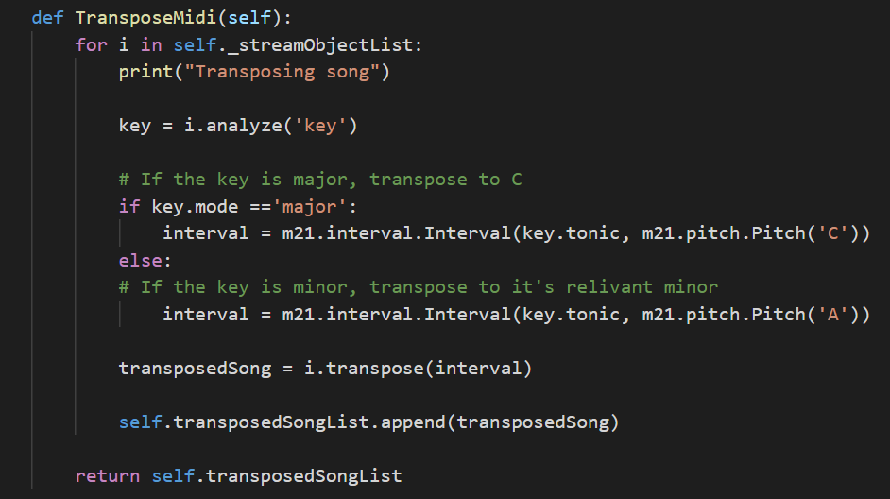
Figure 8: Transposing the Key of Music after [53]
Figure 8 displays the code required to transpose the music from a given dataset from its current key to be either C major or A minor. This code firstly, analyses the key that the current composition is played in and whether it is a major or minor composition, this is where the Music21 library was particularly useful as this can analyse the music to determine the current key of music and the mode is which it’s played, major or minor. This information is usually stored within the meta data of a composition, but if this data hasn’t been provided, the information can be estimated by using the “analyze” method.
The code will then determine the interval (how far away) the current key of the composition is away from the key of C for major, A, for minor, transpose the song and add the transposed song to a list of transposed songs, which can then be used to extract data from, which is discussed in the next section, 4.5.

Data Preparation

Extracting Notes and Chords
Firstly, the MIDI files were converted in to score type, a data type that is exclusive to the Music21 library as this can then be used to efficiently obtain all the data from MIDI file without the need for a custom script which would be timely and inefficient. Furthermore, by using the music21 library to process data means that the structure of the song could easily be viewed in a web browser. This meant that the data could be analysed to find outliers in the composition, such as sharp and flat notes.
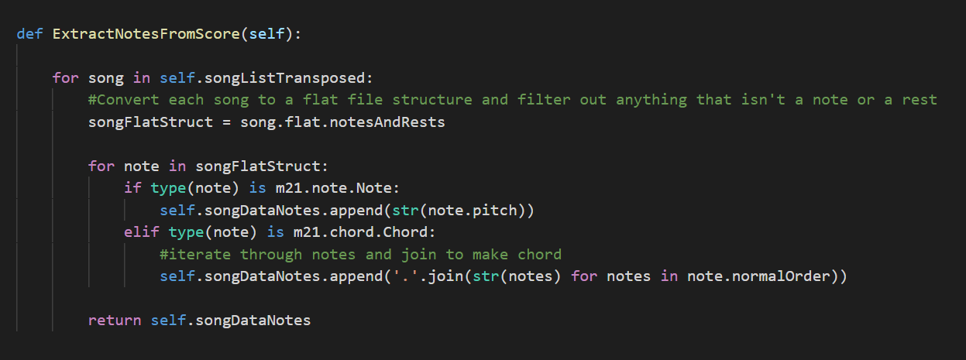
Figure 9: Extracting Data from Stream Object
Figure 9 is the code used to extract notes from the score objects, which as just mentioned is an object representation of a song, influenced by [52] [54]. In this code each song is stripped to only include the notes and rests in the music. By doing this the notes can easily be iterated over to check if it is an individual note or if it’s a collection of notes to make a chord. By this definition any collection of two or more notes are classed as a chord.

Preparing Sequences for Training
To train the model the supervised learning approach will be adopted and can be achieved by creating sequences of data and have the model predict what note should appear after the sequence.
C

F
E

D

B

A
Desired output
Input Sequence
Figure 10: Sequences for Training

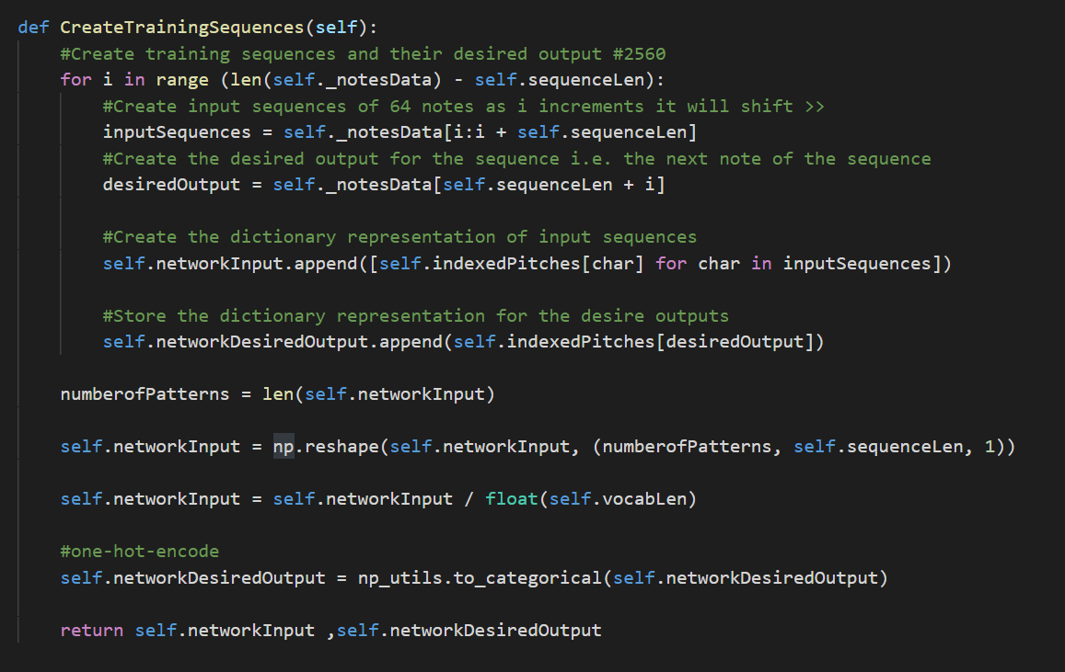
Figure 11: Creating Sequences for Training
Figure 11 shows the process of creating sequences for training the network. As suggested by figure 10, training sequences are obtained by looping through song data and taken a number of notes and chords and creating a list of inputs. The desired output of the model will then be the next note or chord that should appear after the sequence. The desired output is then encoded using one-hot-encoding as the model will require numerical data rather than categorical.
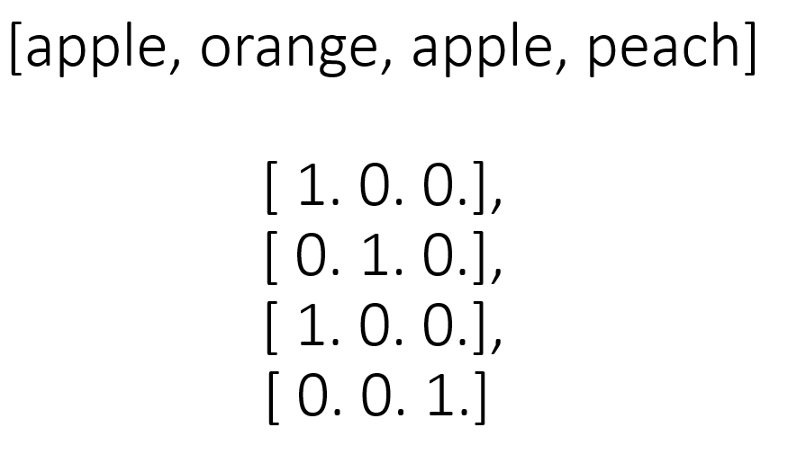
Figure 12: Visual Representation of One-Hot-Encoding

Model Selection
The majority of research discovered on algorithmic music emphasises the key benefits of using LSTM networks because of their ability to store information for many timesteps when training. Therefore, the neural network developed followed the same interest of LSTMs to help reduce the potential impact of unstable gradients.
A sequential model was chosen for this project which means that the model takes a single input, which in this case is the training sequence and has a single output which is the note or chord that is next to appear in the sequence.
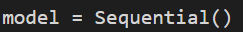
Figure 13: Sequential Model
A sequential model required to be comprised of layers, some of which are described below figure 14.
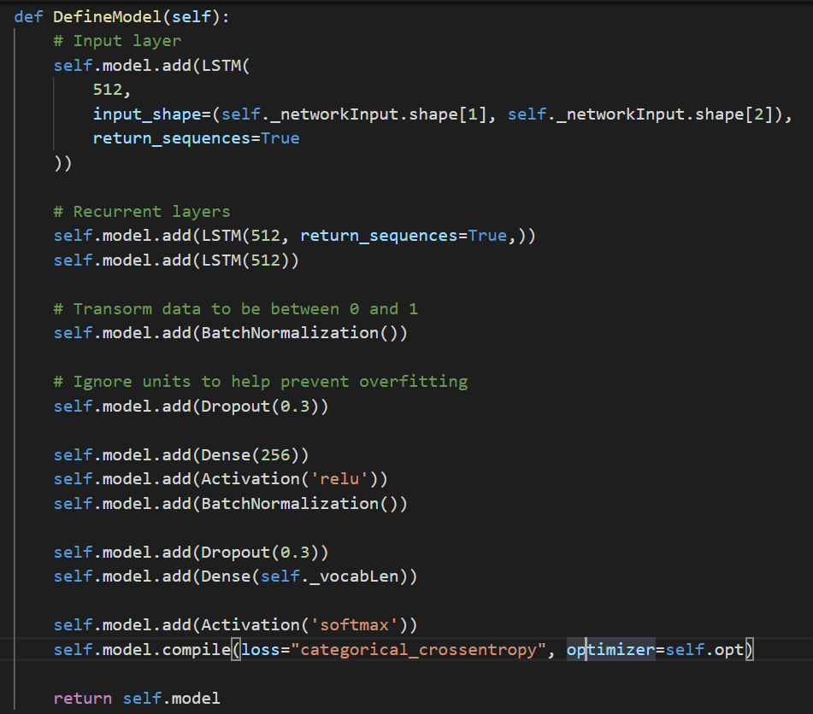
Figure 14: The Layers in the Sequential Model

- Dense layers – These are just a layer of regular neurons that has been discussed throughout this research paper. However, to solidify the understanding of neurons, a neuron is a mathematical function that takes in a summation of its inputs, weights and it’s bias value, performs a mathematical operation based on its activation function and fires if the evaluated input exceeds the threshold.
- Dropout – Neural networks that implement dropout in the models have seen great improvements on the accuracy of models [3]. Dropout is a regularization technique and was proposed by Hinton et al [55] in efforts to prevent overfitting of their model. Dropout refers to the principle that at every training step of a network all neurons, excluding output neurons, have a random probability of being chosen to be completely ignored for that training step then will be activated on the next training step. Neurons that were ignored in a previous training step will still maintain it’s probability of being ignored again.
- Batch normalisation – Batch normalisation is the process of normalizing inputs to a layer. The concept was developed due to troubles when training deep neural networks with multiple layers. The issue being that having data with a very large numerical data range could cause instability when training the network. By normalizing the data set to be within the same scale (0 – 1) not only can support instability but vastly increase the training speed of the network [56].

Self Evaluation of the Model
In cases of musical genres that follow very basic structures and clear progressions, such as pop and Irish folk. However, when attempting to learn structures in more free form music such as jazz and blues the model would struggle. A potential reason for this is because within these genres it’s not uncommon for musicians to improvise and go in and out of their current key.
Furthermore, another potential issue that hadn’t come into consideration until after the collection of data was the possibility that the training data had samples of music that used different modes. A basic definition of modes within music are scales that differ from the standard major scale, also known as “Ionian” or the minor scale, also known as “Aeolian”. The majority of these modes follow the same principles as major and minor scales but will substitute notes by either shifting the note up a half step (sharp) or down a half step (flat). By implementing different modes within a composition means that the music will not follow the same notes than if a composition is written in the standard major or minor scales.
When listening to the music composed by the AI, the model in the case of pop and Irish folk was able to create appropriate chords and melodies that represented a sound resemblance to that of music composed by a human, However, the model was unable to learn appropriate note durations and the velocity in which the notes are played. These make it easy to tell that the compositions were that of AI as human compositions tend to be dynamic and have variance in the velocity and the length of which notes and chords are held for.

Future Improvements
Plagiarism is an extremely important consideration when composing music and can often lead to lawsuits should a musician feel that their music has been plagiarised. Currently, there is nothing in place to check that what the model is producing is that of originality or just a copy of an existing song it was trained with. Therefore, in future developments of the project the author aims to develop a “Turnitin” style script that will check the percentage of plagiarised content within the composition to help avoid the prospect of plagiarism.
Secondly, to improve the quality of output, future iterations of the project will experiment with the use of a generative adversarial network because of their nature of training, specifically that of attempting to differentiate between human composition and that generated by the generative model. Having two models compete to gain an edge on the other should produce better results.
Lastly, the model will be improved in the future by getting much larger training sets as this can help reduce the possibility of overfitting. Also, having larger dataset will also mean that there is more feature coverage for data points allowing for a more accurate model.

Results

What was Tested?
As suggested by Coca et al [37] the quality of output from the model should be analysed to rate the quality of output. To rate the quality of output for this project, the author decided to take a Turing test [6] style approach. To obtain the information, participants will be asked to visit the website https://dissertationdatacollection.web.app/, seen in appendix A and answering a short series of questions. These questions will be broken into three sets and each set containing a sample of music composed by a human and a sample composed by an AI. Visitors of the website will listen to each sample of music and choose which they believe was composed by the human. To further understand what lead the participant to believe that a certain composition was human, the participant will be able to voice their opinions via a comment box. This collection of both quantitative and qualitative data will not only give an understanding of the capabilities of the machine learning model but also how it can be improved in future iterations, thus leading to a model that could be integrated within real life projects such as game music, cinematography and a tool for musicians to use to assist with writer’s block.

Expected Results
Given the current capabilities of the model, it is believed that the model will be able to success in its efforts to compose music to a human standard and be able to fool the majority of participants into believing that its compositions were that of a human.

Actual Results
In this collection of data, 101 participants took part in the study by answering the three questions based on the algorithmic music and music written by a human. From initial looks of the collected data, there seems to be mixed opinions on which samples each participants believe are human. This is promising as it shows that there is a great deal of potential within computational music. This following sub-section will analyse the data for both statistical analytics as well as considering the comments people have left to understand emotional response and reasoning.

Set 1
Question one contains two samples of music from the pop genre, as previously mentioned this style of music is quite simplistic therefore was considered the easiest for the model to learn.

Figure 15: Results for Set 1
Figure 7 shows a clear divide in opinion to which song was composed by a human, however, does also display that the majority of people were able to guess correctly than song 2 was created by the human. To quantify the split, out of 101 participants only 39 believed that the song that the AI composed was human.
When reviewing what made people believe that the music composed by AI was human there was varying opinions. Firstly, one participant stated their reasoning for choosing the AI composed song was because they believed that the song had better rhythm and was “more complex”.
However, another participant who was able to identify the human composition suggested their reasoning for their choice was because the song written by the AI had “little variation”, which when interpreted, it is believed that the participant was talking about the dynamic content of the music as the AI composition lacked in rests and the velocity of the notes were played at a constant level throughout the composition. Furthermore, the human composer was able to make their composition more dynamic put increasing and decreasing the length of which each note is played, which is characteristic for a human composition.
The need for dynamism in composition was also reiterated by another participant who believes that a common trait for human composition is the use of effective rests and the use of “accents” which is a term used to describe the emphasis in which a note is played.

Set 2
Secondly, the second set of samples containing samples from the jazz genre. This was determined to be a more complex genre by the author who believed that the model would require find tuning to output music of a comparable level to a human composer.

Figure 16: Results for Set 2
The results obtained from question 2, participants were found it easier to identify the human composition.
One participant mentioned that the basis for their choice was the complexity of the song. They believed that the human composition had “more layers” and was more complex. This demonstrates that the genre of jazz can be summarised as complex, therefore to have the AI be able to compose music of the same stature as human would require much more fine tuning of the model and could potentially require further layers to optimise the output of the network.
However, an opposing participant argued that the composition by the AI reflected “more mood”. This is a prime example of how music is subjective to an individual and how a piece of music will cause different emotions between different participants.

Set 3

Figure 17: Results for Set 3
Lastly, when comparing the output of the model to the human composition when composing songs within the Irish folk genre the majority of the participants selected the composition by the AI as being the human composition. This means that the AI was able to compose music to a standard that is comparable to a human. However, it is important to note that the way in which the midi file was composed of many different tracks made for many different instruments. To make the test fair the majority of the tracks had to be stripped to just leave the piano parts. However, by doing so only the shell of the composition was left which greatly reduced the listenability of the song as the main context had been removed. When comparing this to the composition by the AI the song composed by the human only made use of a very simplistic melody with no presence of chords, whereas the composition by the AI was able to create a dynamic sound with the use of fitting chords and melodies to create an authentic sound.

Outcome of Results
From the collection of results obtained over the three samples of music show that the AI was able to receive 44% of people believing that the music it had composed came from a human composer. As such means that the model was able to bypass the 30% aim and therefore can be deemed that an artificial neural network can compose music.
However, it is important to note that this percentage comes from the collection of data as a whole and as such doesn’t represent each sample individually. From analysing the data, it clearly shows that the model was able to gain a better understanding of music more so than others and as such requires the model to be fine tuned for better results in the future, should this research be extended.

Future Potential Changes
Having the questions on the website allowed for a good representation of how well the model was able to compose music at a general level. However, it might appear that the majority of the people who took part in the test didn’t have a good understanding of music and therefore left comments that was ambiguous or left no clear reasoning to why they chose the samples they did. Therefore, in future testing of the models capabilities to compose music, the website will ask the participants current knowledge of music theory and musicology to allow for better statistical analytics to understand whether people who has a better understanding of the theory of music performs better than those without.
Secondly, to extend the results, it would be beneficial to vastly increase the amount of questions to ask the participants from all genres of music, as this will give a clear understanding of the problem as a whole and as such, will allow the analysis of an artificial neural network’s capability to compose music on a much larger scope.

Conclusion
This section has discussed the results obtained via the online survey, the results gave various mixed opinions on what makes a composition humanistic.
Furthermore, statistical analysis has uncovered that a collected total from the three samples of music, the AI was able to fool enough people into believing that it’s composition was that of a human and as such proved that artificial neural networks can compose music.

Reflection
When conducting the investigation of algorithmic music using machine learning, the author was able to learn, not only from the research and development of the project, but also the areas in which he excels and areas that need consideration as a person.
Firstly, it was discovered that the field of machine learning is an extremely valued concept in many industries because of its ability to streamline workflow and reduce business costs. However, the current uses of AI far exceeded the expectations of the author and as such came as a surprised during the research stage, finding out the case used for many of the ML techniques. As machine learning is a big interest of the author, doing this project has meant that the author has been able to study a research area of interest and strengthen his current understanding and knowledge of ML and deep learning, which will be used to implement future projects.
However, the completion of this project did come with it’s challenges which had dramatic effects on the timescale of the project and as a result lead to the project taking longer than anticipated.
Firstly, the author didn’t take into account situations that could cause a huge hinderance to the project, such as the emergence of Coronavirus. The closure of the university and the impact of social distancing put a huge strain on the project and as a result disrupted the collection of data, which meant that all surveys had to be done online, potentially causing sampling bias. Furthermore, the lockdown of the UK meant that all work had to be completed from home which became a problem as the author doesn’t have a designated workspace in his home. This resulted in the author spending a lot more time procrastinating.
Secondly, mental health issues also delayed the project and caused the project to get completed much slower than should have been.
Thirdly, the author didn’t take into account the learning curve associated with learning how to programme a machine learning model. The author believes he did well during the collection of information and feels that he is a lot more knowledgeable in machine learning principles, architectures and problems that can be solved with ML.
However, regardless of the struggles that came with the research and implementation of this project, it was an enjoyable process and the author enjoyed learning new information and gaining a deeper understanding on an area of study that has peaked his curiosity throughout his time studying in university. The author has also learned that procrastination is a key flaw that he must work on in the future to reduce stress of potential project incompletion and to complete the project in a timely manner. He discovered that it is also important to consider other aspects that may hinder the completion of the project, however unlikely they may be.

Conclusion
In this project the author has conducted research and development to answer the question “Can an Artificial Neural Network Compose Music?”. The research aimed to understand AI and ML to gain an detailed understanding the history of ML, what problems can be solved with ML and different techniques used to train machine learning models. Research into these areas helped solidify a very basic understanding of the fundamentals of ML but it was imperative to understand how these could be used to fulfil this project.
To obtain solutions to how machine learning may be adapted to music, the author researched projects similar to the nature of this project. By analysing different techniques used in the merger of music and algorithms, the author discovered the overwhelming use of LSTMs to accomplish a project like this.
After learning the necessary information, an LSTM model was trained by taking a supervised learning approach, on three music genres of different complexities.
When analysing the data obtained via the online survey, the question that surrounded the capabilities of AI to compose music verified that AI was indeed able to compose music to a human level with 44% of people believing that compositions from the machine learning model came from a human.
When analysing the data, it was discovered that the main reason why people were able to decipher the AI’s composition was due to the models inability to extend and decrease note duration, something that was not implemented. It seems that dynamism within a composition such as the length of notes and velocity of how a note is played adds to the enjoyability of music and it what makes music ‘human’.
The model was best able to predict new instances of pop and Irish folk music well and as such was able to gain a large amount of people to believe that it’s composition was human. For the author this was expected behaviour due to the simplicity of these genres compared to jazz.
As the results suggest, the model was not able to understand the jazz genre which is believed to the author to be because of it complex nature and although all efforts were made to process the dataset to be contained to use notes and chords within the C major or A minor scale, jazz music has a tendency to jump in and out of it compositional key. If this project is to be continued, the author will research news ways how the output of the model concerning jazz can be improved.
Lastly, due to time constraints of the project, only three genres were able to be picked to study, these genres varied in complexity to bring a wider scope to the project . However, should the author continue in this field of study, the need for all genres to evaluated is a requirement as this will obtain an accurate scope.

References

[1] | Netflix, “Research Areas Machine Learning,” Netflix, [Online]. Available: https://research.netflix.com/research-area/machine-learning. [Accessed 03 Mar 2020].
[2] | Amazon, “Amazon Personalize,” Amazon, [Online]. Available: https://aws.amazon.com/personalize/. [Accessed 03 Mar 2020].
[3] | A. Géron, Hands-On Machine Learinng with Scikit-Learn, Keras & Tensorflow, California: O'Reilly Media Inc., 2019.
[4] | S. Russell and P. Norvig, Artificial Intelligence: A Modern Approach, London: Pearsons, 2016.
[5] | P. Boucher, “How Artificial Intelligence Works,” European Parliamentary Research Service, 2019.
[6] | A. M. Turing, “Computing Machinary and Intelligence,” Mind, vol. 59, pp. 422-460, 1950.
[7] | R. French, “The Turing Test: The First 50 Years,” Trends in Cognitive Sciences, vol. 4, pp. 115 - 122, 2000.
[8] | BBC, “Computer AI passes Turing test in 'world first',” BBC, 09 June 2014. [Online]. Available: https://www.bbc.co.uk/news/technology-27762088#:~:text=A%20computer%20program%20called%20Eugene,talking%20to%20machines%20or%20humans.. [Accessed 12 June 2019].
[9] | G. Hinton and e. al, “A Fast Learning Algorithm for Deep Belief Nets,” Neural Computation, vol. 18, pp. 1527-1554, 2006.
[10] | Y. LeCun and Y. Bengio, “Pattern Recognition and Neural Networks,” AT & T Bell Laboratories, 1997.
[11] | M. Szczepański, “Economic Impacts of Artificial Intelligence (AI),” European Union, 2019.
[12] | P. Aghion and e. al, “Artificial Intelligence and Economic Growth,” University of Chicago Press, Massachusetts, 2017.
[13] | T. M. Mitchell, Machine Learning, McGraw-Hill, 1997.
[14] | L. G. Valiant, “A Theory of the Learnable,” Communications of the ACM, vol. 27, no. 11, pp. 1134-1142, 1984.
[15] | A. L. Samuel, “Some Studies in Machine Learning Using the Game of Checkers,” IBM Journal of Research and Development, vol. 3, no. 3, pp. 210-229, 1959.
[16] | W. L. Hafley and J. S. Lewis, “Analyzing Messy Data,” Industrial & Engineering Chemistry, vol. 55, no. 4, pp. 37-39, 1963.
[17] | A. Burkov, The Hundred-page Machine Learning Book, Andriy Burkov, 2019.
[18] | A. C. Müller and S. Guido, Introduction to Machine Learning with Python A Guide for Data Scientists, O’Reilly Media, Inc., 2016.
[19] | I. Szita, “Reinforcement Learning in Games,” Reinforcement Learning, vol. 12, pp. 539-577, 2012.
[20] | J. Fürnkranz and M. Kubat, Machines that Learn to Play Games, New York: Nova Science Publishers, Inc., 2001.
[21] | S. Singh and e. al, “Learning to Play Go from Scratch,” Nature, vol. 550, pp. 336-337, 2017.
[22] | J. Breuker and e. al, Frontiers in Artificial Intelligence and Applications, Amsterdam: IOS Press, 2007.
[23] | A. Agarap, “On Breast Cancer Detection: An Application of Machine Learning Algorithms on the Wisconsin Diagnostic Dataset,” in ICMLSC '18: Proceedings of the 2nd International Conference on Machine Learning and Soft Computing, 2018.
[24] | Y. López and e. al, “Computer Aided Diagnosis System to Detect Breast Cancer Pathological Lesions,” CIARP '08: Proceedings of the 13th Iberoamerican congress on Pattern Recognition: Progress in Pattern Recognition, Image Analysis and Applications, pp. 453-460, Sep 2008.
[25] | E. Acuna, “On Detection Of Outliers And Their Effect In Supervised Classification,” in Conference: IPSI 2004, Venice, 2004.
[26] | W. McCulloch and W. Pitts, “A Logical Calculus of the Ideas Immanent in Nervous Activity,” Bulletin of Mathematical Biophysics, vol. 5, pp. 115-133, 1943.
[27] | F. Rosenblatt, “The Perceptron: A Probabilistic Model for Information Storage and Organization in the Brain,” Psychological Review, vol. 65, no. 6, pp. 386-408, 1958.
[28] | D. Hebb, The Organization of Behavior: A Neuropsychological Theory, Lawrence Erlbaum Associates, 2002.
[29] | M. Minsky and S. Papert, Perceptrons An Introduction to Computational Geometry Expanded Edition, Massachusetts: The MIT Press, 1988.
[30] | D. Rumelhart and e. al, “Learning Representations by Back-propagating Errors,” Nature, vol. 323, p. 533–536, 1986.
[31] | N. J. Nilsson, “Neural Networks,” in Artificial Intelligence: A New Synthesis, San Francisco, Morgan Kaufmann Publishers, Inc, 1998, pp. 37 - 57.
[32] | B. Xu, N. Wang, H. Kong, T. Chen and M. Li, “Empirical Evaluation of Rectified Activations in Convolution Network”.
[33] | T. Mikolov and e. al, “Recurrent Neural Network Based Language Model,” in 11th Annual Conference of the International Speech Communication Association, Chiba, 2010.
[34] | S. Hochreiter and J. Schmidhuber, “Long Short-Term Memory,” Neural Computation, vol. 8, no. 9, pp. 1735-1780, 1997.
[35] | L. Hiller and L. M. Isaacson, Experimental Music: Composition with an Electronic Computer, New York: McGraw-Hill, 1959.
[36] | Ö. Sandred and e. al, “Revisiting the Illiac Suite - A rule-based approach to stochastic processes,” ResearchGate, 2009.
[37] | A. Coca and e. al, “Computer-aided music composition with LSTM neural network and chaotic inspiration,” in The 2013 International Joint Conference on Neural Networks (IJCNN), Texas, 2013.
[38] | L.-C. Yang and e. al, “MidiNet: A Convolutional Generative Adversarial Network for Symbolic-domain Music Generation,” in ISMIR (International Society of Music Information Retrieval) Conference, 2017.
[39] | Y. Lecun, Y. Bengio and G. Hinton, “Deep Learning,” Nature, vol. 521, pp. 436-444, 2015.
[40] | I. Goodfellow and e. al, “Generative Adversarial Nets,” in Advances in Neural Information Processing Systems 27 (NIPS 2014), 2014.
[41] | I. G. Openai, “NIPS 2016 Tutorial: Generative Adversarial Networks”.
[42] | Quora, “What are some recent and potentially upcoming breakthroughs in deep learning?,” Quora, 2016. [Online]. Available: https://www.quora.com/What-are-some-recent-and-potentially-upcoming-breakthroughs-in-deep-learning. [Accessed 20 Apr 2020].
[43] | O. Mogren, “C-RNN-GAN: Continuous recurrent neural networks with adversarial training,” 29 11 2016.
[44] | J. Franklin, “Recurrent Neural Networks for Music Computation,” Informs Journal on Computing, vol. 18, no. 3, pp. 321-338, 2006.
[45] | N. Agarwala, Y. Inoue and A. Sly, “Music Composition using Recurrent Neural Networks”.
[46] | D. Eck and J. Schmidhuber, “A First Look at Music Composition using LSTM Recurrent Neural Networks,” Istituto Dalle Molle Di Studi Sull Intelligenza Artificiale, 2002.
[47] | Kaggle, “Jazz ML ready MIDI,” Kaggle, [Online]. Available: https://www.kaggle.com/saikayala/jazz-ml-ready-midi?select=Jazz-Midi.tar.xz.
[48] | FreeMidi.org, [Online]. Available: https://freemidi.org/genre-blues.
[49] | Essen Associative Code and Folksong Database, “Essen Associative Code and Folksong Database,” Essen Associative Code and Folksong Database, [Online]. Available: http://www.esac-data.org/. [Accessed 18 06 2020].
[50] | C. H. Botan and e. al, Investigating Communication: An Introduction to Research Methods, Pearson, 1999.
[51] | M. Joppe, The Research Process, 199.
[52] | S. Skúli, “How to Generate Music using a LSTM Neural Network in Keras,” Medium, 07 Dec 2017. [Online]. Available: https://towardsdatascience.com/how-to-generate-music-using-a-lstm-neural-network-in-keras-68786834d4c5. [Accessed 12 Jan 2020].
[53] | V. Velardo, “Generating Melodies with LSTM Nets: Series Overview,” YouTube, May 2020. [Online]. Available: https://www.youtube.com/watch?v=FLr0r-QhqH0&list=PL-wATfeyAMNr0KMutwtbeDCmpwvtul-Xz. [Accessed May 2020].
[54] | M. Lamons and e. al, Python Deep Learning Projects, Packt Publishing, 2018.
[55] | G. E. Hinton, N. Srivastava, A. Krizhevsky, I. Sutskever and R. R. Salakhutdinov, “Improving neural networks by preventing co-adaptation of feature detectors”.
[56] | S. Loffe and C. Szegedy, “Batch Normalization: Accelerating Deep Network Training By Reducing Internal Covariate Shift,” 2015.

Appendix A: Getting Started

Download the Anaconda Package Manager

Create a new Conda environment and give it a purposeful name.
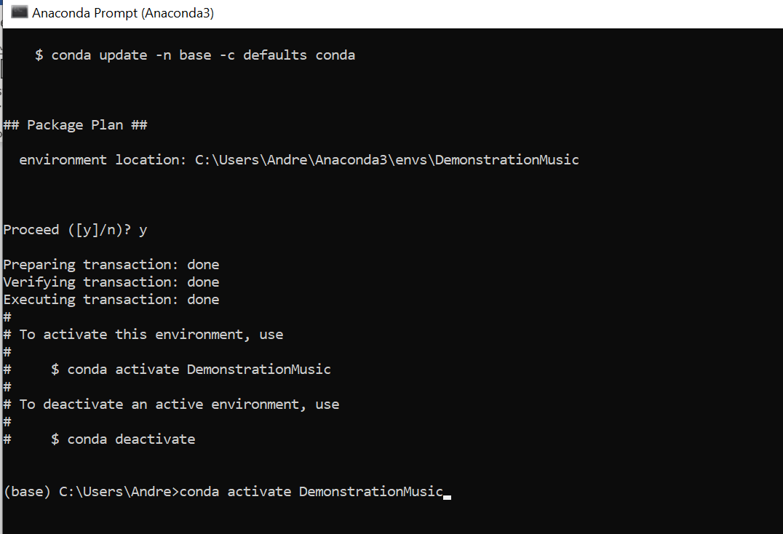
Activate the new Conda environment.

The conda environment has been activated.
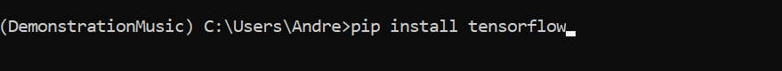
Install all of the necessary packages and libraries. The required libraries for this project are:
- Tensorflow
- Keras
- Music21
- H5py
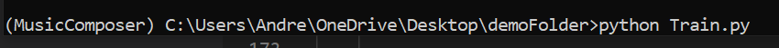
Navigate to the project directory and run the command “python Train.py”.

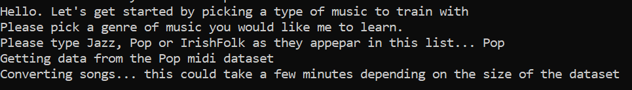
Choose the genre you wish to train the model on.
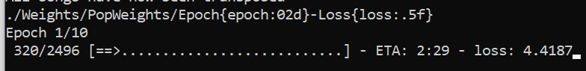
Wait for the neural network to train.
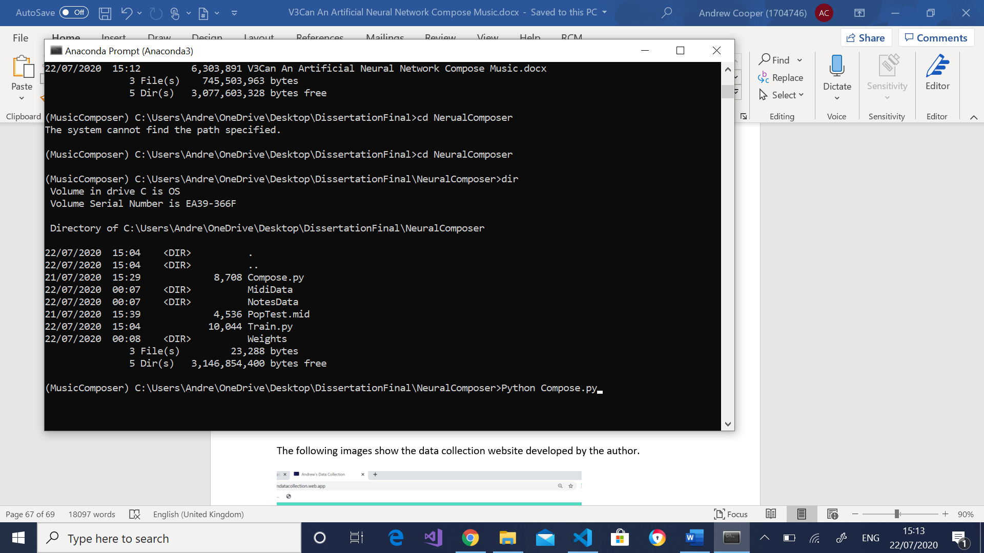
Once the neural network has finished composing, run the compose programme in the conda terminal “python Compose.py”.
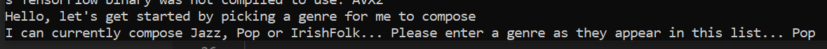
Choose a genre for the model to compose.
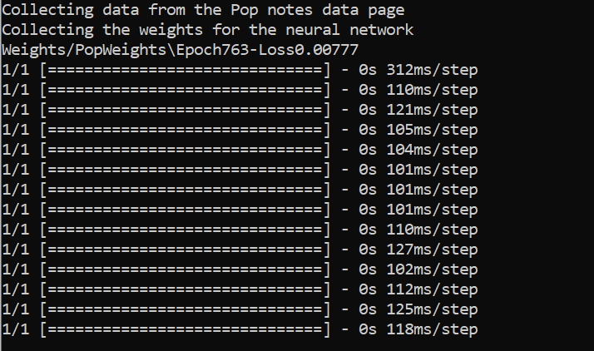
Wait for the model to finish making new predictions.
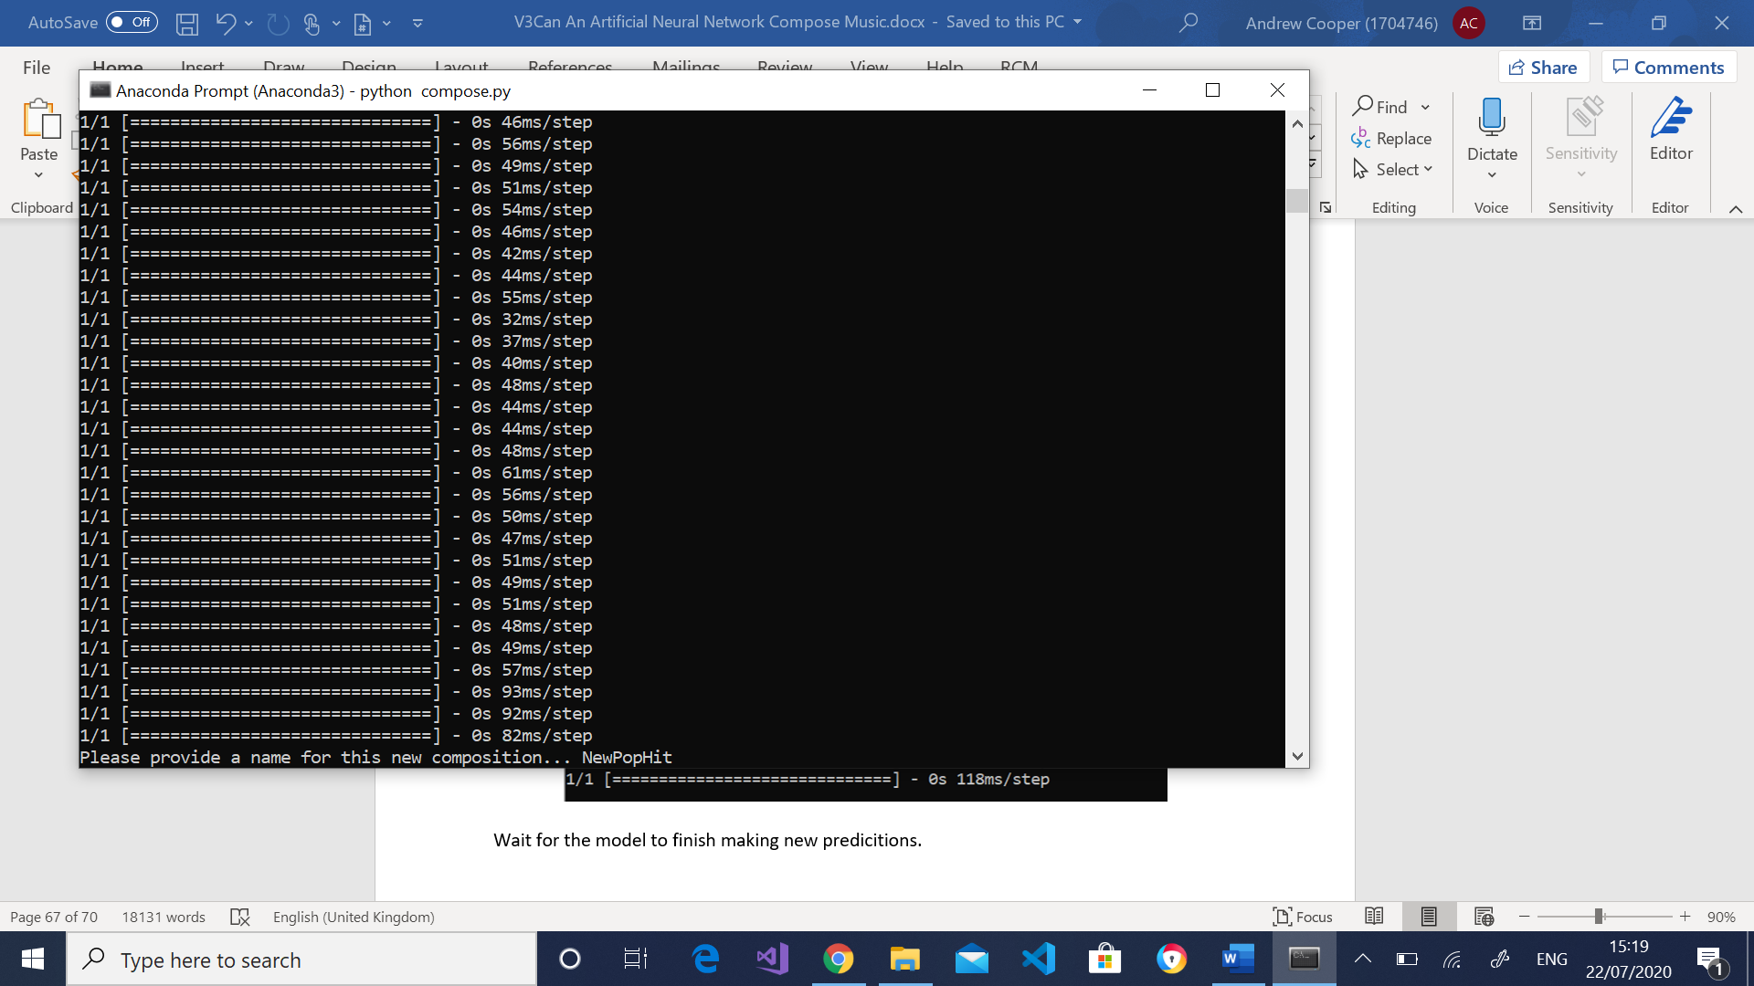
Provide a name for the composition.
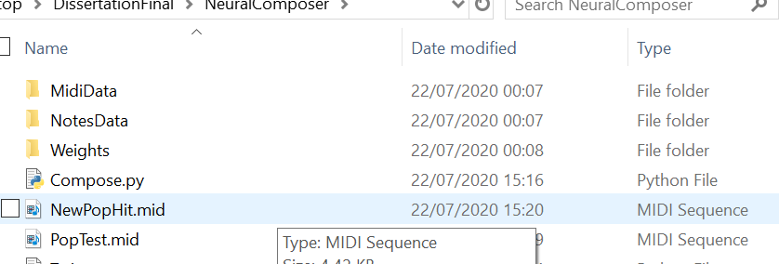
Find the new composition in directory and put this into your chosen digital audio workspace.
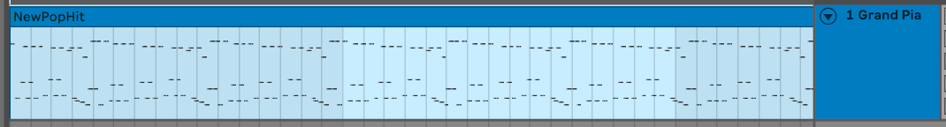
Choose an instrument to interpret the midi file and listen to the new track.

Appendix B: Code Listings

Train.py
"""
Train the network
"""

# Libraries
import glob
import pickle
import numpy as np
import tensorflow as tf
import music21 as m21
from keras.models import Sequential
from keras.layers import Dropout, LSTM, Dense, Activation, BatchNormalization#, CuDNNLSTM
from keras.utils import np_utils
from keras.callbacks import ModelCheckpoint
from keras.optimizers import adam
import time

def main():

print("Hello. Let's get started by picking a type of music to train with")
print("Please pick a genre of music you would like me to learn.")

userInput = input("Please type Jazz, Pop or IrishFolk as they appepar in this list... ")
genre = UserInput(userInput)

############# Get training data from the chosen directory ############
fileHandler = FileHandler(genre)
midiData = fileHandler.GetMidiFromDirectory()
#print(midiData)

############# Pre-processing for dataset ############
dataPreProcess = PreProcess(midiData)

#Convert songs to stream object
streamObjList = dataPreProcess.ConvertDataToStream()

#Transpose songs
transposedSongList = dataPreProcess.TransposeMusic(streamObjList)

#Extract notes from score object
songNotesData = dataPreProcess.ExtractNotesFromScore()
#print(f"song Data {(songNotesData)}")

#Pickle notes
fileHandler.PickleNotes(songNotesData)

#Get length of vocab
dataPrep = DataPrep(songNotesData)
vocabLen = dataPrep.getVocabLen()
#Group together pitches
groupedPitches = dataPrep.GroupPitches(songNotesData)
dictNotes = dataPrep.DictionariseNotes()

#Create training sequences
networkInput, networkDesiredOutput = dataPrep.CreateTrainingSequences()

############ Create the shape of the model ############
modelShape = ModelDefinition(networkInput, vocabLen)
model = modelShape.DefineModel()

########### Train the model ############
TrainNetwork(model, networkInput, networkDesiredOutput, genre)

def UserInput(genre):
while genre != 'Jazz' and genre != 'Pop' and genre != 'IrishFolk':
print("Sorry I haven't got the resources to learn that style yet!")
genre = input("Please choose between Jazz, Pop or IrishFolk as they appear in this list... ")

return genre

def TrainNetwork(model, networkInput, networkDesiredOutput, genre):
filePath = './Weights/' + genre + 'Weights/Epoch{epoch:02d}-Loss{loss:.5f}'
print(filePath)
checkPoint = ModelCheckpoint(filePath, monitor='loss', verbose=0, save_best_only=True, mode='min')

callbackList = [checkPoint]

model.fit(networkInput, networkDesiredOutput, epochs=40000, batch_size=64, callbacks=callbackList)

############ Classes ############
# This class will be used to obtain the data and write to external files #

class FileHandler:
#Attributes
midiSongList = []

#Constructor
def __init__(self, genre):
self._genre = genre

#Properties

#Methods
def GetMidiFromDirectory(self):
print("Getting data from the " + self._genre + " midi dataset")

for i in glob.iglob("MidiData/" + self._genre + "Midi/*.mid"):
self.midiSongList.append(i)

return self.midiSongList

def PickleNotes(self, songNotesData):
#Pickle data to external file
notesFile = open('./NotesData/' + self._genre + 'Notes/NotesPage', 'wb')
pickle.dump(songNotesData, notesFile)
notesFile.close()

###### Data Pre-Processing Class ######
# This class will be used to pre-process the data #

class PreProcess:
#Attributes
songListCon = []
songListTransposed = []
songDataNotes = []

#Constructor
def __init__(self, midiData):
self._midi = midiData

#Properties

#Methods
def ConvertDataToStream(self):
print("Converting songs... this could take a few minutes depending on the size of the dataset")

for i in self._midi:
#convert songs to stream
convData = m21.converter.parse(i)
self.songListCon.append(convData)

print("I have finished converting the songs")

return self.songListCon

def TransposeMusic(self, streamObjList):
print("Transposing songs to key of C major or A minor depending on it's current mode.This could take a few minutes depending on the size of the dataset")

# Loop through dataset and transpose songs from C major or A minor
for i in streamObjList:
# Find current key of an instance
currentKey = i.analyze('key')

if currentKey.mode == 'major':
#Find distance between current key and C major
distanceToKey = m21.interval.Interval(currentKey.tonic, m21.pitch.Pitch('C'))
elif currentKey.mode == 'minor':
#Find distance between current key and A minor
distanceToKey = m21.interval.Interval(currentKey.tonic, m21.pitch.Pitch('A'))
else:
print("Couldn't obtain the mode of the song. Removing sample to reduce potential confusion")
self.songListCon.remove(i)

#Transposed the song by the distance calculated
transposedSong = i.transpose(distanceToKey)

self.songListTransposed.append(transposedSong)

print("All songs have now been transposed")

return self.songListTransposed

def ExtractNotesFromScore(self):

for song in self.songListTransposed:
#Convert each song to a flat file structure and filter out anything that isn't a note or a rest
songFlatStruct = song.flat.notesAndRests

# Loop through track and check for all notes and chords
for note in songFlatStruct:
if type(note) is m21.note.Note:
self.songDataNotes.append(str(note.pitch))
elif type(note) is m21.chord.Chord:
#iterate through notes and join to make chord
self.songDataNotes.append('.'.join(str(notes) for notes in note.normalOrder))

return self.songDataNotes

###### Data Preperation Class ######
# This class will be used to get the data ready to be fed into the neural network #

class DataPrep:
#Attributes
vocabLen = None
sequenceLen = 64
groupedPitches = []
indexedPitches = {}
inputSequences = []
targetOutput = []
networkInput = []
networkDesiredOutput = []

#Constructor
def __init__(self, notesData):
self._notesData = notesData

#Properites
def getVocabLen(self):
self.vocabLen = len(set(self._notesData))

return self.vocabLen

#Methods
def GroupPitches(self, songNotesData):
#Group pitches together
self.groupedPitches = sorted(set(songNotesData))

def DictionariseNotes(self):
#Create a dictionary to store notes/ chords with a respective index value
for i, pitch in enumerate(self.groupedPitches):
#Append index and pitch to dictionary
self.indexedPitches.update({pitch : i})

return self.indexedPitches

def CreateTrainingSequences(self):
#Create training sequences and their desired output #2560
for i in range (len(self._notesData) - self.sequenceLen):
#Create input sequences of 64 notes as i increments it will shift >>
inputSequences = self._notesData[i:i + self.sequenceLen]
#Create the desired output for the sequence i.e. the next note of the sequence
desiredOutput = self._notesData[self.sequenceLen + i]

#Create the dictionary representation of input sequences
self.networkInput.append([self.indexedPitches[char] for char in inputSequences])

#Store the dictionary representation for the desire outputs
self.networkDesiredOutput.append(self.indexedPitches[desiredOutput])

numberofPatterns = len(self.networkInput)

self.networkInput = np.reshape(self.networkInput, (numberofPatterns, self.sequenceLen, 1))

self.networkInput = self.networkInput / float(self.vocabLen)

#one-hot-encode
self.networkDesiredOutput = np_utils.to_categorical(self.networkDesiredOutput)

return self.networkInput ,self.networkDesiredOutput

###### Model Definition Class ######
# This class will be used to define the shape of the model by adding LSTM (CuDNNLSTM layers for GPU, activation functions and optimization layers) #
class ModelDefinition:
#Attributes
model = Sequential()
opt = adam(lr=0.0001, decay=1e-6)

#Constructor
def __init__(self, networkInput, vocabLen):
self._networkInput = networkInput
self._vocabLen = vocabLen

#Properties

#Methods

def DefineModel(self):
# Input layer
self.model.add(CuDNNLSTM(
512,
input_shape=(self._networkInput.shape[1], self._networkInput.shape[2]),
return_sequences=True
))

# Recurrent layers
self.model.add(CuDNNLSTM(512, return_sequences=True,))
self.model.add(CuDNNLSTM(512))

# Transorm data to be between 0 and 1
self.model.add(BatchNormalization())

# Ignore units to help prevent overfitting
self.model.add(Dropout(0.3))

self.model.add(Dense(256))
self.model.add(Activation('relu'))
self.model.add(BatchNormalization())

self.model.add(Dropout(0.3))
self.model.add(Dense(self._vocabLen))

self.model.add(Activation('softmax'))
self.model.compile(loss="categorical_crossentropy", optimizer=self.opt)

return self.model

if __name__ == '__main__':
main()

Compose.py
"""
Code to compose music
"""

# Libraries #
import pickle
import glob
import os
import numpy as np
import music21 as m21
from keras.models import Sequential
from keras.layers import Dense, Dropout, BatchNormalization, LSTM, Activation #, LSTM #CuDNNLSTM for Nvidia graphics card
from keras.optimizers import adam
import time

def main():
# Get the genre from user input
print("Hello, let's get started by picking a genre for me to compose")
genre = input("I can currently compose Jazz, Pop or IrishFolk... Please enter a genre as they appear in this list... ")
genre = CheckGenre(genre)

# Get external data
fileHandler = FileHandler(genre)
notesData = fileHandler.GetNotesData()
networkWeights = fileHandler.GetWeights()

print(networkWeights)

# Prepare data to give to the network
dataPrep = DataPrep(notesData)
vocabLen = dataPrep.GetVocabLen()

availablePitches = dataPrep.GetGroupedPitches()

notesDict = dataPrep.DictionarisePitches()
netInput, normInput = dataPrep.CreateSequences()

# Create the model
model = ModelDef(networkWeights, normInput, vocabLen)
nn = model.BuildModel()

# Compose the song
composer = Composer(nn, netInput, availablePitches, vocabLen)
composition = composer.ComposeSong()

midi = composer.CreateMidi()
title = input("Please provide a name for this new composition... ")

# Write song to midi file to directory
fileHandler.WriteMidiToDir(title, midi)

def CheckGenre(genre):
while genre != 'Jazz' and genre != 'Pop' and genre != 'IrishFolk':
print("Sorry I don't currently know that genre!")
genre = input("Please choose between Jazz, Pop or IrishFolk. Please enter the genre as they appear in this list... ")

return genre

############ Classes ############
class FileHandler:
#Attributes

#Constructor
def __init__(self, genre):
self._genre = genre

#Properties

#Methods
def GetNotesData(self):
print("Collecting data from the " + self._genre + " notes data page")
filePath = "NotesData/" + self._genre + "Notes/NotesPage"

pickleFile = open(filePath, 'rb')
notesData = pickle.load(pickleFile)
pickleFile.close()

return notesData

def GetWeights(self):
print("Collecting the weights for the neural network")
# Loop through directory collecting all files (they will all be weights)
filePaths = "Weights/" + self._genre + "Weights/*"

# Get the latest file to be inserted, this will be the best
weightsList = sorted(glob.iglob(filePaths), key=os.path.getmtime, reverse=True)
bestWeights = weightsList[0]

return bestWeights

def WriteMidiToDir(self, fileName, midiData):
fileName = fileName + ".mid"
midiData.write('midi', fp=fileName)

class DataPrep:
#Attributes
vocabLen = None
sequenceLen = 40
groupedPitches = []
pitchesDictionary = {}
inputSequences = []
outputForSequences = []

#Constructor
def __init__(self, notes):
self._notes = notes

#Properties
def GetNotes(self):
return self._notes

#Methods
def GetVocabLen(self):
self.vocabLen = len(set(self._notes))

return self.vocabLen

def GetGroupedPitches(self):
self.groupedPitches = sorted(set(self._notes))

return self.groupedPitches

def DictionarisePitches(self):
for i, pitch in enumerate(self.groupedPitches):
self.pitchesDictionary.update({pitch : i})

return self.pitchesDictionary

def CreateSequences(self):
for i in range (0, len(self._notes) - self.sequenceLen, 1):
# Create a list of input sequences of notes and chords
inputSeq = self._notes[i:i + self.sequenceLen]
# Get the output (next note / chord) that appears after the sequences
output = self._notes[i + self.sequenceLen]
# Get the integer representation of the notes / chords for the input sequences - based on position in the pitch dictionary
self.inputSequences.append([self.pitchesDictionary[i] for i in inputSeq])
# Get the integer representation of the outputs for the sequences - based on position in the pitch dictionary
self.outputForSequences.append(self.pitchesDictionary[output])

# Get the number of patters
numberOfPatterns = len(self.inputSequences) #2520 sequences

# Reshape
normalizedInput = np.reshape(self.inputSequences, (numberOfPatterns, self.sequenceLen, 1))

normalizedInput = normalizedInput / float(self.vocabLen)

return self.inputSequences, normalizedInput

class ModelDef:
#Attributes
model = Sequential()
opt = adam(lr=0.0001, decay=1e-6)

#Constructor
def __init__(self, weights, normInput, vocabLen):
self._weights = weights
self._normInput = normInput
self._vocabLen = vocabLen

#Properties

#Methods
def BuildModel(self):
self.model.add(LSTM(
512,
input_shape=(self._normInput.shape[1], self._normInput.shape[2]),
return_sequences=True
))

# Recurrent layers
self.model.add(LSTM(512, return_sequences=True))
self.model.add(LSTM(512))

# Transorm data to be between 0 and 1
self.model.add(BatchNormalization())

# Ignore units to help prevent overfitting
self.model.add(Dropout(0.3))

self.model.add(Dense(256))
self.model.add(Activation('relu'))
self.model.add(BatchNormalization())

self.model.add(Dropout(0.3))
self.model.add(Dense(self._vocabLen))

self.model.add(Activation('softmax'))
self.model.compile(loss="categorical_crossentropy", optimizer=self.opt)

self.model.load_weights(self._weights)

return self.model

class Composer:
#Attributes
compLen = 500
predictedNotes = []
offset = 0
newDict = {}
notesForMidi = []
instrument = m21.instrument.Piano()

#Constructor
def __init__(self, model, netInput, pitches, vocabLen):
self._nn = model
self._netInput = netInput
self._pitches = pitches
self._vocabLen = vocabLen

#Properties

#Methods
def NewDictionary(self):
# New format for dictionary
for i, pitch in enumerate(self._pitches):
self.newDict.update({i : pitch})

return self.newDict

def ComposeSong(self):
# Get the number : note dictionary
newDict = self.NewDictionary()

# Create a random seed to start the composition
startNotes = np.random.randint(0, len(self._netInput) - 1)

# Get the sequence from the random int
inputPattern = self._netInput[startNotes]

for i in range(self.compLen):
predSeq = np.reshape(inputPattern, (1, len(inputPattern), 1))
predSeq = predSeq / float(self._vocabLen)

newPrediction = self._nn.predict(predSeq, verbose=1)

index = np.argmax(newPrediction)
res = newDict[index]
self.predictedNotes.append(res)

inputPattern.append(index)
inputPattern = inputPattern[1:len(inputPattern)]

return self.predictedNotes

def CreateMidi(self):
# Loop through the list of notes
for i in self.predictedNotes:
# Check if the notes are a collection to make a chord, if it contains a full stop it's a chord
if ('.' in i):
#Store the notes as seperate values in list
notesCol = i.split('.')
for j in notesCol:
note = note.Note(int(j))
note.storedInstrument = self.instrument
chord = m21.chord.Chord(notesCol)
chord.offset = self.offset
self.notesForMidi.append(chord)
else:
note = m21.note.Note(i)
note.offset = self.offset
note.storedInstrument = self.instrument
self.notesForMidi.append(note)

self.offset += 0.5

midi = m21.stream.Stream(self.notesForMidi)

return midi

if __name__=='__main__':
main()

Appendix C: Images of Data Collection Webiste
The following images show the data collection website developed by the author.



