Mohammed Oliur Rahman
2207462
Marketing Essentials BMIH4005
Christopher Wilkin

Contents
Introduction 3
Company Performance 3
Marketing Communications mix 5
Porter’s five forces 6
Threat of New Entrants: 6
Threat of Substitutes: 6
Bargaining Power of Customers: 6
Bargaining Power of Suppliers: 6
Competitive Rivalry: 6
PESTEL analysis 7
Political factors 7
Economic factors 7
Social factors 7
Technological 7
Environmental factors 7
Legal factors 7
Objectives 8
Segmentation and targeting 8
Strategy 8
Tactics 8
4 P's Marketing mix: 8
Action 9
Marketing channels schedule 9
Control 9
Success measurement 9
Conclusion 10
References 11
Appendix- Power point slides 13

Introduction
Marriott International Inc operates various hotels, timeshare, residential and lodging properties across the globe. In terms of number of rooms, Marriott is the largest Hotel brand in the world. The covid-19 pandemic has negatively impacted the hotel industry across the world (King, 2020). As a result of this, several companies such as Marriott hotels were impacted. Therefore, there is a need to develop a marketing plan to improve the prospects for the company. Current report details the marketing strategy to be adopted to improve the performance of the company.

Company Performance
Even though Marriott International, Inc was severely impacted by the covid-19 pandemic, the company has demonstrated a strong comeback since the second quarter of 2020 (King, 2020). The company has achieved a revenue growth of 34% on a year-on-year basis in the last quarter of 2022 (Marketwatch, 2022).
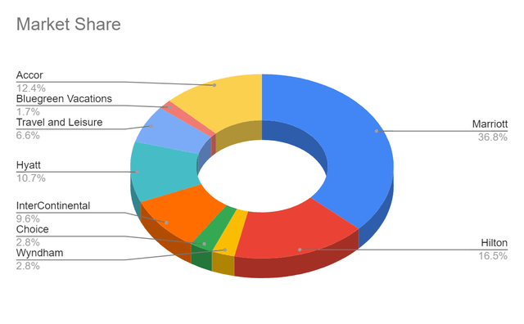
Market Share (Marketwatch, 2022)
The company is demonstrating an increase in operating revenue compared to the previous year.
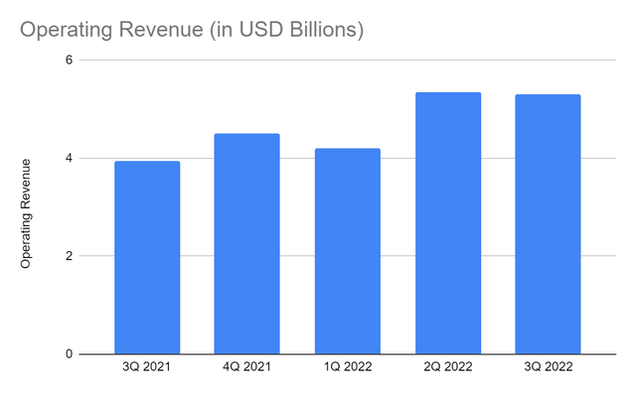
Operating Revenue (Marketwatch, 2022)
Marriott hotels have a 37% market share, which is the highest in the industry. The company’s revenue growth (34%), howeverbelow the industry average of 36%. A comparison of operating margins can be seen below.
Hotel Name | Operating Margin (%)
Marriott | 18
Hilton | 26
Intercontinental Hotels | 20
Hyatt | 10
Accor | 8
(Seekingalpha, 2022)
Marriott has demonstrated impressive performance compared to large players such as Hyatt and Accor. However, small companies such as Hilton and Intercontinental Hotels have shown better performance than Marriott.

Marketing Communications mix
When it comes to the marketing Communications mix of Marriott, the company uses advertising on televisions, and digital platforms (Marriott, 2021). Marriott has identified digital platforms for the future for the company and hence has started to invest increasingly in digital marketing.
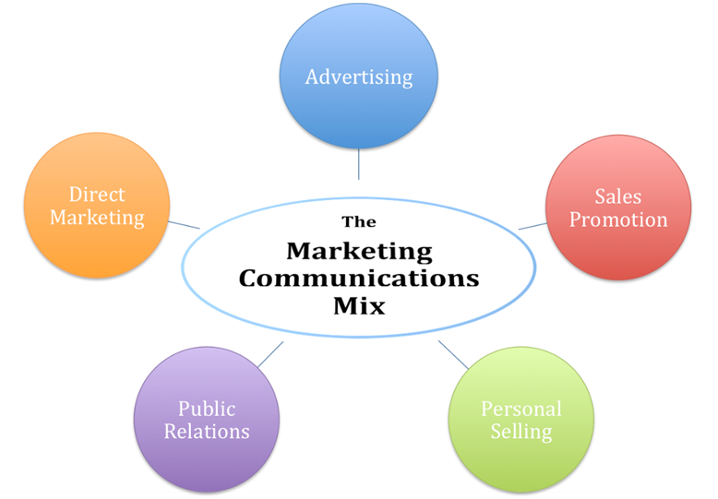
The company also has started an ad media network in partnership with Yahoo (Doty, 2022). The company runs a loyalty program in the name of Marriott Bonvoy. Customers are provided with loyalty points for using the brand’s services. Generating direct sales is the motto behind the loyalty program (Marriott, 2021). Seasonal sales promotions are carried out by the company during periods of low demand, to deliver value to customers and counter the reduced demand.

Porter’s five forces
Porter’s five forces is a strategic tool that presents five forces that shape competition in each industry.

Threat of New Entrants:
Establishing premium hotels requires significant capital investments. Making such investments is difficult for new entrants (Xiong & Yao, 2021). Brand image also plays a key role in the hotel industry. Creating a strong brand image is also difficult for new entrants (Göral, 2015). The threat of new entrants is therefore low.

Threat of Substitutes:
Innovative and unique concepts such as Airbnb, Bubble rooms, and Treehouses are on the rise, and they can act as substitutes for the existing services in the hotel industry (Xiong & Yao, 2021). Therefore, the threat of substitutes is significant in the industry.

Bargaining Power of Customers:
As a result of the covid-19 pandemic, there has been a drop in the demand for hotels (King, 2020). Switching costs are also low resulting in increased bargain power. As a result of this, the bargaining power of customers has increased in the hotel industry.

Bargaining Power of Suppliers:
The presence of multiple suppliers in industry with similar goods and materials makes the bargaining power of suppliers to be low (Citra Birru et al., 2022). Suppliers in the industry value long-term partnerships with hotels. The power of suppliers is low.

Competitive Rivalry:
Prices of hotel rooms are similar in nature. Along with the prices, the services offered by various hotels in the hotel industry are also similar in nature. Competitive rivalry is higher in the luxury hotel industry (Citra Birru et al., 2022). The covid-19 pandemic has also resulted in increased competition among the players of the hotel industry (Xiong & Yao, 2021).

PESTEL analysis

Political factors
The political situation in the UK has become stable after the election of the recent prime minister. It has put an end to the uncertainty that has arisen after the Brexit. Several schemes were announced to support the hotel industry during the covid-19 pandemic (Hancock, 2021).

Economic factors
The economic situation in the UK is characterised by prominent levels of inflation and a slowing down economy (Pezzali, 2022). Decrease in business activity can be negative for the hotel industry. Brexit has also negatively impacted the economy.

Social factors
The social trend to travel abroad for vacation has increased in the emerging economies (Hancock, 2021). This can be an added advantage for businesses operating in the economy.

Technological
There has been an increase in the use of mobile phones and the internet. Introduction of the latest communication Technologies such as 5G is a positive step for the businesses. It would be easier to reach the target audiences with the help of technology (Doty, 2022).

Environmental factors
The Government in the UK is supportive of green practices in accordance with the sustainable development goals of the United Nations (Perry et al., 2021). Alongside, there also has been an increase in preference towards sustainable options among consumers.

Legal factors
The government has formulated several legislations aimed at protecting businesses in the UK. Data protection legislation must be understood and followed by businesses gathering data from customers.

Objectives
The company aims to Improve brand awareness among young individuals looking at alternatives.

Segmentation and targeting
Marriott targets different customers through its assorted brands (Shastri, 2022). Marriott Courtyard is targeted at road travelers. To target businesses that conduct conferences, Marriott conference centers are used by the company. Individuals wishing to have a longer period of stay can make use of Marriott Execustay. Vacation clubs are targeted at tourists.

Strategy
The company can target its marketing activity at the young individuals by making use of Technology. Social media has numerous benefits to offer such as precise targeting, ability to obtain feedback and cost effectiveness (Doty, 2022). Therefore, social media would be used to reach the target audiences. The cost benefits because of using social media can be passed on to the customers.

Tactics

4 P's Marketing mix:
Product - Budget friendly rooms will be provided for the target audience, who will be the younger generation.
Place (Distribution) – Digital marketing will be used to reach the target audience.
Price – A value-based pricing will be provided to the customers considering the economic climate and the purchase power of the customers.
Promotion – Along with digital marketing, social media, and TV advertising, a Loyalty program will be implemented to promote the services of Marriott.

Action
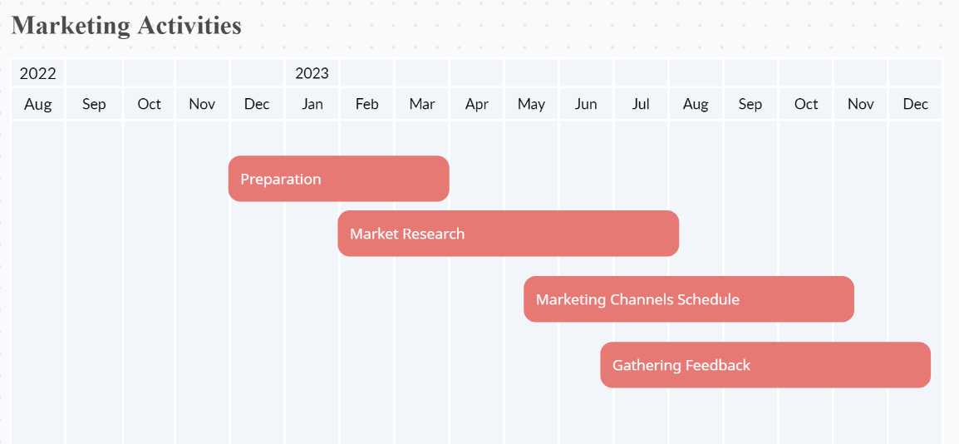
Gantt chart for marketing activities

Marketing channels schedule
The target customers are young individuals who make extensive use of technology. Therefore, it would be advantageous to reach such individuals using digital marketing platforms. Therefore, the marketing strategy will make use of technology and digital marketing to reach the target customers

Control
A Unique Selling Proposition offered by Marriott Hotels is the value offered to young people with a strong brand image. Customers can benefit from increased value for their money as well as improved quality of service.

Success measurement
Success with the Marketing activities can be measured by an increase in the number of young individuals using the services of Marriott hotels. Alongside, a positive brand image in the eyes of young individuals can also demonstrate a successful marketing campaign.

Conclusion
By implementing the identified marketing strategies, it will be possible for Marriott hotels to improve its prospects in terms of reaching young people. Young individuals will be able to better understand the brand and use its services. The identified strategy not only helps reduce the costs but also is effective at reaching the target customers.

References
Citra Birru, A., Sudarmiatin, S. and Hermawan, A. (2022) “Competitive strategies in the lodging service sector: Five Porter analyses and case study SWOT analysis,” Journal of Business and Management Review, 3(1), pp. 001–017. Available at: https://doi.org/10.47153/jbmr31.2732022.
Doty, D. (2022) The era of consumer-driven digital discovery: What is replacing search, Forbes. Forbes Magazine. Available at: https://www.forbes.com/sites/daviddoty/2022/11/06/icymi-the-digital-ad-news-you-havent-been-reading-and-what-youre-missing-as-a-result/?sh=29beca86591c (Accessed: December 6, 2022).
Göral, R. (2015) “Competitive analysis of the hotel industry in Konya by using Porter’s five forces model,” European Journal of Economics and Business Studies, 3(1), p. 106. Available at: https://doi.org/10.26417/ejes.v3i1.p106-115.
Hancock, A. (2021) UK hospitality industry yet to recover to pre-covid trading levels, subscribe to read | Financial Times. Financial Times. Available at: https://www.ft.com/content/ac6266ed-3977-4d51-88bf-d60768ee8c7a (Accessed: December 6, 2022).
King, B. (2020) In the face of a pandemic, Marriott leans on its values, The Wall Street Journal. Dow Jones & Company. Available at: https://deloitte.wsj.com/articles/in-the-face-of-a-pandemic-marriott-leans-on-its-values-01607112132 (Accessed: December 6, 2022).
Mar: Marriott International Inc. annual income statement (2022) MarketWatch. MarketWatch. Available at: https://www.marketwatch.com/investing/stock/mar/financials?mod=mw_quote_tab (Accessed: December 6, 2022).
Marriott (2021) Annual Report | Marriott International, Marriott. Marriott. Available at: https://marriott.gcs-web.com/static-files/b82978a6-9d28-4e38-9855-fc4ae2cebe11 (Accessed: December 5, 2022).
Perry, B. et al. (2021) “Localizing the sdgs in england: Challenges and value propositions for local government,” Frontiers in Sustainable Cities, 3. Available at: https://doi.org/10.3389/frsc.2021.746337.
Pezzali, A. (2022) U.K. inflation reaches 10.1% as Government U-Turns Cloud Outlook, The Wall Street Journal. Dow Jones & Company. Available at: https://www.wsj.com/articles/u-k-inflation-reaches-10-1-as-government-u-turns-cloud-outlook-11666166026 (Accessed: December 6, 2022).
Seekingalpha (2022) Marriott International: Cozy Fundamentals with a costly stock (NASDAQ:mar), SeekingAlpha. Seeking Alpha. Available at: https://seekingalpha.com/article/4561644-marriott-international-mar-cozy-fundamentals-costly-stock (Accessed: December 6, 2022).
Shastri, A. (2022) Detailed marketing strategy of Marriott International - A Case Study, IIDE. IIDE. Available at: https://iide.co/case-studies/marketing-strategy-marriott-international/ (Accessed: December 6, 2022).
Xiong, X. and Yao, R. (2021) “Strategic analysis of the catering industry under covid-19: A case study in China,” E3S Web of Conferences, 253, p. 01047. Available at: https://doi.org/10.1051/e3sconf/202125301047.

Appendix- Power point slides

