Guidance Handbook for Early Years Practitioners: Transitions

‘’Children are like tiny flowers; they are varied and need care but each one is beautiful alone and glorious when seen in the community of peers’’.

(Froebel, no date)


(Source: Pixabay, no date)

Emily Jennison-Mason 2007577
Human Development
EAEE4003

Contents Page no.

1. Introduction: Transition into the Early Years Education. 3-4

2. How to use the guidance handbook. 4

3. Role of the adult. 5-6

4. The needs of the child 7-8

5. Partnerships 8-9

6. Interventions 9

7. Proposed Outcomes 10

8. Reference List 11-14

Introduction

Definition of Transition – A transition is a process or period from when one changes state or condition to another. ‘A student who is in transition is going from one programme to another’ (Oxford dictionary 2018).
Children will experience several transitions in their lifetime, this can be anything from attending nursery from their home life or starting full time school. Transitions is something can and will continue into and throughout adulthood. It is important to remember that each child will have a different experience or understanding when starting at school, some may have previously attended a nursery setting while for others it may be their first time being away from their home. Traditionally many preschools and primary school settings have adopted the staggered start approach for which this is a period for the children to settle into their new setting before building up a full-time attendance. The settling in phase varies between settings and are at the discretion of each setting, by doing this intends to assist teaching staff to settle the children into their new environment and to help parents understand the purpose and arrangement of what happens when their child attends the setting. Transition is the means of which children have a smooth change from one setting or stage to another. It is important that both the care givers of the child and staff work together with a positive attitude to support the child during the transition period. (Department of Education 2015).
Bronfenbrenner (1979) argues that if a transition is run smoothly then there would be a better success at transition in later life and that a poor transition would naturally traumatise a child in future transitions, he states how important a parent to teacher relationship is by arguing that a parent being as involved as possible with school life would have a successful reflection on the child for their overall growth. Bronfenbrenner (1979) created an ecological system theory to explain how everything in a child’s life can effect a child’s development. The main goal of a transition is to make the child feel a sense of belonging and well-being.

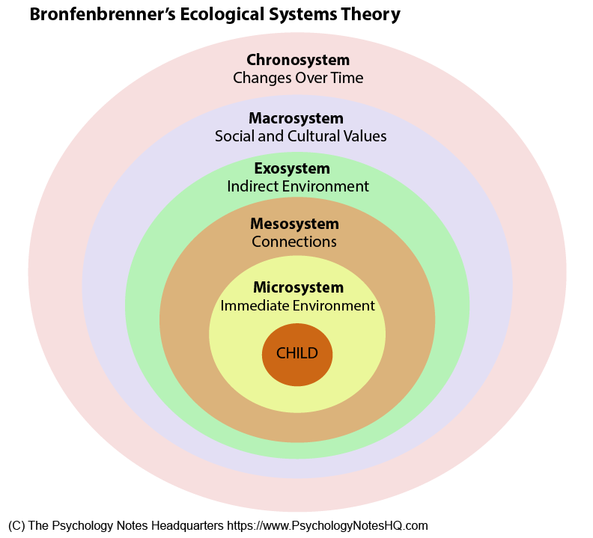
(Source: The
Psychology Notes
HQ 2020)

Research and practise identified that everybody involved in the transition phase is to have a full understanding of their role and how this can relate to the child’s individual needs, this can involve helping the child to build confidence to manage the change and to develop their self-esteem and independence. (Belfast Education and Library Board 2011).

How to use this handbook
This handbook is specially designed for key workers within nursery school settings for children aged 3-5. The main aim of this handbook is designed to provide guidance to Early Years Practitioners to understand and support a smooth transition while providing useful guidance on how to support the child and the family of the child during a transition into a school setting. This handbook also provides information to understand the importance of effective communication for the child’s learning and development during a transition, how an effective partnership and the role of the adult is supported to provide a smooth transition.
Role of the key worker - As suggested by pacey (no date) a key worker is somebody who ensures the child’s needs are met, the person the child should feel most comfortable around while being the person the child can trust and rely on.
The key aim of any transition is making sure the child and the child’s family are supported in a way they feel most comfortable at their new surroundings. Kirklees Research Project (2004) evidence states that all practitioners involved in a child’s transition must understand the importance of the impact a transition can withhold on a child, Kirklees Research Project (2004) suggest that a child will feel happier and more comfortable within a setting they are familiar with other peers.

‘The effectiveness and quality of programmes depends largely on communication and collaboration between all people involved in the process’ (Margetts, K 2004)

Role of the adult
It is the role of the adult to care and help the child understand the level of changes that are happening while supporting the child’s mental well-being, be supportive, attentive and nurturing. It is vital that the teacher in charge is aware of any developmental delays within the child’s needs, this will ensure the child’s needs are met accordingly (Welsh Government 2018). Gelfer (2012) insists that an honest and open communication channel between care givers and practitioners is a vital part of the child’s development, build an honest and open partnership with the child’s care givers. While caring for the child’s needs the key worker/practitioner must ensure that safeguarding procedures are also followed to make sure children are kept safe from harm. The keyworker/practitioner must recognise any safeguarding issues and know who to report them to. (Welsh Government 2014). According to the General Data Protection Regulation (2018) anybody involved with the child must follow the correct procedure on remaining confidential, any information about the child or their family must remain confidential unless it MUST be shared to multi-agencies, for example you may need to share information or concerns you have about the child. The child will have the same rights as an adult when it comes to privacy, this is also supported by The United Nations Convention on the Rights of The Child Article 16. When preparing for a child to begin at the setting it is important to remember that the preparation is not about assessing the child’s academic skills, it is about helping the child develop positive self esteem and confidence. A positive disposition will promote a child’s readiness for starting school. (Central Bedfordshire no date). Primary schools may require to put in place additional arrangements to cater for the individuals needs, including Special Educational Needs, the care givers of the individual must be informed of any additional arrangements made to help the child settle into the setting. (Department of Education (2015).
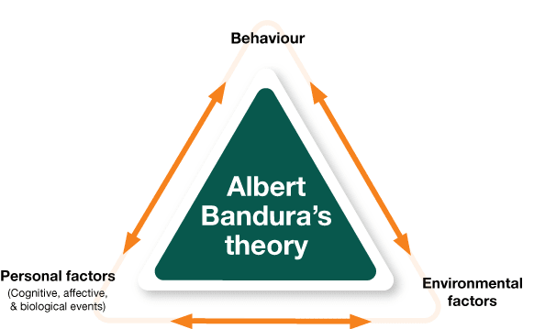
Bandura (1977) social theory suggests that children will mimic adults and peer’s behaviour, adults are the most influential models when it comes to a child’s development, he states that adults around the child will often respond to the child’s behaviour positively or negatively, it is likely that if the response is positive the child is more likely to imitate the behaviour.

(Source: Anaferana 2009)

The teacher in charge may take charge of leading roles during a transition, these roles include - (Flying Start 2017)
- Arranging visits for parents/caregivers so they can have a tour around their child’s new setting.
- Making sure all paperwork is complete in time for the child to attend the setting.
- Discussing any needs the child may have with the parents/caregivers.
- Communicating with specialist staff such as Addition Educational Needs (if there is a requirement to do so).
- Making sure the setting is up to date with Foundation Phase Policy and Guidance to support smooth transitions.
- Ensuring individuals are settling into their new setting comfortably.

As the key worker/practitioner it will be important to communicate within the team, ensure that any concerns are raised. Estyn (2018) state that teamwork and communication often lead to a high-quality teaching which helps the staff to work more effectively within the setting.

Key principles for a supporting a smooth transition.

- Recognise that all children may be vulnerable in times of change and uncertainty.
- Maintain positive relationships, listen and communicate effectively with the child’s caregivers, offer opportunities to the care givers to visit the setting, access the transition process and have regular contact sessions. Work together to establish one another’s aims, purpose and philosophy.
- The emotions of a child that comes with change can be handled by the child successfully when the setting has a clear welcoming procedure.
- Children will develop at their own pace, it will be important to ensure consideration is given to the child’s holistic needs.
- The keyworker will have a particular role to play in supporting and preparing the child for transition, particularly children who may experience feelings of sadness before leaving a setting they are familiar with to attend a new setting.
- Acknowledge the child’s relationships with both children and adults, try and place children in a class with those they are familiar with, by doing this will help the child settle in.

(Central Bedfordshire, no date)

The needs of the child

Maslow Hierarchy of needs theory suggests that we have 5 categories of needs, such as physiological, safety, love, esteem, and self-actualization. In this theory it is suggested that once an individual has sufficiently satisfied the need, they will then begin to emerge higher needs in the hierarchy. Maslow states that all though teaching staff may not be able to meet all the child’s needs in the hierarchy it is important to satisfy many aspects as possible in order to help the individual feel safe. It is also said that teachers must foster an environment that allows healthy levels of risk-taking, an individual must not feel fearful or judged, offer the individual thought sharing sessions or an activity where there is question asking and answering session, this will help the child speak more freely and build upon a trust-based relationship with the teacher or practitioner, by doing this allows the child to have a sense of psychological and emotional safety within the setting.

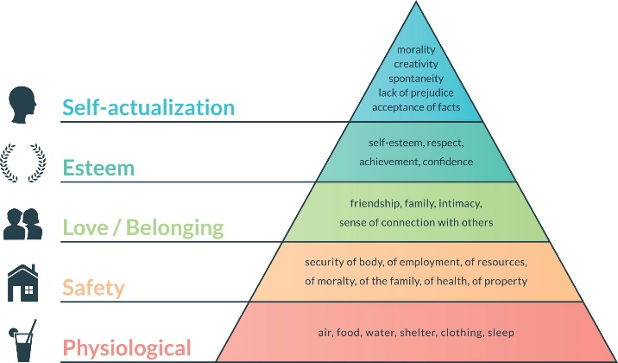

(Source: ThoughtCo. no date)
“The fact is that people are good. Give people affection and security, and they will give affection and be secure in their feelings and their behaviour.” Maslow (no date)

Starting at primary school can be a very exciting time for children but also a very anxious time, for many children starting school could be one of the first occasions they will be without their caregiver. Studies suggest that it is common for children to feel a sense separation anxiety, this phase is usually temporary and managed between parents and staff. (Mentally Healthy Schools no date) It is important to recognise that all children will feel vulnerable in times of change, in particular those children with Special Educational Needs (SEN), Additional Learning Needs (ALN) or a child that is within the care system it will be vital that the setting plans additional support. (Oxfordshire County Council) According to the UNCRC every child has rights at school and in the wider community, a child must feel a sense of safety and comfort within their setting, ensure that the child’s needs and rights are met, effective communication with the child’s keyworker may make the child feel more comfortable and he/she will then be able to speak more freely or any feelings they may be experiencing.
The Welsh Assembly Government Play Policy (2002) adopted a policy to demonstrate the importance of play in childhood in our society, the policy ensures that the child’s needs are central, and that provision is made to meet the needs of the child in order with the United Nations Convention on the Rights of the Child Article 31. The Welsh Assembly Government believes that:
- Play is a learning process within childhood development, children will display a natural desire to play. It will be beneficial the child to play within a natural environment to learn and explore the world.
- Play is the first learning process of the child’s self-directed learning that has a validity for all ages of children. Children should have access to a free-range environment with the opportunity to play.
- A child to have the opportunity to play freely with enrich their learning and well-being development.
- An essential part of a child’s learning and development is to play freely while offering a child to explore environments freely through the child’s chosen play.
- Play is fundamental factor to a child’s physical, social, mental, emotional, and creative skills, society should create and explore opportunities to support this.

Partnerships
Parent to teacher partnerships is said to be the key to a successful early year’s transition, it is usually the role of the key worker to ensure a effective relationship between the parents and the setting is built. Parents know their children the best and usually the child will be most comfortable whilst in the company of his/hers care givers, sharing information or concerns regarding the child will help to improve the individuals needs and development. If a child see’s his/her care givers feel comfortable around the staff at the setting it is more likely the child will feel safer and secure within the setting. (Early Years Careers 2016) As a practitioner at a setting it will be important to communicate effectively with your team, ensure everybody is aware of new or updated information on the child and the child’s development, effective communication will be key, appreciate others within the team may not always have the same opinion as you and provide time to share sufficient information. (Sage Publishing 2007)
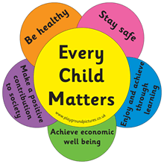
Every Child Matters (2008) state that multi-agency partnerships is an essential link between education and agencies to promote educational achievement. The Government encourage settings to collaborate with one another to achieve the five ECM outcomes which include maintaining the child’s health and well-being.

(Source: Trinity Youth Association no date)

Multi-agency working often will bring professionals from a range of agencies together, this is said to be a good working practice. Communicating effectively between the correct agencies will help to fulfil a family’s needs from a holistic perspective, ensure all agencies contribute to create a plan of action to achieve a care plan which meets the child’s needs. Families First and Team Around the Family (TAF) is a new programme that promotes the development by all local authorities of effective multi-agency systems. Multi-agency working may include professions from these sectors - health visitor, SENco, speech & language therapists, physiotherapist, local authorities. It is paramount to receive permission off the child’s caregiver to work with multi-agency. (Welsh Government no date)

Interventions
Often in a classroom the teacher in charge will take steps to help the individual improve in any areas of need, the individual may be observed to identify the areas of learning that may need improving. The key factors of classroom intervention will include to be proactive, intentional, formal, and flexible. Early intervention may also be introduced to an individual to minimize any educational delays. (The Edvocate no date)
Early intervention will provide effective early support for the individual, often early intervention may prevent any issues reoccurring, it is argued that early intervention works at its best when offered to those of a younger age or in the early years. Evidence shows that effective interventions will improve a child’s life chances at any point through childhood and adulthood. The early intervention approach tends to focus on four aspects of a child’s development, physical, cognitive, behavioural, and social and emotional development where it has the full potential to achieve the biggest difference and provide benefits through a person’s life.

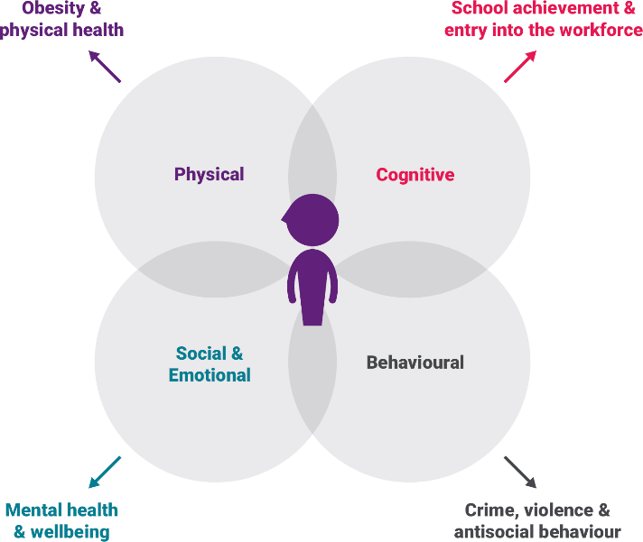

(Source: Early Intervention Foundation no date)
Proposed outcomes
It is important to remember that a transition into a new setting can be hard for some children and its important to understand that some children can adapt to new surroundings better than others, a positive transition will ensure that children have the best possible start in their new setting, often a poor transition can have a lasting effect on a child’s academic, emotional, and social development (Trodd, 2013, p.30)
Early Years Development and Assessment Framework (2015) procedure which is more commonly known as EYDAF which coincides with the Early Years Framework Baseline approach (2017) supports assessment of children’s learning and development, by observing children as they explore, play and learn practitioners will be able to determine that the individual as at the expected stage of development. If the practitioner has any concerns on the child’s development, they must inform the teacher in charge to begin assessments and observations, the observations will take place both spontaneously and at set tasks, the teacher in charge will conduct the observations by using a digital camera to record any evidence and assessment sheets.
Lev Vygotsky (1896) theory of cognitive learning is suggested to be implemented by a setting, in the theory Vygotsky focuses on the importance of social interaction and imaginative play, he believed that to engage a child will help them discover the meaning of things.
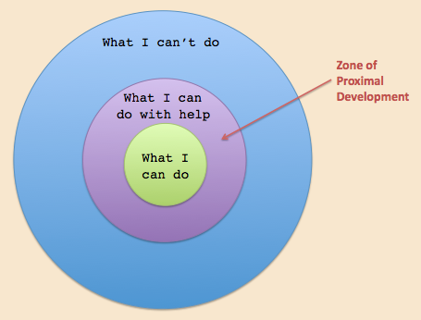

(Source: Instructional Design 2020)

Reference List

Anaferama (2009) Web Plagiarism: Empirical Study. [image] Available at - http://anaferana.blogspot.com/2013/02/article-review-web-plagiarism-empirical.html [Accessed on 10/11/2020]
Belfast Education and library board (2011) Early Years Learner Support Handbook. Available at - https://moodle.uwtsd.ac.uk/pluginfile.php/86467/mod_resource/content/1/Transitions%20handbook.pdf [Accessed on 06/11/2020]
Central Bedfordshire (no date) Smooth Transitions in the Early Years: a Good Practice Guide. Available at - https://www.centralbedfordshire.gov.uk/migrated_images/transition-guidance-pack-2015_tcm3-20762.pdf [Accessed on 11/11/2020]
Country Background Report – Wales (2018) Transitions from Early Childhood Education and Care to School. Available at - http://www.oecd.org/education/school/SS5-country-background-report-wales.pdf [Accessed on 08/11/2020]
Department of Education (2015) Guidance on Induction and Transition Pre School Education. Available at - https://www.education-ni.gov.uk/sites/default/files/publications/de/guidance-on-induction-and-transition-pre-school-education-and-year-1.pdf [Accessed on 05/11/2010]
Department for Education (2017) Statutory framework for the early years foundation stage. Available at - https://assets.publishing.service.gov.uk/government/uploads/system/uploads/attachment_data/file/596629/EYFS_STATUTORY_FRAMEWORK_2017.pdf [Accessed on 17/11/2020]
Early Intervention Foundation (no date) What is early intervention? Available at - https://www.eif.org.uk/why-it-matters/what-is-early-intervention [Accessed 17/11/2020]
Early Years Careers (2016) Why parent partnerships are so important. Available at - https://www.earlyyearscareers.com/eyc/early-years-practice/parent-partnerships-important/#:~:text=Parent%20partnerships%20are%20key%20to%20a%20successful%20early,other%20points%20such%20as%20meetings%20to%20discuss%20development. [Accessed on 15/11/2020]
Education Library (2020) Maslow’s Hierarchy of Needs in Education. Available at - https://educationlibrary.org/maslows-hierarchy-of-needs-in-education/ [Accessed on 13/11/2020]
Estyn (2018) Teamwork leads to high quality teaching. Available at - https://www.estyn.gov.wales/effective-practice/teamwork-leads-high-quality-teaching [Accessed on 11/11/2020]
Everyday Power (no date) Famous Abraham Maslow quotes on the hierarchy of needs. Available at - https://everydaypower.com/abraham-maslow-quotes/ [Accessed on 13/11/2020]

Frobel, F. (no date) Words of Friedrich Frobel. Available at - http://www.froebelweb.org/fblquote.html [Accessed on 04/11/2020]

Gracepoint (1979) Urie Bronfenbrenner Child Development. Available at - https://www.gracepointwellness.org/28-child-adolescent-development-overview/article/7930-urie-bronfenbrenner-and-child-development [Accessed on 06/11/2020]

Instructional Design (2020) Social Development Theory (Lev Vygotsky). [image] Available at - https://www.instructionaldesign.org/theories/social-development/ [Accessed on 18/11/2020]

Mentally healthy schools (no date) Transitions. Available at - https://www.mentallyhealthyschools.org.uk/risks-and-protective-factors/school-based-risk-factors/transitions/# [Accessed on 14/11/2020]

NSPCC (2018) The General Data Protection Regulation. Available at - https://learning.nspcc.org.uk/child-protection-system/children-the-law#heading-top [Accessed on 12/11/2020]

Oxfordshire County Council (2017) Smooth Transitions in the Early Years: A Good Practice Guide. Available at - https://www2.oxfordshire.gov.uk/cms/sites/default/files/folders/documents/childreneducationandfamilies/informationforchildcareproviders/Toolkit/goodpractice/EYTransitionPack.pdf [Accessed on 14/11/2020]

Oxford Dictionary (2018) Definition of transition noun. Available at - https://www.oxfordlearnersdictionaries.com/definition/english/transition_1?q=transition [Accessed on 05/11/2020]

Pacey (no date) Role of the Key Person. Available at - https://www.pacey.org.uk/membership/pacey-membership-benefits/a-taste-of-membership/role-of-the-key-person/ [Accessed on 09/11/2020]

Pixabay (no date) Sunflowers. [image] Available at - https://pixabay.com/illustrations/sunflower-sun-summer-blossom-bloom-2351489/ [Accessed on 04/11/2020]
Sage Publishing (2007) Professional Standards for Teachers and multi-professional working. Available at - https://uk.sagepub.com/sites/default/files/upm-assets/26711_book_item_26711.pdf [Accessed on 15/11/2020]

Simply Psychology (2016) Albert Bandura Social Learning Theory. Available at - https://www.simplypsychology.org/bandura.html#:~:text=In%20social%20learning%20theory%2C%20Albert%20Bandura%20%281977%29%20agrees,the%20environment%20through%20the%20process%20of%20observational%20learning [Accessed on 09/11/2020]
The Edvocate (no date) Types Of Classroom Interventions. Available at - https://www.theedadvocate.org/types-of-classroom-interventions/#:~:text=There%20are%20four%20key%20components%20of%20classroom%20intervention%3A,methods%20based%20upon%20the%20needs%20of%20the%20student. [Accessed on 16/11/2020]
The Psychology Notes HQ (2020) Online Resources for Psychology Students. [image] Available at https://www.psychologynoteshq.com/bronfenbrenner-ecological-theory/ [Accessed on 07/11/2020]
ThoughtCo. (no date) Abraham Maslow Quotes About Psychology. [image] Available at - https://www.thoughtco.com/abraham-maslow-quotes-2795686 [Accessed on 12/11/2020]
Trinity Youth Association (no date) Every child matters. [image] Available at - http://www.trinityyouth.org.uk/about-us/ecm [Accessed on 16/11/2020]

Trodd, L, (2013) Transitions in the Early Years: Working with Children and Families. SAGE Publications LTD.
Udemy (2020) Vygotsky’s Theory of Cognitive Development. Available at - https://blog.udemy.com/vygotskys-theory-of-cognitive-development/#:~:text=Vygotsky%E2%80%99s%20theory%20of%20cognitive%20development%20centered%20on%20the,create%20meaning%20from%20the%20things%20that%20they%20discover. [Accessed on 18/11/2020]

UNICEF (no date) A Summary of the UN Convention on the right of the child. Available at - https://www.unicef.org.uk/child-rights-partners/wp-content/uploads/sites/3/2016/08/CRC_summary_leaflet_Child_Rights_Partners_web_final.pdf#:~:text=article%2023%20%28children%20with%20a%20disability%29%20A%20child,can%20to%20support%20disabled%20children%20and%20their%20families. [Accessed on 12/11/2020]
Welsh Government (2015) Early years foundation stage statutory framework (EYFS) Available at - https://www.gov.uk/government/publications/early-years-foundation-stage-framework--2 [Accessed on 17/11/2020]

Welsh Government (2017) Flying Start Transitions Guidance. Available at - https://gov.wales/sites/default/files/publications/2019-07/flying-start-transition-guidance-for-professionals.pdf [Accessed on 10/11/2020]

Welsh Government (2014) Safeguarding Children in Education. Available at - https://gov.wales/sites/default/files/publications/2018-11/safeguarding-children-in-education-handling-allegations-of-abuse-against-teachers-and-other-staff.pdf [Accessed on 11/11/2020]
Welsh Government (no date) Theme 5: Developing community partnerships and multi-agency working Resources 1–2. Available at - https://gov.wales/sites/default/files/publications/2018-12/theme-5-developing-community-partnerships-and-multi-agency-working-resources-1-2.pdf [Accessed on 16/11/2020]
Welsh Government (2002) Welsh Assembly Government Play Policy. Available at - https://moodle.uwtsd.ac.uk/pluginfile.php/86481/mod_resource/content/1/playpolicye.pdf [Accessed on 19/11/2020]

