

Student Name: Carla Silva
Student ID: 2333077

Module name: Building your Personal Brand for Sustainable Employment
Module code: BMHP5015_LON
Lecturer name: Caroline Salami

Tablet of content

Introduction..................................................................................pag.1,2
Task1...........................................................................................pag.3,4,5
Task2............................................................................................pag.6,7,8
Task3.............................................................................................pag9,10,11
Task4............................................................................................pag12,13,14
Conclusion....................................................................................pag15
References...................................................................................pag16,17

Introduction
This assignment analyzes what I learned from the module’s four sections and how they have helped me advance in the field of health and social care. I studied a number of important topics during the course, such as resilience, work-life balance, ambition, networking, emotional intelligence, boundaryless careers, technology adaptability, and mentoring. These subjects have made it easier for me to see the value of both professional and personal development in a challenging and chaging industry.
I’II show how these courses have hepled me develop my personal brand, sharpen my interpersonal and communication abilities, and get ready for a flexible, boundless future. I’ll also talk about how networking and international ties open doors for career advancement, emphasizing how crucial it is to maintain wellbeing in order to acheive lon-term sucess.
In general. This assigment will demostrate how my education has improved my self-assurance, flexibility, and preparedness to operate well in health and social care settings.

Task1
I analyze what I learnet in Unit 1 and how these concepts can help me grow both personally and professionally in this section. The unit covered a number of significant subjects, including self-awareness, emotional intelligence, boundaryless careers, ambition, and recognizing one’s own abilities. These ideas made it easier for me to comprehend how people can build strong personal and advance professionally.
I completed the assignments in class to learn about autonomy and its significance in the fields of health and social care.
In the context of health and social care, autonomy refers to the ability to manage one’s own health and care requirements with self-governance, indepedent decision-making, and moral discretion. Autonomy in critical care nursing is exemplified by nurses’ capacity for autonomous clinical decision-making, responsability, and critical thinking to solve issues and develop patient care (Okpaluba, F. et al. 2025).
Another crucial idea is self determination, which is related to lifes purpose. According to Pink’s notion of autonomy, mastery and purpose gaining more insight into what drives each of us can be beneficial for both individuals and the organizations they work for. Higher job satisfaction, better performance, and enhanced productivity should result from fostering an environment where individuals feel they are contribuing and are invested in the outcome, whether at work, in an educational setting, on a sports team, or somewhere else (Vocational Training, 2024).
Among the most important lessons I used waay was the value of ambition. Ambition is essential to sucess because it inspires peolple to set objectives and put in the necessary effort to achieve them. An ambitious person is more inclined to take calculated chances and keep pursuing their objectives in the face obstacles. Although sucess frequently necessitates perseverance, patience, and the capacity to oevercome challenges, yhis resolve and resilience are crucial. Knowing the importance of ambition made it clear to me that having a good outlook and being highly motived can have a big impact on on’es own development.
The idea of a profession with no boundaries was another covered in Unit 1. A person with a boundaryless career is not restricted to working in a single company, industry, or position for the whole of their life. Instead, when they acquire new abilities and interests, people may switch between other industries, roles, and opportunities. This concept emphasizes the values of flexibily and ongoing education. People must be adaptable and willing to consider new employment in other industries, roles, and opportunities. This concept emphasizes the value of flexibility and ongoing education. People must be adaptable and willing to consider new employment opportunities that can advance their professional and personal development in the ever-cahnging world of today (Karakus, F. 2021).
Mobility, in which individuals transced organizational boundaries and take responsibility for their professional development based on their own standards, requirements, and values rather than relying on organizational structures, is the fundamental idea of boundaryless careers (Karakus, F. 2021).
Emotional intelligence, which is the capacity to comprehend, control, and communicate on own emotions as well as those of others, was also covered in this course. In fields such healthcare, nursing, and medicine, where workers must effectively communicate and demonstrate empathy for patients and coworkers, emotional intelligence is especially crucial. In both personal and professional contexts, increasing emotional intelligence can enhance relationships, collaboration, and decision-making.
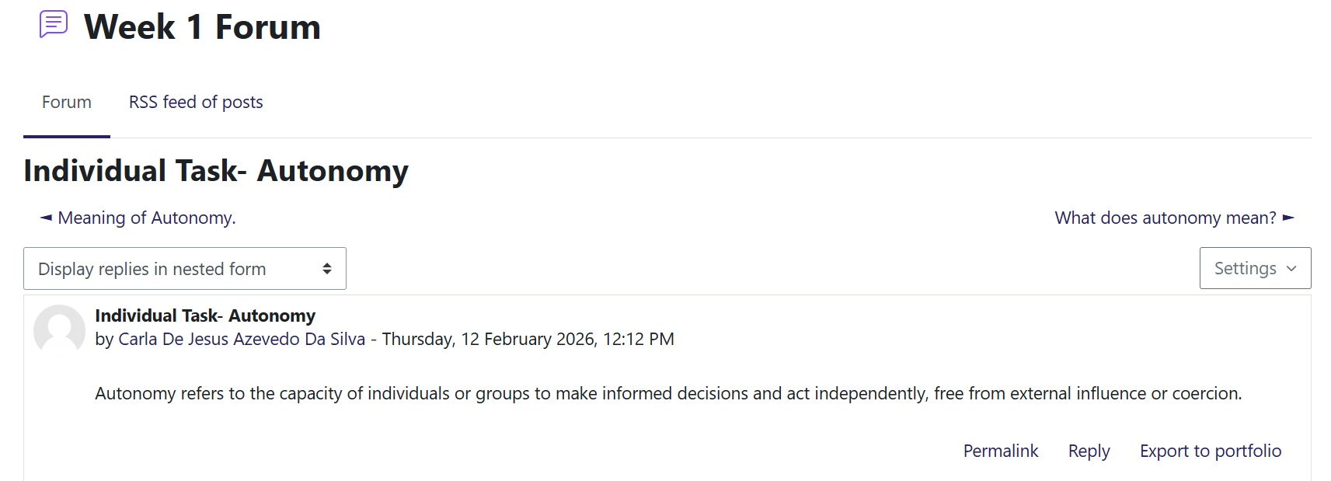Figure 1. Autonomy
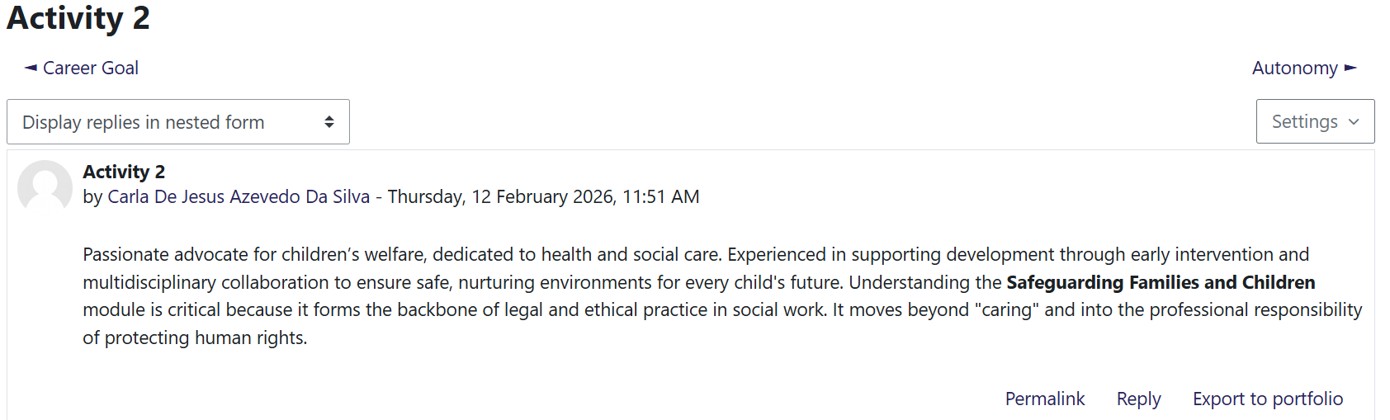Figure 2. Activity 2
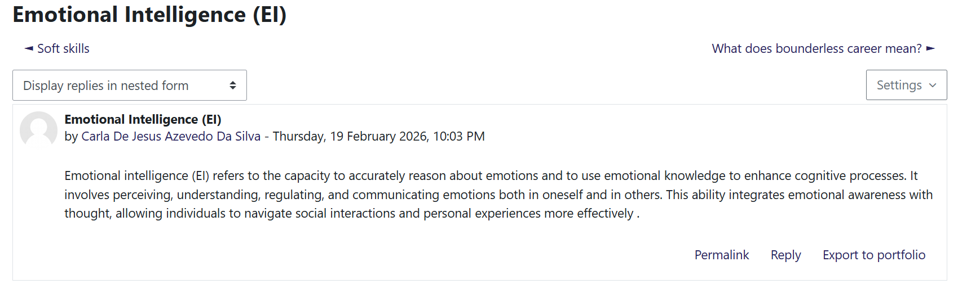Figure 3. Emtional Intelligence

Task2
I preconize the value of networking and organizational structures in the setting of health and social care in Unit 2.
The process of linking several computing devices, including PC’s, serves, and mobile devices, to Exchange data and resources and create a network of linked systems is known as networking (Davies, G. 2019).
Beyond the technological side, networking also includes building and maintaining connections between people or organizations in order to promote cooperation, information sharing, and mutual gain (Davies, G. 2019).
This lesson made me realize that networking is about more than just meeting new people, it's also about developing deep professional connections that can help you grow personally and provide better services.
One of the most important lessons I learned is that successful networking frequently necessitates people stepping outside of their comfort zones.
Although it promotes psychological well-being, personal growth, professional resilience, and genuine engagement with challenges, all which lead to significant chenge and development-moving beyond one’s comfort zone is crucial (Russo-Netzer, P., & Cohen. G.L, 2023).
Interacting with professionals from various fields, organizations, or cultures promotes learning from a variety of experiences and broadens viewpoints. Considering global health concerns including health disparities, aging populations, and access to healthcare necessitate cooperation across industries and nations, this is especially crucial in the fields of health and social care. Practioners can exchange information, best preactices, and creative solutions that enhance patient care and community well-being by forming professional networks.
Bureaucracy is another key idea I acquired in this class. A complex organizational structure with several tiers of power, regulations, and processes is referred to as bureaucracy.
To reduce uncertainty and maintain order, bureaucracy is a structured system of administration built on formal rules and hierarchical authority. However, it also faces difficulties with humanization, integrating technology, and striking a balance between essential limits and flexibility (Borry, E.L., & Reuter, t.K. 2022).
Sociologist Max Weber asserts that bureaucratic structures are intended to guarantee responsibility, efficiency, and uniformity in huge organizations. Bureaucratic structures support the upholding of professional standards, service regulation, and adherence to rules and procedures in health and social care sectors (Weber,1947). The unit did, however, also emphasize that although bureaucracy offers stability and distinct duties, too much bureaucracy can impede decision-making and limit adaptability when addressing patient requirements.
The interaction between networks and hierarchies in health and social care organizations was also examined in this unit. Large healthcare systems require clear lines of power and responsibility, which are provided by hierarchies. Professionals can work together across departments, organizations, and even nations thanks to networks. I was able to see how effective collaboration and communication can enhance service delivery. I was able to see how communication and teamwork can enhance service delivery and health outcomes by comprehending the harmony between these two frameworks.
In general, Unit 2 allowed me to better understand how organizational structures, professional relationships, and cultural sensitivity affect health and social care systems around the world.
It made me realize that professionals who want to promote health, well-being, and community resilience must have the ability to form networks, comprehend bureaucratic processes, and develop cultural competency.
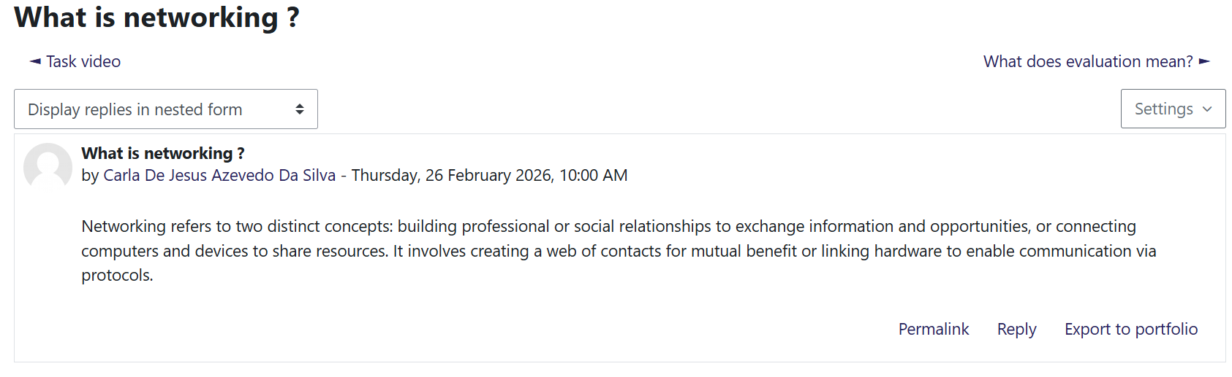Figure 1. What is Networking ?
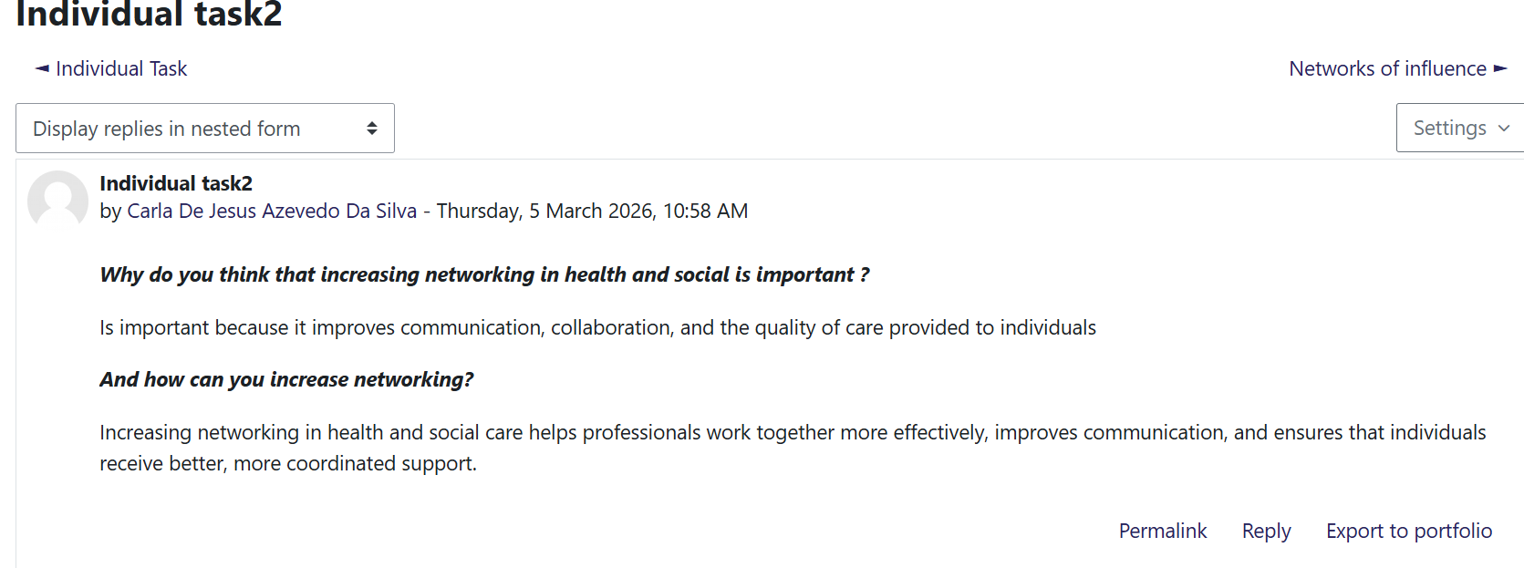Figure 2. Individual task
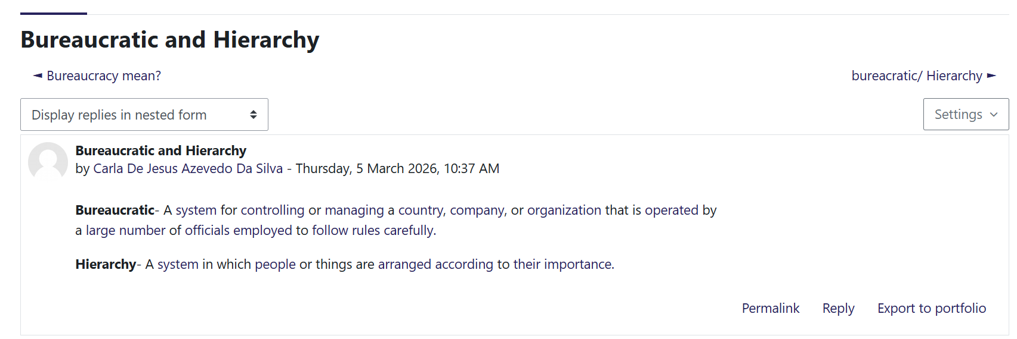Figure 3. Bureaucratic and Hierarchy

Task3
I gained a better understanding of how to spot and seize opportunities, particulary in the health and social care industry, thanks to Unit 3. The significance of viewing the surroundings from various angles was one of the most important concepts I discovered. A more inclusive and successful understanding of environmental challenges is facilitated by acknowledging and incorporating multiple viewpoints, whether through educational strategies, stakeholder involvement, or interdisciplinary approaches. To solve complex environmental concerns, legislation, education, and management approaches can benefit from this multifaceted awareness (Kim, M. 2025).
I can see opportunities for professional and personal development that I may have previously missed by adopting new perspectives on circumstances, obstacles, and opportunities.
I also learned during this course that interpersonal and communication skills are crucial fro success and ‘luck’ in the health and social care fields. I discovered that fostering better relationships with coworkers, clients, and other professionals can open doors to cooperation and professional advancement. I learned that excellent communication, attentiveness, listening, and empathy are critical professional competencies. The significance of interpersonal skills in professional settings is supported by academic literature. I started to see that honing these abilities would help me create solid networks and raise my chances of landing jobs in the industry.
Strech objectives were another significant idea I looked at Unit 3. I discovered that strech goals are intended to push people beyond their comfort zones. Establishing these objectives promotes ongoing gowth and drive. I’ve discovered that setting greater standards for myself can boost my self-esteem and help me acquire new skills.
One of the most important aspects is serendipity. In health and social care, serendipity refers to the identification and development of unexpected results by qualified professionals within supportive systems, which can result in advancements in knowledge and treatment. This emphasizes how critical it is to preserve settings that enable random observations to be observed and investigated (Maojo, V., & Pazos, J. 2024).
Additionally, Unit 3 emphasized useful methods for obtaining employment prospects. I discovered that I could make myself more visible to possible employers by updating a CV on a regular basis, networking with professionals on social media sites such LinkedIn, and going to industry events. In today’s digital environment, I also realized how crucial it is to have a strong and professional online presence.
I used Gibbs’ Reflective Cycle, which encourages people to assess experiences and make plans for future changes, to reflect on what I had learned (Gibbs, 1988). After giving it some thought, I realized that networking, improving my communication skills, and establishing ambitious goals will help me find and seize opportunities more successfully in my future profession.

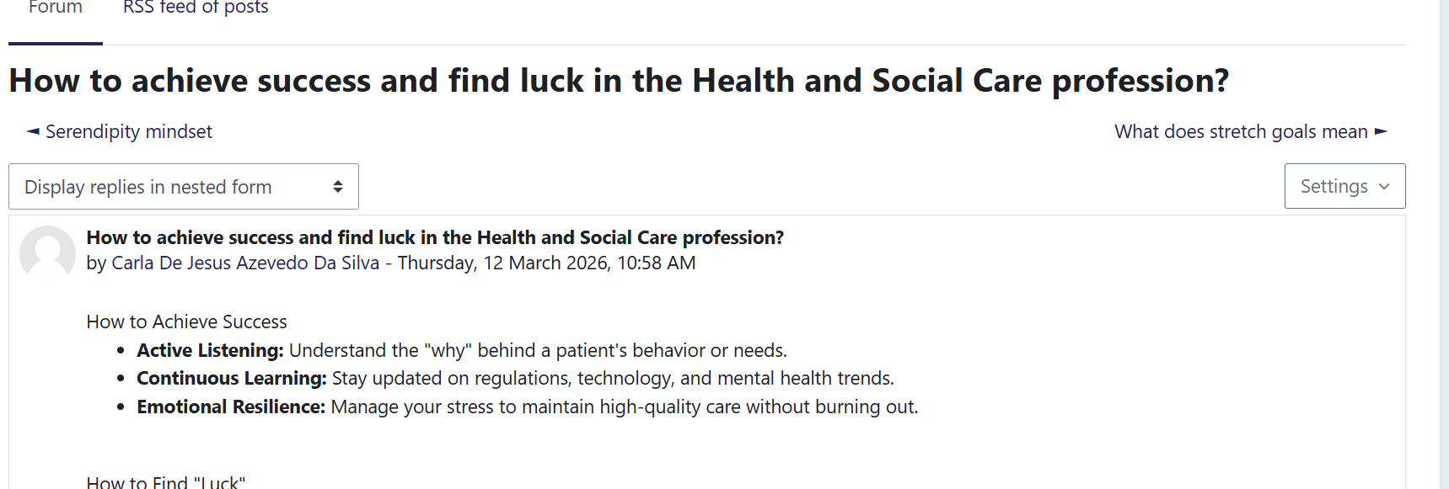 Figure 1. How to achieve sucess and find luck in the Health and Social Care profession?
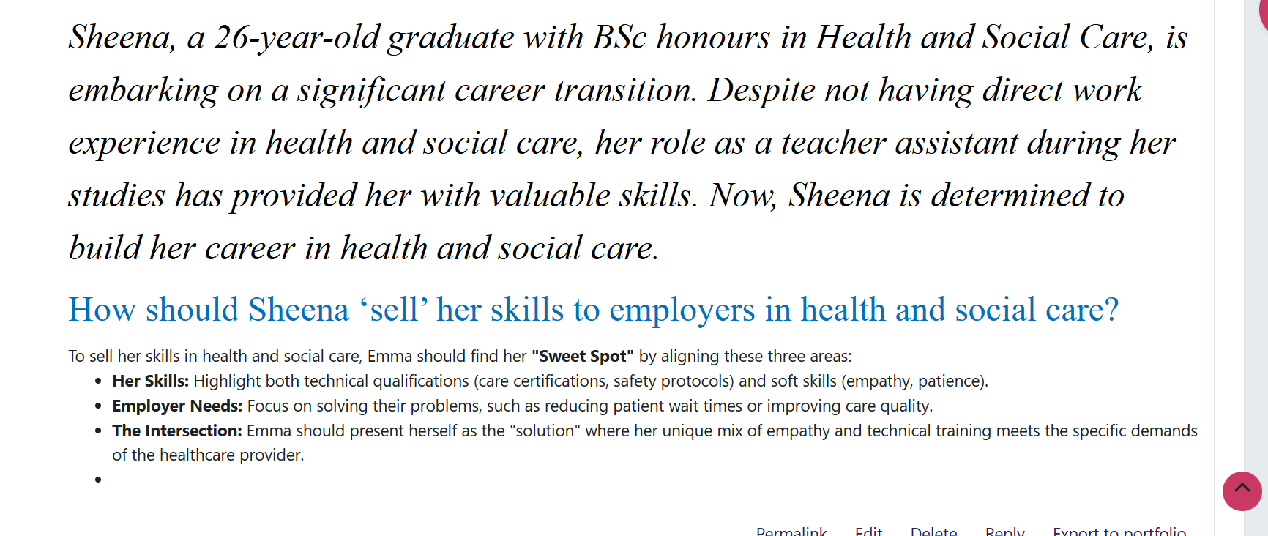Figure 2. Activity group

Task4
Unit 4 highlighted the changing nature of health and social care practice while also deepening my understanding of resilience, wellbeing, and work-life balance. I turned at how preserving wellness is crucial to continuing to perform professionally effectively.
The Perma model of wellbeing offers a multifaceted framework for comprehending well-being, with empirical backing for its elements and uses in social care, corporate, and educational settings. Its continued evolution and contextual relevance are aided by extensions such Perma+4 and certified measurement instruments as the Perma-profiler (Donaldson, S. I., 2022).
In both personal and professional contexts, I realized the significance of pleasant feelings, involvement, relationships, meaning, and accomplishment. I put this approach into practice by actively thinking back on my everyday encounters, fortifying my bonds with other people, and discovering purpose in helping others. This method helped me stay motivated in trying circumstances and increased my emotional awareness.
By learning to identify and confront limiting ideas, I was able to build resilience. I worked on stopping, thinking, and recognizing my feelings without letting them control me. I found that I became more self-assured and receptive to improvement when I reframed from negative thoughts and positively to setbacks has improved because of this change, which is crucial in high-stress health and social care settings.
It has become clear that work-life balance is thought to be crucial for preserving both organized efficiency and worker well-being. The idea has changed because of shifts in technology, economic situations, working conditions, and lifestyles that constantly put the balance between personal and professional life in jeopardy. Finding this equilibrium is related to maximizing worker safety and wellbeing, which boosts business output (Demissie, E.D., et al 2024). I discovered that my capacity to care for others depends on my own well-being, so I learned to prioritize self-care and set boundaries.
Ther impact of technology progress on health and social care was also covered in this unit. I realized that adjusting to new technologies necessitates ongoing education and adaptability.
Although technology can enhance productivity and patient outcomes, there are hazards associated with its fragility, including data security issues and system failures. This knowledge inspired me to continue being flexible and aggressive in acquiring digital skills, which are becoming increasingly important in contemporary practice. My development was greatly aided by mentoring. I realized that professional networking, confidence building, and information sharing are all facilitated by mentorship connections.

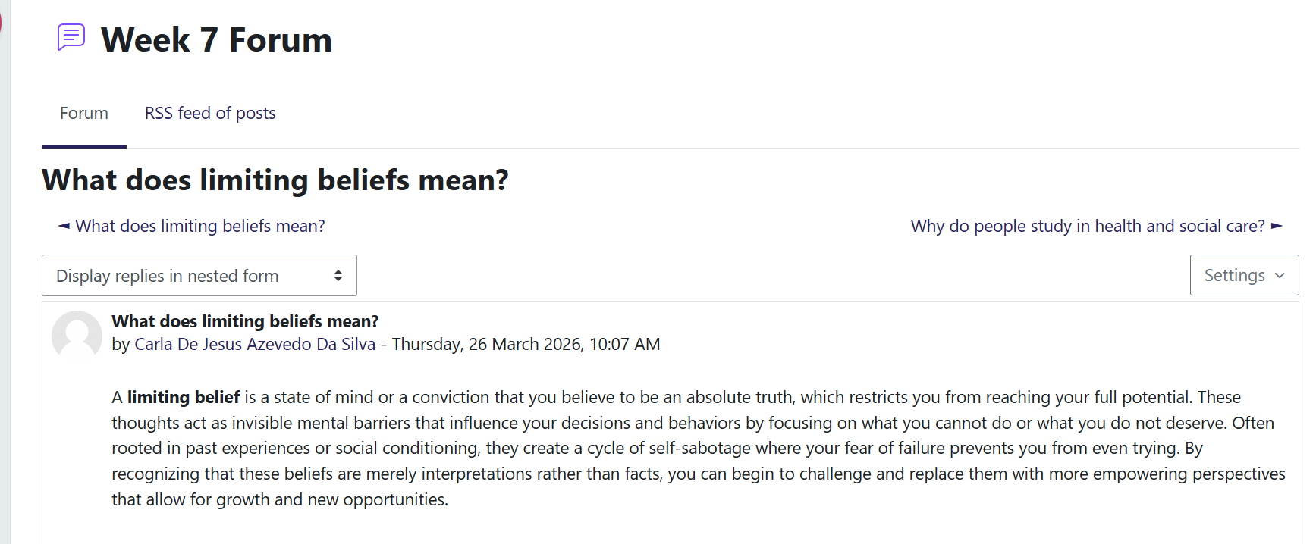Figure 1. What does limiting beliefs mean?
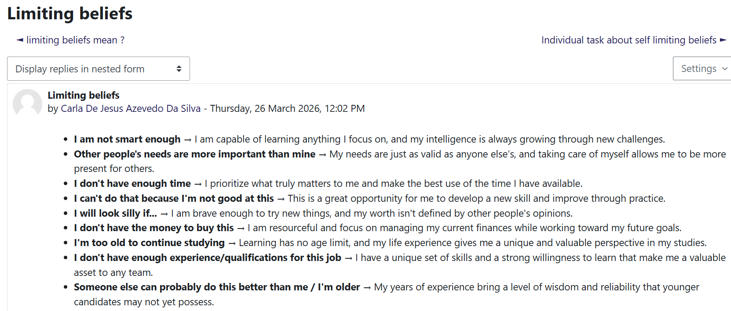Figure 2. Individual task- Limiting beliefs

Conclusion
Whenever I think back on all the subjects, I’ve studied resilience, work-life balance, ambition, networking, emotional intelligence, technology adaptation, and mentoring. I can see how they all help me develop as a health and social care worker.
I’ve learned that preserving wellbeing, identifying limiting beliefs, and controlling emotions are all aspects of personal development that are crucial to delivering effective and compassionate care. In addition, career focused abilities such ambition, networking, and developing a professional internet presence enable me to take advantage of opportunities, adjust to change, and advance in an unrestricted career. The necessity for flexibility and ongoing learning is reinforced by the incorporation of technology into practice and an awareness of its fragility. Collaboration and mentoring foster professional development, confidence, and the exchange of knowledge.
All of these ideas have improved my communication, problem-solving, resilience, and leadership abilities, enabling me to operate successfully in fast paced social and health care settings and positively influence the lives of others.

References
- Borry, E. L., & Reuter, T. K. (2022). Humanizing Bureaucracy: Applying the Human Rights-Based Approach to Weber’s Bureaucracy. Perspectives on Public Management and Governance, 5(2), 164–173. (Accessed March 8 2026).
- Davies, G. (2019). Networking Fundamentals: Develop the Networking Skills Required to Pass the Microsoft MTA Networking Fundamentals Exam 98-366 (1st edition.). Packt Publishing, Limited. https://doi.org/10.0000/9781838648749. (Accessed 5 March 2026).
- Demissie, E. D., Koech, D. K., & Molnár, E. (2024). Work-life balance: Assessing Post COVID-19 Practice of Work-Life Balance and Employee Job Performance: A Literature Review. Multidiszciplináris Kihívások, Sokszínű Válaszok, 1, 3–26. https://doi.org/10.33565/MKSV.2024.01.01. (Accessed 19 March 2026).
- Donaldson, S. I., van Zyl, L. E., & Donaldson, S. I. (2022). PERMA+4: A Framework for Work-Related Wellbeing, Performance and Positive Organizational Psychology 2.0. Frontiers in Psychology, 12, 817244. https://doi.org/10.3389/fpsyg.2021.817244. (Accessed 19 March 2026).
- Okpaluba, F., & Liu, F. (2025). Analyzing Autonomy in Critical Care Nursing: Unveiling the Distinctive Aspects. Nursing Forum (Hillsdale), 2025(1). https://doi.org/10.1155/nuf/3396999. (Accessed 28 February 2026).
- Vocational Training (2024). Learning and development models- Pink's Autonomy, Mastery, and Purpose Framework. Available at:Learning and Development Models – Pink’s Autonomy, Mastery and Purpose Framework - CMS Vocational Training Ltd | CIPD | AAT Accountancy | Personal Training Courses | Apprenticeships. (Accessed 28 February 2026).
- Karakus, F. (2021). A retrospective view from traditional to boundaryless career and career success. International Journal of Research in Business and Social Science, 10(3), 65–81. https://doi.org/10.20525/ijrbs.v10i3.1131. (Accessed 1 March 2026).
- Kim, M., Ahmed, N., Akdemir, K., Wong, S., & Bulut, O. (2025). Children’s perspective-taking and decision-making on forests and land use. Disciplinary and Interdisciplinary Science Education Research, 7(1), Article 10. https://doi.org/10.1186/s43031-025-00130-2. (Accessed 13 March 2026).
- Maojo, V., & Pazos, J. (2024). Serendipity and medicine: its history, foundations and future: towards an artificial serendipity. Anales de la Real Academia Nacional de Medicina, Madrid, 141(141(03)), 248–258. https://doi.org/10.32440/ar.2024.141.03.rev06. (Accessed 13 March 2026).

- Russo-Netzer, P., & Cohen, G. L. (2023). “If you’re uncomfortable, go outside your comfort zone”: A novel behavioral “stretch” intervention supports the well-being of unhappy people. The Journal of Positive Psychology, 18(3), 394–410. https://doi.org/10.1080/17439760.2022.2036794. (Accessed 8 March 2026).
- Weber, M. (1947) The theory of social and economic organization. New York: Oxford University Press. (Accessed 8 March 2026).

