

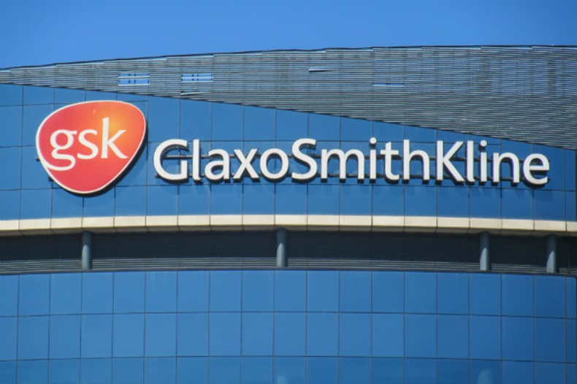

MARKETING MANAGEMENT ASSESSMENT 1
REPORT OF GSK
Name: Pendyala Bikshapathy
ID: 2128324
Module: LCMB7001
Lecturer: Tushara Balendran
Course: Masters in General Management
Submission date: 09/09/2022 – 75%

Executive summary
GSK is an international pharmaceutical company with an exclusive range of product variations and customer range around the entire globe. The company has been famous for its variety of product ranges such as medicines, vaccinations, consumer healthcare products, oral health products, and many more. Marketing management of GSK Plc. has been approaching making a diverse range of services and products with the latest innovation to cure the disease.
Customer journey has been significantly upfolded by GSK Plc in terms of retaining them, increasing their engagement, and others. Awareness, consideration, purchase, and retention are the essential stages of customers' journeys that have been critically performed by GSK through effective digital communications parameters using email, social media and others. Stakeholders are encouraged through annual meetings, providing their profitable earrings to them timely and others by the company for ensuring better organisational structure.
The organisation has efficiently managed its internal and external shareholders, by meeting the requirements of both the groups effectively, which has improved its financial condition in the global market. Through the meeting of the demands of the stakeholders the organisation has been able to achieve a motivated workforce, which has aided the company to achieve its desired goals and objectives effectively in the global market.

Table of Contents
1. Introduction 3
2. Challenges of GSK by operating in competitive marketplace 3
2.1 Impact of globalisation on changing business environment 3
2.2 Effect of digitalisation 3
2.3 Porter’s five forces analysis 4
3. Critical appreciation of innovative marketing strategies of GSK for developing awareness 7
3.1 Innovative marketing strategies of GSK 7
3.2 Management of customer journey by GSK with communication channels 9
3.3 Fulfilling Stakeholder expectations with communication channels of GSK in current and future context 12
3.4 Marketing management of GSK to add value 13
4. Conclusion 15
References 16
Appendices 21

1. Introduction
Marketing management is considered a planning process that helps any organisation to plan and execute the pricing, conception, distribution, and promotion of goods, services, and ideas. The marketing management approach of the organisation helps to create the exchange of the products allowing to satisfy the objectives of the industries and individuals. Marketing management is essential for a company to analyse its competitive market as well as help them to compete with other competitors in the same market. The purpose of the present report is to understand the marketing management approaches of the international biopharma company named GlaxoSmithKline Plc. or GSK.

2. Challenges of GSK by operating in competitive marketplace

2.1 Impact of globalisation on changing business environment
Based on the opinion of Buganová, Šimíčková, and Brutovský (2021), in the present scenario globalisation has moved the business industries into a different dimension. In the competitive marketplace, the organisation has the advantage of successfully managing and integrating risk in a global approach. In the words of Valverde and Pisani (2016), partnership related to product development, mechanism of innovative financing, declaration related to non-assert, and voluntary licensing maintenance is a challenge for the industry. On the other hand, in the words of Saïd, Sevic, and Phillips (2019), GSK has been facing challenges regarding the management of CSR activities on the global approach. GSK maintained a link with its network of extensive alliances with more than 100 companies. This linkage brings challenges to its responsiveness and environment to take market opportunity advantages (Saïd, Sevic and Phillips, 2019). On the other hand, in the words of Rizhamadze (2020), the GSK is unable to replace their medicine Zantac with a new one that can initiate their loss in revenue.

2.2 Effect of digitalisation
Based on the comment of Mannan and Mubeen (2018), digitalisation makes some rapid progress in the pharmaceutical industries as well as brings some challenges for them. According to Taqaddas (2021), changing the economy and social conditions with respect to digitalisation is a challenging approach for the GSK to maintain its product innovation, flexibility, and resilience. All the approaches help the company to ensure its growth and sustainability. Digitalisation needs to enhance the technological skills of the employees of the company. Digitalisation accelerates the development of the vaccine in the case of the GSK. Using the digital twin by GSK can help them to develop more cost-effective, less wasteful, and faster developmental vaccines with a good and fast manufacturing technique. GSK has been trying to implement the digital twin in its developmental activities. It implies the company GSK reduces the real experimentation that helps the company to increase its sustainability.

2.3 Porter’s five forces analysis
Competitive Rivalry (high)
Competitive Rivalry is considered the approach that helps to explain the competition in a particular market within the existing industry. In this respect, the competitive rivalry helps to explain the competitive market of GSK in the pharmaceutical markets. The major competitive rivals of the company GSK are Pfizer, Johnson & Johnson, AstraZeneca, Merck, and many more in the global as well as international market. Among all the competitive rivals Pfizer has a revenue of $81,288 in the year 2021 (Pfizer Inc, 2021). Another major competitor of the company is Johnson & Johnson with a net income of $14,714 million in the year 2020 (Alhosnai et al., 2021). On the other hand, another competitor in this industry is AstraZeneca with total revenue of $37.4bn in the year 2021 (AstraZeneca, 2022).
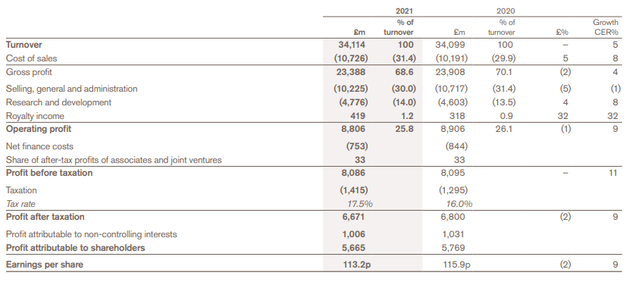
Table 1: The financial performance of GSK in the year 2020 and year 2021
(Source: GSK, 2021)
As per above table 1, the gross profit of GSK in the year 2021 was £ 23388 m with a turnover of 68.6%. In this respect according to the report of GSK in the year 2021, the company has a 4.6% annual growth in sales in the medium-term (GSK, 2021). It can be said that all of these companies have been playing a major role in the competitive rivalry of the company GSK.
The threat of new entrants (moderate)
Based on the comment of Tannoury and Attieh, (2017), the threats of new entrants in the local and international pharmaceutical market are considered moderate as these markets need a large scale of economics as well as requirements of high capital investments. In global pharmaceutical industry, the brand strategy helps to create a beneficial competitive advantage for the companies. On the other hand, in the words of Panchal, Khan and Ramesh (2012), it helps the industries fulfil the requirement of the product, and services, and incorporate the values. In this respect brand value and competitiveness in the market is essential to incorporate brand popularity.
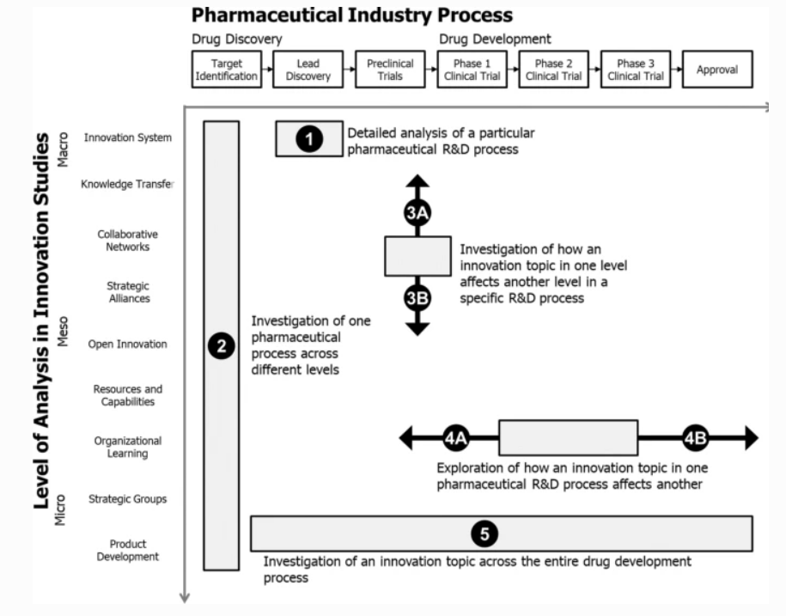
Figure 1: Detailed process of the pharmaceutical industry
(Source: Romasanta, Sijde and Koezen, 2020)
As per the above figure 1, such processes related to pharmaceutical industries show critical ness and complexity in their process of business.
Bargaining power of buyers (high)
Customers or buyers demand the best offer by paying a minimum amount. The demand of the customer can create a challenge for different companies in the UK. The smaller base of customers can create higher bargaining power. As per the opinion of Shang et al. (2008), the company has formed a large customer base for their company that helps them reduce its bargaining power of buyers. They have been trying to manufacture more innovative products for the customers. 1.7 billion medicines, 3.7 billion healthcare products, and 767 million vaccines were produced by the company in 2021 (GSK, 2021). New product arrival helps the company to reduce customer defection to its competitors.
Supplier Power (moderate)
The dominant position of suppliers decreases the market earning of the pharmaceutical sector in the UK (Tannoury and Attieh, 2017). GSK trying to efficient supply China with innovative product design and effective use of raw materials for their products (Mangan and Christopher, 2005). With the involvement of efficient product design and innovation, the company also focuses on developing the profitability.
Substitutes (high)
The competitive market can bring substitutes for the GSK market such as AstraZeneca, Pfizer, and others. GSK has brought differentiation in its products and is trying to increase its market share by 24.1% (from figure 2) to cope with the situation.
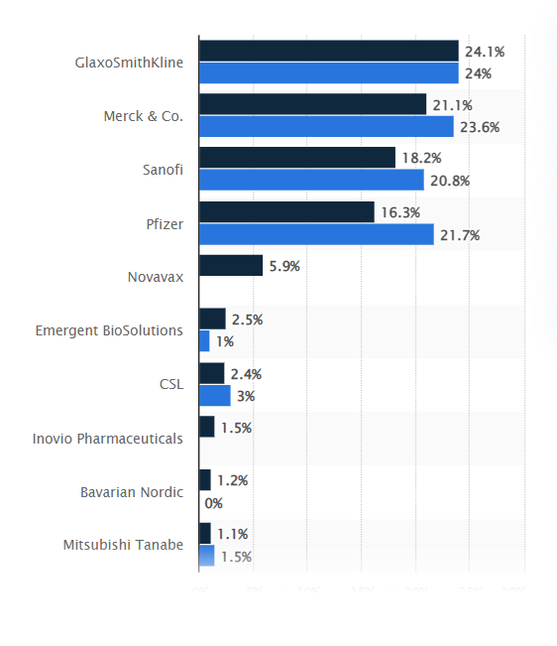
Figure 2: Market share in 2017-2024
(Source: Statista, 2017)

3. Critical appreciation of innovative marketing strategies of GSK for developing awareness

3.1 Innovative marketing strategies of GSK
GlaxoSmithKline is a UK-based pharmaceutical company providing pharmaceutical products, medicines, and vaccinations around the world. With respect to understanding the innovative marketing strategies of the GSK, the marketing mix of 4P analysis is considered here in the present report.
Products
GSK manufactures various products to treat diseases like diabetes, mental health, cancer, infectious diseases, asthma, HIV, COPD, and many more. The company can also enhance premanufacturing of vaccines for mitigating diseases. The marketed vaccines are the broadest portfolio in the industry (GSK, 2021b). More than 20 vaccines have been included in these criteria for diseases like whooping cough, measles, and polio. The company GSK provides nearly 2 million daily doses of vaccines and 40% of children in the entire world revive their vaccines every year. They are taking the initiative to launch the vaccine for the respiratory syncytial virus (RSV) by 2026. GSK has been providing famous medicines for treating diseases named Aquafresh, Ansolar, Benefiber, Cetebe, amoxicillin, Blenrep, and many more (GSK, 2022). The GSK also manufactures consumer healthcare products including oral healthcare such as Sensodyne, Aquafresh, Maclean’s toothpaste, and health drinks such as Horlicks and Boost (GSK, 2021b).
Place
GSK is an international biopharma company with the purpose to utilise technology and science as well as incorporating talent to recover from the disease. According to Rizhamadze (2020), the company has a headquarters located in the UK and with an expansion of nearly one hundred and sixty countries. The major countries that have been sharing the business of the GSK are the US, Japan, China, India, and many more. Furthermore, the company can also enhance the product distribution capacity for enhancing business capacity in different international locations.
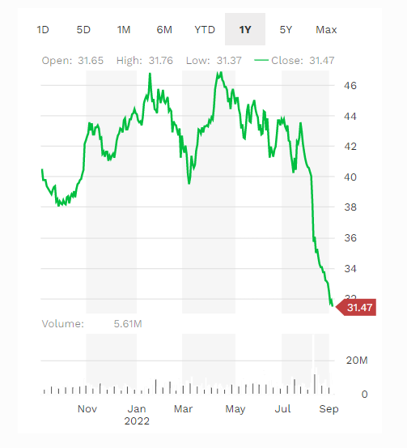
Figure 3: The share price of GSK
(Source: Forbes, 2022)
As per Forbes, 2022, The company has a revenue of $46.9B in the year 2022 with a total asset of $107.1B globally with a share price of $31.47 (Referred to figure 3).
Price
The GSK has a total reported sales of £34.1 billion with a stable +5% CER in the year 2021 (Referred to figure 4). 68% of the entire business of GSK has been held by the consumer healthcare sector of GSK. The company has been holding a total value of acquisition of £50 that has comprised of £41.7 billion of cash and £8.3 billion of universal shares (GSK, 2021d).
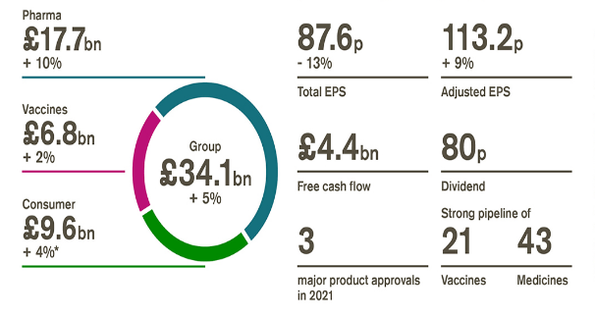
Figure 4: Sales of GSK
(Sources: GSK, 2021d)
The consumer healthcare business is considered a joint venture with Pfizer where the maximum controlling interest held by GSK is 68% and Pfizer holds 32% (GSK, 2021d). Furthermore, the company also can maintain the efficient price range which also can help in attracting potential consumers.
Promotion
Promotion of the GSK brand has been helping to encourage them to enhance their profit and sales. They have been advertising their products such as consumer health care, and medicines with the electronic media by following local laws and regulations of the countries (GSK, 2020). Therefore, GSK can develop the promotion of its public health activities, namely campaigns for vaccination only after approval by the relevant authorities of those countries.

3.2 Management of customer journey by GSK with communication channels
The customer's journey phases of GSK enabling communication channels are outlined below:
- Awareness: Most significant customization attraction and tension process has followed through the awareness phase. Business presentation-oriented education has been given by the companies at this stage considering that the customers get to know about the brand, products, services and offerings better (Følstad and Kvale, 2018; Hamilton et al., 2020). In such a manner, white papers, e-books, leaflets, prospectus billing, online ads and others are effective strategies to communicate with customers potentially (Følstad and Kvale, 2018; Hamilton et al., 2020).
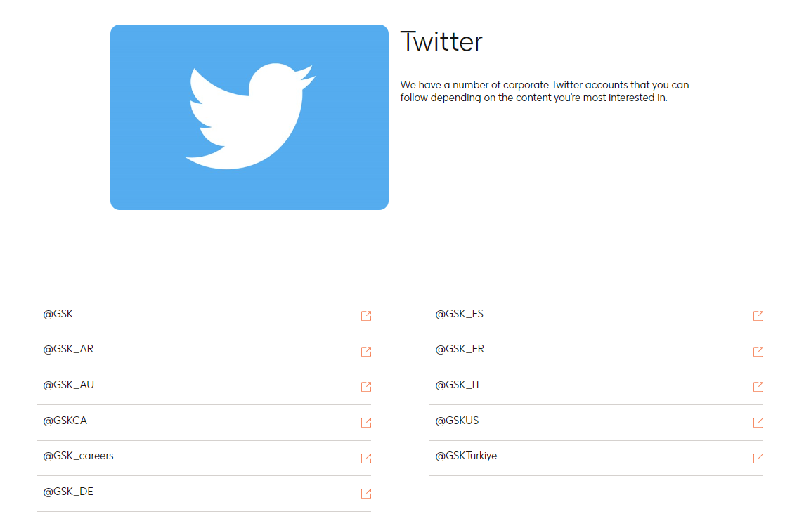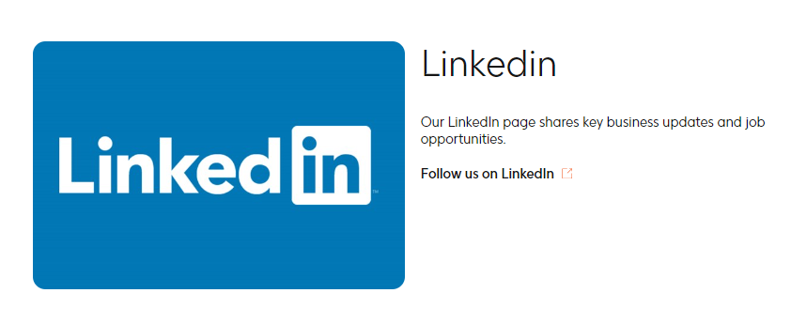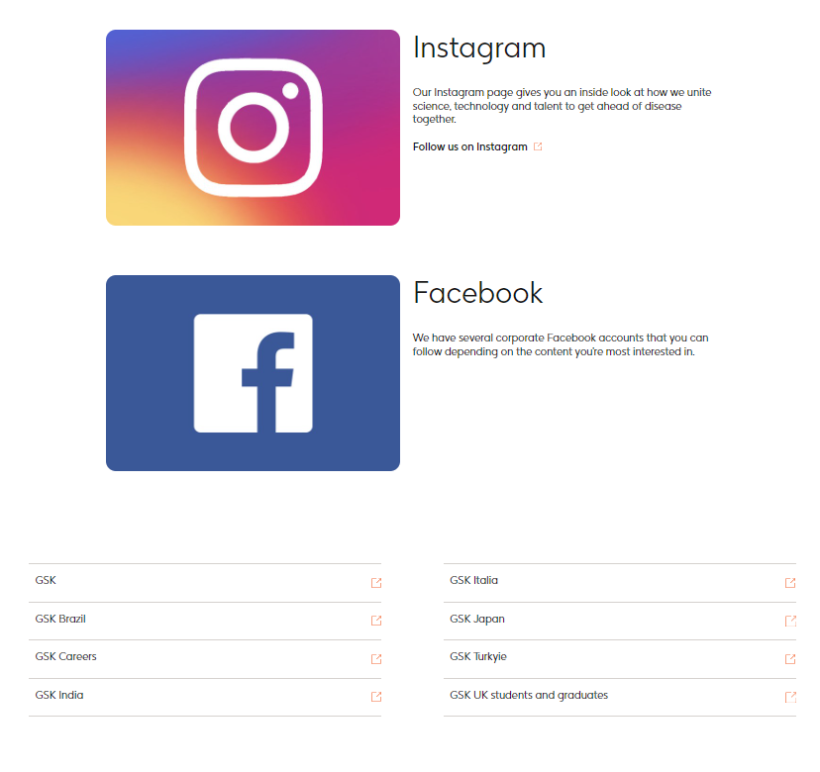
Figure 5: Digital platforms used by GSK
(Source: GSK Plc, 2022b)
GSK has maintained a suitable communication integration for channelling relationships with customers and allowing customers to know about the brand widely. The company spreads awareness about its new launches, existing product variations, pricing strategy and all through promoting the adverts on various digital media platforms such as Twitter, Facebook, Instagram, YouTube, LinkedIn and others (GSK Plc, 2022a; GSK Plc, 2022b). GSK communicates with customers through these channels and makes them aware of its presentations. It helps customers to observe the brand more than its competitors.
- Consideration: At this phase, people are considered the brand as their preferable company and decide to buy from them. In the case of GSK, it has been observed that content posts by the companies through the customers' communication channels will allow customers to see the uniqueness of the products and services of the company (Hamilton et al., 2020; Hamilton and Price, 2019). In GSK, the company has posted various products and service-related content that helps customers to know about the usability, pricing, and other factors of the products effectively (GSK Plc, 2022a; GSK Plc, 2022b). Thus, customers communicate with the company through its digital media and consider purchasing from it.
- Purchase: After satisfying the considerable phenomena of the company, consumers are decided to purchase from it effectively. In such a manner, they would like to outline their desires and refer to their friends and family members or any known person and others after studying the products and service quality (Hamilton and Price, 2019; Towers and Towers, 2021). On the other hand, customers are also likely to communicate with the company when they have any queries. Thus, in order to get to know about customers' queries and to communicate with them effectively, the company named GSK has introduced email marketing efficiently. In such conditions, customers can convey their queries through a particular email address of the company and replies from the marketing associates of GSK have been highlighted within the email effectively (GSK Plc, 2022a; GSK Plc, 2022b).
The Push and Pull strategy states that push marketing involves paid advertising or promotions while pull marketing engages with content creations to increase customers' interest (Puchkova, Le Romancer and McFarlane, 2016). The more effective push and pull marketing strategy involved within a business, it will get to touch the aspect of customers' attention factors (Puchkova, Le Romancer and McFarlane, 2016). The company named GSK has implemented a media strategy as push marketing involving paid content promotions through social media, newspapers, magazines, broadcasts and others since all the platforms required payment for promotions. Moreover, through social media platforms, content creators are paid by the company for increasing customers' connections vastly.
- Retention: After getting better services retention rate of the customers increases potentially, and their opinions of retail loyal to the companies maximise vastly (Hamilton and Price, 2019; Towers and Towers, 2021). GSK has performed precisely and has significantly higher quality products and services produced in the company. Thus, the retention rate in the company is higher which allows existing customers to refer to the company further and retain it strongly.
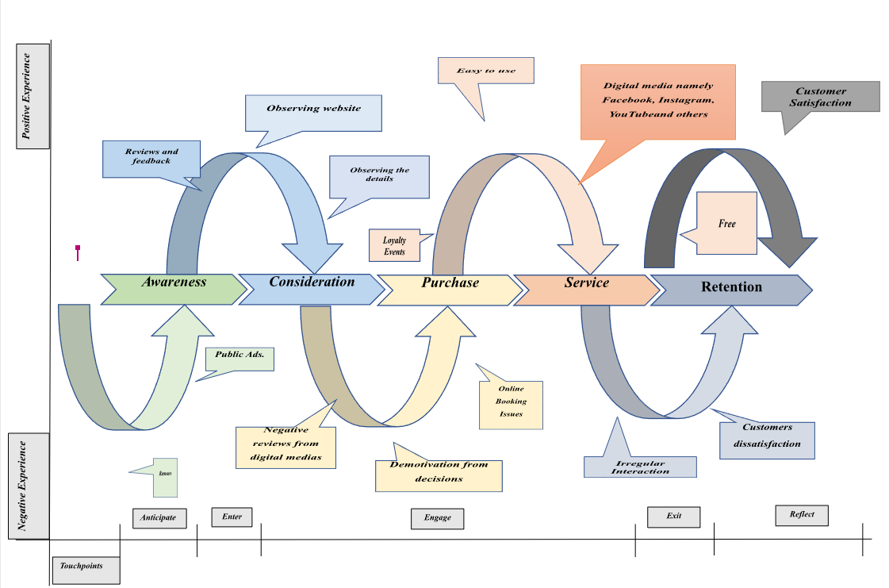
Figure 6: Customer journey mapping for GSK

3.3 Fulfilling Stakeholder expectations with communication channels of GSK in current and future context
In the views of Pinheiro (2015), the internal and external stakeholders of the company, like employees and customers, are the most critical elements which are responsible for the proper functioning of the business activities of the organisation in the local as well as the international market. From the viewpoint of Graham (2017), the employees of companies have certain expectations like effective performance appraisal and better working conditions, which are needed to be fulfilled by the organisation, in order to ensure that the workers remain loyal and dedicated towards the enterprise. Therefore, in order to meet the demands of the employees, GSK has introduced flexible working schedules, paid sick leaves and a friendly environment to work with, which has aided the company in motivating the workers to deliver results for the organisation (GlaxoSmithKline, 2020).
In addition to the meeting of the exceptions to the employees, the company, GlaxoSmithKline has also maintained effective communication channels through the use of social media platforms like Facebook and Twitter for establishing better connectivity with employees of the organisation. In addition to the use of the communicative channels for benefiting its employees, the company can effectively promote its products and consumer-friendly service in order to increase its goodwill among the customers effectively in the international market. Therefore, through the use of the different modes of communication, the organisation, GSK has been effectively increasing its consumer base by providing efficient services to the customers. Even though the organisation has been making effective utilisation of the communication channels, it needs to be more proactive in promoting services among the customer and should also launch campaigns concerning the benefits of the employees on the social platform.
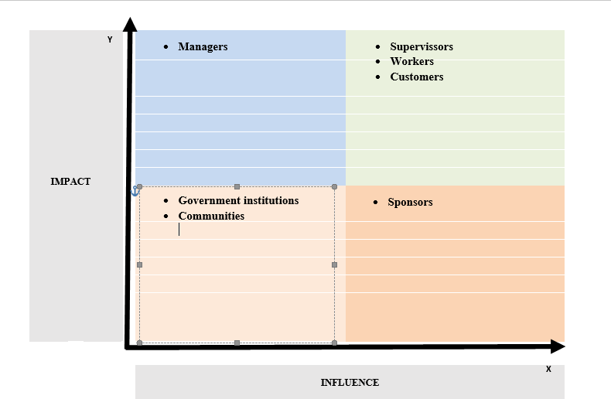
Figure 7: Stakeholders Grid
Addressing the above diagram (Refer to figure 7) it can be idealised that the stakeholders are recognised as per their impact and capacity to influence the corporate structure effectively. Managers have higher impact and lower capacity to influence while customers, supervisors, workers, have higher impact and influences both. On the other hand, governmental institutions, communities have lower impact and influences while the sponsors have only higher influences. GSK has an effective stakeholder’s community, and the company has been providing potential profits to them per year. The company has been also holding annual meetings to understand the opinions of stakeholders and their issues critically to solve the problems and accelerate better organisational growth (GSK Plc, 2022b).

3.4 Marketing management of GSK to add value
The marketing management of the GSK involves promotion of its products using digital media platforms like television which aids the company in generating more awareness about the uses of its products, which aids the organisation in increasing the customer base of the organisation in the global market (GlaxoSmithKline, 2019). The efficiency shown by the company in its marketing management through the promotion of its products is the reason for the increase in its goodwill among the customers in the global market. The reason for the efficient marketing management of the organisation relates to the maintenance of the ethical standards for promoting the products of the organisation in a particular country (GlaxoSmithKline, 2019).
Therefore, through the use of the ethically approved marketing management technique, the organisation, GSK is able to promote its products in the markets of the foreign country and invariably increase its goodwill among the customers in the international market. Additionally, the marketing management of the company also involves detailed scientific research of the product before it is promoted in the local and international market, which is in preventing any negative effect of the medicines on the health of the consumers (GlaxoSmithKline, 2020). Thus, in the views of Thorley and Fulda (2020), innovative marketing strategies like use of social media platforms for the promotion of the products among a large consumer database has helped companies like GSK to witness extensive growth and development in the global market.
In addition to the effective promotion of its products in the local and international market, the company, GSK has also promoted the news about the availability of the COVID-19 vaccines in its organisation, which aided the enterprise to witness extensive growth of goodwill among the consumers in the international market. From the viewpoint of Tavares-Da-Silva et al. (2020), GSK has invested an amount equivalent to £130m on scientific research before, promoting its vaccines in the local as well as the international market. Thus, it can be stated that the company, GSK, through its marketing techniques has been able to carry out detailed scientific research analysis of its products, in order to nullify any negative impacts of its commodities on the health of the consumers.
The effective scientific research carried out by the company, GSK on the COVID-19 vaccines, in turn has aided the company in increasing the goodwill among the customers and with progress in the international market. As stated by Saïd, Sevic and Phillips (2019), the marketing management of the company, GSK also involved collaboration with US immunology company, Vir Biotechnology, in order to research about the discovery of the antibodies which can be used to mitigate the effect of the COVID-19 virtues, which further assisted the organisation, to witness enhancement in the international market. Therefore, it can be concluded that through the efficient marketing management strategy of the company, GSK, the organisation has effectively promoted its services in the international market, which has also aided the organisation in witnessing extensive growth and development in the global market.

4. Conclusion
Through the analysis of the marketing management technique of the organisation GSK, it can be concluded that the company has been using the given tool quite efficiently and has witnessed growth and development in the global market. Moreover, the company has also efficiently utilised its stakeholders, in order to achieve the desired goals and objectives in the global market. The company has fulfilled the demands of the stakeholders, which aided the organisation in getting a motivated workforce and an increase in the goodwill of the organisation in the global market which has aided the organisation in witnessing growth in the local and international market. Thus, it can be concluded that the company, through meeting the needs of the customers, and employees and showing efficiency in its marketing techniques has witnessed progress in the global market and also has gained a competitive advantage over other firms in the global market.

References
Alhosnai, K., Kharbanda, K., Almazrouei, H.S., Alzaabi, A.I., Aldhanhani, W., Mostafa, S., Alhajiri, S.M. and Nobanee, H. (2021). Financial Analysis of Johnson & Johnson in Light of the COVID-19 Vaccination Research Developments. SSRN Electronic Journal. doi:10.2139/ssrn.3896177.
AstraZeneca (2022). Full-year and Q4 2021 results. [online] Available at: https://www.astrazeneca.com/content/dam/az/PDF/2021/full-year/Full-year-2021-results-presentation.pdf.
Buganová, K., Šimíčková, J. and Brutovský, M. (2021). Impact of global changes in the business environment in relation to risk management. SHS Web of Conferences, 92, p.03004. doi:10.1051/shsconf/20219203004.
Davies, M.J. (2001). GSK screens SNPs. Trends in Biotechnology, 19(4), p.129. doi:10.1016/s0167-7799(01)01620-1.
Følstad, A. and Kvale, K. (2018). Customer journeys: a systematic literature review. Journal of Service Theory and Practice, [online] 28(2), pp.196–227. doi:10.1108/jstp-11-2014-0261.
Forbes (2022). GlaxoSmithKline | GSK Stock Price, Company Overview & News. [online] Forbes. Available at: https://www.forbes.com/companies/glaxosmithkline/?sh=438801ff1409 [Accessed 7 Sep. 2022].
GlaxoSmithKline (2019). GSK Public policy positions Marketing Practices and Scientific Engagement A publication of GlaxoSmithKline Communications and Government Affairs 1 GSK Public policy positions BACKGROUND. [online] Available at: https://www.gsk.com/media/2959/marketing-practices-policy.pdf [Accessed 7 Sep. 2022].
GlaxoSmithKline (2020). Life at GSK | GSK. [online] www.gsk.com. Available at: https://www.gsk.com/en-gb/careers/life-at-gsk/ [Accessed 7 Sep. 2022].
Graham, S. (2017). The Influence of External and Internal Stakeholder Pressures on the Implementation of Upstream Environmental Supply Chain Practices. Business & Society, p.000765031774563. doi:10.1177/0007650317745636.
GSK (2020). Our Code of Practice for promotion of prescription medicines and for scientific engagement. [online] Available at: https://www.gsk.com/media/4552/our-code-of-practice.pdf.
GSK (2021a). Annual Report 2021 Contents. [online] Available at: https://www.gsk.com/media/7462/annual-report-2021.pdf.
GSK (2021b). Consumer healthcare | GSK Consumer Healthcare INDIA. [online] india-consumer.gsk.com. Available at: https://india-consumer.gsk.com/en-in/products/nutrition/ [Accessed 7 Sep. 2022].
GSK (2021c). Our product areas | GSK. [online] www.gsk.com. Available at: https://www.gsk.com/en-gb/products/our-product-areas/.
GSK (2021d). Update - GSK Consumer Healthcare | GSK. [online] www.gsk.com. Available at: https://www.gsk.com/en-gb/media/press-releases/update-gsk-consumer-healthcare/.
GSK (2022a). Digital twin: using advanced technology to accelerate vaccine development | GSK. [online] www.gsk.com. Available at: https://www.gsk.com/en-gb/behind-the-science-magazine/digital-twin-using-advanced-technology-to-accelerate-vaccine-development/ [Accessed 7 Sep. 2022].
GSK (2022b). Products A-Z | GSK. [online] www.gsk.com. Available at: https://www.gsk.com/en-gb/products/products-a-z/.
GSK Plc (2022a). About our ads | GSK US. [online] us.gsk.com. Available at: https://us.gsk.com/en-us/about-our-ads/ [Accessed 7 Sep. 2022].
GSK Plc (2022b). Shareholders | GSK. [online] www.gsk.com. Available at: https://www.gsk.com/en-gb/company/governance/shareholders/ [Accessed 7 Sep. 2022].
GSK Plc (2022c). Social media | GSK. [online] www.gsk.com. Available at: https://www.gsk.com/en-gb/media/social-media/ [Accessed 7 Sep. 2022].
Hamilton, R. and Price, L.L. (2019). Consumer journeys: developing consumer-based strategy. Journal of the Academy of Marketing Science, [online] 47(2), pp.187–191. doi:10.1007/s11747-019-00636-y.
Hamilton, R., Ferraro, R., Haws, K.L. and Mukhopadhyay, A. (2020). Travelling with Companions: The Social Customer Journey. Journal of Marketing, [online] 85(1), p.002224292090822. doi:10.1177/0022242920908227.
Mangan, J. and Christopher, M. (2005). Management development and the supply chain manager of the future. The International Journal of Logistics Management, 16(2), pp.178–191. doi:10.1108/09574090510634494.
Mannan, A. and Mubeen, H. (2018). DIGITALISATION AND AUTOMATION IN PHARMACEUTICALS FROM DRUG DISCOVERY TO DRUG ADMINISTRATION. International Journal of Pharmacy and Pharmaceutical Sciences, 10(6), p.1. doi:10.22159/ijpps.2018v10i6.24757.
Panchal, S.K., Khan, B.M. and Ramesh, S. (2012). Importance of ‘brand loyalty, brand awareness and perceived quality parameters’ in building brand engagement in the Indian pharmaceutical industry. Journal of Medical Marketing: Device, Diagnostic and Pharmaceutical Marketing, 12(2), pp.81–92. doi:10.1177/1745790412440569.
Pfizer Inc (2021). Pfizer’s financial performance in 2021. [online] www.pfizer.com. Available at: https://www.pfizer.com/sites/default/files/investors/financial_reports/annual_reports/2021/performance/.
Pinheiro, R. (2015). The Role of Internal and External Stakeholders. Higher Education Dynamics, pp.43–57. doi:10.1007/978-94-017-9570-8_3.
Puchkova, A., Le Romancer, J. and McFarlane, D. (2016). Balancing Push and Pull Strategies within the Production System. IFAC-PapersOnLine, [online] 49(2), pp.66–71. doi:10.1016/j.ifacol.2016.03.012.
Rippin, I. and Finkelman, H.E. (2021). Mechanisms and Therapeutic Implications of GSK-3 in Treating Neurodegeneration. Cells, 10(2), p.262. doi:10.3390/cells10020262.
Rizhamadze, K. (2020). ANALYZING BUSINESS MODEL, NARRATIVE AND NUMBERS OF GSK (GLAXOSMITHKLINE). Eurasian Journal of Social Sciences, 8(1), pp.35–41. doi:10.15604/ejss.2020.08.01.004.
Romasanta, A.K.S., Sijde, P. van der and Koezen, J. van M. (2020). Innovation in pharmaceutical R&D: mapping the research landscape. Scientometrics, 125(3), pp.1801–1832. doi:10.1007/s11192-020-03707-y.
Saïd, K., Sevic, Z. and Phillips, I.L. (2019). The challenges of addressing stakeholders’ expectations through corporate non-market strategies in emerging countries. Critical perspectives on international business, 15(1), pp.87–106. doi:10.1108/cpoib-03-2018-0027.
Saïd, K., Sevic, Z. and Phillips, I.L. (2019). The challenges of addressing stakeholders’ expectations through corporate non-market strategies in emergent countries. Critical perspectives on international business, 15(1), pp.87–106. doi:10.1108/cpoib-03-2018-0027.
Shang, J., Tadikamalla, P.R., Kirsch, L.J. and Brown, L. (2008). A decision support system for managing inventory at GlaxoSmithKline. Decision Support Systems, 46(1), pp.1–13. doi:10.1016/j.dss.2008.04.004.
Statista (2017). Top vaccine companies global market share 2017 vs 2024 | Statista. [online] Statista. Available at: https://www.statista.com/statistics/348702/leading-global-pharmaceutical-companies-by-vaccine-market-share/.
Tannoury, M. and Attieh, Z. (2017). The Influence of Emerging Markets on the Pharmaceutical Industry. Current Therapeutic Research, [online] 86, pp.19–22. doi:10.1016/j.curtheres.2017.04.005.
Taqaddas, A. (2021). Innovation Comparison of GlaxoSmithKline, UK with Sanofi, France and Bayer, Germany. International Journal of Pharmaceutical Science Invention, 10(1), pp.01-24. doi:10.35629/6718-10010124www.ijpsi.org.
Tavares-Da-Silva, F., Co, M.M., Dessart, C., Hervé, C., López-Fauqued, M., Mahaux, O., Van Holle, L. and Stegmann, J.-U. (2020). Review of the initial post-marketing safety surveillance for the recombinant zoster vaccine. Vaccine, 38(18), pp.3489–3500. doi:10.1016/j.vaccine.2019.11.058.
Thorley, M. and Fulda, A. (2020). The Importance of Leverage in GlaxoSmithKline’s China Engagement: A Revelatory Case Study. Journal of Current Chinese Affairs, p.186810262093186. doi:10.1177/1868102620931862.
Towers, A. and Towers, N. (2021). Framing the customer journey: touch point categories and decision-making process stages. International Journal of Retail & Distribution Management. [online] doi:10.1108/ijrdm-08-2020-0296.
Valverde, J.L. and Pisani, E. (2016). Editorial - The innovation and access to landscape. Pharmaceuticals Policy and Law, 18(1-4), pp.1–4. doi:10.3233/ppl-160427.

Appendices

Appendix 1: Supporting visual in the form of poster



