An Investigation Into
UK Market Failures
and The Consequences of The
Solutions Implemented
Rachel Vetter
1708006
March 2020

Anthony Burns
BMSP6007
Economics of Sustainability

Introduction
Industry within the United Kingdom encompasses numerous forms. It is the job of the UK Government to oversee and monitor economic and environmental issues that may arise. Many organisations still neglect to include sufficient allocation of financial provision to environmental issues and contaminants. This report will look at UK industry and examine what environmental solutions the government has implemented and study whether these solutions were a success or failure. Furthermore, it will also discuss what market failures are and give examples of these failure within the UK Industry.

The UK Environmental Issue Pre-Paris Agreement
Environmental issues within the UK have been cultivated over the years, due to the country’s high population and their contact with the natural habitats. Issues such as air pollution, effect many regions within the country, leading to direct and explicit health concerns for those exposed (Cohen, et al., 2017). Concerns about grazing and various other agriculture undertakings have had impacts throughout the country and the industries operating within it. The UK’s coastal industries have been shaped over recent years by various concerns, these include an increasing tourist and leisure industry, building of shoreline housing and industry facilities. Furthermore, concerns with the reduction of fish stocks, can be equated to overfishing and the increase in sea temperature (Smith, 2015). These are just a few of the growing environmental concerns that the UK government promise to improve by adhering to the various sectors within the Paris Agreement.

Supply and Demand within UK Industry
A Government report from 2017 stated that as the British population gets more affluent then demand for infrastructure services grows. The UK people are consuming greater quantities of energy and water and the production of waste has increased. Moreover, due to work related reasons and leisure, people are traveling much more frequently and over longer distances. These growths in production will require the UK to provide more infrastructure services, this will be determined on what industry sectors grow the most. However, Government stated that there will be differences within demand for infrastructure within services and manufacturing (NIC, 2017).
In relation to the supply and demand of UK industries, the objective is to analyse these market conditions and price variations and make any output changes accordingly. The level of demand from consumers relates to the quantity of goods or services they are able or prepared to purchase over a period of time. Prices effect variations in supply, shortages cause prices to rise while a surplus in supplies will lead to prices falling. The equilibrium point is where supply equals demand, forming a state of balance, offering consumer and producer the ideal price and quantity volumes (Sloman, et al, 2013). Figure 1 below shows a basic supply and demand curve and the equilibrium point.
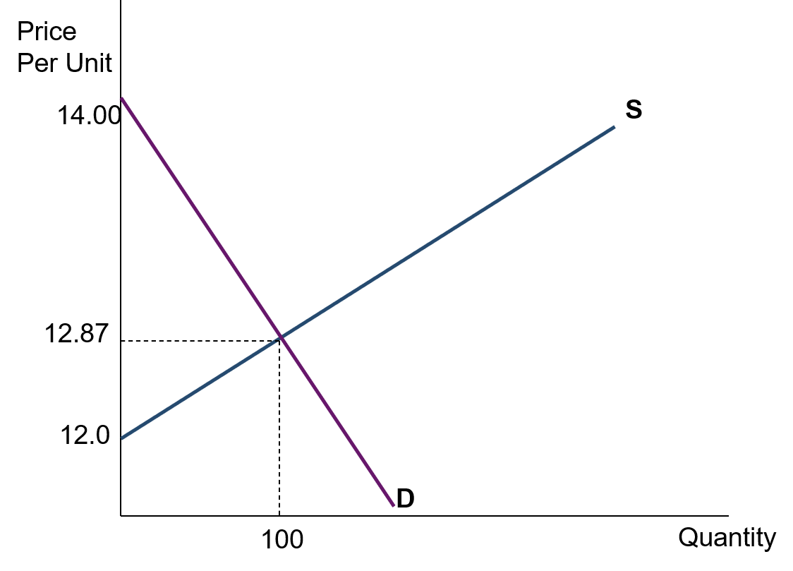

Equilibrium Point
Figure 1: Electricity supply and demand, showing equilibrium point

Changes within the demand of supply will alter the supply curve. If business increase the amount of product they are supplying then the supply curve will shift to the right and to met the equilibrium the price will decrease. A decrease in supply would cause the curve to shift left and prices would need to rise. See figure 2 below.

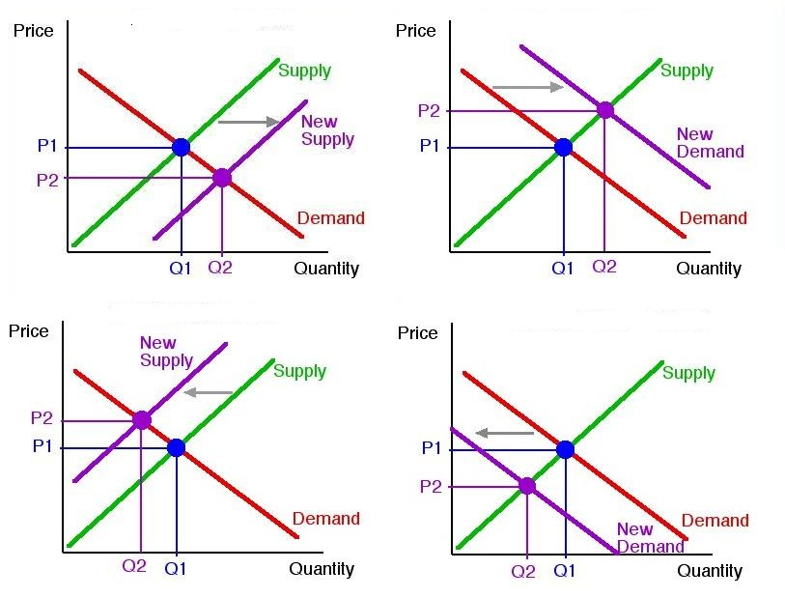
Figure 2: Changes in the levels of Supplies produced (TamoClass, 2014)
Changes in consumer demand will also alter the curve. An increase in product demand will cause the curve to shift to the right, the equilibrium will also move causing the supplier to raise prices. A drop in demand will shift the curve left and dropping prices to remain balanced. See figure 3 below.
Figure 3: Changes in the levels of consumer demand (TamoClass, 2014)

Market Failures
When the organisation neglects to operate competitively and instead operates as part of a monopoly then the likelihood of failure is increased. This is due in part to their ability to determine prices. Traditionally the UK Government has attempted to prevent these issues via the implication of regulations aimed at prevention of collusion and anti-competitive behaviour. Alternatively, the favoured choice within Western Europe is the nationalisation of an industry. Another source of Market failure is the presence of externalities. The challenge presented by externalities is the failure to provide appropriate resource provisions causing inefficiency within the markets because the current market prices do not indicate the entire costs involved. meaning they fail to produce socially effective amounts for consumption and production (Wallis & Dollery, 1999).
Welfare loss is one outcome of a market failure. This is because it impacts circulation of products and services as well as distorting the price structure which can in turn lead to the failure of economic efficiency. These market failures are rooted within the social economic structures of the majority of countries, reinforced by the absence of well-functioning structures this is intended to strengthen our market economy’s resilience to any shortcomings (Winston, 2006).
In January 2018 Carillion PLC a UK Based construction and facilities management company announced it was going into liquidation. This posed a number of issues for the government as to whether it was pertinent to bail the company out, when it had made a commitment of non-interference in relation to bailouts. So why did it bother the government so much ? In July 2017 Carillion PLC were awarded the contract for the new HS2 Rail system which at the time was worth an estimate of £1.34 billion. Critics Question why such a contract was offered to an organisation already reporting financial troubles, stating was it offered as a boost to prop up the organisation. Whatever the reason this was a Market failure that cost the government financially and in reputation (Podmore, 2018).

Estimating Public Good
One of the main boundaries effecting the valuing of marginal private costs within an organisation, is that they fail to include public good. Public good is the term given to a good that is seen as both Non-excludable and non-rivalrous, meaning that any benefit obtained from these goods cannot be limited to those who have paid for them. Moreover, marginal costs required for the supply of these public goods to an additional consumer is zero, meaning if it is available to one it must be available to all. For a business to successfully achieve allocative efficiency of Public good, where production represents consumer preference, they must produce a well-defined supply and demand function. It is therefore not possible to efficiently assign Public good without intervention from a third-party. With this in mind governments could react by imposing the direct provision of public goods, this is achieved simply by increasing the amount of information and education about the area in question. Governments may also choose to implement specific political procedures in place in order to identify societal preference in regards to public goods (Buchanan, 1999).

Externalities and their Effects on Industry
The externalities within UK industry include the economic, social and environmental consequences of the business that are produced from the activities of the organisation but whose effects are borne by other parties, in many cases the public. Reflection of these extremities fails to be replicated within the price of the products or services provided. An example within the current UK Steel industry could be the pollution released from chimneys at a steel works polluting the air and effecting the air quality in the surrounding area. Due to the fact that these issues do not factor directly within the organisation’s financial results they typically remain outside the remit of financial reporting and are viewed as having no internal consequence (Hopwood, et al, 2010). In order for this current position to be amended, externalities must be internalised, this could be achieved in a number of ways. See figure 4.
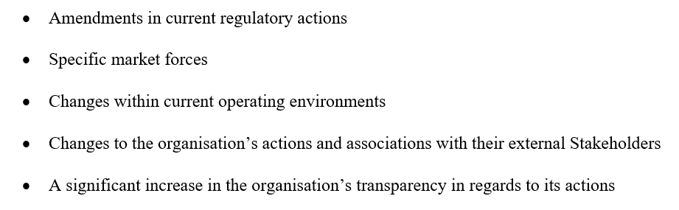
Figure 4: forms of externality internalisation (NCC, 2016)
If organisations continue to neglect to implement these changes, then they will fail to appreciate the long term financial consequences for their business (Hopwood, et al, 2010). However, there are many core intricacies involved in the development of dependable or consequential metrics to monetise the impacts of the externalities (Unerman, et al, 2018).
The National Capital Coalition (NCC), an international partnership who bring together the global natural capital community, state that it is essential that all organisations acknowledge that they are reliant on the condition and wellbeing of the natural world, while recognising nature’s influence to strengthen their success. They believe that recognition by an organisation of their relationship with the natural world will lead to enhanced and well informed decisions, that would not only be an advantage to the business, but also to the communities and society surrounding them, along with positive impacts on the economy and of course the natural world (NCC, 2016)

Marginal Social Costs
Marginal costs are the changes in total costs thar occur once the volume produced is increased by a single unit. The costs of added inputs needed in the production of subsequent units is required to be contained within the marginal cost. Marginal cost includes all variable costs that fluctuate with the level of production, while fixed costs are unchanging and have no marginal cost (Araujo, 2019).
Marginal Social costs echo the effect felt in the economy after the manufacture of one extra component or service. An example of this can be seen within a river polluted by a nearby coal plant, if the plant fails to include social costs within their finances then they will yield a negative effect on the environment, a negative externality.

The sum involved would look like this :-
Marginal Social Cost is greater than Marginal Private costs then Marginal external costs are positive
(MSC >MPC= +MEC).

Simplified it means that the costs of producing energy within the coal plant is higher than the organisation currently charges, this is due to the damage caused to the river and neighbouring environment. If changes were not made then the nearby town would have to cover the cost of reparation for the contaminated waterway. Social costs are an economic principle that must therefore be factored into the equation to continue to produce at an equilibrium. It is however exceedingly challenging for companies to measure in pounds and attach to the resulting impact. This principle is therefore usually employed by economists or legislators when creating an operating and production structure, these are offered to companies to aid reduction of the costs of their actions (Kenton, 2019)
In order to prevent market failure through exclusion of externalities, industries must factor in these Marginal social costs. In Figure 5 below the graph depicts oil supply and demand both with and without the inclusion of Marginal Social Benefits. It shows that by including these social principles the supply curve shifts up and to the left, this in turn causes the equilibrium price to rise while reducing production levels.
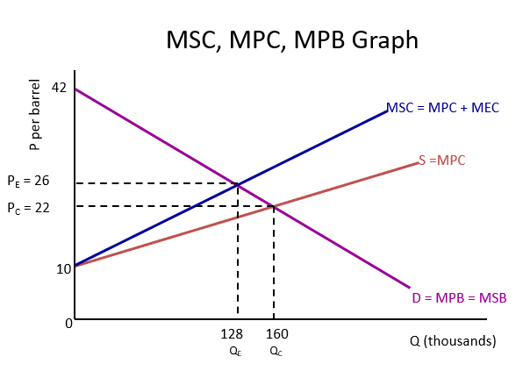
Figure 5: Supply and demand curve with and without Marginal Social Costs (MSC)

Solutions :- The Paris Agreement and its effects on UK Industry
Initially agreed in 2015 by 195 countries, the Paris agreement is a voluntary deal made to aid international climate action. The key objective through the implementation of Article 2, is to maintain the average global temperature to under 2°C above pre-industrial levels (Fuglestvedt, et al., 2018). However, the Paris Agreement goes much further than that covering greenhouse gas emissions, climate change adaptation and climate change mitigation.
Article 6
Article 6 aspires to promote various methods to aid and support governments to implement nationally determined contributions (NDC)s through voluntary global collaboration. This agreement will also aid the establishment of an emissions trading system. This scheme permits countries with lower emissions to offer any exceeding allowances to countries who produce greater emissions. Therefore, supply and demand for these allowances will aid in the creation of a worldwide carbon price, this will link the negative externalities of greenhouse gas emissions to polluters (ICC, 2019) this process could really aid the UK industry, however, it is a voluntary agreement which means those signed up would bear the brunt of those who have not. Moreover, this is not the first emissions trading system (ETS), the first European ETS was launched in 2005. Since its introduction this form of trading has grown in significance in the worldwide fight against climate change (Borghesi, et al, 2016).
Critics of the trading system argue that it is morally wrong (Drury, et al, 1998) because it takes a negative act and converts it into a positive act, continuing that, allowances set are simply a licence to pollute (Goodin R. E., 1994). Other critics site concerns that higher levels of flexibility could lead to organisations within the system becoming responsible for increased environmentally produced health risks (Solomon & Lee, 2000). An example of this can be seen when studying the proximity of landfill sites and comparable polluting businesses to local communities and the effect on the population’s health (Bowen, 2002) (Corburn, 2001). Emission Trading Systems have also been called into question in regards to the allocation of the allowances to controlled firms within cap and trade systems. Stating allowances have been offered for free as well as being auctioned or sold for profit (Goodin R. E., 1994). Moreover, these decisions regarding allocation can be a formidable tool for politicians to utilise in order to achieve personal gains during the introduction of emission trading programmes (Joskow & Schmalensee, 1998).
Government Subsidies
Subsidies are offered by the government as a form of mediation to many different UK Industries. It can be offered as a form of encouragement or to save a dwindling business. if a business was given a subsidy then it could be clearly seen on their supply curve as a shift to the right (Wren, 1996). Figure 6 below shows the various type of subsidy available.
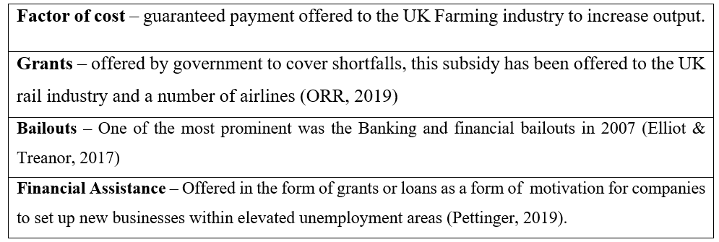
Figure 6: Type of subsidies available in the UK
Government Subsidies may be warranted within UK Industry if it is seen to promote an increase in the supply and consumption levels of commodities that generate improved external benefits. Subsidies assist with managing inflation through the implementation of price controls. This can be achieved through the freezing or capping of prices or quantities of products produced. Applying a subsidy can aid increases in supply and a change in the equilibrium (Murphy & Smeers, 2019). Figure 7 below illustrates this through applying a per-unit subsidy S^{e} signifies the subsidy.
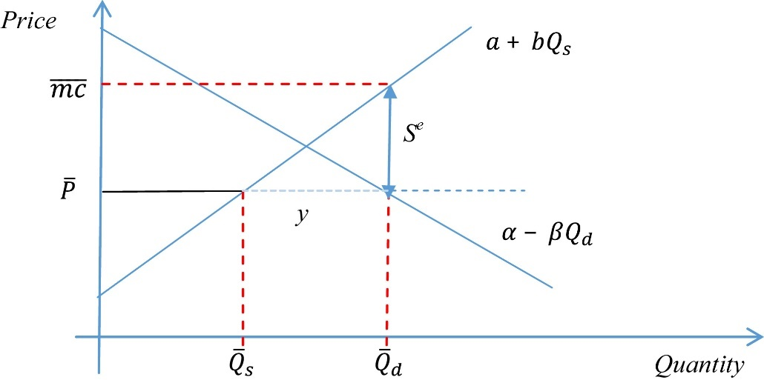
Figure 7: This example shows the implementation of a per unit subsidy (Murphy & Smeers, 2019)
Subsides can also be used to boost demand. This was used within the UK during the last recession, as a support for the car industry. The scrappage scheme as it was known has also been recently reimplemented in London for Vans and Minibuses in the hope that it will relieve air quality (TFL, 2020). Criticism of government subsidies state that they are costly, this expense typically lies with consumers. Allocation of subsidies have been deemed political, with many decisive decisions concerning whom receives them regarded as arbitrary, in 2015 a total of $5.3tn of subsidies was paid worldwide to aid fossil fuel production a cost many feel would be better invested within the renewable energy (Abraham, 2017). Furthermore, other critics state that many of these benefactors have often paid little or no tax within the UK, those organisations include but are not limited to, Amazon, Ford and Nissan. Figure 8 below shows the difference between subsides and grants paid out to the UK industry compared to the income received from corporate Tax.
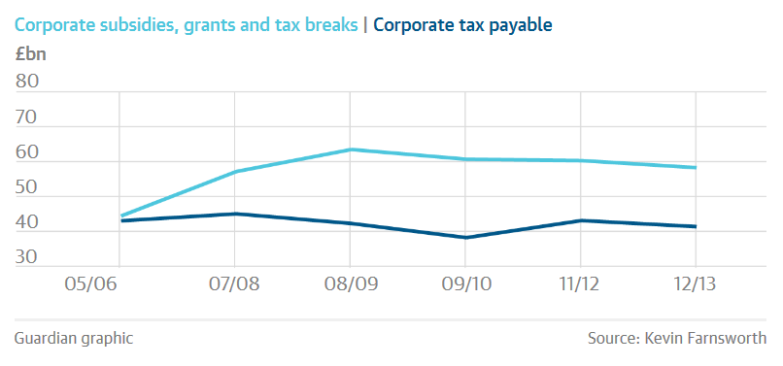

Figure8: comparable graph showing tax breaks and tax payable (Chakrabortty, 2015)
During the financial year 2012/2013 for example the UK government paid out £93bn incorporate aid, a breakdown of these figures can be seen in figure 9 below (Chakrabortty, 2015).
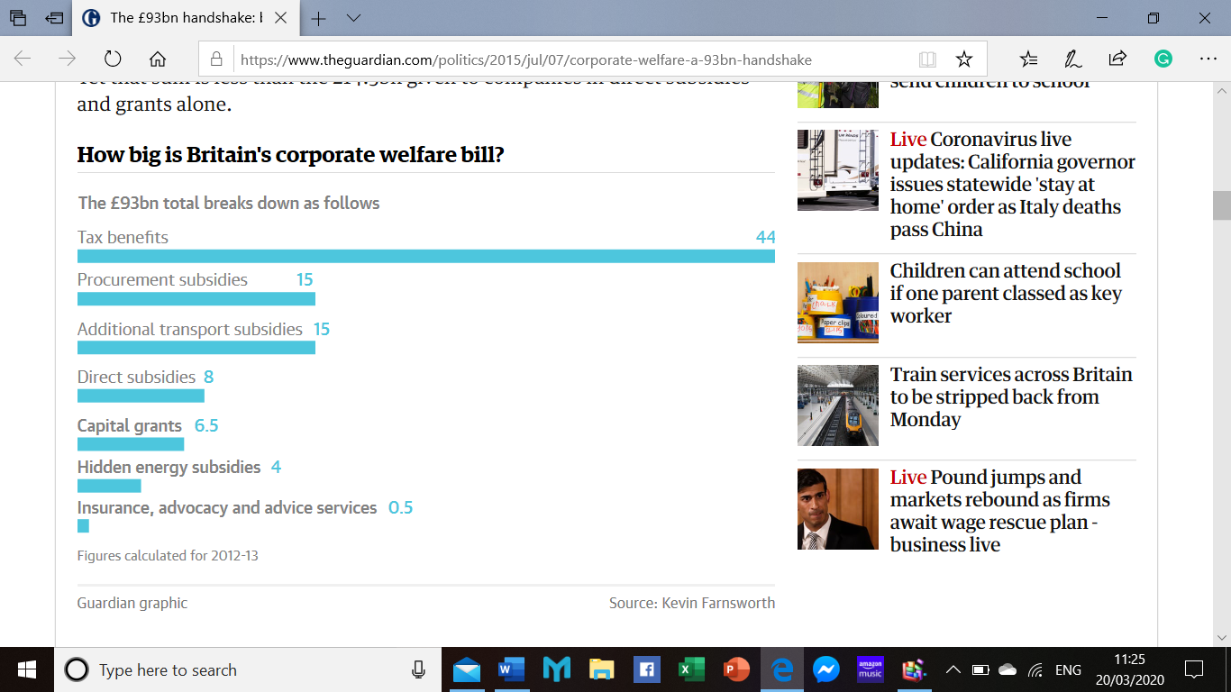

Figure 9: Breakdown of UK Government handouts 2012/2013 (Chakrabortty, 2015)
Continuing on with the allocation of subsidies, in 2015 a total of $5.3tn of subsidies was paid worldwide to aid fossil fuel production a cost many feel would be better invested within the renewable energy
Conclusion
This report has shown a number of issues that may require the UK government to intervene and some instances when they could not. Describing a small number of the UK’s current environmental issues along with several governmental solutions including subsidies and trading systems. It has been seen that these solutions may not always be the most effective resolution to current environmental issues. Subsidies are seen by critics as costly solutions placing the final financial burden on the consumer. While others state its usefulness in stabilising the economy. There are in fact numerous government initiatives and incentives available to business to aid with achieving environmental targets. It is only by choosing the correct ones for each industry that the government can efficiently and effectively resolve its environmental issues and achieve its Paris agreement targets.

References
Abraham, J. (2017, August 7). Fossil Fuel subbsidies are a staggering $5tn per year. The Guardian. Retrieved from https://www.theguardian.com/environment/climate-consensus-97-per-cent/2017/aug/07/fossil-fuel-subsidies-are-a-staggering-5-tn-per-year
Araujo, A. S. (2019, Febuary 28). Marginal Cost & its Variation in Different Economy Scales. International Journal of Tax Economics and Management, 29-34.
Borghesi, S., Montini, M., & Barreca, A. (2016). The European Emission Trading System and Its Followers: Comparative Analysis and Linking Perspectives (First ed.). Switzerland : Springer.
Bowen, W. (2002). An Analytical Review of Environmental Justice Research: What do we really know? Environmental Management, 29(1), 3-15.
Buchanan, J. M. (1999). The Demand and supply of Public Goods. Indianapolis: Liberty Fund INC.
Chakrabortty, A. (2015, July 7). The £93bn Handshake: Businesses Pocket Huge Subsidies and Tax Breaks. The Guardian. Retrieved from https://www.theguardian.com/politics/2015/jul/07/corporate-welfare-a-93bn-handshake
Cohen, A. J., Brauer, M., Burnett, R., Anderson, H. R., Frostad, J., Estep, K., . . . Dandona, R. (2017). Estimates and 25-year trends of The Global Burden of Disease Attributable to Ambient Air Pollution: An Analysis of Data from the Global Burden of Diseases Study. The Lancet, 389.
Corburn, J. (2001). Emissions Trading and Environmental Justice. Environmental Conversation, 28, 323-332.
Drury, R. T., Belliveau, M. E., Kuhn, S., & Bansal, S. (1998). Polution Trading and Environmental Injustice. Duke Environmental Law & Policy Forum, 9, 231.
Elliot, L., & Treanor, J. (2017, August 3). The day the credit crunch began, 10 years on: 'the world changed'. The Guardian. Retrieved from https://www.theguardian.com/business/2017/aug/02/day-credit-crunch-began-10-years-on-world-changed
Fuglestvedt, J., Rogelj, J., Millar, R. J., Allen, M., O'Boucher, O., Cain, M., . . . Shindell, D. (2018, April 2). Implicationsofpossible interpretationsof‘greenhouse gasbalance’intheParis Agreement. Philosophical Transactions of the Royal Society A: Mathematical, Physical and Engineering Sciences 376, no. 2119, 376(2119).
Goodin, R. E. (1994). Selling environmental indulgences. Kyklos, 47(4), 573-596.
Goodin, R. E. (1994). Selling Environmental Indulgences . Kyklos, 47, 573-596.
Hopwood, A. G., Unerman, J., & Fries, J. (2010). Accounting for sustainability : practical insights (1st ed.). London: Routledge.
ICC. (2019). Article 6: What is it and why is it important? Paris: International Chamber or Commerce. Retrieved from https://iccwbo.org/media-wall/news-speeches/article-6-important/
Joskow, P. L., & Schmalensee, R. (1998). The Political Economy of Market-Based Environmental Policy. The Journal of Law and Economics, 41(1), 37-84.
Kenton, W. (2019, November 12). Marginal Social Cost (MSC). Retrieved from Investopedia: https://www.investopedia.com/terms/m/marginalsocialcost.asp
Murphy, F., & Smeers, Y. (2019, June 1). Measuring the effects of price controls using mixed complementarity models. European Journal of Operational Research, 275(2), 666-676.
NCC. (2016). The Protocal. Retrieved from National Capital Coalition: www.naturalcapitalcoalition.org/protocol
NIC. (2017). ECONOMIC GROWTH AND DEMAND FOR INFRASTRUCTURE SERVICES. The National Infrastructure Commission. London: UK Government . Retrieved from https://www.gov.uk/government/publications/economic-growth-and-demand-for-infrastructure-services
ORR. (2019, February 7). Rail investment and subsidies. London: Office of Rail and Road . Retrieved from https://dataportal.orr.gov.uk/statistics/finance/rail-investment-and-subsidies/
Pettinger, T. (2019, June 14). Policies for reducing unemployment. Retrieved from Economics Help: https://www.economicshelp.org
Podmore, W. (2018, February 8). The Collapse of Carillion: Another Free Market Failure. Counterpunch. Retrieved from https://www.counterpunch.org/2018/02/08/the-collapse-of-carillion-another-free-market-failure/
Sloman, J., Hinde, K., & Garratt, D. (2013). EconomicsFor Business (Sixth ed.). Harlow: Pearsons Education LTD.
Smith, B. (2015, June 9). United Kingdom: Environmental Issues, Policies and Clean Technology. AZO Clean Tech. Retrieved from https://www.azocleantech.com/article.aspx?ArticleID=535
Solomon, B. D., & Lee, R. (2000). Emissions trading systems and environmental justice. Environment: Science and policy for Sustainable Development, 42(8), 32-45.
TamoClass. (2014, October 17). Market Equilibrium. TamoClass. World Press. Retrieved from https://tamoclass.wordpress.com/2014/10/17/econ-market-equilibrium/
TFL. (2020). Scrappage Scheme for Vans and Minibuses. Retrieved from Transport for London: https://tfl.gov.uk/modes/driving/ultra-low-emission-zone/scrappage-scheme?cid=scrappage-scheme
Unerman, J., Bebbington, J., & O'dwyer, B. (2018, June 4). Corporate reporting and accounting for externalities. Accounting and Business Research, 48(5), 497-522.
Wallis, J., & Dollery, B. (1999). Market Failure, Government Failure, Leadership and Public Policy (First ed.). Basingstoke , Hampshire : Macmillan Press LTD.
Winston, C. (2006). Government Failure Versus Market Failure: Macroeconomics Policy Research and Government Performance. Washington DC: Brookings Institution Press.
Wren, C. (1996). Industrial Subsidies: The UK Experience. Basingstoke, Hampshire : Palgrave Macmillan.

