Uber Report
Cyrille Rene Tounoudjou (1914188)
University of Wales Trinity Saint David: Module code: BMSW4004 Lecturer: Laura James
2/26/2021
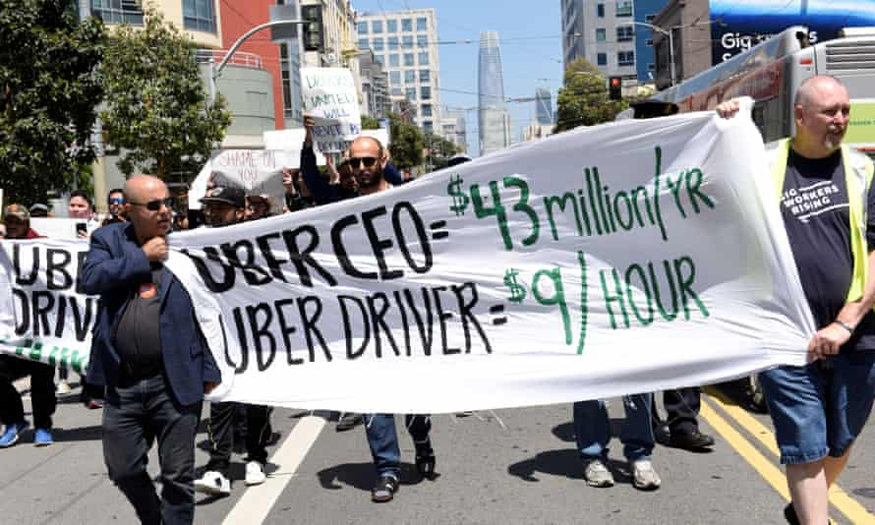

Contents
1.0 Introduction 2
2.0 Main finding 2
2.2.1 Scope 2
2.4 PESTLE Analysis 6
3.0 Conclusion 8
4.0 Appendices 9
4.1 SWOT 9
4.2 PESTLE 10
5.0 Reference List 11

Introduction

The idea of Uber was founded by Garrett Camp and Travis Kalanick in 2009 when they discovered that it was expensive to travel by hiring private cars and they wanted to make a service that was affordable to most people. Camp’s strategy for Uber was to make a service where many people could share the cost. The purpose of this report is to identify a problem by gathering information on Uber, conditioning a SWOT and PESTLE analysis to offer a conclusion.

Main finding
  - Brief overview of UBER
According to a report by MarketLine (2021) Uber has 22263 employees within the USA. Uber Technologies Inc provides ride-hailing services through its mobile application (app) and websites. The company operates across five continents and offers pick up and drop services at airports. Uber also uses its platform to provide food and meal delivery services. The company also delivers to customers with ductless e-scooter and e-bike autonomous vehicle technologies it developed. Other services Uber provides include freight and logistic services, services to corporate for daily commutes (MarketLine, 2021). At the second quarter of 2020, Uber’s revenue was stated to be US$2,241 million which is a decrease of 36.7% compared to the previous year (MarketLine, 2021). Despite the good reports about Uber, it has experienced many legal challenges and controversies with its former CEO resigning as a direct result. The following paragraphs will discuss the main problem faced by Uber while the SWOT analysis will be present in the appendices.
  - The Problem found
The problem I identifies is that, Uber’s business strategy does not accommodate with different government policies. As a result, Uber has had legal challenges related to gig-economy workers in London from 2016 to 2021 (Keane 2021). This problem is caused by poor strategic handling of the business. This problem was also caused by the way the previous CEO ran Uber.

Scope
- Nature of the problem
- Uber’s business strategy does not suit different government policies because Uber has a new business model compared to the traditional taxi service.
- This problem was also caused by the way that the previous CEO poorly managed Uber.
- The problem Uber is facing is also caused by different Income tax regulations across countries and cities. Uber seems not to be adapting its business model to the different regions it is operating in.

- Scope of the problem
Uber’s business strategic problem is worldwide because Uber has faced legal challenges in the UK, Belgium, France, Germany, Italy, Bulgaria, Denmark, Spain, Hungary, Austin Texas, Alaska, Vancouver, Northern Territory Australia (Rhodes {2017).
- Impact of the problem
This problem affects Uber drivers and customers, Traditional Taxi Licenced, and Insurance companies.
- When Uber gets banned in some countries because of its poor business model, drivers who depended on Uber for income will become unemployed, redundant, stressed, and face financial difficulties (Rhodes 2017).
- Uber drivers have not been employees eligible for minimum wage, paid vacations, or health insurance because Also, in case of an accident during an Uber ride, the customer has a significant risk involved in the settlement of any disputes because Uber is not responsible for settling disputes. They are independent contractors (Colley 2019).
- Licenced drivers see Uber as a threat to their working environment. While traditional taxi companies are required to buy expensive licenses to operate in the industry, Uber’s drivers are independent contractors and not employees.

  - SWOT Analysis

- Convenience mobile application
Uber made its mobile app easy to use. Drivers and customers of different classes access Uber services within minutes. Research shows that the most important reasons why people use is ridesharing is because of economic, time and convenience reasons (Amirkiaee and Evangelopoulos 2018). As a result, uber has increased its customer market share. However, because it is easy for drivers to access Uber’s online services, there have been problems relating to vetting and background checks for drivers. As a result of this problem, the California Public Utility Commission fined Uber for refusing to disclose information relating to alleged assaults that happened in 2017 and 2019 in California (BBC 2020). Recently, the new CEO of Uber has been working hard to improve the technological platform to enforce the background checks of the drivers by obtaining criminal offenses from several data sources (UBER 2021). Uber has made partnerships with advocates to develop innovative technologies and systems to improve its safety and services (UBER 2021).
- Well known company
Uber is a global service operating in more than 83 countries and 674 cities as the biggest shared ride services. A report by Statista (2020) said that, global ride sharing market will likely grow to more than 50% between 2020 and 2021 with a market value of about $117 Billion with DiDi, Uber and, Lyft as the main companies in the industry, Though Uber seems to be performing well, it is also losing its market share in the USA to Lyft because of its bad reputation. However, because the company’s name is popular, the business is using its well-known name to expand into different markets with apps like Uber Eat, Making money with Uber, Trip options, Moving cities forward, Helping business move ahead, the future of transportation, Uber X, Uber pool, Uber comport. As a result, Uber has huge strength and more access to market share because of its diverse marketing strategy.

- Growing transportation international Market
In other countries where employment rates are low, Uber’s offers may seem to be a good opportunity for employment welcomed by drivers. This could explain why Uber’s market has become international within 10 years. (Pepić 2018) concluded that, if a service is new, better, and well recognized, it will be in high demand. Therefore, uber can continue to explore some new markets in places like India, China, Nigeria because it is convenient, cheap, and improving its services. Nevertheless, this opportunity can also become a threat because they may still experience the same problems with legislation. For example, Uber was sued in Nigeria by drivers who claimed that Uber did not give them employment benefits such as health insurance (Quartz Africa 2017).
- Uncertain government legislation
Because Uber’s business model is new, many governments and Uber drivers disagree about the legal status of Uber’s business model and if uber service should be treated as a conventional taxi company or as an IT company (Rhodes 2017). As a result, it is difficult for Uber to anticipate whether they will be sued (Kumari and Sharma 2019).

PESTLE Analysis

Uber is having many political problems coming from Uber driver’s employment status not corresponding with government employee requirements. As a result, in September 2017, after Transport Form London refused to renew Uber’s licences, it had to launch an appeal in court to gain a temporarily licence (Colley 2019). Since 2016, Uber has been in court regarding Uber driver’s status in the UK, and the case has moved to the supreme court that ruled that Uber drivers should no longer be contactors (Keane 2021). Unfortunately, this problem has crossed into Uber’s global economy. According to (Colley 2019), Uber had inquired adjustment losses of $1.8 billion in 2018 and $2.2 billion in 2017. Uber also incurred a net loss of US$8,152 million in 2019 compared to a net profit of US$997 million in 2018 per fiscal year (MarketLine 2021).
Jamie Heywood, Uber’s regional director for Northern and Eastern Europe acknowledged that despite the ruling, Uber is implementing changes regarding the driver’s right including, free insurance in case of sickness and injury while committing to doing more to improve driver’s status (Keane 2021).
According to (Wong 2019) Uber faced an unexpected social challenge, and its reputation was harmed. Uber had a crisis in 2019 firstly because Uber took advantage of a strike in the USA against the banning of muslins, by continuing to operate while taxis were on strike and because of an accusation of sexual assault. As a result of Uber’s bad press Uber’s CEO and co-founder Travis Kalanick resigned. Uber acknowledged that because of social and political issues its reputation may continue to be harmed (Wong 2019).
Despite all these problems, Uber has expanded his rideshare to a new market in Africa, Asia, South, America and Europe because Uber is cheap, helps to save time and is convenient for use where there is internet access (Amirkiaee and Evangelopoulos 2018). A report by Statista also shows that more people are adopting fintech technology because about 50% of people in the world have adopted fintech from 2015 to 2019 (Statista 2020). Therefore, Uber has opportunities to continue to grow economically and gain market share globally through technological advancement while improving its business strategy to put up with different governments.
Transport and Environment reported that Uber’s impacts on London’s environment is negative because Uber rides have increased by 25% in the city (Bannon 2019). This increase 23% increase of CO2 emission in the UK. There are also concerns that 90% of uber rides in France are done in diesel-fuelled cars, that intensifying air pollution in cities (Bannon 2019). This problem is causing social problems for Uber because Transport and Environment and Sierra Club are NGOs have started a campaign called #TrueCostOfUber with the objective of informing city authorities and concerned citizens of Uber’s need to solve its emissions problems in cities across Europe and the US (Bannon 2019). This problem can affect uber economically because Uber could lose its customers to traditional transport service, and market in other countries.
Prompted by London city law low-emission 0, Uber has started to switch to electric cars in London. Uber’s objective is also to switch its cars to 0 emissions by 2025 (Bannon 2019). Uber is also improving his services for the environment because it reduces emissions by using the Uber pool which allows customers who are going to the same destination to share the ride and the cost. This will then reduce the number of cars sent out by Uber and reduce air pollution.

Conclusion
In conclusion, Uber’s is a company that has grown and established across the world and in the transport hailing service through its mobile application platform. Even though Uber is a well-known and attractive company with many services provided, Uber’s model is easy to imitate. Uber’s business strategy does not suit many cities and countries where it has tried to establish. Therefore, Uber has been facing many legal challenges where it has been operating. These legal challenges are mostly linked to Uber’s business strategy which does not accommodate with many city and country legislation. These problems have caused Uber to lose market share, law suites and received bans in some cities and counties. Uber also incurred a net loss of US$8,152 million in 2019. After Uber faced all these legal challenges, Uber has now implemented a new business model with its new CEO to solve its problems with gig economy workers, environmental pollution, and safety issues.

Appendices

SWOT
n Strengths
- Well known company
- Convenience to access the platform
- High standard services
- Low cost operation
- New diplomatic CEO
- Attractive for investors
- Varied services
Weaknesses
- Poor business strategy
- The idea can be easily imitated
- Cost of operating vehicles is high
- High dependency on gig-economy workers
- Poor background check of drivers
- Poor connection between Uber and its drivers
- Dependency on technology only
Opportunities
- Growing transportation market
- Expansion through partners
- Cheaper electric Cars
- Can operated in suburban market where there is not traditional taxi
- Additional services
Threats
- Differing government legal regulations
- Drivers strikes
- Political decisions
- Increasing competitor
- Licenced taxi drivers
- Fraud and scandals
- Negative press and medias revealed
- Market shares.

PESTLE
Political factors
- Potential for unfavourable political climate
- Government bans because of business model
- Within economies that have political tension
- Political decision of minimum wage
- Donal Trump’s decision to banned Muslim entered the USA
Economic factors
- Uber is cheaper than traditional taxis
- Uber is a growing company with economic potential
- Uber provides Employment
- New opportunities
Social factors
- Easy access to Uber application
- Convenience customers enjoy using the application
- Bad press revealed
- Fraud and scandal
- Cheapest price

Technology factors
- Internet reliability
- User friendly application
- Increases the use of smart phones
Legal factors
- Uber faces bans and attempted to bans
- Uber must accommodate with different cities and countries laws labour, and employee safety laws.

Environmental factors
- Uber Has to comply with countries and cities policies where it operated
- Increases traffic congestion
- Uber fuel usage have a bad impact in the environment.

Reference List

- Amirkiaee, S.Y. and Evangelopoulos, N. 2018. Why do people rideshare? An experimental study. Transportation Research Part F: Traffic Psychology and Behaviour 55, pp. 9–24. doi: 10.1016/j.trf.2018.02.025.
- Bannon, E. 2019. Uber’s environmental impact in Europe revealed | Transport & Environment. Available at: https://www.transportenvironment.org/news/uber%E2%80%99s-environmental-impact-europe-revealed [Accessed: 19 February 2021].
- BBC 2020. Uber fined over withholding sexual assault records - BBC News. BBC . Available at: https://www.bbc.co.uk/news/technology-55332511 [Accessed: 19 February 2021].
- Colley, J. 2019. Uber’s troubles in London are nothing compared to the bigger picture. Available at: https://theconversation.com/ubers-troubles-in-london-are-nothing-compared-to-the-bigger-picture-127746 [Accessed: 17 February 2021].
- Keane, J. 2021. UK Supreme Court Says Uber Drivers Should Not Be Classified As Contractors. Forbes . Available at: https://www.forbes.com/sites/jonathankeane/2021/02/19/uk-supreme-court-says-uber-drivers-should-not-be-classified-as-contractors/?sh=79b236457e23 [Accessed: 19 February 2021].
- Kumari, A. and Sharma, S. 2019. Management Analysis of Uber. Available at: https://www.researchgate.net/publication/334535923.
- Marketline 2021. Uber Technologies Inc-Financial and Strategic Analysis Review Company Overview. Available at: www.uber.com.
- Pepić, L. 2018. The sharing economy: Uber and its effect on taxi companies. ACTA ECONOMICA 16(28). doi: 10.7251/ace1828123p.
- Quartz Africa 2017. Uber drivers in Lagos, Nigeria sue for employee status — Quartz Africa. Available at: https://qz.com/africa/1125087/uber-drivers-in-lagos-nigeria-sue-for-employee-status/ [Accessed: 17 February 2021].
- Rhodes, A. 2017. Uber: Which countries have banned the controversial taxi app | The Independent | The Independent. Independent 22 September. Available at: https://www.independent.co.uk/travel/news-and-advice/uber-ban-countries-where-world-taxi-app-europe-taxi-us-states-china-asia-legal-a7707436.html [Accessed: 20 February 2021].
- Statista 2020. • Worldwide: fintech adoption rates by product 2019 | Statista. Available at: https://www.statista.com/statistics/1055356/fintech-adoption-rates-globally-selected-countries-by-category/ [Accessed: 19 February 2021].
- UBER 2021. Uber App Safety Features - Rider Safety Toolkit | Uber. Available at: https://www.uber.com/gb/en/ride/safety/rider-safety-features/ [Accessed: 19 February 2021].
- Wong, J.C. 2019. Disgruntled drivers and “cultural challenges”: Uber admits to its biggest risk factors | Uber | The Guardian. The Guardian 12 April. Available at: https://amp.theguardian.com/technology/2019/apr/11/uber-ipo-risk-factors [Accessed: 19 February 2021].

