Digital skills and research methods

Name: Vitalba Leone
Student ID: 1916153
Module code: BMSW4003
Lecture name: Terry Walcott
Name of module: Digital skills and research methods

Contents:
- Overview pag.2

- Introduction p. 2

- Literature Review p.4

- Methodology p.5

- Result p.8

- Conclusion p.12

- List of referencing p.14

- Appendix p.16

Overview
With the advancement of technology, man is making strides in the world of work, especially education. In this report we talk about the impact of virtual learning on people, an anonymous questionnaire was conducted to understand what it’s use, why, when, where, benefits, limitations; explaining things' the VLE experiences, and results obtained from the statistics.

Introduction
Virtual learning is known as online courses in similar environments it has different and broader characteristics. Through the use of electronic supplies such as computers, even inside or outside educational facilities, the better learning experience can be obtained. Lessons are delivered online in environments where teachers and students are physically separated. Professors have the opportunity to teach through the virtual learning environment with a system based on digital solutions to develop active and interactive environments. Educators with VLE are able to create a remote communication, disseminate content, and archive it, plan courses, lessons in the form of e-mails or dialogues even in real-time. (www.vedamo.com/knowledge/what-is-virtual-learning).. The advantages of the VLE are several: Monitoring and understanding of who completes the tasks, simplified assessments with quizzes, and activities help to learn the topics.
Unlimited access to a wide range of educational services anytime, anywhere, educational support considering the personal level of knowledge. Individual needs and different learning styles, to be safe and protected in your environment. Saving time and money in terms of convenience. The disadvantages can be decreased attention, many people are distracted by a thousand things at the same time as online activities. Getting confused in the material always depends on the learning style some people feel lost if they cannot ask a professor for clarification in real-time.
Discomfort with technology, many people are not able to know how to use electronic devices. Limitations like teaching someone to compose or use complex machinery, there is no face-to-face contact preventing teamwork, discussions, and brainstorming. (www.knowledgeanywhere.com)

Literature review
Called virtual learning but we know similar correlatives and various forms, they present different aspects of teaching and learning. A list of the most used ones:
E-learning is an electronic technology for teaching and learning, online activities take place totally or partially online, they can be carried out with devices but without using the Internet.
Web-based learning is used for learning with the use of a web browser. Online learning involves the use of electronic content located on a computer or mobile device. Internet use is possible, but the use of a web browser is optional. You use programs, applications installed on your personal device to be used even offline.
Distance learning does not mean using web-based technologies, but it means learning at a distance, is when the presences are physically separated. It is related to delivering education to people in different places and times than other students and teachers. With the development of digital technologies, distance learning continues on the same level as online learning. With virtual classrooms for online teaching in real-time, the traditional learning methodology is associated with distance learning almost as to not change the main characteristics.
With blended learning, virtual and traditional learning are combined. All contents are digitized and made visible online, to allow students to consider progress or times, rhythms, methods, and places. (www.vedamo.com/ )
In this tragic moment, the whole world is going through the extraordinary effect of the new Covid-19 Pandemic. The impact on students, parents, and educators is strong because the time has come to adapt to new habits and abandon the old ones. Thanks to the technology it allows to use tools suitable for distance teaching. In a hurry, the government and health officials are trying to better control the pandemic, the global education system is adopting methods to guarantee quality in education for all. (www.hundred.org)

Methodology
The analysis carried out was created to understand the frequency of the data collected. Filling in a questionnaire model asking the age from 18 to a maximum of 48 years to estimate the average age range of people participating. Where they live, between London, Canada, Italy, or none to understand geographic area, which device they usually use between the phone, laptop, or tablet, understanding which device is most used. Because do they use virtual resources whether to study, work, entertain themselves, self-taught or for all of them, which categories of people are workers, students o unemployed. Seeking the number of hours they usually spend in front of an electronic device, if them do not spend time, approximately one hour, more than 2 hours, 3-4 hours, 5-7 hours, or more than 8 hours. How they prefer to obtain information through newspapers, television, face to face or online, how they feel more comfortable communicating whether with a device, face to face, or both. Asking if the idea of ​​learning through a device made them happy between yes, no, or maybe, or if they think technology has simplified their lives by using yes, no or maybe as answers, even with the same answers asking if they could manage their time with an electronic device. The activity of the collected data has always been constant without having to adapt any changes to achieve the objectives, a questionnaire conducted with a google form, and delivered to a university class.
From the questionnaire regarding the impact of virtual learning on 52 people in the age group from 18 to 24 who live in Italy usually use an electronic device, mostly mobile phones. As the main reason the data state that it is used to study, work, entertain, and self-taught, but a good percentage in this historical period uses it to study. Statistics say workers and students spend 3-4 hours a day on an electronic device, not forgetting 20% ​​spend an average of 5-7 hours. 41% of them prefer to get information online instead of reading a newspaper, talking to people, or just watching and listening to TV. More than 50% of them prefer to communicate face-to-face and about 40% say they prefer both, but nobody likes to communicate through a device. Investigating the idea of ​​learning online half of the people answered that they are enthusiastic about it and almost 30% say they don't know, well, around 72% say that electronic devices have simplified their lives and only 23% said maybe. In conclusion, more than 60% of them use electronic devices to organize their time and events. The goal of this survey is to understand if people still need challenges to go through this tragic period, what they think about online learning, and if they are aware of the importance. Looking at the results with the question "do you feel more comfortable communicating", the answers are, "face to face", "through a device" or "both". Given the results, 60% answered face to face and almost 40% both, from this it can be deduced that people still love human contact and need to be motivated to achieve awareness of the importance of studying through a device. Most of those people are workers and students who face daily challenges every day to achieve goals using technology.
When asked: "Does the idea of ​​having to learn through an electronic device make you happy?" almost 72% answered "yes". It is estimated that the idea may seem useful to him for reasons of comfort in terms of the environment, staying in safe places, saving time and being more in contact with family and friends; better manage the objectives and tasks to be delivered. (blogs.edweek.orgl)

Result
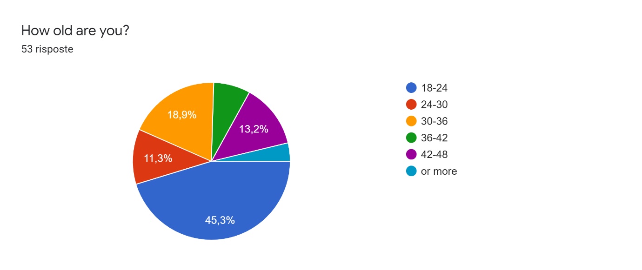
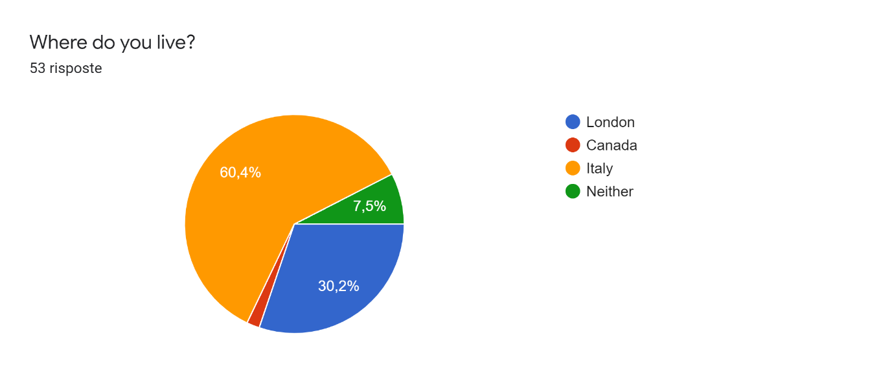
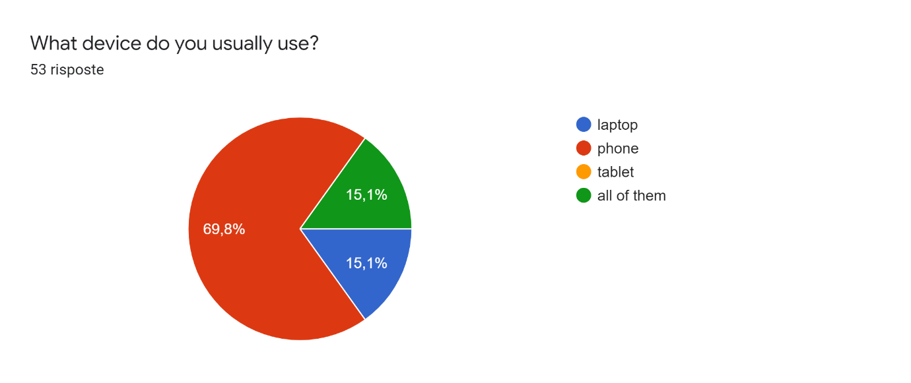
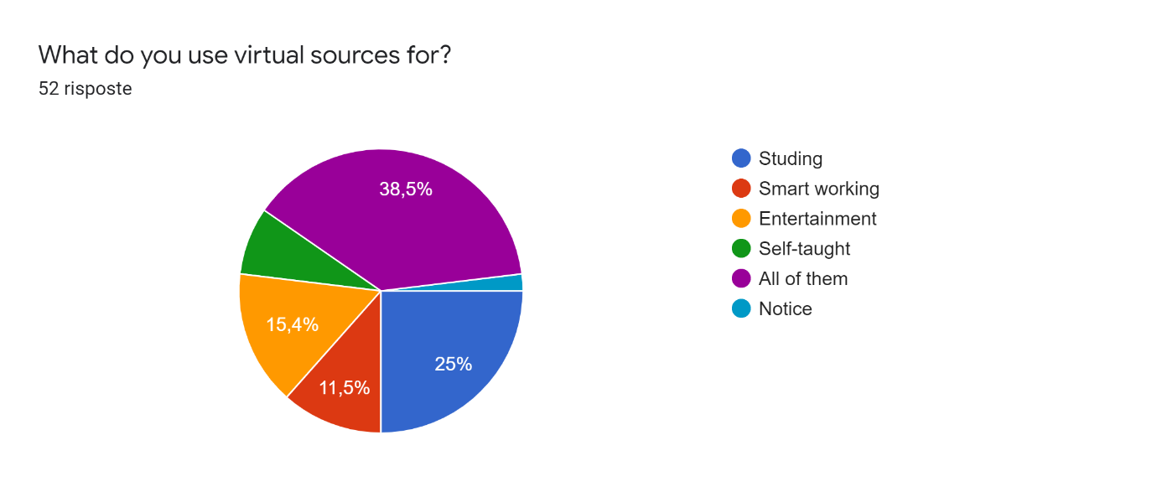
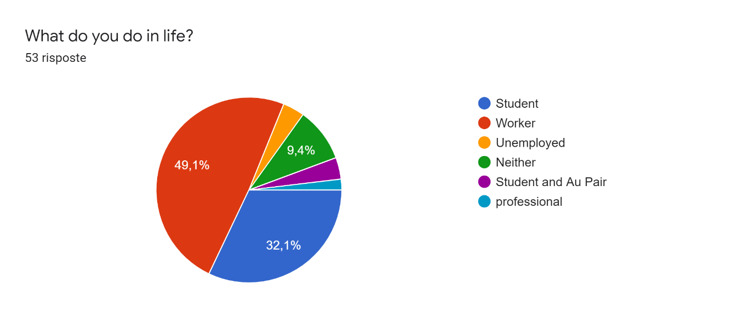
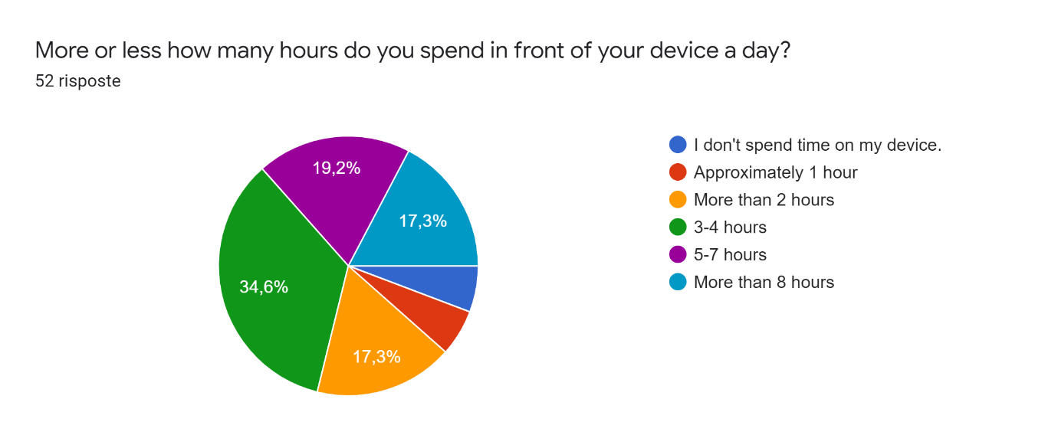
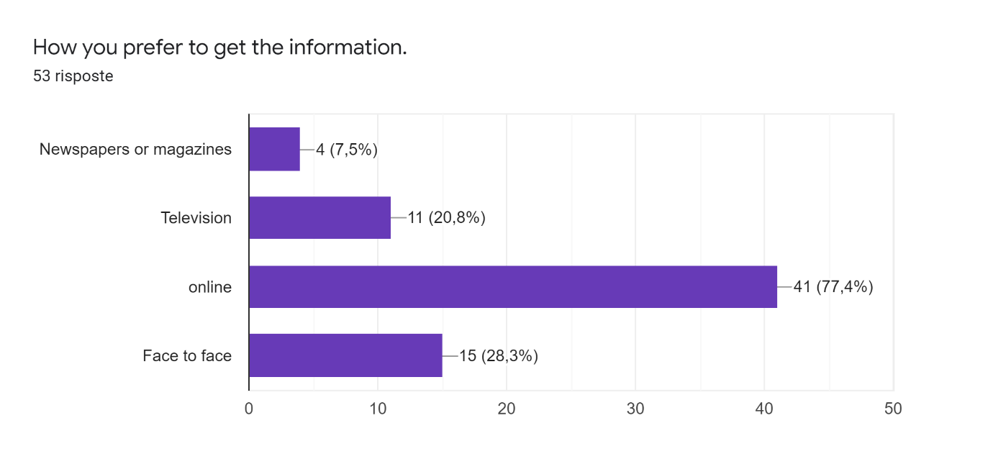
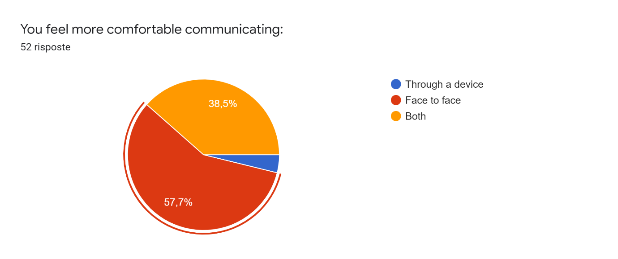
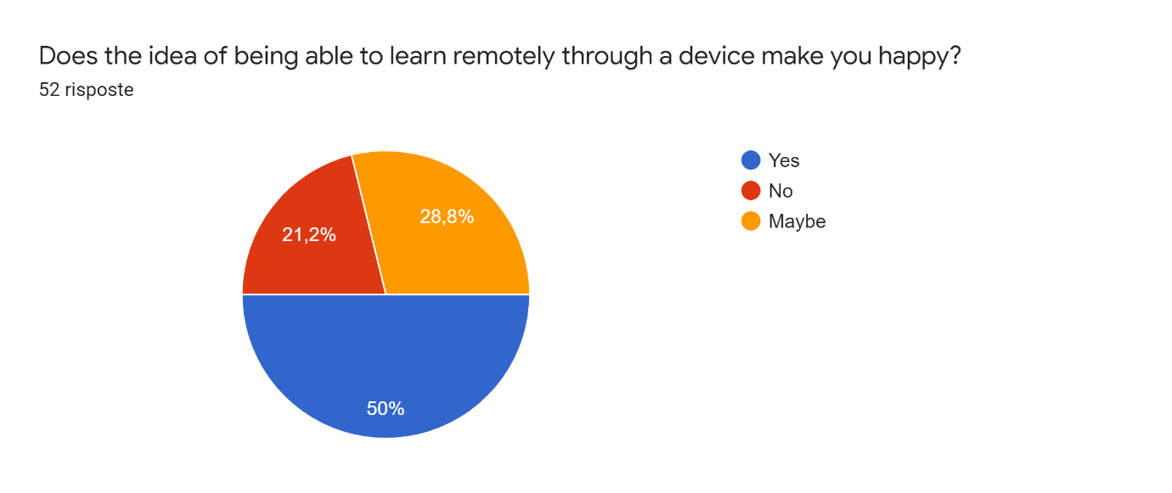
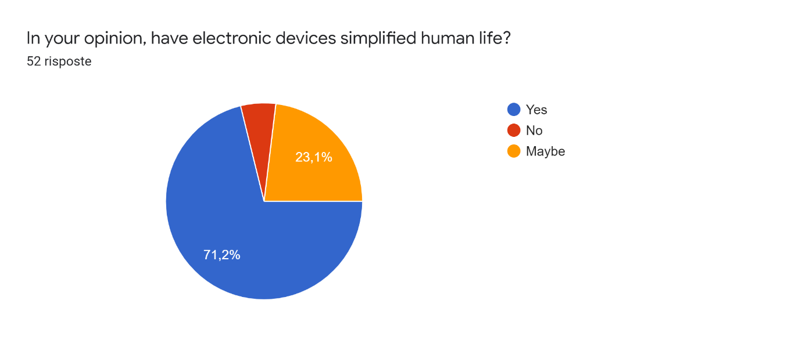
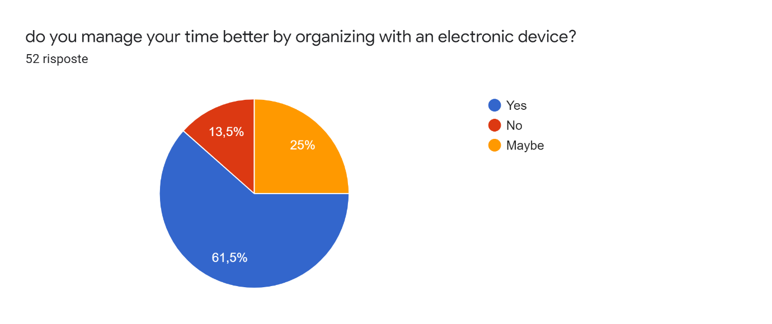

Well, the data speaks for itself, it is the young workers and students who are adapting to living with technology who are aware that it is an excellent ally. To simplify everyday aspects of our lives, keep us safe and sound in safe environments, you can book a medical visit with an e-mail, study, and work through a PC or a telephone. Save important information of any kind on a device, have information of any kind, pay by electronic card, save time and money. Of course, human contact is unparalleled, human beings by nature need to interact with exchanges of energies.

Conclusion
Sticking to the argument the suggestion is to improve the virtual classes. In fact, some online courses have too many images, graphics, and text because teachers think they can keep students motivated, but this instead confuses students. These should be planned and organized in order and the only way to keep students motivated. eLearning materials structured in cohesion and coherence. With images, graphics, and text, the message to be sent should be unique and consistent. They must be harmoniously structured elements that can attract the attention of students.
The virtual environment is a challenge for most students as there are many difficulties they have to face on a daily basis.
The main problem for students is self-motivation, many are in the process of facing an online course with distance learning but after a while, many of them think about giving up. To continue adequately in the educational trends undertaken, students must find a positive attitude to face battles in the future of study and career. To reap the results in the future students must understand even if difficult to practice the importance. It is clear from the survey that many students have a hard time adjusting to virtual learning. It is a problem for people who are used to having traditional teaching in fact with resistance to non-change they have difficulty adapting to online learning. With traditional learning use passive listening and take notes, but with online lessons, you have to activate it. Always with a positive mindset, he can face the challenge and learn to adapt, perhaps understanding the advantages of the VLE by discussing it with his peers and collectively preparing to take an online lesson. (elearningindustry.com )

Referencing list
5 Common Problems Faced By Students In eLearning And How To Overcome Them [WWW Document], 2015. . eLearning Industry. URL https://elearningindustry.com/5-common-problems-faced-by-students-in-elearning-overcome (accessed 8.22.20).

9 Tips To Improve Online Learners’ Engagement [WWW Document], 2014. . eLearning Industry. URL https://elearningindustry.com/9-tips-improve-online-learners-engagement (accessed 8.22.20).
Ferlazzo, L., n.d. What Students Are Really Thinking About Online Learning [WWW Document]. Education Week - Classroom Q&A With Larry Ferlazzo. URL http://blogs.edweek.org/teachers/classroom_qa_with_larry_ferlazzo/2020/05/students_thoughts_about_online_learning.html?cmp=SOC-SHR-FB (accessed 8.22.20).

Impact of Virtual learning [WWW Document], n.d. . Google Docs. URL https://docs.google.com/forms/d/e/1FAIpQLSfUMo0v20FFSEpEqGQZxWuThb-gaSlRwg9rav2EDchuuHGmDw/viewform?usp=embed_facebook (accessed 8.21.20).

Knowledge Anywhere :: The Advantages and Disadvantages of a Virtual Learning Environment [WWW Document], n.d. . Knowledge Anywhere. URL https://www.knowledgeanywhere.com/resources/article-detail/the-advantages-and-disadvantages-of-a-virtual-learning-environment (accessed 8.21.20).

Quality Education for all during Covid-19 [WWW Document],. URL https://hundred.org/en/collections/quality-education-for-all-during-coronavirus (accessed 8.21.20).

Racheva, V., 2017. What Is Virtual Learning? [WWW Document]. VEDAMO. URL (accessed 8.21.20).
Snapshot, n.d.
Trochim, W.M.K., n.d. Descriptive Statistics [WWW Document]. URL https://conjointly.com/kb/descriptive-statistics/ (accessed 8.21.20).

Appendix.

