
Module Name: Computer Architecture and Operating Systems
Operating Systems Assignment
Module Code: (ACCA4022_BIRM)
Student Name: Mavish Iyshia
Student ID:2236706
Lecturer Name: Dr. Md Shantanu Islam
Submission date: 24.07.2026

Contents
Introduction 4
Key functions of general Operating Systems 4
Task Management: 4
Application/Program Management: 5
File/Directory Management: 6
Device Management: 7
Security Management: 8
Use of Windows OS CLI commands 9
Example 1: 10
Example 2: 10
Example 3: 11
Example 4: 12
Example 5: 12
Example 6: 13
Example 7: 14
Example 8: 14
Example 9: 15
Example 10: 16
Use of Linux OS CLI commands 16
Example 1: 16
Example 2: 17
Example 3: 17
Example 4: 18
Example 5: 18
Example 6: 19
Example 7: 19
Example 8: 20
Example 9: 20
Example 10: 21
Use of Windows OS scripts 22
Example 1: 22
Example 2: 23
Use of Linux OS scripts 24
Example 1: 24
Example 2: 25
Conclusion 27
Appendices 27
Online Course name: NDG Linux Unhatched 27
References 28

Introduction
The purpose from this assignment is to outline and address how operating systems maintain and manage the prime functions of a computer. Operating system is the main software that lets hardware, applications and user duties collaborate collectively. It is essential to gain a deeper insight to understand the importance of how operating system manage duties, applications, devices and protection.
The examples illustrate the role of commands in the following: navigation, network diagnostics, automation, and system validation. Moreover, both Batch and Bash highlight the importance of automation, as it decreases manual workload and reduces possible mistakes. At a broader architectural level, these mechanisms interlock into a unified operational framework which makes sure equitable resource allocation, predictable performance trends and ongoing performance of system.

Key functions of general Operating Systems
Operating System OS is the core software that regulates a computer, making sure all components are functioning collectively. Microsoft Windows, macOS, and Ubuntu are operating systems utilised worldwide. Each system has its own tasks that contribute towards computer functionality, safety and effectiveness [1]. The roles are the following: process management.

Task Management:
Firstly, I will outline Process Management, which is a system that ensures a number of programs can run smoothly at the same time, without potential problems such as crashing and reduced performance. Task Manager in Microsoft Windows allows users to identify which programs are currently running and which are consuming excessive CPU resources [2]. Furthermore, Task Manager offers comprehensive performance metrics, provides users with system diagnostics, anticipates performance limitations and Implements corrective measures during initial decline. The prime purpose of this is so that it promotes operating system maintains functionality reliably across diverse load circumstances.This emphasises that effective scheduling plays a critical role in preventing performance decline under heavy workload.
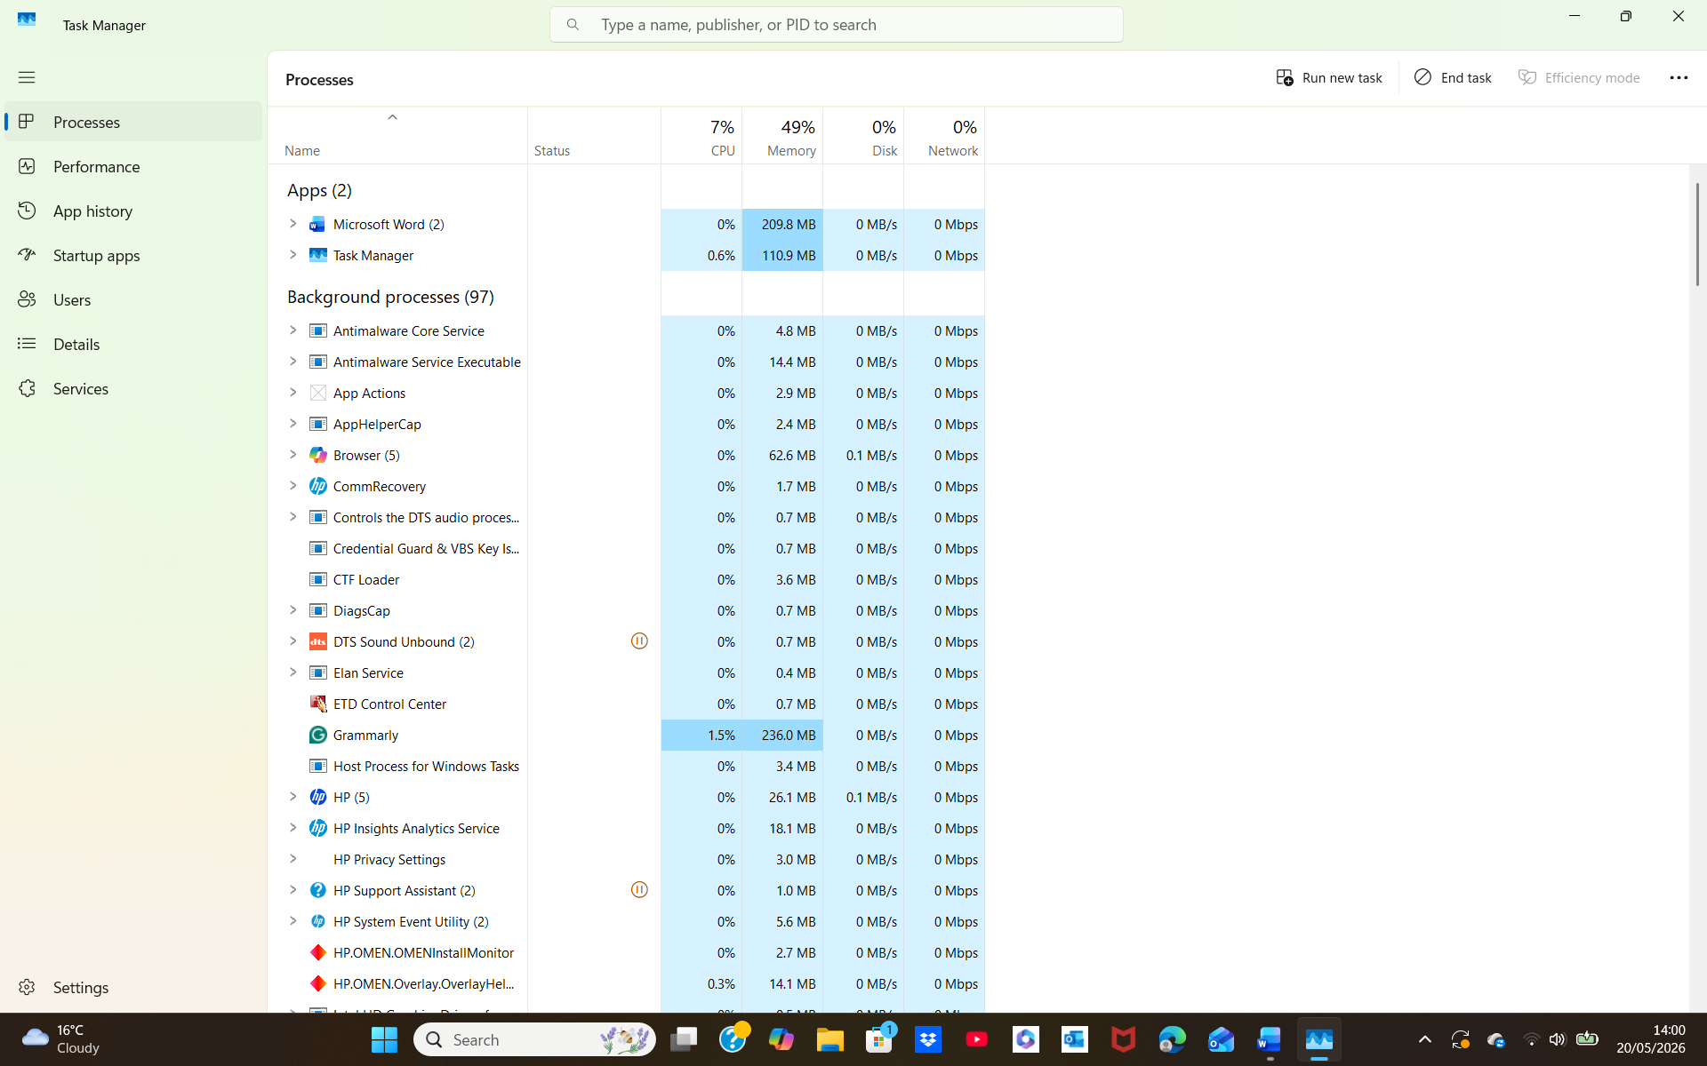

Figure 1: Windows Task Manager

Application/Program Management:
Application and program management in Microsoft Windows is about how the operating system maintains the software when users open and close. Windows oversees loading it into memory and manages the program by allocating the CPU time and hardware resources it requires [3]. Windows maintains the speed performance levels when several programs are running at the same time, preventing possible program freezing. Both Task Manager and Resource Manager provide clarification to users on the level of performance of each program being able to see the amount of memory and CPU has been utilized and shutting down programs which are unresponsive.
Windows preserve system stability by making sure applications are detached through process isolation and by applying virtual memory to manage how programs access memory. The Windows Installer Service (MSI) controls how systems operations are performed such as, installing, updating and removal. From the support from other features Windows is able to manage several programs/applications simultaneously, enhance levels of performance and providing service users with a reliable and stable experience. This reinforces how Windows' approach of isolation and allocating resources effectively is essential in sustaining cross-application responsiveness.
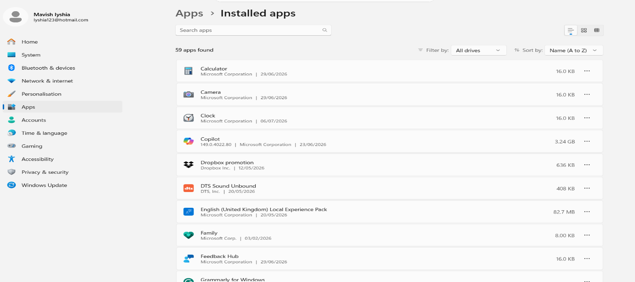

Figure 2: Application/Program Management

File/Directory Management:
A screenshot of Windows file and directory management is displayed below. This system offers a structured and protected place for users to store their files and folders in a safe manner [4]. Moreover, Incorporating several operational features, such as the following: granular access rights, hierarchical folder structure, strong access control and metadata management. These features help strengthen data integrity and system reliability. A file system: NTFS promotes a higher level of security as it enhances the following: permissions, who can access the data, Information about the file/folder, and secure access. This demonstrates that NTFS's design plays an imperative role in keeping files/folders protected as well as in allowing the system to run more smoothly.

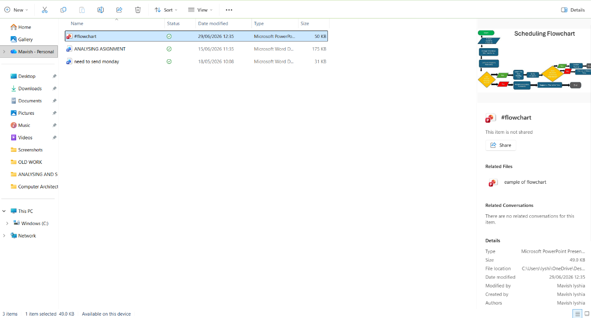
Figure 3: File/Directory Management

Device Management:
Windows device management screenshot is indicated below; it’s a platform that makes use of systems and tools to support computer hardware control [5]. Tools like Device Manager offer a higher level of insight into device status and driver configuration implications, whereas the command-line tool, PowerShell, offers advanced, script-based administration. The Plug and Play subsystem strengthens stability holistically through identification and configuration of hardware components. Moreover, data is retained for each individual device, the purpose of this is to obtain a more comprehensive understanding of long-term behaviour trends. The result of this plays a positive role when solving problems more efficiently, promoting smoother operation involving a range of modern computing duties. System wide device orchestration strengthens integrity, making sure to maintain operational stability and reliable responsiveness under wide range of computational demands.
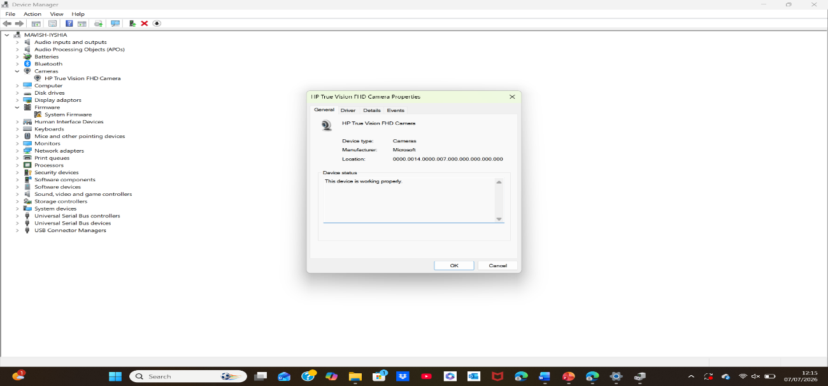
Figure 4: Device Management

Security Management:
I have presented a screenshot of Windows Security below. This system provides real-time threat monitoring and Defender Antivirus to locate and suppress malware activity [6]. Windows ask permission when making modifications to vital system settings, by asking permission only for authorised actions. Moreover, Windows utilises a feature identified as BitLocker to ensure that critical information is both protected and safe from unauthorised use and Group Policy allows operators to define and enforce security rules, maintaining high standards of safety and security. Overall, these operational features demonstrate a comprehensive security framework which upholds platform reliability and supports holistic, platform‑wide protection across the full Windows environment.

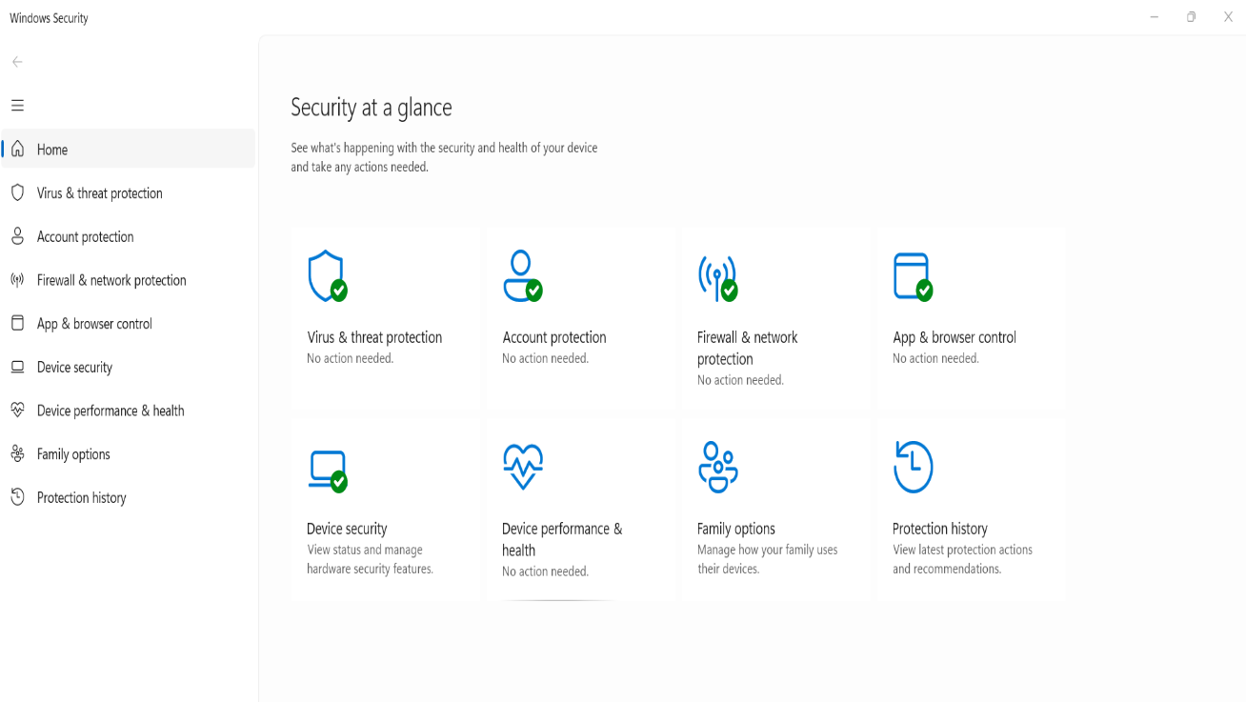
Figure 5: Security Management

Use of Windows OS CLI commands
Windows offer a wide range of command line tools that all contribute to administration, diagnostics, and automation. Windows has two command-line shells such as Command shell and PowerShell [7]. In Command Prompt, I typed the word DIR command to display everything stored in my user directory. The output listed all the folders inside C:\Users\Iyshi, including Documents, Downloads, Music, OneDrive, and Videos. At a broader level, Window's command-line architecture illustrates in depth precision of modern OS design, delivering a robust framework for controlled, reliable and and fine‑grained system governance.

Example 1:
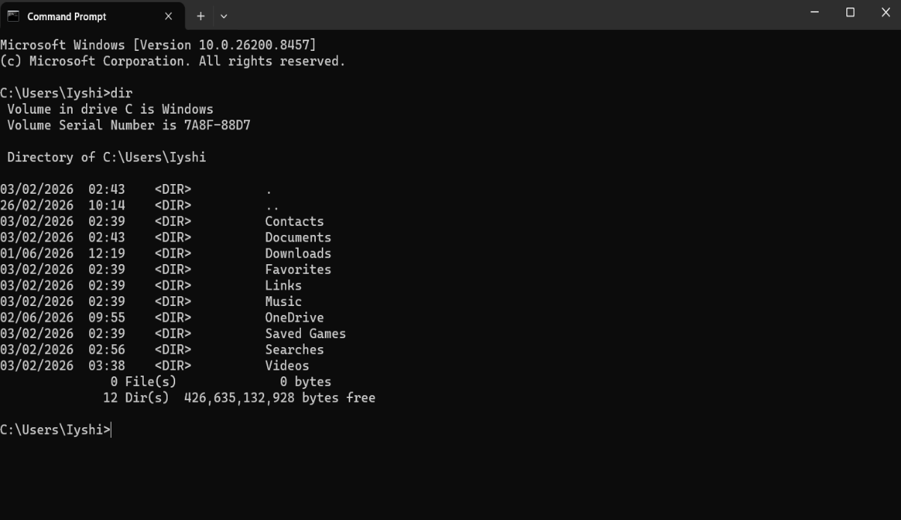

Figure 6: Output of the dir command

Example 2:
The Command Prompt in Windows offers important functions taking control of folders, files and exploring the system paths.[8]. I typed the CD command to browse through directories, moving from Music to the parent directory. After I did not type a path correctly, I fixed my mistake and successfully navigated into the Downloads folder.

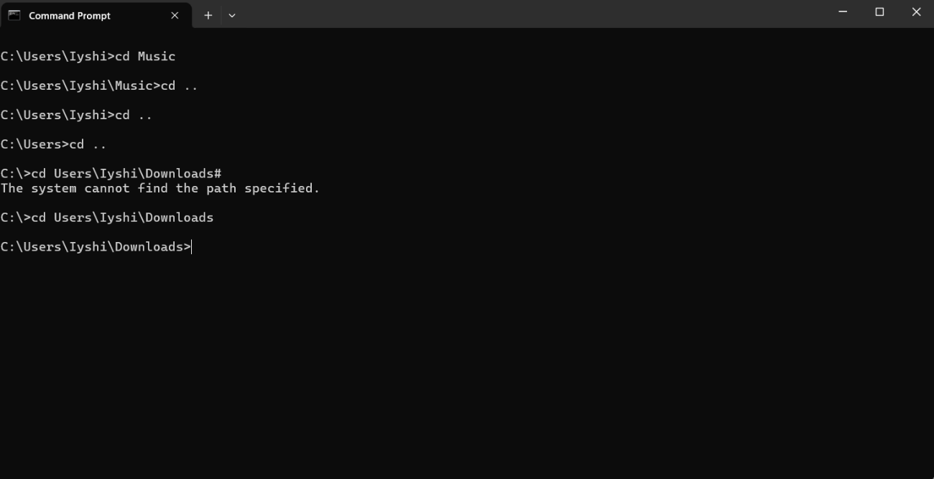
Figure 7: Command Prompt showing folder navigation

Example 3:
Firstly, I used DIR command to check what is in my existing folder and it was a empty folder. Secondly, I typed in mkdir mavish to generate a new folder. To finish with, I ran Dir command again to check if the folder was created.
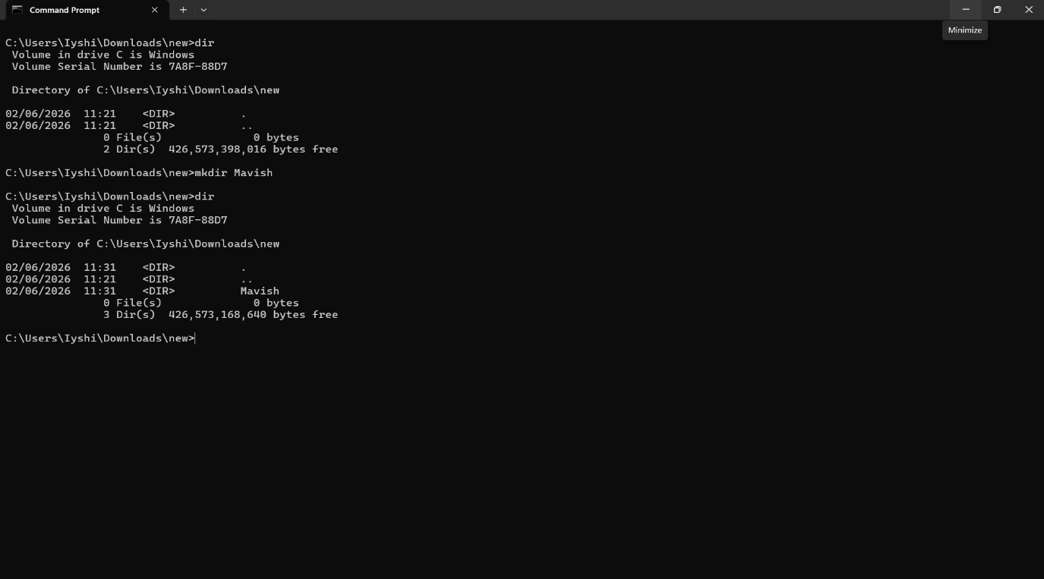
Figure 8: Producing new folder typing mkdir

Example 4:
I typed the command rmdir to remove the folder I no longer require. To check if the folder has been deleted I typed in dir and it displayed successful removal of the folder.
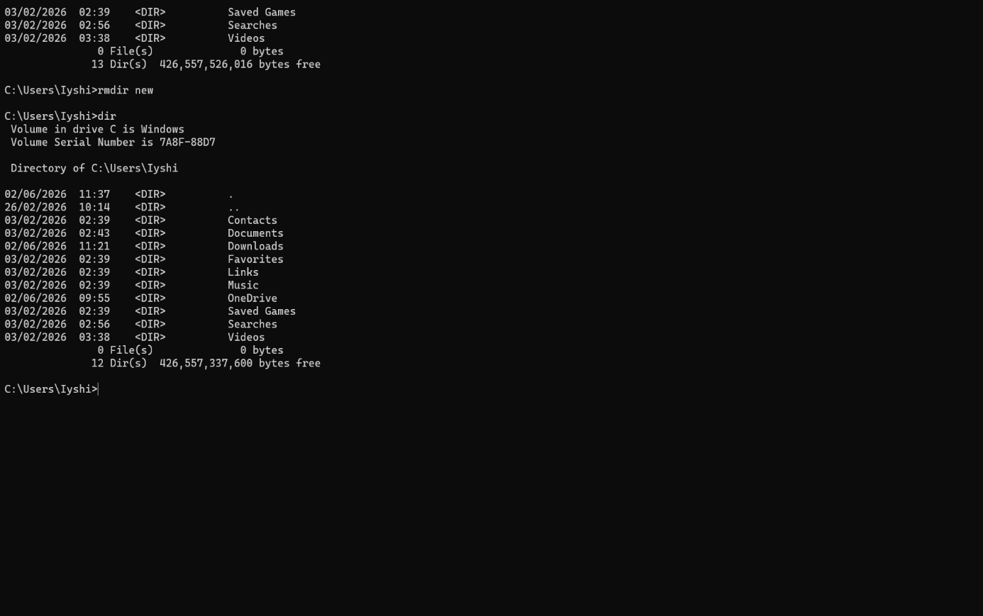
Figure 9: Command Prompt displaying confirmation of new folder produced

Example 5:
I typed rename to change the folder's name. I renamed Music to Songs. Then I typed in dir to check if it has been done.
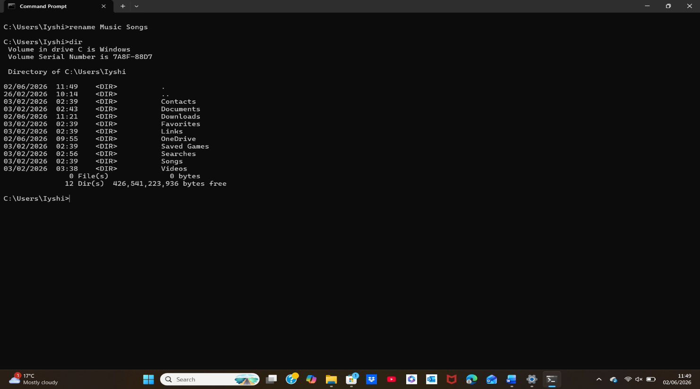
Figure 10: Renaming new folder by using rename.

Example 6:
I typed the command ipconfig to check and see the network information. It showed which adapters were not connected, and it displayed information about the adapters IP information.
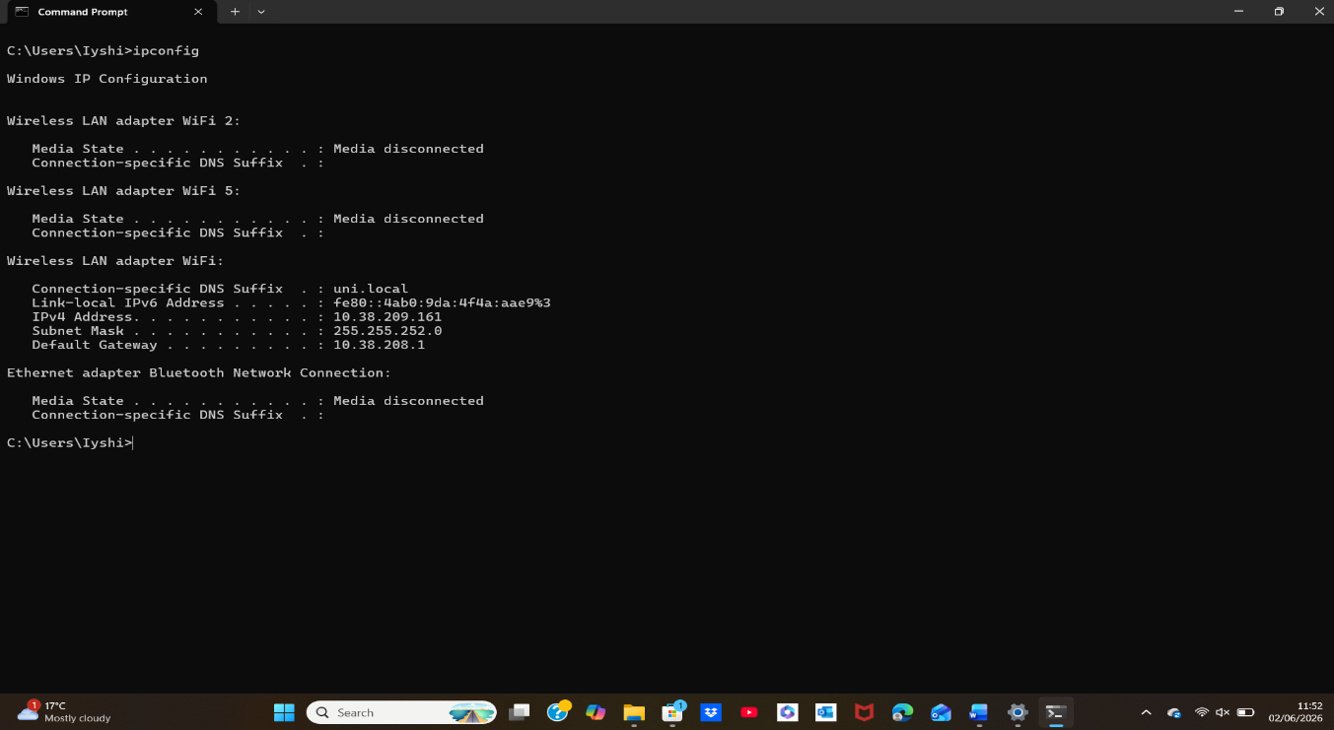
Figure 11: Details of Network shown by using ipconfig.

Example 7:
First, I opened Command Prompt and typed in netstat. Once I typed this, I pressed Enter. A list of off all the connections that are active appeared.
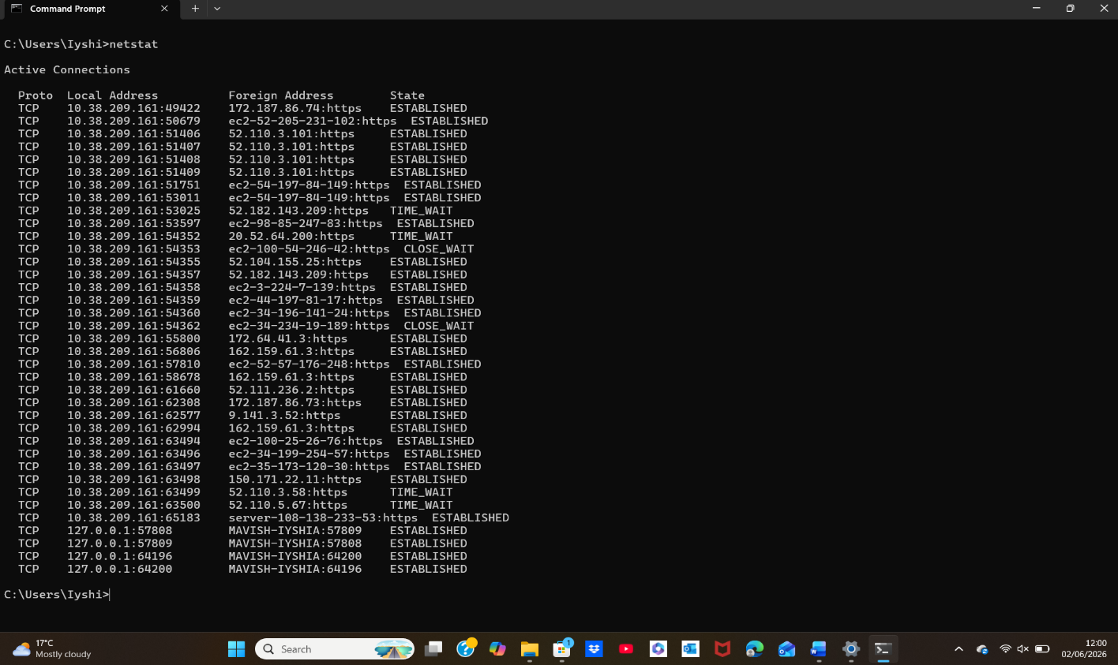
Figure 12: Netstat indicated to display active network connections.

Example 8:
I typed systeminfo within the Command Prompt; this brought up a list of all what the computer has. Such as the following, details of BIOS, network adapters, laptop information like the model, memory and processor.
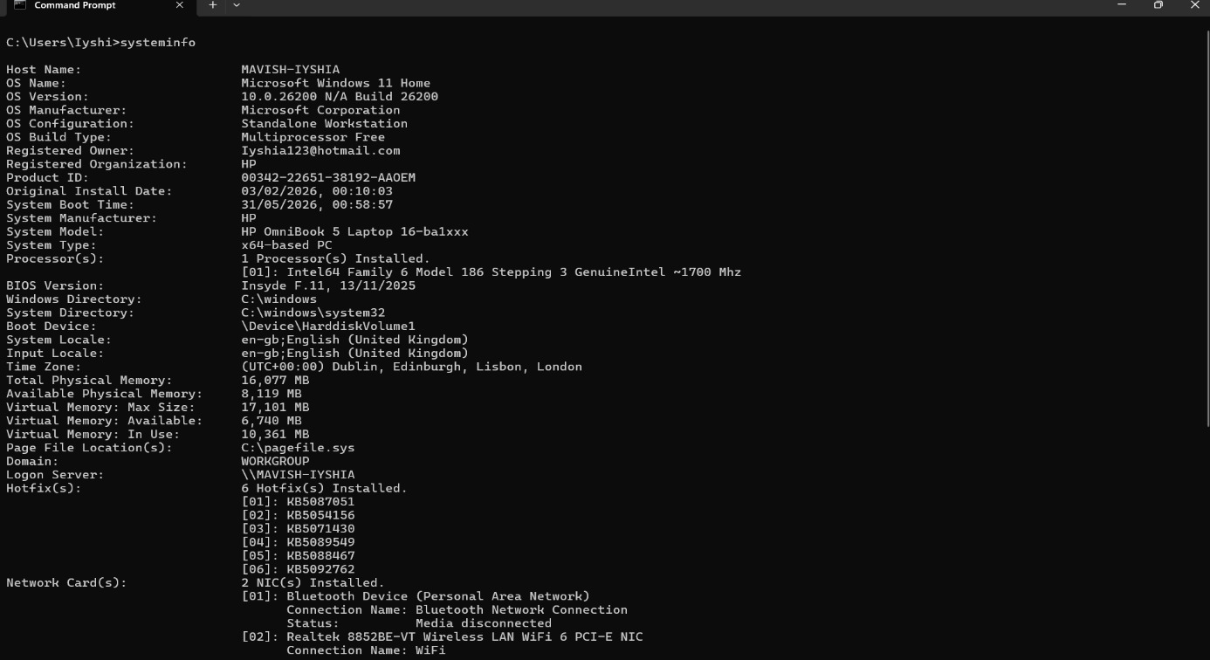
Figure 13: System details shown by indicating systeminfo.

Example 9:
I typed tasklist into the Command Prompt by doing this a list of the running tasks appeared. Also, running background tasks were displayed.
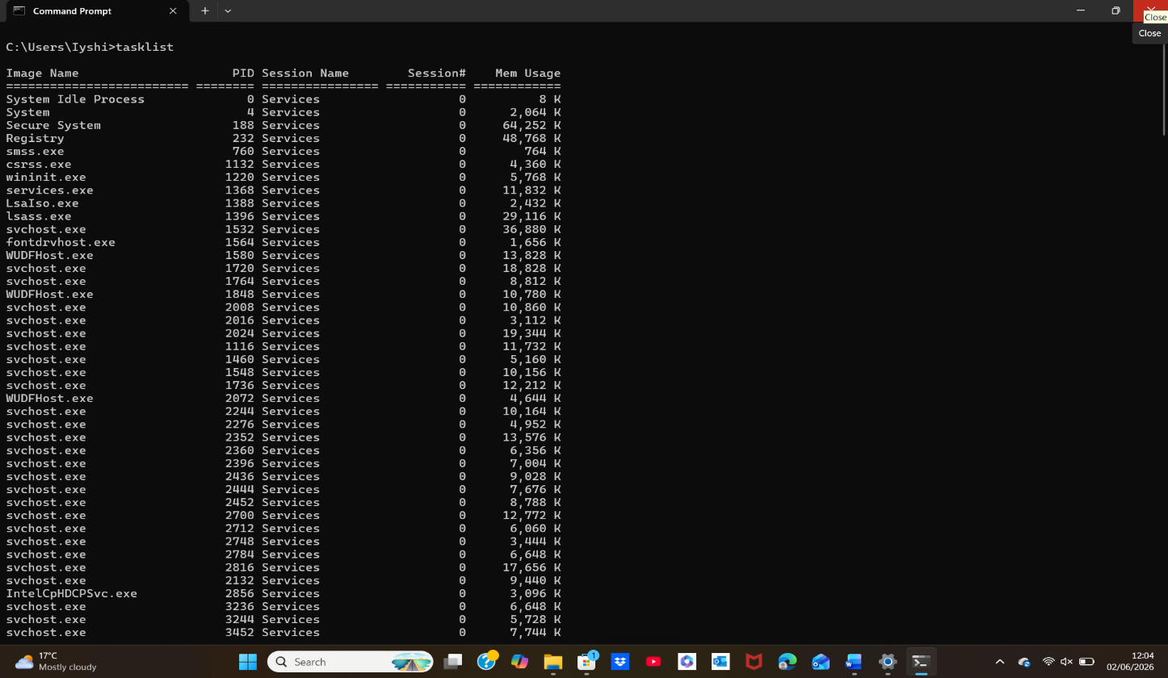
Figure 14: Identifying system activity by typing tasklist.

Example 10:
To test the connection to the internet, I typed ping www.google.com in the Command Prompt. The command ping sends messages to Google and then receives responses. This action showed the internet is working.
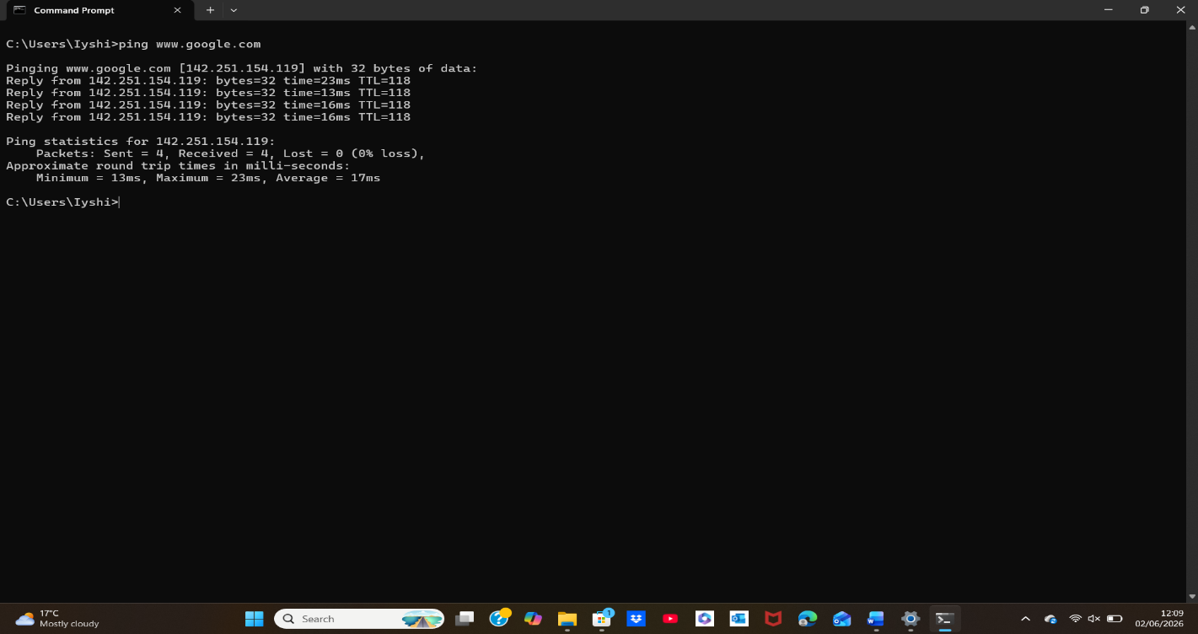
Figure 15: Network check using ping.

Use of Linux OS CLI commands
Linux CLI commands offer efficiency when managing operational systems, making it time-effective [9]. There are several advantages for users, such as overseeing programs which are running, looking at information on systems, setting up networks and managing tasks. As well as assisting towards having tasks/duties done automatically, sorting out conflicts and running Linux systems more seamlessly.

Example 1:
I typed pwd command in the Linux terminal. Now the command displays the folder which I am currently in and the output /home/sysadmin shows me simply that I was using my home directory as a sysadmin user.
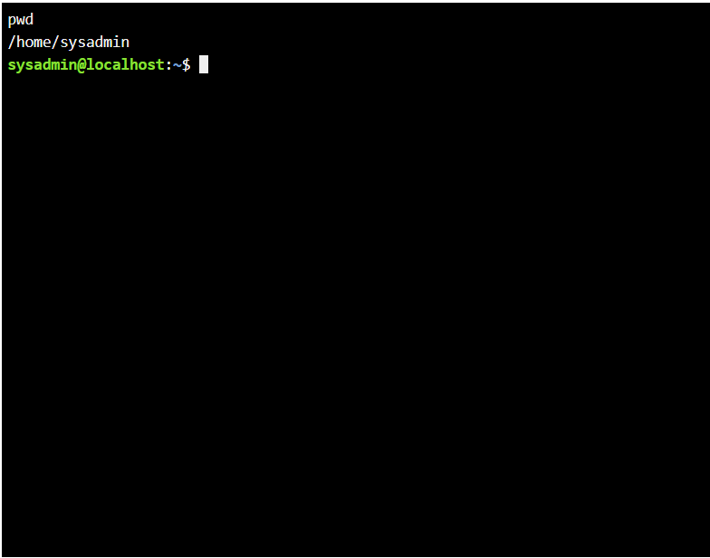
Figure 16: Directory displayed using pwd.

Example 2:
I used the su sysadmin command to switch from the root user to the sysadmin account, and the output displayed the change of prompt. By this, I was provided with confirmation that I was logged in as a sysadmin user.

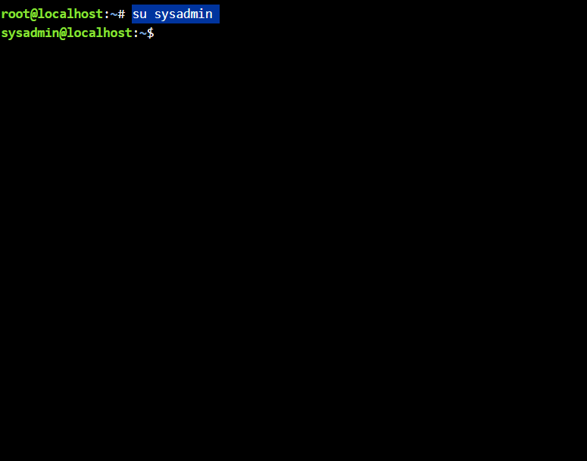
Figure 17: su used to change users.

Example 3:
I used the ls command to take a look at my files. At first I visualised my normal folders and hidden folders with ls -a and ls- a for full information about each individual file.

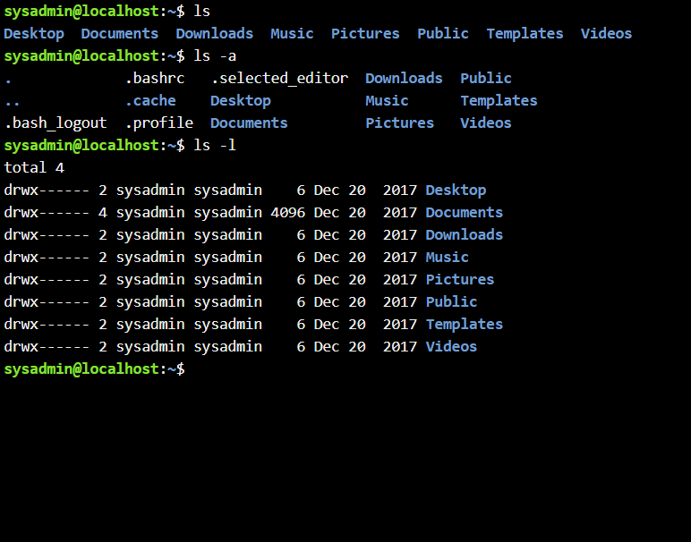
Figure 18: Indicating ls to view files and permissions.

Example 4:
I used the cd command to move into the folder called Desktop and then the prompt altered as now it showed me I was now inside the folder.
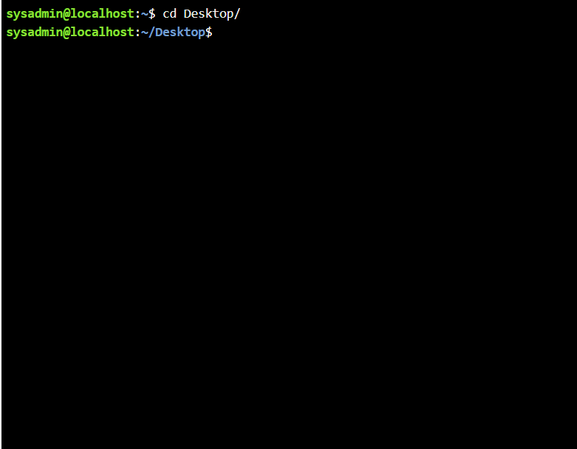
Figure 19: cd command changing to Desktop.

Example 5:
In order to create a new folder I typed in mkdir one. Secondly I typed Is to take a look a the Desktop then the output displayed both the new and one outlined.
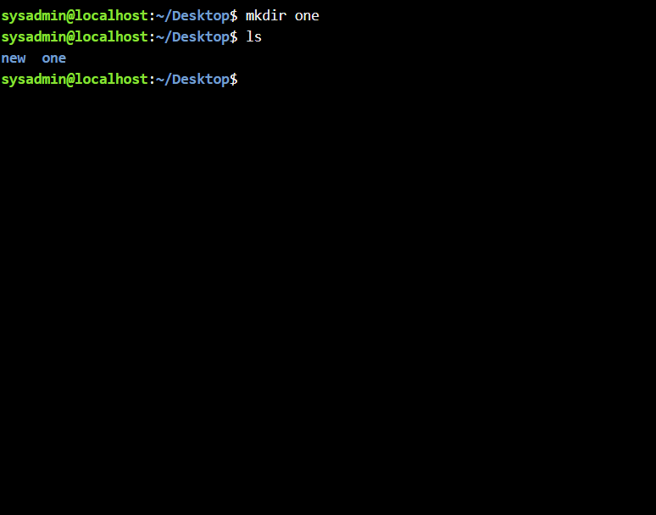
Figure 20: Creating a folder using mkdir.

Example 6:
To delete the folder that is called new, I typed in the command rmdir. I typed ls to find out if the change has happened and the output displayed only one folder remains.
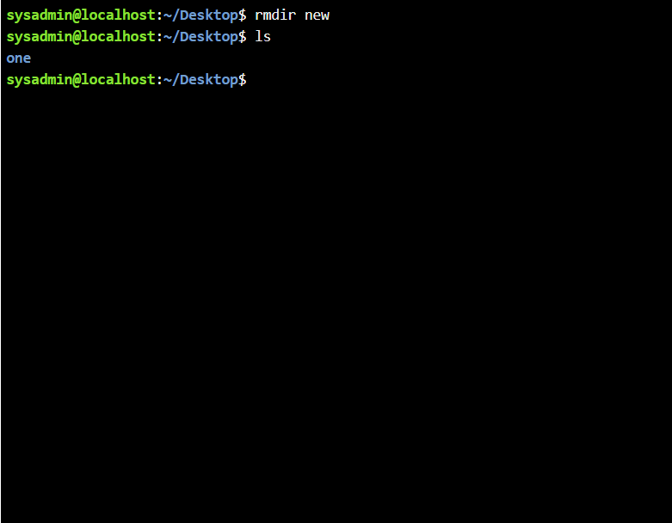
Figure 21: Command erasing new folder by rmdir.

Example 7:
To generate a new empty file I used the command touch and I named the file new. I then typed ls to find out if the action has been done, it displayed both new and one in the folder.
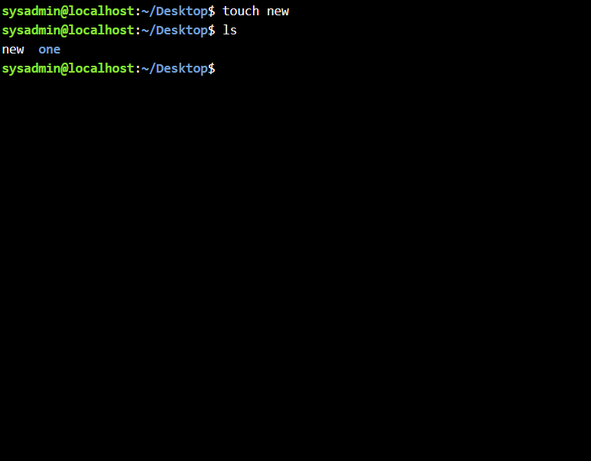
Figure 22: Command adding new file touch.

Example 8:
I typed the command echo to put 'hello' within the files and then I typed cat to dislay the text onto the screen.
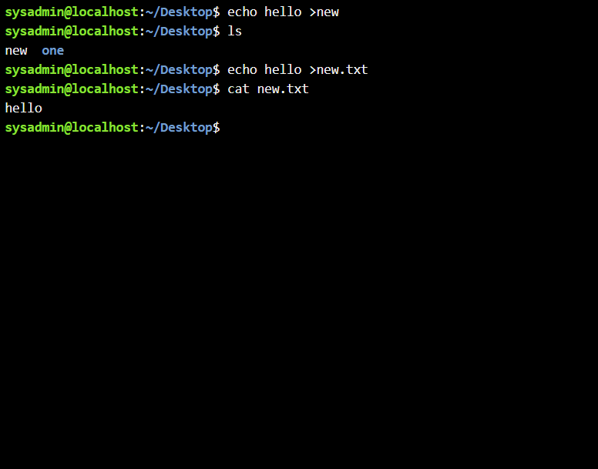
Figure 23: echo hello > new

Example 9:
To check the details of my network I typed ifconfig. Then information about the status of both Ethernet and loopback IP addresses was displayed.
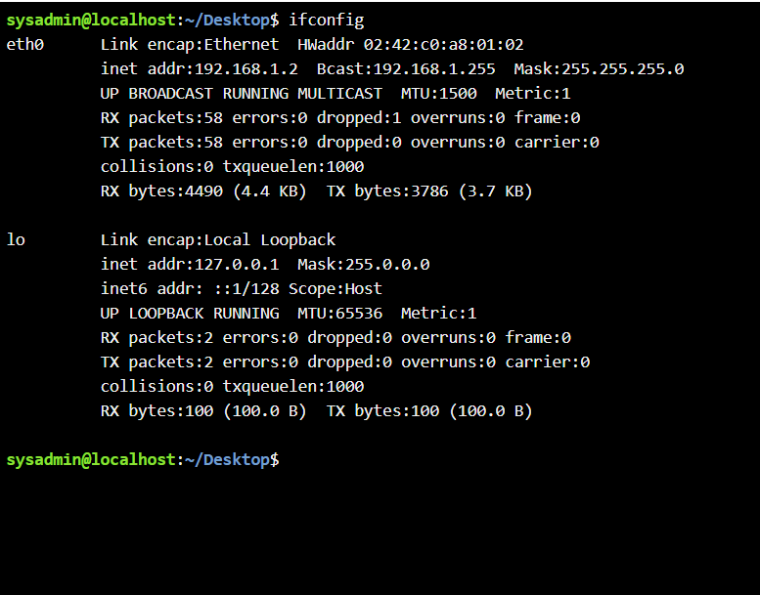
Figure 24: Demonstrating network interface details using ifconfig.

Example 10:

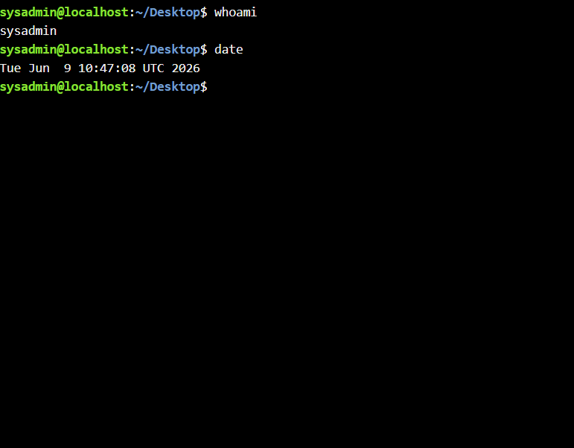
Figure 25: whoami and date command outputs.

Use of Windows OS scripts
To automate tasks/duties batch scripting utilises .bat files [10]. To aid users in gaining a positive experience when dealing with system features such as, sorting out files/folders, conducting system checks and initiating programs. Batch is known for how simple and easy the system is, making it a fast-to-process automation and is efficient across all versions of Windows.

Example 1:
I produced a Windows batch script requesting me for two different numbers then it conducted addition by combinding the both numbers and then result was displayed. I typed @echo off to start the script to conceal repeated command line. Then I typed set /p two times for it to request the user to type in the first and second number. Both values are retained as variables known as number1 and number2. Now the next command I typed is set /a total=number1+number2 conducted the calculations automatically within the script [11]. The next command echo The sum is %total% indicates the end result on my screen and the command pause enforces Windows to remain open so I am able to read it. I put it to the test by typing 8 for both numbers and then displayed the result as 16. From this outcome it demonstrates th script is working properly.
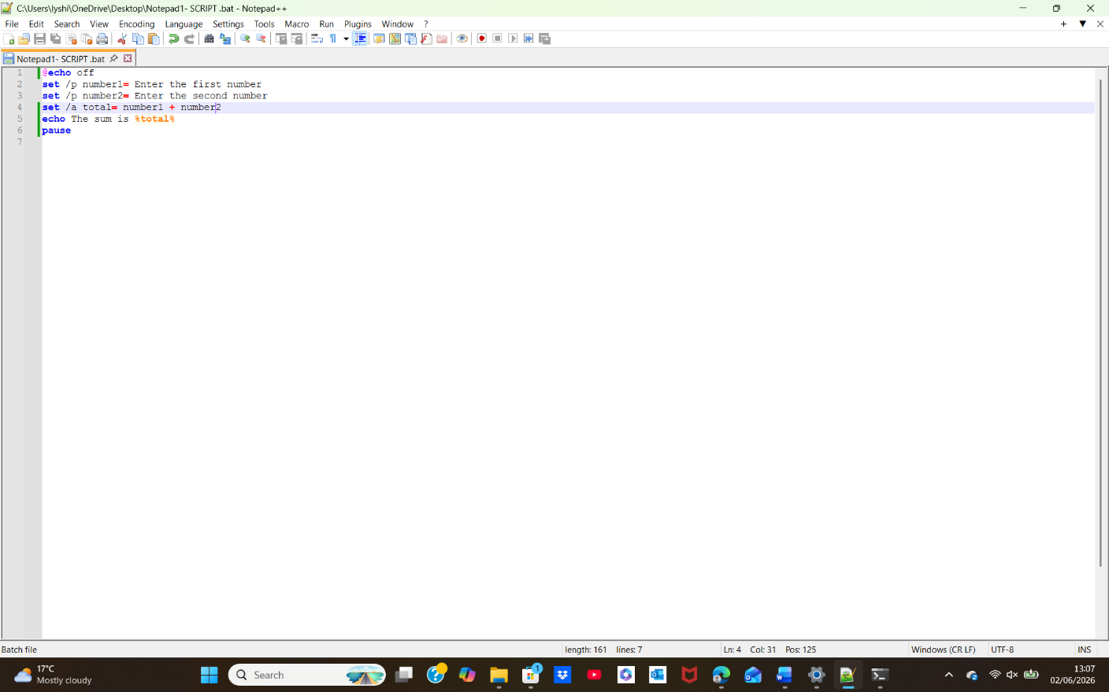
Figure 26: Batch script showing user input, variable storage, and automatic addition in Windows CLI.
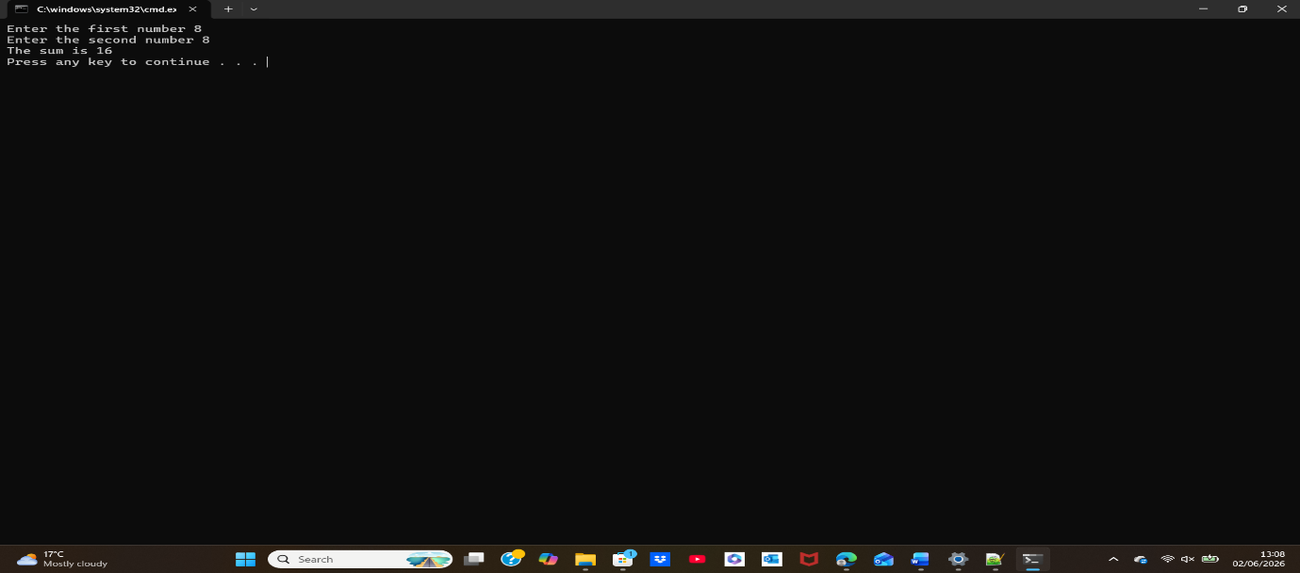
Figure 27: Command-line output displaying an addition program.

Example 2:
The batch script applies a simple condition to undergo a check whether or not the user is allowed to vote. I began with typing echo off to prevent repeated command lines. I then typed set /p age= this is because the script can ask me to enter my age. The value indicated is retained in a variable called age. I then entered an if statement if %age% geq 18 the reason for this is so that it can compare the indicated age with the number 18. Now if the age is greater than or same as 18 , then you will see a message ' You are eligible to vote'. However, if the age is lower then 18 it will come up as, ' You are not eligible to vote yet'. To finalise, pause enforces Windows to remain open. I ran the script I entered the number 50 in one Window and the number 33 in the other. The outputs shown indicated 'You are eligible to vote'. This outcome demonstrated the script worked as intended.
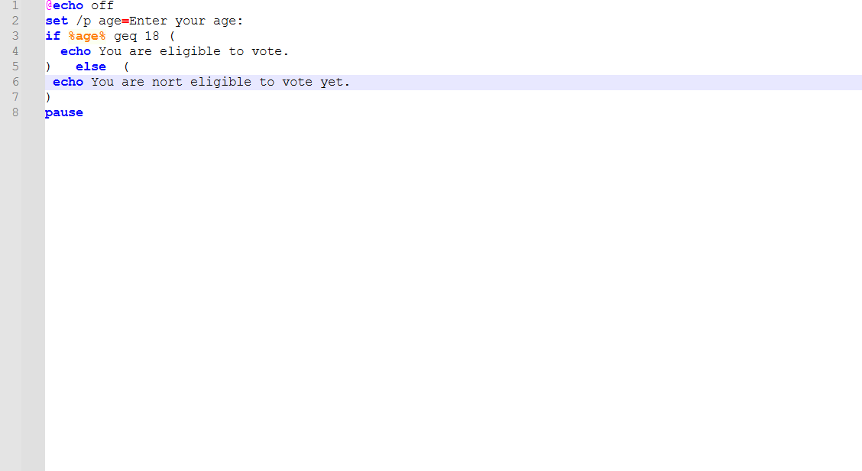
Figure 28: Notepad++ script showing an age check for voting eligibility.
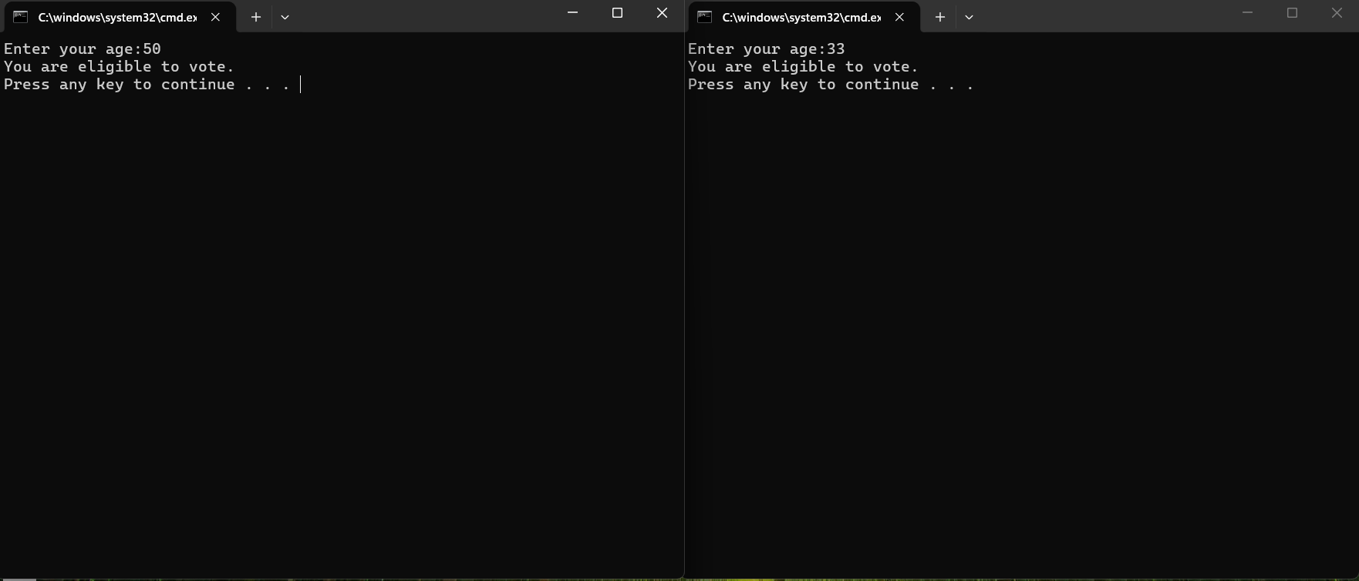
Figure 29: Command-line output presenting voting-eligibility results for entry of age.

Use of Linux OS scripts
By running commands inside a single .sh file, it promotes Bash scripting to automate tasks/duties within Linux[12]. This is utilised for the following: management of files, system checks, similar tasks, calculations and backups. Bash is powerful as it supports variables, conditions, loops, arithmetic and finally allowing Linux tasks to be automated at a higher speed. At a holistic level, Bash scripting constructs a high‑fidelity automation architecture which optimises operational reliability, reduces manual mistakes as well as facilitates optimisation covering core Linux processes.

Example 1:
I produced a Bash script known as script.sh by using Nano. I typed a variety of echo commands within the file, commands instructing me to 'Enter the first number' as well as 'Enter the second number'. Then I typed read num1 and read num2 this is so that the script is able to retain the number i have entered. I then added the line total=$((num1+num2)) to caluculate to obtain the result, and then I typed echo "The sum is $total" by doing this the final answer is shown. Moving on, I saved the script and listed the files by applying ls and then typed chmod +x script . sh to make it run. I then ran ./script.sh and I typed in the number 40 and 8 an error was displayed stating total: command not found, as a result the script had a mistake. I then restarted it in Nano, I ammended the error, saved it and then ran it once again. Now I entered the number 40 and 10 and then the correct output appeared. The result is the number 50.
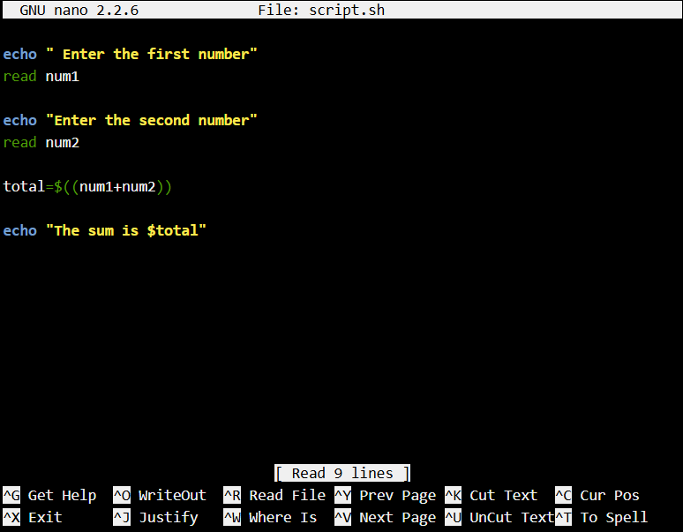
Figure 30: Bash script nano asking for two numbers and revealing the result.
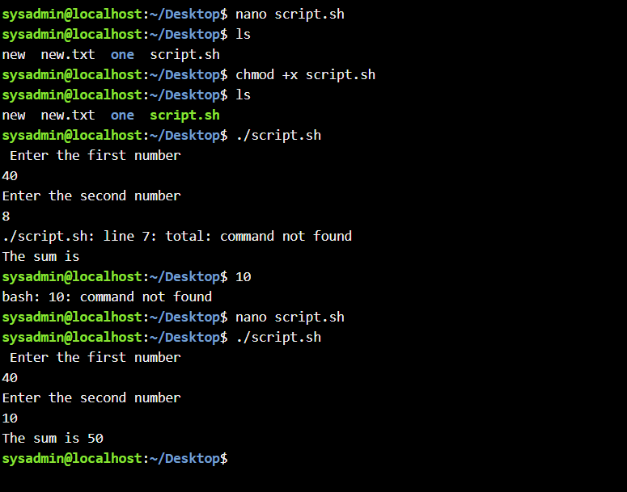
Figure 31: nano script output.

Example 2:
For this demonstration, I generated a Bash script known as loop.sh utilising Nano. Within the file I added the command echo asking the following question "how many times you want to run?" doing so it prompted me for a input. I indicated read count so that the number I entered would then be stored in the variable count. I then added a for loop for ((i=1; i<count; i++)). This loop begins from the number 1 and then moves forward untill it reaches the number 1 entered. I entered echo "$i" within the loop by doing this each number is in a certain pattern would be demonstrated on the screen. Final step I typed Done. Once I saved he file, I typed chmod +x loop. sh to make it run. It asked me how many times I wanted to run it, this showed when I ran ./loop.sh. I entered the number 8, by the loop being displayed it showed it worked accordingly.

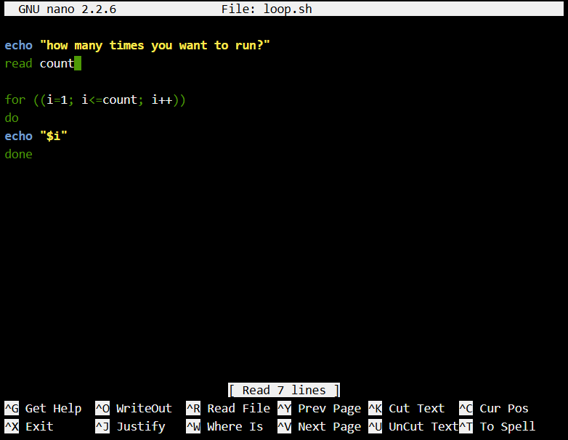
Figure 32: LINUX-INPUT nano editing loop.sh
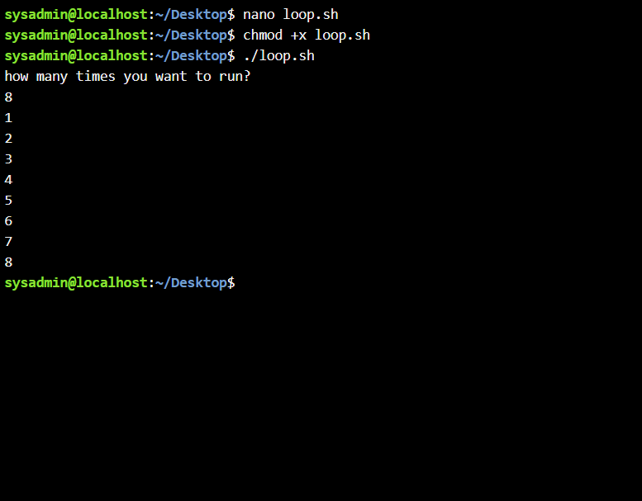
Figure 33: Launching loop.sh script.

Conclusion
Through the implementation of tasks, it has strengthened my knowledge about scripting as a critical automation technique involving operating systems. It is essential to adapt procedural programming concepts, handling of variables and control structures. I have attained an extensive quantitiy of imformation on how both Batch and Bash transform human instructions into deterministic machine operations. By resolving conflicts within each individual script deepened my grasp of logic, efficency, algorithimic thinking and core principles. From a wider operational perspective, all the methods mentioned and practised show how automation strengtens operational consistency, limits fluctuation throughout routine proccesses and boosts system oversight within computing systems.

Appendices

Online Course name: NDG Linux Unhatched

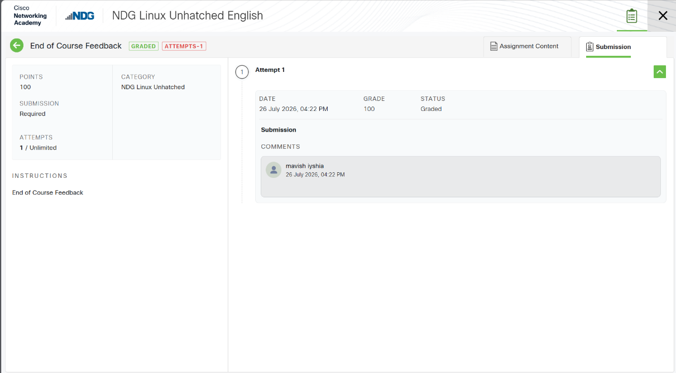
Figure 34: Certificate of completion

References

- [1]GeeksforGeeks, “Functions of Operating System,” Dec. 2018. Accessed: July 25, 2026. [Online]. Available: https://www.geeksforgeeks.org/operating-systems/functions-of-operating-system/
- [2] Deland-Han, “Troubleshoot processes by using Task Manager - Windows Server,” Apr. 2024. Accessed: July 25, 2026. [Online]. Available: https://learn.microsoft.com/en-us/troubleshoot/windows-server/support-tools/support-tools-task-manager
- [3]Karl-Bridge-Microsoft, “Processes and Threads - Win32 apps,” Jan. 2021. Accessed: July 26, 2026. [Online]. Available: https://learn.microsoft.com/en-us/windows/win32/procthread/processes-and-threads
- [4]“File and Directory Management,” 2024. Accessed: July 26, 2026. [Online]. Available:https://www.tutorialspoint.com/computer_concepts/computer_concepts_file_directory_management.htm
- [5] “Device Management in Operating System,” Tutorialspoint.com, 2026.
https://www.tutorialspoint.com/article/device-management-in-operating-system (accessed July 25, 2026).
- [6]Dansimp, “Windows security - Windows security,” 2025. Accessed: July 26, 2026. [Online]. Available: https://learn.microsoft.com/en-us/windows/security/
- [7] JasonGerend, “Windows commands.” Accessed: July 24, 2026. [Online]. Available: https://learn.microsoft.com/en-us/windows-server/administration/windows-commands/windows-commands
- [8] GeeksforGeeks, “How to Change Directories in Command Prompt (CMD),” Oct. 2023. Accessed: Jul. 24, 2026. [Online]. Available: https://www.geeksforgeeks.org/techtips/change-directories-in-command-prompt/
- [9]“Linux Commands Cheatsheet,” Jan. 2026. Accessed: July 26, 2026. [Online]. Available: https://linuxize.com/cheatsheet/linux-commands/
- [10]C. Bennetts, “What Is Windows Script?,” AEANET, Oct. 19, 2025. https://www.aeanet.org/what-is-windows-script/ (accessed July 26, 2026).
- [11]“Batch Script Tutorial - Tutorialspoint,” 2019. Accessed: July 26, 2026. [Online]. Available: https://www.tutorialspoint.com/batch_script/index.htm
- [12] ]Vinayak Baranwal, “Bash Explained: How the Most Popular Linux Shell Works,” DigitalOcean, May 2025. Accessed: July 26, 2026. [Online]. Available: https://www.digitalocean.com/community/tutorials/what-is-bash

