

MODULE CODE : ECPT6001

ASSESSMENT COMPONENT : 1 – Curriculum Development Project

STUDENT NAME: Louise Ridley

STUDENT NUMBER: 1908502

I acknowledge the use of Grammarly (https://www.grammarly.com/) on 9 May 2025 to check my work using the prompt(s):
1. Please check the following text for readability, grammar and syntax.
I confirm that I have not presented any AI generated text as my own work. I confirm that I have copies of my drafts, notes, and other resources I used before, and after the use of AI tools which I may be asked to provide in evidence.

Name: Louise Ridley
Student No: 1908502
Assignment No: ECPT6007
Word count: 4053
Draft

Contents list

- Introduction
- Rationale
  - Theoretical Underpinning and Teaching Strategies
  - Professional Standards
  - Inclusion and accessibility strategy
- Aims and Learning Outcomes
- Assessment Strategy for the Curriculum
- Reference List
- Appendices

Curriculum Development Project

The Art of the Pitch: Selling a World Through Visuals

Introduction

The Art of the Pitch: Selling a World Through Visuals is a 12-week curriculum designed for aspiring illustrators looking to enter the film, television, or gaming Industry through an illustration degree. While the curriculum is mainly based on concepts relevant to film and television production, it remains flexible and inclusive of ideas rooted in game design, allowing students to design their projects to their specific creative interests. The course focuses on the pre-production phase, where illustrators play the crucial role in designing the characters and worlds, visualising stories, and communicating tone and narrative through captivating visual artwork. Central to the course is developing a pitch bible, a professionally structured document that combines narrative and visual elements to present an original film or series concept (Vijendhiran, 2025).
This curriculum is a studio-based module integrating lectures, workshops, and independent project work. Lessons will be designed to replicate industry environments, encouraging collaborative processes and ongoing development. Students will engage in hands-on activities that mirror real-world workflows, encouraging creative exploration and professional discipline.
The curriculum will include Adobe Photoshop/InDesign and Procreate workshops to ensure students are experienced with industry-standard tools. These sessions cover beginner to advanced techniques, enabling students to create and manipulate digital illustrations and artwork effectively. By the end of these workshops, students will have developed a solid foundation in digital software, equipping them with the skills necessary to produce professional-quality visual materials for the entertainment industry.
The curriculum also touches on building a strong social media presence by recognising the pivotal role of digital platforms in today’s creative industry (De La Puente, 2022). ‘Artists use social media platforms for professional opportunities, as a way to socialise with others, and also as a creative space for inspiration, display and conversation’ (De La Puente, p. 9, 2022). Students will learn to display their skills on platforms like Instagram and LinkedIn, engage with online communities, receive feedback, and develop consistent and authentic online branding strategies. By building a social media presence, students will actively market their skills, connect with industry professionals, and adapt to the evolving demands of creative industries.
Assessment is primarily project-based, focusing on creating a comprehensive pitch bible. This includes character designs, environment concepts (world-building), storyboards, and written synopsis. Students will also participate in peer reviews and present their projects in a simulated industry pitch scenario, developing critical communication skills and receiving constructive feedback to refine their work.
The course is aimed at final-year BA students at the University of Wales Trinity Saint David (UWTSD). This project will be a central component of their final year portfolio, demonstrating their readiness for professional roles in the entertainment industry. The curriculum emphasises the illustrator's role in pre-production by aligning with industry practices and drawing inspiration from the workflows of studios such as Netflix Animation, Dreamworks, and Microsoft Gaming. This focus supports artistic growth and professional readiness, which will equip students with the skills and experience necessary to thrive in today’s collaborative, media-driven landscape.

Rationale

There has been a noticeable shift in illustration students' ambitions in recent years. Many aspiring to move beyond traditional illustration roles in publishing and advertising seek opportunities within the entertainment industry. This trend is supported by broader industry observations (Creative Industries Federation, 2018) and my teaching experience, where most students express a clear interest in visual development roles within the entertainment sector. However, many of these students enter the programme without experience using essential industry–standard software such as Adobe Photoshop or InDesign, highlighting a skills gap that the UWTSD curriculum needs to address.
As Graham (2022) mentioned, in the film industry, illustrators often work as concept artists, character designers, storyboard artists, or visual development artists, which demand both technical ability and strong narrative intuition. These creatives shape the look and feel of a story long before animation or live-action production begins. ‘Illustrators are an essential part of the film industry. Without them, many films would lack the rich, detailed visuals that we have come to expect from modern cinema’ (Graham, 2022). While skills such as character design, storytelling and world building are typically included in illustration programmes (Burton, 2011), few offer a focused curriculum on the specialised demands of visual development for film, television, and gaming industries. This observation is evident within UWTSD’s current programme offerings (UWTSD, 2024).
According to the Skills Mismatches in the UK's Creative Industries (2025), essential professional practices, including building pitch bibles, working within collaborative pipelines, and using industry-standard software such as Photoshop, are often underrepresented in undergraduate education. Carey (2025) further emphasises that ‘Creative education and skills provision also need to be more effectively coordinated across education pathways.’ Similarly, Dooley et al. (2024) note that the discourse around ‘skills development’ has fuelled ongoing debate about ‘skills gaps’ within the creative industries. As a result, many graduates are left to independently develop these competencies after completing their studies.
As creative sectors continue to evolve, they are increasingly influenced by emerging practices, shifting audience behaviours, and advancing digital technologies (Design Council, 2020). Professional illustrators are now expected to respond to platform-specific storytelling formats, fast-paced production workflows, and cross-disciplinary collaboration, often using advanced software and digital tools (Carey, 2025). This calls for illustrators who are skilled visual storytellers and proficient in tools and methods aligned with current industry expectations. However, as previously mentioned, few undergraduate illustration programmes provide a focused curriculum addressing the professional expectations of these industries. For example, while the University of Wales Trinity Saint David’s (UWTSD) BA (Hons) illustration course offers access to digital tools and encourages industry-facing projects, it does not explicitly prepare students for visual development roles in pre-production for film, television, or games. Although narrative and digital illustration modules are included, the primary focus for character design and storyboarding is aimed at publishing for books and graphic novels. The course lacks structured content on pitching processes, concept development pipelines, or screen-specific storytelling formats (UWTSD, 2024). While there are undergraduate degrees within UWTSD specifically focused on gaming and animation, these programmes tend to concentrate on complete production workflows, including modelling, rigging, and animation (UWTSD, A&B, 2025), rather than the pre-production stage, where illustrators typically contribute (Graham, 2022). This curriculum is designed to bridge that gap, focusing on an illustrator's role in pre-production, particularly in concept art, storyboarding, world-building, and pitch bible creation, all essential to communicating ideas visually before production begins (Graham, 2022).
The Art of the Pitch: Selling a World Through Visuals has been developed in response to the contemporary creative industry’s evolving landscape and the shifting career aspirations of illustration students (Creative Industries Federation, 2018). With the rapid rise of content-driven platforms and an increased demand for compelling visual narratives, illustrators are playing a more central role in pre-production pipelines, particularly in areas such as concept art and world-building using digital mediums, areas traditionally underrepresented in general illustration curricula (Carey, 2025).

With skill deficiencies in a range of areas, including specialist technical and vocational skills, transferrable skills, and particularly advanced digital skills, there is a need for stronger mechanisms for collaboration between schools, higher and further education, institutions, and industry.
(Carey, P8, 2025)

This module addresses the need for rich visual storytelling in film, television, and gaming. It recognises the industry’s growing expectations for illustrators to produce pitch-ready content that integrates seamlessly with collaborative production environments. As entertainment sectors continue to expand globally, studios require creative professionals who can visualise and communicate complex ideas early in the development process (Creative Industries Federation, 2018). This curriculum prepares students to meet those demands by cultivating creative originality and technical fluency. Through integrated practice in concept design, sequential storytelling, and pitch bible creation, students can navigate interdisciplinary workflows and engage with screen-based storytelling's fast-paced, media-rich environment (Carey, 2025).

Theoretical Underpinning and Teaching Strategies

This curriculum is supported by educational theories that inform its structure and delivery. These theories ensure they meet students' diverse learning needs while aligning with professional practices in the creative industries. The module encourages autonomy, creativity, and real-world application by drawing on constructivist, experimental, and socio-cultural learning theories.

Constructivism advocates student-centred learning in which the teacher serves as a facilitator of the learning process. Thus, constructivism requires a teacher to help students become active participants in their learning and to make meaningful connections between prior knowledge, new knowledge, and the learning processes.
(Chand, 2023)

Constructivism, as Piaget theorised, suggests that learners construct their understanding through active engagement and social interaction (Hussain, 2012). This approach is central to the module, which emphasises project-based learning and encourages students to take ownership of their ideas and creative decisions. By designing characters, developing storyboards, and creating a pitch bible, students build knowledge by doing, exploring, and reflecting.
According to McLeod (2025), experimental learning, suggested by Kolb, is another foundational element. Kolb's learning cycle, comprising concrete experience, reflective observation, abstract conceptualisation, and active experimentation, is mirrored in the course design. Students engage in creative tasks (experience), receive peer and tutor feedback (observation), analyse their process and outcomes (conceptualisation), and revise their work or apply learning in subsequent tasks (experimentation) (McLeod, 2025). This cycle promotes more profound understanding and critical reflection, essential for success in the creative industries.
Vygotsky’s socio-cultural theory also informs the curriculum, particularly the concept of the zone of proximal development (DPD), which highlights the value of guided support, group critiques, peer collaboration, and structured tutor feedback sessions, which all provide the scaffolding necessary for learners to develop beyond their current capabilities (Chand, 2023).

Teachers provide scaffolding to help students acquire knowledge and skills within their reach. In student-centred learning, the responsibility of the learning process is transferred from teachers to students, and learning is assessed through both product and process reflection.
(Chand, 2023)
This also supports the inclusivity and differentiation promoted by Further Education Professional Standards (Professional Standards for Further Education Teachers and Work-Based Learning Practitioners in Wales, 2017). ensuring all learners have the opportunity to succeed at their own pace. In addition, the curriculum reflects Bandura’s social learning theory, recognising the role of observation, imitation, and modelling in learning (McLeod, (b), 2025). By analysing professional work and taking part in real-world creative tasks, students observe industry standards and practices and are encouraged to emulate them within their work.
By integrating these educational theories, the curriculum fosters creativity and industry readiness. It promotes reflective practice, collaboration, and independent learning, all vital to preparing students for professional success in the entertainment industry.

Teaching strategies include:

- Project-based learning through the development of characters, worlds, and pitch bibles.
- Scaffolded digital workshops using Photoshop, InDesign, and Procreate.
- Peer feedback sessions and tutor-led critiques to support reflective practice.
- Group-based practical tasks that simulate industry collaboration.
- Independent research and sketchbook work to support idea generation.
- Integration of online platforms for building digital presence and professional visibility.
- Use of process work and homework to reinforce iterative learning and technical refinement.
- Tutor led lectures with digital innovation

Professional Standards

This curriculum has been designed to be closely aligned with the Professional Standards for Further Education Teachers in Wales, ensuring that it supports academic development, professional readiness, inclusivity, and reflective practice (Professional Standards for Further Education Teachers and Work-Based Learning Practitioners in Wales, 2017). By embedding industry-relevant tasks such as pitch bible creation, character design, storyboarding, and digital illustration using software like Photoshop, the module directly supports the FE sector’s commitment to preparing learners for progression into creative employment and higher-level study.
The curriculum reflects the standard of ‘demonstrating commitment to learners, their learning, safety and wellbeing’ (Professional Standards for Further Education Teachers and Work-Based Learning Practitioners in Wales, 2017) by supporting a range of starting points and progression routes. Students are encouraged to stretch their creative abilities while receiving structured support through tutorials, feedback sessions, and differentiated learning resources. This approach helps create a safe and inclusive environment where learners feel confident taking creative risks and reflecting on their progress.
In alignment with the standard ‘plan and deliver effective learning, teaching and assessment’ (Professional Standards for Further Education Teachers and Work-Based Learning Practitioners in Wales, 2017), this module uses a variety of teaching strategies, including practical tasks, digital workshops, collaboration, peer reviews, and project-based assessment. These methods are informed by up-to-date industry practices, ensuring learners have the creative and professional tools required in the entertainment industry. Through regular formative feedback and peer reviews, students are supported in evaluating their development and identifying areas for improvement.
Also promoting the value of ‘diversity, equality of opportunity and inclusion’ (Professional Standards for Further Education Teachers and Work-Based Learning Practitioners in Wales, 2017) by offering accessible content and inclusive teaching strategies. Projects are designed to be culturally open and responsive to students' interests, allowing them to bring their identities and values into their creative work. This supports personal growth and a deeper understanding of collaborative practice within diverse teams.
The curriculum also fosters ‘positive and collaborative relationships’ (Professional Standards for Further Education Teachers and Work-Based Learning Practitioners in Wales, 2017) by embedding peer feedback and teamwork exercises, preparing students for the collaborative nature of industry environments. It encourages ‘the use of research and evidence to improve practice’ (Professional Standards for Further Education Teachers and Work-Based Learning Practitioners in Wales, 2017), as students are guided to explore concept development, world-building, and character design through reflective enquiry and contextual analysis.
In keeping with the standard to 'critically reflect on one's values, knowledge and skill’ (Professional Standards for Further Education Teachers and Work-Based Learning Practitioners in Wales, 2017), tutors and learners engage in ongoing critical evaluation of work and teaching strategies. Sustainability and social awareness are also promoted through project themes that encourage learners to address global challenges through visual storytelling, supporting the standard of ‘demonstrating a commitment to sustainability (Professional Standards for Further Education Teachers and Work-Based Learning Practitioners in Wales, 2017).
Overall, this curriculum reflects the FE sector's aspiration to empower learners, promote professionalism, and respond dynamically to the evolving needs of Wales' creative economy.

Inclusion and accessibility strategy

This curriculum is designed to embrace inclusive practice, ensuring that all learners, regardless of background, learning style, or ability, can access, engage with, and succeed in the module. In alignment with the Professional Standards for FE Teachers in Wales, particularly the Standards ‘fostering respect and value for all learners, planning inclusive learning, and creating an inclusive and supportive environment’ (Professional Standards for Further Education Teachers and Work-Based Learning Practitioners in Wales, 2017), the module supports equity and learner diversity by removing barriers to participation.
A flexible, project-based approach allows students to direct their creative responses, enabling a broad range of cultural perspectives, lived experiences, and skill levels to be celebrated through character and world-building tasks. Differentiated outcomes are encouraged. Students may respond to the brief through film, television, or gaming concepts, allowing personal interest and identity to drive professional engagement.

Inclusive teaching methods include:

- Using visual, auditory, and written materials to support multiple learning preferences, 'UDL Guideline 1: Provide multiple means of representation' (Cast, 2024).
- Scaffolded Photoshop workshops to support students with varied levels of digital literacy, ensuring access without assuming prior experience ‘UDL Guideline 5: Provide options for expression and communication’ (Cast, 2024).
- Opportunities for both independent and collaborative work, acknowledging varied strengths and promoting choice, ‘UDL Guideline 7: Provide options for engagement’ (Cast, 2024)
- Regular formative feedback and tutorials are needed to ensure timely intervention, reflection, and progress. 'UDL Guideline 8: Foster coping skills and self-assessment' (Cast, 2024).

Assessment strategies also apply Universal Design for learning principles by allowing multiple formats for final submission; students can submit their pitch bible digitally or print, demonstrating learning through their preferred medium while still achieving consistent outcomes. UDL Guideline 4: Provide options for physical action and communication (Cast, 2024). The curriculum fosters an inclusive studio culture that empowers students to contribute creatively and critically while reflecting the entertainment industry's inclusive values and real-world expectations.

Aims and Learning Outcomes

The Art of the Pitch: Selling a World through Visuals aims to equip final-year illustration students with the creative and professional skills required to contribute to the visual development in the film, television, and gaming industries. The curriculum is structured to build students' confidence and abilities in key areas of pre-production, including character design, world-building, storyboarding, and the creation of pitch bibles. Through practical workshops, guided research, and industry-informed tasks, students will learn how to communicate their ideas clearly and effectively to meet studio expectations (Carey, 2025).
The module aims to enhance students' readiness for employment in creative media by supporting the development of portfolio-quality work and essential technical skills. This includes experience with industry-standard software like the Adobe suite, including programmes such as Adobe Photoshop, InDesign, and Procreate, alongside guidance on structuring visual narratives for pitching. As students develop their projects, they will gain insight into collaborative production workflows and explore how their illustrative voice fits within a larger studio pipeline.
The course also introduces professional development practices, including establishing a digital presence, and utilising social media platforms for creative promotion and networking tools expected from emerging illustrators entering the industry.

By the end of the module, students will be able to:

- Apply advanced illustration techniques to design captivating characters and environments ready for screen media.
- Produce professional-quality concept artwork using industry-standard software.
- Create a structured and engaging pitch bible that communicates a straightforward visual narrative.
- Contribute effectively to pre-production workflows through organised, deliverable artwork.
- Present and articulate visual concepts confidently to a target audience.
- Curate artwork towards their final-year portfolio that reflects the expectations of media and entertainment studios.
- Use social media and digital platforms to promote their work professionally and connect with industry networks.

Assessment Strategy for the Curriculum

The assessment strategy for this module is designed to encourage students to engage in iterative creative development and produce work that meets industry expectations. Given the focus on visual storytelling and professional communication, assessment will be both formative and summative, providing regular checkpoints for progress and ensuring students receive structured feedback to guide their work.

Formative assessment

Formative assessment will occur throughout the course via peer feedback, informal critiques, one-to-one and tutor-led reviews. This helps students refine their ideas and presentation skills. Encouraging reflective practice and creative risk-taking in a supportive environment. These regular touchpoints foster a collaborative atmosphere where students can confidently test ideas, receive constructive input, and develop their work through iteration. Group critiques and peer-to-peer feedback sessions will build students’ ability to communicate concepts effectively, respond to critique, and evaluate creative decisions. These skills are directly transferable to industry settings.
One-to-one tutorials offer more personalised guidance, allowing tutors to address individual learning needs and provide tailored advice. This ensures that students with different learning styles and confidence levels are supported throughout their development. The module promotes inclusive learning practices by providing multiple formats for feedback and reflection, and helps students build autonomy in their creative process. The formative assessment strategy aligns with Further Education Professional Standards by promoting reflective practice, learner agency, and collaborative professionalism. These ongoing assessments enhance the quality of students’ final work and develop the behaviours and attitudes necessary for employment and further academic study.

The summative assessment will focus on:

- Pitch Bible (70%) – Students will develop a comprehensive pitch bible for an original intellectual property intended for a film, television series, or gaming concept. This document will include pre-production materials such as character designs, world-building, props, narrative overview, tone, and mood. The pitch bible should demonstrate conceptual depth and strong visual communication, reflecting the standards studios use in early development stages.
- Research and development (20%) – This will document students’ creative process throughout the module. It should include early sketches, design iterations, mood boards, inspiring artists, and draft compositions developed using Photoshop and InDesign. It must also include evidence of professional development activity, such as screenshots of online posts and social media engagement used to build industry presence. These materials should reflect how students experiment, reflect, and refine their visual ideas, while also beginning to build a digital footprint as emerging illustrators.
- Final Pitch Presentation (10%)—In week 12, Students will deliver a pitch simulating a professional industry environment. This will be assessed on clarity, engagement, and the ability to communicate core ideas effectively to an audience.

Module Timetable

Programme Title:  The Art of the Pitch: Selling a World through Visuals. | Venue:  UWTSD Dynevor Campus | Lecturer:  Louise Ridley
Hours per week: 5.5 hours | Day/Time: Thursday 9:30 | Number of weeks: 12
Module Aims:
- To equip final-year illustration students with the creative and professional skills necessary for pre-production roles in film, television, and gaming industries.
- To develop students' abilities in visual storytelling through character design, world-building, storyboarding, and pitch bible creation.
- To enhance students' ability with industry-standard software (e.g., Photoshop) and professional communication, preparing them for collaborative, screen-based workflows and confidence building for pitching ideas.

Module Outcomes:
- Create original, visually compelling characters, worlds, and story concepts suitable for film, television, or gaming pitches.
- Assemble a professional standard pitch bible incorporating narrative, visual design, and layout elements.
- Apply industry-standard digital tools (e.g., Photoshop) to develop visual concepts and sequential storytelling assets.
- Present and articulate original ideas confidently in a format appropriate for industry pitches.

Week Number | Topic | Aim and Objectives | Teaching and learning activities | Resources required | Assessment
1  2  3  4  5  6  7  8  9  10  11  12 | Introduction to the lesson (The Art of the Pitch: Selling a World Through Visuals)  Character development  Character development  Kickstarting your online presence and beginner’s Photoshop workshop  Progression of online presence and Photoshop workshop  Photoshop workshop  World-building  Photoshop/InDesign workshop  Writing for the pitch bible  Pitch bible structure  Assembling and polishing the pitch bible  Final presentations | Introduce module aims, the role of illustrators in pre-production, and an overview of the pitch bible and other pitching formats. Then, start thinking of ideas for own pitch bible.  Introduce character designs for Pitch bible. Start designing characters for their ideas.  Refine character designs with turnarounds and expressions. Give character's personalities and traits.  Introduction to creating a strong online presence and photoshop beginner's workshop.  Review of online building and develop Photoshop skills using their character designs – basic skills.  Develop and refine character designs – photoshop advanced skills.  Explore techniques for creating immersive background settings.  Develop worlds through Photoshop/InDesign skills using world-building sketches.  Introduce the structure and components of a pitch bible  Develop written content: longline, synopsis, character bios, storyboarding.  Developed and refined worlds – advanced skills through Photoshop/InDesign.  Bring visual and written work together using Photoshop techniques or digital tablets and Indesign.  Students pitch their projects. | Lecture, group discussion, analysing existing pitch bibles, mood board, homework.  Lecture, group discussion, silhouette exercises, group task, rough sketches, homework.  Lecture, Character design sheet development, show and tell, homework.  Lecture, group discussion, digital Brushwork and refine art with Photoshop techniques.  Review of online progression and Finalising and refining digital work, homework.  Brushwork and refine art with Photoshop techniques and homework.  Lecture, Environment sketching, visual research task, homework.  Finalising and refining digital work and homework.  Lecture, writing workshop, writing task, open discussions.  Lecture, breakdown, planning of own pitch bible, and homework.  Lecture, layout workshop, final feedback.  Presentations to peers and tutors. | PowerPoint presentation, sketchbooks, pencils, digital tablet (optional).  PowerPoint presentation, sketchbook, pencils, digital tablet (optional).  PowerPoint presentation, sketchbook, pencils, digital tablet (optional).  Powerpoint presentation, Photoshop access, digital tablets, sketchbooks.  PowerPoint presentation, photoshop access, digital tablets, sketchbooks.  PowerPoint, Photoshop access, sketchbooks, digital tablets.  PowerPoint, sketchbooks, mood board. Pencils, digital tablets.  Photoshop/Indesign access, sketchbooks, digital tablets.  PowerPoint presentation, sketchbooks, pencils, pens, digital tablets, Photoshop/InDesign access.  Photoshop/Indesign access,  PowerPoint presentation, sketchbooks, pencils, digital tablet.  Photoshop/Indesign access,  PowerPoint presentation, sketchbooks, pencils, pens, digital tablets.  Printed materials or PowerPoint presentations. | Participate in discussions and design mood boards ideas, one-to-one.  Character design sketches, thumbnails, ideas, one to ones.  Character model sheets, show and tell, one-to-one, Kahoot quiz.  Photoshop observations, Kahoot quiz, one-to-one.  Final digital character piece, one-to-one.  One to ones, Photoshop observations.  One-to-one reviews of work progression.  The final digital piece, one-to-one.  Draft written sections for pitch bible, one-to-one.  One to ones, pitch  bible progression, Kahoot quiz, Q&A.  Near-final pitch bible draft.  Final assessed pitch bible and presentation.
Indicative Reading List

- Whitlach, T. (2015). Principles of Creature Design.
- Bancroft, T. (2006). Creating Characters with Personality.
- Glebas, F. (2008). Directing the Story: Professional Storyboarding and Storytelling Techniques.
- Born, J. (2014). Digital Lighting and Rendering.
- Visual Development Artbooks (e.g., The Art of Pixar, The Art of Netflix Animation).
- Hillenburg, S (1996). Spongeboy Pitch Bible
- Ward, P (2006). Adventure Time Pitch Bible

Reference List

Burton, Michelle. “Illustration Degrees: What Coursework Is Included in a Typical Illustration Program?” Animation Career Review, Animation Career Review, 13 Dec. 2011, www.animationcareerreview.com/articles/illustration-degrees-what-coursework-included-typical-illustration-program. Accessed 21 Apr. 2025.
Carey, Heather. “Skills Mismatches in the UK’s Creative Industries - Creative Industries Policy and Evidence Centre.” Creative Industries Policy and Evidence Centre, Green Doe Ltd, 12 Feb. 2025, pec.ac.uk/state_of_the_nation/skills-mismatches-in-the-uks-creative-industries/. Accessed 21 Apr. 2025.
CAST. “The Universal Design for Learning Guidelines.” 2024.
Chand, Satish Prakash. “Constructivism in Education: Exploring the Contributions of Piaget, Vygotsky, and Bruner.” International Journal of Science and Research (IJSR), vol. 12, no. 7, 5 July 2023, pp. 274–278, www.researchgate.net/publication/378071316_Constructivism_in_Education_Exploring_the_Contributions_of_Piaget_Vygotsky_and_Bruner, https://doi.org/10.21275/sr23630021800. Accessed 24 Apr. 2025.
“Creative UK, Growing the UKs Creative Industries.” Creative UK, Creative UK, 2018, www.creativeindustriesfederation.com/sites/default/files/2018-12/Creative%20Industries%20Federation%20-%20Growing%20the%20UK’s%20Creative%20Industries.pdf. Accessed 23 Apr. 2025.
De La Puente, Gabrielle. “The Impact of Using Social Media as an Artist.” Unlimited Arts Commission Programme, Apr. 2022. Accessed 23 Apr. 2025.
“Design Perspectives.” Design Council, 2020. Accessed 21 Apr. 2025
Dooley, Kath, et al. “Mind the Gap: A Scoping Review of Skills Gaps for Graduates in the Creative Industries.” Arts and Humanities in Higher Education, vol. 23, no. 4, 19 Aug. 2024, pp. 330–349, journals.sagepub.com/doi/10.1177/14740222241276166, https://doi.org/10.1177/14740222241276166. Accessed 1 May 2025.
Graham, Bailey. “The Surprising Truth about Illustrators in the Film Industry – You Won’t Believe What They Can Do.” Raindance, 23 Dec. 2022, raindance.org/the-surprising-truth-about-illustrators-in-the-film-industry-you-wont-believe-what-they-can-do/. Accessed 20 Apr. 2025.
Hussain, Irshad. “Creative Education.” Use of Constructivist Approach in Higher Education: An Instructors’ Observation, vol. 3, no. 2, 2012, pp. 179–184, file.scirp.org/pdf/CE20120200001_53207289.pdf, https://doi.org/10.4236/ce.2012.32028. Accessed 28 Apr. 2025.
McLeod, Saul. “Albert Bandura’s Social Learning Theory.” Simply Psychology, Simply Psychology, 18 Mar. 2025, www.simplypsychology.org/bandura.html. Accessed 25 Apr. 2025.
Mcleod, Saul. “Kolb’s Learning Styles and Experiential Learning Cycle.” Simply Psychology, Simply Psychology, 19 Mar. 2025, www.simplypsychology.org/learning-kolb.html. Accessed 25 Apr. 2025.
“Professional Standards for Further Education Teachers and Work-Based Learning Practitioners in Wales.” 2017.
“UWTSD(A), Illustration (Swansea College of Art).” Ucas.com, 2025, digital.ucas.com/coursedisplay/courses/47035781-8293-4390-75b0-ca65b054eeb6. Accessed 23 Apr. 2025.
“UWTSD(B), Animation and VFX (Full-Time).” University of Wales Trinity Saint David, University of Wales Trinity Saint David, 5 Mar. 2025, www.uwtsd.ac.uk/programme-courses/undergraduate/film-media-and-animation/animation-and-vfx-full-time-campus-full. Accessed 19 Apr. 2025.
“UWTSD(C), Computer Games Design BA.” Whatuni.com, IDB Connected Ltd, 2025, www.whatuni.com/degrees/computer-games-design-ba/university-of-wales-trinity-saint-david/cd/58442582/5225. Accessed 23 Apr. 2025.
Vijendhiran, Sai. “Pitch Bible - Story Telling Tool for the Film Writers and Directors.” Linkedin.com, Linkedin.com, 11 Feb. 2025, www.linkedin.com/pulse/pitch-bible-story-selling-tool-film-writers-sai-vijendhiran-nwk8f. Accessed 20 Apr. 2025.

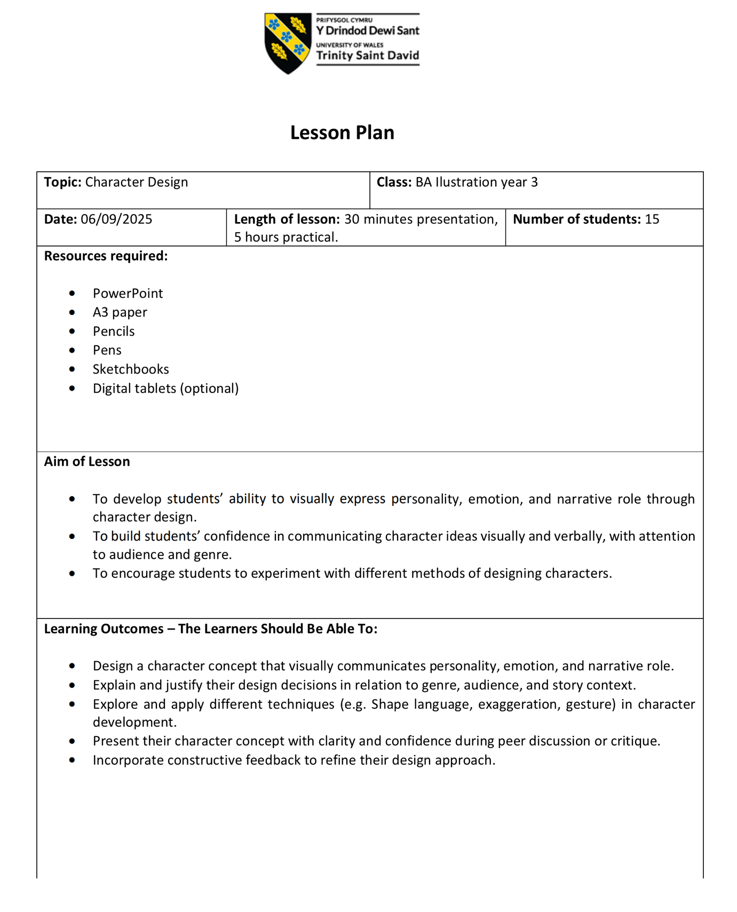
Appendices

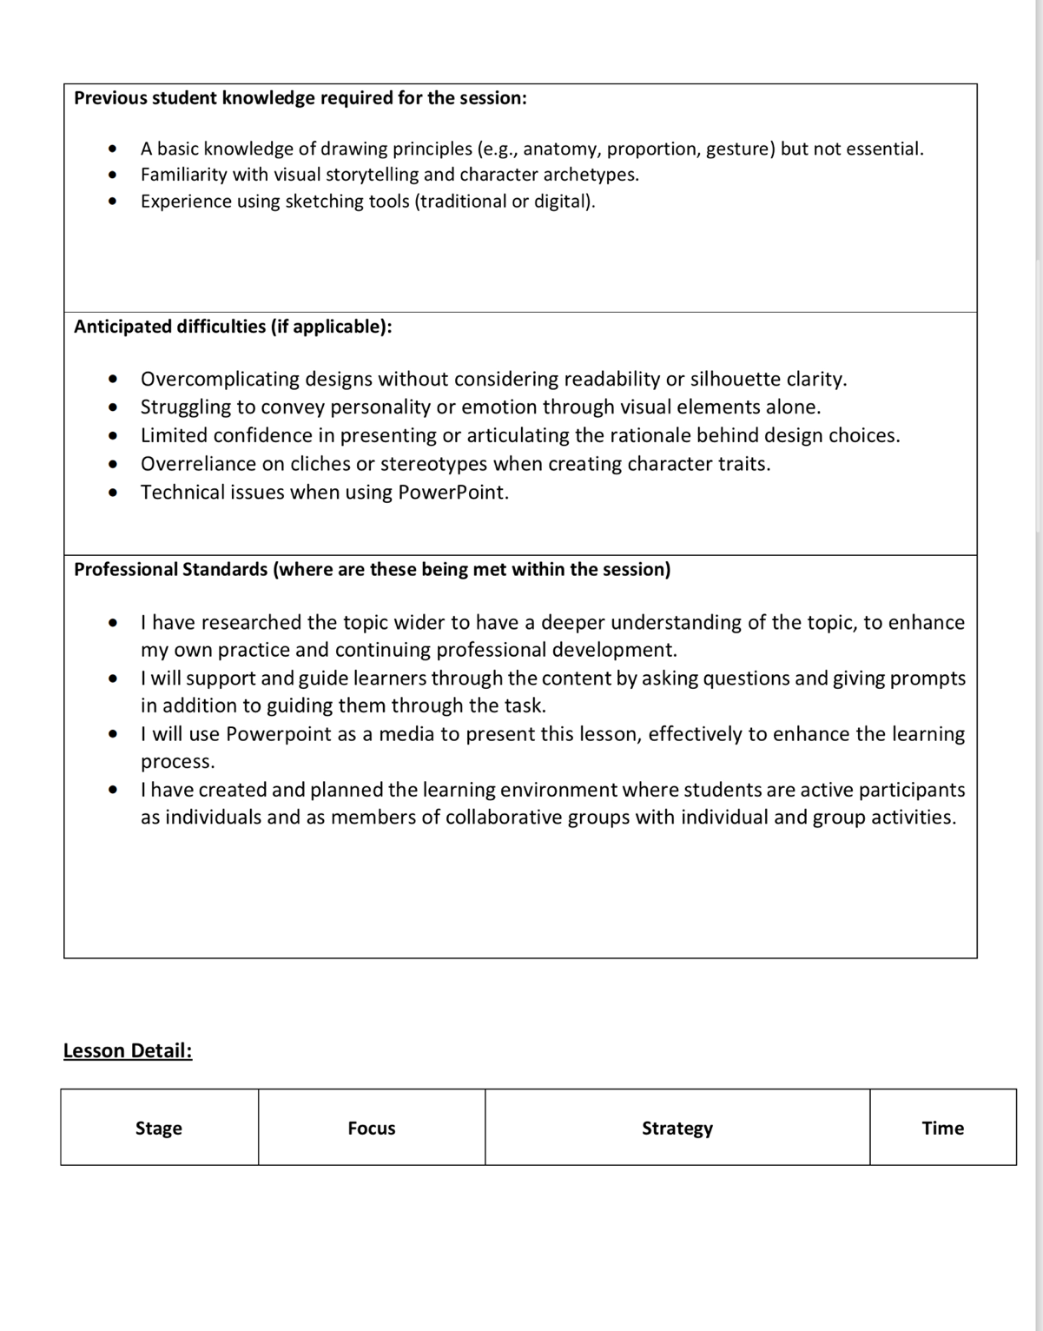

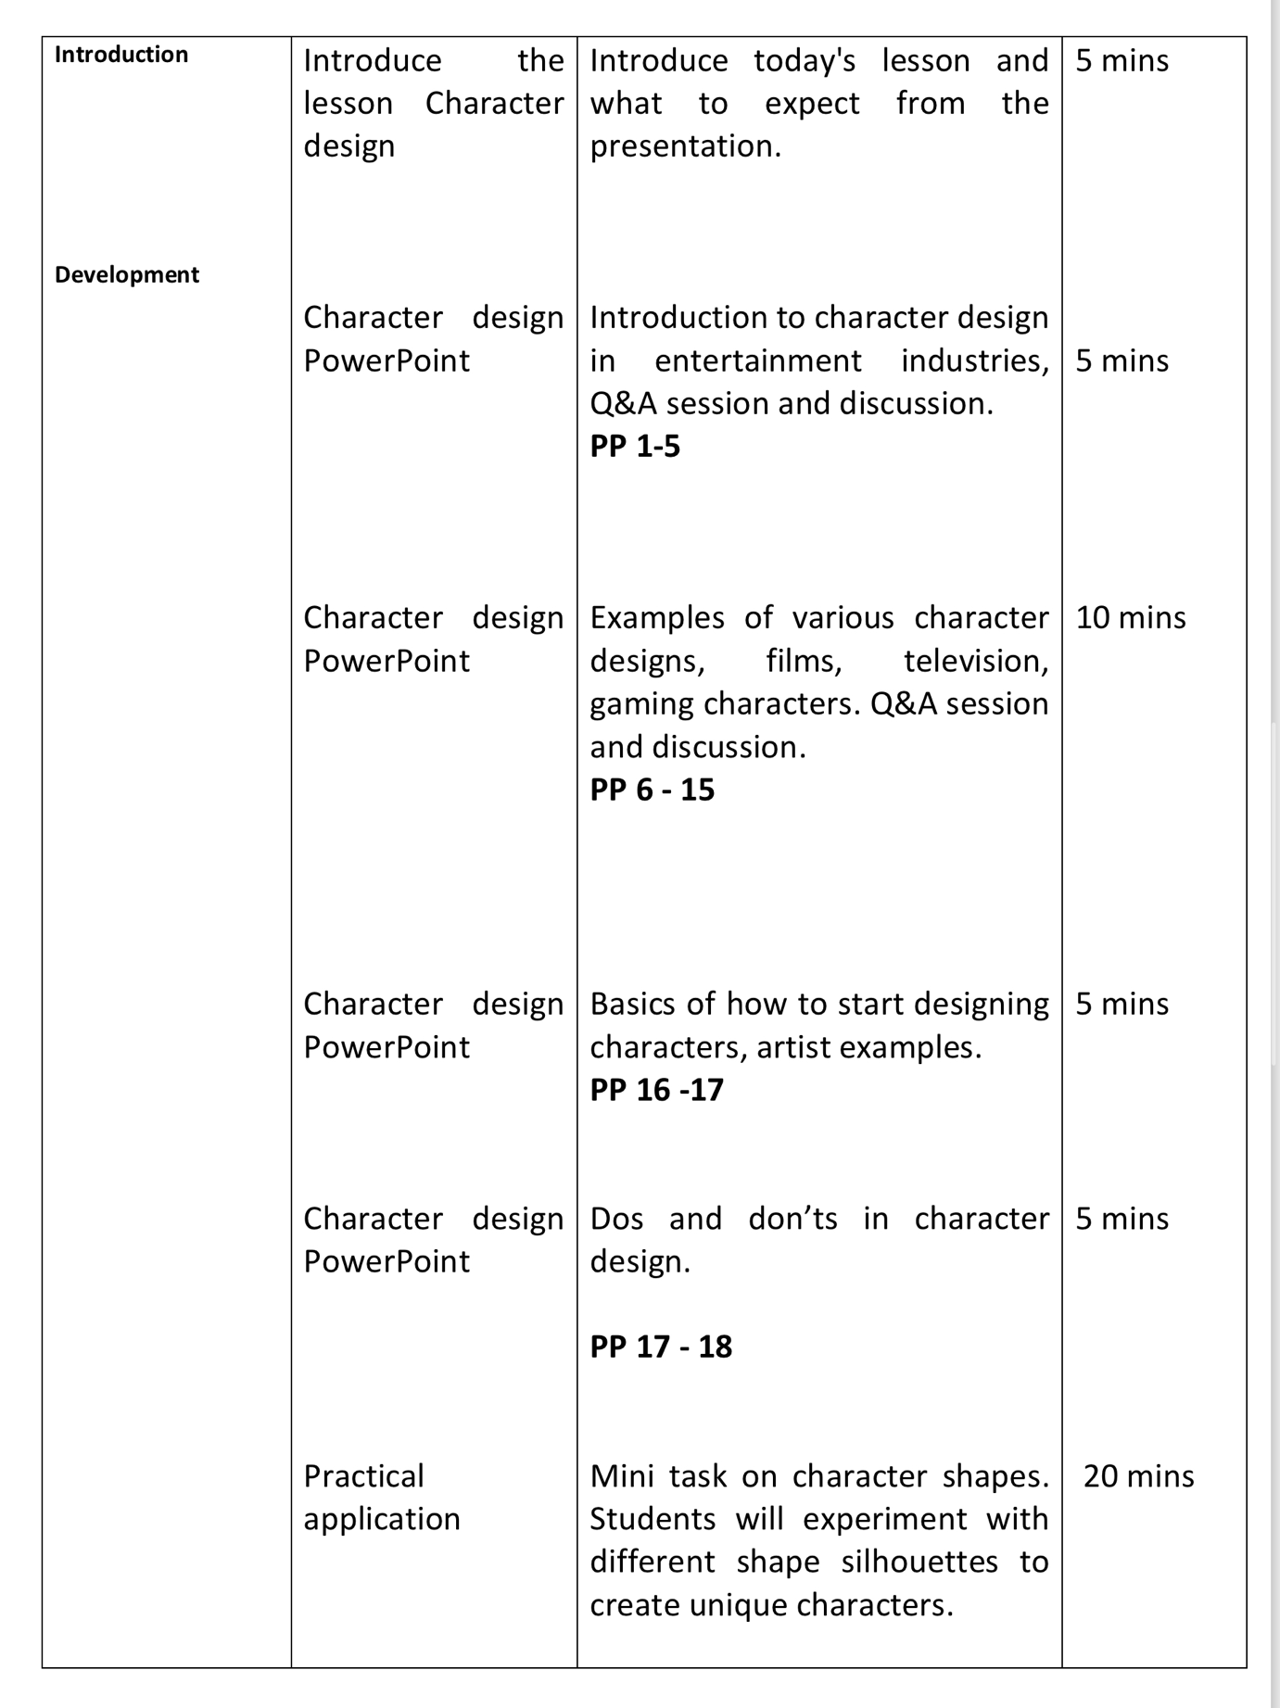
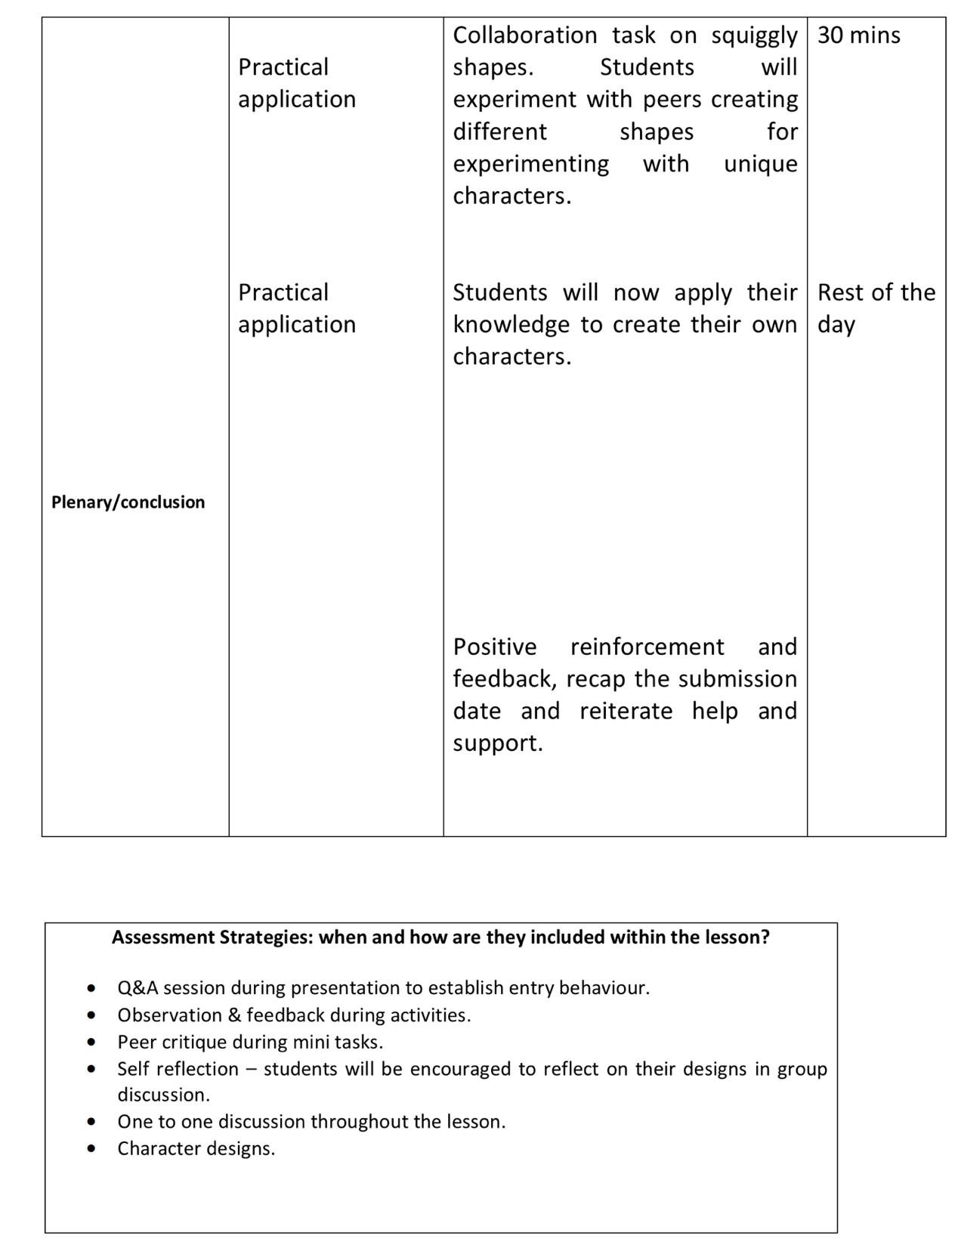
(Figure 1, lesson plan for Character Design, L. Ridley)

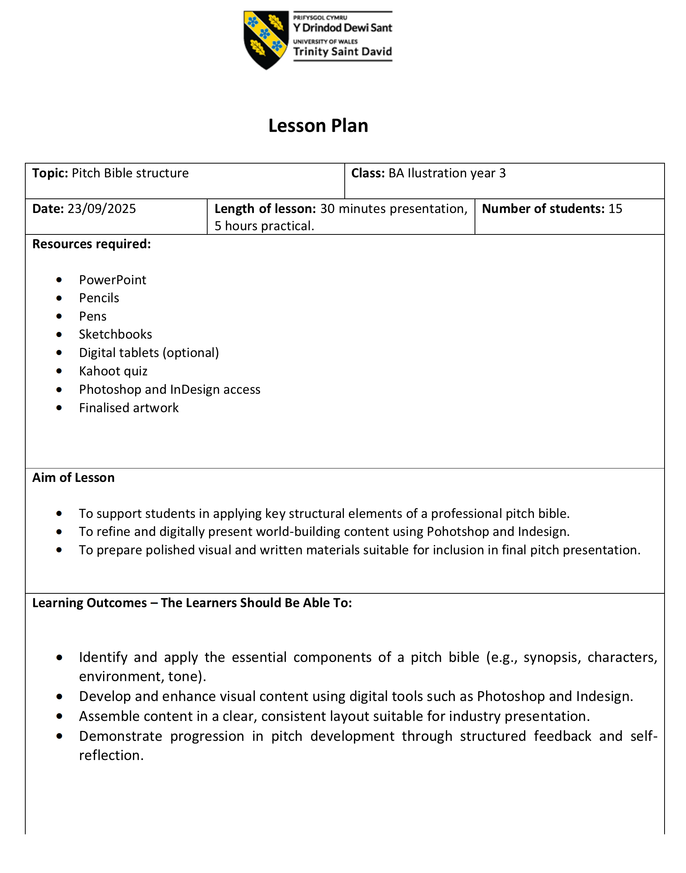
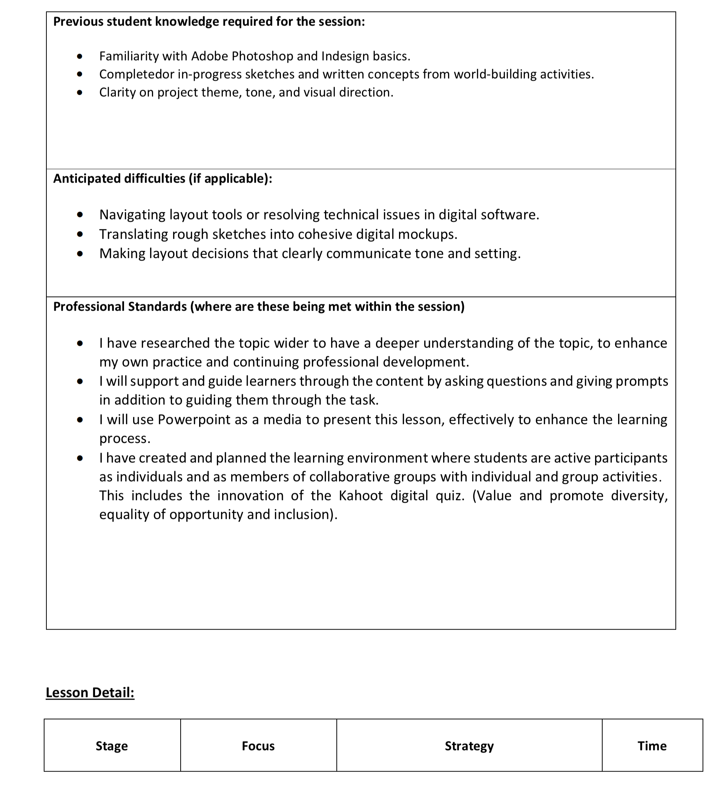
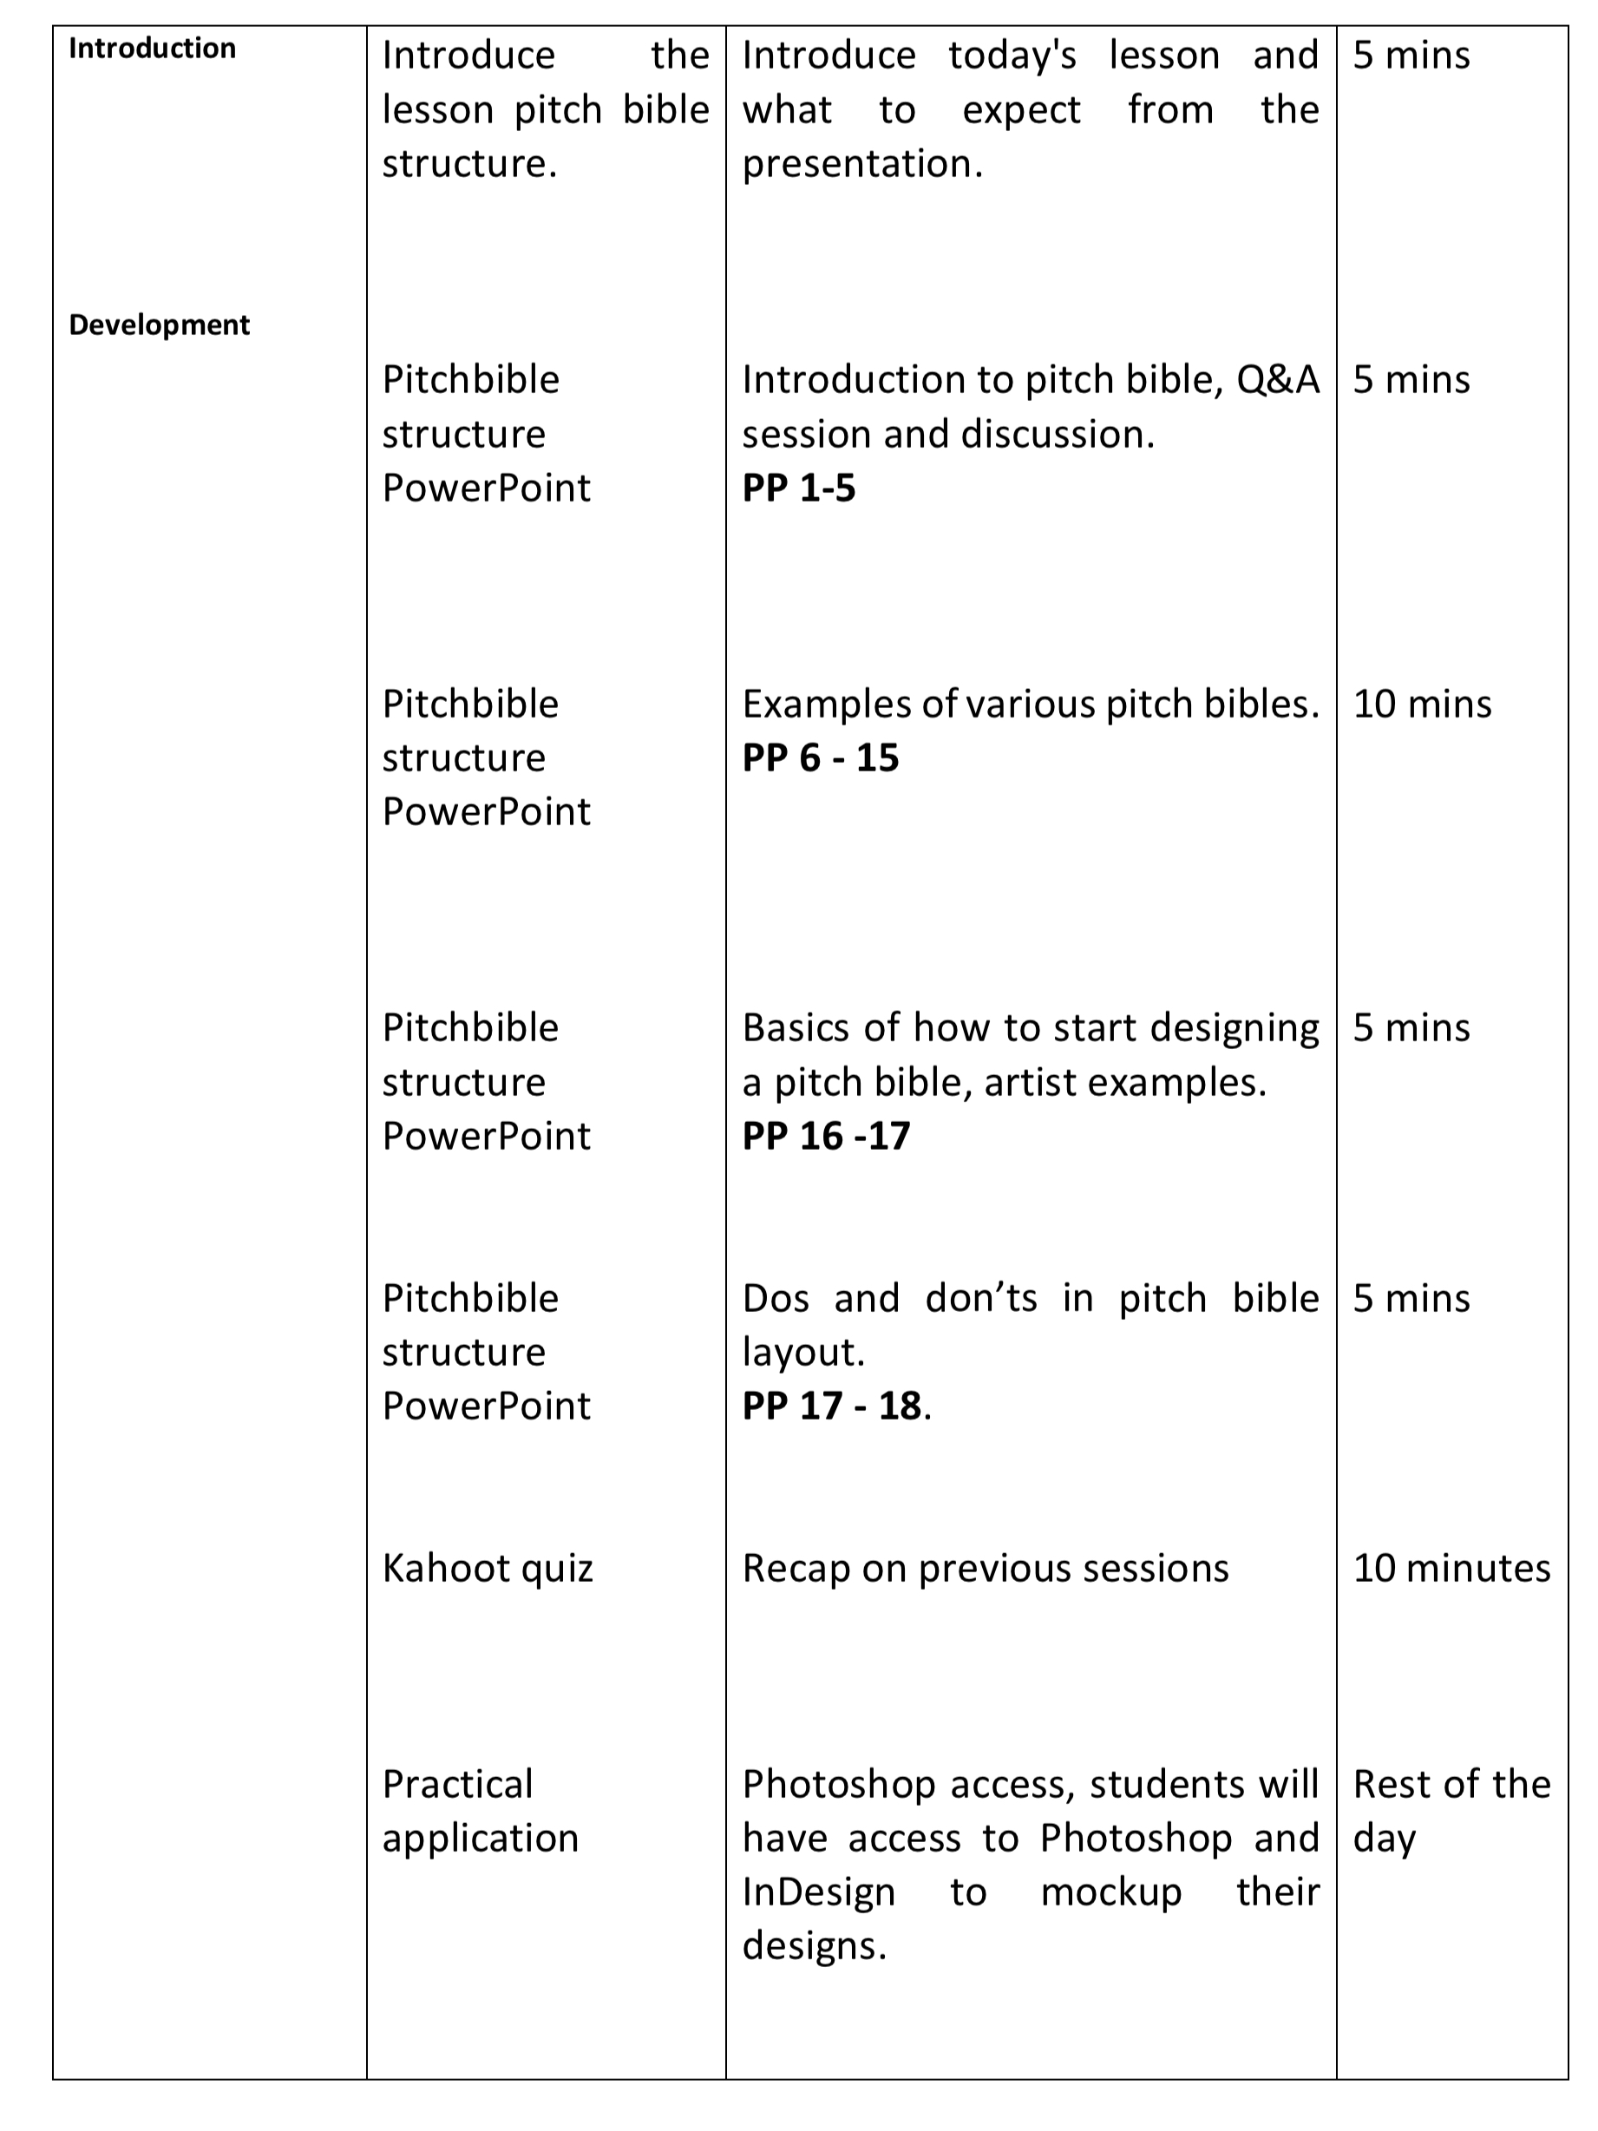

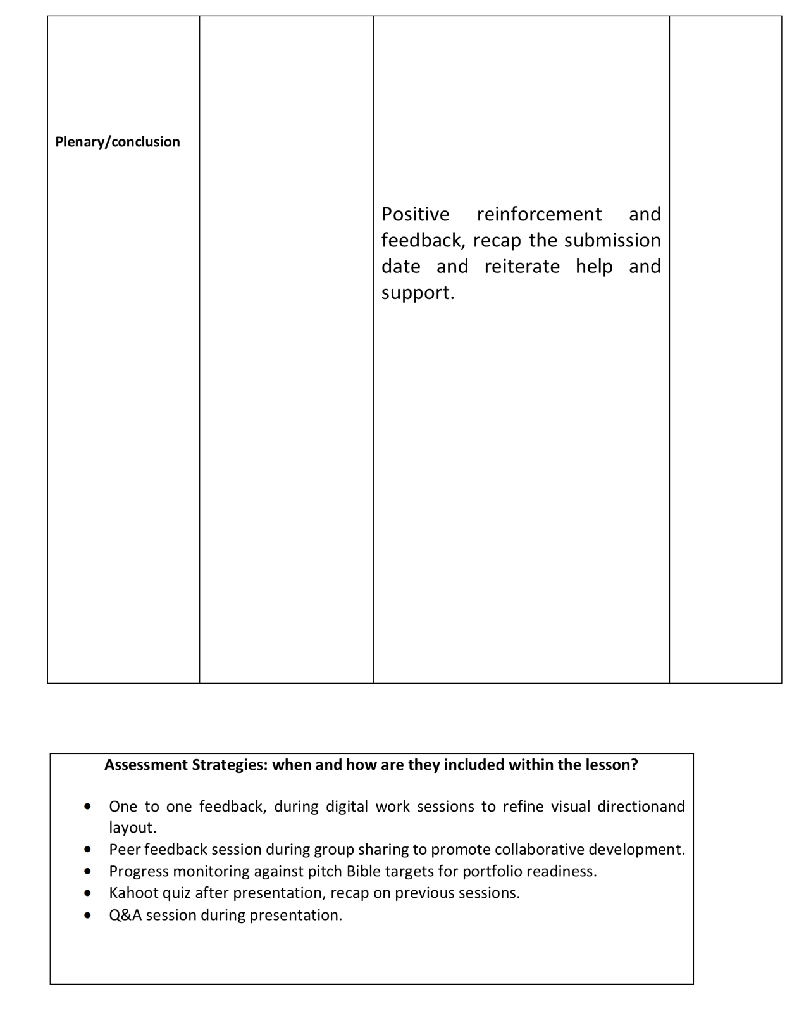
(Figure 2, lesson plan for Pitch Bible structure, L. Ridley)

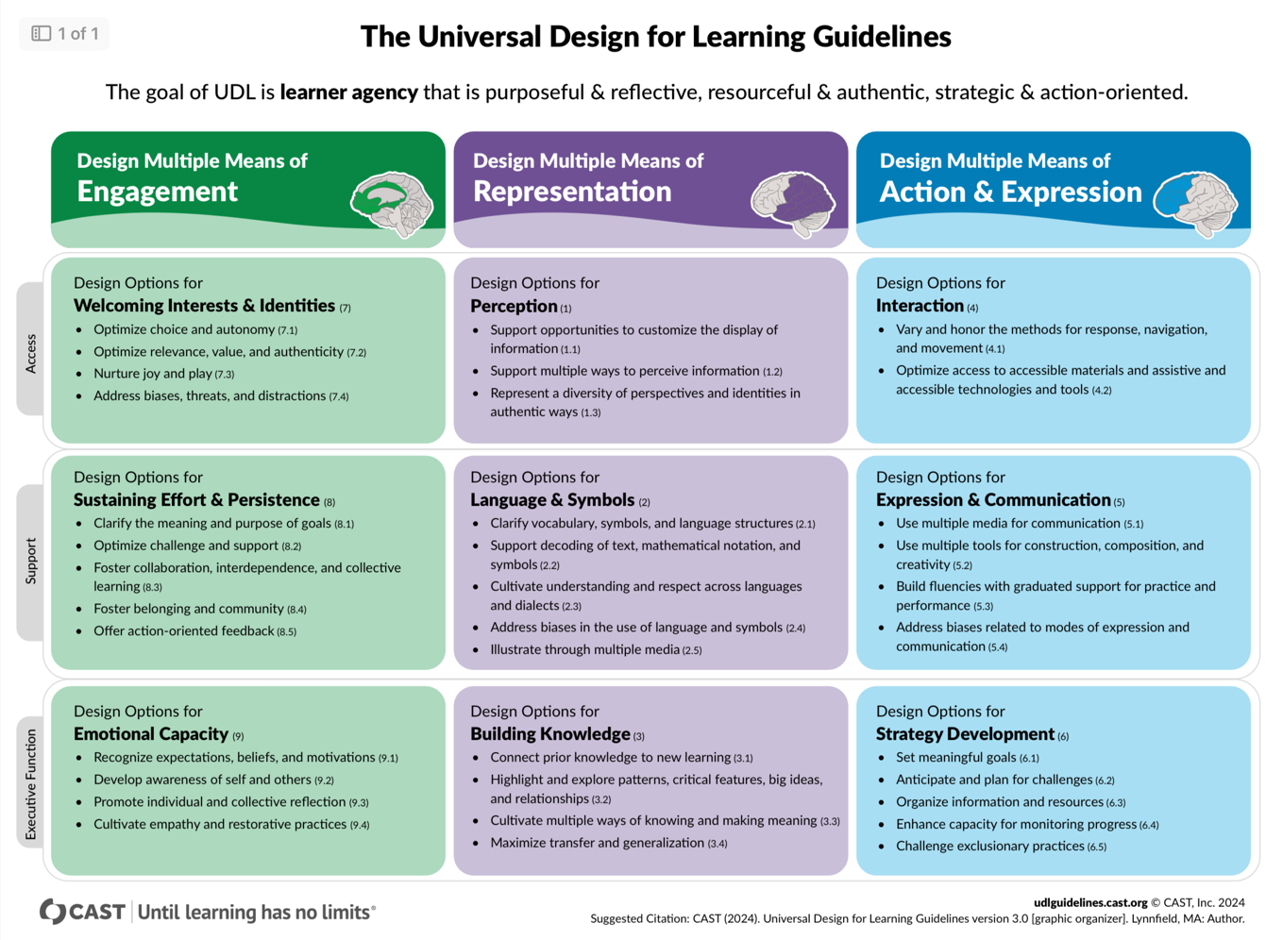

(Figure 3, CAST, 2024)

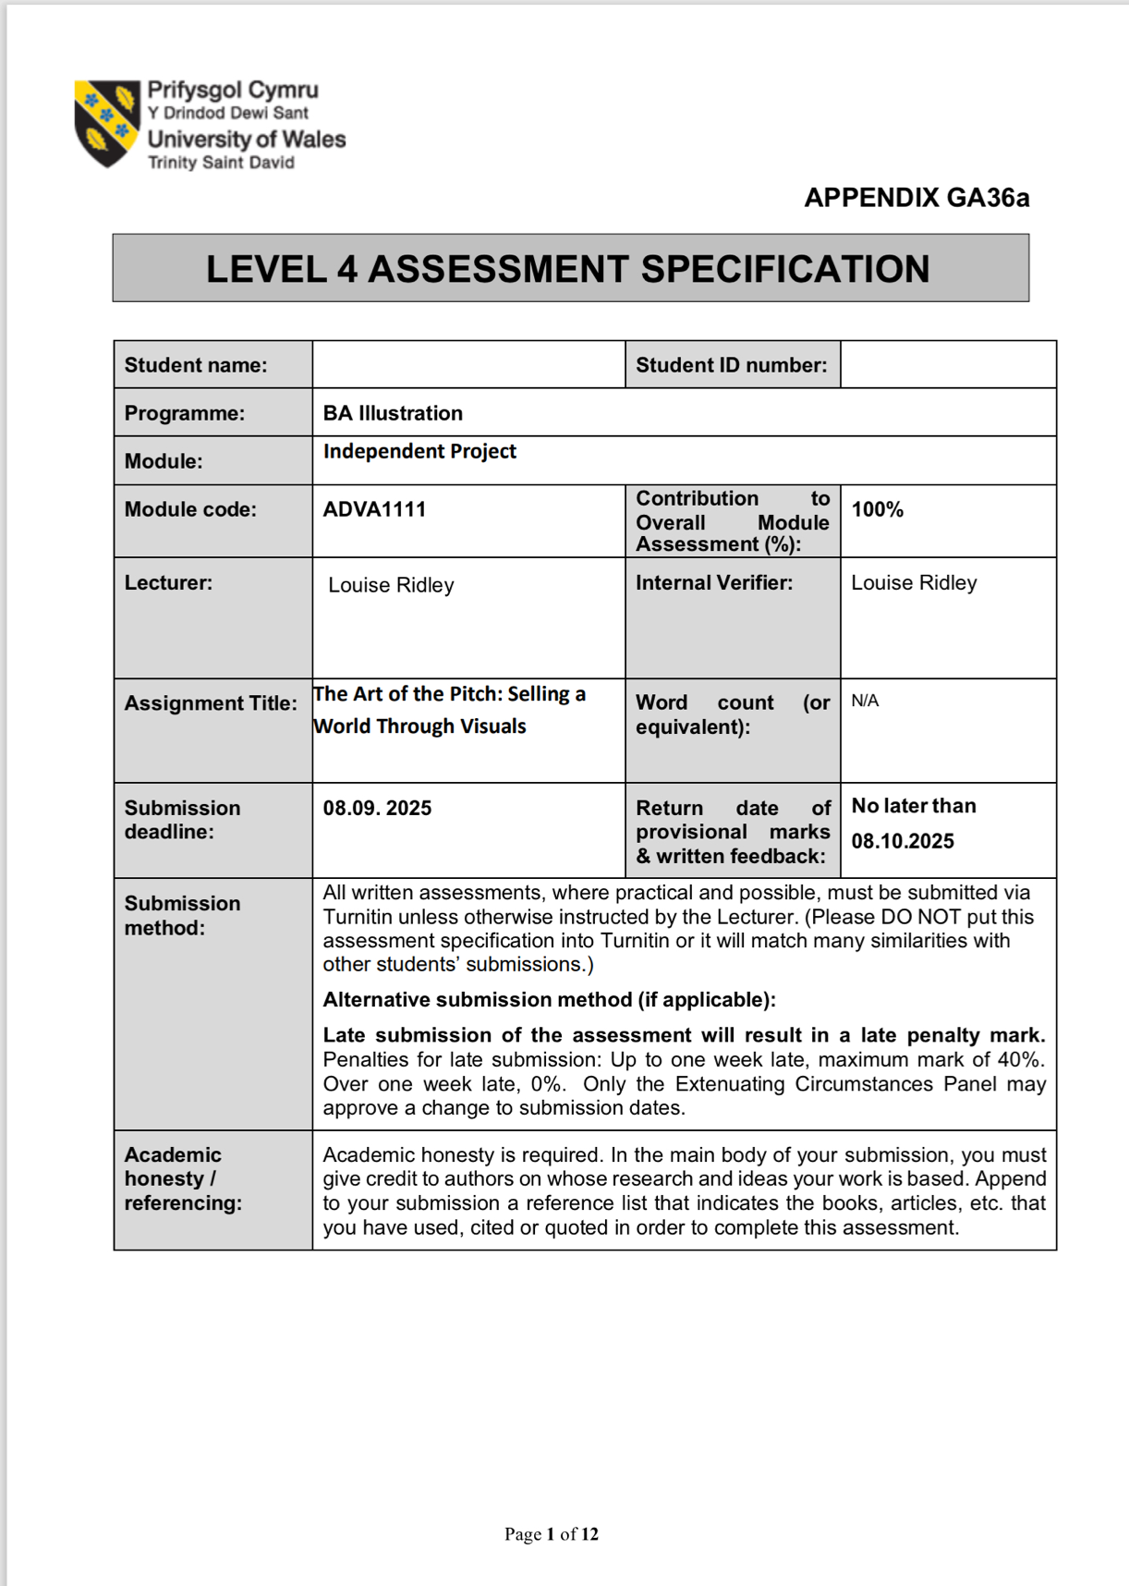

(Figure 4, UWTSD, level Assessment Form, 2025)
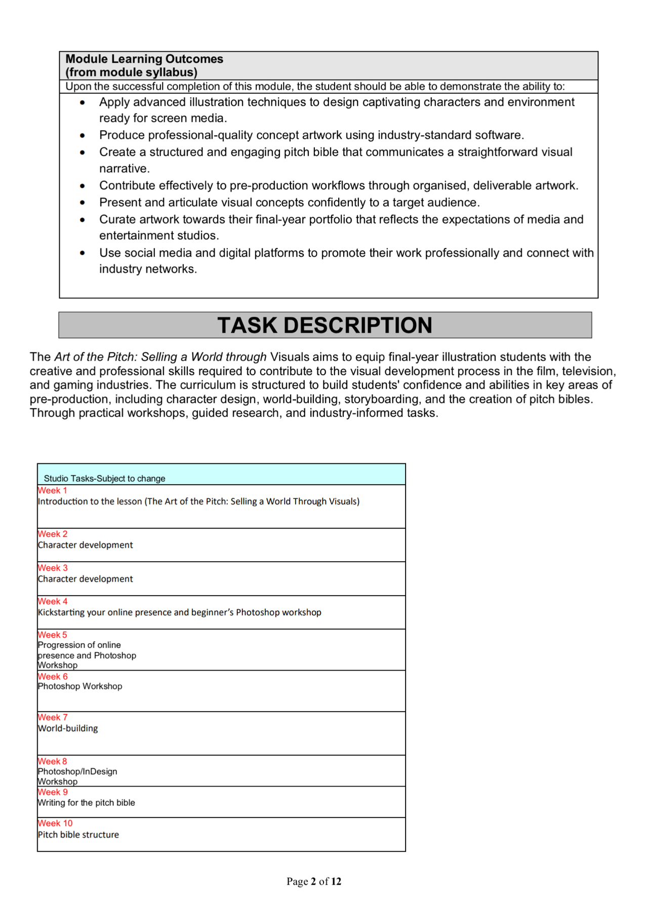

(Figure 5, UWTSD, level Assessment Form, 2025)
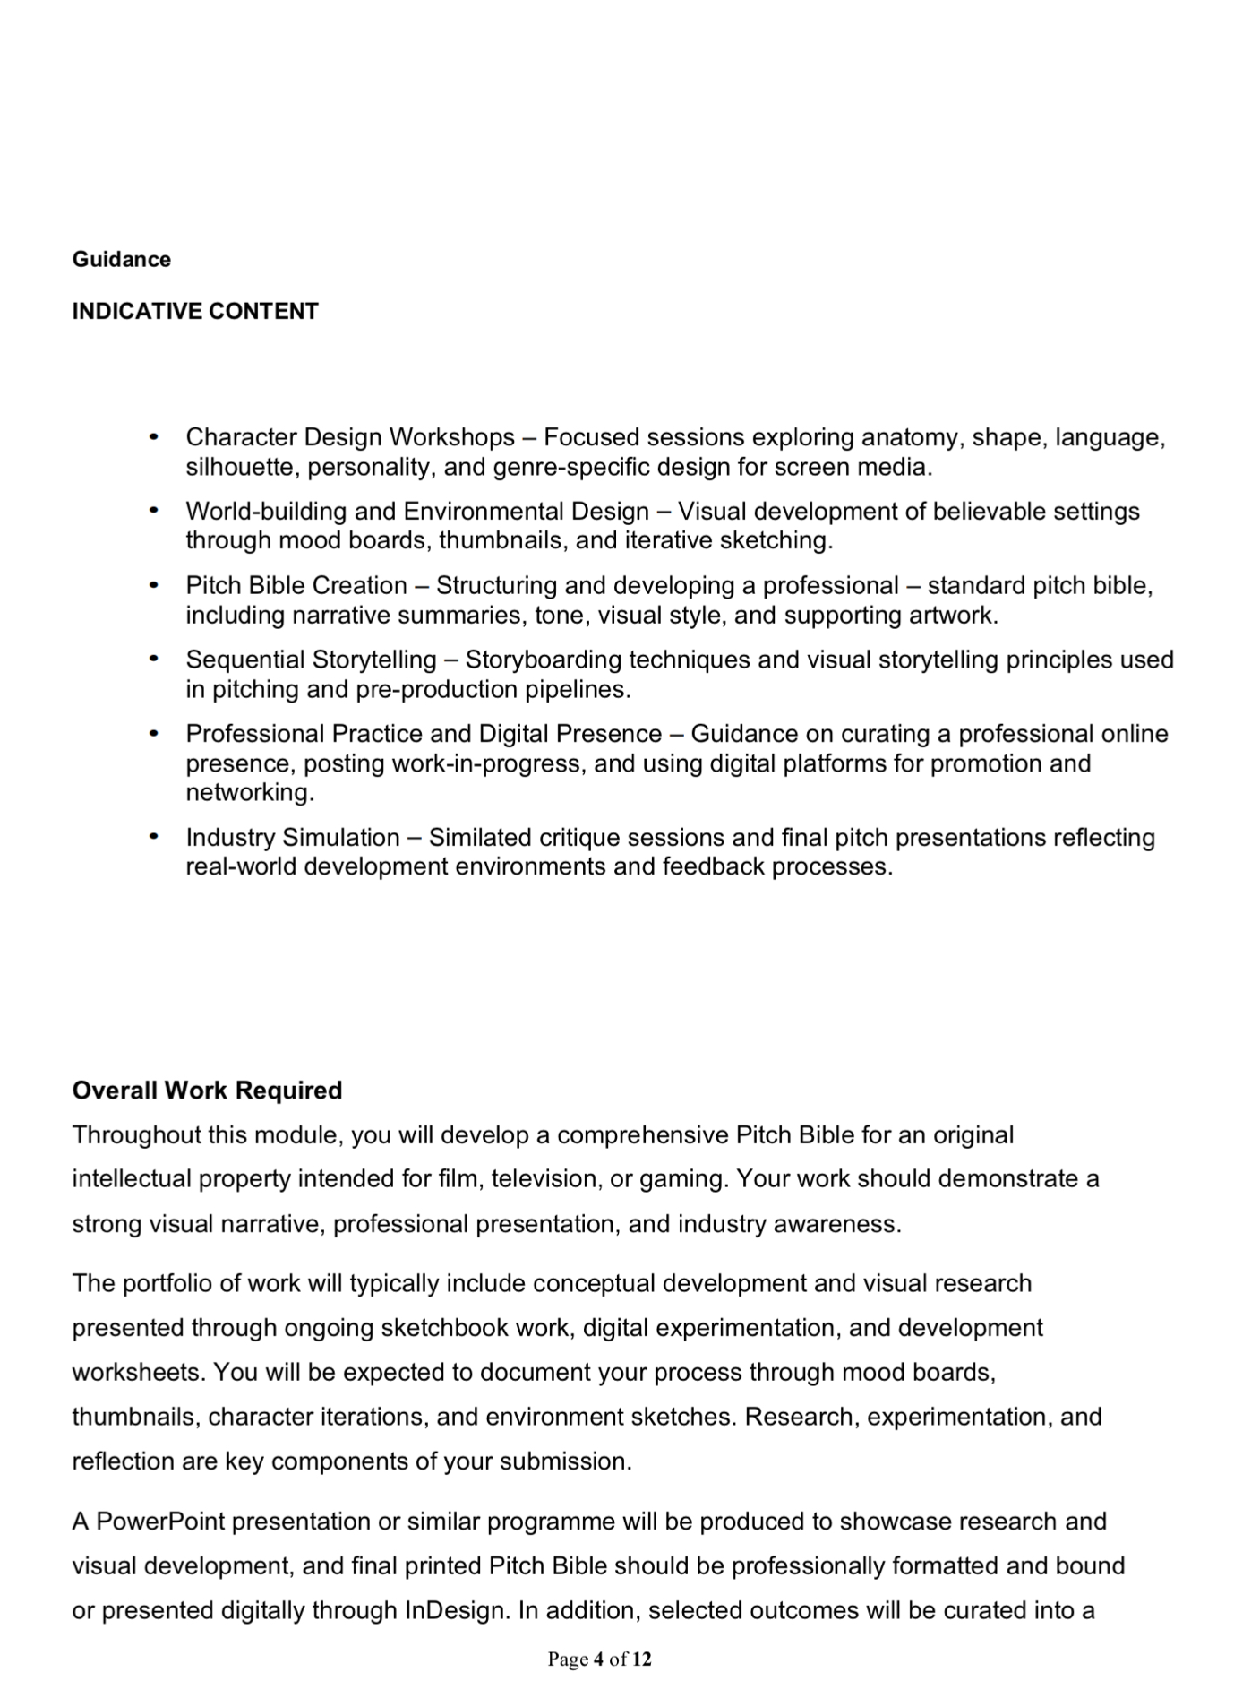

(Figure 6, UWTSD, level Assessment Form, 2025)


(Figure 7, UWTSD, level Assessment Form, 2025)

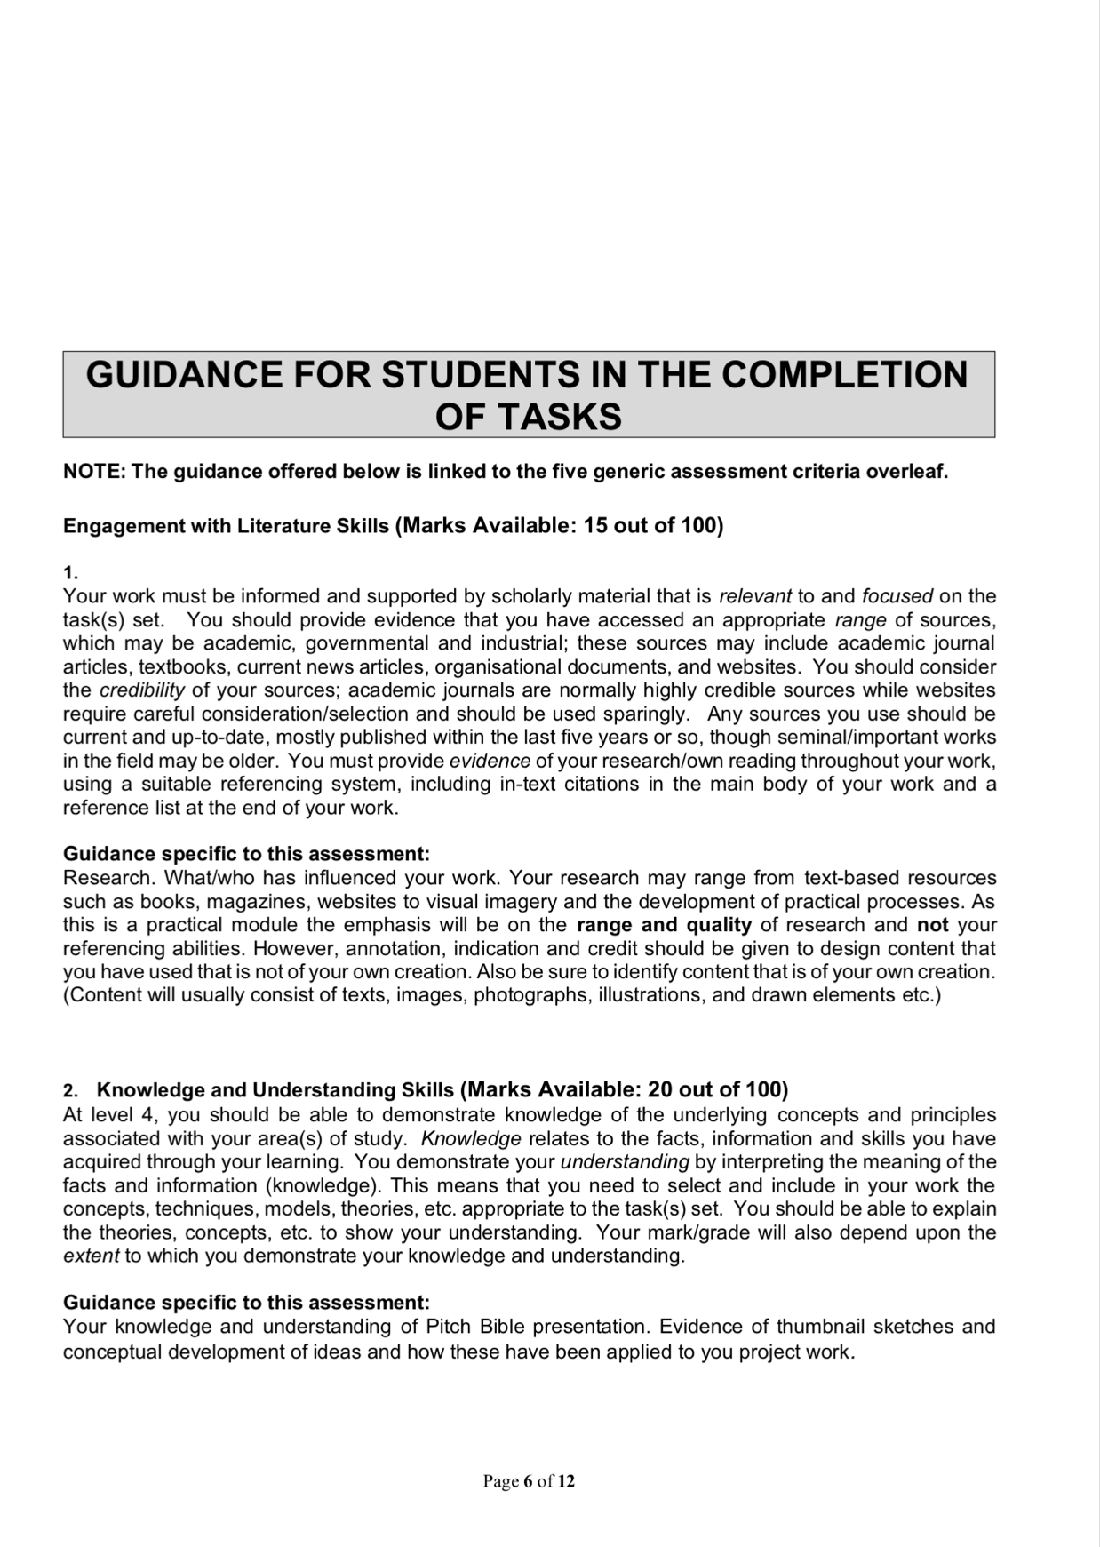

(Figure 8, UWTSD, level Assessment Form, 2025)

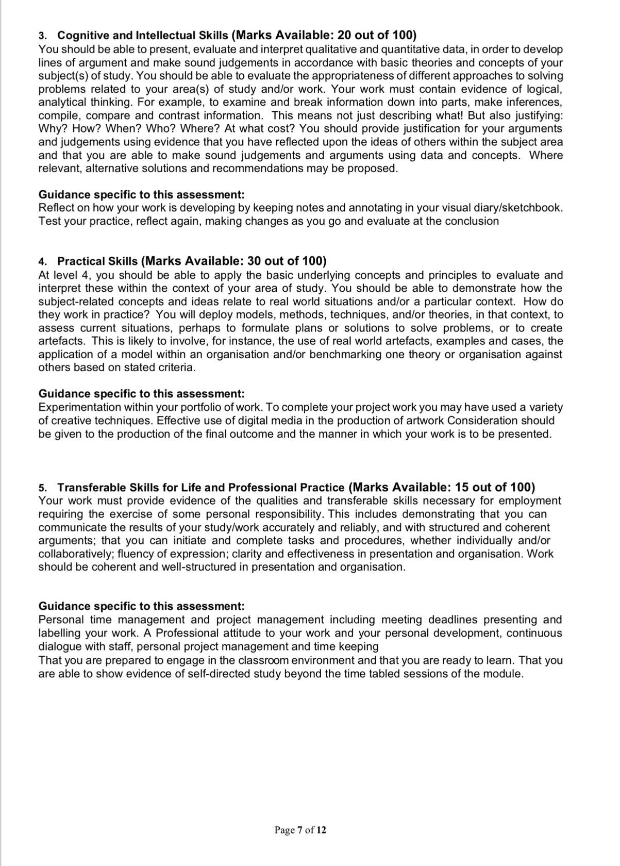

(Figure 9, UWTSD, level Assessment Form, 2025)

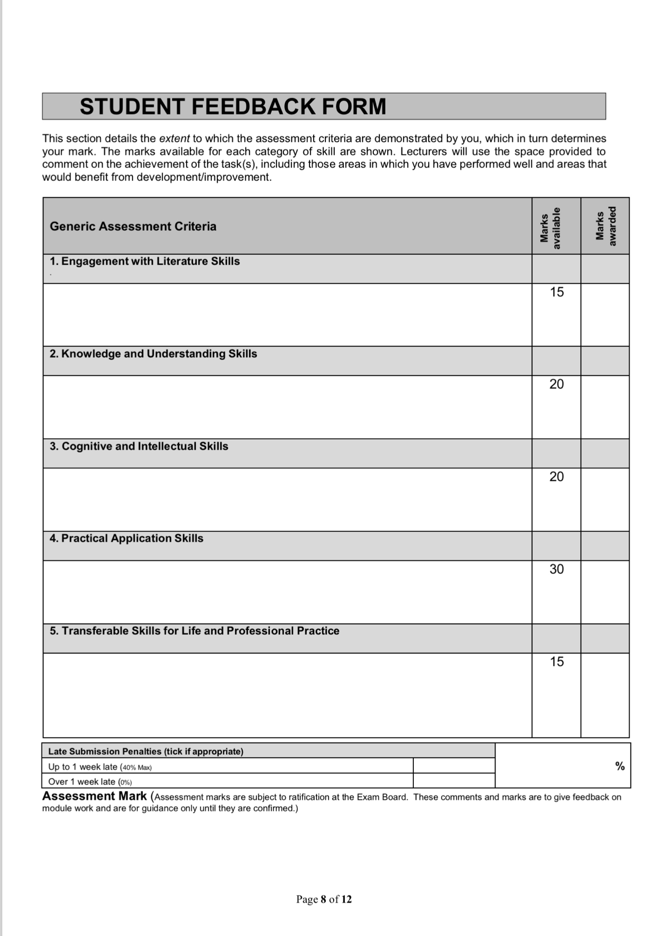

(Figure 10, UWTSD, level Assessment Form, 2025)
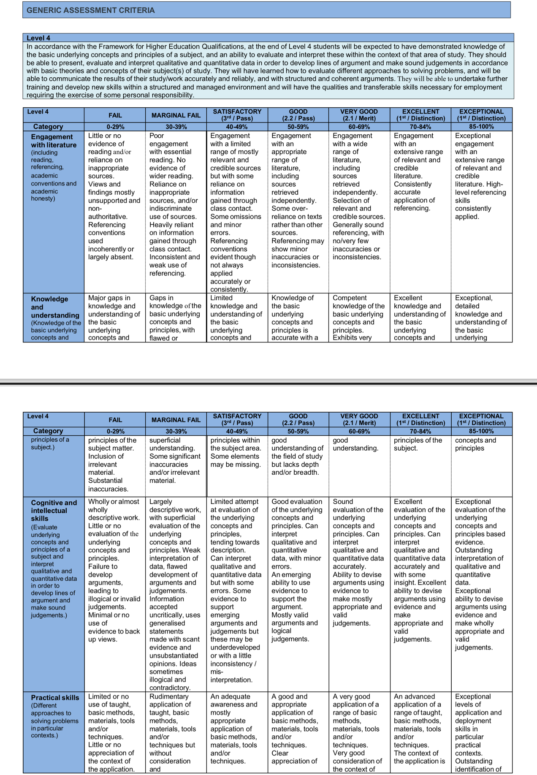

(Figure 11, UWTSD, level Assessment Form, 2025)
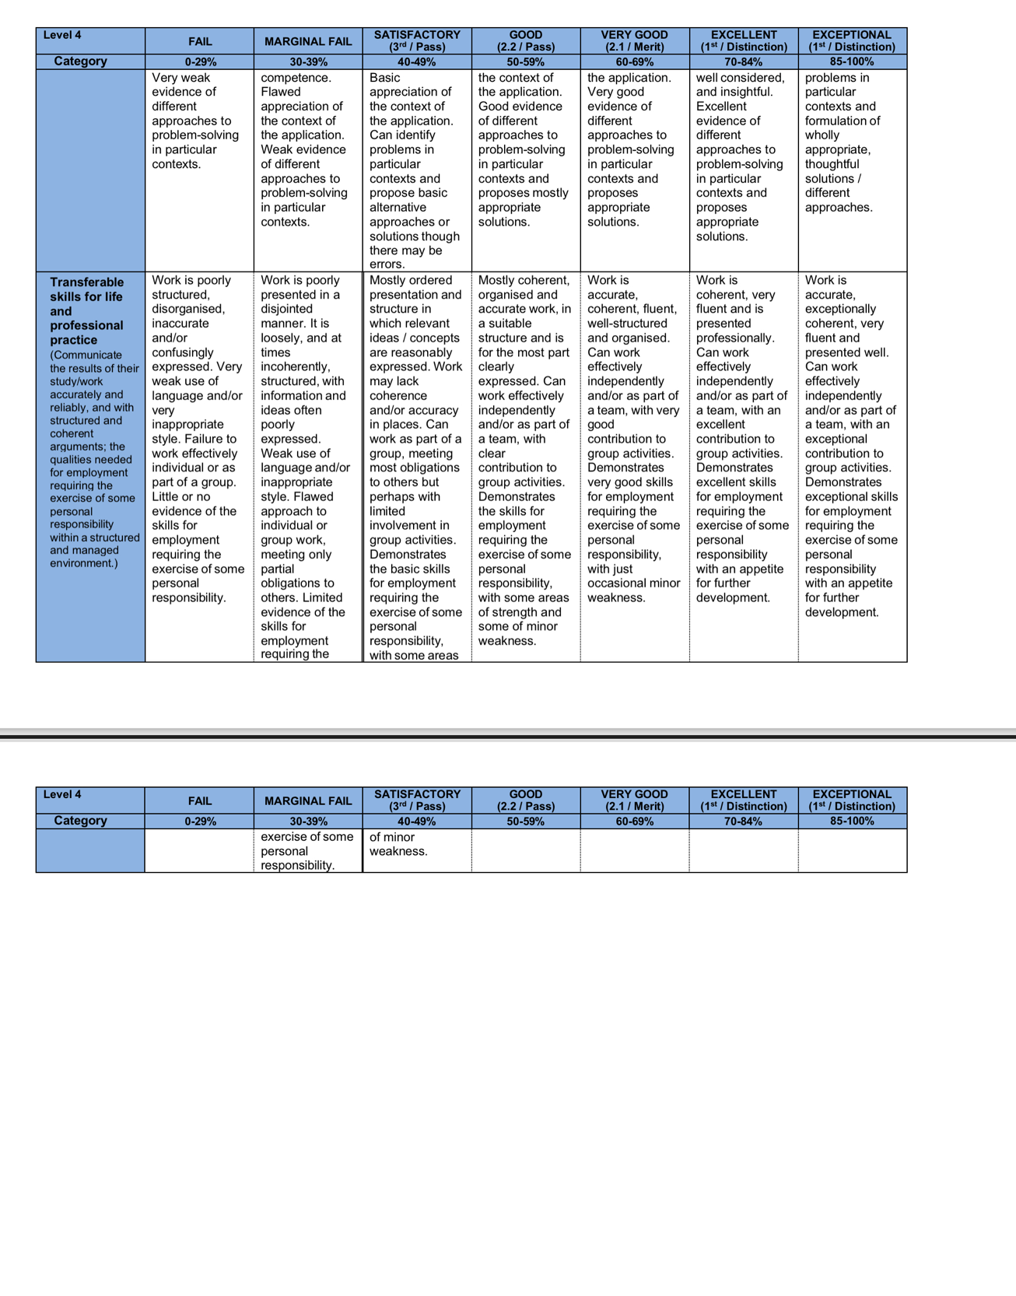

(Figure 12, UWTSD, level Assessment Form, 2025)

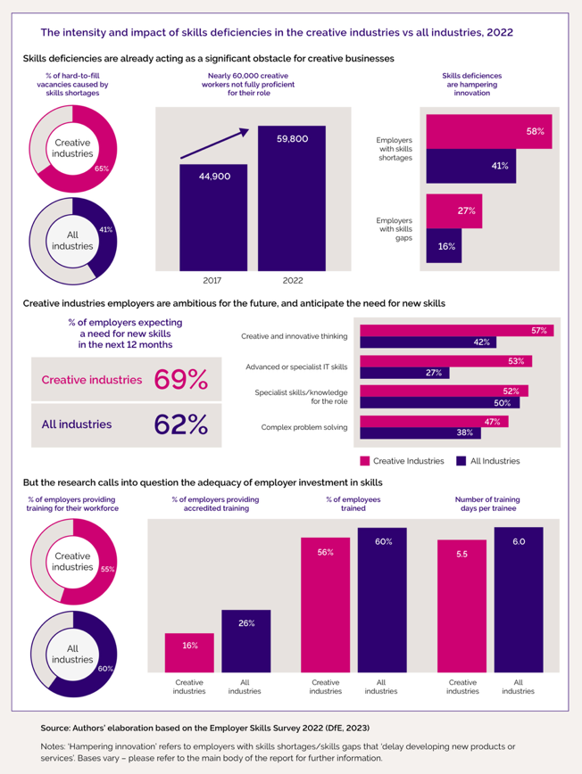
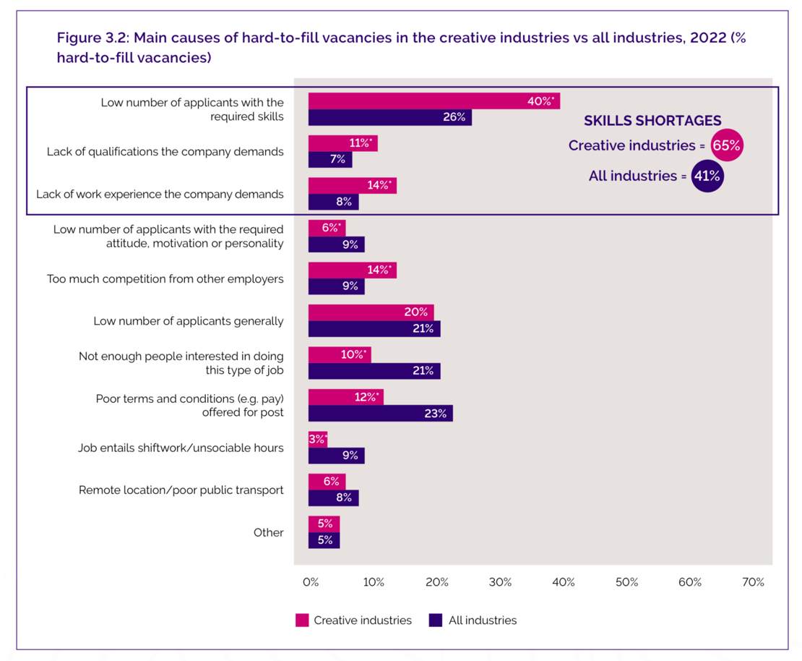
(Figure 13, Carey, 2024)

(Figure 14, Carey, 2024)
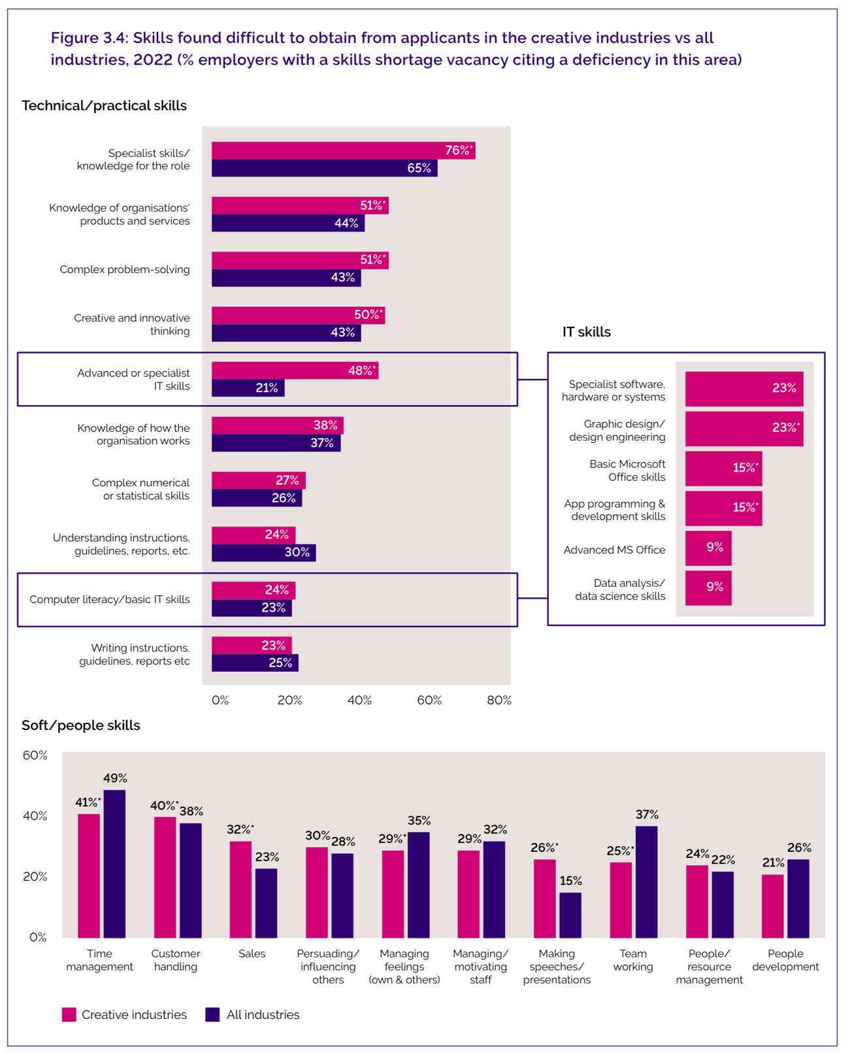
(Figure 15, Carey, 2024)

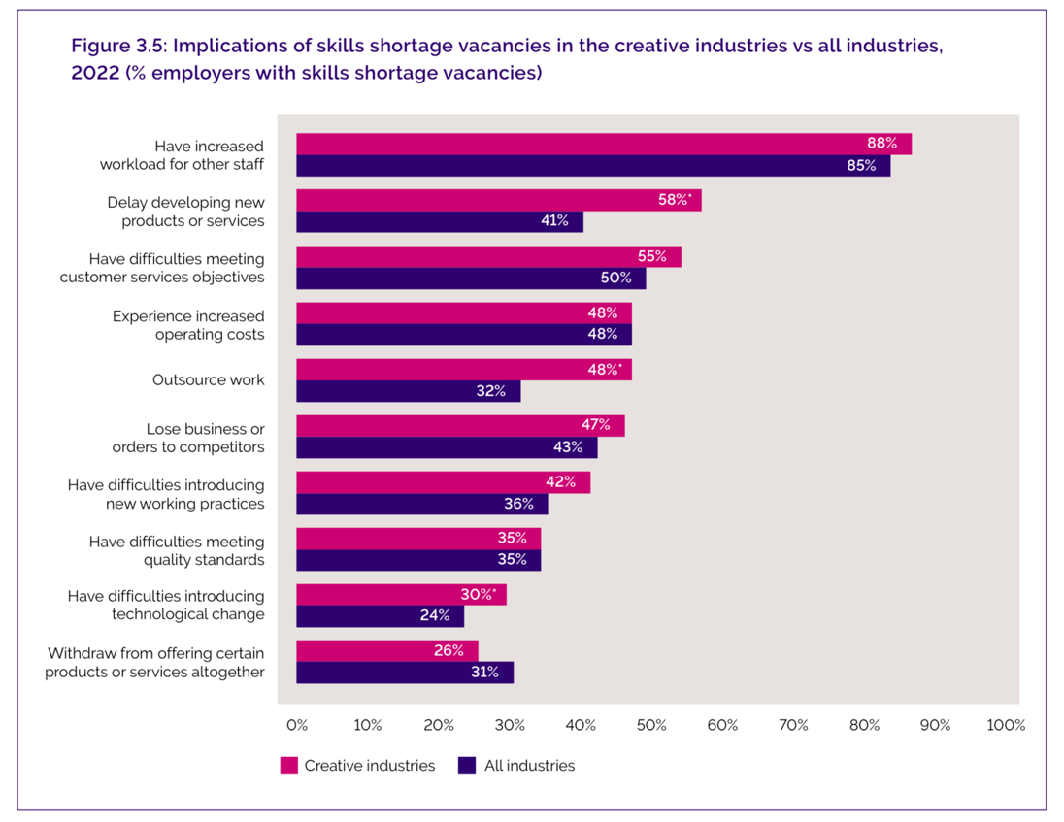
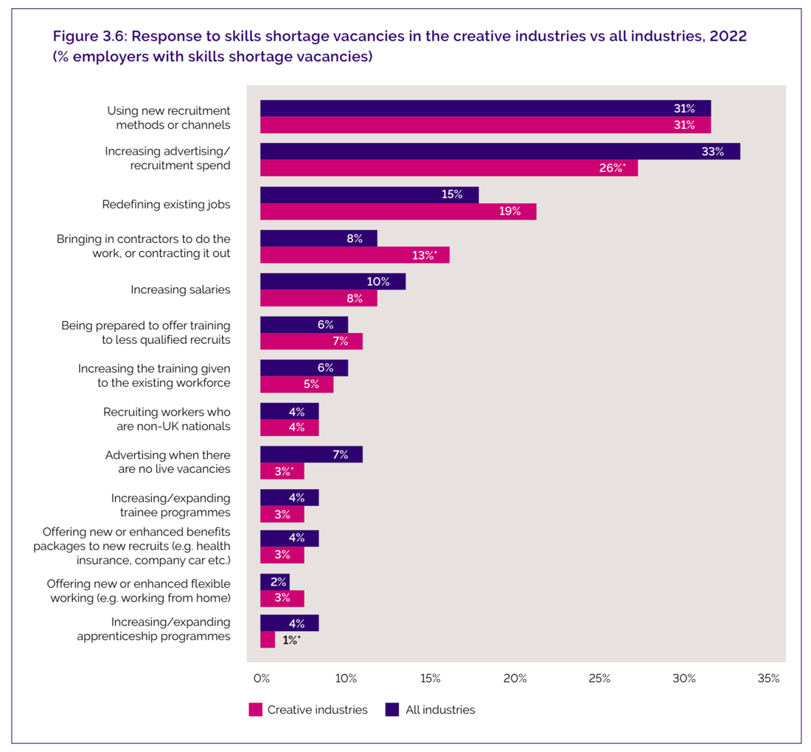
(Figure 16, Carey, 2024)
(Figure 17, Carey, 2024)
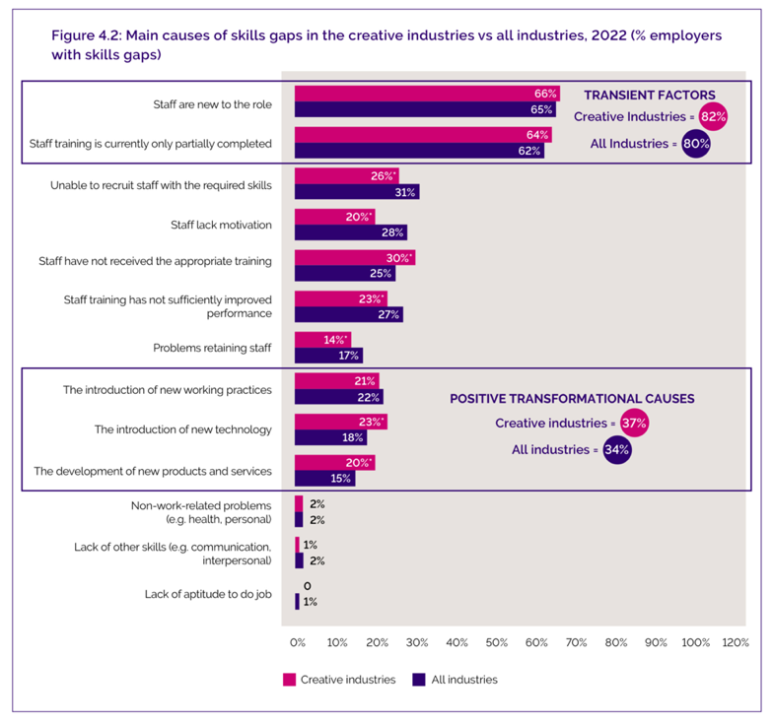
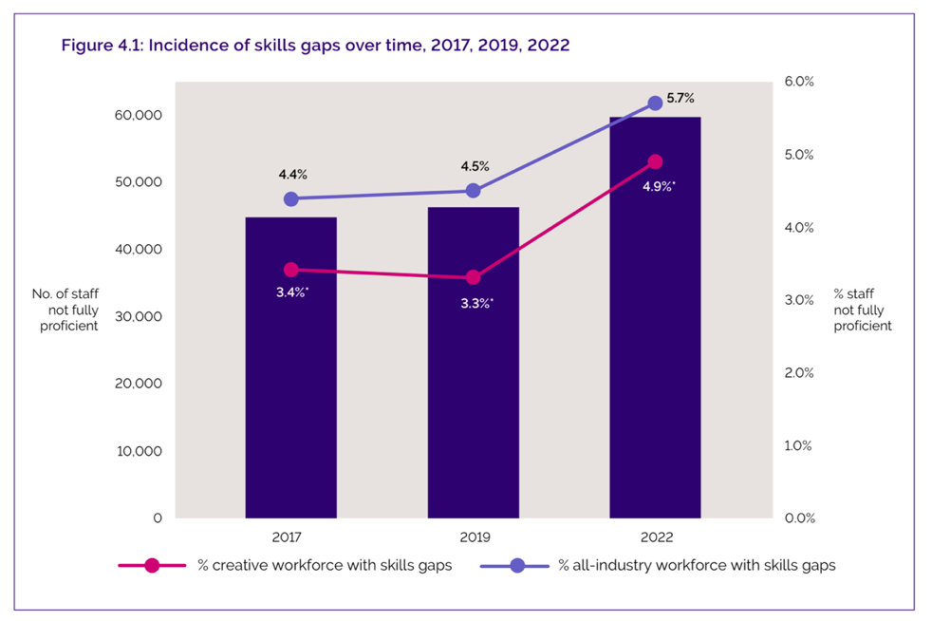

(Figure 18 & 19, Carey, 2024)

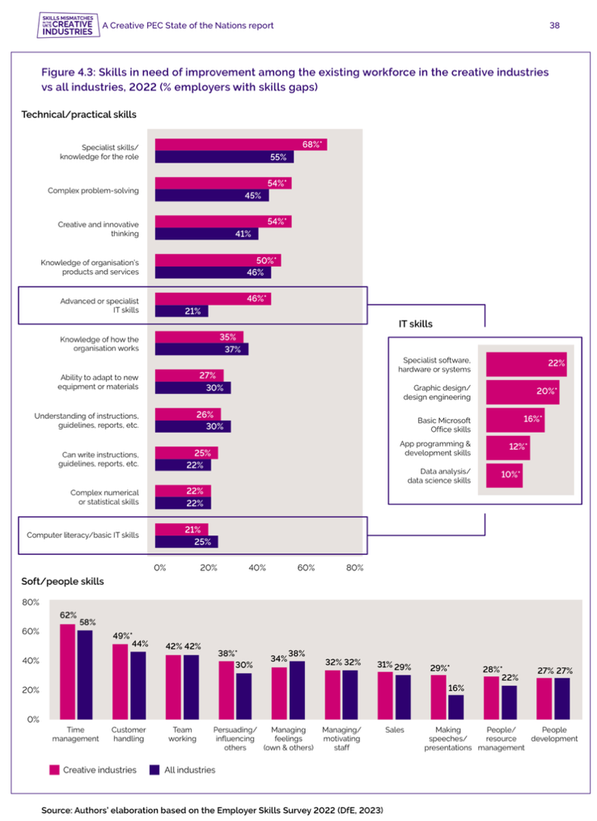

(Figure 20, Carey, 2024)
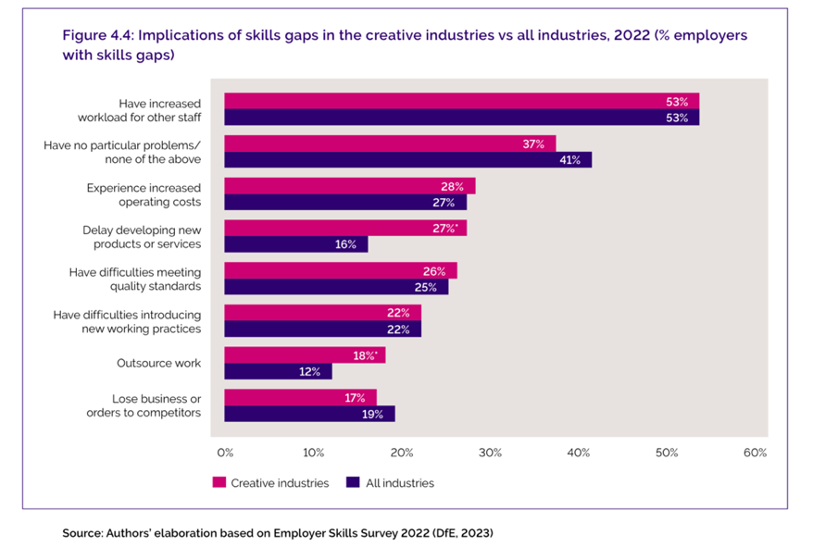

(Figure 21, Carey, 2024)

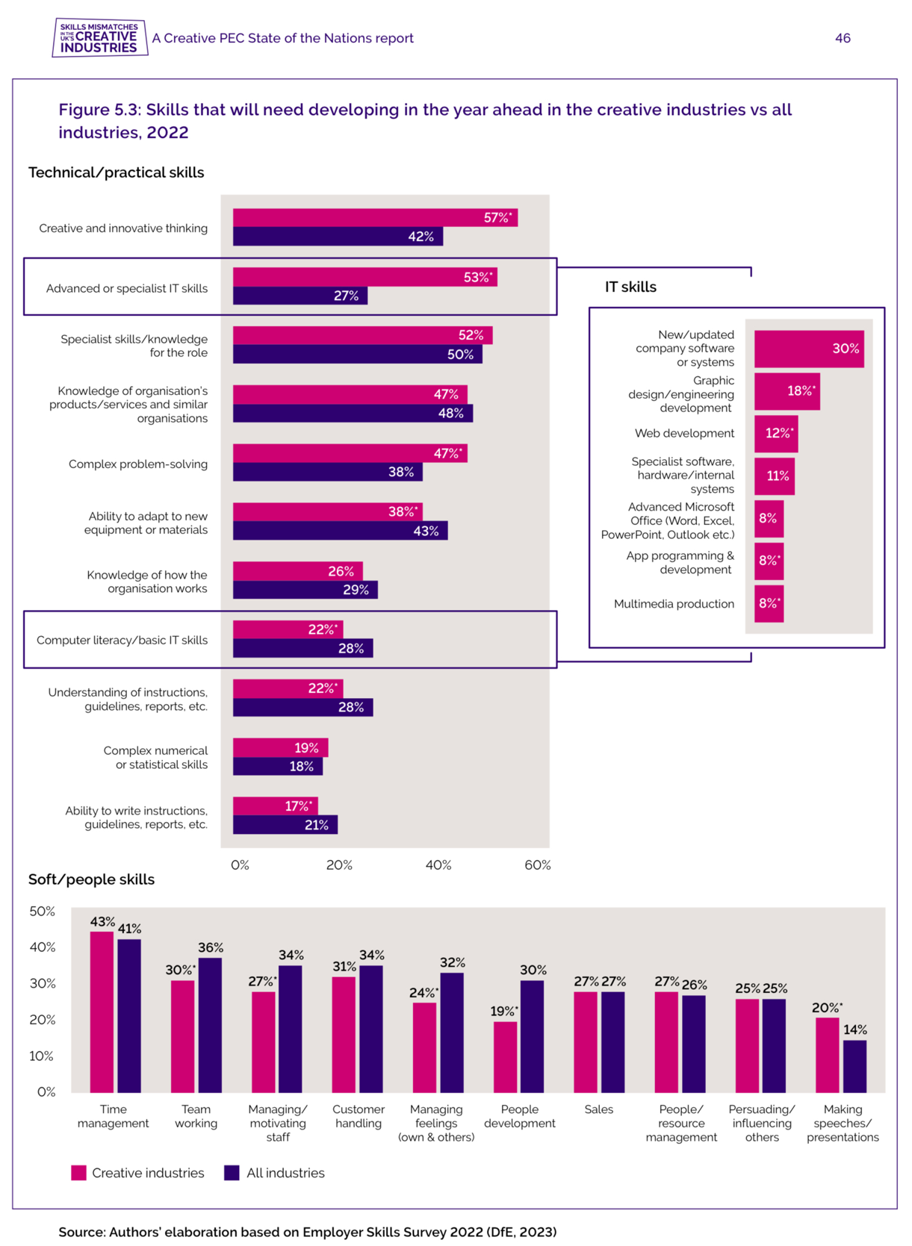
(Figure 22, Carey, 2024)

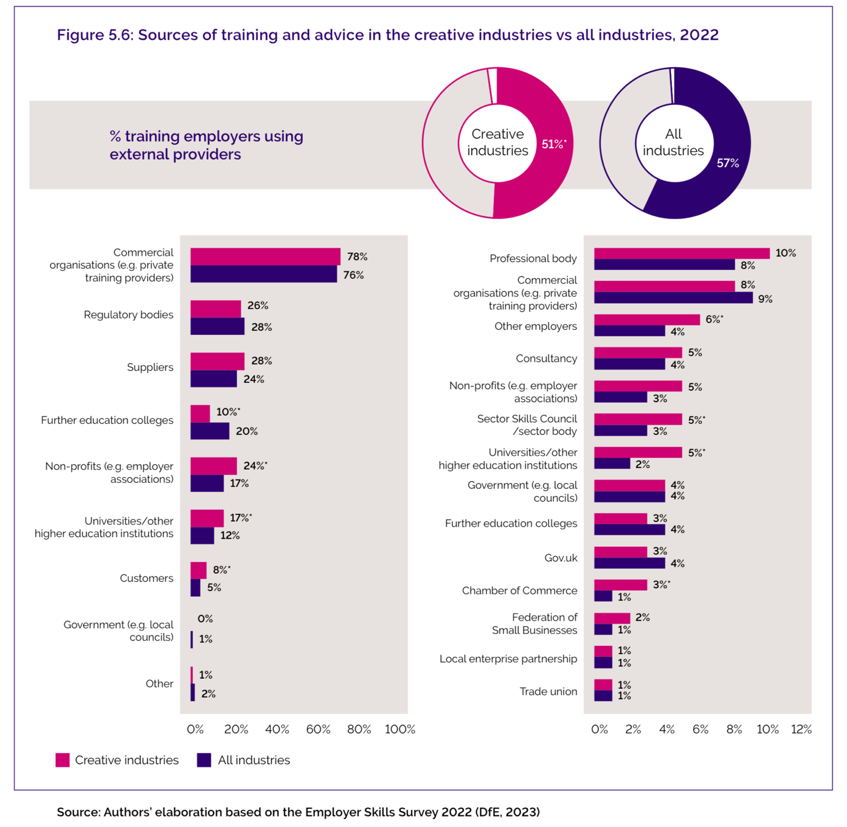
(Figure 23, Carey, 2024)

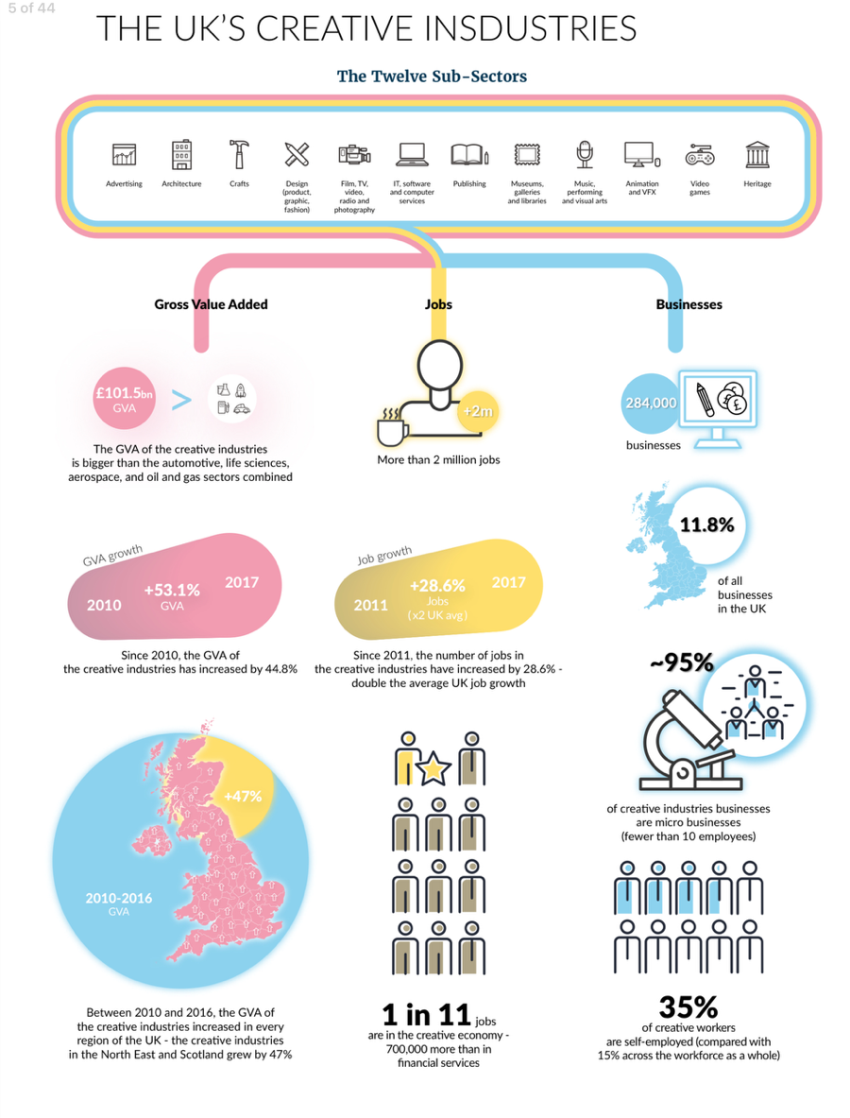
(Figure 24, Creative UK, 2018)

