

Programmes in C and Documentation

Suzanne Davies – 1809913
Software Development

School of Applied Computing
25th February 2019

Contents
1. Introduction 3
2. Background Research 4
3. Variables 5
3.1 What is a Variable? 5
3.2 Importance of variables in writing programs 5
4. Loops 6
4.1 What are loops? 6
4.2 For loops vs Counting loops 6
5. Arrays 8
5.1 What is an Array? 8
6. Exercises 10
6.1 Exercise 1 10
6.2 Exercise 2 12
6.3 Exercise 3 16
6.4 Exercise 4 20
Conclusion 21
Bibliography 22

Introduction
The C programming language was first introduced in 1972 on the Digital Equipment Corporation PDP.11 computer and created by Dennis MacAlistar Ritchie specifically for the Unix Operating System.
In his book ‘C Programming’ [1] Mike McGrath suggests that the C language is quite flexible in terms of development through machines supported by the windows platform.
C is predominantly used to create a computer programme by applying specific instructions that a computer must follow. It is argued that due to the length of time C has been readily available and accepted by programmers worldwide, it is deemed to be most efficient [2].

Background Research
According to David Chisnall [3] optimizing C has a common denominator in the fact that it’s a low-level language and fast paced. In theory the translation of a code will be done so quickly without needing to add a compiler that’s quite complex.
He argues that there isn’t a simple translation method in C programming, even though processor architects have invested a great deal of time and effort in designing chips to run fast code, against the expected performance.
The processing of large amounts of data in C entails writing code in a loop format so that it executes each element in a sequential pattern. In order to ensure its run at an optimum level, the compiler will need to identify whether or not the loop iterations are independent. Once this has been realized, the compiler will attempt to initialize the result.
He [3] states that a survey conducted in 2015 based on C programmers, compiler writers and standards committee members identified that there were a number of concerns highlighted around just how comprehensive the C program really is.
Robert C Seacord [4] believes that behaviors need to change and that the C standards committee need to revise the next set of standards (C2X) before they’re deployed.
He argues that a simple solution would be to completely eradicate trap representations and therefore a contributing factor in simplifying the standard which ultimately provides compiler developers with the ability to optimise the code.

Variables

3.1 What is a Variable?
The C programme contains various types of data values that each have their own unique name which are known as variables and can be a combination of letters and numbers. They can be stored in computer memory and include:
- Integers (int) – whole numbers
- Floats – Numbers with a decimal point
- Characters (char) – Single letters eg “a”,”b”,”c”
- Strings – Multiple letters eg “computer”,”book”,”animal”,”student”
Variables must be declared at the beginning of the programme. Failure to do so will result in the programme not able to work [1].

3.2 Importance of variables in writing programs
Variables are important as programmers require flexibility when creating a program and therefore play a vital part in contributing to that factor.
Variables are used by the programmer to represent data instead of the end user having to directly input it into the program. At the point of execution of the program, the real time data value replaces the variable which enables different sets of data to be processed when using the very same program [5].

Loops

4.1 What are loops?
In the event of the programmer needing to repeat a piece of code, they will use a loop which will enable the repetition process to take place automatically [1].
The loop structure within C programming consists of:
- For loops – A repetition control structure that allows the programmer to write an efficient loop that repeats itself upon execution on a set number of times [6].
- While loops – It can be argued that these are very similar to for loops, however they lack in functionality. As long as the condition within the program maintains its integrity, a while loop will continue to be executed [7].
- Do while loops – This is similar to the while loop, however there’s no guarantee that execution will take place on at least one occasion, as the condition is only checked at the end of the loop cycle [6].

4.2 For loops vs Counting loops
A counting loop is where the program loop is controlled by an integer that counts up to the upper limit from the initial value [8].
There are three elements to a loop that must be correct for it to work:
- Initialisation of counter
- Loop ends on the correct count
- Increase counter
According to Irné Barnard [9] the reason why the for-loop can also be known as a counting loop is because of its control over the number of occasions the loop generates. The for-loop was purposely designed to loop through incrementing a counter.
A for-loop and counting-loop may be used when calculating the sum of positive numbers [10].

Figures 1 and 2 demonstrates the code of a for-loop and counting-loop along with the output.

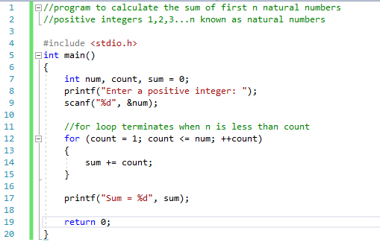
Figure 1 – Program code of for-loop and counting-loop

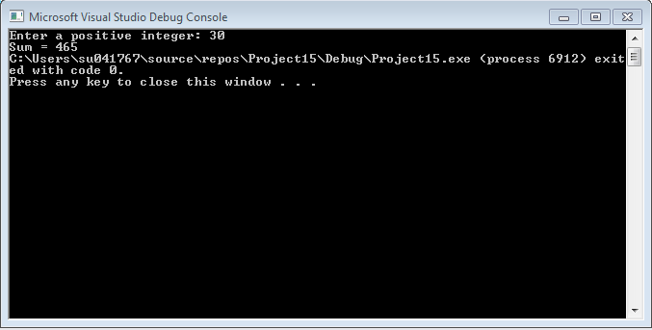
Figure 2 – Output of for-loop and counting-loop

Arrays

5.1 What is an Array?
An array is a type of data structure that has the ability to store specific sized chronological collection of components of a similar type. An array is used within a program to store a group of data and considered as a collection of variables of the same type [11].
The features of an array are:
- The elements contained within an array has an identical data type, however they may have different value types.
- There isn’t any gaps between the elements and therefore the array is stored in its entirety within the memory.
There are two types of arrays – a one dimensional array known as vector and a two dimensional array called the matrix [12].
An example of when an array is used is shown in figure 3, by trying to determine the average of four integers [13].

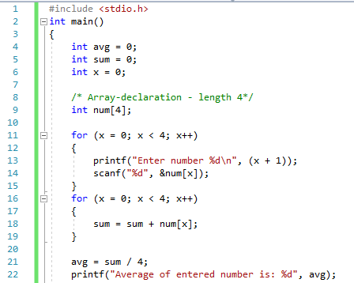
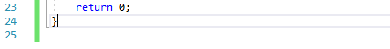
Figure 3 – Program code of arrays
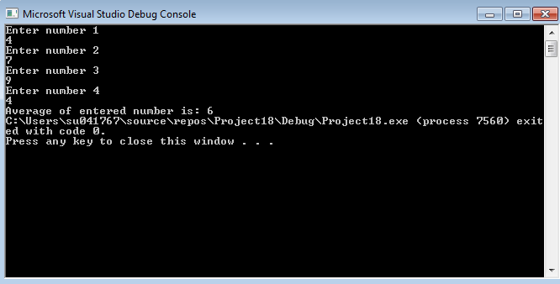
Figure 4 – Output of program demonstrating arrays

Another example of an array is shown in figure 5, which demonstrates an array of 8 elements, counting up from 1.

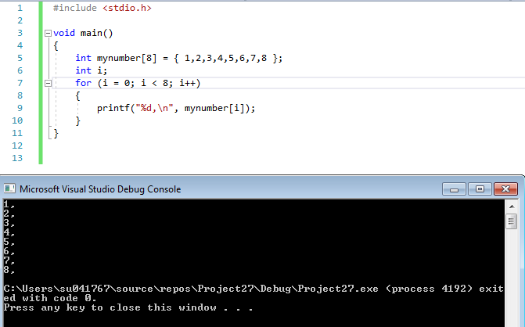
Figure 5

Exercises

6.1 Exercise 1
The following screenshots demonstrates a program that contains different types of variables. In this scenario three variables have been declared in the form of:
- Age
- Height
- Initial
The variables have been declared to incorporate the values of which have been stored to provide assurance that the results will pull through without the user requiring to input any data.

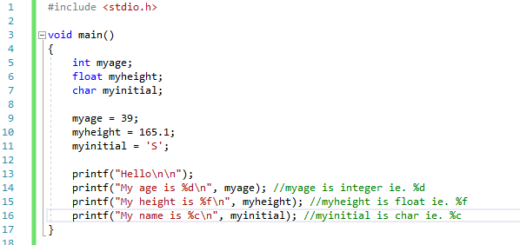
Figure 6

At the point of execution, the program displays that the value of the age is 39, the height is 165.1000006 and the initial is S.

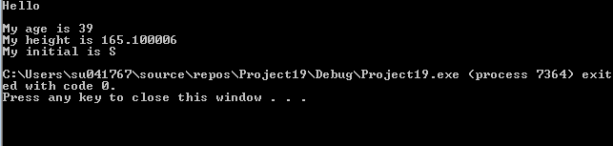
Figure 7
It’s evident that there’s an error within the code as it’s pulled through an incorrect value for the height. This has been rectified by adding “%.2f “ within myheight printf to display the value to 2 decimal places.

There’s also an error with the following command as it says “My name is…” instead of “My initial is…”

This has been rectified within the command and is demonstrated in the following diagram.

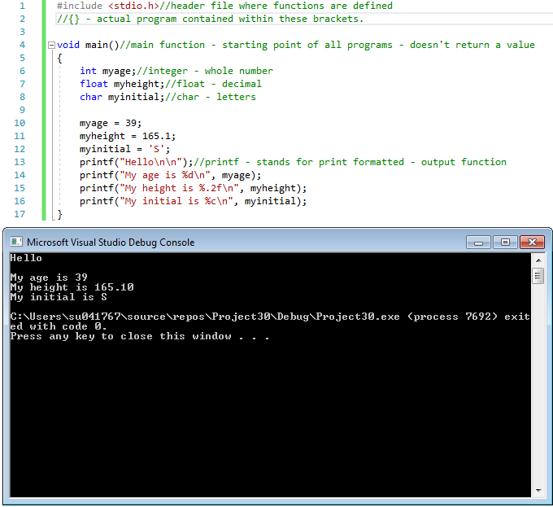
Figure 8

6.2 Exercise 2
The following program has been written to calculate the area of a triangle as well as the radius of the circle around it and allows the user to input the shapes dimensions.
It has been written logically with each stage of the process described in a data-flow diagram.

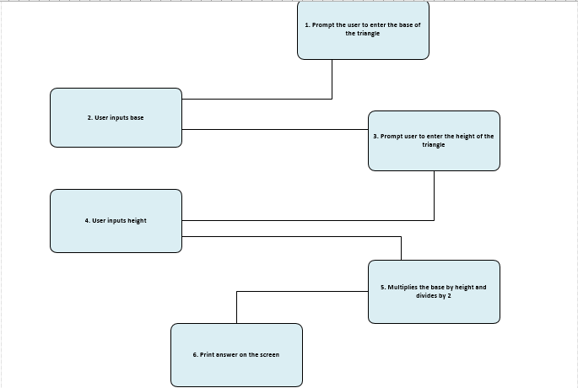

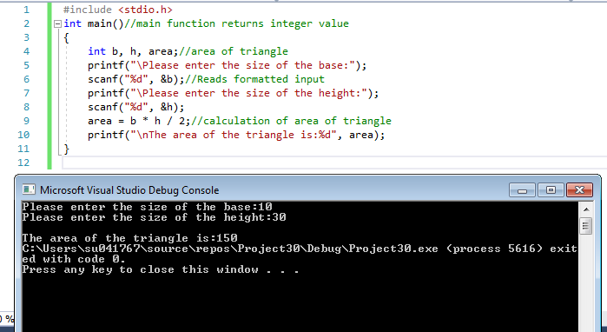
Figure 9 – Area of triangle

The exact same process has been followed to calculate the area of the circle, by following each step of the data flow.

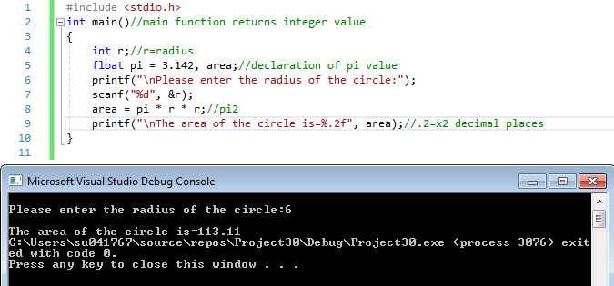
Figure 10 – Area of circle

Whilst the correct calculations have pulled through for each shape, this isn’t a combined program that formulates the measurements as a whole.

In order to have one programme that calculates all measurements, the processes identified in the following data-flow has been followed.

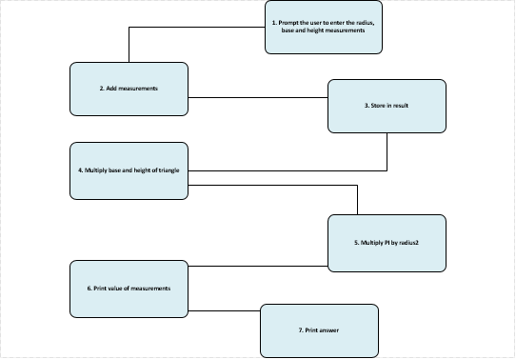

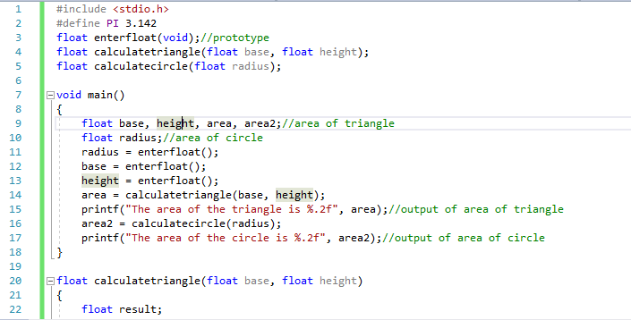
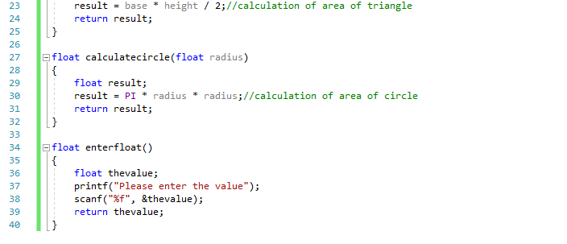
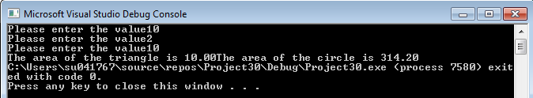
Figure 11
This program ran as expected and calculated the values correctly and generated the correct answer.

6.3 Exercise 3
The following program has been written to enable the user to enter the price of 5 different products as an array and then calculating the total price including 20% VAT.

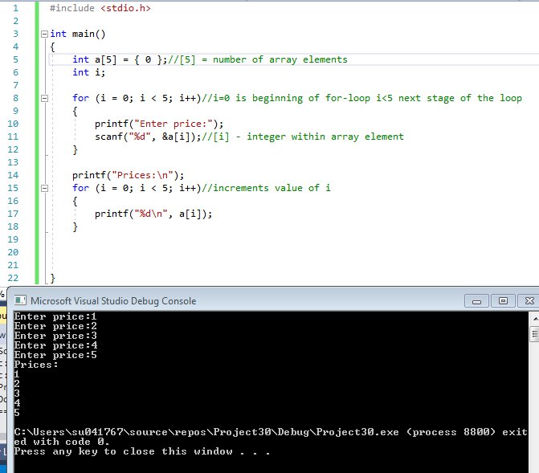
Figure 12

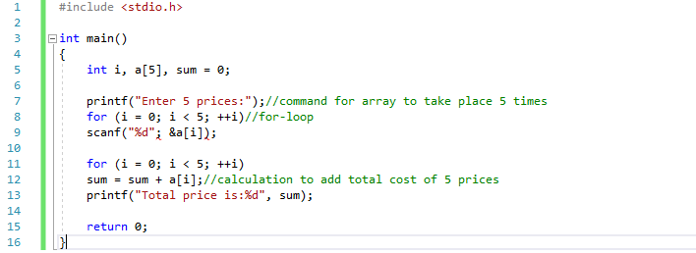
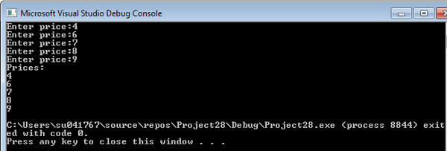
Figure 13
Both of the above programmes has worked as initially hoped, as although a command has been included to calculate the sum of the total process entered, only the array has worked to allow the user to enter 5 different prices.

To correct this method, logical steps have been taken which are demonstrated in a data-flow diagram.

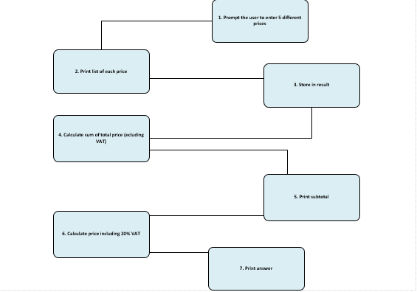

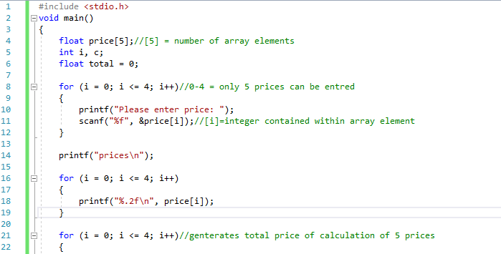

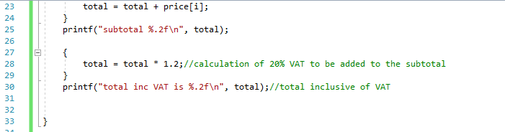
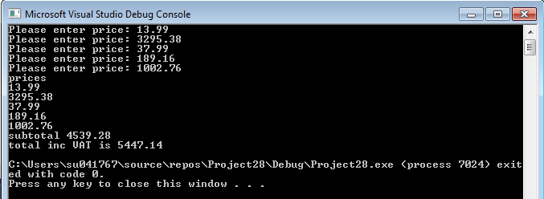
Figure 14

Following the logical steps contained within the data-flow diagram, the program has been updated to include the method to calculate the total price including VAT and has generated the correct answer from the prices entered.

6.4 Exercise 4
The random number method has been used in this exercise to create a program for a fruit machine game. It asks the user if they would like a spin of the wheel. If the answer is yes, it prints the answer and asks the user to press go.
The value of each wheel and point system associated with each is highlighted to the user as:
- If the value of 5 is presented on each of the 3 wheels, the program notifies the user that they’re won the jackpot prize of 2000 points.
- If 3 of the same values are generated (excluding 5) they will win 20 points.
- In the event of any combination of two 5’s being selected, they will win 100 points.

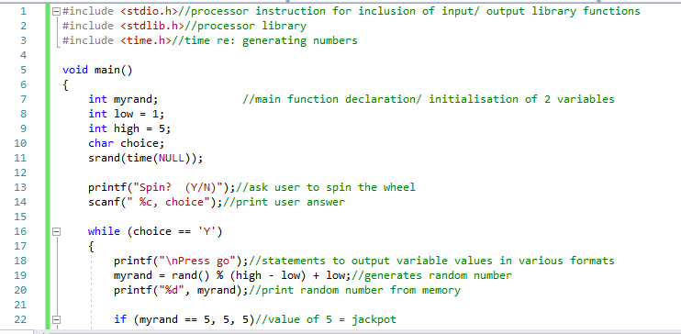
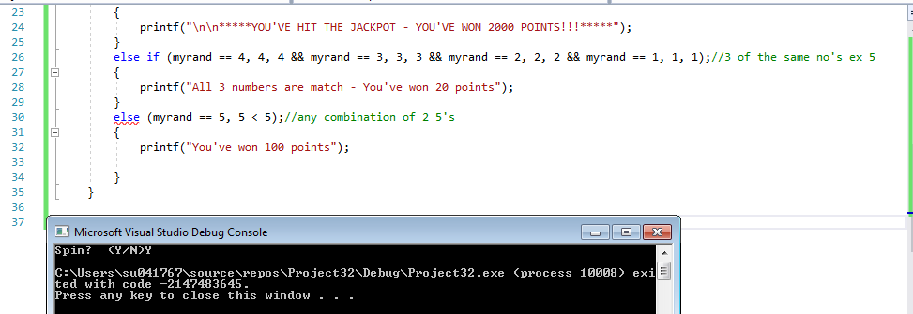
Figure 15
Unfortunately, upon execution of this program it doesn’t go beyond the first stage of the process where it asks the user if they would like to spin.
There’s also an error on the else command as a statement is expected.

Conclusion
C programming is very sophisticated and has the ability to compile a range of programs as long as the correct commands have been used and done so in a logical way.
Software Developers don’t need to over complicate a program and as long as they’ve follow the required standards, then it can be created with simplicity providing ease to the end user.

Bibliography

[1] | M. McGrath, "Introducing the C language," in C Programming In Easy Steps, 4th ed., Warwickshire, 2014, p. 8.
[2] | M. Brain, "The Basics of C Programming," [Online]. Available: https://computer.howstuffworks.com/c1.htm. [Accessed 23 January 2019].
[3] | D. Chisnall, "C is not a low-level language," vol. 61, no. 7, pp. 44-48, July 2018.
[4] | R. C. Seacord, "Unitialised Reads," vol. 60, no. 4, pp. 40-45, April 2017.
[5] | V. Beal, "Webopedia," [Online]. Available: https://www.webopedia.com/TERM/V/variable.html. [Accessed 18 December 2018].
[6] | "Tutorial point simply learning," [Online]. Available: https://www.tutorialspoint.com/cprogramming/c_for_loop.htm. [Accessed 18 December 2018].
[7] | "Learn-C," [Online]. Available: https://www.learn-c.org/en/While_loops. [Accessed 18 December 2018].
[8] | "Beginners Book," 2014. [Online]. Available: https://beginnersbook.com/2014/01/c-for-loop/. [Accessed 17 February 2019].
[9] | I. Barnard, "Quora," 14 November 2016. [Online]. Available: https://beginnersbook.com/2014/01/c-for-loop/. [Accessed 17 February 2019].
[10] | "C programming for loop," [Online]. Available: https://www.programiz.com/c-programming/c-for-loop. [Accessed 17 February 2019].
[11] | "Tutorials point simply easy learning," [Online]. Available: https://www.tutorialspoint.com/cprogramming/c_arrays.htm. [Accessed 18 December 2018].
[12] | "Webopedia," [Online]. Available: https://www.webopedia.com/TERM/A/array.html. [Accessed 21 January 2019].
[13] | "Beginners book," [Online]. Available: https://beginnersbook.com/2014/01/c-arrays-example/. [Accessed 21 January 2019].

