Reflection on Academic and Employability Skills

Author: Katie Rees
Student Number: 1903413
Course: BSc Computer Science
Module: Academic & Employability Skills
Date: 25th July 2019
Table of Contents

Title | Page
1.Introduction | 1
2.Powerpoint Presentation | 1
2.1 Essential Skills for a Successful Presentation | 5
2.2 Techniques to Improve Presentation Skills | 5
3. Key Skills | 6
3.1 Successful Learning | 6
3.2 What employers want | 6
3.3 Self Evaluation | 6
3.3.1 Strengths | 7
3.3.2 Weaknesses | 7
3.3.3 Personality Type | 7
3.3.4 Suggested Career Opportunities | 9
3.3.5 Evaluation | 10
4.Action Plans | 10
4.1 Short Term Goals | 10
4.2 Long Term Goals | 11
4.3 S.M.A.R.T Action Plan | 11
5.Application | 12
5.1 Back Up Strategy | 12
5.2 Disaster Scenarios | 12
5.3 Time Management & Self Organisation | 13
5.3.1 Productivity & Organisation | 13
5.3.2 Stress-levels | 13
5.4 PDP | 13
6. Conclusion | 15
7. References | 15
7.Appendecies | 17

- Introduction
The following report will discuss the attributes and personality traits of the author. It will investigate the essential skills needed to become the most successful version of yourself and weigh up the benefits of implementing these into day-to-day life.

- Power Point Presentation
Katie Rees was born in a small town outside of Cardiff - Bridgend. She currently lives in what used to be a small village, Coity, within Bridgend, with her boyfriend Josh and their Italian Greyhound, Arthur. She works for NWIS, the NHS Wales Informatics Service, helping develop and support the new CYPrIS system, which fundamentally manages child immunisations and monitors child development. In her spare time, she enjoys keeping fit through running and has recently starting her journey with swimming and has a goal of competing in a triathlon by 2020. Katie also spends her free time with her two nieces, Ellie and Emilia, and spent a large amount of 2014 fundraising for Ellie to go to America for life changing SDR surgery. When possible, Katie enjoys travelling with several holidays in the last few years to Budapest, Las Vegas, and Reykjavik and is travelling to Dubrovnik, Croatia in August 2019. Her goals for the next years are to graduate from University of Wales Trinity St David with a degree in Computer Science, all whilst keeping up a healthy and active lifestyle. Figure 1 through to Figure 4 below show several screenshots from a Power Point presentation demonstrating a brief introduction to into the author’s hobbies, strengths and weaknesses, personality traits and goals.

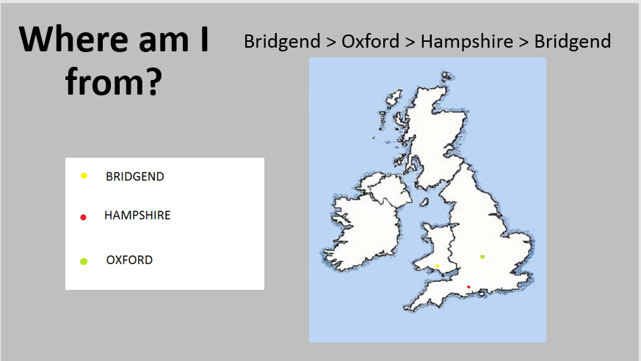
Fig. 1

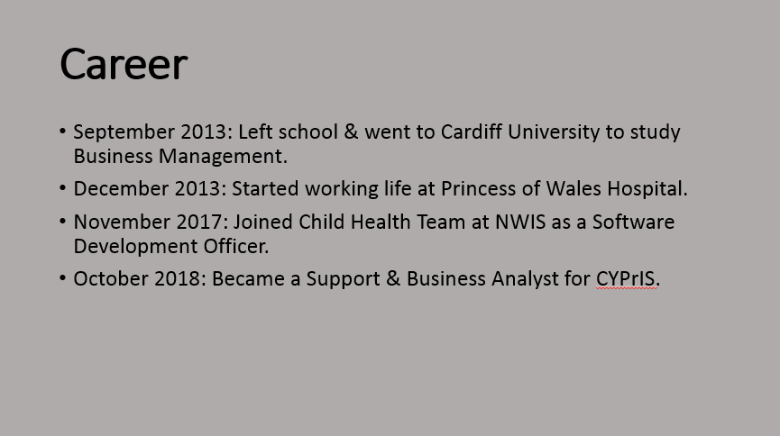
Fig 2.

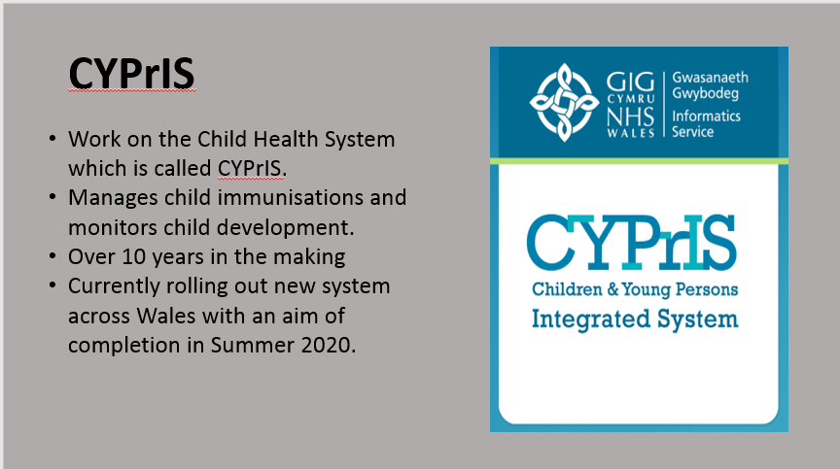
Fig 3.

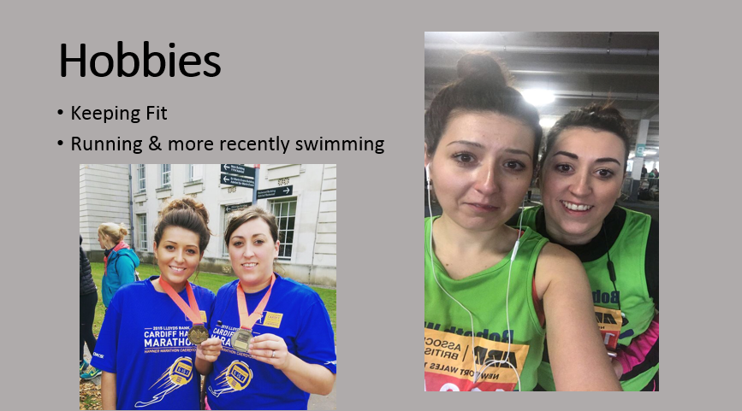
Fig 4.

  - Essential Skills for a Successful Presentation
A presentation which keeps an audience engaged from start to finish, and gives the audience insightful information which can be taken away, can be considered a success. There are many techniques that can be used to make a presentation successful and arguably, one of the most important is preparation. Byström and Schulz [1] discovered this after setting up their own workshop regarding both the oral and written part of the presentation. Participants watched a presentation and then summed up what they thought made a presentation successful or not. These participants went on to note that one of the most important factors that led to a successful presentation is in fact preparation. Preparation can reduce the chance of technology failure, which can be a fundamental contribution to a negative presentation. Another very important element that was brought up in their workshop is to “know your audience”. If your audience has no background knowledge in the topic that you are discussing, then the presenter has to factor this in when constructing the presentation to ensure that the audience can follow the presentation from start to finish.
Whilst conveying a presentation discussing their own attributes and personality traits, the author discovered the following skills to be key in a successful presentation:
- Preparation
- Clear delivery
- Consider the audience
- Time management

  - Techniques to Improve Presentation Skills
Nancy Duarte [2] in her TEDx talk, further backs the statement that the audience is vital in a successful presentation and refers to the audience as the ‘hero’ of the talk. She also mentions that every good presentation has structure. A good technique to improve your presentation skills would be to ensure your power point follows a structure. The author should be including a ‘beginning’, ‘middle’ and ‘end’. To improve in future presentations, a key tip for success is to avoid a large amount of slides. The written presentation should be kept simple and should be expanded on through the oral presentation. Another technique to improve a presentation would be to slow down the delivery. It is very easy to race though a presentation, especially when presenting under a time constraint, and this filters back to the importance of preparation. By ensuring you have set aside enough preparation time ahead of your presentation, you allow yourself time to practice and ensure you can clearly and effectively deliver your presentation within the time constraint. Benjamin Franklin once quoted “by failing to prepare, you are preparing to fail.”

3. Key Skills

3.1 Successful Learning
There are numerous skills that equate to becoming a successful learner. One of the most critical a student should work on is organisation. Once organised, a student will be in control of their time and studies. Milovanova et al. [3] back this up with their research and believe organisation along with communication skills are crucial for first-year students. Their research showed a direct correlation between academic success and being able to learn independently. There are multiple techniques a student can use to become organised. Mirza [4] studied in Germany, and soon realised German students were immense at self-organisation. They were punctual in all aspects of life, both work and personal, and would never leave the house without a pocket planner. They work towards one realistic goal, and work on avoiding distractions. Another fundamental skill mentioned is communication skills. Communicating with not only your fellow peers but being in frequent contact with your teachers can maximise your learning. These skills are not only vital in higher education, but can also be taken in to later life once you start working.

3.2 What Employers Want
Employers will be looking for a multitude of key skills when recruiting, some more desirable than others, depending what job may be in question. However one skill that will always triumph is good communication. Exeter University [5] encourage that communication skills fall within one of the top 10 skills that employers look for. Those who are able to not only converse with others, but to also listen and follow instruction, are desirable. According to Copeland [6], another sought after attribute is professionalism. This is where an individual is able to act in a mature and respectable way in both the work place and their personal life. They also suggest that team work is a popular trait as so many jobs involve some sort of group work. Being able to work well as a team also shows good communication skills, and suggests the individual is reliable and dependable, and can also portray the abilities to delegate and lead. Target Jobs [7] imply that commercial awareness is a desirable characteristic for a potential employee. This shows that an individual has taken time to research what service or product the company offers and what is expected of them to help the company succeed. They may even have knowledge on any market competitors and an understanding of economic and political factors that may affect their potential company.

3.3 Self Evaluation
The author conducted several self-evaluation tests to determine their personality traits, strengths and weaknesses, and best-suited career options. Appendix 1 and 2 [8] both show self-assessment evaluations completed by the author to discover their strengths and weaknesses.

3.3.1 Strengths
Evaluating these assessments we can tell that their strengths include communication skills. They often enjoy the company and other and working within a team. The assessments also suggest that they can offer good advice, and enjoy listening to others. They are also optimistic and always look for the positive in every situation. They are determined and once their mind is set on something, they have to complete it to a high standard.

3.3.2 Weaknesses
Although the author may suggest that they are determined, they also feel they can be easily distracted and also forgetful. They are a spontaneous person and prefer to work without a plan and would rather get stuck into a task than have any kind of structure. This suggests that they may be lacking in organisational skills, which they can overcome by dedicating time to creating plans and a structure before starting tasks.

3.3.3 Personality Type
The first personality test conducted was ‘The Big Five’ [9], which suggests that there are five personality traits in academic psychology. The author’s results are demonstrated in Figure 5 below:

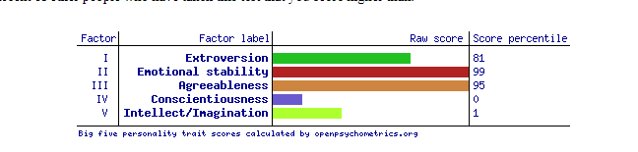
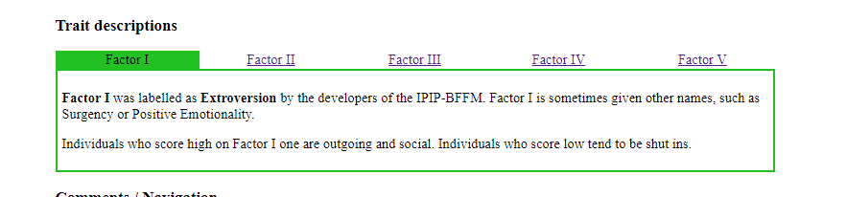
Fig 5.
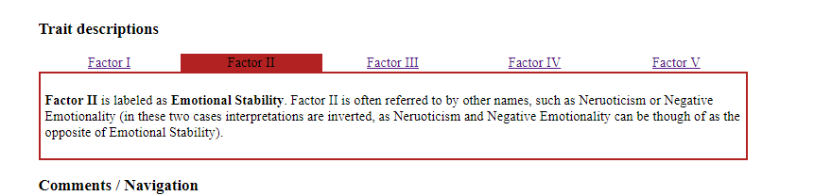

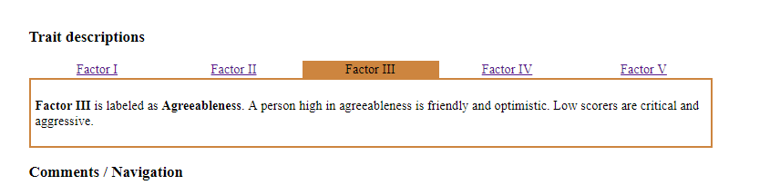

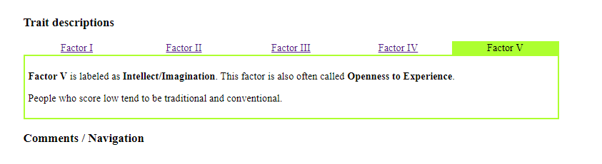
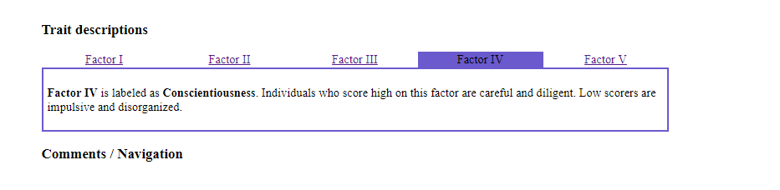

As shown above, these results have scored high in extroversion, which tend to suggest an individual is out-going and craves the company of others. The second trait is emotional stability in which the individual scored incredibly high in. This could consider the individual to deal well under stressful circumstances. The third trait, agreeableness, shows another high score and expresses that the author can get on well with peers and looks at life with optimism. They are friendly and have always worked well in a team environment. The fourth and fifth trait show a much lower score in conscientiousness and intellect/imagination meaning a more disorganised and impulsive personality with a traditional output. The individual agrees through their own self-evaluation that although not a complete extravert, they would prefer to be in the company of other people and are comfortable around those who they have never met before. They agree that they could be considered emotionally stable through the way they have dealt with previous stressful situations in both their work and personal life. However this score could suggest that they are confident in their own abilities and don’t dwell on how they may be interpreted by others, which as discussed previously, is not how the author perceives themselves and they are aware that they may not be as confident as this test suggests. The author also disagrees with the final trait and believes that they are more open to new and exciting ideas. They don’t believe to be conventional however their imagination is not a strong point and is something that can, on times, hold them back.

The second personality test, ‘Open Extended Jungian Type Scales’ [9] is recommended for enjoyment purposes and bases your personality test on four dichotomies. The results from this test are shown in Figure 6 below.

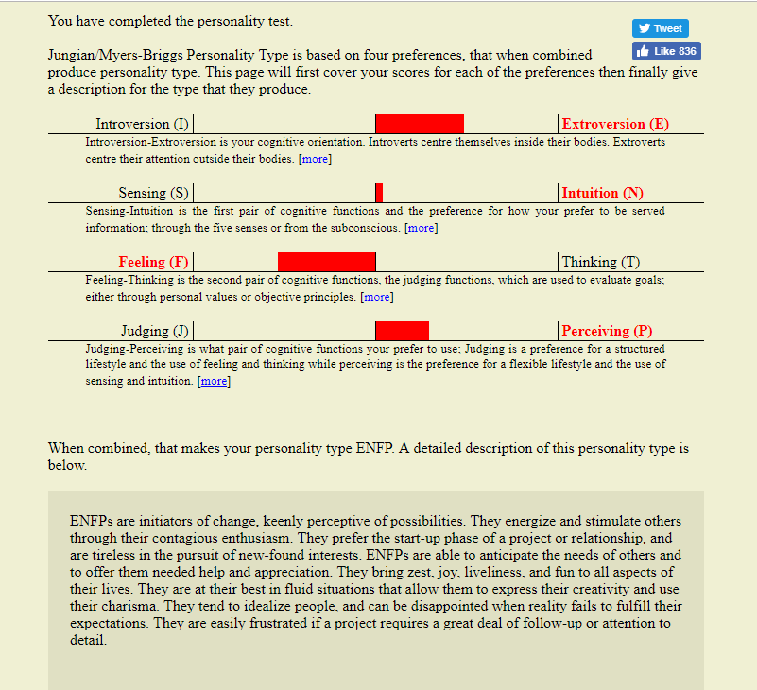
Fig 6.
The second personality test has shown a strong correlation with the first test. Again, it portrays the author as an extravert, which is a true reflection. The author however feels that they should fall in the category of sensing rather than intuition. As we can see in Figure 6 above, the personality test suggests the author is closer to intuition that sensing, but only just. Truthfully, the author believes they are more inclined to live in the present and tend to be more practical and are less imaginative. The personality test perceives someone who is people orientated and is aware of the feelings of others. They can be indirect to avoid upsetting others which the author strongly agrees with. The test also shows a personality trait of spontaneity. It could suggest that they may be disorganised and doesn’t work to a structure, which is a correct representation, according to the author.

3.3.4 Suggested Career Opportunities
Following completing an online career test [10], the career opportunities shown in Figure 7 were suggested.

Figure 7 – Career Opportunities
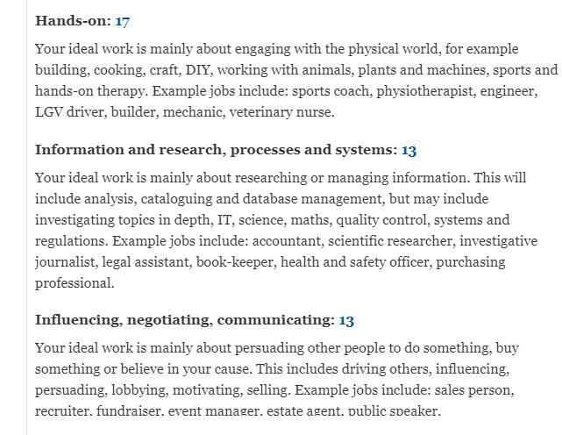

These show that the author would be best suited to a job that is hands-on and potentially working with systems. Doing a computer science degree, this would be a suitable career suggestion and supports the career option that the author is working towards.

3.3.5 Evaluation
Following the personality tests, the author has learnt that they may be more extraverted that originally thought. They suggest that the author could potentially be more imaginative and future thinking.

4. Action Plans
Setting goals can help towards taking control of your own life and help you strive towards success.

4.1 Short Term Goals
The author has several short term goals which they are hoping to complete within the next year. Firstly, they would like to pass their first year of university to progress into second year with a good foundation of knowledge. To do this, they wish to work on their organisation skills and will work on introducing plans and structure into their work. They also wish to compete in a triathlon by 2020 by dedicating more time for exercise.

4.2 Long Term Goals
By 2023, the author is hoping to graduate from University with a respectable grade in BSc Computer Science. They aim to transfer this knowledge into their current role in work, which will hopefully result in career progression. In their own personal life, they wish to keep their healthy work-life balance and to keep up their exercise regime.

4.3 S.M.A.R.T Action Plan
According to ‘Top Achievement’ [11], S.M.A.R.T stands for specific, measurable, attainable, realistic and timely goals. In Figure 8 below you can see the S.M.A.R.T action plan for short term goals and Figure 9 shows long term goals.

Figure 8 – Short Term Goal Action Plan
Specific Goal | How will it be Measurable? | How will it be Attained? | Is it Realistic? | When will you do it? Timely
1. To become more organised | Monitor if assignments are completed in a timely manner | By planning university assignments before starting them | Yes | Beginning of University Term
2. Pass first year of University | Analyse final grades | By working on time management skills and working on saying ‘no’ more often. | This goal is realistic if organisation is attained | By Summer 2020
3. Compete in a Triathlon | Monitor development in three different sports | By allocating a daily time slot to exercise | Yes | By Summer 2020

Figure 9 – Long Term Goals Action Plan
Specific Goal | How will it be Measurable? | How will it be Attained? | Is it Realistic? | When will you do it? Timely
1. Graduate University | Analyse end of year grades for the next four years | By becoming more organised and working to the best of my abilities over the next four years | Yes | Summer 2023
2. Progress in Career | Annual PDR’s | Becoming more confident in my own abilities and transferring knowledge learnt in university into the current role | Yes – especially if long term goal 1 is met | 2023 - 2024
3. Maintain healthy lifestyle | Monitor work-life balance, mental health | Dedicating time several times a week to exercise. | Yes | Constant

5. Application

5.1 Back-Up Strategy
Original data should always be backed-up to ensure nothing is lost in an event of a failure or a cyber-attack, for example. A back-up plan should consider a multitude of factors including cost, reliability and recovery time objective. The author has concluded that the following back-up plan is best suited to their work. All data will be held on their local drive and also on a USB stick. This USB stick will be kept on their car keys which will be on them at all times. They will then have a third copy on Dropbox. As this back-up strategy is predominantly for university work only, the budget is kept to a minimum as a small number of files will be stored at any one time. This back-up strategy conforms to the “3 different places” rule and both back-ups are separate to where the original data is stored, which should avoid any disaster scenarios that can result in an outage.

5.2 Disaster Scenarios
There are several scenarios that result in data loss and if data is not backed-up probably, it can cause a disaster. The following lists examples of potential disaster scenarios:
- Fire
A fire can be detrimental to a hard drive and in extreme circumstances the damage can be too severe to restore the data. According to the data recovery website [12] although fire damage is difficult to recover, it is not impossible. If the USB is in the same area as the hard drive then this could also be destroyed beyond repair. Anything stored on Dropbox however, would not be affected and all data can be restored from here.
- Storm
A thunder storm can result in data loss if the hard drive is plugged into the electrics. Organic Microchip [13] suggests that during a thunderstorm, all electronics should be unplugged as high voltages can get into the computer this way. However both a USB and Dropbox would survive a thunder storm and data would be recoverable here.
- Burglary
A hard drive or USB can be stolen, however unless they are kept in the same place, they are unlikely to get stolen together. If this was to happen though, the data could still be restored from Dropbox.
- Viruses/Malware
Malware is rife within today’s environment, and malware such as ransomware can infect your files. Hard drives, USB sticks and cloud storage such as Dropbox are all vulnerable to malware as shown in Appendix 4. Up-to-date software and antivirus will help avoid this along with education around the latest malware trends. Ensuring you always back-up your files will mean that if files get infected on the hard drive for example, you can still retrieve essential data.
- Application Error
Although Dropbox could be considered as a reliable data back-up source, there have been instances in the past where this may not be the case, and the application has incurred an error. As explained by Bott [14], in 2014 Dropbox experienced a technical glitch with some of their users where there files were accidently removed due to their ‘Selective Sync’ application. In this instance however, as long as the original copy has not been locally removed, then the data could be recovered here. The USB would also be unaffected.
- Human Error
Very often accidents occur and we may delete our own important files. If this does happen, as long as files have been backed-up to a USB stick or Dropbox, files can be retrieved.

Although the back-up strategy above shows a reliable back-up plan during the disaster scenarios, it does highlight a concern if the USB Stick was kept close to the hard drive. It would mean that in the event of several of the above disaster scenarios the only option we would have would be to restore through Dropbox. It may be worth the author considering implementing a NAS system, if the cost was suitable. The NAS system could be kept at a different location to the hard drive which would avoid the above scenarios.

5.3 Time Management & Self Organisation

5.3.1 Productivity & Organisation
There are several factors that can influence productivity. A common theme to increasing productivity is planning. According to Phillips [15] to have a plan is a fundamental factor towards improving your productivity as this allows you to acknowledge how much time you have to complete a task in work, for example. Phillips also suggests that making lists help you focus on completing your task. It creates a sense of achievement once completed which can in turn increase motivation and reduce stress levels. The author believes that by creating lists it will also improve their organisation, as the list will remind them of the tasks ahead which will help towards achieving their short term goal of passing their first year of university. A major distraction of the authors is their mobile phone. If a mobile phone is switched on silent and out of arms reach, this will avoid temptation to mindlessly scroll, which wastes valuable time. Spilker [16] states that finding your peak working hours is invaluable when trying to increase productivity. By determining when you are at your most efficient, allows you to plan when to dedicate time to the most crucial work.

5.3.2 Stress Levels
A reduction in stress-levels is a by-product of increasing both productivity and organisation. When at your most efficient, you are able to improve on your work-life balance. Exercise is an effective tool for managing stress-levels and one that the author believes is critical in keeping a healthy mind. Another aspect towards managing stress-levels is to improve nutrition and according to ‘Mind’ [17] evidence suggests that not only does food impact on your physical health but it can affect your mental health also by increasing energy levels and improving your mood.

5.4 PDP (Personal Development Plan)
The Open University [18] interpret a PDP as a structured plan which can distinguish a person’s qualities and identify any areas that may need improving. It can allow a person to discover what they may want to achieve over a period of time and is a hub for academic and professional information, for example, a CV. Figure 10 shows screen shots of the authors own PDP.

Figure 10
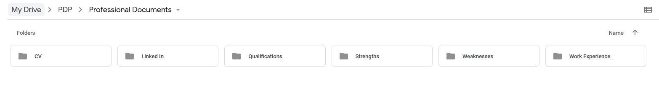
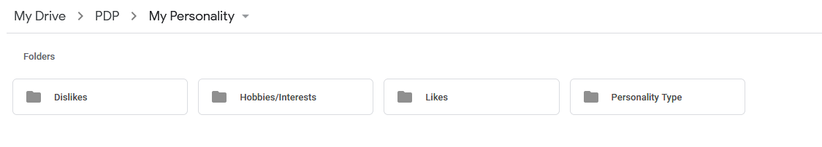
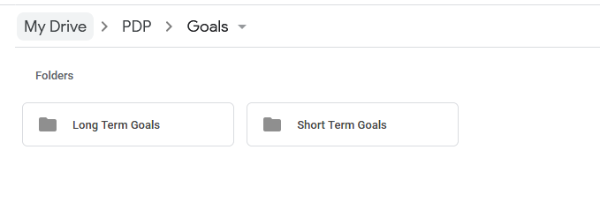
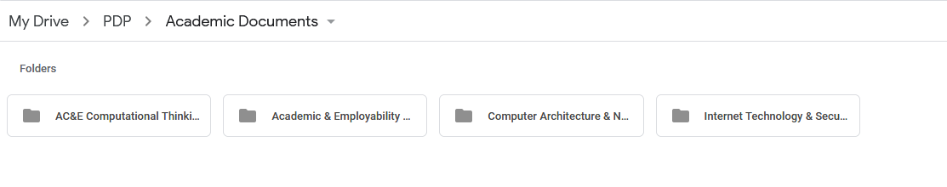
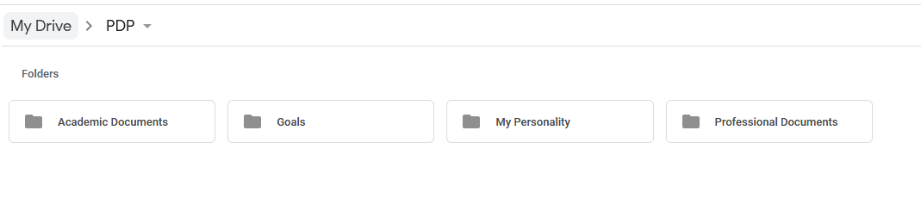

This PDP has been created in Google Drive [19] and includes academic documents, goals, personality traits and professional documents. Academic documents include sub-folders of all the different modules that the author is currently studying and inside these sub-folders are any files relating to that module, for example, assignments. The goals folder contains two sub-folders for both long-term goals (five years plus) and short term goals (0-5 years). The personality type folder contains sub-folders for the author’s likes and dislikes, hobbies and interests, and their personality type. The final folder, Professional Documents, contains sub-folders for the authors CV, Linked In profile, their qualifications and their strengths and weaknesses. It also contains a folder for any work experience that the author has.

6. Conclusion
To conclude, after discussing the key skills which are required for successful learning and a prosperous career, the author has a greater understanding of the qualities that they are able to offer. Not only are they aware of their qualities but they are also aware of the areas that they need to improve and the steps that need to be taken to achieve that. They are aware of the risks that occur when no back-up plan is in place, and understand what it takes to produce a successful back-up strategy. The link between nutrition and stress-levels has highlighted a personal area of interest and further reading would be advantageous.

References

[1] | S. M. Byström K, "Great presentations: improving conference presentation skills," Journal of the European Association for Health Information and Libraries, vol. 9, no. 3, pp. 21-23, 2013.
[2] | N. Duarte, The Secret Structure to Great Talks.
[3] | K. I. F. S. D. A. Milovanova G, "ASSESSING SELF-STUDY WORK’S SIGNIFICANT SKILLS FOR SUCCESSFUL LEARNING IN THE HIGHER SCHOOL," Integraciâ Obrazovaniâ, vol. 21, no. 2, pp. 218-229, 2017.
[4] | M. A, "Self-Organization Lessons You Can Learn from German Students," People, 23 November 2017. [Online]. Available: https://www.hongkiat.com/blog/self-organization-lessons-from-students/.
[5] | "Top 10 Employability Skills," [Online]. Available: http://www.exeter.ac.uk/ambassadors/HESTEM/resources/General/STEMNET%20Employability%20skills%20guide.pdf.
[6] | C. A, "Personal Skills vs. Professional Skills: What’s the Difference?," [Online]. Available: https://www.livecareer.com/resources/resumes/basics/job-skills-values.
[7] | T. Jobs, "What are the top 10 skills that'll get you a job when you graduate?," [Online]. Available: https://targetjobs.co.uk/careers-advice/career-planning/273051-the-top-10-skills-thatll-get-you-a-job-when-you-graduate.
[8] | "Self-Assessment/Strengths - Weaknesses," [Online]. Available: https://salpro.salpaus.fi/tes/CD-rom/pdf/BilSEself-assessment_en.pdf.
[9] | " Open-Source Psychometrics Project," [Online]. Available: https://openpsychometrics.org/.
[10] | "Personality test: what job would make you happiest?," [Online]. Available: https://www.theguardian.com/lifeandstyle/2014/nov/11/-sp-questionnaire-what-job-would-make-you-happiest.
[11] | "Creating S.M.A.R.T. Goals," [Online]. Available: http://topachievement.com/smart.html.
[12] | "What Does a Fire Damaged Hard Drive Look Like?," 6 July 2015. [Online]. Available: https://datarecovery.com/2015/07/what-does-a-fire-damaged-hard-drive-look-like/.
[13] | O. Microchip, "Avoid Data Loss During Thunderstorms and Blackouts," 24 July 2019. [Online]. Available: https://organicmicrochip.com/avoid-data-loss-during-thunderstorms-and-blackouts/.
[14] | E. Bott, "Dropbox sync glitch results in lost data for some subscribers," 13 October 2014. [Online]. Available: https://www.zdnet.com/article/dropbox-sync-glitch-results-in-lost-data-for-some-subscribers/.
[15] | K. Phillips, "How To Become More Productive," 5 July 2016. [Online]. Available: https://www.theodysseyonline.com/become-more-productive.
[16] | J. Spilker, "How To Be More Productive: 18 Top Tips To Help You (Don’t Miss The Last One!)," 8 March 2019. [Online]. Available: https://www.workzone.com/blog/how-to-be-more-productive/.
[17] | Mind, "Food and mood," [Online]. Available: https://www.mind.org.uk/information-support/tips-for-everyday-living/food-and-mood/#.XTiJftJ8CUk.
[18] | T. O. University, "Develop your career: Personal Development Plan (PDP)," 29 March 2018. [Online]. Available: https://help.open.ac.uk/pdp.
[19] | Google, "Google Drive," [Online]. Available: https://www.google.com/drive/.
[20] | A. Donovan, "Always Be Prepared: 5 Annoying Scenarios of Data Loss and How to Recover Your Data," 22 May 2019. [Online]. Available: https://interestingengineering.com/always-be-prepared-5-annoying-scenarios-of-data-loss-and-how-to-recover-your-data.

Appendix 1 - Self Evaluation of Academic Skills

Thinking about yourself, read and mark each statement out of 5, with 5 being 'Totally Agree' and 1 being 'Totally Disagree'. If a statement doesn’t apply to you, leave it blank

Skill
 | 5 | 4 | 3 | 2 | 1
I have the confidence to try new things and express my ideas |  | 4
I am self-motivated and will persevere with difficult tasks |  |  |  |  | 1
I am organised and can meet set deadlines |  |  | 3
I am able to find information from different resources easily |  | 4
I can read complicated texts and understand the general meaning |  | 4
I am able to select what is relevant and what is irrelevant in text |  | 4
I can compare different opinions and decide what are the best grounds for deciding who is right |  | 4
I can write things in my own words | 5
I am able to reflect and evaluate my own work |  | 4
I have good strategies for starting a new task/assignment |  |  | 3
I have good time management skills and can organise my workload effectively |  | 4
I am able to make, store and find my notes |  |  |  | 2
I am able to manage a range of writing skills appropriately |  | 4
I am able to think critically and analytically, and evaluate arguments |  | 4
I have good memory strategies |  |  |  | 2
I know how to use IT to help academic study | 5
I am confident at preparing and delivering oral presentations | 5

Appendix 2 – Self Assessment Test

characteristic | domina  nt | average | weak
characteristic | ++ | + | 
Aggressive |  |  | x
Active | x
Analytical intellectual power |  | x
Adaptable | x
Open minded | x
Balanced | x
Authoritarian |  | x
Enthusiastic | x
Able to work under pressure | x
Dynamic | x
Ambitious | x
Spontaneous | x
Sensitive |  | x
Ready for action | x
Emotional |  | x
Resolute | x
Success oriented |  | x
Able to coordinate | x
Able to motivate others | x
Able to motivate oneself |  | X
Able to organise |  |  | x
Able to structure |  |  | x
Able to influence others | x
Flexible | x
Friendly | x
Happy | x
Patient |  | x
Egotistic |  |  | x
Direct |  |  | x
Special skills interacting with people | x
Able to communicate on the phone | x
Helpful | x
Good sense of humour | x
Impulsive | x
Innovative acting |  | x
Young | x
Competent | x
Ready to make compromises | x
Sociable | x
Concentrated | x
Cooperative | x
Creative |  |  | X
characteristic | domina  nt | average | weak
characteristic | ++ | + | 
Critical |  |  | x
Able to accept criticism | x
Willing to learn | x
Mathematically skilled |  | x
Mobile | x
To have nerve | x
To act naturally | x
Curious |  | x
Optimistic | x
Dutiful | x
Visionary |  | x
To keep calm | x
To be matter-of fact | x
To work very quickly |  |  | x
Self-possessed |  |  | x
Self-confident |  | x
Sensible | x
Confident appearance |  | x
Confident |  |  | x
Social competence | x
Sportive | x
Linguistically skilled |  | x
Likeable | x
Systematic working | x
Team player | x
Technically skilled |  |  | X
Full of spirit | x
Tolerant | x
Entrepreneurial thinking |  | x
Responsible | x
Negotiating skills |  | x
All-round |  | X
Warmhearted | x
Eloquent | x
Goal-oriented | x
Determined | x
Reliable | x

Appendix 3 – Ransomware

Ransomware

Author: Katie Rees
Course: BSc Computer Science
Table of Contents

Title | Page Number
- Introduction | 27
- Ransomware – How it attacks | 27
2.1 Prevention Techniques | 27
- Crypto Wall | 27
3.1 Payments | 28
- Other Types of Ransomware | 28
- Conclusion | 28
- References | 29

1. Introduction
Ransomware is defined by Winder [1] as a form of malware, which is commonly spread by email attachments. Once this email attachment is opened, it will encrypt your files and request your ransom. Any business is at risk of varying forms of ransomware, no matter how large or small. Ransomware can be disastrous to an ill-informed company and Matti Kon [2] states a shocking fact that “more than 70 percent of companies hit by ransomware attacks find themselves out of business within six months”. However, a business who is educated in the prevention of ransomware, and therefore taken the steps required for prevention of a ransomware attack, will make it almost impossible for attack to happen.

2. Ransomware - How it Attacks
Ransomware is detrimental to a company and is on the rise across the globe. It is described by Kujwa [3] as being “Game Over” malware. This form of malware is considered more detrimental due to its ability to actually encrypt all files, ensuring data is lost forever (or at least lead you to believe so). Ransomware does not always inform you as soon as it starts scanning your computer; it can in fact wait weeks to ensure that all files are fully encrypted before it makes itself known to a user. Ransomware has grown in popularity due to the cheap and easy nature of demanding and receiving money, and it has been estimated that it has generated hundreds of millions of pounds for criminals, by Winder [1].

2.1 Prevention Techniques
A business may take several steps once ransomware attacks. However the most effective and therefore recommended is, of course, prevention. Kon [2] suggests two vital steps in the prevention of ransomware, starting with ensuring all systems are up-to-date. Up-to-date systems are assumed to have the most effective anti-virus software installed. Arguably more important than this though, is education. As ransomware most commonly attacks through phishing emails, knowledgeable staff will be cautious of any potential phishing attacks. Staff, who are ill informed however, are innocently one click away from potentially originating business destruction. Ransomware can present itself in various forms, one of the most vicious being ‘Crypto Wall’.

3. Crypto Wall
According to Peters [4], Crypto Wall will not only infect your files and request ransom; it will also infect any back-up files you may have, making it almost impossible to restore any data that has been lost. It can rename your files, making identification of important data files unobtainable. It was released in 2014 and can attack all versions of Windows. It is noted on ‘Bleeping Computer’ [5] that when first infected, Crypto Wall scans your computer to locate any files and encrypt them, ensuring the user is no longer able to access the files. It will then request to pay ransom, usually in bitcoin, for users to gain access back. The cost of ransom will gradually increase until received.

3.1 Payments
A fundamental question when attacked by CryptoWall is ‘Should we pay the ransom?’ Although the initial ransom is not usually a ‘break the bank’ amount of money, often around $1000 dollars of bitcoin, there is no guarantee that the criminal will decrypt your files, leaving you out of pocket, and in no better position. According to Peters [4], 19% of all users who have been attacked by Crypto Wall and pay the ransom, will gain access to their files again.
Instead of making a payment to the criminals, as long as you have taken previous preventable techniques i.e. back-up files, then you are able to decrypt your files. According to Bleeping Computer [5] there are different potential methods to take when attacked by CryptoWall to restore your data. Back-ups is the first and foremost method to restore your data files, thus suggesting that frequent backups of all data files is an excellent prevention method for any potential malware attack. Another suggestion, one that is only valid if you are aware of the attack early on, are file recovery software. Crypto Wall will scan your computer and create copies of all your files; it will then encrypt the copies and delete the originals. This is where a file recovery software, for example ‘R-Studio’ can restore your original copies, as long as Crypto Wall is caught early on.

4. Other Types of Ransomware
Crypto Wall is not the only vicious form of Ransomware that businesses fall foul to. They all have their similarities when it comes to the degree of damage that they can do to a vulnerable business. According to Brunau [6], ‘Bad Rabbit’ is one of the most common and prevails through an ‘Adobe Flash Update’ along with ‘Jigsaw’ who, once infected will continually delete files until ransom is paid. Another form and possibly the most famous following an attack on the English NHS in 2017 is ‘Wanna Cry’. Field [7] conveys that ‘Wanna Cry’ cost the English NHS £92 million, all believed to be due to poor cyber security and using 17-year-old software, making them incredibly vulnerable to an attack.
As discussed previously, good practice within Cyber Security takes form in Education and forever keeping relevant. Up-to-Date systems can avoid ransomware being able to encrypt your files and education for everyone within your work force is vital in the prevention of ransomware. Insists that an effective strategy to compel good practice in cyber security is to implement firewalls at a network level, which will limit and potentially block any data encryption being performed.

5. Conclusion
To conclude, ransomware can be destructive to any business, no matter what size. It is imperative that a business, to protect themselves from all forms of ransomware, conforms a robust procedure in the prevention of ransomware, one in which includes the education of all workforce along with a secure back up system.

References

[1] | D. Winder, "Ransomware," PC Pro, no. 261, p. 107, July 2016.
[2] | M. Kon, "Understanding and Preventing a Ransomware Attack," Response : Multi - Channel Direct Advertising, vol. 26(3), p. 48, December 2017.
[3] | A. Kujwa, "Ransomware doesn’t mean game over," 10 November 2016. [Online]. Available: https://blog.malwarebytes.com/101/2016/11/ransomware-doesnt-mean-game-over/.
[4] | J. Peters, "The State of CryptoWall in 2018," 6 January 2018. [Online]. Available: https://www.varonis.com/blog/cryptowall/.
[5] | "CryptoWall and HELP_DECRYPT Ransomware Information Guide and FAQ," 10 July 2014. [Online]. Available: https://www.bleepingcomputer.com/virus-removal/cryptowall-ransomware-information.
[6] | C. Brunau, "Common Types of Ransom Ware," 24 March 2019. [Online]. Available: https://www.datto.com/blog/common-types-of-ransomware.
[7] | M. Field, "WannaCry cyber attack cost the NHS £92m as 19,000 appointments cancelled," 11 October 2018. [Online]. Available: https://www.telegraph.co.uk/technology/2018/10/11/wannacry-cyber-attack-cost-nhs-92m-19000-appointments-cancelled/.

