NAME: Agna mariya baiju
STUDENT NUMBER: 2130537
MODULE: LCMB7001
LECTURER: Tushara Balendran
COURSE: MBA General management
SUBMISSION DATE:09/09/2022
TITLE: Marketing Assignment 2

TABLE OF CONTENT:
- INTRODUCTION 3
- PESTAL ANALYSIS 3-7
  - POLITICAL
  - ECONOMICAL
  - SOCIAL
  - TECNOLOGICAL
  - ENVIRONMENTAL
  - LEGAL
- PORTAL FIVE FORCES MODEL 7-9
  - THREAT OF SUBSTITUTE PRODUCT
  - THREAT OF NEW ENTRANCE
  - BARGAINING POWER OF BUYERS
  - BARGAINING POWER OF SUPPLIERS
  - COMPETITIVE RIVALRY
- SWOT ANALYSIS 9-10
  - STRENGHS
  - WEAKNESSES
  - OPPORTUNITIES
  - THREATS
- SEGMENTATION, TARGETING AND POSITIONING 10-12
- MARKETING MIX OF ADIDAS 12-14
  - PRODUCT
  - PRICE
  - PLACE
  - PROMOTION
  - CONCLUSION
- RECOMMENTATION 15
- REFERANCE 16

INTRODUCTION
Supply and demand influence the number of things that are really sold and their actual prices. To price products to match demand and make a profit, businesses analyse the demand for their products. The demand curve shows that when a product's price decreases, more people will purchase it. Adidas was established in July 1924 and is a publicly traded German company with its headquarters in Herzogenaurach, Bavaria. The majority of output is in the form of footwear, clothing, and accessories.

Adidas made different collaboration with well-known organisation include Alexander Wang, Jeremy Scott, Pharrell Williams and so on. Adidas ranks second in the globe and is one of the leading manufacturers in Europe the stock price of the company is 144.50 pounds and the revenue is around 21.92 billion EUR. In this report shows the detail analysis of adidas. It includes PESTAL and SWOT analysis of adidas. How Porters 5 forces related with the organisation and test how this force affected the company and targeting, marketing and position of the organisation and future scope of the adidas with recommendations.
- PESTAL ANALYSIS
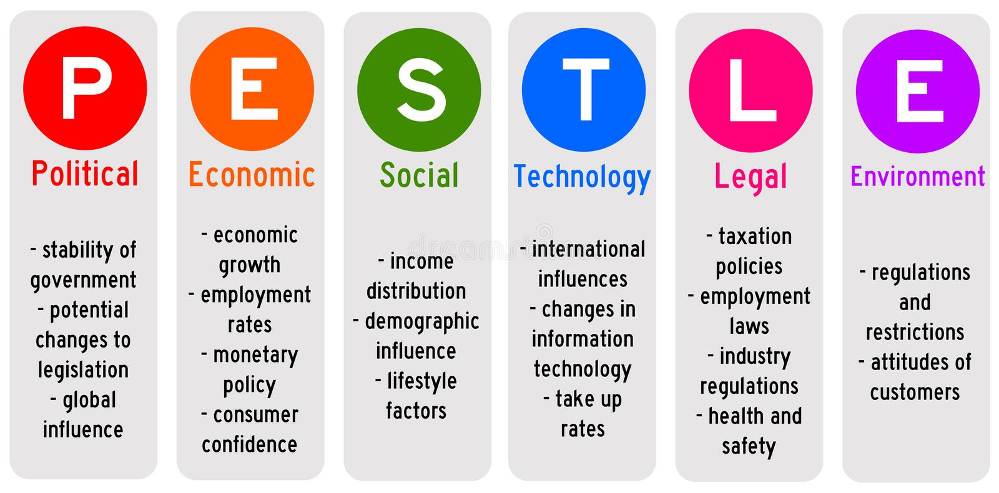
The study of external elements (Political, Economic, Sociological, Technological, Legal, and Environmental) that have an impact on an organisation is known as PESTAL analysis. It helps the business comprehend the value and demand of the current product and, if necessary, develop new business strategies. Here is Adidas's PESTAL analysis.
Adidas operates in an environment where it is influenced by social trends, consumer purchasing patterns, consumer environmental advocacy, technological considerations, and governmental regulations and the legal system.
2.1 POLITICAL FACTORS AFFECT ADIDAS: Political factors frequently have an impact on the type and extent of local and federal government action in the business and economic environment. (Acasestudent.com 2021)
- Taxation: Over the last 20 years, Adidas has benefited from decreasing taxes. It helps the business to grow and prosper by increasing its investment in research and development. Additionally, the carbon footprint of the consumer cyclical sector is taken into account in the local taxation policy for footwear.
- Regulation practice: Adidas controls its regulatory practises as a result of its diverse market. Many economies adjust their policies based on market access and the local market environment.
- Governance system. adidas backs transparent and moral business practises. It doesn't employ legal entities to evade taxes.
This factor is unfavourable to the organisation.
2.2 ECONOMIC FACTORS AFFECT ADIDAS
Economic factors include in and inflation rate, exchange rate, the stage of econ
- ECONOMIC RECESSION-PANDEMIC: The massive Covid-19 epidemic and business closures have triggered a global economic downturn. Between the bottom of 2021 and the start of 2022, the businesses aren't performing to their full potential. Adidas is a financially stable business, although its annual revenue and net income have significantly dropped. According to macrotrends.net, Adidas will bring in an estimated 22.63 billion dollars annually in 2020. In which case, the company's net profit after all costs came to $0.529 billion. In 2022, the brand's yearly net profit and revenue both decreased by about 13.20 and 75.31 percent, respectively.
The pandemic situation affects the company negative way so this factor is unfavourable to this organisation.

2.3 SOCIAL FACTORS AFFECT ADIDAS
Every community and culture operate in a unique way. These elements can aid organisations like company name in knowing not just how to conduct business but also how consumers perform inside the country's consumer cyclical sector.
- HEALTH CONSOUS CUSTOMERS:
- Just recently have people began to realise the value of participating in fitness and health activities. Nowadays, individuals are signing up for a wide range of health and fitness clubs, including those for activities like running, golfing, and others. When they do that, they require appropriate apparel and sports footwear.
- YOGA PANTS TREND: In recent years, yoga and the pursuit of inner serenity have become more popular. People have come to recognise that their lives are lacking something as a result of the materialistic lifestyle. Due to this, many people are signing up for yoga groups. They have to buy yoga pants for it. It's fortunate that Adidas already sells yoga pants.
- NO OUTDOOR ACTIVITIES:

During the closure and outage, people were confined to their houses. Many people lost their jobs as a result of the outbreak. Only the necessities of life have seen their consumption decrease. They will need to spend less on exercise and sporting equipment.
- COMMUNITY SUPPORT PROGRAMS
Adidas cares for the local populations in the areas where it conducts business. Even the company itself has launched several community-supporting programmes to improve people's health and wellness.
The social situation creates a positive impact to the company so its favourable to adidas
2.4 TECNOLOGICAL FACTORS AFFECT ADIDAS
- TECHNOLOGY ADAPTION: If you don’t, the competitors would get a competitive edge over you. In the quick-moving age of research and development, where new products must be introduced every quarter or year. They will eventually envelop you with their full market share. For your business to survive, you must adapt new technology trends. It's a good thing that Adidas has consistently updated its products to reflect the most recent technological breakthroughs; this is one of the key factors in the company's expansion.
- SMART innovation new report: Numerous researchers are developing the basic material for technology. By melting the material, it would be possible for the sportswear businesses to reuse it repeatedly while reducing waste. It would be a major advantage for Adidas if it could somehow create the new synthetic material. Expenses totalled $0.529 billion. The brand's annual revenue and net profit declined by approximately 12.83 percent and 75.31 percent in 2020.
The technological factor aids the organization to increase the productivity hence, it is a favourable factor to the organisation.
2.5 ENVIRONMENTAL FACTORS AFFECT ADIDAS

WASTE reduction PROGRAM: All of these initiatives have as their main goal the use of plastic derived from oil, which also reduces carbon waste and results in a more effective and thinner product. It is also favourable to the company. According to Adidas, none of the business' production plants produce limited or unfavourable products. The company has launched a variety of zero-waste initiatives, including Future Craft Loop, Parley for the Oceans, Adidas Formation Technology, Dyeing Processes, Bio Steel Fibre, and Sports Infinity.
2.6 LEGAL FACTORS AFFECTING ADIDAS
- LOSING TRADEMARK: The corporation lost the legal argument between the three parallel lines logo and the iconic Adidas trademark that is now before the General Court of the European Union.The company failed to persuade the court that customers are familiar with its multiple emblem. It was extremely crucial to the company. After losing the trademark, the brand is now more susceptible to imitation on the international market.
- PATENT RIGHTS: Adidas is in possession of an IP system and intellectual property rights. It aids the business in lowering the risk of infringement, counterfeiting, and design copying. The sportswear sector uses fake goods rather frequently. The corporation is able to reduce risk thanks to the patent rights and legal protection.
- SPONSORING EVENTS & CELEBRITIES: Celebrities and athletes have frequently been chosen by Adidas to serve as brand ambassadors for the company's merchandise. Millions of admirers follow specific celebrities and fans when they join any organisation.

Legal factors make a favourable atmosphere to the adidas.

(Frue, K. (2017). PESTLE Analysis of Adidas.

‌2.7 CONCLUTION: After carefully examining Adidas' pestle analysis, we have concluded that the business is well-positioned in the market. Threats from the macroenvironment, such as counterfeit goods, patents, and intellectual property rights, are significant. To reduce the risk, the sportswear company should address those concerns.

3. PORTERS FIVE FORCES MODEL

These factors have an impact on the number and power of a company's competitors in the market, potential new market entrants, suppliers, consumers, and replacement goods. A Five Forces study may be used to inform business strategy and increase competitive advantage. (Management & Marketing Book 1, Porter's Five Forces: Stay Ahead of the Competition) (Polo, 2018)

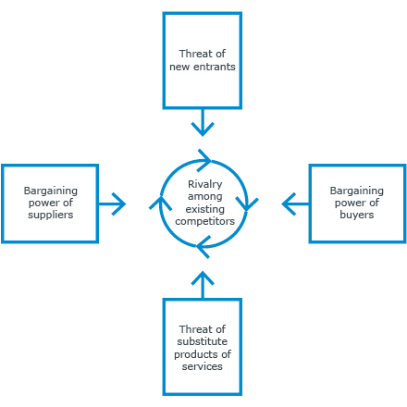
Factors | Description | Impact
3.1  Threat of substitute product | Adidas is a global company based in Germany that makes clothing, accessories, and shoes. Adidas has been active in the apparel and footwear sectors since 1949. The corporation has a very large supply chain and distribution network as a result. A new participant in the market won't have any issues setting up a production facility or starting a firm. However, it would be challenging to surpass a well-established company like Adidas. The percentage of investments made by the company in marketing and research won't be comparable by the new businesses, and the economies of scale that the company can obtain won't be replicable by the new businesses. | Low  Impact on channel
3.2  Threat of new entrance | Adidas is a well-known company; thus, the products are of the highest calibre. The business also makes significant investments in its research activities, enabling it to be among the first to implement innovations into its products.The brand is the best in terms of functionalities due to its numerous patents. Any company that wishes to overtake Adidas in the market must thus provide things that Adidas does not. This seems really improbable. The number of readily available counterfeit goods, however, is an essential component of alternatives that the brand has to be wary of. These provide the same features and pose a danger to the company because of this. | Low impact on the new ideas
3.3  Bargaining power of buyers | The Adidas brand has a large client base. Additionally, in the case of Adidas, each buyer contributes a very small amount. This means that even if a consumer changes his or her mind about which sports shoes they prefer, it won't have a significant impact on the business. As a result, the corporation has more negotiating leverage. In determining the costs, special offers, etc. Additionally, there aren't enough participants on the market. Customers will thus find it challenging to switch brands given the low standards they have for the merchandise. | High impact sale
3.4  Bargaining power of suppliers | There are several providers of rubber, cotton, Eva, and other materials to Adidas in the market. Because it works with a variety of suppliers in various sectors, the company will always be in charge of negotiations. They have commercial links with local suppliers all around the world. Therefore, it is easier for them to switch vendors at any time. Additionally, being associated with well-known firms like Adidas, which are constantly popular, is something that all suppliers would desire. Suppliers will always be eager to collaborate with Adidas as a result, which is fantastic for the company. | Low impact on market
3.5  Competitive Rivalry | Adidas faces intense competition in the markets where it sells its products. The company directly competes with Nike, Puma, and other companies when it comes to selling its products. These businesses sell products that, in terms of quality, price, and other elements, are quite similar. Thus, the likelihood of these brands having a compelling USP is quite low. Additionally, the marketing and R&D endeavours of Adidas' direct competitors are all equally successful. As a result, creating a clear market lead is difficult. The largest issue facing the business is that it doesn't compete in every area that Nike services. As a result, there is a strong possibility that people will select Nike over Adidas. | High in competition

4. SWOT ANALYSIS
Using a SWOT analysis, you may identify your company's internal strengths and weaknesses as well as exterior opportunities and threats (T). To assist you reach your objectives, you can use this information in your company planning. (Junesoo Lee, 2020)

4.1 STRENGHS | 4.2 WEAKNESSES
- Value of the brand: When it comes to brand value, Adidas is one of the most expensive sportswear companies. It is ranked third by Forbes with a brand value of 11 billion pounds. In 2020, Adidas was ranked as the 51st most valuable brand in the world.  - Introduce New Products : Adidas has always placed a strong emphasis on the quality of its products. The company's top-notch, cutting-edge items are one of the elements that contribute to its growing customer base. | - Lack of supply chain: Adidas mostly uses independent manufacturing vendors in China, Cambodia, and Vietnam to produce the bulk of its products. Adidas now faces the danger of relying too much on international suppliers.  - Costly Goods: Adidas excludes folks on a tight budget by charging a premium or high price for their products. Shoes costing more than 90 pounds may only be purchased by people from the upper and middle classes.
4.3 OPPORTUNITIES | 4.4 THREATS
- Diversification into sporting goods Adidas has a huge portfolio, but there is always room for expansion in its product range.  - Global Expansion: Due to the swift growth of new markets in Africa, Asia, and South America, Adidas has many opportunities to make money.  - Sports equipment diversification: Even though Adidas's portfolio is already well-diversified, its product range may yet be increased.  - Product Development in Space: Adidas and the International Space Station National Lab collaborated in 2019 to research how to construct a "Boost midsole" in zero gravity. | - Supplier Dominancy: Adidas outsources the majority of the production of its goods, which suggests that the suppliers have greater negotiating power than the business. Due to the unbalanced power structure, Adidas runs the risk of being kidnapped by its largest suppliers.  - Loss of Trademark: Adidas was left open to copycat threats in 2019 after failing to successfully defend its three-stripe emblem in a trademark dispute before the General Court of the European Union.  - Exchange rates: Adidas operates on a worldwide level, therefore changes in significant currencies like the US dollar and the euro might hurt the company's earnings.
4.5 BENEFITS AND DRAWBACKS OF SWOT ANALYSIS
BENEFITS | DRAWBACKS
- Problem Domain  - Application Neutrality  - Multi-Level Analysis  - Data Integration  - Simplicity  - Law cost | - No Weighting Factors  - Ambiguity  - Subjective Analysis  - Time Focus  - Resource Intensive
4.6 CONCLUSION
Adidas is a very powerful brand in the sporting goods industry, as you can see. Only a few minor flaws, such outsourced manufacturing, a limited selection of products, and a dearth of celebrity endorsements, serve to counteract this strong branding and excellent distribution system. Adidas does, however, have prospects for the future in this expanding market, including smart materials, if it can just withstand the competition. (Teoli, D. and An, J. (2019). SWOT Analysis)
5. SEGMENTATION, TARGETING AND POSITIONING OF ADIDAS
Adidas is a worldwide company that focuses on innovation to draw in more customers and achieve its sales targets. This study aims to educate you how Adidas segments, targets, and positions its market as well as how the targeted consumers respond to its new and improved products. (EDUZAURUS, 2020)
5.1 SEGMENTATION
Adidas divides its market into numerous categories in accordance with the preferences and tastes of various customers. Depending on demographic, regional, psychographic, and/or behavioural market segmentation criteria, multiple consumer categories can be identified. They may need a whole new product, have a marketing mix of benefits, or gain from the products they purchase. It enables a more precise assessment of market potential and the investigation of market gaps. While the conventional Adidas caters to people who wish to participate in sports, Adidas Originals offers limited-edition daily wear, cultural fashion clothes, and footwear that are often more colourful but not as athletic-looking.
A higher social standing increases the likelihood that customers will purchase Adidas products that are more costly. Customers with lesser social standing can choose to buy items that are more affordable to them. Sports enthusiasts are more inclined to buy sporting products from Adidas than non-sports enthusiasts, who are more likely to buy items from Nike. Customers who value street-styled clothing are likely to buy the required items from Adidas Originals or Style since their tastes are comparable. This happens as a result of their shared behavioural patterns and potential relationships. Differentiated marketing, also known as segmented marketing, is employed when a company selects one or more market niches that provide them the best prospects.
In order to appeal to a wider range of age and gender groups and so draw in more customers, Adidas sells clothes, jewellery, and footwear for both men and women. Adidas will be able to improve its ability to personalise goods and services. according to the unique requirements of distinct market niches, the organization's capacity to participate profitably, and perhaps avoiding fierce competition.

5.2 TARGETING
Adidas strives to appeal to both current demographics of customers who are enthusiastic about and love participating in sports for health and fitness and those who have been devoted to the brand from its origin. Between the ages of 20 and 30, they are intended for athletes or young people who appreciate sports. Because they believe they are the athletes of the future who will grow the brand and represent the most significant client segment, Adidas is concentrating on athletes aged 13 to 18. But the business is also well known among those between the ages of 40 and 65. Adidas products are typically more expensive because of their incredible high-end quality, as well as their well-known name.
They serve a predominantly upper-middle-class and affluent clientele as a result. Adidas Originals' target market has recently benefited from the introduction of various new lifestyle products thanks to mobile phones by growing its clientele. Between the ages of 15 and 25, Adidas also serves a smaller group of customers who do not participate in athletics but purchase footwear or clothing as a statement piece of fashion. Given the size and diversity of the market, Adidas is unable to appeal to every customer because doing so would result in a confusing message and a lack of customer satisfaction.
It is also concentrating a particular group of customers hence, it is concentrated.
5.3 POSITIONING
An excellent marketing strategy is positioning, which enables a business to emphasise its advantages and create in customers' minds an image of the firm's services. Diversity, integrity, performance, and passion are some of Adidas' core values since the corporation cares a great deal about its customers. In order to establish its reputation as a significant athletic brand, Adidas creates and markets high-quality products, offers prompt service, and has a long history.
The company sees itself as a brand for individuals who want to be elite football players, athletes, etc. People think that wearing Adidas gear is one of the secrets to success because of this tactic. The majority of this company's commercials are therefore encouraging and inspirational. Adidas is one of the firms that sets standards for the rest of the industry because it never stops focusing on the quality and uniqueness of its products and because it aims to delight its customers with quick, attentive, and upbeat service.

Positioning is based on the distinctive traits or attributes that, in the eyes of your target market, elevate your company beyond that of your competitors. so, it is differentiable. (Market Segmentation by Art Weinstein)
6. MARKETING MIX OF ADIDAS(4Ps)
This is a thorough examination of Adidas' marketing mix (4Ps of Adidas). One of the biggest sportswear producers in the world is Adidas. It is a German business with its office in 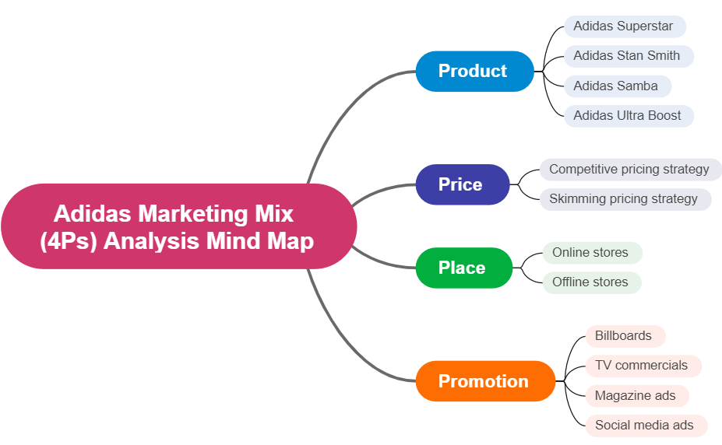Herzogenaurach. ( (Clara Ang, 2018)

6.1 PRODUCT STRATEGIES OF ADIDAS
The sportswear sector is home to the recognised brand Adidas. It is the second-biggest producer of sportswear in the world. It model and makes footwear, accessories, and clothes. It creates products for men, women, and kids.
Adidas sells products in the following categories: back-to-school, sports, clothes, accessories, and shoes. There are several products in each category. The apparel category, such as shorts, pants, tracksuits, swimsuits, hoodies, sweatshirts, joggers, jackets, loungewear, sports bras, football shirts, etc. Along with these products, Adidas also creates balls, hands, watches, goggles, gloves, gym and exercise bags, bags, and packs.
Increasing brand trust, enhancing the customer experience, and pushing the boundaries of sustainable development are our key priorities initiatives. The realisation of our objective is made possible by our digital transformation, an innovative attitude across all facets of our organisation, and other factors.
6.2 PRICING STRATEGIES OF ADIDAS
The sportswear sector is home to the recognised brand Adidas. It is the world's second-largest sportswear maker. It creates and produces clothing, accessories, and shoes. It produces goods for adults, women, and children.
Adidas sells products in the following categories: back-to-school, sports, clothes, accessories, and shoes.
Adidas primarily employs a skimming price approach for apparel due to its strong brand recognition. As a result, Adidas' target market encompasses both high-end and upper-middle class consumers. In actuality, Adidas is considered a luxury brand by consumers due to its high price approach.
6.3 PLACE/DISTRIBUTION STRATEGIES OF ADIDAS
The globe over, Adidas items are offered for sale. They are distributed indirectly and sold via franchisees, retail stores, internet, and e-commerce platforms. By selling on its website and on e-commerce sites like Amazon, Adidas may be able to reach a big audience because its customers have the freedom to make purchases as and when they're needed.
On the Adidas website, customers may customise items to create the perfect present! Similar to this, customers may physically inspect the products they are purchasing at retail locations, which commonly has a positive impact on their purchasing decisions. It's crucial to note, though, that Adidas is having trouble meeting client demand, which is having an effect on its bottom line Port overcrowding, lockdowns, and political turmoil in various Asian countries are only a few of these supply chain constraints and problems. (HART, 2021)
A network of companies or middlemen known as a direct distribution channel is where the end customer purchases goods or services. Examples of distribution channels include distributors, wholesalers, retailers, and the Internet.
6.4 PROMOTION STRATEGIES OF ADIDAS
Adidas promotes their goods via tv news, through print media including publications and magazines, and online. Along with club football clubs like Inter Milan, it also supports national teams like Spain, Germany, Argentina, and Mexico. It mainly focuses on the moving up of brand credibility and design of the products.
Adidas promotes their products with celebrity endorsements. It has worked with celebrities including Beyonce, Stella McCartney, and Lionel Messi. However, it's important to keep in mind how expensive celebrity endorsement is.6.5 CONCLUSION
Adidas has a considerable edge over its rivals in the sector since it is the oldest sports footwear brand in the world and has been in operation for more than seven decades. But longevity hasn't been the only factor in this business' success. Additionally, it has put into practise some of the greatest marketing strategies ever. Adidas has never ceased developing new items that outperform older models in terms of utility and design.

7. RECOMMENDATION
- Adidas has consistently sought out new markets with the intention of creating new markets. Adidas continually expands its company by bringing its current products into new markets in developing nations. Adidas has consistently used the adversarial showcasing method when it comes to business plan for developing markets.
- New Channels of Sale in Supporting Economic growth: Adidas has access to new distribution channels in emerging markets. For instance, Adidas first sold products in India many years ago. However, it just recently, in 2008, was able to dominate the athletics industry in the Indian state of Jammu & Kashmir by opening two outlets, one in each of Jammu and Srinagar (Greater Kashmir, May 23:2008). Similar to this, Adidas opened their largest store in Beijing after donating to the Beijing Olympics.
- By 2025, adidas wants its internal operations to be climate neutral, and by 2050, the entire company. The execution of "Own the Game" is aided by adidas' continued digitization and innovation across all facets of the business.
- Their constant, cooperative marketing tactics have improved the brand's ability to engage with consumers. As a result, by developing a close partnership with professional athletes, Adidas can ensure that its messages are consistent throughout all of its campaigns.
- Adidas primarily employs a skimming price approach for apparel due to its strong brand recognition. As a result, Adidas' target market encompasses both high-end and upper-middle class consumers. In actuality, Adidas is considered a luxury brand by consumers due to its high price approach.
- They have improved the brand's relationship with its customers by using consistent, cooperative marketing techniques. As a result, by developing a close partnership with professional athletes, Adidas can ensure consistency with its messages across all of its ads.
- As a business with a focus on the market, adidas constantly assesses customer needs to make sure its products are meeting them. By modifying its product line to match consumers' shifting wants, it seeks to surpass customer expectations.

- REFERANCE
Clara Ang, H. R. (2018). The Impact of Marketing Mix 4Ps and Consumer Behavior toward Purchase Decision of Adidas Products. The Impact of Marketing Mix 4Ps and Consumer Behavior toward Purchase Decision of Adidas Products, 6.
EDUZAURUS. (2020). Adidas market segmentation, targeting and positioning.
fure, k. (2018). PESTLE Analysis, . theseus.
Gary Armstrong, s. (2014). pricipel of marketing (6 ed.). Australia: Pearson.
Graham J. Hooley, N. P. (2008). Marketing Strategy and Competitive Positioning. FT Prentice Hall.
Junesoo Lee, S.-J. L. (2020). Balanced SWOT: Revisiting SWOT Analysis through Failure Management and Success Management. judo management, 47(2005), 209-2018.
kreutzer, r. t. (2019). Tools for the Strategic Analysis. In Tools for marketing and management (pp. 89-142).
lu ge, c. (2019). Analysis of competitive Power of Chinese Sports Apparel Brand based on Porter's five Force Model. Association for Computing Machinery.
Musandiwa, T. j. (2014). Customer Orientation in Small Business Marketing Mix Strategy Formulation and Implementation. South Africa: University of Johannesburg ProQuest Dissertations Publishing.
Polo, P. M. (2018). Acts or events? spain: University of Seville. .
Rosemary Varley, A. R.-T. (2019). fasion mangement a strategic approach. red globe press.
varley, r. (2022). fasion management: A strstegic Approch.

