

Student name: Paulina Slowik
Student ID: 2332439
Module name: Changemakers: Building your Personal Brand for Sustainable Employment
Module code: BMHP5015
Lecturer name: Caroline Salami
Word count: 2197

Contents
1. Introduction 3
2. Job description of the selected job 3
Analysis of Personal Employability Skills Required for a Radiology Assistant 3
3. Analyse the skills needed for the job and assess your skills and experience 5
Evaluation of My Own Skills in Relation to the Radiology Assistant Role 5
4. Development of personal skills and resources 7
Building a Personal Brand and Professional Identity 7
5. Action Plan and Timeline 8
Action Plan and Timeline for Career Development 8
6. Communication of skills to potential employers 11
7. Conclusion 11
References 13

1. Introduction

This report focuses on the role of a Radiology Assistant within the healthcare sector, specifically in the National Health Service (NHS). My interest in this career developed through a long-standing desire to work in healthcare and my practical experience in a hospital environment. I worked as a domestic assistant in an X-ray department, where I gained exposure to a clinical setting and observed equipment such as X-ray machines, CT scanners, and MRI systems. This experience increased my curiosity about diagnostic imaging and patient care.
Working in the department also allowed me to interact with radiographers, doctors, nurses, and patients, helping me develop communication skills and an understanding of patient-centred care. Observing teamwork and professionalism strengthened my motivation to pursue this career path.
This report examines the key employability skills needed for the role, assesses my current abilities in relation to these requirements, and outlines a structured action plan and timeline for development. It also considers the importance of personal branding, professional identity, and networking within the healthcare sector.

2. Job description of the selected job

Analysis of Personal Employability Skills Required for a Radiology Assistant

The role of a Radiology Assistant within the National Health Service (NHS) requires a combination of technical awareness, interpersonal skills, and professional behaviours to effectively support diagnostic imaging services. A review of current vacancies, such as those from Epsom and St Helier University Hospitals NHS Trust and platforms like NHS Jobs and Indeed, shows that key responsibilities include assisting radiographers, preparing patients for procedures, maintaining cleanliness of equipment, and handling patient records accurately (NHS Jobs, 2025; Indeed, 2025).
The person specification typically requires a good level of education, including GCSEs in English and Maths, basic IT skills, and sometimes prior healthcare experience. Employers also emphasise qualities such as empathy, reliability, and the ability to work under pressure. These expectations align with NHS values such as dignity, respect, and compassion (Department of Health and Social Care, 2021).
Communication is a key employability skill in this role. Radiology Assistants must support patients who may feel anxious about procedures such as CT or MRI scans. Applying the 6Cs of Nursing—particularly care, compassion, and communication—helps ensure patients feel reassured and informed. For example, explaining procedures clearly and adapting language to suit patient needs demonstrates both empathy and professionalism.
Teamwork is equally important, as Radiology Assistants work alongside radiographers, nurses, and administrative staff. The Skills for Care Core Skills Framework identifies teamwork as essential in health and social care (Skills for Care, 2022). In busy clinical settings, effective collaboration helps manage patient flow and maintain service quality. Using the STAR model (Situation, Task, Action, Result), an example would be supporting staff during a high patient demand by prioritising tasks and communicating effectively, resulting in improved efficiency and patient satisfaction.
Resilience and emotional intelligence are also crucial. Healthcare environments can be demanding, and assistants may encounter distressed patients. Being able to remain calm, recognise patient emotions, and respond appropriately is essential. For instance, de-escalating an anxious patient through reassurance and clear communication supports both patient safety and care quality.
Digital literacy is increasingly important, as radiology departments rely on electronic patient records and imaging systems. Radiology Assistants must use these systems accurately to support workflow, reflecting the growing importance of technological competence in employability frameworks.
The development of these skills can be explained using Kolb’s Learning Cycle. My experience in an X-ray department provided practical exposure (“concrete experience”), which I reflected on to understand key skills such as communication and teamwork. This reflection allows me to apply and improve these skills in future roles (Kolb, 1984).
Overall, the Radiology Assistant role requires a balanced set of interpersonal, technical, and professional skills, all of which are essential for delivering effective patient care and supporting NHS services.

3. Analyse the skills needed for the job and assess your skills and experience

Evaluation of My Own Skills in Relation to the Radiology Assistant Role

To assess my suitability for the Radiology Assistant role within the National Health Service (NHS), I conducted a critical self-evaluation of my skills, experience, and personal attributes against job requirements identified in relevant vacancies (NHS Jobs, 2025; Indeed, 2025). This evaluation uses self-assessment tools, reflective models, and feedback to provide a balanced overview.
A key tool used was a SWOT analysis, which helped identify my strengths, weaknesses, opportunities, and threats. One of my main strengths is my experience as a domestic assistant in an X-ray department. This role gave me insight into the clinical environment, infection control procedures, and the importance of maintaining patient dignity. It also strengthened my communication skills through regular interaction with patients, radiographers, and other staff, aligning with the teamwork and communication skills required for the role.
I have also developed strong interpersonal skills such as empathy and patience, which are essential when supporting anxious patients. Feedback from colleagues and supervisors has highlighted that I am approachable, reliable, and work effectively within a team. These qualities reflect key NHS values, including compassion and respect (Department of Health and Social Care, 2021).
However, this evaluation also identified areas for development. I have limited experience using specialised healthcare systems such as electronic patient records, which is a key requirement for the role. In addition, I have not yet taken on direct clinical responsibilities, meaning I need to build confidence and competence in practical healthcare tasks.
To reflect further, I applied Gibbs Reflective Cycle to my experience in the X-ray department. I observed staff communication and workflow (description), felt motivated by their professionalism (feelings), and recognised my lack of technical knowledge (evaluation). This led me to identify the need to improve my clinical understanding and IT skills (analysis), and to plan further training and development (conclusion and action plan) (Gibbs, 1988).
Additionally, Maslow's Hierarchy of Needs explains my motivation, as I am focused on achieving personal growth and career development through this role (Maslow, 1943). A skills audit further confirmed my strengths in communication, teamwork, and reliability, while highlighting areas for improvement such as technical knowledge and confidence in clinical settings.
Overall, this evaluation shows that I have a strong foundation for the Radiology Assistant role but need further development. Identifying these gaps allows me to create a focused action plan to improve my employability and achieve my career goals within healthcare.
Recent vacancies further confirm the demand for this role, such as the Radiology Department Assistant position at Ashford and St Peter’s Hospitals NHS Foundation Trust (NHS Jobs, 2026) and the Radiology Imaging Assistant role at Bedfordshire Hospitals NHS Foundation Trust (Totaljobs, 2026), both of which emphasise patient support, teamwork, and organisational skills.

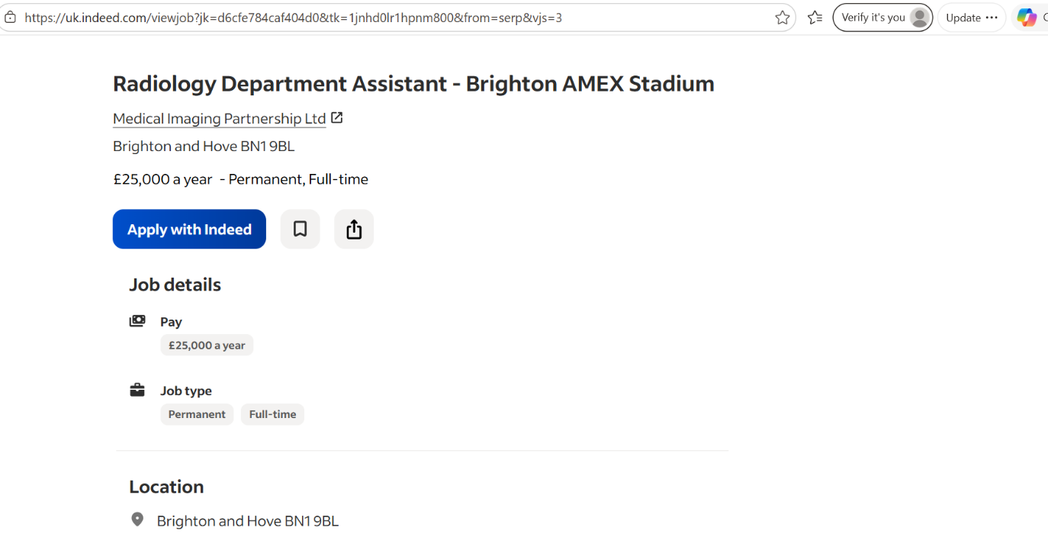
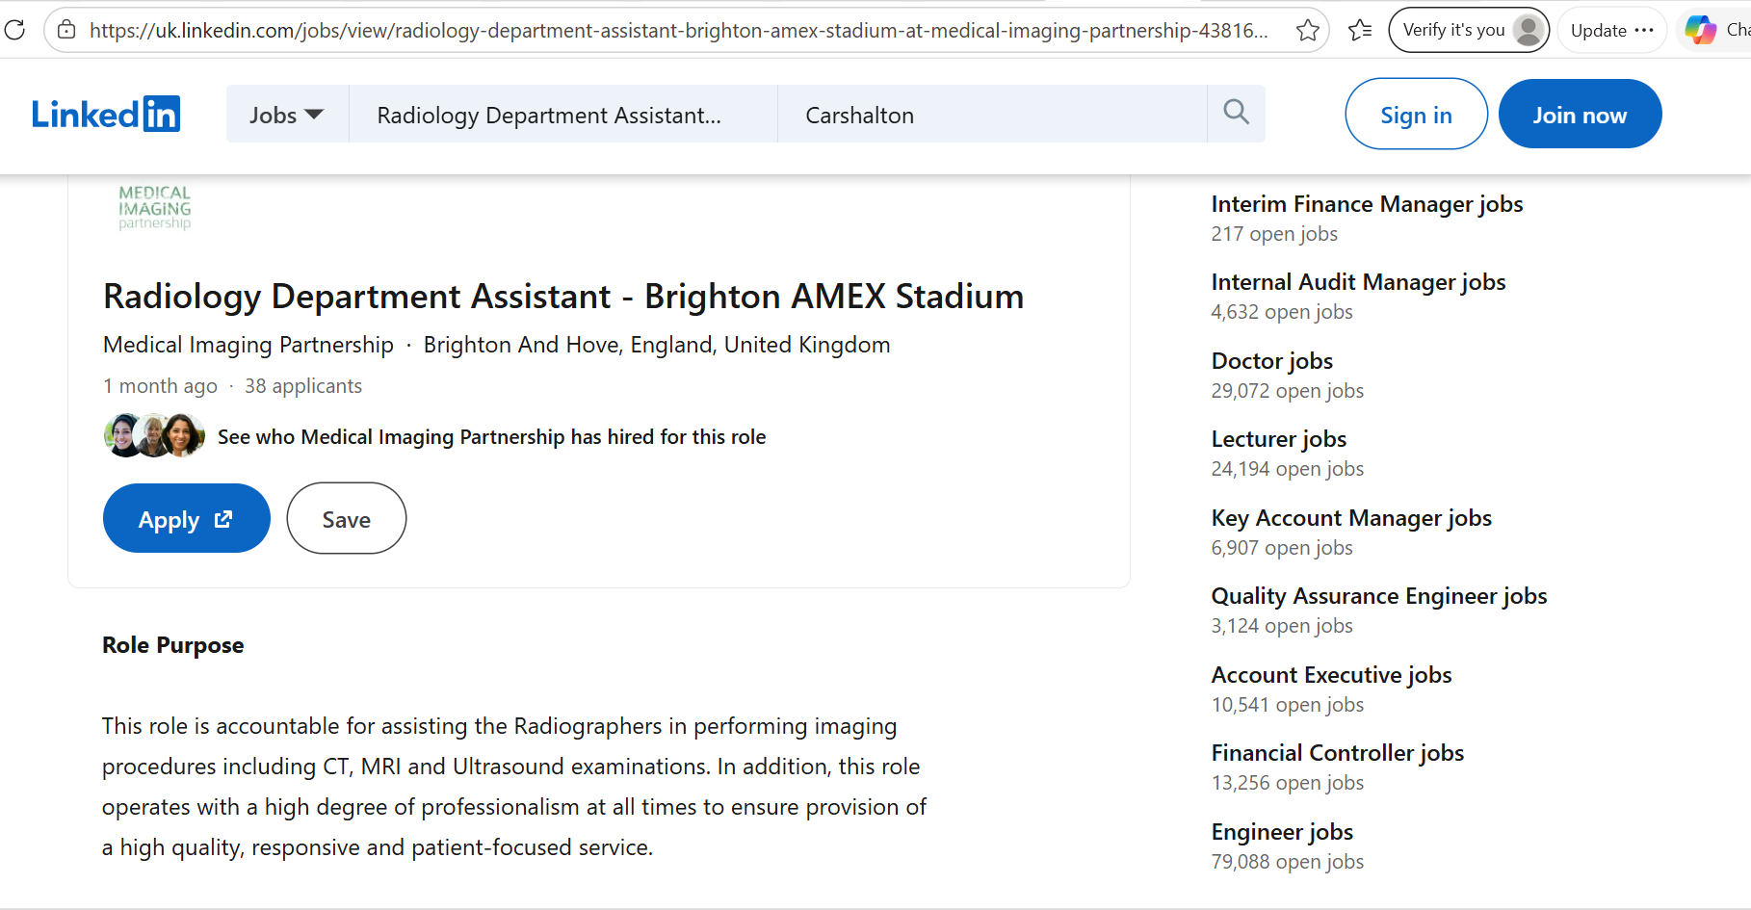

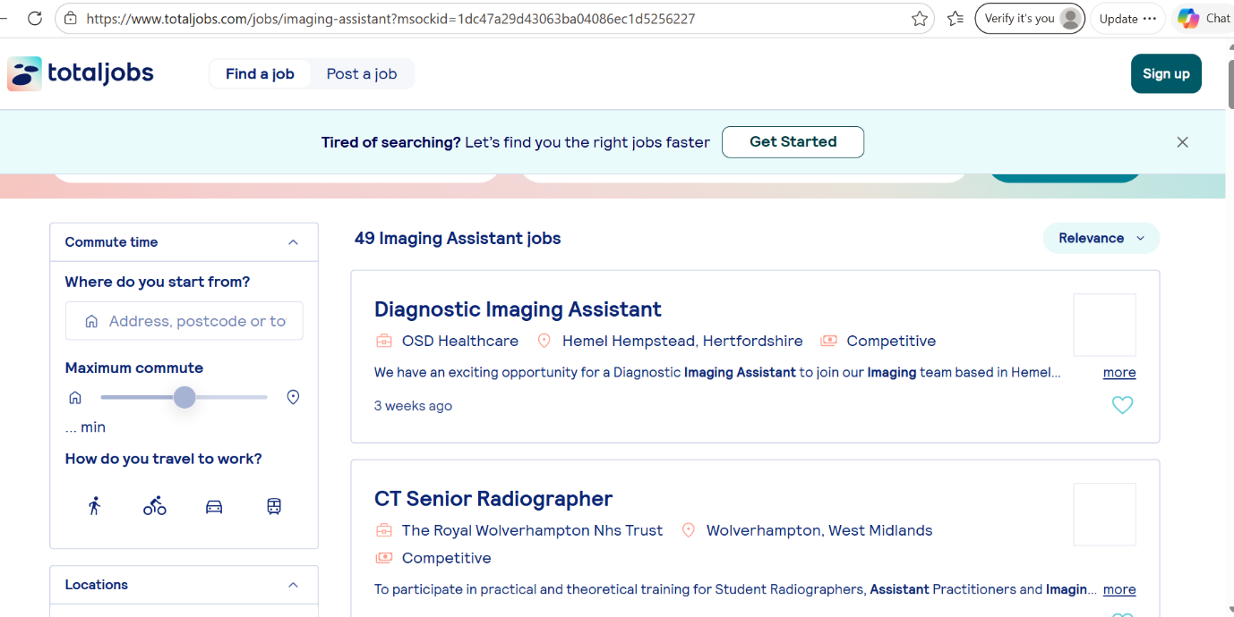

4. Development of personal skills and resources

Building a Personal Brand and Professional Identity

Developing a strong personal brand is essential for standing out in the competitive healthcare sector, particularly within the National Health Service (NHS). My personal values include compassion, respect, reliability, and a commitment to continuous learning. These values align closely with health and social care roles, where patient-centred care and professionalism are essential. Demonstrating these values consistently in behaviour and communication will help build a trustworthy professional identity.
To promote myself effectively, I will develop a professional CV tailored to Radiology Assistant roles, highlighting my experience in the X-ray department as a domestic assistant, along with key skills such as communication and teamwork. I will also create and maintain a strong LinkedIn profile, including a professional photo, a clear headline such as “Aspiring Radiology Assistant,” and a summary of my experience, skills, and career goals. Regular updates and engagement with healthcare content will increase my visibility.
My unique selling point (USP) is my direct exposure to a radiology environment combined with strong interpersonal skills. Unlike many entry-level applicants, I have already worked in an imaging department, observed equipment such as CT and MRI scanners, and interacted with patients and multidisciplinary teams. This gives me a realistic understanding of the role and the ability to adapt quickly to a clinical setting.
Building professional networks is also important. I plan to connect with healthcare professionals through LinkedIn groups and consider joining organisations such as the Royal College of Nursing or similar healthcare networks. This links to Social Capital Theory, which highlights how relationships and networks support career opportunities and progression (Bourdieu, 1986).
The CareerEDGE Model also supports my development, emphasising the importance of experience, reflection, and career learning in improving employability (Dacre Pool and Sewell, 2007). To strengthen my profile further, I will seek volunteering opportunities, short healthcare courses, and training in NHS digital systems.
Overall, combining my values, experience, and proactive development will help me build a strong personal brand and demonstrate my commitment to a career in radiology.

5. Action Plan and Timeline

Action Plan and Timeline for Career Development

To achieve a Radiology Assistant role within the National Health Service (NHS), I have developed a structured action plan that builds on my current academic progress and practical experience. This plan is designed using the SMART goals framework, ensuring that each objective is clear, realistic, and time-bound (Doran, 1981). In addition, Bandura's Self-Efficacy Theory supports my approach, as it highlights how confidence in my ability to develop skills will directly influence my motivation and success in achieving career goals (Bandura, 1997).
At present, I have completed the final term of my Level 5 Health and Social Care qualification and will begin Level 6 in June, which I aim to complete by May 2027. This provides a strong academic foundation to support my progression into a healthcare role. Alongside my studies, I plan to continue developing practical experience and professional skills required for the Radiology Assistant position.

Short-Term Goals

- Begin Level 6 Health and Social Care course in June and maintain high academic performance
- Update CV and strengthen my LinkedIn profile to reflect career goals
- Apply for part-time care work or volunteering roles in healthcare or care home settings
- Develop digital literacy skills relevant to healthcare environments (e.g., patient record systems)
- Seek ongoing feedback from lecturers and mentors to identify areas for improvement

Medium-Term Goals

- Continue progressing through Level 6 qualification (2026-2027)
- Gain consistent hands-on experience in a care or healthcare support role
- Attend CPD (Continuing Professional Development) training sessions related to patient care and healthcare support
- Build professional networks through LinkedIn and healthcare professionals in practice settings
- Strengthen communication, teamwork, and patient interaction skills through real experience

Long-Term Goals

- Complete Level 6 qualification by May 2027
- Apply for Radiology Assistant roles within the NHS
- Progress into a stable healthcare career within radiology or related diagnostic services
- Consider further development such as radiography training or apprenticeship routes

Timeline (Development Plan)

Timeframe | Goal/Activity | Resources Needed | Expected Outcome
June 2026 | Start Level 6 H&SC course | College/university access | Progress to higher-level qualification
2026–2027 | Complete Level 6 course | Study materials, academic support | Advanced knowledge in H&SC
0–12 months | Gain part-time care or volunteer experience | Care homes, NHS contacts | Practical patient care experience
1–2 years | CPD training + networking | Online platforms, training providers | Improved professional skills
By May 2027 | Complete Level 6 qualification | Academic support | Full qualification achieved
2–5 years | Apply for Radiology Assistant roles | Experience, CV, references | Employment in NHS radiology department

Resources Required

To achieve these goals, I will require:
- Access to my Level 6 Health and Social Care programme and academic support
- Opportunities for part-time employment or volunteering in healthcare settings
- CPD training courses related to healthcare practice and patient support
- Guidance from lecturers, mentors, and healthcare professionals
- Continued development of professional networks using platforms such as LinkedIn

6. Communication of skills to potential employers

I plan to communicate my skills to a potential employer through a professional CV, a tailored cover letter, and a strong LinkedIn profile. My CV will clearly highlight my healthcare experience in the X-ray department, my Level 5 and Level 6 Health and Social Care studies, and key skills such as communication, teamwork, and patient care. On LinkedIn, I will include a professional photo, a clear career summary, and regular updates about my studies and relevant experience to show my ongoing development. I will also use my profile to connect with healthcare professionals and join relevant groups to increase my visibility within the sector.

7. Conclusion

In conclusion, this report has explored my aspiration to become a Radiology Assistant within the National Health Service (NHS). It identified that I already have key strengths such as communication, teamwork, empathy, and experience working in an X-ray department. However, I also need further development in digital literacy, clinical confidence, and technical understanding of radiology environments. This shows that while I have a strong foundation for healthcare support roles, additional training and experience are required to fully meet the job demands.
The action plan supports my progression by setting clear goals, including completing my Level 6 Health and Social Care qualification by May 2027, gaining part-time or voluntary care experience, and developing professional networks through LinkedIn. These steps will help me build the required skills and experience for my future career.
Overall, this process has helped me reflect on my abilities and clarified a realistic pathway into healthcare. It has strengthened my understanding of the role and highlighted the importance of continuous development, motivating me to pursue a career as a Radiology Assistant.

References

Bandura, A. (1997) Self-efficacy: The exercise of control. New York: Freeman.
Bourdieu, P. (1986) ‘The forms of capital’, in Richardson, J. (ed.) Handbook of Theory and Research for the Sociology of Education. New York: Greenwood, pp. 241–258.
Dacre Pool, L. and Sewell, P. (2007) ‘The key to employability: developing a practical model of graduate employability’, Education + Training, 49(4), pp. 277–289.
Department of Health and Social Care (2021) The NHS Constitution for England. Available at: https://www.gov.uk
Doran, G.T. (1981) ‘There’s a S.M.A.R.T. way to write management’s goals and objectives’, Management Review, 70(11), pp. 35–36.
Gibbs, G. (1988) Learning by Doing: A Guide to Teaching and Learning Methods. Oxford: Oxford Polytechnic.
Indeed (2025) Radiology Assistant jobs in the UK. Available at: Radiology Department Assistant - Brighton AMEX Stadium - Brighton and Hove BN1 9BL - Indeed.com
Kolb, D.A. (1984) Experiential Learning: Experience as the Source of Learning and Development. New Jersey: Prentice Hall.
LinkedIn (2026) Radiology Assistant jobs in the UK. Available at: 18 Radiology Assistant jobs in United Kingdom
Maslow, A.H. (1943) ‘A theory of human motivation’, Psychological Review, 50(4), pp. 370–396.
NHS Jobs (2025) Radiology Assistant vacancies. Available at: https://www.jobs.nhs.uk
NHS Jobs (2026) Radiology Department Assistant vacancy. Available at: https://www.jobs.nhs.uk
Skills for Care (2022) Core Skills Framework for Adult Social Care. Available at: https://www.skillsforcare.org.uk
Totaljobs (2026) Radiology Imaging Assistant job vacancy. Available at: Imaging Assistant Job Vacancies - Updated May 2026

