
future business plan
[Document subtitle]

June 29, 2020
Katie lewis - 1905310
UWTSD – SWANSEA BUSINESS SCHOOL

Luxury Hair by Katie

Mission statement: To deliver a quality hairdressing service, that is unbeatable in this area. Our principle focus is listening to and understanding our customer needs and views. Ensuring we are always up to date with the newest trends and techniques. We believe in strong leadership and continuous self-development.
Aim and objectives of business
My aim for my clients is to ensure they receive the service and look they desire. High standards will be expected for all clients in past and modern hair. Aiming towards a variety of ages, I want to provide all different preferred styles to the suited client.
The aim for my business is to succeed in its full potential and to become a popular, go to salon. I aim for the business to thrive all through the year with positive income. To maintain a good reputation of loyalty and skills for affordable hair.
The objectives for my service are to ensure my work is always at the highest standard by keep updated with the latest training and qualifications. To ensure all employees are updated with the latest training and qualification certificates.
The objectives for the business to make it its full potential by reviewing all aspects of the business monthly to ensure there are no problems or setbacks that could prevent myself from maintaining this. Such as, client’s satisfaction with the overall service, ensuring my employees are happy, ensuring my employees have happy clients when they leave the salon. This will allow me to keep on top of any mistakes or corrections that need to be adjusted.
Introduction
The business I am investing in is a hair salon and the name of my business is ‘Luxury Hair by Katie’. I have been training in women’s hairdressing and qualified this year, I will pursue my plans to open my new business. There will be no other owners or partners to the business. Hairdressing is a popular trade although there is great competition, there are always clients who want and need this service. I will be discussing in stages the process I will take to build my business to start off strong and use SWOT to assess the best way to do this.

Product/Service
My service will be past and modern hairdressing. To provide styles, colouring and updo’s, from basic hair to extravagant hair. The service I will provide can be very personal and important to any client that needs it. I want to provide the highest standard of customer service whilst following all manufacturer’s instructions, guidelines and health and safety procedures. My plan to provide this whilst running my business will allow me to give clients everything they desire and need.
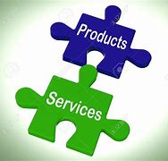

Marketing Activity
Marketing is the study and management of exchange relationships and is the business process of identifying what satisfy the customer most and their wants and needs. Marketing is used to attract customers from the public and elsewhere and is one of the primary components of business management.
Undertaking marketing activities for my service will help get the attention of new clients to make them aware of my new business. Advertising ‘Luxury Hair by Katie’ and its services will be a first and important stage to promote the business. I will need to create flyers, and these will be sent to 1000 homes in the local area and will be reviewed weekly until progress is evident. The cost to do this is estimated at £20.69 online, source - https://www.vistaprint.co.uk
I will create 10 posters and contact popular destinations such as café’s, shops and restaurants to advertise them on my behalf. It will come at a cost of £7.90 per poster online, source - https://www.zazzle.co.uk
Online advertisement such as Facebook and Instagram are a popular, successful and free way to advertise the business. Technology is used for almost everything these days and would be the best way to get the attention of the public. An account for each of these will be set up for friends and family to share and invite new possible clients.
(Laura Lake) – “Marketing is the systematic planning, implementation, and control of a mix of activities intended to bring together buyers and sellers for the mutually advantageous exchange or transfer of products or services”.
(Laura Lake)- “Advertising is that part of marketing that involves directly getting the word out about your business, product, or service to those you want to reach most”.
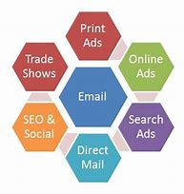

Advertising
Advertising is a marketing communication that employs a non-personal message to promote or sell a product, service or idea. Usually advertisements are used by business to promote their business, product or services.
Before advertising the salon, I will need to recruit the 2 members of staff required for the business. A colour technician and a stylist.
Advertising the job vacancies will be via, social media and free employment sites. This would be a cheap option and due to the generation, itself the most popular way to advertise.
I will then start to advertise the salon, its full services, location, prices and an opening date. Advertisement will be via social media, flyers and posters. The costs of these are stated above.
(T.E.T) “Advertising is a means of communication with the users of a product or service. Advertisements are messages paid for by those who send them and are intended to inform or influence people who receive them, as defined by the Advertising Association of the UK.”
(T.E.T) “Advertising is always present, though people may not be aware of it. In today's world, advertising uses every possible media to get its message through. It does this via television, print (newspapers, magazines, journals etc), radio, press, internet, direct selling, hoardings, mailers, contests, sponsorships, posters, clothes, events, colours, sounds, visuals and even people (endorsements)”.


The 4 P’s
The 4 P’s are the marketing function side of the business that determines the needs of the consumer. It also looks at the target market as well as the products and services. It is important that any individual starting a new business learn how the 4 P’s work so they can manage everything about what they are launching.
Product
Product refers to a service or an item that a business offers to a client/customer. It covers both the usefulness and the demand for an item and any specific benefits which accompanies a business individual offering. When developing a product all aspects should be considered such as the design, quality, features, packaging and customer service.
Price
The price that a service/product is sold is an important part of the business. If the product/service is sold at a higher price for the exact same item that its cheaper elsewhere. This will not be successful, and sales will not increase. Several factors to include with this is include discounting, price setting, cash and credit purchasing and credit selection. Always be aware of your price limits, never price to low or to high, this can be determined by creating a questionnaire for customers to see why are willing to pay for a product or service.
Place
Is the location of the business. Is it accessible to all clients/customers? For the business to be more successful it needs to be in a popular and suited area. Once the decision to buy exists the enterprise must ensure that its service can be acquired in the appropriate time and place. It is important to have a good strategy for the positioning and place. You must make it work for your suitability. You must think about what customers would want to see within the product/ service. A simple catchphrase that is good and easy to remember. It should also satisfy your customers.
Promotion
Promotion is all about how you communicate your product or service to the customer. Using different methods such as, direct marketing, advertising and personal selling. This also focuses on using available marketing for advertising budget in a useful way. An analysis of where and how to approach a service or product that should enable a manager to put together on the form, duration, media type and other aspects of marketing. There are always good ways to advertise your business without having to spend a lot or any money at all.
(Alexandra) - The four Ps of marketing are the key factors that are involved in the marketing of a good or service. They are the product, price, place, and promotion of a good or service. Often referred to as the marketing mix, the four Ps are constrained by internal and external factors in the overall business environment, and they interact significantly with one another.
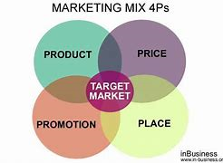

SWOT Analysis
A swot analysis is to investigate what are the strengths, weaknesses, threats and opportunities to a business. This will be used to determine what I will need to work on and use as a strength when the business opens on 01/08/2020.
(Michael. G) – “A SWOT analysis is designed to facilitate a realistic, fact-based, data-driven look at the strengths and weaknesses of an organization, its initiatives, or an industry”.

Strengths
- Good excellent customer service skills
- Good and easy to find location
- Highly qualified staff
- Great knowledge of hair from all staff
- Large range of services
- Good opening hours
- Open on Mondays
Weaknesses
- New business
- Only recent advertising
- Unfamiliar off new employee’s full potential under pressure
- No rapport yet built with clients
- Competition of other salons
- Reputation not yet built

Opportunities
- Popular location will get the salon noticed
- Advertising
- Male barbering and grooming
- Using online bookings
- Offering to rent a chair for extensions
- Setting up a beauty corner to rent out
- Business growth
- Open on Mondays which will earn more money
Threats
- Competition of other salons
- Mobile hairdressing
- Other new salons opening in local area
- Costs for services in other salons

Investigating the strengths and the positives from the SWOT analysis that has been done for Luxury Hair, it shows that there is a high level of skill and knowledge throughout the employees. This will give many new clients positive confidence to come to the salon. It will be and easy location for clients on foot and by car, so client do not get fed up having to come back and feel it is complicated to find or park by. My business will be open on Mondays which will give me an advantage against my competition due to hair salons not usually being open on Mondays.
The weaknesses all relate to the business being new. There will have to a lot of hard work to interest clients to come to the salon, but once they are in, myself and employees can then start to build the rapport and reputation with them.
The opportunities are always important to take advantage of, step by step. The advertising to get the salon noticed is always the first stage of any new business. I will be setting up an online information and booking page. This will have the prices and deals available in the salon. Once the business has settled in and rapports are formed with new clients, I will be looking to see if it would be beneficial to the business to add a beauty corner and rent a chair out for extensions. I believe this will bring more interest from the public. Due to my salon being open on Mondays it will give me the opportunity to earn more money and more busier than my competition as previously mentioned in ‘strengths’, it is unusual for hair salons to be open on this day.
There will always be Threats when owning a business. New and similar business open all the time. I will need to implement my opportunities to protect myself from threats. Competition is a great threat, especially when you are new with hundreds of other businesses almost the same. Becoming unique will push my business that little further to be noticed.
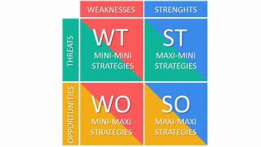
Physical Resources
The salon will be a bricks business venture, set up in a local popular area of Llanelli town with easy access parking. Due to this being a physical job, I will need a place for my customers to come to provide my service. All equipment will be bought knew such as, chairs, mirrors, sinks, electrical equipment and products. These resources are estimated at a total of £5,370.60 to start my business, including wages. The estimate of these costs is from “eBay” and “sallybeauty”.
Physical resources are manmade through ability and skills. Things such as technology, products and equipment are some examples. They are the material assets a business owns. (Reference) this article reads - A company's physical resources, particularly raw materials, are subject to depletion, shrinkage and obsolescence. Physical capital resources, such as expensive industrial equipment, is subject to depreciation.
(Reference) “The physical resources of a business include all the tangible resources owned and used by a company such as land, manufacturing equipment and office equipment. Information technology and its attendant equipment, computers, networks, servers and others, are included in the category of physical resources”.



Financial Resources
The business finance will come from savings. The savings total as £100,000. It will be used for rent, equipment and products needed for the salon. It will also cover a sign for the front of the shop and any extra advertising if necessary. I feel that using the savings is the safest way to avoid any debt before the business grows. Once the business has opened and I start to receive clients. I will review monthly and assess every 3 months in order to identify whether the savings are enough to provide for the business alongside profit. If this is not feasible, I will then query other ways to do so.
Financial resources are the money available to support your business. Options of financial resources are savings, capital venture (investments from other businesses) and bank loans. Financial resources support the business with all its outgoings, such a utility bills, rent, wages, insurances and merchandise.
(Business.Dictionary) “The money available to a business for spending in the form of cash, liquid securities and credit lines. Before going into business, an entrepreneur needs to secure sufficient financial resources in order to be able to operate efficiently and sufficiently well to promote success”.
Cashflow (see appendices for diagram)
Rent: For my town centre located business it with cost me £833 in rent each month. I found this online through a renting agency. It was the most suited area for the needs of my salon, source: www.Zoopla.co.uk .
Wages: Due to the level of qualifications for both of my staff I have based their wage on their skill level and knowledge. A level 3 will be paid more than a level 2 as they are higher qualified within the hair industry (see job vacancies). The monthly cost of paying both my staff will be £1,848.
Utilities: In any building, gas and electric play a big part in running a salon, as for obvious reasons such heating and constant use of electrical equipment. Online I found some quotes and the cheapest one I found was a monthly payment of £126, I found this information on, source: www.confused.com
Equipment: the equipment has been bought brand new so everything is in best condition when the salon has opened, electrical appliances have to be safety tested once a year to make sure it is in working order. As long as this equipment is handed with care they can last much further than a year. The figure to start the business with new equipment is £2,106. This includes, chairs, mirrors, electrical appliances etc. These items should last the year and if not longer. I calculated this figure from, www.ebay.co.uk
Products: products are cheaper to by to start, but the stock has to maintain to level of products needed, depending on what type of clients come in and what you need more of and when, the cost starts at £400 and then varies though the year. I found the information of prices on www.sallysbeauty.co.uk
Insurances: I have been on comparison sites to see which insurance would suit me best, what and who it would cover in case of any scenario. The insurance I found is liability insurance but also covers me for,
- employer’s insurance,
- personal accident cover,
- contents,
- business turnover,
- money in safe
- glass
- transit goods
This is all covered under the insurance that I pay £57.60 monthly. I found this information online through, source: www.confused.co.uk

Human resources
Human resources purpose is to ensure that the business can be successful through people. Fitting the right people to the suited their jobs. Whomever may be in control of the human resources have the responsibility of the things such as the financial resources, hiring, training and has the responsibility of important arrangements for the business.
(careers) - William R. Tracey, in "The Human Resources Glossary," defines Human Resources as: "The people that staff and operate an organization," as contrasted with the financial and material resources of an organization.
I am a sole owner of my business and therefore, all responsibility is mine. I hold a level 2 certificate in women’s hairdressing, and I understand and know how to follow health and safety regulations to keep my staff and clients safe.
Due to myself being a sole owner I will have the roles and the responsibility of human resources, marketing, finance and operations manager.


In relation to my chosen business, due to it being a hairdressing salon. I will be employing 2 members of staff. They will need at least a level 2 qualification in women’s hairdressing, preferably had previous salon experience and are updated with the health and safety regulations.
I will be advertising via social media, flyers and posters in local areas. I require a colour technician and a stylist which is level 2 and 3 qualifications.
Job vacancies:
Once advertising the job roles through the choices mentioned above. The applicants will be required to send in their CV’s providing all qualifications and experience relating to the job role.
The deadline for the CV’s will be 01/08/2020. They will either need to be handed in to the salon or send via email to katiemarie123451@outlook.com
The CV’s will then be narrowed down to 10 applicants per job vacancy and a face to face interview will be arranged. The face to face interviews will commence on 10/07/2020 and finish on 15/07/2020.
4 applicants, 2 per job role, will be chosen for the final stage of the interview where they will have to perform a chosen colour and style. This will place on the 18/07/2020 at 12pm in the salon.
One colour technician and stylist will pair up and work on the clients that I have provided for them.
The 2 members of staff that succeed will be based on the better technique and the outcome of their whole service with their clients.
Their start date will be 01/08/2020.


Colour Technician:
Job type: full time position - 35 hours
Salary: £8.60/hour
Experience:
- In salon – 1 year (required)
- Level 3 certificate (required)

Stylist:
Job type: part time position – 20 hours
Salary: £8.05/hour
Experience:
- Salon – 1 year (required)
- Level 2 certificate (required)

Liability insurance
Liability insurance is the first and most important item to buy before opening the business. It provides legal protection for the business, its owner, its staff and clients. It covers any legal fees and pay outs if a legal matter were to occur.
Liability insurance costs between £322.06 and £1,046.10 depending on the size of the business, I found this information on, https://fitsmallbusiness.com/general-liability-insurance-cost/#:~:text=General%20liability%20insurance%20costs%20range%20from%20%24400%20to,could%20become%20financially%20devastating%20to%20an%20uninsured%20company
As a sole trader the business will need to be covered by ‘sole trader public liability insurance’. A sole trader is liable for all business debts and personal assets can be used to relieve any debts.



Appendices

Cashflow:
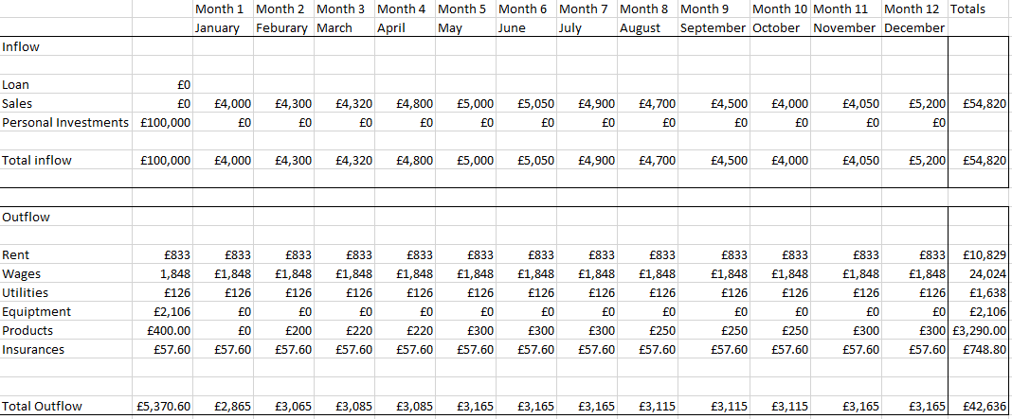

Questionnaire:
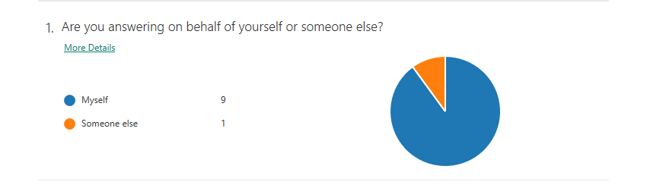
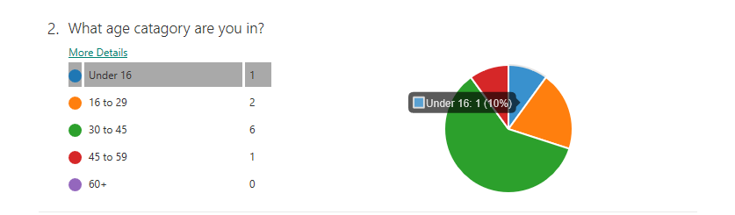
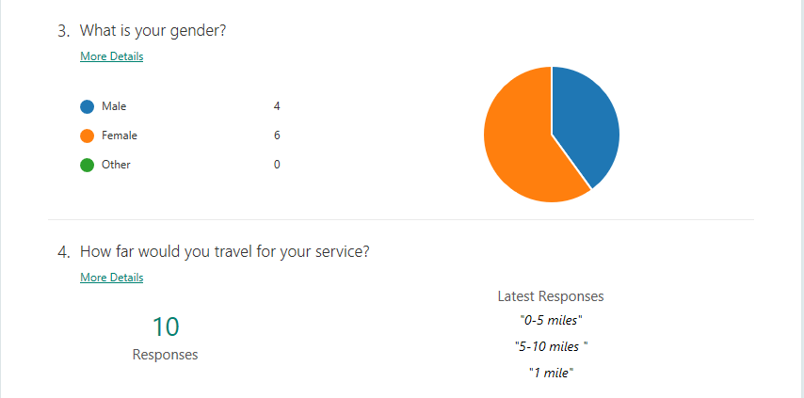
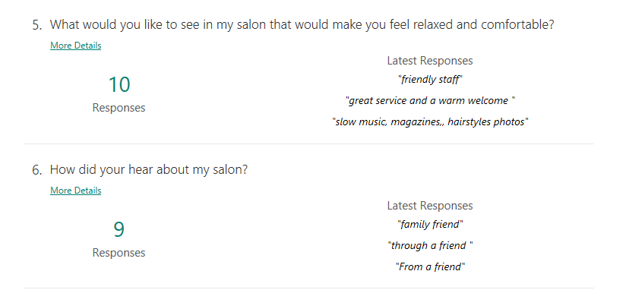
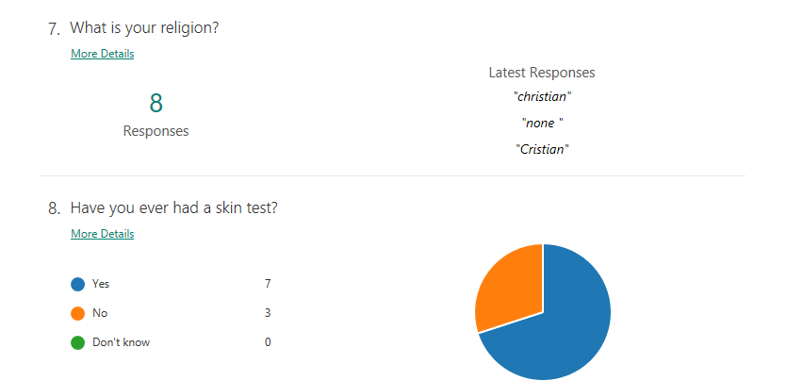
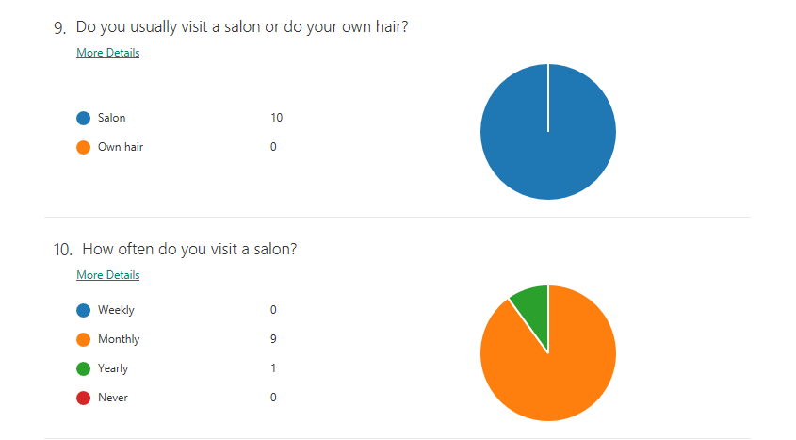

Reference List

Laura Lake [2019] – small businesses - https://www.thebalancesmb.co m/marketing-vs-advertising-what-s-the-difference-2294825

Reference [2019] - What are examples of physical resources - . https://www.reference.com/business-finance/examples-physical-resources-f9dd45a8ec767f5b

Business dictionary [2019] – Financial Resources - http://www.businessdictionary.com/definition/financial-resources.html

Susan M. Heathfield [01 December 2019] – Careers – What is human resources - https://www.thebalancecareers.com/what-is-a-human-resource-1918144

Michael Grant [24 February 2020] – Investopedia – What is a SWOT Analysis - https://www.investopedia.com/terms/s/swot.asp

Reference [2020] – Business & Finance – What are the physical resources of a business? - https://www.reference.com/business-finance/physical-resources-business-c618de7d0f07dc36

The Economic Times [19 June 2020] – Marketing – Definition of Advertising - https://economictimes.indiatimes.com/definition/advertising

Alexandra Twin [30 May 2020] – Investopedia – The 4 P’s - https://www.investopedia.com/terms/f/four-ps.asp#:~:text=Key%20Takeaways.%20The%20four%20Ps%20are%20the%20four,a%20product%20is%20marketed%29%2C%20and%20promotion%20%28the%20advertising%29.

