NETWORK OPERATING SYSTEMS AND SECURITY

Thomas Molner
1804564
Administering Network Infrastructures utilizing Core Intrinsic Network OS Services
Observational Tasks
Terry Walcott

Contents
Worksheet 1 2
Worksheet 2 4
Worksheet 3 5
Worksheet 4 7
Worksheet 5 8

Worksheet 1
1.
PROS
-Manages multiple virtual machines at the same time.
-Allows creating a network connection between machines easily.
-Easy to use and intuitive.
-Can be run across multiple operational systems - not restricted to Windows.
CONS
-Full screen mode not available.
-Network settings- you have to power off the machine to change the network settings each time.
2.
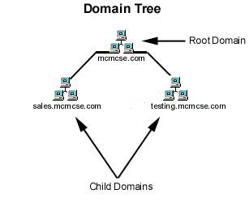
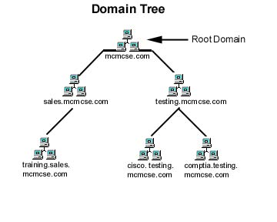
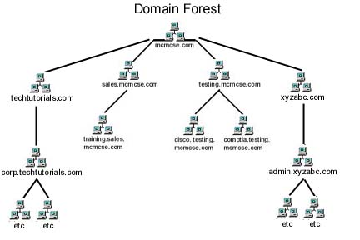
3.
A DC – shortcut from Domain Controller is a server from the network which provides access to domain resources. A Domain Controller also authenticates the users logging from different client machines within the same domain. Therefore, a DC has all user information, it helps users to authenticate and also enforces different policies in the domain.
In AD- shortcut from Active Directory, the servers existent in the same AD can either be member servers or DCs.
4.
If one domain controller would be unavailable (for example hardware failure), a second domain controller should be available within the same active directory, to take over.
Client machines should therefore have in the Internet Protocol Properties also an Alternate DNS Server IP Address available.

Worksheet 2
1.
Below are some password policies and why they are being applied:
- The Maximum Password Age establishes how long the users in a company can have the same password. By implementing this, admins force the users to change their passwords regularly.
- The Minimum Password Length policy establishes how long a password should be. Passwords that are too short are more easily hacked.
-Enforce Password History policy will prevent users from changing their password to a recent one they just had.
-Minimum Password Age will force users not to use too soon an old password that they are, for example, used to. This will prevent users to change a password to an old one immediately after being forced to change it.
-Passwords Must Meet Complexity Requirements will force users to use in their password certain things- for example capital letters, lowercase letters, symbols or numbers.
-Password Audit allows an administrator to track the users password changes and provides evidence if there’s a security breach.
-E-Mail Notifications will create e-mail notifications for the users to let them know their password will expire.

2.
Active Directory Groups
PROS
-Maintained regularly by IT administrators and can be easily maintained.
-Can be nested, meaning you can integrate 1 AD group inside of the other group. This is useful when an administrator wants to build hierarchical structures.
CONS
-The settings applied will affect all members of the group, the group membership should be carefully administrated to only offer necessary access to the members.

Worksheet 3
1.
NTFS permissions control access to files and directories on Windows drives. These permissions apply regardless of whether the files are accessed locally from a computer or using a share via the network.
Permissions:
-List Folder Contents
-Read & Execute
-Modify
-Full Control
Share permissions are used to control access to folders (and their subfolders and files) when accessed over a network. Share permissions therefore have no influence if files are accessed locally using a computer.
When combined with NTFS permissions, share permissions always have priority. This means that share permissions can restrict NTFS permissions, but not extend them. Share permissions are limited to the levels “Read & Execute”, ” Modify” and “Full Control”.
2.
-Safer file protection, file encryption, and improved information security.
-Support large hard disks, and as disk capacity increases, NTFS performance does not decrease as the FAT does.
-Sets permissions for different users. Users can be assigned different permissions for the same folders or files.
-If a system crash is enountered, the NTFS file system restores file system consistency using log files automatically and reviews point information.

3.
Easy to use for admins, so they can:
-Create a group for any department or role (Managers, Accountants, Marketing, etc.).
-Organize groups in a way that’s intuitive, for example hierarchy or geography.
-Implement standard naming conventions across the organization
4.
Advantages of using group policies:
-Saves times and costs
They are being loaded automatically every time by the computer startup.
-The location for the configurations is centralized
The admins manage it from a centralized location.
-The productivity is increased
Users are not limited anymore to a single computer located at their workstation. The files and folders and even the settings can be accessed on any computer they work on.
- Security Benefits
There are many policies that prevent users from being attacked and for securing their accounts.
Benefits of OUs:
-Manage the objects in an efficient way.
-GPO settings: set of configuration settings that administrators can apply to users and computers within an OU. This will segregate the users rights.

Worksheet 4
1.
-Excludes manual IP address configuration, excluding human error.
-Automates and centralizes TCP/IP configuration.
-The management of IP address changes of the users that must change their IP often, for example people who work remotely using wifi.
2.
-DHCP DISCOVER : DHCP Client -> DHCP Server, finds the DHCP server
-DHCP OFFER : DHCP Server -> DHCP Client, offers IP Parameters
-DHCP REQUEST: DHCP Client -> DHCP Server, requests the IP Parameters
-DHCP ACK: DHCP server-> DHCP Client, confirms the use of the IP parameters.

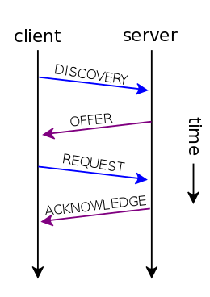
3.
The DHCP does not require authentication, meaning that any user/client can join the network easily. This means that there can be security risks, like unauthorized users being assigned IPs.

Worksheet 5
1.

Iteration is the procedure of a DNS Client, making rehashed DNS Queries to various DNS Servers for name resolution. The DNS Server will give the best answer. If the DNS Server does not have the response, it will refer another DNS Server (lower level one).
Recursive DNS Query: the DNS Client sends a query to a DNS Server for name resolution. The answer can be a response to the inquiry or an error.

2.
The root hints are part of the DNS Server and they offer a list of resources which can be used withing the DNS Service to locate other DNS Servers from the same tree that can supply the needed role. Root hints are therefore used to prepare other servers, which will learn and adapt.

3.
3.1. Server1.subcontA.nwtraders.msft
3.2. A fully qualified domain name, is a domain name that specifies its exact location in the tree hierarchy of the DNS. It specifies all domain levels. The FQDN is very clear and it lacks ambiguity.
A domain namespace is a name service provided by TCP/IP. DNS is broken up into domains, a logical organization of computers that exist in a larger network.
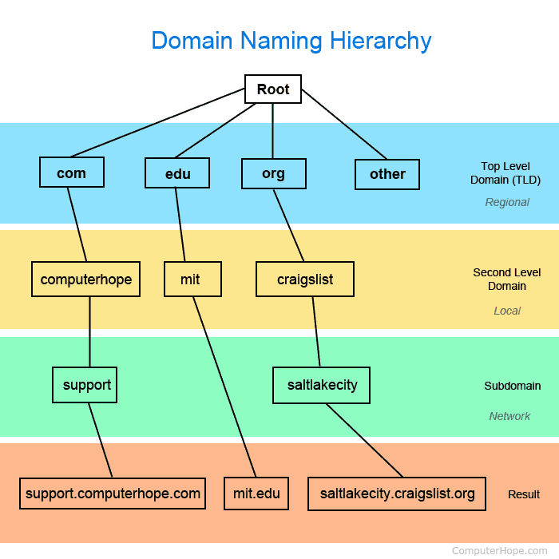

4.
A domain name, that’s part of the DNS system, has multiple DNS settings, which are also called DNS records. The DNS zone was created in order for these DNS records to be kept in order.
A DNS zone refers to a certain portion or administrative space within the DNS.
The DNS namespace is the total of DNS zones that are organized hierarchically.

