Managing People Assessment 2

Student name : Laura Madalina Ghitiu
Student Number: 1914805
Lecturer’s name: Charles Oham
Module: LCBB5004

Table of Contents
Introduction 2
Background of the report 2
Reviewing the concept and drivers of employee engagement 2
Importance of employee engagement within the workplace 3
Evaluation of diagnostic tools for measuring engagement 4
Strategies for raising levels of engagement 6
Constructing employee value proposition from the ideas and analysis covered 6
Conclusion 7
References 9

Introduction
The research paper is focused on identifying the different ways of keeping people engaged in their workplace. The critical understanding of the business environment where the individuals are working professionally has been demonstrated in the paper. The concept of employee engagement along with the factors that drive employee engagement in the workplace has been reviewed. The strategies important for raising the level of engagement along with its involvement in constructing employee value proposition from the analysis and ideas covered have been discussed. Different tools have been evaluated, which can be used for measuring employee engagement within the workplace appropriately.

Background of the report
The report is based on the importance of employee engagement for an organisation to provide productive outcomes. The concept of engagement in the workplace is acquired to help in improving performance and the well-being of the employees in the company. The organisation has not used any kind of employee engagement measures in the past, but with time and the current state of a pandemic, the organisation is concerned about the productivity of the employees (Eldor and Vigoda-Gadot, 2017). New ways of working have been rising in the pandemic, which is influencing employee performance. The Chief Executive of the organisation is worried that the low level of employee engagement experienced might harm the viability of the company. The organisation has adopted measures such as working from home, making the workplace safe from COVID-19, providing flexibility in working hours and restructuring and designing the job roles for the employees (Chandani et al., 2016).

Reviewing the concept and drivers of employee engagement
From the views of Bailey et al. (2017), employee engagement is the concept from HR that helps in describing the different levels of dedication and enthusiasm that is felt by the employees towards their work in the company. Furthermore, the engaged employees show care for their work and work on their performance in the organisation. The engaged employees work towards making efforts for making a difference in the workplace. According to the opinions of Barik and Kochar (2017), employee engagement is the concept of including the employee as a full-time member of the team, with clear and focused goals. Employee engagement helps in making employees trustworthy and empowered. It supports the development of new skills and receiving constructive feedback for improvement. Based on the views of Vorina, Simonič and Vlasova (2017), HR is responsible for making employees engaged within the workplace. Employee engagement is stated as the workplace method followed for designing and improving the feelings of an employee towards the organisation. It also helps in improving the emotional attachment along with job duties and company culture for the employees. For instance, employees with proper job security and health benefits in the company feel their need for safety is satisfied (Motyka, 2018).
According to the opinions of Popli and Rizvi (2016), employee engagement needs to be implemented and followed in the workplace to improve the performance and well-being of the employees in the organisation. The four key drivers of employee engagement for the organisation are engaging managers, integrity, employee voice and strategic narrative or leadership respectively. The leaders must help in engaging the employees within the workplace with work. Leaders should engage with the employees and learn about their issues and problems for resolving them for better employee relationships to develop in the firm (Kazimoto, 2016). Based on the opinions of Young et al. (2018), managers should engage themselves with employees based on supervision and helping them improve their skills for the workplace. Moreover, the voice of the empowered employee should be listened to as it helps in understanding the level of empowerment in the workplace and the level of engagement for the staff as well. Integrity is an important aspect to be followed in the organisation while empowering the employees.

Importance of employee engagement within the workplace
According to the views of Osborne and Hammoud (2017), employee engagement is important for the successful performance of the employees in the organisation. The engagement of the employees helps in making them invest more in the work they are doing, which helps in improving their quality of work as well. The organisation can improve its productivity, retain talented employees and improve work quality by investing in the engagement of employees in the organisation. From the opinions of Jha and Kumar (2016), employee engagement helps in increasing employee safety and provides better health benefits to the employees working in the organisation. Furthermore, employee engagement helps in forming happier employees by increasing the satisfaction levels of the employees. The employees are able of developing better work life and home life balance.
According to the opinions of Gupta and Sharma (2016), the satisfaction levels of the employees are increased with proper employee engagement in the workplace, which reflects on the reduced absenteeism rate in the company. Employee loyalty is increased within the workplace and this helps in retaining talented staff within the organisation. The increased employee commitment based on increased involvement within the workplace for the employees is possible based on the proper techniques for employee engagement in the organisation (Rothmann, 2017).

Evaluation of diagnostic tools for measuring engagement
Employee engagement is essential for leading an organisation towards increased operating efficiency and higher profitability. In the recent business scenarios, business leaders face one of the biggest challenges while running their organisation is to build an organisational culture with better employee engagement, which will drive towards better customer engagement and satisfaction. Measuring employee engagement is a complex process as it is not defined as a particular rule as well as the degree of employee engagement is variable due to the difference in work culture and way of operating business in various organisations (Goswami and Goswami, 2018). To achieve future success, business leaders need the following ways to monitor and measure engagement levels.
Employee Surveys
As opined by Stoyanova and Lliev (2017), the most effective form of evaluating employee engagement is conducting surveys. If the company ensures to conduct anonymous submission from the employees, participant rate is increased as well honest feedback and opinion from the employees can be generated. Moreover, third party organisations are utilised so that employees feel more comfortable while sharing their opinion without being insecure about their position in the workplace. There can be several kinds of survey, such as happiness survey, pulse survey, peer recognition survey and so on where the organisation could enable software to trigger them to a specified group of individuals working in the company and that survey can demand only 5 to 15 minutes to complete.
An effective survey should be able to make the managers comprehend employee motivation and job satisfaction (Byrne et al., 2017). A survey should derive several indicators where professional growth of an individual as well as their quality of work relationships with the other workers. Managers need to consider the following parameters while creating surveys, such as, whether employees feel enough passion during the workforce engagement and community involvement programs held by the organisation. Moreover, the survey questions should be close-ended and able to establish the interrelationship between the work-life balance of the employees and acquiring their best effort to help the company meet business objectives.
Take advantage of the employee lifecycle
Another effective way to measure employee engagement is through prioritizing engagement in every stage of the employee lifecycle. The employee lifecycle refers to every stage an employee goes through while serving in an organisation, such as Attraction, Recruitment, Onboarding, Development, Retention, and Separation. Managers can generate employee feedback in all the different stages of employment tenure (Sato et al., 2020). Beginning with the requisition, an employee can be directed to participate in several employee engagement programmes. While generating employee feedback in each phase of the lifecycle and responding to it consequently, managers emphasise the brand value of the company and reinforce an organisational culture in front of the engaged workforce (Whysall et al., 2019).
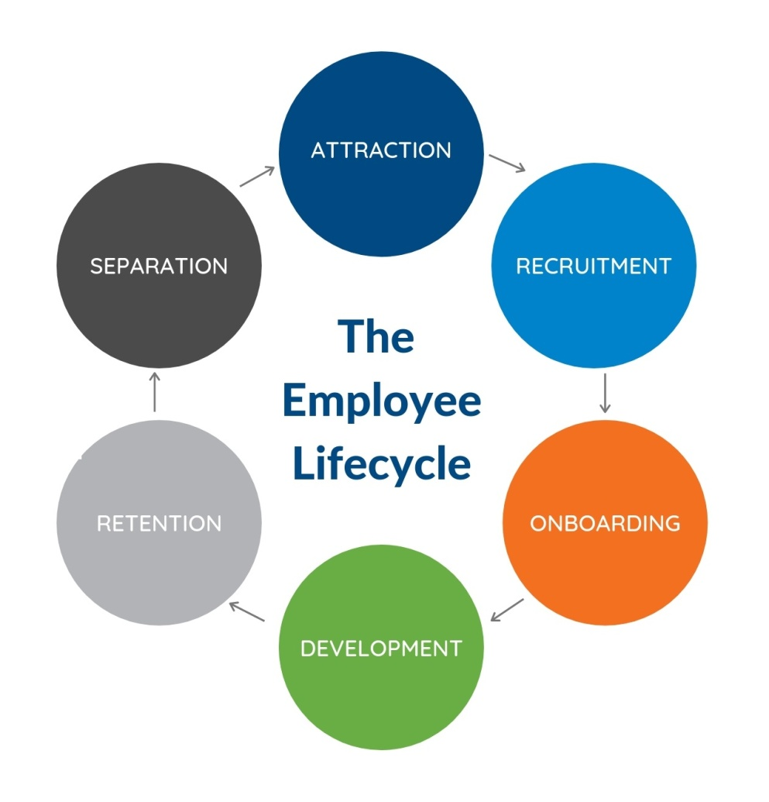
Figure 1: Stages of employee life cycle
(Source: Kakade, 2020)
Kakade (2020) opined that when every stage of the employee lifecycle are utilised for generating feedback, employees feel motivated to go through the next phases in the employment tenure of that same individual or others. For example, employees at their separation period with their organisation may refer a new candidate who is either skilled enough or suitable for a future job description if they have greater job satisfaction. Henceforth, such consistent efforts to engage in employee lifecycle support the company to acquire deserving employee recruitment as well as further employee retention to improve productivity at all organisational levels.

Strategies for raising levels of engagement
According to the views of Shrotryia and Dhanda (2019), HR can improve employee engagement in the workplace with the implementation of proper strategies respectively. Communication is an important strategy that helps in regularly and deliberately improves employee engagement in the organisation. Furthermore, HR has developed strategies for investing in the well-being of the employees to remain engaged with them in the workplace. The well-being of the employees is an important factor to be considered for increasing the levels of employee engagement in the organisation respectively (Men, O’Neil and Ewing, 2020). HR has to empower the employees and recognise good work by providing benefits and incentives.
Based on the views of Eisenberger, Malone and Presson (2016), HR is responsible for the development of performance appraisal programs and 360-degree feedback programs for identifying the strengths and weaknesses of the employees in the company. The employees should welcome the feedback appropriately and they should act on it for increasing the levels of engagement within the workplace. Furthermore, the purpose of the organisation should be discussed and the options should be shared with the employees to help them understand the skills that they need to learn for engaging in the betterment of the workplace (Othman et al., 2018).

Constructing employee value proposition from the ideas and analysis covered
According to the opinions of Ababneh, LeFevre and Bentley (2019), the employee value proposition is the unique set of benefits that are provided to the employees based on their skills, experience and capabilities that they bring to the organisation. The presence of a strong EVP helps the organisation in attracting talented employees and retains the best performers in the company. Based on the views of Kwon and Kim (2020), the EVP comprises the compensation, benefits, career and culture for the employees to keep them engaged and retains them in the organisation. In the organisation, the performance of the employees helps in deciding the benefit for the employee appropriately. The employees are provided incentives for the extra shifts that they work and a bonus based on improved performance for that week or month. According to the views of Stoyanova and Iliev (2017), the employees are provided promotions or demotions based on their performance in the organisation. The culture of the employees and the workplace are aligned while dealing with the ways to engage them in the firm.

Figure 2: Employee Value Proposition (EVP)
(Source: Created by the learner)
According to this EVP, it can be acquired that incentives are provided to the employees based on the hard work and extra shifts conducted by them. The employees are also eligible for increments in their salaries based on their performance in the workplace. Based on the views of Stoyanova and Iliev (2017), health benefits are important benefits to be provided to the employees by the organisation. However, the organisation also provides remote working facilities along with increased recreational breaks to maintain the physical and mental health of the employees in the pandemic. The work quality is improved for the employees by indulging them in training programs.

Conclusion
From the above discussion, it can be concluded that the research paper has focused on the different ways of keeping the people engaged in the organisation. The concept of employee engagement along with the factors that drive employee engagement in the workplace has been concluded. Different tools, which have been used for measuring employee engagement within the workplace appropriately, have been concluded. The critical understanding of the business environment where the individuals are working professionally has been concluded in the paper. The strategies significant for raising the level of engagement along with its involvement in constructing employee value proposition from the analysis and ideas covered have been concluded.

References
Ababneh, O.M., LeFevre, M. and Bentley, T., (2019). Employee engagement: Development of a new measure. International Journal of Human Resources Development and Management, 19(2), pp.105-134.
Bailey, C., Madden, A., Alfes, K. and Fletcher, L., (2017). The meaning, antecedents and outcomes of employee engagement: A narrative synthesis. International Journal of Management Reviews, 19(1), pp.31-53.
Barik, S. and Kochar, A., (2017). Antecedents and consequences of employee engagement: A literature review. International Journal of Latest Technology in Engineering, Management & Applied Science, 6(4), pp.33-38.
Byrne, Z.S., Hayes, T.L. and Holcombe, K.J., (2017). Employee engagement using the federal employee viewpoint survey. Public Personnel Management, 46(4), pp.368-390.
Chandani, A., Mehta, M., Mall, A. and Khokhar, V., (2016). Employee engagement: A review paper on factors affecting employee engagement. Indian Journal of Science and Technology, 9(15), pp.1-7.
Eisenberger, R., Malone, G.P. and Presson, W.D., (2016). Optimizing perceived organizational support to enhance employee engagement. Society for Human Resource Management and Society for Industrial and Organizational Psychology, 2(2016), pp.3-22.
Eldor, L. and Vigoda-Gadot, E., (2017). The nature of employee engagement: Rethinking the employee–organization relationship. The International Journal of Human Resource Management, 28(3), pp.526-552.
Goswami, S. and Goswami, B.K., (2018). Exploring the Relationship between Workforce Diversity, Inclusion and Employee Engagement. Drishtikon: A Management Journal, 9(1).
Gupta, N. and Sharma, V., (2016). Exploring employee engagement—A way to better business performance. Global Business Review, 17(3_suppl), pp.45S-63S.
Jha, B. and Kumar, A., (2016). Employee engagement: A strategic tool to enhance performance. DAWN: Journal for Contemporary Research in Management, 3(2), pp.21-29.
Kakade, S. (2020) What is an Employee Life Cycle? - Definition from WhatIs.com, SearchHRSoftware, [online] Available at: https://searchhrsoftware.techtarget.com/definition/employee-life-cycle (Accessed 9 August 2021).
Kazimoto, P., (2016). Employee engagement and organizational performance of retail enterprises. American Journal of Industrial and Business Management, 6(4), pp.516-525.
Kwon, K. and Kim, T., (2020). An integrative literature review of employee engagement and innovative behaviour: Revisiting the JD-R model. Human Resource Management Review, 30(2), p.100704.
Men, L.R., O’Neil, J. and Ewing, M., (2020). Examining the effects of internal social media usage on employee engagement. Public Relations Review, 46(2), p.101880.
Motyka, B., (2018). Employee engagement and performance: a systematic literature review. International Journal of Management and Economics, 54(3), pp.227-244.
Osborne, S. and Hammoud, M.S., (2017). Effective employee engagement in the workplace. International Journal of Applied Management and Technology, 16(1), p.4.
Othman, A.K., Mahmud, Z., Noranee, S. and Noordin, F., (2018, March). Measuring employee happiness: Analyzing the dimensionality of employee engagement. In International Conference on Kansei Engineering & Emotion Research (pp. 863-869). Springer, Singapore.
Popli, S. and Rizvi, I.A., (2016). Drivers of employee engagement: The role of leadership style. Global Business Review, 17(4), pp.965-979.
Rothmann, S., (2017). Employee engagement. The Wiley Blackwell handbook of the psychology of positivity and strengths-based approaches at work, pp.317-341.
Sato, Y., Kobayashi, N. and Shirasaka, S., (2020). An analysis of human resource management for knowledge workers: using the three axes of target employee, lifecycle stage, and human resource flow. Review of Integrative Business and Economics Research, 9(1), pp.140-156.
Shrotryia, V.K. and Dhanda, U., (2019). Content validity of assessment instrument for employee engagement. Sage Open, 9(1), p.2158244018821751.
Stoyanova, T. and Iliev, I., (2017). Employee engagement factor for organizational excellence. International Journal of Business and Economic Sciences Applied Research (IJBESAR), 10(1), pp.23-29.
Vorina, A., Simonič, M. and Vlasova, M., (2017). An analysis of the relationship between job satisfaction and employee engagement. Economic themes, 55(2), pp.243-262.
Whysall, Z., Owtram, M. and Brittain, S., 2019. The new talent management challenges of Industry 4.0. Journal of Management Development. Management Development, Vol. 38 No. 2, pp. 118-129. DOI: 10.1108/JMD-06-2018-0181
Young, H.R., Glerum, D.R., Wang, W. and Joseph, D.L., (2018). Who are the most engaged at work? A meta‐analysis of personality and employee engagement. Journal of Organizational Behavior, 39(10), pp.1330-1346.

