Name of the Team: Team Coffee
Student Name | Student ID
mARK WILLIAMS | 2022279
ASHLEY REES | 2009258
TIRION WALL | 2023509
JOSH archer | 2011907

Team Evaluation (Self Evaluate your Team)
 | Mark | Ashley |  | Tirion |  | Josh
Mark | 5 |  | 5 |  | 5 |  | 5
Ashley | 5 |  | 5 |  | 5 |  | 5
Tirion | 5 |  | 5 |  | 5 |  | 5
Josh | 5 |  | 5 |  | 5 |  | 5
Rate your Teams Contribution with a scale of 1 to 5 (1 No Contribution and 5 Excellent Contribution)
Ashley: The team worked well very well together, there was a good mixture of Cyber security and Software development. Each stream contributed differently to the overall creation of the assignment. Josh and Tyrion provided the screenshots needed, while I helped with the technical side when setting up the servers and client systems through the type 2 hypervisor. Mark was then able to compile all the screenshots to create the group section of the assignment.
Mark: Our team work exceptionally well together we each contributed parts to the overall task that helped each other understand the subject further for example Ashley assisted those of us who have less experience within Virtual Machines and guided us when the stages got a bit confusing. Tirion and Josh provided important screen shots that showed parts of the task steps that helped with writing up the assignment.
Tirion: Our team worked well together. Josh and I study Software Engineering, it was therefore really helpful to collaborate with Mark and Ashley who study Cyber Security as they have a good understanding on the topic. Ashley helped us troubleshoot problems we came across, Josh and I provided the screenshots and Mark put the screenshots together, created the layout and wrote the captions. We then all edited it together.

Josh: We all worked well as a team and due to us all coming from different disciplines we were all able to bring unique benefits to the team.
Mark was helpful when it came to trouble shooting a few problems for me. One of these was when I couldn’t figure out that when adjoining the domain and testing user logins, I kept getting an error message instead of being prompted to input an admin account details. Mark helped me trace the problem back to the incorrect value for the Preferred DNS Server. This then solved the problem. Ashley was a great help especially in the early stages of setting up the VR Machines and different Server and Client accounts. As I didn’t come from a Network Operating Systems background, Ashley was able to help me understand the layout of what we are trying to do.
Tirion like myself came from a Software Engineering background. Tirion and I both set up the Type 2 Hypervisor platform based Virtualised network. This was to be able to provide us with valuable experiences in network operations and to also provide a back up to each other’s work in case one was lost or corrupted. Tirion and I also both provided the screenshots for the proof.

Dr. Nitheesh Murugan Kaliyamurthy 23/02/2023

Network Operating Systems and Services
ACCA5023

Mark Williams – 2022279

Build, deploy, configure, and manage a
Type 2 Hypervisor platform based Virtualised network

Content page

Team Page 1-2
Front Page 3
Title Page 4
Content Page 5
Abstract 6
Building a virtual LAN using type 2 Hypervisor software 7-14
Deploying network directory and creating an Active Directory 15-24
Observational tasks 25
Type 1 and 2 Hypervisors 25-26
DHCP 26-27
Active Directory 27-28
Terminologies 29
PING 29
IPV4 Default Gateway 30
Firewalls 31
Reflection 32
References 33

Abstract

The purpose of this assignment was to work within a team of three other students to build, deploy and manage a type 2 Hypervisor platform by creating four virtual machines two for client and two for server. Within this team each student had tasks delegated to them which had to be completed, evaluated, and changed to by each of the other members of the group to make sure each steps of the task work together. Within the first part of this assignment it covers the stages taken to create the type 2 Hypervisor with screen shots of the virtual machines showing certain stages and goals reached with descriptions on what is happening and why it is used.
The second part covers task 3 which is completed individually and shows observations details of why Type 2 Hypervisors are used along with a comparison of Type 1 Hypervisors and an in-depth detailed description of different terminologies such as Ping, Server Management Firewall etc. At the end of this assignment shows a brief reflection on the entirety of the tasks set and how working within a team helped and hindered the tasks.

Building a virtual LAN using type 2 Hypervisor software

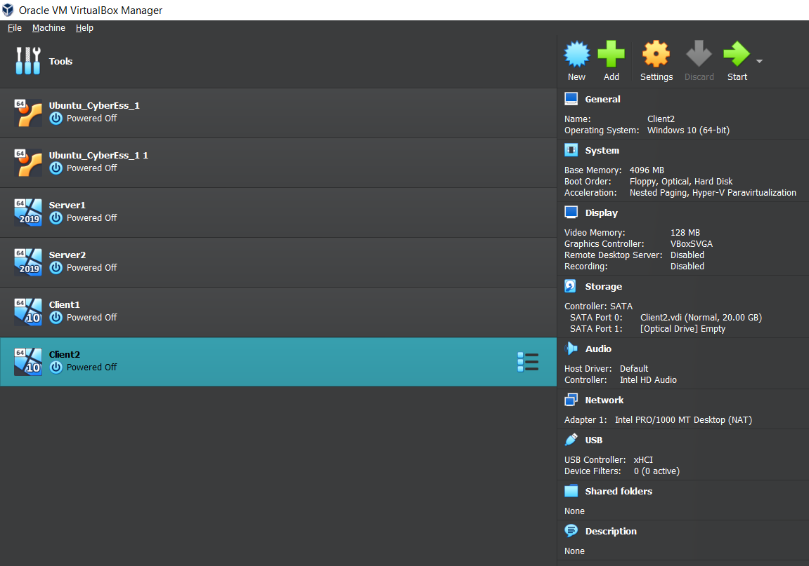
The above image shows Oracle VitualBox Manager with four Virtual Machines, two Client and two Server. The right side of the image shows the configurations for the client Virtual machines showing the systems base memory, operating system, and display settings all of which have been manually set to allow the virtual machine to run smoothly and connect to the server.

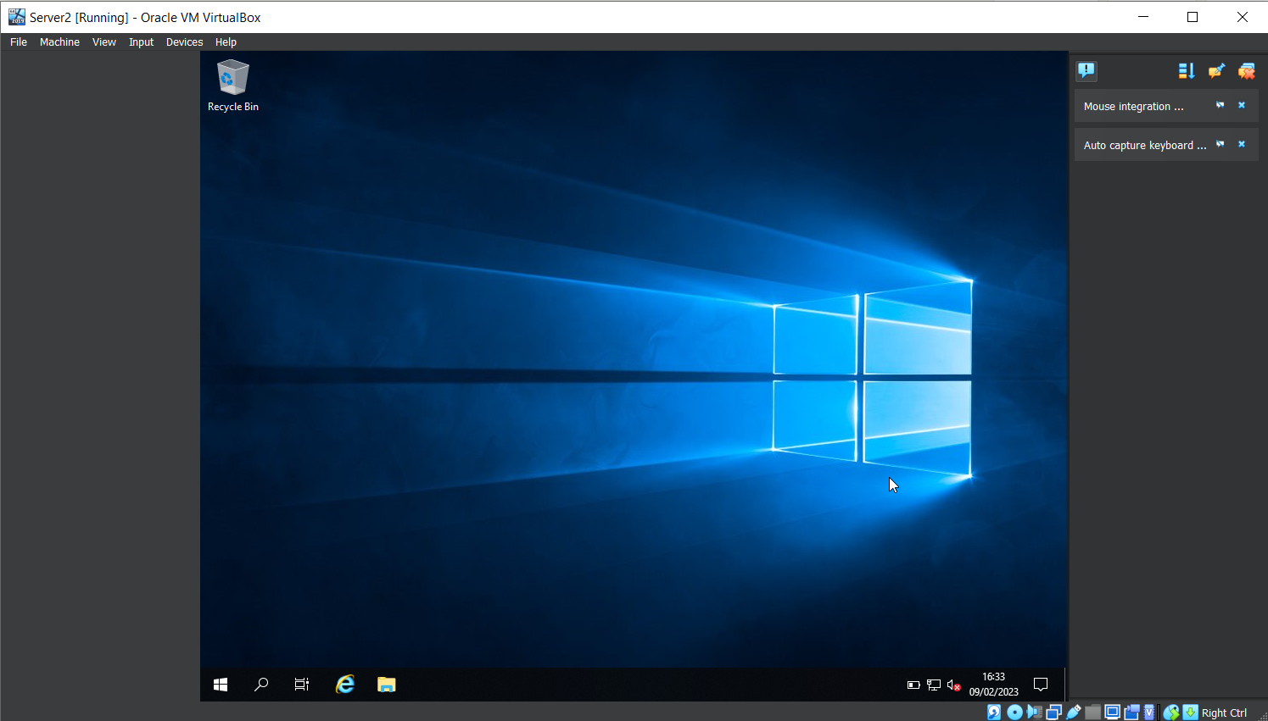
A view of first start up of the Virtual Machine for Server2 which displays like a regular computer would when first starting up, but this Virtual Machine has warnings and errors shown on the right hand side, customisable settings shown in the bottom right of the image and also has the ability to press certain combination of buttons such as alt + control and delete within the “Input” option at the top left.

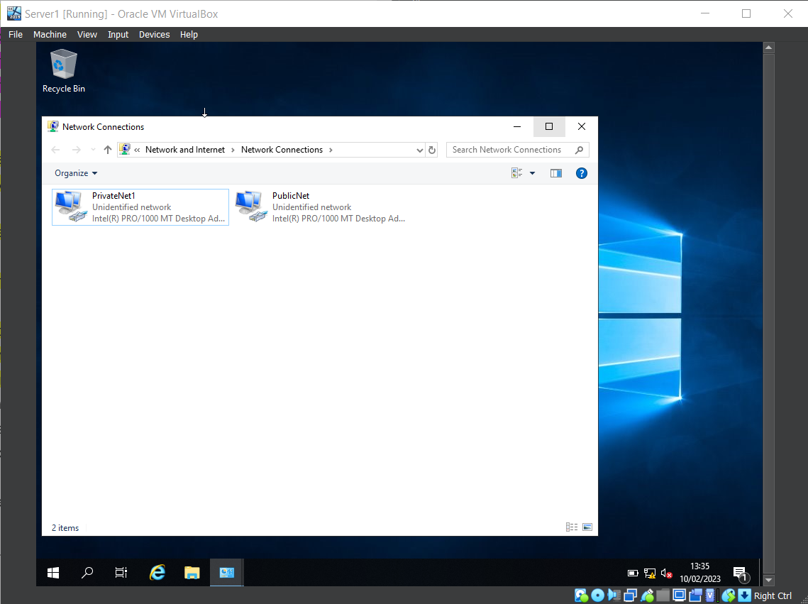
Within this image it shows the Network Connections for both PublicNet and PrivateNet1 this is done on both Server1 and Server2 Virtual machines and allows for the connection between server and client.

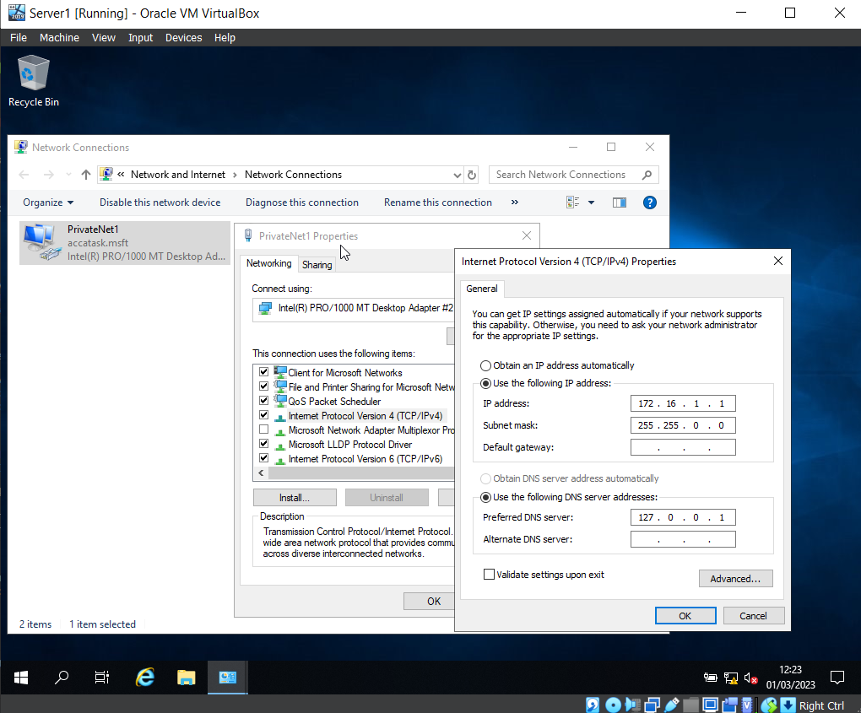
Following from the image above to make the Server and Client Virtual machine communicate there must be an IP address set for the machine. The above image shows the IP address and the Subnet Mask along with the Preferred DNS server which is used for later in the task.

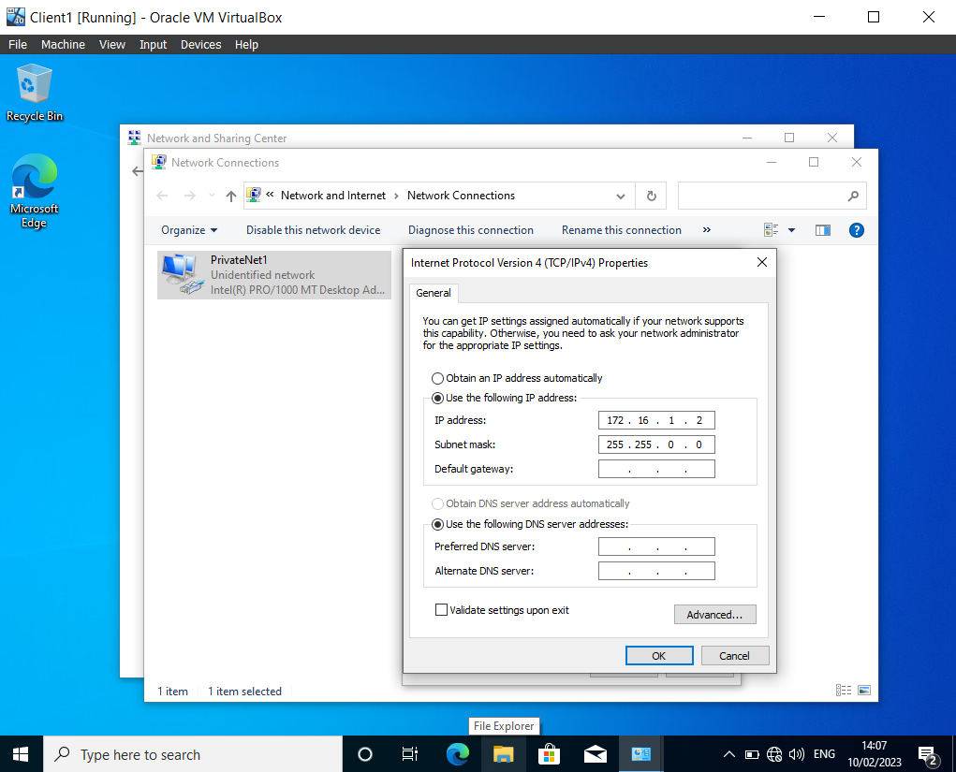
In the image shown above Client1 has been started and as mentioned in the images above to get the Server1 and Client1 virtual machines to communicate the Network Connection PrivateNet1 is created and as shown here the IP address and Subnet mask are inputted.

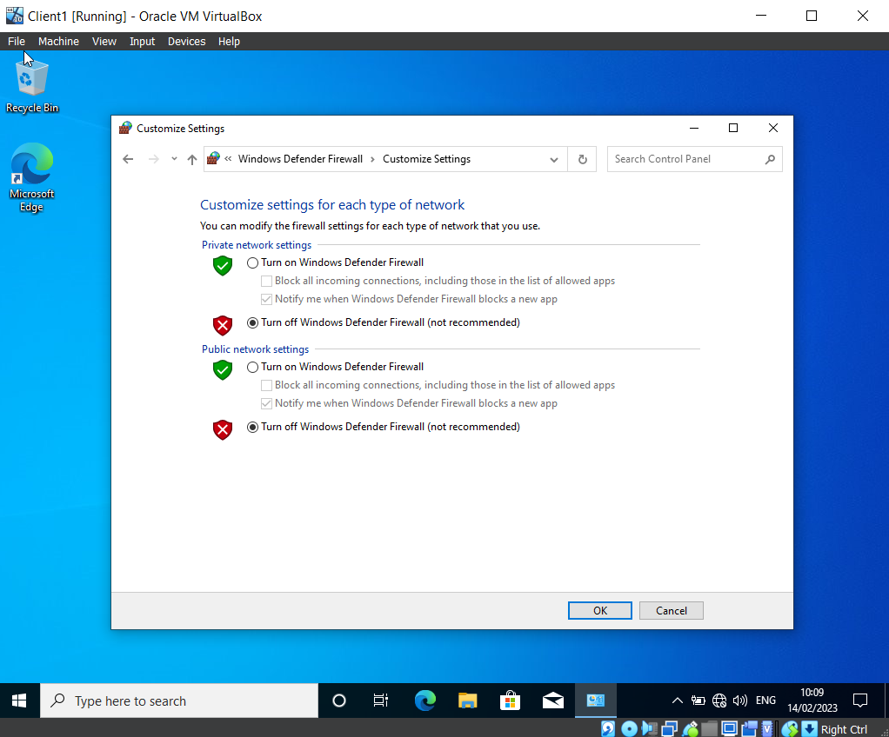
Firewall settings are turned off for the Client and Server Virtual machines to be able to communicate with each other the. The firewall will block incoming ping requests by default from unknown sources as a security measure because pings can be used maliciously.

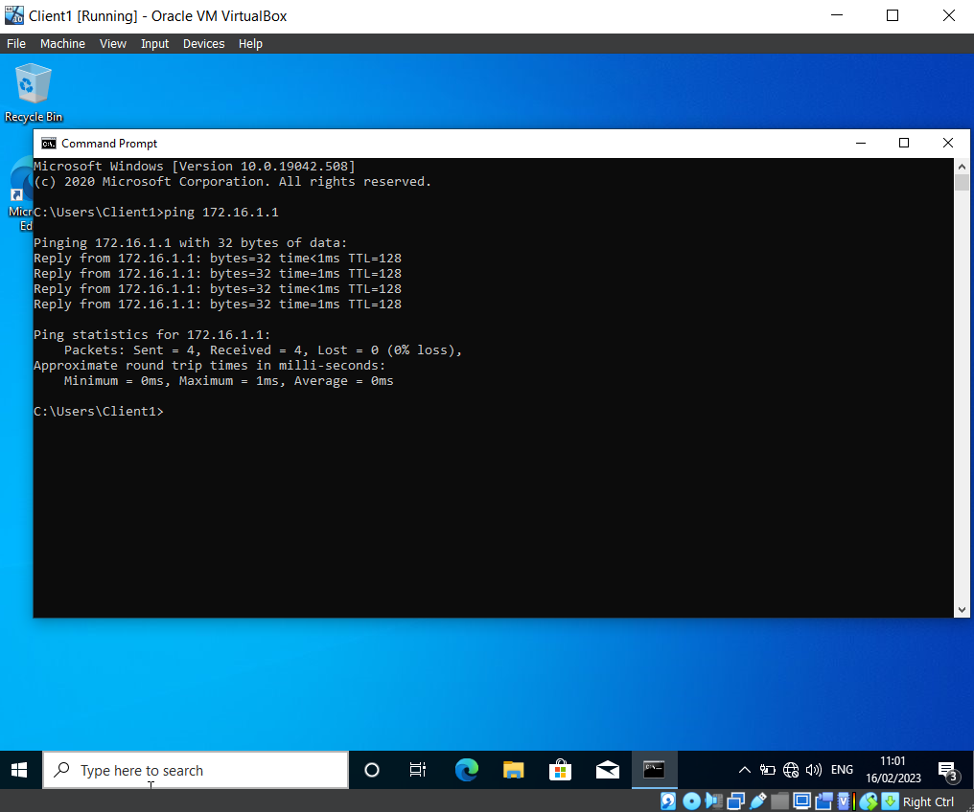Successful ping from Client1 to Server1 virtual machine, the image shows the reply time once the command for the server1 IP address to ping. Which shows that the steps followed within the pictures above have allowed the connection and communication of Server1 and Client1.

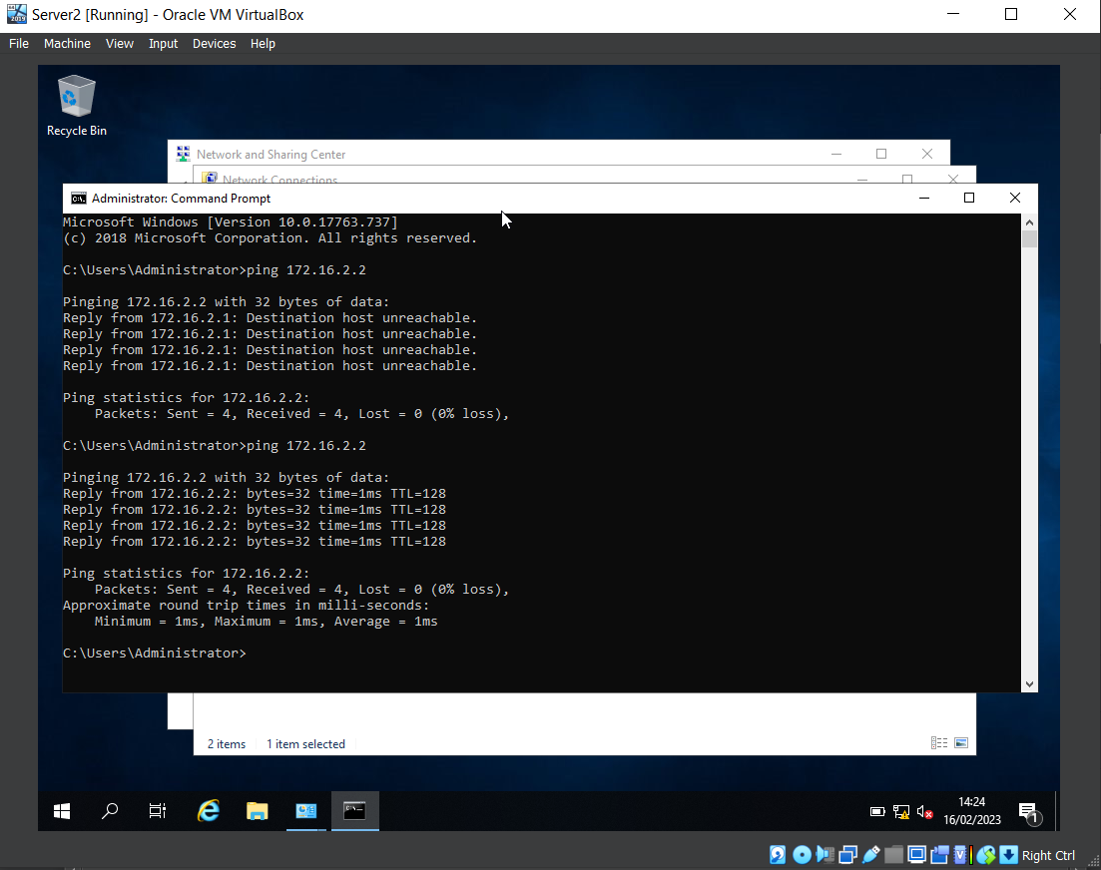Successful ping between Server2 and Client2 virtual machines showing that the setup with network connections was inputted correctly and shows that the IP address set for Client2 are correct.

Deploying network directory and creating an Active Directory

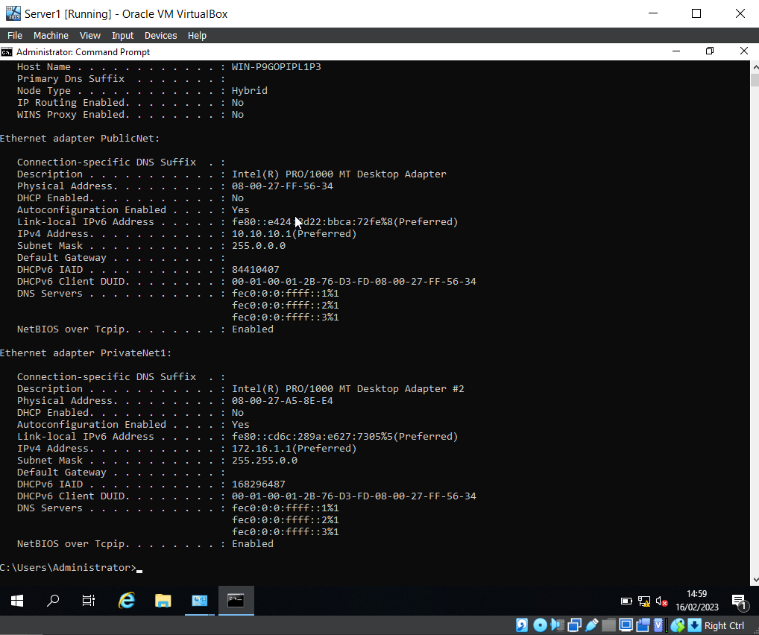
The following image shows that the DNS has not been set up and that the firewall is turned off along with the Server IP being Statically Defined. This confirms all of the steps taken in the task above and shown within the images are correct and confirmed.

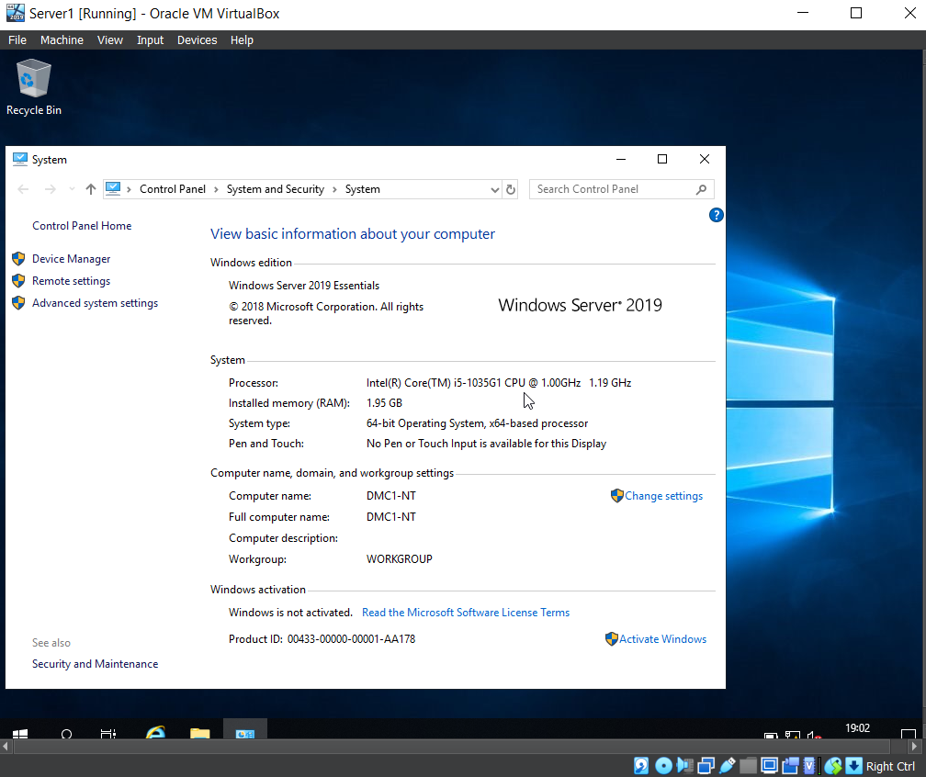 Showing within Server1 the Computer name has been changed to “DMC1-NT” within the control panel system settings.

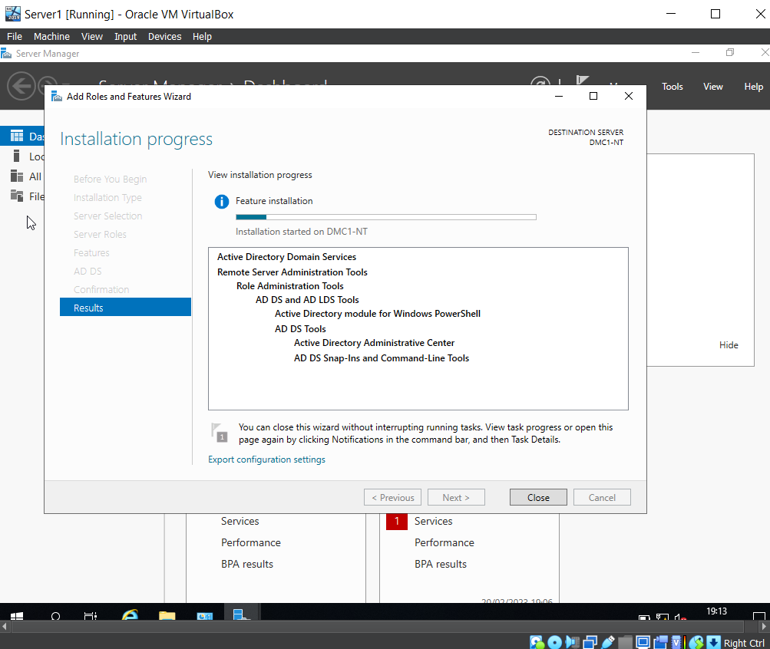Active Directory is a database that manages network resources such as computers and users. It allows for administration to restrict and grant access to all aspects of the network such as groups for specific access, security policies. My experience working within Digital Health Care of Wales active directory houses all of the NHS Nadex’s which are what staff use to log in and each Nadex will have groups that grant access for whichever department that staff member is apart.

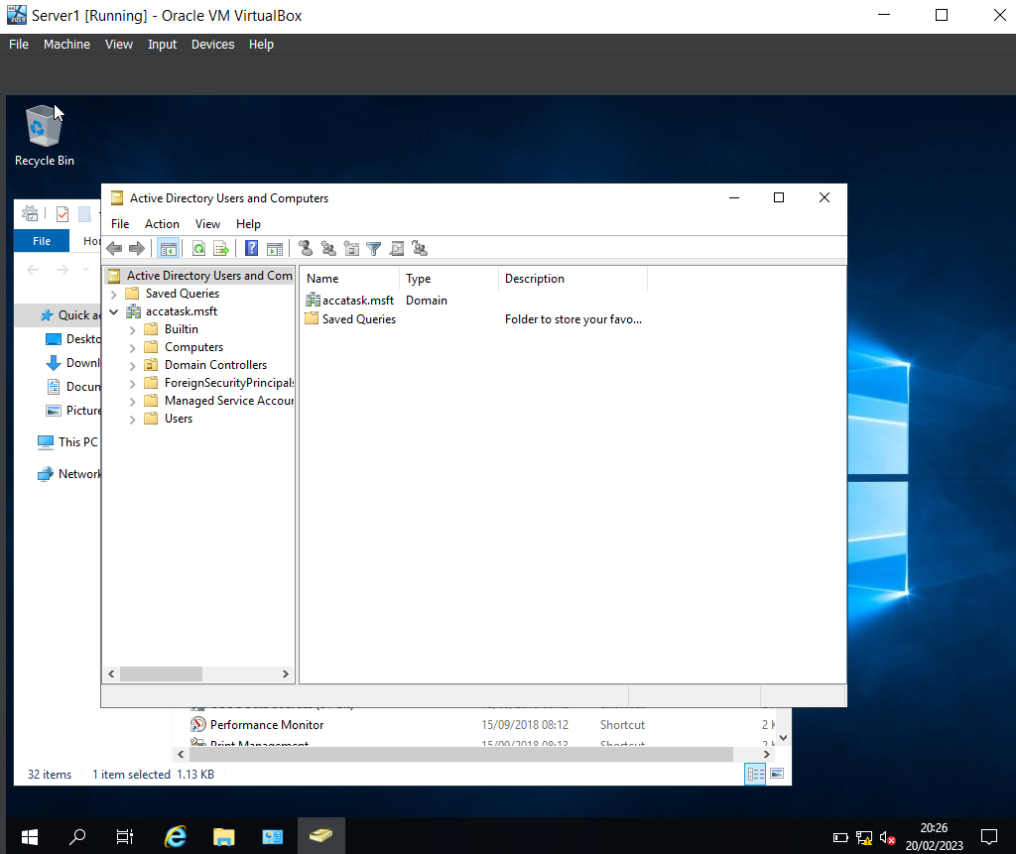
First time opening Active Directory within Server1, on the left hand side of the directory there are the folders for users and computers which allow for creating new users.

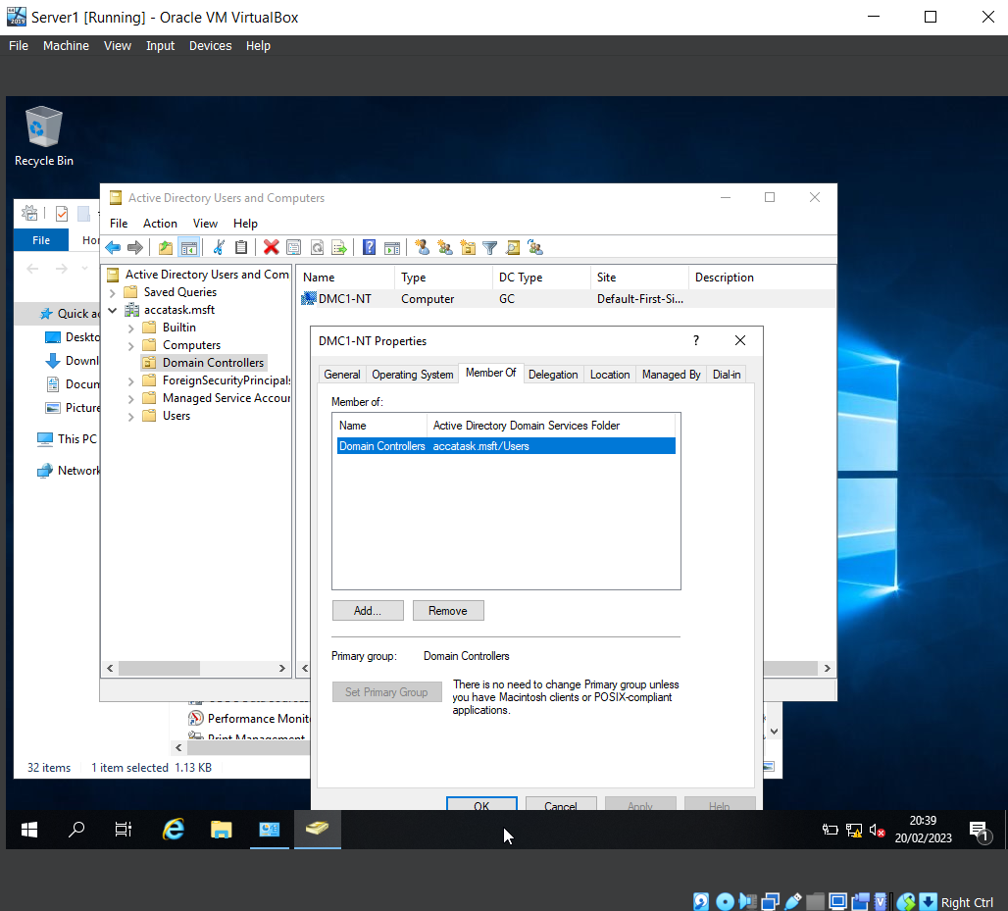The computer name “DMC1-NT” is shown in the image above inside of Active Directory it shows the “member of” group which grants the account access to certain things within the network here the domain controller has been set “accatask.msft”.

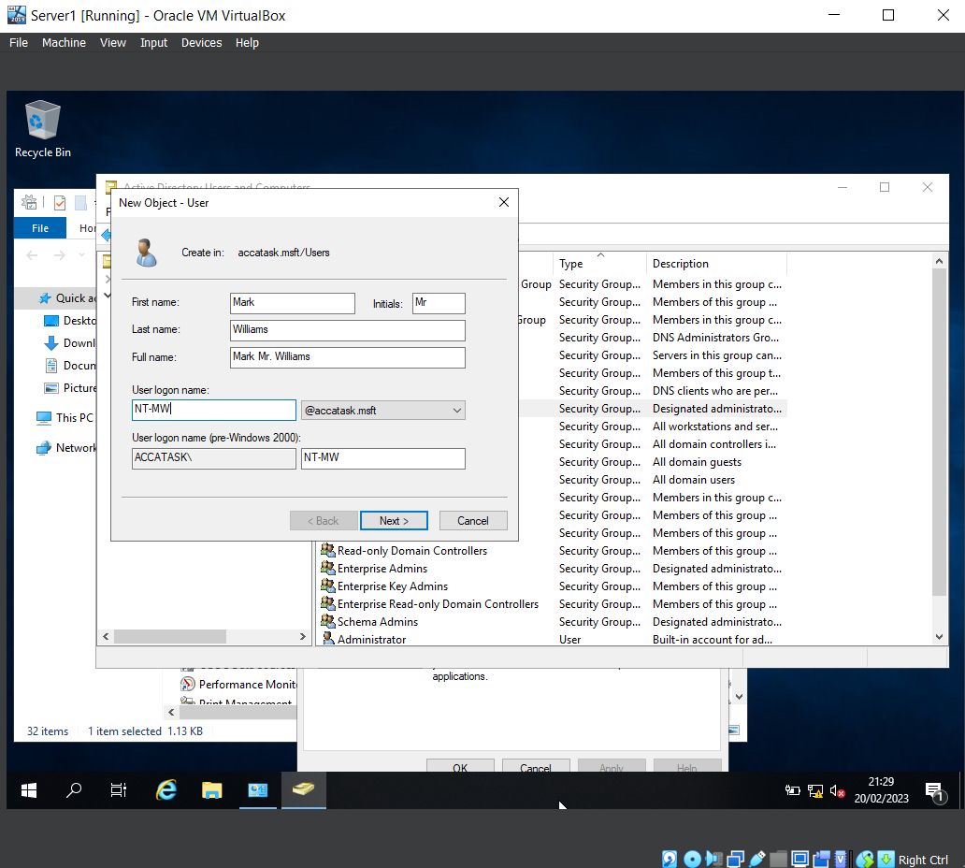Active Directory allows for the creation of users which will than grant access to the network. In this image it shows the users full name and what will be the account details that will be used to login.

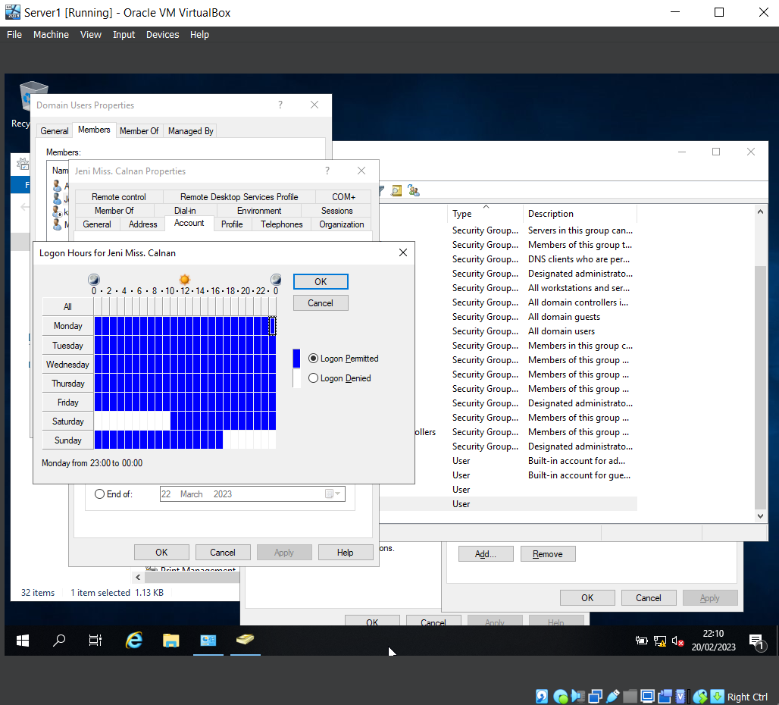A lot can be customized within Active Directory including the times users are able to log in stopping unauthorized access to the network certain times keeping the network safe from possible malicious attempts by users trying to gain access outside of office hours. The customization is simple the white boxes are to deny login at these times and days and the blue allows users to login.

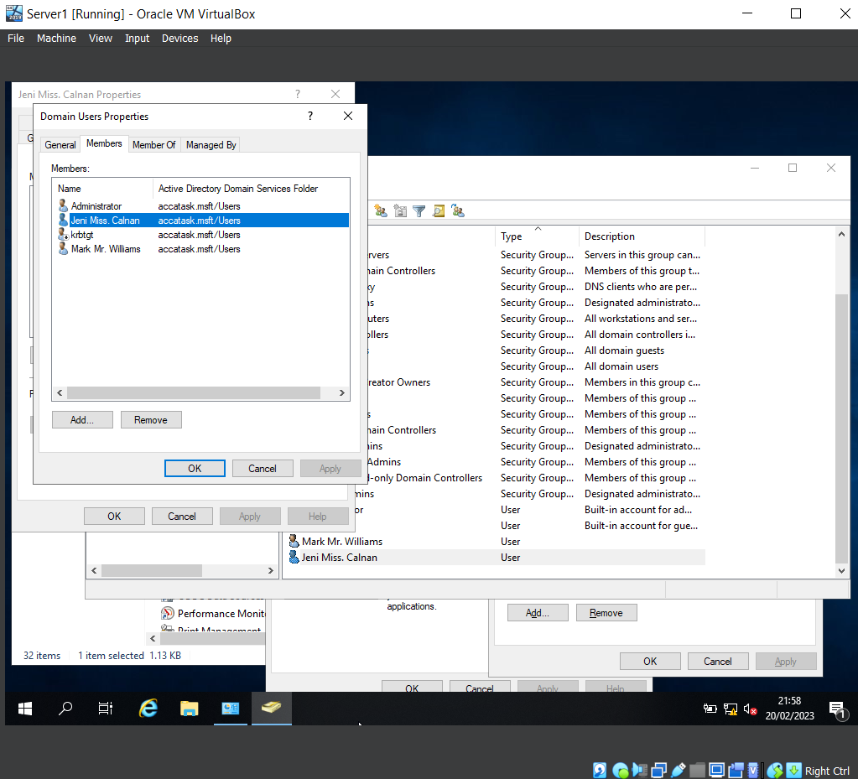The users created within Active Directory and placed within the “Domain Users” group will all appear when accessing the group as shown in the image above where all users that are in that group appear in the list of the “Members” tab inside “Domain Users” properties.

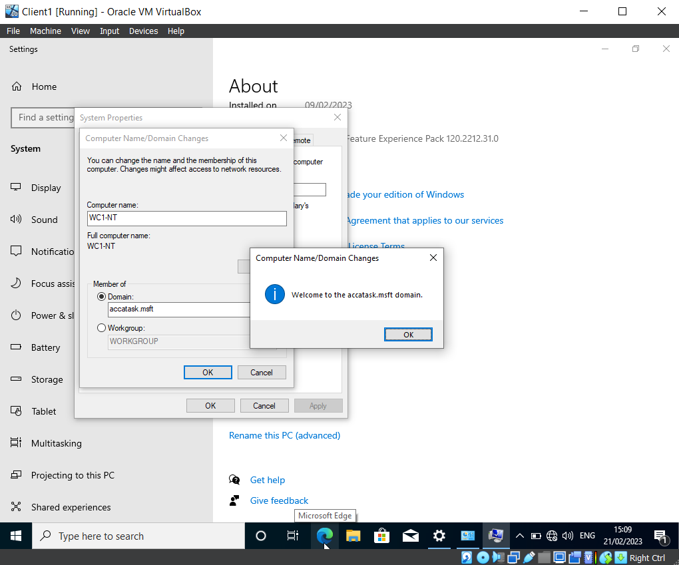Client1 Virtual Machine is connected to “accatask.msft” domain which allows for activate directory users and policies to be used within this computer.

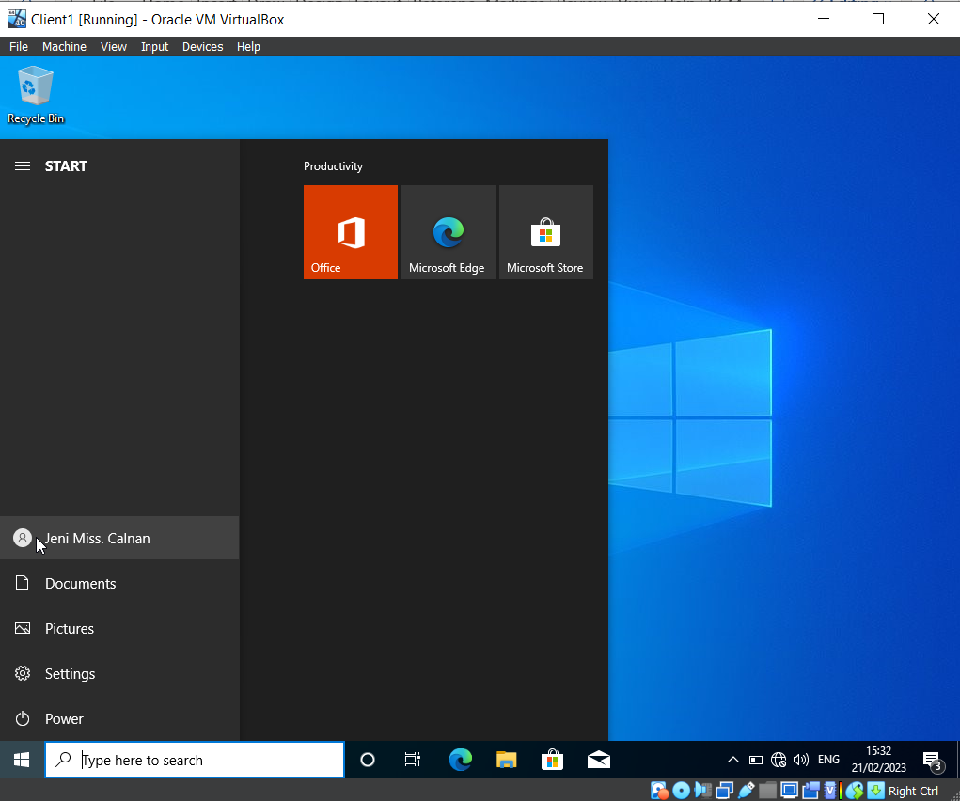Continuing from the above image Client1 is connected to the Active Directory and users are able to login as proven in the image above where a user created “NT-JC” has logged into the Virtual Machine because of the connection to the Active Directory and Network.

Observational Tasks
Type 1 and Type 2 Hypervisors

A Type 2 Hypervisor was used for the practical task because of its ease in installation, this type of Hypervisor is run through the operating system on the host machine. This then runs the Virtual Machines and grants the ability to change system settings such as Operating systems. This type of Hypervisor is mainly used for induvial testing and virtualised work. One major drawback of using a type 2 Hypervisor is the demand on the host machines as it runs through the operating system to use the physical hardware[1] which can cause errors, the image below shows one of the errors that occurred during the practical task.
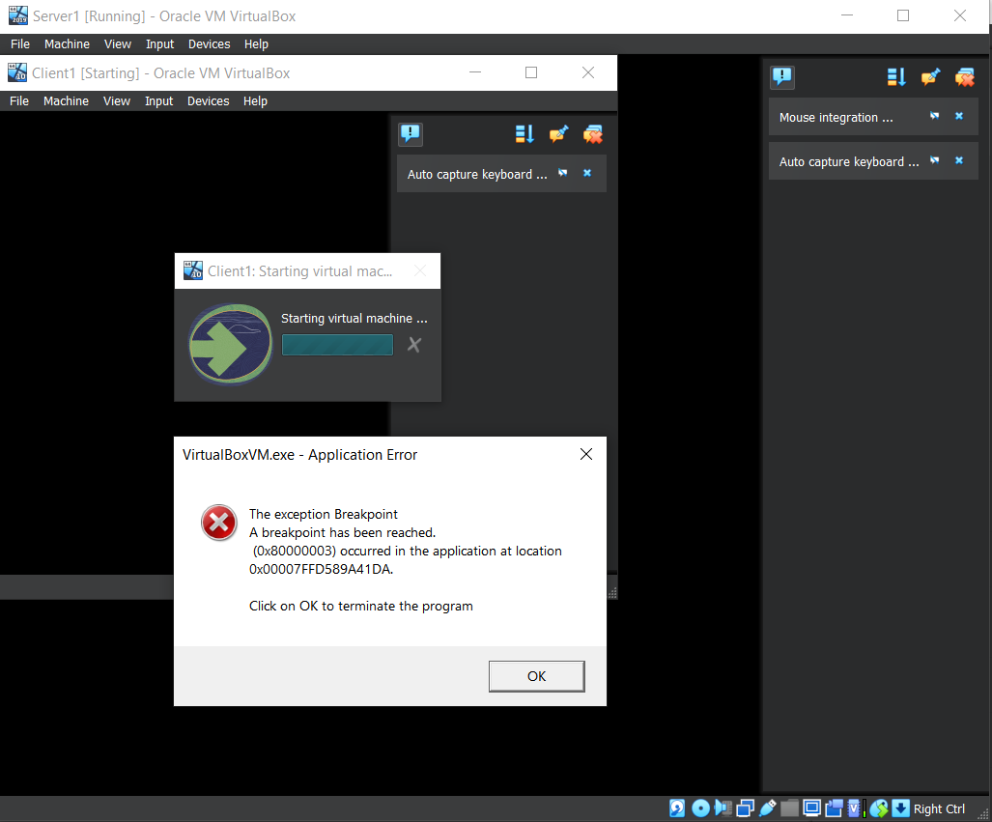This was caused by opening Client and Server Virtual Machines at the same time with too much Base Memory running on both machines at once. Reducing the Base Memory on both machines resolved this issue. The downfall to this type of Hypervisor is also one of the benefits which is the ability to change a wide range of settings such as RAM, Video Memory and system settings as displayed earlier in the practical task which allows for easy customisation if the host machine is capable of it.
Type 1 Hypervisors also known as bare metal Hypervisors[2] are mainly used by organisations that require multiple Virtual Machines running at once. This is done by running the Virtual Machines from a single server as it accesses physical hardware and doesn’t require the host to have an Operating System[3] as it uses the physical hardware of the actual machines using it. One of the benefits for using a Type 1 Hypervisor is the security[4] because there is nothing between the server and the CPU for attackers to compromise, unlike a Type 2 Hypervisor if it is attacked an attacker will have access to all of the Virtual Machines within the Host environment.
Another benefit for using the Type 1 Hypervisor over the Type 2 is the efficiency, as it doesn’t require the host machine to have all the physical demands. This means its not limited to the host machine and uses the physical components of the user’s machine.

Dynamic Host Configuration Protocol
Dynamic Host Configuration Protocol also known as DHCP assigns IP addresses to devices within a network[5]. Below is an image that explains further how DHCP work.
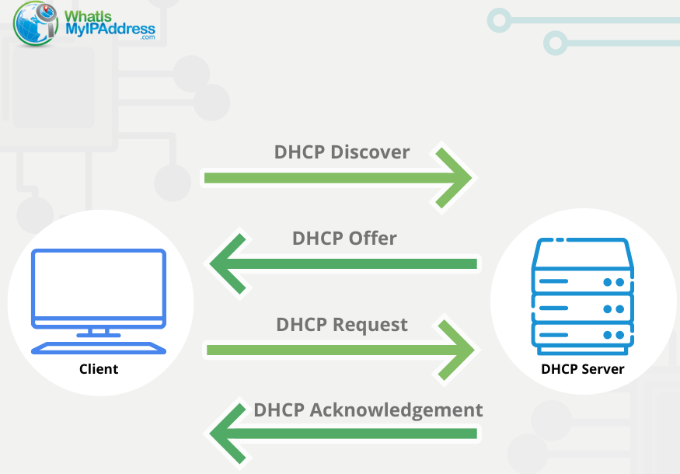
[6]
The image demonstrates how a computer requests an IP address from the DHCP server, the DHCP then receives this request and will then assign an available IP address to the device. The DHCP will also assign configurations such as Subnet mask, default gateways and a DNS, this allows the device to communicate to the network.
One of the benefits to using DHCP is that it eliminates the need to manually assign IP addresses to massive amounts of devices making the process simple. This eliminates time waste and stops any issues that might occur when users try assign IP addresses[7].
A negative to using DHCP is that attackers are able to infiltrate the DHCP and hand out wrong and malicious IP addresses to devices that allow for cyber-attacks known as “Man-in-the-middle”[8]. This type of attack is when an attacker infiltrates a network, usually via the communication between the network and a user, which then allows them to record and steal valuable information[9].

Active Directory
“Windows active directory server has information about all the objects of users, computers, and resources like printers, shared files or folders connected in an organizations network”[10].
The above quote from an article regarding Active Directory describes its main principles. Active Directory is used in various types of businesses and allows for an organized network of all user’s accounts. Within these accounts Active Directory shows the groups and objects that particular user is able to access. This allows for the organisation to allow their users to only access necessary parts of the network that apply to their role. It also provides Single sign-on which allows users that sign into a computer to access everything they’re in an object for such as shared folders without having to re-sign in.
Objects are necessary, as an example, you wouldn’t want a receptionist to have access to certain patient information that only Doctors should have access to. This eliminates issues that could occur if non clinically trained staff or staff that might have malicious intent from accessing parts of the network that could cause larger problems for the Organisation.
Within NHS Digital Health and Care Wales, Service Desk Analysists use active directory daily to create nadex’s that Authorized users have requested, these nadex’s are what user’s login to the network with and consist of two letters and four numbers. Once that has been created the Analysists will then add these nadex’s to specific groups. This will then allow the user access to shared files and the ability to log in within their organisation.

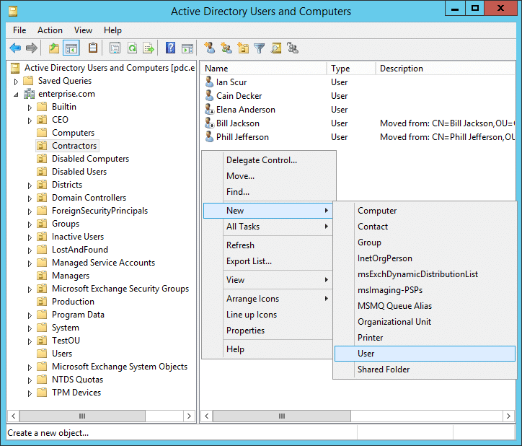[11]
The above image shows Active Directory and how there is an option for creating new users, computers, Shared Folder, etc and on the left hand side of the image there is a list of the objects such as Disabled Users and other Objects that users are placed in and can be granted access to.

Terminologies
Networks have multiple terminologies below are some that were mentioned throughout the first task within this assignment with further descriptions and understanding of how they’re used in real world environments.
Ping
Ping is a command used within Command Prompt to test weather or not a computer or other device is connected to the network, the command for this is “ping”. Along with the devices IP address it will then display the time taken to respond, this is known as latency. If the response time is low that means the connection is fast.
The above image is from the first part of the assignment tasks and shows both examples of a ping being able to communicate with the Server by showing a reply and the speed of the reply. It also shows an example of what message appears when unable to communicate.

IPV4 Default Gateway
Following the above terminology an Internet Protocol also known as an IP, the IPV4 Default Gateway is an address given to a device that allows for it connect to the internet and network. It can be manually provided but larger businesses use a Dynamic Host Configuration Protocol to automatically provide unique IPs to every device connected to the network. IPs are located different ways within different operating systems as shown in the images below.
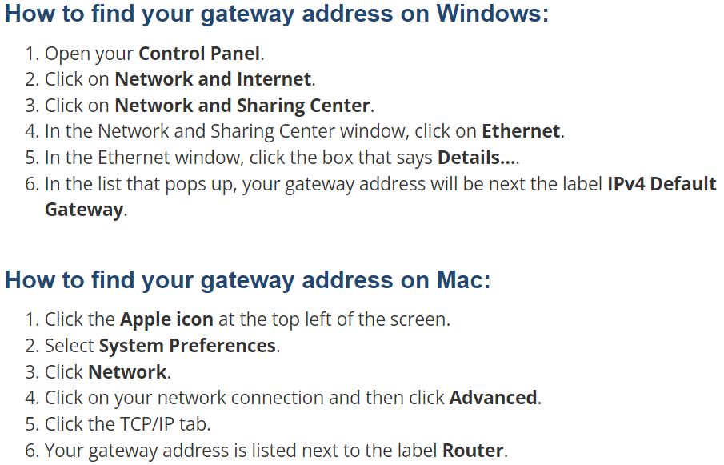[12]
The above image gives instructions on how to locate an IP address on a Windows operating system and an Apple Mac.

Firewall
In an ever evolving technical world Cyber-attacks are growing and creating the need for more safety[13]. Firewalls are a type of software or hardware that provides security to devices by blocking and limiting access to certain aspects to a variety of services, websites, and software. An example of this would be how Digital Health and Care Wales have recently banned TikTok from all Organisation Devices due to the increased risk with Cyber attacks from the application.
There are multiple different types of Firewalls some of which are listed below with descriptions of what protection they provide and possible negatives.
- Packet Filtering Firewalls
The oldest type of firewall which operates at the network, its purpose is to check source IP and destination IP to make sure the IP addresses are within the predefines of either, allowing or restricting access. These type of firewalls are fast and cheap, but the security provided is quite limited in what it is capable of.
- Circuit-Level Gateways
These type of Firewalls use a technique known as Proxying, which handles connections made between Client and Server. The Firewall obtains the request sent from the client to server and creates a private internal connection with the server, which allows all data flowing from client to server to be monitored and keeps data within the set predefines. These types of firewalls are prone to hijacking cyber attacks where attackers take over connections to gain access to the network.[14]
Firewalls are an essential part of any organisation which act as a barrier between user and network preventing, limiting, and maintaining predefines set by an organisation preventing attackers and even helping users that may accidentally click a wrong link.

Reflection
The tasks that were set within this worksheet were fascinating to me, because it relates directly to what I do within the NHS at Digital Health and Care Wales, especially the Active Directory aspect. It allowed for a deeper understanding how information such as user login details and Objects is stored within Active Directory, and how it allows for networks to communicate. I especially enjoyed using the Virtual machines and getting a better understanding of the uses for Type 2 and Type 1 Hypervisors.
The team aspect to this task has been enjoyable and taught me to look at different ways of the subject that I didn’t think to look at. For example Tirion provided important screen shots of the installation of the Active Directory process that I wasn’t aware were needed. Although enjoyable, working within a team did have its drawbacks in terms of students not attending and waiting for certain team members to provide evaluations before being able to complete the assignment.
Overall the task set was enjoyable, and I believe the brief knowledge of active directory I came into this assignment with from my job in the NHS has given me a good foundation, which I have built on during this worksheet. This foundation, along with the different information my team provided during the first part of this assignment will allow me to use in my working environment.

References
[1] C. Jiang et al., “Energy efficiency comparison of hypervisors,” Sustainable computing informatics and systems, vol. 22, pp. 311–321, 2019, doi: 10.1016/j.suscom.2017.09.005. used for: information regarding Hypervisors hardware demand. https://tinyurl.com/2p8du2yz.
[2] Nasim R, Zola E, Kassler AJ (2018) Robust optimization for energy-efficient virtual machine consolidation in modern datacenters. Cluster Comput 21(3):1681–1709.
[3] Article, IBM, Hypervisors, https://www.ibm.com/uk-en/topics/hypervisors, used for information on Type 1 Hyper Visors.
[4] Z. Aalam, V. Kumar, and S. Gour, “A review paper on hypervisor and virtual machine security,” Journal of physics. Conference series, vol. 1950, no. 1, p. 12027–, 2021, doi: 10.1088/1742-6596/1950/1/012027. https://iopscience.iop.org/article/10.1088/1742-6596/1950/1/012027/pdf.
[5] N. Weinberg, “DHCP defined and how it works: Dynamic host configuration protocol simplifies and improves the accuracy of IP addressing but can raise security concerns,” Network World (Online), 2022.
[6] Website, “What is DHCP and How Does It Work”, “WhatIsMyIPAddress”, used for: image of DHCP, https://whatismyipaddress.com/dhcp.
[7] Website, article, “RF Wireless World”, “Advantages of DHCP | disadvantages of DHCP”, used for positives of DHCP use, https://www.rfwireless-world.com/Terminology/Advantages-and-Disadvantages-of-DHCP.html.
[8] Neal Weinberg, 14 March 2022, NETWORKWORLD, “DHCP defined and how it works”, used for negative use of DHCPhttps://tinyurl.com/2s35kcat.
[9] P. Wlazlo et al., “Man‐in‐the‐middle attacks and defence in a power system cyber‐physical testbed,” IET Cyber-Physical Systems, vol. 6, no. 3, pp. 164–177, 2021, doi: 10.1049/cps2.12014, https://ietresearch.onlinelibrary.wiley.com/doi/full/10.1049/cps2.12014?sid=vendor%3Adatabase.
[10] J. Arumugam and R. Balasubramani, “Working Architecture of Active Directory Applications in Libraries,” Library philosophy and practice, pp. 1–7, 2019. https://www.proquest.com/docview/2216863549?accountid=130472&parentSessionId=7PD8Cvl6zzy4inm%2BZB5N70SNGIxfXjQ5%2FOWWbXSs5yI%3D&pq-origsite=primo.
[11] Jeff Melnick, Netwrix, “Active Directory Users and Computers: What It Is and How to Install It”, used for image of Active Directory, https://blog.netwrix.com/2017/01/30/active-directory-users-and-computers-aduc/.
[12] Website, “What is DHCP and How Does It Work”, “WhatIsMyIPAddress”, used for: Image of locating IPs on different Operating Systems, https://whatismyipaddress.com/dhcp.
[13] N. Kumar, K. Mohan, and R. Holowczak, “Locking the door but leaving the computer vulnerable: Factors inhibiting home users’ adoption of software firewalls,” Decision Support Systems, vol. 46, no. 1, pp. 254–264, 2008, doi: 10.1016/j.dss.2008.06.010., https://www-sciencedirect-com.ezproxy.uwtsd.ac.uk/science/article/pii/S0167923608001243.
[14] Giorgio Bonuccelli, November 4 20220, Website, Parallels, “What Are the Basic Types of Firewalls?”, used for different Firewalls and descriptions. https://www.parallels.com/blogs/ras/types-of-firewalls/.

