

Graduate Diploma in Professional Police Practice

LEVEL 6 - 40 Credits

Workbook title: Competency Based Workbook 1 (DHEP)

(SOUTH WALES POLICE, GWENT POLICE AND UWTSD)

Learner name: Dan Davies

Learner’s University Registration Number: 02132089

FACULTY OF BUSINESS AND MANAGEMENT
PUBLIC SERVICE PROGRAMME

Module title: Policing in the Workplace 3 (DHEP)
Workbook Guidance

Please read these notes carefully; they provide essential information.

What is the workbook for?

The purpose of this workbook is to enable learners to demonstrate and provide evidence of how they meet the learning outcomes set by the College of Policing, for the Graduate Diploma programme. Essentially you are being asked to outline your experiential learning based upon your theoretical understanding in a range of operational situations.

Area of Professional Practice covered, (called elements in your module descriptor):

- Wellbeing and Resilience
- Communication Skills
- Managing Conflict
- Valuing Difference and Inclusion
- Criminal Justice
- Decision making, discretion
- Conducting Investigations
- Criminal Justice (Managing offenders)
- Problem Solving
- Evidence Based Policing
- Maintaining Professional Standards
- Public Protection.

You may wish to use the same incidents as you’ve outlined in the Occupational Competence Portfolio.

How should the workbook be presented?

Blank electronic copies can be found on Moodle of this workbook. You must submit this document electronically therefore it is important that you save your work regularly and upload the final typed version through Turnitin on Moodle.

Word count policy can be found in chapter 7 of the Academic Quality under section 7.7 (this applies to presenting work above and under the specified word count).
(https://www.uwtsd.ac.uk/media/uwtsd-website/content-assets/documents/academic-office/aqh-chapters/chapters---en/Chapter_07_Assessment_Taught_Programmes_Pages_72-79-UPDATED-05-11-2019.pdf)

Reflective practice is a core aspect for your workbooks and although there is a variety of useful resources on Moodle, there is one book, which is specifically based on reflective practice in policing, here is a link to one chapter from Selina Copley’s Reflective Practice for Policing Students:
https://moodle.uwtsd.ac.uk/pluginfile.php/298870/mod_resource/content/1/Reflective%20Practice%20for%20Policing%20Students%20-%20Selina%20Copley%20Chapter5.pdf

How is the workbook assessed?

Advice and support about the completion of this workbook will be provided by university staff as part of your initial training day. Your tutor constable and in-force training staff will not be involved in assessing or marking your workbook after it has been submitted.

Dates of workbook submission will be made available during the initial training day and posted on Moodle.

Once submitted your workbook will be assessed and marked independently.

Confidentiality

It is important that no individual can be identified either directly or indirectly from the information in the workbook. Therefore, you must:

- adhere to guidance in the Student Handbook about unfair practice and plagiarism.
- not identify individuals including witnesses, victims or offenders by name.
- not write information that enables any individual to be identified indirectly through the description you provide. This includes references to names, colleagues, places (including hospitals, schools, town, villages, streets) specific incidents which were high profile and could be identified due to past publicity, other professionals or any other personal information including medical or other conditions.
- take personal responsibility for adhering to confidentiality rules.
- not include any dates of any incidents or anything that specifically identifies an actual incident.

The content of this workbook should be your own work. Do not allow anyone else to see your work or use your work for their own submissions.

Please be aware that any content that is deemed to be inappropriate, disrespectful, or abusive will not be tolerated. Following review of any content of this nature the information will be shared with the employer of the student responsible.

Should any health and wellbeing concerns be raised because of disclosures made by the student within this workbook, the employer of the student will be informed.

NOTE

Your workbook will be submitted electronically via Turnitin on Moodle. Guidance on this is in the Student Handbook.

Remember that the workbook is YOUR responsibility you must not rely on the assessor or anyone else to pick up any confidentiality breaches as this is your work and you must accept full responsibility for confidentiality. Meeting all the confidentiality requirements is very important.

Dyslexia and other special circumstances

If you have any condition that you feel may affect your ability to deal with any part of the programme, please see the Student Handbook for further guidance. The University has a Student Services Unit that may be able to help but it is the learner’s individual responsibility to contact them.

Guidance:

- Your workbook must contain the items specified in the table below (clearly identified and in the order given).
- You should use this document to insert your text / answer within each section of this workbook.
- You should upload your completed document as a saved pdf file of this workbook; if this is not possible then a Wordbook file is acceptable. Do not send a scanned file from a photocopier, an apple.dot file or a Microsoft publisher file as Turnitin will not be able to assess them, despite you being able to upload them.

Contents

Workbook | Area of Professional Practice | Word count
Task 1 | Wellbeing and Resilience | 1000
Task 2 | Communication Skills, Managing Conflict, Valuing Difference and Inclusion | 2000
Task 3 | Criminal Justice, Valuing difference and inclusion | 2000
Task 4 | Decision making and discretion, Conducting Investigations and Criminal Justice (managing offenders) | 2000
 | Bibliography
Task 5 | Development Plan | Equivalent 1000 words
Confirmation of Confidentiality and Plagiarism
Confirmed by submission through `Turnitin

Task 1

Relevant areas of the National Policing Curriculum:
Understanding the roll of a constable

Guidance:

Focussing on your initial 6 months of learning and since being attested as a Police Constable, discuss and compare the coping strategies you have applied to develop resilience and minimise stress.

1000 words (+/- 10%: include your actual word count at the end of each section)

ANSWER:

Focusing on my first 6 months of training I developed a range of coping mechanisms to build resilience and minimise stress while I was dealing with something completely new to myself. Firstly, I would like to discuss and compare that two key factors which was developing resilience and minimise stress.
Resilience can be defined as which is stated in Cambridgeshire dictionary as resilience as this allowing people to be happy and successful in the things that they are doing which usually consist of something bad happening to them and they find a way to bounce back from that inconvenient situation. Resilience allows people to thrive on something that they want to do even though there may be obstacles along the way causing problems. It a nature aspect of the body to build resilience against something that may be dragging you down on times, but you find way and means to overcome these issues. This is also the quality behind being able to return quickly under pressure to an earlier good condition after problems (Cambridgeshire Dictionary, 2023).
Secondly stress can be defined as any change that can cause physical, emotional, or psychological imbalance to the human body and brain, stress is when your body responds to anything that requires attention or action – this is something that everyone human being will be exposed to throughout life. The way to respond to stress is different in every case has everyone has different coping mechanisms to overcome the pressure of things that can cause stress on the human body and mental state (World Health Organisation, 2021).
During my 6 months of training, I developed numerous strategies to minimise my stress level and develop resilience in times that were incredibly stressful around exam time and especially when learning something completely new. I developed coping strategies to ensure that I could make the 6 months of training run as smoothly and as stress free as possible for myself. During the 6 months I developed new coping strategies that I had used previously just as a hobby rather that something to decrease my stress levels and use them to develop resilience for my 6 months of work while in training.
Whilst in training, I made sure that I used the usual things such as sport, physical activities such as rugby, cycling and swimming. However, whilst in training I found that reading and meditation was a big factor of developing my resilience and decreasing my stress levels assisted my training and time at Vantage Point over the 6-month period. I found this through finding that revising for my 1st exam was more stressful than I thought it would be. I found that the build up to the exam quite a stressful period of training as starting the police force was something completely new for me and developing my knowledge and skills in order to make sure that I passed the exam.
Rugby, I found was more of a physical release of emotions that were building up within while training. While training I found that playing rugby nearly 3 times a week was a big help to releasing that physical build up that I had inside me and because that it is a physical sport, I found myself having a far bigger release of energy and all the stress leaving my body while either training or playing. This sport is probably the closest team sport that there is and there are a great bunch of boys at the club that I developed a strong with numerous teammates. I also found that they were a big part of the release of stress that I had during training and being with them week in week out was a big relief for myself and being part of a close team this assisted in making sure that I was okay and that I could enjoy myself in training and let me hair down and completely forget about work while playing and having food with the team on a Saturday evening.
Rugby is an excessive passion of mine and involves a prominent level of training commitments as well as making sure that you are available for weekends for the game days. Trying to make myself available for training twice a week during training was hard but something that I needed to make sure I had time for. I have played rugby since a noticeably early age, played at extremely prominent level, and continue to play at a prominent level. I found that trying to make training twice a week was hard at times, but this was a relief for my ongoing stress levels even though it was stressful to organise my revision and workload around training and having that time to relax on the weekend while still playing rugby.
I found that (Healthy life from simply supplement, 2014) states that there a numerous long term health problem that could be brought on by stress which could relate to things such as insomnia and stomach problems. It is suggested that the research had even linked prolonged stress to be the cause of more cancer and diabetes. Due to the research based on this team games such as rugby for example has been shown as a means of reducing stress – this is based on the fact that people play team sports in order to get rid of stress as you are playing with your teammates and friends this allows players to relax around others and also share problems amongst each other. Studies have stated that improvements in mood in direct response to physical sport thus suggesting that this is a key element of reducing the levels of stress relief. Rugby due to the fact that this is a contact sport is a combination of outlet of frustrations as well as releasing the feel-good hormones known as endorphins in the body.
I found that cycling helped relieved my psychological health rather than physical, I found that when I was out cycling, I would come across others that were either out running or doing the same as I was, and it was nice to see a friendly face and say hello to someone different every time I went out on my bike. I would often find myself cycling alongside people that I had never met before and eventually developing a group that would go cycling most Sunday afternoons if we could from my hometown which is Barry. If found this relaxing after playing rugby the previous day and made me feel refreshed in preparation for the Monday morning start back in training school and ready for another week.
Word Count – 1100

Task 2

Relevant areas of the National Policing Curriculum:
Communication Skills, Managing Conflict, Valuing Difference and Inclusion

You must choose a policing incident involving conflict in which you played a significant role with an offender/service user/victim and reflect on what happened.

Critically assess the incident including social and legislative contexts and any relevant cultural, ethnicity and language issues.

Consider the use of effective communication skills that you used within the incident.

Reflecting upon your incident, critically evaluate any theories or models underpinning the causes of conflict within policing interventions. (Examples would include, Betaris Box, The Drama Triangle).

2000 words (+/- 10%: include your actual word count at the end of each section)

ANSWER:

I will be discussing how I managed conflict through using the National decision model, Driscoll’s Reflective model, models linked to managing conflict such as the LEAPS model and the Betari box which will also link with the drama triangle links. I will be discussing how I deescalated the situation while this could have escalated out of hand very quickly had it not been brought down to a normal communication level. In line with Driscoll’s model of reflection this will show at the end of the answer how I dealt with the incident, what the incident was about, explaining my decisions regarding how I dealt with the incident and what I would have done better next time. Thus, playing an essential part in resolving the situation and using it to reflect on what I did well as an officer and the ability to diffuse the situation as soon as it was applicable.
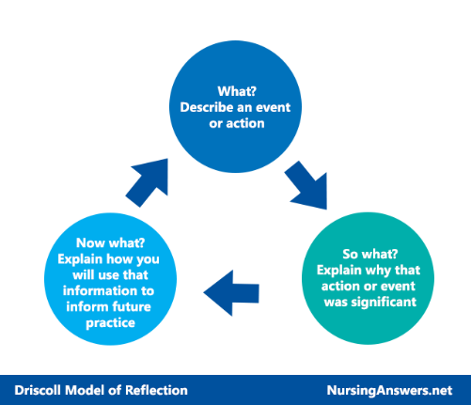

(NursingAnswers.net, 2018).

The use of the LEAPS model with is a policing model acronym for conflict management which is abbreviated for Listen, Empathy, Ask, Paraphrase and Summarise (College of Policing, 2023). The college has developed the LEAPS model for officers to follow something specific and measurable when dealing with incidents alongside the National Decisions Model.

As per the Driscoll’s model of reflection managing conflict and communication skills are an essential part of being a police officer. In lien with this officer needs to understand how to manage different situation to diffuse any potential risk to ourselves or any members of the public. Without the use of fundamental communication skills situations could escalate which could lead to the suspect becoming irate and not responding to our commands from myself. In an attempt to diffuse the situations calmly and professionally, I needed to have the ability to speak clearly, empathise with people and bring them on side when dealing with the law. These situations could escalate extremely quickly and for the worse if officers attend calls with a calm mind to prevent the suspect escalating. As this incident was in a shopping setting and going by the NDM which is the National Decision Model (College of Policing, 2023) and the information and intelligence I had gathered en-route to the incident which came from the force control room that the male that had been detained by the store security guard was extremely agitated and needed de-escalating quickly and efficiently on the arrival of officers. During this situation had officers not used discretion and empathised with the person that had been detained for shoplifting. The male has been moved to the safety of the staff office for his own safety and public safety as the report from the security guard to the force control room as he was the caller that male was extremely agitated from the fact that he had been detained and the male that the other person had made off and nobody seemed to be interested in the second person that had made off.

The male appeared agitated at the start, realising he was going to be arrested and was very unsure to what that meant. He was very irate with officers and staff members as we were dealing with the male. As I was obtaining an account from numerous staff members the male deteriorated therefore, I apprehended the male and told him there would be further arrests if he didn’t calm down before I arrested him for the theft. During this arrest, the male become annoyed that he was being arrested for his crimes but the security guard who detained him was not as the male has alleged that he had grabbed him by the neck. The male was provoked by the fact that the security guard was stood watching him kicking off and kept saying to him that he was going to be arrested for this, he was also saying that he was going to be removed from the store by the police.
During this part of the incident the LEAPS model played an essential part during this incident as the first part was to listen to both stories and the information that I needed to gather from the suspect and the security guard to what the suspect had done in the store. I actively listened to the suspect and carefully noted everything down in my pocket notebook entry what had happened. During this I noted that the suspect had tried to leave the store without paying for the items that he had on him at the time.
Showing the suspect empathy, he had stated that he’d just finished work and was struggling with financial issues to feed his family – during the current times of the cost-of-living crisis. When I was empathising with the suspect, I explained to him that I understood that there was a cost-of-living crisis but the fact that the suspect made an attempt to leave the store without paying – this was still a crime under the theft act and that he would need to be arrested for this crime. This is when the suspect became a little more tolerable towards the police and understood his wrongdoing after empathising with him, he eventually accepted that he was going to be conveyed to the local police station. After approaching the suspect with a cool and calm head he automatically mirrored my behaviour and began to speak with me as a normal person instead of treating me like I was somebody who wasn’t to be interacted with.
After speaking with the security guard and staff witnesses to clarify what had happened during the store and to paraphrase back to them just so I had the full understanding of the incident. After summarising with security and staff witnesses before making the decision to arrest to the suspect on suspicion of theft and take him to the police station where I have then conducted an interview to obtain an account from the suspect and question them to prove or disprove their link to the incident.
The methods outlined by the (Betari’s Box – Help children live better, image.) has assisted myself in appeasing the male as the way I have approached the male and listened to his side of the story has assisted him in remaining calm and the suspect has then mirrored my attitude and the way that I have spoken towards them this has eased the situation a great deal and allowed myself as the lead officer to understand and empathise with the suspect in order to conclude the incident.

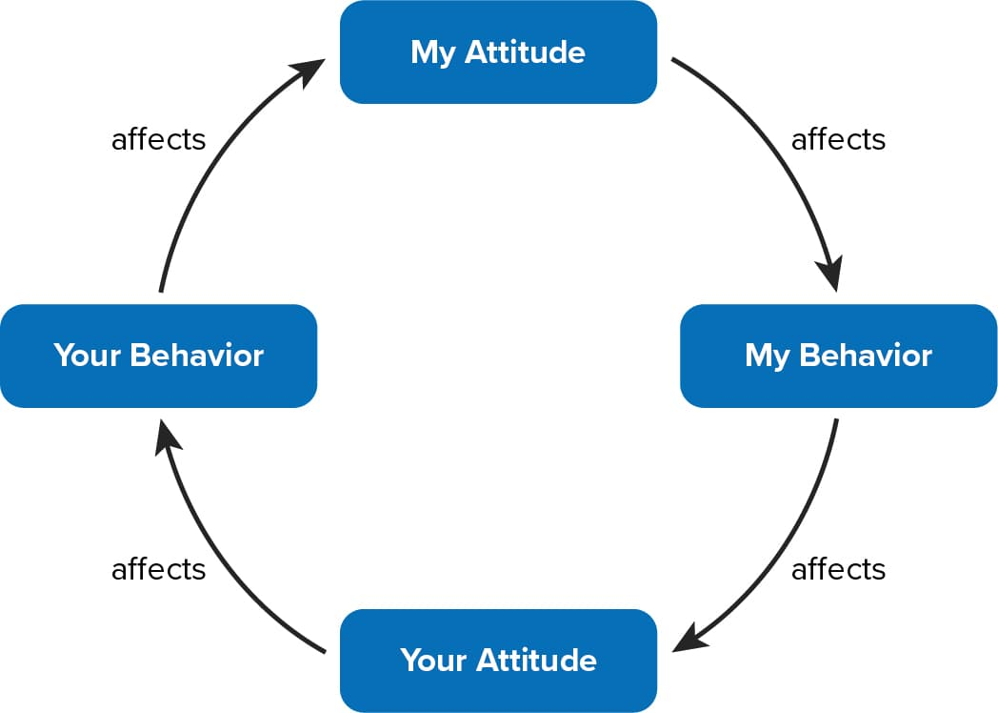

The Betari box has played and essential role in this incident as my attitude had a positive outcome on the male and how he has then remained unflustered throughout the incident. After he was arrested, he has
remained calm while he was conveyed to custody to which he has also become very apologetic about the way he was displaying and acting during his arrest. The Betari box has aided while dealing with the offender as it has played an essential part of dealing with the male and apprehending him when I have then arrested the male.
The Thomas Kilmann conflict model was put in place in order to aid the workplace in making sure that the workplace is a better more relaxed approach place when conflict is managed in the correct manner. Thomas-Kilmann conflict model (Thomas & Kilmann, 1974) had created a conflict model with 5 different components such as competing which states using this one is primarily when we resort to being more assertive regarding conflict. Avoiding states that we should face problems with a more face on approach and confrontation is best avoided.
Thirdly, accommodating this states that downside to this just makes this conflict worse and could potentially lead to further conflict in a worse scenario. Collaborating approach have more of a cooperative dealing this is where both parties may receive help from this solution.
Whilst dealing with the incident I have directed towards a more collaborating approach as it has given the suspect and I had a better relationship while I was dealing with the male as he was very agitated waiting in the store where the incident had happened while we were obtaining details to what had happened. During the incident the male that had been arrested was very agitated as he was claiming that he was accompanied by his mate in the store when he was detained by security, but he claimed that they had left him go after talking to him. The male was displaying passive resistance on arrival to which he didn’t want to be arrested as his mate has been let off the hook – he was more agitated by the fact that he had been assaulted by the security staff whilst being detained to prevent him from leaving the store before we have arrived. At this time, he was showing passive resistance is when a member of the public display’s resistance through nonviolent gestures and arguments against a member of authority (encyclopedia.com, 2018).
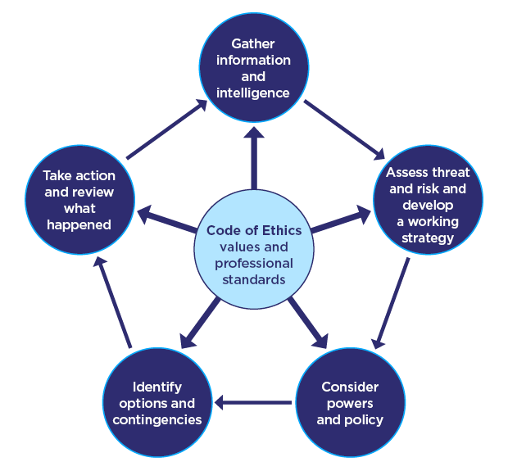

Diagram showing the National Decision Model from the college of policing (College of Policing, 2023)
The National decision model is an essential part of policing as this allows us to risk assess everything that is going on and continuing to work alongside the NDM to deal with the situations as best we can. The NDM allows officers to risk assess and gather information regarding every incident that we respond to. Assessing the threat and risk and develop a plan is an ongoing assessment during the incident from the first call to respond to the end of the incident. Gathering information and intelligence is more based on the fact of what is currently ongoing during the incident. During this incident I have gathered information and intelligent enroute to the emergency for warning markers and previous on the male was detained by the security guard. I have then risk assessed the threat, risk and harm to myself and my colleague at the current time and what we needed to do about the situation regarding arresting the male was detained based on the information that I had gathered at that time of the incident.
Working along the National decision model and the Betari Box I have managed to defuse the suspect’s anger that he was displaying on arrival. My attitude towards the male and the situation defused the male’s anger quite quickly after speaking to him as a person and not so much as a criminal which appears that’s how everyone had been speaking to him in that sort of manner. The way I had reacted the situation – put the male’s mind at rest and leaving him feel at ease whilst I was dealing with the situation. Had my attitude been different that day I can honestly believe that the male would have escalated the whole situation and would have started displaying signs of physical resistance towards us and the security guard that was assisting myself keep an eye on the male while we were trying to establish what had happened in the store and what was the time scale of things that had happened. Regarding the way the male had acted during the incident and how he was when we had arrived, he was vastly different when he was leaving the store with us on his way to the custody suite. The male was like I previously stated was displaying passive resistance and this is why I have then arrested the male to the rear with the handcuffs due to the use of the Betari Box and managing to defuse the situation.
Reflecting on the incident and what I could have done better using these models throughout would be to make sure that I removed the suspect away from the situation that was making him irate which would have been the security guard that had detained him for the purpose of waiting to the police. As I have explained the situation – this allowing me to discuss why my actions have diffused the situation in a calm and collected manner allowing the suspect to get on our side while we were dealing with the situation. In line with the reflection model I would make sure that I removed the male from the store or a private area where I could just discuss with him only as the security guard was adding his opinion into the matter while obtaining an account from the suspect and this was adding tension to the suspect as what the security guard was stating wasn’t all entirely true and didn’t add up to the suspects account of the event.
Word Count - 2094

Task 3

Relevant areas of the National Policing Curriculum:
Criminal Justice, Valuing difference and inclusion

You must choose a policing incident in which you played a significant role with an offender/ service user/victim and reflect on what happened

Critically explore a policing incident that you have attended and examine how you dealt with competing issues such as legalisation, social issues, culture and language.

Consider the victims code of practice and how it was used to support your victim/witness through the criminal justice system.

Your reflection must illustrate your understanding and application of core principles of ethics, equality, diversity and human rights, as well as any relevant Code of Practice considerations.

2000 words (+/- 10%: include your actual word count at the end of each section)

ANSWER:

During my reflection here on a specific incident that I dealt with during the earlier days of my tutorship. On my second day shift accompanied by my tutor we were to attend M&S about a shop lift. Here I would like to analyse and focus on the language barrier that officer was faced with when dealing with the certain male.
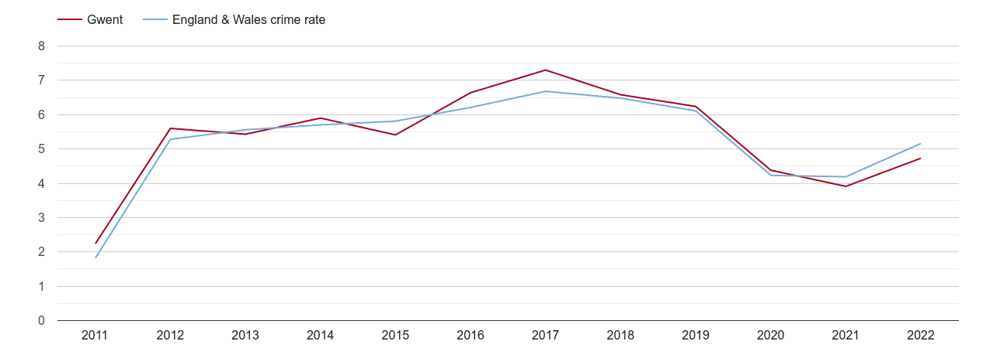
(Plumplot, 2022) this is a graph showing that the levels of shoplifting in the Gwent area is currently on the rise again after dropping over the years that we were in a global pandemic (COVID-19). This showing that Gwent is an area where shoplifting is clearly prolific across the force.
The male was of a Romanian background with extremely limited use of the English language, this made it difficult for him to understand everything that was going on around him. There were multiple staff members from the store talking to him all at once and then upon our arrival this became far too much for the male as he was very unsure to what had happened and why he was detained by a member of the store simply for walking out of the store with unpaid items. In this incident I developed a bond with the male on more of a companionate level as the male was confused and was extremely worried about what was going to happen to him after he was taken to the police station.
After an amount of time, we grew to understand each other, and the male was a little more aware of what had happened and became very apologetic for his wrongdoing that day. M&S had recently banned this male from the store and he had failed to comply with his store ban which has then led to the male being arrested for the theft again. The store had lost a considerable number of items and finances due to this male stealing from the store on multiple occasions. M&S store policy was to prosecute against anyone who commits an offence within the store due to the amount of high-end clothes and foods that they sell during the summer time for BBQ’s and around the festive periods for Christmas time. The male become understanding of what he had done during the incident and that he was going to be arrested for the offence. The male regarding the social issues that he was facing which was extremely poor English and not many people now how he could go about trying to get his name of things and not to charge with the offence.
During the incident I have needed to conduct a developing dynamic assessment of how the male in question was going to understand what we were saying to him and trying to explain to him what was going to happen next. According to ‘communicationtheories.org’ they have said that,
“Prime dynamics of culture are the mutual social perceptual set with coordinated, meaning and action, and cultural variance. The differences in communication recital and the diverse forms of communication can create diversity among various cultures. People who live in various cultures and historical epochs communicate differently and have different patterns of thought.”
This suggests that the male that I had dealt with on that day was using his own understanding techniques and was struggling to understand what he needed from us. He was struggling to understand what crimes he had committed and what the reason was behind him being arrested. During his time at the police station, he was going to be interviewed to obtain his account and prove or disprove his involvement in the incident. We had clear CCTV footage of the incident. Due to the male’s lack of understanding he had opted to not have a solicitor in the interview. Had this been accepted by myself or the custody sergeant then we would have been breaching PACE during interview in line with code C allowing people to be dealt with fairly in the custody unit and when being interview under caution (Gov.uk, 2023) I have then suggested the sergeant that we get one anyway and use a duty solicitor to present with him in interview alongside an interpreter.
During this incident the use of Language line in custody was paramount as this was a great assistance for me and the male that we had currently arrested on suspicion of the theft. We found that he became easier to deal with after he was spoken to by someone of his own nationality and he began to understand why the fact that the police have been called to the store and why he had been subsequently arrested for the offence that he had committed in the store. The matter was resolved through using language line at the custody desk as he needed to be explained of his legal rights and why he had been arrested. We have then made sure that he was dealt with accordingly in interview and that he was interviewed according to PACE and that he had the opportunity to reflect on his needs and what had happened during interview and why he had done what he had.
Without either of these the interview wouldn’t have been legal, and I believe he would have become more confused and disorientated during the interview process. After using his reaction in the store to the amount of people that were questioning him regarding the incident, I thought that it would be best for us to carry out the interview with all the correct relevant people present in the interview room so that the male could have a fair opportunity to explain his involvement in the incident.
In line with the legislation of theft the male had said multiple times that he was going to pay but only if someone was going to let him drive home with the goods for him to be able to feed his family and return later with a means of paying for the items. He didn’t understand that this was not possible and on multiple occasions I needed to remind the male of the definition for theft and how he had dishonestly appropriated property without any means of paying for the items at that time.
During this process about the male’s human rights were to be allowed a free legal representative for the case that he was involved with. He didn’t understand that this was the case so therefore we have then advised the custody sergeant to allow the male to speak with a Romanian national for him to understand the custody process and what he was going to be interview for.
After this is disclosure had I of interviewed the male, I would have been breaching PACE had I of interviewed the male since he had not understood what was going on in interview. He understood the fact that he had been arrested but in terms of the interview we would have been breeching PACE when questioning him. The custody process is for every foreign national to have access to an interpreter during interview and someone of their nationality to speak to them at the custody desk for them to explain their rights and entitlements.
The male was very confused to the fact that he had been arrested for theft and he wasn’t sure of why police had been arrested him. At first, we were concerned for the male as he didn’t understand that he had committed a crime and he didn’t see that he had done anything wrong. The male needed an appropriate adult in interview as he was a foreign national and an interpreter which was extremely difficult to organise as there wasn’t a Romanian interpreter available for interview so soon so that due to this, we have needed to wait for the interpreter to arrive before we have conducted an interview regarding the matter. Officers have obtained the details of his legal representative that he wanted regarding him being interviewed for the crime that had been committed.
Due to the foreign nationality Romanian, we have then needed an ACRO form to be given when he was released from custody to which initially it had come back that he was wanted for similar offences out in Romania. This was not the case as when I have reviewed the ACRO form that was given I have realised that they have given the wrong photo identification for the male that I had arrested and that it wasn’t the case that he was wanted in Romania. I have then made sure that the male understand that he is going to be released on bail with conditions not to attend Spytty Retail Park or attend M&S in the retail park where the male was detained and later arrested for the offence of theft.
When arrested the male as a suspect and his detention authorised in custody the male has then been submitted for his details to be put through the Criminal Justice system in order for them to understand that this male had previous for theft and that he was a further risk to other stores on the high street upon his release from the custody after interview. The male has needed his interpreter with him at all times when he was being dealt with in custody as he needed someone to translate what was happening to him in regards to the offence but when he was arrested we believed that he had very good understanding of what was happening to him but the after spending time in the police van he has then had time to reflect and told the custody sergeant that he doesn’t understand any English at all. Due to his lack of understanding when he came out of the interview room, he thought that he could leave straight away and that he didn’t realise that he needed to stay even after arrest and interview. Language line was an essential part here has this allowed me to interview within Code G of PACE which allows officers to conduct the relevant interview under the correct terms that should be considered in the interview. Since the male in question was Romanian had I of not obeyed the correct PACE codes then I would have been conducting an interview whilst breeching the PACE act.
Language line solutions are a business that are around the world dealing with approximately 40million interactions per year whilst assisting police with interviews and interactions with members of the public. They have nearly 16,000 highly skilled interpreters working globally giving assistance with almost 240 different languages (Language Line Solutions, 2023).
The male was submitted for an ACRO check which initially came back to me that I needed to make arrest enquiries and try and get the male back in as he was wanted in Romania, I do not believe that this male was wanted out in Romania as he had been living in East Wales area for quite some time now. The male was then questioned about his knowledge about the allegation that out in Romania he was alleged that he did something remarkably similar but, in this instance, this was not the male with which I was working.
Word Count - 1864

Task 4

Relevant areas of the National Policing Curriculum:
Decision making and discretion, Conducting Investigations and Criminal Justice (Managing offenders)

You must choose a policing incident in which you played a significant role with an offender/service user/victim and reflect on what happened.

Critically assess a policing incident that you have attended, where you played a significant role with an offender/victim and reflect upon what happened.

Reflect upon your use of the National Decision-Making Model and the Code of Ethics and review this affected upon your decision making and use of discretion within the incident.

Critically review your responsibilities regarding the provision of CPIA when conducting this investigation.

2000 words (+/- 10%: include your actual word count at the end of each section)

ANSWER:

As a response officer there are many incidents and crimes that you attend where there can be a certain way of dealing with such things and having different outcomes other than arrest all the time. There is a wide variety of ways you can deal with people either through verbal warnings, Postal Charge Recognition, or a Traffic Offend Report for all minor traffic offences. There are also things such as an out of court disposal which is a great outcome for first time offenders.
Incidents that we deal with can vary from emergency graded calls to diary appointment where members of the public can call 101 and book an appointment where an officer can either come to their home address or they can attend a local police station to report and incident. During this incident I have spoken with both victims from the accident and the driver to keep all parties calm and collected – the male who was driving accepted that he was in the wrong and felt that he should have made of an effort to stay at the scene. To keep all parties reassured, I updated them regularly about what exactly was going on with the investigation and what course of conduct I was going to take. They were all incredibly grateful for this as they felt that this was something that would not have been investigated at the start and one victim was reluctant to provide a statement at the beginning. The victim of the one vehicle that had been subjected to more damage wanted to make sure that everyone was safe and well and that nobody had been hurt as well as wanted to make a complaint and try and get someone to admit to the incident and develop some plan for receiving a payment without effecting anyone’s insurance policies. Which in the end became the action that was taken where officers and the custody sergeant had decided what the best option for the male was – which was to exchange details after the voluntary interview that was conducted by myself with the victim that had damage to his vehicle that needed repairing by a garage.
The other victim unfortunately did not have enough damage on her car to warrant any sort of payment from the driver as the garage said that the damage was too small and wouldn’t be worthy of an insurance claim.
In this case there was a Fail to Stop Road Traffic Collison in a built-up area where a suspect and reversed into a victim’s car and then had made off from the scene of the incident and failing to report the accident as well. The victim had damage to her vehicle that needed to be assessed by an insurance company to assess the cost of the damage and what was needed to be done by the garage to repair the damage caused. The suspect was unknown in the victim’s statement but her daughter was in the car with her during the time and she has taken photographs of the vehicle in questions and also pictures of the incident and the suspects face which I could then use as evidence against the suspect in order to prove or disprove their involvement in the incident and why they decided that they should drive off away from the scene of a RTC.
In line with the National Decision Model assessing and obtaining the information and intelligence regarding the suspect, I have conducted address checks on the address that the vehicle was linked too and to try and establish who was driving at the time of the incident as there were three occupants on the insurance as this was a works vehicle that had shared insurance policy. The information that I needed to gather from the incident was through obtaining first accounts and statements from people, conduct house to house in the area that the accident occurred, appeal for anyone that was been driving in the area that potentially was recording through using a ‘dash-cam.’
After collecting this information and the intelligence on the vehicle after conducting Automated Number Plate recognition checks on its whereabouts and the way that it was travelling in the day as the address appeared to be difficult to find at first. As well as trying to run the suspects face through the police facial recognition database which returned with a negative result that again couldn’t lead me to an address. The information that I needed to gather after locating the driver was to obtain an account from him and try and work out who was driving at the time of the accident. This is where I have issued the driver with what we call a NIP which is shortened for Notice of Intended Prosecution this allowing the driver 28 days to reply with an answer to who was driving the vehicle at the time. The suspect admitted to driving the van at the time of the accident and was extremely nervous about what was going to happen as the suspect had not been driving the van for exceedingly long.
Still in connection with the NDM, then assessing the threat and risk that he was apposing to the public and other road users which was very low as the suspect only used the vehicle for work purposes and he did note that it had shaken him up a little so wouldn’t be driving it for a little while until all this was sorted. The threat and risk were low as the male was willing to co-operate with police action and wanted it dealt with as soon as possible so that it didn’t affect his insurance prices or is work as he depended on this vehicle for work as he had newly started a gardening company. According to (Kenway Miller Solicitors, 2023) they have given an example of what a NIP means hereby the notice of intended prosecution is issued by the police force that will inform the potential suspect or offender that they are under potential investigation regarding a motoring offence. Under Section 1 of the Road Traffic Offenders Act 1988. The reason that these are issued is that a vehicle has been identified in an incident and the police are unsure of the driver at that time. The offences that are typically linked to the issue of a NIP are speeding, contravening a traffic signal, careless driving, dangerous driving or using a mobile phone whilst driving. The driver was forthcoming with an admission, this is where they will have the opportunity for voluntary attendee for an interview at a police station under caution regarding their account of the incident to prove or disprove their involvement in the incident.
Concluding the offence officers initially planned on issuing the driver with a TOR – Traffic Offence Report which is something that is done online and then sent through to the suspect via email or mobile number. An example from (Norfolk Constabulary, 2023) like the same as Gwent Police they can issue a Traffic Offence Report to the person/driver of the vehicle and the offence at the time of doing so and witnessed by an officer. The TOR is then submitted through officer’s handheld devices and then submitted via email link for the intended suspect to the make a payment online or to the CTO within 28 days of being issued the penalty notice.
Based on the information and intelligence gathered through the NDM that this wasn’t an arrestable office it would be better resolved through a Voluntary Attendee Interview at the local police station under caution and interview conditions to prove or disprove his involvement with the incident. The suspect was then interviewed and questioned about the incident under Section 170 (4) Failure to Stop Road Traffic Collision of the Road Traffic Act 1988. According to (Kang & Co Solicitors, 2023) it is an offence to fail to stop after an accident or failing to report a Road Traffic Accident. Both offences are contained under Section 170 (4) of the Road Traffic Act 1988 and then under Section 170 (2) of the Road Traffic Act 1988 and this allows legislation to state that drivers should immediately stop their vehicle if an accident has occurred on a road or public place due to the presence of the driver’s motor vehicle. When the suspect was questioned regarding the offence he was admitted to driving during the incident and causing the accident as he was reversing up a main road to stop then van from blocking the road for other traffic users. The suspect has then stated that he was able to pay for the damage, however he wanted to avoid going through his insurance company as this would result in as increase to his premium. The victim was happy to resolve the matter in this way, so police involvement was not necessary after the admission – and willing to make a payment to the victim of the incident.
The action that was taken against the suspect was given a No Further Action result from the custody sergeant after the suspect was interviewed with the suspect agreeing for his details to be past to the victim in order for him to contact him regarding the payment of the damage.

Referring to Driscoll’s Reflective Model like used in Task 2 I would like to use this for me to assess how this was developed, investigated and the outcome of the incident. Referring to the graph again at the summit of the Driscoll’s reflective model I have discussed the outcome of the event throughout the question, and this is a in depth account of what the incident is about. The incident developed into something larger than just a Fail to stop Road Traffic Collision as this developed in a search for the vehicle in question and where the suspect lived. Reflecting on how I came to find the address of where the vehicle was linked to and who the suspect was at the time of the incident and who was driving the van at the time. I would make sure that I would try and investigate the incident a little quicker as I was a little apprehended at the beginning of how to find the vehicle. This incident was one of my first investigation outside of my 10-week tutorship with my tutor – I was lacking in confidence and knowledge, but I believe that I dealt with the situation correctly and competently. I made sure that all victims and suspect were updated regularly. The action that was taken on the suspect was proportionate and I felt that a after the suspect had admitted to the accident – making off from the incident and not reporting the accident and causing damage to multiple vehicles. The suspect admitted to the incident after the interview had been terminated, I have then asked the custody sergeant for advice – he was then stated that this is a first offence and that he believed that him contacting the victim in order to sort out a form of payment regarding the damage would be appropriate as this is what both the suspect and the victim wanted.
In terms of working alongside the Criminal Procedure Investigation Act 1996 which allows officer to conduct investigations with a view to it being linked to a person and whether they should be charged with an offence, or whether a person charged with an offence is guilty of it (College of Policing, 2023). Under this act the officers have the power to exercise legal right and power also when looking at vulnerable people and children. In terms of this investigation this Act allowed myself to conduct these enquires slow time while I made sure that all evidence was gathered before conducting the voluntary interview. Using the ethical powers of the act this allowed me to use integrity when dealing with the suspect and sound judgement since he had admitted to the offence and that he showed remorse towards both parties that he had caused damage to their vehicle. The investigation skills that I used during the incident and how I gathered information was through the NDM and being a creative thinker to picture what had happened, returning to the scene of the incident in order to picture the roads and the turnings that matched up with the statements that I had obtained from witnesses. Challenging the suspect in the interview to why he had not stopped at the scene and the making sure that all victim care and witness care has been offered such as medical check-ups through the GP for any underlying potential injuries.
Developing my future as a police officer I believe I wouldn’t do anything different to investigate this type of incident again, I believe that I dealt with the incident in a professional and a competent manner following instruction from my sergeant and the custody VA sergeant to resolve the issue as best as I can which was resolved in the way all involved parties wanted.
Word Count – 2166
‌

Task 5
Personal Development Plan (PDP)

As part of your reflective process, please use this table to aid you in identifying the next steps for development.

This is equivalent to 1000 words towards the overall wordcount, please note this is not the actual number of words used in completing the table, the count reflects the thought and research behind it.

Area of Development | How it will be achieved | Who can supply support | Timeline
Managing situations with higher conflict levels. Therefore, developing my conflict levels through dealing with the city safe allocations on the weekends where there is more conflict and also more ASB jobs where there are usually large groups of people that need dealing with. | I would like the opportunity to carry Taser. Due the high demand. I am going to and put myself forward for anything that involved conflict as I would like to reference this to help myself with the application that I will need to report and register in the station. During the incidents I am right in saying that I saw the male holding the knife walking towards three of my colleagues on a game day in the town. I have found that these incidents can help my matrix to evidence everything. I will try and pick up as much conflict management calls as I can this is also the placements with the Dog section and RPSO to obtain a better range of incidents and authorities. | My Sergeant has authorised for me to put a application in for this course. Since we only currently have one TASER trained officer on shift my colleagues are backing this due to the support, I can offer them in difficult situations. My inspector will also be supporting my evidence based on my improvement of conflict management and the fact that I am going to be allocated the City Safe logs on the weekends in order to improve the way I can deal with conflict and how I manage large groups of people during a conflict situation. | I would like this opportunity whilst in my 2-year probation as this will allow me to use this as evidence for different departments such as Traffic, Firearms and PSU courses going forward.
Witness interviewing being able to engage with witnesses and victims better and being able to engage and create better more detailed statements in preparation for interviews. | I would like to improve with my interview skills and become faster and more efficient when it comes to being in the interview plan/interview with them. I would like to be able to engage with witnesses and victims better to have a more detailed statement. This will allow me to go into interview with a better account from victims and witnesses giving them a better outcome and service from myself and others. | My sergeant will be allocating myself certain victims and witnesses where they need detailed statements such as thefts, domestics, Harassment.  Colleagues will be assisting me with certain elements of the statements to improve my statement and evidence gathering in order to get the best out of a statement and to give a victim and witness the best service that I can.  Family  Friends | I would like to achieve this by the time I have finished my second year MATRIX that I will need to fill out
I would like to obtain my police medics qualification so that I can attend police medical emergencies and assist the Roads policing specialist officers with emergencies as evidence to get onto ‘RPSO’. | Before my current job I was a medic in the heath hospital.  - Evidence as many medical emergencies that I go to.  - Make sure that I speak to the correct people to make sure that I get onto the course.  - Make sure that I deal with the people they would want to be dealt with by a doctor or paramedic.  - Evidence what I have done during the medical incidents – keep update with any first aid refreshers. | My Sergeant in order to put me on the course and in order to rationale this evidence.  Colleagues are supporting this course as we have numerous medical calls per shift that require back up from ambulance and I do attend but without the correct medical equipment we struggle to give the victim the best care that I could.  Family  Friends | Within the next 2 years of my probation. I have obtained a position on a course in the next year so therefore if I pass this course with a high enough mark and evidence then I hopefully will complete this course.

Bibliography
The bibliography should only include sources referenced within the workbook using the Harvard referencing system. Information about referencing in written assignments and how to avoid plagiarism can be found on Moodle. It is important that you are aware of the importance of ensuring that the work submitted is your original work.

Norfolk constabulary (n.d.). Motoring offences. [online] Norfolk Constabulary Motoring offences.
Available at: https://www.norfolk.police.uk/advice/roads-and-vehicles/motoring-offences#:~:text=There%20are%20several%20ways%20in%20which%20we%20deal,Report%20%28TOR%29%20to%20the%20person%20committing%20the%20offence.
[Accessed 27 Jun. 2023].

Cambridgeshire Dictionary (1999). The Cambridgeshire Dictionary of Philosophy

Health and Safety Executive (2015). Heath and Safety Executive.

Gov.uk (2020). Effect of pandemic on children’s wellbeing revealed in new report. [online] Available at: https://www.gov.uk/government/news/effect-of-pandemic-on-childrens-wellbeing-revealed-in-new-report
[Accessed 27 Jun. 2023].

Plumplot, 2022. Gwent Shoplifting crime rate. [Online]
Available at: https://www.plumplot.co.uk/Gwent-shoplifting-crime-statistics.html
(Accessed 06 January 2023].
Policing, C. o., 2023. College of Policing. [Online]
Available at: https://www.college.police.uk/guidance/conflict-management/conflict-management-skills
[Accessed 21 February 2023].
policing, c. o., 2023. College of Policing National Decision Making Model. [Online]
Available at: https://www.college.police.uk/app/national-decision-model/national-decision-model?highlight=neighbourhood%20policing
[Accessed 06 January 2023].
simplysupplements, H. ., 2014. 7 benefits of playing rugby. [Online]
Available at: https://www.simplysupplements.co.uk/healthylife/fitness-tips/7-reasons-why-rugby-is-great-for-your-health#:~:text=Team%20games%20such%20as%20rugby%20have%20been%20shown,as%20releasing%20%E2%80%9Cfeel%20good%E2%80%9D%20hormones%20known%20as%20endorphins.
[Accessed 06 January 2023].
Solicitor, K. &. C., 2023. Kang & Co solicitor. [Online]
Available at: https://kangandco.co.uk/2021/04/22/a-quick-guide-to-failing-to-stop-report-a-road-accident/#:~:text=The%20offence%20of%20failing%20to%20stop%20after%20an,170%20%284%29%20of%20the%20Road%20Traffic%20Act%201988.
[Accessed 23 February 2023].
Solicitors, K. M., n.d. Kenway miller Solicitors. [Online]
Available at: https://www.motoringoffencelawyers.com/other-offences/notice-of-intended-prosecution/
[Accessed 23 February 2023].
Gov.uk (1984). POLICE AND CRIMINAL EVIDENCE ACT 1984 (PACE) CODE C. POLICE AND CRIMINAL EVIDENCE ACT 1984 (PACE) CODE C. [online]
Available at: https://www.gov.uk/government/publications/pace-code-c-2019/pace-code-c-2019-accessible
[Accessed 28 Jun. 2023].
‌Language line solutions (2016). Language Line Solutions . [online] Available at: https://www.languageline.com/uk/interpretation/telephone-interpretation
[Accessed 28 Jun. 2023].
‌

‌

‌

CONFIDENTIALITY and PLAGIARISM – confirmed by submission through Turnitin

Please sign to confirm the work submitted is your own work and has not been copied from another.

Signed: D J G DAVIES

Date: 28/06/2023

