Emergent Leadership Skills in the Workplace

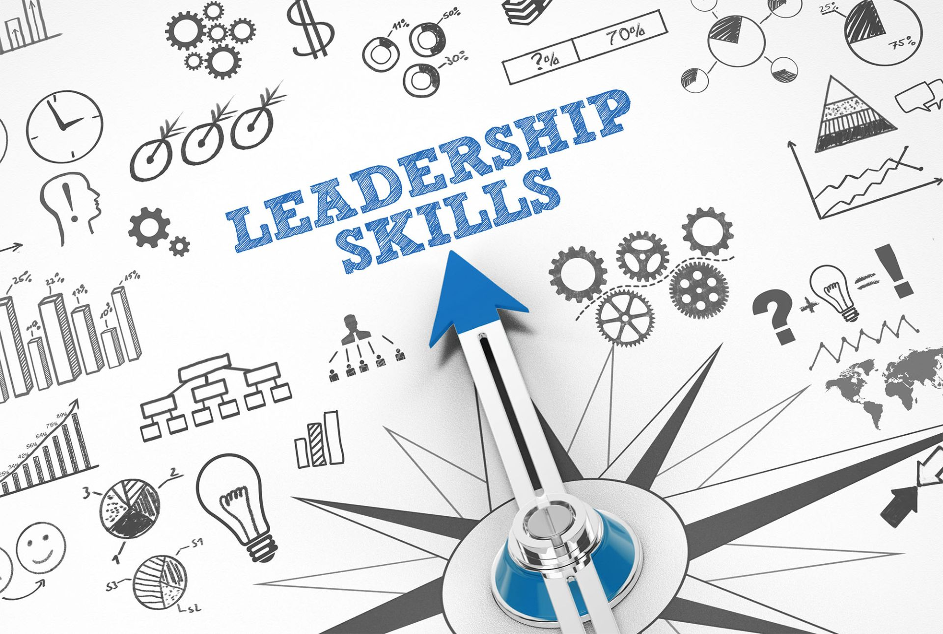

Name: Eltaf Mockbil
Module Code: BMSW6101
Lecturer: Rebecca Stewart
Student number: 1913491

Contents

- Introduction

- Difference between leadership & management

- Effective leadership styles

- Effective leadership skills

- Challenges to leadership in uncertain times

- Ethical leadership

- Conclusion

- References

Introduction

In recent years, every organisation has faced significant leadership issues. The intense pressure in the NHS has been blamed on a lack of staffing, increased service expectations, difficulty in fulfilling financial and operational targets, and a culture of blaming individuals and assigning blame. Being a leader in the NHS has grown increasingly complicated and challenging. To finalise this academic report, I will link back to an attached article summarising the fundamental difficulties in the NHS. As a result, I will review the article and create an academic report to analyse effective leadership in the NHS critically. Still, first, I will explore the difference between leadership and management as fundamental, practical leadership skills and styles, and finally, I will conclude my report by venturing into ethical leadership.

Difference between leadership and management

Influence and inspiration distinguish leaders from managers, not power and control. Enable influential people to believe in the company's goal. Management is concerned with task management and the seamless execution of day-to-day activities. The difference is that leaders have followers, whilst managers have employees. Management and leadership are inextricably intertwined and mutually beneficial. Any attempt to separate the two within a company may cause more issues than it solves. A company's management must be competent in preparing, managing, and integrating its employees to succeed. Managers and leaders must grasp what they must accomplish, and to excel, they must understand the essential distinctions between them. Managers will use situational management to focus on setting, assessing, and attaining goals. Leaders will focus on inspiring others to achieve their goals.

Effective Leadership style

Every leader develops a style representing their personality, goals, and company culture. And each effective leader builds a leadership style based on their character, objectives, and organisational culture, choosing between three leadership styles: authoritarian, democratic, or laissez-faire. Douglas McGregor stated in 1960 that a manager's attitude impacts staff motivation. In his book, The Human Side of Business, McGregor developed two ideas for managers to understand and deal with employee motivation. He referred to these contrasting motivating strategies as Management Theories X and Y. Most firms profit from authoritarian leadership. Autocratic leaders make their decisions based primarily on their viewpoints and ideas. This promotes simplifying internal processes, which can help a company's long-term success. Theory X managers are known for their authoritarian leadership style and dominance. According to McGregor's Theory of Managers, individuals despise work and will take tremendous measures to avoid it. It also means that individuals need leaders' oversight and guidance. There is no need to seek approval from your team or other corporate sectors while making choices under autocratic leadership—just your opinion matters. With fewer decision-makers, structure and direction can be built more rapidly. Employees are frequently overloaded at work.

Google's democratic organisational structure is well-known. This type of leadership can be found in various situations, including corporations and educational institutions. Dr Paul Waldman says adopting a participative leadership style can be highly beneficial. According to Theory Y management, individuals want to work and are self-motivated, self-tolerant, and take personal responsibility.
Theory Y management may necessitate stricter controls, which can be relaxed as an employee progresses. It does not call for a gentle approach. An open debate encourages creativity and innovation. The more people who offer innovative ideas, the more established methods may be improved and updated. Some employees do less effectively under democratic leadership when choices are decided by a team rather than the leader.
Laissez-faire leadership is a management style in which managers step back and outsource decision-making to staff. Retail purchasing, for example, is a business that may thrive under laissez-faire leadership. The technique can be used in a variety of professional settings.
Many IT departments are also successful examples of laissez-faire leadership. Theory Z was an advancement over Theories X and Y, combining the best of Eastern and Western management practices. According to management expert William Ouchi, Western corporations can learn from their Japanese counterparts.
According to Theory Z, people desire to balance work and life. Also, workers may be trusted to accomplish their duties to the best of their ability. Long-term job commitments can be challenging for employers and employees, but Theory Z is not the definitive verdict on management.
Laissez-faire leadership, like other styles of leadership, has advantages. Because employers are so hands-off, employees have the option to be direct. This creates an environment that encourages growth and development. It allows for faster decision-making.

Referring to the article, leadership styles will be influenced by context, political environment, and societal concerns. The NHS's ability to offer safe, effective, high-quality care will be critical to this challenge. Amanda Pritchard, the Chief Executive of the NHS in England, must be highly adaptable in her leadership, employing a variety of leadership styles and techniques in practice.

Effective leadership skills

Individuals' leadership abilities are the attributes and strengths they exhibit to help them monitor procedures, direct initiatives, and guide their staff towards goal achievement. Leadership abilities are required to drive others to execute a set of obligations on time, regardless of whether you are in a managerial capacity or supervising a project. Leadership is a group of talents that function in tandem. Communication, Creativity, Positivity, Problem Solving, Teamwork, Delegation, and Decision Making are among the most common leadership skills.
About the article, the NHS is intricate and powerful, requiring a diverse set of abilities to function correctly. Amanda Pritchard's capacity to lead successfully is vital to her success in her position. The ability to motivate and inspire others to influence change to provide high-quality care and a pleasant working environment for staff is necessary for modern healthcare services. To be an effective leader, Amanda must communicate effectively, motivate her team, manage, and allocate chores, listen to ideas, and solve problems in an ever-changing workplace. When uncertainty and time constraints underline the need for an almost immediate response, the importance of these skills increases considerably. Amber is expected to keep the Nhs's purpose and values in mind when making decisions and to stay loyal to the matters even when it is easier to abandon them. A strong vision based on long-held beliefs drives everyone to perform right, even when it goes against instincts.

Challenges to leadership in uncertain times

Ethical leadership

"Leadership that demonstrates and fosters normatively suitable behaviour via personal acts and interpersonal ties" is the definition of ethical leadership. When it comes down to it, ethical leadership is described as putting individuals in positions of management and leadership who will encourage and model good, ethical behaviour in their activities and workplace interactions.
In today's corporate environment, ethics is becoming a more critical component and topic of conversation. As a result, understanding, developing, and recognising ethical leadership is essential to the corporate world. To be a corporate leader, you must first comprehend ethical leadership. It is your obligation as a leader in an organisation to provide an excellent example of moral behaviour. You must have integrity, ethical behaviour, and ethics to be a good leader.
Treating people fairly, providing an excellent example for others, and actively managing morality are all examples of ethical leadership. Strong leadership is critical in the case study while caring for the most vulnerable. Ethical leadership is associated with a wide range of desirable behaviours in leaders and followers. It has been linked to increased leadership effectiveness, job devotion, satisfaction, and organisational commitment. It has also been related to improved work performance, corporate citizenship, and less unethical behaviour among members.

Conclusion
In summary, leaders should employ a hybrid of the four leadership and management paradigms. Some aspects influence which style may be used, such as how much time is available and whether relationships are built on trust, respect, or something else (Hersey 1984). While dealing with any crisis in the firm, the participative method allows executives to determine what action plan to implement. Instead of utilising penalties such as dismissal, warnings, or even days off to drive staff, positive leaders use rewards such as education. Leaders work through the positives, while bosses go through the negatives. My research on leadership ideas indicates a progression from a great man and characteristic theories to current leadership theories such as transformation and transaction theories. According to studies, each of these theories has advantages and disadvantages, and no perfect leadership philosophy exists. Some variables I identified throughout my research boost the power and effect of individuals, groups, and organisations.
Additionally, most people see how ethical action may benefit them daily. In the long term, all of these occurrences benefit the company. They ultimately returned to the case study to compel or enforce successful change, even when it seemed impossible or exceedingly challenging. It involves developing exceptional leadership abilities, determining the right leadership style and philosophy, and choosing ethical leadership. Amanda Pritchard will be successful in her efforts during these trying times.

References

Herzberg Maslow. What are the similarities and differences between the theories of Maslow and Herzberg? 2022-11-08 (columbia.edu)
“Uzbekistan: Wicker Statement on Jackson Water Crisis.” MENA Report, Albawaba (London) Ltd., 1 Sept. 2022.
McGregor’s Theory of Motivation | The Enterprise World. https://theenterpriseworld.com/mcgregors-theory-of-motivation/
The Power of Influence in Leadership Development. https://trainingindustry.com/articles/leadership/the-power-of-influence-in-leadership-development/
What are the similarities and differences between the three ... - eNotes. https://www.enotes.com/homework-help/what-are-the-similarities-and-differences-between-581519

