Wenshuo Zhang 1805199
1805199@student.uwtsd.ac.uk
BUILDING EUC systems
M6X01097 & Beverley Holland

Abstract
In the report, a prototype solution will be established with MS – Excel and Access software for end user development to implement the design in the scenario of the dental hospital. The system contains different features such as appointment, invoice, form and printing to meet the needs of end users in dealing with real problems in the hospital situation. First, the report shows the appointment system with calendar view in Excel software. Then, forms with automatic printing system has been shown in the Access software. Finally, the mail merge function has been introduced with Word software to help users input patient information quickly and conveniently from the link between two software. In addition, a brief user guide has been provided to make the system more user – friendly.

Table of Contents
1. Introduction 1
2. Development Tools and Environment 1
3. System Prototype Implementation 1
3.1. MS-Excel Development Platform 1
3.3.1 Main Menu 1
3.3.2 Appointment System 3
3.3.3 Invoice System 5
3.2. MS-Access Development Platform 7
3.2.1 Table Setting 7
3.2.2 Main Menu 7
3.2.3 Invoice System 8
3.2.4 Printing System 9
3.2.5 Mail Merge 10
4. User Guide to the System 11
5. Conclusion 13
Reference 13

Table of Figures
Figure 1 Jump Link Macro setting 2
Figure 2 Jump Link Hyperlinks setting 2
Figure 3 setup page of the system 3
Figure 4 Room type setting process 3
Figure 5 Appointment information type in area 4
Figure 6 INDEX function example 4
Figure 7 IF function example 4
Figure 8 Room situation display table 4
Figure 9 HLOOKUP function example 4
Figure 10 Calendar view of the available room type 5
Figure 11 Counting function with IFERROR function example 5
Figure 12 INDEX function with IFERROR function example 5
Figure 13 IF function with VLOOKUP function example 5
Figure 14 VLOOKUP function in invoice template 6
Figure 15 VLOOKUP function in invoice service choosing process 6
Figure 16 Save function code generated by Macro recording 6
Figure 17 Patient information database 6
Figure 18 Service information databases 7
Figure 19 Room table example 7
Figure 20 Main menu to different forms 8
Figure 21 Macro of function “GoToRoom” 8
Figure 22 Invoice form example 9
Figure 23 Printing system example 9
Figure 24 Macro for invoice printing 10
Figure 25 Invoice form printing preview 10
Figure 26 Initial setting of mail merge 11
Figure 27 Result preview of the mail 11

Introduction
In business information technology, the term end users [1] is used to distinguish between the people who have been devised a hardware or software for and the developers or installers of the product. Most BIT in used today includes a series of interconnected product components and the users exist at the end of the process. End users usually do not have the technical understanding of the developers and designers of the product, so considerable development and training are necessary.
End user development (EUD) [2][3] enables end users to take part in the business activities through computer programming with advanced technologies. In reality, these end users are often without professional computer skills but they can leverage the EUD tools to join business activities and create software components to attain data objects. The cycle of end user development including basic needs identification, prototype planning and establishment, user review, enhance the prototype, implementation, support and investigation. The steps of review, refine and enhance should be repeated until the prototype is complete and becomes the final system.
Aim of this report is to develop a real system which contains full working features for “Your teeth our Smile” scenario. To investigate into suitable platform for End User Development, Microsoft Excel and Access have been taken as the main development tools. In the system, the end users’ activities like appointment selecting, invoice generating, and form printing will be realized through serious facilities and a brief user guide will be provided for a user-friendly system.

Development Tools and Environment Evaluation
The system framework offers to use spreadsheets[4][5] as the basis for the user interface for a couple of reasons. Firstly, the users have a general skills with spreadsheets due to their widespread use in office software. Secondly, the data in report spreadsheets can meet the further processing requirements. Thirdly, software developers with professional knowledge are exempted from user interface development. If the work of end users has a good quality level, then this approach saves a lot of time for professionals.
The solutions that found ideal for Access[6][7] are as follows. Firstly, Windows based solutions where all users are on the same local area network. Secondly, solutions that integrate with other Office documents such as Excel, Word, PowerPoint and other files on disk such as PDF, import/export files, etc. Thirdly, "Small" multi-user applications if the back-end database is an Access ACCDB/MDB database. For larger number of simultaneous users Access can be the front-end solution with the data in a SQL Server database that is more scale able and secure.

System Prototype Implementation
The system is designed to help the dental hospital computerise some of its business and work in order to improve its working efficiency and bring convenience to customers and employees. First, a system prototype solution using Microsoft Excel will be found based on the design of the system from Assignment 1 and some facilities like fundamental information system and appointment system will be implemented. Second, a system prototype solution using Microsoft Access will be found to realize the additional facilities like forms printing and so on.

MS-Excel Development Platform

3.3.1 Main Menu
In the main menu setting [8], there are two significant function of the dental hospital management system and two buttons have been settled to help the users get to the right function. Macro in development tools can be used to direct users to the right page. Figure 1 shows the Macro specified process.
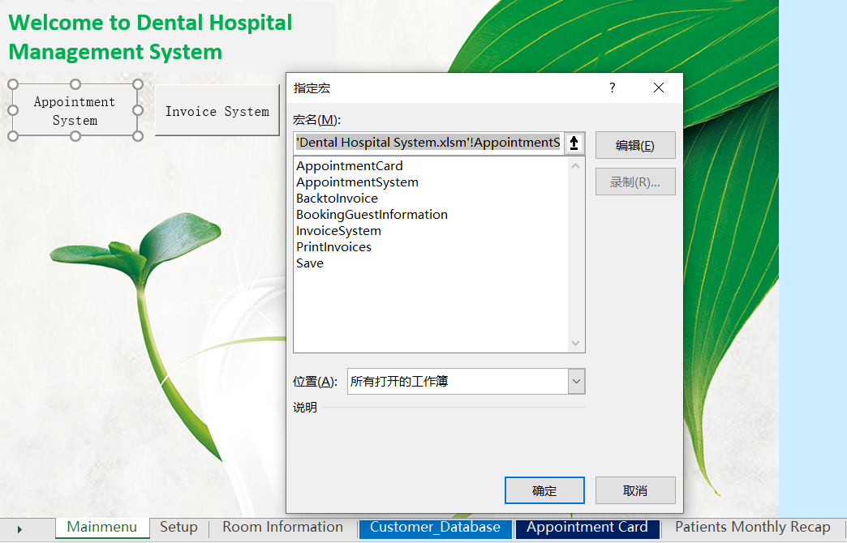
Figure 1 Jump Link Macro setting
In each sheet, there is a navigation bar on the top of the page and each button in the bar can help the users jump to the exact page including setup page, booking page, availability page, summary page and main menu. Different to Macro, Hyper links can be used easily to do the jump links. When users click on the specific button, they will be directed to the right page through hyperlinks. Figure 2 shows the Hyperlinks specific process.
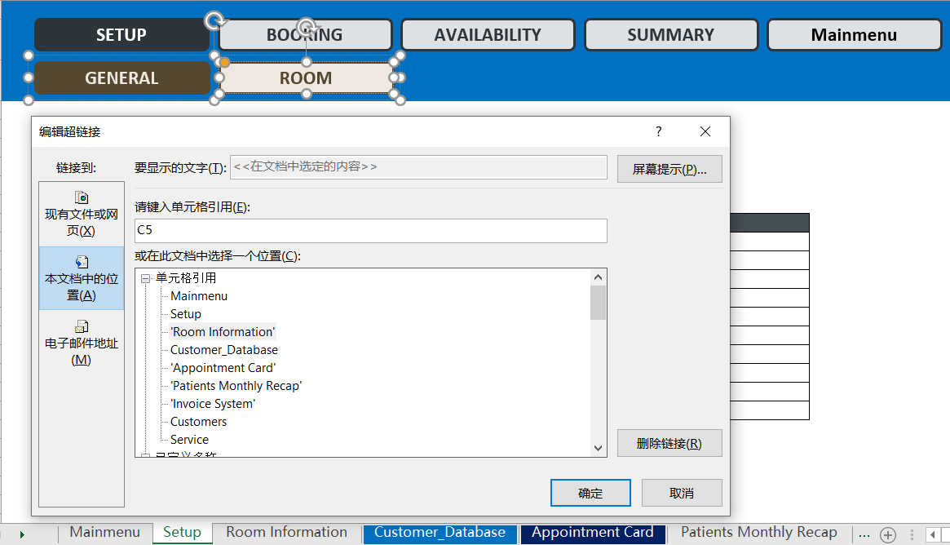
Figure 2 Jump Link Hyperlinks setting

3.3.2 Appointment System
At first, initial attributes including calendar start period, total number of the rooms, status code, calendar colour code, peak and low season information and holiday information should be set. This process should be done carefully because in the later stage, the data here will be cited to make appointment[9] and some limitations will have effects due to the setting here. Figure 3 shows different data that need to be set up.
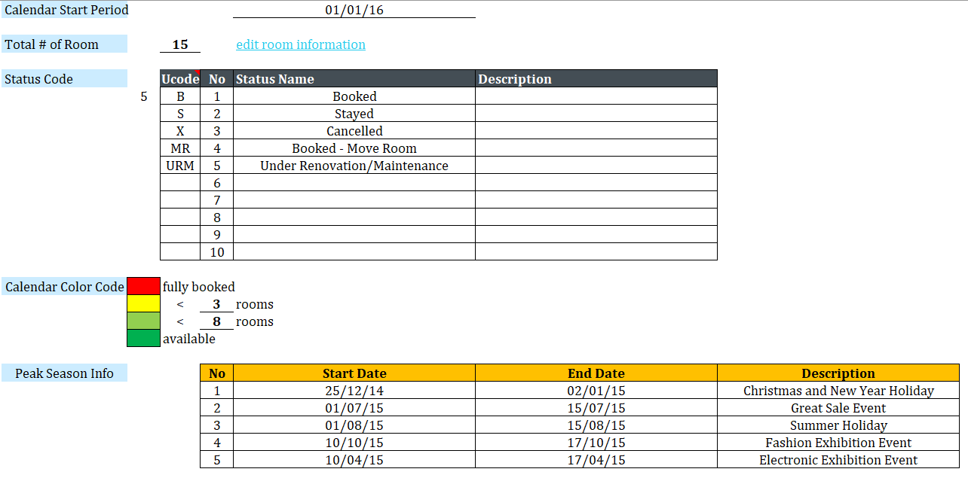
Figure 3 setup page of the system
After the setting here, users can click on the edit room information and a Hyperlink will take users to the room information page. Different room type, amount and facility should be set here, and each room can be given a specific number for later user. Figure 4 shows the room type setting process and users could use a drop-down menu to number each room.
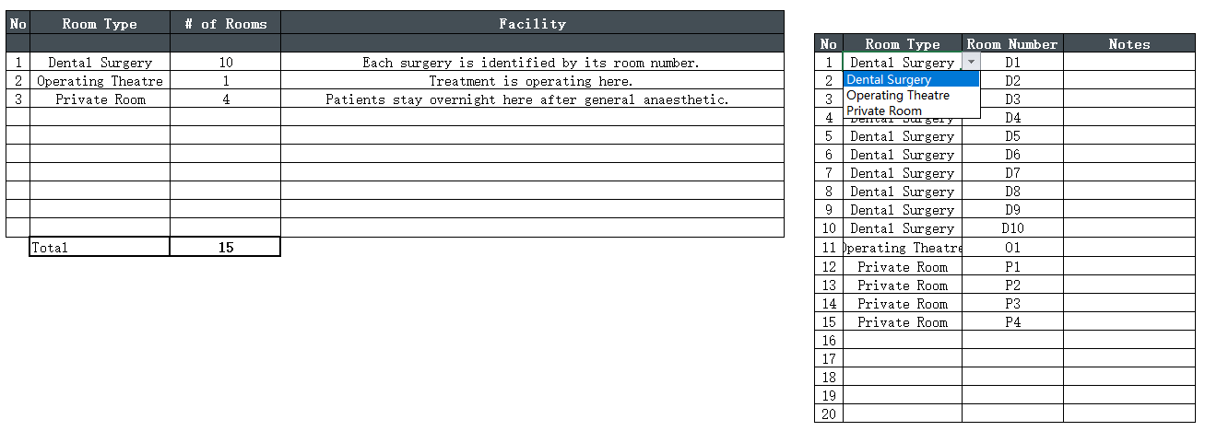
Figure 4 Room type setting process
After all the settings are finished, users can input the appointment information of the patient including booking status, room type, booking date, code, patient name and so on. Figure 5 shows the appointment information type in area. In the process of inputting information, users don’t need to bother typing in each column manually. When a room number is chosen, the full name of the room type will show directly with the INDEX function as shown in Figure 6. In addition, when the check in date and the length of stay are filled, the check out date will be calculated automatically with IF function as shown in Figure 7.
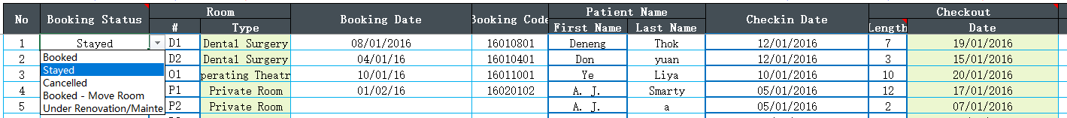
Figure 5 Appointment information type in area
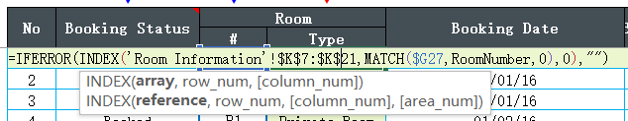
Figure 6 INDEX function example
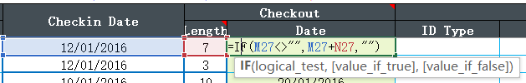
Figure 7 IF function example
After filling in the appointment information table, a room number table will display different situation of different room types in each date as shown in Figure 8 and the calendar colour code set in Figure 3 is used here to represent different situation. In this table, IF and HLOOKUP functions are used to give the number of rooms occupied and available as shown in Figure 9.
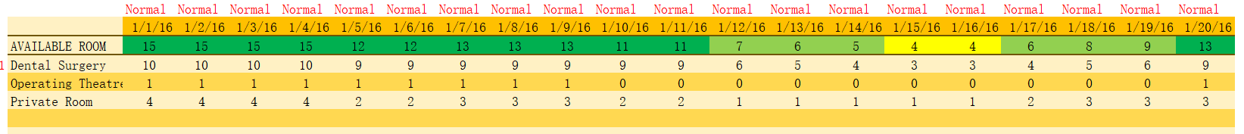
Figure 8 Room situation display table
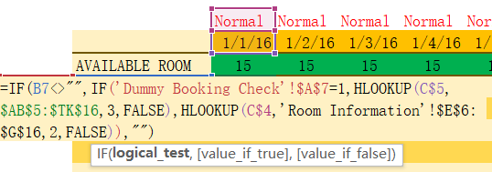
Figure 9 HLOOKUP function example
To check the appointment, there is a sheet for available room type in a calendar view as shown in Figure 10. On the left side of the calendar are the months of the year 2016, on the top of the calendar are the week days and in the calendar different dates of the month are shown in the middle. Most of the dates are in colour green but there are some dates in light green and yellow. This has the link to the setting of the calendar colour code before.
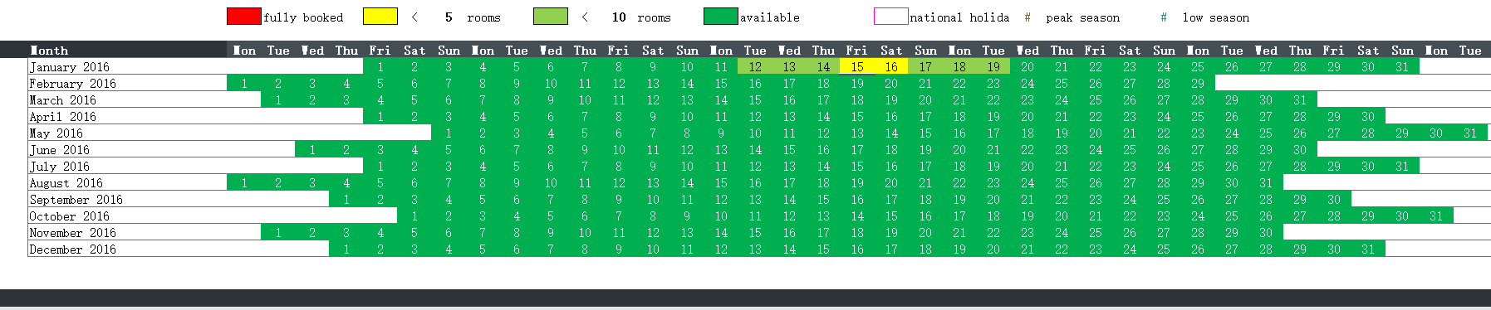
Figure 10 Calendar view of the available room type
When users chose the exact month of the year, it will show the number of available rooms of different room types and the total available rooms. Here, specific function with IFERROR function has been used to count the available room type of the day as shown in Figure 11.
Figure 11 Counting function with IFERROR function example
Also, the name of the patient has been put into the calendar to give the users a clear view of the appointment. This view of the calendar has a little difference with the room type availability calendar in that room number is on the left of the calendar and INDEX function with IFERROR function has been used to specify related patient as shown in Figure 12.
Figure 12 INDEX function with IFERROR function example
In order to give a better view of the patient that has had an appointment, a patient recap sheet has been created with the information of different appointment as shown in Figure 13. Here, IF function with VLOOKUP function has been used to make a copy of the information put in Figure 5.
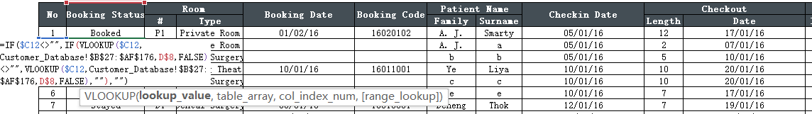
Figure 13 IF function with VLOOKUP function example

3.3.3 Invoice System
In the invoice template system[10][11], users could choose different patient and the information including address, telephone and e-mail will show in the specific column as shown in Figure 14. This feature realized with VLOOKUP function and can save a lot of time of the users.
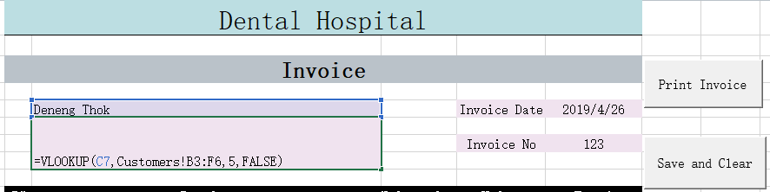
Figure 14 VLOOKUP function in invoice template
Similar, the service in the invoice template can be chosen with the drop-down menu too and the additional information including unit price can be shown automatically with VLOOKUP function as shown in Figure 15. Then, when the user type in the units of the service, the total amount will be calculated automatically with the SUM function.
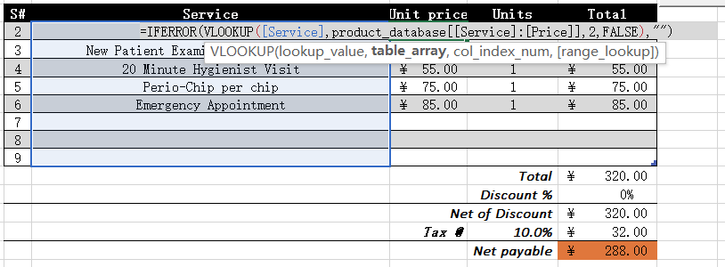
Figure 15 VLOOKUP function in invoice service choosing process
When the users fill in all the information needed, a save button can be used to put the invoice number and total amount automatically into the patient information database with specific Macro function. The code generated by Macro recording is shown in Figure 16.
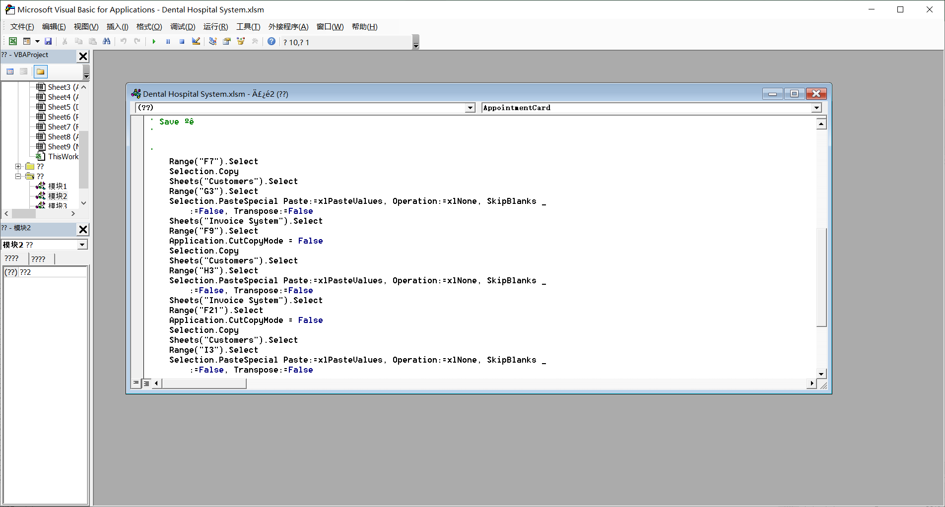
Figure 16 Save function code generated by Macro recording
The patient information database is shown in Figure 17 and the service information database is shown in Figure 18. The information database should be set properly so that the VLOOKUP function can call the right information into the right place.
Figure 17 Patient information database
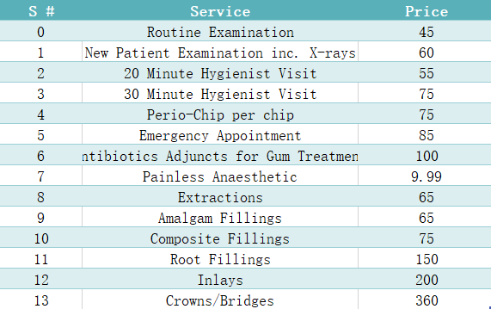
Figure 18 Service information databases
In conclusion, some basic functions and extended functions such as jump link, data lookup, data display and so on have been realized with different functions including Hyperlinks, Macro, HLOOKUP function, VLOOKUP function and so on. Users can simply set up initial data of the system and view available rooms and time slots. Also, they could check the availability of different rooms from two perspectives such as room types and room numbers. Finally, the invoice template can be used to generate a full invoice quickly for users.

MS-Access Development Platform
In the MS-Excel software, some main functions have been realized through different methods. However, more information like the relationship between different tables, table forms and so on can be requested easily in MS-Access software. As a result, Access will be used to do some more works for the computerising process of the dental hospital.

3.2.1 Table Setting
At first, tables of room, patient, invoice, dentist and appointment should be created, and Figure 19 shows the example of room table. In each table, related attributes should be added, and the enough value of the different attributes should be filled.
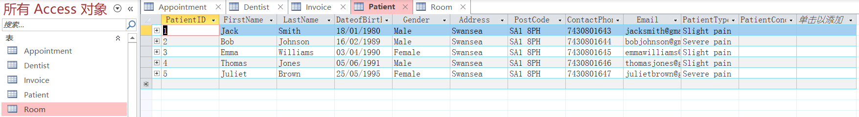
Figure 19 Room table example

3.2.2 Main Menu
Then, a main menu is designed here to guide the users to the specific form that they need as shown in Figure 20. Here, Macro has been used to make users jump to the specific form and each Macro includes “OpenForm” and “GoToRecord” functions as shown in Figure 21 to realize the function.
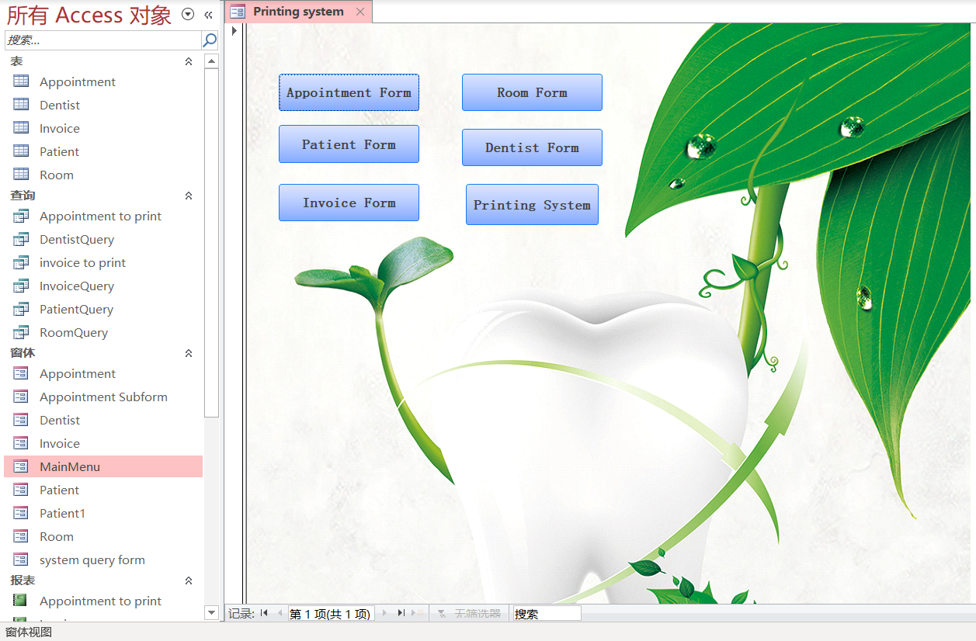
Figure 20 Main menu to different forms
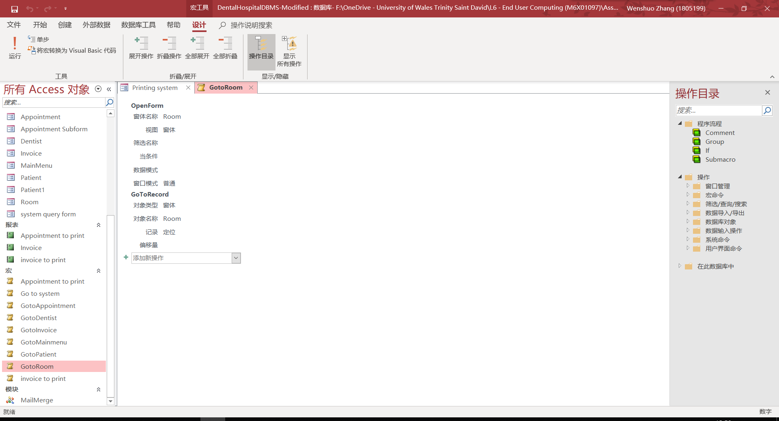
Figure 21 Macro of function “GoToRoom”

3.2.3 Invoice System
Here, invoice form is taken as an example to explain the design and Figure 22 shows the view of the example. When users click on the button “Invoice From”, the form of invoice will be open, and the user will be leaded to the page directly. In the page, the users can view different invoice information including invoice ID, patient ID, service type, VAT ID, rate and cost for each invoice with two simple ways. First is the drop-down menu on the side of the invoice ID and second is two buttons on the bottom of the form to reach previous and next record. The form is generated by form wizard and each ID attribute has been updated in query with external tables. In addition, there are three useful buttons on the right top of the form which have the facilities for exit, print and home. The users can check different forms in the same way.
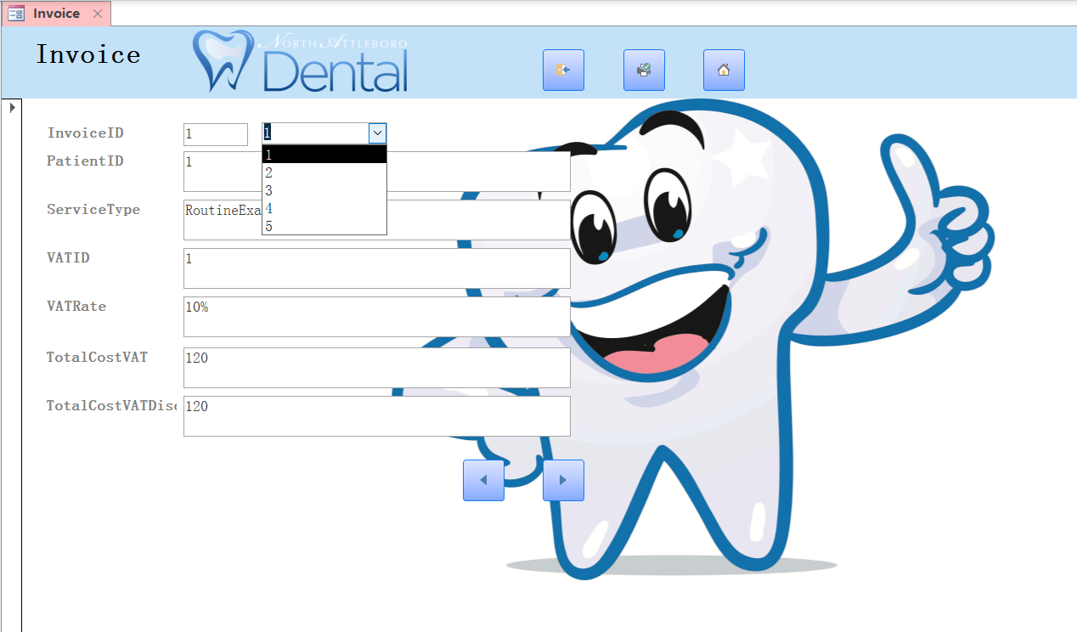
Figure 22 Invoice form example

3.2.4 Printing System
To help the users print common forms more conveniently, a printing system is offered to make it. When users click on the “Printing System” button on the main menu, they will be leaded to the page directly. Figure 23 shows the page of printing system. In the system, users should first choose which form they need to print and enter the ID of the patient or appointment then. When they make sure the ID they want to search, click the button to run the printing Macro, the process of which is shown in Figure 24.
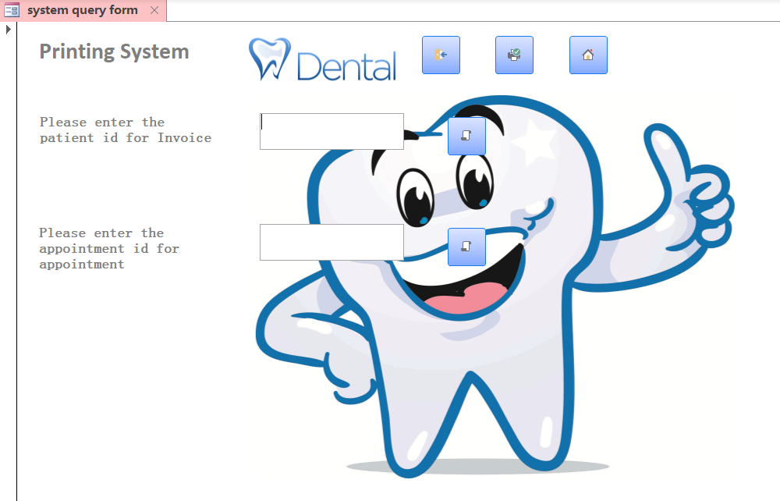
Figure 23 Printing system example
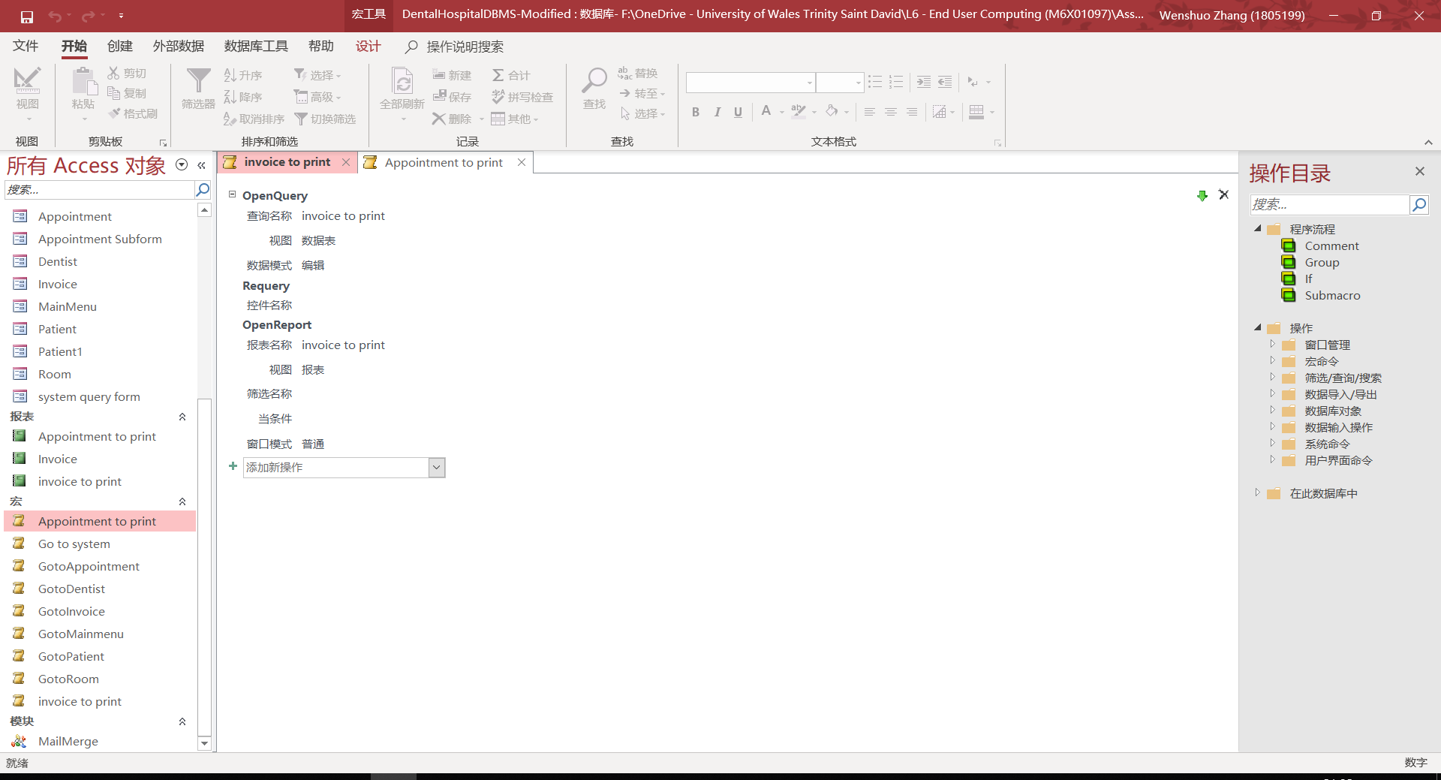
Figure 24 Macro for invoice printing
Here, invoice ID 1 is taken as an example. After typing into the ID and click the button to run Macro, an invoice form with the specific ID will be generated automatically as shown in Figure 25. The users can adjust the printing format of the form and print it easily for further use.
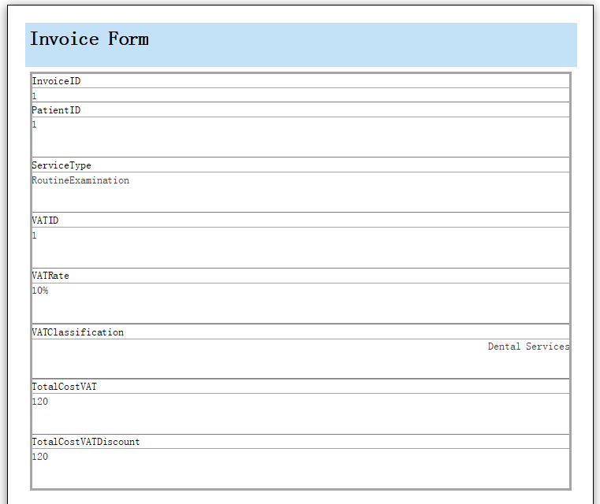
Figure 25 Invoice form printing preview

3.2.5 Mail Merge
Sometimes, the users need to write an e-mail with specific information from the MS-Access database so mail merge[12] function in MS-Word is helpful to simplify the process. After finishing the access file, it should be put in the same folder with word file and a link should be set between the access database and work document. Once the connection has been set properly, users need to select necessary fields directly from the mailings menu tab and users will select them first as merged fields and then change the fields to document variables as shown in Figure 26.
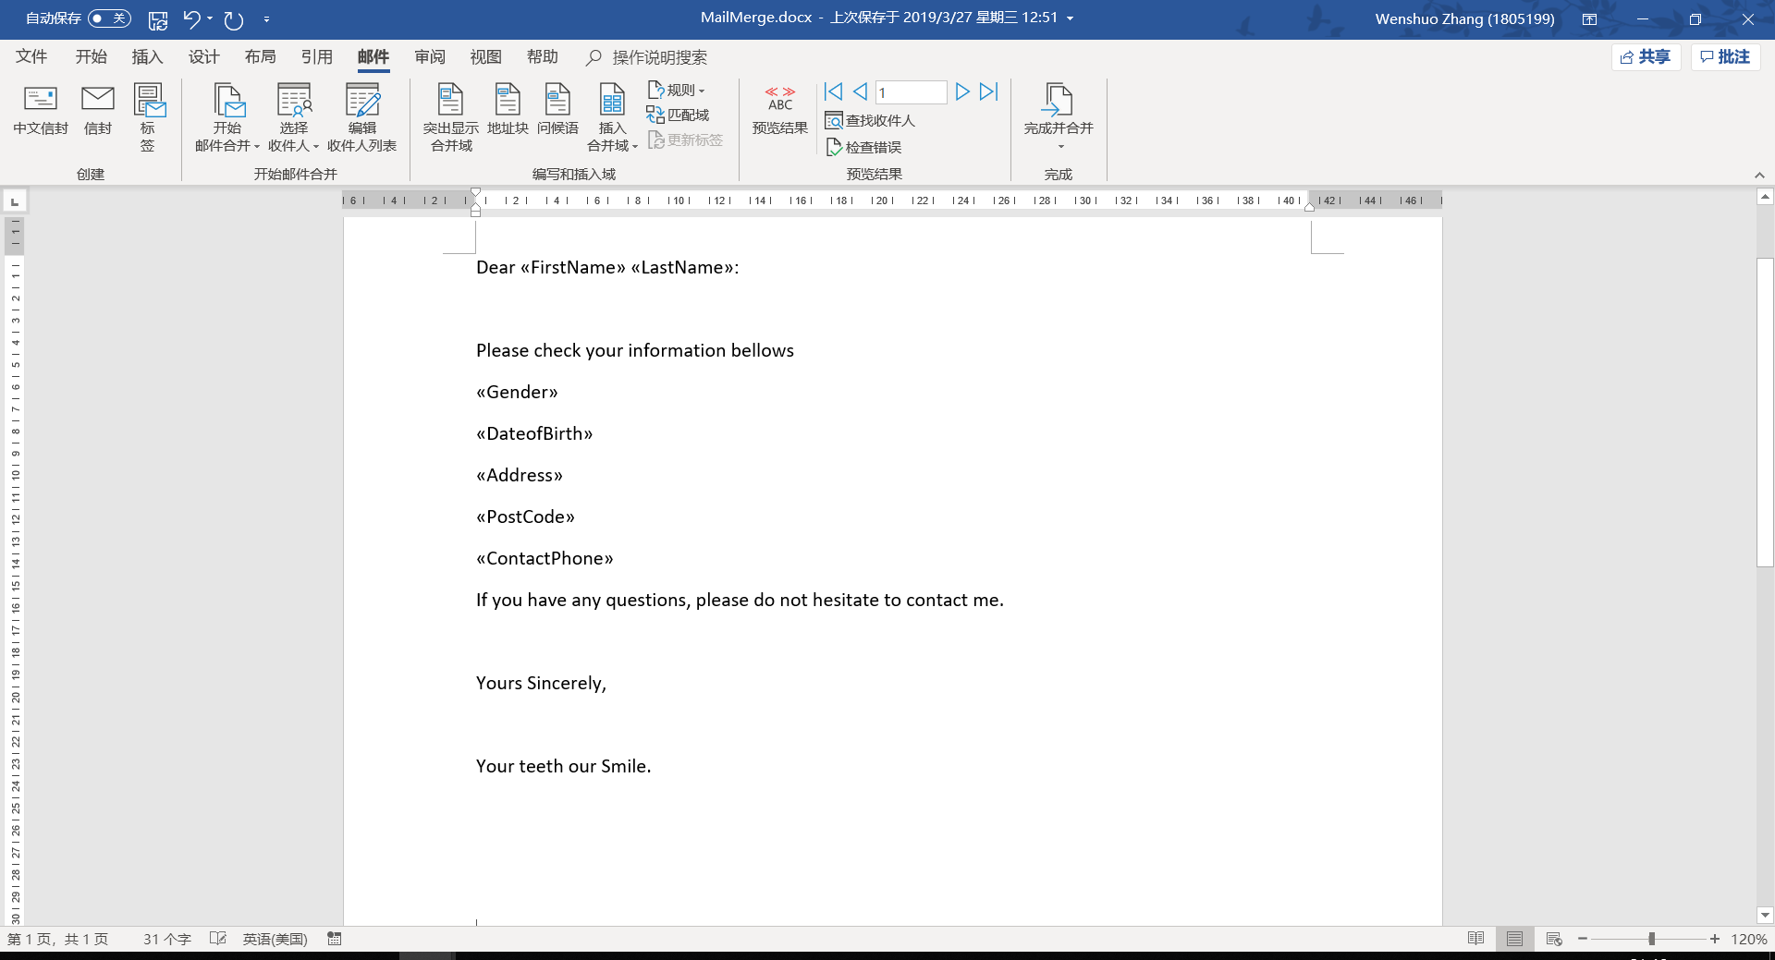
Figure 26 Initial setting of mail merge
The users can preview the mail and go to the previous or next record with specific button as shown in Figure 27. As a result, the users can send the mail to patient easily and conveniently.
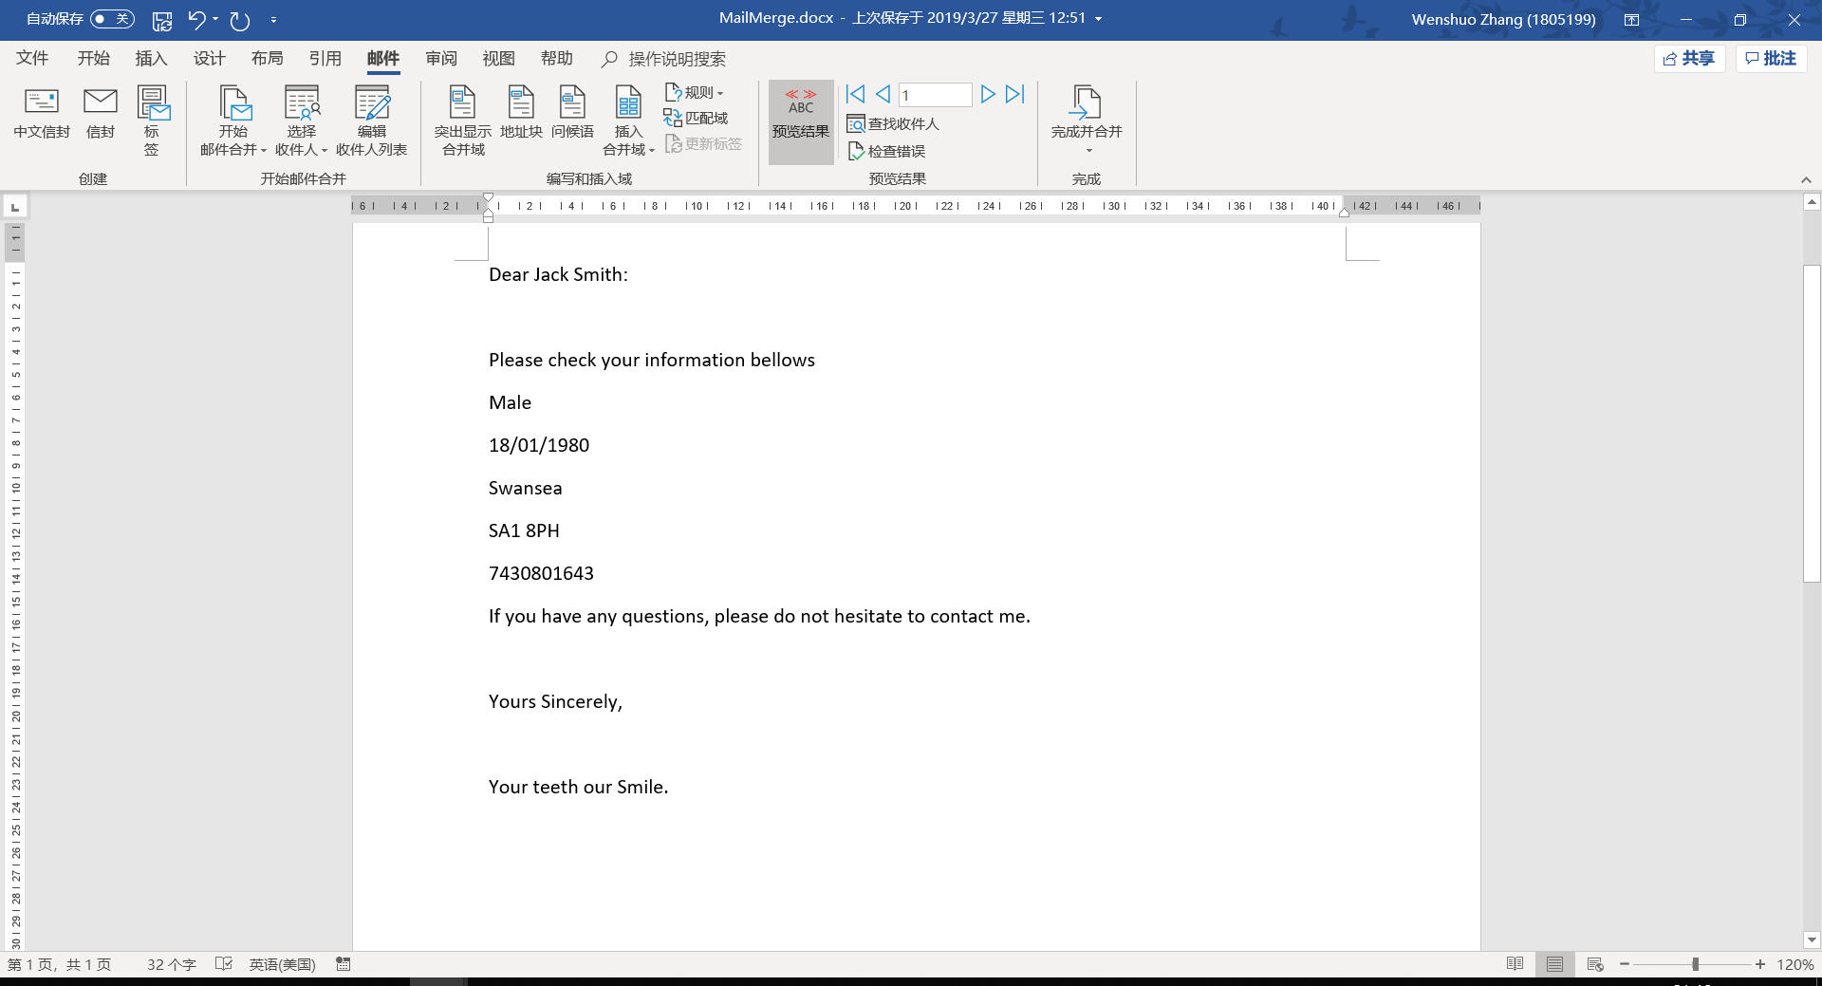
Figure 27 Result preview of the mail

User Guide to the System
In the system instruction, you can find main functions and description of the system including appointment, invoices, forms and mail merge. You can find a title with brief introduction to each function and a detailed description after the title. Also, unique number to different functions give a more convenient way for you to find the function that you need.
1. User navigation interface - Main menu
The menu gives you a clear view of the function that the system has including appointment and invoice. When you need to add a new patient to the appointment, please turn to the appointment system. When you need to make and print the invoice for a patient, please turn to the invoice system.
2. Initial data input – System setting
Before the use of the system, you should follow the instruction of the page to fill each setting choice based on the real situation of your dental hospital. Also, do give more details of each setting to bring convenience for later users.
3. Patient information input – Appointment making
The input of the patient information should be manually and doing carefully. With all the information cells, you do not need to fill all of them but just some of the necessary information. Some cells such as room type will be shown automatically after you choose the room number and can save you some time.
4. Appointment listing and inspection – Appointment Calendar
When you add in the appointment information of the patient in the previous step especially the time, the appointment will display in the calendar view automatically. All you need to do is check whether the appointment is in the right position and check the details of different appointment with the second calendar view with the switch on the top – left of the page.
5. Patient services input – Invoice generating
When you need to generate an invoice for the patient, you need first choose the specific patient and the information details will show below automatically. Then, you need to choose different services that the patient accepted during their stay with a drop-down menu and put the amount of them, the price will show automatically, and the total amount will be calculated automatically.
6. Table forms viewing and inspection – Forms generating
When you need to check different forms including patient, appointment, dentists, room and invoice, you just need to find the right button on the main menu of MS – Access system. Then, you could use the buttons on the bottom to check the former and next record. Also, you could go back the home page or print the form with the buttons on the top.
7. A convenient way for printing – Forms printing
When you click on the “Printing System” button on the main menu, you will be directed to the printing system page. Input the ID of patient or appointment and you will get a pre-view of the form to print.
8. Send an email for notice – Mail merge
When you need to send an email to a patient to notice the appointment, you do not need to type in all the related information manually. You could use mail merge with the link between MS – Access and Word to get the necessary information quickly and some templates have been prepared already for you to use.

Conclusion
To appraise the prototype that has been developed, the environment in Microsoft software has been great because of the supporting methods that Microsoft offered to different kind of users. You could even find different supporting information with detailed descriptions on the official supporting website of Microsoft. In the cases that your code encountered some problems, the error information and code would show on the screen and you could search for them at the forum. Based on the supporting of MS – Excel and Access, the prototype system has been developed to help the dental hospital computerise its working process with some main features. However, more little function and more optimization for different kind of users should be taken into consideration. Further, some comments on the advantages and disadvantages of MS – Excel and Access has been made in Chapter 2.
In conclusion, the solutions to computerise the working process of the dental hospital has been built through MS -Excel and Access and the investigation has been done to optimise the end user development platforms. The appointment system, invoice and form system have been designed to perform the process requested by the user. Some details and methods to realize the function have been explained and more facilities have been provided to computerise the user’s activities. Especially, in the invoice and form system, the users can print each invoice and form easily and quickly with a click on the button which has been set up already to bring convenience for users on the printing activity. Then, a brief instruction including different functions that the system provided has been given to guide the users to the system and make the system more friendly for users to use at real situation.

Reference
[1] KAPPELMAN, L.A. and GUYNES, C.S., 1995. End-user training & empowerment. Journal of Systems Management, 46(5), pp. 36.
[2] The Interaction Design Foundation. (2019). End-User Development. [online] Available at: https://www.interaction-design.org/literature/book/the-encyclopedia-of-human-computer-interaction-2nd-ed/end-user-development [Accessed 1 May 2019].
[3] Melo C O, Moraes J, Ferreira M, et al. A method for evaluating end-user development technologies[J]. 2017.
[4] What-when-how.com. (2019). Spreadsheet End User Development and Knowledge Management (information science). [online] Available at: http://what-when-how.com/information-science-and-technology/spreadsheet-end-user-development-and-knowledge-management-information-science/ [Accessed 1 May 2019].
[5] Rittweger B G, Langan E. Spreadsheet Risk Management in Organisations[J]. arXiv preprint arXiv:1009.2775, 2010.
[6] Anon, (2019). End User Development: An Asset or a Liability? [online] Available at: https://www.skylinetechnologies.com/Blog/Skyline-Blog/November-2012/End-User-Development-An-Asset-or-a-Liability [Accessed 1 May 2019].
[7] Borges C R, Macías J A. Feasible database querying using a visual end-user approach[C]//Proceedings of the 2nd ACM SIGCHI symposium on Engineering interactive computing systems. ACM, 2010: 187-192.
[8] Airweb.org. (2019). Creating an Excel Menu Worksheet. [online] Available at: https://www.airweb.org/eAIR/techtips/Pages/Excel-Menu-Worksheet.aspx [Accessed 21 Jan. 2019].
[9] Cayirli T, Veral E, Rosen H. Assessment of patient classification in appointment system design[J]. Production and Operations Management, 2008, 17(3): 338-353.
[10] Hill, J. (2019). Disruptive Innovation Part 2: Invoice Processing Software. [online] UFC, Inc. Document Scanning and Forms Processing Software. Available at: https://www.ufcinc.com/BLOG/Document-capture/Disruptive-innovation-part-2-invoice-processing-software [Accessed 21 Jan. 2019].
[11] Learnline.cdu.edu.au. (2019). The INVOICE Database. [online] Available at: http://learnline.cdu.edu.au/units/databaseconcepts/module1/popups/invoicedb.html [Accessed 21 Jan. 2019].
[12] Office, s. (2019). Mail merge using an Excel spreadsheet. [online] Support.office.com. Available at: https://support.office.com/en-us/article/mail-merge-using-an-excel-spreadsheet-858c7d7f-5cc0-4ba1-9a7b-0a948fa3d7d3 [Accessed 1 May 2019].

