BA (Hons) Developing Leadership and Management

BMSW5031_Cardiff

Creativity and Innovation (Rework)

Critically detailing and discussing an innovative/creative solution to an operational problem

Lecturer: Chris Wilkin

Dan Timircan, Student ID:2118870

Table of Contents
Part 1 3
1. INTRODUCTION 3
2. CRITICAL ANALYSIS OF CREATIVITY, INNOVATION & CAPITALIST BUSINESS GROWTH 3
2.1 Creativity and Innovation in Operations 3
2.2 Problems of Capitalist Growth in Seren Coffi 4
2.3 Why Traditional Solutions Would Fail 4
3. OPERATIONAL PROBLEM ANALYSIS 4
3.1 Key Operational Issues 4
3.2 Business Model Canvas Analysis 5
4. PROPOSED INNOVATION: “SEREN COMMONS” COMMUNITY OPERATIONS MODEL 6
4.1 Explanation of Innovation 6
4.2 Why This Innovation Fits Seren Coffi 7
5. APPLICATION OF THE 4Ps OF INNOVATION 8
6. CREATIVITY PROCESS & FRAMEWORKS 10
7. FORCE FIELD ANALYSIS & VIABILITY 11
7.1 Driving Forces 12
7.2 Restraining Forces 12
7.3 Viability Evaluation 12
8. ORGANISATIONAL CLIMATE FOR INNOVATION 13
9. CONCLUSION 13
Part 2 14
1. Introduction 14
2. Initial Use of Copilot 14
3. AI-Generated Recommendations 15
4. Critical Evaluation of AI Outputs 15
5. How AI Improved the Innovation 16
6. Limitations and Ethical Concerns 17
7. Reflection on Human Judgement vs AI 18
References‌ 19
Appendix 21

Part 1

1. INTRODUCTION
Seren Coffi is an independent café in Cardiff, known for its ethical practices, its use of a Welsh cultural identity and its sense of community. Even though it is gaining customers and gaining positive publicity, the organisation is facing a lot of operational challenges such as increasing costs due to supplier, employee fatigue, slower decision making and drop in operational efficiency. All these pressures have produced tensions between holding to the ethic of the café and complying with capitalist expectations that it will grow and be standardised. This report is a critical discussion on the link between creativity and innovation to operational sustainability in Seren Coffi. It has the idea that the main problem in the organisation is not the low demand of the markets, but the fragility of the operation that comes from the tensions of democratic governance, ethical authenticity and commercial pressures. The report recommends an innovative operational model for a community integrated approach that would facilitate enhancing the resilience capacities and yet not sacrifice Seren Coffi’s unique character.

2. CRITICAL ANALYSIS OF CREATIVITY, INNOVATION & CAPITALIST BUSINESS GROWTH

2.1 Creativity and Innovation in Operations
Creativity and innovation is crucial for the sustainability of an organisation, especially in a service operation. Schumpeter (1934) asserted that competition is established by innovation, which is embodied in new products, new processes and new organisation methods. Choi and Yoo (2022), however, argue that a focus on profitability is not the only measure of effective innovation, and that such innovation should also be valuable for the society and the operation. In Seren Coffi, innovation is not just about making a sale, but it also enables the organisation's resilience and upholding community identity in uncertain times.
Ye et al. (2025) also hold that creativity emerges from a positive work climate that allows autonomy and shared values. This applies to Seren Coffi, who's ethical culture has an impact on customers' loyalty and cultural distinctiveness. However, the conflict between commercial and moral innovation is found. In contrast to commercial innovations that are mainly about efficiency and scalability, ethical innovations are about authenticity, sustainability and social value (Dionisio and de Vargas, 2020). Thus, a transformative innovation approach, focused on community integration and sustainable value creation is essential for Seren Coffi.

2.2 Problems of Capitalist Growth in Seren Coffi
The operational problems of Seren Coffi arise out of the tensions in capitalist business expansion. Demand for this product is high, but the pressures to scale up operations do pose threats to its authenticity that sets it apart from chain coffee shops. Standardising menus and replacing suppliers is a proposal that shows that a balance has to be struck between efficiency and ethically sourced suppliers. On the other hand, their main competition, chain cafés implementing loyalty programs and offering discounts, puts pressure on commercial standardisation.
One of Blue Ocean Strategy's recommendations is that organisations obtain sustainable advantage by differentiating from direct competition instead of competing directly on prices (Errico et al., 2021). This is a differentiation of Seren Coffi's community-centred identity. Yet these traditional growth models based on scale and efficiency could dilute what customers value most in the form of loyalty – both symbolic and emotional. The Sustainable Value theory also states that the economic, social and cultural value creation is gaining in significance in the long-term process of success (Malinić, 2021).

2.3 Why Traditional Solutions Would Fail
The loyalty apps, franchising and expansionist strategy used in the traditional ways would have a negative impact on the ethical identity and community-like culture of Seren Coffi. The tactics are focused on transacting business and standardisation as opposed to the authenticity and sustainability of the café. Such measures may be effective in the short-term, but can lower the symbolic and cultural significance that sets Seren Coffi apart in a competitive market.

3. OPERATIONAL PROBLEM ANALYSIS

3.1 Key Operational Issues
While there is good consumer loyalty and community recognition, Seren Coffi has extremely high operational volatility. Challenges to operational response have been dampened by the lack of responsiveness stemming from democratic decision making, the delay and implementation fatigue. Other symptoms of founder burnout include a loss of emotional reserves, loss of desire or motivation, financial strain, and diminished ability to lead. Furthermore, the equipment is prone to breakdown and energy costs are increasing to have negative impact on the quality of services and continuity. Other indicators of operational inefficiency include decreased events and services for residents and irregular experiences for customers. However, it is not lack of demand that is causing Seren Coffi problems; it's the fact that they cannot sustain it without losing their sense of morality and community.

3.2 Business Model Canvas Analysis
The Business Model Canvas is useful to analyse the weaknesses of Seren Coffi as it considers aspects of value creation, stakeholder relationships and organisational sustainability. (Felin et al., 2020). Ethical sourcing, Welsh cultural identity and community engagement are good value propositions that are showcased by Seren Coffi. There are some weaknesses in the key activities and key resources, however. Emotionally tired founders and ad hoc organisational arrangements and loose equipment and buildings have negatively affected operational resilience.
Ethical suppliers, energy inefficiency, equipment maintenance also are cost considerations and place a risk on sustainability. Also, a personal touch is essential in customer relations, and it's authentic, not backed by massively scaled processes. At first this makes for a positive emotional and symbolic reaction, but the café does not have mechanisms which could turn into long-term stability in the work. Thus, the business model can create social/cultural value, yet is fragile in the face of augmented commercial pressures.
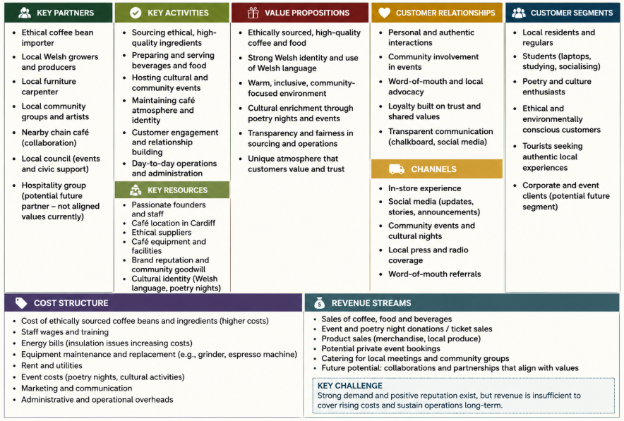
Figure 1: SEREN COFFI - BUSINESS MODEL CANVAS
Source: Created by Author using Canva (2026)

4. PROPOSED INNOVATION: “SEREN COMMONS” COMMUNITY OPERATIONS MODEL

4.1 Explanation of Innovation
The innovation proposed is an extension of Seren Coffi's existing premises, called the “Seren Commons” Community Operations Model, which aims to convey the café's business model, but this time the community is part of the process to sustain the organisation's operations, culture and long-term sustainability. This reflects the idea of social innovation, which Arroyabe and Arranz (2026) describe as innovative practice that seeks to address social needs and challenges, and who argues that it is also a social relationship- and organisation-strengthening endeavour. The Seren Commons model takes a different approach to growing by prioritising efficiency and standardisation to harness existing community goodwill to build resilience within the business and shared value creation.
The innovation involves multiple working programs that are all connected to each other. Residents from local communities would provide workshops, poetry recitations and community events as their contribution in exchange for recognition in the community, opportunities for interaction with other artisans or offer a one-time fee for participation, during evenings of structured skill sharing. Second, by creating a volunteer supported cultural event its community activities that already exist in the café would be formalised, easing the strain on the already tired founders, and maintaining the café's cultural identity, Seren Coffi. Thirdly, practical skills would be used to promote community maintenance efforts, particularly those involving someone who knows their way around a saw, a socket or some type of equipment. This aligns with Prahalad & Ramaswamy's (2004) theory of co-creation as the integration of customers as active players in the value creation within organisations and not as passive consumers.
Moreover, the model features cooperative micro-contributions using the optional contributions made by the customers associated with operational improvement projects, e.g., improving equipment or sponsoring local culture. Council, university and community group partnerships would also enhance civic engagement and access to shared resources. Operationally, the innovation enables to better spread organisational responsibilities, avoiding the ‘burnout' of founders or its fragility. Simultaneously, it boosts its symbolic value, customer loyalty, and organisational sustainability, and helps with community engagement. Put another way, the Seren Commons model is an operating change with the organisation's actions, bringing social resilience and long-term sustainability to the forefront of change rather than commercial expansion in the short-term.

4.2 Why This Innovation Fits Seren Coffi
The Seren Commons model resonates very well with Seren Coffi's values of ethics, working together and community. Throughout the case study, it has been shown that, customers are not only drawn to the products on offer in the café, but also by its transparency, its Welshness and its socially inclusive nature. Kandampully et al. (2023) argued that consumers today are increasingly interested in experiential and symbolic aspects of services environments, which means that Seren Coffi's competitive edges are based on emotional and cultural authenticity instead of operational standardization.
Importantly, the innovation reinforces, rather than undermines, the notion of authenticity, made through aggressive commercialisation. In terms of traditional capitalist solutions, there would be such things as loyalty apps, franchising, etc., and replacing suppliers, which would focus more on scale and efficiency, but not on keeping customers’ trust and symbolic value. This aligns with issues raised by Sustainable Value theory which states that companies with only a financial focus could end up jeopardising the social and cultural nature that will enable companies to be sustainable over time (Edwards, 2021). The Seren Commons model is distinct, because the community is enriched by the model, rather than the community being supplanted by the model, and the ethical sourcing practices and the democracy structures are retained. Also, the innovation aligns to Blue Ocean Strategy, given that the eventual means of competing are price-cutting and minimising customer experience – elements that chain cafés already offer. Instead, Seren Coffi develops differentiated value through community integration, the participation of culture and collaborative operational support. Hence, the innovation effectively complements the defects found in the case and is well in line with the vision, mission and ethical values of the organisation.

5. APPLICATION OF THE 4Ps OF INNOVATION
Product Innovation
The Seren Commons model is a model of product innovation because Seren Coffi no longer simply provides coffee and refreshments, but a wider community-cultural experience which emphasises participation, creativity and social interaction. Tidd and Bessant (2020) describe product innovation as the addition or improvement of value received by customers through the introduction of a new product and/or product improvement. In this instance the value proposition of any café is not only about the food and beverages, but also about the cultural stake, the ethical stake, and the community stake.
Process Innovation
The proposed innovation also includes process innovation in terms of the introduction of operational participation of collaborators cooperatively. Community-supported events, skill-sharing activities and cooperative maintenance efforts spread the burden of operational responsibilities among community members, leading to greater organisational resiliency and less burden on the founders. Goni and Van Looy (2022) suggested that organisations are able to enhance the performance of their processes through process innovation by adopting new process. Instead of enhancing the efficiency of the operations through automatic technology or standardisation, Seren Coffi advances operational sustainability by engaging and comprising community members into the operational processes and resource management.
Position Innovation
Position Innovation has been achieved by the repositioning of Seren Coffi from a stand-alone café to a community-centred cultural commons. Position innovation leads to a change in the way organisations are perceived in the market, as outlined by Tidd and Bessant (2020). In competition, what differentiates Seren Coffi is not the price or the convenience but the degree of cultural authenticity, ethical engagement and social participation. This new positioning will help build the brand's symbolic strength and reinforce customer loyalty in the independent café sector in Cardiff.
Paradigm Innovation
Most importantly, the Seren Commons model is paradigm-changing as it is defined by a different construct of what success in business is. Common strategies used by traditional capitalists measure an organisation's success based on its financial growth, scalability and operational efficiency. The proposed innovation, however, reconnects success to operational sustainability that is aligned with the community, value creation in the community and long-term social resilience. It resonates with the concept of social innovation theory that involves achieving economic sustainability along with the social impact (Deepalakshmi and Lakshmi, 2024). As a result, Seren Coffi questions the conventional thinking on growth, focusing on ethical sustainability and collective participation, rather than aggressive commercial ventures.
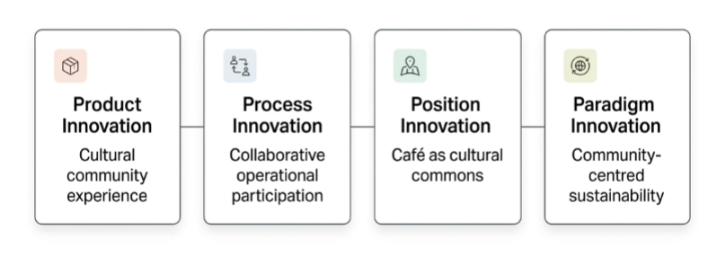
Figure 2: Application of the 4Ps of Innovation to the Seren Commons Model
Source: Adapted from Tidd and Bessant (2020)

6. CREATIVITY PROCESS & FRAMEWORKS
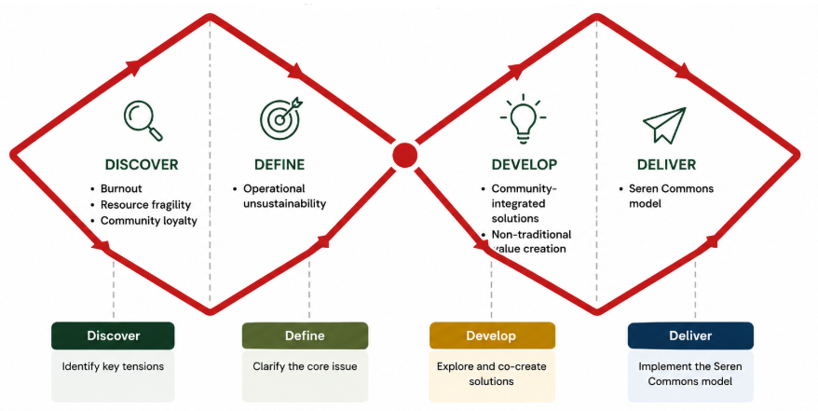
Figure 3: Application of the Double Diamond Framework to the Development of the Seren Commons Model
Source: Adapted from Design Council (2019)
The Double Diamond design process developed by the Design Council (2019) was used to guide development of the Seren Commons model. In the discovery phase, several operational challenges were revealed, such as founder fatigue, fatigue of the entire team, lack of scalability and diminishing organisation sustainability despite high community engagement. The define phase identified that the centre's real challenge is not lack of demand, but a lack of operational resilience – due to a conflict between ethical identity and growth expectations from a capitalist perspective.
Lateral thinking was encouraged during the development phase, in which alternative solutions to the commercial ones were considered, resulting in concepts based on community operational integration (COI), collaborative participation and social value creation. Lastly, the delivery stage yielded the Seren Commons model as an operational innovation arising from the community. Most importantly, the concept illustrated that the linear problem solving methods of capitalism that prioritise efficiency, standardisation or fast growth are likely to jeopardise the cultural authenticity and symbolic value that is creating Seren Coffi's competitive edge.

7. FORCE FIELD ANALYSIS & VIABILITY
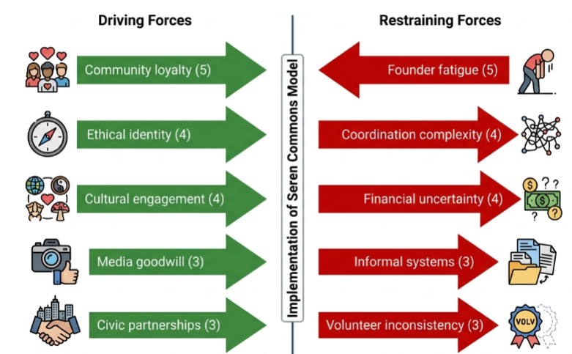
Figure 4: Force Field Analysis of the Seren Commons Innovation Model
Source: Adapted from Lewin (1951)
Lewin’s (1951) model of Force Field Analysis illustrates that there may be different driving and restraining forces to implementing the Seren Commons model relating to organisational change.

7.1 Driving Forces
Lewin's (1951) Force Field Analysis shows that Seren Coffi has several strong driving forces for implementing the model of Seren Commons. Community loyalty is the strongest support (5) as the café already has emotional attachment with the customers and cultural engagement and positive local recognition. Ethical brand identity (4) helps implement as it builds trust and symbolic value with socially conscious consumers. The cultural activities already in place (4), e.g. poetry evenings and language exchanges, serve as the basis for activities concerning community participation. Further, there is media goodwill (3) and civic partnership opportunities (3) that adds to the strength of external legitimacy and collaborative potential.

7.2 Restraining Forces
But there are some forces that could stop such efforts from being successful. The most relevant obstacle is the death of the founder, i.e. emotional fatigue (5), that could affect the leader's capabilities in handling innovation. Coordination complexity (4) also poses risk as community participation models need to be well organised and well communicated. Given financial uncertainty (4), it may be difficult to invest in operational redesign, and informal organisational structures (3) may diminish accountability and the consistency of implementation. Inconsistency of volunteer participation (3) also leads to operational uncertainty when the number of volunteers changes over time.

7.3 Viability Evaluation
However, they cannot in any way vitiate the viability of the Seren Commons model, which is looking at longer haul operational resilience and not just short haul profit maximisation. The innovation doesn't directly lead to capitalist growth, it ensures social sustainability, differentiates Seren Coffi from the chain playthangs and translates the value injected into society into business support. The model therefore presents a more sustainable and culturally relevant answer to the problem that the organisation is facing.

8. ORGANISATIONAL CLIMATE FOR INNOVATION
Seren Coffi exemplifies a number of supportive characteristics of an innovation climate. Zaeni et al. (2024) state that a creative environment cultivates autonomy and collaboration, along with intrinsic motivation. The aligned values of the café open space for experimenting and engaging creatively in a community culture and collaborative way. Additionally, employees and members of the community can suggest ideas without fear of criticism and increase innovation potential (Dekker and Edmondson, 2022).
There are, however, high costs and other barriers as well. Burnout, emotional fatigue and operational exhaustion among founders, and slow democratic decision making, decrease implementation efficiency and organisational responsiveness. Plus, there are no formal operational systems to help with coordination under pressure. Importantly, Seren Coffi's culture is also extremely values-led, which fosters creativity but impedes effective execution, thus highlighting the operational/innovative trade-off between working collaboratively and sustaining the operations.

9. CONCLUSION
In a values-led organisation, traditional capitalist growth models come up against limits when confronted by the operational challenges that confront Seren Coffi. The Seren Commons model, on the other hand, creates operational resilience and shared value creation, based on community loyalty. When it comes instead to consideration of ethics and ethical identity, the innovation process intensifies cultural authenticity, collaboration and sustainability as a matter of long-term profitability as well. It is therefore a solution that is consistent with the community oriented approach of Seren Coffi, and at the same time, is realistic and innovative in terms of an operational approach to fragility.

Part 2

1. Introduction
This supplement is a critical review of how Seren Coffi utilises Microsoft Copilot to create the Seren Commons model for innovation. Copilot was chosen due to its user-friendliness, human-like interaction and effectiveness in quickly producing business operations and creative concepts. Using AI was not to replace independent thinking, but to aid in exploring ideas and having critical reflections to then develop innovative ideas during assignment process. Copilot was leveraged to explore operational challenges, propose alternative solutions and assess risks during implementation during the interaction. But human judgment would still be needed to fine-tune thoughts and make sure they were consistent with what Seren Coffi believes in and how they align with the work culture of his organization. So, AI was more of a brainstorming aid than a critical investigation or strategic decision-making tool.

2. Initial Use of Copilot
It wasn't simply about marketing failures or falling sales when I started working with Copilot. I was more interested in finding out what was going on at Seren Coffi, the operational and sustainability issues that were plaguing the business. In the initial prompts, I started asking the AI system why the café is having trouble with its operations despite its positive reputation and community standing. Copilot was able to spot a number of significant challenges such as founder burnout, a shortage of staff, slow decision-making, equipment breakdown and high energy bills. This was helpful in structuring a case to themes of operation and also in understanding that there was a business problem that had a relationship with a fragile organisational posture and not a low demand for their product or service.
I did note, however, that many of the early pieces remain rather descriptive and haven't necessarily offered more in terms of theoretical or critical investigation. While Copilot identified poor performance and utilisation, it did not go deeply enough to analyse the impact of Seren Coffi’s democratic management on implementation delays and organisational fatigue. Likewise some of the first recommendations were based on the more traditional commercial perspectives, in particular regarding the need to generate revenue and retain customers. This showed me that although Copilot was helpful in quickly producing operational insights, I still had to critically assess if the suggestions matched the ethical identity and sustainability goals of Seren Coffi.

3. AI-Generated Recommendations
As these conversations progressed, Copilot came up with a broader list of suggestions for membership programs, subscription-based revenue models, digital involvement concepts, community activities, and civic collaborations. At the beginning, it appeared that a lot of the tips were things you'd run at a good chain café, like a loyalty thing and good regular income. These recommendations could have failed to benefit the financial stability, but I felt it was not working for Seren Coffi's independent identity and community-based culture.
Following refinement of the prompts and specific request for less traditional ideas, outputs were more contextually relevant and creative. Copilot started to recommend activities like repair workshops, chalkboards on stories, exchanges of skills, joint activities and models of participation in the community. The ideas were much more useful since instead of promoting over-commercialisation they were in line with Seren Coffi's ethical values and cultural atmosphere. I was impressed by the shared stewardship discussion which played a significant role in the formulation of Seren Commons concept and put customers on the operational sustainability side, being active participants of the process, not just passive consumers.
Simultaneously, it illustrated an important aspect of AI-aided creativity, which is that the process is not entirely flawless.But at the same time, it showed an important point about using AI to create: Not all cleverness is flawless. Despite ethical and community culture prompts, Copilot often defaulted to the business models that are prevalent in commerce. This showed that ideas generated by a prompt were not necessarily the only factor to be credited to effective AI-assisted innovation; the human factor was crucial, too, and prompting needed constant evolution and refinement.

4. Critical Evaluation of AI Outputs
Copilot proved to be useful in several ways for the Seren Commons model development, including the following: Several things were learned from the use of Copilot in developing the Seren Commons model: It also showed, however, that innovation processes with the help of AI have certain restrictions. The most striking problem was that the system was more focused on commercially dominant business solutions like loyalty programs, recurring membership schemes and planned revenue-based processes. Despite ethical identity and community culture being highlighted in the prompts, many of the outputs started with assumptions regarding capitalist growth models that prioritise scalability, efficiency and retaining customers. This helps alleviate the fear that the business recommendations produced by AI may replicate the dominant business patterns of the training data, instead of innovation approaches that are appropriate for the situation (Edwards, 2021).
Additionally, some of the outputs lacked a deeper understanding of the cultural and symbolic significance of Seren Coffi. The AI system identified operational issues like burnout and equipment failures, but couldn't fully capture the emotional, ethical and community-focused aspects that set the café apart from its chain counterparts. For example, for service-based businesses such as Seren Coffi, where the concept of loyalty and membership structures was mentioned, it was found that the importance of not only being transactional, but also being invested in the company's identity development was largely underestimated. This revealed AI's lack of symbolic interpretation and the socially embedded organisational cultures (Malinić, 2021).
There were also some repeated suggestions over prompts, specifically on issues of financial sustainability and customer engagement strategies. While in many instances these ideas were workable from an operational perspective, they were frequently uninspiring and needed lots of development to make them strategically viable. But, this interaction was still extremely useful in the sense that it promoted iteration and critical examination of ideas instead of an uncritical taking of AI output. A significant part of this filtering, refining and redirecting of the recommendations was done by human judgment in order to achieve an ethically appropriate and integrated solution into the community. The final Seren Commons model was therefore the result of a process of collaborative refinement that involved the use of AI to explore ideas, coupled with contextual judgement and critical analysis, ensuring the innovation was realistic and consistent with the identity of the Seren Commons.

5. How AI Improved the Innovation
Even though it had its drawbacks, Copilot offered substantial benefits for the innovation development process: It provided a rich set of alternative ideas in a short time and catalysed creative brainstorming. The AI system quickly detected areas of weakness, pointed out sustainability issues and provided potential solutions to the staffing, customer involvement, partnerships and organisational resilience areas. This facilitated divergent thinking and facilitated more diverse consideration of the operational possibilities when compared to traditional methods of running a café (Tidd and Bessant, 2020).
The interaction proved also to be effective in detecting the operational risks and obstacles to the implementation of the Seren Commons model. The critical evaluation elements in the Force Field Analysis and organisational climate sections were reinforced with responses that talked about the inconsistencies of volunteers and governance stress and coordination challenges. Copilot also helped with the development of the framework structure, organising concepts under community participation, co-creation and collaborative sustainability. This was in line with the idea put forward by Prahalad and Ramaswamy (2004) of value creation becoming more about stakeholder participation and less about consumption.
Moreover, AI-based dialogue enables us to relate operational issues to the greater concepts associated with social innovation and sustainability. While contextual understanding in terms of writing and analytical organisation was improved, however, human contextual judgement was inescapable in ensuring the originality and the ethical appropriateness and operability. Hence, in general, AI has not been a game-changer when it comes to innovation creation, but rather a good auxiliary device.

6. Limitations and Ethical Concerns
While Copilot was helpful in generating ideas and analysing operations, the following constraints and ethical concerns emerged during the interaction. A major problem was that of originality. A number of the AI-driven suggestions were similar to widely-used business techniques, such as loyalty programs, membership plans, and customer retention strategies. That potentially meant a risk of over-standardised outputs, with creative thinking being curtailed by dominant patterns in the AI training data sets. Consequently, sometimes there was a tendency to focus on capitalist solutions that happen to be foreseeable rather than the creativity required if you're working in a specific context.
Another - hallucination risks, oversimplification. Some outputs seemed to lack deeper understandings of the symbolic meaning and organisational culture of Seren Coffi, and were presented with assurance. The AI system was able to pinpoint operational problems but not fully understand the emotional attachment, community identity, and ethical conflicts that influence the decision-making of the organisation. This is consistent with the general perception that AI is not widely attuned to cultural and emotional aspects in creative problem-solving scenarios (Dionisio and de Vargas, 2020).
Ethical issues also arose about reliance on AI-generated creativity. Overuse of AI-generated ideas can stifle original thinking and lead to a tendency to follow a formula when running a business. In addition, AI systems can embody the dominant commercial and growth conceptions around growth, efficiency and monetisation, restricting a social innovativeness thinking (Edwards, 2021). The Copilot gave useful support during innovation development but the outputs had to be evaluated, analysed and interpreted in the context of the text and had to be analysed in terms of the ethical aspects, in order to ensure originality and a suitable fit within the organisation.

7. Reflection on Human Judgement vs AI
As I went through this, I discovered that the completed idea for Seren Commons wasn't a strictly automated process, as much as the output of interacting with AI suggestions and my own critical thought. While Copilot was useful for establishing ideas rapidly and outlining operational risks, the results were a great deal of commercially generic ideas that needed to be fleshed out. I needed to assess what I thought were feasible and possible ideas that would meet Seren Coffi's moral beliefs and community culture. This showed that AI can contribute to the development of innovative ideas, however, there is still a significant need for human interpretation and decision making to fully appreciate that innovation has a meaning within a context.

References‌
Arroyabe, M.F. and Arranz, C.F.A. (2026). Social innovation in SMEs: Examining the role of artificial intelligence and social and environmental sustainability. Journal of Environmental Management, 398, p.128439.
Canva (2026). Amazingly Simple Graphic Design Software – Canva. [online] Canva.com. Available at: http://canva.com [Accessed 19 May 2026].
Choi, S. and Yoo, J. (2022). The Impact of Technological Innovation and Strategic CSR on Firm Value: Implication for Social Open Innovation. Journal of Open Innovation: Technology, Market, and Complexity, 8(4), p.188. doi:https://doi.org/10.3390/joitmc8040188.
‌Deepalakshmi, N., and Lakshmi, M. S. (2024). Innovative Models in Social Entrepreneurship: Balancing Profit with Social Impact. Library of Progress-Library Science, Information Technology & Computer, 44(3).
Dekker, S., and Edmondson, A. (2022). Psychological safety. In Restorative Just Culture in Practice (pp. 187-196). Productivity Press. ‌
Design Council (2019) The Double Diamond: A universally accepted depiction of the design process. [online] Available at: https://www.designcouncil.org.uk/our-resources/the-double-diamond/ [Accessed 18 May 2026].
Dionisio, M., and de Vargas, E. R. (2020). Corporate social innovation: A systematic literature review. International business review, 29(2), 101641.
Edwards, M. G. (2021). The growth paradox, sustainable development, and business strategy. Business Strategy and the Environment, 30(7), 3079-3094.
Errico, F., De Benedetto, G., Corallo, A., and Ragone, M. M. (2021). A start-up innovation development framework: The business model canvas and blue ocean strategy. Special Issues on Regional Entrepreneurship & Innovation Planning, 235.
Felin, T., Gambardella, A., Stern, S., and Zenger, T. (2020). Lean startup and the business model: Experimentation revisited. Long Range Planning, 53(4), 101889.
Goni, J.I.C. and Van Looy, A. (2022). Process innovation capability in less-structured business processes: a systematic literature review. Business Process Management Journal. doi:https://doi.org/10.1108/bpmj-07-2021-0487.
Kandampully, J., Bilgihan, A., and Amer, S. M. (2023). Linking servicescape and experiencescape: creating a collective focus for the service industry. Journal of Service Management, 34(2), 316-340.
Lewin, K. (1951) Field Theory in Social Science. New York: Harper & Row.
Malinić, D. (2021). Value-based management, long term sustainability and corporate social responsibility. Facta Universitatis-Economics and Organization, 18(4), 357-367.
Prahalad, C.K. and Ramaswamy, V. (2004). Co-creation experiences: the next Practice in Value Creation. Journal of Interactive Marketing, 18(3), pp.5–14.
Tidd, J., and Bessant, J. R. (2020). Managing Innovation: Integrating Technological, Market and Organizational Change. John Wiley & Sons.
Ye, L., Li, Y. and Zhang, N. (2025). The impact of autonomy-supportive organizational environments on employees’ emotions and creative performance: A self-determination theory perspective. PLOS One, 20(5), p.e0322184.
Zaeni, N., Maryadi, M., Salim, M. and Kitta, S. (2024). The Relationship Between Employee Motivation, Creativity and Performance. PARADOKS Jurnal Ilmu Ekonomi, 7(4), pp.466–480.

Appendix
Copilot chat
https://copilot.microsoft.com/chats/nnaTrYdMCZQ86iCE6yUo6


