Applied Professional Skills
BMBM5005
Benjamin John (1707698)
Activity 1
This part of the report is going to be looking at and evaluating what it means to be a professional. As well as this it will also be discussing the professional standards that are currently being used in the marketing profession by looking at the CIM professional marketing competencies framework. To be seen as a professional there are some criteria that have to be met. According to Stan Lester, a professional is someone who “makes proficient use of expert or specialist knowledge, exercises autonomous thought and judgement, and makes a voluntary commitment to a set of principles (Lester, 2015). Lester suggests that a person has to do all of these things to be a classed as a professional. In order to be seen as a professional within the marketing sector, a specific set of skills need to be met and kept up with. The Chartered Institute of Marketing or CIM is the governing board for people working within the marketing sector. The CIM has a professional marketing map that shows a framework of marketing abilities that are expected from varying levels. Appendix 1. The CIM states that in order to be professional you need to “maintain high standards of professional skill, ability and integrity among persons engaged in marketing products and services” (Chartered Institute of Marketing, 2017). To be a professional in the marketing sector it is important to follow these sets of skills.

Activity 2
Group Dynamics
This part of the report is going to be discussing group dynamics and conflict resolution methods as well as discussing some examples of conflict resolution methods that could be used in real-world organisations. In the early 1940s, Kurt Lewin, a social psychologist and change management expert discovered “group dynamics”. Lewin noted that people often take on distinctive roles and behaviours when they are tasked with working in teams. The term “group dynamics” describes the effects of these roles and behaviours on other group members and on the group as a whole (Mindtools, n.d.). There are many different variables that can affect the dynamics of a group and how people work together. One thing that can affect the group dynamics and overall success of a group is leadership within the group. Leadership is a vital role within a team in order for it to be successful. According to (Anderson and Kilduff, 2009) people who are “dominant are more likely to attain high levels of influence in groups” and therefore are more likely to complete the task in the way that they believe the task should be completed without taking on board the opinions of other group members. This would likely result in there being problems in the group and would result in poor group dynamics.
Teamwork Theories
In order to create a successful team, there are different teamwork theories that can be used to ensure that the group is set up for success. The two theories that this report will be looking at are the Tuckman Model and the Belbin Nine team roles model.

TUCKMAN
One of the theories that can be used when creating a group is Bruce Tuckman’s Forming, Storming, Norming and Performing theory. This theory originally had four stages but later went on to include the Adjourning stage. This theory is a helpful explanation of team development and behaviour which allows groups of people to successfully work together in order to achieve a common goal. The Tuckman theory “describes each of the stages that a group of people are likely to go through before they become a successful group” (Mindtools, n.d.). Tuckman’s theory suggests that teams work through progressive stages when working towards a common goal.
BELBIN
In order to have a successful group, it is important that there is a range of people who have different strengths and weaknesses. According to Dr Meredith Belbin, there are “Nine clusters of behaviour” that need to be accessed by every team in order for it to be a high performing team (Belbin, 2019). This is shown in the Belbin 9 Team role model. Appendix 2. However, this doesn’t mean that in order to have a successful team you need to have nine team members as it is likely that over time each team member will feel more comfortable with more of the roles. Each of the roles that Belbin mentions has its strengths and weakness and each of the roles has equal importance when it comes to the success of a group. The use of the Belbin model allows groups to understand the strengths and weaknesses of each of the team members, this ensures that each of the team members is working to their full potential and working in a role that is fitted to their strengths to ensure the best possible outcome from any tasks.
Conflict Resolution Methods
Conflict is something that is inevitable when it comes to group work as no two individuals have the same expectations or desires, conflict is a natural part of daily interactions with others. When working in a group it is important that you are able to solve any conflict issues that may arise quickly. There are many different ways to resolve conflict when working in groups to ensure the best possible outcome for the group.
THOMAS KILMANN
The Thomas Kilmann model is one conflict resolution method that can be used by organisations in order to solve any conflict within a group. The Thomas Kilmann model has been the “leader in conflict resolution assessments for more than forty years” (Kilmann, 2015). The fact that it has been the leading model for conflict resolution for forty years suggests that it is one of the best conflict resolution methods that can be used by organisations when it comes solving the conflict in groups of people. The Thomas Kilmann model works by assessing the behaviour of people in conflict situations, or in situations where the expectations and desires of the team members are different. In conflict situations, Kilmann’s model describes a person’s behaviour as “two basic dimensions, assertiveness and cooperativeness” (Kilmann, 2008). The first being assertiveness. This is the extent to which the individual attempts to satisfy their own concerns. The second is cooperativeness. This is the extent to which the individual will attempt to satisfy the other person's concerns. These two dimensions can then be used to define five different methods of dealing with conflict. This model works well for resolving conflict situations as it enables organisations to understand how each member of the group handle conflict and therefore allows the organisation to work around each individuals conflict handling method. After using the Thomas Kilmann method, myself, I was able to see that I am an accommodating person when it comes to conflict situations. Appendix 3.

Activity 3
5 Stages of Project Management
When working in a group to complete a project there are 5 different stages of project management. Developed by the Project Management Institute, the five phases of project management include, initiation, planning, execution, performance and project close (Eby, 2018). Each of these stages plays a vital role if the team is going to be successful with the project. According to the Project Management Institute, “project management is the application of knowledge, skills, tools and techniques to a broad range of activities in order to meet the requirements of a particular project” (PMI, 2020).
Previous Projects
During my first year studying at university, I took part in two different projects that required me to work within a small team. The first project I took part in was to raise money for a local charity so they would be able to provide hot meals for the homeless or vulnerable. The second project that I took part in was a project that required me and my team to create a small lifestyle business. As part of this report, I am going to be mentioning both of the projects and discussing areas of the projects that required the use of some problem-solving techniques. The project that I am going to be discussing as part of this report is the first project that I was part of which was the charity fundraising project. The aim of the project was to raise £250 to donate to the local charity Matthew’s House.
During the project, my team encountered some issues in terms of the management of the group and as a group, we needed to use problem-solving techniques in order to successfully overcome the issues we were facing. One of the issues we initially faced was deciding who was to be the team leader. In order to make a decision, we looked at the different leadership styles of each of the team members to see who would be the best suited to be the leader of the team. After looking into the leadership styles, it was decided that I would be the leader of the group as I have a democratic leadership style. A democratic leadership style is a “very open leadership style in which members of the group take participation in the decision-making process” (Business Phrases, 2020). This leadership style works very well for group projects as each member of the team is able to give their opinion, thus making this style a commonly effective leadership style in group projects.
GANTT CHART
During the project, my team used a Gantt chart in order to plan out the activities that we needed to complete in order to make sure the fundraising was a success. Appendix 4. It was important that we were able to manage all of our activities and to ensure that they were all completed by the dates and deadlines that we had set out. Gantt charts “convey information visually. They outline tasks involved in a project and their order, shown against a timescale” (Mindtools, 2020). A Gantt chart is an essential tool to use in any project as it ensures that all deadlines are met and that the project can be a success. Within a marketing organisation, a Gantt chart can be very useful as it is likely that there will be many ongoing projects at the same time. One advantage of using a Gantt chart in marketing organisation is that it can be used to “communicate with stakeholders” of the business (Aramyan, n.d.). By showing your Gantt chart to the stakeholders of the business it is possible to show them the real-time progress of the project and therefore they are able to visually see how well the project is doing and to see if it is reaching the milestones that it had set out.

BRAINSTORMING
A good problem-solving technique for a democratic leader is to brainstorm ideas. A brainstorm is a “process for generating creative ideas and solutions through intensive group discussion” (Business Dictionary, 2020). During the project, my team used the brainstorming method in order to come up with fundraising ideas for the charity Appendix 5. The reason why brainstorming ideas is good for this type of management style and for group work, in general, is because it allows each team member to give their opinion and have their say in the discussion. Brainstorming is also an effective way to come up with creative ideas that would be less likely to be achieved by a single person working alone. This is also suggested when (Brown and Paulus, 2002) said: “group brainstorming can be an effective technique for generating creative ideas”. The brainstorming method is an effective method for problem-solving as it ensures that there is a minimum amount of conflict within the group as everyone has a chance to share their ideas.
DEBONO
Another problem-solving method that my group could have used during the project is the Debono ‘Six Thinking Hats’. The six thinking hats method is “a simple, effective thinking process that helps people to be more productive, focused and mindfully involved” (De Bono Group, n.d.). The De Bono method is helpful for problem-solving as it allows you to separate thinking into six clear functions and roles. Each of the roles is identified with a different coloured hat. The different hats allow for each team member to focus on a specific issue or to redirect their thoughts, so they are able to make decisions.

Activity 4
CPD stands for Continuing Professional Development. “CPD is the term used to describe the learning activities professionals engage in to develop and enhance their abilities” (CPD, n.d.). Continuing professional development is important as it will allow me to develop skills within the marketing sector. Using a personal development plan, I have been able to see what areas I need to work on in order to be able to develop my marketing skills. Appendix 6.

References
Anderson, C. and killduff, G. (2009). Why do Dominant Personalities Attain Influence in Face to Face Groups? The Competence Signalling Effects of Trait Dominance. Journal of Personality and Social Psychology, pp.491-503. https://doi.org/10.1037/a0014201
Aramyan, P. (n.d.). 5 Advantages of Gantt Charts for Marketing Department. [online] Available at: https://explore.easyprojects.net/blog/5-advantages-of-gantt-charts-for-your-marketing-department [Accessed 6 January 2020].
Belbin, (2019). The Nine Belbin Team Roles. [online] Available at: https://www.belbin.com/about/belbin-team-roles/ [Accessed 30 December 2019].
Brown and Paulus, (2002). Making Group Brainstorming More Effective: Recommendations from an Associative Memory Perspective. Sage Journals. [online] Available at: https://journals.sagepub.com/doi/abs/10.1111/1467-8721.00202 [Accessed 5 January 2020].
Business Dictionary, (2020). Brainstorming. [online] Available at: http://www.businessdictionary.com/definition/brainstorming.html [Accessed 5 January 2020].
Business Phrases, (2020). Leadership Styles in Business. [online] Available at: https://www.businessphrases.net/leadership-styles/ [Accessed 5 January 2020].
Chartered Institute of Marketing, (2017). The Code of Professional Conduct. [online] Available at: https://www.cim.co.uk/media/1542/code-of-professional-conduct.pdf [Accessed 6 January 2020].
CPD, (n.d.) CPD Explained. [online] Available at: https://cpduk.co.uk/explained [Accessed 7 January 2020].
De Bono Group, (n.d.). Six Thinking Hats. [online] Available at: http://www.debonogroup.com/six_thinking_hats.php [Accessed 5 January 2020].
Eby, K. (2018). Demystifying the 5 Phases of Project Management. [online] Available at: https://www.smartsheet.com/blog/demystifying-5-phases-project-management [Accessed 5 January 2020].
Kilmann, T. (2008). Thomas Kilmann Conflict Mode Instrument. [online] Available at: https://www.organizationimpact.com/wp-content/uploads/2016/08/TKI_Sample_Report.pdf [Accessed 4 January 2020].
Kilmann, T. (2015). An Overview of the Thomas Kilmann Conflict Mode Instrument. [online] Available at: https://kilmanndiagnostics.com/overview-thomas-kilmann-conflict-mode-instrument-tki/ [Accessed 2 January 2020].
Lester, S. (2015). On Professionals and Being Professional. [online] Available at: http://devmts.org.uk/profnal.pdf [Accessed 4 January 2020].
Mindtools, (2020). Gantt Charts: Planning and Scheduling Team Products. [online] Available at: https://www.mindtools.com/pages/article/newPPM_03.htm [Accessed 6 January 2020].
Mindtools, (n.d.). Forming, Storming, Norming, and Performing- Understanding the Stages of Team Foundation. [online] Available at: https://www.mindtools.com/pages/article/newLDR_86.htm [Accessed 2 January 2020].
Mindtools, (n.d.). Improving Group Dynamics: Helping Your Team Work More Effectively. [online] Available at: https://www.mindtools.com/pages/article/improving-group-dynamics.htm [Accessed 30 December 2019].
PMI, (2020). What is Project Management? [online] Available at: https://www.pmi.org/about/learn-about-pmi/what-is-project-management [Accessed 5 January 2020].

Appendix
Appendix 1 - CIM Professional map
https://www.cim.co.uk/membership/professional-marketing-competencies/
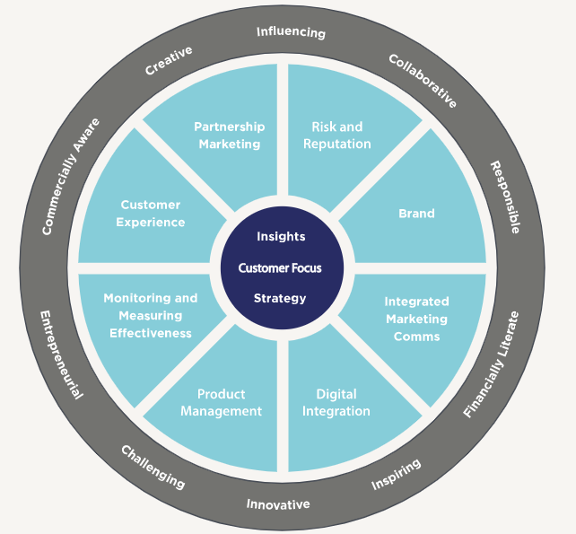

Appendix 2- Belbin- 9 Team roles model
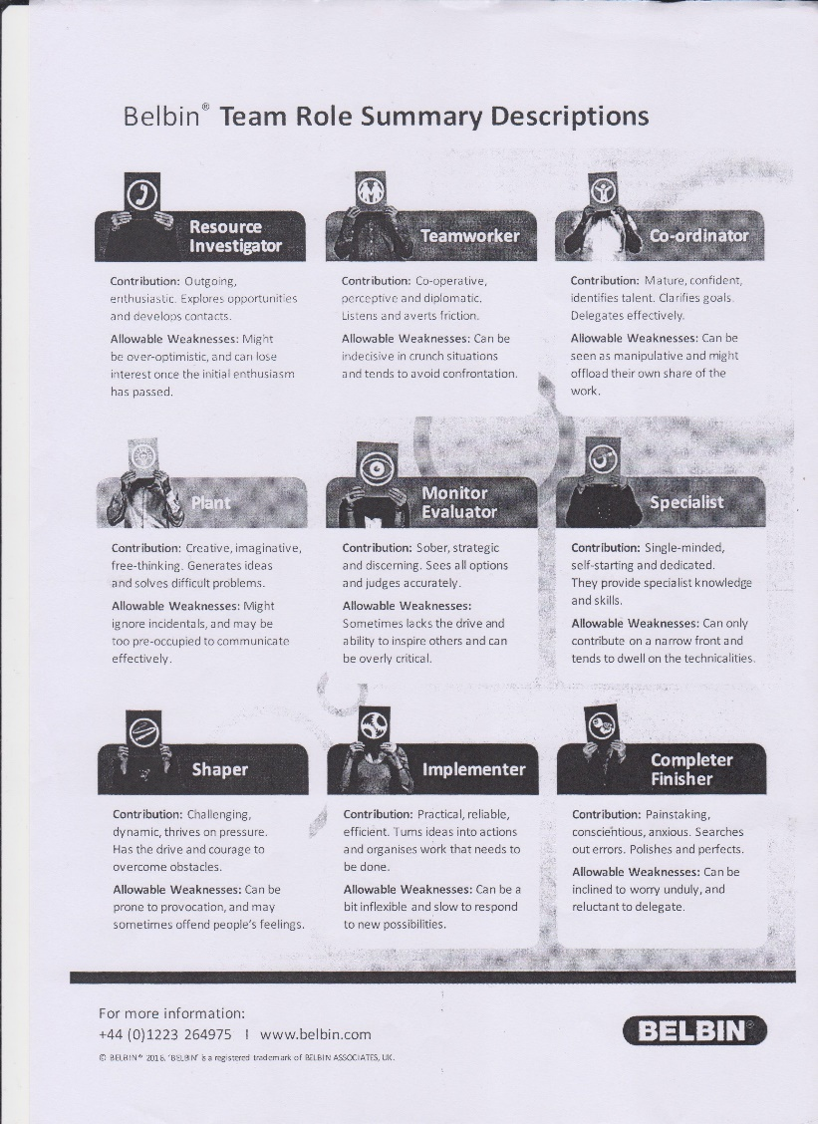

Appendix 3- Kilmann How do I manage differences
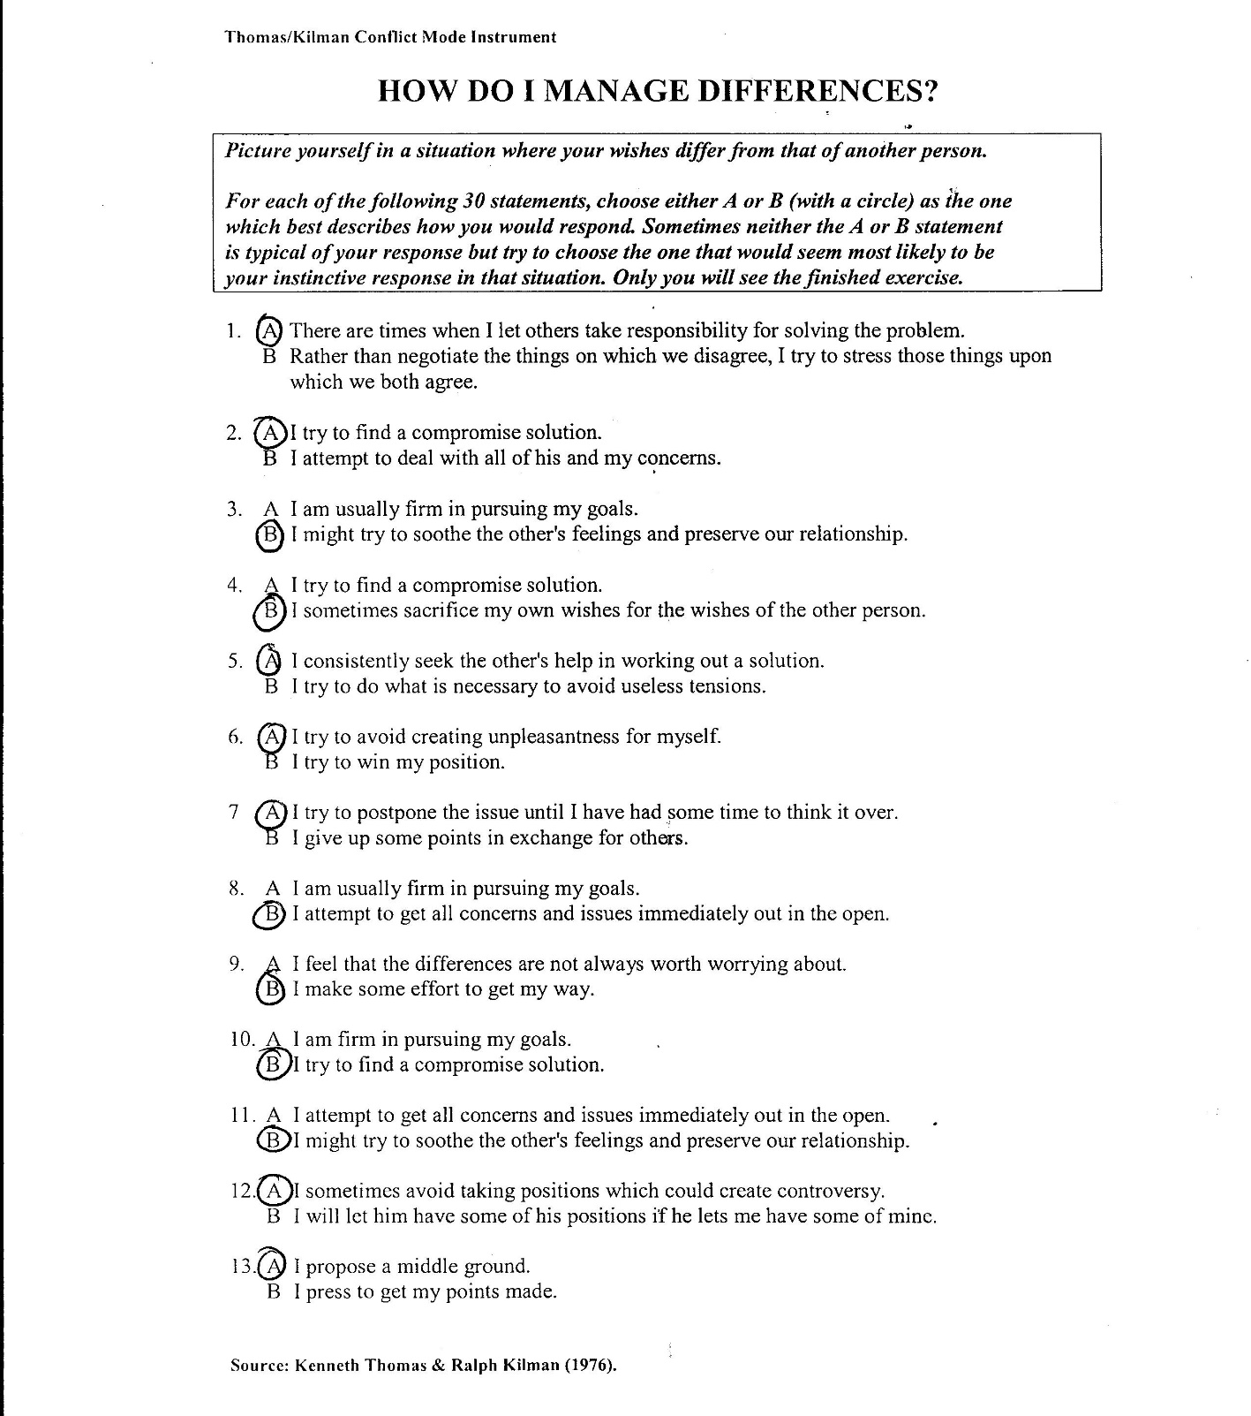
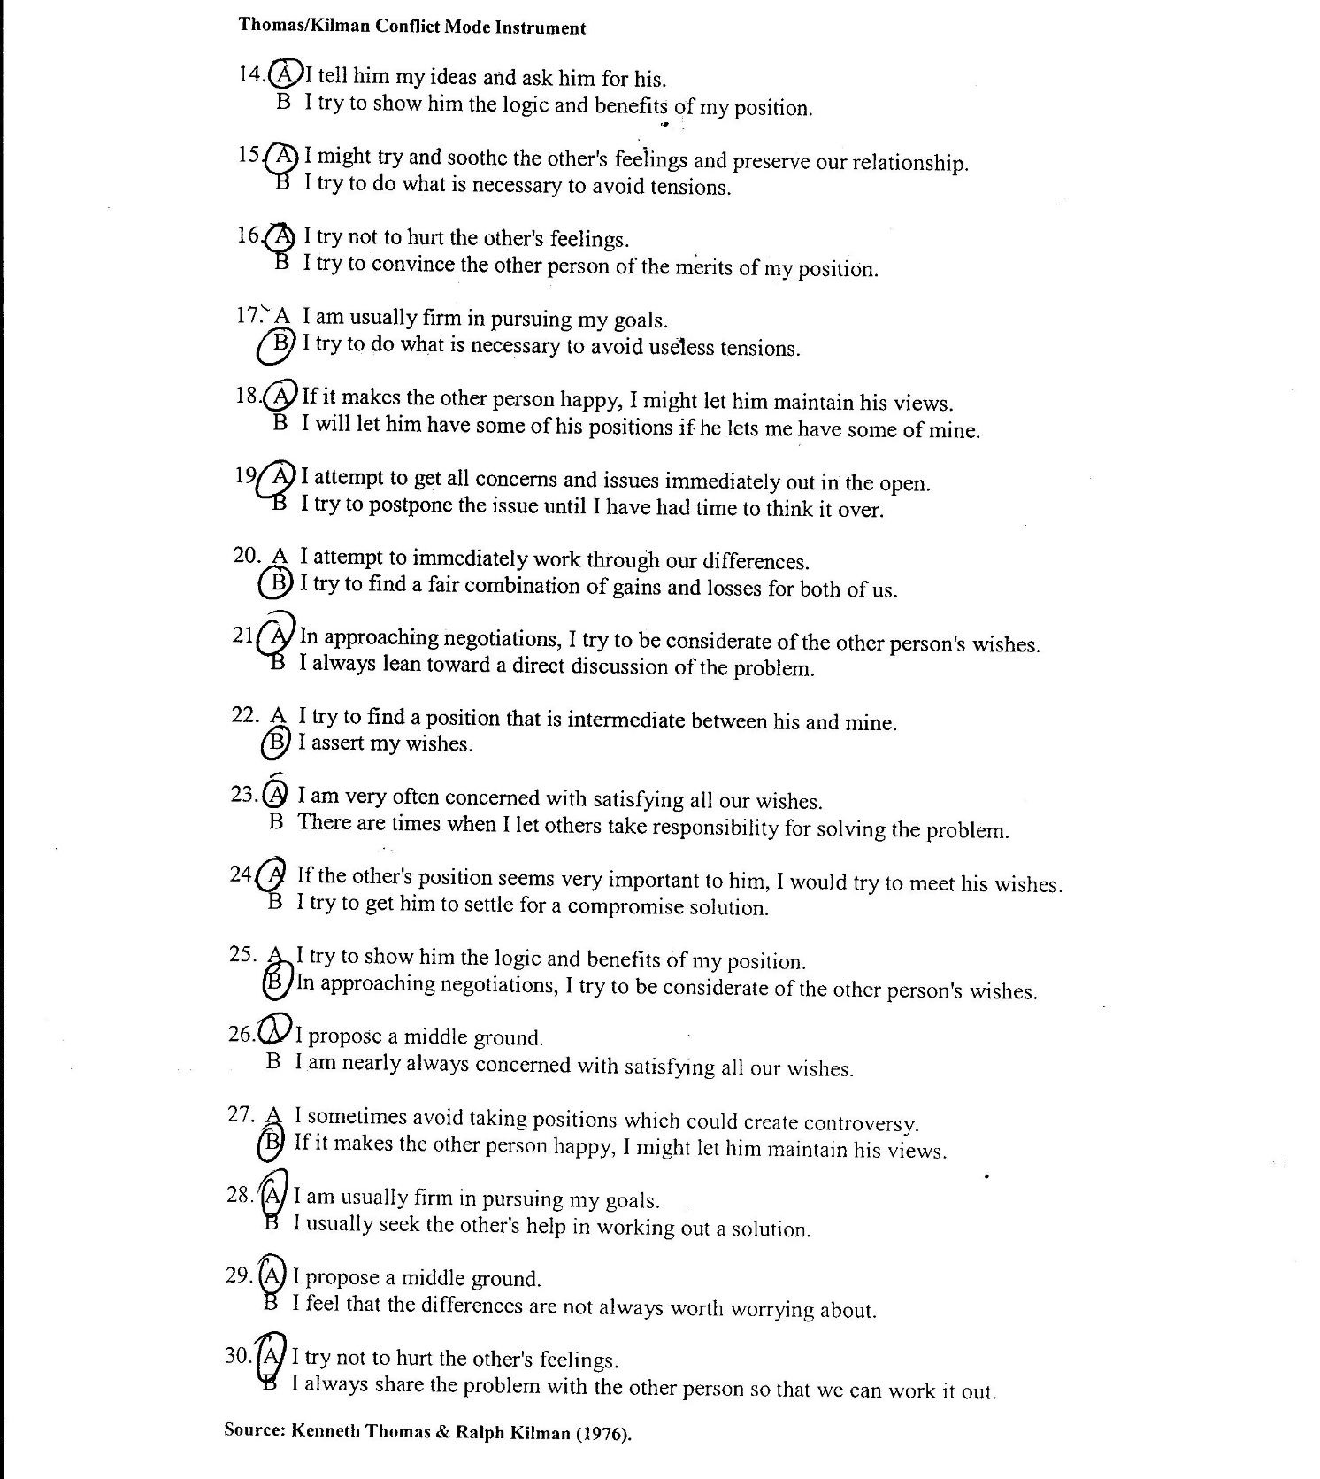
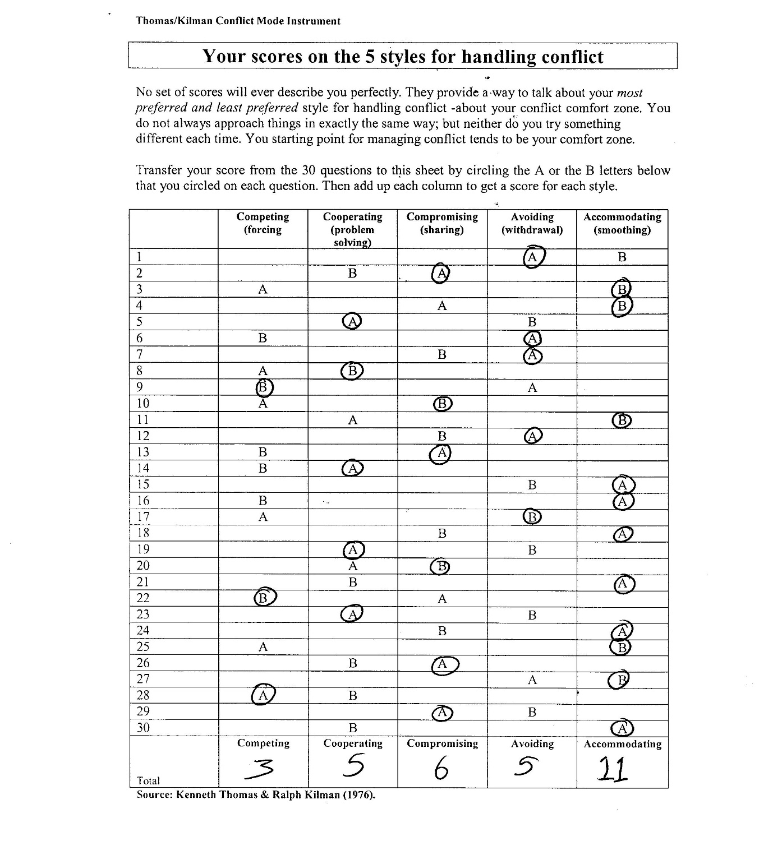
Appendix 4- Gantt chart
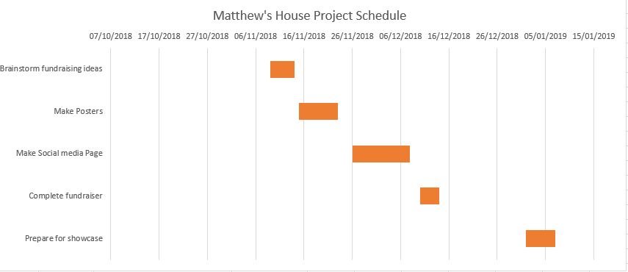

Appendix 5- Brainstorming Mind Map
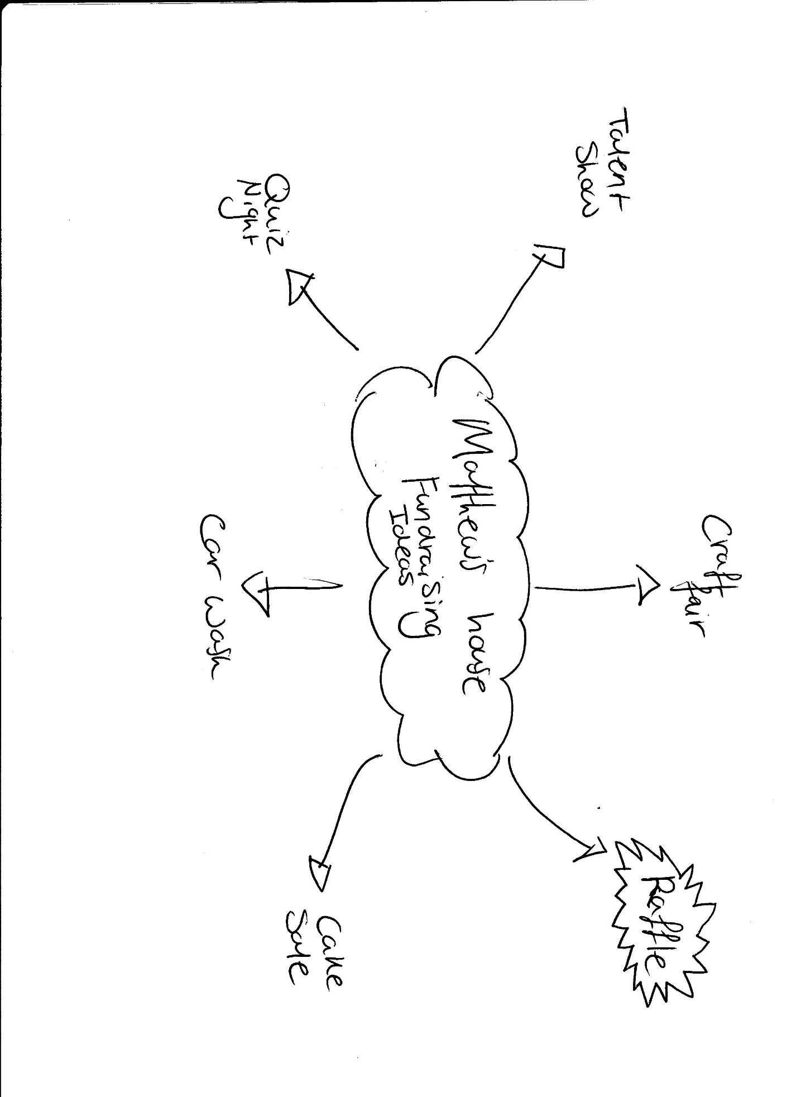
Appendix 6 – Personal Development Plan


