

University of Wales Trinity Saint David (London)
Module: Management Economics
Module code: LCBB5003
Lecturer: Taye Osadiya, Isaiah Oino,
Zainab Atta
Assignment Title: Assessment 1 Essay 2500 words
By: Kristina D. Ralcheva
Date: December 2023

Table of contents.
1. Introduction
- Overview of Supply and Demand in Economics

2. Question One: Economic Disruptions Amidst the Covid-19 Pandemic
- Impact on Demand and Supply Chains
- Shortages in Labour and Supply
- Repercussions on Global Supply Chains
- Supply Chain Disruptions and Consumer Behaviour

3. Strategies to Alleviate Economic Challenges
- Workforce Development
- Supply Chain Diversification
- Technological Integration
- Managing Consumer Behaviour
- Strategic Policy Interventions
- Embracing Sustainable Practices

4.Conclusion

5. Question Two: Relevance of Demand and Supply in the Case Study
- Alteration of Demand and Supply Equilibrium
- Shifts in Consumer Behaviour
- Impact on Pricing Mechanisms
- Global Interconnectedness of Supply Chains

6. Elasticity and Inelasticity of Demand for Fuel
- Concepts Explained
- Implications for Consumer Behaviour and Market Dynamics

7. Laws of Supply and Demand
- Law of Demand and its Explanation
- Law of Supply and its Explanation

8. Conclusion
9. References.

Introduction.
The laws of supply and demand are fundamental ideas in economics that support the operation of marketplaces. These rules delicately govern the ebb and flow of trade, outlining the complicated links between what customers want and what producers can provide. The rule of demand sets up an inverse link between price and quantity needed, illustrating how customers react to price changes. The rule of supply, on the other hand, highlights the direct relationship between price and amount provided, revealing producer behaviour in reaction to changing market conditions. These principles are the foundation of economic analysis, explaining the complicated interplay between buyers and sellers that results in equilibrium prices and quantities. Understanding these fundamental concepts is critical because they give a framework for understanding market behaviours, dynamics, and the complicated balance of supply and demand that guides economies throughout the world.

Question one.
The global impact of the Covid-19 epidemic has caused a slew of economic shocks, drastically changing the commercial environment. The consequences have rippled across major industrialised economies, notably in the United Kingdom, where business is based on continuous demand and supply networks. Pandemic-induced shortages in both demand and supply have had a profound impact on these supply networks, resulting in a ripple effect with important consequences for price and supply chain resilience.
The complicated interplays between demand and supply chains are at the heart of the economic problems addressed in this case study. Labour shortages, worsened by the epidemic, have created imbalances in these supply networks. This scarcity, particularly in the labour force, has set off a chain reaction, adding to shortages in crucial industries and putting further strain on supply chains. As a result, the spike in demand for gasoline amid labour shortages has worsened the burden on these supply systems, resulting in imminent price adjustments.

The increased reliance on imported raw materials and intermediary goods by UK companies has been a significant effect of the Covid-19 epidemic. The ensuing reliance on global supply networks has been put to the test. The Federal Global Supply Chain Barometer, a long-running indicator that tracks such pressures, has shown the exceptional severity of these difficulties, outstripping any previously known as standards. During the pandemic, a change in consumer preferences from services to commodities added to the demand on supply networks, increasing the existing difficulties.

According Andreyeva, T., Long, M. and Brownell, K. (2010) to the effects on supply chains have resulted in concerning behaviours such as panic buying and service outages. The driver shortage, mostly caused by the flight of EU drivers from the UK, has considerably affected delivery systems, particularly in the gasoline supply chain. The departure of these drivers has created a tremendous problem in replacing their skills, which might be affected by the joint consequences of Brexit and the pandemic. As a result of the driver scarcity, consumers have rushed to fill their tanks amid reports of shortages, worsening an already tight supply scenario.

As it is mentioned in the article of McKinsey & Company- 2017 at the height of the crisis, a lack of drivers resulted in a shocking 20% fall in gasoline availability at forecourts in badly impacted regions, compared to the average 43%. This discrepancy between demand and supply proves the supply chain's deep upheavals, reflecting the major economic issues resulting from the intersection of pandemic-induced labour shortages, Brexit consequences, and consumer behaviour adjustments.

To sum up, the case study underscores the multifaceted economic problems emanating from the Covid-19 pandemic's impact on demand and supply chains. The shortages in labour, coupled with consumer behaviour shifts and global supply chain vulnerabilities, have collectively led to unprecedented pressures on businesses, especially in the UK. The ramifications of these economic challenges continue to reverberate, posing intricate hurdles that demand strategic interventions for sustained economic stability.

Moreover, these economic challenges have highlighted systemic vulnerabilities within supply chains, needing revaluations of resilience strategies. The intersection of Brexit-related uncertainties and the labour shortage crisis has accentuated the fragility of the UK's supply chain infrastructure. To mitigate future disruptions, proactive measures such as investments in domestic workforce development, diversification of supply sources, and enhanced collaboration between industry stakeholders and policymakers are imperative. Addressing these fundamental economic challenges demands a holistic approach that not only resolves immediate shortages but also fortifies the resilience of supply chains to withstand unforeseen crises and ensure sustained economic stability.

1b.) The economic challenges sparked by the Covid-19 pandemic have underscored critical areas requiring targeted intervention to alleviate supply chain strains and labour shortages. Mitigating these issues demands a multifaceted approach encompassing workforce development, supply chain diversification, technological integration, consumer behaviour management, and strategic policy interventions.

Firstly, addressing labour shortages needs a concerted effort in workforce development. Investing in vocational training programs tailored to sectors facing acute shortages, such as logistics and transportation, is pivotal. Collaborations between government entities, educational institutions, and industry stakeholders can act on skill acquisition and employment, easing the strain on labour-intensive supply chains.

Diversification stands as a linchpin strategy to fortify supply chains against future disruptions. Reducing reliance on single-source suppliers through geographic diversification or alternative sourcing methods bolsters resilience. Closer collaboration with domestic suppliers also mitigates vulnerability to global market fluctuations, enhancing supply chain stability.

The infusion of technology presents a potent solution to streamline supply chain operations and mitigate disruptions. Advanced tracking systems, predictive analytics, and automation perfect inventory management, reducing lead times and augmenting overall efficiency. This not only offsets the impact of labour shortages but also enhances adaptability to fluctuating demands.

Addressing consumer behaviour shifts needs proactive communication and transparency about supply chain challenges. Educating consumers about supply chain intricacies can temper panic buying tendencies. Implementing measures like purchase limits or staggered buying schedules ensures fair access to goods, alleviating strain on the supply chain.

Strategic policy interventions wield substantial influence in resolving these economic challenges. Governments can extend targeted support through financial incentives or grants to businesses investing in workforce development and technology adoption. Facilitating international collaborations and trade agreements to mitigate cross-border trade barriers eases supply chain disruptions caused by geopolitical uncertainties like Brexit.

Long-term resilience hinges on a pivot towards sustainable practices within supply chains. Encouraging eco-friendly production methods, promoting circular economy principles, and investing in renewable energy sources mitigate environmental impact while enhancing supply chain stability.

In conclusion, resolving the economic challenges worsened by the Covid-19 pandemic demands a holistic approach. Addressing labour shortages, fortifying supply chains through diversification and technology integration, managing consumer behaviour shifts, and implementing supportive policies are integral sides of a robust strategy. Embracing resilience and sustainability as guiding principles not only mitigates immediate disruptions but also future-proofs supply chains, fostering enduring economic stability.

Question two.
2a.) The importance of demand and supply in this case study cannot be overstated, as they serve as the underlying pillars of the economic disturbances illustrated by the Covid-19 epidemic. The complex interaction between demand and supply chains is critical in understanding the systemic issues that firms confront, particularly in big, developed economies such as the United Kingdom.
Demand and supply dynamics are critical to the functioning of any economy, and their importance in this case study stems from their substantial influence on company continuity and stability. The disruptions caused by the epidemic have dramatically disrupted the equilibrium between demand and supply, resulting in catastrophic shortages, imbalances, and later economic consequences.

The pandemic has caused substantial changes in consumer behaviour, with people shifting from service to products consumption, placing strain on supply systems meant to balance commodities and services. A fundamental issue, labour shortages, affected supply chains at many levels, notably in the gasoline sector. The flight of European Union drivers from the United Kingdom, probably spurred by Brexit and the epidemic, resulting in a shortage of skilled personnel important for transport and logistics, limiting the delivery of commodities. This disturbance in supply and demand equilibrium resulted in impending price fluctuations, notably in gasoline, worsening the difficulties met by enterprises trying to stabilise operations in uncertain market circumstances.
Furthermore, the global interconnection of supply networks emphasises the importance of demand and supply. The UK enterprises' reliance on imported raw materials and intermediary goods highlights their reliance on international supply chains. The findings of the Federal Global Supply Chain Barometer, which reflect unprecedented strains on global supply networks, illustrate the severity of the difficulty that interconnected economies confront in satisfying demand.

The importance of demand and supply in this setting is not only academic, but also extremely practical. They underpin the global economy's complexity and weaknesses, particularly in the aftermath of a catastrophe. Understanding the deep interdependence of these components is critical for developing successful methods for mitigating shocks, encouraging resilience, and guaranteeing long-term economic stability.
Finally, the importance of demand and supply in this case study cannot be overstated. They serve as the foundation for the economic issues brought on by the Covid-19 epidemic. Disruptions in these fundamental economic dynamics have highlighted the urgent need for deliberate interventions in a post-pandemic world to restore equilibrium, reinforce supply networks, and adapt to new consumer behaviours.

2b) Demand elasticity and inelasticity are important economic concepts that describe how customers react to price fluctuations. When applied to the cost of gasoline, these notions define how customers adjust their demand in response to changes in fuel costs.

The responsiveness of the quantity demanded to price fluctuations is referred to as demand elasticity. A slight change in price causes a correspondingly bigger change in quantity needed in elastic demand. If fuel demand is elastic, a little rise in fuel prices may result in a significant drop for gasoline needed. For example, if the price of petrol rises dramatically, customers may choose alternate forms of transportation, such as carpooling or taking public transit, to minimise their fuel usage.

In contrast, inelastic demand depicts a scenario in which price changes generate a correspondingly lesser change in quantity desired. When demand for fuel is inelastic, major price increases may result in only a modest decrease in the quantity needed. This scenario often arises with important commodities or items with few replacements. For example, if the price of petrol skyrockets, people may continue to buy almost the same quantity of petrol for vital purposes such as commuting to work or moving goods if alternatives are not readily available.

The distinction between elasticity and inelasticity of demand for fuel relies on the availability of substitutes and the necessity of the product. If consumers have various alternatives and flexibility in their choices, fuel demand tends to be more elastic. Conversely, when fuel is considered indispensable, and practical substitutes are limited, demand for fuel becomes more inelastic.

The concept of elasticity and inelasticity of demand for fuel has significant implications. In the case of elastic demand, a price increase might lead to reduced revenue for fuel suppliers because the percentage decrease in quantity demanded outweighs the percentage increase in price. On the other hand, inelastic demand can result in higher revenue despite price increases since the percentage increase in price may offset the smaller percentage decrease in quantity demanded.

Understanding the elasticity or inelasticity of fuel demand helps policymakers, businesses, and consumers expect and respond to price changes. For instance, if demand for fuel is relatively inelastic, consumers might need aid or support in coping with price increases, while elastic demand might incentivize fuel suppliers to consider competitive pricing strategies to retain customers in a more flexible market.

In summary, the difference between elasticity and inelasticity of demand concerning the price changes in fuel lies in the degree of responsiveness of consumers to alterations in fuel prices. Elastic demand denotes a more sensitive response, while inelastic demand signifies a less sensitive reaction to price changes, thereby affecting consumer behaviour and market dynamics accordingly.

2c.) he laws of supply and demand are fundamental principles in economics that govern the behaviour of markets, deciding prices and quantities exchanged. They form the basis of how goods and services are bought and sold in a market economy.

1. Law of Demand:
The law of demand states that, all else being equal, as the price of a good or service rises, the quantity demanded for that good or service decreases, and vice versa. In simpler terms, when prices go up, consumers tend to buy less of a product, while lower prices typically lead to increased consumer demand. This inverse relationship between price and quantity demanded is depicted by a downward-sloping demand curve on a graph.

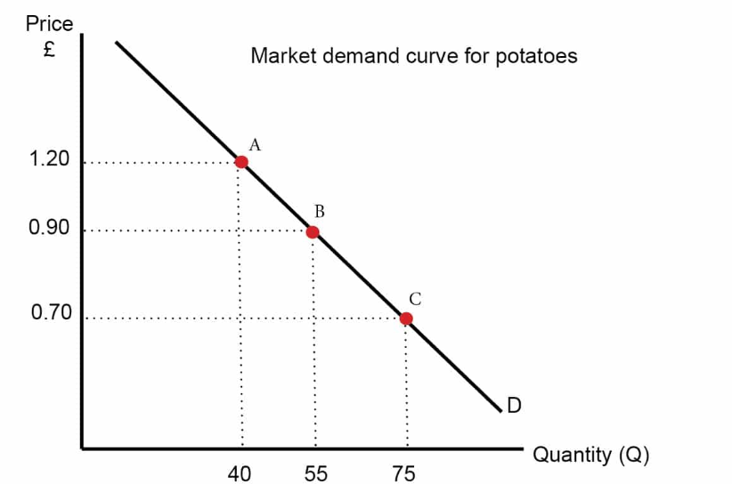
Diagram 1. Web picture- Economicshelp.org

2. Law of Supply:
The law of supply, on the other hand, posits that, all else being equal, as the price of a good or service increases, the quantity supplied for that good or service also increases, and conversely, as the price decreases, the quantity supplied decreases. In essence, suppliers are willing to produce and offer more of a product at higher prices, while lower prices lead to reduced supply. This direct relationship between price and quantity supplied is represented by an upward-sloping supply curve on a graph.

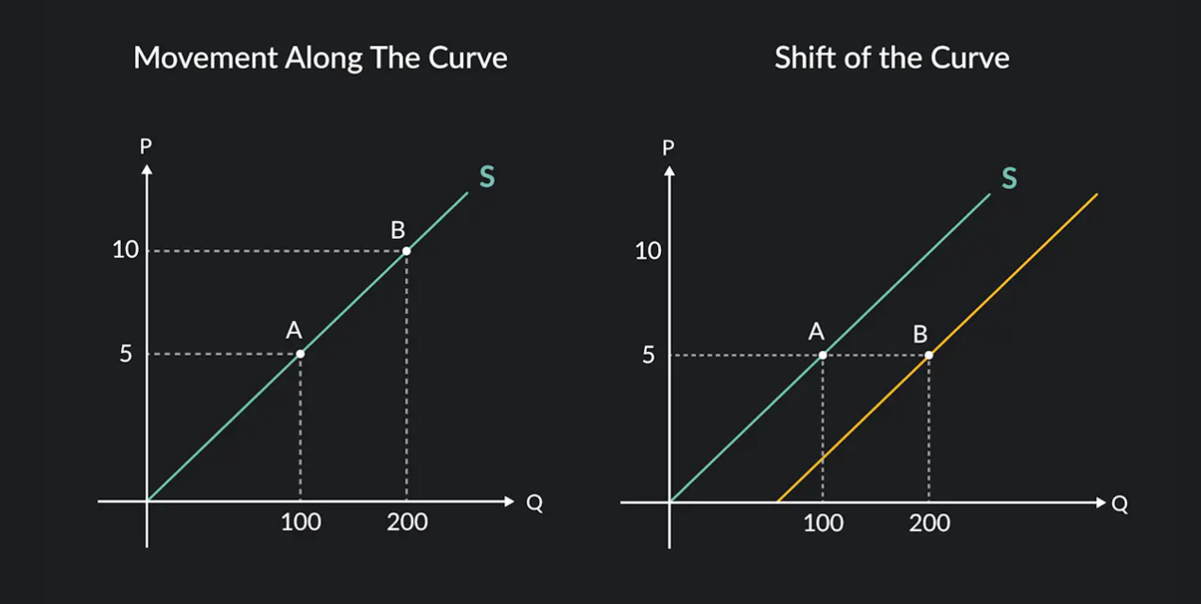
- Diagram 2 - Web picture- economicshelp.org

Explanation:
Consumer behaviour drives the law of demand: when prices are lower, customers can afford more of a commodity, resulting in increasing demand. When prices rise, customers seek alternatives or reduce their consumption, resulting in lower demand.
Higher prices incentivise producers to boost output as it becomes more lucrative, hence increasing the amount offered to the market, according to the law of supply. When prices fall, manufacturers find it less helpful to offer goods or services, reducing the amount they are ready to supply.
These rules are fundamental to understanding how supply and demand factors interact to decide equilibrium prices and quantities exchanged in a competitive market. When demand and supply meet at a given price point, known as the equilibrium price, the amount desired equals the quantity provided, resulting in market stability.

In essence, these laws supply a framework for studying and forecasting how changes in pricing, customer preferences, production costs, and other factors impact market behaviour, affecting market outcomes.

Conclusion.
The Covid-19 pandemic has worsened economic issues by disrupting the delicate balance between demand and supply in markets. The case study highlights the complex relationship between these factors, with pandemic-induced shortages, labour difficulties, and changes in consumer behaviour triggering a chain reaction of economic repercussions. To address these challenges, a diverse approach is needed, including diversifying supply networks, integrating technology, and developing staff. Policy interventions can mitigate disruptions caused by labour shortages and global market reliance. Understanding the elasticity or inelasticity of demand for gasoline is crucial for developing responsive tactics. The rules of supply and demand are at the heart of these economic difficulties, influencing market conduct and deciding equilibrium pricing. To overcome the economic problems, a thorough understanding of the delicate dance between demand and supply is needed. Resilient methods, technology breakthroughs, sustainable practices, and legislative interventions contribute to economic stability. Adhering to these fundamental rules supplies a compass for navigating the intricacies, guiding economies towards balance, resilience, and long-term stability.

References.
- Aigner-Walder, B. (2015) Effects of the Demographic Changes on Private Consumption: An Almost Ideal Demand System Analysis for Austria. Journal of Economic and Social Studies, 5, 1, 33-57
- Andreyeva, T., Long, M. and Brownell, K. (2010) The Impact of Food Prices on Consumption: A Systematic Review of Research on the Price Elasticity of Demand for Food. American Journal of Public Health, 100, 2, 216-222.
- Bagwell, K. (2005) The Economic Analysis of Advertising. Columbia University Discussion Papers No.: 0506-01
- Baker, J. (2003) Competitive Price Discrimination: The Exercise of Market Power Without Anticompetitive Effects (Comment on Klein and Wiley). Articles in Law Reviews & Other Academic Journals. Paper 278.
- Cigliano, J. (1980) Price and Income Elasticities for Airline Travel: The North Atlantic Market, Business Economics, pp. 17–21.
- Ellickson, P. (2013) Market Structure and Performance. International Encyclopaedia of the Social & Behavioral Sciences, Forthcoming; Simon School Working Paper No. 13-21
- Foot, D. and Gomez, R. (2006) Population aging and sectorial growth: the case study of the UK, 2006- 2026. OJBE, 5:1
- Griffith, G. (2003) The Impact of Supermarkets on Farm Suppliers. The Australian Economic Review, 37, 3, 329–336
- Heien, D. and Pompelli, G. (1989) The Demand for Alcoholic Beverages: Economic and Demographic Effects, Southern Economic Journal, pp. 759–769.
- McKinsey & Company. 2017 “Brexit: The bigger picture—Rethinking supply chains in a time of uncertainty” Available at: https://www.mckinsey.com/featured-insights/europe/brexit-the-bigger-picture-rethinking-supply-chains-in-a-time-of-uncertainty [ Accessed on: 17/12/2023]
- OECD (2015), OECD Employment Outlook 2015, OECD Publishing, Paris. Available at: http://ifuturo.org/documentacion/Employment%20outlook%202015.pdf
- OECD (2015) GENERAL ASSESSMENT OF THE MACROECONOMIC SITUATION. OECD Economic Outlook Volume 2015/1
- Osadiya T. (2023), Introduction to Economics. Amazon
- Rauch, D. and Schleicher, D. (2015) Like Uber, But for Local Governmental Policy: The Future of Local Regulation of the 'Sharing Economy'. George Mason Law & Economics Research Paper No. 15-01. Available at: http://ssrn.com/abstract=2549919
- Shapiro, M. (1987) Measuring Market Power in U.S. Industry, NBER Working Paper, No. 221

