

LEVEL/ LEFEL 6 Term 2
MODULE CODE: ACUA6002_LON
Big Data by

Aleksandar Nedelchev
BCs Cloud Computing


BIG DATA MODEL AND WAREHOUSE FOR PESTRON
Table of Contents
I. INTRODUCTION 3
A. RESEARCH BACKGROUND 3
B. PROBLEM STATEMENT 3
C. SIGNIFICANCE OF THE STUDY 4
II. Literature Review 4
A. Introduction 4
B. Concept of Big data 5
C. Importance of Big data 5
D. Advantages of Big data for Petron 6
E. Data Visualization and Data mining with Big Data model 7
F. Challenges associated with the implementation of big data in small firms 8
G. THEORIES 9
H. SUMMARY 10
III. Methods 10
A. TOOLS AND TECHNIQUES 10
3.2 Big data model 11
IV. RESULTS 13
V. Conclusion 14
References 15

I. INTRODUCTION

A. RESEARCH BACKGROUND
Big data handling and management have been instrumental elements of modern industry. It has influenced different aspects of business ideas and strategies that are currently being implemented by leading entities. This has resulted in significant success for the associated business proprietors and industry operations. These implications of big data models and strategies are expected to be analyzed by implementing them on the company operations of Pestron Foods. In addition to this, various aspects of the data analysis and visualization ideas have been seen to be helpful for business companies in acquiring a complete overview of their operation [1]. It has been seen that the ability to process large data structures and provide critical pieces of information regarding them can be influential in terms of ensuring an appropriate output.
The advancement in industrial technology and increasing complexity has resulted in large data structures that require attention evaluation. This is a necessary fact in ensuring a stabilized position in the marketplace. Furthermore, the abundance of digital appliances and associated platforms has resulted in an overflow of data. In order to manage this, an effective data processing model is required. Henceforth, in this following study, a big data model is being proposed for Pestron Food to organize its current business operations. In addition to this, different innovative data processing and visualization ideas have been implemented in this report.

B. PROBLEM STATEMENT
Analysis of the company is indicative of it being associated with a large amount of data handling and associated issues. In order to maintain the positive growth of the company, Pestron is required to make continuous changes to its business operation. In this context, the primary issues have been observed with its data handling capabilities. As a business entity operating in the current industry, the company has to market its products and services through both online and traditional channels [2]. This created an overflow of information that needed to be processed properly. However, issues were observed in the data processing ideas currently implemented in the business sector. Lack of effective big data analysis tools and strategies can be critical in terms of ensuring maintaining efficiency outfits business operations. Furthermore, it results in different critical issues for both the company and its target market.
Another concern that has been seen in this context is the selection of inadequate data processing ideas. Big data is a vast area of modern business operations that requires critical thinking and analysis abilities. Continuous developments have to be done on the company operation to ensure the integrity of the data analysis outcome [3]. This is one of the highly critical areas for the company and its business operations. It is seen that both the marketability of Pestron products and its ability to maintain profits is dependent on these variables. Henceforth, the implementation of improper data analysis solutions has been critical in terms of ensuring an appropriate outcome for the study. In addition to this, it is identified as a critical problem area that can affect the sustainability of its business operations. Thus, these have been identified as crucial research elements and have been analyzed further in the following segments of the report.

C. SIGNIFICANCE OF THE STUDY
This study can be considered as significant for customers in terms of acquiring an in-depth understanding of the industry. It can enable the customers to be informed about the data analysis ideas currently being followed by Pestron. This can help them to make well-informed purchase decisions during shopping and other economic transactions with the company.
The study can also be seen as significant for leading business operators that are affected by changes in the food industry. Both Pestron and its market alternatives can benefit from the study by acquiring information on big data models. It can help the company leaders to make changes in improving current competencies [4]. Furthermore, the analysis of big data models and its implication can be critical in developing innovative information evaluation strategies. In this research the effectiveness of KNIME software can be understood and the ways through which the changes of an organization can be compared to ensure security the security against the changes that are unintentional are also discussed.
Also, the study can be considered as significant for experts and future researchers in a similar field. It can provide a holistic overview of the analysis ideas currently being followed and their impact on the industry.

II. Literature Review

A. Introduction
From the overall literature reviews on this one of the essential technologies, a basic idea has been taken that Big Data is a collection of data that needs to be managed through complicated tools for an ultimate result. There is a need for the intense setting of data amounts of information eventual data analysis, so for any companies in this developed sector, a more significant dimension with a great volume of data need to be solved through business intelligence.

B. Concept of Big data
Big data is a new procedure of managing vast amounts of data for small firms to modify complicated problems. For this case, this Patron Foods Company has structured a Big data model to develop their strategic decisions and to perform more modified approaches. This Big data technology is a specific factor to lead the business analyst for an accurate decision making. It is useful for any firm to perform better options for the organization. The past research on this Big Data analytics has even analysed its impactful concepts through their analysis [1] as to reflect its importance for designing a developed model by the companies to upgrade the capabilities through the modified factors.

C. Importance of Big data
Big Data processing is not so easy as to maintain all its sources to develop its model in a successive way for a firm. It has a number of features to be analysed for getting an ultimate data format to identify the essential aspects of the necessity of a company. For a smart activated company profile, this Pestron Food must research on its developed strategies by the Big Data model. There are even several firms that should implement this new technology for internal development. As from the researchers view in their literature, there are several advantages, important factors that get objectified through this technology [4]. Some of the essential features are, Big data model would reduce the cost from the economic sites, even there is a chance of time reductions through a developed way for the small firms, sometimes there would be more new developed factors with optimized offers.
There are some real-time determined factors to increase the success and to reduce the faults, failures. This technology would detect the deceptive behaviours of the risk management approaches for any start-up company rather than a company like Petron Foods [2]. Apart from this, the generative factors would create a relevant result through this model for a developed challenging aspect. From a data security factor, this would store such data so that the targeted objectives would get solved in a challenging way. There would be a rapid growth to look up the further identities of the relevant factors for a company [3]. Hence, these articles had given clear essential points to get an understanding of this technology for a positive and advantageous system to be initialized for this organization for a proposed system efficiently and to help its internal factors in a better way. There are utilized capabilities to access the business decisions to process the technology.
To identify the efficient factors with overall accessed factors of this Big Data would surely update the collective data to analyse the structured and unstructured descriptive operational efficiency for an improved features and factors. Strategic elements of the generative data would assist to reach up to the targeted factors to work with the modified factors of structured data. However, the huge data of any company would be analysing for an upgraded structured multiple abilities to modify the ranges of structured data to get the ultimate successive concern. Big data has been identified as a critical element of the modern business industry. It has been observed that the implementation of innovative big data ideas can be critical in terms of ensuring an appropriate outcome for small companies. It is seen as especially critical as a market expansion and profitability for companies with limited resources. The ability to analyse large data sources and identify factors critical to the industry can be beneficial for companies in ensuring an appropriate market navigation strategy. In addition to this, it has been observed that the ability to analyse big data has proved to be beneficial in terms of understanding consumer demand. This aspect of the said technological idea makes it a critical component for companies and the marketability of their products. Companies such as Pestron can benefit significantly from implementing this data analysing ideas in its operational structure.

D. Advantages of Big data for Pestron
Usage of big data can be beneficial for Pestron food companies as it can help the organization empower its workforce by adding value to the business. The biggest advantages of big data technology and tools are it provides cost advantages to the business while it comes to processing, storing, and analyzing the huge quantity of data. The tools of big data can recognize the cost-saving and efficient ways of executing business.
Big data tools present excellent ways to highlight the benefits of cost-reduction of big data. Big data analytics can help the company to reduce the return cost of product return by the prediction of the likelihood of the returns of the product. They can be able to estimate which one product can be most preferably to be returned, therefore permitting companies for taking proper measures to decrease the losses on return. The tools of big data can help to improve operational efficiency through fast progress.
The company can interact with the customers and gain priceless feedback from them, and in this case, the tools of big data can help to amass plenty of effective data from customers. Those data can be interpreted and analyzed to extract the meaningful patterns that can be hidden, which can permit the company to create the personalized products. Big data can help to foster competitive fostering, retain the loyalty of customers and boost sales, improve the techniques of marketing and productivity of employees, and optimize their service for customers. It also helps to find radical ways for the expansion of brand outreach.

E. Data Visualization and Data mining with Big Data model
Data Mining can be stated as the process of sorting out a few huge data sets and the extraction of a few data out of them and patterns out of the data that can be extracted where the visualization of data can be the process of displaying or visualizing the extracted data in the form of multiple visual or graphical formats like the statistical representation, bar graphs, pie charts, graphical image, and others. The process of data mining includes path analysis, classifications, analysis, forecasting and clustering, while data visualization includes analyzing, processing, communicating that data and others.
In data mining, the big data can be displayed automatically in the process of search that can be displayed by the analysis of the system itself where the visualization of data can provide a clear perception of the big data, and it can be easy for the human brain to memorize and remember the big data at the single glance. In data mining, there can be four stages that are data gathering, data sources, data deploying and modelling; where data visualization has seven steps: parsing, acquiring process, mining, filtering, refining, interacting, representing. Data mining applications can include the management of customer relationships, that is, the application of the software that gives the advantage to the data mining where the data visualization applications include the measurements, surveys and computer simulations and others.
The advantage of "Data Mining” is that the relationship can be unhidden among various variables and data sets which the visualization of data states because it can be stated as the visual object through the representation of the data in the forms of charts and graphs. Data mining can be considered as the area of "Data Science” in which place the huge data sets can be thoroughly processed to give comfortable results in the search through the identification of different patterns. The visualization of data can be stated as the process of displaying the visual information out of the complicated data that can exist to draw the specific conclusion at one glance except for the requirement of studying any kind of theoretical results. These applications contain the information of satellite data, information of research results, data that have been studied scientifically and others.
The tools of big data analytics can help to make actionable decisions and strategies for business.

F. Challenges associated with the implementation of big data in small firms
Securing Big data: Security has been considered as the big concern for an organization with stores of big data. A few stores of big data can be the targets that are attractive for the APTs, "advanced persistent threats", or hackers. Maximum firms seem to trust that the methods of data security that exist are not enough for their requirement of big data as well. Organizational Resistance: People have become the issues also besides the technological aspect of big data. Maximum firms have their commitment to creating a culture that is data-driven, but a few per cent of firms have achieved success in this commitment with their efforts. The obstacles of becoming unsuccessful can be addressed as insufficient understanding and adoption of middle management, improper alignment of organization, lack of understanding or business resistance.
Lack of data professionals: The firms require data professionals with proper knowledge and skills to run the big data tools and modern technologies. The professionals can be data analysis, data scientists, data engineers who have enough experience to work with the technologies and tools. But firms are currently experiencing problems of lack of data professionals as the tools of data handling have constantly been evolving, but in maximum cases, the number of professionals is not enough.

Conceptual Framework
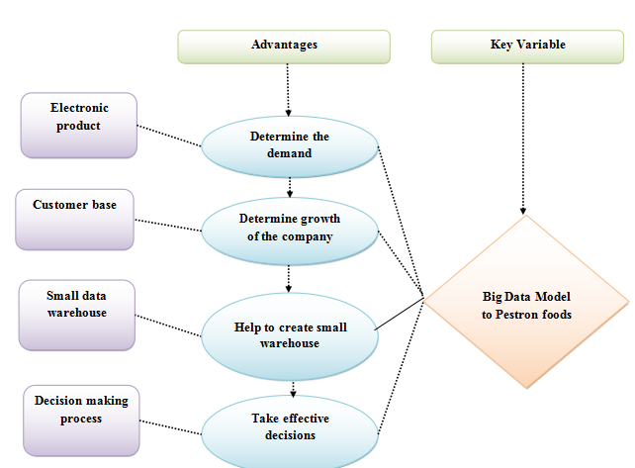
Figure 2.7: Conceptual Framework
The above framework has shown the key variables as Big Data Model to Pestron foods, and other variables are electronic product, Customer base, Small data warehouse, decision making process-take effective decisions. Big data models can help the company to determine the demand for electronic products, determine the growth of the company from the customer base, help to create small warehouses and to change or make effective decisions for further improvement of the business of Pestron food company. From the framework, the ways through which the big data model can help Pestron food company can be easily understood.

G. THEORIES
TAM: TAM or the technology acceptance model is based on the implantation of innovative technologies in the operational context of different technologies. It has been observed that modern industry and its business operations are dictated by advanced ideas and strategies. In order to maintain a positive efficiency in the organizational procedure, companies are encouraged to use technological solutions. This process is, however, determined by different factors and ideas related to technology implementation. It has been seen that technological advancements are usually accepted on the basis of various factors [10]. Similar elements have been observed for Big data technology in the food industry. Companies such as Pestron implore these models according to two primary factors. These are the perceived benefits provided by the idea and its ease of use.
It has been seen that both of these factors contribute significantly to ensure operational efficiency. As a technological solution, Big data has been identified as beneficial for the company and its operational effectiveness. In addition to this, it can be seen as critical in terms of ensuring an appropriate result for different instances. Also, big data methods are often seen to be relatively easy to use [11]. There are a number of data analysis tools available that can be implanted in relation to this technology [25]. Henceforth, it can be speculated that this technology is a critical factor that has provided different benefits to the company and its regular operations. In addition to this, it can be used to ensure an appropriate business operational model that is able to evaluate different aspects of an industry.

H. SUMMARY
The big data solution currently being used by leading business proprietors can be seen as critical for ensuring profits. In addition to this, it is seen as especially valuable for small companies in maintaining profitable business operations. This aspect of the said technology makes it instrumental for Pestron. It is further supported by the theories related to this technological sector.

III. Methods

A. TOOLS AND TECHNIQUES
In this study, different technologies and ideas have been incorporated to ensure appropriate big data analysis procedures for the company. The primary objective of this study is to develop a model that is able to analyse different aspects of the information available. In addition to this, tools that have been selected for the big data model are able to highlight company performance through in-depth analysis [12]. This can be critical for the company in ensuring a sustainable organizational landscape. Furthermore, the techniques used in this report have been selected as per their ability to provide a complete overview of the selected area of analysis.
It can be speculated that the implementation of different innovative ideas is instrumental for the selected company in improving its overall presence in the industry. In addition to this, different data warehouse designing techniques have been discussed in this report, which can be studied to develop an appropriate model [13]. It can be seen that the implementation of an appropriate model in this context can be critical in enhancing current issues faced by the organization. In addition to this, it can improve the overall effectiveness of the design and its ability to provide appropriate outcomes.
In this research, KNIME software has been used for the analysis of big data for Pestron foods. This software can allow the users to visually create the data flows and run a few stages of all analysis, and after that inspect that model, results, using views and interactive widgets. KNIME has been stated as the tool for the purpose of data analysis based on the paradigm of graphical programming. It is the scalable platform of data analytic that can help to toggle the data scientists effortlessly on come stream, computer and run the big data.
It offers mathematics and statistical function, algorithms those are advanced predicative, workflows control, ML algorithms and others. It has the intuitive interface that has been designed for assisting the users to navigate this software and help to create the data flows, implement the tactics of specific analysis, and analyses models, results, and the interactive reviews simply. KNIME Analytic tool has been created and uses the ability of the extension of module through connectors and plugin.
The capability of local automation of the software offers the added layer of flexibility to the arsenal when permitting the user for making the reusable workflow. The difference functionality of its workflow permits the users to track each modification made on the workflow and help to compare changes that have been made by Pestron foods. It is specially used for business intelligence, analysis of customer data, analysis of financial data and text mining.
In this research KNIME software has been chosen for its effectiveness in performing big data analysis with complex data and use fullness in data visualization and data mining with big data.

3.2 Big data model
In this study, a data warehouse has been built for the Pestron food company with different kinds of tools and techniques. It can be needed to combine and integrate the data in different kinds of systems thematically from the perspective of the total enterprise for creating the model of the data warehouse. Big data models can be considered through which the data can be stored and organized. A good big data model can properly decrease not required the redundancy of data, reuse results of computing, reduce computing costs and the storage for the system of big data. The big data models can help to improve the experiences of the user and enhance the efficiency of the utilization of the data. Big data models can make the statistics of data more consistent and decrease the possibilities of the errors of computing.
There can be a lot of tools of big data and technologies with the main feature, and it includes the handpicked software and tools for their big data. Below, a few tools of big data have been discussed.
Hadoop
Apache Hadoop can be considered as the framework of big data, which allows the distributed processing of huge data sets across the clusters of computers. It can be considered as the best tool of big data that can be designed to scale up from single servers to thousands of machines.
Storm
Storm can be stated as the big data that is free of the computation system of open source. It also has been stated as another best tool of big data that offers the processing system of fault-tolerance, distributed real-time with the real-time capabilities of computation.
Qubole
Qubole data can be considered as the autonomous management platform of big data and considered as the tool of open-source big data that is self-optimizing, self-managed and permits the team of data to concentrate on the outcomes of the business.
RapidMiner
RapidMiner can be stated as one of the best analytics tools open source that have been used for machine learning, data prep, and the deployment of data. It provides the suite of products to construct the new process of data mining and set up the analysis of prediction.
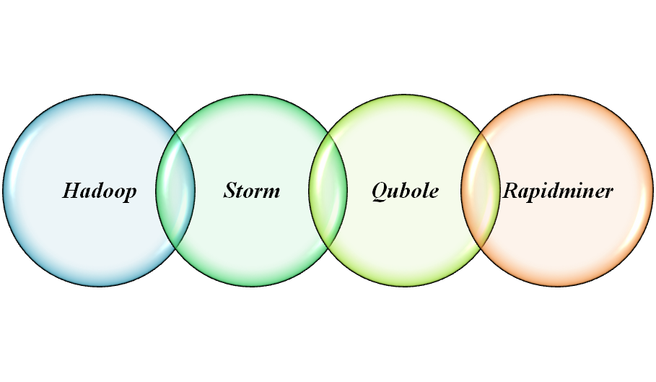
Figure 3.2: Tools of Big data model

IV. RESULTS
The results of this report indicate that Pestron and its business operation is highly inclined by the different strategies related to big data. It can be seen that the implementation of an effective big data model has been beneficial for the company in ensuring profitable outcomes. In addition to this, the analysis of the given data indicates that the company and its business operation has been able to maintain their efficiency [16]. However, it can be further improved by developing new and innovative ideas related to market data analysis. This can be significant for the company in acquiring knowledge about the complete structure and its efficiency.
Another critical factor that has been seen in this context is the use of innovative technologies to ensure improvement. The data analysis process has been crucial in identifying factors that are resulting in problems for the company. Also, issues related to business operation and evaluation of market conditions can be easily averted by developing an appropriate data model [17]. Data warehouses can be used to store the information acquired from these analysis procedures. These are considered to be beneficial for the company and enable it to expand its operations in the global food industry.
In order to acquire results for the following research process, different specific strategies and ideas have been implemented. The majority of these ideas have been selected in relation to the given dataset and KNIME software. In this task, two datasets of the company information have been analyzed. Each of these contains different kinds of information which can be seen as critical in terms of acquiring a complete overview. The dataset containing information on the food stores have been analyzed to identify all of the branch names. This process has been helpful in identifying company branch locations situated in different parts of the regions. In addition to this, the presence of these branches in the total company operation has been evaluated in the selected software. According to the output developed by KNIME, all of the branches contribute to the complete Pestron operation and each of them has been allocated resources equally.
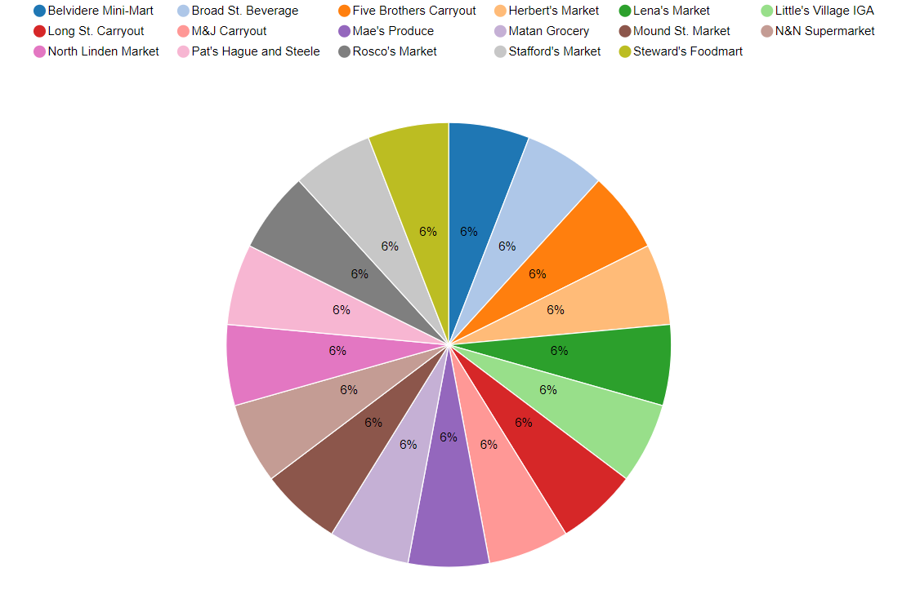
Figure: Branch name
(Source: Acquired from Knime Analytics)
As it can be seen from the above image, different critical aspects of the company operation indicate the branches being equally important. Henceforth, this factor is required to be taken into consideration by the warehouse management and strategy development process. It can be seen as critical in improving the current operational efficiency of the company and its business procedures.
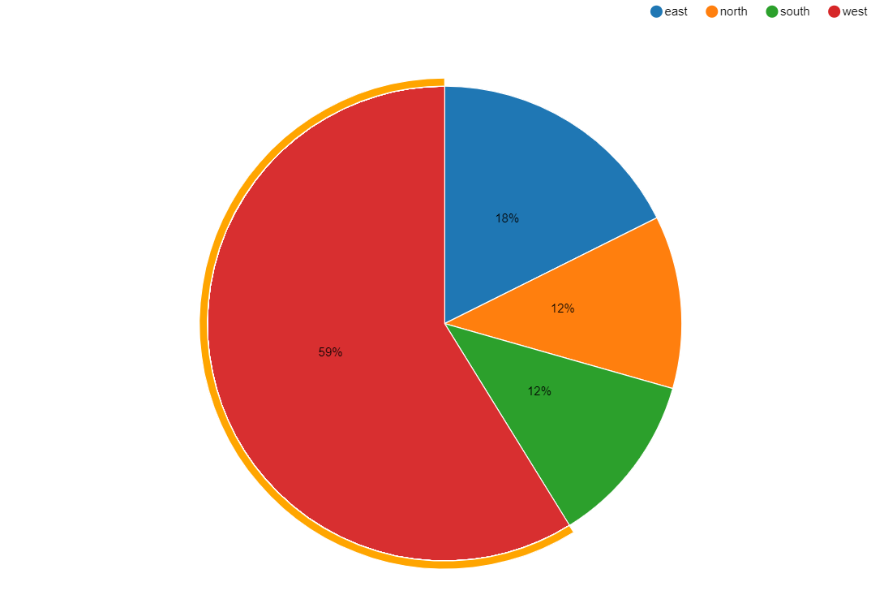
Figure: Location
(Source: Acquired from Knime Analytics)
All of the branches that can be seen from this dataset are located in Columbus. However, the locations of each of these establishments are spread across the city in a distributed manner. In order to identify the localities of these branches, the company has decided to segment the city boundaries into four segments. These are North, South, East, West, which are all identified in accordance to the developed objectives of the module. It can be seen from this dataset that the majority of the company branches are situated on the West side of the city. This amounts to 59 % of the total company establishments pregnant in this location. It indicates that this area of the city is highly profitable and consists of individuals who are most related to the company operations of Pestron. In addition to this, developments can be made in the other areas to improve company reputation and create growth opportunities.
Pestron sales
In this part, a complete overview of the operational structure of the company has been provided using appropriate implications. Information regarding this aspect of Pestron has been acquired from evaluating the company sales data using analytical tools and technologies. It has resulted in a critical business design that is indicative of the company derivatives needed for improving operational efficiency.
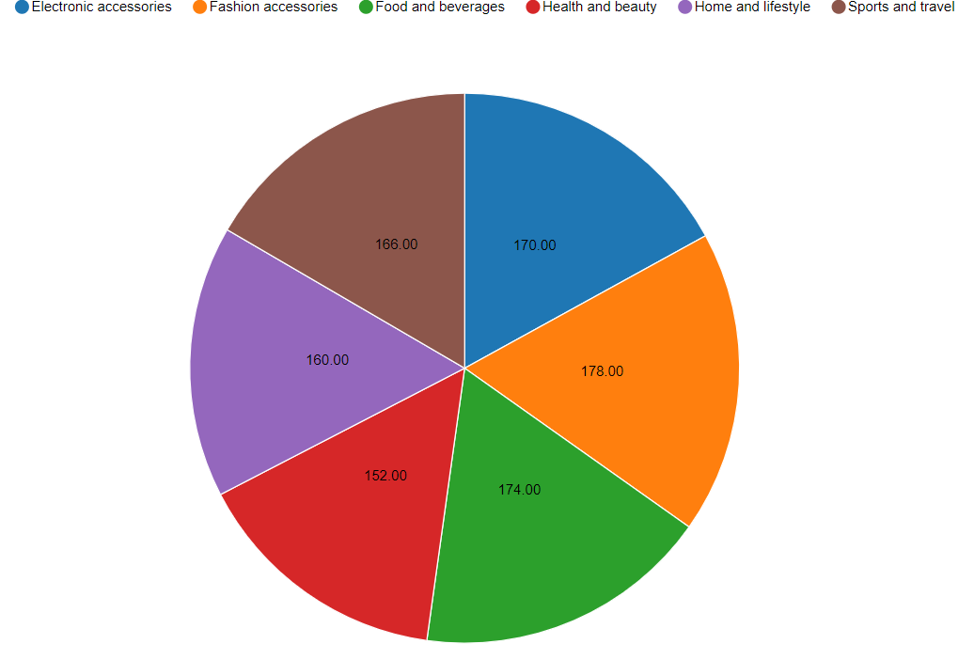
Figure: Product line
(Source: Acquired from Knime Analytics)
It has been observed that the company markets a range of products targeted to a diverse consumer group. Each of these products has been selected according to the ideas and implications associated with generating revenue. However, it can be seen from the sales records of Person that Fashion accessories and food and beverages are the primary marketable for the company. However, the organization is able to maintain a balance between all of its products and their impact on the operation. It can be seen from the image that all of the product categories consist of similar values for the organization.

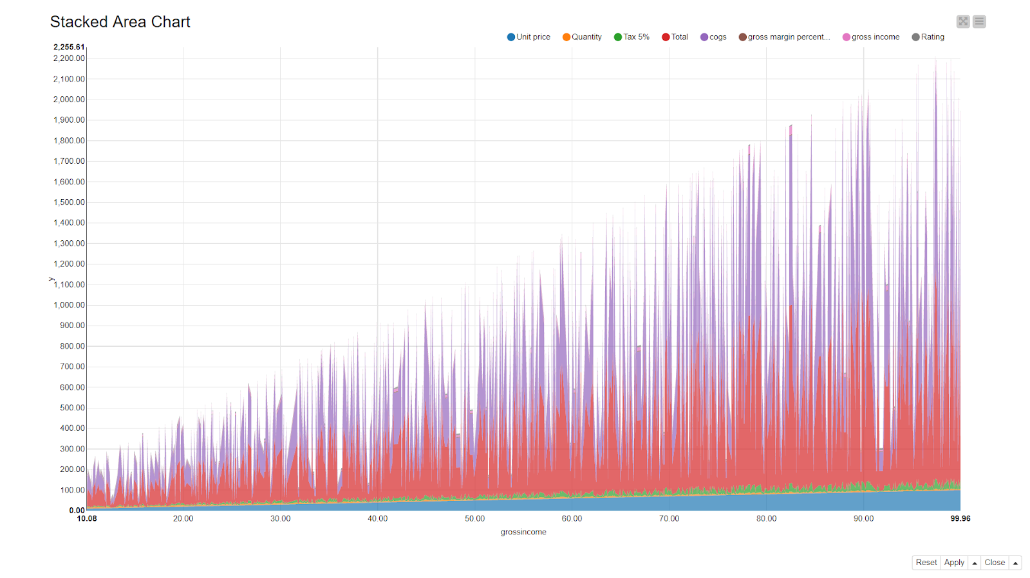
Figure: Gross income
(Source: Acquired from Knime Analytics)
In the above image, it can be seen that gross income for the company has increased with products sold. In addition to this, its relation to each of the company operational variables can be seen in the above image. It can also be used to develop ideas that are critical for ensuring an appropriate outcome for the company operations. In order to get a better understanding of the company profits and sales, different aspects of the operation have been critically analyzed in the following segments of the report.

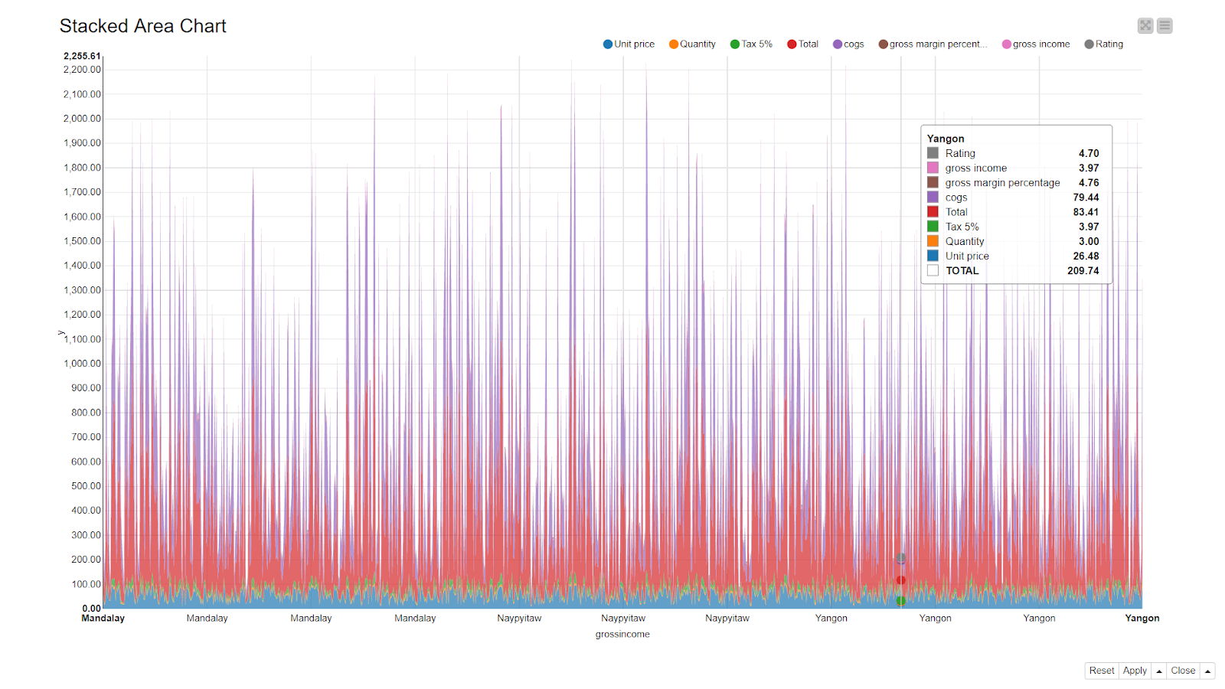Figure: Gross income over time
(Source: Acquired from Knime Analytics)
The below images have been critical in terms of providing a visualized overview of the company operation and its key variable performance related to sales records.
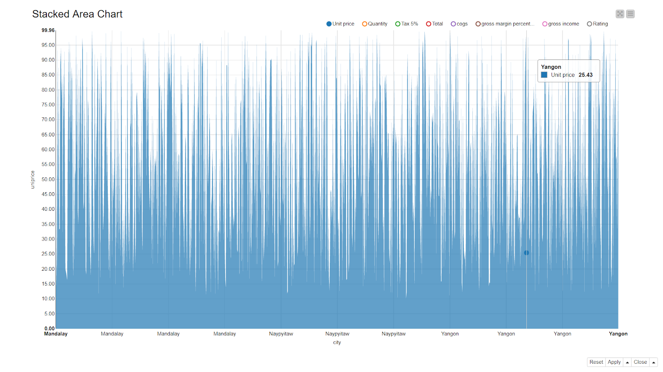
Figure: City vs Unit prices
(Source: Acquired from Knime Analytics)
In the image, different changes in product prices can be seen for various branch locations. These can be the result of an appropriate mitigation strategy. Also, the below image can be studied to identify the changes in unit prices for different product categories. These can be a critical element in acquiring an understanding of the company profits from the current product line.
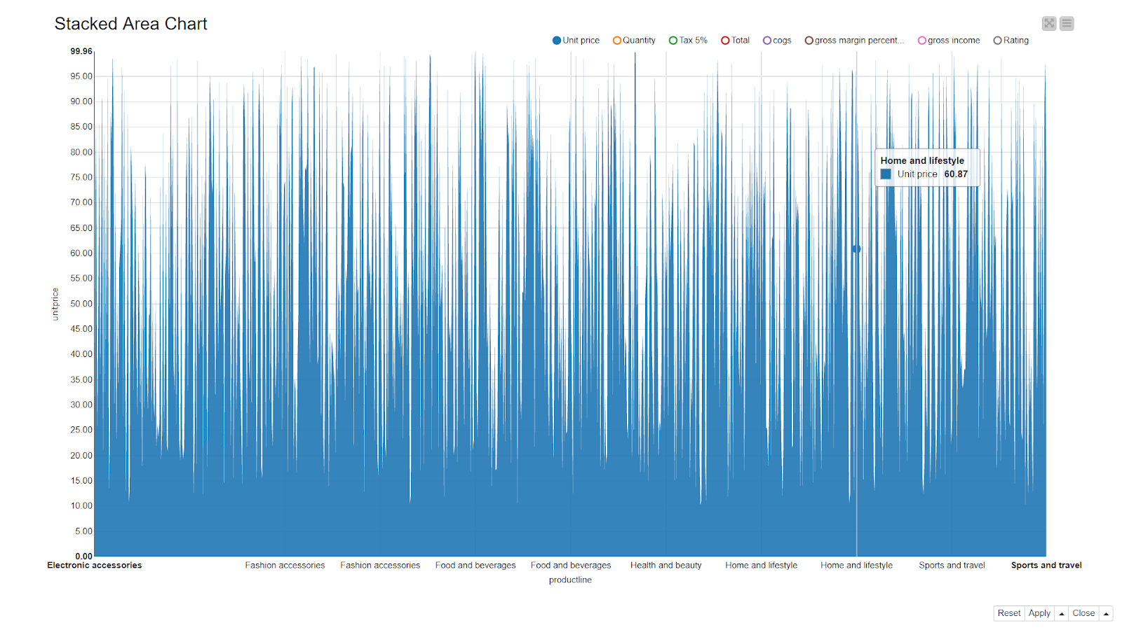
Figure: Product line vs unit price
(Source: Acquired from Knime Analytics)
This is seen as critical in terms of ensuring an appropriate output for the company operations. In addition to this, it indicates that Pestron is currently able to maintain positive growth in its business initiatives.
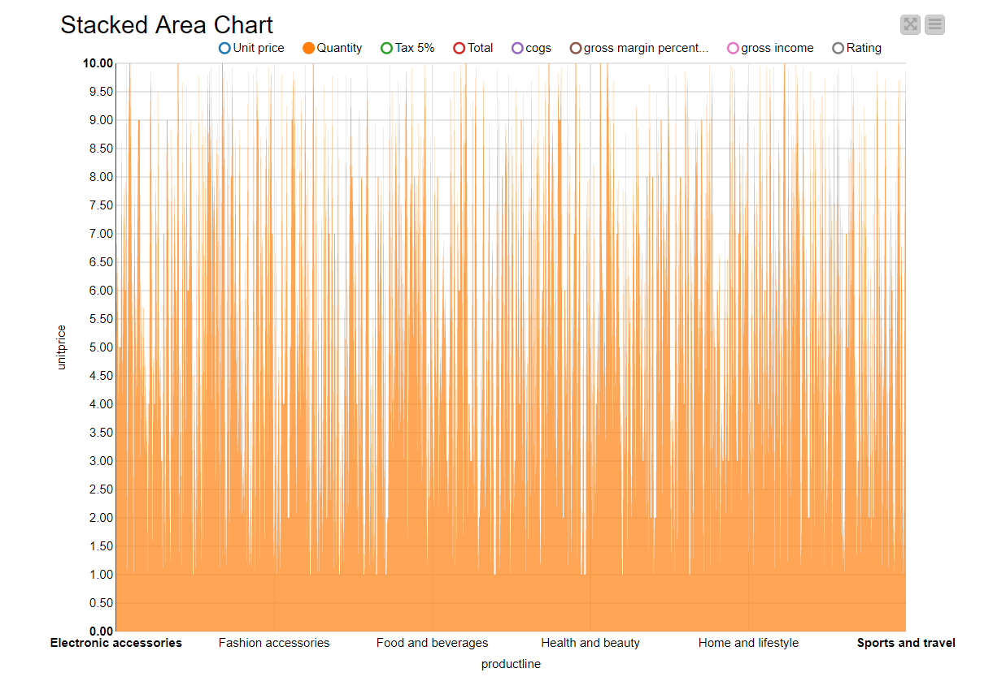
Figure: Product Line vs Quantity
(Source: Acquired from Knime Analytics)

It can be seen that the product sales have been differentiating for the available records. The company has been able to achieve a positive revenue margin thanks to the number of units sold. In addition to this, the profits generated from the products are also seen to vary across time and in relation to the number of sales.
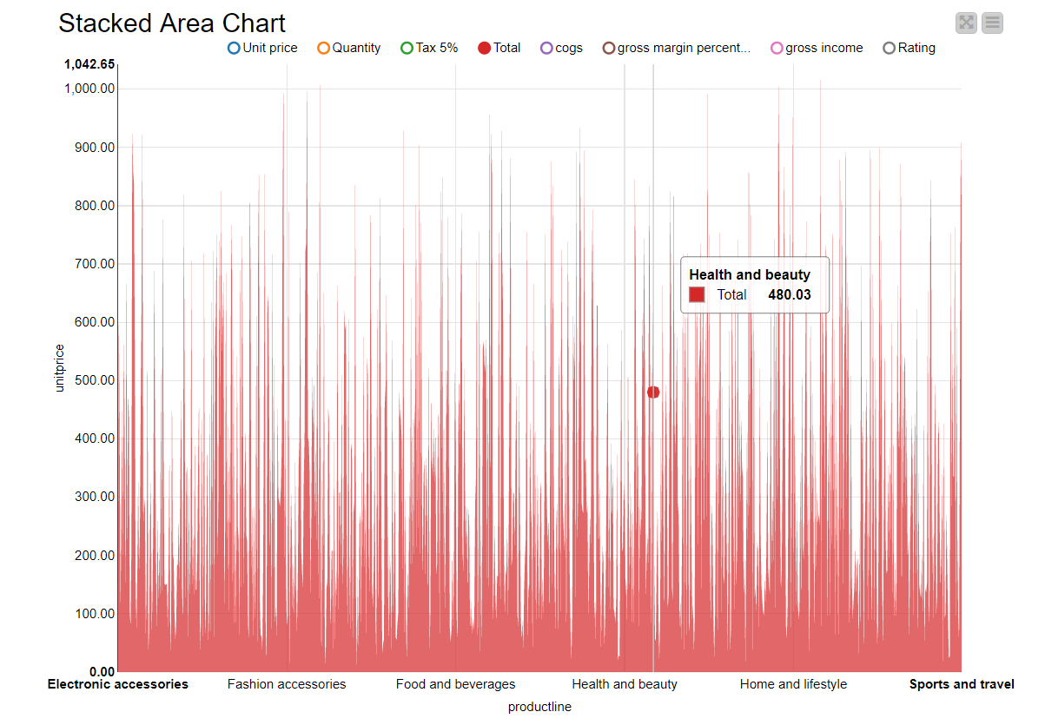
Figure: Product line vs total numbers of units sold
(Source: Acquired from Knime Analytics)
In The above image, the number of units sold can be identified for each of the product categories. The graph has been plotted according to the units old over time. IT can be seen from the graph that the popularity of each of these product categories can change in a dynamic manner. However, in order to maintain the relevance of the operation, appropriate changes are required to be made in the company strategy.
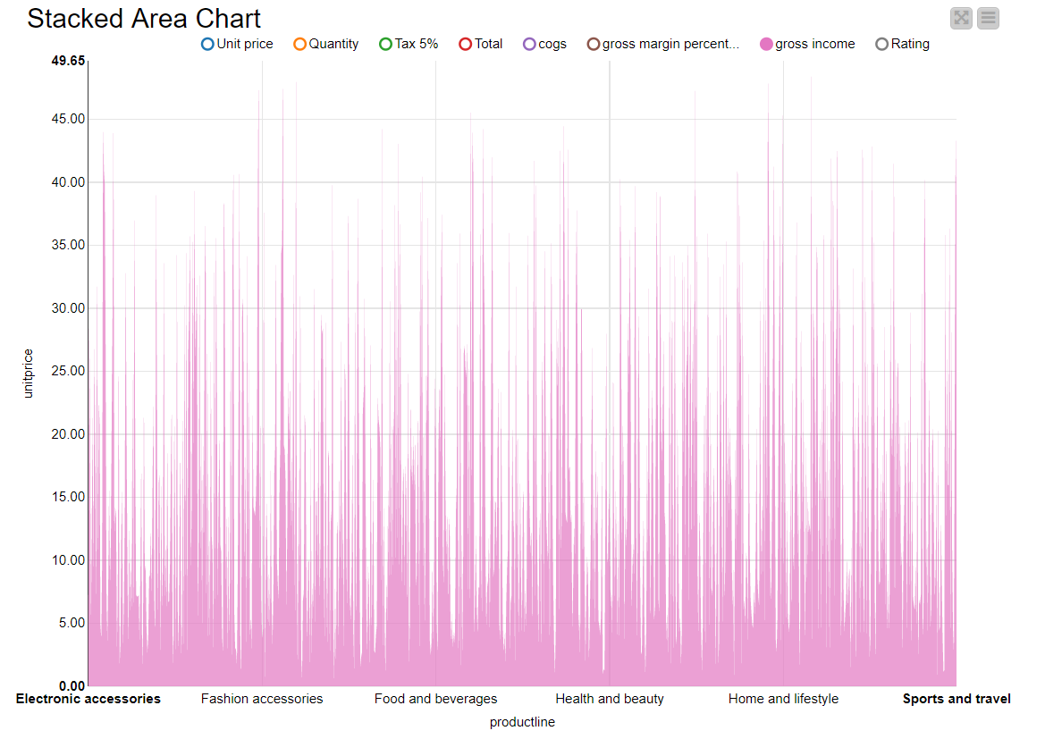
Figure: Productline vs. unit price
(Source: Acquired from Knime Analytics)
It can be seen from the above image that gross income for the product line has varied significantly across time. There have been instances where the company experienced a marginal income margin for its products. These are the areas that are required to be analyzed to identify issues to be improved.

V. Conclusion
The study concluded that big data models could help to extract information from the enormous number of data sets and processing complicated data. In this study, different kinds of tools and techniques of the big data model that can be beneficial to business have been discussed. It can be understood that a huge amount of data can be hard to process in traditional databases, and for this reason, the big data model has been used to manage the data very simply and easily. The study has provided sufficient evidence and information about the big data model; thus, the small data warehouse can be easily constructed.
The study has stated that big data models can help Pestron food companies in determining the demand of the market of any product, the growth of the food organization, and creating small warehouses and taking proper strategies and effective decisions. The current challenges to implementing big data in firms have been understood, and it has been expected in upcoming years, more firms can implement big data in their organization to make the data-driven culture. It is observed that the operational effectiveness of business variables can be determined using data analysis ideas. It can enable the analysis process to be considered as a critical source of knowledge in gathering information on different alternatives. Furthermore, issues with effective data analysis planning and evaluation can be averted by implementing innovative technological solutions. This concludes that the implementation of different big data tools and techniques can be beneficial for the company and its business operation in ensuring an appropriate return. In addition to this, it can be used by the company to provide information on factors that can improve its suitability.

References
[1] Zheng, S., Chen, S., Yang, L., Zhu, J., Luo, Z., Hu, J. and Yang, X., Big data processing architecture for radio signals empowered by deep learning: Concept, experiment, applications and challenges. IEEE Access, 6, 2018. pp.55907-55922.
[2] Qi, Q. and Tao, F. Digital twin and big data towards smart manufacturing and industry 4.0: 360-degree comparison. Ieee Access, 6, 2018, pp.3585-3593.,
[3] Gohar, M., Ahmed, S.H., Khan, M., Guizani, N., Ahmed, A. and Rahman, A.U. A big data analytics architecture for the internet of small things. IEEE Communications Magazine, 56(2), 2018. pp.128-133.,
[4] Xu, X. and Hua, Q. Industrial big data analysis in smart factory: Current status and research strategies. Ieee Access, 5, 2017. pp.17543-17551.
[5] Sheng, J., Amankwah-Amoah, J. and Wang, X. A multidisciplinary perspective of big data in management research. International Journal of Production Economics, 191, 2017. pp.97-112.,
[6] Jones, M., Collier, G., Reinkensmeyer, D.J., DeRuyter, F., Dzivak, J., Zondervan, D. and Morris, J., Big data analytics and sensor-enhanced activity management to improve effectiveness and efficiency of outpatient medical rehabilitation. International journal of environmental research and public health, 17(3), 2020. p.748., 2020.
[7] Sivarajah, U., Irani, Z., Gupta, S. and Mahroof, K., Role of big data and social media analytics for business-to-business sustainability: A participatory web context. Industrial Marketing Management, 86, 2020. pp.163-179.
[8] Hamilton, R.H. and Sodeman, W.A., The questions we ask: Opportunities and challenges for using big data analytics to strategically manage human capital resources. Business Horizons, 63(1), 2020. pp.85-95.
[9] Sousa, M.J., Pesqueira, A.M., Lemos, C., Sousa, M. and Rocha, Á., Decision-making based on big data analytics for people management in healthcare organizations. Journal of medical systems, 43(9), 2019. pp.1-10.
[10] Cheah, S. and Wang, S., Big data-driven business model innovation by traditional industries in the Chinese economy. Journal of Chinese Economic and Foreign Trade Studies. 2017.
[11] Gepps, A., Linnenluecke, M.K., O’Neill, T.J. and Smith, T., Big data techniques in auditing research and practice: Current trends and future opportunities. Journal of Accounting Literature, 40, 2018. pp.102-115.
[12] Nocker, M. and Sena, V., Big data and human resources management: The rise of talent analytics. Social Sciences, 8(10), 2019. p.273.
[13] Kang, S.K., Rawson, J.V. and Recht, M.P., Supporting imagers’ VOICE: a national training program in comparative effectiveness research and big data analytics. Journal of the American College of Radiology, 15(10), 2018. pp.1451-1454.
[14] Brock, V.F. and Khan, H.U., Are enterprises ready for big data analytics? A survey-based approach. International Journal of Business Information Systems, 25(2), 2017. pp.256-277.
[15] Yue, L., Junqin, H., Shengzhi, Q. and Ruijin, W., August. Big data model of security sharing based on blockchain. In 2017 3rd International Conference on Big Data Computing and Communications (BIGCOM), 2017. (pp. 117-121). IEEE.
[16] Salloum, S., Huang, J.Z. and He, Y., Random sample partition: a distributed data model for big data analysis. IEEE Transactions on Industrial Informatics, 15(11), 2019. pp.5846-5854.
[17] Küçükkeçeci, C. and Yazıcı, A., Big data model simulation on a graph database for surveillance in wireless multimedia sensor networks. Big data research, 11, 2018. pp.33-43.
[18] Wang, G., Gunasekaran, A. and Ngai, E.W., Distribution network design with big data: model and analysis. Annals of Operations Research, 270(1), 2018. pp.539-551.
[19] Sun, Q. and Tsai, S.B., An Empirical Study on Application of Virtual Reality Animation Technology by Big Data Model. Mathematical Problems in Engineering, 2021.
[20] Wang, J., Yang, Y., Wang, T., Sherratt, R.S. and Zhang, J., Big data service architecture: a survey. Journal of Internet Technology, 21(2), 2020. pp.393-405.
[21] Zhang, B., Chen, Z., Peng, D., Benediktsson, J.A., Liu, B., Zou, L., Li, J. and Plaza, A., Remotely sensed big data: Evolution in model development for information extraction [point of view]. Proceedings of the IEEE, 107(12), 2019. pp.2294-2301.
[22] Yacchirema, D., de Puga, J.S., Palau, C. and Esteve, M., Fall detection system for elderly people using IoT and big data. Procedia computer science, 130, 2018. pp.603-610.
[23] Osman, A.M.S., A novel big data analytics framework for smart cities. Future Generation Computer Systems, 91, 2019. pp.620-633.
[24] El-Hasnony, I.M., Barakat, S.I., Elhoseny, M. and Mostafa, R.R., Improved feature selection model for big data analytics. IEEE Access, 8, 2020. pp.66989-67004.
[25] Elhoseny, M., Abdelaziz, A., Salama, A.S., Riad, A.M., Muhammad, K. and Sangaiah, A.K., A hybrid model of internet of things and cloud computing to manage big data in health services applications. Future generation computer systems, 86, 2018. pp.1383-1394.
[26] Ardagna, C.A., Bellandi, V., Bezzi, M., Ceravolo, P., Damiani, E. and Hebert, C., Model-based big data analytics-as-a-service: take big data to the next level. IEEE Transactions on Services Computing, 14(2), 2018. pp.516-529.
[27] Fillbrunn, A., Dietz, C., Pfeuffer, J., Rahn, R., Landrum, G.A. and Berthold, M.R., 2017. KNIME for reproducible cross-domain analysis of life science data. Journal of biotechnology, 261, pp.149-156.
[28] Dietz, C., Rueden, C.T., Helfrich, S., Dobson, E.T., Horn, M., Eglinger, J., Evans III, E.L., McLean, D.T., Novitskaya, T., Ricke, W.A. and Sherer, N.M., 2020. Integration of the ImageJ Ecosystem in KNIME Analytics Platform. Frontiers in computer science, 2, p.8.
[29] Sydow, D., Wichmann, M., Rodríguez-Guerra, J., Goldmann, D., Landrum, G. and Volkamer, A., 2019. TeachOpenCADD-KNIME: a teaching platform for computer-aided drug design using KNIME workflows. Journal of chemical information and modeling, 59(10), pp.4083-4086.
[30] Muchmore, B. and Alarcón-Riquelme, M.E., 2017. Cymer: cytometry analysis using knime, docker and r. Bioinformatics, 33(5), pp.776-778.
[31] Karimah, N. and Schaftenaar, G., 2021. KNIME-based Analysis of Off-Target Effect of Drugs Related to The Molecular 2D Fingerprint. Journal of Pharmacy & Pharmaceutical Sciences, 24, pp.256-266.
[32] Pynam, V., Spanadna, R.R. and Srikanth, K., 2018. An extensive study of data analysis tools (rapid miner, Weka, R Tool, Knime, Orange). SSRG International Journal of Computer Science and Engineering, 5, pp.4-11.

