

Module:
LCMB7001 Marketing Management
Name: Niranjan Kondapally
Student Id: 2226891
Table of Contents
1. Introduction 3
2. Communication 3
Definition of communication 3
SHANNON and WEAVER's communication model 3
Integrated marketing communication (IMC) 5
3. New promotional strategies 5
Online promotion 5
Offline promotion 6
4.Brand Equity using Keller’s 6
Advantages and Disadvantages of Keller's brand equity model 8
5. Customer Journey 8
6. Customer touch points 9
Pre-purchase Purchase 9
Post-purchase 9
7. Diagram and explain the customer journey map 10
8. Strengths & weakness of customer journey map 10
9. The total engagement models 11
10. Conclusion 12
11. Recommendation 13
References 14

1. Introduction
In the business environment, it is very common for brands to increase the satisfaction of the customers. Customer satisfaction has helped them to increase revenue as with increased customer satisfaction the firms can increase revenue. Here are many other aspects to focus on apart from customer satisfaction. The aspect of marketing strategy and brand awareness has been very important and has been the reason for the success of the brands. The management of the customer journey is also very crucial because it helps to make the experience of the customers better. The marketing strategies help the brands to increase awareness and also facilitateattractingcustomers. These strategies are important because it helps to increase the sales of the company.
In the following assignment,the creation of innovative marketing strategies for Ford will be discussed. The assignment will also discuss the customer journey of Ford in great detail. The marketing strategies of Ford will be elaborated with the help of various models and theories. The steps taken by Ford for brand awareness will be analyzed. The communication channels used by the brand will also be discussed in detail. The expectations of the stakeholders will also be highlighted and the ways to fulfill the expectations of stakeholders will also be explained.

2. Communication

Definition of communication
According to Chakraborty & Jain (2022), communication within the business is the interchanging of information with the employees and also with the customers outside of the firm effectively. Communication is generally deemed as a Two-way procedure in which any business organisation conveys their message or strategies towards their varied stakeholder groups. So that they can collectively act towards the fulfilment of any organisational goals in an effective manner (Gupta et al 2020). The presence of effective communication is very much essential for any firm to adequately handle relationships with their staff, customers and also with their other stakeholders as poorer or lesser communication can lead to the ruining of relations and potentially result in the loss of sales percentages and also managing of organisational reputation (Hewett & Lemon, 2019).

SHANNON and WEAVER's communication model
It is a mathematical model focusing on the technical aspects of communication which has mentioned in the following section in detail.
Information source: It is the individuals or entities that originate the massage. The marketing or public relations division of Ford, which creates messaging about the company's goods or services, can be mentioned as the information source in this communication model.
Transmitter: The tool or medium used to broadcast the message is known as the transmitter. In the case of Ford, this can be any channel with the help of which, the business organisation interacts with its constituents, including social media, news releases, and advertising.
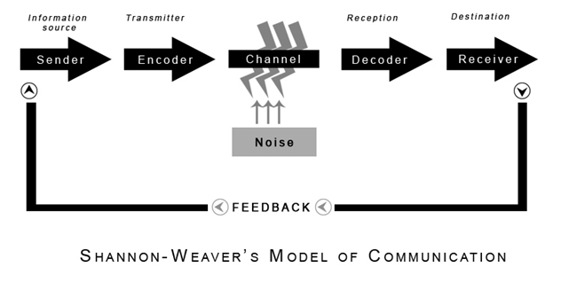
Figure: SHANNON and WEAVER's communication model
(Source: communicationtheory.org, 2022)
Channel: The medium through which the message is transmitted is known as a channel. However, it could be both, physical channels like phone lines as well as digital channels like social media and email.
Receiver: The individual or entity that receives the communication is known as the receiver (Kubota, 2019). This might apply to Ford's existing or prospective customers as well as other stakeholders of the company like investors or employees.
Destination: The location or object to which the message is supposed to be sent is known as the destination in this model. In Ford's situation, the target market could be a particular demographic or region where the business organisation is attempting to advertise new cars and other products or services.

Integrated marketing communication (IMC)
As per Turan (2022), IMC is considered a concept that permits the markers in combining the varied messages aimed towards a specified group of customers in a comprehensive way that supports acquiring the desired levels of outcomes. In this context, Ford aims towards increasing their overall market share in varied markets by 21% by the end of 2023. And is also aiming towards enhancing their brand awareness percentages by 32% within their targeted audiences through the help of marketing activities (Alwash,Savarimuthu&Parackal, 2021). Ford company generally as a part of their endorsing plan uses the higher profile prime time television programming strategy for their promoting their newer car models. And along with that, the firm also puts higher stress on the word such as Brand promise,Media mix, Market positionTone of voice and so on which shows the levels of impact that the firm intends to create on the minds of its customers through their diverse advertisements (Kadia, 2022).
The firm is also known for its different social media platforms for marketing purposes which involve Instagram, Facebook, Twitter and much more. Ford with the generation of effective posts and stories for their clients tends to generate higher brand awareness about their goods within any marketplace (Rashkova et al 2023). Along with that the firm also collects valuable information about the market trends and also about the likes and preferences of their clients within varied markets. So that they can design their products in accordance with the likes and preferences of their intended customer groups successfully (Scholz & Smith, 2019).

3. New promotional strategies
In order to effectively operate in the business of automobiles it is necessary for Ford to implement more effective as well as business performance. It is the time to operate promotional activities in both, online and offline modes. The reason behind both types of marketing approaches is the wide segment of target customers. The youngsters can be engaged with the promotional campaign conducted on online media and due to the less presence of older people on online media, the offline promotional campaign has the potential to target them effectively. A detailed analysis of the new promotional strategy of this multinational automobile company is mentioned below.

Online promotion
Social media marketing: According to Petrosyan (2021), there are almost 4.33 billion active social media users present across the world. Some of the leading social media platforms are Facebook, Instagram and Twitter. For that reason, these platforms will be most effective for Ford in order to conduct its promotional campaign. It will support the organisation to receive high engagement on its social media campaigns. In addition, it will take less time to reach a huge number of people.
Email Marketing: one of the most impressive ways to connect people personally with the brand is email marketing. Ford should attach attractive content regarding the features of the cars and offers applied to these cars and send it to its potential customers via email (Labanauskaitė, Fiore & Stašys, 2020). Email always makes the customers ever of the product and service which can enhance the effectiveness of the company's promotional campaigns.
Search Engine Optimisation: According to a study organic search contributes 53% of overall website traffic (Search Engine Land, 2019). Ford can also conduct its promotional campaign online by focusing on its website and ranking it higher in the search engine result. It will enhance the chance of success of its promotional campaign.

Offline promotion
Trade Shows and Events: For the purpose of showcasing its most recent cars and innovations as well as taking part in trade exhibitions and events associated with the automotive sector (Uteng, Julsrud & George, 2019). They should be aware, meanwhile, that trade fairs and events can be expensive and that situating issues on their return on investment.
Outdoor Advertising: According to the estimation of OAAA (2023), outdoor advertising revenue increased by 20 per cent in the previous year which signifies its demand for business promotion. Ford should use bus shelters, billboards as well as other outdoor advertising venues to improve brand recognition in important markets. However, it is suggested to the organisation that the message should be brief, obvious, and attention-grabbing because motor drivers and pedestrians have a short amount of attention span.
Sponsorship: Apart from that, sponsoring car racing events and other events that have a viewer base or participant base that can be potential customers of Ford can be an effective promotional campaign for this company.

4.Brand Equity using Keller’s
Step 1: Brand Identity
The company Ford is an automotive company that designs, makes also sells a wide range of cars, electric vehicles, ports utility cars also trucks. The uniqueness of the company Ford lies in its distribution as well as production capabilities. It has been found from the evidence that those are also the source of competitive advantage(Subramaniam, 2022). The organisation also gives good value to people's money and also shapes good standards. The personality of the brand reflects that the cars produced by the company are accessible.
Step 2: Brand Meaning
Brand meaning has two parts one indicates the performance another indicates the brand imagery. In the case of performance management, the company follows a Just-in-time inventory strategy(Siddiqui, 2022). Through maximising the workflows as well as resources also through using automation in the production process, and robotics in production facilities the company maintains its performance. It has been found from the resources that the company Ford is one of the chief automobile brands worldwide particularly when it is compared to American contestants. With a history of modernisation also commitment to durability and commitment Ford has created a strong consumer base also a perfect brand image(Carlier,2023).
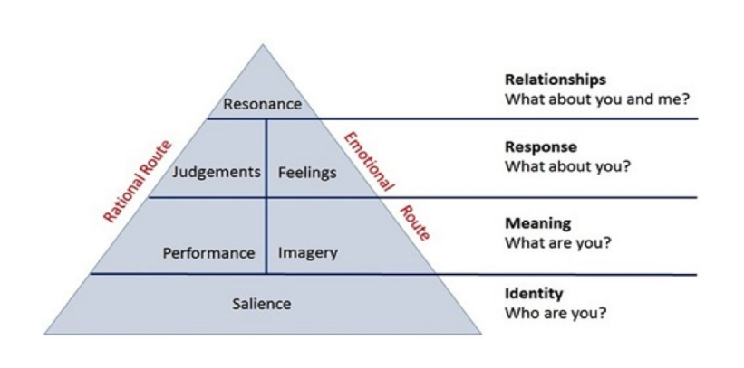
Figure: Keller’s Brand Equity Model
(Learning Material)
Step 3: Brand Response
The brand response indicates the combination of brand marketing as well as direct-response advertising. It also helps firms in creating a long-lasting association with the consumers also to gain the desired outcomes. Through the assistance of various brand agendas and considering the requirement of the consumer, Ford responds(Kumar et al., 2020).
Step 4: Brand Resonance
According to Van Loggerenberg, Enslin& Terblanche-Smit, (2021), brand resonance indicates how one consumer recognises themselves with the brand. Ford maintains its relationship with consumers by giving assistance through dealer outlets also anyone can get support by calling Ford's relationship centre.

Advantages and Disadvantages of Keller's brand equity model
As per Keller's brand equity model the has succeeded in attaining a higher amount of competitive advantage in the market which helped in gaining and retaining the trust of its customers in which global markets. Ford with the following of the Just in Time inventory management strategy has become able enough in fulfilling their customer's wants and desires in an effective manner. And it in turn results towards an increment in their brand equity levels with the designing of effective and innovative cars with a lesser amount of wastage through the usage of AI and robotics mechanisms within their diversified production line (Hewett & Lemon, 2019)
On the other hand, if the firm falls short of commitment towards the building and maintaining of brand equity which highly required a heavy number of investments, especially for promoting their services and products then Ford can face huge monetary as well as reputation losses within varied markets. And it in turn can damage their market position in the long run (Scholz & Smith,2019). Along with that one bad promotional activity with the creation of inappropriate and irrelevant content with false information about the firm can also hamper the credibility and brand equity percentages of Ford to an unrepairable extent in any market (Rao, 2019).
5. Customer Journey
The customer journey includes all the steps from when a customer is unaware of a company to become an advocate. This includes becoming aware of the company, investigating, buying, using, assimilating it, and recommending it to others. Ford has a total of 99 million customers worldwide, with half of them located in the U.S. Each year, the company adds roughly 6 million, new customers. However, Ford's customer experience is average compared to other companies, and may not necessarily ensure repeat business (Priddle, 2019). So that means the company has a good customer journey and that is why they have a good number of customers who will help them to boost their sales in the organization. If the organization has the capability to provide the best customer services then it helps them to get the best customer services and not only that it will also influence the other customers to purchase from the brand which helps increase the sales of the organization (Zhang, Følstad, & Bjørkli, 2023).
6. Customer touch points

Pre-purchase Purchase
When a customer is in the pre-purchase phase, they are considering a product or service and may have questions or concerns about it. It is important for businesses to have multiple touchpoints in place to address these inquiries and build trust with the customer. Some common touch points during the pre-purchase phase include advertisements, social media presence, website design and accessibility, customer reviews, and product demonstrations (Lassila, Heikka, & Nätti, 2023).
A strong social media presence can create a sense of community for the brand and allow customers to engage with the company on a more personal level. It is important for businesses to monitor their social media channels and respond promptly to any customer inquiries or concerns (Fenton, Keegan, & Parry, 2023). For example, Ford invests a lot of capital in advertisements in order to grab the attention of the customers and that is why the company has a lot of customers which helps them to improve sales in the market (Naughton, 2022).

Post-purchase
After a customer completes a purchase, there are still several touch points that can impact their overall satisfaction with the buying experience. These touch points include anything and everything that the customer may interact with after the purchase, such as customer service, packaging and shipping, and any onboarding materials or instructions provided with the product (Siqueira, et.al, 2020).
One of the most crucial post-purchase touchpoints is customer service. If a customer has any issues with their purchase or has questions about how to use the product, their interaction with customer service can greatly impact their overall satisfaction with the brand. Poor customer service can lead to negative reviews and can damage the brand’s reputation (Pham, 2022). According to the 2023 J.D. Power U.S. Customer Service Index Study, customers who are looking for car repairs are not as satisfied as they were in the past, and Ford Motor Co. is ranked among the worst (Howard, 2023). This is despite Ford promoting its dealer model as a competitive advantage. Thus it shows that the company does not have good customer service.

7. Diagram and explain the customer journey map
Consider
Explore
Compare
Test
Negotiate
Figure: Customer journey map of Ford
Source: learner
In the case of Ford has been seen that people at first consider the new arrivals in the market. then they choose the product. the company reached customers with the help of social media marketing and traditional marketing. It has been seen that after creating awareness about the products they leave the customers to take the decision. Before making the decision the customers first consider the product. then they explore the website or the advertisement. While exploring the products the customers also take a look at their budget of them. While exploring the products they make one of two choices and keeps it on the wishlist. From consideration to exploring the options takes a little time.
After all this, they compare the products with other brands. At this time the customers compare everything from speed, comfort, safety and design, and price with the other brands. At this time the customer also discusses the choice with their trusted people. In the next stage, they select a set of cars and ants to try them. The test drive of the cars makes the customers trust the quality of the cars. It also helped them to understand the features of the car. It helps them to decide on their choice before deciding the one car. In the next step, the customer negotiates the car and wants to bargain. In this step, the customer also tries to contact the finance teams and then buys the new car. There are probably of nit choosing the car when they compare t will the other brads in the market. if they get a better deal then they will switch to another brand.

8. Strengths & weakness of customer journey map
The description of the customer journey map can explain the steps a customer takes to buy a car. It can explain the feelings the customer goes through. Its strength of it is the map helps to increase the customer experience and retains the customer. It helps to lower costs and increases the value for the customers (Dwityas, Briandana&Aulia 2020). the customer value is increased because while buying a car from Ford they can try and can take the experience of actually driving it.
The weakness of the customer journey map is that the customer does not follow these steps and takes their own decision. These steps are helpful when they are followed. Another disadvantage is that the feelings and emotions of the customers are not able to understand by the map. The feelings of the customer are very crucial because they help to make the customer decide on the options (Semerádová&Weinlich 2019). The companies are also needed to act on the details of the map because it can provide many details about the customer. If the brands can take the details from the customer journey map, then they can increase sales.

9. The total engagement models
The total engagement model focuses on four factors those are explained below
Advertising: For raising awareness about the brand Ford can use the digital advertising method because through digital advertising the company become able to get in-depth knowledge regarding the consumers, their likes and dislikes. Also creating advertising on the basis of consumer insight can provide extra benefit to the organisation(Darma&Noviana, 2020).
Brand Culture: The culture indicates the procedure that organisations follow to do things in the organisations. It also refers to the different aspects of the organisation such as values, and internal behaviour also values the organisation. Ford always wants to give good value to their consumers if the company continuously follows that will help the company in attaining more consumers(Haralayya,2021). Also, the company have worked for creating the finest environment for their employees which will give a good consumer experience.
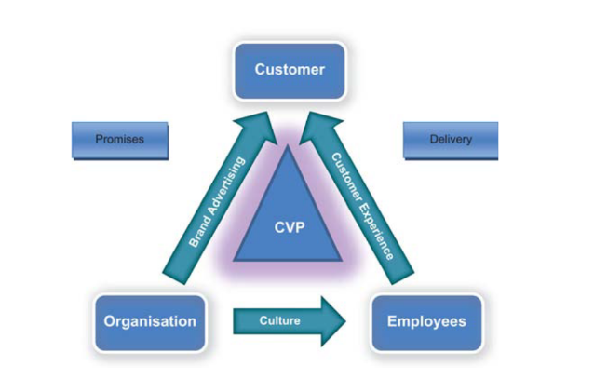
Figure: Total Engagement Model
(Source: Learning Material)
Customer experience: The consumer experience refers to the blend of physical as well as emotional experiences that the consumer feels when they interact with the brand. It has been found on its website of Ford that the company wants to create a setting or an environment which reinforces trust as well as transparency. For giving the best consumer experience the company can offer an extension of warranty. Also, if the company provide a rebate on sales and gives the consumers win a wide range of gifts at the time of purchase that will increase the benefit of the organisation.(Batat,2019).
Costumer value proposition: In simple words, the customer value proposition indicates the value given by a company also it is the reason behind purchasing a product. In the case of Ford, the automobiles offered by the company hold high safety features such as multiple airbags, traction control, and electric stability control and it can be also found in every range of Cars of the company(Chittawar, Mohan&Kase, 2021). If the company provide more innovation in the cars and a painless purchasing experience the company can achieve more benefit.

10. Conclusion
Thus, it can be concluded by saying that, the generation of innovative marketing strategies is very much needed by bigger firms like Ford to effectively provide a higher amount of customer satisfaction towards their clients. Along with that the effective management of the customer journey also plays quite a vital role within the organisation as it generally supports the firm in effectively designing their marketing strategies for creating higher brand awareness about their goods and services amongst their intended group of clients and also in increasing their sales percentages to the utmost levels by providing adequate customer satisfaction to them in the long run.
It is very essential that the organization should have better customer service as it helps the organization to improve their sales as well as the brand value and thus it influences the other customers to purchase from the brand. Also if the organization has a better customer journey then also it helps the organization to get more customers and not only that it boosts the sales of the organization. But if the organization failed to do so or even dissatisfies its customers then it can create a huge challenge for them and they need to resolve it as soon as possible to overcome the situation.

11. Recommendation
The company Ford faced a product recall issue in 2016 and also in 2015 which impacted adversely the brand image of the organisation(Turan, C2022). If the company take measure to fewer errors in their production process and that will help the company in avoiding this kind of issue. Also, the company had put emphasis on hybrid car production instead of that if Ford will produce more eco-friendly electric vehicles that will assist the brand in attaining more consumers.
As the company has the bad reputation about the customer service so that is why the organization should take feed back where they will be able to get to know the demand of the customers and make changes according to them. Not only that implementing AI technology will also helps the organization to get a clear idea about the changes that the customer is looking for or even the customers wants in the organization which helps in get out if the situation that they are facing.

References
Alwash, M., Savarimuthu, B. T. R., &Parackal, M. (2021). Mining brand value propositions on Twitter: exploring the link between marketer-generated content and eWOM outcomes. Social Network Analysis and Mining, 11(1), 83.
Batat, W. (2019). Experiential marketing: Consumer behavior, customer experience and the 7Es. Routledge.
Carlier, M. (2023) Topic: Car brands: Ford, Statista. Available at: https://www.statista.com/topics/6154/car-brands-ford/ (Accessed: April 13, 2023).
Chakraborty, A., & Jain, V. (2022). Leveraging Digital Marketing and Integrated Marketing Communications for Brand Building in Emerging Markets. In Marketing Communications and Brand Development in Emerging Economies Volume I: Contemporary and Future Perspectives (pp. 281-305). Cham: Springer International Publishing.
Chittawar, A., Mohan, M., &Kase, S. (2021). Importance of Electronic Stability Control (ESC) System in Road Vehicles. Advances in Systems Engineering: Select Proceedings of NSC 2019, 597-602.
Darma, G. S., &Noviana, I. P. T. (2020). Exploring Digital Marketing Strategies during the New Normal Era in Enhancing the Use of Digital Payment. JurnalMantik, 4(3), 2257-2262.
Dwityas, N. A., Briandana, R., &Aulia, P. (2020). Consumer journey of culinary products through social media in Indonesia. Humanities & Social Sciences Reviews, 8(1), 306-314.
Fagundes, L., Gomes-e-Souza Munaier, C., &Crescitelli, E. (2022). The influence of social media and brand equity on business-to-business marketing. Revista de Gestão.
Fenton, A., Keegan, B. J., & Parry, K. D. (2023). Understanding sporting social media brand communities, place and social capital: A netnography of football fans. Communication & Sport, 11(2), 313-333.
Garanti, Z., &Kissi, P. S. (2019). The effects of social media brand personality on brand loyalty in the Latvian banking industry: The mediating role of brand equity. International Journal of Bank Marketing.
Gupta, S., Gallear, D., Rudd, J., &Foroudi, P. (2020). The impact of brand value on brand competitiveness. Journal of Business Research, 112, 210-222.
Haralayya, B. (2021). Effect of Branding on Consumer Buying Behaviour at Vijay Bharat Motors Pvt Ltd, Bidar. Iconic Research And Engineering Journals, 4(12), 207-222.
Hewett, K., & Lemon, L. L. (2019). A process view of the role of integrated marketing communications during brand crises. Qualitative Market Research: An International Journal.
Howard, P.W. (2023) Ford ranks among worst in JD Power Customer Service Survey of 2020-22 vehicles, Detroit Free Press. Detroit Free Press. Available at: https://www.freep.com/story/money/cars/ford/2023/03/09/jd-power-customer-service-survey-2023-ford-gm/69986777007/ (Accessed: April 14, 2023).
Kadia, S. (2022). Influence of IMC on Communication Dissemination. In Integrated Marketing Communications for Public Policy: Perspectives from the World’s Largest Employment Guarantee Program MGNREGA (pp. 15-44). Singapore: Springer Nature Singapore.
Kumar, A., Luthra, S., Mangla, S. K., &Kazançoğlu, Y. (2020). COVID-19 impact on sustainable production and operations management. Sustainable Operations and Computers, 1,
Lassila, E., Heikka, E. L., & Nätti, S. (2023). Supporting value co-creation through interaction during the pre-purchase customer journey: empirical evidence from B2B HR services. Journal of Business & Industrial Marketing, 38(13), 63-73.
Naughton, K. (2022) Ford CEO Jim Farley sees electric cars helping pare $3 billion ad budget, Bloomberg.com. Bloomberg. Available at: https://www.bloomberg.com/news/articles/2022-06-01/ford-ceo-sees-evs-helping-carmaker-pare-its-3-billion-ad-budget (Accessed: April 14, 2023).
Pham, L. (2022). The Critical Touchpoints and Disruptive Technology in The Post-Purchase Stage of Cosmetics Brands to Improve Customer Experience.
Priddle, A. (2019) Here are 5 things Ford is doing to improve your customer experience, MotorTrend. MotorTrend. Available at: https://www.motortrend.com/news/ford-improve-customer-experience/ (Accessed: April 13, 2023).
Rao, C. (2019). Making Marketing Music: Integrated Marketing Communications at Work. Bloomsbury Publishing.
Rashkova, Y., Moi, L., Marku, E., &Cabiddu, F. (2023). Online integrated marketing communication strategies of international brands: standardization vs. adaptation approaches. Journal of Marketing Communications, 1-24.
Scholz, J., & Smith, A. N. (2019). Branding in the age of social media firestorms: How to create brand value by fighting back online. Journal of Marketing Management, 35(11-12), 1100-1134.
Semerádová, T., &Weinlich, P. (2019). Computer estimation of customer similarity with Facebook lookalikes: Advantages and disadvantages of hyper-targeting. IEEE Access, 7, 153365-153377.
Siddiqui, A. (2022). The importance of just in time JIT methodology and its advantages in health care quality management business â€‘‘A scoping review. Biomed. J. Scient. Tech. Res, 42, 33317-33325.
Siqueira, J. R., ter Horst, E., Molina, G., Losada, M., & Mateus, M. A. (2020). A Bayesian examination of the relationship of internal and external touchpoints in the customer experience process across various service environments. Journal of Retailing and Consumer Services, 53, 102009.
Subramaniam, M. (2022). The future of competitive strategy: Unleashing the power of data and digital ecosystems. MIT Press.
Turan, C. P. (2022). Deal or deny: The effectiveness of crisis response strategies on brand equity of the focal brand in co-branding. Journal of Business Research, 149, 615-629.
Turan, C. P. (2022). Deal or deny: The effectiveness of crisis response strategies on the brand equity of the focal brand in co-branding. Journal of Business Research, 149, 615-629.
Van Loggerenberg, M. J., Enslin, C., & Terblanche-Smit, M. (2021). Towards a definition for branded entertainment: An exploratory study. Journal of Marketing Communications, 27(3), 322-342.1-7.
Zhang, J. J., Følstad, A., & Bjørkli, C. A. (2023). Organizational factors affecting successful implementation of chatbots for customer service. Journal of internet commerce, 22(1), 122-156.

