Student Name: Claire Mainwaring
Student Number: 1706525
BA Course Title: Surface Pattern Design
Programme of Study: Practices in Context
Module: ADAD5001
Tutor’s Name: Julia Lockheart

2,407 Words

I have chosen ‘colour’ as my first key word. Colour has influenced my own life and all aspects of human life throughout history. Colour psychologically affects our body, mind and spirit. ‘Stitch’ is my second key word which I have chosen because of my passion for sewing. The philosophy of ‘wabi sabi’ is symbolised within simple stitch techniques although its meaning is far from simple and has great cultural significance. My third key word is ‘feminine’ which describes how embroidery has influenced the feminist movement and led to this skill becoming an acceptable art form.

Colour
I have chosen ‘colour’ for my first key word. As a creative maker, colour has always been particularly important to me. My earliest interest in colour began in the early seventies when I was mesmerised with curtains in my bedroom. They were printed with large flowers in brown, orange, yellow and green, and I can still visualise them. This print would now be considered as ‘retro’ and I am very influenced by this style and colour in my artwork.
The Cambridge English Dictionary (2019), describes the meaning of ‘colour’ as being ‘the appearance that something has as a result of reflecting light’. I need to understand the science of how colour is visible and their energy properties. Colour is contained in the energy from the emanations directed to earth by the sun, in the form of electro-magnetic vibrations contained in white light. We can only see about 40% of this spectrum which we know as variations of the seven colours of the rainbow. Each colour has a different vibratory length known as its wavelength, red has the longest wavelength and the slowest vibration while violet has the shortest wavelength and the fastest vibration. Each colour has its own intrinsic qualities and actions upon us and affects our entire being. Our colour ‘mood’ changes and certain colours become more dominant to us throughout our lives.
We need an optimum balance of colour energies in order to promote harmony and balance between our body, mind and soul. We all know that colour affects our moods. Certain colours like blue can calm our minds while yellow can stimulate mental activity. Colour Therapists use colour as a complimentary treatment for many physical, emotional and mental problems. I will research certain aspects of Colour Therapy for my Dissertation because I need to understand how the colour I use in my designs will influence emotional response. I will use this knowledge to enhance the understanding of my work and its message both to myself and others.

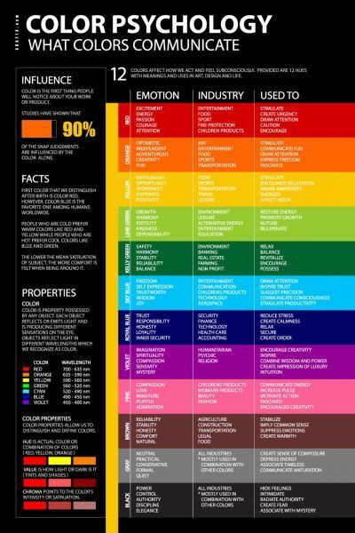

People are drawn to certain colours at certain times which can promote feelings of healing, health, relaxation, inspiration and protection. Early cultures were aware of how the colours in nature affected them and that the colours of their environment influenced their health and vitality. The ancient Egyptians knew of the power and influence of colour and built great temples, notably Heliopolis, which had healing halls of colour. These rooms were constructed so that the sunlight entering them was refracted into a spectrum of colours. Each room was tuned to a certain colour frequency. Colour theory is not new, the healing and emotional value have always been influential. According to Faber Birren (2013:4), ‘The Egyptians in truth, had an expressive color symbolism which pervaded all their art and culture’.
Sound and fragrance are also vibrations, and therefore colour, aromatherapy and music are all closely linked. Sound waves are really colour vibrations slowed down. This is interesting to research because I would like to combine colour, light, sound and fragrance to enhance my work in an exhibition so that everything harmonises to create a memorable sensual experience. I believe that we are sensitive not only to colour but to the appeal of the environment under which our creative work is displayed.
Colour has influenced textile dye throughout history at a time when only natural dyes were available. Only the wealthy could afford sumptuous coloured textiles which is why this became a prosperous trade commodity. Gold, purple, green and blue were the most sumptuous colours and became symbolic. Faber Birren (2013:3) provides information that Christian priests wore purple to show their high spirituality, The Holy Grail was emerald, the Virgin Mary was cloaked in royal blue, Buddha’s symbolic colour was yellow or gold and Mohammed’s colour was green. According to Faber Birren (2013:6), historical records describe colour as being ‘symbolism that attempted to resolve the strange workings of creation and gave it personal and human meaning’.

Stitch
Sewing is my passion and why I have chosen ‘stitch’ for my second key word. My aunty regularly took me to Pontypridd market on a Saturday morning where there were lots of wonderfully coloured stalls of fabric, we looked at every one. My aunty always bought material and I would then spend the afternoon watching her sew clothes for me with her sewing machine at my nan’s house. This is when my love of sewing and colour came alive and at 6 years old, she taught me how to sew. At school I learnt how to embroider and at 10 years old I had my own sewing machine and started to make my own clothes.
I hope to take my lifelong passion of embroidery and combine it with metal to creatively make light shades as a business when I leave University. As stated by Korn (213:7), ‘why do we choose the spirituality, emotionality, and physically demanding work of bringing new objects into the world with creativity and skill?’. I consider the reason to be because this work makes my life fulfilled and gives my life meaning. Csikszenrmihalyi (1996:107) describes this craftsmanship further, ‘it is not the hope of achieving fame or making money that drives them: rather, it is the opportunity to do the work that they enjoy doing’.
The Cambridge English Dictionary (2019), describes the meaning of ‘stitch’ as being ‘a piece of thread sewn in cloth’. When deciding to use ‘stitch’ as a word to describe a lifelong passion, it was difficult to comprehend something that I had only experienced as a feeling of happiness. Gendlin (1981:10), called this emotion the “felt sense”, “a special kind of internal bodily awareness … a body-sense of meaning” and “…as you stand there and gaze at it you feel your chest welling up with an expansive, flowing, warm feeling”. I would further describe this feeling of completeness as also giving me a sense of self identity in that I am doing what I have always felt I was meant to do. Now that my two girls have grown up and left home, I have the opportunity to take this passion further.
I would like to research in depth the sewing culture of Japan because of its vast documented history and philosophy. I am inspired by the Japanese philosophy of Wabi Sabi which celebrates imperfection and the enchanting character of an aged repaired item. There are many symbolic embroidery techniques in Japan such as Sashiko, Boro and Kantha, each one has a story to tell and I find this fascinating.
Wabi sabi is hard to describe because it is an accepted attitude towards life rather than a physical describing word. Kempton (2018: xviii) describes wabi sabi as connected to nature and as ‘..intimately intertwined with this fundamental relationship with nature. It relates to the acceptance of the transience of all things, and the experiencing of life with all the senses’.

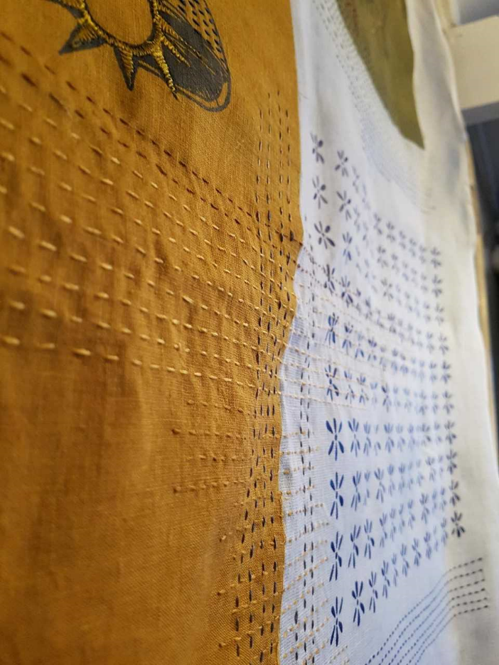

Kempton (2018:3), emphasises ‘In recent years, society has gathered pace, our stress levels have gone through the roof and we have become increasingly obsessed with money, job titles, appearance and the endless accumulation of stuff. There is a growing discontent as we push ourselves harder and juggle more. We are overworked, overstretched and overwhelmed’. Kempton (2018:5), describes the philosophy of wabi sabi as basically ‘…an intuitive response to beauty that reflects the true nature of life, is an acceptance and appreciation of the impermanent, imperfection and incomplete nature of everything and is a recognition of the gifts of simple, slow and natural living.’. I consider that this philosophy is reflected through Japanese embroidery. I have chosen ‘stitch’ to compare this philosophy with ‘fast fashion’ and the impermanence, unappreciation and depletion of planetary resources in our current climate.

Feminine
I have chosen ‘feminine’ as my third key word. The Cambridge English Dictionary (2019), describes the meaning of ‘feminine’ as being ‘qualities that people generally think are typical of women’. Embroidery has been a means of educating women into the feminine ideal but from the latter part of the nineteenth century embroidery provided a weapon of resistance to the constraints of femininity. Parker states (2010:ix), that ‘to know the history of embroidery is to know the history of women’.
Today, in the UK, there is no longer a thriving political movement for women partly because of the influence in the 1970’s by the Second Wave Feminism’ movement. Feminists of this time were described as rejecting embroidery, because of its association with femininity, sweetness, passivity and obedience which was considered to subvert the feminist vision. However, I consider that femininity and possibly sweetness are part of a woman’s strength and should not be mistaken for vulnerability. It was felt that embroidery was symbolic to give rise to the consciousness that women were only seen as to have the identifying characteristics of a homemaker. However, 1970’s feminists did not wish to exchange the frying pan for masculinity rather it was to challenge the subordination and oppression of women. The 1970’s movement gave rise to the evolution of embroidery as being part of art practice and not homogenously as a woman’s craft.
Karen Rosenberg, reviewing ‘Pricked: Extreme Embroidery’ commented, ‘In the 70’s artists who swapped their paint brushes for a needle and thread were making a feminist statement’, Parker (2010:xiii). Historically, men were famous and celebrated for painting works of art and not women. Men dominated the art world and their creative skill was a professional paid practice. Embroidery was considered as a skill for the home only, it was not worthy of being called art or celebrated as such and was unpaid. When women embroidered it was only seen as an expression of femininity. When the artists ‘swapped their paint brushes for a needle’ the message was that women’s creativity had been overlooked for too long, women had been oppressed for too long. Because of the feminine movement, embroidery became a symbol of women’s rights to creativity and equality, both in art practice and in society.
Embroidery in the twenty first century is celebrated not only for its aesthetic textile properties but for its inclusion as a form of expressional art. Tracey Emin is a celebrated embroider who produced a famous stitch work titled ‘Everyone I Have Ever Slept With 1963-1995’. She sewed into the walls of a tent the names of all the people she had slept with including that of her grandmother and teddy bear. Another of her famous embroidered pieces is a series of embroidered floral rectangles re-enforcing the tension of today’s society appliqued with the words ‘There is no fucking peace’. This is a far cry from sweetness and passivity, and I love it. Parker (2010:xvi), states that ‘Emin is displaying a ‘cosy’ domestic art in a professional setting, breaking the boundary between the private, the personal and the public – both psychologically and formally’.



A group of six women artists took over the ground floor of a house in Lambeth, London in 1975, creating an embroidered installation titled ‘Housework’, exposing the hidden side of the domestic dream. It was of a traditionally sewn white gown surrounded by wall collages of Princess Anne’s wedding decorations, and symbolically depicted stretched out arms welcoming an unseen groom. Parker suggests (2018:xvii), ‘The spirit of anarchy informed the project. The desecration of the domestic provided a creative energy.’.
Later in 2009, creativity banners displayed stitched slogans challenging capitalism, global poverty and injustice. Of course, there are different political agendas in the twenty first century, and contemporary embroidery is being used to convey family and life continuance. In 2010, an exhibition at the Arnolfini Gallery in Bristol took place of 14 projects intended to question the dominant models of mass culture and consumerism. Embroidery and stitch are certainly being used to convey political messages.

Colour, stitch and feminine are the three key words I have chosen to research further for my Dissertation. They are connected to each other through art and creativity; they also relate to my future work practice.
Personally, I am excited to research the history of dye colours because it is knowledge that will help me with my future work. I am also interested in the emotional responses towards certain colours and hope that I can use this to further the meaning of my creative work both to myself and to others. Embroidery and stitch have always been my passion, because of my research, I have discovered new cultural designs and symbolic patterns which have become influential in my own designs and given me a fresh approach. I admire the Japanese philosophy of ‘wabi sabi’ and feel that this is of great importance in today’s wasteful society and could lead to a better relationship, understanding and appreciation of our natural environment.
I am very interested in the history of embroidery but discovered that I knew very little about this when I first began research for this assignment. I was surprised to learn that embroidery had great political significance in the ‘Second Wave’ feminist movement in the 1970’s. Embroidery became established as an art form and not just considered as a pastime craft by women at home. In the twenty first century, contemporary embroidery is expressional, heterogeneous, has no boundaries and is not ‘twee’. I intend to research current expressional embroiderers as part of my dissertation which I have no doubt will influence my work.
My three key words have led to a question that looks in depth as to how embroidery has contributed to the appreciation and liberation of women’s creative skills and become accepted as a professional art form. Colour and stitch will be included in this researched question because of their influence on historical and contemporary design and towards giving me a better understanding of my own design work.
The question I have composed gives me the opportunity to research these aspects.
Has the pen or pencil dipped so deeply into the blood of feminine history as the sewing needle?

Bibliography
Faber Birren 2013 Color Psychology and Color Therapy
CT 06250 USA Martino Publishing

Gendlin, Eugene T. 1981 Focussing second edition
London Bantam New Age Books

Crawford, Matthew 2009 The Case for Working with your Hands
London Penguin Books

Csikszentmihalyi, Mihaly 1996 Creativity
London, New York Harper Perennial

Korn, Peter 2013 Why We Make Things & Why It Matters
Great Britain Clays Ltd., St. Ives PLC

Kempton Beth 2018 Wabi Sabi Japanese Wisdom for a Perfectly Imperfect Life
Great Britain Clays Ltd., Elcograf S.p.A.

Parker, Rozsika 2010
The Subversive Stitch Embroidery and the Making of the Feminine
London, New York I.B. Tauris & Co. Ltd.

