Independent Project

Evaluating the impact of hybrid working arrangements on workers’ performance within the UK context.

Student Name: Irina Zuican
Student ID: 2313334
Module: Independent project
Lecturer name : Liyanage Rodrigo

Table of Contents
INTRODUCTION 2
Problem Statement 3
Research Background 3
Research Aim and Objectives 3
Significance of Research 3
Research Rationale 4
Study outline 4
Justification of Research 4
Literature Review 4
Theme 1: Significance of Remote and Hybrid Working 4
Theme 2: Remote and Hybrid Working Challenges 5
Theme 3: Strategies Related to Remote and Hybrid Working 5
Theoretical Framework 5
Research Methodology 6
Research Type 6
Research Approach 6
Research Design 6
Research Philosophy 6
Data Collection 6
Data Analysis 6
Ethical Consideration 6
Timeline 7
Gantt chart 7
REFERENCES 8

INTRODUCTION

Problem Statement
While there are considerable advantages to working from home and using hybrid working, they can also cause difficulty for workers who are either communicating via email or video or experiencing isolation because of lack of social interaction. Finding difficulty balancing between home and work due to mixed locations. Lack of supervision for measuring productivity, performance and overall employee wellbeing. These problems may greatly influence worker productivity, performance and employee wellbeing at company (Anika, 2025).

Research Background
Flexible working arrangements gained popularity after the coronavirus pandemic as remote and hybrid workplaces emerged as common types of working arrangements (Ngonini, 2025). Some employers are now allowing employees to work from home or in some cases, the employer and employee can agree upon working both at home and in the office. In addition to being flexible, many organisations have implemented flexible working arrangements to improve employee satisfaction and increase their business performance (Zerhouni, 2022). Flexible working arrangements are intended to provide support for employees and maintain the organisation’s productivity.

Research Aim and Objectives
Research Aim
To analyse impact of remote and hybrid working on employee’s productivity, performance and well-being.
Research Objectives
- To analyse significance of remote and hybrid working for employee’s productivity, performance and well-being.
- To identify remote and hybrid working challenges which impact employee’s productivity, performance and well-being.
- To recommend strategies related to remote and hybrid working for enhancing employee’s productivity, performance and well-being
Research questions:
What are the impacts of remote and hybrid working for employees’ productivity, performance, and well-being?
How can we mitigate the challenges associated with remote and hybrid working?

Significance of Research
The information created by this research study provides company an opportunity to understand how these types of arrangements affect employees so they may create positive work environments that provide benefits for everyone involved. Several recommendations will be provided to enable company to enhance productivity, performance and ultimately workers’ Wellbeing.

Research Rationale
The driving force behind this research is the growth of remote and hybrid work occurring within many organisations. While this has implications for employees in terms of productivity and performance, it will also help identify the benefits, challenges, and best practices to provide support to employees and improve organisation effectiveness (Vuong, and Nguyen, 2022).

Study outline
This study will effectively analyse remote and hybrid working to enhance employee’s performance, and it will also focus on literature review for detailed analysis (Tawalbeh, 2025). It will also include research methodology to conduct structured research.

Justification of Research
Remote and hybrid working have emerged as critical models for most organisations, so it is necessary to examine their influence on organisational performance, employee productivity, and employee well-being to be successful within business (Telu, and Kumar, 2025). In addition, company’s endorsement of flexible working options makes it an ideal case study for this research as it allows for analysis of the benefits and challenges of remote and hybrid working. Furthermore, findings from this research will assist company in improving employee experience, enhancing productivity, and creating effective remote and hybrid working strategies.

Literature Review

Theme 1: Significance of Remote and Hybrid Working
As per Malone, (2025), there are various opinions about whether or not telecommuting or hybrid working concepts contribute positively to employee flexibility, job satisfaction, and a healthy balance of work and personal life. The time that employees can save by working from home, including travel time to and from work as well as time spent organising tasks at both their home and in the workplace, may lead to higher levels of productivity, improved job performance, and greater overall well-being.
However, Charalampous, Grant, and Tramontano, (2022), said that experience of remote working could have negative effects on employee performance by creating distractions for employees working at home, reducing the level of cooperation among coworkers, and hindering verbal interactions among coworkers, which ultimately leads to decreased productivity.

Theme 2: Remote and Hybrid Working Challenges
As reported by Sokolić, (2022), communication barriers, technology issues, social isolation, and difficulty separating work from home are examples of challenges which present themselves in remote and hybrid working situations. All of these challenges can adversely impact an employee’s well-being and performance.
As argued by Ahmadi, Gholipoursoleimani, and Shahrodi, (2024), modern communication technologies and flexible scheduling may help employees overcome these challenges according to other researchers. Adequate organisational support can help alleviate the negative impact on remote employees and hybrid employees.

Theme 3: Strategies Related to Remote and Hybrid Working
As believed by Gupta, and Nagariya, (2025), some practices include consistent communication, employee development and training, mental wellness support, flexibility in work hours, and performance assessment as specific strategies that will allow employees to have issues of productivity to be sustained during working hours.
As specified by Karl, Peluchette, and Aghakhani, (2022), that having too much continuous surveillance and having too many virtual meetings may create additional strain on employees and decrease their overall job satisfaction, thus the best approach for an organisation to take would be to find a balance between offering support to employees and maintaining proper controls over them.

Theoretical Framework
According to the Job Characteristics Theory, increased motivation and productivity are created through an increase in flexibility or autonomy in the workplace. The Work-Life Balance Theory identifies that balancing personal and work commitments will lead to improving overall well-being (Zulkiflee, Rashid, and Abd Razak, 2024). The Social Exchange Theory states that employees will give more commitment, performance, and productivity in return for an organisation providing them support and flexibility. All three of these theories can be used to show how remote and hybrid working will impact employees.

Research Methodology

Research Type
This research will include qualitative research together to gain a fuller picture of how Remote Working and Hybrid Working have affected employee performance (Lynn, 2022).

Research Approach
This will include inductive approach using organisation to demonstrate how remote working and hybrid working has impacted on levels of productivity, performance, and well-being for employees.

Research Design
The research design will be inductive. Inductive research design enables the researcher to generate new findings and conclusions from data as opposed to testing already established theories (Yuwono, and Rachmawati, 2023).

Research Philosophy
It will utilise Interpretivism philosophical approach due to its compatibility with using both quantitative and qualitative research methodologies while concentrating on real-world outcomes associated with research problems.

Data Collection
Secondary data will be collected during the study, and it will be gathered from a variety of sources, including but not limited to, journals, books, corporate reports and other credible internet sources.

Data Analysis
Using thematic analysis, it will analyse the theme structure to identify common themes, patterns, and opinions regarding remote working and hybrid working (Gernandizo, 2023).

Ethical Consideration
The study will adhere to ethical protocols and provide participants with the purpose of the study and receive their consent after explaining the study’s purpose. Confidentiality will be maintained throughout the study and all data will be collected solely for academic purposes. In addition, all participants have the right to withdraw from participation at any time.

Timeline

Gantt chart
Task Name | Duration | Start | Finish
Research approval | 6 days | Sat 16/05/26 | Thu 21/05/26
Literature review | 8 days | Fri 22/05/26 | Fri 29/05/26
Methodology design | 9 days | Sat 30/05/26 | Mon 08/06/26
Questionnaire development | 5 days | Tue 09/06/26 | Sat 13/06/26
Data collection | 12 days | Mon 15/06/26 | Fri 26/06/26
Data analysis | 9 days | Sat 27/06/26 | Sun 05/07/26
Findings and discussion | 6 days | Mon 06/07/26 | Sat 11/07/26
Recommendations | 8 days | Mon 13/07/26 | Mon 20/07/26
Final submission | 6 days | Tue 21/07/26 | Sun 26/07/26

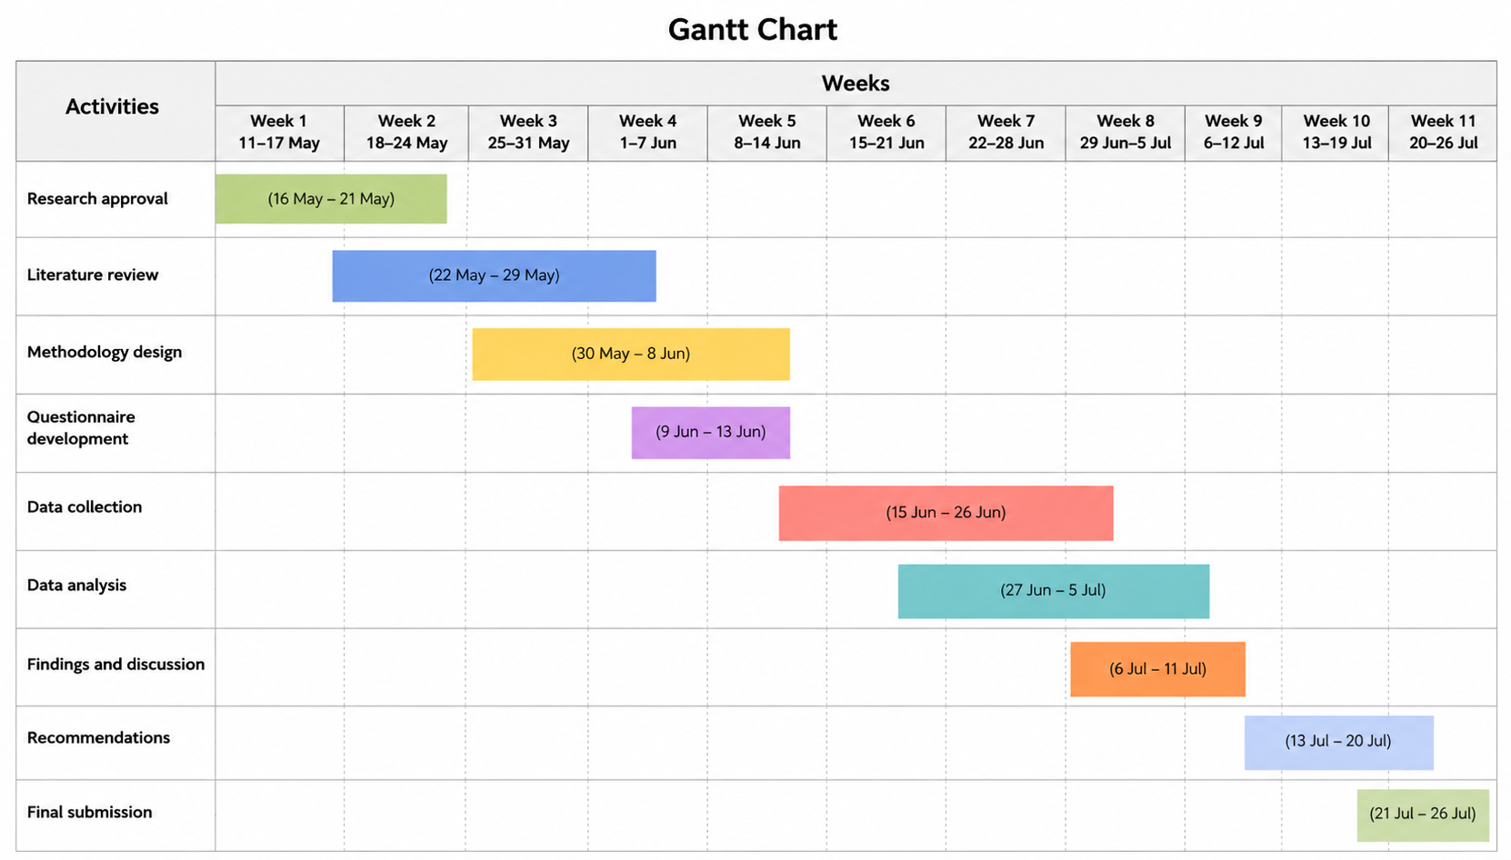

REFERENCES
Books and Journals
Ahmadi, M., Gholipoursoleimani, A. and Shahrodi, K., (2024). Employee experiences with flexible work arrangements and their impact on productivity. Journal of Resource Management and Decision Engineering, 3(1), pp.26-32.
Anika, R.R., (2025). The impact of remote work on performance management practices in the banking sector.
Charalampous, M., Grant, C.A. and Tramontano, C., (2022). “It needs to be the right blend”: A qualitative exploration of remote e-workers’ experience and well-being at work. Employee Relations: The International Journal, 44(2), pp.335-355.
Gernandizo, J., (2023). Thematic analysis investigating the impact of remote working during Covid-19 pandemic on communication and face-to-face interaction (Doctoral dissertation, Dublin, National College of Ireland).
Gupta, I. and Nagariya, R., (2025). The impact of flexible work policies on employee well-being and retention in modern organizations. In Prioritizing employee mental health and well-being for organizational success (pp. 185-218). IGI Global Scientific Publishing.
Karl, K.A., Peluchette, J.V. and Aghakhani, N., (2022). Virtual work meetings during the COVID-19 pandemic: The good, bad, and ugly. Small group research, 53(3), pp.343-365.
Lynn, H.R., (2022). Qualitative Case Study on the Impact of Remote Work Arrangements on Employee Engagement in a Higher Education Institution (Doctoral dissertation, Trident University International).
Malone, R., (2025). Job Satisfaction, Productivity and achieving a Work-Life Balance. A comparative analysis on Traditional vs. Hybrid Working Environments conducted based on Civil Servants (Doctoral dissertation, Dublin, National College of Ireland).
Ngonini, X., (2025). Exploring Hybrid Work Dynamics in Public Organizations: Remote Work and Blended Office-Home Arrangements. In A Review of People Oriented Leadership-Evolving Approaches to Work, Culture, and Management. IntechOpen.
Sokolić, D., (2022). Remote work and hybrid work organizations. Economic and social development, pp.202-213.
Tawalbeh, J., (2025). Remote and hybrid work models: Enhancing employee engagement and redefining performance management in a new era. Journal of Posthumanism, 5(3), pp.101-116.
Telu, S. and Kumar, S., (2025). Towards a sustainable future: a comprehensive review of employee well-being in hybrid work settings. Management & Sustainability: An Arab Review, 4(3), pp.407-430.
Vuong, T.D.N. and Nguyen, L.T., (2022). The key strategies for measuring employee performance in companies: a systematic review. Sustainability, 14(21), p.14017.
Yuwono, M.A. and Rachmawati, D., (2023). Combined methods. Can this solve the differences between deductive and inductive methods in qualitative research?. Moroccan Journal of Quantitative and Qualitative Research, 5(3).
Zerhouni, L., (2022). The effect of flexible work arrangements on employees’ well-being, job satisfaction, and work performance in Morocco: A case study (Master's thesis, Istanbul Aydin University (Turkey)).
Zulkiflee, H., Rashid, W.E.W. and Abd Razak, N., (2024). Literature review on theories of work-life balance. Journal of Emerging Economies and Islamic Research, 12(2), pp.1678-1678.
Online
COMPNAY, (2026). Company History, [Online] [Access through] < https://www.Compnay.com/who-we-are/our-strategy-and-values/our-history> [Assessed on: 07th June 2026]

