

Student name: Sofia Sethi
Student ID:2517112

Module name: Health and Social Care Assignment 1
Module code: LCHS 4003
Lecturer name Muhammad Aliyu

Content page.

1. DETAILED POSTER LAYOUT ………. page 1

2. IMAGES RELATED TO POSTER ……… page 2

3. A Brief description of why it is good to help support in the community.

4. References.

Different Needs, Equal Rights

Together, we break barriers.

Accessibility opens doors.
1980s: community-based services expand.
1990s: Disability Rights strengthened.
2000s: Inclusion becomes a priority.
2010s: Present: Full participation & Accessibility.

Building an inclusive Community.
Workshop events.
Awareness activities for Everyone.
Fun accessible clubs and play sessions
For All Abilities (Care Act 2014).
Feel Valued, Supported and able to
Participate Fully in the Community
Life.
Support and advice.
Health Well-being Support.
Support for children & Young people.
Independence Living Assistance.
Community Inclusion.
Advocacy.
Transport Help(Morris 1991).

History of service.
1950-1960s:
Support is limited by charity. People with disabilities are cared for at home.
1970s: Rights awareness grows
Community Disability Care.
Health Social Care Level 4
Name: Sofia Sethi Student Number:2517112
I chose to focus on community within the disability topic because community environments play a crucial role in shaping disabled people's experiences, opportunities, and well-being. By examining how social attitudes, local services, and shared spaces either enable or restrict participation, I can highlight the importance of inclusive, accessible and supportive communities in promoting equality and independence.

Talking about community brings the topic to life – it's about real people, real relationships and real environments. It shows empathy and awareness of the broader social context.

Referances,

- Journal Article: Bray, A. and Gates, S. (2003) 'Community participation and inclusion: people with disabilities', Disability & Society, 18(6), pp. 785-802. Available at: doi.org.
- Book/Report: World Health Organisation and The World Bank (2011) World report on disability. Geneva: World Health Organisation.
- Online Article/Website: Adata.org (2025) Guidelines for Writing About People With Disabilities. Available at: https://adata.org/factsheet/ADANN-writing (Accessed: 21 March

- Care Act 2014, c. 23. Available at: https://www.legislation.gov.uk/ukpga/2014/23/contents.
- Equality Act 2010, c. 15. Available at: https://www.legislation.gov.uk/ukpga/2010/15/contents.
- SEND Code of Practice (Department for Education and Department of Health, 2015).
- The Bradley Report (Bradley, 2009).

A few Examples of disabilities.

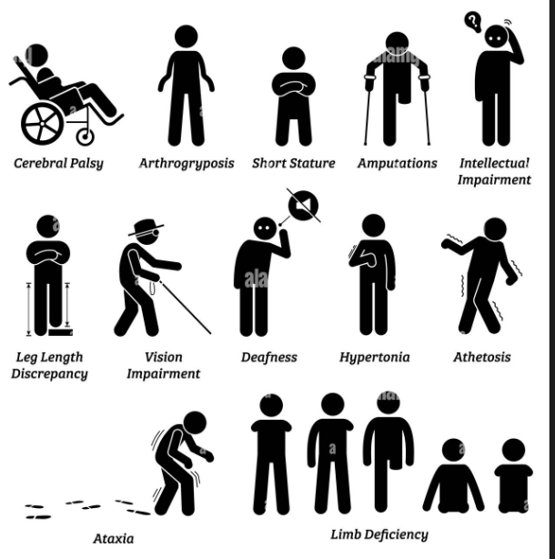

Task 2

PHARMACY SERVICES.
My introduction
Pharmacy services within the National Health Service (NHS) play a vital role in delivering safe, effective, and accessible healthcare across the UK.
Pharmacists are highly trained healthcare professionals who ensure patients receive the right medicines and understand how to use them properly and achieve the best possible health outcomes.
Since its establishment in 1948, the NHS has aimed to provide comprehensive healthcare that is free at the point of delivery, funded through taxation. Within this system, pharmacists have evolved from a primarily dispensing-focused profession to one that is clinically oriented, patient-centred, and increasingly integrated into multidisciplinary health care teams.
Medicines are the most common therapeutic intervention in modern healthcare. However, inappropriate prescribing of medication errors, poor adherence, and adverse drug reactions remain significant causes of preventable morbidity, hospital admissions, and health care costs.
Pharmacy services exist to address these challenges. Their core purpose is to optimise medicine use, enhance patient safety, promote public health, and improve clinical outcomes.
Pharmacists are uniquely positioned to bridge the gap between prescribers and patients, combining pharmacological expertise with clinical judgement and communication skills.

Name: Sofia Sethi
Module Health: social care, Health services
Module number: LCHS 4003
Lecturer's name: Mahmood Aliyu

1: Health care service on
Pharmacy services.
2: My introduction.

3: My research.

4. Challenges faced, using a Qualitative and quantitative approach.

Research on role:

Reflecting on providing services like diabetic medication reviews, blood pressure monitoring, or managing chronic illnesses.
Patient-centred care and professional growth. Key themes include evolving from a technical focus on dispensing to clinical roles, such as medication therapy management, counselling and addressing health inequalities. Many experiences highlight a shift from simple medication
dispensing to providing “pharmaceutical care,” which focuses on ensuring the safe and appropriate use of drugs and medication.
Building rapport and Empathy with patients to understand their needs, especially for elderly patients or those with chronic conditions.
Reflecting on counselling patients on new medications, addressing side effects, and advising on self – care (often assessed in competitions or clinical scenarios). The community often highlight the importance of being an accessible healthcare resource, particularly for the vulnerable
Populations.
Current pharmacy research (2025 – 2026) focuses on integrating AI for personalised medicine, expanding community pharmacy roles in primary care, and pharmacy first, and enhancing digital health technologies. Key areas include pharmacogenomics for tailored treatment,3D printing in pharmaceutics, and managing pharmacy services in conflict. Highlights pharmacy first services for treating common conditions to reduce GP pressure. Studies are exploring the role of pharmacies in smoking cessation and prescribing for long – term conditions. Improvement and advancement by using AI to predict adverse drug reactions and optimise medication regimens. Automated dispensing systems are increasing accuracy and allowing for more patient-centred care. Studies are using more genetic data to tailor treatment, known as pharmacogenomics. New research is emerging on using GLP-1 agonists for weight loss. Research into education trends shows a shift toward hybrid, blended learning models for pharmacists.
The two challenges the pharmacists are facing today include unsustainable financial pressure.
Severe workforce shortage and burnout. Staff shortages and increased pressure due to these shortages. Stating that their mental health has been negatively impacted. Temporary closures and significantly longer waiting hours. Medicine supply disruptions, which force pharmacists to take longer to search for stock, often force pharmacists to dispense at a financial loss.

Conclusion.

Local pharmacy teams collaborate to provide people with rapid access to public face-to-face and by using the latest technology to give fast access to health improvement services that meet local needs (such
as point-of-care testing) and prevention programmes. Pharmacists prescribe medicines and work alongside pharmacy technicians. Connected, they monitor treatment and medicines as part of a digitally
connected multidisciplinary team. Community pharmacies are used routinely by the public as easily accessible “health hubs” for women's health and minor illnesses, monitoring of long-term conditions, and administration of medicines. In particular, they provide accessible support to underserved communities.

REFERENCES:

Alzubaidi, H., Namara, K.M., Saadawi, W., Hasan, S. and Krass, I. (2020). Pharmacists’ experiences and views on providing screening services: An international comparison. Research in Social and Administrative Pharmacy. Doi: HTTPs://doi.org/10.1016/j.sapharm.2020.07.019.

