3/24/2025
University of Wales Trinity Saint David
London campus
E-Portfolio Link:
https://2513628.wixsite.com/erenkulahlioglu
Module Name: Learning In the Digital Era
Module Code: ACCA 4025

Student Name: Eren Kulahlioglu
Student ID: 2513628
Group: 2

Lecturer’s Name: Koushik Modak

LDE Assignment 1
E-Portfolio
Table of Contents
Introduction 2
Main Body 2
Task 1: Essential Academic and Employment Skills for the future career Path 2
Task 1 (a): Report on Essential Academic and Employment Skills 2
Task 1 (b): Evaluation of Task 1 (a) based on Similarity report 4
Task 2: Collaborative Mind Map and Individual Poster 5
Mind Map (Collaborative) 5
Poster (Individual) 5
Task 3: Virtual Collaboration and RefWorks 6
Report on Virtual Collaboration 6
Step-by-step process of using RefWorks with visuals 8
Task 4: E-Portfolio Creation and Evaluation 12
Task 4 (a): E-Portfolio Creation 12
Task 4 (b): Illustrative Review of E-Portfolio tool Selection 16
Conclusion 16
References 17
Task 1 References: 17
Task 3 References: 18

Introduction

Main Body

Task 1: Essential Academic and Employment Skills for the future career Path

Task 1 (a): Report on Essential Academic and Employment Skills

Technical skills are not enough to do the trick in study life as well as corporate life nowadays. We have to acquire many other skills in order to be successful in study life as well as working life. Those students as well as working people with skills like critical thinking, communication, active learning, creative thinking, research, teamwork, computer skills, organisational skills and time management will reach a new level. [1] [2]
Such skills render people more effective at professional and academic work. [2] Teamwork is perhaps the most useful skill in professional and academic work. Successful teamwork makes people share ideas and solve big issues faster. Meanwhile, it gives rise to greater job satisfaction and good outcomes in the work accomplished. [3] Critical thinking is something that can be applied to every field, be it communication, problem-solving, or team building. Technology and the global economy are evolving at some unspecified rate these days, and it is tough for employees as well as managers to make decisions. That is where critical thinking steps in, something that assists in making decisions quickly and rationally and improves one's performance. [4]
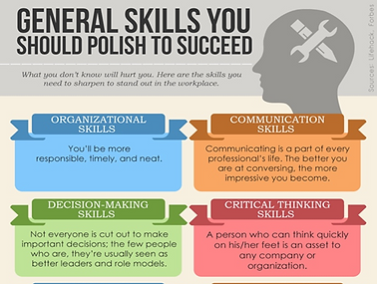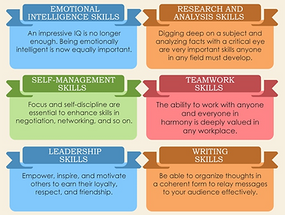
Figure 2 : General skills need to be polished to succeed [5]

All these abilities, along with digital literacy, will be useful to me in the technology startup that I plan to set up. By critical thinking, I will be able to make rational and creative judgments. By teamworking skills, I will be able to build a good team and develop ideas together. With time management, I will be able to maintain my organisations in operation.

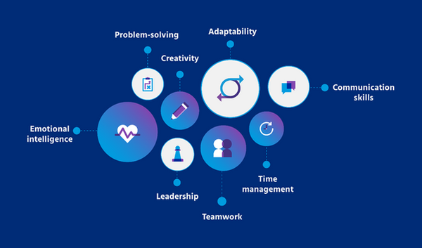

Task 1 (b): Evaluation of Task 1 (a) based on Similarity report

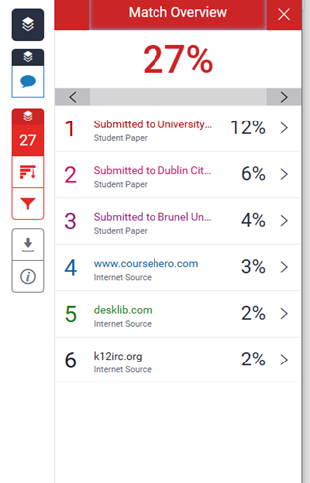

I think why that I scored a 27% on Turnitin was because I used academic keywords that are frequently hard to correctly quote. Even though I can now see where I can improve, I tried to achieve the standards by writing and referencing this project. I would like to spend more time in the future to rewriting topics in my own unique way and improving the flow of my writing. By keeping with the Generic Assessment Criteria, I would place my work at about 70%. I may use extra editing, but the structure and referencing were fair. All things put together, this assignment improved the way I understood of IEEE referencing and increased my confidence in my academic writing at UWTSD.

Task 2: Collaborative Mind Map and Individual Poster

Mind Map (Collaborative)
Link: https://mm.tt/map/3845106917?t=zkVUczRebZ
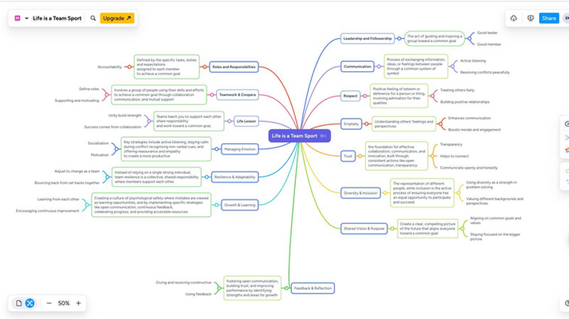

Poster (Individual)
Link: https://www.canva.com/design/DAG2_vLoM_g/ExBkwH8mZ9gsgO1fLGWibA/edit?utm_content=DAG2_vLoM_g&utm_campaign=designshare&utm_medium=link2&utm_source=sharebutton
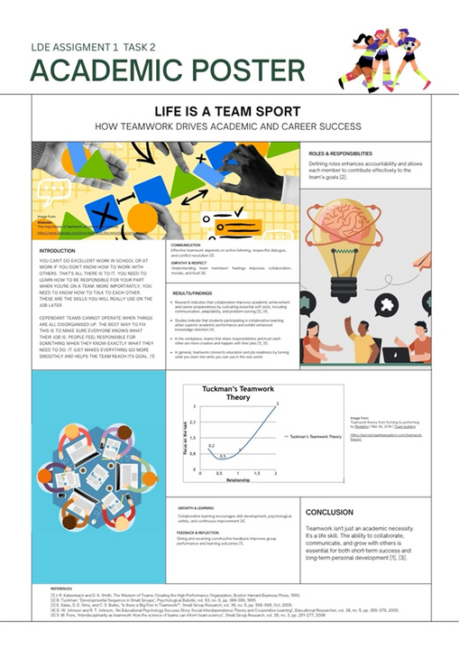

Task 3: Virtual Collaboration and RefWorks

Report on Virtual Collaboration
Topic: Riding the Storm
It's a clear contradiction that businesses are quickly adopting virtual teams because of advances in technology. A lot of teams still have trouble reaching their business goals, even though they happen more often [9].
​
Virtual teams face three main types of problems: diversity, technology, and social issues [9]. People who speak different languages, come from different cultures, or live in different time zones may have trouble with diversity. They make it more difficult to coordinate teams [9]. Because of these problems, it's not easy for us working as online and collaborate effectively as a team. People can get through these hard times by helping each other and talking to each other.
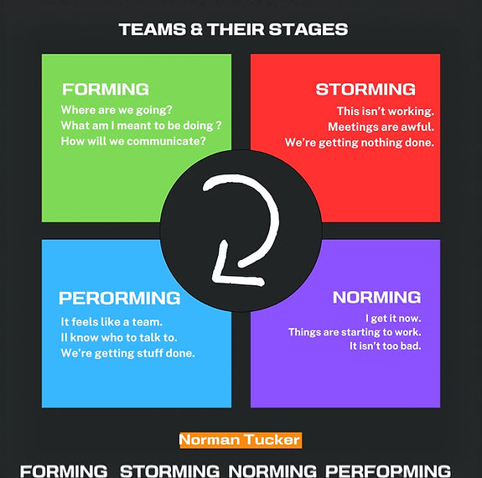
Figure: [11] how to make your team happy

It’s normal for people in virtual teams to have conflicts, but what really matters is how they deal with them. These moments can actually bring the team closer. Gupta, Pathak, and Biswas found that this empowerment makes people perform better and enjoy themselves more [10]. But virtuality can also be bad if disagreements aren't handled well. Good conflict management helps teams solve problems quickly and stay close to each other. This makes problems with performance less likely. [10].
​
Another important part in working together is empathy. Yu and Zhang point out that empathy defined as having an understanding of how others feel, help improve relationships. This helps team members build a kind of unspoken understanding called moqi [8]. Moqi helps people figure out what other people want without them having to say it. This agreement makes up for the fact that the team can't talk to each other in person. [8].

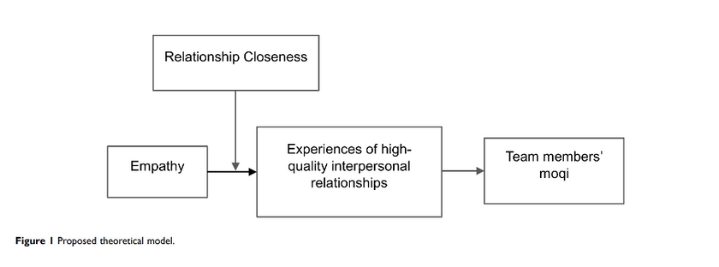

Communication is very important for building a productive team culture. Vătămănescu and Dinu discovered that leaders and team members who communicate well and with kindness foster trust and enhance team culture [7]. A strong team culture not only helps people get things done and do them better, but it also makes them happier with how well they work together [7].
​
Technology alone won't make virtual teams work. They need things like being able to make decisions, feeling understood, and good communication. When these things work together, teams can deal with the problems that come up when they work together online and really ride the storm.[7]–[10].

Step-by-step process of using RefWorks with visuals

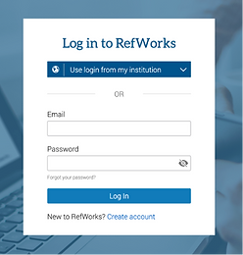
Sign up for a RefWorks account or log in to your existing one.

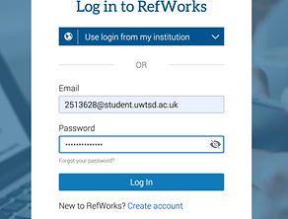

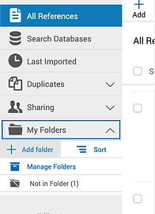 Click the option to create a new folder.
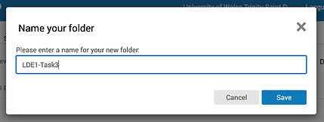
Assign name to your folders so you can organize related reference lists.


You can use Google Scholar to find and collect your citations and references, then link them directly to RefWorks.
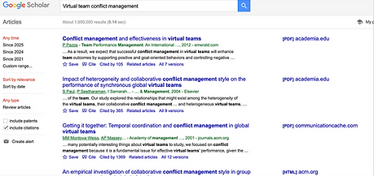

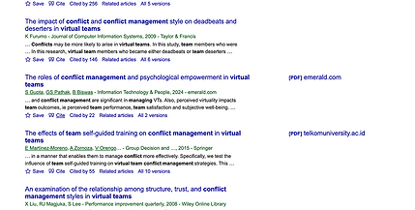
Look up your chosen topic, and when you find a relevant source, click Cite to connect the reference to RefWorks.

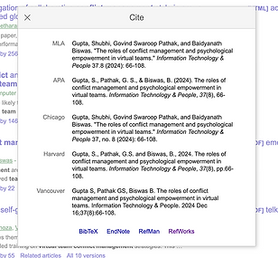
Click RefWorks to send the reference details directly to your RefWorks library then select import references to retrieve the information on RefWorks.

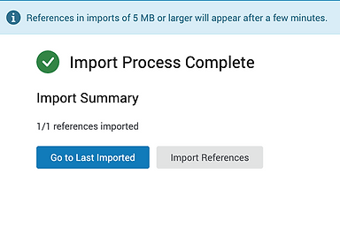
Select the Go to Last imported.

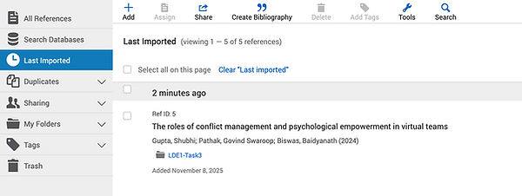
Check the most recent import to ensure it has been added successfully.

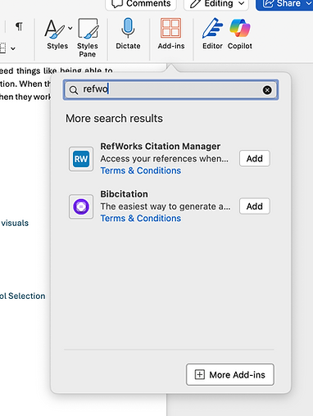
To insert citations and references into a Word document, open the file and go to the Add-ins tab.
Search for RefWorks, and when prompted, sign in to your RefWorks account

Task 4: E-Portfolio Creation and Evaluation

Task 4 (a): E-Portfolio Creation
https://2513628.wixsite.com/erenkulahlioglu/task4-a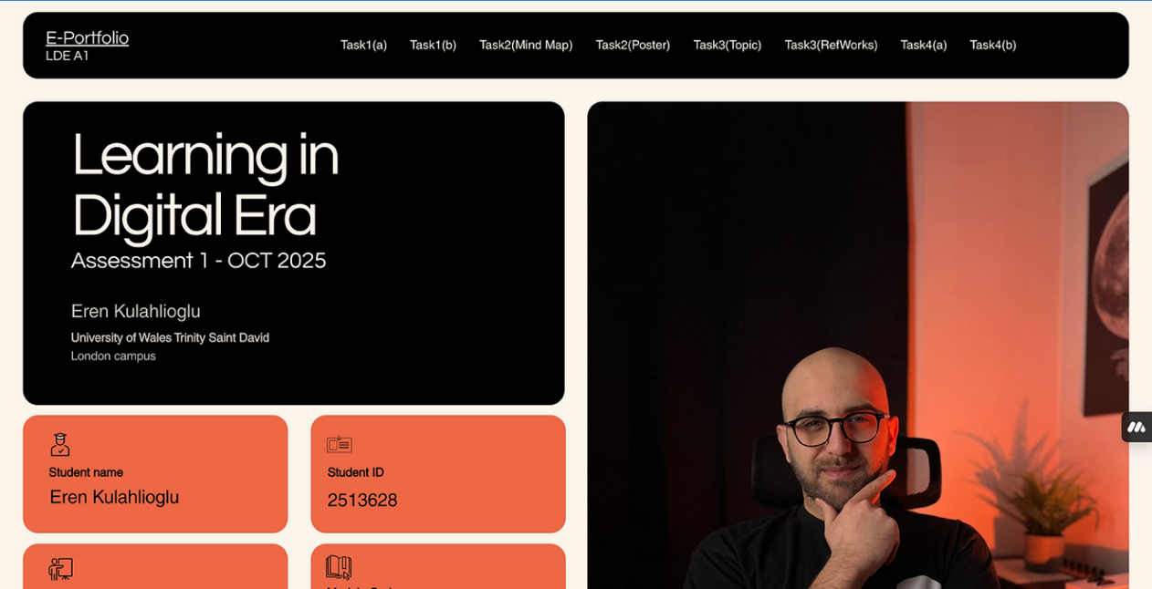

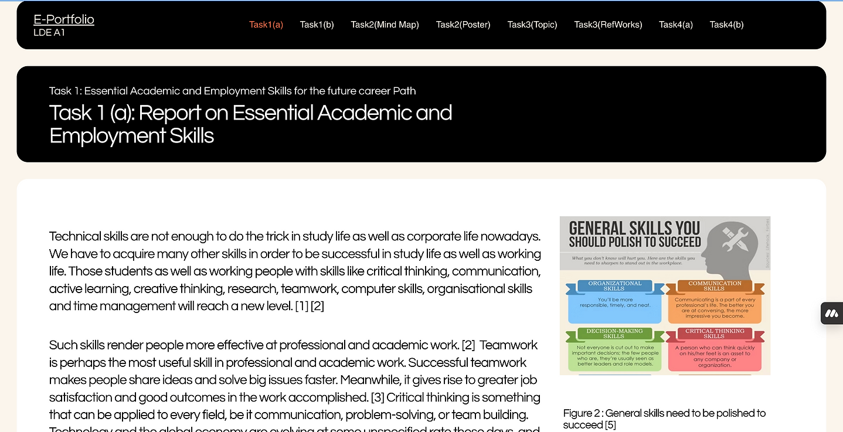

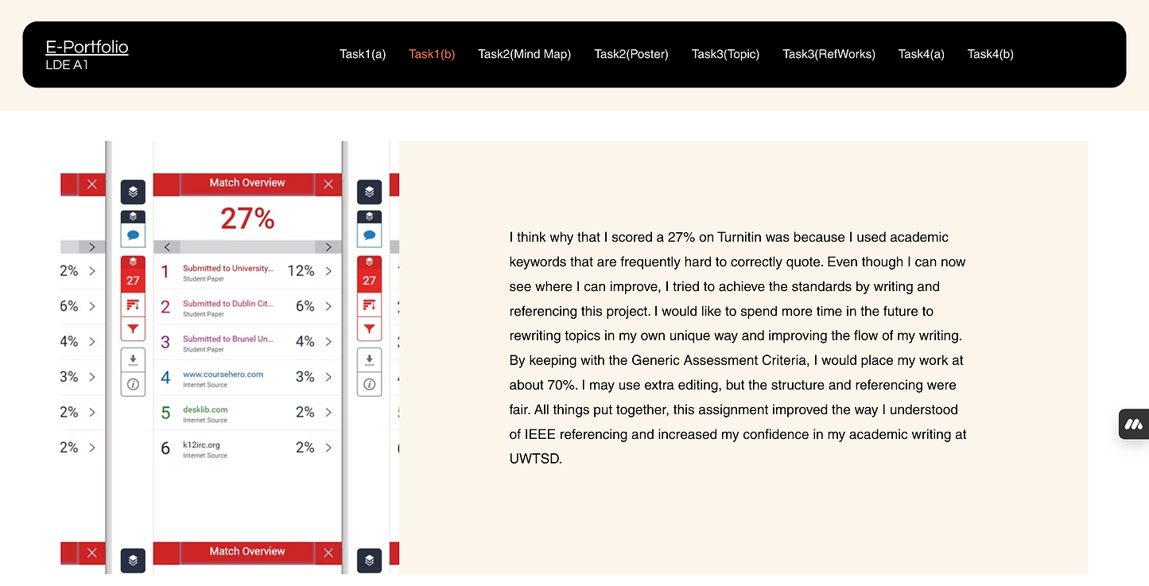

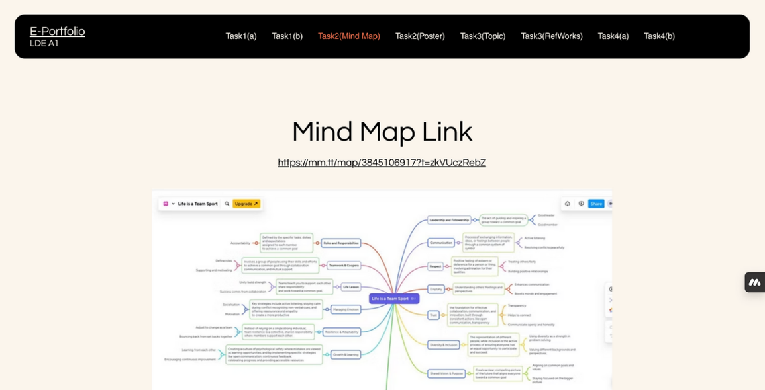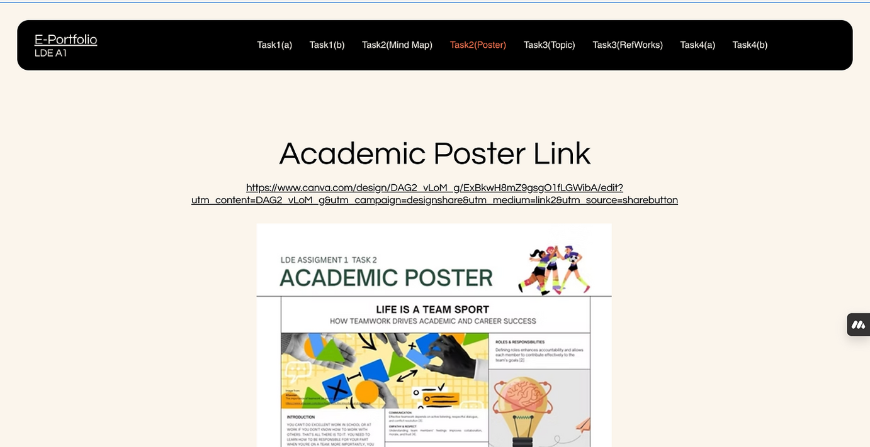

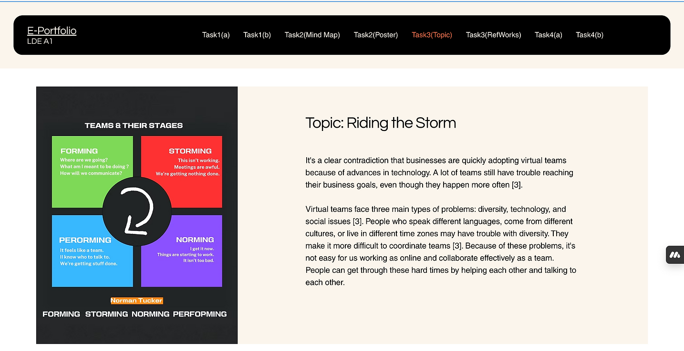

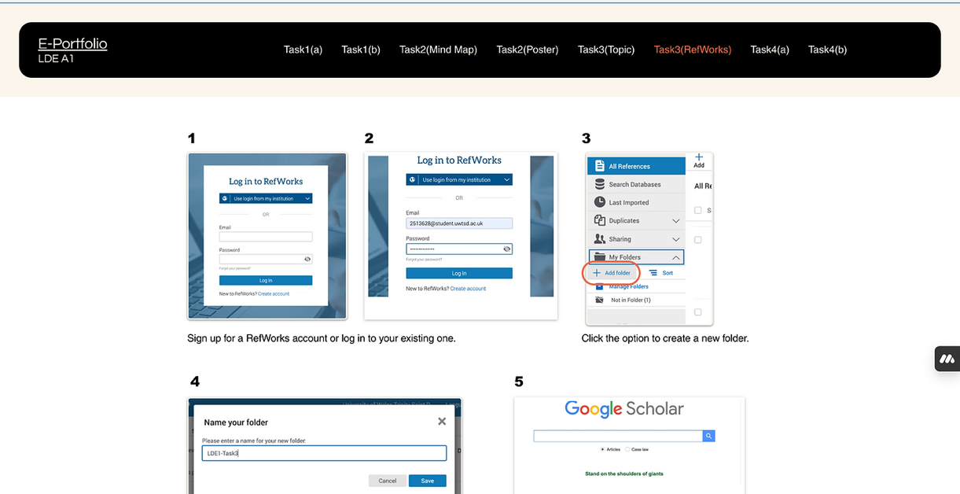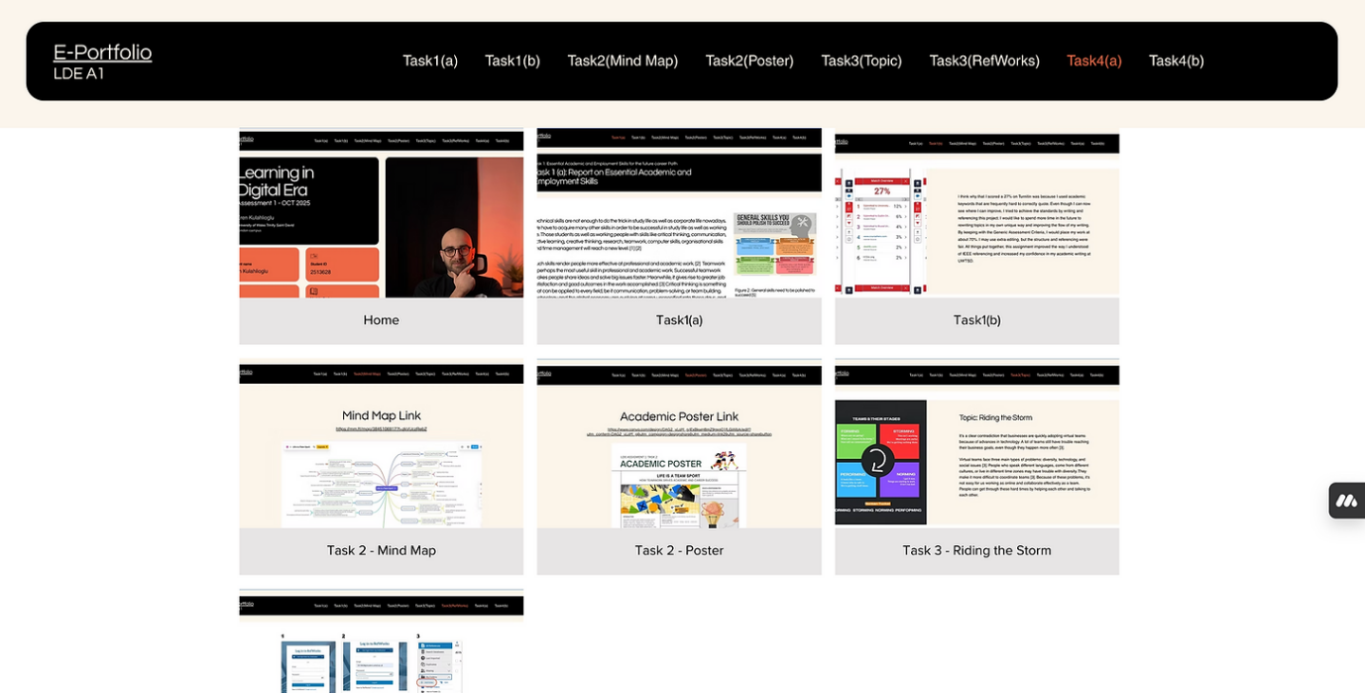
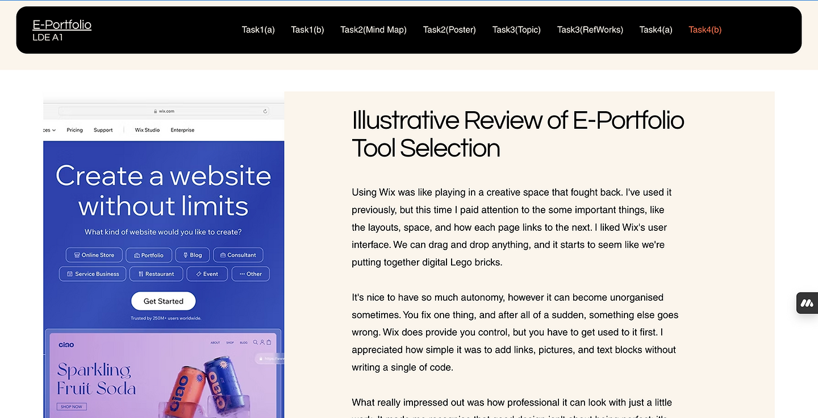

Task 4 (b): Illustrative Review of E-Portfolio tool Selection
Using Wix was like playing in a creative space that fought back. I've used it previously, but this time I paid attention to the some important things, like the layouts, space, and how each page links to the next. I liked Wix's user interface. We can drag and drop anything, and it starts to seem like we're putting together digital Lego bricks.
It's nice to have so much autonomy, however it can become unorganised sometimes. You fix one thing, and after all of a sudden, something else goes wrong. Wix does provide you control, but you have to get used to it first. I appreciated how simple it was to add links, pictures, and text blocks without writing a single of code.
What really impressed out was how professional it can look with just a little work. It made me recognise that good design isn't about being perfect; it's about being clear. Wix makes it seem possible to get things clear, even for those like myself who are IT student.

Conclusion
This e-portfolio displays what I learnt in the Learning in the Digital Era program. The tasks taught me vital academic and professional abilities that I will need to do well in the future.
I learnt how to do research and reference sources in Task 1 while utilising the IEEE referencing style to look into crucial academic and job abilities.
For Task 2, I worked with my classmates to build a mindmap called "Life is a Team Sport." This showed me how vital it is to work together and talk to each other at school and at work.
In Task 3, I worked with other people online and used automatic referencing programs like RefWorks. This helped me get better at using computers.
Lastly, I developed this e-portfolio in Task 4 to show off my work in a clean and professional style.
Overall, this program helped me feel more sure of my research, teamwork, and digital communication skills, which will assist me in school and in my future job.

References

Task 1 References

[1] | S. Cottrell, The Study Skills Handbook (Bloomsbury Study Skills), Bloomsbury Academic, 2024, p. 456.
[2] | S. S. Tom Burns, Essential Study Skills: The Complete Guide to Success at University, SAGE Publications Ltd, 1905, p. 336.
[3] | G. M. Parker, Team Players and Teamwork: New Strategies for Developing Successful Collaboration, 2008, p. 256.
[4] | M. Tripathy, “Dimensions of Critical Thinking in WorkplaceManagement & Personal Development: A ConceptualAnalysis,” Researchgate, 2020.
[5] | Resumeprime, “Common Job Skills That You Should Master [Infographic],” 13 November 2015. [Online]. Available: https://www.resumeprime.com/general-job-skills-infographic/.
[6] | V. Parnami, “Significance of soft skills in today’s dynamic workplace,” 23 Aug 2023. [Online]. Available: https://blog.mettl.com/soft-skills-at-workplace/.  Task 3 References
[7] | E.-M. E. D. M.-E. S. R.-M. S. F. V. Vătămănescu, “Adding Knowledge to Virtual Teams in the New Normal: From Leader-Team Communication towards the Satisfaction with Teamwork,” 24 May 2022.
[8] | L. Z. M. L. B. H. Xuan Yu, “The Effect of Empathy on Team Members’ Moqi in Virtual Teams: A Moderated Mediation Model,” p. 2619—2633, 12 Jul 2023.
[9] | D. Z. S. M. S. Saleh Alkoud, “Challenges, Barriers, and Obstacles Facing Virtual Teams: a Conceptual Study,” p. 1194 – 1206., 19 April 2023.
[10] | G. S. P. B. B. Shubhi Gupta, “The roles of conflict management and psychological empowerment in virtual teams,” Information Technology & People, Vols. Volume 37, Issue 8, p. 66–108, Jul 2023.
[11] | S. Fisher, “how to make your team happy,” Susan’s Site, 15 Aug 2024. [Online]. Available: https://www.susanfisher.biz/post/virtual-team-how-to.

