International Meetings Management for the Hotel Industry
BMIH6007
Event Strategic Planning and Delivery Considerations for an International Meeting
Syeda Samia Begum
2130491
Jemma Smith
Table of Contents
Introduction 1
The Event Cycle 1
Event Concept 3
Aim and Objectives of the Meeting / Event 4
Event Operations 4
Event Budget 6
Industry Trends / Issues / Impacts 7
Cultural and Situational Considerations 10
Reference list 11

Introduction
There will be an innovative exhibition named “Hospitality Tech-Experience”. This aims to represent the correlation between hospitality and technology. This event is drafted to portray the latest technology advancements in the hospitality industry for providing smart hotel experiences to guests. This event has been selected to demonstrate how the incorporation of technology is vastly growing in this sector. This will be dedicated to showing how the operations and guest interaction of the hotel industry are transforming with emerging technologies (Eisenhardt and Martin, 2022). The exhibition will create comprehensive platform for communicating with tech innovators, industry leaders, hotel owners, visitors and others to disseminate the future facilities. The exhibition will be held in the largest convention centre ExCel London in London. London is known to be a global hub for not only tech-based innovation but also the hospitality industry enhancing the event backdrop perfectly. This convention centre has well reputation for its space, quality service, innovative support and perfect ethos experience for the guests.

The Event Cycle
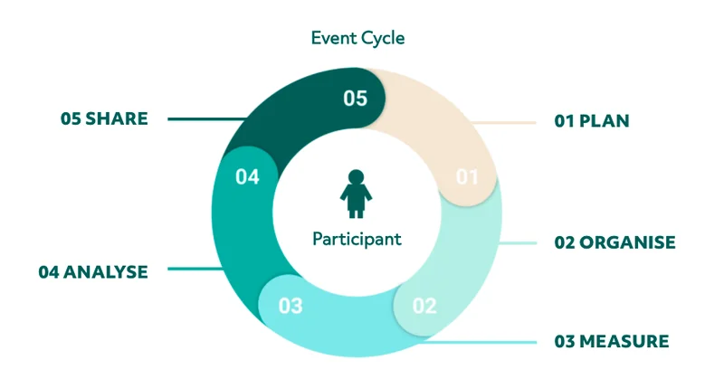
Figure: Event Cycle.
Source: (Barrows, Powers and Reynolds, 2022).
The event cycle is a systematic framework dividing the phases according to required activities. This helps the event organisers to accomplish all the tasks according to the predetermined plans within the appropriate timeline (Tiew, Holmes and Bussy, 2022). This enables the event managers to attain goals properly to maximize the possible success in regard of desired outcomes. Here, the above-presented event cycle is applied below for proper execution of “Hospitality Tech-Experience”.
Plan: This is considered to be the first stage of the Event cycle where the key finding from previous experience are reviewed. This stage will be effective for setting the aims and objectives of the event (Semenchuk and Nechyt, 2021). This will contain the description of the target audience of the exhibition where the ideal characteristics and budget will be specified. This will help how the spacious location of ExCel London will be decorated according to required operations.
Organise: This will execute designed operations like catering, lighting, staging, procreation, discussion, refreshment and others (Pirani and Arafat, 2022). This will gather information about the latest advancement in the hospitality industry and their initiatives for delivering enhanced experience. Here, the arrangers will communicate with the exhibitors about the schedule, location and agenda. The main focus will be the layout of the event in ExCel London to deliver an unbeatable experience.
Measure: The arrangers and associated parties are supposed to collect relevant data during the event. There needs to be incorporated numerous methods of gathering data to interpret the performance and deliberation of the event. (Park, 2020) Here, counting the number of attendees will indicate the effectiveness of the invitation approach. The engagement level and feedback attained from the participants can be effective in measuring the alignment of outcomes with plans.
Analyse: This stage is dedicated to interpreting the gathered data from the previous stage of the Event Cycle. Interpreting such a wide range of data and comprehensively summarising the findings can be effective (Padron and Stone, 2020). This can help to understand the success rate in terms of outstanding performance. This can also help recognise the inadequacies of the executed events. Here, the analysis of feedback gained from the participants can be effective for understanding current visitor experience and guiding future events.
Share: Lastly, the findings of the gathered and interpreted information will be worked as the learning outcomes for the event managers and associated parties (Nash, 2021). Here, the results are discussed with participants. Team members and stakeholders for reshaping future events. The executors and managers can prepare it as a post-event presentation or report as an organisational record.

Event Concept
The below presented brief itinerary of the exhibition named Hospitality Tech-Experience is representing the concept and offerings of the event. The event will take place on the weekend of 10-11 August 2024. Both days will follow the same schedule.
Welcoming speech (9:00 AM - 10:00 AM):
In this phase, the event organisers will welcome the participants by delivering an opening speech. They will briefly outline the curriculum for the whole day within a specific timeframe. They will also introduce the core theme of the exhibition. They will demonstrate how the incorporation of technology is vastly growing in this sector (Murray, 2020). This will be dedicated to showing how the operations and guest interaction of the hotel industry are transforming with emerging technologies.
Exhibition Showcase (10:00 AM - 1:00 PM):
This is going to be the core section of the event in which the startups, tech suppliers, innovators and others will represent their latest solutions and products. This can show how the services of the hospitality industry can be transformed to deliver enhanced experience to visitors (Moussouri, 2022). There will be an open and welcoming environment so that the participants can get engaged with the presented technologies. This can be beneficial for understanding how these can be used in their operational areas to align with trends.
Lunch (1:00 PM - 2:00 PM):
There will be various cuisines for satisfying the appetite of participants. This can great opportunity for representing the food quality of the hospitality sector. This can be considered as a scope for casual discussion for the participants. This can be conducive to them for forming connections and networks with associated parties.
Panel Discussions (2:00 PM - 4:00 PM):
The guests and delegates will be encouraged to join the discussion with technologies and innovation in the hospitality sector. The industry influencers and leaders can communicate future trends and usage of technologies sharing their predictions and perceptions (Mayer, Davis and Schoorman, 2020). The event planners have kept an engaging session as Q&A to enable the participants to meet queries and eliminate confusion.
Tech-Talks (4:00 PM - 6:00 PM):
This section of the day will be dedicated to the students, newcomers and pioneers in the hospitality industry. Experienced people can share success stories, case studies and tech-based transformational journeys in their working areas. This can widen their knowledge and experience base to the relevant factors.
Recapitulation (6:00 PM - 7:00 PM):
The exhibition will be closed recapitulating the acknowledgements and highlights of the events considering the perceptions of attendees.

Aim and Objectives of the Meeting / Event
Aim of Hospitality Tech-Experience
The exhibition aims to promote technological advancement and innovation in the hospitality industry to deliver an enhanced experience to the guests and gain operational excellence.
Objectives
- To entice 500 industry professionals such as tech companies, hoteliers, and investors for effective networking and knowledge sharing within 2 weeks.
- To facilitate at least 50 marches of cutting-edge technologies in the hospitality sector in 3 hours
- To increasing 10% the collaboration of industry associates within post 6 months of the event.

Event Operations
Catering: There will be 2000 participants in the exhibition so there needs to be professional services catering. This will be a great opportunity for the food organisations operating in the hospitality sector to represent their special cuisine (Lindgren and Bandsholm, 2023). There will be various beverages and food items considering the preferences and restrictions of the dietary plans. There will be a well-organised kitchen and serving station in the venue.
Lighting and placing: The ambience and lighting of the event will be emphasized effectively because the well-lit venue will ensure convenience and comfort (Godfrey, Merrill and Hansen, 2020). The professional team will be maintaining management and setup considering harshness and eye-soothing lighting system. The stage will be placed in the centre ensuring closeness to the surrounding people.
Seating Facilities: Considering the well-absorption of information, the seating arrangement will be planned strategically. The layout will contain seating near both catering and presentation areas so that the participants can rest comfortably while joining the discussion (Engberg and Altmann, 2021).
Parking: Having 2000 participants must require proper parking facilities. Though ExCel London is highly spacious, the venue parking might seem inadequate for such large participants. The event managers can rent close parking areas while Valet parking can be added to parking facilities.
Others: Apart from the above-discussed operations, there can be other operations like cleaning, security, waste management, first aid medication and others. The professional team can handle these operations effectively maintaining standard quality (Eisenhardt and Martin, 2022).
Required Skills and Resources
The possibility of a successful event depends on detailed planning and competent execution. The operations are interconnected so the required skills and resources are discussed comprehensively. Each operational execution is dedicated to providing a seamless attendee experience.
The event manager of the ATPI Group will require event management skills to integrate cross-functional operations and confirm their smooth functioning. To set up and maintain lighting, the team members need ideas for decoration (Borsenik, 2021). Fostering the interactive and digital display of the exhibition requires the technical skills of the associated parties. To manage seating facilities, catering and transportation, the staff need logistical skills. In addition to this, staff assigned to interact with the participants must have customer service skills for handling the information desk and catering team.
Apart from this, analysing the necessity of resources highlighted human resources for operational execution. It needs physical resources such as seating furniture, lighting equipment, digital devices, utilities, catering supplies and others (Barrows, Powers and Reynolds, 2022). Further, it needs financial resources for hiring service assistance, renting required equipment, and managing other expenditures.

Event Budget
ATPI Group
Project (Hospitality Tech-Experience)
Income and Expenditure projection (August 2024)
Details | Amount (£) | Amount (£)
Revenue:
Sales of ticket | 25000
Sponsorships | 20000
Total |  | 45000
Expenses:
Rent of venue | 12000
Catering | 9000
Branding | 2000
Marketing and promotion | 3000
Lighting and audiovisual equipment | 4000
Cost of staff | 4500
Miscellaneous | 2500
Total |  | 37000
Net income |  | 8000

Costs explanation
The venue renting costs will be required for using the space of ExCel London. Catering costs will be arranged for food and beverages for 2000 participants. Branding, marketing and promotion costs will raise awareness of the exhibition theme while attracting people to join the event. Lighting and audiovisual equipment will ensure an adequate and convenient environment (Tiew, Holmes and Bussy, 2022). The staff costs will pay the workers for their indulged effort.
Funding sources
The organiser company will associate with hotel and technology supplier companies for sponsorship of the exhibition. There can remain some investors interested in short-term investment while government funds will be supportive of executing operations
Income generation
The revenue of the exhibition will be generated by selling tickets and contributions of the sponsors interested in exhibiting their products and industrial networking.

Industry Trends / Issues / Impacts
Industry Trends
The MICE industry is currently adopting to Hybrid events as a trend. These supports combine the physical and virtual present elements to increase popularity. This helps to provide flexibility and reach to wider audience by engaging the participants virtually. Secondly, the AI Experimentation trend enables using artificial intelligence to engage participants with personalised experiences and interpret gathered data (Semenchuk and Nechyt, 2021). Next, the Experience-First Events trend is dedicated to arranging unique events for interactive and immersive experiences. Then, the Sustainability and Accessibility trend guides the events to reflect brand value effectively representing offerings.
Industry Issues
The event management and hospitality sectors are facing issues with escalating costs of materials. The era of digitalisation necessitated integrating technologies requiring high technical skills (Pirani and Arafat, 2022). Uncertainties like COVID-19 variants and other restrictions plague live events creating industry issues.
Industry Impacts
Events in the hospitality sector increase travel spending to boost their business revenue while creating job opportunities for local people (Park, 2020). Inevitably, the MICE industry has seen tremendous advancement in technology during the pandemic. The necessity of virtual meeting has changed the overall format of event management.
SWOT Analysis for Hospitality Tech-Experience Exhibition
Strengths | Weaknesses
- Expertise in demonstrating technological advancements of hospitality industry.  - Locating the event in prominent place of ExCel London | - Sole dependence on technology and no robust technical issue management plan.  - Higher cost of arranging such large exhibition
Opportunities | Threats
- Escalating demand for tech-based smart hotel experience in customers.  - Wider reach for hybrid event layout. | - Uncertainty and restrictions like corona pandemic (Padron and Stone, 2020).  - Higher industrial competition for technology usage.

PESTLE Analysis for the Hospitality Tech-Experience Exhibition
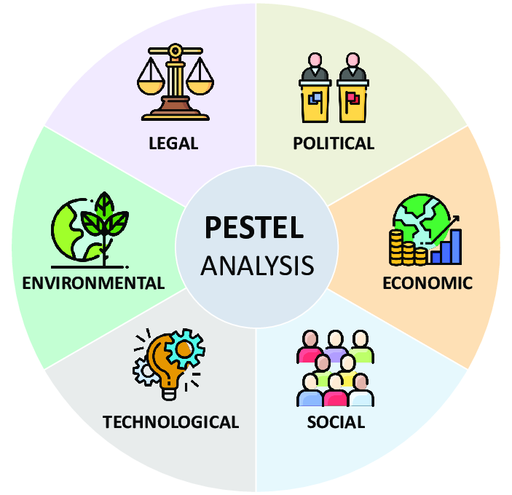
Figure: PESTEL analysis.
Source: (Nash, 2021).
Political: The political stability of the UK is going to be supportive of exhibition success. The changed government policies about travelling, immigration and others due to Brexit can impact gatherings, technology transfer, international travel, and participant numbers of the event (Murray, 2020).
Economic: Every business sector is influenced by the national economic condition. The intention to embrace technologies in operational areas depends on the financial condition of the technology and hospitality industries. The savings of participants and their intention to invest in technologies also will influence the adoption (Moussouri, 2022). The purchasing parity of potential customers in the hospitality sector will also influence the decision.
Sociocultural: The exhibition will certainly focus on the escalating social interest toward technological usage in hotels. The trend of sustainability and individualised experiences will attract wider audience to the exhibition. Nevertheless, the cultural differences of international participants about technology acceptance can create issues.
Technological: The rapid transformation of technology will influence this exhibition (Mayer, Davis and Schoorman, 2020). Exclusive areas such as IoT, AI, data analytics and others will be focused. A higher transitioning rate in the technology sectors can create challenges for the exhibited technologies to emerge.
Legal: ATPI Group needs to comply with health and safety regulations to ensure proper security for staff, arrangers, exhibitors, influencers, visitors and industry experts (Lindgren and Bandsholm, 2023). It also needs to consider the enforced global trade regulations to avoid legal issues. Besides, it needs to comply with the regulations of data protection while demonstrating technological usage in the hospitality sector.
Environmental: The exhibition needs to emphasize different measures such as energy efficiency, waste management, sustainable sourcing and others for reducing environmental impact and promoting sustainability (Godfrey, Merrill and Hansen, 2020). This can contribute to the credentials of the exhibition to the eco-conscious members.

Cultural and Situational Considerations
Cultural Diversity: The exhibition will attract diverse cultural people, so it will ponder cultural sensitivities like dietary restrictions, language barriers, social norms and others. This can rethink the caterer's choice and incorporate materials of marketing along with considering the event planning schedule (Engberg and Altmann, 2021).
Technology Acceptance: It is known to all that cultural differences regulate the adoption and acceptance of technology among people. The ability to understand cultural differences can assist the exhibition to tailor its representation. This can also influence the relevance of the core concept and engaging methods of participants.
Local Culture: The exhibition is supposed to be held in London so considering the local culture of the geographical areas with the experience of global participants is necessary (Eisenhardt and Martin, 2022). This can consider decoration, food choice and entertainment content.
Situational Factors: The situational consideration contains political stability, economic circumstances, public health and others. This can reshape the number of participants and intention to travel to the event (Borsenik, 2021). Here, the health and safety measures need to be ensured to deliver adequate comfort to the attendees.
Considering the cultural and situational factors is important for ensuring the success of the exhibition. This can regulate the satisfaction of the attendees and the reputation of the event. This can also impact the adoption and usage of advanced technologies in the hospitality sector. These can be conducive to enhancing the inclusivity and relevance of the exhibition (Barrows, Powers and Reynolds, 2022). This can help the organisers to create a valued and welcoming environment for the event. Ultimately, these will add to the success of the Hospitality Tech-Experience exhibition.

Reference list
Barrows, C.W., Powers, T.F. and Reynolds, D.E. (2022). Introduction to the Hospitality Industry. Hoboken, New Jersey: Wiley.
Borsenik, F.D. (2021). Hospitality Technology in the 21 St Century. Hospitality Research Journal, 17(1), pp.259–269.
Eisenhardt, K.M. and Martin, J.A. (2022). Dynamic capabilities: what are they? Strategic Management Journal, 21(10-11), pp.1105–1121.
Engberg, R. and Altmann, P. (2021). Regulation and Technology Innovation: A Comparison of Stated and Formal Regulatory Barriers throughout the Technology Innovation Process. Journal of technology management & innovation, 10(3), pp.85–91.
Godfrey, P.C., Merrill, C.B. and Hansen, J.M. (2020). The relationship between corporate social responsibility and shareholder value: an empirical test of the risk management hypothesis. Strategic Management Journal, 30(4), pp.425–445.
Lindgren, P. and Bandsholm, J. (2023). Business Model Innovation from an Business Model Ecosystem Perspective. Journal of Multi Business Model Innovation and Technology, 4(2), pp.51–70.
Mayer, R.C., Davis, J.H. and Schoorman, F.D. (2020). An integrative model of organizational trust. Academy of Management Review, 20(3), pp.709–734.
Moussouri, T. (2022). Knowledge management for collaborative exhibition development. Museum Management and Curatorship, 27(3), pp.253–272.
Murray, A.I. (2020). Top management group heterogeneity and firm performance. Strategic Management Journal, 10(S1), pp.125–141.
Nash, R.T. (2021). Event Classification. Operations Research, 17(1), pp.70–84.
Padron, T.C. and Stone, M.J. (2020). Leadership Skills in Event Management Courses. Event Management, 23(6).
Park, H.-Y. (2020). The Study on Improvements of Statistics in the MICE Industry: Focused on MICE Industry Statistics Survey. Journal of MICE & Tourism Research, 20(3), pp.253–268.
Pirani, S.I. and Arafat, H.A. (2022). Reduction of food waste generation in the hospitality industry. Journal of Cleaner Production, 132, pp.129–145.
Semenchuk, K. and Nechyt, D. (2021). Project Management According to Event Industry Trends. Development of Management and Entrepreneurship Methods on Transport (ONMU), pp.76–86.
Tiew, F., Holmes, K. and Bussy, N. de (2022). Investigating Stakeholder Salience across the Event Management Lifecycle. Event Management.

