ACBA 5000 - Modern and Traditional Construction. Managing the Design and Construction Process / Civil Engineering Technology

Prepared for:

Rhodri Thomas

Created by:

Joshua Hughes

Date Completed:

07/01/2024

Table of Contents Page Number

Introduction 3

Substructure 4

Site History 5

Suitable Foundation 9

Superstructure 10

Conclusion 12

Bibliography 13

The aim of this study is to analyse and considser all works associated with the UWTSD (University of Wales Trinity Saint David) ‘Innovation Matrix’ building. This study will:

- Analyse and outline the foundation requirements of the building, with consideration being given to the location of the buildings.

- Estimate the required excavation works for the construction of the foundation.

- Analyse and discuss all materials used to form the superstructure, taking in to account the durability, structural strength, fire safety, aesthetics, environmental impact and sustainability of the completed build.

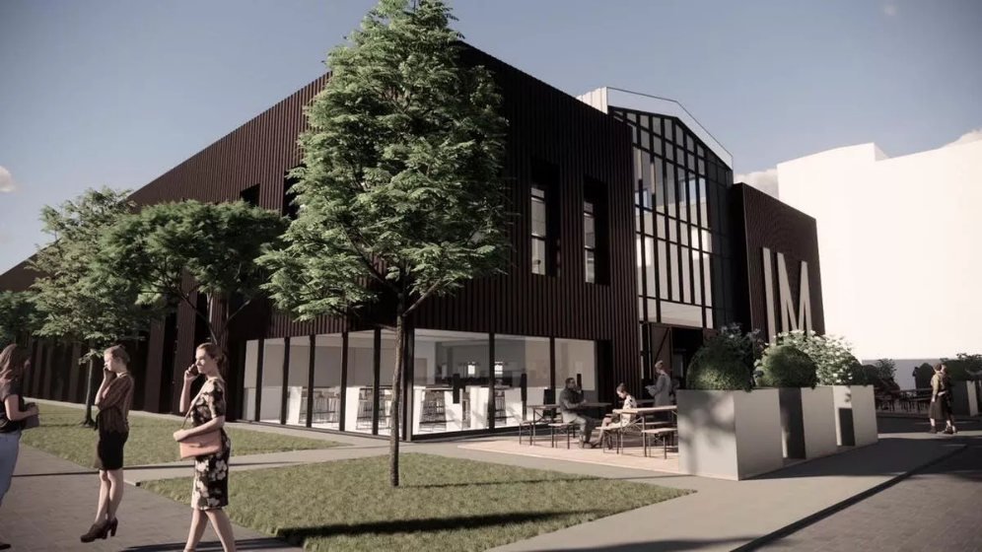
Figure 1 Shows an image of the planned Innovation Matrix, University of Wales Trinity Saint David (Richard Youle, 2022)

The Innovation Matrix began construction in June 2023. Located in SA1 Swansea, this is the next phase of development within the University's Waterfront Innovation Quarter which also comprises the IQ and Y Fforwm buildings.. It is a two-storey, steel framed building which provides a 2200 square meter (m2) office space. The plan for the Innovation Matrix is to assist with partnerships with UWTSD, providing a high quality work space for all involved.

The objective for Kier Construction was to produce an environmentally friendly building, that would be the most suitable for the climate in the SA1 area. Stride Treglown were the designated architects for this project and they provided assistance with the university’s ‘net-zero carbon agenda’ (Davies, R. 2023). The building has been designed to use natural sources of energy to assist with the heating and lighting within it.
The Innovation Matrix was designed to be significantly sustainable. UWTSD state that “The building will achieve an EPC rating of A, a BREEAM rating of Excellent and the landlord areas will be net zero carbon in operation” (UWTSD, 2023a). EPC’s (Energy Performance Certificates) provide an efficiency rating for buildings, with A being the most efficient and G being the least. The ratings produced will provide knowledge-based estimates of future costs associated with the heating and lighting of a building. The Innovation Matrix’s rating of A means that the building will be highly efficient with regards to these costs, and also contribute to environmental aims by lowering carbon emissions.
The BREEAM website discuss their ranking system and state that “A BREEAM assessment uses recognised measures of performance, which are set against established benchmarks, to evaluate a building’s specification, design, construction and use.” (BREEAM, ND). The Innovation Matrix has a rating between 70% and 85%, meaning that it is deemed highly efficient by the BREEAM scoring system.
The building is constructed with a steel frame, which is a highly durable and sustainable material. Structural steel is recyclable meaning it can be re-used should the building be no longer in use by the University in the future. Given the location and surrounding environment of this build, steel is the ideal material for the construction as it is regarded the most durable building material. Sustainability is also in focus with this building. To support sustainability aims the building will have high levels of insulation and incorporate natural ventilation and glazing that optimizes the sunlight to minimise the use of lighting will also be installed.

Substructure

To decide the most suitable foundation for a building, there are a number of essential factors that must be considered:
- The weight of the building
- The area of the proposed structure
- The history of the buildings location
- The existing ground conditions
- The costs of the work

Weight

The likely outcome of using steel frame for the building being is that it will be heavier than it would be if a timber frame was used. The use of steel is considered to be less sustainable than the use of timber, but steel is completely recyclable after its use making it a good option, from a sustainability perspective, when timber isn’t suitable for the build. Given the building is two storeys high, the load weight on the ground will be a lot lower than that of a taller building. The relatively heavy nature of the steel frame will increase the weight pressure on the soil beneath the building. If the ground conditions are soft, the use of a stronger foundation will be a necessity to support the steel framed structure.

Area

The floor area of a building is a large factor when deciding the correct foundation for it. Calculations for the weight distribution can be made when the surface area of the floor is known. The smaller the surface area, the higher the weight pressure would be per square metre (m2). If the weight distribution is higher, spread across a greater surface area, there will be less pressure on the soil beneath.

Site History

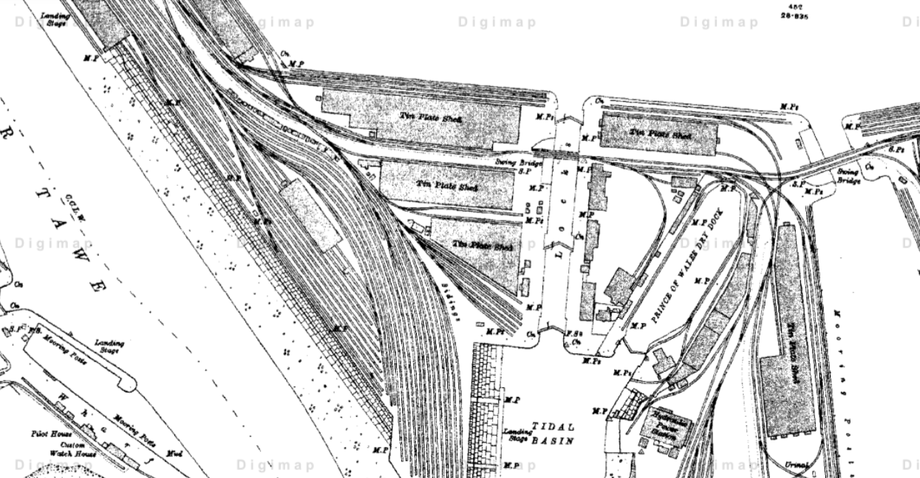
Figure 2 a historical map of the SA1 area in the year 1910 with the location of the university buildings highlighted. (Digimap, 2024)
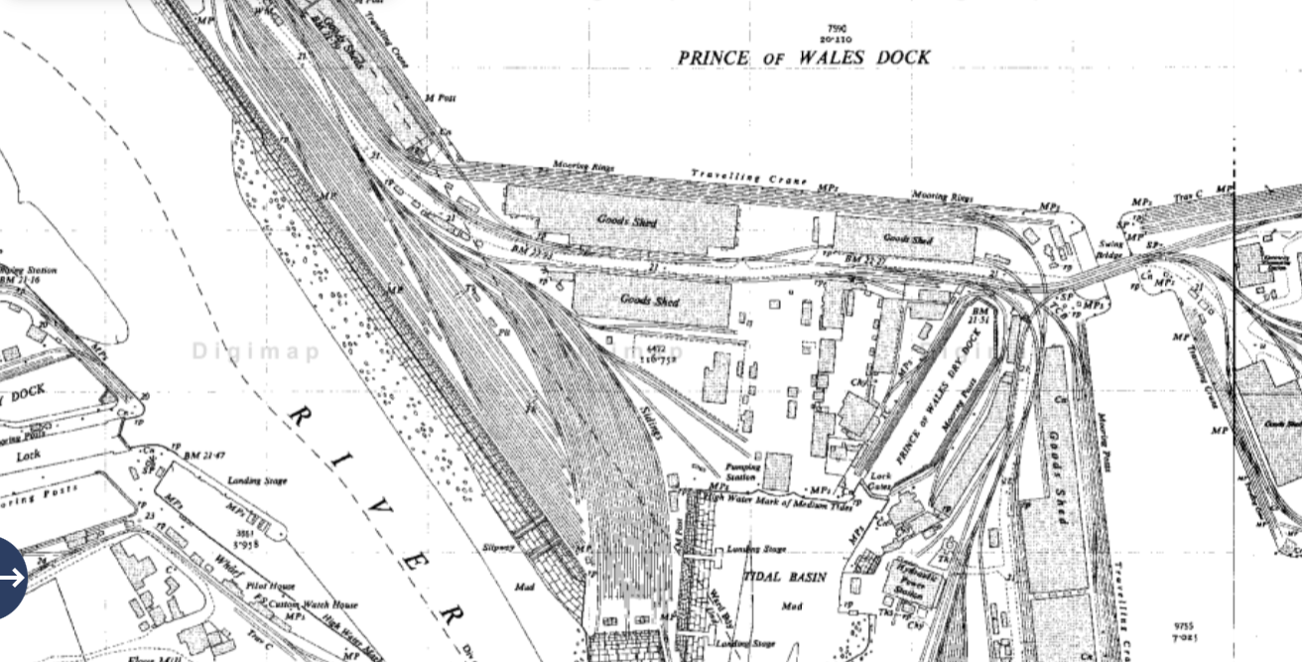
Figure 3 a historic map of the SA1 area in the year 1950 with location of university buildings highlighted. (Digimap, 2024)
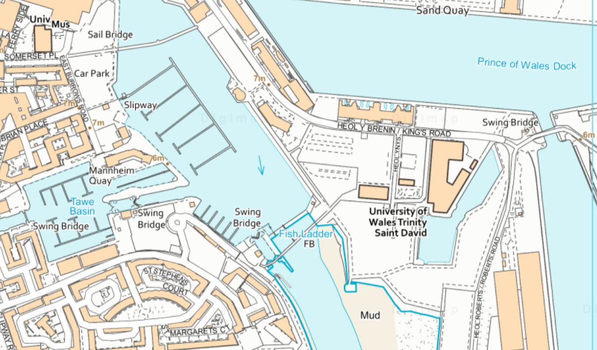
Figure 4 An ordnance Survey of the site (Digimap, 2024)

The historic maps obtained from Digimap show that the site was previously used for railway systems and docklands. The use of railway systems in this area means that the ground conditions are likely to be strong, but there is a possibility that whatever the rails were carrying could have contaminated the area. The ground should be investigated thoroughly before any decision is made on the correct foundation. If the ground is contaminated due to the pollution from the railway systems, further considerations and caution will be required when deciding on the correct foundation to be used. The site being used as a docklands presents further issues, as the soil in this environment is much less stable than other locations.

Existing Ground Conditions

The soil conditions have a significant role when deciding which foundation type is most suitable. The most efficient way to work out the nature of the soil is to use boreholes. The use of boreholes is vital in construction as they provide the necessary knowledge to make accurate and meaningful decisions on the designs of buildings. A borehole examines the build up of the soil beneath the ground, providing accurate readings on the load bearing capacity that the soil can withstand. If the Innovation Matrix was constructed without considering the information deduced from the boreholes, on low load bearing soil, it would likely collapse.

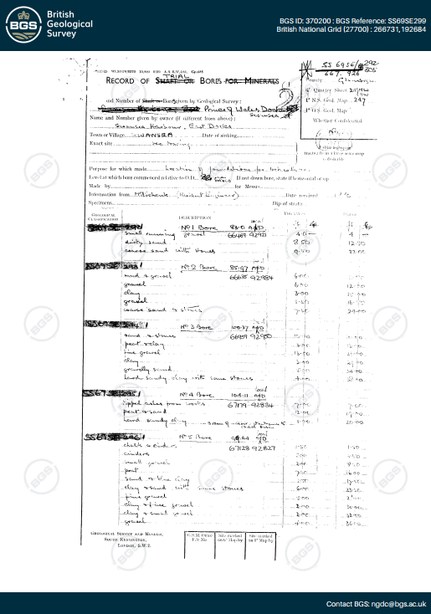
Figure 5 shows a borehole log from 1880 that was completed next to the location of the Innovation Matrix. (British Geological Survey, 1880)

Figure 5 shows that the soil is mainly made up of sand and gravel, which are generally soft soils. This will be a major factor when considering the type of foundation on this build as the ground is likely to have a low load bearing capacity. The example borehole (above) was taken very close to the location of the Innovation Matrix, It is likely that the soil build up will be the same in the location of this build.

Costs

Whilst cost is a mitigation factor, the cost of the foundation is not the highest priority, against the safety and sustainability of the building, which are the main factors to be considered when in construction. However, the sustainability of the building will provide a saving over time, as lighting and heating costs will be reduced.

Suitable Foundation

Considering the buildings’ usage when complete, and the weight of the steel frame structure, the most suitable foundation would be a pile foundation. A pile foundation is used when the building is heavy and is on a low load bearing soil. A driven pile foundation would be the most suitable for this location, as the piles are driven into the soil directly and take place of the existing. Designing Buildings (2022) discuss the use of driven piles, mentioning their ability to also “densify loose soil”. This is beneficial as the piles will also strengthen the soil that is surrounding them.
This method of piling is also more sustainable than many other forms, as there is the ability to remove the pile if there are any inaccuracies. If using bored piles and there is an error, it is unlikely that the issue is resolvable.
The piles are produced off site and can be made from concrete or steel, resulting in a lessened impact on the local environment of the site. Figure 6 is a diagram showing the use of the driven piles, displaying the pile being driven in to existing soil, making the soil more dense.
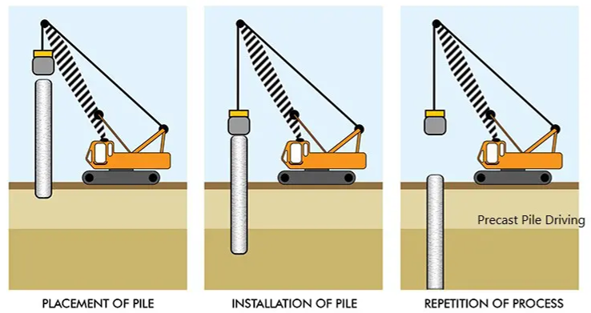
Figure 6 a diagram of driven pile installation (SkyCiv, 2022)

Superstructure

A steel frame was chosen for the Innovation Matrix throughout, due to the structural stability and the sustainability of the material. Steel is a reliable material to use for a buildings frame evidenced by its use on many larger buildings. The building will also have metal cladding that will assist with the buildings ability to withstand difficult climate conditions without failing. The roof will be made and finished with “highly efficient monocrystalline photovoltaic panels” (UWTSD, 2023b) These panels are highly sustainable.

Design

The use of a steel frame is beneficial regarding the design. Steel is popular due to its ease of assembly. Medium (2022) discuss the flexibility of steel, stating that it can be “manufactured as needed”. This is advantageous as it allows the designer to produce almost any design that they would like. Using steel also supports faster construction times as the materials will only require to be connected when on site.

Structural Strength & Stability

Steel is an extremely strong material and is very predictable when in place. Steel will be used for the beams and the columns in The Innovation Matrix structure. Steel has a very high tensile strength, so is able to maintain heavy loads without breaking or cracking. Steel frames are lighter and stronger than load bearing wood or concrete structures, and considering all the mitigating factors will be the most beneficial for this building. The additional strength provided by steel could potentially result in using thinner joists between each floor than if another material, such as timber, was used. A steel frame is important for a building in the SA1 area, as there are strong winds due to its close proximity to the sea. The Innovation Matrix is a tall structure, so the use of a steel frame will allow the maximum strength to withstand the natural climate.

Sustainability & Environmental Impact

Although steel is not a renewable material, it can be recycled and re-used on multiple occasions. It is more commonly recycled than other materials such as aluminium and plastic. The steel will be manufactured off site and will be ready for any easy installation upon its arrival. This manufacturing of the steel off site minimises the environmental impact locally. An important factor in the decision to use a steel frame is the capacity for reuse on other projects if the sizing is correct, reducing potential waste. The Innovation Matrix has a metal cladding finish, to assist the insulation of the building. Buildings-uk (2022) discuss the use of insulated metal panels, mentioning their assistance in reducing energy consumption and carbon footprint. The University are determined to reduce their carbon footprint, so using this material is a strong step in the right direction. The buildings use of monocrystalline photovoltaic panels also assists with the attempts of reducing the carbon footprint of the university. These solar panels provide completely natural sources of energy, capturing the sunlight and converting it to electricity.

Fire Safety

The risk of fire is greatly reduced in Steel framed buildings given the materials high resistance to fire. Before the steel is installed on site, they will be covered in a powder coating, increasing the fire resistance even further. Where a material like timber, will catch fire, steel has a very high melting point and the building would need to reach extreme temperatures to cause any structural issues. Charles E, Whitley (2019) discusses the effects of fire on structural steel, mentioning its ability to “regain close to 100 percent of its pre‐heated properties if the temperature does not exceed 720°C (1330°F)”. This provides further evidence that steel is more reliable than a timber frame.

Aesthetic

The most important consideration for the Innovation Matrix was the sustainability of the project, but the building has been designed to still look like a work of art. The large windows used to provide natural lighting to the building, provides a clean and modern look. The use of metal cladding is beneficial, Cladspray Solutions (2020) discuss this, highlighting its weather resistance and ease of cleaning in comparison to other cladding materials.

Costs

Although costs are not the primary focus point on a construction project, when trying to achieve sustainability, cost effective materials will be used on this constriction and some of the sustainability driven construction features will produce future savings. The use of metal cladding on the building provides long term savings in comparison to materials like concrete or a masonry finish. Tritec Building Solutions (2018) discuss the advantages of the use of metal cladding in comparison to other materials, further describing the durability and low maintenance that it requires. The buildings use of natural lighting also provides a further future saving, as there will be less of a requirement for artificial lighting.
Conclusion

The Innovation Matrix will meet the goal of becoming a sustainable building with a low carbon footprint. The design and aesthetics of the building will mean that the construction costs are quite high. However, with the sustainable methods of saving and producing energy, the running costs of the building will be low. The construction of the building will have a low impact on the local environment. The materials used will provide sustainable methods of producing energy that will further reduce the environmental impact. The metal cladding and solar panels that will be installed on the roof will bring the most benefit in terms of sustainability and reducing carbon footprint. The solar panels will allow the building to generate its own power from natural resources and the cladding will help maintain the core temperature in the building. The natural lighting provided by the large windows will is also essential in sustainability of the building. The Innovation Matrix is a great demonstration of how the construction industry is transforming to produce buildings that are better for the environment.

Bibliography

Buildings-uk (2022). Are steel framed buildings eco friendly? [Online] Available at: https://buildings-uk.com/are-steel-framed-buildings-eco-friendly/ [Accessed on 05/01/2024]
British Geological Survey (1880). Page 1 / Borehole Reference - SS69SE299 – Borehole Logs [Online] Available at: https://api.bgs.ac.uk/sobi-scans/v1/borehole/scans/items/370200 [Accessed on 03/01/2024]
Cladspray Solutions (2020). Pros and Cons of Metal Cladding [Online] Available at: https://www.cladspraysolutions.co.uk/2020/01/29/pros-and-cons-of-metal-cladding/ [Accessed on 05/01/2024]
Davies, R (2023). Work starts on UWTSD’s Innovation Matrix in Swansea - a new centre for digital innovation and enterprise [Online] Available at: https://www.uwtsd.ac.uk/news/press-releases/press-2023/work-starts-on-uwtsds-innovation-matrix-in-swansea----a-new-centre-for-digital-innovation-and-enterprise.html [Accessed on 02/01/2024]
Designing Buildings (2022). Pile Foundations [Online}. Available at: https://www.designingbuildings.co.uk/wiki/Pile_foundations [Accessed on 04/01/2024]
Digimap (2024). Historic Digimap [Online] Available at: https://digimap.edina.ac.uk/roam/map/historic [Accessed on 03/01/2024]
Digimap (2024). OS Digimap [Online] Available at: https://digimap.edina.ac.uk/roam/map/os [Accessed on 03/01/2024]
Medium (2022). Advantages And Disadvantages of Steel Frame Construction [Online] Available at: https://medium.com/@xstructural22/advantages-and-disadvantages-of-steel-frame-construction-76ba840457f5 [Accessed on 05/01/2024]
SkyCiv (2022). Concrete Piles: An Overview [Online] Available at: https://skyciv.com/docs/skyciv-foundation/piles/an-overview-of-concrete-piles/ [Accessed on 04/01/2024]
Tritec Building Solutions (2018). 8 Advantages of Metal Cladding over Concrete or Masonry Cladding [Online] Available at: https://tritecbuildingcontractors.co.uk/blog/8-advantages-of-metal-cladding-over-concrete-or-masonry-cladding/ [Accessed on 06/01/2023]
UWTSD (2023a). Page 21 / Innovation Matrix Partnership Guide. [Online} Available at: https://www.uwtsd.ac.uk/media/uwtsd-website/content-assets/documents/campuses/UWTSD-Innovation-matrix-brochure.pdf [Accessed on 02/01/2024]
UWTSD (2023b). Page 21 / Innovation Matrix Partnership Guide [Online[ Available at: https://www.uwtsd.ac.uk/media/uwtsd-website/content-assets/documents/campuses/UWTSD-Innovation-matrix-brochure.pdf [Accessed on 05/01/2024]
Whitley, C (2019). Fire Effects on Steel [Online] Available at: https://www.edtengineers.com/blog-post/fire-effects-steel [Accessed on 05/01/2024]
Youle, R (2022). State-of-the-art digital technology building to open at waterfront campus. [Online] Available at: https://www.walesonline.co.uk/news/wales-news/swansea-jobs-tech-economy-city-23923731 [Accessed on 02/01/2024]

