

Title: Exploring Factors Contributing to Postpartum Depression and Intervention Strategies in Women in the United Kingdom

Name: Sharon McDermott

Supervisor’s name: Dr Jolly Nwankwo

Dissertation submitted as part of the requirements for the award BSc (Hons) Health and Social Care

May 2026

DECLARATION

This work has not previously been accepted in substance for any degree and is not being concurrently submitted in candidature for any degree.

Signed…SharonMcDermott...

Date…30/ 03/2026…

STATEMENT 1
This dissertation is being submitted in partial fulfilment of the requirements for the degree of BSc.

Signed…SharonMcDermott...

Date…30/ 03/2026…

STATEMENT 2
This dissertation is the result of my own independent work/investigation, except where otherwise stated.

Other sources are acknowledged by footnotes giving explicit references. A bibliography is appended.

Signed…SharonMcDermott...

Date…30/ 03/ 2026…

ACKNOWLEDGEMENTS

I would like to express my heartfelt gratitude to my sister, Nichola, for her unwavering love, support, and constant encouragement throughout this journey. Her belief in me has been a source of strength, and her motivation has reminded me never to give up.

To my children, Malachi, Benjamin, and Ezra, thank you for reminding me that nothing is impossible when you work hard with determination. Your presence has been my inspiration.
I am also deeply grateful to my niece for her kind words and encouragement, which helped carry me through my academic studies. My sincere thanks go to my wonderful grandparents for their prayers and words of wisdom, which have guided me along the way. I would also like to say big than you to best friend Jasmin I am incredibly grateful for her motivation and inspired me to attend university.

I would like to extend my appreciation to all my lecturers for their guidance and support. A special thank you to Bianca, Laila, my disability officer Carol, and my supervisor Jolly for their invaluable assistance.
Finally, I would like to thank the university for giving me the opportunity to pursue and achieve my academic goals.

ABSTRACT

Background: Postpartum depression (PPD) is a significant public health concern in the United Kingdom, affecting a substantial proportion of women and carrying long-term consequences for maternal wellbeing and child development. Despite increased awareness, many cases remain undiagnosed or inadequately supported.
Aim: This study aimed to explore the main factors contributing to postpartum depression among women in the UK and to explore intervention strategies used to support maternal mental health.
Methods: A systematic literature review was conducted using secondary research methods. Ten peer-reviewed UK-based studies published between 2015 and 2025 were identified through searches of academic databases, including PubMed, ProQuest, Google Scholar, and the UWTSD Library database. Data were analysed using thematic analysis.
Findings: Four key themes were identified: young maternal age as a significant vulnerability factor; the strong influence of previous mental illness; the role of social context and structural inequality; and the potential value of community-based and group-oriented support strategies. The findings indicate that postpartum depression is shaped by various risk factors and often persists beyond the first postpartum year. Community- and peer-led interventions were found to be acceptable and beneficial for reducing isolation and improving emotional wellbeing among mothers.
Conclusion: The study says that postpartum depression is a long-term condition that is influenced by social factors, not just a short-term adjustment problem. Drawing on theoretical perspectives, this research highlights the need for integrated, multi-level intervention approaches that address individual, relational, and structural determinants of maternal mental health in the UK.

Table of Contents
DECLARATION ii
ACKNOWLEDGEMENTS iii
ABSTRACT iv
Table of Contents v
CHAPTER 1: INTRODUCTION 1
Definition of the main concepts of the study 1
Rationale: 2
Aim: 2
Objectives: 2
Structure of the dissertation 3
CHAPTER 2: BACKGROUND 4
Historical background 4
Theoretical background 5
Biopsychosocial perspective on postpartum depression 5
Bronfenbrenner’s Ecological Systems Theory 6
International context 9
National and local UK context 10
CHAPTER 3: METHODS 12
Research Design 12
Data Collection 12
Keywords 13
PRISMA flowchart 14
Sampling Strategy 14
Inclusion and Exclusion Criteria 15
Data Analysis 15
Ethical Considerations 16
CHAPTER 4: RESULTS AND DISCUSSION 17
RESULTS 17
DISCUSSION 30
CHAPTER 5: RECOMMENDATIONS AND CONCLUSION 35
RECOMMENDATIONS 35
CONCLUSION 36
REFERENCES 38

CHAPTER 1: INTRODUCTION

This chapter introduced the topic of postpartum depression (PPD) and explained why it is an important public health issue in the United Kingdom. It defined the key concepts related to postpartum depression and highlighted how the condition differs from other postnatal emotional experiences, such as the baby blues. In addition, the chapter presented the rationale for the research, aim and objectives of the study and described the overall structure of the dissertation.

This research aims to explore the factors that contribute to postpartum depression (PPD) among women in the UK. PPD is a significant public health issue in the UK, affecting more than one in five new mothers, with an estimated annual cost to the NHS of around £1.8 billion. PPD takes various forms and is often overlooked or left undiagnosed for long periods. When undiagnosed, PPD can lead to adverse health outcomes for both mother and child, including long-term health problems and a negative effect on the child's development (Pisavadia et al. 2025).

Definition of the main concepts of the study

Postpartum depression is a type of mood disorder that can affect new mothers, characterised by persistent sadness, fatigue, difficulty bonding with the baby, and intense anxiety (Cho and Jeong, 2021). Unlike the common ‘baby blues,’ postpartum depression is more serious, lasts longer, and disrupts daily life. Effective management usually involves a combination of therapy, medication, and emotional support from loved ones (NHS, 2025). Many new mothers experience the ‘baby blues’ shortly after childbirth, characterised by mood swings, frequent crying, restlessness, and difficulty sleeping. These symptoms usually appear within a few days of childbirth and typically resolve within two weeks. However, some women develop a more persistent and severe form of depression known as postpartum depression. This condition, sometimes called peripartum depression, can start during pregnancy and carry on into the postpartum period. In rare cases, an even more severe mental health condition, postpartum psychosis, may occur after childbirth (National Institutes of Health, 2023).

Although awareness and understanding of the condition have significantly improved, many individuals still experience it privately and without support. It is generally accepted that the actual prevalence of postpartum depression is higher than reported data suggest (Keepanasseril et al., 2023). Factors such as social stigma, fear of judgment, and limited awareness often discourage individuals from disclosing their symptoms. When these experiences go unreported, they are excluded from public health data, leading to an underestimation of the condition’s true scope (Rawal, 2025). However, extensive research has provided valuable evidence that emphasises postpartum depression as a significant and urgent global health issue (Langdon, 2025). This study focuses on women in their reproductive years, which, according to the World Health Organisation (2025), range from 15 to 49 years of age.

Rationale:
Postpartum depression is a serious mental health issue that impacts many women, but its causes and effective treatments are still complex and not fully understood (Khamidullina et al., 2025; Norazman and Lee, 2024). In the United Kingdom, in 2024, over 57,000 women experienced PPD, although many cases remain undiagnosed or unsupported due to stigma, limited awareness, and barriers within healthcare systems (NHS, 2024). Maternal postpartum depression (PPD) and other perinatal mental health conditions impose a substantial economic burden on society. In the UK, the total societal cost is estimated at approximately £8.1 billion for each annual birth cohort, with around 72–75% of this cost attributed to the long-term impact on children, in addition to significant healthcare expenditures incurred by the NHS for treatment and support (Pisavadia et al., 2025). This research aims to examine the key factors contributing to PPD and to evaluate existing intervention strategies to inform more effective, inclusive, and evidence-based approaches to supporting maternal mental health.

Aim:
To explore the main factors contributing to postpartum depression (PPD) among women in the United Kingdom and evaluate the effectiveness of existing intervention strategies to support maternal mental health.

Objectives:

- To discuss the experiences of postpartum depression among women living in the United Kingdom.
- To analyse key factors linked to the development of postpartum depression in women in the UK.
- To evaluate the effectiveness of current intervention and support programmes.
- To propose evidence-informed recommendations for enhancing intervention strategies and public health awareness about postpartum depression.

Structure of the dissertation

Chapter 1 introduces the topic, including the definition of the main concepts, the study’s rationale, and its aims objectives.
Chapter 2 offers an overview of the historical and theoretical background of PPD, including the services available in the UK, and discusses PPD within the UK context.
Chapter 3 explains the methodology and methods used in the research. This includes approaches to secondary studies, systematic reviews, data analysis, and ethical considerations.
Chapter 4 presents the table of findings summarising the characteristics of the studies selected for the systematic review, with the results organised into themes, alongside a discussion of the key findings.
Chapter 5 concludes and offers recommendations for healthcare policy and practice.

Summary
This chapter has introduced postpartum depression (PPD) as an important public health issue in the United Kingdom, outlining its prevalence, impact, and key characteristics. It clarified how PPD differs from other postnatal conditions and highlighted the challenges of underreporting due to stigma and limited awareness. The chapter also explained why this research is needed, particularly given the effects of PPD on both mothers and children and the wider impact on healthcare systems. The aim and objectives of the study were clearly defined to guide the research. Overall, this chapter provides the foundation for the dissertation, which will further explore the topic through literature review, methodology, findings, and recommendations.

CHAPTER 2: BACKGROUND

This chapter explores the historical development of postpartum depression and how it has evolved over time. It reviews key theoretical perspectives used to explain PPD, including biomedical, psychological, and social approaches. Particular attention is given to the biopsychosocial model and Bronfenbrenner’s ecological systems theory. This chapter also considers the broader international context of PPD and explores the national policy and healthcare framework within the United Kingdom. This includes an overview of current NHS strategies, service provision, and policy initiatives aimed at improving perinatal mental health support.

Historical background

Postpartum mental health issues have been recognised for centuries, although the official recognition and medicalisation of postpartum depression (PPD) are relatively recent developments (Fusar‐Poli et al., 2025). Historical accounts from the 19th and early 20th centuries often describe maternal distress through moral, religious, or behavioural explanations rather than as a clinical mental health condition (Krohn and Matone, 2017). For instance, mental distress, such as depression, was described as a hysterical condition. Early psychiatric research mainly focused on severe mental health issues like postpartum psychosis, while milder PPD was often overlooked. Overall, historically, mental distress was only defined through a medical model. Depression was considered a personal issue due to abnormalities in the brain. By the 1970s and 1980s, feminist scholars began challenging the medical model of women’s emotional responses to childbirth, arguing that structural factors such as gender inequality, domestic expectations, and lack of social support significantly shaped maternal wellbeing (Kumar, 1994). The formal medical recognition of postpartum depression is recent. It was only in 1994 that the Diagnostic and Statistical Manual of Mental Disorders (DSM-IV) introduced a ‘postpartum onset’ specific for major depressive episodes (Godderis, 2013). Since the early 2000s, increased public awareness, advocacy, and improvements in perinatal mental health services have helped normalise discussion of PPD and promote early screening and intervention (Rysavy, 2013).

Over the past twenty years, advances in perinatal psychiatry, combined with increasing public health interest, have led to the formal recognition of PPD as a distinct condition within diagnostic frameworks. Screening tools such as the Edinburgh Postnatal Depression Scale (EPDS) accelerated clinical recognition, and research increasingly emphasised the biopsychosocial nature of PPD, acknowledging the roles of hormonal, psychological, and socio-environmental factors. Contemporary developments position PPD as a major public health concern, highlighting both its prevalence and its long-term consequences for mothers, infants, and families (Walsh, 2024).

Theoretical background

A range of theoretical perspectives contribute to understanding PPD. Biomedical models emphasise neurobiological mechanisms, including hormonal fluctuations after childbirth, genetic predispositions, and changes to neurotransmitter systems (Schiller et al., 2015).
These models account for the physiological changes in the woman’s body that can trigger depressive symptoms but do not fully explain variations in prevalence across demographics, socioeconomic or cultural groups. Psychological theories, particularly cognitive-behavioural and attachment frameworks, focus on how stress and early relational experiences influence maternal mood. Social theories focus on structural determinants such as social support, socioeconomic inequality, intimate partner relationships, and exposure to trauma or domestic abuse (Guintivano et al., 2018).
Ecological models integrate these perspectives by examining how individual, relational, community, and societal factors interact. More recent intersectional approaches argue that PPD cannot be understood without considering inequalities linked to race, migration status, poverty, and gendered expectations of motherhood. Together, these frameworks support a multidimensional understanding of PPD and justify the need for holistic intervention strategies.

Biopsychosocial perspective on postpartum depression

Postpartum depression is widely understood through a biopsychosocial model (Figure 1), which recognises that the condition arises from an interaction of biological, psychological, and social influences rather than from a single cause (Schiller et al., 2015). From a biological perspective, rapid hormonal changes after childbirth, including fluctuations in oestrogen and progesterone, can increase vulnerability to mood instability. Research shows that women with high sensitivity to these hormonal shifts, or with underlying neurobiological or genetic predispositions, are more likely to develop PPD (Guintivano et al., 2018).

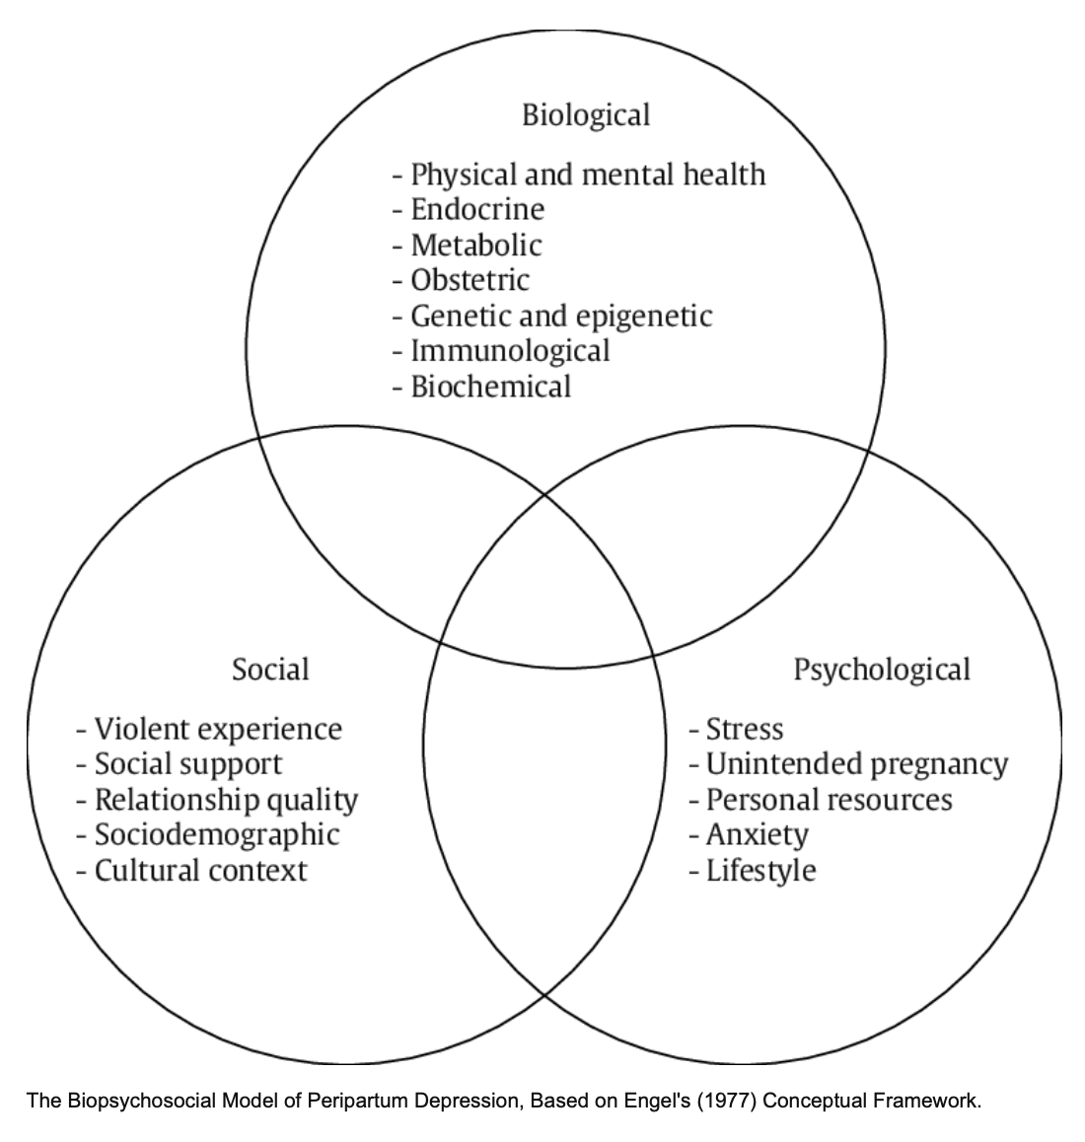
Figure1: Biopsychosocial model
Psychological factors also play a significant role. Women with a history of depression or anxiety, low self-esteem, or limited coping resources are at elevated risk. At the same time, stressful life events and unresolved trauma may further increase emotional responses in the postpartum period. Cognitive patterns such as feelings of inadequacy have been repeatedly associated with PPD (Yim et al., 2015). These factors illustrate how individual psychological vulnerability interacts with the physiological demands of childbirth.

The social dimension highlights the importance of relationships, environment, and structural conditions. Low levels of social support, strained partner relationships, domestic abuse, financial hardship, and cultural expectations of motherhood all significantly contribute to PPD risk (Norazman and Lee, 2024). Migrant and minority ethnic women may also face additional challenges, including social isolation, language barriers, and reduced access to healthcare, which can intensify distress (Fellmeth et al., 2017).
Taken together, the biopsychosocial model provides a comprehensive framework for understanding PPD by emphasising how biological susceptibility, psychological processes, and social environments interact. This perspective supports the need for holistic approaches to prevention and treatment rather than a sole focus on individual symptoms or isolated risk factors (Engel, 1977).

Bronfenbrenner’s Ecological Systems Theory

While biomedical and psychological models offer useful insights into the causes of postpartum depression (PPD), they are not enough on their own. It should also be considered how individual factors interact with social, economic, and policy influences. Bronfenbrenner’s ecological systems theory is a helpful way to understand this complexity (Bronfenbrenner, 1994) (Figure 2). Bronfenbrenner proposed that human development and wellbeing are shaped by dynamic interactions across multiple, nested systems. Applied to postpartum mental health, this model highlights that PPD is not solely the result of biological or psychological processes, but rather develops from the interaction of individual, relational, community, and structural influences (Place et al., 2024).

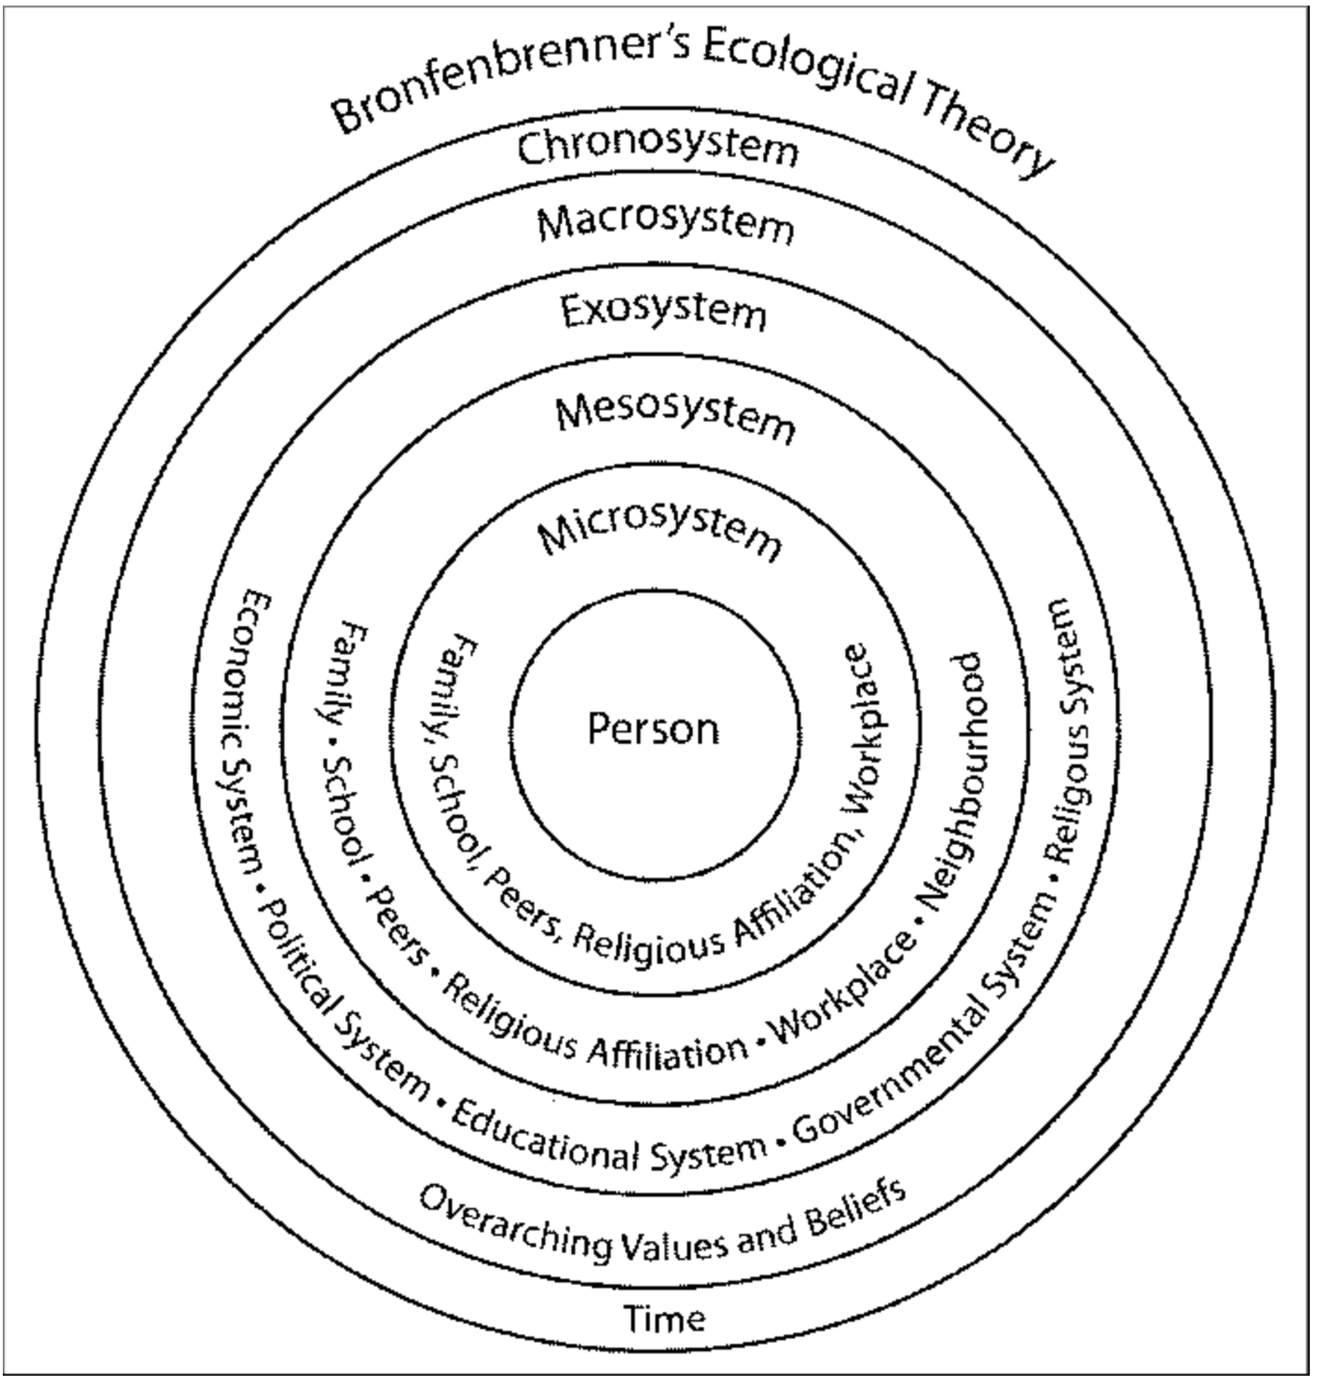
Figure 2: Bronfenbrenner’s Ecological Systems Theory

At the microsystem level, PPD is shaped by immediate environments and relationships, including the mother–infant relationship, partner support, family dynamics, and daily caregiving demand. Evidence from UK cohort studies demonstrates that low partner support and strained interpersonal relationships are strongly associated with higher postnatal depressive symptoms (Taylor et al., 2022). This aligns with ecological theory, which emphasises that sustained emotional and practical support within close relationships can buffer stress and promote psychological resilience.
The mesosystem refers to interactions between microsystems, such as the relationship between family life and healthcare services. In the context of PPD, this includes how effectively maternity services, health visitors, primary care, and community organisations communicate and coordinate care. Breakdowns at this level, such as poor continuity between antenatal and postnatal services, can exacerbate distress and delay recognition and treatment. Community-based interventions, including peer-support and group programmes, operate within this mesosystem by strengthening connections between mothers and supportive services (Cust, 2016; Naysmith et al., 2015).

The ecosystem encompasses settings that indirectly influence maternal wellbeing, including employment conditions, welfare systems, housing stability, and service availability. UK evidence consistently shows that socioeconomic deprivation, financial stress, and insecure employment increase vulnerability to PPD (Petersen et al., 2018; Best et al., 2024). Although women may not directly control these factors, they shape stress exposure and access to support, reinforcing inequalities in mental health outcomes.

Finally, the macrosystem includes wider cultural values, social norms, and policy frameworks. In the UK, dominant cultural expectations of motherhood, emphasising resilience, self-sacrifice, and intensive parenting, may discourage disclosure of distress and reinforce stigma. Policy decisions regarding funding for perinatal mental health services, eligibility thresholds, and service duration further shape women’s experiences. For example, the routine limitation of specialist perinatal mental health support to the first 12 months postpartum contrasts with emerging evidence of sustained need into the second year after birth (Jones et al., 2025).

Taken together, Bronfenbrenner’s ecological model provides a theoretically coherent framework for understanding PPD as a socially embedded condition. It supports the argument that effective intervention must operate across multiple levels, addressing individual symptoms while also strengthening relational support, improving service integration, and tackling structural inequalities. This framework underpins the thematic findings of this review and justifies the emphasis on community-based and group-oriented strategies as complementary to clinical care rather than as substitutes for it.

International context

Internationally, PPD is recognised as a significant global health issue affecting mothers across diverse regions. The World Health Organisation estimates that depressive symptoms during pregnancy or after childbirth affect between 10 and 20 per cent of women worldwide, with higher rates reported in low- and middle-income countries due to limited access to healthcare, socioeconomic disadvantage, and cultural stigma (WHO, 2019). Global research highlights common risk factors, including inadequate social support, a history of mental health conditions, intimate partner violence, and stressful life events. Countries, however, differ in how PPD is screened, diagnosed, and treated. For example, Scandinavian countries routinely implement universal perinatal mental health screening and integrate psychological support within primary maternity services (Castaner et al., 2022). In contrast, many regions of Asia, Africa, and Latin America rely heavily on extended family networks rather than professional services, which can exacerbate distress, depending on cultural norms. Growing cross-national evidence also points to the need for culturally adaptable interventions, especially for migrant or marginalised women (Ekpenyong and Munshitha, 2023). International literature, therefore, provides valuable comparative insights, demonstrating both the widespread nature of PPD and the importance of context-specific support systems.

National and local UK context

Within the United Kingdom, PPD is a major public health priority, with recent NHS data showing record numbers of women seeking perinatal mental health support, although many cases remain undiagnosed due to stigma and social barriers. Figure 1 shows a map of PPD condition prevalence across England (OHID, 2025).

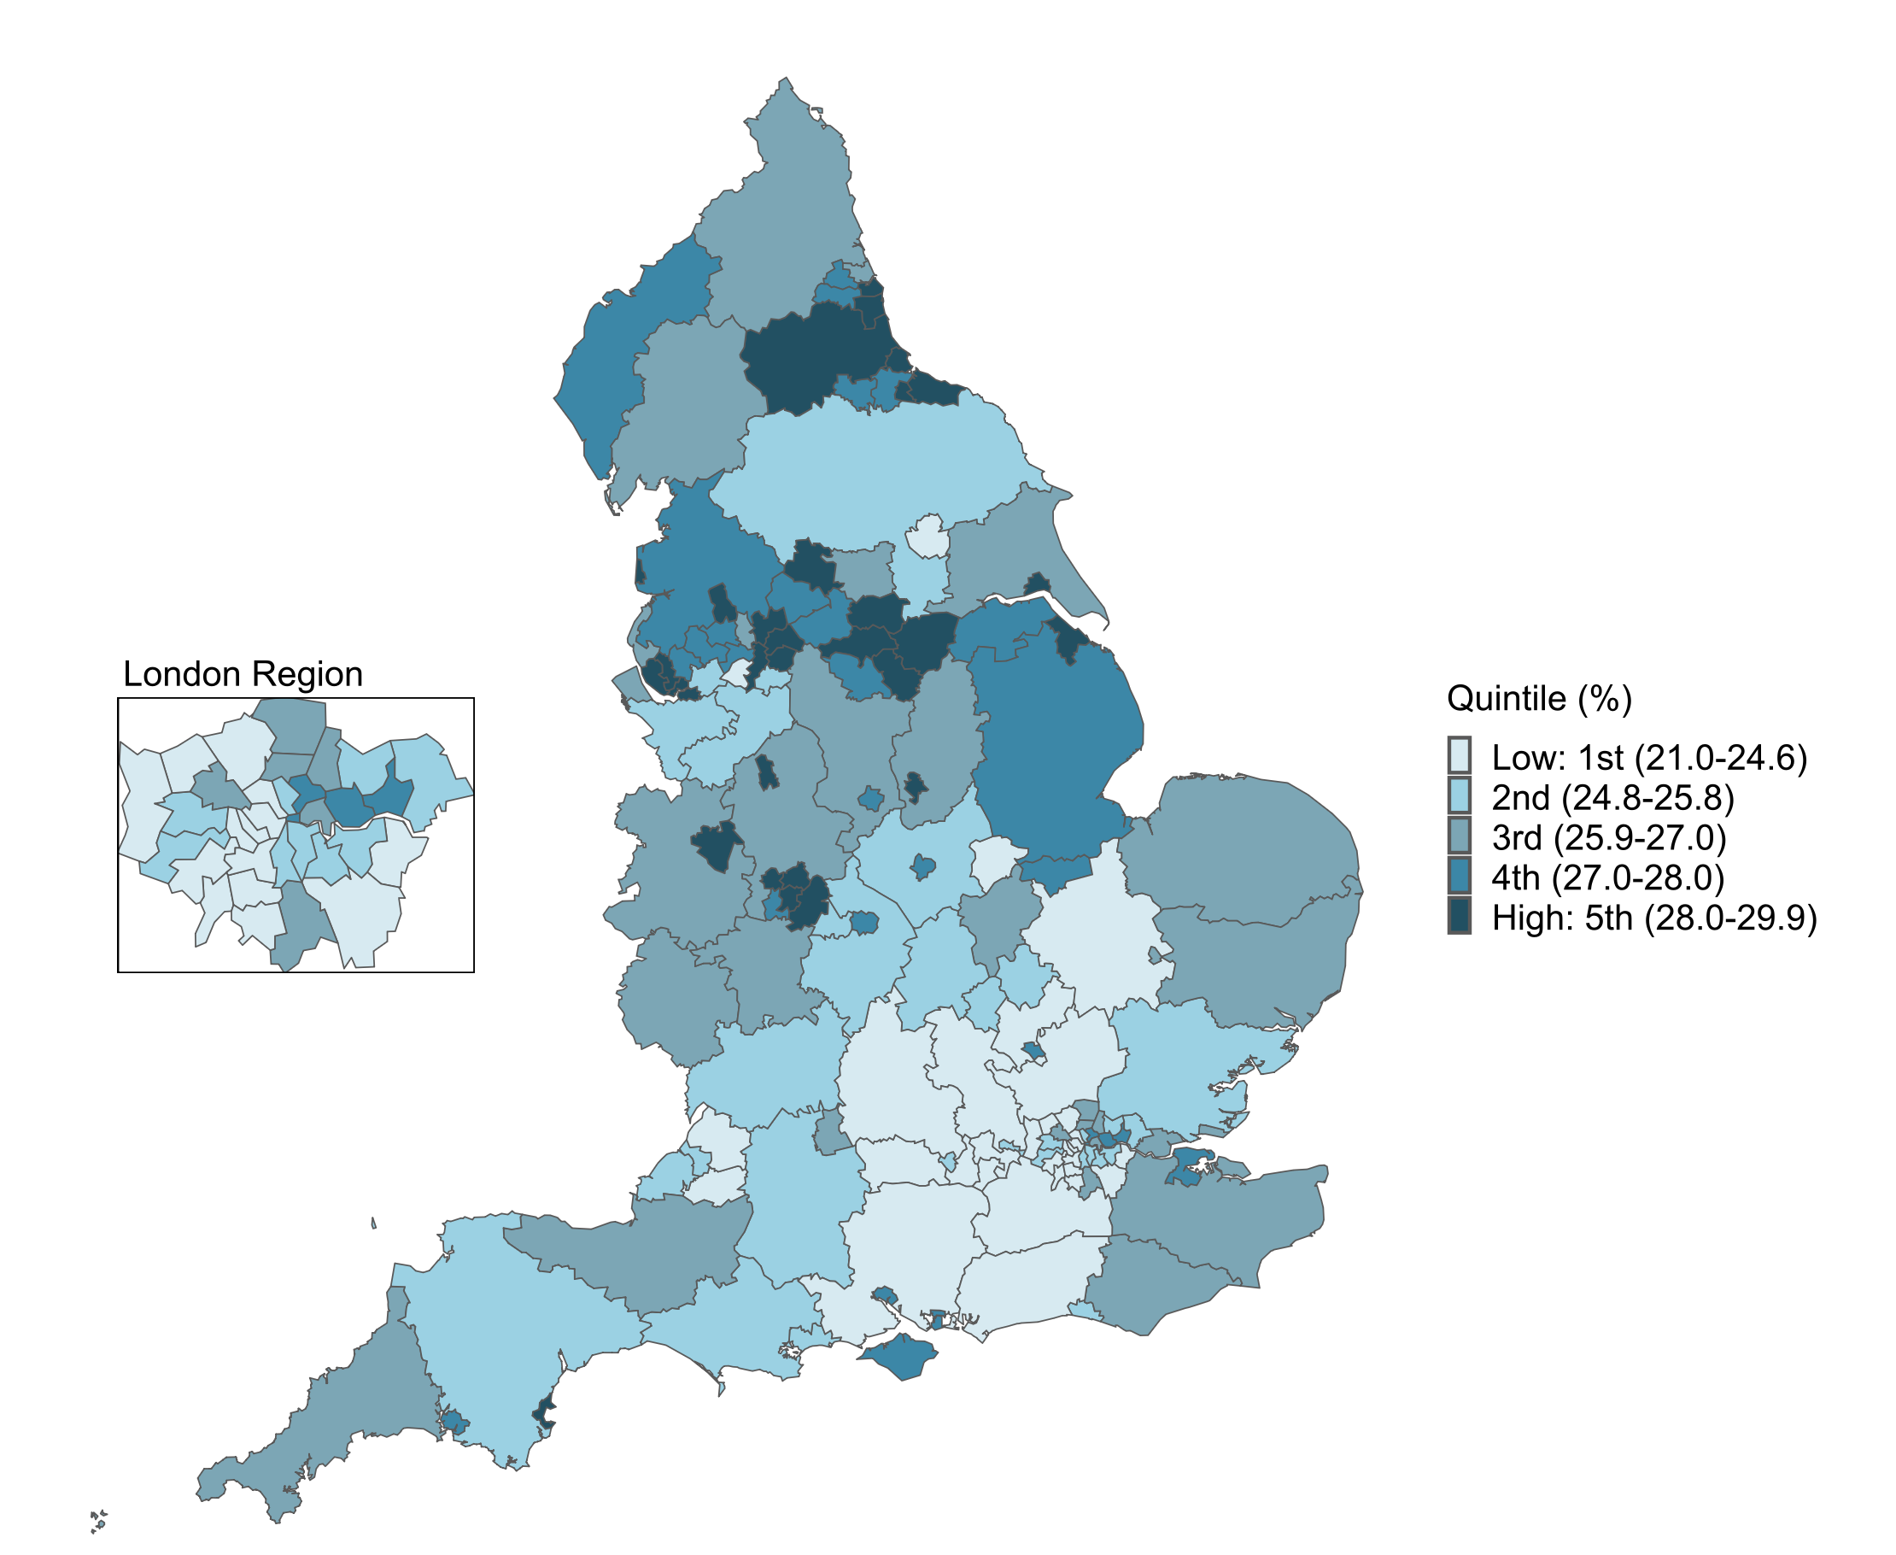
Figure 1: Prevalence of PPD in England (Office of Health Improvement and Disparities - OHID, 2025)

UK policy frameworks, including the 10 Year Health Plan for England (Department
of Health and Social Care, 2025), emphasise early identification, integrated maternity care, and expansion of perinatal mental health teams across all regions. The UK context is characterised by relatively strong clinical infrastructure, including specialist midwives, health visitors, and dedicated mother-and-baby units; however, access remains uneven, particularly for minority ethnic groups, migrant women, and those facing socioeconomic disadvantage. Local services often vary in capacity and responsiveness due to staffing shortages, regional funding constraints, and differences in community resources (PHE, 2020). The UK also faces rising reports of domestic abuse, financial stress, and social isolation, all of which correlate strongly with PPD risk. National guidelines encourage routine screening and referral pathways, yet implementation can be inconsistent at the local level (Felker et al., 2025). In the UK, perinatal mental health services aim to prevent, detect, and manage mental health conditions during pregnancy and the first year after birth, with support delivered through specialist services, health visitors, and primary care professionals. Women are expected to be asked about their emotional wellbeing during routine antenatal and postnatal appointments to help identify mental health concerns early and enable appropriate referrals for support (Kulakiewicz et al., 2021). The NHS Fit for the Future Plan (Gov.UK, 2025) further commits to expanding access to specialist perinatal mental health services so that an additional 24,000 women annually can receive evidence-based care, while also extending support for mothers from preconception to up to 24 months after birth. These policy developments demonstrate growing acknowledgment of maternal mental health as a national priority, although challenges persist in achieving consistent implementation and equitable access to services across various regions of the UK.

Summary
This chapter has provided a comprehensive background to postpartum depression (PPD) by examining its historical development, theoretical foundations, and policy context. It demonstrated that understanding of PPD has evolved from early moral and biomedical explanations to a more holistic recognition of the condition as a complex mental health issue influenced by biological, psychological, and social factors. The chapter highlighted the importance of the biopsychosocial model and Bronfenbrenner’s ecological systems theory in explaining how individual experiences of PPD are shaped by wider relational, social, and structural contexts. It also situated PPD within both international and UK-specific frameworks, showing that while it is a global concern, responses vary depending on healthcare systems and cultural contexts. Within the UK, although policy initiatives and NHS services have strengthened support for perinatal mental health, challenges such as unequal access, stigma, and service variability remain. Overall, this chapter establishes a strong theoretical and contextual foundation for the study, supporting the need for multidimensional and context-sensitive approaches to understanding and addressing postpartum depression.

CHAPTER 3: METHODS

This chapter explains the research methods used in the study. A systematic literature review was conducted using secondary research to explore factors contributing to postpartum depression (PPD) and the effectiveness of intervention strategies in the UK. Relevant studies were identified through academic databases using specific keywords, and the selection process followed the PRISMA framework. Ten peer-reviewed studies were included and analysed using thematic analysis to identify key patterns and themes. Ethical principles were maintained by using credible sources and properly referencing all materials.

Research Design

This study adopts a secondary research design using a systematic literature review to explore the factors contributing to postpartum depression (PPD) and the effectiveness of intervention strategies among women in the United Kingdom. Secondary research is appropriate when the aim is to synthesise and critically evaluate existing research evidence rather than to produce new primary data (Mathew, 2022).

A systematic review approach enables a transparent process for identifying, evaluating, and synthesising relevant research (Halcomb and Fernandez, 2015). Systematic reviews are widely used in health and social care research because they support evidence-based practice by drawing together findings from multiple studies and identifying patterns, key findings, and implications for policy and practice (MacEntee, 2019). Although systematic reviews provide strong evidence synthesis, this study is limited by its reliance only on secondary published research, which may exclude data from primary studies. Additionally, restricting the review to English-language UK studies may limit the breadth of perspectives (Pope, 2020).

Data Collection
A comprehensive literature search was conducted to identify ten peer-reviewed primary research studies examining postpartum depression within UK-based populations. Searches were undertaken using the following academic databases:
- PubMed
- ProQuest
- Google Scholar
- UWTSD Library database

These databases were chosen for their relevance to health, psychology, nursing, and social care research, as well as for their comprehensive inclusion of high-quality peer-reviewed journals.

Keywords
A combination of Boolean operators and keywords was used to maximise search sensitivity and specificity.

The primary search terms included:
‘Postpartum depression’
‘Maternal mental health’
‘UK women’
‘Risk factors’
‘interventions’

Search strings combined these terms using operators such as AND and OR, for example:
‘Postpartum depression’ AND ‘UK women’ AND ‘interventions.

(postpartum depression factors UK women) OR (postpartum depression interventions United Kingdom) OR (postnatal depression causes and treatments UK) OR (postpartum depression) OR (maternal mental health UK) OR ((postpartum depression) AND (intervention strategies) AND (UK women) OR (postpartum depression AND United Kingdom AND (factors) OR (causes) OR (determinants) OR (postnatal depression) OR (postpartum mood disorders AND intervention strategies AND women AND UK) OR ((maternal mental health) AND (risk factors) AND (postpartum period) AND (United Kingdom)) OR (postpartum depression AND (psychosocial) OR (biological) OR (environmental) factors AND treatment approaches) OR (perinatal depression AND prevention) OR (management AND women AND UK) OR (Exploring Factors Contributing to Postpartum Depression and Intervention Strategies in Women in the United Kingdom).

PRISMA flowchart
The search process followed the PRISMA (Preferred Reporting Items for Systematic Reviews and Meta-Analyses) framework to ensure transparency and methodological rigour (Page et al., 2021). A PRISMA flowchart will be included to illustrate the stages of study identification, screening, eligibility assessment, and final inclusion (PRISMA, 2020).

Identification of studies via databases and registers

Records removed before screening:
Duplicate records removed
(n = 10)
Records marked as ineligible full text not available (n =150)
Records removed - older sources (n = 150)
Records identified from*:
Databases (n = 3)
Registers (n = 346)

Identification

Records screened
(n = 36)
Records excluded as not fully align with the research aim and objectives (n = 10)

Reports sought for retrieval
(n = 26)
Reports not retrieved:
full text not available (n = 3)

Screening

Reports assessed for eligibility
(n = 23)
Reports excluded:
Reason 1: not matching with study’s objectives (n = 5)
Reason 2: not based on women in the UK (n = 5)
Reason 3: secondary research (n = 3)

Studies included in review
(n = 10)

Included

Sampling Strategy
A final sample of ten peer-reviewed journal articles was selected. These studies employed primary research methods. A purposive sampling strategy was employed to select studies that were most relevant to the research aim and objectives. From the initial search results, titles and abstracts were screened to assess relevance. Full-text articles were then reviewed against the inclusion and exclusion criteria.

Inclusion and Exclusion Criteria
Clear inclusion and exclusion criteria were applied to ensure consistency and relevance.
Inclusion criteria:
- Peer-reviewed studies published between 2015 and 2025
- Focus on women living in the United Kingdom.
- Participants within the fertile age range of 15–47 years
- Based on primary research (e.g. interviews, surveys, cohort studies)
- Address factors contributing to postpartum depression and/or intervention strategies
- Published in English
- Available in full text
Exclusion criteria:
- Published before 2015
- Conducted outside the UK
- Not focused on women in the specified age range
- Based on secondary research
- Did not address PPD risk factors or interventions
- Not published in English or not available in full text

Applying these criteria strengthened the validity of the review by ensuring that only current, contextually relevant, and methodologically robust studies were included.

Data Analysis

Data from the selected studies were analysed using thematic analysis, following the six-phase framework developed by Braun and Clarke (2017). Thematic analysis was chosen because it is a flexible and systematic method for identifying, analysing, and reporting patterns across qualitative and quantitative findings.

The six stages included:
Familiarisation with the data through repeated reading
Initial coding of relevant findings
Searching for recurring themes
Reviewing and refining themes
Defining and naming themes
Writing the themes.

This process enabled the identification of key themes related to biological, psychological, and social risk factors for PPD, as well as themes relating to intervention effectiveness, access to services, and barriers to support. Thematic analysis is widely recognised as a reliable method in health research for synthesising complex evidence across diverse study designs (Clarke and Braun, 2017).

Ethical Considerations

As this study is based solely on secondary data, it did not require ethical approval from an ethics committee. However, ethical principles were still upheld throughout the research process. All sources were accurately cited and referenced in accordance with Harvard Cite Them Right guidelines to avoid plagiarism and ensure academic integrity.
Care was taken to interpret findings responsibly, avoiding misrepresentation of participants or overgeneralisation of results. Using peer-reviewed sources further ensured that the original studies had already met appropriate ethical standards, including informed consent and participant confidentiality (BHBIA, 2020).

Summary
This chapter outlined the methodological approach used to investigate postpartum depression (PPD) in the United Kingdom. A systematic literature review was adopted as the research design, enabling the study to synthesise existing evidence on the factors contributing to PPD and the effectiveness of intervention strategies. Relevant studies were identified through a structured search of academic databases using defined keywords and Boolean operators, with the selection process guided by the PRISMA framework to ensure transparency and rigour. A purposive sampling strategy was applied, resulting in the inclusion of ten peer-reviewed primary research studies that met clearly defined inclusion and exclusion criteria. Data from these studies were analysed using Braun and Clarke’s thematic analysis, allowing for the identification of key patterns related to biological, psychological, and social factors, as well as intervention outcomes and barriers to support. Although the study is limited by its reliance on secondary data and English-language UK-based research, it maintains methodological strength through a systematic and transparent approach. Ethical considerations were upheld throughout, with all sources accurately referenced and findings interpreted responsibly, ensuring academic integrity and credibility.

CHAPTER 4: RESULTS AND DISCUSSION

This chapter presents the findings from the systematic literature review and discusses the key patterns identified across the selected studies. The results are based on ten peer-reviewed articles examining postpartum depression (PPD) among women in the United Kingdom. The chapter first summarises the characteristics and key findings of the included studies in a table. Following this, the results are organised into four main themes that emerged from the thematic analysis. These themes relate to young maternal age, previous history of mental illness, social context and structural inequalities, and community-based support strategies. The chapter then discusses these findings and their implications for policy and practice.

RESULTS

The table below summarises the main characteristics and findings of the ten studies included in this systematic literature review. It provides an overview of each study’s author and year of publication, research aim, methodology and methods, and key findings related to postpartum depression among women in the United Kingdom. The table is designed to facilitate comparisons across studies and to highlight similarities and differences in study design, sample characteristics, and key findings.

Author/s year of publication | Aim | Methodology and methods | Summary and key findings
- Petersen et al. (2018) | The study aimed to investigate how depression and depressive symptoms are recognised and treated in the first year after childbirth in UK clinical practice, with particular attention to:  The prevalence of postnatal depression and depressive symptoms  The timing of diagnosis and recording in primary care  Associations with age, social deprivation, and prior history of depression. | Retrospective population-based cohort study  Data source: UK primary care electronic health records from The Health Improvement Network.  database  Study period: 2000–2013  Women were followed for 12 months post-delivery  Measures:  Read codes for depression, postnatal depression, and depressive symptoms  Prescriptions for antidepressants  Referrals for counselling, psychotherapy.  Associations with age, deprivation, calendar period, and prior mental health history was analysed.  Sample size: 206,517 women  Inclusion criteria:  Women who had a birth  Permanently registered with the same GP practice  At least one year of follow-up post-delivery. | Risk factors:  -Younger women (under 30) had significantly higher rates of depression and treatment  -Social deprivation showed a clear gradient, with women in the most deprived areas at greatest risk  -A prior history of depression strongly increased the likelihood of postnatal depression and early treatment
- Swift et al. (2020) | The study aimed to examine whether the effect of childbirth on the onset of mental illness varies by maternal age, by comparing the risk of incident mental illness during postpartum periods with non-postpartum periods in women with no prior history of mental illness in UK primary care.  The authors hypothesised that younger women would be the most vulnerable to postpartum mental illness | Retrospective matched cohort study  Data source: UK Clinical Practice Research Datalink (primary care database  Selection:  Postpartum period (up to 12 months following a live birth)  Sample Size:  355,864 women  Age range: 15–44 years. | The effect of childbirth on mental illness was strongly age-dependent:  Ages 15–19:  Over 5 times higher risk of any mental illness postpartum  7 times higher risk of depression following childbirth  The magnitude of risk decreased steadily with age, with the lowest relative risk seen in women aged 35–44.  Disorder-specific findings  Depression:  Most common postpartum mental illness - highest risk in adolescents  Anxiety:  Increased risk in women aged 15–29  No increased risk (and slight reduction) in women aged 35–44  Key conclusion  Younger women, particularly adolescents, are disproportionately vulnerable to the mental health effects of childbirth, especially depression and anxiety.
- Taylor et al. (2022) | The study aimed to examine the longitudinal relationship between social support during pregnancy and postnatal depression, and to assess whether this relationship is moderated by maternal age or relationship status, within a diverse inner-city maternity population in England. | Prospective longitudinal cohort study  Setting: Inner-city NHS maternity service in England  Data collection points:  Early pregnancy (10–12 weeks gestation)  Follow-up at 3 months postnatally.  Sample size: 525 women  Mean age: 32.9 years  Ethnically and socioeconomically diverse inner-city cohort. | Primary association:  Lower social support in pregnancy was significantly associated with higher postnatal depressive symptoms  Stronger association between low antenatal social support and postnatal depression among women not living with a partner  Overall conclusion:  Low social support during pregnancy is an independent risk factor for postnatal depression, and interventions aimed at strengthening social networks in pregnancy may help reduce postnatal depressive symptoms, particularly for women without partner support.
- Best et al. (2024) | The study aimed to examine the prevalence, risk factors for perinatal anxiety, with a specific focus on how socioeconomic deprivation operates at both neighbourhood and regional levels across three regions of England. | Observational prospective cohort study  Study period: November 2020 – November 2021  Total cohort: 2,243 women  Regional breakdown:  Region 1 (North East England & North Cumbria): 512  Region 2 (London North Thames): 665  Region 3 (West Midlands): 705  Age range: 16–50 years  Follow-up: From early pregnancy to postnatal period | Perinatal anxiety is shaped by a complex interaction between social context, deprivation, ethnicity, and health, rather than deprivation alone  Screening and support should consider relative disadvantage and contextual vulnerability, not just regional deprivation levels.
- Jones et al. (2025) | The study aimed to describe the prevalence and incidence of moderate and severe mental illness in the second postpartum year in England, and to estimate the proportion of women who could benefit from extending specialist perinatal mental health (PMH) services from 12 to 24 months postpartum. | Study design: National retrospective cohort study  Data source: UK Clinical Practice Primary Care Database  Study period: Births recorded between 1995 and 2020 (main analysis up to 2018 to allow 2-year follow-up)  Population identification: Pregnancy Register  Follow-up: Women followed for two years after birth.  Sample size: Total women: 1,361,497.  Nationally representative UK primary care population. | Overall prevalence of mental illness in the second postpartum year: 5.9%.  Most common: Depression and anxiety.  Risk factors  -Younger maternal age, particularly adolescents  -Preterm, near-term, or post-term birth  -History of mental illness (strongest predictor)  -Mental illness during pregnancy or first postpartum year  -Smoking and substance use disorders  -Greater socioeconomic deprivation (IMD)  -Being recorded as White ethnicity (likely reflecting under-detection in minority groups)  -Policy implication  Mental illness frequently persists beyond the first postpartum year, and many cases first emerge in the second year  Findings provide strong empirical justification for extending specialist PMH services to two years postpartum.
- Husain et al. (2025) | The study aimed to assess the feasibility, acceptability, and preliminary effectiveness of a culturally adapted group cognitive-behavioural intervention (Positive Health Programme, PHP) for postnatal depression among British South Asian (BSA) women. | Randomised controlled trial  Setting: Community and primary care services in Manchester and Lancashire, England  Participants: British South Asian women (Indian, Pakistani, Bangladeshi) with postnatal depression and a baby aged <12 months  Intervention:  Positive Health Programme (PHP):  Culturally adapted group CBT  12 weekly sessions over 3 months  -Delivered by bilingual female facilitators in participants’ preferred language.  Sample size: 83 women  Age range: ≥16 years living in North West England. | Women who attended four or more therapy sessions showed significant reductions in depression severity compared with TAU  -Greater symptom reduction associated with higher session attendance  -Recruitment and retention rates demonstrated strong engagement with a population often described as ‘hard to reach’  Feedback indicated the intervention was acceptable and culturally appropriate.
- Cust (2016) | The study aimed to explore whether one-to-one peer support from mothers who had previously experienced and recovered from postpartum depression (PPD) could reduce depressive symptoms in new mothers identified as being at elevated risk of PPD | Exploratory mixed-methods pilot study  Intervention:  One-to-one peer support delivered by Peer Support Workers (PSWs)  Weekly home visits lasting approximately one hour  Six-week intervention starting around 6 weeks postnatally.  Peer Support Workers: 8  All had previously experienced mild–moderate PPD and had recovered  Mothers recruited: 30 first-time mothers  Intervention group: 15  Control group: 15  Participant characteristics:  Aged 25–35  English as first language  No previous mental health history. | One-to-one peer support appeared to reduce the severity and persistence of postnatal depressive symptoms  The intervention was acceptable, meaningful, and psychologically beneficial for participants.
- Barlow (2021) | The study aimed to evaluate the feasibility, acceptability, and preliminary clinical and cost effectiveness of a structured telephone-based peer-support intervention for women experiencing postnatal depression. | Pilot and exploratory randomised controlled trial.  Setting: Primary care and community services in Coventry and Warwickshire, England  Participants: Women identified with postnatal depressive symptoms at or after the 8-week postnatal check  Intervention:  Mums4Mums telephone peer-support  Delivered by trained peer supporters with lived experience of PPD  Support provided over 4 months  Comparator:  Routine GP and health visitor care.  Sample Size  Total participants: 30 women  Eligibility:  Aged ≥16 years with mild and moderate depression | -Recruitment via health visitors and self-referral was achievable.  -Training and deployment of peer supporters was acceptable and sustainable.  -Acceptability:  Telephone-based peer support was viewed positively by mothers and professionals  -Flexibility and anonymity of telephone delivery reduced barriers to engagement  -Early evidence suggested potential reductions in depressive symptoms.  -Economic potential:  Telephone peer-support showed promise as a low-cost, scalable intervention, suitable for further economic evaluation.
- Naysmith et al. (2015) | The study aimed to describe the development, implementation, and preliminary outcomes of a therapeutic group programme for women with postnatal depression (PPD) delivered within community health visiting services, and to evaluate whether group-based psychological support could reduce depressive symptoms and improve maternal wellbeing | Study design: Practice-based service evaluation using a pre–post intervention design  Setting: Community health visiting services in Oxfordshire, England  Intervention:  A 10-week therapeutic group programme  Weekly sessions lasting approximately 2 hours  Groups of up to 8 women  Co-facilitated by health visitors trained in perinatal mental health.  Sample Size  Women referred: 44  Age range: Mean age approximately 45 years reported for facilitators; participant ages not precisely specified  Inclusion criteria:  Mothers with postnatal depression identified via health visiting services  Exclusions:  Severe depression requiring specialist psychiatric care. | Therapeutic group programmes delivered by health visitors can reduce depressive symptoms and improve maternal wellbeing  The model is feasible and acceptable within routine community services.  -Participants rated overall satisfaction with the group very highly (average 9/10)  Women valued:  -Sharing experiences with other mothers  -Feeling understood and less isolated  -Learning practical coping strategies.
10. Davis and Kola-Palmer (2025) | The study aimed to evaluate whether a socially prescribed (SP) creative play programme for new parents was associated with changes in postnatal depression, reflective functioning, and birth-related trauma, and to explore parents’ experiences of social connection generated through the programme. | Study design: Pilot mixed-methods pre–post evaluation  Setting: Family theatre organisation delivering a socially prescribed creative play programme in Northern England  Intervention:  5-week socially prescribed creative play programme  Weekly sessions including guided singing, curated creative play, and group reflection  Delivered by professional arts practitioners and hosts  Child-led, non-judgemental, community-based format  Participants: Parents/carers of children aged 0–3 years, referred via health professionals or self-referral.  Sample Size  Total participants: 57 parents - Age range: 17–42 years. | Socially prescribed creative play appears to function as good intervention, offering meaningful reductions in postnatal depressive symptoms with emotional wellbeing improved.

Based on the analysis of the ten articles, four main themes were identified, as shown in the table below.

Theme 1 | Young Maternal Age as a Key Vulnerability Factor
Theme 2 | Previous History of Mental Illness
Theme 3 | Social Context, Support Available, Deprivation, and Structural Inequality
Theme 4 | Community-Based and Group-Oriented Support Strategies

Theme 1: Young Maternal Age as a Key Vulnerability Factor

Across the literature, young maternal age consistently emerges as a significant risk factor for postnatal and perinatal mental health difficulties. Large-scale UK primary care studies provide particularly robust evidence. Petersen et al. (2018) showed that women under 30 were significantly more likely to be diagnosed with postnatal depression and to receive treatment within the first postnatal year, highlighting age-related disparities in both risk and service engagement. This pattern is reinforced by Swift et al. (2020), whose analysis of the same age cohort showed a strong age effect on postpartum mental illness, with adolescents aged 15–19 experiencing over five times the risk of any mental illness and seven times the risk of depression following childbirth. Importantly, this elevated risk declined steadily with increasing age, suggesting that younger mothers face unique and complex psychosocial, developmental, and structural stressors. Jones et al. (2025) extend this evidence beyond the first postnatal year, showing that younger maternal age, particularly adolescence, remains a predictor of moderate to severe mental illness into the second year after birth. Collectively, these findings position young motherhood as a sustained period of vulnerability rather than a short-term adjustment issue, underscoring the need for age-sensitive prevention and extended postnatal support.

Theme 2: Previous History of Mental Illness
A second dominant theme is the strong predictive role of prior mental illness in shaping postnatal mental health outcomes. Petersen et al. (2018) identified previous depression as one of the strongest predictors of postnatal depression and earlier treatment initiation, suggesting a continuity of vulnerability across the reproductive life course. This continuity is further substantiated by Jones et al. (2025), who found that a history of mental illness was the most powerful predictor of moderate to severe mental illness in the second postpartum year, surpassing obstetric and demographic factors. Notably, over half of second-year cases represented new-onset illness, yet these were disproportionately concentrated among women with earlier antenatal or first-year postpartum symptoms. Best et al. (2024) similarly showed that prior mental health difficulties significantly increased the likelihood of perinatal anxiety, interacting with social and contextual factors rather than operating in isolation. Together, these show that pre-existing vulnerabilities may be reactivated or intensified during the perinatal period.

Theme 3: Social Context, Support Available, Deprivation, and Structural Inequality

Beyond individual risk factors, the literature consistently highlights the role of social context and structural inequality in shaping postnatal mental health outcomes. Taylor et al. (2022) demonstrated that low antenatal social support was independently associated with higher postnatal depressive symptoms, with particularly strong effects among women not living with a partner. This finding aligns with Best et al. (2024), who showed that perinatal anxiety cannot be explained by deprivation alone but rather by relative deprivation within regional and neighbourhood contexts, interacting with ethnicity, physical health, and social support. Large-scale population evidence from Petersen et al. (2018) and Jones et al. (2025) further reveals clear socioeconomic gradients, with women living in the most deprived areas experiencing substantially higher risks of postnatal mental illness. Importantly, Jones et al. (2025) also observed higher recorded rates of mental illness among White women, which the authors suggest may reflect under-detection and barriers to care among minority ethnic groups rather than true prevalence differences. Collectively, these findings position postnatal mental health not simply as an individual clinical issue, but as one deeply embedded within social inequality, relational support structures, and differential access to recognition and care.

Theme 4: Community-Based and Group-Oriented Support Strategies

A final theme concerns the growing evidence base for community-based, peer-led, and group interventions as acceptable and potentially effective strategies for supporting postnatal mental health. Several studies demonstrate that non-clinical, relational forms of support can reduce depressive symptoms and enhance wellbeing. Cust (2016) found that one-to-one peer support from mothers with lived experience of postnatal depression reduced symptom severity and was experienced as meaningful and validating. Similarly, the Mums4Mums telephone peer-support intervention evaluated by Barlow (2021) was found to be feasible and acceptable, with early indications of symptom reduction and strong engagement facilitated by flexibility and anonymity. Group-based approaches show comparable promise: Naysmith et al. (2015) reported clinically meaningful reductions in depressive symptoms following a health visitor–led therapeutic group programme, alongside high satisfaction and reduced isolation. Husain et al. (2025) further demonstrate the importance of cultural adaptation, showing that British South Asian women who engaged consistently in a culturally tailored group CBT programme experienced significant symptom improvement. More recently, Davis and Kola-Palmer (2025) highlight the potential of socially prescribed creative play groups, which produced significant reductions in postnatal depressive symptoms while fostering social connection and emotional wellbeing. Taken together, these studies suggest that community- and group-based strategies can complement formal clinical care, particularly by addressing isolation, stigma, and barriers to engagement that often limit uptake of traditional services.

DISCUSSION

This review synthesises evidence from ten peer-reviewed articles to examine the risk factors for PPD and strategies to overcome it. Collectively, the findings suggest that PPD is caused by varied factors such as age, prior mental health illness, structural inequality, and the availability of support.

Young maternal age and sustained vulnerability
A consistent finding across the studies is the vulnerability of younger mothers to PPD. Evidence from UK primary care data indicates a clear age-related risk factor, with adolescents and women under 30 experiencing disproportionately higher risks of depression, anxiety, and broader mental illness following childbirth (Petersen et al., 2018; Swift et al., 2020; Jones et al., 2025). Importantly, PPD does not disappear after the first postpartum year, with younger maternal age continuing to predict moderate and severe mental illness into the second year after birth (Jones et al., 2025). These findings challenge the common idea that postnatal distress is just a short-term problem (Carlson et al., 2025). Instead, they suggest that younger mothers face ongoing structural and psychosocial challenges. Factors such as economic instability, disrupted education or work, limited or absent partner support, and limited informal care networks may explain this issue.

Continuity of mental illness across the perinatal period
The evidence also strongly supports the role of previous mental illness as a key determinant of PPD outcomes. Prior depression or anxiety consistently emerged as one of the strongest predictors of postnatal depression, early treatment initiation, and persistent or recurrent illness (Petersen et al., 2018; Best et al., 2024; Jones et al., 2025). Notably, although many women experience new-onset illness postnatally, these cases are disproportionately concentrated among those with earlier antenatal or first-year postnatal symptoms, suggesting cumulative rather than episodic risk. The persistence of symptoms into the second postpartum year further strengthens arguments for extending specialist perinatal mental health services beyond the first 12 months after birth (Hellyer et al., 2025).

Social context and inequalities
Beyond individual-level risk factors, the reviewed studies demonstrate that postnatal mental health is deeply embedded within social context and structural inequality. Socioeconomic deprivation showed a clear risk factor across multiple studies, with women living in more deprived areas experiencing higher risks of depression and anxiety (Petersen et al., 2018; Best et al., 2024; Jones et al., 2025). However, deprivation did not operate in isolation, and PPD is caused by multiple factors. Taylor et al. (2022) highlighted the protective role of antenatal social support, particularly for women living with a partner. These findings suggest that postnatal mental health is shaped by relational and contextual factors, including isolation, partner status, and perceived social position. Furthermore, the apparent lower prevalence of recorded mental illness among minority ethnic women recorded in medical databases likely reflects under-detection and barriers to help-seeking due to stigma and language barriers rather than true differences in need, pointing to ongoing inequities in recognition and access to care.

Community and group-based strategies as alternative forms of support
Evidence from intervention studies highlights the potential value of community-based, peer-led, and group-oriented support strategies. Peer support interventions, whether delivered face-to-face or by telephone, were consistently found to be acceptable, meaningful, and associated with reductions in depressive symptoms (Cust, 2016; Barlow, 2021). Group-based programmes facilitated by health visitors or culturally adapted for specific communities also demonstrated clinically meaningful improvements in wellbeing, alongside reduced isolation and high participant satisfaction (Naysmith et al., 2015; Husain et al., 2025). More recent socially prescribed creative play interventions further suggest that non-clinical, relational spaces can support emotional wellbeing and reduce postnatal depressive symptoms by fostering connection and reflective capacity (Davis & Kola-Palmer, 2025). Overall, these studies highlight the importance of social connection, shared experience, and accessibility in postnatal mental health support. These approaches may be particularly valuable for women who face barriers to engaging with formal mental health services (Carlson et al., 2025; Jones et al., 2025).

Implications for policy and practice
Taken together, these findings raise important questions about the adequacy of current postnatal mental health provision. The concentration of services in the first postnatal year appears inconsistent with evidence that healthcare services should be extended to support PPD beyond this period, particularly among younger mothers and those with prior mental illness. Moreover, dominant models that prioritise individual resilience and short-term interventions risk obscuring the structural and relational conditions that underpin postnatal distress. Expanding specialist perinatal mental health services to two years postpartum, as advocated by Jones et al. (2025), alongside greater investment in community-based and peer-led interventions, may offer a more equitable and responsive approach. However, such strategies might be difficult to implement in community services due to limited public funding (Naysmith et al., 2015; Husain et al., 2025).

Strengths of the Research
This research has several important strengths. First, it uses a systematic literature review, which brings together findings from multiple high-quality studies. This approach strengthens the reliability of the results because conclusions are based on a wide range of evidence rather than on a single study. Second, focusing on UK-based research is a key strength. This ensures that the findings are relevant to the UK healthcare system, including NHS services, health visitors, and perinatal mental health teams. As a result, the conclusions and recommendations are more applicable to current UK policy and practice. Another strength is the inclusion of different types of studies, such as cohort studies, longitudinal research, randomised controlled trials, and qualitative studies. This provides a broader understanding of postpartum depression by capturing both statistical trends and women’s experiences of support. The use of thematic analysis is also a strength, as it offers a clear and structured way to identify common patterns across studies. This method made it possible to group findings into meaningful themes that directly address the research aims. In addition, the research is strengthened by its theoretical framework, particularly the biopsychosocial model and Bronfenbrenner’s ecological theory. These frameworks support a holistic understanding of postpartum depression by recognising the influence of individual, social, and structural factors. Finally, the study follows ethical and transparent research practices, using peer-reviewed sources, clear inclusion and exclusion criteria, and accurate referencing.

Limitations and future directions
This review has some important limitations. It mainly depends on secondary research and mostly uses evidence from the UK. As a secondary review, it is limited by the quality and methods of the original studies. Many studies use routine primary care data, which may not fully record mental health issues, especially among marginalised groups, and miss women who do not seek or get formal support. Similarly, several intervention studies included small samples, short follow-up periods, or non-randomised designs, limiting the strength of causal inferences that can be drawn from their findings.

Second, the focus on UK research reflects the policy and service context of the NHS, which enhances contextual relevance but limits generalisability. Postnatal mental health services in the UK are shaped by specific funding structures, professional roles (e.g. health visitors), and eligibility criteria that may not exist in other healthcare systems. As a result, effective strategies developed elsewhere, such as integrated maternal mental health care in primary care settings, extended family-centred interventions, or community-based models embedded within social welfare systems, are underrepresented in this review. Evidence from countries with different maternity care models and social support infrastructures could offer innovative and transferable solutions, particularly in relation to prevention, continuity of care, and culturally embedded support.

Finally, secondary research limits the ability to incorporate women’s lived experiences in depth, particularly regarding how services are navigated, avoided, or experienced as supportive or exclusionary. Although some qualitative studies are included, the review cannot fully capture how factors such as migration status, cultural expectations, stigma, or informal caregiving networks shape postnatal mental health across contexts. Future research would benefit from primary, mixed-methods, and cross-national studies that compare postnatal mental health strategies across countries and examine how ecological, cultural, and policy environments influence both risk and recovery.

Overall, the evidence reviewed here positions postnatal mental health as a long-term, socially situated, and relational issue rather than a short-lived clinical episode. Addressing it effectively requires moving beyond narrow temporal and individualised frameworks to policies and practices that recognise vulnerability, social inequality, and the value of community-based support. Such a shift is essential if postnatal mental health provision is to respond meaningfully to the realities of women’s lives.

Summary
This chapter presented and analysed the findings from ten peer-reviewed studies on postpartum depression (PPD) in the United Kingdom. The results identified four key themes: young maternal age, previous history of mental illness, social context and structural inequalities, and community-based support strategies. The findings show that younger women and those with a prior history of mental health conditions are at greater risk of developing PPD, with some experiencing ongoing difficulties beyond the first year after childbirth. The analysis also highlights the significant role of social factors, including low social support, socioeconomic deprivation, and inequalities in access to care, in shaping maternal mental health outcomes. In contrast, community-based and peer-led interventions, such as group support and culturally adapted programmes, were found to be effective in reducing symptoms and improving wellbeing. Overall, the chapter demonstrates that PPD is a complex condition influenced by multiple interconnected factors and emphasises the need for holistic, long-term, and socially informed approaches to support.

CHAPTER 5: RECOMMENDATIONS AND CONCLUSION

This chapter presents the study’s recommendations and conclusions. The recommendations are derived from the findings of the systematic literature review and aim to enhance support for women experiencing postpartum depression in the United Kingdom. The chapter also summarises the key findings and highlights the importance of developing more effective and inclusive strategies to support maternal mental health.

RECOMMENDATIONS
Based on the findings of this review, the following recommendations are proposed for policy, practice, and future research:

Extend perinatal mental health services beyond the first postpartum year
Given consistent evidence that postpartum depression may persist or emerge in the second year following childbirth, there is a clear need to extend specialist perinatal mental health services to at least 24 months postpartum. Current service models, which are largely concentrated within the first year, risk leaving a significant proportion of women without appropriate support during a period of continued vulnerability. Extending services would enable earlier intervention for late-onset cases and provide continuity of care for women with ongoing symptoms. This is particularly important for high-risk groups, including younger mothers and those with a prior history of mental illness, whose needs may not be adequately met within existing time-limited frameworks.

Prioritise early identification and targeted support for high-risk groups
Early identification remains a critical component of effective intervention. Healthcare professionals, including midwives, health visitors, and general practitioners, should adopt more proactive and sustained screening approaches throughout the perinatal period. Rather than relying solely on early postnatal checks, risk assessment should be continuous and responsive to changes in women’s circumstances. Targeted support should be prioritised for groups identified as particularly vulnerable, such as adolescents, women with previous mental health conditions, and those experiencing socioeconomic disadvantage. This approach requires not only clinical awareness but also improved training to recognise the complex and sometimes subtle presentations of PPD.

Strengthen community-based and peer-led support initiatives
The findings highlight the value of community-based, peer-led, and group-oriented interventions in reducing isolation and improving emotional wellbeing. These approaches offer a relational and accessible form of support that complements clinical care, particularly for women who may be reluctant or unable to engage with formal mental health services. Investment in such initiatives should be increased, with a focus on sustainability, scalability, and integration within existing community infrastructures. Social prescribing models, creative group programmes, and peer support networks represent cost-effective strategies that can enhance engagement and promote recovery through shared experience and social connection.

Improve cultural sensitivity and accessibility of services
Inequalities in access to perinatal mental health services remain a significant concern, particularly for minority ethnic and migrant women. Services must therefore be designed to be culturally responsive, inclusive, and accessible. This includes addressing language barriers, stigma, and differing cultural understandings of mental health. The expansion of culturally adapted interventions, alongside the recruitment and training of bilingual and culturally competent practitioners, is essential. Moreover, services should actively engage with communities to build trust and improve awareness, thereby reducing barriers to help-seeking.

Enhance service integration and continuity of care
Fragmentation across maternity, primary care, and mental health services can lead to gaps in support and delayed intervention. Strengthening integration between these services is therefore essential to ensure continuity of care across the perinatal period. This may involve the development of shared care pathways, improved communication systems, and multidisciplinary collaboration. Health visitors play a key role in bridging clinical and community services and should be supported through adequate resourcing and training. A more coordinated approach would enable timely identification of need and more consistent delivery of support.

Support further research using longitudinal and cross-national approaches
Future research should prioritise longitudinal and mixed- methods designs that capture the long-term trajectories of postpartum depression and women’s lived experiences of care. There is also value in cross-national comparative research, which can provide insights into alternative models of service delivery and identify transferable best practices. Such research is particularly important in addressing current gaps in understanding how structural, cultural, and policy contexts shape both risk and recovery.

CONCLUSION
This study aimed to explore the key factors contributing to postpartum depression (PPD) among women in the United Kingdom and to evaluate the effectiveness of current intervention strategies. Through a systematic review of ten UK-based studies, the findings demonstrate that PPD is a complex and multifaceted condition shaped by the interaction of individual, relational, and structural factors. These include young maternal age, previous mental health difficulties, social support, and broader socioeconomic inequalities.
Importantly, the findings challenge the assumption that PPD is a short-term condition confined to the immediate postnatal period. Instead, the evidence indicates that PPD may persist or emerge beyond the first year after childbirth, reinforcing the need for longer-term and more flexible support systems. This has significant implications for current service provision, which remains largely time-limited and focused on early postnatal stages.
The four key themes identified in this review highlight the need for a more holistic and integrated approach to maternal mental health. While clinical interventions remain essential, they are insufficient in isolation. The evidence strongly supports the inclusion of community-based, peer-led, and culturally sensitive approaches as complementary strategies that address social isolation, stigma, and barriers to access. These interventions reflect a broader shift towards recognising mental health as socially embedded rather than solely individually experienced.
Furthermore, the findings underscore the importance of addressing structural inequalities that shape maternal mental health outcomes. Socioeconomic disadvantage limited social support, and unequal access to services continue to contribute to disparities in both risk and recovery. As such, effective responses to PPD must extend beyond healthcare systems to include wider social and policy interventions.
In conclusion, postpartum depression should be understood as a long-term, socially situated condition requiring coordinated, multi-level responses. A shift towards integrated, inclusive, and prevention-focused approaches is essential to ensure that all women receive timely and appropriate support. By foregrounding both individual and structural determinants, this study contributes to a more comprehensive understanding of maternal mental health and highlights the need for sustained investment in equitable and accessible care. Overall, the findings support the need for a holistic and integrated approach to postpartum mental health that recognises the interaction between biological, psychological, and social factors.

REFERENCES

Barlow, J. (2021) ‘MUMS 4 MUMS: structured telephone peer support for women experiencing postnatal depression. Pilot and exploratory RCT of its clinical and cost effectiveness’, NIHR Open Res, 1:15 (document). Available at: https://doi.org/10.3310/nihropenres.1115159.1

Best, C. et al. (2024) ‘Socioeconomic deprivation and perinatal anxiety: an observational cohort study’, BMC Public Health, 24(1). Available at: https://doi.org/10.1186/s12889-024-20608-4.

British Healthcare Business Intelligence Association (BHBIA) (2020) Secondary Data – Ethical Principles: BHBIA Data Analytics Guidelines. Updated August 2020. Available at: https://www.bhbia.org.uk/assets/Downloads/Guidelines/4_secondary_data_ethical_principles_aug2020_fv.PDF (Accessed: 12 December 2025).

Carlson, K. Mughal, S. Azhar, Y. et al. (2025) Perinatal Depression. Available at: https://www.ncbi.nlm.nih.gov/books/NBK519070/# (Accessed: 5 February 2026).

Castaner, M. et al. (2022) ‘Universal screening for postpartum depression? Inequalities and barriers among immigrant mothers’, European journal of public health, 32(Suppl 3). Available at: https://doi.org/10.1093/eurpub/ckac129.455.

Cho, H. and Jeong, I. S. (2021) ‘The relationship between mother‐infant contact time and changes in postpartum depression and mother‐infant attachment among mothers staying at postpartum care centers: An observational study’, Nursing & health sciences, 23 (2), 547–555. Available at: https://pubmed.ncbi.nlm.nih.gov/33914405/

Clarke, V. and Braun, V. (2017) ‘Thematic analysis’, The journal of positive psychology, 12(3), pp. 297–298. Available at: https://doi.org/10.1080/17439760.2016.1262613.

Cust, F. (2016) ‘Peer support for mothers with postnatal depression: A pilot study’, Community practitioner : the journal of the Community Practitioners’ & Health Visitors’ Association, 89(1), pp. 38–41. Available at: https://eprints.staffs.ac.uk/3504/1/3504.pdf

Davis, P.E. and Kola-Palmer, S. (2025) ‘A socially prescribed creative play intervention for new parents: investigating post-traumatic stress around birth and changes in postnatal depression and reflective function’, BMC Psychology, 13(1). Available at: https://doi.org/10.1186/s40359-025-02578-3.

Department of Health & Social Care (2025) Fit for the future: 10 Year Health Plan for England. Available at: https://www.gov.uk/government/publications/10-year-health-plan-for-england-fit-for-the-future/fit-for-the-future-10-year-health-plan-for-england-executive-summary (Accessed: 27 January 2026).

Ekpenyong, M.S. and Munshitha, M. (2023) ‘The impact of social support on postpartum depression in Asia: A systematic literature review’, Mental health & prevention, 30. Available at: https://doi.org/10.1016/j.mhp.2023.200262.

Engel, G.L. (1977) ‘The Need for a New Medical Model: A Challenge for Biomedicine’, Science (American Association for the Advancement of Science), 196(4286), pp. 129–136. Available at: https://doi.org/10.1126/science.847460.

Felker, A., Patel, R., Kotnis, R., Kenyon, S. and Knight, M. (2025) (Eds.) on behalf of MBRRACE-UK. Saving Lives, Improving Mothers’ Care Compiled Report - Lessons learned to inform maternity care from the UK and Ireland Confidential Enquiries into Maternal Deaths and Morbidity 2021-23. Oxford: National Perinatal Epidemiology Unit, University of Oxford 2025. Available at: https://www.npeu.ox.ac.uk/assets/downloads/mbrrace-uk/reports/maternal-report-2025/MBRRACE-UK%20Maternal%20Report%202025%20-%20Main%20ONLINE%20v1.0.pdf (Accessed: 27 January 2026).

Fellmeth, G., Fazel, M. and Plugge, E. (2017) ‘Migration and perinatal mental health in women from low‐ and middle‐income countries: a systematic review and meta‐analysis’, BJOG: an international journal of obstetrics and gynaecology, 124(5), pp. 742–752. Available at: https://doi.org/10.1111/1471-0528.14184.

Fusar‐Poli, P. et al. (2025) ‘The lived experience of postpartum depression and psychosis in women: a bottom‐up review co‐written by experts by experience and academics’, World psychiatry, 24(1), pp. 32–45. Available at: https://doi.org/10.1002/wps.21264.

Godderis, R. (2013) ‘A Tricky Object to Classify: Evidence, Postpartum Depression and the DSM-IV’, Journal of the history of the behavioral sciences, 49(2), pp. 123–141. Available at: https://doi.org/10.1002/jhbs.21590.

Gov.UK (2025) An NHS Fit for the Future. Available at: https://nhsfitforthefuture.campaign.gov.uk/?gad_source=1&gad_campaignid=23492403353&gbraid=0AAAABCq2dIQwxzO19kRSPc1fVYq1ix2Pe&gclid=CjwKCAiAzZ_NBhAEEiwAMtqKy6tUzF8iP9Ma-K1Y0hBssMV1CsTig4RtzjV9cS4liZAPS5hbMtifMRoCNUYQAvD_BwE (Accessed: 4 March 2026).

Guintivano, J., Munro, C. and Meltzer-Brody, S. (2018) ‘The role of epigenetics in postpartum depression’, Clin Obstet Gynecol, 79(4), pp. 591-603. Available at: https://pmc.ncbi.nlm.nih.gov/articles/PMC6059965/

Halcomb, E. and Fernandez, R. (2015) ‘Systematic reviews’, Nursing standard, 29(33), pp. 45–51. Available at: https://doi.org/10.7748/ns.29.33.45.e8868.

Hellyer, E., Nash, K., Jones, E., Sitch, A., Jankovic, J., Berrisford, G., Casey, A. and MacArthur, C. (2025) ‘Postnatal Depression Beyond 12 Months: A Systematic Review and Meta‐Analysis’, International Journal of Mental Health Nursing, 34(2), e70018-n/a. Available at: https://doi.org/10.1111/inm.70018

Husain, N. et al. (2023) ‘Exploratory RCT of a group psychological intervention for postnatal depression in British mothers of South Asian origin – ROSHNI-D’, Acta psychologica, 238. Available at: https://doi.org/10.1016/j.actpsy.2023.103974.

Jones, E. et al. (2025) ‘Prevalence and incidence of moderate and severe mental illness in the second postpartum year in England (1995–2020): a national retrospective cohort study using primary care data’, The Lancet regional health. Europe, 53. Available at: https://doi.org/10.1016/j.lanepe.2025.101312.

Keepanasseril, A., Singh, S. and Bharadwaj, B. (2023) ‘Postpartum Mental Health Status & Role Transition to Mother in Primigravid Women: A Cross-Sectional Study’, Journal of reproductive and infant psychology, 41(1), pp. 43–52. Available at: https://doi.org/10.1080/02646838.2021.1952552.

Khamidullina, Z. et al. (2025) ‘Postpartum Depression Epidemiology, Risk Factors, Diagnosis, and Management: An Appraisal of the Current Knowledge and Future Perspectives’, Journal of clinical medicine, 14(7), p. 2418. Available at: https://doi.org/10.3390/jcm14072418.

Krohn, J. and Matone, M. (2017) ‘Supporting Mothers with Mental Illness: Postpartum Mental Health Service Linkage as a Matter of Public Health and Child Welfare Policy’, Journal of law and health, 30(1), p. 1.

Kulakiewicz, A., Parkin, E. and Baker, C. (2021) Maternal mental health. Available at: https://researchbriefings.files.parliament.uk/documents/CDP-2021-0025/CDP-2021-0025.pdf (Accessed: 4 March 2026).

Kumar, R. (1994) ‘Postnatal mental illness: a transcultural perspective’, Social Psychiatry and Psychiatric Epidemiology, 29(6), pp. 250–264. Available at: https://doi.org/10.1007/BF00802048.

Langdon, K. (2025) Statistics on Postpartum Depression. Available at: https://www.postpartumdepression.org/resources/statistics/ (Accessed: 7 November 2025).
MacEntee, M.I. (2019) ‘A typology of systematic reviews for synthesising evidence on health care’, Gerodontology, 36(4), pp. 303–312. Available at: https://doi.org/10.1111/ger.12439.

Mathew, J.L. (2022) ‘Systematic Reviews and Meta-Analysis: A Guide for Beginners’, Indian pediatrics, 59(4), pp. 320–330. Available at: https://doi.org/10.1007/s13312-022-2500-y.
National Institutes of Health (2023) Perinatal Depression. Available at: https://www.nimh.nih.gov/sites/default/files/documents/perinatal-depression.pdf (Accessed: 1 November 2025).

Naysmith, C. et al. (2015) ‘Development and outcomes of a therapeutic group for women with postnatal depression’, Community practitioner : the journal of the Community Practitioners’ & Health Visitors’ Association, 88(3), pp. 35–38.

NHS (2024) Record numbers of women accessing perinatal mental health support. Available at: https://www.england.nhs.uk/2024/05/record-numbers-of-women-accessing-perinatal-mental-health-support/ (Accessed: 10 October 2025).

NHS (2025) Overview - Postnatal depression. Available at: https://www.nhs.uk/mental-health/conditions/post-natal-depression/overview/ (Accessed: 3 November 2025).

Norazman, C.W. and Lee, L.K. (2024) ‘The influence of social support in the prevention and treatment of postpartum depression: An intervention-based narrative review’, Women’s health (London, England), 20, p. 17455057241275587. Available at: https://doi.org/10.1177/17455057241275587.

Office of Health Improvement and Disparities – OHID (2025) Estimated prevalence of perinatal mental health conditions in England, 2016 and 2019. Available at: https://www.gov.uk/government/publications/perinatal-mental-health-condition-prevalence/estimated-prevalence-of-perinatal-mental-health-conditions-in-england-2016-to-2019 (Accessed: 27 January 2026).

Petersen, I. et al. (2018) ‘Depression, depressive symptoms and treatments in women who have recently given birth: UK cohort study’, BMJ open, 8(10), p. e022152. Available at: https://doi.org/10.1136/bmjopen-2018-022152.

Place, J.M.S. et al. (2024) ‘Barriers to help-seeking for postpartum depression mapped onto the socio-ecological model and recommendations to address barriers’, Frontiers in Global Women’s Health, 5, p. 1335437. Available at: https://doi.org/10.3389/fgwh.2024.1335437.

PHE, Public Health England (2020) Maternity high impact area: Supporting good parental mental health. Available at: https://assets.publishing.service.gov.uk/media/67efd103ba15e341025cef91/Maternity_high_impact_area_2_Supporting_good_parental_mental_health.pdf (Accessed: 27 January 2026).

Pisavadia, K. et al. (2025) ‘Healthcare use and costs of perinatal anxiety: a UK NHS perspective’, BMC health services research, 25 (1), pp. 1-12 Available at: https://bmchealthservres.biomedcentral.com/counter/pdf/10.1186/s12913-025-13318-z.pdf

Pope, C. (2020) Qualitative research in health care. Fourth edition. Edited by C. Pope and N. Mays. Hoboken, New Jersey: Wiley Blackwell.

PRISMA (2020) PRISMA flow diagram. Available at: https://www.prisma-statement.org/prisma-2020-flow-diagram (Accessed: 12 December 2025).

Rawal, S. (2025) ‘Mental Health Awareness and Access to Services in Postpartum Women’, Journal of pharmacy & bioallied science. 2nd ed, 17(Suppl 1), pp. S417–S419. Available at: https://doi.org/10.4103/jpbs.jpbs_1593_24.

Rysavy, G. (2013) Sadness and support: A short history of postpartum depression. Available at: https://bioethics.medicine.uiowa.edu/sites/bioethics.medicine.uiowa.edu/files/2024-08/2013%20Rysavy%20essay.pdf (Accessed: 28 November 2025).

Schiller, C.E., Meltzer-Brody, S. and Rubinow, D.R. (2015) ‘The role of reproductive hormones in postpartum depression’, CNS spectrums, 20(1), pp. 48–59. Available at: https://doi.org/10.1017/S1092852914000480.

Swift, E.R. et al. (2020) ‘Young women are the most vulnerable to postpartum mental illness: A retrospective cohort study in UK primary care’, Journal of affective disorders, 277, pp. 218–224. Available at: https://doi.org/10.1016/j.jad.2020.08.016.

Taylor, B.L. et al. (2022) ‘The relationship between social support in pregnancy and postnatal depression’, Social Psychiatry and Psychiatric Epidemiology, 57(7), pp. 1435–1444. Available at: https://doi.org/10.1007/s00127-022-02269-z.

Walsh, A. (2024) ‘Pregnancy in the shadow of psychosis: Navigating first‐time motherhood with increased likelihood of postpartum psychosis and postnatal depression’, Journal of psychiatric and mental health nursing, 31(6), pp. 1040–1045. Available at: https://doi.org/10.1111/jpm.13051.

World Health Organisation, WHO (2019) Perinatal mental health. Available at: https://www.who.int/teams/mental-health-and-substance-use/promotion-prevention/maternal-mental-health#:~:text=Worldwide%20about%2010%25%20of%20pregnant,trained%20non%2Dspecialist%20health%20providers. (Accessed: 27 January 2026).

World Health Organisation, WHO (2025). Women of reproductive age (15-49 years) population (thousands). Available at: https://platform.who.int/data/maternal-newborn-child-adolescent-ageing/indicator-explorer-new/mca/women-of-reproductive-age-(15-49-years)-population-(thousands)#:~:text=Definition:,July%20of%20the%20year%20indicated. (Accessed: 6 November 2025).

Yim, I.S. et al. (2015) ‘Biological and Psychosocial Predictors of Postpartum Depression: Systematic Review and Call for Integration’, Annual Review of Clinical Psychology, 11(1), pp. 99–137.

