ACBA 5005: Plastics in civil engineering
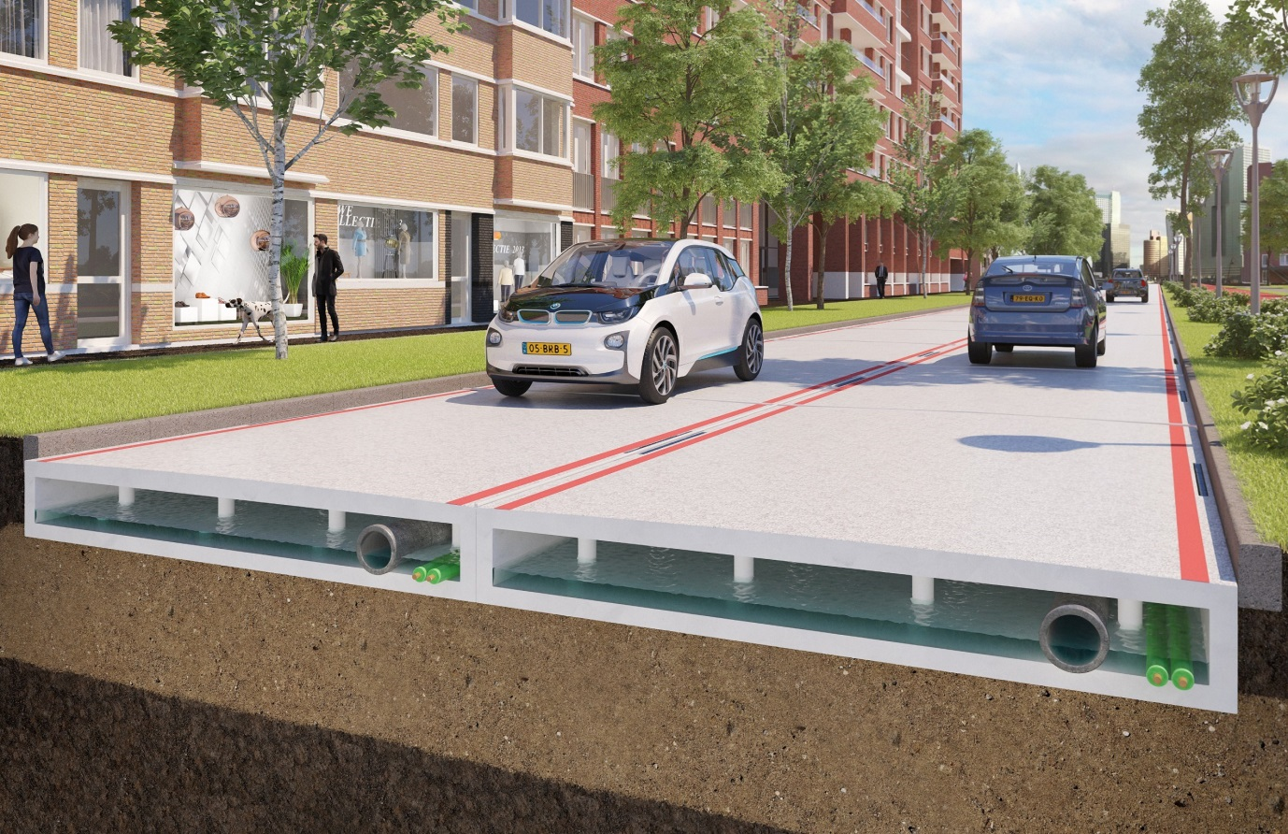
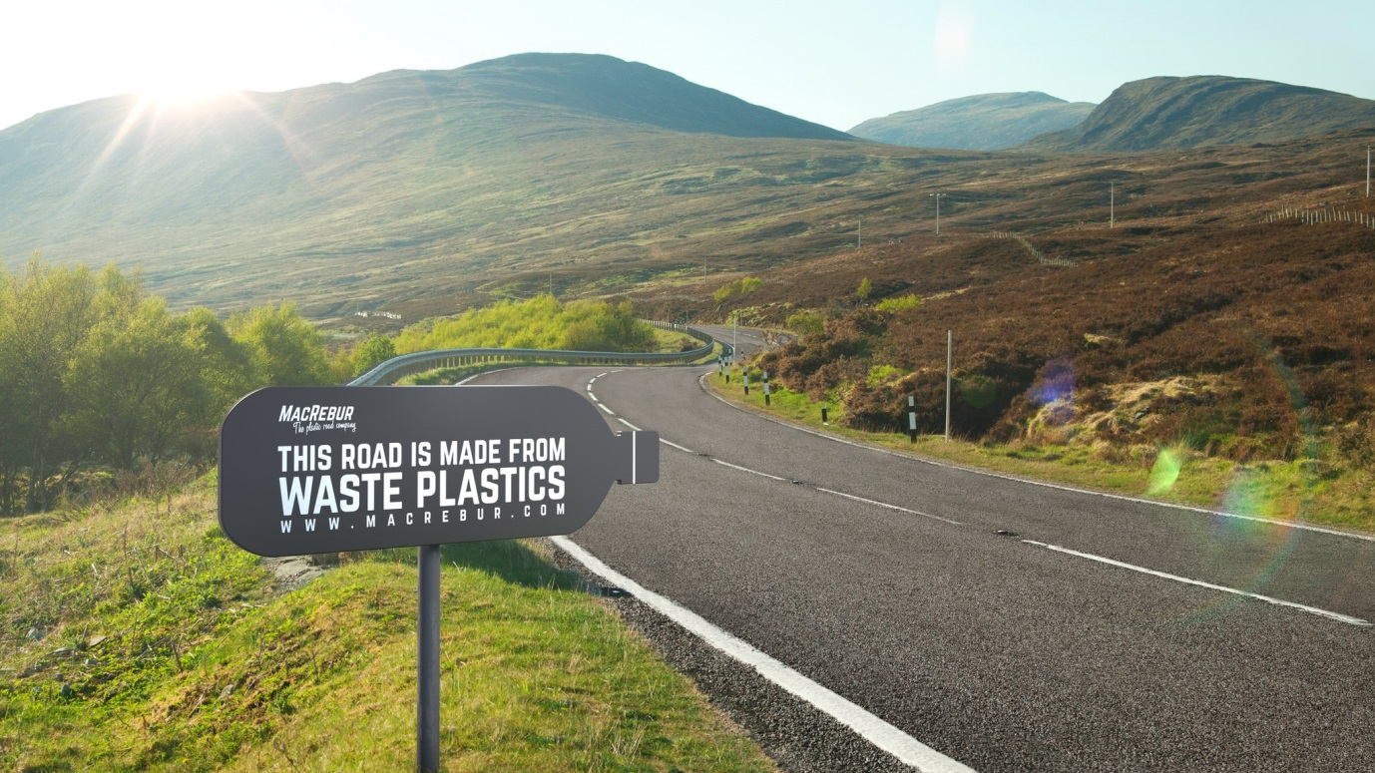
  - By Ben Kneeshaw – 1902457

Table of contents

1. Introduction…………………………………………………………….. Page 3
2. Plastic as a material…………………………………………………... Pages 3-4
2.1. Overview……………………………………………………………... Page 3
2.2. Plastic types and properties……………………………………….. Pages 3-4
3. Waste plastic as a material for road construction………………..... Pages 4-6
3.1. Overview……………………………………………………………... Page 4
3.2. Design methodology and application: Bituminous mixes………. Page 5
3.3. Design methodology and application: Modular construction…... Page 6
4. Evaluation…………………………………………………………….... Pages 6-8
4.1 Advantages and disadvantages: Bituminous mixes……………... Pages 6-7
4.2 Advantages and disadvantages: Modular construction…………. Page 7
4.3 Conclusion…………………………………………………………… Pages 7-8

Introduction

The aim of this report is to critically evaluate plastic as a material for use in civil engineering projects, with specific attention towards the use of waste plastics in road construction.

Plastic as a material

Overview

Plastic can be broadly defined as a wide range of synthetic or semi-synthetic materials, created using raw materials such as: cellulose, coal, natural gas, salt and crude oil (plasticseurope, 2020). Various chemicals can also be added to produce polymers with complex properties. It is a material that is particularly pertinent to the construction industry as they are the second largest consumer of plastics after packaging (bpf, 2020).

Plastic types and properties

The main property of plastics is their ‘plasticity’, from which they gain their name. This is the ability to be moulded into any desired shape prior to setting (plasticseurope, 2020).
As the term ‘plastic’ covers a wide range of materials, all with varying properties, it is important to divide said plastics into their subcategories, of which there are three: thermoplastics, thermoset plastics and elastomeric plastics.
The first of these are thermoplastics. Mamlouk & Zaniewski (2018, p.100) cite ‘these can be characterised by linear carbon chains which are not cross-linked’, when at a low temperature secondary bonds will adhere to these chains, this results in a strong hard material. However, when heat is re-applied to a substantial level, the secondary bonds will melt causing it to become a viscous liquid-like material which can then be re-set. This essentially means thermoplastics can be repeatedly heated and re-set without risk of damaging the structural integrity of the material. An example of a thermoplastic material is Asphalt, with its resettable nature being ideal for road construction. Although it is available via natural sources the vast majority of today’s Asphalt comes from the fractional distillation of petroleum (Mamlouk & Zaniewski, 2018, p.385).
The second category of plastics is thermoset plastics. Thermosets are characteristically formed of a resin and a hardener, these chemically react to harden. Mamlouk & Zaniewski (2018, p.100) state that when solid ‘the carbon chains are cross-linked to form stable compounds that do not soften upon reheating’. This means that unlike thermoplastics, once formed, the material cannot be reheated and remoulded. A common example of this form of plastic is Tupperware containers; these can withstand heat in an oven without the chemical bonds breaking, thus keeping their original shape. Due to the strength of the bonds Thermoset plastics are excellent at retaining water as no moisture can enter the material. As such, Thermoset plastics are utilised in the construction industry in the form of underground utility pipes and sluice tanks.
The final category of plastics is elastomeric plastics. Mamlouk & Zaniewski (2018, p.100) cite that these can be categorised as ‘linear polymers with limited cross-linking. At atmospheric temperatures, the secondary bonds have melted’. This cross-linking means the material is able to return to its original shape when unloaded. This gives the material elastic properties meaning it will take a lot of stress to deform the material when compared with most other conventional materials. A good example of this form of plastic is rubber, used widely in tires due to its ability take high levels of stress without deformation. This is also an excellent material for cables as it is naturally an insulator therefore the electrical charge is retained. Its ability to flex without losing elasticity makes it ideal for cables which may be subject to environmental factors, such as wind.
As all plastics are hydrocarbons, the main differences between them come from the physical structure of the polymer chain of which they are comprised. Different bonds will react differently under unique circumstances.

Waste plastic as a material for road construction

Overview

Plastics are one of the highest produced materials on the planet, with 448 million tons being produced in 2015 alone (Parker, 2019). As they have a lifespan of up to 400 years, much of the plastic produced since its inception is currently sitting in landfill. From here it seeps into the environment and breaks down into micro plastics, ending up in the bodies of many animals and causing serious ecological issues. As such it is important to find a use for waste plastic. In Europe 32% of plastic is currently recycled (bpf, 2019). Although this is a vast increase compared to the past, it is clear that improvements must still be made. As such, innovators have proposed new and exciting ways to use up waste plastics; one of these ways is through using them for road construction. There are two main ways of doing this which will be covered in the next two sections of this report.

Design methodology and application: Bituminous mixes

The first method to be covered will be bituminous mixes. This is the incorporation of waste plastics into existing bituminous mixes (Asphalt). The general concept of this is adding small amounts of waste plastic into the bituminous mix in order to improve the performance of the resulting Asphalt. Studies have shown a mix with 5-10% plastic (compared to the weight of the bitumen) can have positive results (Sasidharan et al, 2019, p.2). There are two ways of doing this, one is known as the ‘dry process’ and the other is the ‘wet process’.
The dry process consists of plastic waste being shredded and added to hot aggregate; it subsequently softens and melts to form a coating around said aggregates. Hot bitumen is then added to the mixture before it is used for road construction. The recommended size of said shredded plastic is 2-3mm (Sasidharan et al, 2019, p.5). Whilst a plastic percentage, in comparison to the bitumen, of roughly 10% has performed best under laboratory conditions (Nkanga et al, 2017, p.5).
The wet process consists of plastic waste being processed into a powder form, this is then directly mixed with the bitumen before being added to the aggregate (Sasidharan et al, 2019, p.5). The ideal percentage of plastic compared to bitumen is suggested to be 6-8% with this process (Asare et al, 2019).
This is a method that has been trialled extensively both nationally and internationally. On a national level there is a Scottish company called ‘MacRebur’ that has developed its own form of ‘dry process’ for Asphalt production. This involves converting the waste plastic into pellets before being added to a bituminous mix in much the same way as detailed above (Sasidharan et al, 2019, p.5). They claim that each kilometre lain with this form of Asphalt equivocates to 740,541 one-time use plastic bags, with each metric tonne being equivalent to 80,000 plastic bottles (MacRebur, 2020). These roads have been laid across the UK and internationally with ‘MacRebur’ being the only waste plastic road firm to have made it to global commercial use (Sasidharan et al, 2019, p.4).
On an international level India stands out as the country with the most experience in plastic road construction using bituminous mixes. This has been approved as the default method for repair and renewal of roads within 50km of any urban area with a population of 500,000 or more (Arora, 2015). The Indian national road congress (2013) published guidelines relating to this whilst claiming that more than 2500km of roads have been constructed since 2002 using this method. They report these roads have little sign of wear and tear associated with Asphalt, such as potholes, after ten years of being in place.

Design methodology and application: Modular construction

The other method to be covered is modular construction. This consists of building roads out of pre-fabricated plastic elements, formed using waste plastic they fit together in a manner similar to Lego. There is a cavity within the blocks used, allowing for cables and pipes to be laid, with additional space for water drainage in rainy conditions (Plasticroad, 2020).
This is a relatively new concept in comparison with the previous method; as such it has not yet been trialled on a national level. On an international level it has been trialled by the company that pioneered the concept, known as ‘PlasticRoad’. They are a Netherlands based company and have currently built one cycle path as a ‘proof of concept’, with plans to build more as a pilot for the scheme (PlasticRoad, 2020). The cycle path in question has performed well thus far but tests are still being conducted to determine the feasibility of such a structure for wide-scale use.

Evaluation

Advantages and disadvantages: Bituminous mixes

There are a number of advantages exhibited by waste plastic based bituminous mixes when compared to traditional Asphalt. It has been shown that the addition of waste plastic is capable of enhancing the performance and lifespan of the pavement (Kalantar et al, 2012). This is partly due to the polymers added letting in much less water than traditional Asphalt, meaning potholes take longer to appear, due to this the road needs resurfacing far less often. This is another benefit as the cost of resurfacing is vastly reduced. It also means user satisfaction for the road is increased as fewer accidents will take place. Vasudevan et al (2012) also conducted a lengthy review into this form of Asphalt; along with concurring with the previously mentioned benefits they found a number of others. They found its increased binding and durability allowed for heavy traffic whilst increasing its resistance to adverse weather conditions. They also cite the reduced level of bitumen required as a cost reduction factor whilst also providing environmental benefits, as bitumen can contribute heavily to pollution through its production. They state the main benefit from this form of Asphalt is environmental with the use of plastics meaning they avoid ending up in landfill or being incinerated. Kursheed & Singh (2017) cite the use of mining waste as aggregate as a way of further increasing the environmental benefits of a road constructed in this way.
There is however a few negatives involved with this form of Asphalt. Chakraborty & Meta (2017) identified two hazards involved with this process. The first is the leaching of toxic compounds during the cleaning process; the second is that hazardous chlorine gases can be released during the road construction process. White (2019) cites the releases of compounds as negligible however, so this may not be a huge detriment. It is also likely that the long-term effects of the plastic not being used in this way are worse. As this is a process that can be done in situ, workers will need to be trained to carry out the process without risking their health (Sasidharan et al, 2019, p.7). This is a negative as the cost of training will increase the overall cost of the roads construction for companies looking to implement this process. It is also important to note that the first roads constructed in this manner are only 10 years old; as such long-term outcomes are not yet clear (Sasidharan et al, 2019, p.2).

Advantages and disadvantages: Modular construction

There are a number of advantages to roads constructed using the modular system. Davis (2017) cites that due to the prefab method roads can be constructed in a much quicker time than Asphalt based construction. As the road can be laid upon sand it eliminates the need for sub-layers, further decreasing construction time. He also states that due to being constructed from 100% recycled plastic it contributes positively to the environmental need for plastic recycling. It is likely this method will use more plastic than the previous method as it is 100% made from plastic.
There are also a few negatives to this concept. The main negative is that due to the fact it is in its inception, all scientific studies into it are currently being conducted by the company that invented it, as such they are inaccessible. Another negative is that for inner cities where manhole covers are installed to access underground infrastructure, this type of road will be unviable. This is because the access will have to be moved to allow the road enough space to be laid. It is also unclear how well car tyres will grip to the surface in rainy conditions (expertskiphire, 2016). Another disadvantage is the amount of equipment and training current road construction companies will have to invest in if they wish to implement this process.

Conclusion

In conclusion both of these methods have future potential in different circumstances. Waste plastic based Asphalt is ideal for repairs to existing roads due to its increased performance over traditional Asphalt. It also lends itself to roads being constructed in areas where underground utilities are of concern; this is because it will be far easier to access these than it would if the road was of modular construction. Modular construction lends itself towards roads being newly constructed in areas where underground utilities are not already present; as the utilities can be laid throughout the road eliminating the need for excavation. They also lend themselves to cycle paths where utilities are not so much of a concern. However additional developments will be required for this form of road as it is not yet clear how safe cars will be on their surfaces. Both methods will contribute significantly to the reduction of plastic waste if proved to be feasible, which can only be a positive so far as the environment is concerned.

Reference list

- Arora, R. (2015). Government makes use of plastic waste in road construction mandatory. [online] Economic times. Available at: https://economictimes.indiatimes.com/news/economy/infrastructure/government-makes-use-of-plastic-waste-in-road-construction-mandatory/articleshow/49919167.cms (Accessed: 01.11.20)
- Asare et al. (2019) Evaluation of incorporating plastic wastes into asphalt materials for road construction in Ghana. [Online] Available at: https://www.cogentoa.com/article/10.1080/23311843.2019.1576373 (Accessed: 30.10.20)
- Bpf (2019). Plastic recycling. [Online] Available at: https://www.bpf.co.uk/sustainability/plastics_recycling.aspx (Accessed on: 27.10.20)
- Bpf (2020). Construction. [Online] Available at: https://www.bpf.co.uk/innovation/Construction.aspx (Accessed on: 26.10.20)
- Chakraborty, A and Mehta, S. (2017) Utilization & Minimization Of Waste Plastic In Construction Of Pavement: A Review. International Journal of Engineering Technology Science and Research. [Online] Volume 4 (8). Available at: http://www.ijetsr.com/images/short_pdf/1502283949_354-358-ieteb877_word_etsr.pdf (Accessed: 17.11.20)
- Davis, A (2017). Are prefabricated sustainable plastic roads the future?. [Online] Available at: https://highways.today/2017/02/25/prefabricated-sustainable-plastic-roads-future/ (Accessed: 17.11.20)
- Expertskiphire (2016). PLASTIC ROADS - FUTURE INNOVATIONS FOR OUR HIGHWAYS? [Online] Available at: https://www.expertskiphire.co.uk/plastic-roads (Accessed:17.11.20)
- Kalantar et al (2012). A review of using waste and virgin polymer in pavement. Construction and Building Materials. [Online] Volume 33, pp 55-62. Available at: https://www-sciencedirect-com.ezproxy.uwtsd.ac.uk/science/article/pii/S0950061812000323 (Accessed: 17.11.20).
- Kursheed, T and Singh, B K. (2017). ROAD CONSTRUCTION FROM SOLID WASTE IN JAIPUR. International Journal For Technological Research In Engineering. [Online] Volume 4 (9). Available at: http://www.ijtre.com/images/scripts/2017040948.pdf (Accessed: 17.11.20)
- MacRuber (2020). It’s the end of the road for waste plastics. [Online] Available at: https://www.macrebur.com/ (Accessed: 30.10.20)
- Mamlouk, M S and Zaniewski, J P. (2017). Materials for civil and construction engineers. 4th edition. Harlow, UK: Pearson education limited
- Nkanga et al (2017). Characterization of Bitumen/Plastic Blends for Flexible Pavement Application. Procedia manufacturing. [Online] Volume 7, pp.490-496. Available at: https://www.sciencedirect.com/science/article/pii/S2351978916302141 (Accessed: 30.10.20)
- Parker, L (2019). The world's plastic pollution crisis explained. [Online] National geographic. Available at: https://www.nationalgeographic.com/environment/habitats/plastic-pollution/ (Accessed: 27.10.20)
- Plasticroad (2020) Building the future. [Online] Available at: https://www.plasticroad.eu/en/ (Accessed: 10.11.20)
- Plasticseurope (2020). WHAT ARE PLASTICS? [Online] Available at: https://www.plasticseurope.org/en/about-plastics/what-are-plastics (Accessed: 26.10.20)
- Sasidharan et al (2019). Using waste plastics in road construction. K4D Helpdesk Report. [Online] Available at: https://assets.publishing.service.gov.uk/media/5d41b34040f0b60a86a5e5dc/595_Use_of_Waste_Plastics_in_Road_Construction.pdf (Accessed: 30.10.20)
- The Indian national road congress (2013). GUIDELINES FOR THE USE OF WASTE PLASTIC IN HOT BITUMINOUS MIXES (DRY PROCESS) IN WEARING COURSE. [Online] Available at: https://www.tce.edu/sites/default/files/PDF/IRC-Spec=Road-with-plastic-waste.pdf (Accessed: 01.11.20)
- Vasadevan et al (2012) A technique to dispose waste plastics in an ecofriendly way – Application in construction of flexible pavements. Construction and Building Materials. [Online] Volume 28 (1), pp. 311-320. Available at: https://www-sciencedirect-com.ezproxy.uwtsd.ac.uk/science/article/pii/S0950061811004648 (Accessed: 17.11.20).
- White, G (2019) EVALUATING RECYCLED WASTE PLASTIC MODIFICATION AND EXTENSION OF BITUMINOUS BINDER FOR ASPHALT. [Online] Available at: https://www.researchgate.net/publication/331465864_EVALUATING_RECYCLED_WASTE_PLASTIC_MODIFICATION_AND_EXTENSION_OF_BITUMINOUS_BINDER_FOR_ASPHALT (Accessed (17.11.20)

