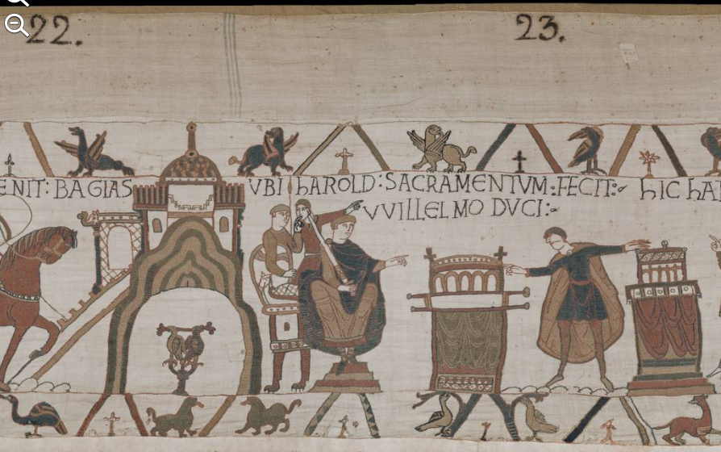

Claire Mann
1602593
Identity and Myth: The Normans and their World HPHI5009
The Bayeux Tapestry, often referred to as England’s first comic strip features 58 episodic scenes embroidered onto a 70 meter canvas, made up of 9 successive pieces of linen. Illustrated over the length of the fabric are 380 latin words, 632 human figures, 560 animals, 202 horses, 41 ships and 37 buildings that together give a visual justification for the conquest of England by William, Duke of Normandy. For this commentary we will be looking at the scene featured on pl. 22 and pl. 23 where Harold Godwinson swears an oath before William of Normandy. The nature of the oath is not certain, however, it is widely accepted as being in support of William succeeding Edward as King of England. I will start by attempting to decode the main frieze then consider the detail within the margins, which does not only frame but also comments-symbolically, cryptically, ironically and humorously-on the main narrative of the dynastic power-game played out in the opening decades of the second millennium.
The building depicted in scene 22 is probably the ducal castle that existed in Bayeux at the time or could be an attempt by the designer to represent the town of Bayeux as a whole. A round, bare central mound is formed from several alternately coloured layers, on top of which is an imposing structure with two crenelated turrets spanned by a tiled dome. Beneath the mound a pair of eagles or hawks sit on one perch, as though in a mews, grasping a sceptre-like object. Both are fierce, merciless birds of prey delighting in feeding off the weak. Wright suspects they represent regal promises by William to Harold, promises of shared power and continued close friendship.
Beyond the building the main event takes place within scene 23, Gale Owen-Crocker suggests that a change of scene marks a change of location meaning the narrative illustrated in scene 23 possibly did not take place in Bayeux, but perhaps in Bonneville-sur-Touques as was recorded by William of Poitiers in his Gesta Guillelmi, or Rouen as suggested by Orderic Vitalis’s Ecclesiastical History.
Duke William can be seen dressed in long robes, seated on a throne with legs ending as clawed animal feet. He is holding a sheathed sword, looking and pointing in the direction of Harold. Stood behind William are two figures, probably noblemen given their proximity to the Duke, one has a sword and shield while the other is stood unarmed as they gesture up to the inscription VBI hAROLD SACRAMENTVM FECIT VVILLELMO DVCI (Where Harold swore a sacred oath to Duke William).
To the right of the scene Harold is pictured, stood between two house shaped reliquaries, concealed under altar cloths, on what looks to be a cobbled surface. The reliquary or altar to the left of Harold appears portable, with what look like carrying poles beneath it, indicating that it had been carried from one location to a different location, the one where the oath scene is set. The reliquary to Harold’s right appears to be placed on an altar, and is thought, according to the Hyde Chronicle to contain the ‘most important among the relics, the phylactery of St Pancras, which they call the ‘ox eye’ because the middle part contains a huge and beautiful gem. This would explain the central crystal atop the reliquary in the embroidery. Also, the inclusion of Pancras is purposeful and moralising as he is the patron of vows and treaties.
If we consider Harold’s stance, his posture appears somewhat contorted, as if he is being pulled in opposite directions. This could reflect his internal conflict of what he is promising on the holy relics and his future ambitions. It has also been noted that Harold’s fingers barely touch the reliquaries, a sign perhaps that his oath was not in earnest.
If we now turn our attention to the borders of the main frieze, along the bottom paired birds and heraldic beasts appear to be sharing spaces, between very stylized, almost cruciform plants and borders. The animals look to be chattering excitedly as the momentum gathers within the main embroidery, below the ‘portable reliquary’ two long necked birds appear to be laughing at the action above.Below the fixed reliquary there is what looks like a fox, possibly included by inspiration from Aesop, a sly and clever creature, never short of promises, schemes and ideas of self-improvementleaving the scene and moving into the next part of the story.
The top border again features birds and beasts, but this time they appear singularly between the same diagonal borders. Winged lions or fantastic griffins adorn the top border, both representations of strength and destiny, the colours of them matching the cloak colours within the main embroidery, this seems purposeful, though could just be confusion on the embroiderers part.
Directly above Harold there is an eagle featured, he again is depicted in the matching colours to Harold’s cloak, he is stood, head covered by his wing, averting his eyes from what is going on below.
The contents, narrative and purpose of the Bayeux tapestry has caused much scholarly debate, I feel that my commentary is a concise and thorough interpretation of the scene.
I hope to study the tapestry in more detail in the future and look forward to uncovering more of history’s secrets within the stitches. Who commissioned it? Who embroidered it? And where? but particularly the content and possible location of the lost piece.

Bibliography
Primary Source
David M Wilson, The Bayeux Tapestry (London: Thames and Hudson, 1985)
Bayeux Tapestry ‘Harold’s oath’ course handbook.

Books
Arthur C Wright, Decoding the Bayeux Tapestry: The Secrets of Britain’s Most Famous Embroidery Hidden in Plain Sight (Great Britain: Frontline Books, 2019)
Elizabeth Carson Pastan, Stephen D. White, Kate Gilbert, The Bayeux Tapestry and Its Contexts A Reassessment (United Kingdom: Boydell Press, 2014),
Karen Eileen Overbey, Taking Place: Reliquaries and Territorial Authority in the Bayeux Embroidery (United Kingdom: Boydell, 2009)
David M Wilson, The Bayeux Tapestry (London: Thames and Hudson, 1985)
David Musgrove and Michael Lewis, The story of the Bayeux Tapestry unravelling the Norman Conquest (London: Thames and Hudson, 2021), p. 171.

Journal Articles
Gale R. Owen-Crocker, 'The Bayeux 'Tapestry': Invisible seams and visible boundaries', Anglo-Saxon England, 31, (2002), 257-273.

Websites
Bayeux Museum, La Tapisserie De Bayeux () <https://www.bayeuxmuseum.com/en/the-bayeux-tapestry/discover-the-bayeux-tapestry/explore-online/#> [accessed 12 April 2021].

Arthur C Wright, Decoding the Bayeux Tapestry: The Secrets of Britain’s Most Famous Embroidery Hidden in Plain Sight (Great Britain: Frontline Books, 2019), p. 1.
Gale R. Owen-Crocker, 'The Bayeux 'Tapestry': Invisible seams and visible boundaries', Anglo-Saxon England, 31, (2002), 257-273 (p. 257).
David Musgrove and Michael Lewis, The story of the Bayeux Tapestry unravelling the Norman Conquest (London: Thames and Hudson, 2021), p. 171.
Arthur C Wright, Decoding the Bayeux Tapestry: The Secrets of Britain’s Most Famous Embroidery Hidden in Plain Sight (Great Britain: Frontline Books, 2019), p. 42.
Ibid, p.42
Gale R. Owen-Crocker, 'The Bayeux 'Tapestry': Invisible seams and visible boundaries', Anglo-Saxon England, 31, (2002), 257-273 (p. 261).
David M Wilson, The Bayeux Tapestry (London: Thames and Hudson, 1985), p. 198.
Elizabeth Carson Pastan, Stephen D. White, Kate Gilbert, The Bayeux Tapestry and Its Contexts A Reassessment (United Kingdom: Boydell Press, 2014), p. 109.
Karen Eileen Overbey, Taking Place: Reliquaries and Territorial Authority in the Bayeux Embroidery (United Kingdom: Boydell, 2009), p. 36.
Karen Eileen Overbey, Taking Place: Reliquaries and Territorial Authority in the Bayeux Embroidery (United Kingdom: Boydell, 2009), p. 37.
David Musgrove and Michael Lewis, The story of the Bayeux Tapestry unravelling the Norman Conquest (London: Thames and Hudson, 2021), p. 176.
David Musgrove and Michael Lewis, The story of the Bayeux Tapestry unravelling the Norman Conquest (London: Thames and Hudson, 2021), p. 277.
David Musgrove and Michael Lewis, The story of the Bayeux Tapestry unravelling the Norman Conquest (London: Thames and Hudson, 2021), p. 252.
Arthur C Wright, Decoding the Bayeux Tapestry: The Secrets of Britain’s Most Famous Embroidery Hidden in Plain Sight (Great Britain: Frontline Books, 2019), p.153.
David Musgrove and Michael Lewis, The story of the Bayeux Tapestry unravelling the Norman Conquest (London: Thames and Hudson, 2021), p. 187.

