

BUSINESS PLAN
Managing Enterprise in the 21st Century
Life through a lens

By Charlene Morgan 1906685

Contents Page

Introduction

Introducing my new solo venture into the world of photography. The logo is the main feature of my business it gives an insight to the customer on what I want to represent and shows clarity on what I am trying to achieve. In this instance a striking bright blue eye with the main feature of a camera lens represents its mission to take exceptional photographs.
As long as I can remember I have had a passion for taking photographs, I have never been a professional, but capturing the most natural images of people really fulfils my heart, pictures can portray the most unexpected emotions, and to reveal that to someone can touch their heart in an instant.
In life we talk about pictures all the time, what does it say, how is it being portrayed, how does it make you feel, where was this picture taken, by who, why. Vision is important to people what we see is not just a blur but a fascinating tale of emotions. This is what I want to create, and for people to talk about my work for a very long time.
Families are the core reason of wanting to take incredible long-lasting memories, it can become a special moment in time, at a very poignant place with the people you love the most. To make sure my business is the one that consumers will flock to and rise above the competition, I will use a unique perspective which would entail me becoming the customer only when this is achieved you understand the customers wants, needs and desires.

Mission Statement
As a photographer I aim to capture ‘the moment’ breathing life into every image and simply aiming to give you the very best in quality and simplicity. Displaying the finest in natural imageries to tell a story rather than it being just a photograph. No staged moments here.

Product/Service
My product is to sell effortless high standard quality pictures. It will allow the customer to explore my portfolio, get a feel for the person I am and the way I work. The product will come with additional products in numerous package services, these can include, photo albums, frames, USB sticks and CD’s. The service is to produce a professional friendly, comfortable relaxed environment but most importantly making sure my work is on time and of the highest quality. This will also include any requests or extra additions the client may want to incorporate into their photo shoot.
Can I include anything else here?

Human Resources
‘Life through a lens’ is undoubtably a newly founded business. As I have no qualifications in taking professional images, I do however have lots of skill and experience in taking personal pictures that I deem are natural, photogenic and are talked about in social circles. When I have created a vocal point about my work, this makes it worthwhile for me to progress further in wanting to learn more about this subject.
At this moment the business solely relies on myself, in time I would like to involve an apprenticeship who can train alongside myself as well as them again a qualification into photography. They will learn social skills, understand the meaning of the business, handle telephone calls, take bookings, diary entrees, evolve the website, come with a sense of creativity, and learn to take breath-taking pictures.
I have devised a swot analysis to help me through different hurdles, that shall become my path into finding various ways to make my business a successful one. It may at times be overwhelming and stressful so this will help me keep myself on the tight track. The diagram clearly illustrates a good strength approach, in terms of the location of my new start up, while it shall remain at my home address, it will give the customer a sense of getting to know me on a slight personal level and a feel for my environment and work. This leads me on to variable price, I shall always come across numerous competitors displaying offers and the best deals, I believe the quality of my work should reflect a suitable price, and given the chance match the work ethic that comes with it as it will always remain the biggest focus. Being a new business can come with several weaknesses, building a reputation will come with time and networking in the right way. Not all cash flows will be accurate although, this is put in place for incoming and outgoing expenses, it projects in terms of business how much revenue I will obtain through the demand of my work. Opportunities is a great way to create more doors opening to expand the business, word of mouth and meeting new clientele will steer me in the right direction. I shall plan and produce great advertising strategies to propel my services and make me stand out from the crowd. Competitors and price wars will always remain a threat. To stay on top of my game I shall immerse myself into making sure that my prices remain on par with others and allow time to check in with rivals. The technology in photography is always advancing there always seems to be a new shutter speed, or lens, exposure etc. Every camera can take a picture, but quality of that picture needs to always be up to date to ensure the best product. (see appendices pg. 9)

I have created a job description for an opening to assist me in my line of work, they shall already be on an apprenticeship scheme where they can gain work experience with myself and gain a qualification too. The way I shall advertise this job opening, is by using local universities, Career agencies, social media platform and my own website. I shall recruit the successful candidate and follow up on all references and DBS checks. They shall receive minimum national wage as the government states and receive their -20 days annual leave including any statutory bank holidays. The position is only part time averaging about 10hrs per week. All skills shall include daily tasks, the candidate will need good communication, a professional approach, a good ear, enthusiasm and work ethic.

Marketing Strategies
My specific market segment will be divided into 4 different types, I need to firstly look at geographic section, I shall want to keep my business for South Wales purpose only, the next part is demographic there is no specific person I want to attract as we are highly influenced by our emotions, if I heavily rely on the demographics here then I would be missing a trick, so I have a much more of a broader range. Behavioral segment will allow me to think more of the client’s needs and desires. Giving them an environment which they can feel comfortable in puts a lot of nerves at ease. Psychographic requirements will determine where I should be regarding my clientele to become more willing to purchase my work, the right events, social circles and networking will lead me to have the right people interested in purchasing my images.
I shall be targeting families, and couples who desire the need for professional quality photographs. This does not mean that any individuals who approach my business will be looked at any differently.
I am targeting people who want more than just a picture, but someone who is looking for a story to be told through one single shot.

I will target clients who attend photo Fayres, anyone who is available to browse online pages such as social media, newspapers, word of mouth, signage on my personal vehicle, business cards/flyers, Trip advisor so potential clients can look up reviews, universities and of course my own website.
South Wales currently stands at 2.2 million people, the size of my market will determine on how I stand up to my fellow competitors I need to analyse a source of data which include how much value is out there for my current business venture and if there is a demand for it. A time period of 3 years will show growth and planning. Targets will have the power of wanting to be met.
‘People do not buy goods and services, they buy relations, stories and magic’ – Seth Godin (2016)
Defining the 4p’s (Price, Promotion, Product and Place) simply means making sure your product can sell at the right price, in a great area and promoting it at the right time. There is a lot of research that goes into each of these. I aim to take my Photography business and ideally piece together these 4 main parts to start off my plan. Using the term ‘marketing mix’ which refers again to these purposes I shall keep making sure that all are used in according to my business plan.

I shall talk about my PEST here.

Physical Resources
The idea is to gradually build the business from home. Once the business expands in time and profit is reaching its target goals, I would like to seek a small rented studio somewhere near to where I already reside. This will allow me a chance to be close to home and commute will not be an issue, ideally a captivating website will let me reach out to a wider audience. In other resources, this may not be an issue to me at this point in time, as it will be from my home, I will display pieces of my work and convert a studio in my garden and create an idyllic comfortable social environment for the client and myself to build up a rapport , I shall explain what I do, decorate the room with a shabby chic look with a sense of family and love in mind, and my equipment on show.
I would need to investigate reputable suppliers to help me develop my pictures including printing to my standard, whilst in turn they would have my business to advertise and my work to keep returning. This can help both business and build a great relationship between local small traders.

Financial Resources
My business will start off with £10,000 bank loan, my plan is to use most of this money on setting up a summer house at my own property and conduct first initial meetings and appointments there. I also will include my equipment and advertising my brand within this amount. I hope to not be borrowing any more money, but if it becomes an issue, I would need to start looking into crowdfunding or a personal loan from family. These are areas which would need to be looked at very carefully before committing to such an arrangement.

According to my cash flow, I have considered all my inflows and outflow costs. The results will show a profit in my first year of business, when looking at my sales figures, these shall most definitely change towards the second year, a lot as been a focus on seasonal changes and the data being collected from the questionnaire I designed.
More needed on cash flow here.

Swot Analysis
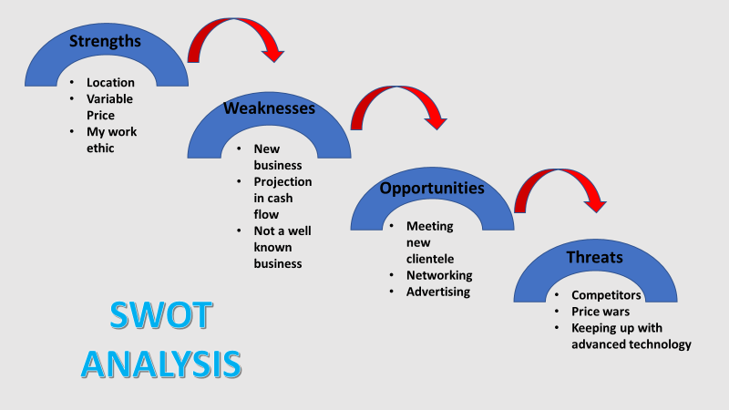

Pest Analysis
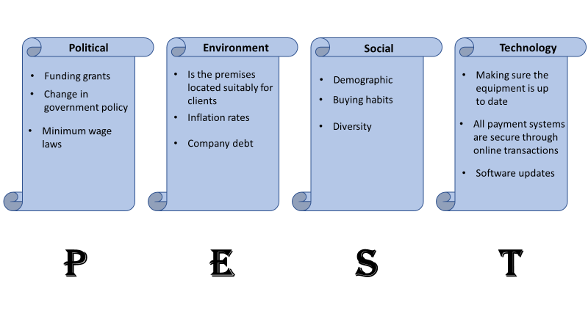
Life through a Lens
Job Description

Position: Apprentice Helper
Job Description: The successful applicant will be required to take responsibility of photographic equipment, whilst in the studio and on various locations.
Whilst on location, setup will take place, communication between photographer and apprentice shall always remain clear.
Being in the studio there shall be a process of editing, processing and creating keepsake albums, CDs and USB sticks.
Report to: The Photographer
Responsibilities/Duties:
• Help on Location for photoshoots
• Have a thirst for learning
• Dealing with customers
• Make appointments
• Take telephone calls
• Motivation is key
Requirements: Must adhere to apprenticeship guidelines, will gain experience whilst training on the job.
Salary: National minimum wage
-20 days annual leave inc statutory bank holidays
Application instructions: submit CV at lifethroughalens20@gmail.com

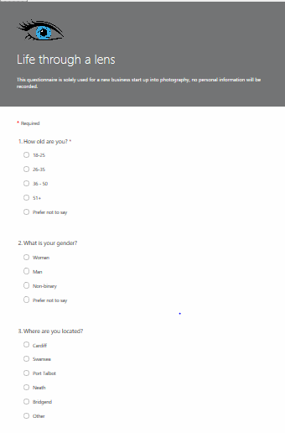
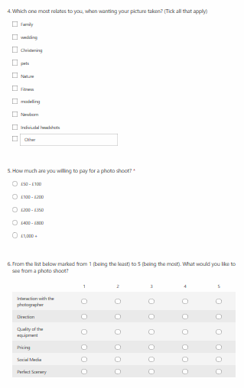

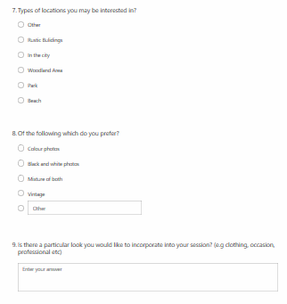

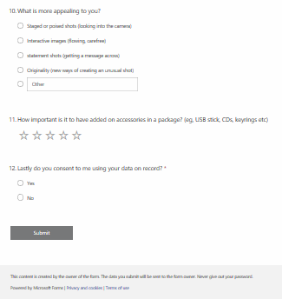

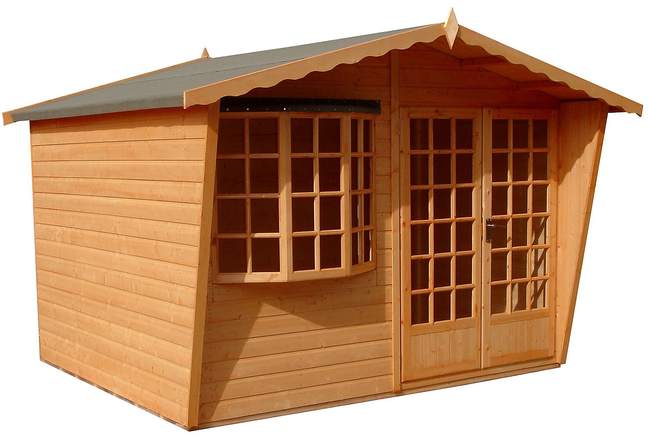

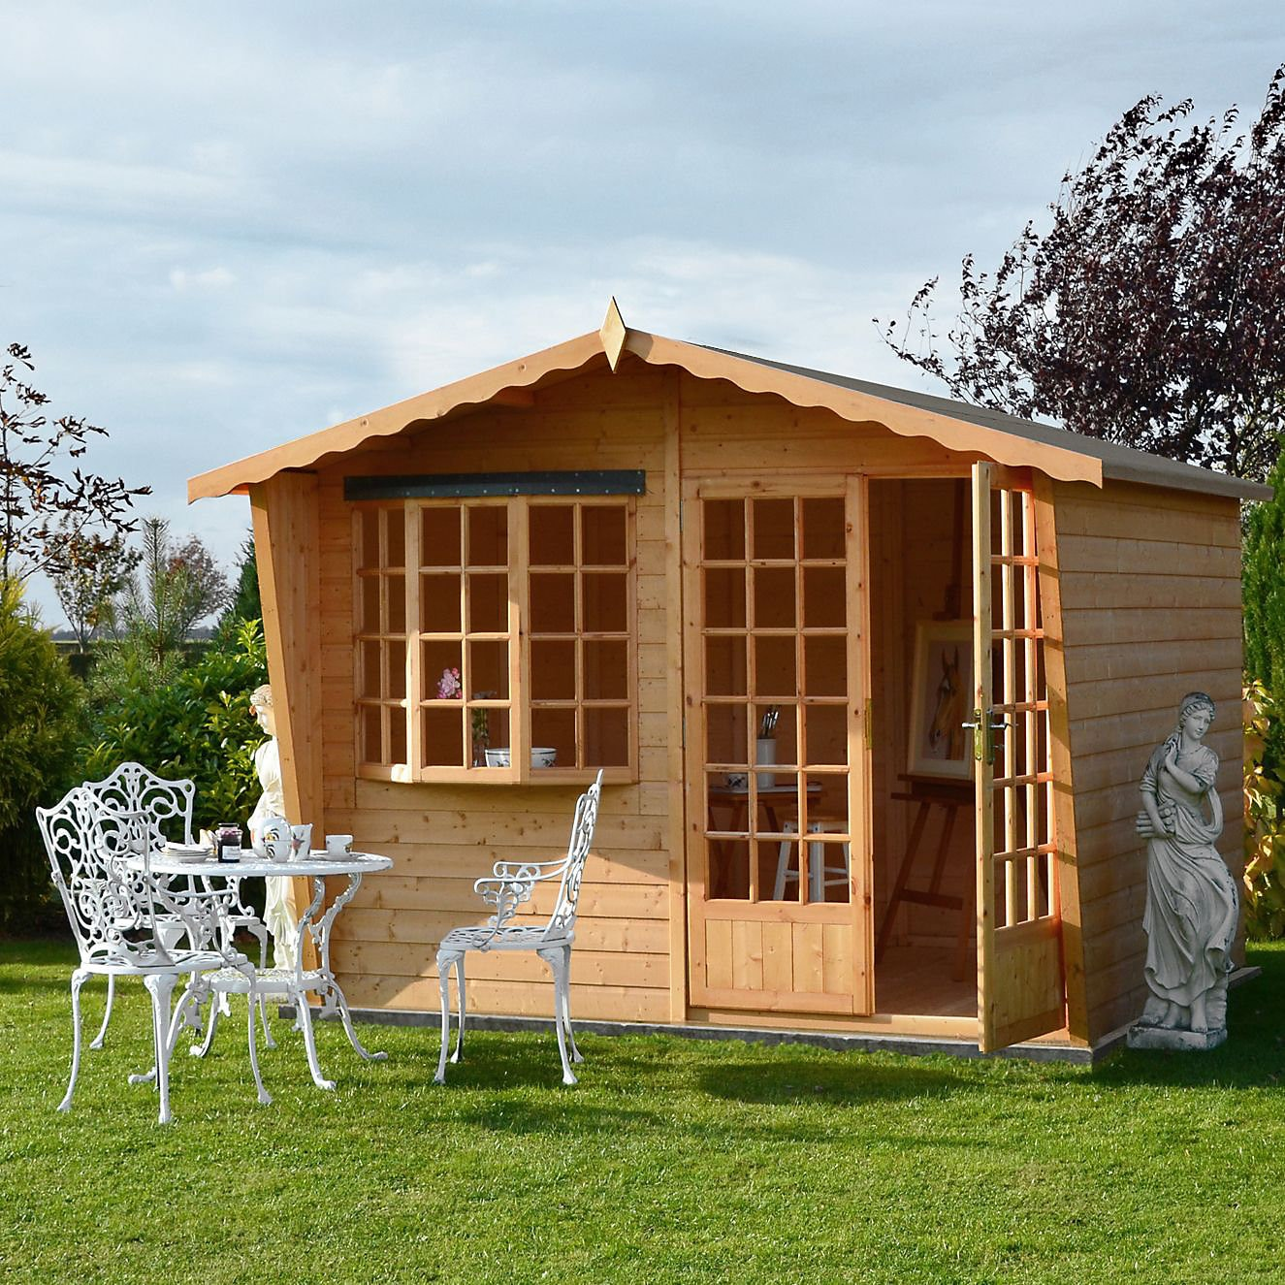

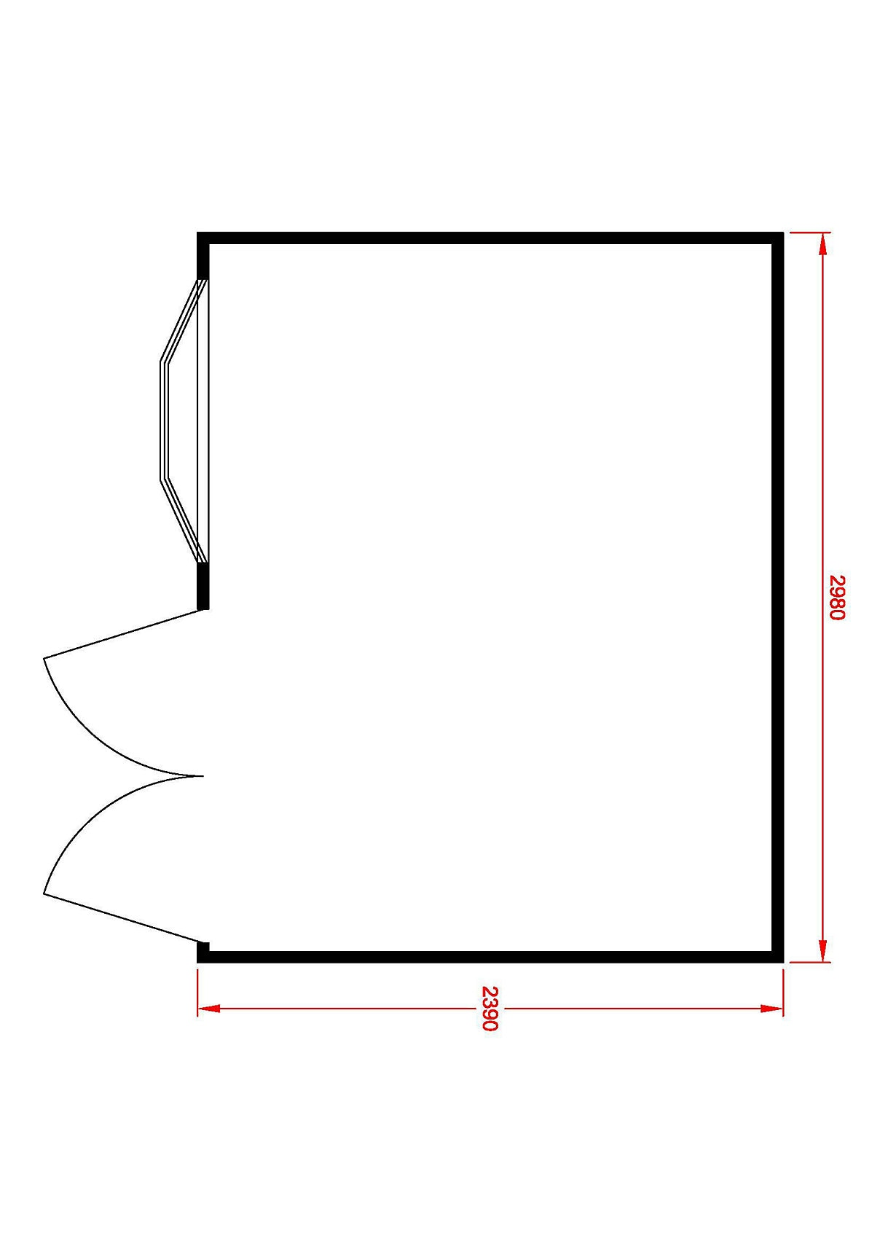

Shire Sandringham 10x8 Apex Shiplap Wooden Summer house
£1,270

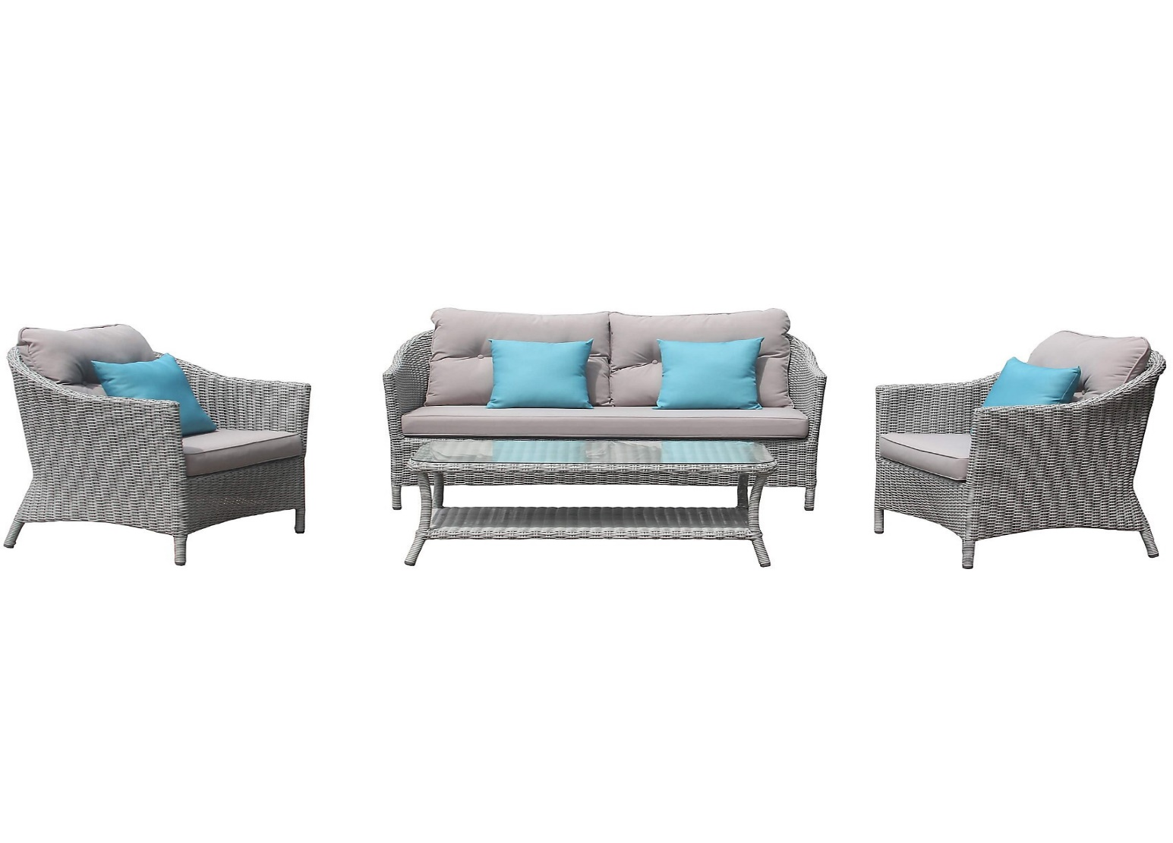

Floral 4-seater Coffee set £630

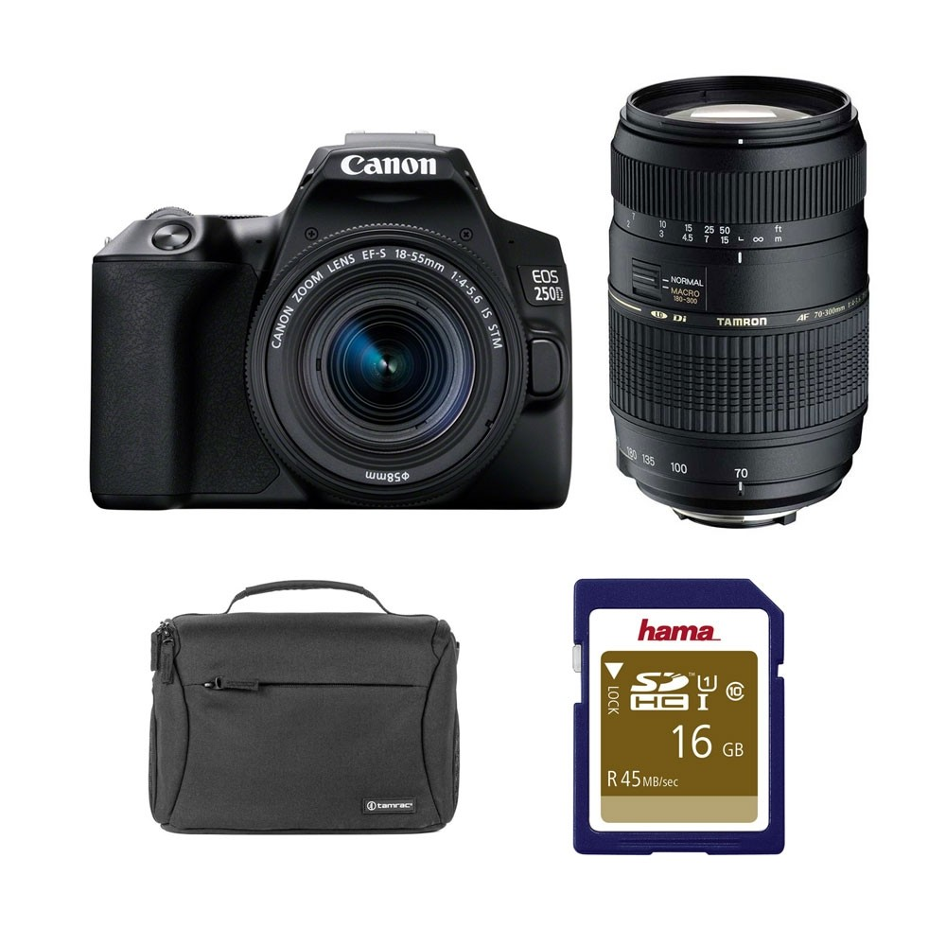

Canon EOS 250D DSLR Twin Lens Value Kit £699

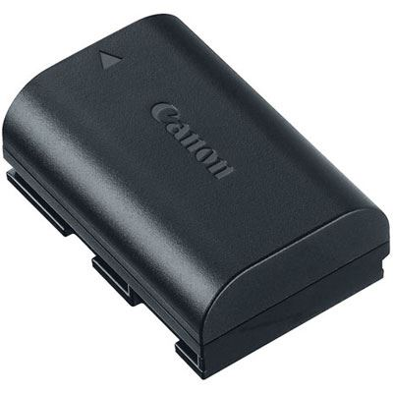

Canon LP-E6N Battery Pack £74.99

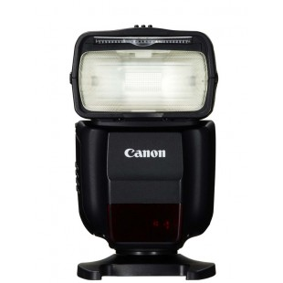
Canon Speedlite 430EX MKIII-RT £249
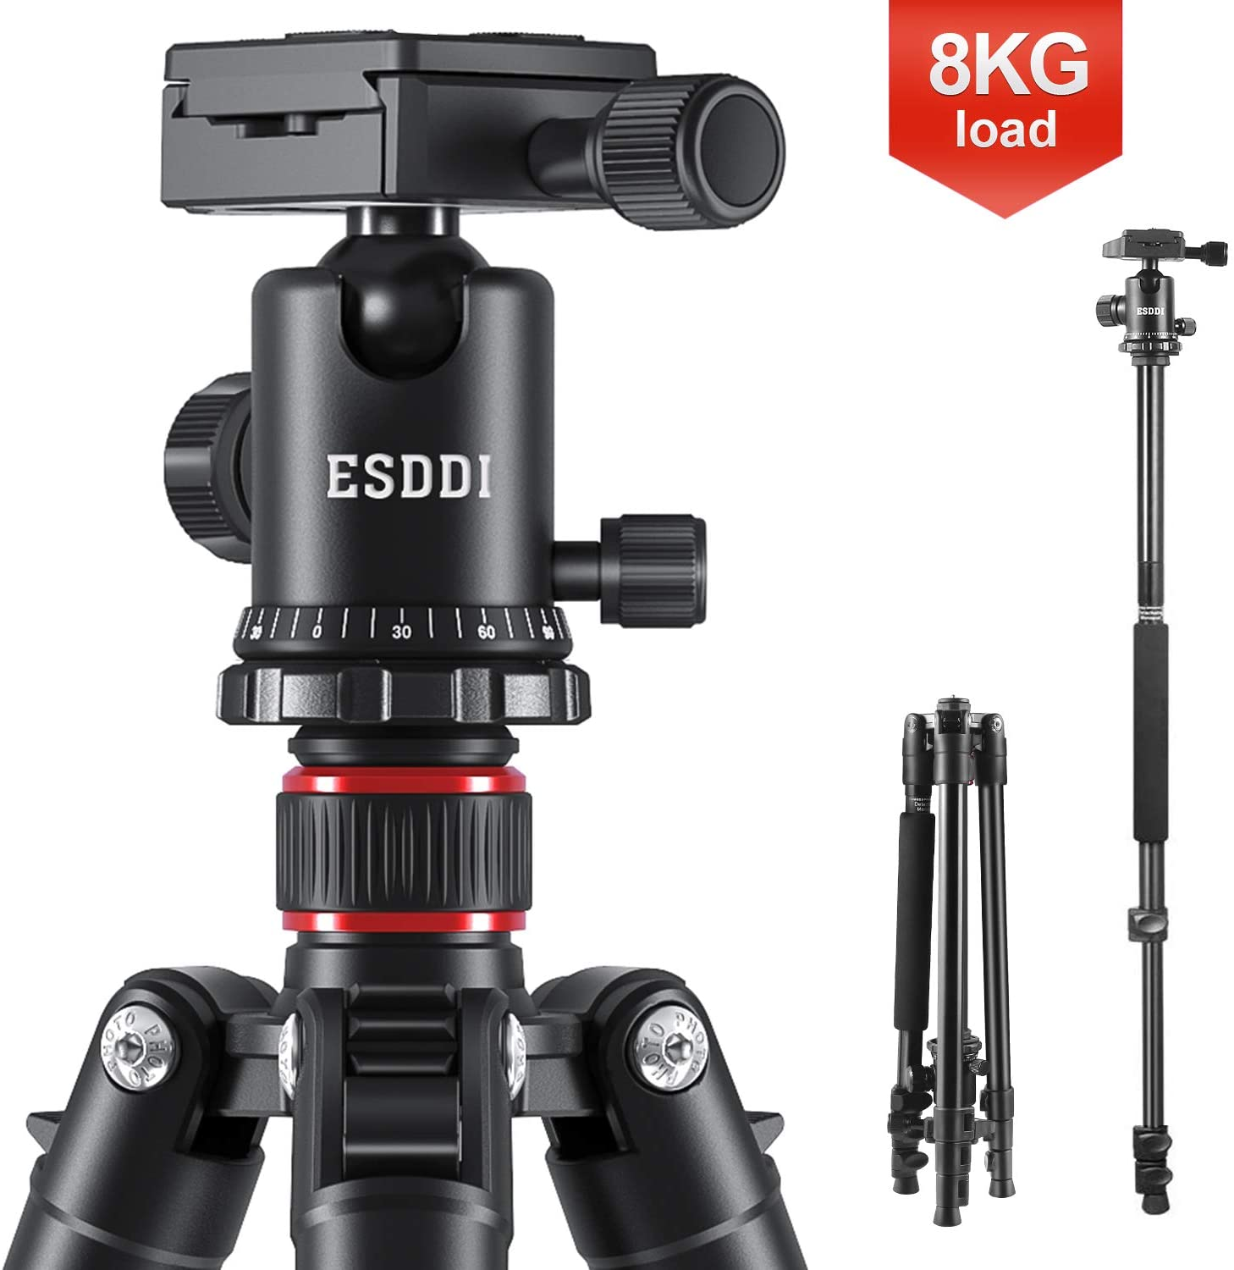

Camera Tripod, ESDDI 64 Inches Aluminum Tripod with Monopod 360 Degree Ball Head Lightweight Compact Tripod for DSLR Canon Nikon Sony for Travel and Work £51.99

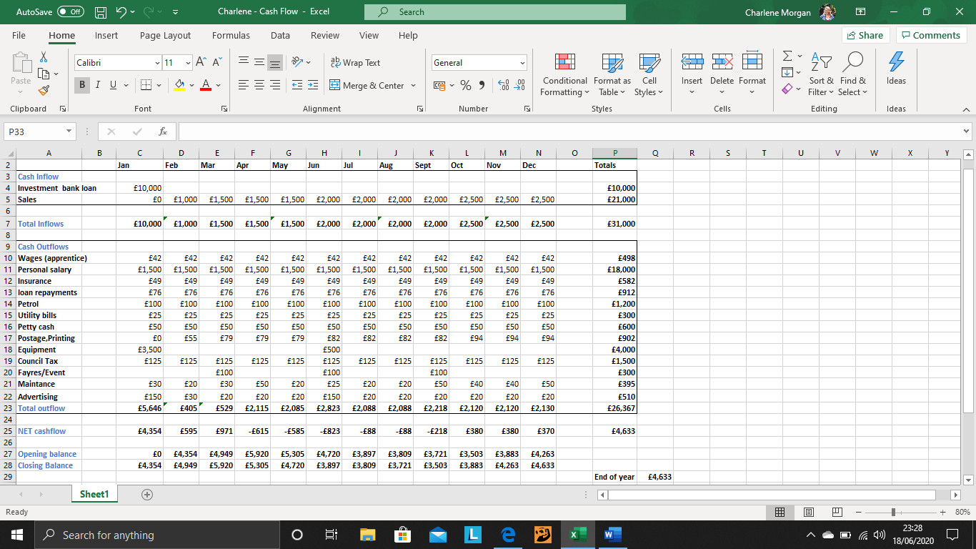
Cashflow – First 12 months of buisness

Conclusion

References

B & Q (2020) Shire Sandringham 10x8 Apex Shiplap Wooden Summer house [online]. Available at https://www.diy.com/departments/shire-sandringham-10x8-apex-shiplap-wooden-summer-house/199528_BQ.prd (accessed 1st June 2020)

Wilkinson Cameras (2020) Canon EOS 250D DSLR Twin Lens Value Kit [online]. Available at:https://www.wilkinson.co.uk/canon-eos-250d-dslr-camera-black-ef-s-18-55mm-f-4-5-6-is-stm-lens-ef-75-300mm-f-4-5-6-ii-lens/ (assessed 1st June 2020)

Emily Smith. (2020) Remesh 5 Types of market segmentation & How to use them [online]. Available at https://blog.remesh.ai/5-types-of-market-segmentation-how-to-use-them#psychographic-segmentation (accessed 17th May 2020)

Martin Luenendonk. (2014) Cleverism Understanding the Marketing Mix Concept – 4Ps [online]. Available at https://www.cleverism.com/understanding-marketing-mix-concept-4ps/ (accessed 18th May 2020)

Wex Photo-Video (2020) Canon LP-E6N Battery Pack [online]. Available at https://www.wexphotovideo.com/canon-lp-e6n-battery-pack-1560403/ (accessed 1st June)

B & Q (2020) Floral 4 seater Coffee set [online]. Available at https://www.diy.com/departments/floral-4-seater-coffee-set/5036581055943_BQ.prd (assessed 1st June 2020)

Fred (2019) What is a PESTEL/PESTLE Analysis? [online]. Available at https://small-business-success-wnc.com/pestel-pestle-analysis-for-small-businesses (accessed 9th June 2020)

Wedding Photography Industry, (2019), Average spend on Photography. Available at: https://www.yourperfectweddingphotographer.co.uk/wedding-photography-industry-2018/ (accessed on 16.06.2020)

Wilkinson Cameras (2020) Canon Lightening [online]. Available at: https://www.wilkinson.co.uk/brands/canon/canon-lighting/ (accessed 17th June 2020)

Amazon (1996) Camera Tripod, ESDDI 64 Inches Aluminum Tripod with Monopod 360 Degree Ball Head Lightweight Compact Tripod for DSLR Canon Nikon Sony for Travel and Work [online]. Available at: https://www.amazon.co.uk/Camera-Aluminum-Monopod-Lightweight-Compact/dp/B07P45PSXY/ref=sr_1_4?dchild=1&keywords=tripod+for+canon+camera&qid=1592521507&sr=8-4 (accessed 17th June 2020)

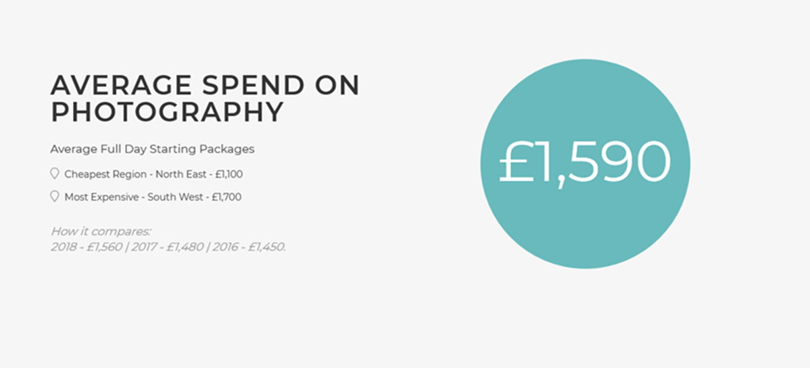
wedding photography industry 2019 (reference purpose)

